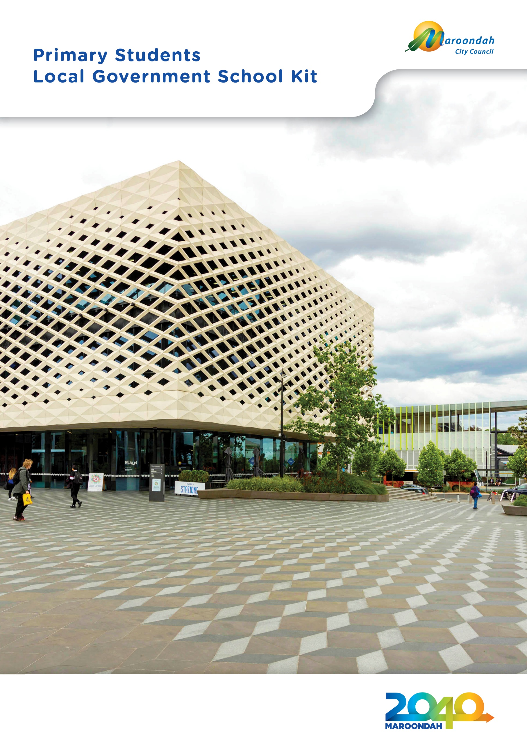

Government in Australia
Why do we need to have governments?
Without government, life would be very difficult. Governments decide what is best for the general good of our community. They put rules and systems in place so that people in our community can live together peacefully.
Imagine what would happen if people could do exactly what they liked with no concern for anyone else. Imagine your own household or school without rules. Picture the chaos on our roads if we had no road rules. Try playing any type of sport without rules! We need rules to keep many aspects of our lives in order.
Governments make and enforce rules to benefit us all.

What types of government are there in Australia?
We have three kinds or ‘spheres’ of government - federal, state and local. When the British arrived in Australia they established the Colony of New South Wales which included the whole of the east coast of Australia.
Other colonies were established in Tasmania, South Australia and Western Australia.
Victoria and Queensland later separated from New South Wales as individual colonies.
These colonies set up their own governments, now called state governments and also established local governments to look after their particular area and assist with building roads.
The British Government still made decisions on matters affecting all the colonies.
As the colonies grew and developed, a call for them to join together as one nation or ‘Federation’ grew. After lengthy discussions with the British Government, the colonial governments agreed to give up some of their powers to a new Commonwealth or Federal Government. The colonial or state governments kept most of the powers they had within their own territory, including local government.
So these are the three spheres of government - federal, state and local.

Government in Australia

Australian Government  The Australian or Federal Government is made up of politicians from all the states and territories of Australia, and its leader is called the Prime Minister. Our Australian Government meets or ‘sits’ in Canberra at Parliament House.  The Federal Government looks after matters that affect the whole nation, such as:  - our dealings with other countries  - our defence forces – the Army, Navy and Air Force  - immigration – people coming from other countries to live here  - making or ‘minting’ our money  - the welfare system – supporting those who need help  - the health system – hospitals and medical services  - Australia Post. | State Government  The state governments make decisions and rule for people within each state.  Each state government has its own elections and is based in the state’s capital city.  Victoria’s State Government sits at Parliament House in Spring Street, Melbourne.  The leader of the state government is called the Premier.  Each state government controls its:  - police force  - network of highways and freeways  - education system  - public transport system  - power supplies  - electricity  - gas  - water. | Local Government  Each state is divided into regions called ‘municipalities’ that are run by local government or ‘councils’.  People who live in a municipality elect their council representatives democratically.  The Councillors then elect a leader, the Mayor. Councils hold their meetings in a room called the ‘Council Chambers’. Maroondah City Council's Chambers are at Realm, 179 Maroondah Highway, Ringwood.  Local councils manage:  - collecting garbage  - street cleaning  - approving new buildings  - providing libraries  - sports facilities  - parks and gardens  - local roads and footpaths  - recycling services  - and more than 120 other services needed by residents and businesses

Democracy
Australia is a democracy, governed by its people through representatives they elect. The government representatives are elected by people aged 18 years and over who are Australian citizens.
The voting system is more complicated than electing a school captain but the idea is the same. Individuals ‘running’ for government make their ‘policies’ or plan of action known to the voters in their particular district or ‘electorate’ and the candidate who wins the most votes wins the ‘seat’ - the right to ‘sit’ as a member of the government and represent the people from his or her electorate.
People can make suggestions or complaints to the government by contacting the person who represents them.

Now you know
Fill in the spaces from the information on page 3.
The Australian Government looks after matters which affect the whole nation.
It sits at Parliament House, C _ _ _ _ _ _ _ .
And the leader of this government is called the P _ _ _ _ M _ _ _ _ _ _ _.
The Victorian State Government sits at Parliament House located in Spring Street,
M _ _ _ _ _ _ _ _ . The leader of this government is the P _ _ _ _ _ _ .
Maroondah City Council sits at the C _ _ _ _ _ _ C _ _ _ _ _ _ _ .
Located in R_ _ _ _, 179 Maroondah Highway, Ringwood.
The leader of Council is called the M _ _ _ _ .

Government in Australia

The following diagrams of Australia, Victoria and the City of Maroondah show the area of each of the three spheres of government is responsible for.

From the list of words in the box below, indicate which government is most likely to be responsible for each activity by writing the words near the maps.

Road laws Immigration Public Transport
Parks and gardens Police Postal Services
Footpaths Libraries Defence
Garbage

Australian Government Victorian Government
(National matters) (State matters)

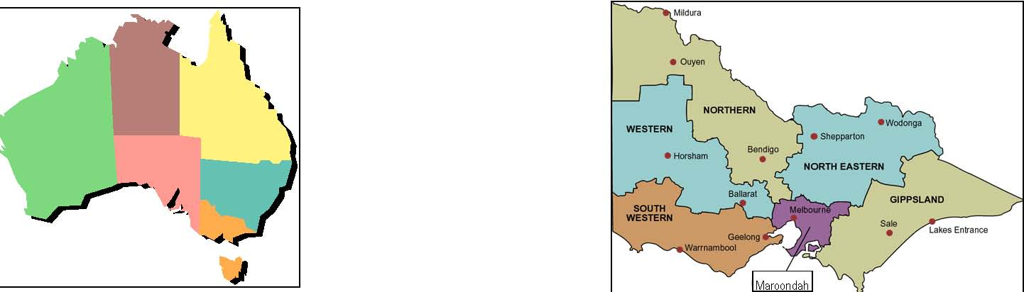

_________________________ ___________________________

_________________________ ___________________________

_________________________ ___________________________

Maroondah City Council
(Local matters)

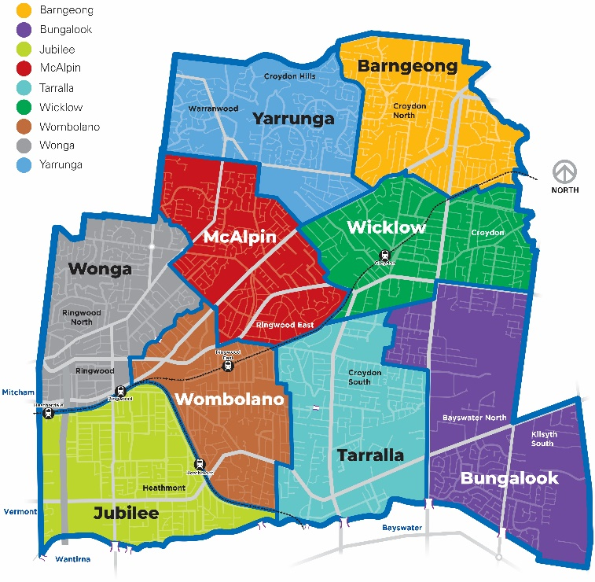

____________________________

_________________________

_________________________

_________________________

Maroondah City Council

There are over 700 separate local governments in Australia. Victoria has 79 which vary in size and population.  The Maroondah City Council was created in 1994 when the cities of Ringwood and Croydon joined with parts of Doncaster, Templestowe and Lilydale. It covers an area of 61.4 square kilometres.  You can see its boundaries on the map below.  Over 118,000 people live in Maroondah - if they all went to the football on the same day they would more than fill the MCG! | The name Maroondah was chosen by the State Government because the Maroondah Highway is the major road linking the east and west of the municipality. ‘Maroondah’ is an aboriginal word meaning ‘throwing’ and ‘Maroon’ means ‘leaves’.  The Councillors represent the people who live and own property in Maroondah.  The municipality is divided into areas called ‘Wards’ – you’ll see them on the diagram below.  One Councillor is elected from each Ward, then together these Councillors elect the Mayor and Deputy Mayor.

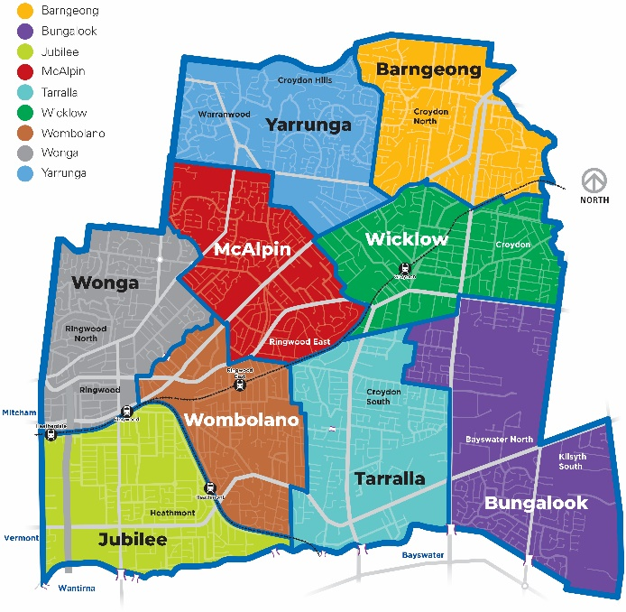

The Mayor is the leader of the Council – they are in charge of the Council meetings and attendmany events in the municipality, such as festivals, school awards, gallery exhibitions, the opening of new facilities and participate in any community activities.

The Mayor and the other Councillors are paid an allowance for the work they do on Council but it’s not their full time job. They take on this responsibility because they want to play a part in local government and feel strongly about issues in their community. Anyone can be a Councillor as long as they are over 18 and eligible to vote in state and federal elections. They must also win enough votes!

Word search
Find these words in the box - they may be vertical, horizontal or diagonal.
VOTES | MAYOR | CANDIDATE | ELECTION | COMMUNITY
COUNCIL | FEDERAL | MUNICIPALITY | COUNCILLORS | LOCAL
CITY | STATE | MAROONDAH | GOVERNMENT | CHAMBERS
SEATS | PREMIER | PARLIAMENT | PRIME MINISTER | WARDS

B | X | C | C | O | M | M | U | N | I | T | Y | Y | A
S | P | C | H | W | S | T | V | M | W | P | L | H | E
E | W | X | A | M | C | O | U | N | C | I | L | M | R
A | Q | R | M | N | R | Y | V | O | T | E | S | U | S
T | D | D | B | C | D | N | R | Q | M | S | K | N | C
S | P | R | E | C | C | I | L | R | T | Z | P | I | Q
G | M | A | R | O | O | N | D | A | H | W | L | C | P
Y | A | L | S | U | W | Y | T | A | R | B | K | I | A
Z | Y | P | O | N | Q | E | V | K | T | I | P | P | R
N | O | L | O | C | A | L | F | E | D | E | R | A | L
T | R | E | V | I | S | Q | U | D | B | O | E | L | I
N | M | R | E | L | E | C | T | I | O | N | M | I | A
P | T | R | W | L | C | H | I | B | G | U | I | T | M
R | W | Y | X | O | Q | M | F | T | J | U | E | Y | E
I | O | B | Z | R | L | F | S | Q | Y | M | R | J | N
M | E | W | R | S | Q | Y | T | M | K | F | U | L | T
E | I | G | O | V | E | R | N | M | E | N | T | P | B
M | I | N | I | S | T | E | R | T | R | S | B | Q | C

List the names of the Mayor and the eight other Councillors at Maroondah City Council.

Ask your teacher if one of the Councillors could be invited to the school to talk to the class about the role of a Councillor.

Mayor’s Name

_____________________________________

Councillors’ Names

______________________________ | ______________________________
______________________________ | ______________________________
______________________________ | ______________________________
______________________________ | ______________________________

Class activity

Imagine that each member of your class is a Junior Councillor. You have each been elected to represent all primary school students in the City of Maroondah. Junior Council is to approve building one of the following:

A: Skate park B: Giant water slide C: Playground

- When democratic governments are deciding an issue, the majority rules. What is a majority?
- How many members of your class would make a majority?
- Take a vote in your class to see which of the proposals A, B or C receives the majority vote.
- Choose a person to present reasons for voting for each of these proposals to the class – and someone to argue against each proposal. After some discussion, take another vote to see if there is any change in the outcome.
- How could Councillors find out what the people they represent think about an issue they are considering?
- Look on Council’s Your Say engagement portal on Council’s website for issues being decided by Maroondah City Council at the present time.

Maroondah City Council provides community services and facilities using the money it raises. It is also responsible for making and enforcing local laws.

Look around and you’ll see your Council at work everywhere:

- The school crossing supervisor works at keeping you safe  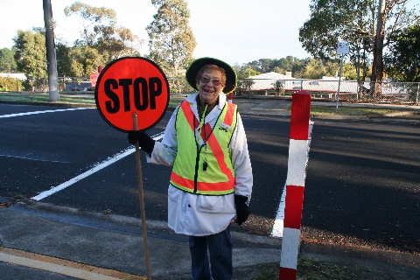  - Immunisation sessions are available to make sure you don’t catch infectious diseases like measles, polio and hepatitis.  - Libraries – there are two in Maroondah  - Council staff plan the events and keep the buildings and grounds in top condition at the Karralyka Centre and Maroondah Federation Estate.  - Council staff run activities for all ages at the Wyreena Community Arts Centre and Maroondah Federation Estate  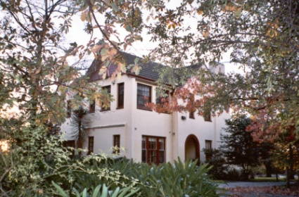  - Parking officers make sure people obey parking restrictions so that car park spaces are available for as many people as possible.  - Holiday programs and under-age entertainment is planned by Youth Workers who also give young people advice on education, employment and personal problems. | - Swimming pools with their office staff, life guards and swimming teachers.  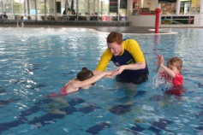  - Meals on Wheels staff and volunteers deliver low cost meals mainly to elderly people living alone  - Gardeners keep the plants in our parks, gardens and public places attractive and colourful.  - Council workers repair roads, footpaths and street lights, and replace signs.  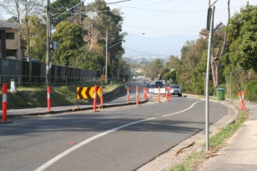  - Garbage trucks remove rubbish from outside houses and businesses every week.  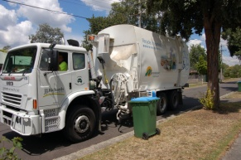  - Ringwood and Dorset Golf courses are kept in top condition by Council staff.
There are four main ways Council raises money:
Rates  Every property owner in Maroondah pays an amount to Council each year called ‘rates’. The amount depends on the value of the property – the more valuable the property, the higher the rates. The property owner can pay the rates all at once or in four parts called ‘instalments’ spread over the year. The Victorian Government reviews the value of each property every year.  Grants  Each year the State and Federal Government collect money called ‘taxes’ from Australian citizens and businesses and give some of it to local government. Sometimes these grants are for something specific, like the development of the former Ringwood Primary School into the Maroondah Federation Estate, but Council can decide how other grants will be used. | Fees  People in Maroondah pay fees for some Council services. When you go to a swimming pool, you pay an entry fee; your dogs and cats are registered each year with the payment of a fee; if you want a special rubbish collection there’s a fee; when you go to a Council organised concert or art show you may need to buy a ticket; people have to pay for a building permit or for a permit to remove large trees.  There are also fees called ‘fines’, which are collected from people who have ignored the rules. If your library book is overdue, you pay a fine before you can borrow another one; if a car is parked too long in a restricted area, its owner has to pay a parking fine; if a dog is found away from its home, it’s taken to the pound and its owner has to pay a fine to get it back.  Loans  Councils can borrow money for larger projects and repay the loan over a number of years. However interest must be paid as well as the original amount borrowed, so this is an expensive way to raise money.

How does Council decide where the money should be spent?
One of the main roles of Council is to manage the money it raises. In June each year it allocates amounts of money to be spent in various areas. This is called a ‘budget’.

There are some things that must always be included in the budget – things like rubbish removal, maintenance of roads, paths, street lighting, bike tracks and parks – things that make Maroondah a safe and pleasant place to live and work.

New projects are often suggested by the people living here. For instance some might request a new netball centre to benefit the local netball clubs, other groups may want roundabouts in their street to slow the traffic, a Stop sign at a dangerous corner, a drinking tap or more play equipment in their park.

Council staff work out how much the projects would cost and who would benefit from them. Then they can work out the priorities and include them in the budget. Once a project is approved by Council it can go ahead.

Anyone can attend Council meetings to hear what is going on or to present their point of view and watch the Councillors vote on a particular issue. If there are the same number of votes for a project as against, the Mayor can use his or her vote to decide the issue. Maroondah City Council usually meets on the third Monday of the month at 7.30pm in the Council Chambers at Realm. Council Meetings are also live streamed and can be watched on Council’s website.

Council’s budget is like your family budget. Some things, like food, are essential. Other things are bought when they become a high priority, things like new school shoes.

List some of the things that must be bought each week in your household and then list some things that are bought when they are a high priority.

Weekly essentials Items that are bought when they are
high priority

______________________________ | ______________________________
______________________________ | ______________________________
______________________________ | ______________________________
______________________________ | ______________________________
______________________________ | ______________________________
______________________________ | ______________________________

Write down five things Council must include in its budget:

______________________________ | ______________________________
______________________________ | ______________________________
____________________________________

If Council were making a decision about the three proposals you looked at as a Junior Councillor, what sort of information would they require? How would they obtain this?

Who does the work?

Many people work for Council so it can provide its services. Council staff are not elected, they apply for their positions and are paid for their work.

Maroondah City Council has about 650 staff. The Chief Executive Officer is the head of staff – it’s a bit like a school community, where the Principal is in charge of the teachers. A number of Managers make sure all the areas of Council are running efficiently and effectively.

There are hundreds of different jobs in Council, requiring a wide variety of people. Many staff have tertiary qualifications from a university or college, others have developed special skills.
- Accountant – keeps records of money being received and paid by Council  - Aged and Disability Officer – helps people to access aged and disability services  - Building Surveyor – makes sure builders follow the regulations when constructing new buildings or changing existing buildings  - Computer programmer – manages the computer software used by Council staff  - Construction Engineer – gives advice on structural matters  - Engineer – involved in design of footpaths, roads and drainage  - Environmental Health Officer – advises on pest control, tests water at swimming pools and spas, inspects restaurants, hotels and shops to make sure the food being sold is safe to eat  - Environmental Officer – makes sure the environment is protected and improved  - Occasional Care Worker - looks after other people's children in a Council-owned centre  - Family Day Care Worker – looks after other people’s children in her own home  - Gardener – works in the parks and gardens and around Council properties  - Librarian – manages the resources in libraries  - Local Laws Officer – advises on Council rules like parking and pet controls | - Maternal & Child Health nurse – gives advice to parents of young children and monitors babies’ growth and progress  - Open Space Officer – manages the development and preservation of open spaces  - Payroll Officer – is in charge of staff wages  - Communications and Engagement Officer – prepares and distributes information about Council to the community and media  - Records Officer – keeps Council documents in order and finds information when requested  - Leisure Officer – plans and manages sporting programs and events  - Theatre Manager – organises theatre programs, bookings and publicity  - Statutory Planner – advises whether developments are suitable for particular areas of the City  - Traffic Engineer – surveys local traffic, designs traffic management devices like roundabouts and advises where pedestrian and school crossings are needed  - Youth Worker – looks after issues and interests of people aged 12 to 25 years

Your Council in action

Class activity

Discuss with the rest of the class where Maroondah City Council is currently carrying out road works and other maintenance work. Write the location of one of the jobs being carried out and describe the work being done.

Find out about Council’s recycling program and make a list of rubbish that can be recycled.

Make a list of rubbish that goes to landfill because it cannot be recycled. How could you reduce this sort of rubbish?

Who does what?

Draw a line to match the people to the work done by Council.

Environmental Health Officer  Building Inspector  Maternal & Child Health nurse  Leisure Officer  Landscape Gardener  Youth Worker  Child Care Worker  Traffic Engineer  Customer Service Officer | designing a roundabout  setting up a youth Drop-in Centre  planting trees  checking that food for sale is safe to eat  answering residents’ inquiries  making sure buildings are correctly constructed  monitors babies’ growth & progress  looking after pre-school children while parents work  organising school holiday programs

Of all the Council jobs mentioned, select one and draw a picture showing this person at work.

What do they do?
Name the Council staff in the drawings then in the space below list some of the jobs this officer does.

A B

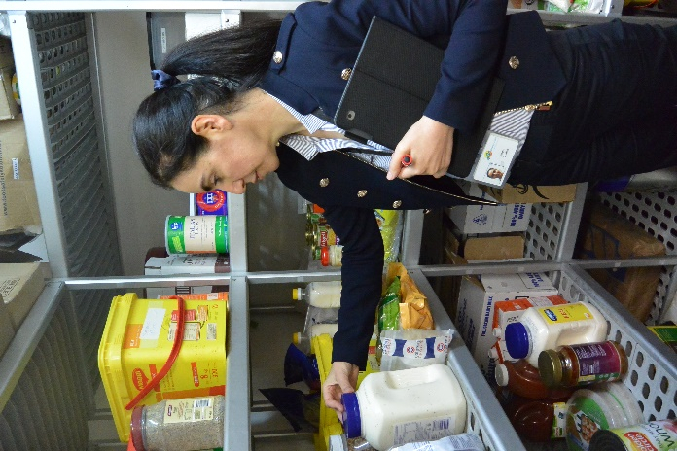 | 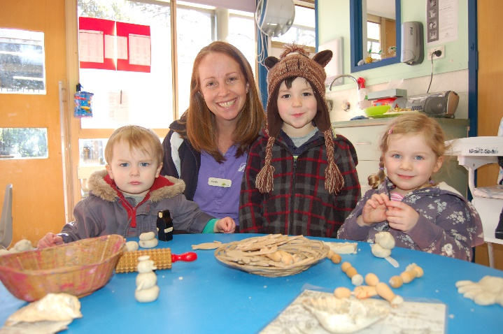

______________________________ | ______________________________
______________________________ | ______________________________
______________________________ | ______________________________
______________________________ | ______________________________
______________________________ | ______________________________
______________________________ | ______________________________

Community services

Make a poster called ‘Maroondah City Council at Work’.
From magazines cut out pictures of a toddler, primary school student, teenager, young adult, middle aged adult and an elderly adult.
Stick these pictures onto a sheet of paper then draw a box next to each.
In the boxes write down the Council services you think that person might use.

Why have local laws?

There are a number of Council rules designed to make the community a safe and pleasant place to live in:

- Burning off  - Registration of dogs and cats  - The number and types of pets you can own  - What you can put out to be collected by the garbage truck  - What can be recycled and how it is collected | - Where cars can and cannot be parked  - What types of buildings can be built in particular areas  - How close new constructions can be built next to neighbouring buildings  - What buildings can be used for

People who break the rules sometimes have to pay fines. However Council staff will always try to solve problems for people in the community, so as to avoid these penalties.

For instance if a resident complains that a neighbour’s dog is barking too much, a staff member from the Neighbourhood Services Department can speak to the dog’s owner and suggest ways of stopping the noise. It’s always better to solve a problem by talking it through and Council can advise people how to do this.

Do the rules ever change?
Local government laws are reviewed regularly and altered if necessary to meet the needs of the community. Sometimes new laws are required to control a particular problem.
For example over the years many trees have been removed from properties to make way for new developments, so that it became necessary to introduce a rule requiring people to apply for permission from Council to remove large trees. In this way Council is able to preserve the ‘green’ look of the municipality and preserve its historic and beautiful trees.
Similarly, if riding skate boards and roller blades became a nuisance and a danger to pedestrians in some busy shopping areas, Council may be asked to introduce some rules to make these areas safe.
People who feel something needs to be improved or changed can write directly to Council or they can contact the Councillor who represents them to talk it over.

You’ll be pleased to know Maroondah City Council aims to meet the needs of residents across all age groups, income levels and cultural backgrounds.

