Secondary Students
Local Government
School Kit

Government in Australia
Why do we need to have governments?
Without government, life would be very difficult. Governments decide what is best for the general good of our community. They put rules and systems in place so that people in our community can live together peacefully.
Imagine what would happen if people could do exactly what they liked with no concern for anyone else. Imagine your own household or school without rules. Picture the chaos on our roads if we had no road rules. Try playing any type of sport without rules! We need rules to keep many aspects of our lives in order.
Governments make and enforce rules to benefit us all.
What types of government are there in Australia?
We have three kinds or ‘spheres’ of government - federal, state and local. When the British first settled Australia they established the Colony of New South Wales which included the whole of the east coast of Australia.
Other colonies were established in Tasmania, South Australia and Western Australia.
Victoria and Queensland later separated from New South Wales as individual colonies.
These colonies set up their own governments, now called state governments and also established local governments to look after their particular area and assist with building roads.
The British Government still made decisions on matters affecting all the colonies.
As the colonies grew and developed, a call for them to join together as one nation or ‘Federation’ grew. After lengthy discussions with the British Government, the colonial governments agreed to give up some of their powers to a new Commonwealth or Federal Government. The colonial or state governments kept most of the powers they had within their own territory, including local government.
So these are the three spheres of government - federal, state and local.

Government in Australia

Federal Government  The Federal or Commonwealth Government is made up of politicians from all the states and territories of Australia, and its leader is called the Prime Minister. Our Federal Government meets or ‘sits’ in Canberra at Parliament House.  The Federal Government looks after matters that affect the whole nation, such as:  - our dealings with other countries  - our defence forces – the Army, Navy and Air Force  - immigration – people coming from other countries to live here  - making or ‘minting’our money  - the welfare system – supporting those who need help  - the health system – hospitals and medical services  - Australia Post. | State Government  The state governments make decisions and rule for people within each state.  Each state government has its own elections and is based in the state’s capital city.  Victoria’s State Government sits at Parliament House in Spring Street, Melbourne.  The leader of the state government is called the Premier.  Each state government controls its:  - police force  - network of highways and freeways  - education system  - public transport system  - power supplies. | Local Government  Each state is divided into regions called ‘municipalities’ that are run by local government or ‘councils’.  People who love in a municipality elect their council representatives democratically.  The Councillors then elect a leader, the Mayor. Councils hold their meetings in a building called the ‘Council Chambers’.  Local councils manage community needs including:  - collecting garbage  - street cleaning  - approving new buildings  - providing libraries  - sports facilities  - parks and gardens  - recycling services  - and the many other services needed by residents and businesses

Democracy
Australia is a democracy, governed by its people through representatives they elect. The government representatives are elected by people aged 18 years and over who are Australian citizens.
The voting system is more complicated than electing a school captain but the idea is the same. Individuals ‘running’ for government make their ‘policies’ or plan of action known to the voters in their particular district or ‘electorate’ and the candidate who wins the most votes wins the ‘seat’ - the right to ‘sit’ as a member of the government and represent the people from his or her electorate.
People can make suggestions or complaints to the government by contacting the person who represents them.
Maroondah City Council

There are over 700 separate local governments in Australia. Victoria has 78 which vary in size and population.  The Maroondah City Council was created in 1994 when the smaller cities of Ringwood and Croydon joined with parts of Doncaster, Templestowe and Lillydale. It covers an area of 61.4 square kilometres.  You can see its boundaries on the map below.  Over 100,000 people live in Maroondah… if they all went to the football on the same day they would more than fill the MCG! | The name Maroondah was chosen by the State Government because the Maroondah Highway is the major road linking the east and west of the municipality. ‘Maroondah’ is an aboriginal word meaning ‘throwing’ and ‘Maroon’ means ‘leaves’.  The Councillors represent the people who live and own property in Maroondah.  The municipality is divided into areas called ‘Wards’ – you’ll see them on the diagram below.  Three Councillors are elected from each Ward, then together these Councillors elect the Mayor.
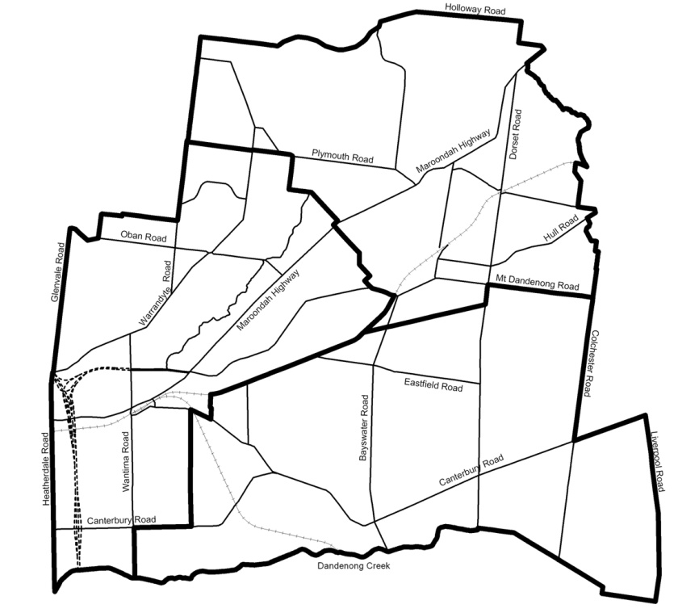

The Mayor is the leader of the Council – he or she is in charge of the Council meetings and attends many events in the municipality, such as festivals, school awards, gallery exhibitions, the opening of new facilities like the Croydon Leisure & Aquatic Centre.

The Mayor and the other Councillors are paid an allowance for the work they do on Council but it’s not their full time job. They take on this responsibility because they want to play a part in local government and feel strongly about issues in their community. Anyone can be a Councillor as long as they are over 18 and eligible to vote in state and federal elections. They must also win enough votes!
Maroondah City Council provides community services and facilities using the money it raises. It is also responsible for making and enforcing local laws.

Look around and you’ll see your Council at work everywhere:

- The school crossing supervisor works at keeping you safe  - Immunisation sessions are available to make sure you don’t catch infectious diseases like measles, polio and hepatitis.  - Libraries – there are two in Maroondah  - Council staff plan the events and keep the buildings and grounds in top condition at the Karralyka Centre and Maroondah Federation Estate.  - Council staff run activities for all ages at the Wyreena Community Arts Centre and Maroondah Federation Estate  - Parking officers make sure people obey parking restrictions so that car park spaces are available for as many people as possible.  - Holiday programs and under-age entertainment are planned by Youth Workers who also give young people advice on education, employment and personal problems.  - Swimming pools with their office staff, life guards and swimming teachers. | - Meals on Wheels staff and volunteers deliver low cost meals mainly to elderly people living alone  - Gardeners keep the plants in our parks, gardens and public places attractive and colourful.  - Council workers repair roads, footpaths and street lights, and replace signs.  - Garbage trucks remove rubbish from outside houses and businesses every week.  - Ringwood & Dorset Golf courses are kept in top condition by Council staff.

There are four main ways Council raises money:

Rates  Every property owner in Maroondah pays an amount to Council each year called ‘rates’. The amount depends on the value of the property – the more valuable the property, the higher the rates. The property owner can pay the rates all at once or in four parts called ‘instalments’ spread over the year. A property valuer working for the Council reviews the value of each property every two years.  Grants  Each year the State and Federal Government collect money called ‘taxes’ from Australian citizens and businesses and give some of it to local government. Sometimes these grants are for something specific, like the development of the former Ringwood Primary School into the Maroondah Federation Estate, but Council can decide how other grants will be used. | Fees  People in Maroondah pay fees for some Council services. When you go to a swimming pool, you pay an entry fee; your dogs and cats are registered each year with the payment of a fee; if you want a special rubbish collection there’s a fee; when you go to a Council organised concert or art show you may need to buy a ticket; people have to pay for a building permit or for a permit to remove large trees.  There are also fees called ‘fines’, which are collected from people who have ignored the rules! If your library book is overdue, you pay a fine before you can borrow another one; if a car is parked too long in a restricted area, its owner has to pay a parking fine; if a dog is taken to the pound, its owner has to pay a fine to get it back.  Loans  Council can borrow money for larger projects and repay the loan over a number of years. However interest must be paid as well as the original amount borrowed, so this is an expensive way to raise money.

How does Council decide where the money should be spent?
One of the main roles of Council is to manage the money it raises an in June each year it allocates amounts of money to be spent in various areas…..this is called a ‘budget’.

There are some things that must always be included in the budget – things like rubbish removal, maintenance of roads, paths, street lighting, bike tracks and parks – things that make Maroondah a safe and pleasant place to live and work.

New projects are often suggested by the people living here. For instance some might request a new netball centre to benefit the local netball clubs, other groups may want roundabouts in their street to slow the traffic, a Stop sign at a dangerous corner, a drinking tap or more play equipment in their park.

Council staff work out how much the projects would cost and who would benefit from them. Then they can work out their priorities and include them in the budget. Once a project is approved by Council it can go ahead.

Anyone can attend Council meetings to hear what is going on or to present their point of view and watch the Councillors vote on a particular issue. If there are the same number of votes for a project as against, the Mayor can use his or her vote to decide the issue. Maroondah City Council usually meets on the third Monday of the month at 7.30pm in the Council Chambers situated in Braeside Avenue, Ringwood.

Why have local laws?

There are a number of Council rules designed to make the community a safe and pleasant place to live in:

Rules covering:
- Burning off  - Registration of dogs and cats  - The number and types of pets you can own  - What you can put out to be collected by the garbage truck  - What can be recycled and how it is collected | - Where cars can and cannot be parked  - Noise restrictions particularly at night and early in the morning  - What types of buildings can be built in particular areas  - How close new constructions can be built in neighbouring buildings  - What buildings can be used for

People who break the rules sometimes have to pay fines. However Council staff will always try to solve problems for people in the community, so as to avoid these penalties.

For instance if a resident complains that a neighbour’s dog is barking too much, a staff member from the Neighbourhood Services Department can speak to the dog’s owner and suggest ways of stopping the noise. It’s always better to solve a problem by talking it through and Council can advise people how to do this.

Do the rules ever change?
Local government laws are reviewed regularly and altered if necessary to meet the needs of the community. Sometimes new laws are required to control a particular problem.
For example over the years many trees have been removed from properties to make way for new developments, so that it became necessary to introduce a rule requiring people to apply for permission from Council to remove large trees. In this way Council is able to preserve the ‘green’ look of the municipality and preserve its historic and beautiful trees.
Similarly, if riding skate boards and roller blades became a nuisance and a danger to pedestrians in some busy shopping areas, Council may be asked to introduce some rules to make these areas safe.
People who feel something needs to be improved or changed can write directly to Council or they can contact the Councillor who represents them to talk it over.

You’ll be pleased to know Maroondah City Council aims to meet the needs of residents across all age groups, income levels and cultural backgrounds.

