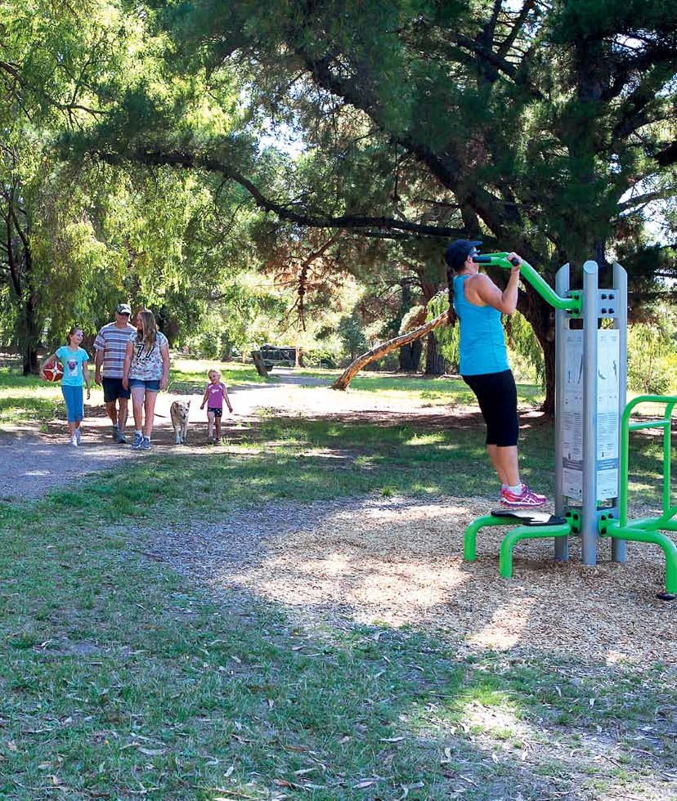Physical Activity Strategy 2015 - 2020
Getting Maroondah Moving - More Often

Safe, healthy and active

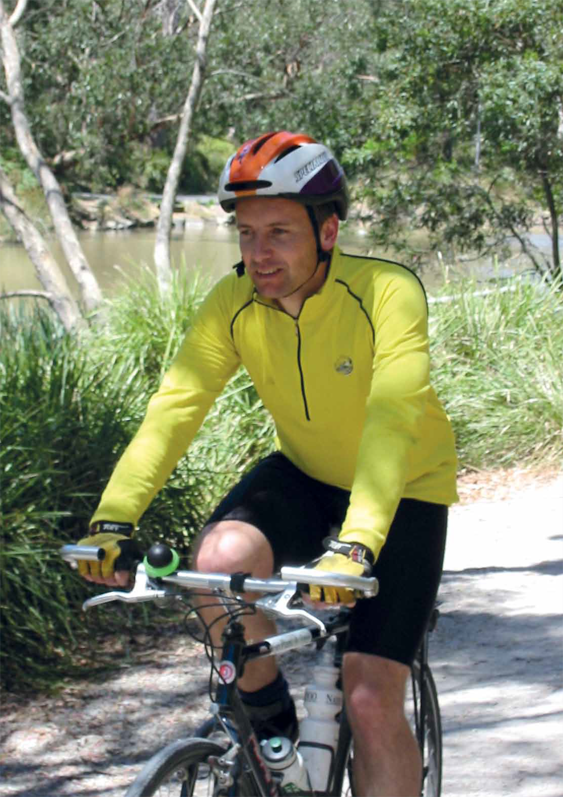

Safe, healthy and active

Executive summary 4
Council Priority - Active Travel 5
Council Priority - Activating Open Space 5
Council Priority - The Future of Sport 5
Council Priority - Schools and Workplaces 5
Consultation 6
Action 6
Introduction 7
Aim of the physical activity strategy 8
Objectives 9
Definitions 10
Strategic context 11
Maroondah - a snapshot 13
Active opportunities 14
Council’s role in influencing physical activity levels 15
Evidence for action - active living and its impact 17
State and federal priorities 18
Federal Government - national sport and
active recreation framework 18
Sport and Recreation Victoria Strategic
Framework 2013-2015 18
How much is enough? 19
National physical activity & sedentary behaviour guidelines 20
Sport is not enough 21
Maroondah’s current physical activity levels 22
Understanding who is not as active as they need to be. 25
Children and adolescent activity levels. 25
Challenges to participation in physical activity 26
General community 26
Youth 28
Older people 29
Women 31
LGBTI community 32
Gay, Lesbian and Bisexual people 33
Intersex and Transgender people 33
People with disabilities 34
Culturally and linguistically diverse (CALd) communities 35
Council Priority - Active Travel 36
Council Priority - Activating Open Space 40
Council Priority - The Future of Sport 43
Council Priority - Schools and Workplaces 44
Taking action and making an impact 45
Maroondah 2040 Community Indicator Reporting Baseline 46
Physical Activity Strategy Action Plan 47

Safe, healthy and active

Executive summary
The majority of Maroondah residents do not undertake enough physical activity.

Obesity levels and other chronic health problems associated with sedentary lifestyles are increasing. Only 35% of adult Maroondah residents are undertaking enough physical activity to meet the National Physical Activity Guidelines and on a state level children’s participation decreases with age, from 36% of 5 to 8 year olds to just 6% of 15 to 17 year olds.
Increasing the level of physical activity in the Maroondah Community is likely to have a major impact on public health and therefore Maroondah City Council will prioritise the development and/or improvement of environments to support physical activity.
The Physical Activity Strategy 2015-2020 builds on the recommendations of Marooondah’s 2013 – 2017 Community Wellbeing Plan and the Maroondah 2040 Vision and sets actions for the next five years to address the Maroondah 2040 community indicators of progress related to physical activity.
Lack of time is reported as the primary reason Maroondah residents do not undertake enough regular physical activity. This reasoning indicates the need to support environments for physical activity in a range of different settings such as schools, workplaces, residential streets and public open space and recognise that while sport is an important component; incidental exercise is of primary importance to increasing overall activity levels. Furthermore information and education is essential to ensure that residents understand the importance of regular physical activity for health and wellbeing.

The top five activities undertaken by Maroondah residents were reported as walking, aerobics/ fitness/gym, running/Jogging, cycling and swimming, acknowledging an increasing preference for physical activity pursuits that are non structured or pursuits that can be undertaken in one’s own time.
There are different factors that affect the physical activity levels of specific populations and therefore different strategies are required to overcome these. The Physical Activity Strategy highlights the challenges and opportunities being experienced by the general community and then focuses on six different specific populations in order to target specific actions which will have a positive impact on participation. For the general community a key challenge for engaging the general Maroondah community is the perception of, or real issue of not enough time. While many people are indeed time poor, time constraints is not the whole explanation. For many it is a vicious cycle of, a lack of motivation fuelled by poor diet, sedentary behaviour, and possibly poor sleeping habits which leads to feeling low on energy. To address this challenge and to make physical activity an easier option the strategy focuses on four key Council Priorities which highlight opportunities for Council action.

Council priority -
Active Travel
despite the many benefits of active transportation, physical and attitudinal barriers prevent people from extensively using active travel modes (predominantly public transport, walking and cycling). A sustained holistic approach of physical infrastructure, education and enforcement will be necessary to increase ongoing usage.
There are a range of opportunities that Council can undertake to improve the pedestrian and cycle network. These will include expansion of pathways for better connectivity, removing physical barriers, improving permeability across roads and installing wayfinding signage.
Council is well placed to take the lead implementation role within the active transportation sector and engage with other planning and transport authorities to leverage greater capital works and community program investment in active transportation.

Council priority - Activating Open Space
The results of the recent Maroondah 2040 visioning consultation highlighted the high level of importance that public open space plays to Maroondah residents. This level of regard may be a key factor in promoting active living, providing opportunities for people to be more active and to adopt healthier behaviours.
The creation of vibrant, active public open spaces also contributes to strengthening community connections and safety perceptions and has a positive influence on the independent mobility of younger and older Maroondah residents.
Generating greater volumes of park users will assist in activating spaces, where people feel safer and feel welcomed and motivated to exercise by the energy of others. In programming open space there is also an opportunity for Maroondah Leisure to utilise public open space to engage residents who do not access facility based programs.

Council priority - The Future of Sport
While Maroondah’s current physical activity profile highlights that 70% of Maroondah residents do not participate in organised sport and may not ever have the interest or ability to do so, sport still plays an important role in the community, for health and fitness, social interaction and social cohesion.
Sports organisations need to be aware that there is a shift in the motivation for people to play sport, and to embrace new ways of delivering sport to those who want to be involved. Increased participation should be encouraged through an emphasis on social opportunities, casual visitation and the availability of modified and /or non competitive options.

Council priority - Schools and Workplaces
With lack of time, a key inhibitor for Maroondah residents engaging in enough physical activity it is imperative to seek out opportunities to incorporate more physical activity at school or in the workplace.
Most Council facilities have capacity for far greater weekday usage and therefore scope to explore new initiatives to engage schools and workplaces. Council’s Maroondah Leisure facilities should explore avenues for corporate membership packages, corporate challenges and schools participation.

Safe, healthy and active

Consultation
In preparation for the development of Council’s Physical Activity Strategy 2015 - 2020, a range of consultation methods were undertaken to establish a clear picture of Maroondah’s current participation levels, reasons for non participation and community needs. Given the extent and breadth of the Maroondah 2040 Visionary consultation, there was also a wide range of recent data and extensive community feedback, relevant for inclusion in this strategy. Eight Council departments were identified as having a direct impact on Maroondah Community’s ability to participate in physical activity and individual team workshops were held with these areas to gain specific insight into the issues, opportunities, priorities and potential actions relevant to the role of each team. The potential actions were then combined with the opportunities from the four Council Priority Focus areas to develop the 2015-2020 action plan.

Action
In order to increase Maroondah’s participation levels in physical activity Maroondah Council must consider the barriers and opportunities highlighted in this strategy and commit to undertaking measurable actions over the next 5 years. To measure the impact of these actions, the strategy has established a reporting baseline based on current ABS data and /or other current sources which will continue to be updated to enable future measurement. In 2019, the physical activity household telephone survey will be undertaken again to ascertain the percentage of residents who meet the National Physical Activity Guidelines.
The five year action plan will guide the development of new policies, infrastructure improvements, programs and initiatives which will improve practices, respond to demonstrated need, increase access and encourage residents to prioritise physical activity in their daily routine.
The four key focus areas of the action plan are:
- Information / Health Promotion
- Access : Physical, Social and Attitudinal environments
- Infrastructure
- Activation Initiatives / Opportunities
The plan contains 45 actions from a wide range of Council service areas. The implementation will be the responsibility of each lead area with support from relevant service areas detailed in the plan.
Reporting will be undertaken annually under the facilitation of Council’s Sport and Recreation Team.

Introduction

The majority of Maroondah residents do not undertake enough physical activity.

Obesity levels and other chronic health problems associated with sedentary lifestyles are increasing. Reports are emerging that for the first time children may have a shorter life expectancy than their parents if physical activity levels are not addressed. A paper published in the New England Journal of Medicine1 predicts a decrease in life expectancy. Adrian Bauman, a professor of public health at the University of Sydney, agreed that these findings were applicable to Australia, which is tracking just behind the US in obesity trends.
Increasing the level of physical activity in the Maroondah Community is likely to have a major impact on public health and therefore Maroondah City Council will prioritise the provision of supportive environments for physical activity to assist residents to adopt an active living lifestyle change.
The Physical Activity Strategy 2015-2020 builds on the recommendations of Marooondah’s 2013 – 2017 Community Wellbeing Plan and the Maroondah 2040 Vision and sets actions for the next five years to address the Maroondah 2040 community indicators of progress related to physical activity and to increase the overall percentage of Maroondah residents who meet the National Physical Activity Guidelines.
The primary reason Maroondah residents do not undertake enough regular physical activity is self reported as ‘lack of time’.2 This reasoning indicates the need to support environments for physical activity in a range of different settings such as schools, workplaces, residential streets and public open space and recognise that while sport is an important component; incidental exercise is of primary importance to increasing overall activity
levels. Council needs to ensure that an extensive range of opportunities exist to make it an easier choice for those who have indicated they do not have time to meet the required physical activity guidelines. Furthermore information and education is essential to ensure that residents understand the importance of regular physical activity for health and wellbeing.
The Victorian Health Promotion Foundation (VicHealth) has recently released its Physical activity, sport and walking Investment Plan (2014 to 2018).3 The strategic approach focuses on making physical activity participation part of everyday living, and competitive and social sport. The four key areas align with the physical activity priorities for Maroondah City Council.
The Four Key Areas of VicHealth’s Strategic Approach:
Walking | Making Active Travel an Easier Choice support a culture and environment that encourages active travel
Physical Activity | Developing new partnerships and approaches for active recreation Support new approaches and connect people to opportunities for physical activity
Sport | Enabling sport to get ahead of participation trends  Build more welcoming and flexible approaches to organised and social sport participation
Sitting | Reducing sitting in the workplace Influence workplaces to encourage less sitting and more standing and walking

1Olshansky, S., Passaro, D., Hershow, R., Layden, J., Carnes, B., Brody, J., et al. (2005). A potential decline in life expectancy in the United States in the 21st century. New England Journal of Medicine 352, 1138-1145
2Maroondah City Council (2014) Physical Activity Strategy Household survey
3VicHealth, (2014) Physical activity, sport and walking Investment Plan (2014 to 2018)

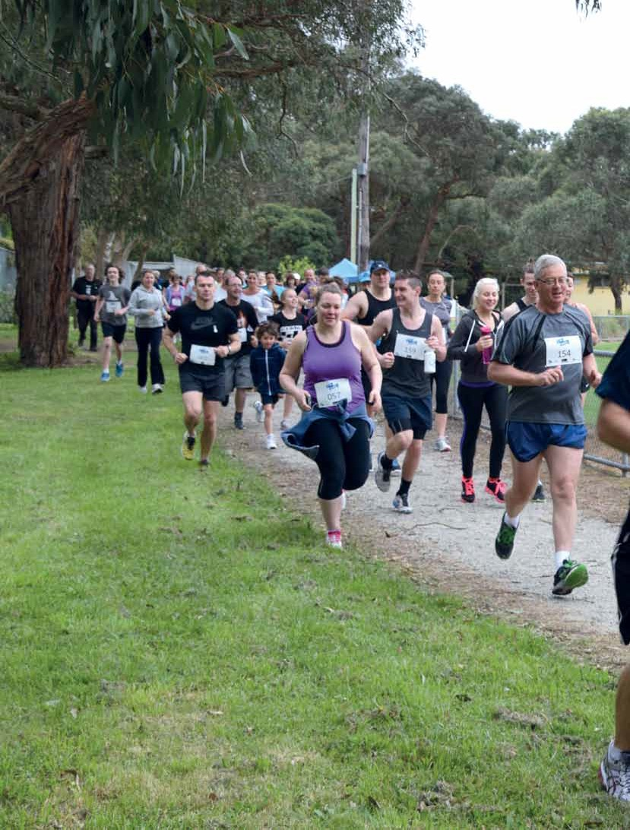Safe, healthy and active

Aim of the Physical Activity Strategy

To implement strategies to address the determinants of physical inactivity, improving health outcomes for Maroondah residents and empowering them to be physically active every day.

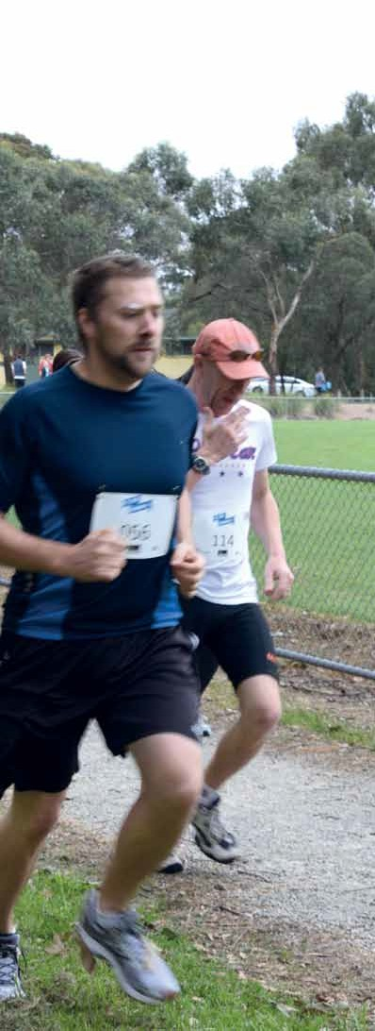

Objectives
  - Identify current levels of physical activity

  - Identify key factors that affect physical activity levels

  - Identify key determinants of physical inactivity to inform Council of priorities for action

  - Integrate planning for physical activity across Council

  - Ensure design, planning, programming, management and the allocation of resources for community assets and open space maximises opportunities for participation.

  - Identify specific interventions that aim to increase physical activity across marginalised or low participatory groups.

  - Provide recommendations for resource allocation to support physical activity

Safe, healthy and active

Definitions

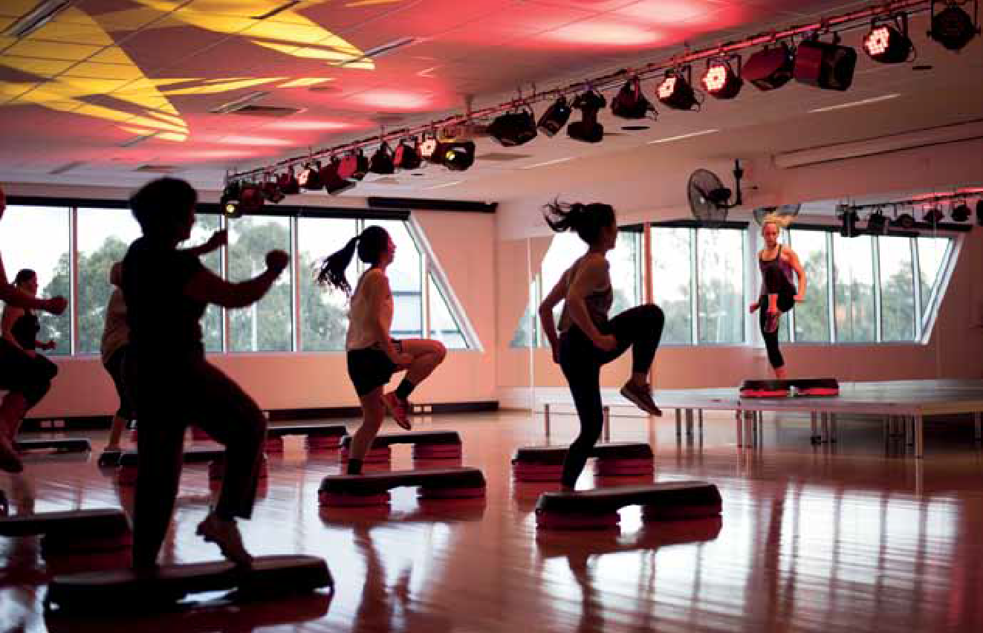

Physical Activity
World Health Organisation defines physical activity as any bodily movement produced by skeletal muscles that requires energy expenditure – including activities undertaken while working, playing, carrying out household chores, travelling, and engaging in recreational pursuits.

Active Living
A way of life that integrates physical activity into daily routines.

Sport
The Australian Sports Commission defines sport as: ‘A human activity capable of achieving a result requiring physical exertion and/or physical skill which, by its nature and organisation, is competitive and is generally accepted as being a sport’.

Incidental Physical Activity
Physical activities performed that are undertaken as part of carrying out normal daily chores.

Sedentary Behaviour
The department of Heath describes ‘Sedentary behaviour’ as a term used to describe time spent doing physically inactive tasks that do not require a lot of energy.

Pedestrian
A person who travels by foot.

Strategic context

To fully understand the context for the strategy as it relates to Maroondah City Council, the document must highlight the relevant links between current Council policies and the provision of planning, design, infrastructure, programs & services and information that support active living.

Fundamental to the implementation of Council’s roles and responsibilities, is Maroondah’s Integrated Planning Framework. The framework sets out the relationship and priority order of Council’s strategic documents that will guide the development and implementation of the Physical Activity Strategy. The primary documents include:

Maroondah 2040: Our Future Together (Maroondah Community’s Vision and Priorities)

- Maroondah City Council - Council Plan 2013 - 2017 (4 year Strategic Direction)

- Maroondah Community Wellbeing Plan 2013 - 2017 (Municipal Public Health Plan)
A number of other relevant Council policies and strategies were referenced in the development of this document.

Maroondah Disability Policy and Action Plan 2014-2018

- Maroondah City Council’s Youth Plan 2012 - 2016

- The Maroondah Arts and Cultural Development Strategy 2014 - 2018
- The Maroondah Bicycle Strategy (2004)

- Open Space Strategy 2005

- Leisure Services Strategic Plan 2009 – 2013

- Integrated Transport Strategy 2006

- Pedestrian Strategy 2007

Additionally there are four aligning strategic documents being developed concurrently. Consultation and discussion pertaining to these draft strategies has also informed the direction and development of the Physical Activity Strategy.

Children’s Plan

- Maroondah Active and Healthy Ageing Initiative, Towards an Age-friendly Maroondah 2015-2020

- Open Space Strategy

- Housing Strategy

The Strategy must ensure that the recommended future direction correlates and complements these linking documents and above all reflects Maroondah’s vision, Maroondah 2040.

Safe, healthy and active

From the Maroondah 2040 community vision engagement process, 8 preferred future outcomes have been identified as community priorities looking ahead to the year 2040 and beyond.
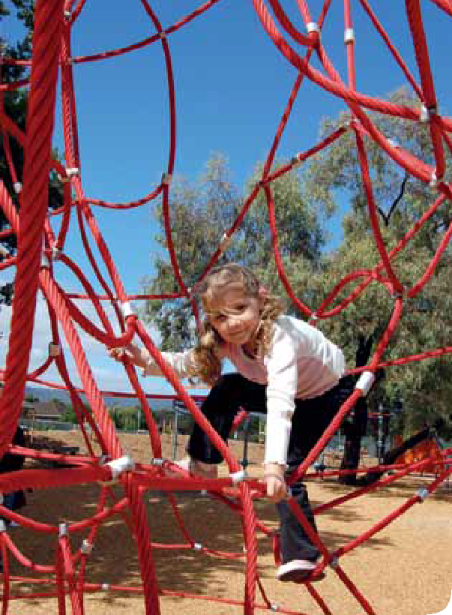These future outcomes will drive the 2040 vision. The most relevant future outcome to this strategy is:

A safe, healthy and active community

In 2040, Maroondah will be a safe, healthy and active community with local opportunities provided for people of all ages and abilities to have high levels of social, emotional and physical wellbeing.
Community indicators of progress for this future outcome

Proportion of residents who feel safe walking alone at night

- Proportion of children with good physical health & wellbeing

- Average community rating of subjective wellbeing

- Proportion of residents who eat recommended serves of fruit and vegetables

- Proportion of residents who undertake adequate physical exercise

- Proportion of community members who are involved in organised sport, and have access to recreational and leisure facilities

- Proportion of local residents who do not meet physical activity guidelines

Given Council’s commitment to the community indictors of progress above, this strategy must address how to positively impact these statistics and how to effectively measure progress.

Maroondah- a snapshot

Maroondah is located in Melbourne’s eastern suburbs, approximately 25km from Melbourne CBD.

Warranwood

North Ringwood Community House

Croydon Hills

Yarrunga Community House

Croydon North

Croydon
Council offices Train lines Train stations Creeks
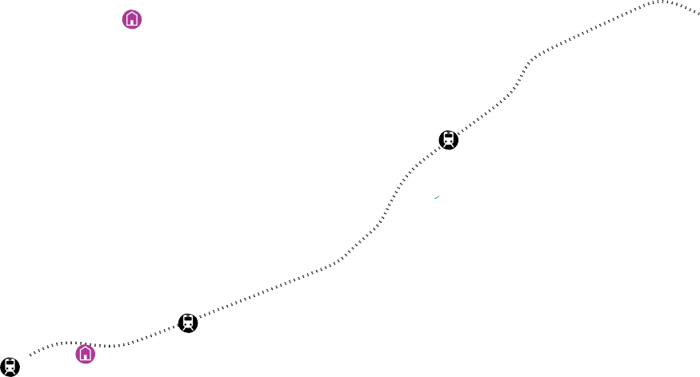Community houses Parks
Leisure facilities

Arts and cultural centres

Croydon

Croydon

Wyreena Community Arts Centre

Memorial Pool

Ringwood
North Ringwood
Aquahub

Dorset Golf

Karralyka
East

Ringwood

Heatherdale

Realm and Eastland

Ringwood

Maroondah

Central Ringwood Community House

Ringwood East

Croydon South

Bayswater
Dorset Road
North Kilsyth

Federation Estate
Wantirna Road
South

Aquanation
EastLink

Heathmont
r

Heathmont
The Rings Ringwood Golf

Glen Park Community House

Arrabri Community House
Liverpool Road

Our suburbs include Bayswater North, Croydon, Croydon Hills, Croydon North, Croydon South, Heathmont, Kilsyth South Ringwood, Ringwood East, Warranwood, Ringwood North and parts of Wonga Park, Kilsyth, Park Orchards and Vermont. Maroondah is served by Maroondah Highway and the Belgrave and Lilydale railway lines.
There are two major retail centres at Ringwood and Croydon, as well a significant industrial area in the south, dominate the economy of Maroondah. It mainly consists of developed suburbs however suburbs to the north are semi-rural in parts, set amongst native bushland.

Safe, healthy and active

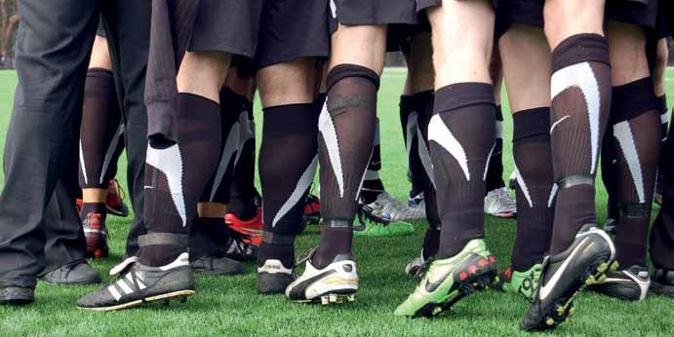

In 2012, there were 108,104 (estimated residential population), people living in Maroondah. Most residents have English, Australian, Irish, Scottish or German ancestry, but in recent years there has been an increase in the number of people settling in Maroondah from China, India and Burma.
Maroondah is home to the largest Burmese community in Melbourne’s East, and it is likely that the Burmese population will continue to grow in the future. We also have a higher proportion of people who are Aboriginal compared with the Eastern Metropolitan Region.

Over 30,000 people live with some form of disability in Maroondah. This is an estimated 29% of the population. There is an estimated 5,300 people (4.8%) who live with profound or severe disabilities (ABS 2009). The rate
of disability is increasing in part due to ageing populations and an increase in chronic health conditions.
Our main mode of travel to work is by car and we are less likely to cycle or walk to work compared with the population of Greater Melbourne.
Active opportunities
Maroondah is home to approximately 280 recreation organisations and 166 sporting clubs including 23 AFL clubs, 14 netball clubs, 17 cricket clubs, four soccer clubs and four calisthenics clubs.
There are 45 Sporting ovals; 121 playgrounds; 34km of walking tracks and shared pathways; three bowling clubs; three community gardens; three skate areas, two athletics tracks, a croquet club; 82 tennis courts; 10 court outdoor netball centre and six multiuse indoor halls. Maroondah City Council owns and manages two golf courses, Ringwood Golf and Dorset Golf; a multiuse stadium, The Rings; an outdoor 50 metre pool, Croydon Memorial Pool; a combined aquatic and fitness centre, Aquahub and the regional diving, fitness and aquatic facility, Aquanation.
Maroondah is also home to five Neighbourhood Houses and boasts a comprehensive listing of community organisations offering varied physically active opportunities for differing interests, ages and abilities.
Maroondah has a significant number of active organisations for retirees and in recent years has seen an increase in churches offering a range of social and leisure programs to extend their reach within the community.
Schools play a large role in offering physical activity opportunities to children and young people through school curriculum, interschool sports and out of school hours programming.
Maroondah also has a range of private recreation providers offering fitness programs, organised sports and other physically active pursuits.

Council’s role in influencing physical activity levels

Maroondah City Council plays an integral role in the provision and facilitation of physical activity opportunities though both the provision of services and infrastructure and the strategic planning and development of environments that support Active Living.
There are eight Council service areas that have been identified as having a direct impact on Maroondah Community’s ability to participate in physical activity. The internal key stakeholders and their role in relation to impacting physical activity levels are as follows:

Maroondah Leisure
The Rings, Aquahub, Aquanation, Ringwood Golf, Dorset Golf.
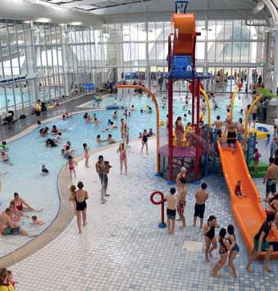direct provision of fitness and lifestyle programs

Maroondah Sport and Recreation
Planning and provision of programs and events, advocacy and facilitator of community networks, provision of funding, training and other support for community providers.

Communications & Marketing
Assist in the promotion of programs and events and targeted health promotion campaigns.

Operations
Bushland Management, Sportsfield Maintenance, Construction Maintenance, Tree and Park Maintenance
Responsible for the ongoing audits and maintenance of playgrounds, parks and bushland reserves, as well as the footpath and trail network.

Safe, healthy and active

Community Services
Aged & Disability Services, Youth Services, Children’s Services, Maternal & Child Health
Provision of targeted support and initiatives; facilitate health promotion initiatives and facilitation of community partnerships to enhance the wellbeing of Maroondah residents aged 0- 12 years, 12- 26 years, 65+ years and persons with a disability.

Assets
Asset Management, Building Projects, Building Maintenance
Management of Council’s community assets, to facilitate safety, longevity, and continued provision of services for the community. Advice and management of capital works projects and strategic planning relating to the ongoing lifecycle management of Council’s assets.

Engineering & Building Services
Provision of engineering technical expertise in areas of traffic and transportation planning, engineering development approvals, and project management for the development and/or enhancement of assets such as roads, footpaths, bicycle paths, and buildings.

Integrated Planning
Strategic Planning and Sustainability, Community Planning and Development
Work with the community and Council for the creation of a Maroondah Planning Scheme that supports and encourages active living through urban design, landscapes, buildings and land uses in Maroondah.
develop initiatives to support and increase regular utilisation of Active Transport.
Undertake health and wellbeing planning, advocacy and support for persons with a disability, culturally and linguistically diverse communities, marginalised and disadvantaged communities, prevention of violence against women, improving community safety and perception of safety and strengthening and building the capacity of the community.

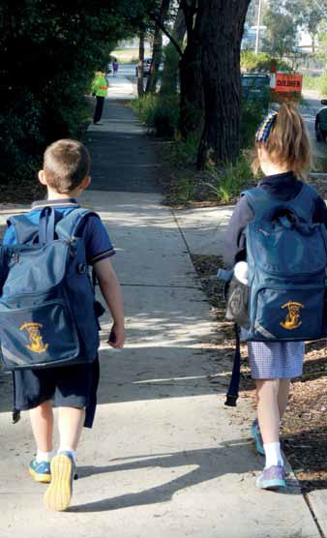

Planning, Health & Local Laws
Community Health, Local Laws
Facilitate health promotion initiatives for residents and food premises.
Promote responsible pet ownership - dogs on leash, encourage regular dog walking.

Furthermore Human Resources have been highlighted as a valuable resource for leading workplace initiatives aimed at improving physical activity levels and implementing healthy eating strategies.

Evidence for Action - Active Living and Its Impact
Active living is incorporating regular activity into daily routine. It includes active travel, play, gardening, incidental exercise as well as competing in a sport or participating in an activity class or pursuit for pleasure and fitness. Prioritising physical activity as an individual, an organisation and as a community has multiple benefits to overall health, social, economic and environmental benefits.

Some of the benefits are listed below.

Health Benefits
Social Benefits

Increases
Fitness, stamina and energy
Lean muscle, muscle strength and bone density
Flexibility, coordination, balance and motor skills
Improved immune system
Healthy ageing, mobility, independence and quality of life in older adults
Mental health and wellbeing
Reduces
Chronic illness and disability
Mortality rates and risk of dying prematurely
Risk of coronary heart disease, cardiovascular disease and stroke
Risk of diabetes, high cholesterol & high blood pressure
Risk of colo-rectal and breast cancer
Risk of asthma
Risk of osteoporosis and symptoms of arthritis
Body fat, overweight and obesity
Falls and injuries in older people
Risk of developing dementia
Feelings of fatigue, depression, stress & anxiety
Constipation and back pain
Risk of postnatal depression
Supports
Improved sleep and rehabilitation
Weight management
Cognitive functioning, memory, learning
Increases
Active and vibrant community hubs
Social skills and networks
Social capital and community connections
Access to services and resources
Independent living
Improved communication, team building, leadership and cooperation skills
Volunteering
Community participation in recreational and social activities
Reduces
Social isolation and loneliness
Antisocial behaviour
Supports
Stronger, connected communities
Community inclusion and public enjoyment
Community cohesion and capacity building
Crime prevention
Cultural links through activities

The Multiple Benefits of Physical Activity Diagram
– BE Active WA

Environmental Benefits
Economic Benefits

Increases
Uptake of active transport, walkability and economic viability of local areas
Influences the development of well planned and designed spaces
Reduces
Traffic congestion, air and noise pollution
Use of fossil fuels and energy use
Greenhouse gas emissions, global warming and climate change impacts
demand for major road infrastructure (roads, car parks)
Supports Incidental activity Community safety
Settings for active living
Improved public access and linkages to neighbourhoods and key
Increases Tourism Retail
Business and employment opportunities
Investment opportunities Productivity and growth Reduces
Vandalism costs Absenteeism
Workplace accidents/injury and workers compensation claims
Health care costs and claims
Pressure on insurance premiums for employers
Staff turnover
High costs of passenger transport and infrastructure
Supports
Local business Attracts workforce Active and healthy
employees and workplaces
The Multiple Benefits of Physical Activity

Safe, healthy and active

State and Federal priorities

Federal Government - National Sport and Active Recreation Framework
In June 2011, the National Sport and Active Recreation Framework was endorsed by the Australian Government and all state and territory governments and will remain in place until 2021. The Framework is not a policy document but provides a guide for the development of policies by all governments. The document sets a framework for government activity and resource allocation in the sport and active recreation sector. It provides a mechanism for engaging the whole sport and recreation industry in the achievement of agreed goals for sport and active recreation.
The document outlines the Federal and State Government expectations of local government:
  - Facilitating a strategic approach to the provision of sporting and active recreation infrastructure including open space, and other needs.
  - Establishing local management and access policies to sport and recreation facilities.
  - Supporting and coordinating local and regional service providers (venues and programs).
  - Liaising and partnering with state and territory governments on targeted program delivery.
  - Supporting and partnering with non-government organisations that enable sport and active recreation participation.
  - Incorporating sport and recreation development and participation opportunities in Council plans.
  - Collaborating, engaging and partnering across government departments on shared policy agendas.
  - Investment in sport and active recreation infrastructure.
These expectations ensure a planned, collaborative approach to the development of sport and active recreation opportunities and infrastructure provision.

Sport and Recreation Victoria Strategic Framework
2013-2015
The Victorian Framework mirrors the priorities of the National Framework with slight changes merging the seven national priorities to five State priorities.

Nationl Framework

- Participation
- International Performance
- National Competitions
- System Sustainability
- System Alignment and Collaboration
- Helping to meet Broader Objectives
- data Review Research

SRV Framework

- Participation
- National / International Performance Systems
- System Sustainability
- Meeting Broader Objectives of Government Research
- data Review Research and Information Provision

Participation strategies outlined in the document include promoting physical activity, supporting the sector to increase participation, building community confidence about the safe and welcoming sport and recreation environment.
Participation actions include:
- Work in partnership with key stakeholders to address barriers to participation for underrepresented sectors of the community.
- Support work by the sport and active recreation sector that builds capacity to provide opportunities for participation.
- Support work by local clubs and recreation organisations to provide a welcoming and inclusive environment.

How much is enough?

It is widely accepted that regular physical activity is essential in improving health and wellbeing, but how much physical activity is enough to maintain
a healthy lifestyle?

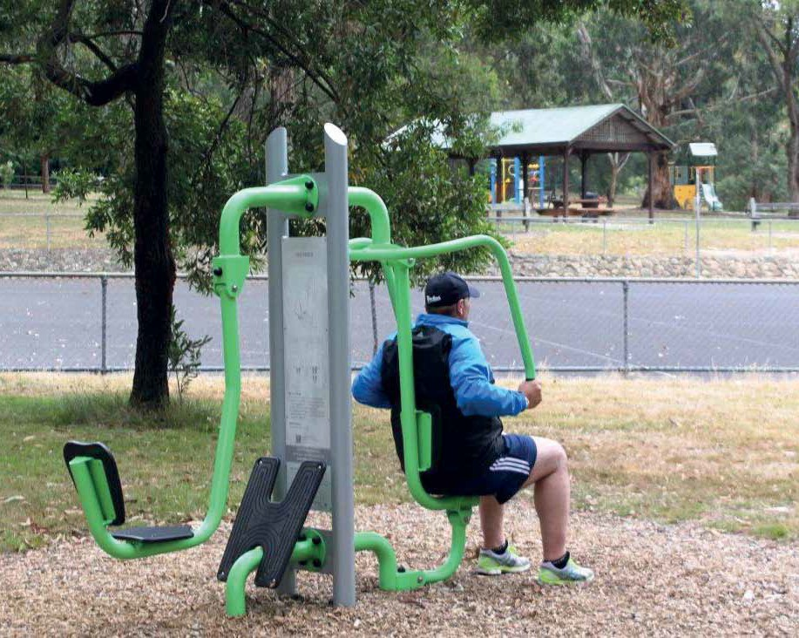

The Australian Government department of Health and Ageing have developed an evidenced based set of National Physical Activity Guidelines for children, adults and older Australians. The most recent update was released in 2014 and added Sedentary Behaviour (sitting time) to the guide as well as a new guideline for muscle strengthening activities.
The intensity of the physical activity should represent a noticeable increase in a person’s breathing and heart rate.

Safe, healthy and active

National Physical Activity & Sedentary Behaviour Guidelines8

0-5 years | 5-12 years | 13-17 years | 18-64 years | 64+ years
- Babies should be encouraged to take part in physical activity from birth, particularly supervised  floor-based play in safe environments.  - Toddlers and pre-schoolers should be  physically active every day for at least three hours, spread throughout the day.  - Children 0-5 yrs should not be sedentary, restrained or kept inactive for more than 1 hour at a time , with the exception of sleeping  - Less than 2 years  -no screen time, 2-5 years limit to less than one hour screen time per day | - Primary school aged children should take part in a combination of moderate and vigorous activities for at least 60 minutes a day.  - Children should engage in activities that strengthen their muscles and bones on at least three days per week.  - Limit use of electronic media for entertainment to no more than two hours a day  - Break up long periods of sitting as often as possible | - Young people of secondary school age should take part in at least 60 minutes of physical activity every day.  - This can built up throughout the day with a variety of activities.  - They should also engage in activities that strengthen their muscles and bones on at least three days per week  - Limit use of electronic media for entertainment to no more than two hours a day  - Break up long periods of sitting as often as possible | - Adults 18-64 years of age should accumulate  150-300 minutes of moderate intensity physical activity each week or 75-150 minutes of vigorous intensity physical activity each week (or an equivalent combination of both).  - Muscle strengthening activities should also occur on at least two days each week.  - Minimise the amount of time spent in prolonged sitting.  - Break up long periods of sitting as often as possible | - Older adults should accumulate at least 30 minutes of moderate intensity physical activity on most, preferably all, days of the week.

  - Department of Health (2014) Australia’s Physical Activity and Sedentary Behaviour Guidelines
  - Active Healthy Kids Australia (2014). Is Sport Enough? The 2014 Active Healthy Kids Australia Report Card on Physical Activity for Children and Young People. Adelaide, South Australia: Active Healthy Kids Australia

Playing sport is not enough

In 2014, The Heart Foundation’s Active Healthy Kids Australia published a report, Is sport enough? 2014 report card on physical activity for children and young people.9 Modelled on a Canadian initiative, this report provides information on the physical activity and sedentary behaviours of Australia’s children and young people. The report concludes that “while it is encouraging that a large number of children are obtaining some of their weekly physical activity from organised sport, we need to ask ‘Is sport enough?”. The Report Card results indicate a clear, No, as demonstrated by overall current physical activity levels, physical fitness and obesity levels,
While Maroondah’s participation rates in organised sport remain high in comparison to Victorian data, participation in other forms of unstructured
physical activity are low and declining. Also noted that “many Australian children and young people, even those who participate in sport and meet physical activity guidelines, are engaging in levels of recreational electronic screen use and other sedentary behaviours that are likely to adversely affect their health, growth and development”.
The Report Card rates young Australians a d- for overall physical activity levels and notes that less than 50% of time spent in organised sport is spent in moderate to vigorous physical activity . For example, during junior sports training participants may spend a significant time taking instruction, waiting for a turn, observing a new skill, or discussing game tactics with the actual time on task and the intensity of the activity being minimal.

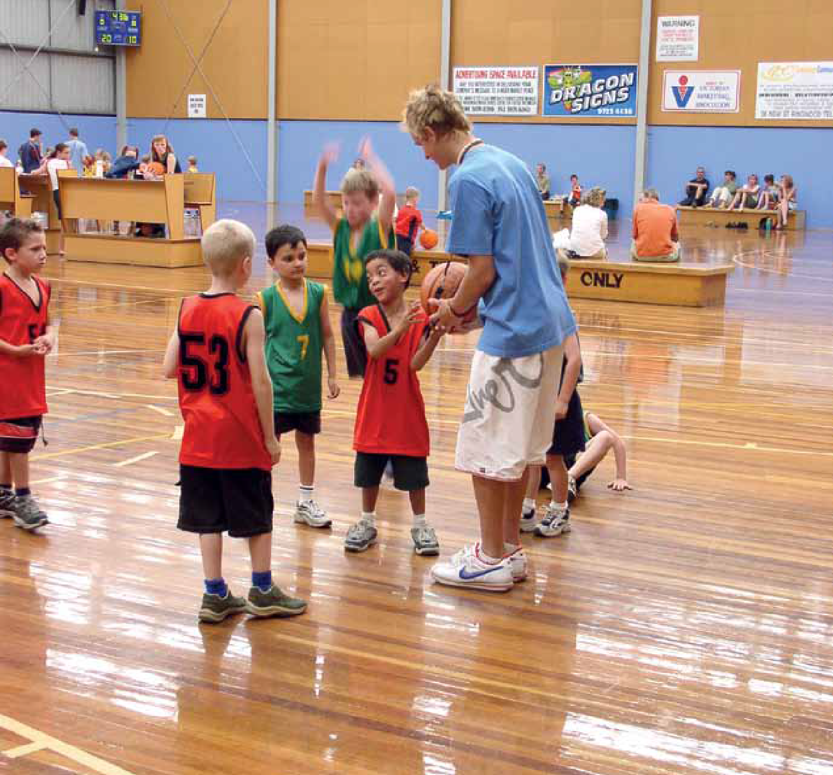

Safe, healthy and active

Maroondah’s current physical activity levels
As part the consultation strategy to inform the development of the Maroondah City Council Physical Activity Strategy, a statistically representative sample of 301 Maroondah residents aged 15+ participated in a telephone survey during July 2014.

The survey was undertaken to ascertain Maroondah residents levels of physical activity according to National Physical Activity Guidelines as at April 2014.
The study also sought which activities residents currently participate in, those they would like to participate in and reasons for participation and non- participation. A similar questionnaire was carried out in 2009.
35%
While the questionnaire was designed to enable direct comparisons with the 2009 survey data, the primary question relating to
physical activity levels was changed from: during the past 12 months, did you participate in any physical activities for exercise, recreation or sport? to: In the past 7 days, how often have you
= the number of respondents who met the National Physical Activity Guidelines and are undertaking enough activity to achieve health benefits.

met the recommended 30 minutes per day of moderate intensity physical activity? in order to relate to National Physical Activity Guidelines rather than a specific focus on recreation or sports participation.
These respondents undertook the required 30 minutes of moderate intensity physical activity in five or more days in the seven days prior to their interview during the month of July 2014.

Maroondah’s current activity levels by age
Frequency of minimum 30 mins moderate physical activity over 7 days

60%
% of respondants by age group
50%
40%
30%
20%
10%
0%

15-24 yrs 25-34 yrs 35-334 yrs 45-54 yrs 55-64 yrs 65+ yrs

n 5 or more

n 4 days

n 3 days

n 2 days

n 1 day

n No days

Number of days in past week

Overall the most active age cohort were 15 – 24 year old and the least active were from 25 - 34 years with almost 40% undertaking no physical activity during the past 7 days.

The top physically active pursuits undertaken by Maroondah residents
70%
Participation - Top Activities
60%
50%
Percent
40%
30%
20%
10%
0%
Walking
Aerobics / Fitness / Gym
Running / Jogging
Cycling
Swimming
Basketball
Netball
Yoga / Pilates
dance
Tennis
AFL
Golf
Martial Arts
Soccer

n Maroondah 2014 | 57.4% | 21% | 13.9% | 7.4% | 5.7% | 4.5% | 3.7% | 3.3% | 3% | 2.5% | 2% | 1.6% | 1.6% | 1.6%
n VIC (ABS) 2011-12 | 24.4% | 17.6% | 7.8% | 8.8% | 7.7% | 3.2% | 3.5% | 1.9% | 1.3% | 4.2% | 2% | 4.6% | 1.4% | 1.9%
n Maroondah 2009 | 28.7% | 14.8% | 10.5% | 8.9% | 14.4% | 7.2% | 4.1% |  |  | 7.4% | 3.1% | 2.4% |  | 4.8%
n VIC (ERRAS) 2007 | 234% | 20.8% | 8.7% | 10.7% | 11.3% | 3.5% | 3.8% | 3.1% | 2.2% | 6.4% | 3.3% | 6.8% | 1.7% | 3.6%

*2009 Survey activities undertaken during previous 12 months, 2014 Survey activities undertaken during previous 7 days
**No previous data available for Maroondah 2009 Yoga, Dance & Martial Arts

Adjustment for cricket, tennis, golf and swimming
Given that the household survey occurred during mid winter, predominantly summer activities such as tennis, cricket and golf will not have accurately reflected overall Maroondah participation.In 2009 Maroondah participation rates for cricket were 3.6% placing it in the top 8 activities undertaken in Maroondah. 10 In 2009 Maroondah’s golf participation rate of 2.4% was significantly below the rate of participation by all Victorians (6.8%, ERRAS 2007) Given the Victorian decline from 6.8% in 2007 (ERRAS11) to 4.60% in 2011 (ABS12)
then it could be assumed that the overall

Maroondah rate would be approximately 1.8% – 2.0%. Victorian rates of participation in tennis has seen a significant decline from 6.4% in 2007 to 4.20% in 2011 so it is highly probable that Maroondah’s current overall participation in tennis would be greater than the 2.5% but less than the 2011 Victorian rate of 4.2%.
In 2014 swimming participation was also significantly affected by the closure of the Ringwood Aquatic Centre during construction of Aquanation.

  - Maroondah City Council, (2009) Leisure Services Strategic Plan
  - (2007)Participation in Exercise,Recreation and Sport Survey (ERASS)
  - Australian Bureau of Statistics, Involvement in Organised Sport and Physical Activity, Australia, April 2010 (cat. no. 6285.0).

Safe, healthy and active

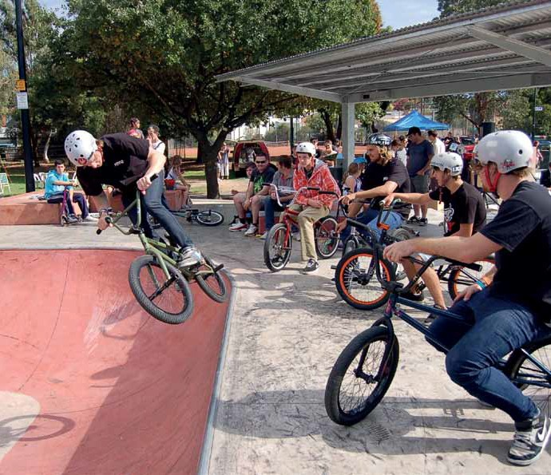

Top 3 Activities undertaken in the 7 days - by age

 | #1 | #2 | #3
15-24 years | Running/Jogging | Aerobics/Fitness/Gym | Walking
25-34 years | Walking | Basketball, Boxing, Running/Jogging
35-44 years | Walking | Aerobics/ Fitness/Gym | Running/Jogging, Cycling
45-54 years | Walking | Running/Jogging | Aerobics/Fitness/Gym
55-64 years | Walking | Cycling | Aerobics/Fitness/Gym, Yoga/ Pilates
65+ years | Walking | Aerobics/Fitness/Gym | Cycling, Lawn Bowls

These two data sets above affirm the current literature and industry trend information that acknowledge an increasing preference for physical activity pursuits that are non structured or pursuits that can be undertaken in one’s own time. This
preference is further highlighted by the recent change in the top 10 activities undertaken by Maroondah residents. Yoga/pilates and dance which were not present in 2009, now sit at numbers 8 and 9.

Understanding who is not as active as they need to be

Breakdown of respondents who did not meet the Physical Activity Guidelines
Percent

100%
90%
80%
70%
60%
50%
40%
30%
20%
10%
0% | 15-17  years |  |  |  | 18-24  years |  |  |  | 25-34  years |  |  |  | 35-44  years |  |  |  | 45-54  years |  |  |  | 55-64  years |  |  |  | 56-74  years |  |  |  | 75+  years
n Male | 20% |  |  |  | 25% |  |  |  | 92% |  |  |  | 88% |  |  |  | 58% |  |  |  | 64% |  |  |  | 41% |  |  |  | 62%
n Female | 60% |  |  |  | 75% |  |  |  | 79% |  |  |  | 86% |  |  |  | 59% |  |  |  | 59% |  |  |  | 60% |  |  |  | 86%

196 respondents did not meet the National Physical Activity Guidelines of a minimum five days of 30 minutes moderate physical activity per week to maintain optimal health.
Percentages within age groups and gender varied greatly. There was a substantial difference between males and females in the 15 – 17 years and 18 – 24 years and the 56 – 74 and 75+ categories with a much higher percentage of males meeting the guidelines than females. In the 18- 24 years only 25% of females are doing enough physical activity compared to 75% of their male counterparts.
While within the 25 – 44 years age group the gender divide is far less, both sexes had an exceptionally low rate of respondents meeting the five day minimum.
Also concerning is that 92% of males in the 25-34 year age group did not meet the guidelines.
Breaking this down further 42% of 25 – 35 year old males did no activity at all and 25% did 3 days. 1, 2 and 4 days were even at 8%.

Children and adolescent activity levels

While the Maroondah household survey did not obtain data on residents under 15 years of age the most recent Australian Heath Survey shows that the majority of Australian children between the ages of 5 to 17 do not currently meet physical activity guidelines. Approximately 30% in this age bracket met the guidelines. Participation decreases with age, from 36% of 5 to 8 year olds to just 6% of 15 to 17 year olds.13
Approximately 61% of Victorian children participate in at least one organised sport and information collected on recreational activities showed children’s participation in more active recreational activities increased since 2009, with the proportion of children skateboarding, rollerblading or riding a scooter rising from 49% to 54%, and the proportion of children bike riding increasing from 60% to 64%. A higher proportion of males were
involved in skateboarding, rollerblading or riding a scooter (60%) and bike riding (70%) than females (47% and 57% respectively).
A triannual study by Cancer Council and National Heart Foundation, the National Secondary Students’ diet and Activity Survey, studied 9,000 Australian Year 8 – Year 11 secondary school students in 2012/2013 and found that:

18% of students achieve the recommended 60 minutes of physical activity a day.
- 24% of boys and only 11% of girls met the guidelines.14
The study also highlighted a marked increase in the amount of students using devices for over two hours per day from 71% in 2010 to 77% in 2012/2013.

- Australian Bureau of Statistics. (2013) Australian Heath Survey: Physical Activity, 2011-12 ABS Cat. No.4364.0.55.004
- Cancer Council Australia & National Heart Foundation, National Secondary Students’ Diet and Activity Survey 2012-2013

Safe, healthy and active

Challenges to participation in physical activity
In order to plan strategies to encourage active living and increase the physical activity levels of Maroondah residents we need to understand what are the inhibitors?
There are different factors that affect the physical activity levels of specific populations and therefore different strategies required to overcome. This document highlights the challenges and opportunities for the general community and then focuses on six different specific populations in order to target specific actions which will have a positive impact on participation. These specific populations were selected from the household telephone survey data and through the Maroondah Community Wellbeing Plan 2013-2017 which highlights that, discrimination and disadvantage on the basis of gender, cultural background, socio economic status, age, disability and LGBTI status were identified as issues that are present in the Maroondah community”.15

General community

Challenges
Opportunities for Maroondah City Council It is important to convey the message that physical activity can be accumulative and
need not be undertaken in one block of time.
Building opportunities for physical activity into everyday routines can be achievable but requires a change in mindset and recognition of its importance in our daily routine.
A key challenge for engaging the general Maroondah community is the perception of, or a real issue of not enough time. While many people are indeed time poor, time constraints is not the whole explanation. For many it is a vicious cycle of, a lack of motivation fuelled by poor diet, sedentary behaviour, and possibly poor sleeping habits which leads to feeling low on energy.

- Maroondah City Council, (2013). Maroondah Community Wellbeing Plan 2013 - 2017

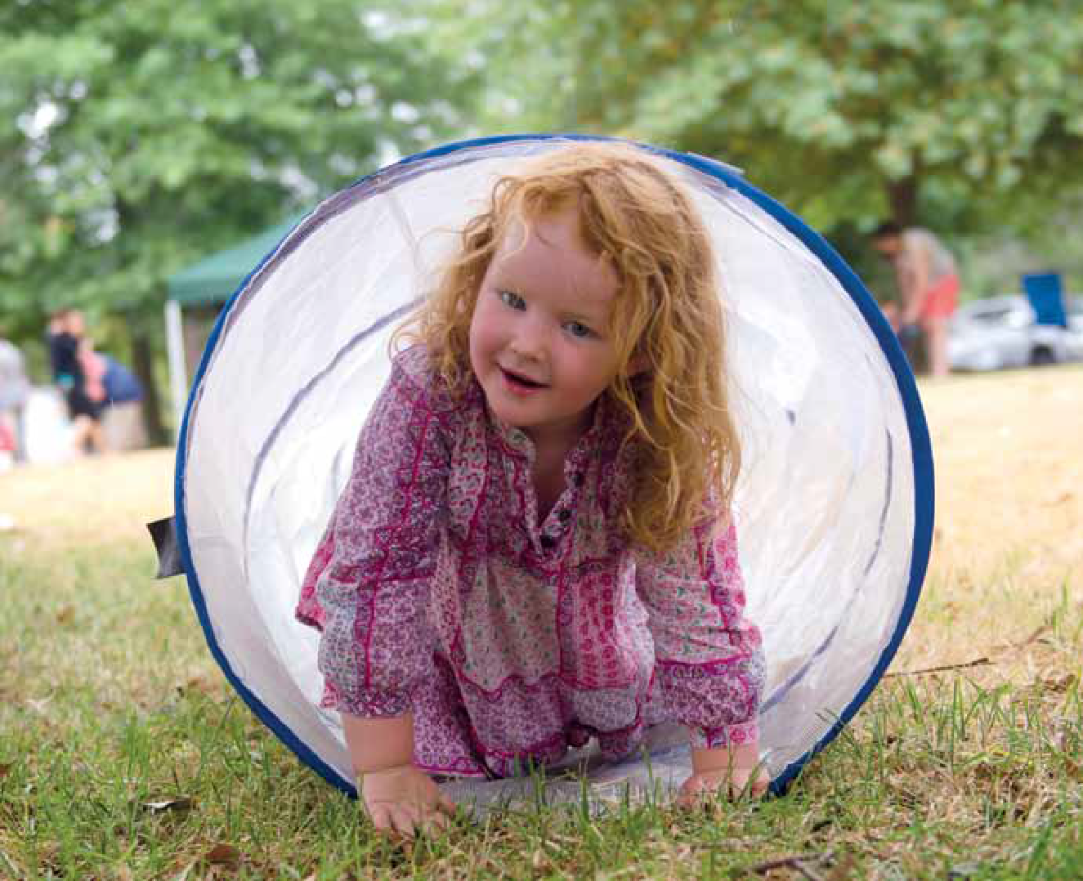

The Maroondah household survey
Main reasons for not participating in any physical activity during the past seven days

  - Physical constraints (injury/illness/disability)
  - Lack of Time
(Family/work/study commitments
  - Inclement Weather
  - Lack of motivation
  - Nothing, not interested

NOTE
Given that the survey occurred in mid winter and the high prevalence of colds and flu at this time, it can be asserted that during the warmer months, less illness would reduce physical constraints from being the primary reason for non participation in Maroondah.
To validate the assertion that poor weather had skewed results, further consultation was undertaken at the 2014 Maroondah Festival.
One-hundred-and-forty-three Festival patrons were asked: What are your ‘hurdles’ to being as active as you’d like to be? The results were:
- Lack of time
- Lack of motivation
- Physical constraints

Safe, healthy and active

Youth

defined as young people aged between 12 – 26 years

Challenges
  - Cost of activities
  - Lack of motivation
  - Lack of confidence or self-esteem.
  - No companion or other people to participate with
  - Circle of friends who are not active
  - Inability to access child care
  - Drinking Culture- binge drinking, effecting young people’s capacity to undertake exercise the next day
  - Timing of activities – early morning activities often not conducive to the biorhythm of young people
  - Not having found something that interests them, don’t know what they enjoy or what’s out there.
  - Not having the correct knowledge about health & fitness
  - Body Image Perceptions
  - Lack of Healthy Role Models (parents)– Healthy versus Skinny misconception
  - Not having the rest/ restorative sleep they need to meet the demands of daily life
  - Mental Health Issues
  - Identity Stereotyping ‘I’m not a sporty person’, ‘Exercise isn’t my thing’
  - Perception of safety – young person’s and / or parents.
  - Active commuting to school - student & parent safety concerns related to traffic, crime, bullying, or violence
  - Girls are more likely to report barriers such as embarrassment, sweating, fear of injury, and weight criticism by peers and family members compared with boys16
  - Older adolescents listed homework and lack of time because of part-time work as a barrier more often than younger adolescents 16

Opportunities for Maroondah City Council
- Changing lifestyles mean traditional participation times (week nights and weekends) may no longer be appropriate for many families. Early morning is also not a preferred option for most young people
- The social opportunities presented by sport should be as important as the competitive aspect.
- Rethinking how and where sport is delivered, including providing more flexible options for involvement
- Allowing for more flexible approaches to playing sport could encourage more young people to get involved
- Health promotion initiatives aimed at both young people and /or parents to dispel misconceptions and promote the healthy mind and body aspects of physical activity.
- Improved infrastructure to support Active Travel. data from the Australian Children’s Nutrition and Physical Activity Survey indicate that, in contrast to sport and play, active travel tends to increase with age and indicates that young people are more likely to meet recommended levels of physical activity if they actively commute to school.
- Provision of low cost opportunities
- Pilot Interventions which link multimedia technology with physical activity

Simply providing information to youth about benefits, frequency, and duration of physical activity is not sufficient for enhancing physical activity behaviour. Subtle changes in framing physical activities can have a dramatic influence on youths’ physical activity motivation and behaviours. Adults should encourage youth to participate in activities they find enjoyable, feel competent doing, have chosen to do, and that include positive social support—these conditions optimize their motivation for sustaining physical activity and thus the physical, social, and psychological health benefits afforded from such participation.18

- Pate, Saunders, Ruth ; O’Neill; Dowda, American College of Sports Medicine Health & Fitness Journal: Jan/Feb 2011 – Vol.15 - Issue 1 - p 7-12 OVERCOMING BARRIERS TO PHYSICAL ACTIVITY: Helping Youth Be More Active
- Commonwealth of Australia ( 2008) 2007 Australian Children’s Nutrition and Physical Activity Survey – Main Findings 18 The Convergence Partnership Fund of the Tides Foundation, (2010) Fostering Physical Activity for Children and Youth

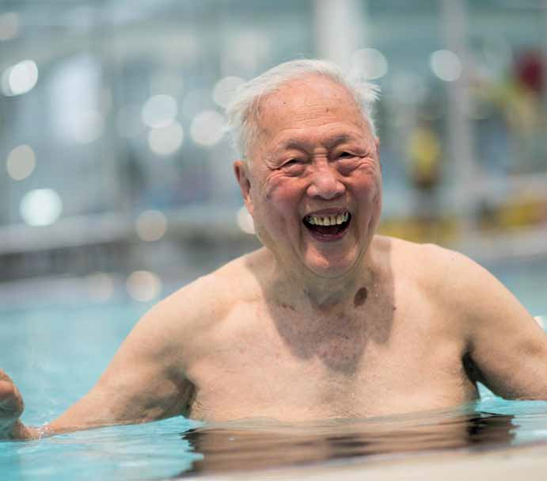

Older people

Maroondah Active and Healthy Ageing Initiative The City of Maroondah has recently been accepted as a member of the World Health Organisation’s
Global Network of age – friendly Cities and
Communities Network. This network was formed in response to global population ageing and focuses on action at the local level that fosters the full participation of older people in community life and promotes active and healthy ageing.
Selection is in recognition of Council’s commitment to listen to the needs of our ageing population, assess and monitor age-friendliness and to work collaboratively with older people and across sectors to create accessible physical environments, inclusive social environments, and an enabling service infrastructure. The Global Network of
Age-friendly Cities and Communities provides a world-wide platform for information exchange,
mutual learning and support.
In 2006, the World Health Organisation consulted with people in 22 countries and 33 cities around the world to find out what the challenges of ageing were in their respective cities and to build on their active ageing framework.
Active ageing: a framework for age-friendly cities Active ageing is the process of optimising opportunities for health, participation and security
in order to enhance quality of life as people age. In
an age-friendly city, policies, services, settings and structures support and enable people to age actively.
The outside environment and public buildings have a major impact on the mobility, independence and quality of life of older people and may affect their ability to participate in physical activity.

Safe, healthy and active

Opportunities for Maroondah City Council Green spaces and walkways
  - Well-maintained and safe green spaces, with
adequate accessible shelter, toilet facilities and seating
Pedestrian-friendly walkways free from obstructions.
  - Well maintained outdoor seating is available, and spaced at regular intervals.

Pavements
  - Well-maintained, smooth, level, non-slip and wide enough to accommodate wheelchairs with low curbs that taper off to the road. • Pavements are clear of any obstructions and pedestrians have priority of use.

Roads
  - Roads have well-designed and appropriately placed physical structures, such as traffic islands, pedestrian crossings, overpasses or underpasses, to assist pedestrians to cross busy roads.
  - Pedestrian crossing lights allow sufficient time for older people to cross the road and have visual and audio signals.

Safety
  - Public safety in all open spaces and buildings is a priority and is promoted by, for example, good street lighting, police patrols, enforcement of
by-laws, and support for community and personal safety initiatives.

Buildings
  - Buildings are accessible, meeting DDA compliance. Additional features include adequate signage; railings; non-slip flooring; rest areas with comfortable chairs; sufficient numbers of public toilets.

Public toilets
  - Public toilets are clean, well-maintained, easily accessible for people with varying abilities, well-signed and placed in convenient locations.

Events and activities
  - Locations are convenient to older people in their neighbourhoods, with affordable, flexible transportation.
  - Events and activities and local attractions are affordable for older participants, with no hidden costs
  - A wide variety of activities is available to appeal to a diverse population of older people, each of whom has many potential interests.

- Gatherings, including older people, occur in a variety of community locations, such as recreation centres, schools, libraries, community centres in residential neighbourhoods, parks and gardens.
- Activities and events are well-communicated to older people, including information about the activity, its accessibility and transportation options. Community-wide settings, activities and events attract people of all ages by accommodating age-specific needs and preferences.
- Older people are specifically included in community activities for “families”.
- Activities that bring generations together for mutual enjoyment and enrichment are regularly held.

Fostering community integration
- Community facilities promote shared and multipurpose use by people of different ages and interests and foster interaction among user groups.
- Local gathering places and activities promote familiarity and exchange among neighbourhood residents.

Respectful and inclusive services
- Older people are consulted on ways to serve them better.
- Provision of services and products adapted to older people’s needs and preferences. and have helpful and courteous staff trained to respond to older people.

Public images of ageing
- Promotions include older people in public imagery, depicting them positively and without stereotypes.

Information
- Regular and reliable distribution of information is assured by government or voluntary organisations.
- Information is disseminated to reach older people close to their homes and where they conduct their usual activities of daily life.
- Information dissemination is coordinated in an accessible community service that is well- publicised – a “one-stop” information centre.
- Regular information and programme broadcasts of interest to older people are offered in both regular and targeted media.

Women

Preventing Violence against Women in our Community project (PVAWC)
The Office of Women’s Policy, department of Human Services funded a joint project between Yarra Ranges, Knox and Maroondah councils to develop strategies for the prevention of violence against women in our community.
The Preventing Violence against Women in our Community project (PVAWC) project ran from September 2011 until december 2014 and included the development of a research paper titled The Gender Lens For Leisure.20 The purpose of the Gender Lens for Leisure project was to support Council’s to provide gender equitable leisure settings for all users of Council leisure and sporting and assist to create a culture where women and men are equally valued and respected.
Through club engagement, staff consultation and in depth literature review the most common influencing factors or opportunities affecting women’s participation were collated.

Drivers for Women’s Participation
  - Health
  - Weight management
  - Improved physical appearance
  - Social support
  - Rewarding sense of achievement.

Challenges
- Time poor
- Child care responsibilities - options not available or not provided when needed
- Sensitivity to body image
- Perception of safety
- Psychological/Socio-cultural/Environmental
- safety and/or perception of safety.
Opportunities for Maroondah City Council
- Suitably scheduled / short duration activities
- Availability of activities popular with females
- Women only teams/programs
- Family friendly policies/ places
- Design sensitive to perceptions of security
- Providing and promoting active female role models
- Actively targeting and marketing participation to females and those most vulnerable
- Specific design features preferred by many women
- Encouraging equitable access to facilities.

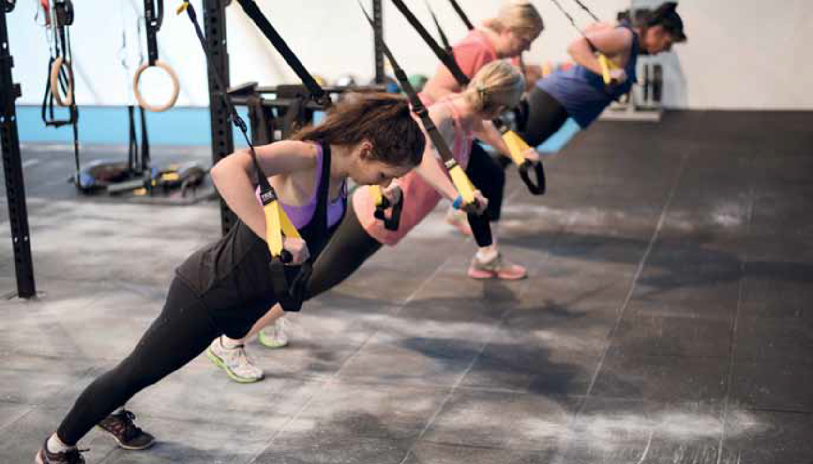
20 Office of Women’s Policy, Department of Human Services. (2014) Gender Lens for Leisure

Safe, healthy and active

Lesbian, Gay, Bisexual, Transgender and Intersexual (LGBTI) community
At the Maroondah City Council, Ordinary Council Meeting on 15 december 2014, Council committed to increasing its support of Maroondah’s LGBTI community and to take a stand against homophobia and transphobia, celebrate the diversity in our community, and increase the inclusion of Maroondah’s LGBTI community members.
Research shows sport is a significant site of homophobic harassment, discrimination and exclusion.21 The 2009 Crawford Report into the Future of Sport in Australia, highlighted the need “to understand issues of sexual and gender diversity and develop strategies to address these issues”. The report goes on to highlight that “within school studies have shown that LGBTI students feel most unsafe in sport.” 22

Definitions:

Bisexual – people attracted to both sexes in varying degrees.
Gay – refers to men who have a primary sexual and romantic attraction to men, but it is also used by women as the way they identify their erotic and romantic attraction for the same sex.
Lesbian – main term used by women who have primary sexual and romantic attraction to women.
Gender identity – the self-perception one has of their core identity being male, female, in between or fluid.
Homophobia – prejudice, discrimination, harassment or violence based on a fear, distrust, dislike or hatred of someone who is lesbian, gay or bisexual. Homophobia can be verbal, physical or emotional harassment, insulting or degrading comments, name calling, gestures, taunts, insults or jokes, offensive graffiti, humiliating, excluding, tormenting, ridiculing or threatening, refusing to work or cooperate with others because of their sexual orientation or identity.
Transgender – people who live a gender identity which is ‘other’ or opposite to their birth (genetic, genital) sexed embodiment and correspondingly assigned gender identity. Transgender people may or may not seek surgery and hormonal treatment to bring their sex in line with their core gender identity.
Trans people – includes transgendered people and transsexuals.
Transsexual – a medical term for people who have undergone sex-realignment surgery (bringing their sexed embodiment – genitals, hormones, gonads, secondary sexual characteristics) in line with their core gender identity. Sex-realignment surgery is sometimes also referred to as gender affirmation surgery.
*Intersex refers to people who have genetic, hormonal or physical characteristics that are not exclusively ‘male’ or ‘female’. A person who is intersex may identify as male, female, intersex or of indeterminate sex.
*Sex refers to a person’s biological characteristics. A person’s sex is usually described as male or female, however some people may not be exclusively male or female (referred to as ‘intersex’), or may not identify as either male or female.
*Gender refers to the way in which a person identifies or expresses their feminine or masculine characteristics. Generally understood as a social/ cultural construction, a person’s gender identity is not always exclusively male or female, and may or may not correspond to their sex.
23

- Human Right Commission, Fair go, sport! http://www.humanrightscommission.vic.gov.au/index.php/our-projects-a-initiatives/fair-go-sport Accessed 5/3/2015
- Australian Sports Commission (2009) .The Future of Sport in Australia -Independent Sport Panel Report (Crawford Report)
- Australian Human Rights Commission. (2011) Addressing sexual orientation and sex and/or gender identity discrimination, Consultation report

Lesbian, Gay and Bisexual people

Challenges
  - Verbal homophobia (from not only players but officials and coaches this can include name calling and “sledging”)
  - Sexism (A female playing soccer must be a “dyke”)
  - Perceived homophobia (I don’t want to join that club because I think they don’t like lesbians)
  - Change rooms can create feelings of angst and discomfort
  - Mental health issues
  - Physical homophobia (from team mates and rougher play on field)
  - Inappropriate sledging from spectators (“You faggot”)
  - Lack of role models (still limited high profile “out” sports players)
  - Negative past experiences

Transgender and Intersex people

Challenges
- Lack of understanding the difference between gender and sex
- Lack of understanding of what is transgender
- Transphobia
- Perceived transphobia
- Verbal abuse
- Not fitting within change rooms and toilets
- Sporting codes strict rules on gender and sex (leaving transgender people without a code to compete in)
- Some medically prescribe drugs transgender people are required to take are on banned substance lists
- Change rooms can create feelings of angst and discomfort
- Mental health issues
- Physical abuse (from team mates and rougher play on field)

Opportunities for Maroondah City Council
- Education within sport and recreation clubs
- Private spaces (cubicles) within change rooms
- Anti homophobia policies for players, officials and spectators (ensuring the word homophobia is used and address not simply a diversity policy)
- Ensure policy is referred to, communicated and updated as required
- Implement events such as the “Pride Cup” held in the Yarra Ranges municipality
- Offer support services such as counselling
- Inappropriate sledging from spectators (“You faggot”)
- Lack of role models
- Negative past experiences

Opportunities for Maroondah City Council
- Work with clubs on gender rules
- Education within sport and recreation clubs
- Private spaces (cubicles) within change rooms
- Anti-transphobia policies for players, officials and spectators (ensuring the word transphobia is used and address not simply a diversity policy)
- Ensure policy is referred to, communicated and updated as required
- Offer support services such as counselling

Safe, healthy and active

People with disabilities

disability is defined as “an umbrella term, covering impairments, activity limitations and participation restrictions”( disabilities discrimination Act 1992).
Council’s disability Policy and Action Plan 2014- 201824 (The Plan) was endorsed by Maroondah City Council on december 15th, 2014. The Plan has been developed to provide a framework to address the aspirations and priorities for people with disabilities and their families over the next four years. The Plan aims to remove barriers to ensure people with disabilities are equal members of the community.
Over 30,000 people live with some form of disability in Maroondah - an estimated 29% of the population
On average people with a disability are 15% less likely to participate in sport and active recreation than the general population.25

Challenges
Cost was identified as a major factor due to limited disposable income costs included transport, equipment, registration fees, support to participate and other additional costs associated with disability.26
Attitudinal barriers are those that discriminate against people with disabilities or are perceived as unwelcoming.
Physical barriers are features of buildings, playspace or open spaces that impede access or participation by people with disabilities.
Information or communications barriers happen when a person cannot easily access or understand information
Access to opportunities There are a limited number of activities for children with disability. Sometimes available activities run at inconvenient times, or have long waiting lists.27
A person with a disability is more likely to face several challenges and barriers which require understanding as part of investigating practical solutions.
For example:
- A person with a disability may have a particular medical condition that affects the body’s metabolism
- Reduced mobility and lack of regular exercise
- Reduced muscle tone
- Medication that may increase appetite
- Eating habits that may be affected by depression, anxiety, boredom or frustration
- Dependence on family members of carers to provide meals; who in some cases are poorly educated on nutrition
- 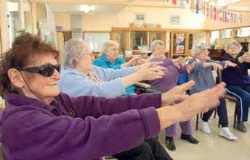Poor knowledge of weight management and nutrition
Opportunities for Maroondah City Council
- Raise awareness within the community of access and inclusion barriers, rights and inclusive practices
- Promote participation in Council recreation, arts, leisure and cultural activities and events ensuring all communication tools are accessible and Disability Discrimination Act (ddA) compliant
- Ensure access for people with disabilities is considered in the planning and design of playspaces and open spaces.
- Continue to deliver disability awareness training to Council staff particularly those involved program development, infrastructure planning and direct service delivery.

- Maroondah City Council (2014) Disability Policy and Action Plan 2014-2018 25 Australian Bureau of Statistics (2006) General Social Survey Cat.4159.0
- Australian Sports Commission (2010). Getting Involved in Sport. Participation and Non Participation of people with a disability in sport and active recreation
- Dr Nora Shields and Ms Anneliese Synnot La Trobe University (2010) Barriers & facilitators to physical activity & community sports for children with disability

Culturally and Linguistically Diverse (CALD) communities

Physical activity opportunities should be planned and developed in ways that are responsive to our CALd communities.
21% of Maroondah residents were born overseas and in recent years there has been an increase in the number of people settling in Maroondah from China, India and Burma. Maroondah now has the largest Burmese community in Melbourne’s east.
In 2006, Moonee Valley Melbourne Primary Care Partnership in partnership with the Centre for Ethnicity & Health undertook a research project to identify and present key considerations for inclusion in planning, implementing and evaluating physical activity programs with CALd communities.28
The findings, drawn from the research, have been collated under headings as key considerations for service providers responsible for planning, implementing and evaluating successful physical activity programs:

Attitudes to physical activity
  - The notion physical activity varies within and between CALd communities
  - Preference for children to participate in study rather than sport
  - Often not seen a priority for particularly those who arrived as refugees, who have other more immediate settlement concerns such as employment and education.

Gender as an important factor
  - Culturally appropriate childcare options
  - Women from certain religious backgrounds regard some sports attire as a barrier to participation in physical activity initiatives.

Engaging communities for the development of physical activity initiatives
  - Genuinely engaging CALD communities was seen as a means of ensuring physical activity initiatives were targeted to community needs and addressed the concerns or preconceived ideas about the value of such activity.

Avoiding the ‘one size fits all’ approach
  - Awareness of diversity within diversity
  - Differences in age groups, gender, tribal or clan identities may result in different needs and expectations.

Communicating for success
- Standard good practices that apply to communication in mainstream society, such as knowing your audience and tailoring your message accordingly, equally apply to communication techniques for CALd communities

Programs and activities that reflect our diverse communities
- Having an environment that overcomes language barriers and reflects community diversity can provide a powerful message to encourage participation.

Getting the timing and costing right
- Making sure physical activity programs are planned to suit the lifestyles of CALd communities, where possible, is an important consideration for service providers. Another important consideration is particular national, cultural and religious calendars
- When considering charges, the need to pay must be balanced with the ability to pay.

Organisational planning for cultural difference.
- Develop and deliver education on cross cultural awareness to the health and fitness sectors.

In addition, considering these recommendations Council should develop strategies to address the concerns of the Burmese community specifically relating to their desire play soccer in Maroondah, such as:
- cost - in particular for purchasing uniforms and footwear
- transport - many don’t drive, so find it difficult to get to soccer grounds
- access - restricted or no access to soccer grounds
- schedules - structured and ‘inflexible’ game times on Saturday mornings.

- Centre for Culture Ethnicity & Health, Melbourne, Australia, (2006).Engaging Culturally and Linguistically Diverse Communities in Physical Activity: A Discussion Paper,

Safe, healthy and active

Council Priority - Active Travel

Integrating the transport network
Our productivity, cultures, social connections and lifestyles are all irreplaceably tied to our ability to travel cheaply, independently and conveniently. The lifestyles we have grown accustomed to, and the urban neighborhoods in which we live , have been made possible by the proliferation transport, both public and private.
Public transport, walking and cycling are the most prevalent forms of active travel within Maroondah. They are the most basic and easily accessible forms of transports available to the broadest population demographic. Even among the predominance of private vehicle and public transport commuting, our lifestyles are still dependant on active travel, particularly walking.
The most recent ABS Journey to Work data shows that the percentage of commuter trips that would include a component of activity travel (trains, bus, bicycle and walked only categories) have increased to from 11.1 to 12.129
The mode share for active travel is even more prominent within the realm local journeys, fitness and recreation pursuits and social activities. For the percentage of local trips (less than 2 km) that are walked within Maroondah is 37%.30
A Household Participation Survey indicates that walking, running/jogging and to a lesser extent cycling, constituted a significant proportion of the physical activity done across all ages.31 It is evident that predominantly walking, running and cycling continue to play significant role in our lifestyles.
Active Travel enables the connectivity that

The Advantages of Active Travel
There are economic, community connectivity and health and environmental benefits associated with encouraging more people to complete a greater proportion of their journeys by active travel modes. A shift to a greater proportion of Maroondah’s transport mix being conducted by active travel will assist to ease congestion, meet city planning strategies, reduce greenhouse emissions, improve the health of people working and living in Maroondah and promote social connections.

Local Economic Prosperity
The economic value of walking is referred to as the walking economy. There is a direct link between the Melbourne’s City Centre’s economic prosperity and the safety and convenience of the pedestrian experience.32 Beyond its overall transport system integration roll, walking plays a significant role in fostering economic development and prosperity of activity centres.
The National Heart Foundation discussion document Good for Busine$$33 provides a useful summary of the positive relationship between walkable environments and retail health. A variety of studies are cited demonstrating that providing a more pedestrian friendly environment will increase retail turnover and retail property values.
Cycling has economic benefits as well. In a policy statement released by Anthony Albanese, cycling has been found to have significant benefits for the national economy. As each person that cycle to work contributes $21 per journey to the national economy, while walking to work contributes

integrates the transport system to connect people
$8.50.34
There is increasing body of evidence from

to jobs and services. It provides the means to complete the last leg of journeys and interchanging between transport modes.
Europe, United States and Australia that cycling
has economic benefits for business districts.
Pedestrians and cycling shoppers contribute 24% of the retail spend in the dublin City Centre, a higher spend volume than people arriving by car.35

- Australian Bureau of Statistics. (2013). Census of Population and Housing 2006 and 2011. Profile i.d.
- Department of Transport. (2010). Pedestrian Access Strategy: Increasing Walking for Transport in Victoria. Melbourne: Victorian Government.
- Maroondah city Council. (2014). Sport and Recreation Household Participation Survey. Melbourne: Maroondah City Council. 32 City of Melbourne. (2012). Transport Strategy: Planning for Future Growth. Melbourne: City of Melbourne.
33 Tolley, R. (2011). Good for Busine$$: The Benefits of Making Streets More Walking and Cycling Friendly. Melbourne: Heart Foundation. 34 Wade, M. (2013, July 31). Bicycle Riders save Economy $21 on Each Commute. Sydney Morning Harold
35 Millward Brown. (2015). Dublin City Centre Shopper Survey . Dublin: National Transport Authority

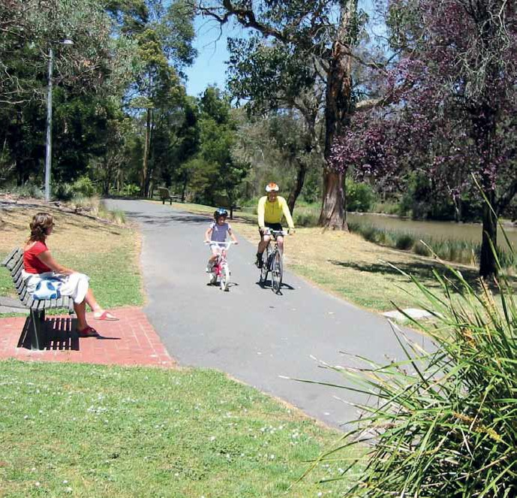

Walkers and cyclists where also shown to visit more shops than any other commuter type.
An economic benefit study of bicycle parking for Lygon St, Carlton found that the economic benefit per square metre is $31 per hour for bikes, against
$6 for cars.36 Even though people on bikes may spend less per visit than those travelling by car, the economic benefit per parking space per hour is higher for bike parking as many more people can park their bike in the space required for one car.
More broadly, a Cycling Promotion Fund fact sheet summarises how cycling is good for business.37 It is becoming understood that supporting a cyclecomony brings additional boost to local activity centre economies.
Finally walkability and cyclability translates into substantial increase in the value of retail, office and residential property.
A strong relationship is being found linking walkability and property values.38 Homes and work places situated in more walkable neighbourhoods, have more pleasant amenity, better accessibility, provide greater transport opportunities are more desirable places to live, work, study and recreate. The increase desirability attracts a price premium over otherwise similar property in less walkable areas.

36 Alison, L. &. (2010, June). Recoginising the Economic Role of Bikes: Sharing Parking in Lygon Street, Carlton. Australian Planner , pp. 85 - 93 37 Cycling Promotion Fund. (2007). Bicycles are Good for Business. Sydney : Cycling Promotion Fund and Bicycle Federation of Australia
- Cortright, J. (2009). Walking the Walk: How Walkability Raises Home Values in U.S Cities. Impresa

Safe, healthy and active

Planning
Higher density is good for active travel. Higher urban density increase travel mode choices by reducing distance between places, therefore making alternative transport modes such as active transportation a viable alternative.
The increase in residential density and commercial economic revitalisation of Maroondah’s activity centres will inevitably boost the adoption of active travel into the future. The community vitality, greater amenity of the urban realm, greater public transport access and simply living closer to a greater diversity of job, shops and services destinations are all growth enablers of pedestrian and cycling activity. Careful land use and transport planning will be vital to ensuring that appropriate, sustainable, healthy and active activity centres are created. A key aspect will be planning for active transportation.
Active transport is fundamental to many primary objectives of planning, i.e. intensified urban centres, 20 minute neighbourhoods, reduced vehicle use and congestion, greater use of public transport, supporting local business economy and maintaining high liveability.
The way streets, neighbourhoods, commercial precincts and residential developments are built affects the way and the extent to which people move and use spaces and places. However, all too often active transport modes are given only minimal consideration in urban planning in proportion to other transport modes.
The consequence of inadequate planning consideration for active transport is that the walkability and cyclability across Maroondah is variable. discontinuous footpaths, a disjointed bicycle network and often limited local services within walking and cycle distance results in areas such as Croydon Hill’s, Croydon North, Warranwood, Bayswater North, Ringwood North having a low walkability. Improving pedestrian and cycling facilities and linkages to public transport within these neighbourhoods is vital to achieve significant modal shifts to alternate transport modes.
Opportunities for Maroondah City Council despite the many benefits of active transportation, physical and attitudinal barriers
prevent people from extensively using active
travel modes. A sustained holistic approach of physical infrastructure, education and enforcement will be necessary to bring about substantial mode shift towards active transportation.
A key aim of Maroondah 2040’s Accessible and Connected Communities theme is to support the creation of walkable neighbourhoods, effective on and off road transport networks and access to a range of sustainable transport options.41 Thus the vision is for a Maroondah where a greater proportion of all journeys are conducted by active transportation.
Good walkability and cyclability has a considerable impact on the liveability of the municipality. How activity centres, neighbourhoods and streetscapes are planned and designed significantly influences transport opportunities and subsequently how people choose to move around. Progressing planning schemes and design standards to give greater consideration to pedestrian and cycling connectivity and streetscape amenity will play an important role in achieving the 20 minute neighbourhood aspirations of Plan Melbourne.

Social connection and Individual Health and Wellbeing
There is increasing evidence that creating more connected and liveable neighbourhoods has the potential to reduce some of the negative impacts of the social isolation, and produce significant community health benefits.39
The two most common physical and social activities participated in by the Maroondah community are walking and running. Walking and running can take many forms depending on the intensity and purpose and is enjoyed by the young, the old and both genders equally.
It is accepted that regular participation in activity travel has been proven to play an important role in the physical, intellectual, social development and independence of children and youth. In adulthood, incidental exercise opportunity of active travel enables the day inclusion of the 30 minutes of medium intensity physical required for good health and wellbeing. Bus Association Victoria research found that people who used public transport in Melbourne are likely to be getting their recommended daily level of physical activity during their travel.40
In the senior years, walking and to a lesser extent cycling will increasingly become important for maintaining health, wellbeing, mobility and community connection. The loss of independent mobility in old age, especially walking, is associated with loss of strength, stamina and increased risk of anxiety, depression and social isolation.
Active transport also has the ability to address social disadvantage by providing affordable transport options and enhanced social interaction and connectedness.

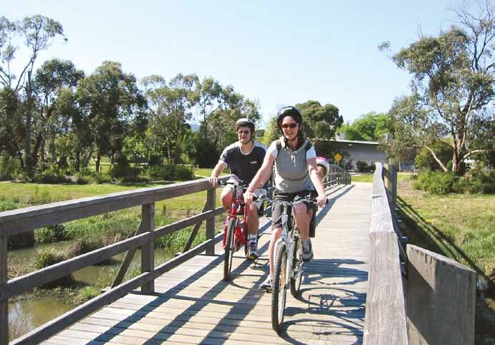

Given our closeness to the community, Council possesses an informed understanding of the trends, barriers and enablers to active transportation adoption. Council has had a long history in delivering community engagement programs that encouraged active travelling. These programs are often targeted towards vunerable sections of the community, such as primary school children, seniors or people with disability.
Authority over pedestrian and cycling infrastructure and facilities predominantly rests with Council. In accordance with Council’s Integrated Transport Strategy, Bicycle Strategy and Pedestrian Strategy considerable investment has seen the expansion of the municipal cycling and principal pedestrian network. There are a range of opportunities that Council can undertake to improve the pedestrian and cycle network. These will include expansion of pathways for better connectivity, removing physical barriers, improving permeability across roads and installing wayfinding signage.
Council is well placed to take the lead implementation role within the active transportation sector and engage with other
planning and transport authorities to leverage greater capital works and community programs investment in active transportation.

- Heart Foundation. (2009). Delivering Melbourne’s Newest Sustainable Communities: Submission to the Growth Areas Authority . July 40 Bus Association Victoria, . (2010). Briefing Paper, Public Transport Use a Ticket to Health. Melbourne.
Opportunities for Maroondah City Council Process a framework to set the strategic planning, prioritisation and investment for
future action to grow active travel. The
framework is to encompass the following five broad actions.
- Encourage people to walk and cycle by changing attitudes and behaviors.
- Collaborate to improve provision for predominately walking and cycling but also other forms of active travel, i.e. scooter or skateboarding.
- Create pedestrian friendly built environments and public spaces.
- Increase the safety of walking and cycling.
- Continue to integrate the pedestrian and cycling networks within the public transport network.
41 Maroondah City Council. (2014). An Accessable and Connected Community. In Maroondah 2040 Community Vision (p. 35). Melbourne: Maroondah City Council.

Safe, healthy and active

Council Priority - Activating Open Space

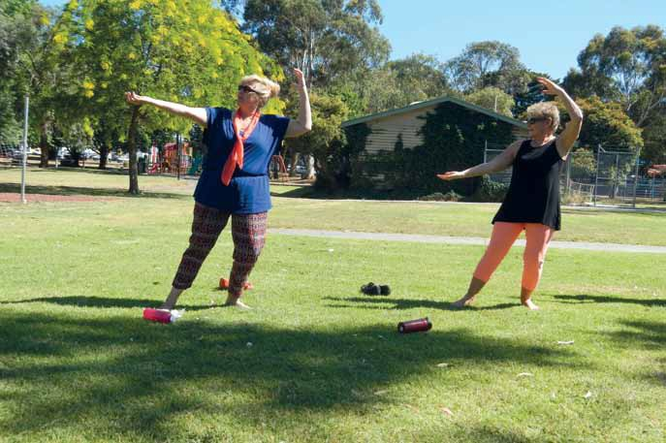

Open space is extremely important to Maroondah residents as highlighted in the Maroondah 2040 consultation results.
Forty three per cent of survey feedback relating to physical activity was related to the acquisition, maintenance and development of parks and open space. Its importance to Maroondah residents may be a key factor in promoting active living, providing opportunities for people to be more active and to adopt healthier behaviours.
The creation of vibrant, active public open spaces also contributes to strengthening community connections and safety perceptions and has a positive influence on the independent mobility of younger and older Maroondah residents.
Maroondah City Council should consider the principles of the Urban design Protocol for Australian Cities42 to guide the development of open space environments that encourage physical activity, together with the provision of supportive infrastructure, eg lighting, toilets, paths and; the
facilitation of partnership programs to drive participation, activation of public spaces and increase physical activity levels of Maroondah residents.
The Creating Places for People, Urban design Protocol for Australian Cities identifies 12 principles for quality urban places in Australia. Under the pillar of Liveability there are four principles:
- Comfortable - Comfortable & Welcoming
- Vibrant - Vibrant, with people around
- Safe - Feels Safe
- Walkable - Enjoyable & easy to walk and bicycle around
These principles are validated by the results of the internal and external consultation in relation to what the community believed were elements required to drive participation in Maroondah’s outdoor spaces.

- Australian Government (2011) The Creating Places for People, Urban Design Protocol for Australian Cities
- South Australian Active Living Coalition. (2010) Creating active communities. How can open and public spaces in urban and suburban environments support active living? A literature review.

Perception of safety in public open spaces Safety and the fear of crime are likely inhibitors to participation in physical activity in public open
space for some members of the community.
Issues concerning safety impinge upon public open space usage. While the provision of naturally vegetated green open space has been documented as having a positive influence on physical activity, it must also be acknowledged that vegetation can be perceived negatively by some community members. Vegetation can provide or be seen to provide cover for persons engaged in anti-social and/or illegal activities, thereby reducing public open space usage by other community members.43 Council needs to ensure a balance between retaining and planting vegetation for the preservation of the natural environment, aesthetics and natural shade and the provision of clear pedestrian areas for visability, surveillance and improved perception of safety.
Consultation for Maroondah 2040 highlighted the community need for improved lighting within public open space areas.
Opportunities for Maroondah City Council develop a lighting policy to ensure a planned approach to lighting projects
Continue to install lighting within public open space to encourage increased usage.
Ensure a safety lens is utilised when designing and maintaining vegetation to ensure that it does not negatively affect participation.

Vibrant activity precincts
Another essential element to reducing the fear of crime in public open space is to elevate visitation. Greater volumes of park users will assist in the creation of vibrant active spaces, where people feel safer and feel welcomed and motivated to exercise by the energy of others. The need for the creation of vibrant activity precincts in Maroondah was highlighted strongly within the consultation results. Examples from other municipalities included The Tan – City of Melbourne, and Lilydale Lake and the 1000 Steps – Yarra Ranges Council.
Attributes that respondents felt supported a well utilised activity precinct included the quality of the facilities, lighting for extended hours usage, parking and toilet facilities, and the preference for the provision of a circuit where participants can walk, run, cycle and return to their commencement point. Facilities such as The Tan and the 1000 Steps also featured a unique point of difference which attracted participants to travel great distances to experience this unique quality.

Driving participation
Opportunities for Maroondah City Council Jubilee Park Precinct, incorporating Aquanation, Ringwood Multipurpose Pavilion, playground,
Jubilee ovals 1 and 2, Ringwood Croquet and
Ringwood Tennis.
Croydon Parklands Precinct incorporating Croydon Park, Town Park and the Tarralla Creek Trail.
Maroondah residents have indicated a preference for unstructured activities which primarily occur outdoors. In order to encourage residents to adopt regular participation in the wide range of unstructured activities available within Maroondah, Council needs to create or facilitate and promote opportunities to inspire residents to walk, run, cycle, scooter, skate, exercise or play.
Active in Parks44 is an award-winning Healthy Parks Healthy People program that encourages interaction with nature to improve people’s physical, mental and social wellbeing. The program has set up successful programs in municipalities across Australia. The Active in Park program has a number of specific programs developed by health professionals and based on international research and evidence. These have been running successfully for many years and implementation guides are provided to support implementation of new programs. There is also funding available through the Foundation to foster collaborative and innovative approaches to connecting people to parks. Active in Parks Local Champions Grant
$7500 - $15000, and Active in Parks Take It outside Small Grants Program $500 -$1500.
The VicHealth Be Active Program45, in partnership with Sport and Recreation Victoria have recently supported 5 Victorian Councils to support innovative initiatives by councils to respond to the specific barriers to physical activity for their communities.
City of Greater Geelong’s Active in Parks program adopts a multi-sector approach to actively create healthier communities. Its success was achieved by partnering the health and community sector with local government, corporate agencies and the park sector.
The program brought together, through local organisations and local natural assets, the capacity to activate community leaders to use parks as part of the solution for health and well-being and provide programs for both the general public and targeted programs to meet the particular needs for specific populations. In 2014, City of Greater Shepparton’s Activities in the Park Program

- Active in Parks - A Healthy Parks Healthy People program http://activeinparks.org/, accessed November 2014 45VicHealth Be Active Program. www.vichealth.vic.gov.au. accessed November 2014

Safe, healthy and active

involved over 200 events and activities held in 43 parks, reserves and playgrounds in 12 townships and in partnership with over 40 community groups, businesses and government departments.
In order for Maroondah City Council to forge strong partnerships across the private and community sector Council should allocate adequate staffing resources. Council does not currently have an officer dedicated to the facilitation of and /or delivery of community activity programs other than those provided through Maroondah Leisure membership and several annual general population participatory events. Specific interventions, programs and campaigns, tailored to the needs of target populations are necessary to adopt effective strategies to engage these populations. This requires a planned approach requiring evidence based planning, time and staff resources to develop and maintain partnerships and sound evaluation processes.
Council has an opportunity to capitalise on the existing resources and the expertise of staff at the Maroondah Leisure facilities through the utilization of Council’s public open space and open space infrastructure such as exercise stations.
Only a small percentage of the Maroondah population utilises Council’s gym and group fitness facilities. While there are a myriad of reasons for not accessing these facilities there has been a marked rise in interest for outdoor group fitness.
While there would be many residents who would never envisage themselves entering a gym environment, the casual use of outdoor exercise stations or casual attendance at an outdoor group fitness class may be a catalyst needed to motivate a move to regular membership or fitness regime.
To stimulate interest, promote correct usage and activate new outdoor fitness equipment in the City of Woolongong, the Council provided free personal trainers at the new equipment at set times during the week.
This and many other opportunities presented by the use of open space should be explored by Council to engage the majority of Maroondah residents who are not undertaking enough physical activity to maintain optimal health.
Opportunities for Maroondah City Council
A dedicated Active Participation Officer to forge strong partnerships across Council, the private and community sectors to deliver a range of targeted programs and health promotion initiatives to increase physical activity levels within Maroondah.
Explore opportunities for Maroondah Leisure to utilise Council’s public open space to engage residents who do not access facility-based programs.

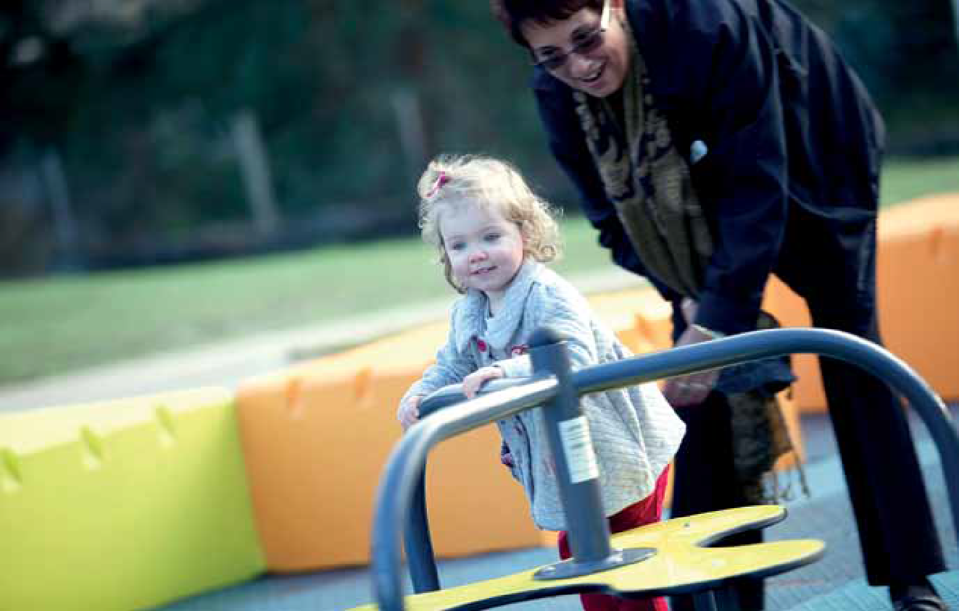

Council Priority - The Future of Sport

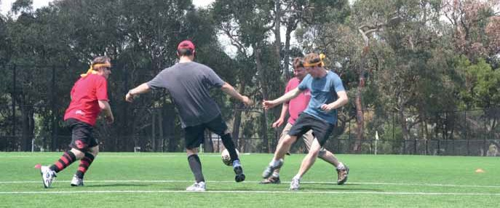

While Maroondah’s current physical activity profile highlights that 70% of Maroondah residents do not participate in organised sport and may not ever have the interest or ability to do so, sport still plays an important role in the community, for health and fitness, social interaction and social cohesion.
Sport teaches important values and helps to build character. Involvement in sport also provides a rewarding opportunity to interact with others as a participant, volunteer, leader, or supporter.
Sports organisations need however, to be aware that there is a shift in the motivation for people to play sport, and to embrace new ways of delivering sport to those who want to be involved.
The Australian Sports Commission (ASC) commissioned the CSIRO to identify what maybe likely to shape the Australian sports sector over the next 30 years. It highlights that there are six megatrends that may strongly influence the future of Australian Sport.46

Opportunities for Maroondah City Council Seek out opportunities to pilot modified and/ or emerging sports in Maroondah.
Most Maroondah sportsgrounds are currently used to capacity during peak periods.
Undertake benchmarking and consultation to develop Council policy which will enable these new sports or new target groups to gain access to Council facilities.
Highlight the success stories to local clubs to promote the possibilities beyond the structured, membership-based delivery model.
A perfect fit Individualised sport for personal health and fitness objectives. Fitting fitness in to increasingly busy time fragmented lifestyles.
Participation rates in gym/aerobics, personal training, running and walking have increased significantly, most organised sports have seen a plateau or decline.
From extreme to mainstream The rise of lifestyle, adventure and alternative sports. The pursuits have a strong lifestyle element and participants often obtain cultural self-identity and self-expression through these sports
46 Australian Sports Commission. (2013) The Future of Australian Sport
More than sport If managed appropriately, sport can be an effective mechanism for the attainment of social change, health, community and overseas aid objectives.
Everybody’s game demographic, generational and cultural change. The need to cater for older Australians and the changed cultural make-up of Australia.
different cultures have different sporting preferences and recreation habits.
New wealth, new talent Population and economic growth within Asia will create new opportunities and tougher competition.
Tracksuits to business suits Market pressures to place greater pressure on sporting organisations to adopt more formal governing structures and business models.

Safe, healthy and active

Council Priority - Schools and Workplaces

With lack of time, a key inhibitor for Maroondah residents engaging in enough physical activity for health benefit, it is imperative that there be greater opportunities for residents to incorporate physical activity at school or in the workplace.
While Council does not have enormous capacity to create change in this sphere there are opportunities for Council to assist in influencing change and to offer supportive environments for activities to occur.
Council’s Maroondah Leisure facilities should explore avenues for corporate membership
Maroondah City Council has a workforce of approximately 900 staff, many of whom have links to the local community or reside within Maroondah. Internal staff consultation highlighted a demand for Council to ‘lead by example’ in the development of physical activity initiatives to engage & support workers who are not undertaking sufficient regular physical activity.
The majority of Australian children between the ages of 5 to 17 do not currently meet physical activity guidelines. Participation decreases with age, from 36% of 5 to 8 year olds to just 6% of 15 to

packages, corporate challenges and schools
17 year olds.47
ABS,2013. Within the secondary

challenges. Most Council facilities have capacity for far greater weekday usage and therefore scope to explore new initiatives to engage schools and workplaces. Council’s outdoor sporting facilities should remain readily available for school usage and continue to be free of charge to primary schools. Local parks and their facilities should be promoted to nearby workplaces calling on workers to take the opportunity to get active and to minimise the adverse effects of long periods of sitting.
Australian Sports Commission’s The Future of Australian Sport report poses the question:
school environs, planned physical activity options
are predominantly within a competitive environment.
For those young people who are not confident or interested in competitive sport there are limited social, non competitive options formally sanctioned by schools. Council’s Youth Services Team could actively encourage the trial introduction of modified sports or other innovative physically active pursuits which have an emphasis on fun and social interaction rather than achievement.
Opportunities for Maroondah City Council Explore new initiatives to engage schools, Swinburne University and workplaces in
weekday usage of Maroondah Leisure facilities
Council to ‘lead by example’ in the development of physical activity initiatives to engage & support workers who are not undertaking sufficient regular physical activity.
Actively encourage and support the introduction of modified/ social sporting or other innovative physically active pursuits in Maroondah secondary schools.

Is there an under-developed opportunity to engage people in sport within working hours? People, especially males, now spend greater amounts of time at work. Furthermore, a large and increasing portion of their recreation time is spent watching television and internet screens. Therefore, an effective avenue for actively engaging people in sporting activity might be through their work environment. This might be achieved by employers encouraging staff participation in sporting events and making time available for sport during the working week. The benefits to employers would be a more physically and mentally healthy workforce. This may lead to increased levels of productivity.

47 Australian Bureau of Statistics. Australian health survey: physical activity, 2011–12. Cat no. 4364.0.55.004. Canberra: ABS, 2013

Taking action and making an impact

In order to increase the community’s participation levels in physical activity, Maroondah City Council must consider the barriers and opportunities highlighted in this strategy and commit to undertaking measurable actions over the next five years.

The next section details a range of actions from across Council that address many of the barriers and / or opportunities herein. There is also great scope to continue to build upon these actions and seek out further opportunities to improve access, information, services and supports to enable greater participation levels.
Of particular focus should be the marginalised groups detailed within the strategy, with careful consideration of their needs and wherever possible thorough consultation rather than assumption during program, facility or marketing development.
The actions are linked back to relevant Maroondah 2040 Vision community indicators. To measure the impact of these actions, the strategy has
established a reporting baseline based on current ABS data and or other current sources which will continue to be updated to enable future measurement.
In 2019, the physical activity household telephone survey will be undertaken again to ascertain the percentage of residents who meet the National Physical Activity Guidelines. This figure will assist in determining whether this strategy has had a positive impact on the physical activity levels of Maroondah residents.

Safe, healthy and active

Maroondah 2040 Community Indicator Reporting Baseline

# | Maroondah 2040  Community Indicator | Current status | Source
1 | Proportion of residents who feel safe walking alone at night | When walking alone at night 64.6% of persons in Maroondah felt safe or very safe, compared to 71.6% in the Eastern Metro Region and the Victorian State average of 70.3% | 2011 VicHealth Indicators Survey
2 | Average community rating of subjective wellbeing | 78.1 Maroondah 77.5% Victoria | 2011 VicHealth Indicators Survey
3 | Proportion of residents who undertake adequate physical exercise | 35% Maroondah Adults 43% Australian Adults | Maroondah – Household Physical Activity Telephone Survey 2014  2011-12 Australian Health Survey
4 | Proportion of local residents who do not meet physical activity guidelines | 65% Maroondah Adults 57% Australian Adults | Maroondah – Household Physical Activity Telephone Survey 2014  2011-12 Australian Health Survey
5 | Proportion of community members who are involved in organised sport, and have access to recreational and leisure facilities | 30% Maroondah Adults  23.7% Victorian 15 years & over  Physical activities are organised by a club, association or other group. | Maroondah – Household Physical Activity Telephone Survey 2014  ABS Involvement in Organised Sport and Physical Activity Australia 2010
6 | Proportion of children with good physical health and wellbeing | Children aged five to under 13 years of age who are reported to be physically active for 60 minutes or more everyday  2013 Victoria - 5 to 8 years 70.2%  2013 Victoria - 9 to 12 years 53.8%  Proportion of children with good health - Number of children aged 0 to 13 years of age who are reported to have ‘good’, ‘very good’ or ‘excellent’ health  2013 Victoria - 5 to 8 years 97.4%  2013 Victoria - 9 to 12 years 98.0% | Victorian Child and Adolescent Monitoring System (VCAMS) Source: Victorian Child  Health and Wellbeing Survey (VCHWS)
7 | Proportion of residents who eat recommended serves of fruit and vegetables | Children aged 4 to 12 years who eat the minimum serves of both fruit and vegetables daily  2013 Victoria - 4 to 8 years Both fruit and vegetables 2.4%  2013 Victoria - 9 to 12 years Both fruit and vegetables 3.0% In 2011-12, 48.5% of Australians aged 18 years and over reported that they usually ate two or more serves of fruit per day (meeting the guidelines), while 8.2% usually ate 5 or more serves of vegetables per day (meeting the guidelines) | Victorian Child and Adolescent Monitoring System (VCAMS) Source: Victorian Child  Health and Wellbeing Survey (VCHWS)  ABS - Profiles of Health, Australia, 2011-13

2015 – 2020 Physical activity strategy
47

Physical Activity Strategy Action Plan

Focus area | - Information / Health Promotion  - Access : Physical, Social and Attitudinal environments  - Infrastructure  - Activation Initiatives/Opportunities
Indicator of Progress | Maroondah 2040 Vision progress measures refer to baseline
Source | Action sourced from an existing Council strategic document
Action | Activities/initiatives required to be implemented
Measure | Quantifiable effective measure of success
Lead | Council team or department who will facilitate the action
Support | Other Council department who will provide support to the initiative
$ | Source of funding
Timeframe | Year/ years of implementation

Focus Area: Information/Health Promotion
Safe, healthy and active
48
2015 – 2020 Physical activity strategy

Maroondah 2040  Community indicator of progress | Source | Action | Measure | Lead | Support | $ | Timeframe
2 | NEW | Production, promotion and dissemination of health promotion messages and information highlighting the achievements of Council and it's partners in delivering against Maroondah Community Wellbeing Plan actions that work towards enhanced health and wellbeing outcomes for Maroondah residents. | Inclusion of a minimum of 1 health promotion/health & wellbeing achievement focused article per edition of 'Maroondah in Focus' per year and a minimum of four 'That's Maroondah' articles per year. | Community Planning & development |  | Within Budget | 2015/2020
2 | NEW | Implement an active living awareness initiative targeting young people and their parents | Inclusion of a minimum of four articles in secondary school newsletters | Youth Services  Comm. P& d. | Children’s Services |  | 2017
5 | NEW | Installation of interactive signboard at Town Park Athletic Track informing casual users of track availability & promotion of program opportunities | Feedback from users, reduced enquiries from general public, increased public usage. | Sport & Recreation |  | $6,000  Within Budget | 2017
5 | NEW | Increase use of technology to promote physical activity opportunities including but not limited to the social media and VicHealth’s Team Up App. | VicHealth can provide data by municipality. Aim to increase use of the app. | Sport & Recreation | Communications  & Marketing | Within Budget | 2016/2017
2,3,4,7 | NEW | Capitalise on existing State & Federal Government health promotion initiatives and develop strategies to assist in engagement and implementation at a local level. | development a calendar of initiatives  & action plan. Minimum 2 campaigns per year | Sport & Recreation | Cross Council Working Group | Within Budget | 2016  - 2020

2015 – 2020 Physical activity strategy
49

Focus Area: Information/Health Promotion

Maroondah 2040  Community indicator of progress | Source | Action | Measure | Lead | Support | $ | Timeframe
3 | NEW | Promotion of Council's Living | Ensure the promotion | Active & |  | Within | Ongoing
 |  | Longer, Living Stronger program | of physically active | Healthy |  | Budget
 |  | & other senior physical activity | programs feature in | Ageing
 |  | programs through the Maroondah | each of the quarterly | Initiative
 |  | Healthy Ageing Network and the | chatterbox
 |  | Senior Newsletter "Chatterbox" | publications.
3 | NEW | Collaborate with Council on the | Ensure that COTA | Active & |  | Within | Ongoing
 |  | Ageing (COTA) to provide and | information is shared | Healthy |  | Budget
 |  | share research based evidence on | to community | Ageing
 |  | the benefits of physical activity | through varied | Initiative
 |  | and techniques to encourage | information channels.
 |  | increased physical activity to the
 |  | age cohort 45+
3 | Maroondah | Secure partnerships, support and | Funding secured by | Strategic | Business | Seek | 2015/16
 | Bicycle | funding the project proposal for | June 2016. | Planning and | development, | External
 | Strategy | the development of Ringwood |  | Sustainability | Assets, | Funding
 |  | Cycle Map. |  |  | Communications
 |  |  |  |  | & Marketing
6 | Maroondah | Produce and distribute School | Feedback from | Strategic | Engineering | Within | 2015/16
 | Pedestrian | Walkability Guides to encourage | schools on the | Planning and | Services, Assets, | Budget
 | Strategy | school to develop long term | adoption of guide. | Sustainability | Business
 |  | strategies to support active travel |  |  | development
 |  | to school.
2 | NEW | develop a comprehensive ‘Get | The development of | Sport & | Active & Healthy | New | 2017
 |  | Walking’ promotional strategy | costed strategy with | Recreation | Ageing Initiative | Budget
 |  | and program initiative to assist | actions and key |  |  | Initiative
 |  | residents to prioritise walking as | performance
 |  | part of everyday. | measures.
6,7 | Healthy | Implement relevant initiatives of | Completion of | Children’s |  | Within | 2015-2018
 | Together | the Healthy Together Victoria | evaluation and | Services |  | Budget
 | Victoria | Program through Children’s | reporting
 |  | Services to address rising rates of | requirement as part
 |  | obesity and related chronic | of the Healthy
 |  | disease. | Together Initiative

Focus Area: Access : Physical, Social and Attitudinal Environments
Safe, healthy and active
50

Maroondah 2040
2015 – 2020 Physical activity strategy
Community indicator of progress
Source Action Measure Lead Support $ Timeframe

4 disability
Action Plan
Key direction
1.2 Action 10
Undertake awareness training within the community on access and inclusion barriers, rights and inclusive practices
A minimum of two awareness raising exercises targeting Recreation, Leisure, Sport, Arts or Cultural Activities
Community Planning & development
Within Budget
2015/2018

2 NEW Support the introduction of the Pride Cup to senior Eastern Football League fixtured season
Club participation supporting awareness initiatives
Sport & Recreation
Youth Services Comm.
Grants Funding Program
2016/2017

4 NEW Review Maroondah Leisure and Occasional Care childcare provisions to ensure equality of access for working parents who wish to participate in physical activity programs.
Undertake a comprehensive survey process to gain feedback from a wide cross section of the community
Maroondah Leisure
Children’s Services
Within Budget
2016/2017

2 Open
Space Strategy
Undertake a promotional strategy to increase awareness of open space facilities and their level of accessibility.
Increased usage of parks and facilities measured by user surveys
Open Space Communications
& Marketing
Ongoing

2 | Open | develop matrix to ensure | Implementation of | Open Space | Sport & | Within | 2016/2017
 | Space | equitable spread of open space | matrix to guide |  | Recreation | Budget
 | Strategy | opportunities within reasonable | capital renewal
 |  | distance of every household | priorities and for land
 |  |  | acquisition/retention
 |  |  | advocacy

2015 – 2020 Physical activity strategy
51

Focus Area: Access : Physical, Social and Attitudinal Environments

Maroondah 2040  Community indicator of progress | Source | Action | Measure | Lead | Support | $ | Timeframe
4 | NEW | In consultation with community leaders, trial and evaluate new inclusive initiatives to enable the CALd community greater access to Maroondah Leisure Facilities | Implement and evaluate a minimum of one new initiative per annum. | Maroondah Leisure | Community Planning & development | Within Budget | 2015- 2020
3 | NEW | Undertake benchmarking and consultation to develop Council policy which will enable emerging sports and marginalised groups opportunity to access to Council facilities. | Endorsement of Council Policy | Sport & Recreation |  |  | 2016/2017
1 | NEW | Seek funding for lighting upgrade to Town Park Athletic Complex and trial lighting track on available evenings during winter for general participation | Increase in evening usage, through weekly count. | Sport & Recreation |  | Seek External Funding | 2016/2017
3 | NEW | Explore the possibility of hosting golf programs and /or tournaments for organisations such as deaf golf and paragolf | Pilot and evaluate at least 1 inclusive program and from the evaluation learnings implement further strategies to increase access & inclusion. | Maroondah Leisure | Community Planning & development | Within Budget
3 | NEW | develop and implement an initiative to increase the physical activity levels of people with an intellectual disability | develop initiative in partnership with at least two external organisations | Community Planning & development | Aged & disability | Within Budget/ Seek external | 2016/2018

Focus Area: Access : Infrastructure
Safe, healthy and active
52
2015 – 2020 Physical activity strategy

Maroondah 2040  Community indicator of progress | Source | Action | Measure | Lead | Support | $ | Timeframe
4 | disability Action Plan | Assist community organisations operating in Council facilities to identify and address access issues. | decrease in the number of annual requests received by Council | Assets |  | Within Budget | Ongoing
2 | disability Action Plan | Identify, prioritise and implement community facility access improvement works, as part of Council's annual capital works Access and Inclusion Programs, monitor and review Access & Inclusion Grants | Ensure full annual budget allocation is expended on access improvement works. | Assets |  | Within Budget | Ongoing
3 | disability Action Plan | Advocate to State Government for Arterial Road and other infrastructure upgrades that include the provision of pedestrian and cycling infrastructure. |  | Engineering & Infrastructure | Open Space | Within Budget | Ongoing
2 | disability Action Plan. Key direction1.2  Action 15 | Advocate for the inclusion of ‘Changing Places’ toilets in major developments in Maroondah. | Advocacy undertaken on all Maroondah major development projects | Community Planning & development |  | Within Budget | 2015/2018
3 | NEW | Installation of outdoor gym circuit at Jubilee Activity Precinct. | Consistent usage of the equipment through visual monitoring and possibly QR code data. | Open Space | Maroondah Leisure | Within Budget | 2016-2017

2015 – 2020 Physical activity strategy
53

Focus Area: Infrastructure

Maroondah 2040  Community indicator of progress | Source | Action | Measure | Lead | Support | $ | Timeframe
1 | NEW | develop an overarching public | Endorsement of | Engineering | Open Space | Within | 2016 - 2017
 |  | lighting policy to ensure a consistent approach to the | policy |  | Assets | Budget
 |  | resource allocation, planning and |  |  | Integrated
 |  | installation of lighting projects. |  |  | Planning
3 | NEW | Parkour - investigate additional | develop a minimum | Open Space | Sport & | Within | 2017
 |  | infrastructure that provides safe | one additional |  | Recreation | Budget
 |  | and accessible options for this activity. | Parkour site in Maroondah |  | Youth Services
1 | Open | Improve open space | Parkscape survey, | Open Space | Engineering | Within | Ongoing
 | Space | infrastructure, eg toilets, seats, | resident feedback. |  |  | Budget
 | Strategy | paths, drinking fountains, and | Expenditure of
 |  | lights that are accessible to all | allocated budget.
3 | NEW | Implement consultation program | Undertake a | Open Space, | Communications | Within | 2016/2018
 |  | for users and non users of new | minimum 2 programs | Sport & | & Marketing | Budget
 |  | developments to understand | and evaluate. Survey | Recreation
 |  | barriers to usage and /or whether | residents within a
 |  | the new infrastructure has had a | minimum 400 m
 |  | positive impact activity levels. | radius of facility prior
 |  |  | to construction and 3
 |  |  | months after
 |  |  | installation to gain
 |  |  | meaningful data.
1 & 3 | NEW | develop monitoring and | All formalised trails | Operations | Asset | Within | 2017/2018
 |  | maintenance program for walking | will meet a minimum |  | Management | Budget
 |  | and shared trails to the Australian | surface standard and
 |  | Standard. Monitoring and removal | a width of 1.5 metres
 |  | of vegetation for improved
 |  | visibility, reduce trip hazards and
 |  | debris.
3 | NEW | Source external funding to | The development, | Local Laws | Open Space | External | 2016/2017
 |  | develop designated dog parks in | installation and |  |  | funding
 |  | Maroondah. | promotion of a
 |  |  | minimum of two dog
 |  |  | parks.

Focus Area: Activation Initiatives/Opportunities
Safe, healthy and active
54
2015 – 2020 Physical activity strategy

Maroondah 2040  Community indicator of progress | Source | Action | Measure | Lead | Support | $ | Timeframe
2 | NEW | Identification of collaborative physical activity orientated initiatives that foster the sharing of resources and knowledge of partners, to be included in the Maroondah Community Wellbeing Plan (MCWP) Action Plan 2016- 2017. | Inclusion of a minimum of one action item in both MCWP Action Plan Focus Areas 1 and 2. | Community Planning & development |  | Within Budget | 2016/2017
2 | NEW | Continue to work collaboratively with all stakeholders on the implementation of physical activity orientated actions within the MCWP Action Plan | Successful implementation of MCWP action items 1.1.7, 1.2.1, 2.4.4 and  3.4.1 | Community Planning & development |  | Within Budget | 2016/2017
2 | NEW | Continue to develop the model for the ‘Pathways for Carers’ project, seek endorsement and implement a pilot program. | Implementation of pilot ‘Pathways for Carer’ program | Community Planning & development | Open Space  Maroondah Leisure | Within Budget | 2015/2016
3 | NEW | develop a comprehensive evidence based business case outlining the benefits of employing an active participation officer | Presentation of business case to Corporate Management Team | Sport & Rec |  | Within Budget | dec 2015
5 | NEW | Facilitate discussions with peak sporting bodies to investigate increasing social sport opportunities in Maroondah | Pilot and evaluate a minimum two new social sport opportunities | Sport & Rec |  | Comm. Grants Program | 2016/2018
5 | NEW | Explore new initiatives to engage schools, Swinburne University and workplaces in weekday usage of Maroondah Leisure facilities. | Pilot and evaluate at least one school initiative, Swinburne initiative and workplace initiative. Undertake secondary evaluations at 3 & 6 month intervals | Maroondah Leisure | Sport & Rec  Business development  Youth Services | Within Budget | 2016/2019

Focus Area: Activation Initiatives/Opportunities

Maroondah 2040  Community indicator of progress | Source | Action | Measure | Lead | Support | $ | Timeframe
2 | NEW | Council to trial new initiatives to | Undertake at least one | Human | Sport & Rec, | Within | 2015/2020
 |  | engage & support staff who are | physically active | Resources | Leisure | Budget
 |  | undertaking insufficient physical | initiative per annum
 |  | activity.
3 | NEW | develop ongoing initiatives for | The delivery of at least | Maroondah | Open Space | Within | 2015/2020
 |  | Maroondah Leisure to utilise Council’s public open space to engage residents who do not access facility | two scheduled outdoor programs per annum | Leisure | Community Planning | Budget
 |  | based programs
3 | NEW | deliver a minimum of 3 new initiatives | Minimum of three new | Youth |  | Within | 2016/2020
 |  | that utilise social and/or informal | initiatives | Services |  | Budget
 |  | activities to increase levels of physical
 |  | activity by young people
2 | NEW | Facilitate discussions with key health | Make contact with at | Youth |  | Seek | 2016/2018
 |  | providers to explore the development | least two health | Services |  | External
 |  | of a specialised program to assist | services to gauge |  |  | Funding
 |  | young people with obesity | community need.
2 | NEW | Implement a number of programs to | Ensure that at least | A&d Social |  | Within | Ongoing
 |  | increase the level of physical activity | one physically active | Inclusion |  | Budget
 |  | in the Planned Activity Group setting | initiative is | &WB
 |  |  | incorporated into the
 |  |  | monthly PAG program
 |  |  | schedule
3 | NEW | Facilitate increased number of | Facilitate the formation | Bushland |  | Within | 2015/2020
 |  | volunteer planting groups. to increase | and provide ongoing | Management |  | Budget
 |  | community ownership of open space, | support to a minimum
 |  | visitation, & opportunity for social | three new groups over
 |  | interaction & physical activity. | the strategy period
2 | Integrated | Pursue funding to expand support, | Number of Maroondah | Strategic | Youth, | Seek | Annually

Transport Strategy
2015 – 2020 Physical activity strategy
promotion and school participation in school focused active travel events ,
i.e. Walk to School day and Ride to School day.
school registrations with VicHealth and Bicycle Network Victoria for respective events.
Planning and Sustainability
Local Laws, Engineering, Communications
& Marketing
55
External Funding

to contact council
• phone 1300 88 22 33 or (03) 9298 4598
- visit our website at www.maroondah.vic.gov.au
- email maroondah@maroondah.vic.gov.au
translating and interpreter service
13 14 50
National relay service (Nrs)
13 36 77
MaroondahCityCouncil
@CityofMaroondah CityofMaroondah
Maroondah City Council MaroondahCityCouncil

