Maroondah Innovate Reconciliation Action Plan 2018 to 2020

Working towards a vibrant and culturally rich community

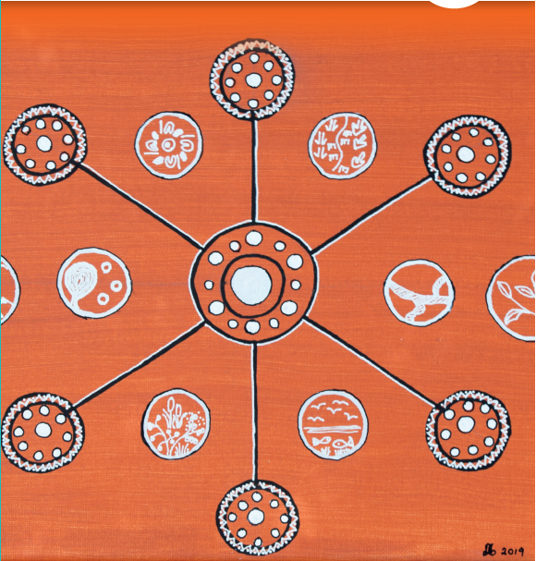

Artist biography - Aunty Daphne Milward
Aunty Daphne Milward is a strong Yorta Yorta Woman and a positive role model for all within the local and broader Indigenous community.

Through her role as a community Elder, she supports the Mullum Mullum Indigenous Gathering Place (MMIGP) Community Art Space by encouraging young and beginning artists to express themselves through
painting.

Aunty Daphne possesses a strong sense of cultural connection and shares her cultural experiences with the community through her support of the MMIGP Culture Group.

Her long list of achievements include Board Member of Native Title Services; Director of Victoria’s Women’s Trust; Committee Member of Koori Women Mean Business; Member of the Equal Opportunity Commission; and work at the Aborigines Advancement League.

Maroondah City Council is represented at the centre of the artwork, with the offshoots showing the many different cultures that Council works with. The floating circles tell about Bunjill’s creation story.

What is Reconciliation?
Reconciliation is unity and respect between Aboriginal and Torres Strait Islander peoples and non-Indigenous Australians. It is about respect for Aboriginal and Torres Strait Islander heritage and valuing justice and equity for all Australians. (1)

All Australians are invited to participate in our nation’s reconciliation journey.

Reconciliation must live in the hearts, minds and actions of us all as we move forward, creating a nation strengthened by respectful relationships between Aboriginal and Torres Strait Islander peoples and non-Indigenous peoples (2).

- Australian Government www.australia.gov.au/about-australia/australian-story/reconciliation
- Reconciliation Australia www.reconciliation.org.au/nrw/what-is-nrw/

Reconciliation Australia Model
The Reconciliation Action Plan (RAP) program, developed by Reconciliation Australia, a not-for-profit organisation, in collaboration with Aboriginal and Torres Strait Islander communities and organisations as well as government and corporate Australia, is a framework for organisations to realise their vision for reconciliation.

The RAP program guides organisations in developing a strategic action plan that identifies practical actions and measures for building respectful relationships and creating opportunities for Aboriginal and Torres Strait Islander peoples. RAPs create social change and economic opportunities for Aboriginal and Torres Strait Islander peoples.

There are four different RAP frameworks within the program:
- Reflect
- Innovate
- Stretch
- Elevate

The Maroondah RAP has been developed in accordance with the ‘Innovate RAP’ framework.
- The Innovate RAP framework is for organisations that have developed relationships with their Aboriginal and Torres Strait Islander stakeholders and are ready to develop or implement programs for cultural learning, Aboriginal and Torres Strait Islander employment and supplier diversity.
- An Innovate RAP provides Council with the freedom to develop and test new and innovative approaches and embed the RAP within Maroondah City Council.

Endorsement from Reconciliation Australia
Maroondah City Council has a strong commitment to promote and work towards greater reconciliation in the City of Maroondah.

This is evidenced in part by Council’s decision to undertake the first Reconciliation Action Plan for the municipality and seek endorsement by Reconciliation Australia.

Council has worked closely with a range of Aboriginal and Torres Strait Islander community members in the development of the Reconciliation Action Plan. The consultation process itself has raised the profile of reconciliation in the broader community.

The journey so far
In July 2008, Maroondah City Council endorsed the Maroondah Reconciliation Policy Statement 2008.

This document guided the work of Council within the reconciliation space for a number of years. During this time some significant actions were achieved in working towards a reconciled, just and equitable Maroondah and beyond, these include but are not limited to:

- The development and implementation of an Acknowledgement of Traditional Landowners and Welcome to Country Protocol at all Council Meetings and civic events.
- Facilitation of collaborative National Reconciliation Week events.
- Implementation of Cultural Awareness Training with identified Council staff.
- Cultural Heritage Review of the Dandenong Creek Shared Pathway Project.
- Permanently flying the Aboriginal flag.
- Collaborating with local Aboriginal and Torres Strait Islander organisations and individuals on various initiatives, networks and events.

During 2014, Council undertook a research project to identify the most beneficial and advantageous model by which to review, document and progress Council’s commitment to reconciliation. In 2015, Maroondah’s Councillors and Corporate Management Team endorsed the recommendation to proceed in accordance with Reconciliation Australia, Reconciliation Action Plan Program. Work then commenced on Maroondah Reconciliation Action Plan (MRAP) project planning and the formation of the Maroondah Reconciliation Action Plan (MRAP) Working Group.

In 2016, the Maroondah Reconciliation Action Plan Working Group (MRAP Working Group) was formed in accordance with the Reconciliation Australia model and comprised of Aboriginal and Torres Strait Islander and non- Indigenous individuals from both within and external to Maroondah City Council.

The MRAP Working Group is chaired by Council’s Chief Executive Officer and consists of key local Elders, Aboriginal and Torres Strait Islander and non-Indigenous local organisations and key internal senior decision makers.

The MRAP Working Group has supported and guided the development of the MRAP and will continue to work collaboratively on the implementation and evaluation of the MRAP. Each MRAP Working Group member has brought with them a unique and invaluable set of knowledge, skills and experiences that have not only enriched the MRAP and its expected outcomes but also worked to enhance relationships, respect and opportunities throughout the development process. All internal MRAP Working Group members will champion the MRAP.

MRAP Membership
Agencies represented on the MRAP Working Group include the following:

- Wurundjeri Tribe Land Compensation and Cultural Heritage Council
- Mullum Mullum Indigenous Gathering Place
- Boorndawan William Healing Service
- EACH – Consumer, Carer and Community Engagement Planning, Strategy and Development Unit and Aboriginal Mental Health Unit
- Maroondah Movement for Reconciliation
- Maroondah City Council - Chief Executive Officer, Director Strategy and Community, Manager Community Services, Manager Integrated Planning, Manager Workplace, People and Culture
- The Maroondah Reconciliation Action Plan Working Group includes six Aboriginal and/or Torres Strait Islander members.
Council would like to thank each individual member of the MRAP Working Group. We would like to specifically acknowledge the support and guidance of Aunty Daphne Milward, Aunty Irene Norman, Aunty Doreen Garvey-Wandin, Aunty Gail Smith, Aunty Julianne Axford, Aunty Margaret Gardiner and Les Chessells.

Consultation
Council, along with members of the MRAP Working Group, has undertaken meaningful engagement and consultation with the whole of community and key stakeholders on the identification of actions that Council can undertake towards reconciliation in Maroondah.

The consultation program included the following:
- Café Consult at Maroondah Festival
- Activity based sessions at Mullum Mullum Indigenous Gathering Place
- Stakeholder workshop at Karralyka.

The MRAP Consultation program was highly successful in reaching a diverse range and number of stakeholders and therefore ensuring the voices of many have shaped the document and positioned it for successful implementation.

Our City
The City of Maroondah covers a land area of 61.4 square kilometres in Melbourne’s outer east, 22 kilometres from the Central Business District.

The area is a substantially developed peri-urban residential municipality, with an estimated population of 117,498 and 45,621 households with an average of 2.58 people per household. Council employs over 1000 individuals and has three customer service centres along with staff being located at numerous Council owned and operated facilities throughout the municipality.

Though we have not yet collected data on the number of Aboriginal and Torres Strait Islander staff we employ, we have committed to collect this data in the future as part of our Reconciliation Action Plan.

The City of Maroondah includes the suburbs of Bayswater North, Croydon, Croydon Hills, Croydon North, Croydon South, Heathmont, Kilsyth South, Ringwood, Ringwood East, Ringwood North and Warranwood. The City also includes small sections of Kilsyth, Park Orchards, Vermont and Wonga Park. With little remaining land available for greenfield residential development, future population growth will mainly be stimulated by housing consolidation and medium density development.

Maroondah has the strategic advantage of being located at the north-eastern junction of the Eastern Freeway- Eastlink corridor. There are two train lines and a large number of bus routes linking the City with other regions.

Our sustainable transport links continue to expand, with on-road cycling paths and shared paths on major trails, including Mullum Mullum Creek Trail, the Eastlink Trail, Taralla Creek Trail and the Dandenong Creek Trail.

The first settlers to the area were the Wurundjeri people of the Kulin nation approximately 40,000 years ago. The territory of the Wurundjeri lies within the inner city of Melbourne and extends north to the Great Dividing Ranges, east to Mt Baw Baw, south to Mordialloc Creek and west to the Werribee River.

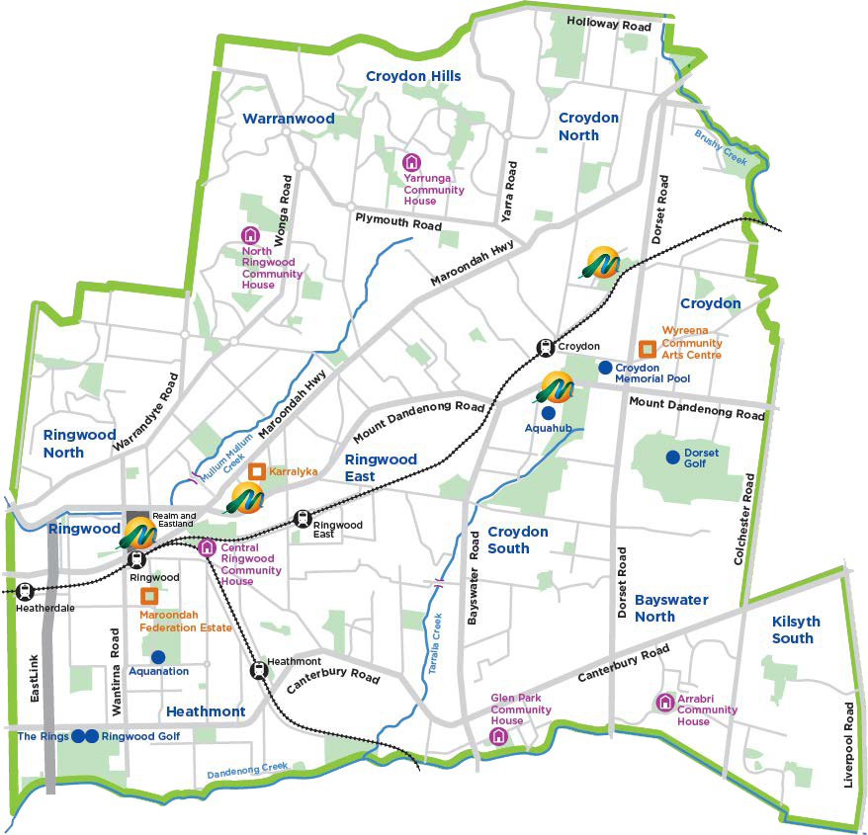

The 2016 ABS Census reported that there were 566 residents identifying as Aboriginal and/or Torres Strait Islander. The number of Aboriginal and/or Torres Strait Islander individuals with a significant connection to Maroondah, that is those that live, work or play in the municipality is likely to be significantly higher. Mullum Mullum Indigenous Gathering Place is located within Maroondah and plays a key role in fostering connection, promotion, support, celebration and strengthening of the local Aboriginal communities, cultures, knowledge and traditions.

Cultural diversity is increasing within Maroondah with the highest numbers of recent oversea immigrants arriving from Burma, China, Malaysia, India, Thailand and Iran. Maroondah is now home to the largest Burmese community in Melbourne’s eastern region.

As a local government authority, Maroondah City Council’s core role is to perform the functions and exercise the powers conferred by the Local Government Act 1989. As the closest level of government to the community, Councils work with their communities in setting the overall direction for a municipality through short, medium and long-term planning. The MRAP will sit within the Maroondah Integrated Planning Framework which outlines Council’s planning and resourcing to deliver against legislated requirements and community expectations and aspirations.

Maroondah City Council strives to engage with all of community to deliver against the following eight broad outcome areas:
- A safe, healthy and active community
- A prosperous and learning community
- A vibrant and culturally rich community
- A clean, green and sustainable community
- An accessible and connected community
- An attractive, thriving and well-built community
- An inclusive and diverse community
- A well governed and empowered community

The MRAP documents Council’s commitment to and identified actions for working towards reconciliation and enhancing equality across these broad outcome areas.

Maroondah Aboriginal and Torres Strait Islander Statistics
As identified in the 2016 Census, there are 566 Aboriginal and/or Torres Strait Islander peoples recorded in Maroondah. This is a notable increase from 412 in 2011. The majority of Aboriginal and Torres Strait Islander peoples in Maroondah are Aboriginal (94.2%). This is in line with results across Victoria (93.3%). A much smaller proportion identify as Torres Strait Islander (5.7%) or both (1.4%).

There is a relatively even spread of males (48.2%) compared to females (50.7%) and this is similar to Victorian proportions (49.4% compared to 50.6% respectively). Looking across age groups, most Aboriginal and/or Torres Strait Islander peoples in Maroondah are under 50, with over a third (36.0%) being 17 years or younger. However, this proportion is smaller than in Victoria (46.0%). Almost half (44.4%) are between the ages of 18-49 (43.5% in Victoria). Less than one in five (19.6%) are over 50 (10.6% in Victoria).

Almost one in four (23.4%) Aboriginal and Torres Strait Islander peoples living in Maroondah have either an Advanced Diploma, or Diploma, or Bachelor Degree level or higher. This is higher than the proportion in Victoria (16.8%). 41.4% of Aboriginal and/or Torres Strait Islander peoples living in Maroondah have finished Year 12 or equivalent. This is again higher than in Victoria (34.2%).

The majority (92.4%) of Aboriginal and/or Torres Strait Islander peoples in Maroondah are employed. This is higher than the proportion in Victoria (86.0%). Reflecting this, the unemployment rate amongst Aboriginal and/or Torres Strait Islander peoples is lower in Maroondah (7.6%), compared to 14.0% in Victoria.

Policy context
The Maroondah Reconciliation Action Plan (MRAP) 2018-2020 sits within the overall Maroondah Integrated Planning Framework which is underpinned by the shared long-term community vision outlined in Maroondah 2040: Our future together.

From Maroondah 2040: Our future together evolves a four-year Council Plan that establishes Council’s medium-term key directions (strategies) and resourcing to deliver on the outcomes identified within the vision.

The development of the MRAP is Priority Action within the Council Plan 2017–2021 and works towards the Maroondah 2040: Our future together community outcome of an inclusive and diverse community.

The vision for this outcome is that:

Maroondah is an inclusive community where social connections are strong across generations and diversity is embraced and celebrated.

The following Council Strategies and Plans have objectives that support the delivery of the MRAP:
- Maroondah Health and Wellbeing Plan 2017-2021
- Children’s Plan 2015-2019
- Arts and Cultural Development Strategy 2014-2018
- Active and Healthy Ageing initiative – towards an age-friendly Maroondah 2015-2020
- Disability Policy and Action Plan 2014-2018
- Business Development Strategy
- Open Space Strategy 2016
- Physical Activity Strategy 2015-2020
- Maroondah Planning Scheme

Externally, the MRAP acknowledges:
- United Nations Declaration on the Rights of Indigenous Peoples (UNDRIP)
- Aboriginal Heritage Act 2006
- Victorian Aboriginal Affairs Framework 2013/18
- Victorian Local Government Aboriginal Employment Framework
- Victorian Aboriginal and Local Government Action Plan
- Victorian Local Aboriginal Networks Five Year Plan 2016/2020

Reconciliation vision and principles
The Maroondah City Council Reconciliation Action Plan (MRAP) vision and principles have been developed collaboratively by the MRAP Working Group and are designed to guide the work being undertaken by Council and its many external partners in working towards reconciliation between Aboriginal and Torres Strait Islander and non-Indigenous Australians.

Vision
Maroondah City Council is committed to working collaboratively on a journey of meaningful and sustainable reconciliation between Aboriginal and Torres Strait Islander peoples and non-Indigenous Australians.

Our vision for Maroondah is that we will be a municipality that
- fosters and promotes equality, openness, trust, mutual respect and opportunities
- strives to enhance health (physically, emotionally and spiritually), social, cultural, economic, education and employment outcomes for Indigenous Australians
- recognises and celebrates traditional and contemporary Aboriginal and Torres Strait Islander people’s cultures, knowledge, customary practices and Aboriginal and Torres Strait Islander peoples’ deep relationship to land, kinship and country.

Principles
Council, together with its many MRAP partners, is committed to making a meaningful and measurable contribution to reconciliation within Maroondah. All MRAP activities will be undertaken in a positive and mutually beneficial and respectful manner and in accordance with the following collaboratively developed principles:

Equality and Equity
Council will work to enhance equality and equity within our community by demonstrating the need for fairness, equal status, rights and outcomes for all.

Recognition Respect and Celebration
Council will recognise, respect and celebrate the cultural values, customs, knowledge and land of all local Aboriginal and Torres Strait Islander peoples. We will recognise and respect the sacred significance of the Wurundjeri land upon which the Maroondah community lives, works and gathers.

Council will build and strengthen mutually respectful relationships and understanding.

Innovation
Council will be open to and seek out new and innovative approaches that work towards reconciliation. We will strive to engage with all generations of the local community to identify new and meaningful responses to address local needs and aspirations.

Collaboration
Council will develop, strengthen and maintain relationships that work towards achieving our shared vision. We will actively listen to each other and respect the value of communication in all its forms including story- telling and other forms of cultural expression.

Council will value the diversity of our backgrounds and knowledge in developing and implementing a rich and purposeful Reconciliation Action Plan.

Action Plan

Focus Area 1: Relationships

We aim to build and strengthen respectful and sustainable relationships and understanding between Aboriginal and Torres Strait Islander peoples and non-Indigenous Australians and to collaboratively work towards achieving our shared reconciliation vision.

As the level of government closest to the people, Council sees it as important to be a community leader in delivering on initiatives that promote reconciliation for Aboriginal and Torres Strait Islander peoples and non-Indigenous Australians. By doing this, Council will be aiming to strengthen relationships between other community members.

Action |  | Responsibility | Timeline | Deliverable
1.1 | RAP Working Group (MRAP Working Group) actively monitors MRAP development and implementation of actions, tracking progress and reporting | Manager Integrated Planning | Jan 2019 | 1.1.1 | MRAP Working Group will oversee the launch of the MRAP
 |  |  | Jan 2019 | 1.1.2 | Review Terms of Reference for the MRAP Working Group.
 |  |  | March and Sept 2019 &  2020 | 1.1.3 | Conduct two working group meetings annually.
 |  |  | Nov 2019  Nov 2020 | 1.1.4 Aboriginal and Torres Strait Islander peoples are represented on the  MRAP Working Group.
 |  |  | Nov 2019  Nov 2020 | 1.1.5 | Maintain a minimum of 8 MRAP Working Group members.
1.2 | Collaborate with local Aboriginal and Torres Strait Islander peoples and non- Indigenous organisations to acknowledge and celebrate National Reconciliation Week (NRW) | Manager Community Services | April 2019  April 2020 | 1.2.1 Organise a minimum of one internally lead National Reconciliation Week initiative per annum, delivered collaboratively with representatives from the  MRAP Working Group.
 |  |  | April 2019  April 2020 | 1.2.2 Register National Reconciliation Week events via Reconciliation Australia’s National Reconciliation  Week website.
 |  |  | May 2019  May 2020 | 1.2.3 | Support an external National Reconciliation Week event.
 |  |  | April 2019  April 2020 | 1.2.4 | Ensure the MRAP Working Group participates in an external event to recognise and celebrate National Reconciliation Week.

1.3 Develop and maintain mutually beneficial relationships with Aboriginal and Torres Strait Islander peoples, communities, and organisations to support positive outcomes. | Manager Integrated Planning | Feb 2019 | 1.3.1 | Meet with local Aboriginal and Torres Strait Islander organisations to develop guiding principles for future engagement
 |  | Mar 2019 | 1.3.2 | Develop and implement an engagement plan for undertaking relevant MRAP action items with local Aboriginal and Torres Strait Islander stakeholders
 | Manager Assets | Dec 2019 | 1.3.3 | Work collaboratively with Mullum Mullum Indigenous Gathering Place to secure a permanent facility within Maroondah to enable the continuation and growth of the Gathering Place, its programs and services and role as a cultural hub within the municipality.
1.4 Raise internal and external awareness of the MRAP to promote reconciliation throughout the organisation and municipality | Manager Integrated Planning | Feb 2019 | 1.4.1 | Develop and implement a strategy to communicate the MRAP to all internal and external stakeholders.
 |  | Feb 2019 | 1.4.2 | Conduct an official MRAP Launch event.
 | Manager Communications & Engagement | Aug 2019  Aug 2020 | 1.4.3 | Promote reconciliation inclusive of a minimum of one media release/new article per annum
 |  | Dec 2019  Nov 2020 | 1.4.4  1.4.5 | Maintain a permanent Aboriginal and Torres Strait Islander peoples section in Council’s corporate communications including Council’s website.  Promote reconciliation through ongoing active engagement with all stakeholders
July 2019
July 2020
1.5 Ensure local  Aboriginal and Torres Strait Islander peoples organisations, Elders and individuals are actively involved in reconciliation planning undertaken by COUNCIL | Manager Integrated Planning | July 2020 | 1.5.1 | Develop and implement the RAP Consultation and Engagement Program 2020 to inform the development of the next RAP.

1.6 | Maintain | Manager | Dec 2018 | 1.6.1 | Participate as an active member of the Eastern Metropolitan Region Local Government Indigenous  Planners Network.
 | participation in the | Integrated Planning | Nov 2020
 | Local Aboriginal
 | Network (LAN) and
 | the Eastern |  | Dec 2018 | 1.6.2 | Collaborate on regional initiatives
 | Metropolitan Local |  | Nov 2020 |  | being undertaken as appropriate.
 | Government
 | Indigenous Planners
 | Network meetings
 | (EMRLGIPN)

Focus Area 2: Respect

Maroondah acknowledges and embraces its responsibility in working collaboratively to enhance understanding, appreciation and celebration of Aboriginal and Torres Strait Islander people’s heritages and cultures. We aim to enhance organisational and community awareness of and respect for Aboriginal and Torres Strait Islander people’s, cultures, land, waters and histories.

Council is a leader in the Maroondah community and therefore has a responsibility as an organisation and a level of government to demonstrate respect for which others will follow.

Action |  | Responsibility | Timeline | Deliverable
2.1 | Engage employees in continuous cultural learning opportunities to increase understanding and appreciation of Aboriginal and Torres Strait Islander cultures, histories and achievements. | Manager Workplace People and Culture | July 2019 | 2.1.1 | Work with local Traditional Owners and/or Aboriginal and Torres Strait Islander consultants to develop a  Council’s Cultural Awareness Training Program.
 |  |  | Oct 2019 | 2.1.2  2.1.3 | Develop and implement an Aboriginal and Torres Strait Islander cultural awareness training strategy for staff which defines cultural learning needs of employees in all areas of business and considers how various cultural learnings can be provided (online, face to face workshops or cultural immersions).  Provide opportunities for RWG members, RAP champions, HR managers and other key leadership staff to participate in cultural training
2.2 | Engage employees in understanding the significance of Aboriginal and Torres Strait Islander cultural protocols, such as Welcome to Country and Acknowledgemen of Country. | Manager Finance & Governance | Sept 2019  Sept 2020 | 2.2.1 | Continue to implement and promote the Council’s Acknowledgement of Traditional Landowners and Welcome to Country Protocol at all  civic events and Council meetings.
 |  |  | Jan 2019  Jan 2020 | 2.2.2 | Invite a Traditional Owner to provide a Welcome to Country at significant events, including Australia Day  Citizenship Ceremony.
 |  | Manager Integrated Planning | Aug2019 Aug 2020 | 2.2.3 | Encourage staff to include an Acknowledgement of Country at the commencement of meetings.
 |  | Manager Community Services | July 2019 | 2.2.4 Arts and Cultural Development will work with Assets to ensure that opportunities for cultural recognition in Council buildings is considered.

 | Manager Integrated Planning | April 2019 | 2.2.5 Develop a list of key contacts for organising a Welcome to Country and maintaining respectful partnerships.
2.3 Provide opportunities for Aboriginal and Torres Strait Islander staff to engage with their culture and communities by celebrating NAIDOC Week | Manager Workplace People and Culture | Feb 2019 | 2.3.1 Undertake a review of human resources policies and procedures to ensure there are no barriers to staff  participating in NAIDOC Week.
 |  | June 2019  June 2020 | 2.3.2 Provide opportunities for Aboriginal and Torres Strait Islander staff to participate with their cultures and communities during NAIDOC Week.
2.4. Seek to enhance and promote internal and external awareness of Maroondah’s rich Aboriginal and Torres Strait Islander heritage | Manager Integrated Planning | Aug 2019 | 2.4.1 Seek external funding to work with local Aboriginal and Torres Strait Islander peoples and non-Indigenous organisations to document and promote the Aboriginal and Torres Strait Islander history of the  Maroondah municipality.
 |  | Oct 2019 | 2.4.2 Seek external funding to undertake a project to map and document sites of cultural significance within Maroondah.
 | Manager Statutory Planning | Feb 2020  May 2020 | - Preserve Aboriginal artefacts and sites of significance via compliance with statutory planning regulations  - Adhere with requirements of the Aboriginal Heritage Act 2006 and amendments made in 2016.to ensure all relevant matters are considered in planning applications and  development proposals.
2.5 Demonstrate respect for our Aboriginal and Torres Strait Islander heritage and communities via public expressions of acknowledgement. | Manager Finance & Governance | May 2020 | 2.5.1 Continue to permanently fly the Aboriginal flag at COUNCIL Civic Centre buildings.
 |  | Nov 2018 | 2.5.2 Arrange to permanently display the Aboriginal flag in the Council Chambers.

 | Manager Finance & Governance | Mar 2019 | 2.5.3 Implement opportunities to introduce components of Aboriginal and Torres Strait Islander cultures and histories into Council’s Citizenship Ceremonies and action accordingly.
 | Manager Leisure | Jul 2019 | 2.5.4 Investigate opportunities to play Aboriginal and Torres Strait Islander music in the Foyer at Karralyka and  action accordingly.
 | Manager Leisure | Nov 2019  Nov 2020 | 2.5.5 Support and foster the involvement of Mullum Mullum Indigenous Gathering Place and Maroondah Movement for Reconciliation as part of the annual Maroondah Festival.
 | Manager Integrated Planning | Feb 2019 | 2.5.6 Include an Aboriginal  Acknowledgement in all Council key strategic documents.

Focus Area 3: Opportunities

Council aims to be open to and seek out new and innovative opportunities which strive to enhance health, social, cultural, economic, education and employment outcomes for Aboriginal and Torres Strait Islander peoples.

Council needs to demonstrate that as an organisation it is working towards best practice in the delivery of opportunities for Aboriginal and Torres Strait Islander peoples.

Action |  | Responsibility | Timeline | Deliverable
3.1 | Investigate opportunities to improve and increase Aboriginal and Torres Strait Islander employment outcomes within Council | Manager Workplace People and Culture | July 2019 | 3.1.1 | Implement internal procedures to capture statistical data on Council’s staff members self-identifying as Aboriginal and/or Torres Strait Islander peoples.
 |  |  | Feb 2020 | 3.1.2 | Consider the promotion of positions vacant through local Aboriginal and Torres Strait Islander networks.
 |  |  | Feb 2019 | 3.1.3 | Review human resources and recruitment procedures and policies to ensure there are no barriers to Aboriginal and Torres Strait Islander employees and future applicants  participating in our workplace.
 |  |  | July 2020 | 3.1.4 | Engage with existing Aboriginal and Torres Strait Islander staff to determine how best to improve employment outcomes including  professional development at Council.
 |  |  | July 2019 | 3.1.5 | Within the Maroondah Employment and Retention Strategy, include a specific strategy for Aboriginal and Torres Strait Islander people’s  employment and retention.
3.2 | Investigate opportunities to incorporate Aboriginal and Torres Strait Islander supplier diversity within Council. | Manager Finance & Governance | Nov 2019 | 3.2.1 | Review and update procurement policies and procedures to identify potential barriers for procuring goods and services from local Aboriginal and Torres Strait Islander businesses.
 |  |  | Aug 2019 | 3.2.2 | Investigate Supply Nation membership.
 |  | Manager Finance and Governance | Feb 2020 | 3.2.3 | Develop and communicate to staff a list of Aboriginal and Torres Strait Islander businesses that can be used to procure goods and services.

 |  | Manager Finance and Governance | Feb 2020 | 3.2.4 | Develop at least one commercial relationship with an Aboriginal and/or Torres Strait Islander owned business.
 |  | Manager Communications & Engagement | Oct 2019 | 3.2.5 Investigate opportunities to purchase Aboriginal and Torres Strait Islander made or designed corporate gifts.
3.3 | Identify and undertake arts orientated opportunities designed to enhance equity in outcomes for Aboriginal and Torres Strait  Islander peoples. | Manager Community Services | Feb 2019 | 3.3.1 | Develop and commence implementation of a Maroondah Indigenous Arts Action Plan.
3.4 | Seek to improve awareness of and respect for Aboriginal and Torres Strait Islander cultures and contributions within the Early  Years settings. | Manager Community Services | May 2019  May 2020 | 3.4.1 | Invite schools and early learning centres to participate in Council run reconciliation events.
3.5 | Seek to enhance the opportunity to strengthen health and developmental factors for Aboriginal and Torres Strait Islander children 0-6 years of age. | Manager Community Services | May 2020 | 3.5.1 | Continue to develop initiatives to increase local Aboriginal and Torres Strait Islander peoples maternal and child health participation and immunisation rates and action accordingly.
3.6 | Review the inclusivity and accessibility of Council services for young people in respect to certain groups including Aboriginal and Torres Strait Islander young  people. | Manager Community Services | Dec 2019 | 3.6.1 | Undertake investigations and action accordingly.

Focus Area 4: Reporting

Action | Responsibility | Timeline | Deliverable
4.1 Undertake Reconciliation  Australia Reporting  Report RAP achievements, challenges and learnings to Reconciliation  Australia | Manager Integrated Planning | Sept 2019  Sept 2020 | 4.1.1 | Complete and submit the RAP Impact Measurement Questionnaire to Reconciliation Australia annually.
 |  | May 2020 | 4.1.2 | Investigate Council’s participation in the RAP Barometer
4.2 Report on RAP achievements annually to Council. | Manager  Integrated Planning | Dec 2019  Dec 2020 | 4.2.1  4.2.2 | Prepare a public annual implementation Council report that highlights achievements, challenges and learnings.  Prepare a report that highlights achievements, challenges and learnings and make available via Council’s intranet to all staff.
Report RAP  achievements, challenges and learnings internally and externally |  | Dec 2019  Dec 2020
4.3 Review, refresh and update RAP | Manager Integrated Planning | June 2020 | 4.3.1 | Liaise with Reconciliation Australia and the MRAP Working Group to develop a new RAP based on learnings, challenges and achievements. Send draft back to  Reconciliation Australia for review and feedback.
 |  | Nov 2020 | 4.3.2 | Submit draft RAP to Reconciliation Australia for formal endorsement.

