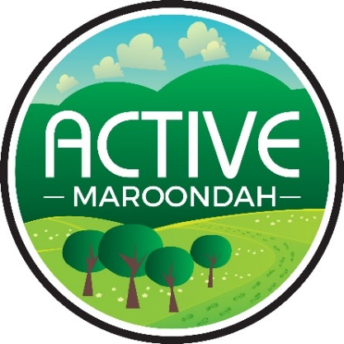
Maroondah Junior Ranger Walks

Yarrunga Reserve

Walking and exploring our local Maroondah environment is good fun, good for our health and easy to do with our family and friends.

Use your Maroondah Ranger skills to spot these species.

Tick each off when you find them.
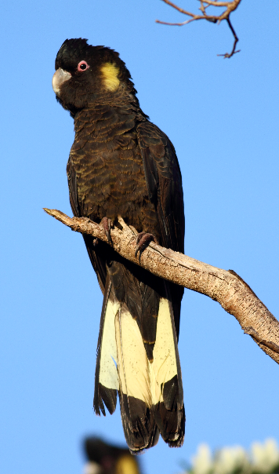  Yellow-tailed Black Cockatoos in the Pine trees | 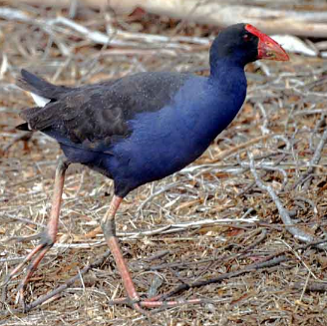  Purple Swap Hen | 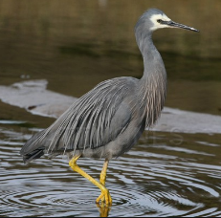  White-faced Heron | 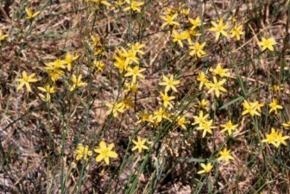  Yellow Rush Lily
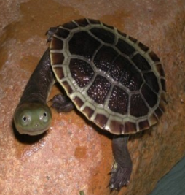  Turtle | 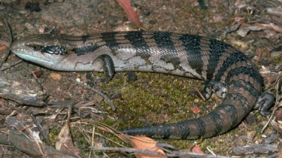  Blue Tongue Lizard | 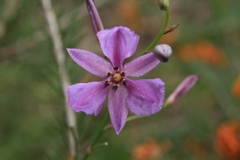  Chocolate Lily

These four tips will help keep you and the park safe:

Check the weather and make sure you have the right clothes and sturdy covered footwear.

Respect animals’ homes by leaving logs, leaf litter, twigs and rocks as you find them.

The best souvenirs of your adventure are your photographs and memories.

And always remember, nature’s treasures all belong in the bush and not in your pocket.

