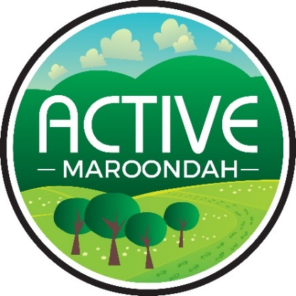
Maroondah Junior Ranger Walks

Wombolano Reserve

Walking and exploring our local Maroondah environment is good fun, good for our health and easy to do with our family and friends.

Use your Maroondah Ranger skills to spot these species.

Tick each off when you find them.

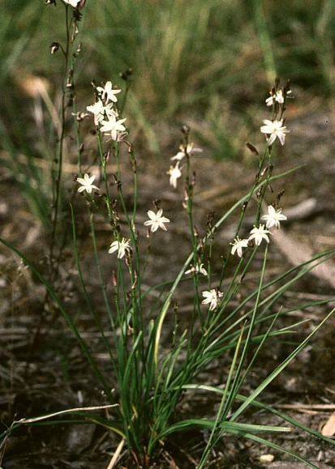  Pale Grass Lily | 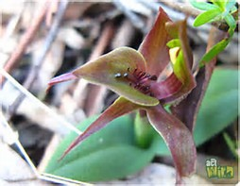  Common Bird Orchard | 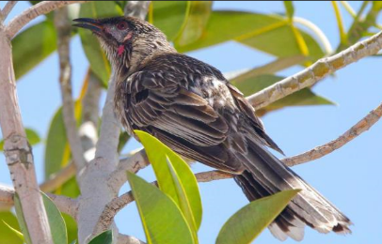  Red Wattlebird | 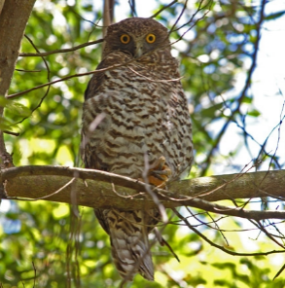  Powerful Owl (has not been spotted for a long time, but you never know!)
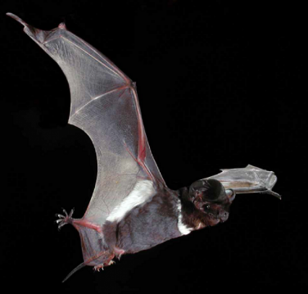  White striped Freetail Bat | 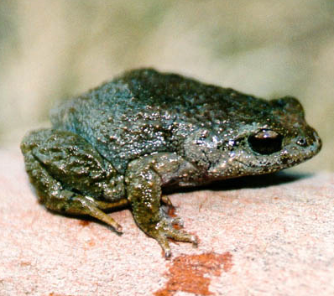  Listen for Victorian Common Froglet

These four tips will help keep you and the park safe:

Check the weather and make sure you have the right clothes and sturdy covered footwear.

Respect animals’ homes by leaving logs, leaf litter, twigs and rocks as you find them.

The best souvenirs of your adventure are your photographs and memories.

And always remember, nature’s treasures all belong in the bush and not in your pocket.

