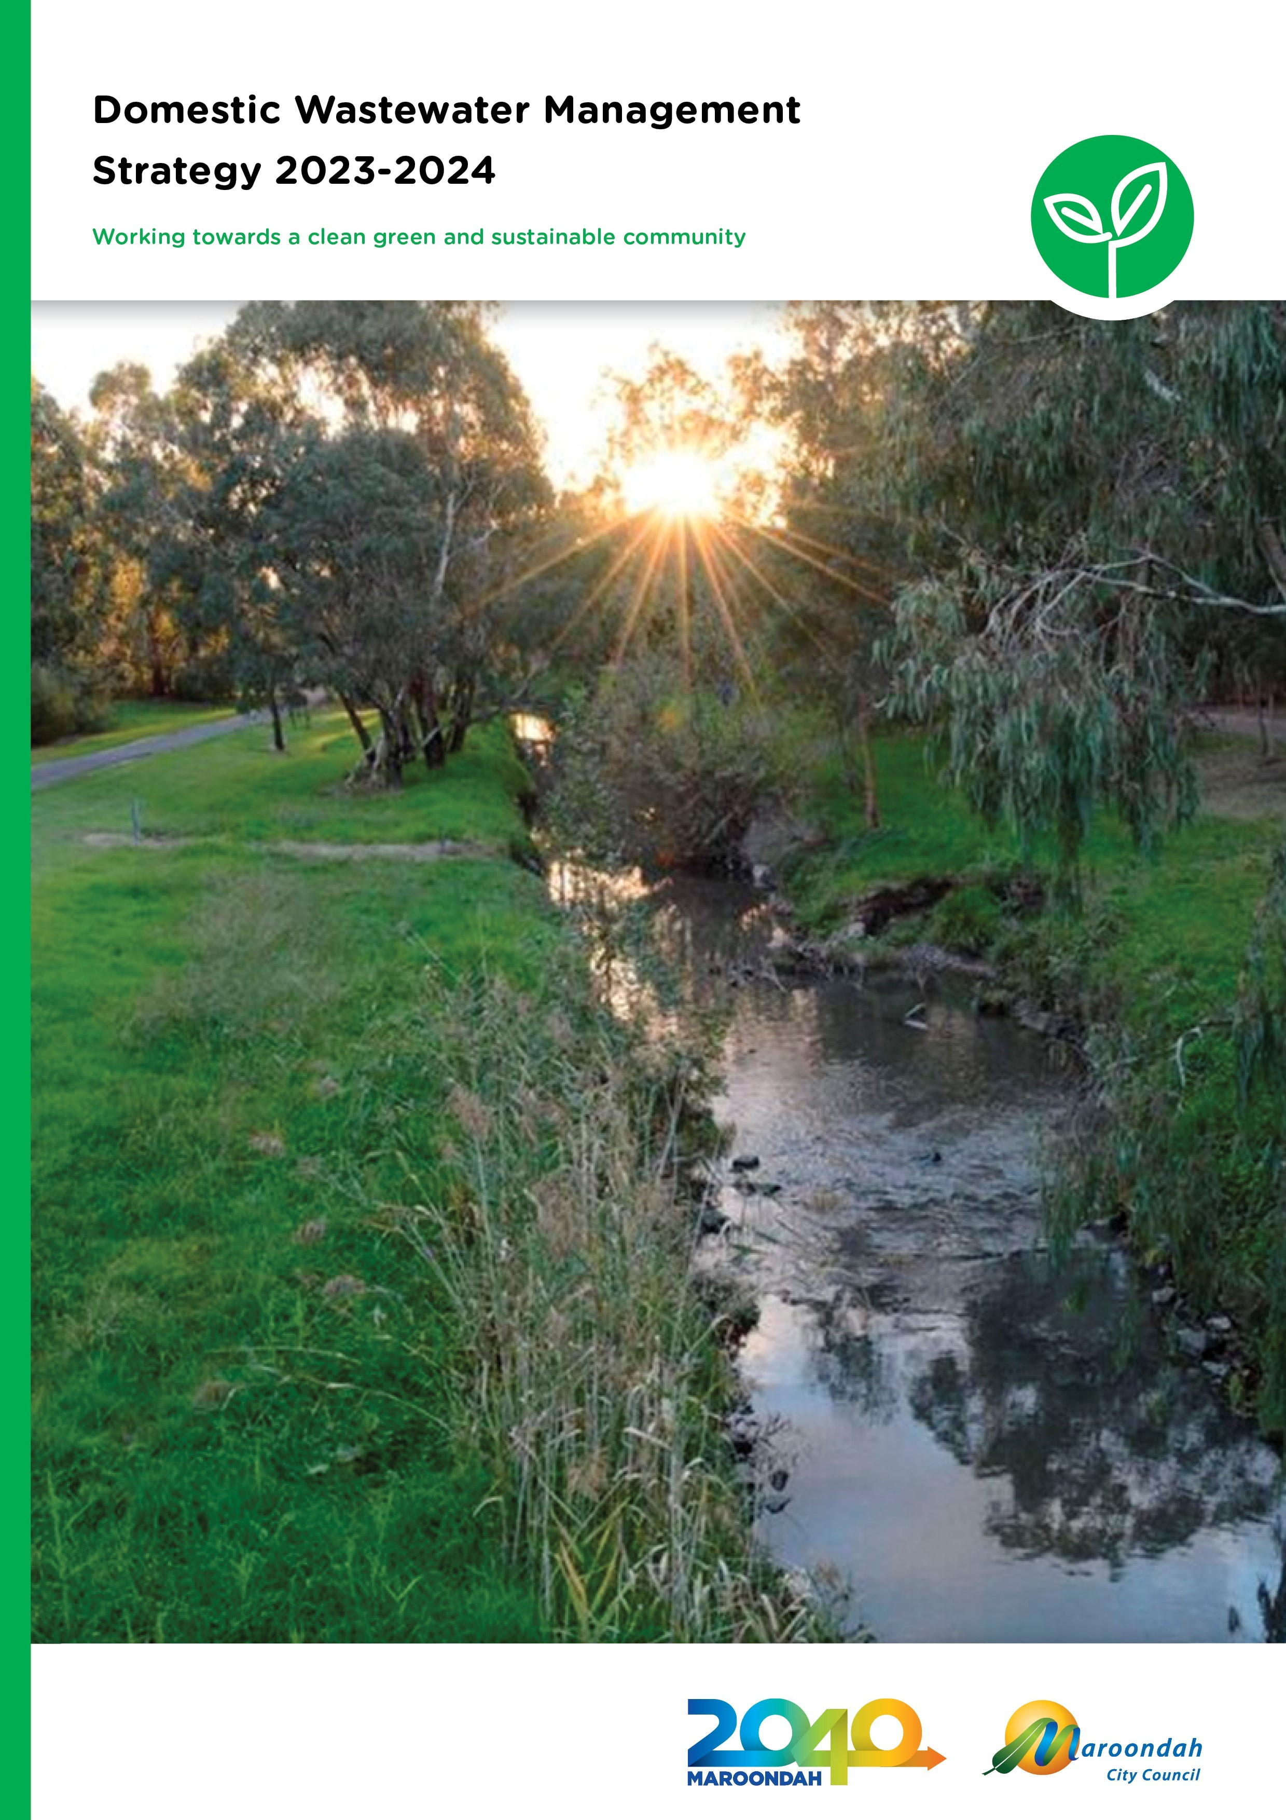

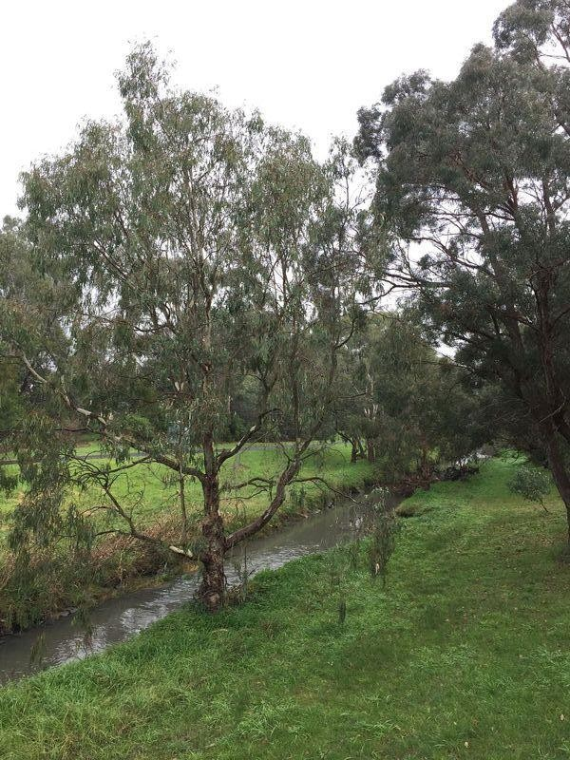

Contents
Contents 3
Introduction 5
Public Health 5
Environmental 5
Economic 5
Transitional arrangements to 2023 6
Background 7
Legislative Context 7
Community Sewerage Program 9
Maroondah in Context 10
Strategic context 11
Maroondah 2040 11
Council Plan 2021 - 2025 11
Maroondah’s Domestic Wastewater Management Profile 13
Risks Associated with Domestic Wastewater for Maroondah 16
Public Health Risks 16
Environmental Health Risks 16
Legal Risks 16
Economic and Amenity Risks 16
Our strategic response 17
Our vision 17
Future outcomes 17
The way forward 18
Outcome 1 - Healthy Environments 18
Key Directions 18
Our journey so far 18
Priority actions 2021-2023 18
Measuring our success 19
Outcome 2 - Collaborative Cultures 20
Key directions 20
Our journey so far 20
Priority actions 2021-2023 21
Measuring our success 21
Outcome 3 - Information Management 22
Key Directions 22
Our journey so far 22
Priority actions 2021-2023 22
Measuring our success 22
Implementing the Strategy 23
References 24

Glossary 25
Appendix One 27

Introduction
‘Wastewater’ is now defined within the Environment Protection Regulations 2021 means ‘waste principally consisting of water and includes sewage or other human-derived wastewater. This means any wastewater from the toilet, bathroom, kitchen or laundry of any premises.

An onsite wastewater management system means an on-site wastewater treatment plant with a design or actual flow rate of sewage not exceeding 5000 litres on any day and includes all beds, sewers, drains, pipes, fittings, appliances and land used in connection with the treatment plant;

An on-site wastewater treatment plant is a treatment plant for the bacterial, biological, chemical or physical treatment of sewage generated on site.

Onsite wastewater management systems can include septic tanks, aerated wastewater treatment systems, composting toilets, sand filters, reed beds and wetlands that treat wastewater produced by households or businesses generating up to 5000 litres of wastewater per day.

Well maintained onsite wastewater management systems provide a viable, often cost-effective and sustainable alternative where reticulated sewer is not available. However, wastewater systems that are poorly operating or inadequate, can pose a serious risk to human health and the environment. Sewage from a septic tank system is considered a ‘priority waste’ under the Act and Regulations. This means it has the potential to pose a higher risk to the environment. More specifically, the risks associated with wastewater include:

Public Health
- People coming into contact with recreational water that has been contaminated by domestic wastewater face significant risk of illness
- Drinking water supplies becoming contaminated with chemicals and bacteria from effluent as a result of poorly drained soils, small lot sizes, high usage, ageing systems and inadequately maintained wastewater systems

Environmental
- Poorly operating wastewater systems contribute high rates of nitrogen and phosphorous to receiving waters due to surface runoff
- Polluted soils, waterways and groundwater with the potential to harm aquatic species
- Malfunctioning wastewater systems create direct bacterial contamination of the environment, with E coli found in catchments near residential areas

Economic
- Trying to alleviate years of environmental contamination is costly and involves overcoming a host of practical issues
- Unsightly discharges and seepage leading to a reduction in property values
- In the event of a contamination incident there is the cost of advising residents and visitors to the area of the risk, managing community anxiety and the indirect costs associated with the perception that the area is unsafe

Transitional arrangements to 2023
Council has a significant role and legislative responsibility for protecting the health of the community and to prevent off-site discharge of domestic wastewater. We want to promote environmental best practice in the management of onsite wastewater management systems in Maroondah.

Previously under the State Environment Protection Policy (SEPP) Waters, local governments were required to prepare a Domestic Wastewater Management Plan (DWMP). These plans strategically describe the situation with respect to the management of wastewater from onsite wastewater management systems within municipalities. The plan outlines the actions that will be taken, both now and in the future, to overcome the current environmental, health and amenity risks that exist. These actions include Local Government’s commitments to address all issues using a risk-based, priority approach.

As of 1 July 2021, the Environment Protection Act 2017 (the Act) and Environment Protection Regulations 2021 (the Regulations) came into force. Many of the requirements and clauses of the SEPP (Waters) will remain in force for up to two years (from 1 July 2021) under the Environment Protection Transitional Regulations 2021, including clause 29 that requires councils to develop a domestic wastewater management plan

The Domestic Wastewater Management Strategy (the Strategy) is Maroondah City Council’s strategic plan to enhance the management of onsite wastewater management systems by not only improving the current situation but by ensuring processes are improved to guarantee environmentally sustainable and best practice decisions are made in the future. This Strategy provides the necessary actions to ensure that existing onsite wastewater management systems and any new installations are installed, maintained and monitored as to protect the health of the community and the surrounding physical environment.

This Strategy continues to have the following purposes:
- To protect public health and the physical environment from the impacts of domestic wastewater;
- To promote environmental sustainability by reducing the impacts of onsite wastewater management systems on the local receiving environments;
- To identify onsite wastewater management system priorities and develop short and long term strategies for the implementation of these priorities; and
- To provide a mechanism for coordinated onsite wastewater management system planning, community education and compliance monitoring by Council and other stakeholders.

Background
Prior to the commencement of Maroondah City Council’s Domestic Wastewater Management Project in 2016, the potential risks of failing wastewater systems had been reactively managed across the Municipality. The legislative framework supported Council moving to a more strategic and proactive management regime as a core focus of Community Health Services at Maroondah City Council.
The DWMP was developed in 2013 and highlighted a number of key issues relating to domestic wastewater management at Maroondah. These included:

- Inconsistencies in relation to domestic wastewater data;
- A need to ensure ongoing strategic alliances with the water authority and ensuring the DWMP aligns with future Sewerage Management Plans developed by the authority;
- Decisions concerning domestic wastewater management at Maroondah are not supported by an over-arching wastewater operational management strategy or decision making framework;
- The need for regional land capability mapping system to assist in the decision making process
regarding individual septic tank installations;
- The number of failing wastewater systems in operation within the municipality is unknown;
- The need for referral processes for developments within unsewered areas within the municipality;
- The need to develop a wastewater community education program to assist in improving the community’s knowledge of the risks associated with the poor maintenance of wastewater systems;
- The need for a greywater reuse policy and an associated community education program to ensure greywater is managed appropriately; and
- The current legislative framework in Victoria is complex and outdated.

To address these issues, an action plan was developed and additional resourcing put in place by Council. A Wastewater Project Officer position commenced in 2016 to support delivery of these actions.

This Domestic Wastewater Strategy 2017-2021 was developed to provide a framework for the continued management of domestic wastewater in Maroondah.

A summary of achievements from this strategy is outlined below in The Way Forward.

Legislative Context
There are a number of key pieces of legislation, policies and guidelines that assist Council and other stakeholders in ensuring best practice management of domestic wastewater. These include:
  - Environment Protection Act 2017
  - Environment Protection Regulations 2021
  - Environment Protection Transitional Regulations 2021
  - Public Health and Wellbeing Act 2008
  - Local Government Act 2020
  - Planning and Environment Act 1987
  - Water Act 1989
  - State Environment Protection Policy (Waters) 2018 (until July 2023)
  - Code of Practice Onsite Wastewater Management (EPA 891.4, 2016)
  - Victorian Land Capability Assessment Framework (MAV)
  - AS/NZS 1546.1: 2008, On-site domestic wastewater treatment units, Part 1: Septic tanks

  - AS/NZS 1546.2: 2008, On-site domestic wastewater treatment units, Part 2: Waterless composting toilets
  - AS 1546.3:2017, On-site domestic wastewater treatment units, Part 3: Secondary treatment systems
  - AS 1546.4:2016 On-site domestic wastewater treatment units, Part 4: Domestic greywater treatment systems
Specifically, the Environment Protection Act 2017 and the Environment Protection Regulations 2021 are the primary legislation that regulates and controls domestic wastewater management. The Environment Protection Authority (EPA) has the overall responsibility for legislation, policy and standards for wastewater management systems. All domestic onsite wastewater management systems need to be issued with a Certificate of Conformance by an accredited conformity assessment body under an Australian Standard, before they are permitted to be installed in Victoria.

The EPA is responsible for any wastewater treatment system that discharges capacities of 5,000 litres or more of wastewater daily. Generally, these are commercial and industrial applications.
Domestic wastewater management in Victoria is one of the environmental health responsibilities delegated to local government, where the Council acts as the permitting authority and approves the installation of wastewater systems and now will regulate appropriate maintenance and use of the systems.

Under the Environment Protection Act 2017 and Environmental Protection Regulations 2021, local government is the primary agency responsible for the management of domestic wastewater, including systems that have a capacity to treat less than 5,000 litres. Under this Act, a property owner cannot construct, alter or install a wastewater system without a permit from Council.

Councils use permits to regulate the installation and alteration of wastewater systems within their municipal boundaries. Councils are also responsible for identifying failing wastewater systems that are causing environmental, public health and amenity risks and ensuring owners and operators of onsite wastewater management systems are meeting their obligations under the Regulations and the Act.

The cornerstone of the Act includes a General Environmental Duty which states that: A person who is engaged in an activity that may give rise to risk of harm to human health or the environment from pollution or waste must minimise those risks, so far as reasonably practicable.

Under delegation from the Environment Protection Authority, Council can now consider management of onsite wastewater management systems that give rise to risk of harm to human health or the environment.

The Regulations also place obligations on owners and operators of onsite wastewater management systems to ensure they are:

    - Maintaining the system in good working order
    - Ensuring those operating the system have the information they need to maintain and operate it effectively and;
    - Responding to any failures

Council has a duty to exercise its enforcement powers where it knows there is a breach of legislation and there is the likelihood of impact to public health and the environment.

The Environment Protection Transitional Regulations 2021 retains clause 29 of the SEPP (Waters) for the next two years and states that Councils, where relevant, need to develop domestic wastewater management plans that set out how unsuitable sites should be assessed and managed.

Section 30 of the SEPP Waters is also retained in the Environment Protection Transitional Regulations 2021 outlining the responsibility of water authorities to implement sewerage management plans in coordination with Council’s prioritised high-risk properties.

Community Sewerage Program

Yarra Valley Water (YVW) provides reticulated sewerage services to properties located within the Maroondah. If reticulated sewerage is identified in a domestic wastewater management plan as the preferred option for improved domestic wastewater management, water authorities, in conjunction with the EPA and Councils, and in consultation with the local community, need to develop and submit to Government a sewerage management plan.

YVW have set a Community Sewerage Program which has an aim to provide sewerage to identified areas in all municipalities within their catchment. Within their current plan (2018/19 – 2022/23) which was undertaken in July 2016, YVW have prioritised properties within Maroondah to be connected to sewer between 2029 to 2032. YVW are currently reviewing their prioritisation program.

Appendix 1 provides a series of maps which identify properties in Maroondah that are included in the Yarra Valley Water Community Sewerage Program.

Maroondah in Context
The City of Maroondah is located within the eastern suburbs of Melbourne and covers an area of approximately 61.4 square kilometres. The area is a substantially developed peri-urban residential municipality, with an estimated population of 119,401 residents and 41,632 households with an average of 2.57 people per household.
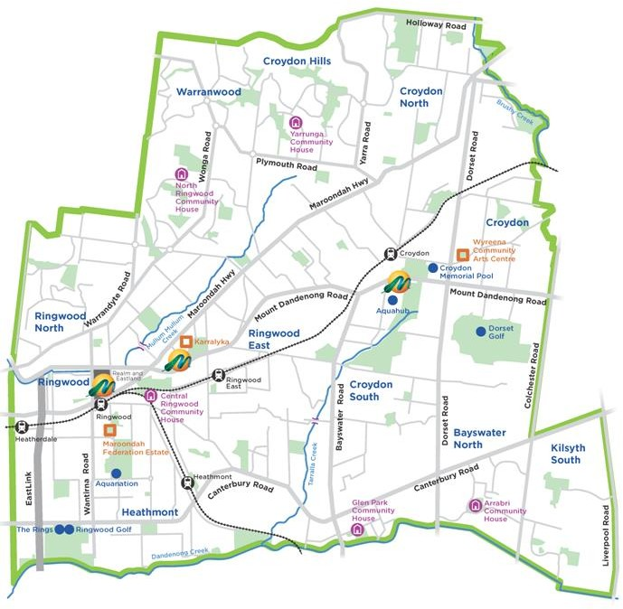
Map of Maroondah

Maroondah is well known for its leafy streets, broad areas of open space, bushland reserves, parks and playgrounds. Sustainable transport links include on-road cycling paths and shared path links to the Mullum Mullum Creek Trail, the EastLink Trail, Tarralla Creek Trail and the Dandenong Creek Trail.

Maroondah’s natural environment is highly valued and our green character is treasured by locals. There is a strong desire for our green open spaces and bushland reserves to be enhanced and protected.

Mullum Mullum Creek and Dandenong Creek are the major waterways in the Maroondah area, with established recreational routes that are well utilised. The waterways within Maroondah also drain to two of Melbourne Water’s main catchments - Dandenong Creek and Yarra River which are enjoyed by a broader community and therefore need to be carefully managed.

Strategic context

Maroondah 2040
The Maroondah 2040 Community Vision captures the aspirations, desires, dreams, and priorities of the community looking ahead to the year 2040 and beyond. This long-term vision provides a ‘roadmap’ for the community, Council and other levels of government to partner together and create a future that enhances Maroondah as a great place to live, work, play and visit.

The following Maroondah 2040 outcome areas align this Domestic Wastewater Management Strategy with Maroondah’s future direction.

A safe, healthy and active community - Maroondah is a safe, healthy and active community with local opportunities provided for people of all ages and abilities to have high levels of social, emotional and physical wellbeing.

A clean, green and sustainable community - Maroondah is a green leafy community with high levels of waste diversion and sustainable approaches to infrastructure development, urban design and management of natural resources. Our community is resilient and has the knowledge, capacity and resources to make sustainable lifestyle choices.

A well governed and empowered community - Maroondah is an empowered community that is actively engaged in Council decision making through processes that consider the needs and aspirations of all ages and population groups. Council provides strong and responsive leadership, ensures transparency, while working with the community to advocate for and ‘champion’ local needs.

Council Plan 2021 - 2025
The Council Plan 2021- 2025 is Maroondah City Council’s key medium-term strategic plan that sets out key directions and priority actions to achieve the long-term community vision outlined in Maroondah 2040. This Domestic Wastewater Management Strategy is strongly linked with the following three Council Plan key directions:

A safe, healthy and active community
1.6 Promote the health and wellbeing of the community through accessible and affordable initiatives and services that respond to community needs

A clean, green and sustainable community
4.3 Work in partnership to ensure the long-term protection and renaturalisation of Maroondah’s creeks and wetlands to improve water quality; streamflow; habitat connectivity and function; and adjacent surroundings

A well governed and empowered community
8.2 Ensure responsible and sustainable management of Maroondah’s resources, assets, infrastructure and natural environment

In addition, there are a wide range of other strategic documents that contribute to the delivery of outcomes and key directions within Maroondah 2040: Our future together and the Council Plan. The figure below shows the relationship between the Domestic Wastewater Management Strategy and many of the other strategic documents adopted by Council.

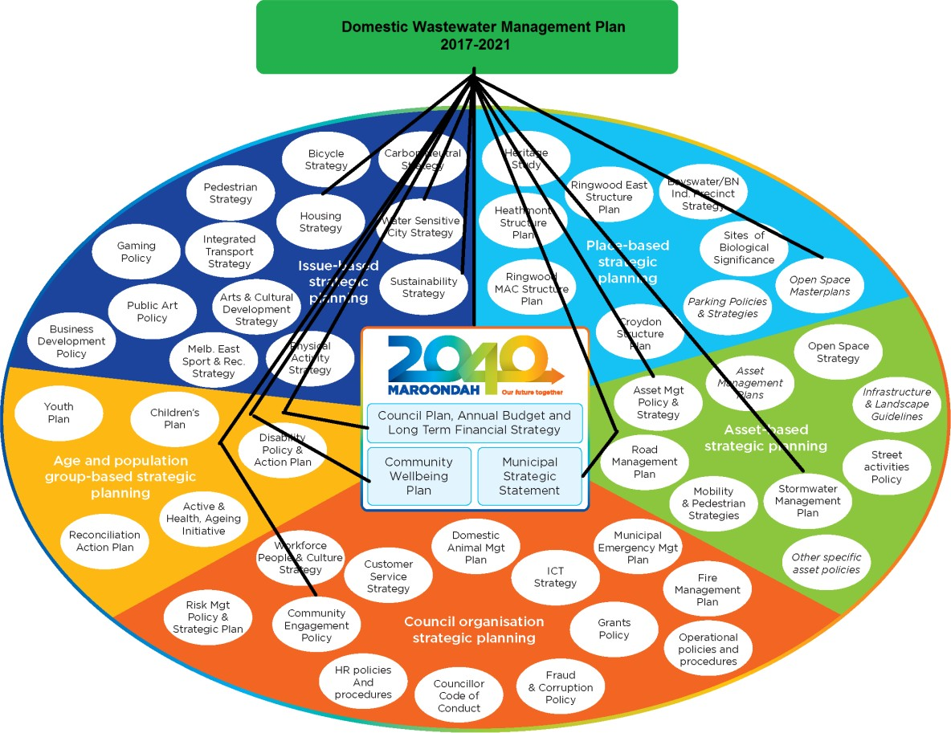

Maroondah’s Domestic Wastewater Management Profile
Research for the DWMP (2013) initially estimated there to be 437 wastewater systems servicing properties throughout Maroondah.

After cross referencing data provided by YVW with Council records and undertaking inspections of properties, it was determined that there are 158 domestic wastewater management systems within the municipality. Figure 1 provides an overview of the pocket areas of wastewater systems in Maroondah.
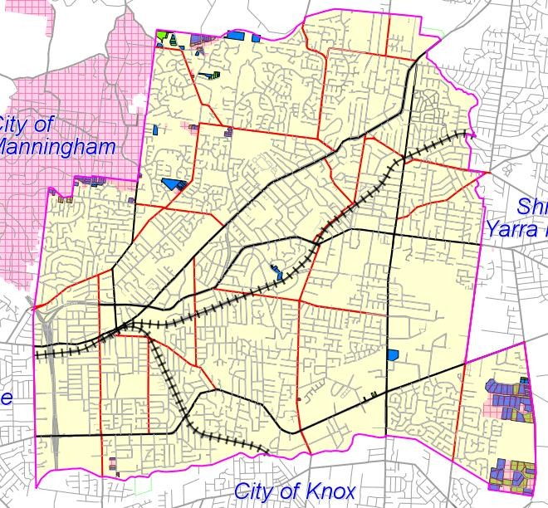

Figure 1: Overview of wastewater systems located throughout Maroondah

There are also approximately 20 vacant properties in these areas that do not have an available connection point to sewer. Owners of these properties must fund the connection point. Table 1 provides a breakdown of the number of properties with wastewater systems for each suburb in Maroondah and the number of properties on the community sewerage program.

Table 1: Number of wastewater systems per suburb in Maroondah
Suburb | Unsewered allotments | Community Sewerage Program | Discharging to stormwater
Bayswater North | 8 | 3 | 2
Croydon | 6 | 0
Croydon Hills | 1 | 0
Heathmont | 6 | 6
Kilsyth South | 60 | 51 | 5
Park Orchards | 5 | 5 | 5
Ringwood | 4 | 4
Ringwood North | 34 | 24 | 5
Warranwood | 34 | 16 | 4
Total | 158 | 109 | 21

These systems include septic tanks, aerated wastewater treatment systems (AWTS), sand filters, greywater treatment systems and worm farms disposing to underground trenches, subsurface irrigation and discharging to stormwater (figure 2). Of the 158 properties serviced by a wastewater system, Council has no records for 63 properties. This could be due to installation prior to Council’s record keeping or due to amalgamations*. There is no sewer currently available for these properties.
*Note: this is consistent with the findings of the Victorian Auditor General (2006) report.

Council records indicate that 49 properties that utilise onsite wastewater management systems are not identified in YVW’s Community Sewerage Program.
Wastewater System Type
120
100
80
60
40
20
0
AWTS
Septic Tank Wormfarm Greywater Pump Out Total Primary Total
No Permit
Treatment Secondary
Treatment
System Type
No. Installed

Figure 2: Wastewater system types servicing properties within Maroondah

From original inspections carried out by Council’s Wastewater Project Officer, while it was determined that 86% of the systems are operating satisfactorily within their permit conditions (Figure 3), some systems were still not compliant with current standards.

Systems were assessed against their permit conditions and in the absence of records, systems were assessed in accordance the EPA guidelines. The systems considered to be operating unsatisfactorily were found to be discharging wastewater to stormwater, not being serviced by a contractor and wastewater discharging to the surface.
Inspection Findings

14%

86%

Unsatisfactory Satisfactory

Figure 3: Inspection results - Wastewater systems operating satisfactorily vs unsatisfactorily

Figure 4 shows the percentage of properties discharging wastewater to the stormwater system. These properties were granted consent to carry out this activity under their Permit issued by Council. This method of disposing wastewater is no longer permitted in Victoria. Current legislation makes it very difficult for Council to impose an upgrade to the system.
Discharge to Stormwater vs Disposal Onsite

13%

87%

Discharge offsite Onsite Disposal

Figure 4: Percentage of properties permitted to discharge wastewater offsite to stormwater.

Risks associated with Domestic Wastewater for Maroondah
From the 1950s, wastewater systems were used and continue to be used extensively throughout Victoria in areas not serviced by reticulated sewerage. Wastewater systems are an acceptable solution to treat domestic wastewater provided the wastewater is contained and disposed of effectively onsite.

In the past, wastewater systems were a key contributor to the increasing pollution of Melbourne’s rivers and creeks that threatened the health of Port Phillip Bay. Wastewater from onsite wastewater management systems, seeps into stormwater drains, waterways and groundwater whilst also polluting soils and increasing the risks to public health, environmental health and creating detrimental effects to the local amenity.

Maroondah City Council has a responsibility in ensuring the risks associated with domestic wastewater are appropriately managed. From the workings undertaken as part of the domestic wastewater management project, the risks identified for Maroondah include:

Public Health Risks
Domestic wastewater poses a potential public health risk such as:
- Human diseases such as gastroenteritis, caused from contaminated water bodies; and
- Increased capacity of mosquito breeding as a result of pooling, stagnant wastewater resulting in a vector of disease.

Environmental Health Risks
Domestic wastewater poses a potential risk to the natural environment:
- Contamination of groundwater by nitrates and faecal pathogens;
- Seepage can raise the groundwater table causing salinity;
- Domestic wastewater discharge into water catchments stimulates algal growth and land degradation;
- Domestic wastewater carries suspended solids, ammonia and organic matter, which can affect fish, aquatic plants and micro-organisms; and
- Domestic wastewater can be carried into other water bodies and cause further pollution.

Legal Risks
Under the Environment Protection Act 2017 and the Environment Protection Regulations 2021, local government is the primary agency responsible for the management of onsite wastewater management systems. In addition to the approval of the installation of wastewater systems within the municipality, Maroondah City Council is also responsible for identifying failing wastewater systems that are causing environmental, public health and amenity risks.

The 2006 Auditor General’s report Protecting Our Environment and Community from Failing Septic Tanks, found that most local governments have not allocated adequate resources to effectively carry out their legislative responsibilities for domestic wastewater management.

Council is bound to implement the Environment Protection legislation and ensure owners and occupiers of onsite wastewater management systems are meeting their responsibilities to maintain the system in good working order, ensuring those operating the system have the information they need and respond appropriately to any failures.

Economic and Amenity Risks
The impacts of failing wastewater systems and the associated risks to public health and the health of our natural environment are easy to obtain in comparison to the long term effects on the local economy and local amenity. Domestic wastewater can affect the local economy and amenity of Maroondah in the following ways:
- Poor septic tank management decreases land amenity and economic value;

- Contaminated water bodies can negatively impact on aquaculture and agriculture using recreational water bodies;
- Possibility of increased maintenance to stormwater drains which receive wastewater due to poor system maintenance.

Our strategic response

Our vision
The vision of this Domestic Wastewater Management Strategy is to:

“Protect public health, the natural environment and the amenity of the municipality by promoting environmental best practice in the management of domestic wastewater”

Future outcomes
To achieve this vision, we will work towards three key outcomes in order to promote environmental best practice in the management of domestic wastewater. These outcomes have been developed through extensive research of industry best practice, from the work carried out throughout the wastewater project, and legislative requirements. The key outcome areas align with the Water Sensitive City Strategy (2016). They are:
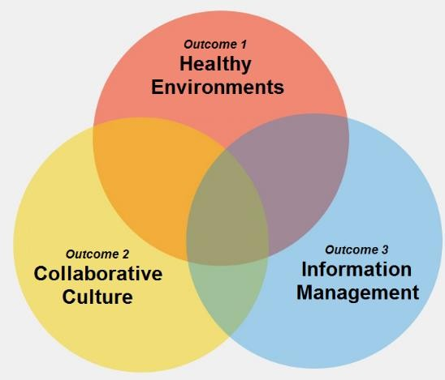

The way forward

Outcome 1 - Healthy Environments
Appropriate and effective wastewater management aids in protecting public health and the environment. Domestic wastewater poses a potential public health and environmental risk.

Key Directions

Work in partnership to reduce wastewater pollution and encourage healthy waterways
Prior to 1997, wastewater systems in Victoria were permitted to discharge to stormwater. There are now legislative mechanisms that enable Council to enforce property owners to ensure wastewater does not enter the stormwater system from these previously approved systems, however a policy around implementation of this legislation still needs to be developed. For water quality to improve, the quantity of wastewater permitted to discharge into stormwater systems must be reduced.
Preventing and minimising failing systems is also required to protect our waterways.

Proactively educate and build community awareness of environmental health issues Education and awareness is an important mechanism to support homeowners in maintaining their systems appropriately in order to minimise the potential public health and environmental risk.
Enhanced monitoring of properties with wastewater management systems in accordance with relevant legislation and current standards is required by Council Environmental Health Officers.

Our journey so far

A domestic wastewater monitoring and compliance program was due to commence in late 2020 and has now been planned to commence at the start of 2022. This program has been postponed due to the Covid19 pandemic.

Properties that have been identified in the Yarra Valley Water Community Sewerage Program with 10-15 properties connected to sewer over the last 4 years. Council is again working with Yarra Valley Water to reprioritise connection to sewer particularly for system discharging wastewater offsite and in commercial/industrial areas.

All aerated wastewater treatment system maintenance reports provided to Council by wastewater servicing agents are being reviewed and actioned as required.

As part of the permit process, owners have been requested to connect to sewer when it becomes available.

Information through Council’s media outlets including website and social media has been provided to the community with information on managing their wastewater systems.

Priority actions 2021-2023
  - Establish a domestic wastewater monitoring and compliance program within the unsewered areas of Maroondah focusing on properties that are to be considered to be high risk, in line with the new legislative framework.
  - Increase the number of properties connected to sewer by encouraging property owners to connect when it becomes available.
  - Review all aerated wastewater treatment system maintenance reports provided to Council by wastewater servicing agents and action as required
  - Investigation of other funding opportunities for programs to improve domestic wastewater management in the Municipality.
  - Provide information through Council’s media outlets including website and social media to provide the community with information on managing their wastewater systems.

Measuring our success
  - An increase in the number of properties connected to sewer that are currently serviced by a wastewater management system
  - Maintenance reports from servicing agents are reviewed and actioned as appropriate.
  - Education material is distributed to properties with onsite wastewater systems in accordance with the communication strategy and to provide information on new legislative requirements.

Outcome 2 - Collaborative Cultures
Encourage community participation and partnerships with key stakeholders for greater involvement in wastewater issues.

Key directions

Work in partnership to ensure integrated planning for sewerage connection services
Yarra Valley Water’s Community Sewerage Program aims to eliminate environmental, public health and amenity risks caused by failing wastewater systems. It is critically important that both YVW and Maroondah City Council continue to work together to ensure that this Strategy and future Sewerage Management Plans are aligned. This will provide sewerage connection in areas of environmental or public health concern.

Facilitate a collaborative approach to the management of domestic wastewater
The successful management of domestic wastewater is not the responsibility of one agency. An integrated approach to approving new developments, managing complex issues relating to wastewater complaints and advocating for legislative change is integral.

Build engaged and responsible communities in the effective maintenance of wastewater systems
Ensuring owners are aware of their responsibilities in maintaining their wastewater system and how this can be achieved is a key strategy in minimising health risks and possible financial implications of poorly functioning systems. There are numerous educational publications and materials available to use.

Advocate for the consistent application of the new legislative across Local Governments and to ensure it meets future wastewater management requirements.
The Environment Protection Act 1970 has undergone substantial amendments to form the Environment Protection Act 2017, the Environment Protection Regulations 2021 and the Onsite Wastewater Management Toolkit guidance for Local Government, in consultation with relevant stakeholders including Council to provide an effective legislation and guidance to assist with the installation, alteration and maintenance of all onsite wastewater management systems. Council will continue to work with the EPA and Yarra Valley Water to ensure the legislation remains relevant and is applied consistently across Local Government.

Our journey so far

Work on the Community Sewerage Program reprioritisation has continued in 2021 with YVW to advocate for all properties, based on risk and being serviced by an onsite wastewater system to be included in the Community Sewerage Program.

Over the last two years Council officers have participated in stakeholder discussions to inform the Environment Protection legislative framework pertaining to the management of onsite wastewater management systems.

Relationships between Community Health, Planning and Building have been strengthened, including automated referral systems and regular team information sessions to ensure all new developments and alterations to existing properties that are serviced by an onsite wastewater management system, are managed appropriately.

The development of a communication strategy is in progress to ensure key wastewater messages including sustainable re-use of greywater; are received by the community on an ongoing basis.

The development of information on Maroondah’s website on onsite wastewater management system maintenance and the new Environment Protection legislation is increasing the community’s understanding of the importance of managing wastewater systems appropriately.

Priority actions 2021-2023
  - Continue to work with YVW and advocate for all properties serviced by a wastewater system to be included in the Community Sewerage Program.
  - Continue partnerships with other Councils and peak associations including Environmental Health Professionals Australia to advocate to the State Government to accelerate the community sewerage program..
  - Provide technical expertise and strengthen the relationship between Community Health, Planning and Building to ensure all new developments and alterations to existing properties that are serviced by a wastewater management system, are managed appropriately.
  - Provide support and guidance to plumbers, installers, servicing agents and consultants to improve standards in the industry and outline Council expectations.
  - Develop a communication strategy to ensure key wastewater messages including sustainable re-use of greywater; are received by the community on an ongoing basis.
  - Increase the community’s understanding of the importance of managing wastewater systems appropriately

Measuring our success
  - A wastewater portfolio established and seen as a key priority area for Environmental Health
  - All new developments and alterations to existing properties that are serviced by a wastewater management system, are provided with information to help property owners meet legislative requirements
  - All properties within Maroondah that cannot contain wastewater onsite are included on the Community Sewerage Program

Outcome 3 - Information Management

Key Directions

Ensure the accuracy of information relating to wastewater systems in Maroondah
Without complete and accurate information about wastewater systems, it is not possible to fully understand the magnitude of environmental, public health and amenity risks or the likely emerging risks. A sustainable strategy to treat the risks and the likely cost of doing so would also not be possible.

By having complete and accurate information we are able to share this with other stakeholders including YVW, and internal departments to better plan for sewer and sustainable development.

Apply a continuous improvement approach to domestic wastewater management
Clear and precise policies and procedures for the management of onsite wastewater management systems is important to assist in consistent and transparent decision making to support the Environmental Health Officers in undertaking their statutory responsibilities under the Environment Protection Act 2017 and Environment Protection Regulations 2021.

Our journey so far
Continued maintenance of an information management system is ensuring all information relating to a wastewater system is stored appropriately.

Continuing the development of policies and procedures to underpin consistency in our processes relating to onsite wastewater management systems and the new legislative framework.

YVW information on sewered properties is being updated on an annual basis and integrated into Council’s GIS system

A review of Council’s Domestic Wastewater Management Strategy has been conducted annually to monitor progress.

Priority actions 2021-2023
  - Maintain the information management system to ensure all information relating to a wastewater system is stored appropriately
  - Ensure property information from YVW is updated on an annual basis and integrated into Council’s GIS system
  - Review Council’s wastewater strategy on an annual basis and update as necessary
  - Ensure policies and procedures in relation to wastewater are updated annually
  - Develop a risk-based policy to support the implementation of the Environment Protection Act’s general environmental duty and management of onsite wastewater management systems previously approved to discharge wastewater to the stormwater system.

Measuring our success
  - Monitoring and compliance programs are developed based on accurate data and information contained in the information management system
  - Implementation of policies and procedures inline with the new legislative framework see improvements in the containment and management of wastewater onsite.

Implementing the Strategy
The Domestic Wastewater Management Strategy forms part of Council’s response to delivering on Maroondah 2040: Our future together. It will be implemented with an integrated whole-of-Council approach to promoting environmental best practice in domestic wastewater management

The Strategy outlines priority actions to be undertaken to work toward three outcome areas which support the overall vision for domestic wastewater management in Maroondah. Additional priority actions and projects that support this vision and adapt to the changing needs of the Maroondah community may be identified and resourced over the period of the Strategy.

Some measures of success have been identified in this Domestic Wastewater Management Strategy to monitor progress. Over time, these measures will be used to identify how successful Council and its partners have been in working towards the preferred outcomes and key directions outlined in this Strategy. These indicators are not intended to form a definitive list, rather they will be helpful in revealing progress over time.

An update on progress towards delivery of the Domestic Wastewater Management Strategy will be reported to the Director Development and Amenity on an annual basis. This report will incorporate an update on progress towards the priority actions and the measures of success identified in the Strategy. A full review of the Domestic Wastewater Management Strategy will be undertaken in 2022/23 following the outcomes of EPA’s legislative reform program.

References
Victorian Auditor General, 2006, Protecting our environment and community from failing septic tanks, Victoria
Environment Protection Act 2017. Environment Protection Regulations 2021
Environment Protection (Transitional) Regulations 2021
Environment Protection Authority, May 2021, Regulating onsite wastewater management systems: local government toolkit

Environment Protection Authority, 2016, Code of Practice – Onsite Domestic Wastewater Management (EPA Publication 891.4)

Environment Protection Authority, 2018, State Environment Protection Policy (Waters ) 2018. Maroondah City Council, 2021, Council Plan 2021 - 2025.
Maroondah City Council, 2016, Water Sensitive City Strategy. Maroondah City Council, 2021, Maroondah 2040 – Our Future Together Yarra Valley Water, 2012, Water Plan 2013/14 to 2017/18.

Glossary
Aerated Wastewater Treatment Systems Aerated wastewater treatment systems treat all household wastewater and have several treatment compartments. They comprise of a septic tank, aeration chamber, settling chamber and chlorination tank. They are a secondary treatment system.
Blackwater Wastewater from toilets containing faeces and urine.
Community Sewerage Program A legislative requirement under the SEPP (WoV) that requires Water Authorities to implement a Sewerage Management plan that reviews available wastewater management options, costs, funding and timelines for provision of services. The program is to identify how the wastewater collected will be sustainably managed in accordance with the waste hierarchy and reviewed every five years.
Domestic Wastewater Wastewater arising from a domestic dwelling. Domestic wastewater can comprise of blackwater or greywater (from bathrooms, laundry and kitchen) or a combination of both.
Domestic Wastewater Management Plan A planning and management document to minimise the impact of domestic wastewater on public health and the local environment using a risk management approach.
Onsite Wastewater Management System or Wastewater Management System A system for the bacterial, biological, chemical or physical treatment of sewage includes all tanks, beds, sewers, drains, pipes, fittings, appliances and land used in connection with the system.
Disposal Area An area of land specifically designated for the disposal of wastewater.
Effluent Wastewater discharging from a wastewater management system.
Environmental Health Officer An individual who has the qualifications and/or experience necessary to be appointed as an Environmental Health Officer (EHO) and be authorised to undertake responsibilities of relevant Acts such as the Environment Protection Act 2017 and Environmental Health Regulations 2021.
Environment Protection Authority The Victorian Environment Protection Authority administers the Environment Protection Act 2017 and Environment Protection Regulation 2021 and is responsible for producing guidance for onsite wastewater management, including the Code of Practice and other documents, and issuing Certificates of Conformity for particular onsite wastewater treatment systems.
Greywater Domestic wastewater from sources other than the toilet, urinal or bidet (showers, baths, hand basins, laundry, dishwashers and kitchen sinks). Greywater may still contain pathogens, nutrients and potentially harmful chemicals. Also known as sullage.
Sand Filter A secondary treatment method.
Septic Tank A conventional septic tank that temporarily holds wastewater. The septic tank provides primary treatment of wastewater.
Sewage Any waste containing human excreta or domestic wastewater (Environment Protection Act 2017).
Sewer Pipe used to transfer sewage from one location to another.
Sewerage The infrastructure used to carry, treat and dispose of sewage.
State Environment Protection Policy (Waters) A policy which provided a legal framework for State and Local Government agencies, businesses and communities to work together to protect and rehabilitate Victoria’s surface water environments. The SEPP (WoV) set out the provisions for managing domestic wastewater in Victoria. From 1 July 2021 this SEPP is no longer have a formal legal role as majority of requirements are now managed under the Environment Protection Act 2017, Environmental Protection Regulations 2021 and EPA Environmental reference standards. Some sections of this SEPP were saved and placed into the Environmental Protection Transitional Regulations 2021 which will remain in force for up to two years. This includes:

Section 29: Councils to develop a domestic wastewater management plan.
For further information please see: https://www.epa.vic.gov.au/about-epa/publications/1994
Subsurface Irrigation The disposal of wastewater through a series of pressure-compensating pipes and emitters at a depth of 100 mm to 150 mm below ground surface level.
Trenches A disposal area which uses the principle of absorption where wastewater is distributed via underground trenches.
Waterway River, creek, stream, watercourses, natural channel in which water regularly flows, lake, lagoon, swamp, marsh or dam.
Yarra Valley Water Local Water Authority

Appendix One
Properties in Maroondah currently included in the Yarra Valley Water Community Sewerage Program. The Community Sewerage Program areas are currently under review. To check updated maps, please contact the Community Health team at Maroondah@maroondah.vic.gov.au.
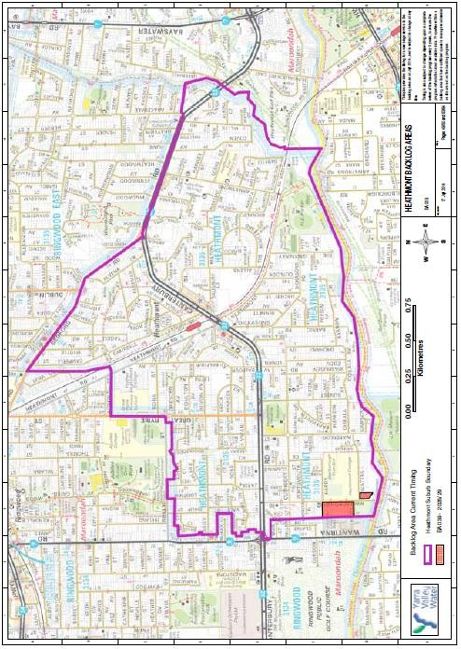

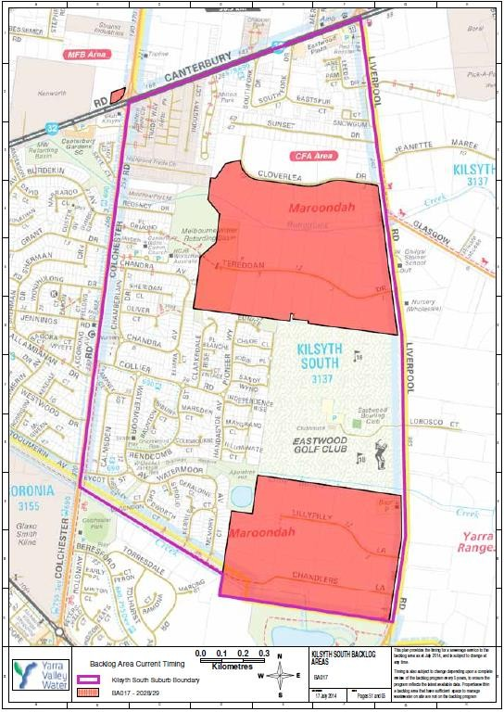
DOMESTIC WASTEWATER MANAGEMENT STRATEGY |28

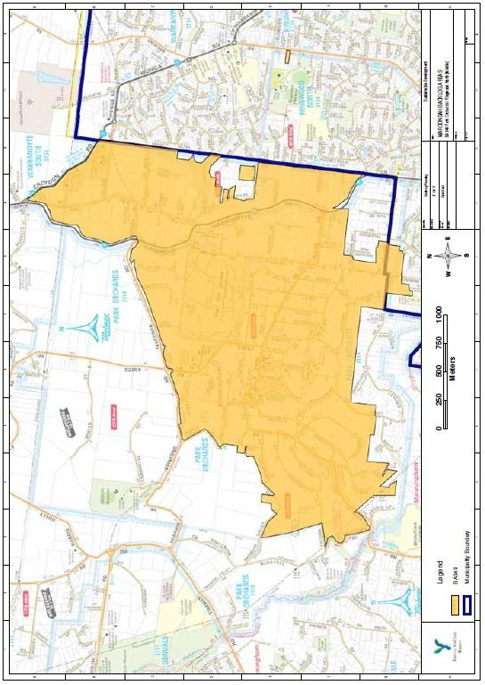

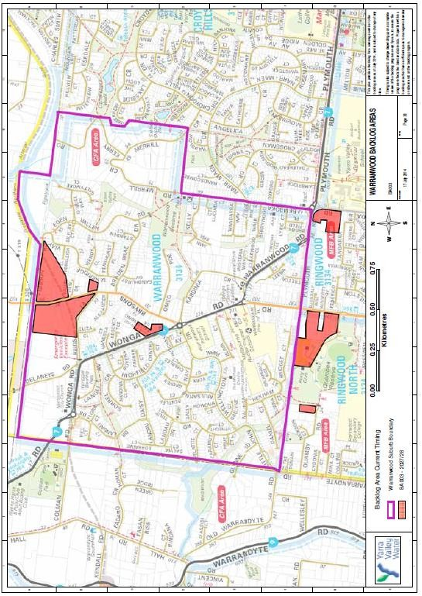

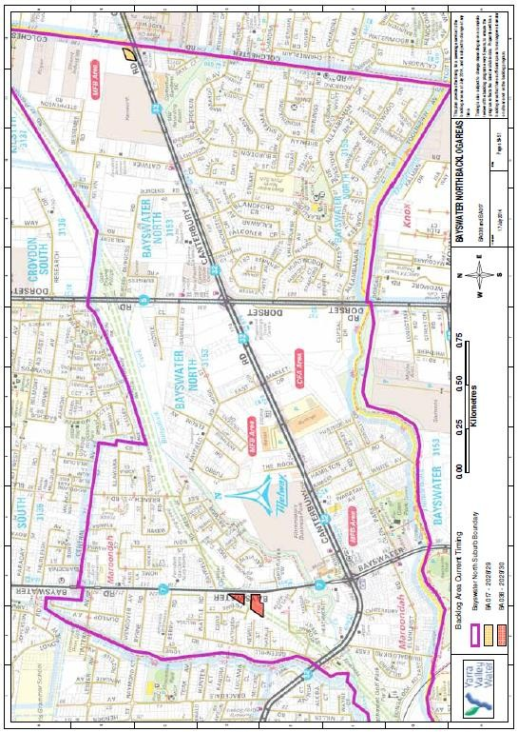

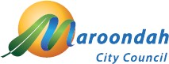

To contact Council telephone 1300 88 22 33 visit our website at: www.maroondah.vic.gov.au or call in to one of our service centres:

Realm Service Centre Maroondah Highway Ringwood

Croydon Service Centre Civic Square
Croydon

Translating and Interpreter Service 13 14 50

National Relay Service (NRS) 13 36 77

www.facebook.com/MaroondahCityCouncil
@CityofMaroondah
www.youtube.com/CityofMaroondah

maroondah@maroondah.vic.gov.au www.maroondah.vic.gov.au

