20 Braeside Avenue, Ringwood East

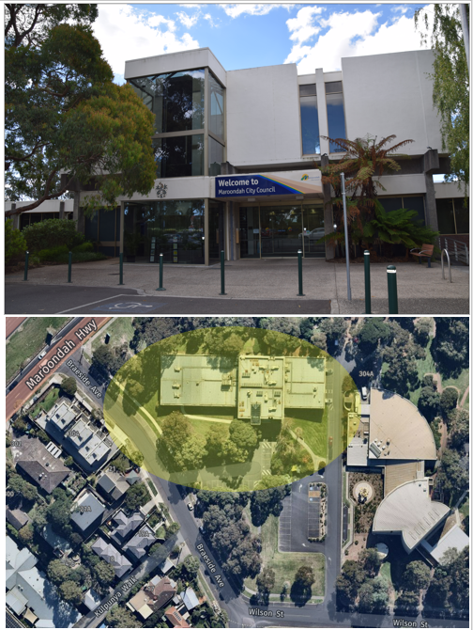
Background
Maroondah City Council is seeking expressions of interest (EOI) from suitable potential tenants to explore whether there may be interest in occupying a portion of 20 Braeside Avenue, Ringwood East (previous Civic Centre Offices) under the terms of a commercial lease agreement.
Council will consider proposals from individual organisations or multiple proponents that wish to collaborate on a joint proposal.

The space available for lease is located on the Ground floor and First floor, whilst the Lower Ground floor level will be utilised for Civic purposes in conjunction with the neighbouring property, the Karralyka Centre. The office space is nestled in greenery and residential landscape, in close proximity to Eastland Shopping Centre, Ringwood Train Station and the Maroondah Hospital.

The premises itself is approximately 1,900m2 and comprises an open office shell space, that can easily be fitted out by the tenant to their liking. The office space comprises of ample storage space, amenities including a considerable amount of parking spaces that can be included as part of the lease arrangement for exclusive parking use during business hours as well as appealing outdoor spaces. A floorplan of the overall site is provided below for ease of reference.

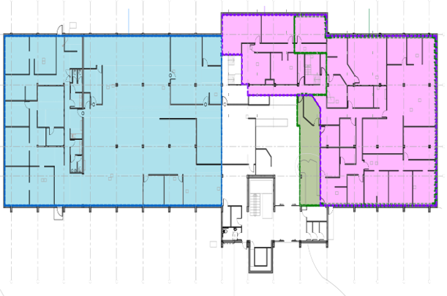
The successful commercial tenant will be utilising a building that is rich with municipal history and situated in the heart of both commercial and community significance.

Site visits will be facilitated upon request and interested proponents are encouraged to
contact the Maroondah City Council Property Team to arrange a suitable time.

Council will assess expressions of interest in line with the criteria set out in this document and may choose to engage with multiple proponents if a mix of aligned concepts/uses are proposed.

It is noted this process intends to seek expressions of interest only, and Council may choose not to lease the premises.

For enquiries regarding this EOI please contact Helen Young, Property Advisor via email at property@maroondah.vic.gov.au or phone 9294 5521

Proposals must be submitted electronically via email to property@maroondah.vic.gov.au no later than Friday 30th June 2023.

Key information
Council approval
The selected applicant and subsequent Lease is subject to Council approval.
Council reserves the right to amend, make additions to, include or delete any conditions included within the Lease taken to Council for approval. Council reserves the right not to accept an Applicant or Lease taken to Council for approval.

Lease term and commencement date
Maroondah will offer a lease term to the successful proponent/s based on the concept agreed upon, and with consideration given to the merit and specific requirements of the successful proposal.
The Lease commencement date will commence on the delivery of the property to the Lessee, after any fit-out works are completed by the lessee. This is currently estimated to be on or around 4 December 2023 but may be subject to change.
The Lease commencement date will also be dependent on any additional approvals that will be required, such as, development approvals, building works, and other statutory approvals as applicable.
Occupancy may not occur in the premises until the Lessee has finalised all fit out works and obtained all relevant approvals.

Proposed rent, rent reviews and KPIs
Rent proposals will be considered as part of the assessment and in line with the proposed use. Should the successful proposal be of a commercial nature, commercial rent payable would be expected to align with market rent.
Rent reviews will be annual on the anniversary of the Lease commencement date, based on the Consumer Price Index.
Market rent reviews will be conducted periodically during the lease term. Market reviews will not include any Lessee improvements/fit out.

Outgoings
The Lessee will be required to undertake all required connections to Electricity, Gas and Telecommunications providers. On demand charges may include (as/if applicable) but not be limited to;
- Cleaning
- Pest control
- General maintenance
- Air conditioning servicing and maintenance
- RCD testing
- Tagging and testing
- Security – alarms and locks
- Signage
- Lift servicing and maintenance
- Water rates
- Water usage
- Backflow testing
- Grease trap cleaning
- Council Rates
- Emergency Service Levy
- Land Tax

The Lessor, at their discretion, may undertake scheduled maintenance requirements for the property and recover the costs from the Lessee.
The Council Rates and Emergency Service Levy will be calculated on the final leased or licensed area and a Gross Rental Valuation provided by Landgate at the completion of the development.
Land Tax is charged directly by the State Revenue Office (SRO). This will be determined by the SRO once the property is developed and the lease is finalised.

GST
The Lessee will be required to pay goods and services taxes on all taxable supplies made under the Lease agreement, including the supply of the premises.

Bank guarantee
The approved Applicant will be required to provide a Bank Guarantee equivalent to twelve (12) months’ gross rental (inclusive of GST).

Guarantors and financial statements
The approved Applicant will be required to provide a guarantee and indemnity form from each of the Directors and principal shareholders. If the Applicant is a trust, then the adult beneficiaries of the trust may need to provide guarantees and indemnities.
Accordingly, current balance sheets, profit and loss statements for the Applicant and signed and dated statements of Assets and Liabilities will be required from each of the Guarantors. The Applicant must ensure that the information provided is true and accurate and that all of the assets are owned noted on the statements are owned only by the Applicant and Guarantors.

Lessor right to veto sub lease
If the accepted Applicant includes a proposal to sub lease, a clause of this nature will be included in the Lease. The Lessor reserves the right to veto, on any grounds, a proposed sub lessee.

Lease assignments
The Lessee will have the right to assign the lease subject to the approval of the Lessor. The Lessor reserves the right to veto, on any grounds, a proposed assignee. Council will
consider Lessee applications to utilise the premises and/or surroundings for Lessee benefit including events or activations, on a case-by-case basis.

Fit out by Lessee
The approved Applicant will be required to complete fit out within 90 days from the commencement of the Lease or as otherwise agreed upon between all parties.

Condition precedent clause
If the accepted Submission is subject to other approvals, including development approval, a condition precedent will be considered in the Lease.

Approvals
The Applicant will be responsible for all costs associated with due diligence, infrastructure, planning approval, and statutory compliance such as consultation and connection to necessary services.

Disclaimer
The contents of this EOI are believed to be accurate and complete as of the date of issue of this EOI. The statements, opinions, projections, forecasts or other information contained in this EOI are subject to change.

Canvassing
If an Applicant, whether personally or by an agent, canvasses any of the Lessor’s Elected Councillors, Officers, Contractors or their Representatives (as the case may be) then regardless of such canvassing having any influence on the acceptance a submission, the Applicants submission will be omitted from consideration.

Marketing
On the execution of a formal Lease by both parties, the Lessor will seek the successful applicant(s)’ acknowledgement that the Lessor can use the applicant(s)’ trading name in press releases or advertising/promotional materials.

Additional documents
Applicants may include and attach to the EOI Form; additional documentation they feel supports their submission.

Approval process
Strict timelines will be applied as part of the Council approval of a Lease. These may be as follows but will be dependent on the selected applicant.

EOI applications
Assessment process – undertaken by panel | Four weeks
Selected Applicant and Lease terms taken to Council for approval | Most appropriate Council meeting
Selected Applicant to submit DA for approval (if applicable) | 90 days from Council approval of Lease
Lease finalised | 30 days from the delivery of all conditions as required by Council.

Selection criteria and submitting proposals
Proposals must be submitted electronically via email to property@maroondah.vic.gov.au no later than Friday 30th June 2023

Submissions will be assessed on the basis of the following selection criteria. Applicants must address the criteria in their submissions.

Council Criteria | 50%
Business Sustainability | 20%
Financial | 30%

Council criteria - Overview of Business (Weighting 50%)

Mandatory - the business or organisation must:
    - Commercial proponent - Pay market rent.
    - Pay outgoings as/if required
    - Establish how they will deliver or undertake fitout and over what timeframe
    - Establish the intent of the business that will be based at the property and how it may fit the overall residential and entertainment aspect of the site
    - Propose what the business will bring to the municipality by being based at the property and within the Maroondah Municipality
    - Provide insight into the business’ operating hours and clientele

Business Sustainability (Weighting 20%)
Please provide recent copy of audited financial statements for the last two financial periods, as well as a current year projected financial position to allow this section of the weighting to be considered.
Additional documents can be provided to support the submission if necessary.

Financial (Weighting 30%)
Please note that full completion of this section is required in order to meet the selection criteria.
- Proposed Rent per annum exclusive of GST
- Outline any proposed incentive requests if applicable.

EOI form - 20 Braeside Avenue Ringwood East

PROPOSED LESSEE/S:

Company Name:

Name of Director:

Address:

Contact Details:

Business Phone:

After Hours Phone:

Mobile Phone:

Email Address:

Name of Director:

Address:

Contact Details:

Business Phone:

After Hours Phone:

Mobile Phone:

Email Address:

GUARANTORS:

Please provide details of any guarantors.

SELECTION CRITERIA

Provide a submission that covers all the Selection Criteria as outlined in the EOI document and attach to this form.

Full Name of Respondent:
Trading Name:
ABN:
Registered Office Address:
Place of Business Address:
Respondent Contact Name:
Respondent Job Title:
Telephone Number:
Mobile Number:
Email Address:

I (or We) make the following statement of all my (or our) assets and liabilities at the above date and give other material information and agree to notify you promptly of any material change therein.

PRIVACY DISCLOSURE STATEMENT

Below is the Maroondah City Council’s Privacy Disclosure Statement. It is important that you read the statement.

“Maroondah City Council is committed to protecting your privacy as prescribed by the Privacy and Data Protection Act 2014 and the Health Records Act 2001. The information you provide on this form is being collected by Maroondah City Council for the strict purpose of conducting Council business. Your information will not be disclosed to any external party without your consent, unless Council is required to do so by law or it is part of the Council business that is being undertaken. Failure to provide the information requested may make you ineligible to receive the service or be part of an event/function that is the subject of this form. Any access to the information, amendments that may be required or any privacy enquiries may be directed to Council’s Privacy Officer and Health Records Officer on 1300 88 22 33 or email - privacy@maroondah.vic.gov.au

SIGNED:

DATED:

