

**Municipality of Maroondah**

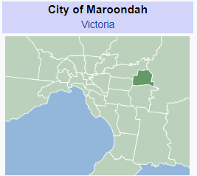

**Municipal Emergency Management Plan**

**2023-2026**

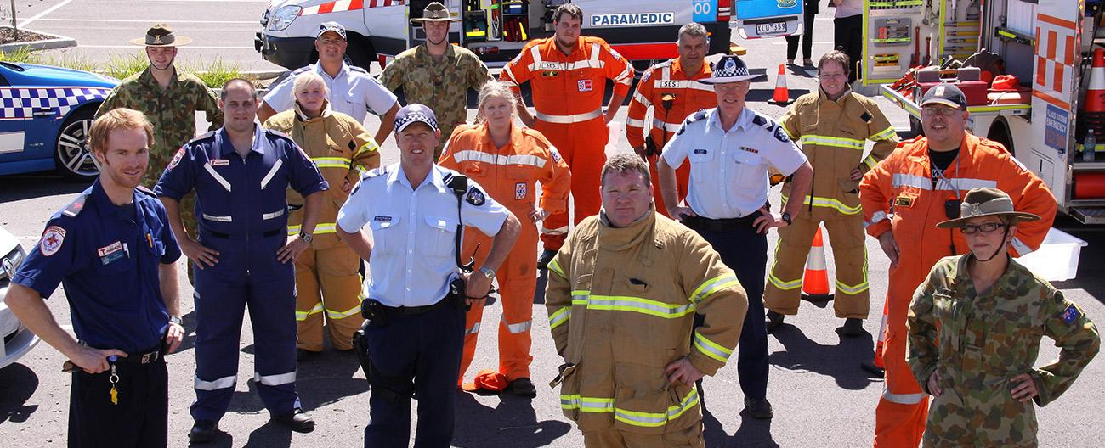

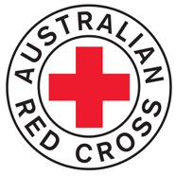



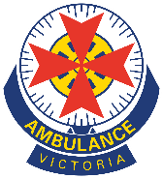

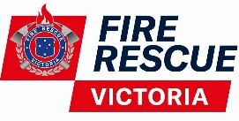





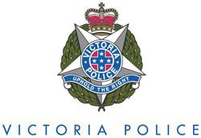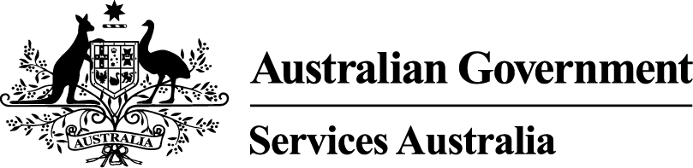

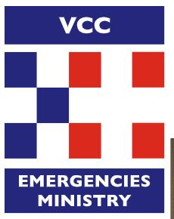



**TABLE OF CONTENTS**

1 Introduction 4

1.1 Acknowledgement of Country 4

1.2 Authority, Governance and Administration 4

1.3 Plan Assurance and Approval 4

1.3.1 Assurance 4

1.3.2 Approval 4

1.4 Plan Review 4

1.5 Planning Context 5

1.6 Plan Aim and Objectives 5

2 Municipal District Location and Characteristics 6

2.1 Municipal Location Map 6

2.2 Topography 6

2.3 Demography 6

2.4 Vulnerable Persons (Community Organisations and Facilities) 7

2.4.1 Vulnerable Persons Register (VPR) 8

2.4.2 Facilities Housing Vulnerable People Listing 8

2.5 History of Emergencies 9

3 Municipal Planning Arrangements 11

3.1 Victoria’s Emergency Management Planning Framework 11

3.2 The MEMPC, Sub-Committees and Working Groups 12

3.2.1 MEMPC responsibilities 12

3.2.2 Special Sub Committees and Working Groups 13

3.3 Sub-Plans and Complementary Plans 14

3.3.1 Sub-Plans 14

3.3.2 Complementary Plans 14

3.4 Plan Exercising 15

4 Mitigation Arrangements 16

4.1 Introduction 16

4.2 Hazard, Exposure, Vulnerability and Resilience 16

4.2.1 Hazard 16

4.2.2 Exposure 16

4.2.3 Vulnerability 16

4.2.4 Resilience 17

4.3 Risk Assessment Process and Results 18

4.3.1 Victorian Fire Risk Register (VFRR) 20

4.3.2 Victorian Emergency Risk Management System (VERMS) 20

4.4 Treatment Plans 21

4.5 Monitoring and review 21

5 Response 22

5.1 Introduction 22

5.1.1 Definitions of Emergencies 23

5.2 Control, Command, Coordination, Consequences, Communication and Community Connection 24

5.3 Local Response Arrangements and Responsible Agencies 26

5.3.1 Level 1 – Small Scale Incidents 26

5.3.2 Level 2 – Medium scale incidents 27

5.3.3 Level 3 – Large scale incidents 27

5.3.4 Emergency Response - Control Agencies 27

5.4 Emergency Response Coordination Roles 29

5.5 Control, Coordination and Operations Centres and Areas 30

5.5.1 Incident and Regional Control Centres 30

5.5.2 Municipal Emergency Coordination Centre(s) (MECC) 30

5.5.3 Crisisworks 30

5.5.4 Emergency Management Common Operating Picture (EM-COP) 31

5.5.5 Operations Centres/Staging Areas/Marshalling Points 31

5.6 Financial Considerations 31

5.6.1 Donations 32

[5.7 Neighbourhood Safer Places (NSP) Bushfire Places of Last Resort (BPLR)  
 and Community Fire Refuges (CFR) 32](#_Toc108079963)

5.8 Planning for Cross Boundary Events 32

5.8.1 Regional Emergency Management Planning Committee (REMPC) 32

5.8.2 Eastern Metropolitan Councils Emergency Management Partnership (EMCEMP) 32

5.9 Resource Sharing Protocols 33

5.9.1 EMCEMP 33

[5.9.2 Municipal Association of Victoria (MAV) Protocol for Inter-Council Emergency Resource   
Sharing 33](#_Toc108079969)

5.10 Response Escalation 34

5.11 All Agencies Debriefing Arrangements 34

5.12 Transition to Recovery 34

5.12.1 Handover of Resources 36

6 Relief and Recovery Arrangements 37

6.1 Introduction 37

6.2 Principles and Scope of Relief 38

6.3 Principles and Scope of Recovery 39

6.4 Impact Assessments and Consequence Management 39

6.5 Management Structure 40

6.5.1 Relief Management Structure 40

6.5.2 Recovery Management Structure 40

6.6 Government Assistance Measures 41

6.7 After Action Review 41

7 Roles and Responsibilities 42

7.1 Agency Roles and Responsibilities 42

7.2 Community and Business Organisation Roles and Responsibilities 43

8 Appendices 44

Appendix A - Acronyms 44

Appendix B - Document Distribution List 46

Appendix C - Restricted Information 47

Appendix D – Sub-Plans and Complementary Plans 48

Appendix E – References 49

Appendix F - MEMP and Sub-Plan Exercise Record 51

Appendix G - Amendment History 52

Appendix H – Authorisation 53

# Introduction

## Acknowledgement of Country

The Municipal Emergency Management Planning Committee (**MEMPC**) acknowledges the Traditional Custodians of the land now known as the City of Maroondah, where Indigenous Australians have performed age old ceremonies. We acknowledge and respect their unique ability to care for Country and their deep spiritual connection to it. The committee also acknowledges and pays respect to the Elders, past and present and is committed to working with Aboriginal and Torres Strait Islander communities to achieve a shared vision of safer and more resilient communities.

## Authority, Governance and Administration

In 2018, the [Emergency Management Legislation Amendment Act 2018](https://content.legislation.vic.gov.au/sites/default/files/f4ec2736-7fc9-3001-a9ef-cf71ef72f5c7_18-036a.docx) amended the [Emergency Management Act 2013](https://content.legislation.vic.gov.au/sites/default/files/2020-12/13-73a019.docx) to provide for new integrated arrangements for emergency management planning in Victoria at the State, regional and municipal levels; and create an obligation for an MEMPC to be established in each of the municipal districts of Victoria, including the alpine resorts which, for the purposes of the act, are taken to be a municipal district. Each MEMPC is a multi-agency collaboration group whose members bring organisation, industry or personal expertise to the task of emergency management planning for the municipal district.

This Municipal Emergency Management Plan (**MEMP**) has been prepared in accordance with and complies with the requirements of the Emergency Management Act 2013 including having regard to the guidelines issued under s77, [Guidelines for Preparing State, Regional and Municipal Emergency Management Plans](https://www.emv.vic.gov.au/how-we-help/emergency-management-planning/planning-guidelines). Refer to Appendix E for a full list of reference material used in formulating this MEMP.

This Plan makes reference to a number of organisations and people by acronym. For a full list of acronyms used in this plan, please refer to Appendix A.

## Plan Assurance and Approval

### Assurance

A [Statement of Assurance](https://files.emv.vic.gov.au/2021-05/Fact%20Sheet%206_EMPR%20New%20assurance%20model%20March%202020.pdf) (including a checklist and certificate) has been prepared and submitted by the MEMPC pursuant to the Eastern Metropolitan Regional Emergency Management Planning Committee (**EMR-REMPC**) [Emergency Management Act 2013](https://content.legislation.vic.gov.au/sites/default/files/2020-12/13-73a019.docx) (s60AG) and [[Emergency Management Legislation Amendment Act 2018](https://content.legislation.vic.gov.au/sites/default/files/f4ec2736-7fc9-3001-a9ef-cf71ef72f5c7_18-036a.docx)](https://content.legislation.vic.gov.au/sites/default/files/f4ec2736-7fc9-3001-a9ef-cf71ef72f5c7_18-036a.docx).

### Approval

This Plan has been prepared by the Municipal Emergency Management Planning Committee (MEMPC) and is approved by the Eastern Metropolitan Region Regional Emergency Management Planning Committee (EMR-REMPC). Refer Appendix H.

The MEMP is to be published on the Emergency Management Victoria website and Maroondah City Council website and also available on Emergency Management - Common Operating Picture (**EM-COP**) and Crisisworks. The MEMP will be deposited with State Library Victoria under section 49 of the [Libraries Act 1988](https://www.legislation.vic.gov.au/in-force/acts/libraries-act-1988/053).

## Plan Review

Reviews of the MEMP will be conducted to ensure it remains current, effective, integrated, coordinated and comprehensive in its approach to emergency management. The plan will be reviewed:

* At least every three years in line with the statutory MEMP self-assurance process.
* Following ‘After Action Reviews’ if a significant emergency or incident occurs.
* After an emergency management exercise where the exercise identifies an opportunity for improvement.
* A change in relevant legislation or developments or changes in the relief and recovery sector.
* Organisational change.
* Changes to previously identified hazards.
* Changes to MEMPC membership.

Amendments to the municipal information and re-issuing this MEMP is the responsibility of the MEMPC Chair after the endorsement of the MEMPC.

Urgent reviews and updates to this MEMP are permitted outside regular plan reviews if there is significant risk that life or property will be endangered if the plan is not updated (Emergency Management Act 2013 s60AM) and come into effect when published on the Maroondah Council website and remain in force for a maximum period of three months. Any major review may be undertaken by a Working Group consisting of members of the MEMPC.

Refer to Appendix B for a full plan distribution list and Appendix C for a list of restricted information which is excised for versions of this plan for various audiences.

After each major update to the MEMP or associated Sub-Plans, the MEMPC will determine whether to undertake the MEMP assurance process and resubmit a statement of assurance to the REMPC:

[https://www.emv.vic.gov.au/publications/statement-of-assurance-template-memp-or-memp-Sub-Plan](https://www.emv.vic.gov.au/publications/statement-of-assurance-template-memp-or-memp-sub-plan)

This Plan will be reviewed and updated, if necessary, not later than March 2026.

This Plan is current at the time of publication and remains in effect until modified, superseded or withdrawn. Please refer to this MEMP’s amendment history located at Appendix G.

## Planning Context

This Plan, prepared by the MEMPC, reflects the shared responsibilities of government, emergency management agencies and communities for the actions they will take to prepare for, respond to, provide relief for and recovery from emergencies.

It is important for enhancing resilience that community, emergency services and relief and recovery agencies work together. This Plan is the overarching document for the integrated management of emergencies in the municipal area. It is supported by a range of hazard plans as determined by a risk identification process and a number of response-based plans to ensure smooth coordination of service delivery in emergencies.

This Plan is supported by a variety of information, including:

* Management arrangements that contain general information about emergency planning, response and recovery arrangements; and roles and responsibilities of people and organisations involved in emergency management.
* Sub-Plans, including hazard specific Sub-Plans and Standard Operating Procedures which are to be used during actual emergency events and are designed to be used as stand-alone operational documents.
* Appendices that contain ancillary information including a contact directory that lists contact details for all persons and organisations that have a role in this plan, administration details and a list of municipal resources.

## Plan Aim and Objectives

The aim of this MEMP is to outline the agreed multi-agency and community arrangements for the prevention of, the response to, relief for and the recovery from emergencies that could occur in the municipality as identified in Emergency Management Act 2013 Part 6A.

The broad objectives of this MEMP are to:

* Implement measures to prevent or reduce the causes and/or effects of emergencies.
* Manage arrangements for requesting and using municipal resources in response to emergencies.
* Manage the process for resource supplementation when resources within the municipal are exhausted.
* Assist the affected communities to recover following an emergency.
* Compliment other Local, Regional and State planning arrangements.

# Municipal District Location and Characteristics

## Municipal Location Map

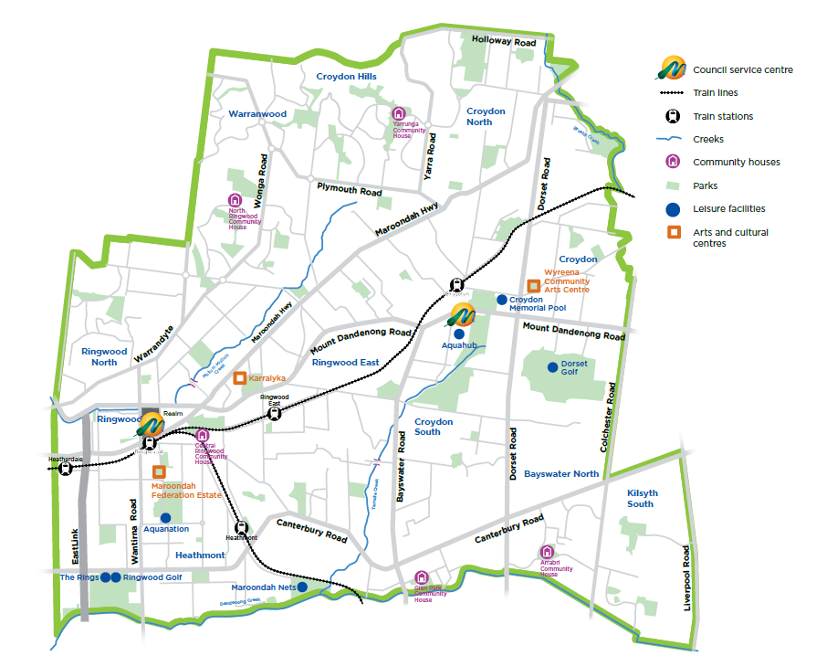

***Figure 1 - Municipal Location Diagram***

## Topography

The City of Maroondah is a predominantly residential area, with some commercial, industrial and semi-rural areas and substantial parklands. Maroondah has the strategic advantage of being located at the north-eastern junction of the Eastern Freeway-East Link corridor. There are two train lines and a large number of bus routes linking the City to other regions. The City of Maroondah covers a land area of 61.4 square kilometres in Melbourne’s outer east, 25 kilometres from Melbourne CBD. There are three main waterways that flow through Maroondah - Brushy Creek along the northeastern boundary, Mullum Mullum Creek in the west and Dandenong Creek along the southern boundary.

The City of Maroondah hosts a regional health precinct including a major public hospital and a large private hospital, educational facilities that cater from early childhood learning to tertiary level, two libraries, arts and cultural centres, an art gallery and a range of community centres. Maroondah is also home to a range of world-class sporting facilities including Aquanation, a regional recreation and leisure facility incorporating the State Diving Centre.

Further information can be found on [Maroondah’s website](http://www.maroondah.vic.gov.au/) or [Profile ID](https://profile.id.com.au/maroondah).

* 1. **Demography**

The City of Maroondah Estimated Resident Population for 2022 is 115,645 with a population density of 1,884 persons per square km.

***Maroondah is home to:***

* Median age is 39 years old
* 0.6% (734) of our residents are Aboriginal or Torres Strait Islander
* 47,021 households
* 9,569 business
* 31 neighbourhood centres, community and local shopping centres

***We provide...***

* 1 metropolitan activity centre
* 1 major activity centre
* 133 public playgrounds
* 3 skate parks
* 3 aquatic centres
* 2 golf courses
* 2 indoor stadiums
* 3 arts and cultural centres
* 2 libraries
* 52 sporting ovals

***We maintain...***

* 572 parks and reserves
* 486.6 kms of local roads
* 792 kms of stormwater drainage pipes
* 39 kms of shared trails
* 91,416 street trees
* 44 bushland reserves
* 644 kms of footpaths

**Culturally and Linguistically Diverse (CALD) communities.**

Maroondah has a culturally diverse population with 25% of people born overseas. There are 21.5% of our residents that speak a language at home other than English.

* 4.4% born in United Kingdom
* 3.7% born in China
* 2.2% born in India
* 1.6% born in Myanmar
* 1.2% born in Malaysia

Further demographic information can be found on [Councils website](http://www.maroondah.vic.gov.au/Explore/About-our-city/Population-profiles-and-resources), or [Profile ID](http://profile.id.com.au/maroondah)

## Vulnerable Persons (Community Organisations and Facilities)

Planning for needs of vulnerable people and undertaking appropriate activities before, during and after an emergency at a municipal level begins with:

* The identification of vulnerability factors.
* The location of vulnerable people and communities.
* Building relationships with local, community-based service providers working with key groups on a day-to-day basis.

Vulnerability factors may include:

* Age (children, youth, older people with or without family of social support)
* Disability
* Lack of familiarity with an area or environment (e.g. tourists and seasonal workers)
* Language, culture, settlement
* Health (physical and mental)
* Social issues (family violence, financial stress, homelessness, poor quality housing)
* Isolation and disconnectedness

For more information, please refer to the Department of Families, Fairness and Housing (**DFFH**) [Vulnerable People in Emergencies Policy.](https://providers.dffh.vic.gov.au/vulnerable-people-emergencies-policy)

### Vulnerable Persons Register (VPR)

The VPR is a list of the most vulnerable people who meet all the following VPR criteria:

* Frail, and/or physically or cognitively impaired
* Unable to comprehend warnings and directions and/or respond in an emergency situation
* Cannot identify personal or community support networks to help them in an emergency

This register is only required to be maintained by municipalities wholly or partly in a CFA district. The register is managed by DFFH and hosted in Council’s emergency incident management system, Crisisworks. Clients are added or removed from the register based on an assessment by an agency funded to provide practical support and care to a client.

The agency will assess clients based on the defined criteria and added to the register if eligible. The register is designed to list only the most extremely vulnerable residents. Council acts as the VPR coordinator and manages agency VPR users, not vulnerable people.

During an emergency, Victoria Police have access to the VPR and can use it in planning for evacuation. Each person is advised before being placed on the register and that there is no guarantee they will be evacuated during an emergency.

### Facilities Housing Vulnerable People Listing

Facilities housing vulnerable persons refers to:

* Buildings where vulnerable people are likely to be situated, including aged care facilities, hospitals, schools, disability group homes and childcare centres.
* Facilities funded or regulated by DFFH and Department of Education (DoE)
* Commonwealth funded residential aged care facilities.
* Other locally identified facilities likely to have vulnerable people situated in them.
* For more information refer to the [DFFH Vulnerable People in Emergencies Policy](https://providers.dffh.vic.gov.au/sites/default/files/2019-11/vulnerable-people-emergencies-policy-guideline-1-Emergency-planning-screening.docx).

The facilities housing vulnerable people listing is maintained by Council and may be obtained from the Municipal Emergency Management Officer (MEMO) or Municipal Recovery Manager (MRM).

## History of Emergencies

A list of previous significant emergencies is provided below in Table 1. This list does not include non-major emergency events which are generally short term in nature and handled by local resources.

| **Emergency Date(s)** | **Emergency Type** | **Emergency Location** | **Emergency Details/Impacts** |
| --- | --- | --- | --- |
| 27-31 January 2009 | Heatwave | Victoria | The State experienced the most extreme temperatures over the 5 days. Maximum temperatures were 12 to 15 degrees above normal over much of Victoria with an additional 374 deaths recorded compared to the previous years. |
| 9 February 2009 | Black Saturday | Victoria | Bushfires impacted many areas of Victoria resulting in many lives lost. |
| 6 March 2010 | Hailstorm | Melbourne/ Maroondah | A severe hail event impacted Victoria on causing widespread damage to much of metropolitan Melbourne. Many properties sustained significant damage from both the hailstorm and the heavy rain that followed. |
| 1 December 2010  4 February 2011  9 November 2011 | Flooding | Melbourne/ Maroondah | Maroondah experienced significant flash flooding throughout many areas of the municipality. The heaviest impact occurred in around Civic Square in Croydon with several properties significantly inundated. |
| 17 October 2013 | Windstorm | Melbourne/ Maroondah | A mini windstorm on caused extensive tree damage and damage to property in parts of Maroondah. |
| 14-17 January 2014 | Heatwave | Victoria | Although maximum temperatures were slightly lower than those observed during earlier heatwaves, mean temperatures were high and the heat lasted for a longer time with Victoria experiencing the hottest 4-day period on record. |
| 29 December 2016 | Storm | Melbourne/ Maroondah | A major storm on the afternoon of caused widespread flash flooding through Maroondah and most of metropolitan Melbourne |
| 15 December 2018 | Flash Flooding | Melbourne/ Maroondah | Flash flooding event in CBD and eastern suburbs with 31 millimetres of rain falling in 16 minutes. SES received 22 calls from people trapped in their cars by floodwaters particularly in the western suburbs near Altona and South Melbourne. Trains services across the East were seriously disrupted. |
| 25 January 2020 | Pandemic | Worldwide | Coronavirus disease 2019 (COVID-19) is a contagious disease caused by severe acute respiratory syndrome coronavirus 2 (SARS-CoV-2). The first known case was identified in Wuhan, China, in December 2019. The disease has since spread worldwide, leading to an [ongoing pandemic](https://en.wikipedia.org/wiki/COVID-19_pandemic). |
| 9 June 2021 | Storm / Power Outage | Eastern Metro Region including Maroondah and Macedon Ranges | Significant storm damage. Melbourne under lockdown conditions. 73 requests received for minor flooding, 232 jobs were received by the operations team for trees and 35 incident reports, SES reported approx. 400 jobs to attend. Warrien Playground was destroyed and 4 residential properties significantly damaged/uninhabitable.  Damage was widespread with power outages approx. to 10,000 properties in Ringwood East, Kilsyth, Bayswater, Warranwood, Kilsyth, Croydon, Croydon North and Croydon Hills. Some of these areas also experienced internet outages. Power was restored over time, with all properties back on power by Sunday 20th June. |
| 29 October 2021 | Windstorm | Melbourne/ Maroondah | A number of trees down across the municipality Widespread damage across southwest and metropolitan areas with 526,000 households suffering power outages. |
| 12 October 2022 | Storm/ Flooding | Victoria/ Maroondah/ | Maroondah experienced a number of trees down and blocked drains.  Several areas across Victoria experienced major flooding. Maribyrnong was the worst impacted suburb with several homes and businesses inundated. In northern Victoria, towns along the Goulburn River, towns along the Campaspe River such as Rochester, along the Loddon River (Kerang) also experienced major flooding. |

***Table 1 - History of Significant Emergencies in the Municipality***

A list of Emergencies/Events that have impacted the State but either had no significant impact for Maroondah or were managed as part of normal business is provided below in Table 2.

| **Emergency Date(s)** | **Emergency Type** | **Emergency Location** | **Emergency Details/Impacts** |
| --- | --- | --- | --- |
| Nov 2019 - March 2020 | Bushfire | East Gippsland | Bushfires in Clifton Creek, Sarsfield, Buchan, Mallacoota, Genoa, Bruthen, Orbost, Club Terrace, Cann River and Goongerah. Maroondah deployed staff to East Gippsland to support relief and recovery efforts. |
| January 2020 | Air Quality Warning | Victoria | An air quality warning was warning for very poor to hazardous across East Gippsland. Northeast of Victoria, Geelong, Latrobe valley Melbourne and the central region due to bushfires in the State’s East. |
| 22 September 2021 | Earthquake | The epicentre was south of Mansfield | No damage was experienced in the Maroondah municipality. The earthquake was a magnitude 5.8 with 4 and 3.1 aftershocks. |
| 26 January 2022 | Storm | East and Southeast Regions, Melbourne | No significant impact for Maroondah. The storm moved through the eastern and south-eastern suburbs dumping 30-40mm of rain resulting in road closures due to trees down and about a dozen people rescued from their cars in Melbourne. |

***Table 2 -*** ***History of Emergencies/Events that have impacted the State***

# Municipal Planning Arrangements

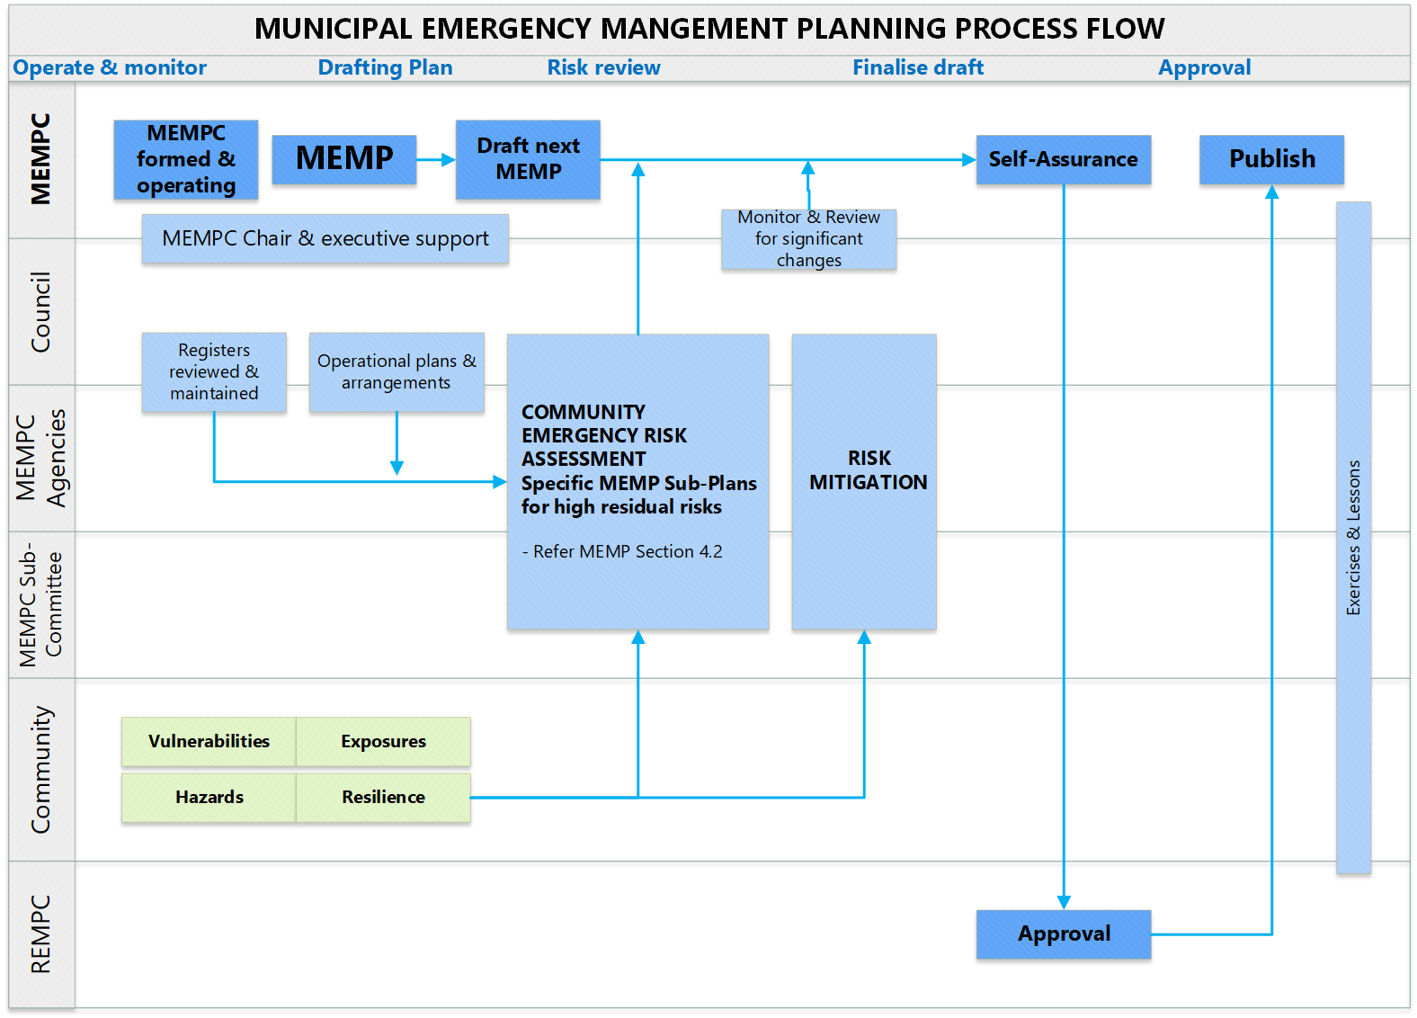

***Figure 2 - MEMP Planning Flow Chart***

## Victoria’s Emergency Management Planning Framework

This Plan supports holistic and coordinated emergency management arrangements within the municipality. It is consistent with and contextualises the [State Emergency Management Plan (**SEMP**)](https://www.emv.vic.gov.au/responsibilities/semp) and the Eastern Metropolitan Regional [Emergency Management Plan (**REMP**)](https://www.emv.vic.gov.au/responsibilities/emergency-management-planning/remps/eastern-metro-remp). The REMP is a subordinate plan to the SEMP and this MEMP is a subordinate plan to the REMP.

To the extent possible, this MEMP does not conflict with or duplicate other in-force emergency management plans.

Figure 3 below outlines this MEMP’s position in Victorian emergency planning hierarchy. This MEMP should be read in conjunction with the SEMP and the REMP.

***Figure 3 - Victorian Emergency Management Plan Hierarchy***

## The MEMPC, Sub-Committees and Working Groups

### MEMPC responsibilities

The MEMPC is responsible for undertaking:

* Regular emergency risk assessments to understand and manage municipal risk profiles and to support planning.
* Mitigation actions and planning including:
  + Being responsible for the preparation and review of the MEMP.
  + Considering community EM plans if they have been developed.
  + Ensuring the MEMP is consistent with the SEMP and with the relevant REMP.
  + Providing reports and recommendations to the region’s REMPC in relation to any matter that affects or may affect EM planning in their municipal district.
  + Sharing information with the region’s REMPC and with other MEMPCs to assist effective Emergency Management planning in accordance with Emergency Management Act 2013 Parts 6 and 6A.
  + Collaborating with any other MEMPC that the MEMPC considers appropriate in relation to Emergency Management planning including preparing MEMPs.

The MEMPC governance arrangements conform to legislation and are detailed in the MEMPC Terms of Reference (available from MEMPC Chair - Council).

Maroondah MEMPC membership consists of:

|  |  |  |
| --- | --- | --- |
| **Maroondah Council members** | **Response and recovery agencies/organisations** | **Local businesses/community representatives** |
| Municipal Emergency Manager | Victoria Police - (MERC) | Eastlink |
| Municipal Emergency Management Officer | Country Fire Authority | Eastland |
| Municipal Recovery Manager (Chairperson) | Department Families, Fairness and Housing | Eastern FM 98.1 |
| Municipal Fire Prevention Officer | Department of Education | Centrelink |
| Emergency Management Officer | Ambulance Victoria | Maroondah Hospital |
| Manager, Communications and Citizen Experience | Victoria State Emergency Service | Community Representatives |
| Coordinator Corporate Planning, Risk and Information | Red Cross |  |
| Coordinator Community Health | Department of Defence |  |
|  | Yarra Valley Water |  |
|  | Metro Trains |  |
|  | St John Ambulance |  |
|  | Fire Rescue Victoria |  |
|  | Victorian Council of Churches Emergencies Ministry |  |
|  | Ausnet Services |  |
|  | Department of Health |  |
|  | Emergency Recovery Victoria |  |
|  | Salvation Army |  |
|  | Department of Transport and Planning *(attendance as needed)* |  |

### Special Sub Committees and Working Groups

The MEMPC may form, or contribute to, special permanent or temporary sub-committees or Working Groups to plan for the management of hazard specific identified risks or functions which require an additional level of planning. Examples of these include Municipal Fire Management, Flood and Storms, Risk Management and Municipal Relief and Recovery.

Refer to Figure 4 for the relationship between the MEMPC and its sub-committees.

Municipal Emergency Management Planning Committee (MEMPC)

(Municipal Emergency Management Plan)

Storm and Flood Planning Sub Committee

(Maroondah Storm and Flood Emergency Plan)

CERA Risk Assessment Working Group

(CERA Plan)

CERA Risk Assessment Working Group

(CERA Plan)

Municipal Fire Management Planning Sub Committee (MFMPC)

(Municipal Fire Management Plan)

Municipal Fire Management Planning Sub Committee (MFMPC)

(Municipal Fire Management Plan)

***Figure 4 - Example MEMPC Committee Hierarchy***

## Sub-Plans and Complementary Plans

### Sub-Plans

The MEMPC will determine if a sub-plan is required to detail more specific or complex arrangements that either enhance or contextualise this MEMP. All sub-plans are multi-agency plans and may be hazard-specific where the consequences are likely to be significant, for example a municipal flood response Sub-Plan.

Sub-plans to this MEMP are subject to the same preparation, consultation, assurance, approval and publication requirements as this MEMP, as outlined in the Emergency Management Act 2013 Part 6A.

Agencies with roles or responsibilities in a Sub-Plan must act in accordance with the plan (Emergency Management Act 2013 s60AK).

Sub-plans for the MEMP are developed and reviewed to ensure alignment with both state and regional plans. These plans may have been developed by a MEMPC sub-committee or in collaboration with neighbouring municipalities.

These plans could also be supported by operational documents or complementary plans. A list of Sub-Plans that have significance to the comprehensive, coordinated and integrated emergency management arrangements in the municipal district are at Appendix D.

In the Eastern Metro Region (EMR), the Eastern Metropolitan Councils Emergency Management Partnership (EMCEMP) may produce regionally consistent Hazard Based Sub-Plans for hazards that are relevant across the entire region. Sub-Plans produced by the EMCEMP will require approval by each MEMPC.

### Complementary Plans

Complementary plans are prepared by industry/sectors or agencies for emergencies that do not fall within the Emergency Management Act 2013 Part 6A. They are often prepared under other legislation, governance or statutory requirements for a specific purpose.

Complementary plans do not form part of this MEMP and are not subject to approval, consultation and other requirements under the Emergency Management Act 2013.

Examples of complementary plans are:

* A plan prepared by a water corporation under the [Water Act 1989](https://content.legislation.vic.gov.au/sites/default/files/2021-06/89-80a133.docx).
* A responsible entity’s emergency risk management plan prepared under the critical infrastructure resilience arrangements in Emergency Management Act 2013 Part 7A.
* An individual agency’s plan for a specific hazard.

A list of complementary plans that have significance to the comprehensive, coordinated and integrated emergency management arrangements in the municipal district are at Appendix D.

## Plan Exercising

The MEMP and Sub-Plans are to be tested on an annual basis. This will be performed in a manner determined by the MEMPC, examples include:

* Through an annual, regional exercise e.g. Exercise East.
* Through a desktop review of a specific hazard or risk from the Community Emergency Risk Assessments (**CERA**) with relevant members of the MEMPC.
* To be tested in conjunction with other agencies.

For a list of recent exercises refer to Appendix F.

# Mitigation Arrangements

## Introduction

The MEMPC has a key role in reducing risks, mitigating the impact of events and minimising the consequences of emergencies that may occur in the municipality. At the municipal level, this is achieved by conducting the CERA process using the Victorian State Emergency Service (**VICSES**) [on-line CERA system](https://cera.ses.vic.gov.au/login), to draw on local and expert knowledge to identify risks and strategies for risk management and create safer and more resilient communities.

## Hazard, Exposure, Vulnerability and Resilience

### Hazard

A hazard can be defined as a dangerous phenomenon, substance, human activity or condition that may cause loss of life, injury or other health impacts, property damage, loss of livelihoods and services, social and economic disruption, or environmental damage.

The hazards of concern to disaster risk reduction are of natural origin and related environmental and technological hazards and risks. Such hazards arise from a variety of geological, meteorological, hydrological, oceanic, biological, and technological sources, sometimes acting in combination. In technical settings, hazards are described quantitatively by the likely frequency of occurrence of different intensities for different areas, as determined from historical data or scientific analysis.

This MEMP, informed by the Community Emergency Risk Assessment, includes identified hazards which would lead to sources of municipal risks. Risk statements are generated to establish a credible relationship between a source of risk and an element of risk. An overview is provided with detailed information in the [online CERA system](https://cera.ses.vic.gov.au/login) maintained by VICSES.

### Exposure

Exposure refers to people, property, systems or other elements present in hazardous zones that may be subject to potential losses.

While the literature and common usage often mistakenly combine exposure and vulnerability, they are distinct. Exposure is a necessary, but not sufficient, determinant of risk. It is possible to be exposed but not vulnerable (for example by living in a floodplain but having sufficient means to modify building structure and behaviour to mitigate potential loss). However, to be vulnerable to an extreme event, it is necessary to also be exposed.

Exposure to potential loss for people, property, systems or environment in the municipality includes:

* Increased number of residents moving into the municipality
* Expansion of the CALD community and their needs
* Ageing population
* Increased number of high-rise developments that may present access issues for emergency services
* Residents/businesses located in treed areas or landslip, flood or grass/bushfire zones
* Heat island effects in urban areas
* Potential increased environmental impacts due to climate change

For further information please refer to [Maroondah Profile ID](https://forecast.id.com.au/maroondah/home)

### Vulnerability

Vulnerability refers to the characteristics and circumstances of a community, system or asset that make it susceptible to the damaging effects of a hazard.

There are many aspects of vulnerability, arising from various physical, social, economic, and environmental factors. Examples may include poor design and construction of buildings, inadequate protection of assets, lack of public information and awareness, limited official recognition of risks and preparedness measures, and disregard for wise environmental management. Vulnerability varies significantly within a community and over time.

Vulnerable characteristics and circumstances of communities, systems or assets in the municipality include:

* Zones of low SEIFA rating
* Homeless people
* Ageing population
* People with chronic diseases
* CALD community not having timely access to appropriate emergency information
* Critical infrastructure

For further information please refer to [Maroondah Profile ID](https://forecast.id.com.au/maroondah/home).

### Resilience

Resilience can be defined as the ability of a system, community or society exposed to hazards to resist, absorb, accommodate to and recover from the effects of a hazard in a timely and efficient manner, including through the preservation and restoration of its essential basic structures and functions. It is the capacity of individuals, institutions, businesses and systems within a city to adapt, survive and thrive no matter what kind of chronic stresses and acute shocks they experience.

Whilst the MEMPC members are focused on building general community-wide preparedness and resilience, The MEMPC has identified that there are harder-to-reach sections of the community that require more targeted support. These include but are not limited to:

* CALD communities
* Disability sector
* Youth
* Older Adults
* Homeless
* Indigenous
* Newly arrived citizens to Australia
* Children

Some of the key strategies to better engage are:

* Community emergency planning
* Council and agency community engagement
* Council and agency notifications through social and print media
* Use simplest language – tailored to audiences
* Multiple engagement channels - focus on audience’s existing networks
* Greater regular communications and engagement – audiences reminded and updated
* Outreach preferably in-place – go to where audiences meet

The Victorian Community Resilience Framework for Emergencies *(*[*Community Resilience Framework for Emergency Management | Emergency Management Victoria (emv.vic.gov.au)*](https://www.emv.vic.gov.au/CommunityResilienceFramework)*)* defines seven resilience characteristics:

* Connected, inclusive and empowered (networks, social capital)
* Sustainable built and natural environment
* Reflective and aware
* Culturally rich and vibrant
* Safe and well
* Dynamic and diverse local economy, and
* Democratic and engaged.

## Risk Assessment Process and Results

The MEMPC has a responsibility under the Emergency Management Act 2013 to protect the safety of its community and visitors to the municipality. Furthermore, the MEMPC is committed to engaging the community in the development of strategies which enhance public safety, through effective service delivery and asset management.

Through the use of CERA, the MEMPC implements the [AS/NZS ISO 31000 Risk Management Standard](https://www.iso.org/iso-31000-risk-management.html) for the identification, risk and consequence assessment and treatment of risks. This risk process is an all-hazards approach through the CERA system in collaboration with VICSES. The CERA assessment process helps identify hazards and assess impacts and consequences based upon the vulnerability or exposure of the community using:

* The history of municipal emergency events and events in similar and neighbouring municipalities
* Municipal demographics and topography
* Known vulnerable locations and people
* Existing ‘single hazard’ risk assessments, (e.g., the Victorian Fire Risk Register (**VFRR**), Strategic Fire Management Planning and Flood studies)
* Subject matter experts and local community representatives

A working group of the MEMPC including Council staff and key stakeholders from the emergency service/support organisations consider emergency risks within the following context:

* Whole of community perspective
* Responsibility for the whole municipality
* Consideration of events which require multi-agency responses
* Consideration and acknowledgement of existing controls
* Mitigation activities and their effectiveness, and
* Subsequent level of risk.

Risks are assessed and rated according to consequence and likelihood scales and risk matrices in the CERA tool kit.

The risk assessment process comprises:

* Identifying the risks that pose the most significant threat to the whole community.
* Identifying, describing and understanding the exposure and vulnerability of key community assets, values and functions essential to the normal functioning of the community.
* Discussing and understanding the consequence and likelihood, causes and impacts for each risk.
* Identifying opportunities for improvement to prevention, control, mitigation measures and collaboration.

The results of the assessment process are used to inform emergency management planning and to develop risk action plans and help inform communities about hazards and the associated emergency risks that may affect them. The process is documented, and the recommended treatment options presented to the MEMPC for consideration and action. The risks are subject to regular review by the MEMPC.

The progress of implemented treatment options is regularly monitored on at least an annual basis by the MEMPC through reports provided by agencies listed as “owners” of the treatment options at MEMPC meetings or after any significant event. The CERA risk assessment process is summarised in Figure 5.

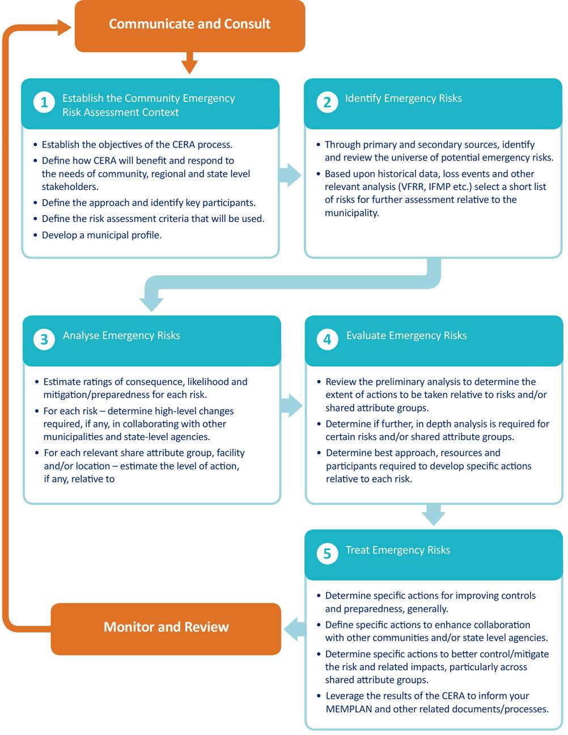

***Figure 5 - CERA Risk Assessment process***

The likelihood, consequence and risk matrices used for CERA are documented in the [National Emergency Risk Assessment Guidelines (NERAG)](https://knowledge.aidr.org.au/resources/handbook-national-emergency-risk-assessment-guidelines/).

The resulting list of risks and CERA risk ratings for Maroondah are shown in Table 3 below.

| **Risk** | **Confidence Rating** | **Residual Risk Rating** |
| --- | --- | --- |
| Extreme Temperatures - (Heat/cold) | High | Medium |
| Storm | High | Medium |
| Bushfire/ Grassfire | High | Medium |
| Road Incident - Road | High | Medium |
| Civil Disturbances | Medium | Medium |
| Essential Services Disruption | High | Medium |
| Fire - Commercial/Industrial/High rise (commercial) | High | Medium |
| Human Disease (Pandemic) | Medium | Medium |

***Table 3 - Identified Municipal Risks for Maroondah***

For more detail about the Municipal Maroondah CERA data refer to the municipal [CERA web site](https://cera.ses.vic.gov.au/login) or contact the MEMO.

### Victorian Fire Risk Register (VFRR)

The VFRR is a systematic process that identifies assets at risk of bushfire on a consistent state-wide basis using the [Australian/New Zealand Risk Management Standard ISO:31000](https://www.iso.org/iso-31000-risk-management.html).

The aim of the VFRR is to minimise the risk of adverse impact of bushfires on assets and values in human settlement, cultural heritage, economic and environmental contexts for parts of the municipality that lie within the Bushfire Prone Areas (**BPA**).

The objective of the VFRR is to:

* Identify and rate bushfire risks to assets
* Identify current mitigation treatments to manage the risk
* Identify the agencies responsible for implementing mitigation treatments and strategies
* Produce an integrated document and risk register across responsible agencies; and
* Support and inform planning at a local level.

The primary outputs of the VFRR-B process are a series of maps displaying assets at risk, plus a municipal bushfire risk register, listing the risk rating for each asset and current risk mitigation treatments. Details of the VFRR outputs for the municipality are available in the appendices of the Municipal Fire Management Sub-Plan.

### Victorian Emergency Risk Management System (VERMS)

The VERMS provides a sound platform for conducting a structure fire risk assessment which is clearly defined by a robust 10 step process. The VERMS tool uses the methodology recognised in NERAG which is underpinned by ISO 31000, the International Standard for Risk Management. A risk working group of subject matter experts and key Council staff identify risks by their building class via the following statement “There is potential that an accidental ignition will result in a fire in:

* Class 2 buildings (flats, apartments)
* Class 8 buildings (factory)
* Class 1(a) buildings (house)
* Unregistered/illegal Class 1(b) buildings (boarding house)
* Class 9(c) buildings (aged care facility)
* Class 3 buildings (large boarding house)

This in turn, will cause serious injury or loss of life, economic loss and/or displacement.” Using available evidence, the expertise in the room and participant agreement, the group identify the consequence categories for the above building classes to include – ‘People’ and ‘Economy’, with ‘Social Setting’ also identified for Class 2 and Class 1(b) buildings and ‘Environment’ also identified for Class 8 buildings. A risk assessment is then completed for each consequence category.

## Treatment Plans

The treatment and mitigation of risks are incorporated in MEMP sub-plans, complementary plans and standard operating procedures (SOP) that have been developed as part of the risk management process and, if required, in the Council and agency strategic plans and sub-plans. Refer Appendix D for a list of sub-plans and complementary plans.

## Monitoring and review

The MEMPC is responsible for reviewing the municipal risks listed in Table 3 via the CERA process at least once every three years or upon a significant emergency event.

# Response

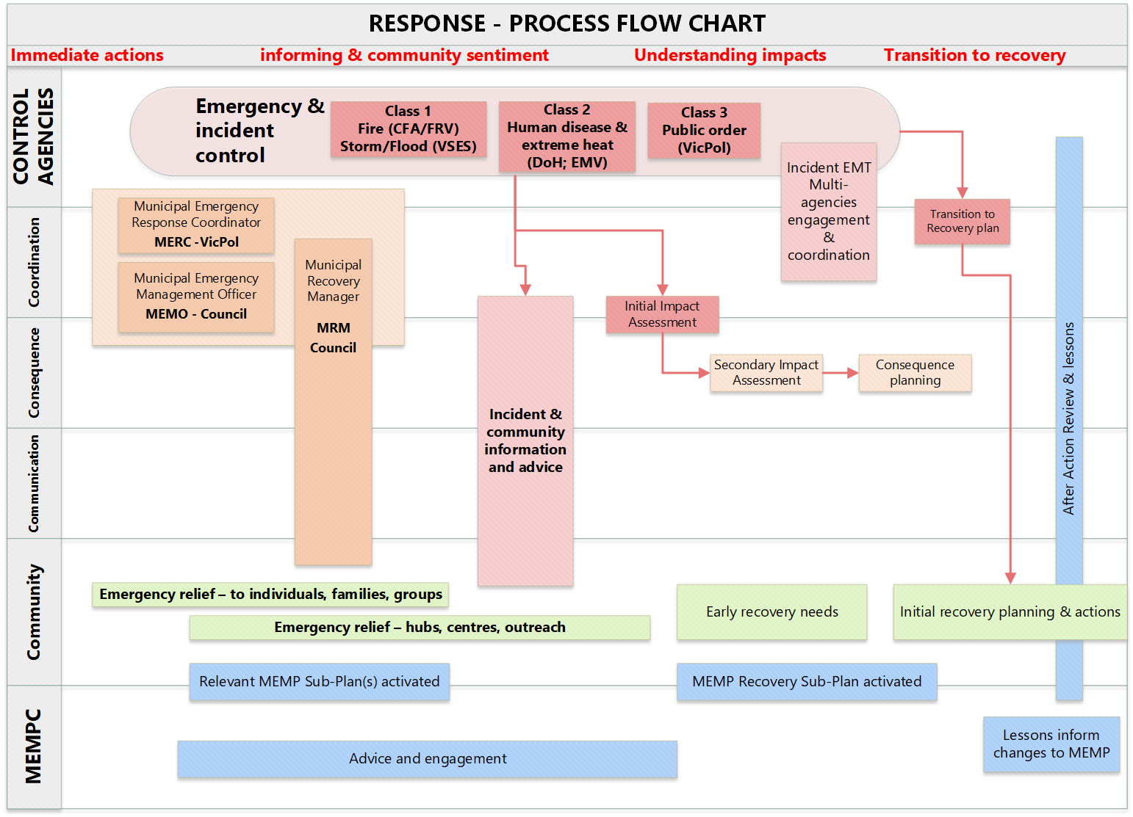

***Figure 6 – Emergency Response Flow Chart***

## Introduction

Emergency response is the action taken immediately before, during and in the first period after an emergency to reduce the effect and consequences of emergencies on people, their livelihoods and wellbeing, property and the environment and to meet basic human needs.

The Victorian State emergency management priorities underpins and guides all decisions made during emergencies in Victoria. The priorities are:

* Protection and preservation of life is paramount. This includes:
  + - Safety of emergency response personnel and Safety of community members, including vulnerable community members and visitors/tourists.
    - Issuing of community information and community warnings detailing incident information that is timely, relevant and tailored to assist community members to make informed decisions about their safety.
* Protection of critical infrastructure and community assets that support community resilience.
* Protection of residential property as a place of primary residence.
* Protection of assets supporting individual livelihoods and economic production that supports individual and community financial sustainability.
* Protection of environmental and conservation assets that considers the cultural, biodiversity, and social values of the environment.

The SEMP provides the mechanism for the build-up of appropriate resources to cope with emergencies throughout the State. It also provides for requests for physical assistance from the Commonwealth when State resources have been exhausted.

Emergency response operations are managed via three operational tiers which include state, regional and incident levels. Most incidents are of local concern and can be coordinated from local municipal resources. When those resources are exhausted, however, the Regional Emergency Response arrangements provide for further resources to be made available, firstly from neighbouring regions and then, secondly, on a state-wide basis.

All response arrangements within this document are consistent with the arrangements detailed in the [SEMP](https://www.emv.vic.gov.au/responsibilities/semp) to ensure the continuity of resources with all levels of government.

Particular effort has been made by agencies and Council within the municipality to ensure that relationships have been formed with neighbouring municipalities and local and regional emergency and support agencies in the event resource support and coordination is needed between the operational tiers.

* + 1. **Definitions of Emergencies**

The following table defines the types of emergencies that may occur:

| Term | Definition |
| --- | --- |
| Major Emergency | Major emergencies are distinguished by their scale, the effort required to respond to them and their consequences to the community and infrastructure. They are defined as:   1. a large or complex emergency (however caused) which:    1. has the potential to cause or is causing loss of life and extensive damage to property, infrastructure or the environment; or    2. has the potential to have or is having significant adverse consequences for the Victorian community or part of the Victorian community; or    3. requires the involvement of two or more agencies to respond to the emergency; or 2. a Class 1 emergency; or 3. a Class 2 emergency. |
| Non-Major Emergency | A non-major emergency is an event that has occurred on a small scale, where individuals or a family may have had their home or possessions severely damaged or destroyed due to an emergency event such as a house fire or storm. |
| Class 1 Emergency | 1. a major fire; or 2. any other major emergency for which the Fire Rescue Victoria (**FRV**), the Country Fire Authority (**CFA**) or VICSES Authority is the control agency under the SEMP. |
| Class 2 Emergency | Means a major emergency which is not   1. a Class 1 emergency; or 2. a warlike act or act of terrorism, whether directed at Victoria or a part of Victoria or any other state or territory of the Commonwealth; or 3. a hi-jack, siege or riot. |
| Class 3 Emergency | Also known as security emergencies, Class 3 emergencies are classified as a warlike act or act of terrorism, where directed at Victoria or any other State or Territory or the Commonwealth or a hi-jack, siege or riot |

***Table 4 - Classification of Emergencies - Emergency Management Act 2013 Section 3***

## Control, Command, Coordination, Consequences, Communication and Community Connection

The six Cs of emergency management in the state of Victoria are detailed below.

| **Six C’s of Emergency Management** | **Description** |
| --- | --- |
| **Control** | Control is the overall direction of response activities in an emergency, operating horizontally across agencies.  Control of an emergency situation will at all times remain the responsibility of the designated agency or authority for that type of emergency. The control agency is required to appoint an Incident Controller, who will control operations.  (A list of the control agencies can be found in the [SEMP](https://www.emv.vic.gov.au/responsibilities/semp)) |
| **Command** | Command is the internal direction of personnel and resources, operating vertically within an agency. Each agency has a ‘chain of command’, which is the agency’s organisational hierarchy that identifies the link between each individual and their supervisor. |
| **Coordination** | Coordination is the bringing together of agencies and resources to support the response to and recovery from emergencies. |
| **Consequences** | Consequence management involves the coordination of the activities of agencies with a role in delivering of services to the community, with the aim of minimising the adverse consequences of emergencies on the community.  It is a precursor to relief and recovery activities.  During a major emergency all agencies may need to activate their business continuity arrangements in order to manage the adverse consequences of the emergency on their area of responsibility.  The Emergency Management Commissioner is responsible for consequence management for major emergencies. |
| **Communication** | Communications relates to the engagement and provision of information across agencies, communicating to the public, reporting to government, and communicating with stakeholder agencies during emergencies. The Emergency Management Commissioner is responsible for the communication function for major emergencies but will be supported by the relevant Control Agency. |
| **Community Connection** | The understanding of and connecting with trusted networks, trusted leaders, and all communities to support resilience and decision making. |

***Table 5 - The Six Cs of Victorian Emergency Management (SEMP)***

|  |  |  |  |  |  |  |  |  |  |
| --- | --- | --- | --- | --- | --- | --- | --- | --- | --- |
|  | **Command** | **Control** | **Community Connection** | **Communication** | | **Consequence Management** | **Coordination** | | |
| **Emergency Class** | **All Classes** | **All Classes** | **All Classes** | **Class 1 or 2 – Emergency Management Commissioner** | | **All Classes** | **Response** | | **Relief and Recovery** |
| **Class3 - Chief Commissioner of Police** | | **Class 1 or 2** | **Class 3** | **All Classes** |
| **State Tier** | Agency Chain of Command | State Control Team | Emergency Management Commissioner/ Chief Commissioner of Police  State Strategic Comms Cell (SSCC) | Emergency Management Joint Public Information Committee (EMJPIC)  Public Information Section (PIS) at SCC | Emergency Management Commissioner/ Chief Commissioner of Police  State Strategic Comms Cell (SSCC) | State Emergency Management Team (SEMT) | Emergency Management Commissioner | Chief Commissioner of Police | State Relief and Recovery Team |
| **Regional Tier** | Regional Control Team | Regional Joint Public Information Committee (RJPIC)  PIS at RCC | Regional Joint Public Information Committee (RJPIC)  PIS at RCC | SSCC Representative  (If required) | Regional Emergency Management Team (REMT) | RERC | | Regional Recovery Planning Committee  (or equivalent) |
| **Incident Tier** | Incident Management Team (IMT)  (Major Emergencies) | Incident Joint Public Information Committee (IJPIC)  PIS at ICC | Incident Joint Public Information Committee (IJPIC)  PIS at ICC | SSCC Representative  (If required) | Incident Emergency Management Team (IEMT)  (Major Emergencies) | MERC / IERC | | Municipal Recovery Planning Committee  (or equivalent) |
| Incident Emergency Management Team (IEMT)  (Non-Major Emergencies) | | | | |

***Table 6 - Six Cs Roles and Responsibilities for Emergencies (Refer*** [***State Emergency Management Plan***](https://www.emv.vic.gov.au/responsibilities/semp)***)***

## Local Response Arrangements and Responsible Agencies

The objective of the response phase of this plan is to minimise the effects of an emergency on affected persons and property within the municipality.

This is achieved by coordinating municipal resources to assist responding agencies, and in providing community support, as requested, or as the situation requires. The basic functions at a local level can include all or any of the following:

* Provision of resources as available and needed by the community and response agencies
* Establishment of Municipal Emergency Coordination Centre – facilities and staffing
* Under the direction of the control agency, facilitate the delivery of warnings to the community
* Guided by the control agency, provision of information to public and media
* Coordination of the provision and operation of Emergency Relief Centres (ERC) and emergency shelters
* Undertake Impact Assessments to inform both response and transition to recovery. This may include Rapid Impact Assessment, Initial Impact Assessment and Secondary Impact Assessments. Impact Assessment processes are defined in various guidelines, plans and SOPs
* Clearance of blocked drains and reinstatement of local roads, including tree removal and other physical works as deemed appropriate and where possible
* Support to Victoria Police for partial/full road closures and determination of alternative routes
* Repairing or replacing damaged public utilities, services and assets.

Resource support by municipalities occurs when services or control agencies exhaust their own avenues of supply and there is a requirement for continued supply. Council-managed resources available during an emergency include Council staff resources for Emergency Relief Centre and Municipal Emergency Coordination activation and Council equipment that can be used to assist response agencies.

Responding agencies requiring support or additional resources should make their request through the Municipal Emergency Resource Coordinator (MERC), Municipal Emergency Management Officer (MEMO) or Municipal Recovery Manager (MRM). If the request cannot be achieved, the request will be passed to the Regional Emergency Response Coordinator (RERC).

During an emergency activation, the MERC, MEMO and MRM perform a leadership role and provide a link between the Incident Control Centre (ICC), Council and agency Emergency Management Liaison Officers (EMLO) and the Municipal Emergency Coordination Centre (MECC)/ERC support staff to ensure that requests for resources and any other related requirements can be addressed. These roles have the responsibility for the coordination of municipal resources during the response phase of an emergency.

The MEMO, MRM and MERC will refer to the MEMP contact directory (Refer Appendix C) if additional resourcing or services are required. Role descriptions for these roles can be found in the [SEMP](https://files.emv.vic.gov.au/2021-10/Victorian%20State%20Emergency%20Management%20Plan%20%28SEMP%29%20-%20Interactive%20and%20functional%20PDF%20document%20-%20October%202021.PDF) and the EMCEMP [MEC Sub-Plan](https://files-em.em.vic.gov.au/IEMP/Regions/EMR/Management-Plans/EMR-Management-Plans.htm?v=1626395724410).

Emergencies may range from small through to large scale and will require different response levels:

### 5.3.1 Level 1 – Small Scale Incidents

A small-scale emergency (including non-major emergencies) that can be resolved through the use of local or initial response resources. Local small-scale incident response will be coordinated at a municipal level by the MERC. The request usually comes from the coordinator of the response agency who is at the incident. A physical MECC might not necessarily be always activated with the MERC and MEMO in close communication. It may be activated via a “virtual MECC” at the site/scene of the incident. The MERC and MEMO will undertake the planning and logistics functions concurrently. They may direct and authorise the use of physical resources in response to the local incident and activate the MRM to provide relief and recovery support if required. They will also monitor the emergency and its impact on the area, the community, the weather, and other elements/variables which may lead to a higher level of activation. Following the direction of the Incident Controller, the MERC, in consultation with the MEMO, may also formally direct the establishment of a virtual or physical MECC or a municipal relief centre to be placed on standby.

### Level 2 – Medium scale incidents

A medium scale emergency is more complex in size than a small-scale emergency. A virtual or physical MECC may be activated. If activated the function will be the deployment of resources beyond initial response, and multi-agency representation in the MECC. The emergency may potentially require forward planning to address response issues, and for recovery during the response phase.

* + 1. **Level 3 – Large scale incidents**

A large-scale emergency is characterised by levels of complexity that require the activation and establishment of all MECC functions. This level of emergency will require forward planning as the emergency continues and will specifically require recovery planning during the early stages of the response phase of the emergency.

Attendance at ICC by the MERC and MEMO may be sought in conjunction with the above mentioned “virtual MECC” arrangements.

Emergency events impacting on an area larger than the local region will also involve the activation of the State Control Centre (SCC).

These descriptions are in line with the Australasian Inter-Service Incident Management System (AlIMS) Classification of incidents. Further information on accessing supplementary supplies can found in [Practice Note: Sourcing Supplementary Emergency Response Resources through Municipal Councils](https://urldefense.com/v3/__https:/comms.emv.vic.gov.au/ch/54138/1d38z/2860339/yUW9_oSpy0krLR5ats_LD.d7zEuaHsCnGPfT4JRV.pdf__;!!BRtXJfoaXEo0!mAjamohq_hQci1PfgJzBGm1w-cDCdhaLvC3ep8OoL17yOzUAqub4xA7-sYK5J-CIWl9xZYrVlYCJGqMAD8PNzc01ne2dg9XWEQdmdGuu4wdKMT-l$).

* + 1. **Emergency Response - Control Agencies**

A single agency is appointed as the control agency at each emergency (Refer Table 7). If it is unclear which agency will be in control at any incident the responding agencies should determine the control agency by agreement. Where there is any doubt as to who the control agency is, the Emergency Management Commissioner (**EMC**), RERC, MERC or Incident Emergency Response Coordinator (**IERC**) will determine who will exercise control.

During the emergency response the control agency may change depending upon the circumstances. Handover of control must be made to the appropriate agency representative, be formal in nature and the details of the handover must be noted.

It is the control agency’s responsibility to plan for the relevant emergency and ensure that adequate resources are in place. Agencies and Council may be support agencies during emergencies. This may be in relation to the agency performing a specific response, relief, or recovery function, or to ensuring the continuity of its normal services during a major emergency, as part of consequence management.

Below is a list of control agencies and the role that they would undertake during an emergency.

| **Emergency** | **Emergency Form** | **Control Agency** |
| --- | --- | --- |
| Fire and explosion | Fire | [FRV](https://www.emv.vic.gov.au/responsibilities/semp/roles-and-responsibilities/role-statements/frv) / [CFA](https://www.emv.vic.gov.au/responsibilities/semp/roles-and-responsibilities/role-statements/cfa) / [Forest Fire Management Victoria (**FFMV**)](https://www.emv.vic.gov.au/responsibilities/semp/roles-and-responsibilities/role-statements/delwp) |
| Violence/Terrorism | Threats against persons, property or environment | [Victoria Police](https://www.emv.vic.gov.au/responsibilities/semp/roles-and-responsibilities/role-statements/vicpol) |
| Earthquake, flood, windstorm or other natural event | Flood | [VICSES](https://www.emv.vic.gov.au/responsibilities/semp/roles-and-responsibilities/role-statements/vicses) |
| Storm | [VICSES](https://www.emv.vic.gov.au/responsibilities/semp/roles-and-responsibilities/role-statements/vicses) |
| Heat | [EMV](https://www.emv.vic.gov.au/responsibilities/semp/roles-and-responsibilities/role-statements/emv) |
| Landslip | [VICSES](https://www.emv.vic.gov.au/responsibilities/semp/roles-and-responsibilities/role-statements/vicses) |
| Earthquake | [VICSES](https://www.emv.vic.gov.au/responsibilities/semp/roles-and-responsibilities/role-statements/vicses) |
| Essential service disruptions | Food supply, critical infrastructure damage or disruption | [Victoria Police](https://www.emv.vic.gov.au/responsibilities/semp/roles-and-responsibilities/role-statements/vicpol) |
| Electricity | [Department of Energy, Environment and Climate Action (DEECA)](https://www.emv.vic.gov.au/responsibilities/semp/roles-and-responsibilities/role-statements/djpr) |
| Natural Gas | [Department of Energy, Environment and Climate Action (DEECA)](https://www.emv.vic.gov.au/responsibilities/semp/roles-and-responsibilities/role-statements/djpr) |
| Petroleum and liquid fuels | [Department of Energy, Environment and Climate Action (DEECA)](https://www.emv.vic.gov.au/responsibilities/semp/roles-and-responsibilities/role-statements/djpr) |
| Public transport | [Department of Transport and Planning (DTP)](https://www.emv.vic.gov.au/responsibilities/semp/roles-and-responsibilities/role-statements/dot) |
| Roads/bridges/tunnels | [Department of Transport and Planning (DTP)](https://www.emv.vic.gov.au/responsibilities/semp/roles-and-responsibilities/role-statements/dot) |
| Water and sewerage | [Department of Energy, Environment and Climate Action (DEECA)](https://www.emv.vic.gov.au/responsibilities/semp/roles-and-responsibilities/role-statements/djpr) |
| Uncontrolled release of water from dam | [Department of Energy, Environment and Climate Action (DEECA)](https://www.emv.vic.gov.au/responsibilities/semp/roles-and-responsibilities/role-statements/djpr) |
| Road accident or any other accident | Road traffic accident (major) | [Victoria Police](https://www.emv.vic.gov.au/responsibilities/semp/roles-and-responsibilities/role-statements/vicpol) |
| Hazardous materials, high consequence dangerous goods or dangerous goods (including leaks and spills) | [CFA](https://www.emv.vic.gov.au/responsibilities/semp/roles-and-responsibilities/role-statements/cfa) / [FRV](https://www.emv.vic.gov.au/responsibilities/semp/roles-and-responsibilities/role-statements/frv) |
| Search and Rescue | Search –Land and Water  Road Crash Rescue | [Victoria Police](https://www.emv.vic.gov.au/responsibilities/semp/roles-and-responsibilities/role-statements/vicpol) |
| Rescue - Rail, Aircraft and Industrial Accidents | [FRV](https://www.emv.vic.gov.au/responsibilities/semp/roles-and-responsibilities/role-statements/frv)  [VICSES](https://www.emv.vic.gov.au/responsibilities/semp/roles-and-responsibilities/role-statements/vicses) |
| Plague or an epidemic or contamination | Human Disease | [Department of Health](https://www.emv.vic.gov.au/responsibilities/semp/roles-and-responsibilities/role-statements/dhhs) |
| Plant disease / pest incursion | [Department of Energy, Environment and Climate Action (DEECA)](https://www.emv.vic.gov.au/responsibilities/semp/roles-and-responsibilities/role-statements/djpr) |
| Radioactive Materials – Incidents | [Department of Health](https://www.emv.vic.gov.au/responsibilities/semp/roles-and-responsibilities/role-statements/dhhs) |
| Drinking water supply contamination | [Department of Health](https://www.emv.vic.gov.au/responsibilities/semp/roles-and-responsibilities/role-statements/dhhs) |
| Exotic animal disease | [Department of Energy, Environment and Climate Action (DEECA)](https://www.emv.vic.gov.au/responsibilities/semp/roles-and-responsibilities/role-statements/djpr) - Agriculture Victoria |

***Table 7 - Emergency Control and Support Agencies - Refer to Appendices for Agency Role Descriptions***

## Emergency Response Coordination Roles

| Emergency Response Coordination Roles | Role Description | Supporting Emergency Management Team | Team Description |
| --- | --- | --- | --- |
| Incident Emergency Response Coordinator (Victoria Police - IERC) | The senior Police Officer present at the site of a non-Major emergency who has the responsibility of coordinating resources to provide the most effective support to the control agency and the functional service agencies. | Incident Emergency Management Team (**IEMT**) | The IEMT supports the incident controller. Their focus is on managing the effects and consequences of an emergency. Agencies may assign an EMLO to assist the Incident Controller as a member of the IEMT. |
| Municipal Emergency Response Coordinator (Victoria Police - MERC) | A Senior Sergeant at a local police station or his/her deputies and appointed by Victoria Police.  Control agencies request support through the MERC, who will pass on the request to the MEMO. | MEMG at the MECC | The primary role of the MECC and the EMG is to coordinate the provision of human and material resources within the Municipality during emergencies. They will also maintain an overall view of the operational activities within this Plan’s area of responsibility, for recording, planning and debrief purposes. |
| Regional Emergency Response Coordinator (Victoria Police - RERC) | Will receive and action any requests from the MERC for further assistance when municipal resources are unavailable, have been fully committed or exhausted. | Regional Emergency Management Team (**REMT**) | The REMT supports the RERC and those exercising control at a regional level (Regional Controllers). Their focus is to raise awareness of the emergency across the whole of government, identify and manage strategic tasks and consequences and develop a regional strategic plan outlining high level action of all agencies. The Eastern Region assigns a Local Government REMT Representative who acts on behalf of all Councils in the Eastern Region to assist the Regional Controller as a member of the REMT. |
| Emergency Management Commissioner | Coordination before and during major emergencies including the management of consequences of emergencies. | State Emergency Management Team (**SEMT**) | The SEMT is usually located at the State Control Centre or other location determined by the control agency.  If an emergency requires the activation of a state tier response, the SEMT is formed comprising senior representatives from response, recovery and support agencies and relevant departments. The role of the SEMT is to develop consistent situational awareness, identify strategic state risks and consequences and to develop a strategic plan with high level, all agency actions. |

***Table 8 - Emergency Response Coordination Roles and Teams***

## Control, Coordination and Operations Centres and Areas

### Incident and Regional Control Centres

The designated Incident and Regional Control Centres in the Eastern Region are listed in Table 9 below.

|  |  |
| --- | --- |
| **Type** | **Address** |
| ICC | 27/69 Arcadia Road, Ferntree Gully  7-9 Symes Road, Woori Yallock  45 Assembly Drive, Dandenong South |
| RCC | 272 Maroondah Highway, Chirnside Park |

***Table 9 - Designated Incident Control Centres***

### Municipal Emergency Coordination Centre(s) (MECC)

Activation and operation of Municipal Emergency Coordination is detailed in the complementary plans: EMCEMP [Municipal Emergency Coordination (**MEC**) Standard Operating Procedures](https://files-em.em.vic.gov.au/IEMP/Regions/EMR/Management-Plans/EMR-Management-Plans.htm?v=1626409666459) .

Municipal emergency coordination and the MECC may be activated upon the request of the MERC or may be activated at the discretion of the MEMO and/or MRM. Its primary function is to coordinate the use of municipal resources, to receive and transmit information updates, and to provide an administrative and management base for the MEMG (MERC, MEMO and MRM) and its operations.

Municipal emergency coordination can be undertaken from a variety of locations which provide flexible options including operating in the designated MECC, virtually, the emergency site or at an ICC if required.

The designated Municipal Emergency Coordination Centres for Maroondah are listed in Table 10 below.

|  |  |
| --- | --- |
| **MECC Type** | **Address** |
| Primary MECC | Maroondah Operations Centre, 24-28 Lincoln Road, Croydon |
| Secondary MECC | Maroondah Council Offices, Realm, 179 Maroondah Highway, Ringwood |

***Table 10 - Designated MECC Locations***

### Crisisworks

[Crisisworks](https://maroondah.crisisworks.com/public) is an emergency incident operating system activated by Council that may be activated to manage an incident. It comprises a suite of cloud-based tools for Council and emergency agency emergency managers providing enhanced coordination, communication, situational awareness and resilience across all phases including planning, preparedness, response and recovery. It also incorporates Post Impact Assessment and Recovery, Vulnerable Persons Registers, Fire Prevention Register and Community View.

Crisisworks is used to record the following information and can be used by Council and Agency staff:

* Communications between agencies in the ICC, MECC and ERC
* Requests for assistance
* A full account of assigned tasks given to Council and agencies
* Telephone logs
* Emergency management documentation.

### Emergency Management Common Operating Picture (EM-COP)

[EM-COP](https://cop.em.vic.gov.au/sadisplay/main.seam) is a web-based information gathering, planning and collaboration tool that runs on any full screen device with a modern browser such as desktop computers, laptops and tablets. It is designed is designed to provide users with a simple way to gather, organise, create and share emergency management information between emergency managers at no cost to agencies. It also acts as a portal to state government agency web sites and planning tools.

EM-COP can be used in any control centre, shire council, not-for-profit relief organisation, essential service provider or on the ground. It is used before an emergency (to help plan and prepare), during and after an emergency (to assist with recovery). EM-COP can also be used to manage planned events.

### Operations Centres/Staging Areas/Marshalling Points

An Operations Centre is established by an agency for the command / control functions within their own agency. Council will establish an operations centre when it becomes necessary to control its own resources in an emergency.

Staging areas and marshalling points are strategically placed areas where support response personnel, vehicles and other equipment can be held in readiness for use during an emergency. They are predominately managed by control agency but may be shared with other agencies. They may also be co-located with the Council’s operations centre, or alternatively may be established at one of Council’s alternative locations (depending upon the nature, size, and location of the event). A detailed list of all of Councils facilities is available via the MEMO.

| **Location Type** | **Agency** | **Address** |
| --- | --- | --- |
| Staging Area/Marshalling Point | Victoria Police | Quambee Reserve, Wonga Road, Ringwood North |

***Table 11 - Staging Area and Marshalling Point for the Municipality***

## Financial Considerations

Control Agencies are responsible for all costs involved for that agency to respond to an emergency. Government agencies supporting the Control Agency are expected to defray all costs from their normal budgets. When a control agency requests services and supplies (for example, food and water) on behalf of a number of supporting agencies, the control agency will be responsible for costs incurred.

A requesting agency will be responsible for all associated costs for the provision of resources to support the response to an emergency event. Council is able to keep track of resources distributed by recording their provision in Council’s emergency operating system Crisisworks.

Municipal Councils are responsible for the cost of MECC setup costs and emergency relief services and provisions however, depending on the magnitude of the emergency, some financial assistance may be available for prevention, response or recovery activities.

All expenditure is to be authorised by the MEMO or MRM in accordance with the normal Council financial arrangements and recorded and logged for potential cost recovery.

Municipal employees from other Councils who volunteer during a municipal emergency are to claim staff costs through their Council finance systems which in turn may claim against the affected Council(s).

Depending on the magnitude of the emergency some government financial assistance may be available for prevention, response and recovery activities through the administration of the Victorian [natural-disaster-financial-assistance](https://www.emv.vic.gov.au/natural-disaster-financial-assistance) **(NDFA)** and/or [Australian Disaster Recovery Arrangements](https://www.disasterassist.gov.au/Pages/related-links/disaster-recovery-funding-arrangements-2018.aspx) **(DRFA)** both of which are accessed through emv.vic.gov.au or via email ndfa@emv.vic.gov.au. NDFA should be contacted as soon as practicable after an event to register a potential application. NDFA should be contacted as soon as practicable after an event to register a potential application.

### Donations

Council is accountable for any monies donated for an emergency where an appeal is created by Council and will implement systems to receive and account for all such donations.

Donations of services and material aid during relief and recovery stages will be managed in accordance with the EMCEMP [Municipal Emergency Coordination Sub-Plan](https://files-em.em.vic.gov.au/IEMP/Regions/EMR/Management-Plans/EMR-Management-Plans.htm?v=1626409666459) and [Emergency Relief Centre Sub-plan Standard Operating Procedures](https://files-em.em.vic.gov.au/IEMP/Regions/EMR/Management-Plans/EMR-Management-Plans.htm?v=1626409666459).

* 1. **Neighbourhood Safer Places (NSP) Bushfire Places of Last Resort (BPLR) and Community Fire Refuges (CFR)**

Maroondah’s municipal area does not have any designated Neighbourhood Safer Places - Bushfire Places of Last Resort or Community Fire Refuges. This is based on the relatively low risk of bushfire and recommendation from the MEMPC. Residents and visitors are encouraged to leave or avoid visiting areas of high bushfire risk on days of elevated fire danger.

## Planning for Cross Boundary Events

Planning for both response and recovery at the regional level supports effective incident management when emergencies traverse multiple municipal boundaries. Further, planning for cross boundary events is necessary as services provided by State government agencies are often administered and delivered at a Regional level. To support regional planning the following forums, operate in the Eastern Metro Region (EMR).

### Regional Emergency Management Planning Committee (REMPC)

At least one MEMPC member representative is a member of the Eastern Metro REMPC. The REMPC undertakes planning activities to support capability and capacity across the seven municipalities of the EMR including:

* Assessing existing capability and capacity levels, gap analysis, developing and implementing an improvement strategy.
* Conducting integrated training and exercising activities to support seamless transition from readiness to response to recovery.
* Reviewing previous season effectiveness of the coordination, control, consequence management and communications functions/outcomes/actions/improvements.
* Coordinating pre-season fire and severe weather briefings.
* Preparing and renewing interagency partnership agreements and memorandums of understanding as required.
* Preparing and reviewing joint agency procedures.
* Supporting and encouraging collaborative initiatives and activities such as the Eastern Metropolitan Councils Emergency Management Partnership (EMCEMP)
* Coordinating and integrating actions across the sector and phases of emergencies.

### Eastern Metropolitan Councils Emergency Management Partnership (EMCEMP)

Maroondah Council is a member of EMCEMP which is constituted through a Memorandum of Understanding (**MOU**) (available from the MEMO) to manage and coordinate Council activities before, during and after emergencies by promoting consistent practices by Councils across the region as well as facilitating inter-Council collaboration and resource sharing. EMCEMP meets regularly to collaborate on a range of emergency management issues. It has developed sub-plans and standard operating procedures to provide consistent guidance to emergency support teams.

EMCEMP comprises the following Eastern Metropolitan Region Municipal Councils:

* Boroondara
* Knox
* Manningham
* Maroondah
* Monash
* Nillumbik (North and West Region)
* Whitehorse
* Yarra Ranges

The members of the EMCEMP have agreed to collaborate in the following areas:

* Developing, reviewing and be guided by a three-year rolling Strategic Plan.
* Effectively collaborating on Emergency Management matters amongst Councils, with existing partners and any new groups identified.
* Advocating on relevant emergency management matters.
* Seeking appropriate funding and resources as enablers to support the Partnership.
* Developing and improving common ways of working for consistency of approach – planning for shared risks.
* Strengthening communities.
* Building capacity and capability through joint training, exercises and other forms of professional development.
* Developing processes to enable effective activation of the MAV Protocol for Inter-Council Emergency Resource Sharing.

## Resource Sharing Protocols

### EMCEMP

In times of emergencies, requests for support from the EMCEMP partners will be made by the MRM or MEMO of the affected Council with approval from their Chief Executive Officer (CEO) to the CEO (or the officer with the delegated authority to action requests for support) of the assisting Council.

Requests need to be made in writing and, in most cases, will be logged in Crisisworks

### Municipal Association of Victoria (MAV) Protocol for Inter-Council Emergency Resource Sharing

Council is a signatory to the [MAV Protocol for Inter-Council Emergency Resource Sharing](https://www.mav.asn.au/what-we-do/policy-advocacy/emergency-management/protocol-for-inter-council-resource-sharing). The Protocol provides an agreed position between Victorian Municipal Councils for the provision of inter-Council assistance for response and recovery activities during an emergency. This Protocol is most commonly enacted for emergency support staff requests to fulfil MECC and ERC shifts. Requests for resources will be made by the MRM or MEMO of the affected Council with approval from their Chief Executive Officer (**CEO**) to the CEO (or the officer with the delegated authority to action requests for support) of the assisting Council.

Requests need to be made in writing using the resource request form and, in most cases, will be logged in Crisisworks.

The MERC or RERC of the assisting Council should be contacted before the resources are moved.

Council will initially seek assistance from surrounding Councils so as to reduce travel times and expenses for assisting Councils to respond and return to base.

## Response Escalation

Each agency is expected to maintain the capability to fulfil its emergency response role and responsibilities and must notify the Emergency Management Commissioner of situations that may affect its capability to respond to emergencies.

If resources are required beyond the capacity of the control agency, requests are made through the MERC. If the resources are those owned or under the control of Council, or relate to a responsibility of Council, the request will be directed to the MEMO or MRM.

* 1. **All Agencies Debriefing Arrangements**

A debrief should take place as soon as practicable after an emergency. The MERC or MEMO will convene the meeting, and all agencies who participated should be represented with a view to assessing the adequacy of this MEMP and sub-plans and to recommend any changes. Such meetings would be chaired by the MEMPC chair or an appropriate facilitator.

It may also be appropriate to conduct a separate recovery debrief to address recovery issues. This should be convened and chaired by the MRM.

Where a MECC has been activated during an emergency, all emergency support staff that undertook their allocated MECC roles will be debriefed by the MEMO or their delegate as soon as practicable following the cessation of MECC operations. The MECC debrief has the aim to assess the adequacy of the MECC operations and to identify and make recommendations for future planning and operations related to the MECC.

Agencies and Council are responsible for staff psychological debriefing.

## Transition to Recovery

After consultation with the control agency and any other relevant agency, and the MEMO and MRM are satisfied that the response to the emergency has been completed, the Incident Controller will advise all participating agencies of "hand over" to the MRM. Refer to the EMV [Transition](http://files-em.em.vic.gov.au/IMT-Toolbox/RelRec/Template-Transition-from-Response-to-Recovery.docx) from Response to Recovery Template to authorise the transition from the response agency to Council. A flow chart of the escalation/de-escalation and handover process is shown below.

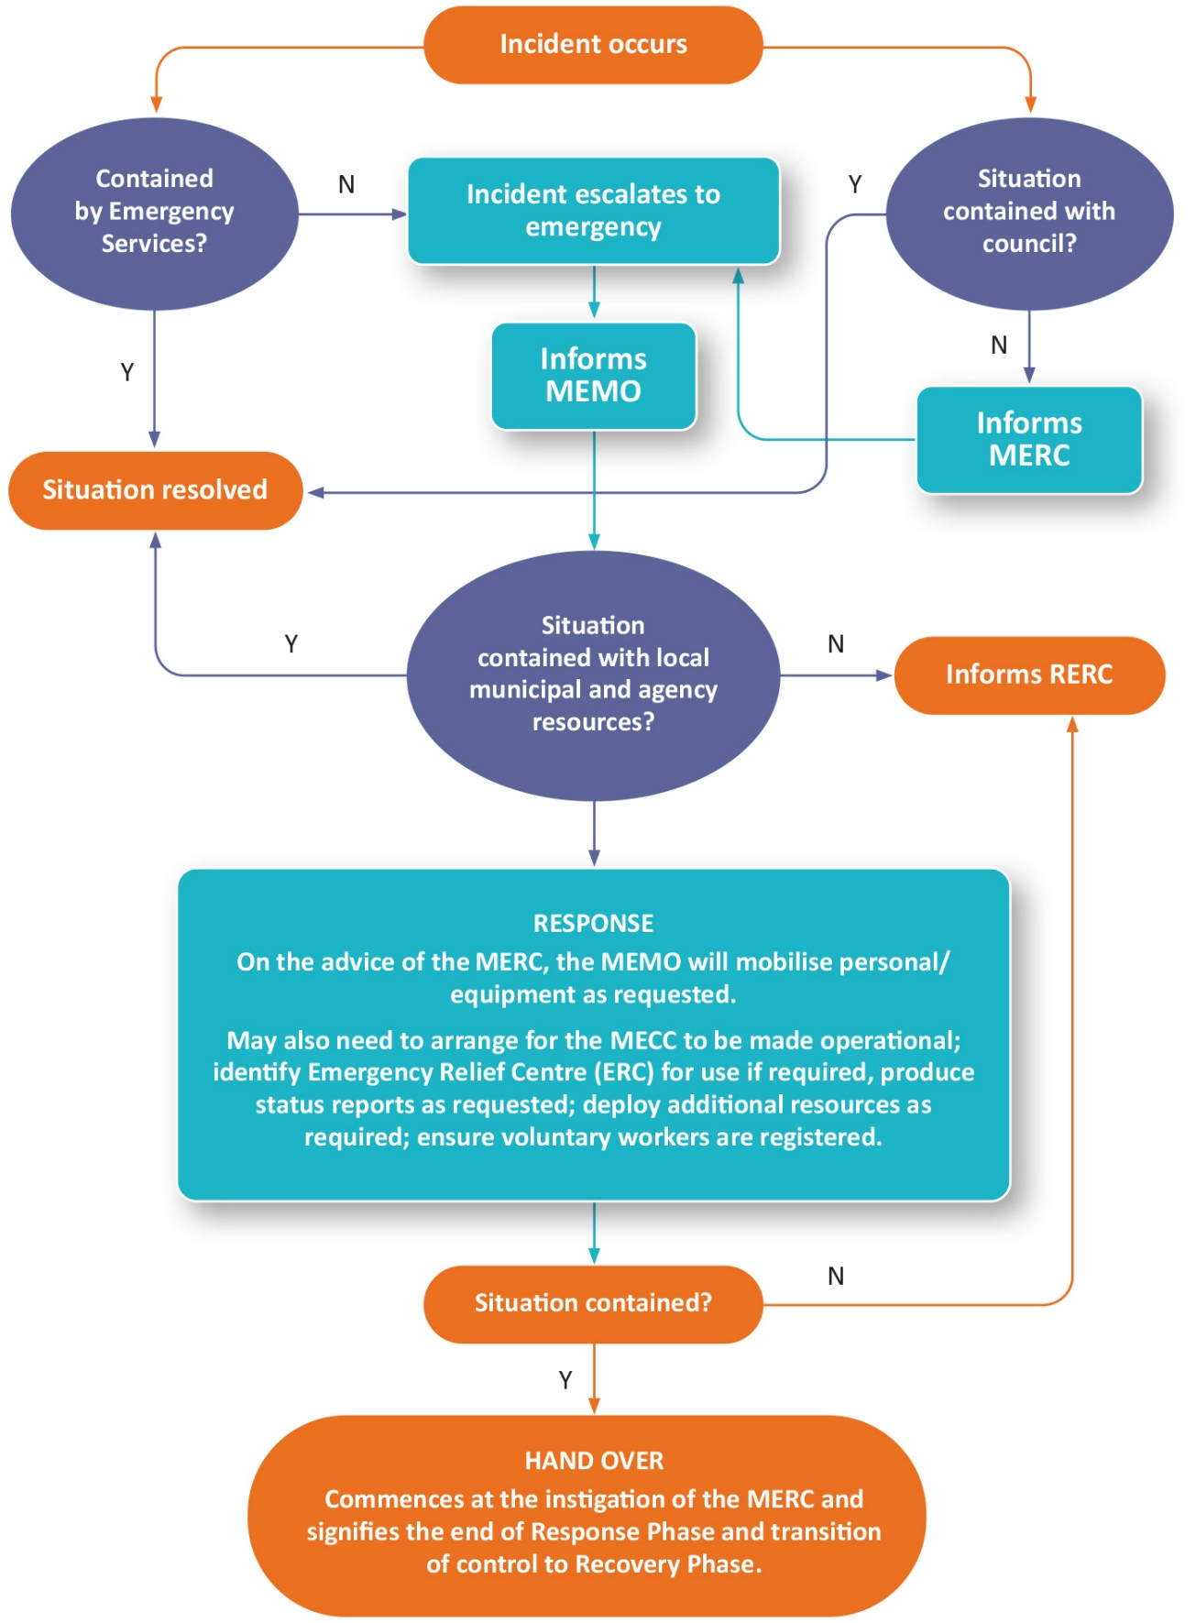

***Figure 7 - The Emergency Escalation/De-escalation and Handover process***

Effective transfer of control and coordination responsibilities from response agencies to relief/recovery agencies for all major Class 1, 2 or 3 emergencies is required for all major incidents and may also be required for local level incidents that have resulted in significant impacts on the local community requiring continued provision of relief and/or recovery services.

The MEMO, MRM and MERC will start planning for the transition from response, relief to recovery, as soon as possible following the initial impact of an emergency. Until handover occurs, relief and recovery activities are integrated with response and managed under response arrangements until such time as a transition to recovery is required.

At the response to recovery transition, the responsibilities of Victoria Police as the response coordinator are handed over to local government as the responsible agency for municipal recovery coordination. It is the responsibility of the MRM to ensure recovery management structures are defined and in place at handover to ensure a smooth transition. It is the responsibility of the MERC to advise all agencies involved in the emergency at the time of the transition from response to recovery and associated transition of responsibilities. However, some response agencies may be required after transition to support recovery.

Issues to be considered for the timing of transition from response to recovery include:

* The nature of the emergency and what ongoing specialist resources are required.
* Whether a recurring threat is likely to occur compounding the impact on the community.
* The extent of the impact on communities, as this may determine the length of the transition period.
* The level of loss/damage and the extent to which this has been validated (the stage of impact assessment reached e.g. if phasing into secondary/post impact stages may indicate transition requirements).
* The extent to which the community requires emergency relief services.
* The resources required for the activation of recovery arrangements.
* The transition agreement will be developed at the appropriate level between the response agency Incident Controller, MERC, MEMO, MRM and the recovery agency coordinator ERV.
* EMV Transition from Response to Recovery – Emergency Management Template to authorise the transition from the response agency to Council.

When requested, a transition agreement will be developed at the appropriate level between the response agency Incident Controller, MERC, MEMO, MRM and the Regional Recovery Manager.

This and other arrangements (transition activities and tasks, information management, communication and signatories) will be documented in a transition agreement developed between the Incident Controller, Emergency Response Coordinator - Victoria Police, the State Recovery Coordinator - ERV, Regional Recovery Coordinator - ERV and the MRM. The level of recovery coordination will depend on the scale of the emergency.

In large scale emergencies, municipal recovery operations will continue to be managed from the MECC with a consolidated team responsible for the continued coordination and delivery of relief (if required) and recovery operations.

The Municipal Relief and Recovery Sub-Plan provides details on how the coordination of activities, resources and information is managed effectively between the response agencies to the recovery organisations to support this changeover or responsibility.

### Handover of Resources

In some circumstances, it may be appropriate for facilities and goods obtained under emergency response arrangements during response to be utilised in recovery activities. In these situations, there would be an actual handover to the Recovery Manager of such facilities and goods and the details should be included in the transition agreement. This handover will occur only after agreement has been reached between response and recovery managers. Payment for goods and services used in the recovery process is the responsibility of the MRM through the MEMP arrangements.

Resources acquired for the response, which are not required for recovery, remain under the control of the requesting response agency which remains responsible for their return or disposal.

# Relief and Recovery Arrangements

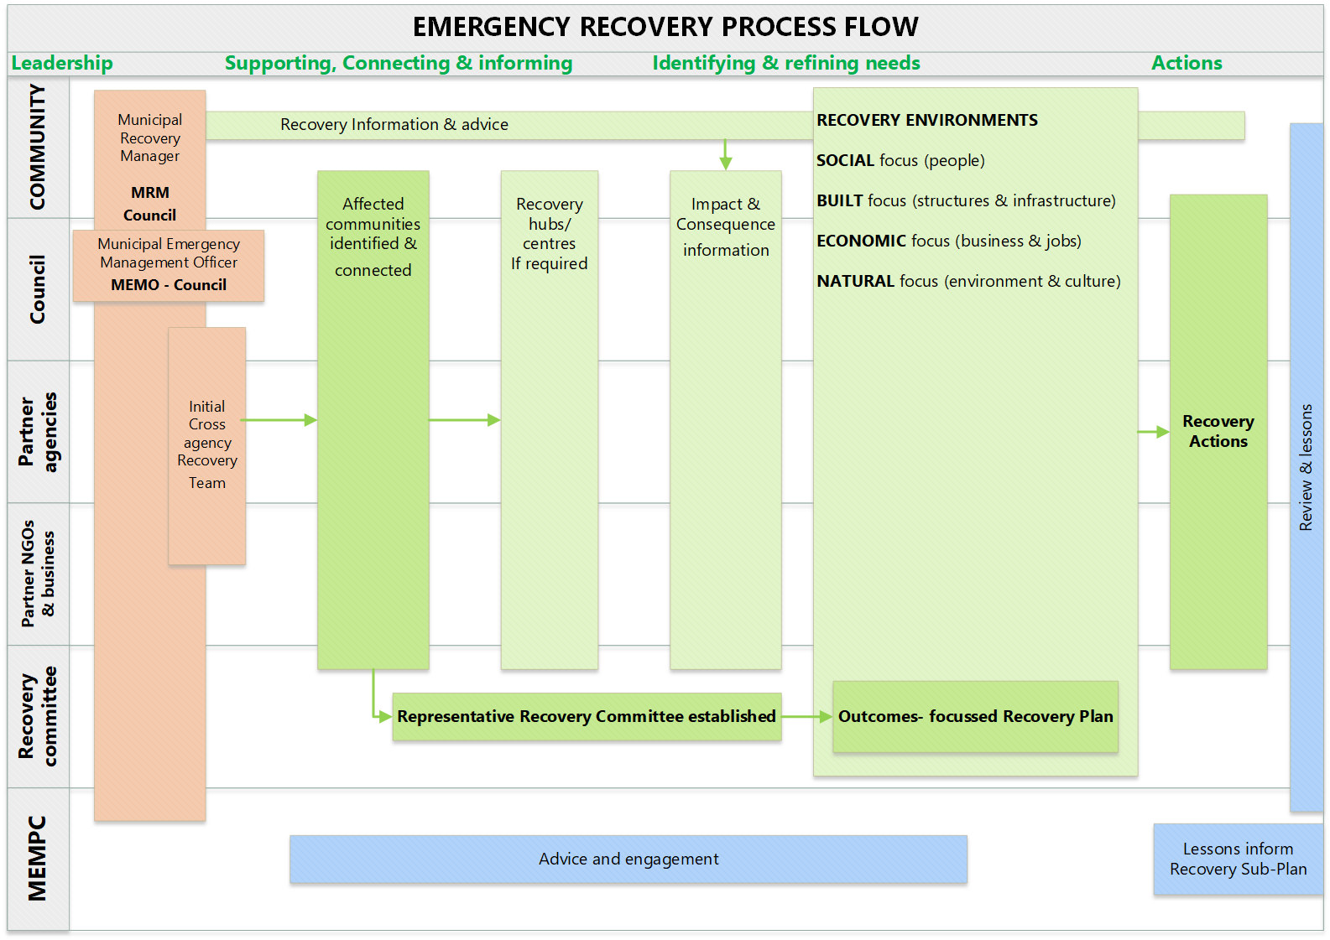

***Figure 8 - Emergency Recovery Process Flow Chart***

## Introduction

Emergency relief is the provision of essential needs to individuals, families and communities in the immediate aftermath of an emergency.

Relief services could be provided at the site of an emergency, a dedicated relief centre, places of community gathering, to isolated communities, transit sites or other safe locations as appropriate. Relief is the first stage of recovery and must be seamlessly integrated with all other early recovery activities.

Recovery is assisting individuals and communities affected by emergencies to achieve an effective level of functioning. Recovery planning must ensure that there is a clear understanding of the community context (prior to the emergency) and is informed by an initial and continuing assessment of impacts and needs.

Relief operations and recovery planning begin when an emergency occurs and response, relief and recovery activities are undertaken concurrently. Typically, relief is provided during and in the immediate aftermath of an emergency. Recovery is generally a longer-term process for affected individuals and communities.

Planning for emergency relief and recovery must integrate with the preparation and response phases to provide a seamless transition between each phase. Figure 9 illustrates the integrated prevention, response and recovery model linking emergency activities.

Figure 9 - Relationship between Preparation, Response, Relief and Recovery illustrates the integrated prevention, response and recovery model linking emergency activities.

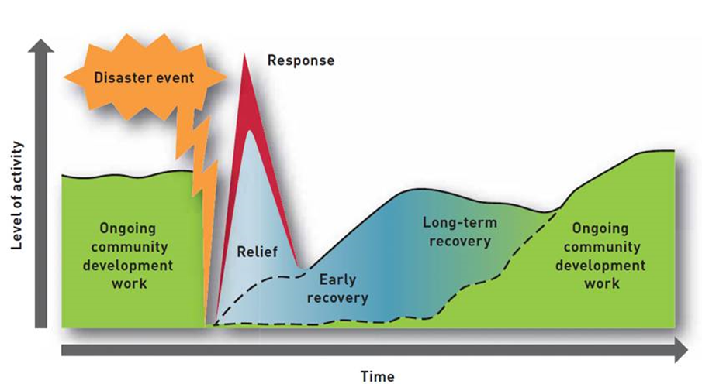

***Figure 9 - Relationship between Preparation, Response, Relief and Recovery***

Relief and recovery are responsibilities that require collaboration and coordination between individuals and communities, non-government organisations, businesses and government agencies. They occur in the context of clear and agreed arrangements and involves processes of consultation and cooperation through established communication channels. Wherever possible, short (relief) and longer-term recovery activities will become part of core business to ensure they remain responsive to the needs of the affected community.

## Principles and Scope of Relief

Emergency Management agencies with relief responsibilities incorporate the following principles into their planning, decision-making and delivery of services:

* Emergency-affected communities receive essential support to meet their basic and immediate needs
* Relief assistance is delivered in a timely manner, in response to emergencies
* Agencies communicate clear, relevant, timely and tailored information and advice to communities about relief services through multiple, appropriate channels
* Relief promotes community safety and minimises further physical and psychological harm
* Relief services recognise community diversity
* Relief is adaptive, based on continuing assessment of needs
* Relief supports community responsibility and resilience
* Relief is well-coordinated, with clearly defined roles and responsibilities
* Relief services are integrated into Emergency Management coordination efforts.

Relief encompasses:

* Community information
* Emergency Shelter (including Emergency Relief Centres)
* Food and water to individuals
* Drinking water for households
* Food supply continuity
* Psychosocial support
* Disbursement of material aid (non-food items)
* Reconnecting family and friends
* Health care and first aid
* Emergency financial assistance
* Animal welfare
* Legal aid
* Coordination of good will (including spontaneous volunteer management)

## Principles and Scope of Recovery

To ensure successful recovery is delivered to affected communities, recovery at all levels of government is implemented in alignment with the nationally recognised disaster recovery principles:

* Understanding the context
* Recognising complexity
* Using community-led approaches
* Coordinating all activities
* Communicating effectively
* Recognising and building capacity

There are four recovery environment categories and many recovery services that are encompassed within each environment category. The four categories will set the direction of the recovery planning process at the municipal level. The implementation of recovery requirements in each of the functional environments will be coordinated by the MRM:

1. **Social environment** – the emotional, social, spiritual, financial and physical wellbeing of affected individuals and communities
2. **Built environment** – the restoration of essential and community infrastructure
3. **Economic environment** - the revitalisation of the affected economy; and
4. **Natural environment** – the rehabilitation of the affected environment.

Note: Relief and recovery initiatives may address specific elements of one or multiple aspects of the above recovery environments.

## Impact Assessments and Consequence Management

Good decisions about recovery require timely, accurate and progressively more comprehensive information about the impact of an emergency. This informs the type of relief and recovery services required.

Disaster impacts may be described as *“the total effect, including negative effects (e.g., economic losses) and positive effects (e.g., economic gains), of a hazardous event or a disaster. The term includes economic, human and environmental impacts, and may include death, injuries, disease and other negative effects on human physical, mental and social well-being”.* ([Disaster | UNDRR](https://www.undrr.org/terminology/disaster). United Nations for Disaster Risk Reduction)

In general, impacts are therefore best characterised as most obvious effects immediately and in the very short term.

Impacts lead to Consequences. Consequences may be described as what follows those immediate and very short-term impacts through to the medium and long term. These may not be obvious without consideration of how the whole community and systems handle impacts and changing circumstances over time.

Impact, needs, and loss and damage assessments will be informed by using the following sources of information:

* Initial impact assessment conducted by the response agency
* Secondary impact assessment (SIA) coordinated by local councils in partnership with DFFH/DH recovery coordinating agency etc
* The Victorian Impact Assessment Model developed by Emergency Management Victoria
* Post impact needs (loss) assessment conducted by local government and Victorian government departments and agencies (EMV Impact Assessment Guidelines for Class 1 Emergencies). http://files.em.vic.gov.au/IMT-Toolbox/Inc/IIA-Guidelines-Class-1.htm)
* Information provided by relief and recovery agencies

The initial stage focuses more on response and immediate relief and wellbeing needs but may also inform recovery as time progresses. The [EMV Impact Assessment Guidelines](https://emv.au.auth0.com/login?state=hKFo2SA5NU83SzhqckNjYWE0TEItemhaNkFSYUN4bllzSGxlWKFupWxvZ2luo3RpZNkgTm9RSjdULXBnaHpTejg0QWRvUC1lbXhwR3RSRGxVZW-jY2lk2SByTWRJZUJBTFVmbjdmT0EzeU52RmtRZDhnc00yWmo0SA&client=rMdIeBALUfn7fOA3yNvFkQd8gsM2Zj4H&protocol=oauth2&response_type=code&scope=openid%20email%20profile&redirect_uri=https%3A%2F%2Ffiles-em.em.vic.gov.au%2Fprotected%2Fredirect_uri%2F&nonce=qllc8nFyRrZxlH86NF00g1X22niETdLwKdyFfN-LR2s) have been written primarily for government and emergency responders with a responsibility for impact assessment in Victoria. The guidelines support the [Victorian Preparedness Framework](https://www.emv.vic.gov.au/victorian-preparedness-framework) Impact Assessment core capabilities.

The Regional Recovery Coordinator, or delegate, will seek to capture early impact data to inform initial recovery planning. These data will be sought through the Incident Controller unless agreement has been reached and transition to secondary impact assessment has occurred.

A template to capture early impact data to inform initial recovery planning is available in the [Disaster Recovery Toolkit](https://www.emv.vic.gov.au/how-we-help/disaster-recovery-toolkit-for-local-government).

A recovery web-portal will be made available at the discretion of the State Recovery Coordinator to assist in the collation of data across agencies. The Department of Families Fairness and Housing (DFFH) will coordinate regional level loss and damage reporting in support of the State Recovery Coordinator.

## Management Structure

### Relief Management Structure

Relief and coordination arrangements at the regional levels are the responsibility of DFFH and municipal Councils have the responsibility at the local level. ERV is responsible for state-level relief and recovery coordination.

Municipal Councils take the lead in delivering on-the-ground relief services, because they are considered to be closest to an affected community. The Victorian government supports municipalities to fulfil these local responsibilities.

Council is responsible for the coordination and provision of relief services for an affected community during times of emergency. Council has adopted the EMCEMP [ERC Sub-Plan](https://files-em.em.vic.gov.au/IEMP/Regions/EMR/Management-Plans/EMR-Management-Plans.htm?v=1626395724410). The ERC sub-plan details the arrangements that are in place for the activation, management and deactivation of ERCs for municipal and regional scale events.

### Recovery Management Structure

Recovery coordination arrangements at the State and regional levels are the responsibility of Emergency Recovery Victoria (ERV) and municipal Councils have the responsibility at the local level.

Municipal Councils take the lead in delivering on-the-ground recovery services, because they are considered to be closest to an affected community. The Victorian government supports municipalities to fulfil these local responsibilities.

The recovery structure operates under four functional areas of recovery (social, economic, built, and natural environments). Affected communities will appropriately represented through either established Community Recovery Committees or other suitable arrangements set up during or immediately after an event.

A Municipal Recovery Committee and underpinning recovery structures will need to be flexible, scalable and adaptive to the diverse range of community needs.

Emergency Recovery Victoria (ERV) also plays a part in in the emergency recovery process by:

* Acting as principal recovery planning and coordination agency at the regional level.
* Assuming a role of facilitation in developing a coordinated response as appropriate to the circumstances e.g. when the event is of a magnitude which is beyond the resources of the municipality or the incident affects only a few people but the affected population is dispersed.

For detailed information on post incident municipal recovery arrangements including triggers for transition from response to recovery to normal business, refer to the Municipal Relief and Recovery Plan and supporting standard operating procedures and templates.

## Government Assistance Measures

Councils may claim assistance via such programs as the DRFA and NDFA. The Victorian Government provides funding through the Natural Disaster Relief and Recovery Arrangements (NDRRA) Fund to assist the Victorian community through natural disaster relief and recovery payments and infrastructure restoration. Details of these arrangements are contained in the EMCEMP [Municipal Emergency Coordination Sub-Plan](https://files-em.em.vic.gov.au/IEMP/Regions/EMR/Management-Plans/EMR-Management-Plans.htm?v=1626395724410). Alternatively information can be located via emv.vic.gov.au.

Individuals, families, business etc. are able to source other government assistance from agencies such as Services Australia, DFFH, Red Cross and Salvation Army etc.

## After Action Review

An After-Action Review should take place as soon as practicable after an emergency. The MERC will convene the meeting, and all agencies who participated should be represented with a view to assessing the adequacy of this MEMP and sub-plans and to recommend any changes. Such meetings would be chaired by the MEMPC chair or an appropriate facilitator.

It may also be appropriate to conduct a separate recovery debrief to address recovery issues. This should be convened and chaired by the MRM.

The RERC holds these responsibilities for regional level events, which must include local response agency participation.

Where a MECC has been activated during an emergency, all emergency support staff that undertook their allocated MECC roles will be debriefed by the MEMO or their delegate as soon as practicable following the cessation of MECC operations. The MECC debrief has the aim to assess the adequacy of the MECC operations and to identify and make recommendations for future planning and operations related to the MECC.

Agencies and Council are responsible for staff psychological debriefing.

# Roles and Responsibilities

## Agency Roles and Responsibilities

An agency that has a role or responsibility under this MEMP must act in accordance with the MEMP.

The SEMP and REMP outline agreed agency roles and responsibilities, noting that existing duties, functions, power, responsibility or obligation conferred on an agency by law, licence, agreement or arrangement prevail to the extent of its inconsistency with this plan ([Emergency Management Act 2013](https://www.legislation.vic.gov.au/in-force/acts/emergency-management-act-2013/019) s60AK).

The roles and responsibilities outlined in this plan are specific to the region and are in addition to, or variations on, what is outlined in the SEMP and REMP. In the case of municipal-specific modifications or additions, these are clearly identified as modifications/additions.

All agencies with responsibilities under the MEMP should provide written confirmation of their capability and commitment to meet their obligations. This can be evidenced by their endorsement of the draft MEMP, including revisions, before it is presented to the REMPC for consideration.

This Plan details emergency management agency roles and responsibilities for Mitigation, Response, Relief and Recovery. It also maps agency roles for core capabilities and critical tasks under the [Victorian Preparedness Framework](https://www.emv.vic.gov.au/victorian-preparedness-framework) (VPF) for the management of major emergencies.

Table 12 provides links to agency roles and responsibilities as detailed in the SEMP.

| **Agency** | **SEMP Roles and Responsibilities Link** |
| --- | --- |
| [Ambulance Victoria (AV)](https://www.ambulance.vic.gov.au/) | <https://www.emv.vic.gov.au/responsibilities/semp/roles-and-responsibilities/role-statements/ambulance-victoria> |
| [Australian Red Cross (ARC)](https://www.redcross.org.au/) | <https://www.emv.vic.gov.au/responsibilities/semp/roles-and-responsibilities/role-statements/aus-red-cross> |
| [Country Fire Authority (CFA)](https://www.cfa.vic.gov.au/) | <https://www.emv.vic.gov.au/responsibilities/semp/roles-and-responsibilities/role-statements/cfa> |
| [Department of Energy, Environment and Climate Action (DEECA)](https://www.delwp.vic.gov.au/) | <https://www.emv.vic.gov.au/responsibilities/semp/roles-and-responsibilities/role-statements/delwp> |
| [Department of Families Fairness and Housing (DFFH)](https://www.vic.gov.au/department-families-fairness-and-housing) | <https://www.emv.vic.gov.au/responsibilities/semp/roles-and-responsibilities/role-statements/dhhs> |
| Department of Health (DH) | https://www.emv.vic.gov.au/responsibilities/semp/roles-and-responsibilities/role-statements/dh |
| [Department of Jobs, Skills, Industry and Regions (DJSIR)](https://djpr.vic.gov.au/) | https://www.emv.vic.gov.au/responsibilities/semp/roles-and-responsibilities/role-statements/djpr |
| [Department of Transport and Planning (DTP)](https://transport.vic.gov.au/) | https://www.emv.vic.gov.au/responsibilities/semp/roles-and-responsibilities/role-statements/dot |
| [Emergency Management Victoria (EMV)](https://www.emv.vic.gov.au/) | https://www.emv.vic.gov.au/responsibilities/semp/roles-and-responsibilities/role-statements/emv |
| [Emergency Recovery Victoria (ERV](https://www.vic.gov.au/emergency-recovery-victoria)) | [Role statement - Emergency Recovery Victoria | Emergency Management Victoria (emv.vic.gov.au)](https://www.emv.vic.gov.au/responsibilities/state-emergency-management-plan-semp/roles-and-responsibilities/erv) |
| [Fire Rescue Victoria (FRV)](https://www.frv.vic.gov.au/) | <https://www.emv.vic.gov.au/responsibilities/semp/roles-and-responsibilities/role-statements/frv> |
| [Forest Fire Management Victoria](https://www.ffm.vic.gov.au/) | https://www.emv.vic.gov.au/responsibilities/semp/roles-and-responsibilities/role-statements/delwp |
| [Municipal Councils](https://www.viccouncils.asn.au/home) | <https://www.emv.vic.gov.au/responsibilities/semp/roles-and-responsibilities/role-statements/municipal-councils> |
| [Salvation Army – Victorian Emergency Services](https://www.salvationarmy.org.au/about-us/our-services/emergency-disaster-recovery/) | <https://www.emv.vic.gov.au/responsibilities/semp/roles-and-responsibilities/role-statements/salvation-army> |
| [Services Australia](https://www.servicesaustralia.gov.au/) | <https://www.emv.vic.gov.au/responsibilities/semp/roles-and-responsibilities/role-statements/services-australia> |
| [St John Ambulance (Victoria)](https://www.stjohnvic.com.au/) | <https://www.emv.vic.gov.au/responsibilities/semp/roles-and-responsibilities/role-statements/st-john-ambulance-aus> |
| [Victoria Police](https://www.police.vic.gov.au/) | <https://www.emv.vic.gov.au/responsibilities/semp/roles-and-responsibilities/role-statements/vicpol> |
| [Victoria State Emergency Service (VICSES)](https://www.ses.vic.gov.au/) | <https://www.emv.vic.gov.au/responsibilities/semp/roles-and-responsibilities/role-statements/vicses> |
| [VCC – Emergencies Ministry (VCC EM)](https://vccem.org.au/) | <https://www.emv.vic.gov.au/responsibilities/semp/roles-and-responsibilities/role-statements/vcc-em> |

***Table 12 - Agency Roles and Responsibilities Detailed in the SEMP***

## [Community](https://www.easternhealth.org.au/) and Business Organisation Roles and Responsibilities

There is no State Emergency Management Plan role/responsibility description for Community/Business Organisation representatives. The role of community and business organisation representatives is to provide advice and feedback; advocate for stakeholder/community views; represent and communicate with communities on behalf of the MEMPC and control agencies; give suggestions for quality improvement; and actively participate in MEMPC decision making before, during and after emergencies and disasters. They bring valuable perspectives but cannot represent all diverse groups, so the MEMPC needs to support these representatives to reach into and draw information and support from their extensive networks.

A list of Business and Community representative members on the MEMPC is listed in the MEMPC Terms of Reference (available from MEMPC Chair - Council).

1. **Appendices**

**Appendix A - Acronyms**

| **Acronym** | **Description** |
| --- | --- |
| AIIMS | Australasian Inter-Service Incident Management System |
| BPA | Bushfire Prone Area |
| ARC | Australian Red Cross |
| CEO | Chief Executive Officer |
| CERA | Community Emergency Risk Assessments |
| CFA | Country Fire Authority |
| DEECA | Department of Energy, Environment and Climate Action |
| DFFH | Department of Families. Fairness and Housing |
| DH | Department of Health |
| DJSIR | Department of Jobs, Skills, Industry and Regions |
| DoE | Department of Education |
| DTP | Department of Transport and Planning |
| EM-COP | Emergency Management Common Operating Picture |
| EMC | Emergency Management Commissioner |
| EMCEMP | Eastern Metropolitan Councils Emergency Management Partnership |
| EMLO | Emergency Management Liaison Officer |
| EMR | Eastern Metropolitan Region |
| EMV | Emergency Management Victoria |
| ERC | Emergency Relief Centres |
| ERV | Emergency Recovery Victoria |
| FFMV | Forest Fire Management Victoria |
| FRV | Fire Rescue Victoria |
| ICC | Incident Control Centre |
| IEMT | Incident Emergency Management Team |
| IERC | Incident Emergency Response Coordinator |
| MEC | Municipal Emergency Coordination |
| MECC | Municipal Emergency Coordination Centre |
| MEMG | Municipal Emergency Management Group |
| MEMPC | Municipal Emergency Management Planning Committee |
| MEMO | Municipal Emergency Management Officer |
| MERC | Municipal Emergency Response Coordinator |
| MFPO | Municipal Fire Prevention Officer |
| MOU | Memorandum of Understanding |
| MRM | Municipal Recovery Manager |
| NERAG | National Emergency Risk Assessment Guidelines |
| NSP | Neighbourhood Safer Places - Places of Last Resort |
| REMP | Regional Emergency Management Plan |
| REMPC | Regional Emergency Management Planning Committee |
| REMT | Regional Emergency Management Team |
| RERC | Regional Emergency Response Coordinator |
| SCC | State Control Centre |
| SEIFA | Socio-Economic Indexes for Areas |
| SEMP | State Emergency Management Plan |
| SEMT | State Emergency Management Team |
| TOR | Terms of Reference |
| VERMS | Victorian Emergency Risk Management System |
| VCC - EM | VCC – Emergencies Ministry |
| VFRR | Victorian Fire Risk Register |
| VICSES | Victoria State Emergency Service |
| VPF | Victorian Preparedness Framework |
| VPR | Vulnerable Persons Register |

**Appendix B - Document Distribution List**

The most up to date amended versions of this MEMP and Sub-Plans will be distributed by the MEMPC Executive Officer by:

* Loading on to the Council website
* Storing in the Council document management system
* Distributing electronically by email with link to the website
* Legal Deposit with [National eDeposit system](https://ned.gov.au/)
* Storing in the Emergency Management Victoria website
* Sending by Australia Post when requested
* Loading into Crisisworks.

| **Organisation** | **Recipient Officer** | **Contact Email** | **Distribution Method** |
| --- | --- | --- | --- |
| EMV | N/A | N/A | * [EMV Document Library](https://cop.em.vic.gov.au/sadisplay/nicslogin.seam) |
| Council | MEMO | maroondah@maroondah.vic.gov.au | * Council Website – De-sensitised version only * Council document management system * Council libraries – hard-copy of the de-sensitised version only |
| REMPC | REMPC Executive Officer |  | * Email |
| Regional Municipal Partners | MEMOs and MRMs | Refer contact list | * Email with link to Council website |
| Crisisworks | Officers with Crisisworks access | Refer contact list | * [Crisisworks document library](https://maroondah.crisisworks.com/public) |

## Appendix C - Restricted Information

A short summary of the restricted information is included here, including who the contact point is should the user of this plan seek access to this information.

|  |  |  |  |
| --- | --- | --- | --- |
| **Summary of the restricted information (including location within the MEMP, e.g. page or section number)** | **Restriction Reason** | **Agencies that hold this information in full** | **Contact point/s** |
| Maroondah MEMP Contact List | Personal Information | Maroondah City Council | MEMO  Crisisworks library |
| MEMPC TOR | Personal Information | Maroondah City Council | MEMPC Chair |

## Appendix D – Sub-Plans and Complementary Plans

| **Complementary/ Sub-Plan Name** | **Plan Type**  **Complementary/ Sub-Plan** | **Emergency Type** | **Plan Revision Date** | **Responsible Agency** | **Link (If exists)** |
| --- | --- | --- | --- | --- | --- |
| Eastern Metropolitan Council’s Emergency Coordination Sub Plan (Pt 1-4) | Sub-Plan | General | 2021 | EMCEMP | [EM-COP](https://files-em.em.vic.gov.au/IEMP/Regions/EMR/Management-Plans/EMR-Management-Plans.htm?v=1626395724410) |
| MECC Facility Plan | Complimentary | General | 2022 | Council | Contact MEMO |
| Eastern Metropolitan Council’s Emergency Relief Sub Plan (Pt 1-3) | Sub-Plan | General | 2021 | EMCEMP | [EM-COP](https://files-em.em.vic.gov.au/IEMP/Regions/EMR/Management-Plans/EMR-Management-Plans.htm?v=1626395724410) |
| Emergency Relief Centre Facility Plans | Complimentary | General | 2022 | Council | Contact MRM |
| Maroondah Municipal Relief and Recovery Plans | Sub-Plans | General | 2021 | MEMPC | Contact MRM |
| Maroondah Business Continuity Plan | Complimentary | General | 2018 | Council | Contact MEMO |
| Maroondah Municipal Fire Management Plan | Sub-Plan | Fire | 2023 | Council | <https://www.maroondah.vic.gov.au/About-Council/Planning-for-our-future/Strategies-and-plans> |
| Maroondah Storm and Flood Emergency Plan | Sub-Plan | Storm and Flood | 2023 | VICSES | <https://www.ses.vic.gov.au/plan-and-stay-safe/flood-guides/maroondah-city-council> |
| Municipal Local Flood Guides | Complimentary Plans | Flood | 2020 | VICSES | <https://www.ses.vic.gov.au/plan-and-stay-safe/flood-guides> |
| Maroondah Municipal Public Health Emergency Sub-Plan | Sub-Plan | Health | 2022 | Council | Contact MRM |
| Eastern Region Pandemic Plan | Sub-Plan | Health | 2022 | EMCEMP | [EM-COP](https://files-em.em.vic.gov.au/IEMP/Regions/EMR/Management-Plans/EMR-Management-Plans.htm?v=1626395724410) |
| Maroondah Municipal Pandemic Plan | Complimentary | Health | 2023 | Council | Contact MRM |
| Maroondah Municipal Heatwave Operations Plan | Complimentary | Health | 2022 | Council | Contact MRM |
| Eastern Region Extreme Heat Plan | Sub-Plan | Health | 2022 | EMCEMP | [EM-COP](https://files-em.em.vic.gov.au/IEMP/Regions/EMR/Management-Plans/EMR-Management-Plans.htm?v=1626395724410) |
| Eastern Region Emergency Animal Welfare Plan | Sub-Plan | General | 2021 | EMCEMP | [EM-COP](https://files-em.em.vic.gov.au/IEMP/Regions/EMR/Management-Plans/EMR-Management-Plans.htm?v=1626395724410) |

A copy of many Sub-Plans and Complimentary Plans can be found on [EM-COP](https://urldefense.com/v3/__https:/files-em.em.vic.gov.au/IEMP/Regions/EMR/Management-Plans/EMR-Management-Plans.htm?v=1626395724410__;!!M3P2Ca3Qotsy!J1HB-xxRnM3NMW-71by3_Ohvk7Tf8EqCj2jxD0f9LkGFHKzHUCcJ6o6APH5rnm0veigwXy6nOHewRoU$) - [https://files-em.em.vic.gov.au/IEMP/Regions/EMR/Management-Plans/EMR-Management-Plans.htm?v=1626395724410](https://urldefense.com/v3/__https:/files-em.em.vic.gov.au/IEMP/Regions/EMR/Management-Plans/EMR-Management-Plans.htm?v=1626395724410__;!!M3P2Ca3Qotsy!J1HB-xxRnM3NMW-71by3_Ohvk7Tf8EqCj2jxD0f9LkGFHKzHUCcJ6o6APH5rnm0veigwXy6nOHewRoU$). If you don’t have a log-in to this portal a copy may be obtained from the MEMO

## Appendix E – References

Does not include Sub-Plans and complementary plans (Refer Appendix F)

| **Reference Document** | **Emergency Type** | **Plan Revision Date** | **Responsibility** | **Link (If exists)** |
| --- | --- | --- | --- | --- |
| Guidelines for Preparing State, Regional and Municipal Emergency Management Plans | General | 2020 | Issued by the Minister for Police and Emergency | EMV Website  [https://www.emv.vic.gov.au/how-we-](https://www.emv.vic.gov.au/how-we-help/emergency-management-planning/planning-guidelines) [help/emergency-management-](https://www.emv.vic.gov.au/how-we-help/emergency-management-planning/planning-guidelines) [planning/planning-guidelines](https://www.emv.vic.gov.au/how-we-help/emergency-management-planning/planning-guidelines) |
| Victoria’s Climate Science Report 2019 | General | 2019 | Dept Energy, Environment, Climate Action | DEECA Website  [https://www.climatechange.vic.gov.au/ data/a](https://www.climatechange.vic.gov.au/__data/assets/pdf_file/0029/442964/Victorias-Climate-Science-Report-2019.pdf) [ssets/pdf_file/0029/442964/Victorias-Climate-](https://www.climatechange.vic.gov.au/__data/assets/pdf_file/0029/442964/Victorias-Climate-Science-Report-2019.pdf) [Science-Report-2019.pdf](https://www.climatechange.vic.gov.au/__data/assets/pdf_file/0029/442964/Victorias-Climate-Science-Report-2019.pdf) |
| Eastern Metro Environmental Scan | General | 2020 | Emergency Management Victoria | EMV Website  [https://www.emv.vic.gov.au/publications/easter](https://www.emv.vic.gov.au/publications/eastern-metro-environmental-scan) [n-metro-environmental-scan](https://www.emv.vic.gov.au/publications/eastern-metro-environmental-scan) |
| Resilient Recovery Strategy Nov 2019 | General | 2019 | Emergency Management Victoria | EMV Website  [https://www.emv.vic.gov.au/how-we-](https://www.emv.vic.gov.au/how-we-help/resilient-recovery-strategy) [help/resilient-recovery-strategy](https://www.emv.vic.gov.au/how-we-help/resilient-recovery-strategy) |
| Victorian Emergency Operations Handbook | General | 2021 | Emergency Management Victoria | EMV Website  [https://www.emv.vic.gov.au/publications/victori](https://www.emv.vic.gov.au/publications/victorian-emergency-operations-handbook) [an-emergency-operations-handbook](https://www.emv.vic.gov.au/publications/victorian-emergency-operations-handbook) |
| Victorian Preparedness Framework | General | 2022 | Emergency Management Victoria | EMV Website  [https://www.emv.vic.gov.au/how-we-](https://www.emv.vic.gov.au/how-we-help/emergency-management-capability-in-victoria/victorian-preparedness-framework) [help/emergency-management-capability-in-](https://www.emv.vic.gov.au/how-we-help/emergency-management-capability-in-victoria/victorian-preparedness-framework) [victoria/victorian-preparedness-framework](https://www.emv.vic.gov.au/how-we-help/emergency-management-capability-in-victoria/victorian-preparedness-framework) |
| Victorian Emergency Management Strategic Action Plan | General | 2022-2025 | Emergency Management Victoria | EMV Website  <https://www.emv.vic.gov.au/strategic-priorities/strategic-action-plan-sap-2022-25> |
| Regional Relief and Recovery Plan | General | 2021 | DFFH and ERV | [EM-COP](https://files-em.em.vic.gov.au/IEMP/Regions/EMR/Management-Plans/EMR-Management-Plans.htm?v=1626395724410) |
| Victorian State Emergency Management Plan | General | 2021 | Emergency Management Victoria | EMV Website  <https://www.emv.vic.gov.au/responsibilities/semp> |
| MEMPC Document Template | General | 2020 | Emergency Management Victoria | [https://www.emv.vic.gov.au/publications/mempc-document-template](https://urldefense.com/v3/__http:/webdefence.global.blackspider.com/urlwrap/?q=AXicTYzLToNAFECvn-AnkLhlhkIfVDfSQmJJNa1pauuG0GF4pDMMMg-Yf3Xjn6iJC5cnJ-fc3sAnA_gyAD2z3uKKZG8QzxtGRKt6wRARHCYz3ytWl8Nk6ofLJaSibtGTVqRuWvlY94Qg0xBUCYNyDbVSnbzHWPesoCVtJf19YBPgLPtzwzAgys2_Cnf6whqSq0a0EnPKO-IWgmhOW-WqH2S5oln24DjPwc5f58FeKGmd9BRsrfXixDbz0hWdEmYMR-sdXTNeX9LZLtnw-ek14mpaHYbj9hxX0i_T9RsfY32OO29l91HNE74JPxY8ugOAdwLwDdTxXic&Z__;!!M3P2Ca3Qotsy!MWMlc-Bdx0LysX7CIn6QNCDtGudNyBsRip-UFHLst8YZ8n-zdyDWeh7Gfjw2U77vGhaQtGxM-kg77yA$) |
| Advisory Material for the Development of a Municipal Emergency Management Plan | General | Dec 2020 | Emergency Management Victoria | <https://www.emv.vic.gov.au/publications/advisory-material-for-the-development-of-a-municipal-emergency-management-plan-memp> |
| Advisory Material for the Development of a Municipal Emergency Management Planning Committee Terms of Reference | General | Dec 2020 | Emergency Management Victoria | <https://www.emv.vic.gov.au/publications/advisory-material-mempc-terms-of-reference> |
| Fact Sheet: Integrated Emergency Management planning | General | Dec 2020 | Emergency Management Victoria | <https://www.emv.vic.gov.au/publications/fact-sheet-integrated-emergency-management-planning> |
| MEMPC Written Reports to REMPC Template | General | Dec 2020 | Emergency Management Victoria | <https://www.emv.vic.gov.au/publications/mempc-written-report-to-the-rempc> |
| Statement of Assurance Template for MEMP or MEMP Sub-Plan | General | Dec 2020 | Emergency Management Victoria | [https://www.emv.vic.gov.au/publications/statement-of-assurance-template-memp-or-memp-Sub-Plan](https://www.emv.vic.gov.au/publications/statement-of-assurance-template-memp-or-memp-sub-plan) |
| Fact Sheet: Municipal Level Planning | General | Dec 2020 | Emergency Management Victoria | <https://www.emv.vic.gov.au/publications/fact-sheet-3-empr-municipal-level-planning> |
| Fact Sheet: Changes to Council Functional Roles | General | Dec 2020 | Emergency Management Victoria | <https://www.emv.vic.gov.au/publications/fact-sheet-changes-to-council-functional-roles> |
| Transition Guide for Reforming Municipal Emergency Management Planning Arrangements | General | Dec 2020 | Emergency Management Victoria | <https://www.emv.vic.gov.au/how-we-help/emergency-management-planning-reform-program/resource-library/transition-guide-for> |
| Municipal Risk Assessment (CERA Online) | General | Dec 2020 | Emergency Management Victoria | <https://www.ses.vic.gov.au/em-sector/community-emergency-risk-assessment-cera> |

## Appendix F - MEMP and Sub-Plan Exercise Record

* Exercise records prior to 2022 are located in previous versions of the Municipal Emergency Management Plan and available on request.

| **Exercise Date** | **Exercise Name** | **Exercise Description** | **Exercise Convenor** | **Participating Agencies** |
| --- | --- | --- | --- | --- |
| 31 May 2022 | MOTUS | Dandenong Ranges Bushfire emergency evacuation exercise | Victoria Police | All Agency Exercise |
| 15 November 2022 | Exercise East | Regional Relief Exercise - Knox ERC Council site | Eastern Metro Councils | All Agency Exercise |
|  |  |  |  |  |
|  |  |  |  |  |
|  |  |  |  |  |
|  |  |  |  |  |
|  |  |  |  |  |
|  |  |  |  |  |

## Appendix G - Amendment History

| **Version** | **Author** | **Update Details** | **MEMPC Approval Date** |
| --- | --- | --- | --- |
|  | EMCEMP Working Group | Complete re-write of the MEMP based on the EMCEMP MEMP Template – Version 1 (January 2022) | 2022 |
| 1.0 | MEMPC Executive Officer | Populated template and updated layout based on updated EMCEMP MEMP Template Version 1.1 | 2022 |
| 1.1 | MEMPC Executive Officer | Minor administrative changes made based on feedback from Maroondah SES and DFFH | 2022 |
| 2.0 | MEMPC | Plan endorsed by the MEMPC Committee | 17 November 2022 |
|  | MEMPC Executive Officer | Minor administrative change to department name changes for DoT to DTP, DJPR to DJSIR, DET to DoE and DELWP to DEECA, | January 2023 |
|  | MEMPC Executive Officer | MEMPC endorsed minor administrative change to role of ERV. | May 2023 |
|  | MEMPC Executive Officer | MEMPC endorsed updated paragraph for Section 5.7 Neighbourhood Safer Places, Bushfire Places of Last Resort and Community Fire Refuges. | August 2023 |
|  | MEMPC Executive Officer | MEMPC endorsed an additional table be added to the MEMP for a list of emergencies/events that have impacted the State but had no significant impact for Maroondah or were managed as part of normal business under Section 2.5. | November 2023 |
|  |  |  |  |
|  |  |  |  |
|  |  |  |  |

## Appendix H – Authorisation

**Plan Preparer:** Maroondah Municipal Emergency Management Planning Committee

I certify that the Municipal Emergency Management Plan complies with the requirements of the *Emergency Management Act 2013,* including having regard to any relevant guidelines issued under section 77 of that Act, to the extent outlined in the attached checklist.

|  |  |
| --- | --- |
| **On behalf of the Municipal Emergency Management Planning Committee:**  **Kirsten Jenkins**  Chair, Municipal Emergency Management Planning Committee  17/11/2022 | **On behalf of the Eastern Metro - Regional Emergency Management Planning Committee:**  **Ray Jasper**  Chair, Regional Emergency Management Planning Committee  18/05/2023 |