MUNICIPAL

FIRE

MANAGEMENT

PLAN

2023 - 2026

This document is a sub-plan to the Municipal Emergency Management Plan
Version 2.0

ACRONYMS

Abbreviation | Definition
BMO | Bushfire Management Overlay
BPA | Bushfire Prone Area
CERA | Community Engagement Risk Assessment
CFA | Country Fire Authority
DEECA | Department of Energy, Environment and Climate Action
DTP | Department of Transport and Planning
EMV | Emergency Management Victoria
ESV | Energy Safe Victoria
FFMV | Forest Fire Management Victoria
FRV | Fire Rescue Victoria
HAZMAT | Hazardous Material
IAP2 | International Association of Public Participation 2
MAV | Municipal Association of Victoria
MCC | Maroondah City Council
MEMP | Municipal Emergency Management Plan
MEMO | Municipal Emergency Management Officer
MEMPC | Municipal Emergency Management Planning Committee
MFMP | Municipal Fire Management Plan
MFMPSC | Municipal Fire Management Planning Sub-Committee
MFPO | Municipal Fire Prevention Officer
ParksVic | Parks Victoria
REMPC | Regional Emergency Management Planning Committee
REMP | Regional Emergency Management Plan
RSFMPSC | Regional Strategic Fire Management Planning Sub Committee
SEMP | State Emergency Management Plan
TFB | Total Fire Ban
VERMS | Victorian Emergency Risk Management System
VicPol | Victoria Police
VICSES | Victorian State Emergency Service
VFRR | Victorian Fire Risk Register
YVW | Yarra Valley Water

TABLE OF CONTENTS

ACRONYMS 2
VERSION CONTROL 4
1. COMMITTEE ENDORSEMENT 5
1.1 Municipal Fire Management Planning Sub-Committee members 6
2. INTRODUCTION 7
2.1 Introduction to Fire Management 7
2.2 Municipal Fire Management Planning 7
2.3 Plan Amendment, Monitoring and Review 8
2.4 Reporting 8
3. VISION, MISSION AND OBJECTIVES 9
3.1 Vision 9
3.2 Mission 9
3.3 Objectives 9
3.4 Alignment with regional objectives 9
4. ENGAGEMENT AND COMMUNICATION 10
4.1 Engagement Process 10
4.2 Stakeholder Analysis 10
4.3 Community Engagement Principles 11
4.4 Community and Organisational Engagement Process 11
4.5 Outcomes 11
5. SUMMARY OF THE ENVIRONMENTAL SCAN 12
5.1 Summary 12
5.2 Population and Demographic Information 13
5.3 History of fires in the municipal area 13
6. RISK ASSESSMENT 13
6.1 Risk Assessment Process 13
6.2 Victoria Fire Risk Register - Bushfire 13
6.3 Community Emergency Risk Assessment (CERA) 14
6.4 Bushfire Management Overlay and Bushfire Prone Area 14
6.5 Victorian Emergency Risk Management System (VERMS) 14
6.6 Responsible Agencies 15
6.7 Treatment of Risk 15
6.8 Hazardous Trees/Electric Line Clearance 16
6.9 Neighbourhood Safer Places (NSPs) 17
6.10 Individual Bushfire Risk Treatments 17
APPENDIX A: RISK MANAGEMENT ACTION PLAN 18
APPENDIX B TERMINOLOGY 20
APPENDIX C: ATTACHMENTS 21

VERSION CONTROL

Version | Date | Author | Section Changes
Version 1.0 | April 2022 | Executive Officer/ MFMPSC Chair | New version created
Version 2.0 | November 2022 | MFMPSC | Plan endorsed by MFMPSC
 | January 2023 | Executive Officer | Minor administrative change for State department name changes
Version 2.0 | February 2023 | MEMPC | Plan Endorsed by MEMPC

1. COMMITTEE ENDORSEMENT

The Municipal Fire Management Sub-Plan (MFMSP) for Maroondah municipal area has been prepared with and is in agreement with the advice and recommendations of the Municipal Fire Management Planning Sub-Committee (MFMPSC).

This Municipal Fire Management Sub-Plan (MFMSP) has been endorsed by the Municipal Emergency Management Planning Committee (MEMPC) and presented to the Eastern Regional Emergency Management Planning Committee (REMPC) for endorsement.

Steve Mole
Chair Municipal Fire Emergency Management Planning Sub-Committee
17 November 2022

Kirsten Jenkins
Chair Municipal Emergency Management Planning Committee
23 February 2023

1.1 Municipal Fire Management Planning Sub-Committee members

Title | Agency
Commander | Fire Rescue Victoria (Chair)
Commander Community Resilience | Country Fire Authority
A/Vegetation Management Officer | Country Fire Authority
Manager Business Resilience | Metro Trains
Senior Sergeant Ringwood | Victoria Police
Network Operations Manager | Ausnet Services
Risk Officer | Yarra Valley Water
Regional Emergency Management Officer | Department of Transport and Planning
Team Leader Tree Maintenance | Maroondah City Council
Director Development and Amenity | Maroondah City Council
Municipal Fire Prevention Officer | Maroondah City Council
Deputy Municipal Fire Prevention Officer | Maroondah City Council
Team Leader Bushland Management | Maroondah City Council
Municipal Emergency Management Officer | Maroondah City Council
Deputy Municipal Emergency Management Officer | Maroondah City Council
Coordinator Planning, Risk and Information | Maroondah City Council
Executive Officer | Maroondah City Council

2. INTRODUCTION

2.1 Introduction to Fire Management
The Municipal Fire Management Plan (MFMSP) is a sub plan of the Municipal Emergency Management Plan (MEMP). The Plan was prepared by the Municipal Fire Management Planning Sub-Committee (MFMPSC) which is a sub-committee of the Municipal Emergency Management Planning Committee (MEMPC) and reflects the shared responsibilities of government, fire agencies and committees. It demonstrates a collaborative approach between responsible agencies and covers both public and private land. The purpose of this Plan is to chart the planned and coordinated implementation of measures designed to minimise the occurrence and mitigate the effect of bushfires and the planned use of fire for a variety of purposes.

The Maroondah municipal area of the Eastern Metropolitan region and is located in the State of Victoria. Maroondah is on the urban fringe and has a relatively low bushfire risk however we observed longer periods of a declared fire danger periods. Maroondah shares its border with 3 high risk areas. Maroondah is a shared Fire Rescue Victoria (FRV) and Country Fire Authority (CFA) municipal area and has a predominately higher urban risk.

2.2 Municipal Fire Management Planning
The objective of all fire management activities in Victoria is to reduce the impact and consequences of fire on human life, communities, essential and community infrastructure, the economy and the environment. Development of this plan has been undertaken by representatives of the various agencies that comprise the Municipal Fire Management Planning Sub-Committee (MFMPSC) ensuring implementation of the actions detailed in the plan and monitoring the effectiveness of those actions. This plan is not intended to duplicate existing agency plans but to consolidate and coordinate the range of plans that exist within Maroondah City Council’s municipal area regarding fire.
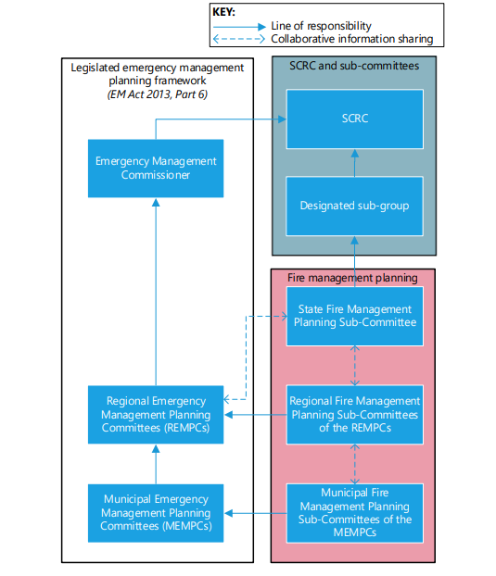
Figure 1 - Interface of fire specific planning with Victoria’s all-emergencies planning framework (pg 26 SEMP - Bushfire Sub-Plan)

2.3 Plan Amendment, Monitoring and Review
The Maroondah MFMPSC will review this plan:
- Annually in association with the MEMP.
- Following significant incidents if required.
- As directed by the State or Regional Fire Management Planning Sub-Committees.
- As required by legislation.
- As further works are completed by the MFMPSC.

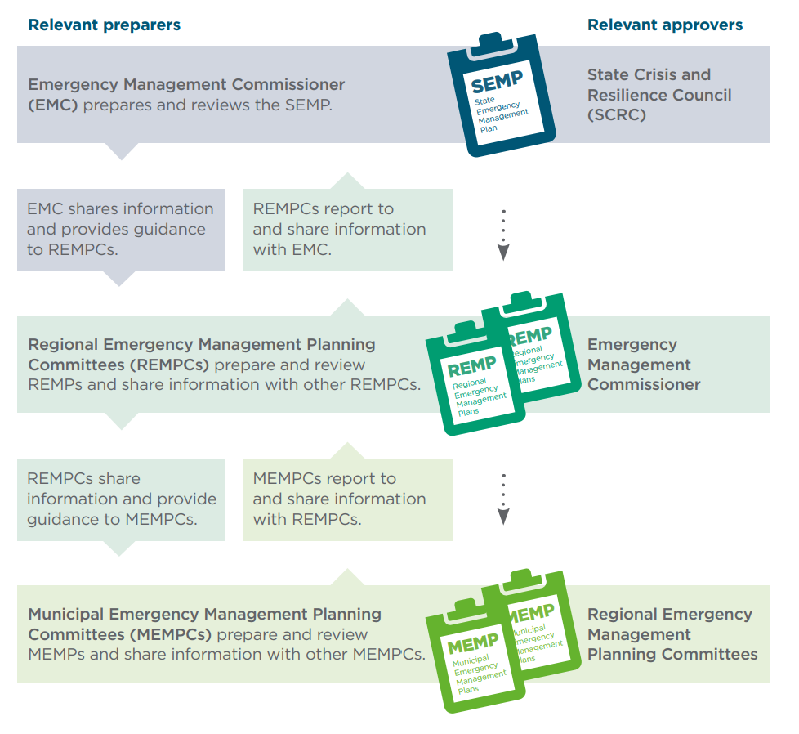
Figure 2 - Framework for emergency management Planning (SEMP, Page 15)

2.4 Reporting
Objectives, actions and measures included in this plan will be reported to the MEMPC at each half yearly meeting. Reports will be provided to the Regional Strategic Fire Management Planning Sub Committee (RSFMPSC) as required.

3. VISION, MISSION AND OBJECTIVES

3.1 Vision
Active partnerships with our community, emergency services and local government, working together; to reduce the destructive impact of fire on communities and the environment and strengthen community resilience to the effects of fire by providing a greater understanding of fire management planning within the community and for the environment.

3.2 Mission
Agencies working together with communities to reduce the impact of fire. This will be achieved by the following objectives.

3.3 Objectives
Approaches to emergency management are framed by the assessment of risk. This includes an analysis of the risks and identification of options for positive change. It places greater emphasis on addressing underlying causes and seeking long-term, sustainable solutions that incorporate the essential elements of emergency management and to minimize the occurrence and mitigate the impacts of bushfire, grass fire, structural and chemical incidents in the community. The objectives of this plan are:
- Lead fire management planning across the Maroondah municipal area.
- Develop the municipal fire management sub plan based on shared knowledge.
- Work with the community to reduce the negative impacts of fire to strengthen resilience, enhance on risk and assist recovery.
- Ensure effective community engagement about fire management planning; and commit to continuous improvement.
- For each of these objectives there is a goal set and an action defined in order to achieve these goals. This information is presented in the action plan located in Appendix A.

3.4 Alignment with regional objectives
The development of the vision and mission for the Maroondah MFMSP were guided by the Regional Strategic Fire Management Sub-Plan vision and mission. The Regional vision aligns with the State vision.

Fire management in the Eastern Metropolitan Region that delivers:
- Active participation of community, the sector and government working together in fire management planning to reduce the destructive impact of fire on communities and the environment
- Communities that are resilient to the effects of fire
- Greater understanding of the fire sector within the community; and
- Healthy natural, social, built and economic environments.

Eastern Metropolitan Region Strategic Fire Management Sub- Plan mission:
Agencies of the Eastern Metropolitan Region working together with communities to reduce the impact of unplanned fire. The Region will achieve this by the following key themes:
- Committee becomes the driver (lead body) for fire management planning across the region.
- Building and using knowledge of Council, partner agencies and community.
- Working with the community to manage fire.
- Delivering cross tenure outcomes that address fire risk at a local, landscape and regional level.
- Effective communications and marketing regarding fire management.
- Continuous improvement.
- Identifying and treating significant natural, social, built and economic environments at risk from fire.

4. ENGAGEMENT AND COMMUNICATION

4.1 Engagement Process
Community participation is an integral part of risk management. The engagement plan used identifies key stakeholders and the level, method and timing of the stakeholder engagement for this plan and has been developed using International Association for Public Participation Australasia (IAP2) principles. These principles are as follows:

Inform
Provide appropriate detailed and accurate information to assist stakeholders develop a shared understanding of the complexity of issues, alternatives and possible solutions.

Consult
Utilise stakeholder expertise and diversity to obtain input into analysis, alternatives and develop key decisions.

Involve
Work directly with the suite of key stakeholders throughout the various processes to ensure key issues and intent are understood and considered.

Collaborate
Partner with key stakeholders in each aspect of decision making. This includes the development of alternatives and the identification of contributions and priority actions with a clear understanding of the responsibilities of each stakeholder.

Empower
Foster and promote transparent and accountable processes that allow each stakeholder organisation to empower themselves through key actions and the implementation of responsibilities.

4.2 Stakeholder Analysis
Stakeholders for this Plan have been grouped into three categories according to their chosen level of participation in fire management planning and their information requirements. The three engagement categories are:
- Primary (permanent MFMPSC members)
- Secondary (attend MFMPSC by request) and
- Other stakeholders/interested groups that could benefit from an awareness of this plan

4.3 Community Engagement Principles
The MFMPSC recognises the value of local knowledge and the unique contribution the community can make to local fire management planning.
Effective community engagement in fire management planning is required to:
- Promote acceptance, understanding and joint problem solving
- Raise knowledge and skills of fire management through participation
- Produce plans that support community and organisational expectations; and
- Incorporate community and organisational needs into the development of fire management sub plans.

4.4 Community and Organisational Engagement Process
The ability of a community to respond to a fire situation and in turn recover from the effects of a fire will depend on the attitude of the people affected. Obtaining the preferred response from people during fire incidents will require community and organisational engagement, education, and awareness programs to be implemented for this purpose.

This MFMSP aims to collate and integrate the fire agencies and Council prevention and awareness programs within Maroondah. This Plan details the process to be undertaken in relation to stakeholder engagement and communications including the implementation of the MFMSP Actions (Refer Appendix A).

4.5 Outcomes
The desired outcomes from the community and organisational engagement process are:
- Relevant stakeholders are engaged at the appropriate stage of plan development and actively participate in shaping and implementing this plan.
- The roles and responsibilities of individuals, agencies and government in preparing for fire and improving people’s safety are well understood.
- Agency fire management activities are better integrated and coordinated with Maroondah City Council activities.
- Community knowledge and understanding of fire risks and fire management in Maroondah is significantly increased; and
- This plan supports or is revised to support community and organisational needs.

5. SUMMARY OF THE ENVIRONMENTAL SCAN

5.1 Summary
Maroondah is located in Melbourne's eastern suburbs, about 25 kilometres from the Melbourne CBD. Maroondah is bounded by Manningham in the north, Yarra Ranges in the east, Knox in the south, and Whitehorse in the west.

Maroondah includes the suburbs of Bayswater North, Croydon, Croydon Hills, Croydon North, Croydon South, Heathmont, Kilsyth South, Ringwood, Ringwood East, Ringwood North and Warranwood.

Maroondah is a predominantly residential area with some commercial, industrial and semi-rural areas and substantial parklands. The city encompasses a total land area of about 61 square kilometres. Established residential areas are located along the major transport routes and railway lines, while newer residential areas are located in the northern and south-eastern peripheries.

Maroondah is an Aboriginal word meaning "leaf".

Municipal Location Map

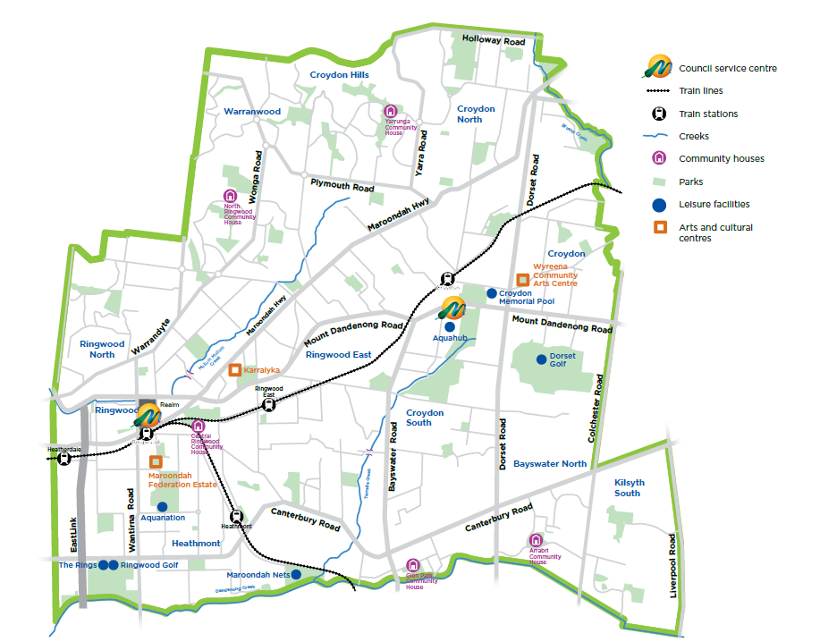
Further information can be found on Maroondah’s website.

5.2 Population and Demographic Information
The City of Maroondah Estimated Resident Population for 2022 is 115,645 with a population density of 1,884 persons per square km. There is a diverse mix of living styles from large acreages to apartment style residential development. Cultural diversity is increasing with the highest numbers of recent overseas immigrants arriving from Burma (Myanmar), China, India, Malaysia and Sri Lanka.

For a full breakdown of Maroondah demographics follow links to the Maroondah’s website or Profile ID.

5.3 History of fires in the municipal area
Bushfires
Over the years there have been many threats of bushfire to the municipality. A bushfire in January 1913 burnt between Warrandyte and Ringwood and several houses were damaged. In 1927 bushfires threatened properties in the northern area and crossed Maroondah Highway and threatened homes on the southern side of the highway down to the railway line, Croydon.

In 1962 there were fires that circled around Croydon and Ringwood townships. To our knowledge there was no reported damage to buildings during this fire. In November 1967 to March 1968 there were major fires through the state, Croydon and Ringwood were again encircled by the bushfires.

Bushfires in February 2009 impacted many areas of Victoria resulting in many lives lost. Maroondah, though not affected directly by the fires did provide resources to Councils affected.

6. RISK ASSESSMENT

6.1 Risk Assessment Process
To determine the bushfire risk within Maroondah municipal area, four main risk assessment methods were used:
- Victorian Fire Risk Register (VFRR-B)
- Community Engagement Risk Assessment (CERA)
- Bushfire Management Overlay mapping
- Bushfire Prone Area Mapping
- VERMS - Victorian Emergency Risk Management System

6.2 Victoria Fire Risk Register - Bushfire
The Victorian Fire Risk Register (VFRR-B) application is a systematic process that identifies assets at risk of bushfire on a consistent state-wide basis using the Australian/New Zealand Risk Management Standard ISO:31000 2009.
The aim of the VFRR-B is to minimise the risk of adverse impact of bushfires on assets and values in human settlement, cultural heritage, economic and environmental contexts.

The objective of the VFRR-B is to:
- Identify and rate bushfire risks to assets
- Identify current mitigation treatments to manage the risk
- Identify the agencies responsible for implementing mitigation treatments and strategies
- Produce an integrated document and risk register across responsible agencies; and
- Support and inform planning at a local level.
The primary outputs of the VFRR-B process are a series of maps displaying assets at risk, plus a municipal bushfire risk register, listing the risk rating for each asset and current risk mitigation treatments.

6.3 Community Emergency Risk Assessment (CERA)
The CERA process is designed to systematically identify hazards, determine risks and prioritise actions to reduce the likelihood and effects of an emergency. A working group of the MEMPC including Council staff and key stakeholders from the major emergency service/support organisations have identified the top eight risks in the municipal area including bushfire large and small and Fire residential – multi occupancy.

The group considered emergency risk within the following context using the International Standard ISO 31000:
- Whole of community perspective
- Responsibility for the whole municipality
- Consideration of events which require multi-agency responses
- Consideration and acknowledgement of existing controls
- Mitigation activities and their effectiveness, and
- Subsequent level of risk.

6.4 Bushfire Management Overlay and Bushfire Prone Area
The following two planning controls are used to inform risk identification and prioritisation of delivery of treatment programs for bushfire in Maroondah.

Bushfire Management Overlay
The Bushfire Management Overlay (BMO) is established under the Victorian Planning Provisions, mapping developed by the State government and administered by local government identifies land in Victoria that may be at risk from bushfire. Land identified in the local planning scheme may require a planning permit to develop or subdivide.

Bushfire Prone Area
Bushfire prone areas (BPA) are designated under Regulation 810 (Building Regulations 2006) as areas that are subject to or likely to be subject to bushfires. This building control aims to regulate the constructions standards of residential buildings depending on the level of risk posed to the planned dwelling. Properties in designated BPAs will require Bushfire Attack Level assessment and minimum constructions standards apply.

6.5 Victorian Emergency Risk Management System (VERMS)
The VERMS provides a sound platform for conducting a structure fire risk assessment which is clearly defined by a robust 10 step process. The VERMS tool uses the methodology recognised in the National Emergency Risk Assessment Guidelines (NERAG) which is underpinned by ISO31000, the International Standard for Risk Management.

6.6 Responsible Agencies
This Plan brings together all agencies with legislative responsibility for fire management to collectively work together with the community to effectively and efficiently prepare for, respond to and recover from fire. Whilst the emphasis is currently on bushfire within the Maroondah area, it is envisaged that chemical and structural fire elements will be added as the risk assessment tools for these areas are developed.

Key Agencies
Agency | Responsibilities
Country Fire Authority (CFA) | Emergency service agency that prevents and responds to bushfires, structural and chemical fires, road accidents, rescues and other emergencies
Department of Energy, Environment and Climate Change (DEECA) | Responsible for fire suppression and preparedness on public land in coordination with Parks Victoria
Fire Rescue Victoria (FRV) | Responsible for fire management and response in the metropolitan area as well as conducting broader activities with communities such as education and fire investigation
Metro Trains | Metro trains operates Melbourne train network. The train network has 15 lines and 212 train stations servicing more than 200 million customer journeys per year.
Parks Victoria (Parks Vic) | Responsible for managing and expanding Victoria’s parks network
Department of Transport and Planning (DTP) | Manages the Victorian arterial road network and its use as part of the overall transport system
Victoria Police (VicPol) | Provide 24 hour police service to the Victorian community. VicPol is also responsible for the effective coordination of resources or services in emergencies and for the relocation/evacuation, and registration of evacuees in conjunction with Red Cross
AusNet Services | Manages electricity transmission and electricity and gas distribution.
VicTrack | VicTrack is the owner of Victoria railway land and infrastructure which is leased to public transport operators.
Yarra Valley Water | Is the largest of Melbourne’s three retail water businesses providing water supply and sewerage services over 1.6 million people and over 50,000 businesses in the northern and eastern suburbs of Melbourne

6.7 Treatment of Risk
The State fire management priorities are underpinned by the primacy of life and the protection of property, the economy and the environment. These priorities inform and are integrated into the primary fire risk management strategies used in this plan, which are:
- Community education and engagement
- Hazard reduction
- Preparedness; and
- Regulatory controls.

In addition to these recommended municipal strategies, there are a number of state-wide and municipal treatments that have been identified for each fire risk management strategy, which can be used by agencies to reduce the risk and effect of fire on the community. The generic state and municipal treatments include:
- Community education and engagement activities such as community forums, festival, website and other agency events and media releases
- Public awareness – multimedia communications
- Fire hazard inspection program and issue of fire prevention notices
- Legislative compliance and enforcement
- Bushland assessments with CFA/FRV
- Bushland Management Plan
- Electric Line Clearance Plan
- Building code of Australia
- Permits to burn; and
- Local laws.
To effectively reduce community vulnerability to fire will require more than inter-agency effort alone. It will require more self-reliant and self-aware communities that have the knowledge, motivation and capacity to manage risks to reduce the threat of fire and that work as active partners with fire management agencies.

6.8 Hazardous Trees/Electric Line Clearance
The Electricity Safety Act 1998 (Victoria) (ES Act) Division 2A provides the obligation for municipal councils Municipal Emergency Management Plans must specify procedures for the identification of trees that are hazardous to electric lines”. This will be achieved through:
- Procedures and criteria for the identification of trees that are likely to fall onto, or come into contact with, an electric line (hazardous trees); and
- Procedures for the notification of responsible persons of trees that are hazardous trees in relation to electric lines for which they are responsible.
A hazardous tree, according to the ES Act, is a tree which ‘is likely to fall onto, or come into contact with, an electric line’. Responsibility is allocated between distribution businesses and other owners of electricity infrastructure, land owners and occupiers for clearance of private power lines, public land managers, where they are identified as the responsible person such as municipal councils, the DEECA and DTP.
Councils are responsible for trees on public land within their municipalities, for which they are the land manager, that are within a Declared Area for the purpose of the ES Act. Primary responsibility for vegetation clearance and management within the municipality, for areas which are not within the Declared Area, will usually fall to the relevant electricity distribution company.
Maroondah’s Electric Line Clearance Plan is available on Councils website.

6.9 Neighbourhood Safer Places (NSPs)
Maroondah municipal area does not have any designated Neighbourhood Safer Places.

Following recommendation from the MFMPSC, Maroondah municipal area has no nominated Neighbourhood Safer Places. An assessment of likely need indicated the following:
- Maroondah municipal area is at relatively low risk of bushfire.
- No suitable sites were available in areas most likely to be impacted by fire (e.g. on Northern boundary).
- Neighbourhood Safer Places located in the FRV Districts were not deemed as appropriate.
- More appropriate and accessible facilities such as shopping centres, libraries and other community facilities would be available in preference to a Neighbourhood Safer Place.
- In the event that fire impacted significantly on Maroondah or neighbouring municipalities, Maroondah City Council would likely activate relief centres.

6.10 Individual Bushfire Risk Treatments
Vegetation Management Rights
Native vegetation is important to many Victorians and its removal is carefully regulated by both State Planning controls and Local Planning Schemes. Local schemes include Significant Landscape Overlays (SLO) and Vegetation Protection Overlays (VPO).
Local Laws and Permit to Burn
Under Maroondah City Council’s Local Laws, a fire may not be lit or remain alight in the open air without a permit, and the requirements of the Fire Danger Period and Total Fire Bans must be complied with.
During the declared Fire Danger Period, limited permits may be obtained by individuals to conduct a fuel reduction or stubble burn within the municipal area. These permits are issued by Maroondah City Council under authority of the CFA Act. These permits contain stringent conditions that must be complied with.
Further information about local laws and permits may be obtained from the Maroondah City Council website www.maroondah.vic.gov.au.
Inspection of Private Properties and Issue of Notices
Maroondah City Council will conduct fire hazard inspections within the municipality, concentrating on high risk areas. Fire prevention notices will be issued on land considered to be a fire risk as soon as practicable upon declaration of Fire Danger Period.
Planning Permits
When applications are lodged with Maroondah City Council for permits under the Planning and Environment Act for the subdivision of land or the construction of buildings in areas of fire risk, the Council may give consideration to the Planning Guidelines for Subdivisions in bushfire-prone areas in determining any such application, and also refer the application to the relevant fire agencies for comment.

APPENDIX A: RISK MANAGEMENT ACTION PLAN

- To lead fire management planning across the municipal area
No. | Objective | Actions | When | Who | Measures
1.1 | Integrate fire management planning with broader emergency management planning | Maintain cross membership of the MFMPSC and MEMPC and the RSFMPSC and build improved relationships across agencies | Ongoing | MEMPC  MFMPSC | Committee representatives attend MEMPC and RSFMPSC and cross border meetings including participation in multi-agency exercises and engagement activities.
 |  | Participation in the Community Engagement Risk Assessment (CERA) process | Ongoing | CERA Risk Management working group | MEMPC and MFMPSC members participate in the CERA risk review process.
1.2 | Establish processes to ensure committee stay abreast of changes in policy, legislation and strategies | Meetings of MEMPC and MFMPSC | Ongoing | MEMPC and MFMPSC | Meetings held as per terms of reference with associated correspondence including minutes and agenda’s distributed.  The Maroondah Municipal Fire Management Sub Plan is available to the committee, community and stakeholders

2. Manage and reduce the risk of fire
No. | Objective | Actions | When | Who | Measures
2.1 | Regulate fire use and other ignition sources. | Regulate burning off during Fire Danger Period using Schedule 12, 13 &14 MCC permits as required. | As Required | MCC  CFA | Report received including details of permits issued, compliance/infringement notices and burning offs attended
2.2 | Coordinate fuel modification activities around power lines in line with current legislation and guidelines. | Manage vegetation in proximity to electricity and distribution lines including hazard trees in accordance with MCC Electric Line Clearance Management Plan. | Ongoing | Ausnet Services  MCC  ESV  Metro Trains | Maroondah Electric Line Clearance Management Plan is reviewed annually.  Metro Trains Electric Line Clearance Plan.  Proactive tree inspection completed in accordance with the program.
2.3 | Ensure vacant land is maintained to minimise fire risk. | Undertake vacant land inspections and provide educational advice. | Dec-Mar | MCC | Engagement with the Community prior to each fire season.  Report received regarding vacant land inspections completed.  Compliance/infringement notices issued, and contractors engaged.
2.4 | Development and maintenance of operation pre-plans for high life risk accommodation buildings | Inspection program for high life risk accommodation buildings to ensure relevant fire safety regulations are complied. | Ongoing | MCC (MBS)  FRV  CFA | Pre-plans established and number of inspections completed.
2.5 | Support initiatives and actions that prevent deliberate and accidental ignition of fires. | Support Fire Awareness programs  Fuel reduction initiatives undertaken at high fire risk locations. | Ongoing | FRV  VicPol  CFA  MCC | Problem areas identified.  Offenders identified.  Community information delivered.  Fuel reduction activities planned and undertaken.

3. Working with community to strengthen resilience, engage on risk and assist recovery
No. | Objective | Actions | When | Who | Measures
3.1 | Publicise the introduction and meaning of the Fire Danger Period | CFA/FRV Media Campaigns including targeted areas. | Annually | CFA  FRV  MCC | Articles and activities published.  Calendar for fire season ie. Maroondah news, website, social media, letter drops in high-risk areas.
3.2 | Regulate fire use and other ignition sources and promote safe practices | Publicise the introduction and meaning of the Fire Danger Period  Educate residents of fire safety using Fire Ready Victoria strategy based on the VFRR data. | Annually | CFA, FRV, MCC | Each agency has provided a report regarding the works completed at conclusion of Fire Danger Period.  Each agency has provided a report on initiatives implemented.
3.3 | To identify and manage risk to community regarding matters associated with hoarding and squalor | Continue to support hoarding and squalor intervention programs by working with engaged stakeholders to provide the best possible outcomes. | Ongoing | MFMPSC  MCC  FRV | Feedback on notification programs for hoarding properties and at risk register and update from the Maroondah Hoarding and Squalor network committee representative.

APPENDIX B TERMINOLOGY

Agencies | Refers to the agencies of the Municipal Fire Management Planning Committee.
Bushfire | A general term used to describe fire in vegetation, including grass fire.
Fire Management | All activities associated with the management of fire (bushfire, structural, chemical) including the use of fire to meet land management goals and objectives. In simple terms, ‘fire management’ is Prevention, Preparedness, Response and Recovery as well as use of fire for ecological, agricultural and cultural purposes.
Preparedness | All activities undertaken in advance of the occurrence of the incident to decrease the impact, extend and severity of the incident and to ensure more effective response activities.
Prevention | All activities concerned with minimizing the occurrence of incidents, particularly those of human origin.
Recovery | The coordinated process of supporting emergency affected communities in reconstruction of the physical infrastructure and restoration of emotional, social, economic and physical wellbeing.
Response | Actions taken in anticipation of, during and immediately after an incident to ensure that its effects are minimized and that people affected are given immediate relief and support.
Risk Assessment | The overall process of risk identification, risk analysis and risk evaluation.
Risk Environments | There are four types of risk environments based on the VFRRs risk tool which are human settlement, economic, environment and cultural heritage.
Risk Identification | The process of determining what, when, why and how something could happen.
Victorian Fire Risk Register (VFRR) | The Victorian Fire Risk Register is a systematic map based process that identifies assets, assesses assets and provides a range of treatments which contribute to the wellbeing of communities and the environment, which suffer the adverse effects of bushfire.
Vulnerability | The susceptibility of an asset or community to the impacts of fire.

APPENDIX C: ATTACHMENTS

- Municipal Emergency Management Plan - Maroondah City Council website
- Victorian Fire Risk Register
- Information available via VFRR website
- MEMP CERA Risk Matrix
- Information via the SES CERA website
- Maroondah Electric Line Plan
- Available on Maroondah City Council website
- CFA - Community Information Guide on the CFA Website

