# ­­­Table of contents

Table of contents 1

List of tables 3

List of figures 4

SECTION 1: INTRODUCTION 5

1.1 Local context 5

1.2 Project background 6

1.3 Project methodology 6

1.4 Stadium sport in Maroondah - quick facts 7

SECTION 2: COUNCIL POLICY CONTEXT 8

SECTION 3: EXISTING PROVISION 25

3.1 Council stadium facilities 25

3.2 Basketball 25

3.3 Netball 30

3.4 Volleyball 32

3.5 Badminton, Pickleball and Table Tennis 34

3.6 Major stadium facilities near Maroondah 36

SECTION 4: MARKET ASSESSMENT 38

4.1 Maroondah population overview 38

4.2 Demographic overview 38

SECTION 5: SUPPLY AND DEMAND ASSESSMENT 41

5.1 Sports participation 41

5.2 Current capacity of school sporting facilities in Maroondah 57

5.3 Non-Maroondah sporting facilities 58

5.4 Facility provision 59

SECTION 6: CONSULTATION 62

6.1 Consultation overview 62

6.2 Consultation with Associations 62

6.3 Community consultation 64

SECTION 7: IDENTIFIED NEEDS 66

7.1 Five-year participation projections 66

7.2 Breakdown of basketball and netball projected participants 66

7.3 Individual sporting needs 67

7.4 Overall needs for stadium sports 69

SECTION 8: FUTURE OPPORTUNITIES 70

8.1 Opportunities to maximise capacity and increase participation 70

8.2 Opportunities to partner with other Councils 70

8.3 Opportunities to partner with schools 70

8.4 Opportunities with Council facilities 71

SECTION 9: RECOMMENDATIONS 72

# ­­­

# List of tables

Table 1: Population projections 2021-2036 38

Table 2: 2021 breakdown of sports participation 56

Table 3: School sporting facilities in Maroondah 57

Table 4: Non-Maroondah sporting facilities 58

Table 5: Facility provision comparison (2017-2023-2026) 59

Table 6: Facility provision to population ratio (2023 to 2026) 60

Table 7: Population to facility provision (ratio) 61

Table 8: Projected change in estimated participants for stadium sports in Maroondah (2021 to 2025)

Table 9: Projected change in estimated participants by activity for adults (2021 to 2025) 67

Table 10: Projected change in estimated participants by activity for children (2021 to 2025) 67

Table 11: Recommendations 73

# List of figures

Figure 1: Maroondah location map 4

Figure 2: Maroondah basketball competition and training venues 26

Figure 3: Basketball Victoria members that live in Maroondah 27

Figure 4: Basketball Victoria members that live in Yarra Ranges 27

Figure 5: Maroondah netball competition and training venues 30

Figure 6: Volleyball venues 32

Figure 7: Badminton, Table Tennis and Pickleball venues 34

Figure 8: Major stadium facilities near Maroondah 36

Figure 9: Forecast age structure for Maroondah 2021-2031 38

Figure 10: Badminton participation – AusPlay (adults) 41

Figure 11: Badminton – five-year projections 42

Figure 12: Basketball participation rates 2018-2021 (AusPlay and Maroondah) 43

Figure 13: Basketball – female participation in Maroondah (2018-2021) 44

Figure 14: Basketball – male participation in Maroondah (2018-2021) 44

Figure 15: Basketball – gender diverse participation in Maroondah (2018-2021) 44

Figure 16: Basketball – five-year projections 45

Figure 17: Netball participation rates 2018-2022 (AusPlay and Maroondah) 46

Figure 18: Netball – female participation in Maroondah 47

Figure 19: Netball – male participation in Maroondah 47

Figure 20: Netball – gender diverse participation in Maroondah 47

Figure 21: Netball – five-year projections 48

Figure 22: Pickleball – five-year projections 50

Figure 23: Table tennis – five-year projections 52

Figure 24: Volleyball Victoria members (2017-2022) 53

Figure 25: Maroondah Volleyball Association participation 2021 53

Figure 26: Volleyball – five-year projections 54

# 

# SECTION 1: INTRODUCTION

#### 1.1 Local context

The City of Maroondah covers a land area of 61.4 square kilometres in Melbourne’s outer east, 22 kilometres from the Central Business District (CBD). The area is a substantially developed peri-urban residential municipality, with an estimated population of 118,833 residents and 46,933 households with an average of 2.53 people per household.

The City of Maroondah includes the suburbs of Bayswater North, Croydon, Croydon Hills, Croydon North, Croydon South, Heathmont, Kilsyth South, Ringwood, Ringwood East, Ringwood North and Warranwood. It also includes small sections of Kilsyth, Park Orchards, Vermont and Wonga Park

With little remaining land available for greenfield residential development, future population growth will be mainly stimulated by housing consolidation and medium density development.

Over 9,500 businesses operate within the City with small business comprising over 96 percent of these organisations. The majority of businesses are in the construction, property and business services, finance and insurance, retail trade and manufacturing sectors. The largest industry employers are the manufacturing, retail trade and health care sectors. In total, businesses in Maroondah provide employment for 44,630 people.

There is a strong sense of community participation within Maroondah which is embodied by a large number of committed volunteers. More than two thirds of parents in Maroondah are actively involved in their local schools and one third of Maroondah’s residents are members of organised community groups.

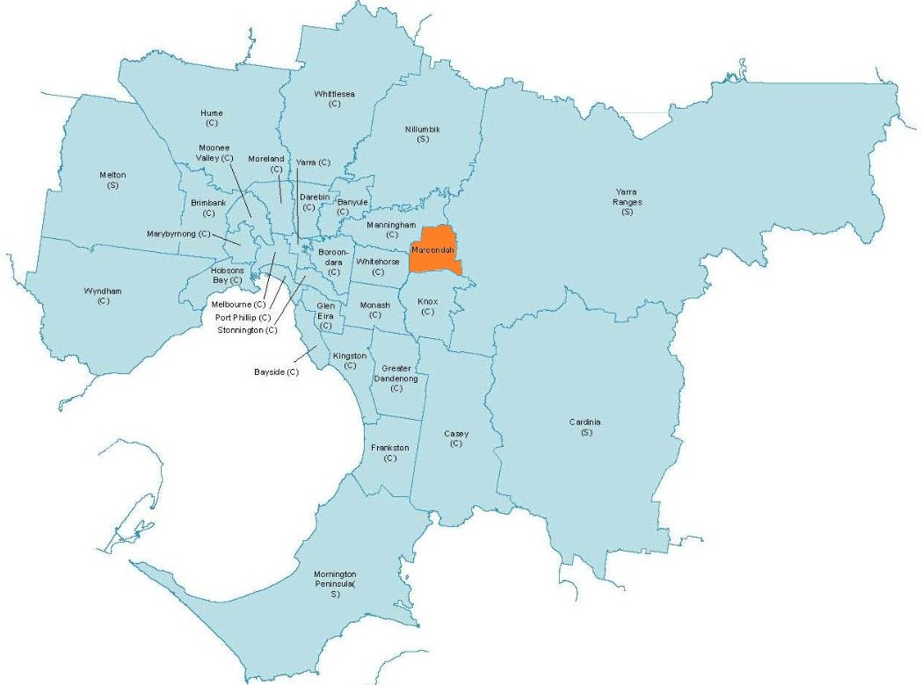Figure 1: Maroondah location map

#### 

#### 1.2 Project background

The Maroondah Sport Demand Analysis 2017 included a recommendation to review the need for additional basketball and netball courts, or additional use of existing courts.

This strategy will address this recommendation, and will also include badminton, pickleball, table tennis and volleyball, to provide an overall strategy for stadium sports in Maroondah.

The strategy will look at existing stadium facilities in Maroondah and surrounding LGA’s, and identify any additional stadium facilities that will be required in the next 10 years to meet the demand for stadium sports in Maroondah.

#### 1.3 Project methodology

The following tasks were undertaken in the preparation of this study:

* Review of relevant strategic documents;
* Review of demographic data;
* Review of relevant local, regional, state and national participation data;
* Consultation with sporting clubs, state and regional sporting associations, Council staff, schools and other LGA’s;
* Mapping of existing provision;
* Assessment of the current capacity of stadium facilities in Maroondah;
* Five-year usage projections;
* Gap analysis;
* Explore opportunities to increase capacity at existing sites;
* Understand possible future locations for multi court stadiums;
* Explore opportunities for potential school or Council partnerships; and
* Preparation of a Draft Report.

#### 1.4 Stadium sport in Maroondah - quick facts

# 

**Impact of COVID on sport in Maroondah** – Maroondah has bounced back well from COVID, with a 15.5% participation rate in 2019, 11.7% in 2020 and 15.3% in 2021.

Source: Vic Health ‘Sport participation in Victoria 2015–2021. The impact of COVID-19 and the recovery of participation in sport’

**Sport in Maroondah** - in 2021 Maroondah was ranked as the 7th highest LGA in metro Melbourne for participation in sport, and had the highest sport participation in the Eastern suburbs (57%)

**Sport participation** – 51% of all sport participants are aged between 4 and 14 years old, with participation being the highest in the 10- to 14-year-old age group (57%)

# SECTION 2: COUNCIL POLICY CONTEXT

This section of the report provides an overview of the local policy context in relation to the provision of sport in Maroondah and surrounding LGA’s, as well as strategic priorities from State Sporting Associations. Documents that have been reviewed include: -

* Maroondah 2040 Community Vision – our future together;
* Maroondah City Council Plan 2021-25 (2022-23 update);
* Maroondah Liveability, Wellness and Recovery Strategy 2021-2031;
* Maroondah City Council Physical Activity Strategy 2015-2020;
* Maroondah Sports Demand Analysis 2017;
* Maroondah Equally Active Strategy 2019;
* Maroondah Golf Strategy 2020-2030;
* Maroondah Disability Action Plan 2022-2026;
* Maroondah City Council Youth Strategy 2017;
* Maroondah Positive Ageing Framework and Action Plan 2021-2025;
* Maroondah Sustainability Strategy 2016-2020;
* Melbourne East Regional Sport and Recreation Strategy 2022-2032;
* Active Victoria – A Strategic Framework for Sport and Recreation in Victoria 2017-2022;
* Victorian State Government – Design for Everyone Guide (cited online May 2022);
* Victorian State Government – Female Friendly Sport Infrastructure Guidelines (cited online May 2022);
* Basketball Victoria – 2022 – 2024 Strategic Plan (summary document) and Basketball Victoria Facility Infrastructure priorities 2022;
* Badminton Victoria – Strategic Plan 2021 – 2025;
* Netball Victoria – Strategic Plan 2019-2022;
* Table Tennis Victoria – Strategic Plan 2019-2022;
* Volleyball Victoria – Strategic Plan 2021-24 (draft);
* City of Whitehorse Recreation Strategy 2015-2024;
* City of Whitehorse Indoor Stadium Facility Feasibility 2020;
* City of Whitehorse – Draft Strategic Partnerships Framework August 2021;
* City of Manningham – Active for Life Recreation Strategy 2010–25 (reviewed 2019);
* City of Yarra Ranges – Recreation and Open Space Strategy Implementation Plan 2013 -2023.

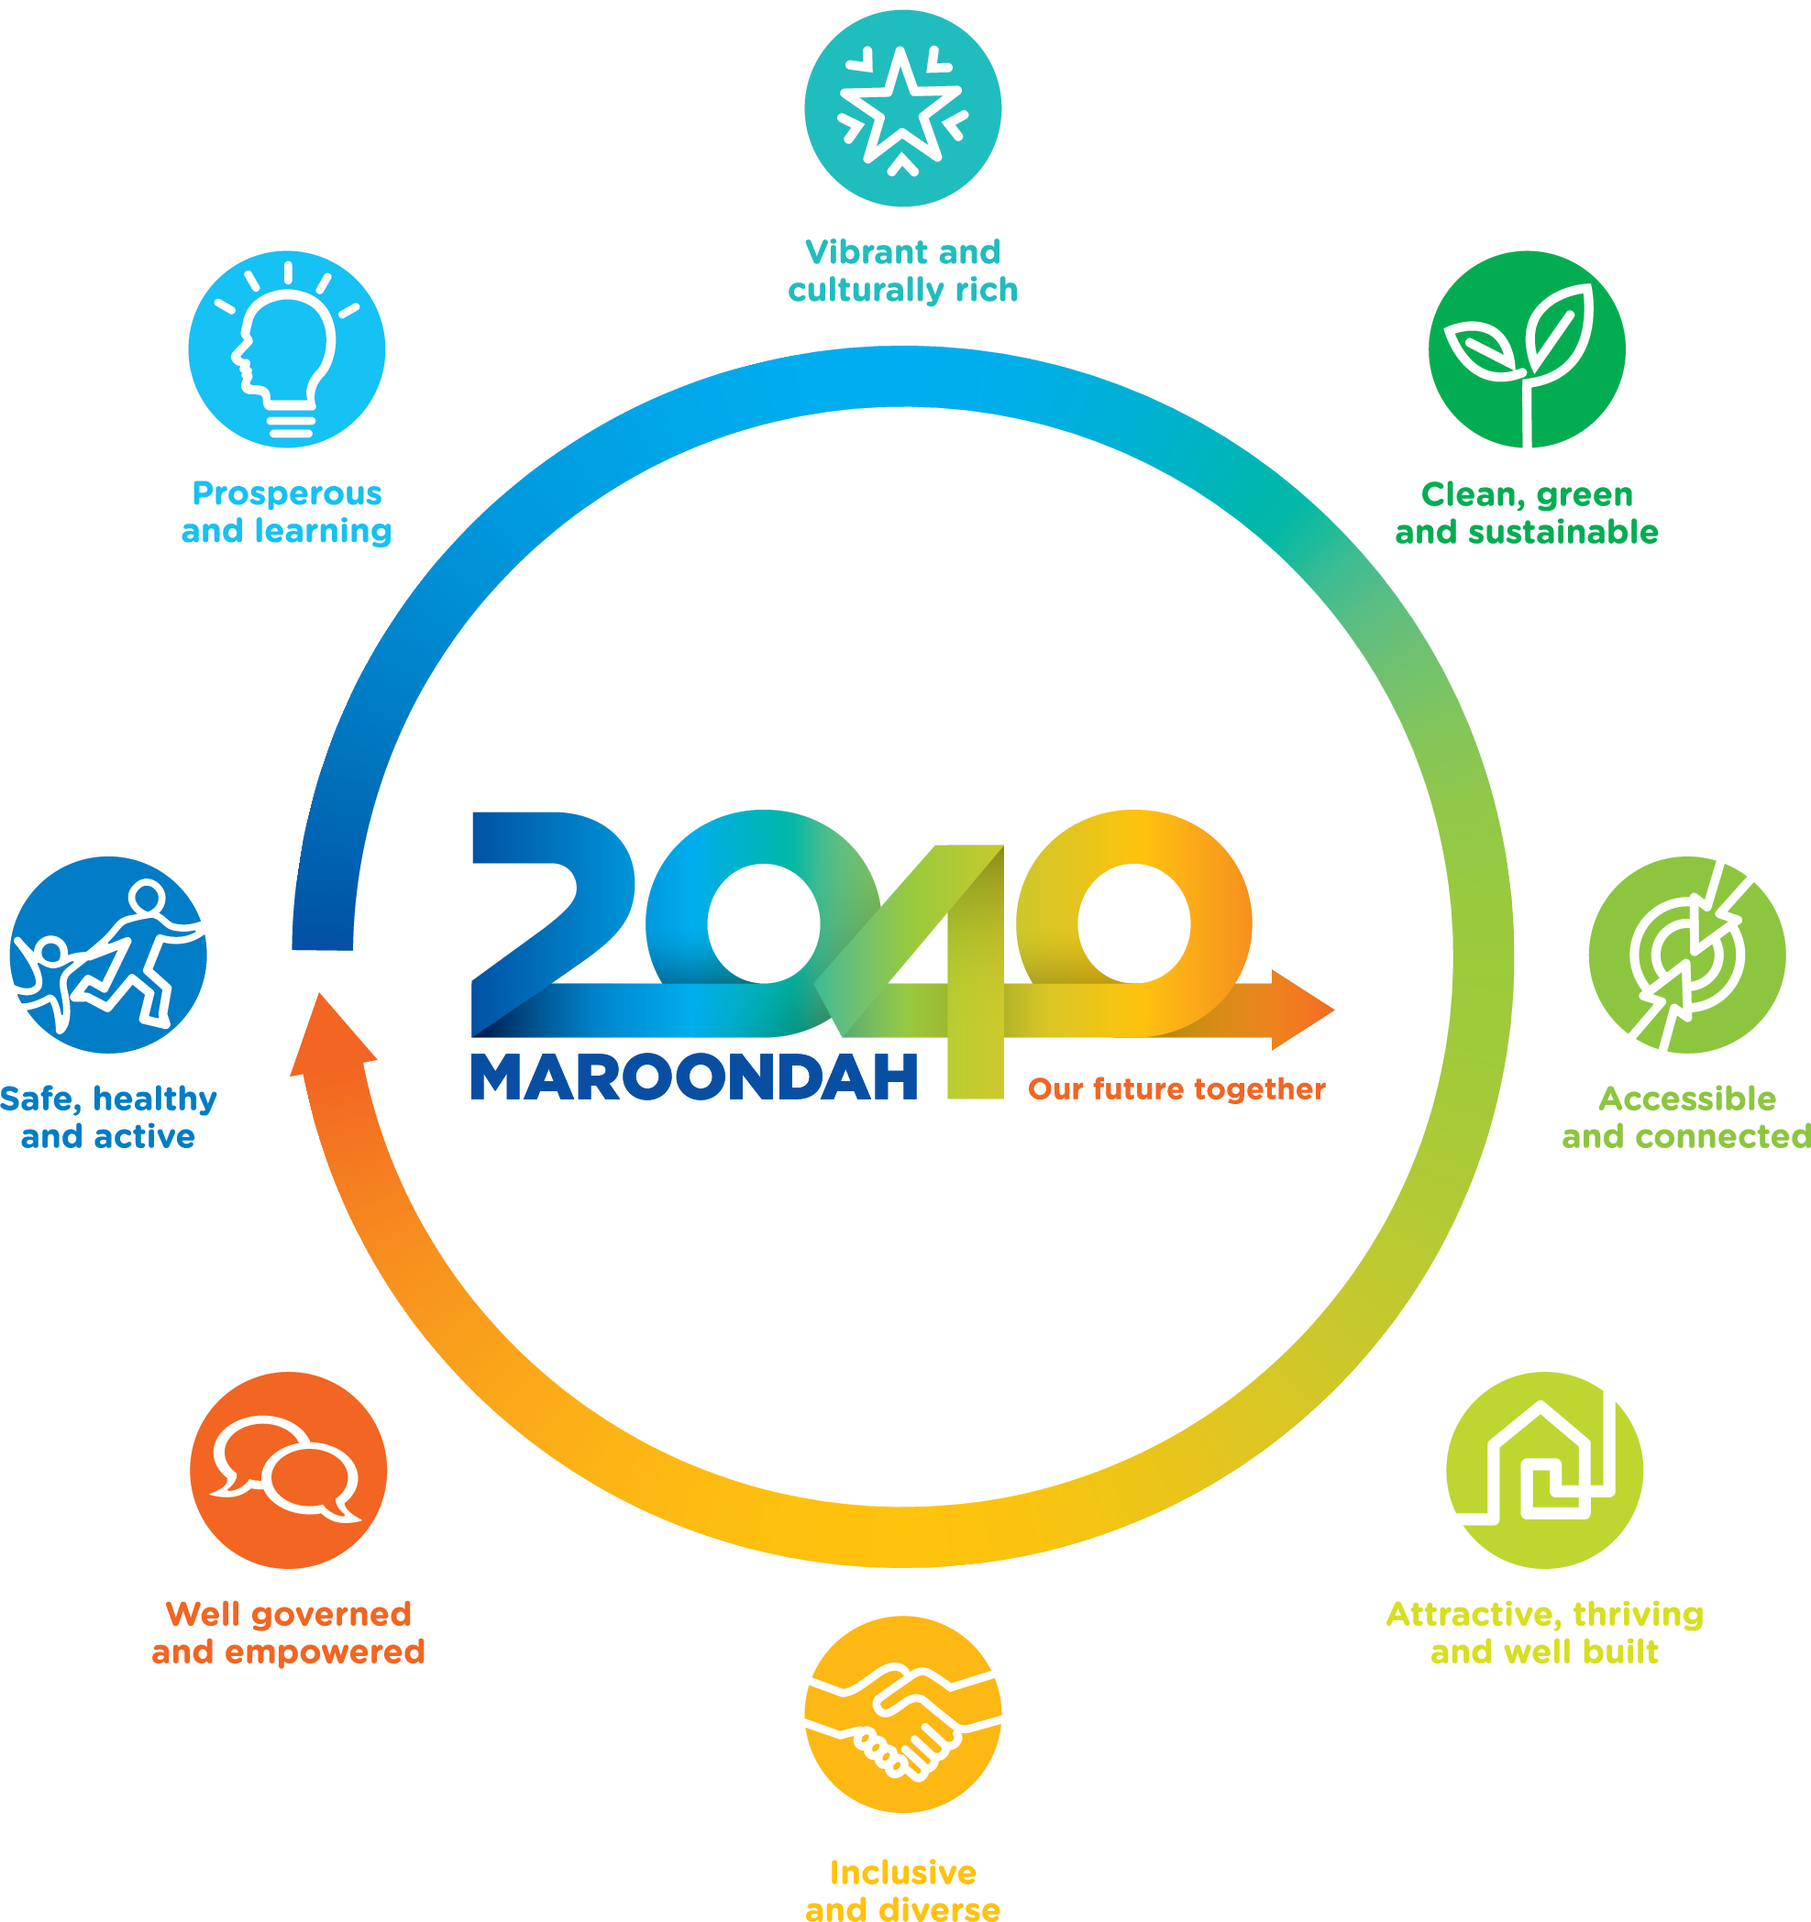

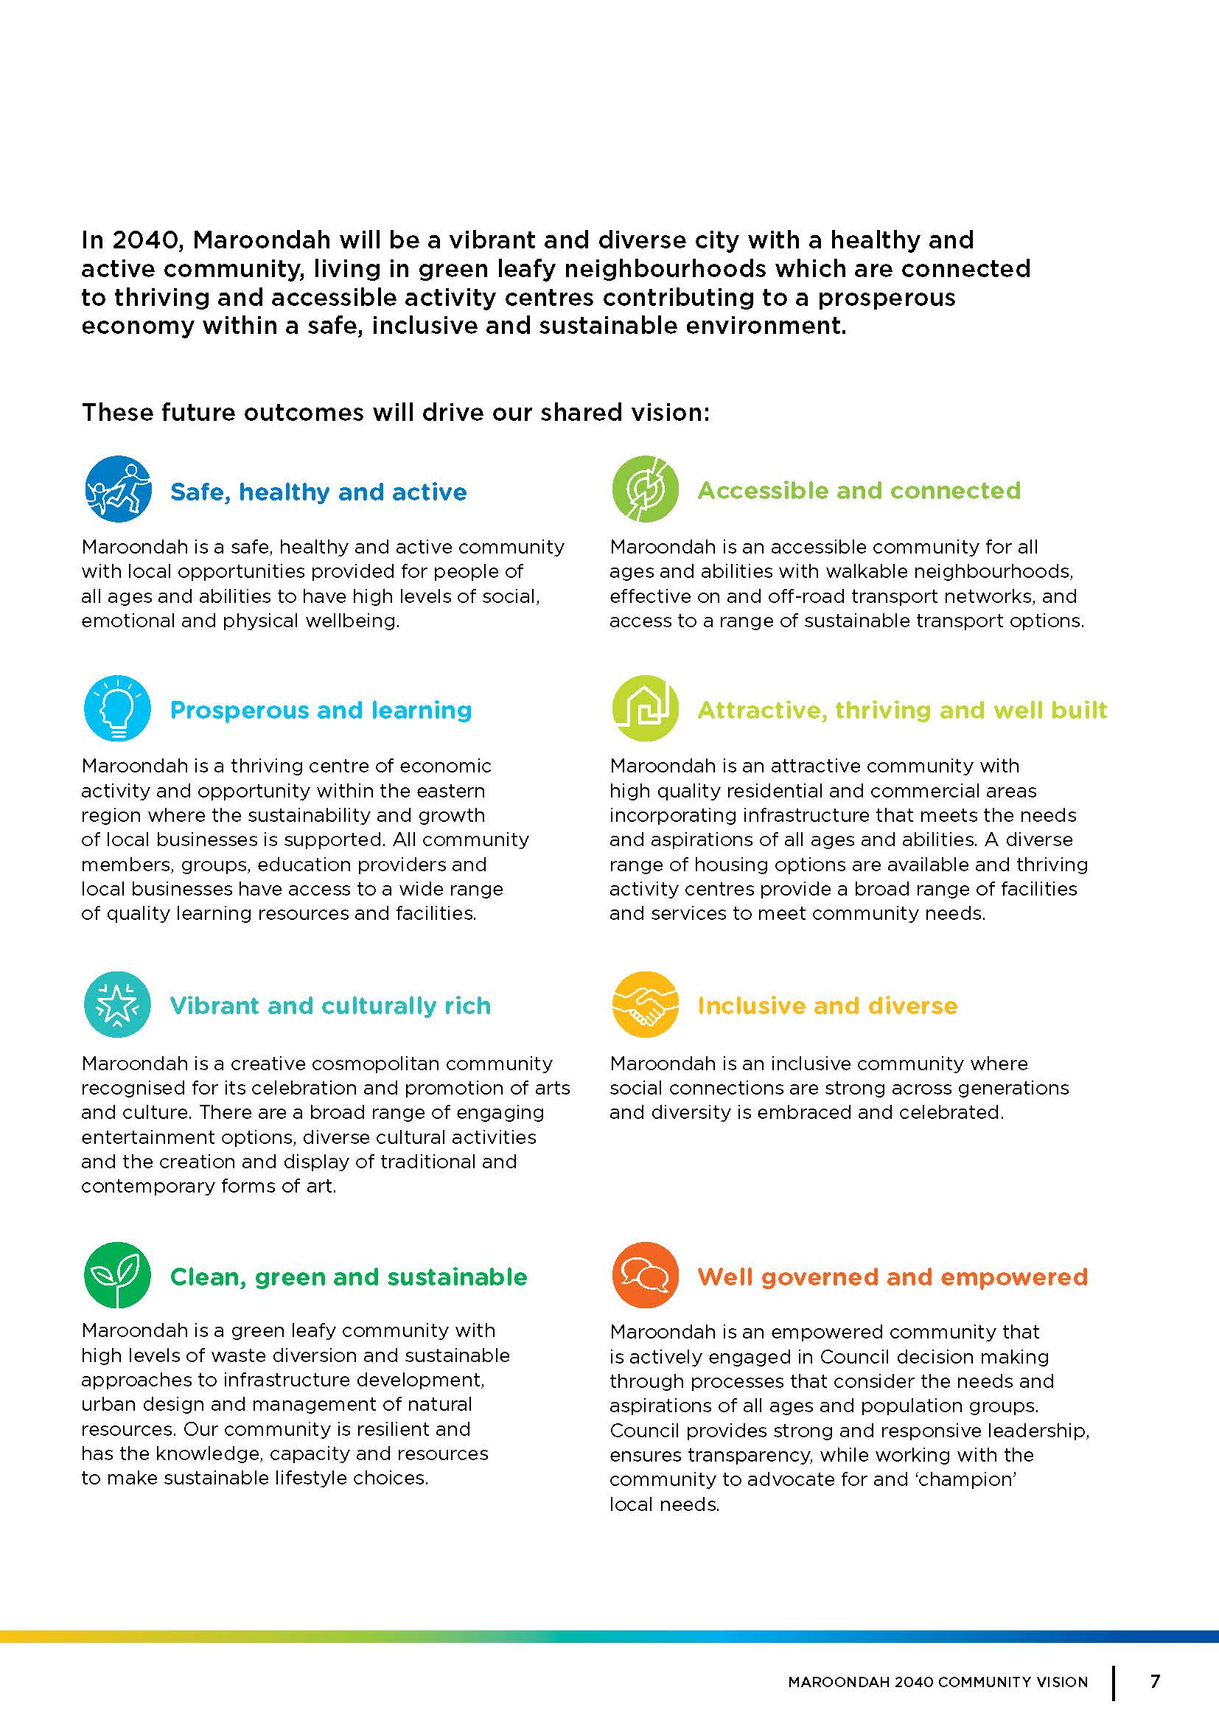

#### Maroondah 2040 – our future together

Maroondah 2040 provides a ‘roadmap’ for Council, government and the community to plan for the future. It captures the priorities and aspirations for the community.

A series of key directions to achieve the Vision’s desired future outcomes are detailed in the document. Of relevance are the following outcomes Council is striving to achieve:

* **A safe, healthy and active community** and the specific key directions of:
* applying the *healthy by design* principles in the development and revitalisation of activity centre’s and public spaces,
* increasing the *“proportion of children with good physical health”,*
* increasing the*” proportion of residents who undertake adequate physical exercise”,*
* “*providing a range of integrated recreation and leisure facilities that meet the needs of all ages and abilities*”, and
* increasing the *“proportion of community members who are involved in organised sport and have access to recreational leisure facilities*”.
* **A clean, green and sustainable community** and the specific key direction of:
* striving to become a *“carbon neutral Council by implementing energy efficient initiatives and embracing clean energy solutions”.*
* **An inclusive and diverse community** and the specific key directions of:
* “*increasing the availability and access to social and recreational opportunities for people with disabilities”,*
* *“increasing the proportion of residents who are members of organised groups”, and*
* “*ensuring that the needs of community members from all ages, backgrounds and lifecycles are considered in planning for local services, programs and infrastructure”.*
* **An attractive, thriving and well-built community** and the specific key directions of:
* ensuring that *“the management of infrastructure and prioritisation of capital works considers demographic change, the impacts of climate change, and accessibility for all ages and abilities”;* and
* “*coordinate and advocate for the increased utilisation, longevity and availability of fit-for-purpose public, private and not-for-profit buildings and spaces that can act as key places for neighbourhood connection”.*
* **A well governed and empowered community** and the specific key direction of:
* “*ensuring responsible and sustainable management of Maroondah’s resources, assets, infrastructure and natural environment”.*

#### Maroondah City Council Plan 2021-25 (2022/23 update)

The Council Plan sets out key directions and priority actions to work towards the community long-term vision described in Maroondah 2040: our future together. It is used to inform Council’s decision making about resources and priorities.

Council has identified minimal remaining land for large scale development so acknowledge the need to develop multi-use and shared facilities.

The Plan lists the key areas from the vision statement that are priorities. Of relevance to this strategy are:

* **An inclusive community**, with the key directions of *“support people of all ages, abilities and backgrounds to be connected, valued and empowered within their local community through accessible and inclusive services, programming and facilities*” and “*ensure social inclusion principles inform the planning for local services, programs and community infrastructure*”
* **An accessible community**, with the key directions of “*ensure community infrastructure, services and events are accessible for people of all ages, abilities and backgrounds” and “apply universal design principles to create a built environment that strengthens the inclusiveness and accessibility of our local neighbourhoods, activity centre, facilities and services”.*

#### Maroondah Liveability, Wellness and Recovery Strategy 2021-2031

The Maroondah Liveability Wellbeing and Resilience Strategy 2021-2031 is Council’s key social environment strategic plan that describes how Council and partners will work towards achieving enhanced community wellbeing, liveability and resilience over the next 10 years. The following are relevant to this strategy:

Focus area: healthy lifestyles, and the priority of:

* ‘physical health and activity’ with key actions of “*work in partnership to promote physical health, through the delivery of accessible initiatives, programs and services*”, “*provide and enhance accessible open spaces, active travel infrastructure, sporting precincts and integrated recreation facilities, to increase opportunities for and participation in physical activity*” and “*work in partnership to provide safe inclusive and accessible environments for all community members to undertake physical activity*”.

Focus area: social inclusion, and the priorities of:

* ‘community participation’ and the key priority to “*promote and create opportunities for equity across all abilities, ages, cultures, genders, languages, religions, sexualities and socio-economic groups*”; and
* ‘community participation; and the key priority to “*work in partnership to create opportunities for community participation and social connection for all people*”.

#### Maroondah City Council Physical Activity Strategy 2015-2020

The Physical Activity Strategy sets out actions to achieve the physical activity indicators of progress in the Maroondah 2040 Vision and builds on recommendations of Maroondah’s 2013-2017 Community Wellbeing Plan. The strategy highlights that Maroondah City Council “*will prioritise the development and/or improvement of environments to support physical activity*” with increased physical activity by the community having an impact on public health.

The document discusses challenges and barriers to physical activity levels amongst the general community, and then focuses on different factors affecting different population groups, including: ‘youth’ and the relevant opportunity for Council of “*allowing for more flexible approaches to playing sport [to] encourage more young people to get involved*” and that “*social opportunities presented by sport should be as important as the competitive aspect*”; ‘older people’; ‘women’ and the relevant opportunities for Council of “*availability of activities popular to females*”, “*women only teams/programs*”, and “*encouraging equitable access to facilities*”; ‘Lesbian, Gay, Bisexual, Transgender and Intersexual (LGBTI) community’, including the opportunity for Council to provide “*private spaces (cubicles) within change rooms*”; ‘people with disabilities’; and ‘Culturally and Linguistically Diverse (CALD) communities’.

Four Council priorities are detailed in the strategy, of relevance is the priority of ‘the future of sport’ and the shift in motivation for participating in sport and the need for sporting organisations to embrace new methods of delivering sport to participants. An opportunity for Council highlighted in the report is for Council to “*undertake benchmarking and consultation to develop Council policy which will enable [new] sports or [new] target groups to gain access to Council facilities*”.

#### Maroondah City Council Sports Demand Analysis (2017)

Maroondah City Council has a commitment to “*increasing community participation in physical activity with a particular focus on increasing female participation and supporting the introduction of new or non-traditional sports*”. The Sports Demand Analysis explores the current and future demand for sports in the municipality to inform planning and strengthen grant submissions.

The report highlights that “*with limited additional land left for sporting infrastructure, it is important that Council make considered decisions which maximise the use of existing facilities and sporting reserves*”.

The analysis looked at a large range of sport and recreation activities in Maroondah, along with a series of sports not currently based in the municipality to determine the need for facilities to support them. It explored the provision of sport at Council venues and some private venues in Maroondah by electoral ward.

Of relevance to this Stadium Sports Strategy, the supply and demand assessment and identified needs found:

**Badminton** – In 2017 there were no badminton clubs located in Maroondah. The analysis identified no demonstrated need for a specific badminton facility, or even a club to be established within Maroondah in the short term.

As part of the analysis recommendations, it suggests “*exploring whether there is a need for casual badminton at an existing facility*” in the short term (1 to 5 years).

**Basketball** – As part of the analysis recommendations, it suggests “*reviewing the need for additional basketball courts and/or additional use of existing use of existing courts in line with the review of netball*” in the medium term (6 to 10 years).

**Netball** – The analysis found the “*development of HE Parker Multi Sports Complex will meet a large number of needs for netball clubs in the short, medium and long term with the main ongoing concern being lack of adequate car parking*”.

As part of the analysis recommendations, it suggests a “*review of needs for additional netball courts and/or additional use of existing use of existing courts in line with a review of basketball*” in the medium term (6 to 10 years).

**Table Tennis** – the analysis found that based on available data “*there does not appear to be a demonstrated need for a club to be established in Maroondah*”. “…*external providers [may need to] access Maroondah facilities to offer table tennis*”. A number of new stadiums planned, including HE Parker Multi-Sport Complex and several school facilities, will be able to provide for table tennis.

As part of the analysis recommendations, it suggests to “*explore whether there is a need for causal table tennis at an existing facility*”.

**Volleyball** – The analysis found “*the new facilities at HE Parker Multi-Sport Complex will meet the needs of volleyball and allow them to both grow, and to host state level competitions*”.

**Pickleball** is not mentioned in the analysis.

A series of potential ‘future opportunities’ are suggested in the analysis to maximise capacity and increase participation at existing facilities and opportunities for Council to partner with schools. Opportunities including:

* Repurpose facilities, with a Master Plan of the site being suggested in most instances to ensure that the best possible outcome is achieved;
* Maximise capacity and increase participation of existing facilities, without the need to build additional facilities; and
* Partner with schools. The analysis recognises that “*Council should continue to work with schools, where appropriate, to facilitate joint usage of school facilities by clubs*”

#### Maroondah City Council – Equally Active Strategy 2019

The Equally Active Strategy is an active participation strategy for women and girls. The vision driving the strategy is “*in Maroondah, women and girls will have equal opportunity to undertake sport and recreational physical activity in environments where they feel welcomed, supported and safe*”. The strategy builds on recommendations of Council’s 2015-2020 Physical Activity Strategy, which highlights women as a specific population group for targeted actions to address low physical activity levels. The strategy highlights that “*changing the physical, the social, and the attitudinal environment that supports women to be active will instigate change*”.

The strategy highlights that “*Council will continue to improve facilities to support women and girls to undertake sport and recreation…*”

The document contains four outcomes areas, with associated key directions and priority actions. Of relevance they include:

* Outcome area 1: Gender equality in sport, including the key directions of “*ensuring that investment in sporting infrastructure prioritises demand for female-friendly facilities”; “developing initiatives to influence the equitable usage of Council sporting infrastructure”.*
* Outcome area 2: Women of Culturally and Linguistically (CALD) diverse backgrounds, including the priority action of “*collaborating with the Melbourne East Netball Association to offer social and beginner Netball programs at Maroondah Nets to provide introductory casual, social netball opportunities which will be promoted in adherence to the CMY Good Practice Principles”.*
* Outcome area 3: Young women, including the key direction of “*working with recreation providers to ensure that activities of interest to young women are available in safe and welcoming environments”.*
* Outcome area 4: Women with care responsibilities, including “*when designing active spaces and programs, Maroondah City Council will be cognisant of factors which may affect the inclusion of women with caring responsibilities and diverse strategies to make participation easier”.*
* “*Council will continue to improve facilities to support women and girls to undertake sport and recreation…”*

The strategy does not specifically address gender diversity, however it acknowledges that in achieving a safe, inclusive and gender equitable environment the needs of trans and gender diverse people should always be considered.

#### Maroondah Golf Strategy 2020-2030

The Maroondah Golf Strategy was developed to enable two golf courses owned and operated by Maroondah City Council to remain financially sustainable, achieve performance targets and increase and diversify participation. Three key planning principles detailed in the strategy will guide future decisions for Maroondah golf:

1. Achieve an operating surplus greater than capital expenditure requirements and sufficient to mitigate risks that may hinder financial performance;
2. Set operating targets and report annually to the community;
3. Continue to monitor usage, evaluate and evolve to meet the changing community needs.

Key directions and priority actions detailed in the strategy sit under four focus areas. Focus area 1 is relevant to this strategy:

* Focus area 1: enhancing facilities, including a relevant priority action “*1.1 Develop a Maroondah Golf facilities master plan that demonstrates both social and financial positive outcomes for Council and community and considers modifications to part of Ringwood, without reducing the number of holes, to accommodate a possible future expansion of The Rings”.*

#### Maroondah Disability Action Plan 2022-2026

The City of Maroondah, according to 2016 Census, has a total of 5,482 (5.0% of total population) people living with a profound or severe disability, who require assistance with any or more daily activities. Between 2016 and 2031, the population of Maroondah living with disabilities is expected to increase by almost 2,000, with an overall percentage increase of 35%, to 7,560 people.

This Disability Action Plan identifies priorities that respond to the outcomes and key directions with the Maroondah Liveability Wellbeing and Resilience Strategy 2021-2031, ultimately working towards the community vision for Maroondah outlined in Maroondah 2040: our future together.

The aim of the Maroondah Disability Policy Action Plan is to reduce key issues faced by people with disabilities in Maroondah, and to create opportunities for people with disabilities to participate equally in the life of the community.

Maroondah’s vision for disability inclusion and access in Maroondah is ‘*Maroondah will be an inclusive and accessible community that provides equitable opportunities for people of all abilities, their families and their carers to actively and fully participate*’.

The Plan includes four key focus areas, with associated actions. Of relevance are:

* **Focus area 1**: Social and economic inclusion, including “*provide and support leisure and community services that are engaging for people of all abilities and ages*”;
* **Focus area 3:** Design, infrastructure and transport, including “*supporting environments and community facilities that are accessible to people with disabilities*” and “*ensure inclusive design of all major projects in Maroondah*”. A specific priority action is to “*continue to incorporate universal design principles into infrastructure planning, upgrades and maintenance to promote mobility and accessibility”.*

#### Maroondah City Council Youth Strategy 2017

The Youth Plan aims to ensure “*…that Council is actively engaged with Maroondah’s young people, responsive to their needs and delivers best practice services*”. It provides a strategic direction for Council’s work with young people aged 12-25 years who live, work, study and/or recreate in the municipality.

A series of objectives and actions are detailed in the plan, which all combine to help achieve the elements of the Plan’s vision and mission statement. Of relevance are: objective 1.1 “*provide high quality accessible services and activities that support young people to develop their health and well-being in all aspects of their lives*”, objective 1.4 “*ensure Maroondah provides a safe and healthy natural and built environment for young people now and into the future*” and objective 3.4 “*provide, promote and advocate for a wide range of meaningful opportunities in Maroondah that are engaging for young people*”.

#### Positive Ageing Framework and Action Plan 2021-2025

Maroondah City Council is committed to developing an age-friendly community, ensuring that it benefits all community members, not just older residents.

In 2015, Council released our Active and Healthy Ageing Initiative: Towards an Age-Friendly Maroondah 2015–2020. Over the five-year term of the initiative, Council undertook numerous projects and activities across the municipality to deliver on its commitments, particularly ‘optimising opportunities for health, participation and security in order to enhance quality of life as people age’.

The Positive Ageing Framework and Action Plan 2021–2025 aims to build on the foundational success established as an age–friendly city and address the current challenges faced by an ageing population.

Of the six key priority areas identified for the next five years, the following have relevance to this strategy:

* **Social connection** – with the strategy to “*facilitate opportunities for participation in accessible and affordable recreation, lifelong learning and cultural pursuits*” and the key action to “*continue to support physical activity, learning, cultural and recreational initiatives that incorporate social connection through community partnerships*”
* **Health and wellbeing** – with the strategy to “*support, promote and develop opportunities for older people of all abilities to engage in activities that promote good health and wellbeing*”, and the key action to “*partner and promote a range of programs and initiatives that improve older people’s physical activity, healthy eating and mental health*”.
* **Safety and security** – with the strategy to “*promote mobility and accessibility by incorporating universal design principles into planning for infrastructure*”
* **Quality of life** – with the strategy to “*continue to create and develop public spaces that encourage intergenerational participation and connection*”

#### Maroondah Sustainability Strategy 2016-2020

The Maroondah City Council Sustainability Strategy details actions Council will take in partnership with the Maroondah community to achieve community aspirations for environmental sustainability, as expressed in the Maroondah 2040 Community Vision. The strategy details principles which demonstrate Council’s commitment to sustainability, including: ‘a whole of Council approach’; ‘engaging with and empowering the community and key stakeholders’; ‘evidence-based decision making’; and ‘focusing on what is achievable’.

There are five focus areas in the strategy, of relevance are:

* **Focus area 1** – climate change, energy efficiency and transport, specifically the key direction of “*striving to become a carbon neutral Council by implementing energy efficient initiatives and embracing clean energy solutions*”;
* **Focus area 2** – green assets and water, including the key direction of “*encouraging increased green spaces within activity centre’s that link the built environment to the natural landscape”;* and
* **Focus area 4** – governance, evaluation and improvement, and the priority action of “*adopting sustainable design guidelines for Council buildings and facilities*”.

#### Melbourne East Regional Sport and Recreation Strategy 2022-2032

The Melbourne East Regional Sport and Recreation Strategy is a decision-making tool to guide regional priorities for sport and recreation facility provision in Melbourne’s East. The strategy was developed through a partnership between seven Councils in the eastern region. A key outcome of the Strategy is “*the development of financially viable and sustainable facilities*”.

The strategy discusses a framework connecting government, sport and community stakeholders for the planning and provision of regional level facilities in the region. It highlights the priority of government, particularly the seven Councils involved in the strategy development, as the “*…planning and development of multipurpose facilities which cater for a range of sport and recreation activities and meet broader community needs”. It highlights that “…the delivery of regional level facilities requires a more collaborative approach and integration with state and local planning objectives*”.

Some key recommendations that are relevant to this strategy include:

* **Pillar 1** – a balanced network of regional sport and recreational facilities:
  + Strategic priority 1 – progress the delivery of established regional facility priorities, and the recommendation to “*develop additional indoor sports courts to address capacity and access requirements identified within state facility strategies for basketball, netball and volleyball*”
  + Strategic priority 4– develop regional facility opportunities in partnership with schools and other land managers, and the recommendation to “*explore with schools in the delivery of regional/sub-regional level sport and recreation facilities, including indoor stadiums (3-4 courts) and sports fields to address areas of facility provision shortfall*”
* **Pillar 3** – a collaborative approach to regional planning, policy development and advocacy:
  + Strategic priority 4 – Create regional partnerships to plan, advocate and fund priorities, and the recommendations to “*establish and promote partnerships with land managers to create new opportunities for facility development and collaboration, including Dept of Education, Dept Environment, Land, Water and Planning, Parks Victoria, VicRoads, VicTrack and Water Authorities*” and “*consider funding partnerships, where regional facilities provide regional benefits and significant municipal servicing across LGA boundaries*”

#### Active Victoria – A strategic framework for sport and recreation in Victoria 2017-2022

*Active Victoria* sets out the vision for sport and active recreation in the state and details six strategic directions to achieve this vision. The *Active Victoria* vision is:

* More active – “*an increased proportion of Victorians participate in sport and active recreation*”.
* More diverse and inclusive – “*an inclusive system that provides all Victorians with the opportunity to be involved*”.
* Collaborative – “*well-planned and connected investment that maximises participation and health, economic, community and liveability benefits*”.
* Robust, flexible sustainable and affordable – “*a sustainable and efficient approach that responds to changing demands and provides flexible and affordable choices for participants*”’.
* Broad-based and connected – “*an integrated system that addresses the different demands, contributors and structure of community sport, active recreation and high-performance sport and events and maximises the pathways and connection across the system*”.

Strategic directions of relevance include:

**1. Meeting demand, including the key areas of change:**

* ‘increasing the capacity of sport and active recreation infrastructure’, specifically: “*new and existing infrastructure that ‘works harder for longer*” for example lighting, durable surfaces, multi-sport surfaces; “*maximised use of existing spaces (for example Parks Victoria land, school land, government surplus land…)*”; “*designing infrastructure in accordance with universal design principles and to be resilient to future risks*”; “*investment in female sport participation*”; and “*integrated school and community sport and recreation infrastructure*”.
* ‘increased participation opportunities’, specifically “*better connection of schools and health providers with the sport and recreation system*”.
* ‘flexible and innovative options’, specifically offering more flexibility in time and type of activity, modified options of sports and support for new sports, including those involving emerging technologies.

**2. Broader and more inclusive participation, including the key areas of change:**

* ‘operational structure of sport and active recreation’, specifically “*access for low-participation population groups prioritised for both programs and infrastructure investment*” [including Aboriginal Victorians, people with disability, LGBTI and disengaged youth]; “*adoption of universal design in both infrastructure and program delivery…*”.
* ‘increase the participation of women in sport’, specifically “*female-friendly sport and active recreation infrastructure and facilities*”.

**5. Connect investment in events, high performance and infrastructure.**

Other changes and challenges highlighted include an ageing population, changing lifestyles and expectations, increasing female participation in sport, land availability in inner city and established suburbs and broader and more inclusive participation. The document also highlights the need for *“…sport and recreation infrastructure [to be] future-proofed to meet both changed and increasing demand and the impacts of climate change*”.

#### Victorian State Government – Design for Everyone Guide (cited online May 2022)

Universal Design aims to simplify life for everyone by making the built environment more usable to as many users as possible, it is a process rather than an outcome. The aim of universal design is to provide a solution that can accommodate all people, not just one group from the community. The seven principles of Universal Design include: 1. equitable use; 2. flexibility in use; 3. simple and intuitive use; 4. perceptible information; 5. tolerance for error; 6. low physical efforts; and 7. size and space for approach and use.

The ‘Design for Everyone: A guide to sport and recreation settings’ is a resource to assist the planning, design and development of inclusive sport and recreation facilities. The guide details a range of elements to apply the universal design principles to, including kitchens, buildings, landscape design, toilets and change rooms to name a few. The guide also lists principles that can be interpreted and adapted to a range of indoor and outdoor sports settings, including skate parks, aquatic leisure facilities, sports pavilions and sport and recreation reserves to name a few.

The guide provides links to various other documents for support and further information.

#### Victorian State Government – Female Friendly Sport Infrastructure Guidelines (cited online May 2022)

The Female Friendly Sports Infrastructure Guidelines provide information and advice on how to deliver more gender equitable environments. The guidelines highlight that “*facilities at clubs play a key factor in encouraging female involvement*” and that user-friendly facilities are required to encourage more women and girls to be active and involved in sport and active recreation.

The guidelines focus on three key enablers:

1. **Facility planning and design** – including the redevelopment of existing facilities and the design and building of new facilities with the needs of female users in mind. The following themes form the basis of the guidelines: planning process; design principles; facility design; colours and materials; and building management.
2. **Maximising use** – with a focus on scheduling and programming that addresses female needs. The following themes form the basis for the guidelines for maximising the use of community sport and active recreation clubs and centres: female life stages; equal scheduling; diverse programs; role modelling; promotion; and integrated clubs.
3. **Policy to drive change** – with a focus on implementing strategy through collaborative approaches. The following themes form the basis for the guidelines: strategic planning considerations; funding; and measuring success.

The guidelines provide links to various other documents and supporting materials for further information and direction.

#### Basketball Victoria – 2022 – 2024 Strategic Plan (summary document) and Basketball Victoria Facility Infrastructure priorities 2022

Basketball Victoria’s vision is that “*Basketball is the sport of choice for ALL Victorians – through leadership, innovation, engagement and accessibility*”. The organisations Strategic Plan for 2022-2024 outlines the priorities for the sport over the three-year period, with four pillars of growth outlined to achieve the organisations objectives. The four pillars are: ‘promote basketball’; ‘deliver leadership’; ‘infrastructure growth’, including through strengthening partnerships with local, state and federal governments to “*continue bringing new and redeveloped stadia to the Victorian basketball community to help slash wait times for courts and give everyone the best possible access to elite infrastructure*”, and ‘provide pathways’.

The Basketball Victoria Facility Infrastructure Priorities document for 2022 details facility priorities for numerous LGAs and locations across the state, including Ringwood Secondary College. The document details a plan for a new open plan indoor multi-purpose sports stadium at the College. The planning process is in its fifth year and has included discussions with Basketball Victoria, Ringwood Basketball Association, Volleyball Victoria, Maroondah Volleyball Association, Eastern Football Netball League and member clubs. According to the document, Ringwood Secondary College is, together with its own investment, seeking Federal and State Government funding contributions to enable project construction. The plan is for a proposed shared operations model between the school and user sports, which will have the centre self-sustaining following construction.

#### Badminton Victoria – Strategic Plan 2021 – 2025

Badminton Victoria’s four-year strategic plan lists six strategic pillars: an effective performance pathway; members and participants interests are paramount; a financially sustainable badminton community; continued development of our sport; good governance and strong brand reputation; and events – bringing together a vibrant community.

#### Netball Victoria – Strategic Plan 2019-2022

The high-level strategic plan sets out how Netball Victoria will “*go about the business of netball in Victoria over the next four years*” [2019-2022]. The plan is supported by annual operational plans and budgets. The document includes four strategic drivers; a lifelong love of netball; being member centric; Victorian Netball dominance; and building our netball economy. Examples of relevant focus areas aligned to these strategic drivers include:

* within the strategic driver ‘a life-long love of netball’, specifically “*providing a range of options to participate [in netball] (both traditional netball and other netball products)*”; “*safe and compliant netball facilities across the state and in locations addressing the community needs and enabling growth*”; and “*more opportunities available for males to play in mixed and male competitions*”.
* Within the strategic driver ‘building our netball economy’, including “*implementing our state-wide facilities strategy, enabling a greater number of participants to play*”, with success including “*affiliates having more access to courts to enable their membership to grow*”; “*supporting our netball affiliates to become key tenants of quality sporting facilities*”; and “*delivering Rock Up Netball in more states across Australia*”.

#### Table Tennis Victoria – Strategic Plan 2019-2022

The ‘Our Future Now’ is Table Tennis Victoria’s “*blueprint for how [the organisation] will work in open collaboration with member clubs and partners to drive the increased capacity, relevance and sustainability…*” of table tennis across the state. The priorities detailed in the plan for Table Tennis Victoria are: raising the profile of the sport to connect more people in with the sport, with a measure of success of relevance being “*more facilities being used to deliver the sport across Victoria*”; making the sport more accessible, relevant and rewarding for participants; and developing and delivering frameworks, programs and systems to help players, coaches and referees achieve their performance goals.

#### Volleyball Victoria – Strategic Plan 2021-24 (draft)

Volleyball Victoria’s draft strategic plan details the purpose of the organisation, with accompanying objectives and strategies, which combined, aim to achieve its mission “*to enhance volleyball in Victoria*”. Of relevance to this strategy, the purpose of Volleyball Victoria is to:

* promote accessible and sustainable opportunities that encourage health, participation and social inclusion. Relevant objectives include:
  + “*Increase accessibility for junior players regardless of location, age, or ability*” and more specifically the strategy “*work with the school network to increase opportunities in volleyball*”.
* enable our community to succeed, including the relevant strategy to “*strengthen partnerships with state and local government to realise an increase in resourcing, programming and facility access*” [this strategy aligns with Volleyball Australia’s Strategic Framework] and to “*develop strategic partnerships with sporting associations*”.

#### City of Whitehorse Recreation Strategy 2015-2024

The City of Whitehorse Recreation Strategy will be used to guide Council planning of recreation and sport services and facilities over a ten-year period, 2015-2024. To achieve the vision for recreation, ten principles are detailed in the strategy to guide the planning for recreation. Of relevance:

* Principle 2. A range of opportunities, including “*access to a range of local, neighbourhood and district level facilities…”;* and *“effective planning that minimises the need for the duplication of facilities and encourages variety of opportunity”.*
* Principle 6. Partnerships, including *“Council will enter into different partnerships over time to achieve recreation and sport objectives”.*
* Principle 7. Facilities, including that “*Council will focus on the development of local and municipal level facilities to deliver greatest benefit. Council will consider the funding of regional projects, however, funding will generally be in line with relevant Council policies that focus on local and municipal level facilities”* and “*Council will seek to optimise the use of existing facilities (including Council, school and private facilities), before considering the development of new facilities”.*

The strategy presents a map of recreation facilities located within the Whitehorse municipality and highlights some located within neighbouring municipalities, including Maroondah, highlighting that indicative catchment distances used within the industry indicate *“…80% of residents will travel up to 5 kilometres*” to participate in recreation and sport activities. For regional facilities the distance is greater.

The strategy highlights the limits to suitable land being available for some future sporting and recreation needs in the municipality and that “*partnerships with other land holders and services providers, such as schools and neighbouring Councils, will be an important factor in providing for the future recreation and sporting needs of the community*”. Table tennis is a sport mentioned as needing a Feasibility Study to explore facility requirements for the sport, with Whitehorse Council receiving requests for a specific facility. Basketball and netball are also highlighted, with reference given to work being undertaken in the neighbouring municipalities of Manningham and Knox to explore the needs of the sports, including at the regional sports facility in Knox.

An implementation plan is included in the strategy, with a series of actions assigned to four themes. Of interest is theme 3. ‘Flexible facilities’ and the actions:

* 20. *“continue efforts to develop a strong working relationship with schools to identify opportunities to gain access to indoor facilities for community organisations”.*
* 30. “*identify opportunities to improve access to indoor court space with a focus on optimising access to school facilities; joint initiatives with adjoining Councils; and additional provision within Whitehorse subject to further investigation through an Indoor Sports Feasibility Study”.*
* 32. *“Undertake a feasibility study to better understand the demands of various indoor sports and facility provision with a particular focus on gymnastics, basketball and table tennis. The indoor sports study will be informed by the Melbourne East Regional Sport and Recreation Strategy* [being coordinated by Maroondah City Council].

#### City of Whitehorse - Indoor Sports Facility Feasibility Study 2020

The Indoor Sports Facility Feasibility Study was a project identified from Council’s Recreation Strategy (2015-2024).

This study found that most indoor sports facilities had constraints in meeting current sporting requirements, with little to no capacity in the current facilities during peak times to provide for either additional sports or an expansion of the competitions played.

The study recommended a strong focus on sharing of indoor sports facilities needs to continue, however at a club competition level some sports (such as table tennis and badminton) need dedicated facilities.

Three investment priorities were recommended:

* Upgrade existing Council facilities;
* Explore opportunities for a multi-use community facility to include table tennis, in central Box Hill; and
* Advocate to encourage community use, when partnerships with schools propose upgrades to indoor sports courts

Three sites were identified as having potential for additional stadium courts. These included:

* Nunawading Basketball Centre (11-12 courts);
* Aqualink Box Hill (2 courts); and
* Sportlink in Vermont (2 courts).

#### City of Whitehorse – Draft Strategic Partnerships Framework August 2021

The Strategic Partnerships Framework will assist Whitehorse City Council when considering suitable indoor sports facility projects or partnerships for Council investment where the opportunities provide additional community use. Alongside the ‘Indoor Sports Facility Feasibility Study’, the framework will be used to prioritise capital investment in indoor sports infrastructure that highlight and encourage community use.

The document highlights the increase in demand for indoor sport court use in the City of Whitehorse and states “*Council will need the assistance of partners to achieve the required number of courts and financial contributions to complete these facilities*” and that “*Council is interested in discussing project/partnership proposals with…*” stakeholders, including neighbouring/Eastern Region LGA’s, including Maroondah.

Partnership principles for investing in facilities are detailed, for example investment in facilities that are “*identified in a suburb or an area with a large forecasted percentage population growth of (over 20%); [those that] address sports prioritised in the [Indoor Sports Facility Feasibility Study] with the greatest need for additional facilities in the short term (basketball, netball and table tennis) and those that provide multi-court (especially 2+ courts)…*”.

#### City of Manningham – Active for Life Recreation Strategy 2010–25 (reviewed 2019)

The reviewed Active for Life Recreation Strategy builds on the Recreation Strategy developed in 2010 and is seen as an appendix to the original strategy. The review highlights achievements made since the development of the strategy and sets new priority areas for action. It acknowledges the community change since the strategy’s development, including population growth, sport participation, multiculturalism and housing density.

Future facility requirements are discussed in the review document, including findings from an analysis that netball will require additional facilities to cater for demand within the municipality. The strategy states that “*there will, eventually, be a time where Council’s sporting facilities reach maximum capacity, with no further opportunities to build new facilities*”. It also suggests that the *“…provision of infrastructure and access to facilities to support social sport is likely to be a future challenge*”.

The four key areas of focus for 2019-2025 include:

* Priority area 1. Provide flexible, multi-use and durable spaces for recreation to meet the needs of a growing community.
* Priority area 2. Collaborate with key partners and organisations, including analysing opportunities for using school facilities capable of being used for organised sport.
* Priority area 3. Foster and environment of inclusion.
* Priority area 4. Build capacity for our community.

#### City of Yarra Ranges – Recreation and Open Space Strategy Implementation Plan 2013-2023

The Recreation and Open Space Strategy’s implementation plan details of actions for the ten-year period 2013-2023. The actions are grouped into two areas, ‘issues actions’ and ‘precinct strategy actions’. A consistent action for a number of the precincts is to explore partnerships with schools for joint use of school sport facilities and reserves.

# SECTION 3: EXISTING PROVISION

#### 3.1 Council stadium facilities

Council owns and manages two stadiums, Maroondah Nets and The Rings. Each of these stadiums have one or more sporting associations based out of the stadium, who run their own competition and do their own scheduling. Council staff also run programs that cater for other sectors of the community at these sites.

Staff facilitate overall facility bookings to ensure that fair and equitable access is provided to a range of different sports, that covers different age, gender and ability groups.

#### 3.2 Basketball

##### 3.2.1 Context

There are three basketball associations that service Maroondah residents, and use facilities in Maroondah. The Ringwood Basketball Association (RBA) and the Vic Baptist Basketball Association (VBBA) are the key basketball associations that are based in Maroondah. The Kilsyth Basketball Association (KBA) is based in Kilsyth (Yarra Ranges) but due to the geographic split, and location of facilities, 21% of Maroondah residents that have registered with Basketball Victoria, play for the KBA rather than the RBA.

There is also a Phillipino basketball club that is not part of any association, that trains and plays at a school stadium.

Basketball competitions run from 8.30am until 8.30pm on a Saturday, with training on Sunday and until 11pm on weeknights.

The information in this section focuses on basketball facilities located in Maroondah, and those in other LGA’s that RBA teams train at.

##### 3.2.2 Venues for basketball games

There are three main stadiums in Maroondah where basketball is currently played, these include:

* **The Rings** – four court stadium which caters to basketball, netball, volleyball and junior sporting programs. This facility is managed by Council
* **Norwood Secondary College** – two court stadium that was built by the Education Department. The RBA have a long-term hire agreement with the school, and are sole users of this stadium out of school hours
* **Melba College** – four court stadium that was built with a combination of Education, Sport and Recreation Victoria and KBA funding. The KBA have a long-term agreement with the school, and are the sole users of this stadium out of school hours

##### 3.2.3 Venues for basketball training

There are many basketball courts that clubs train at. These include:

* **The Rings**
* **Schools courts** in and around Maroondah – many of these are multi-use courts, not used solely for stadium sports. Feedback from clubs and the RBA is that most school courts are not up to standard and not well maintained
* **John Frost Stadium (Cheong Park)** – this is a single court stadium that and does not meet basketball run off standards. SCYC Scorpions (which are a KBA club) have an annual hire agreement with Council to use the hall for training, and have done so for many years

Refer to **Figure 2** on the following page for a map of facilities currently used for basketball training or playing.

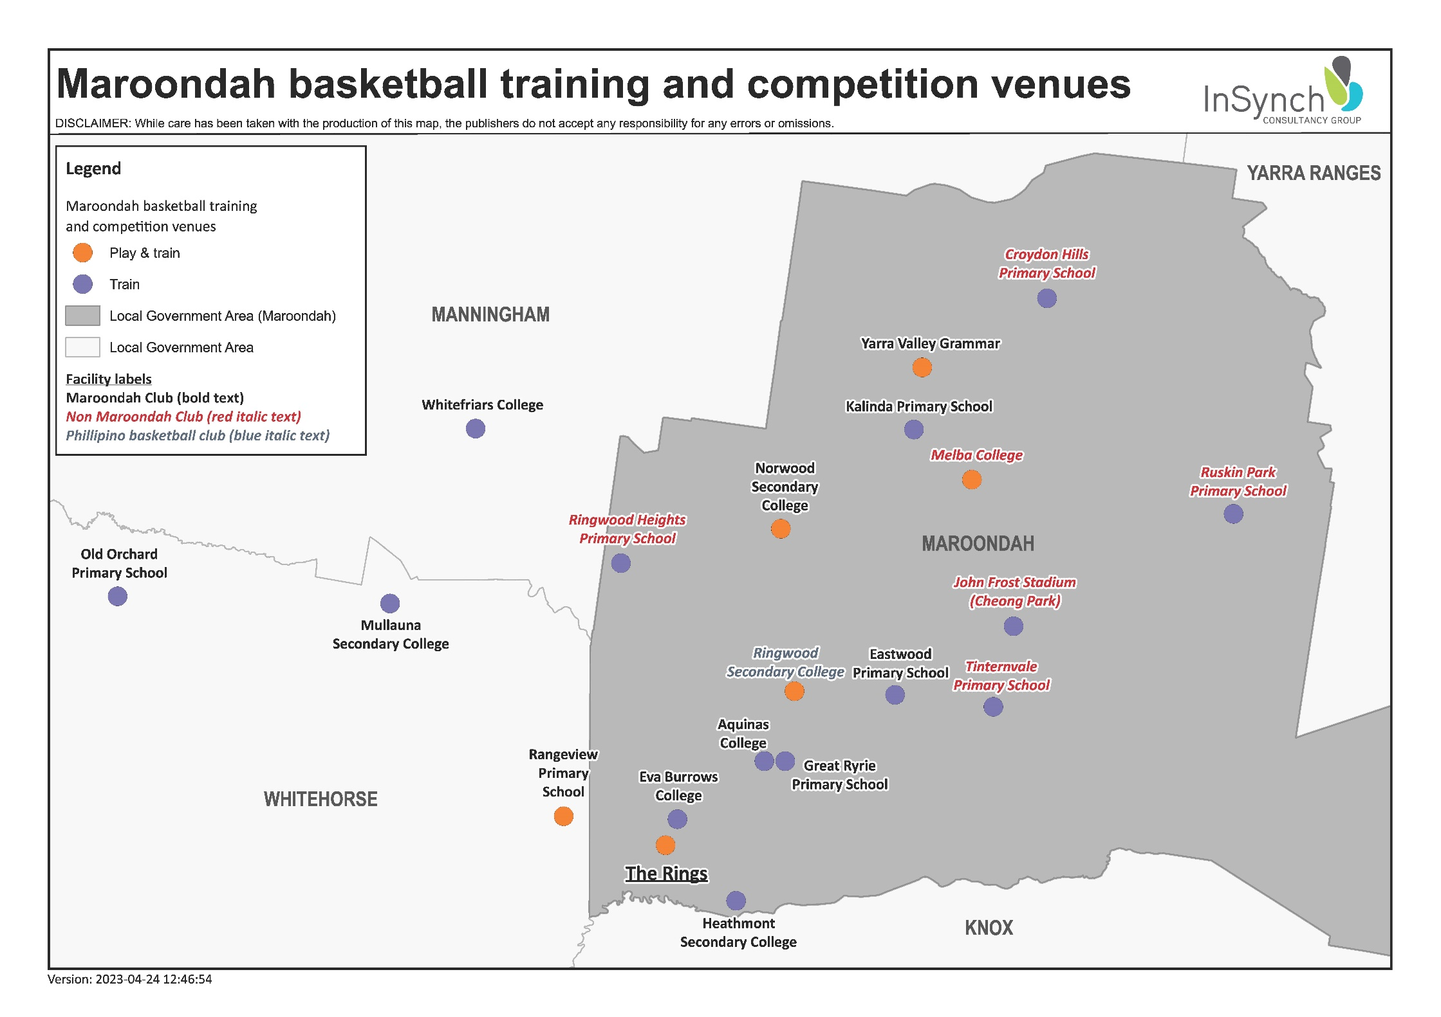

##### 3.2.4 Crossover with other LGA’s

Basketball Victoria was able to provide data for surrounding LGA’s which details the crossover of players across LGA’s. **Figure 3** below shows that of the 6,318 Basketball Victoria members that live in Maroondah, only 52.2% of them play in Maroondah, with a significant 23.8% playing in Yarra Ranges (1,504 players). In addition, 7.5% play in Manningham (478), 7.4% play in Whitehorse (472) and 6.3% play in Knox (395).

Figure 3: Basketball Victoria members that live in Maroondah

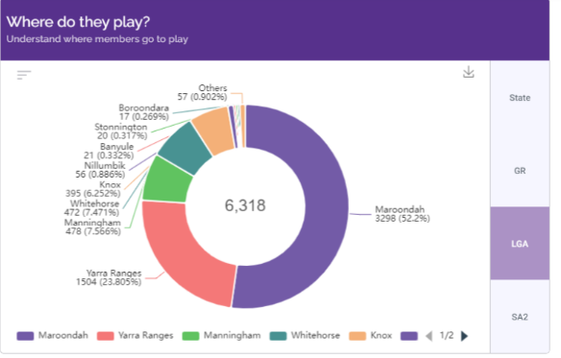

Comparatively, **Figure 4** shows that of the 8,618 players registered with Basketball Victoria that live in Yarra Ranges, 82% of them play in Yarra Ranges, with only 6.7% playing in Maroondah (578 players).

Figure 4: Basketball Victoria members that live in Yarra Ranges

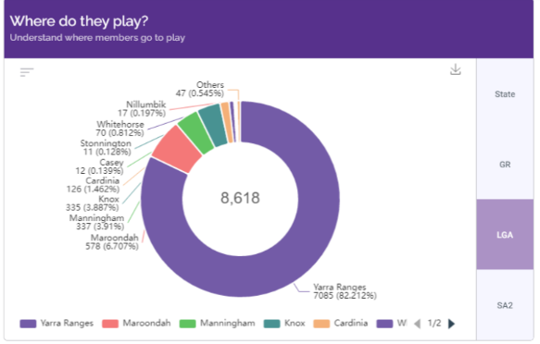

In relation to other LGA’s having residents that play in Maroondah: Knox have 153, Manningham have 151 and Whitehorse has 135, so there are more Maroondah residents playing in other LGA’s than residents from other LGA’s playing in Maroondah. It demonstrates that other LGA’s help to meet the basketball demand for Maroondah residents.

#### 3.3 Netball

##### 3.3.1 Context

The Melbourne East Netball Association (MENA) and Ariels VCNA (Ariels) are the two netball associations that are based in Maroondah. MENA has clubs based in both Maroondah and Whitehorse. As with basketball, many Maroondah residents that live in Croydon, Croydon South, Croydon North, Croydon Hills and Kilsyth South play for the Lilydale and Yarra Valley Netball Association, which is based at Pinks Reserve in Kilsyth (approximately 14% of the Maroondah residents that are registered with Netball Victoria). In addition, the Eastern Football Netball League (EFNL) also plays netball at Maroondah Nets.

MENA netball competitions run from 8am until 5pm on a Saturday and until 9.30pm on Monday and Wednesday nights, with training on Sunday morning and until 7.30pm on weeknights.

Ariels run a competition until 9.30pm on Sunday night, and train Monday night until 8.30pm and Sunday afternoons.

The EFNL plays at Maroondah Nets until 10.30pm on Friday nights.

The information in this section focuses on netball facilities located in Maroondah, and those in other LGA’s that MENA teams train at.

##### 3.3.2 Venues for netball games

Maroondah Nets is managed by Council and is a key venue for netball games, with four indoor courts and four outdoor courts. MENA, Ariels and the EFNL play games at this venue.

The Rings is also used by Ariels for a social competition.

##### 3.3.3 Venues for netball training

There are a number of schools in and around Maroondah that clubs use for training.

##### 3.3.4 Crossover with other LGA’s

Netball is similar to basketball with crossover to other LGA’s. The most significant crossover is from Maroondah into Yarra Ranges, with 14% of residents playing at Pinks Reserve in Kilsyth. While specific data was not available for other LGA’s, we know that Whitehorse, Manningham, Yarra Ranges and Knox residents all play in Maroondah. Similarly, Maroondah residents play in these LGA’s.

Refer to **Figure 5** on the following page for a map of facilities currently used for netball training or playing.

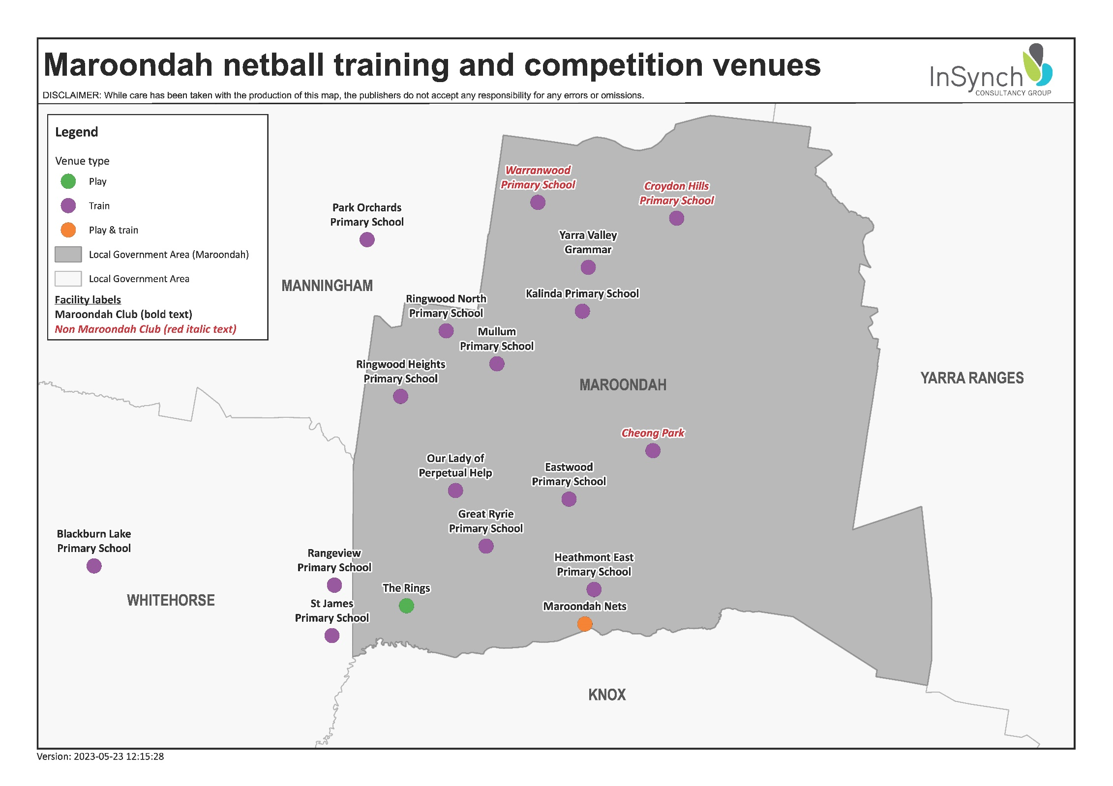

#### 

#### 3.4 Volleyball

Maroondah Volleyball Association is based at Maroondah Nets. They run programs and competitions there and have access to six courts Tuesday (4.30pm to 11pm), Thursday (6pm to 10pm) and Sunday (6pm to 8.30pm).

They also hire two courts at Heathmont Secondary College on Tuesday evenings for their competition, and two courts at The Rings on a Sunday afternoon for state league training.

##### 3.4.1 Crossover with other LGA’s

Due to a lack of suitable venues, Maroondah and Dandenong are the two key associations that span Dandenong, Monash, Knox, Whitehorse, Maroondah, Yarra Ranges. While not affiliated with Volleyball Victoria, Manningham have a strong social competition with approximately 80 teams.

For surrounding Council’s, Knox residents would go to either Dandenong or Maroondah; Yarra Ranges residents would be most likely to go to Maroondah, Manningham residents would either play socially or go to Maroondah, and Whitehorse residents are likely to go to Maroondah also.

Refer to **Figure 6** on the following page for a map of facilities that cater for volleyball in and around Maroondah. It should be noted that Manningham DISC do not run a volleyball competition, but the courts can be set up and hired for volleyball.

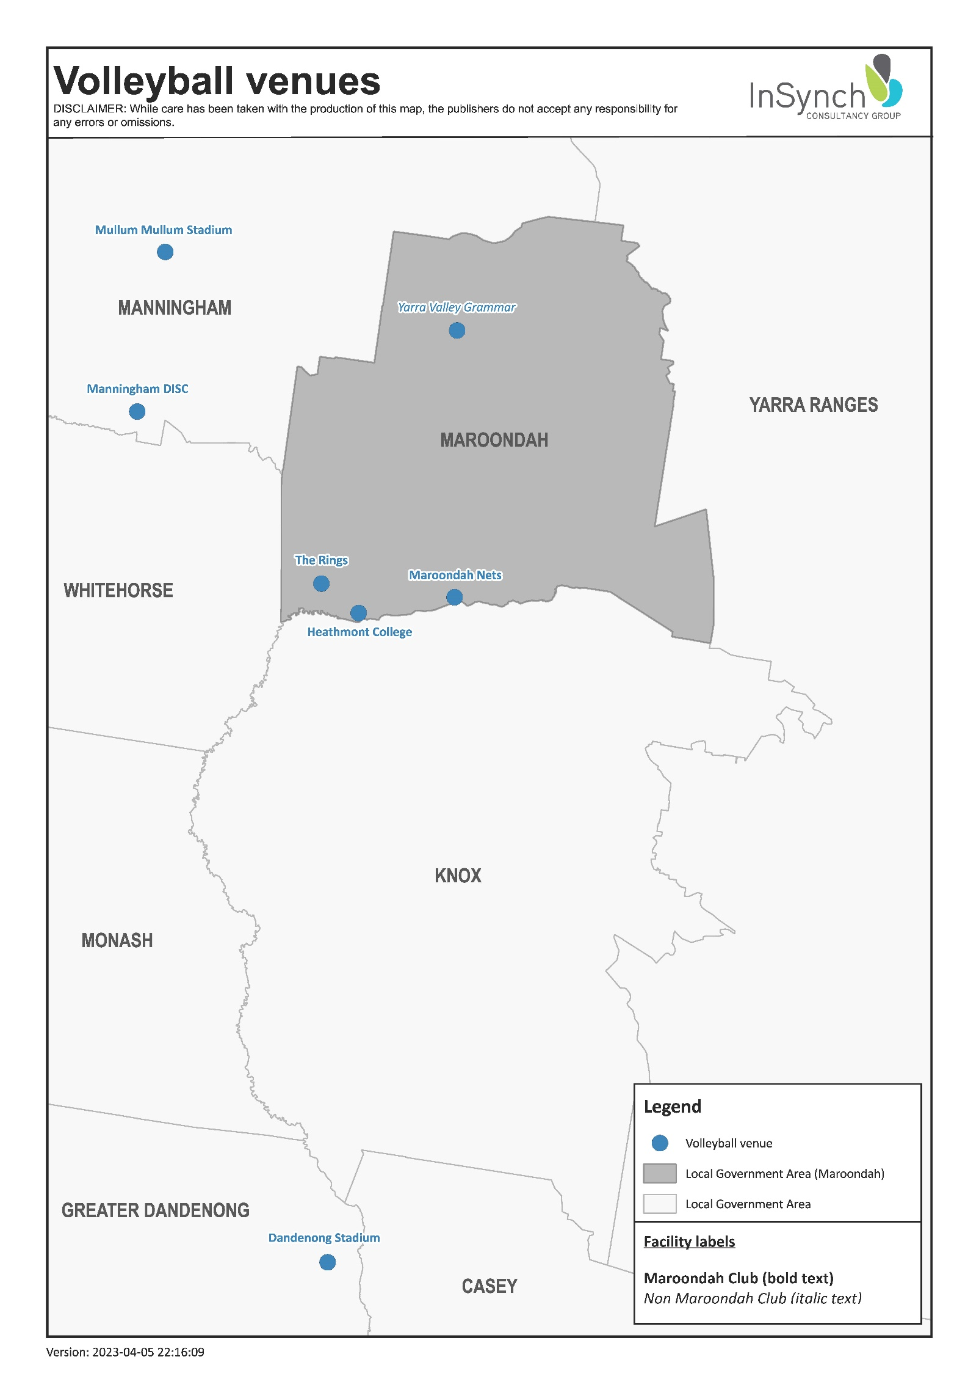

#### 

#### 3.5 Badminton, Pickleball and Table Tennis

##### 3.5.1 Badminton

Yarra Ranges and Whitehorse have a number of purpose-built badminton facilities with established clubs.

Maroondah Nets, Manningham DISC and Mullum Mullum stadium (in Manningham) offer social badminton.

##### 3.5.2 Pickleball

Pickleball is offered in Maroondah (Maroondah Nets), Manningham (Mullum Mullum Stadium and Manningham DISC), Whitehorse (Box Hill Indoor Sports Centre) and Knox (Rowville Community Centre). Yarra Ranges do not currently offer this at any of their facilities. Manningham DISC is the closest facility to Maroondah Nets.

Whilst pickleball is currently only played at stadium facilities in these LGA’s, there are examples in other areas where pickleball plays at tennis clubs.

##### 3.5.3 Table tennis

Yarra Ranges and Whitehorse have purpose-built table tennis facilities with established clubs. There is also a coach that runs a table tennis competition out of Sportlink in Whitehorse and Kilsyth Sports Centre in Yarra Ranges.

Manningham DISC and Mullum Mullum stadium (in Manningham) offer social table tennis. Maroondah Nets offers social table tennis, in line with their social badminton, but have had no interest in table tennis for some time now.

Refer to **Figure 7** on the following page for a map of facilities that cater for badminton, pickleball and table tennis in and around Maroondah.

#### 3.6 Other sports

Council’s stadiums also cater well for people with all abilities, with a combination:

* Council run programs - all abilities soccer, basketball and biddy ball (basketball for children);
* Association run programs - all abilities volleyball, seated volleyball, all abilities netball and walking netball;
* Hire groups – ‘teach your all abilities child to ride a bike’, and the ‘benefits of community sport participation from a wellbeing and resilience perspective’, and;
* Casual shooting opportunities.

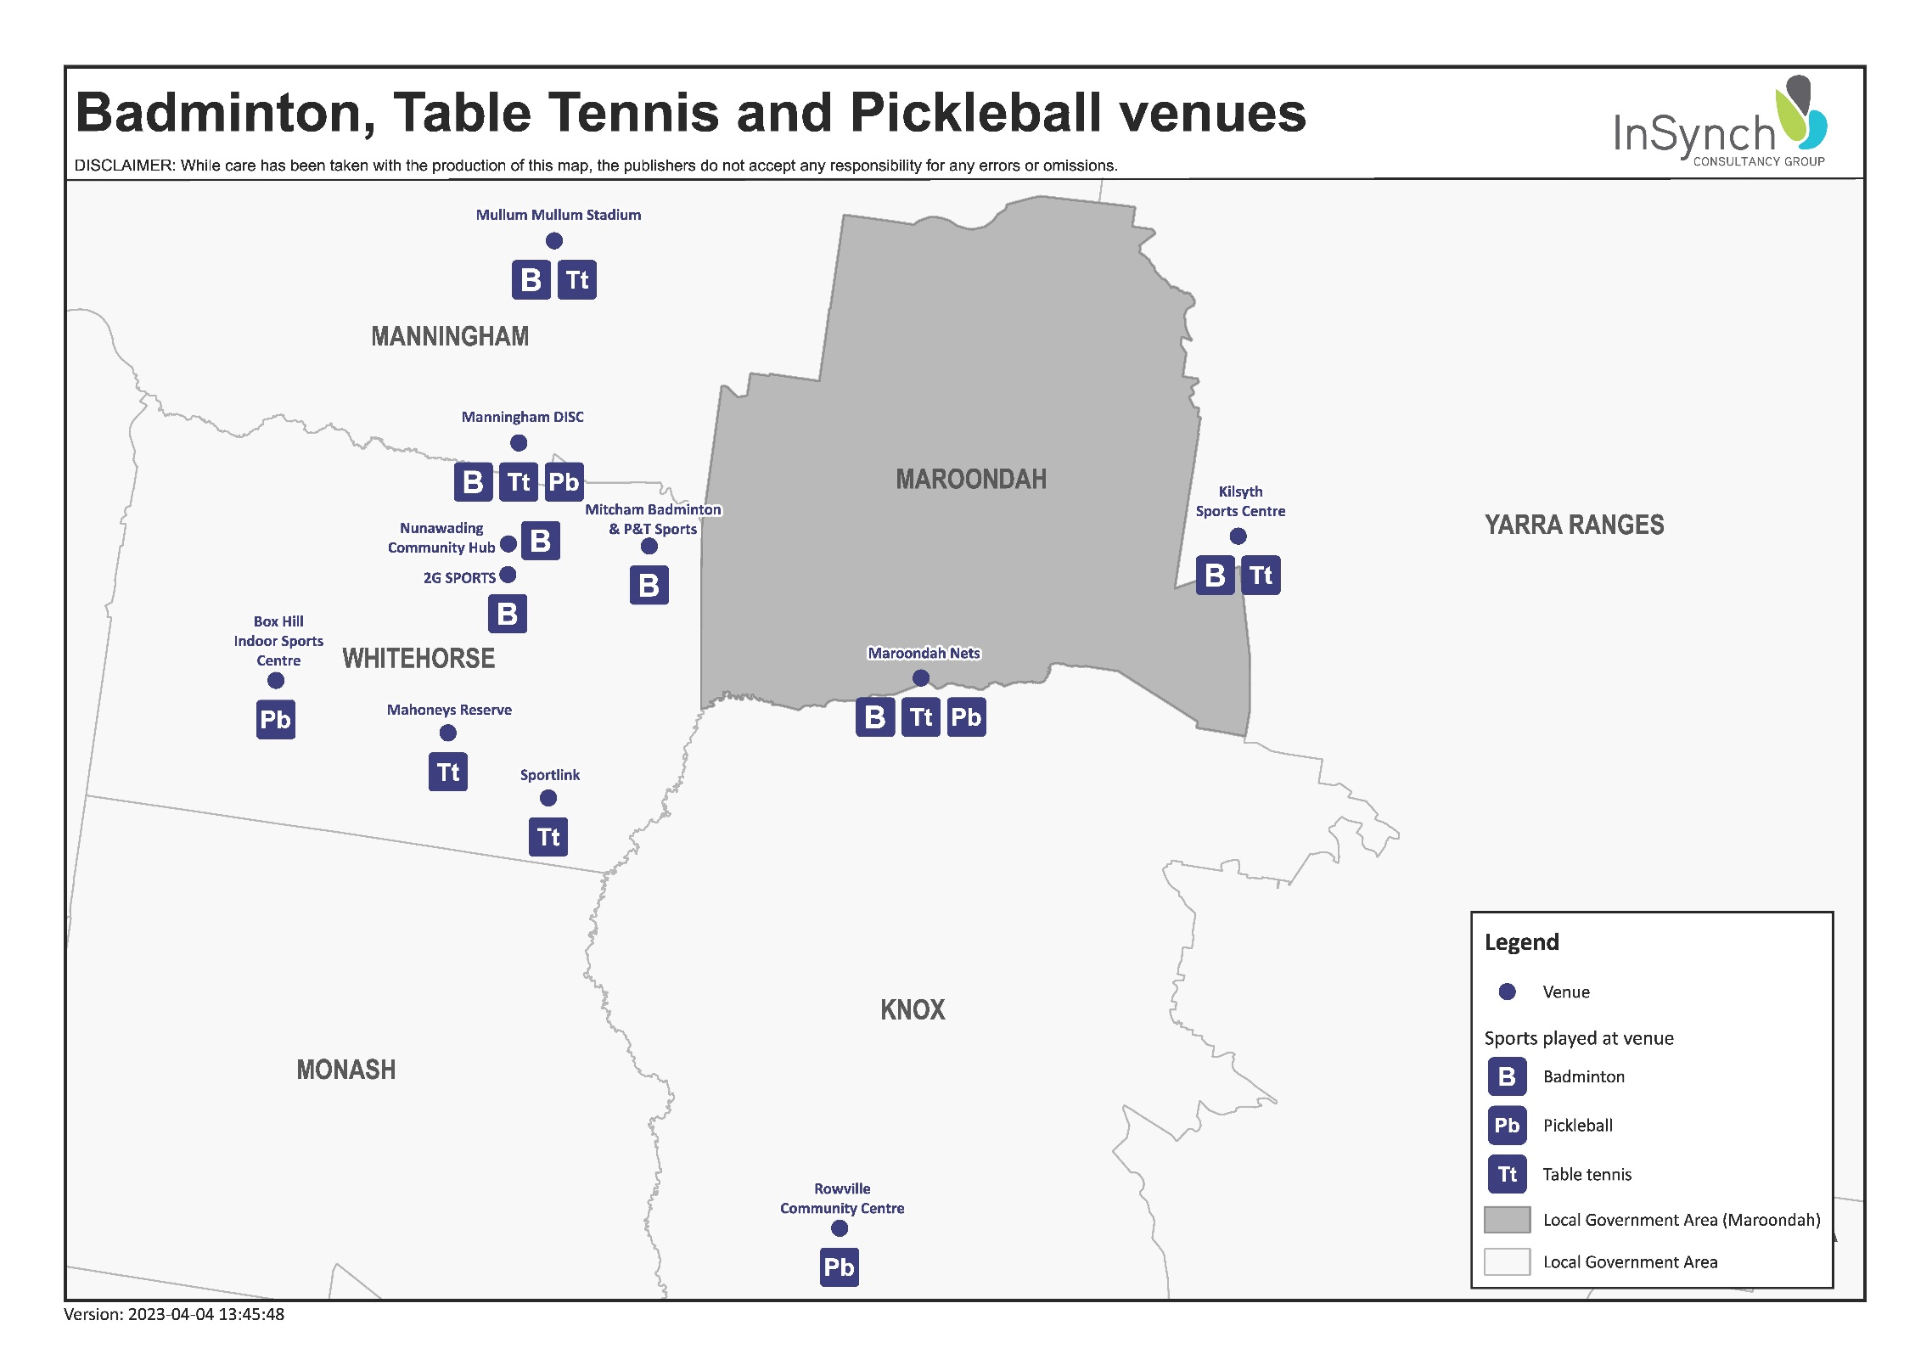

# 

#### 3.7 Major stadium facilities near Maroondah

**Figure 8** on the following page provides a visual overview of the major stadium facilities in Maroondah and surrounding LGA’s. This includes the sports which each of them offers.

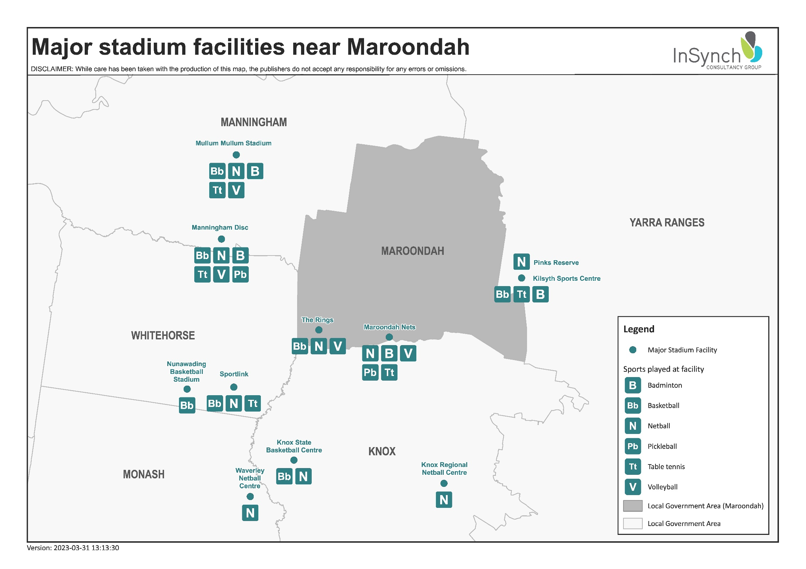

# 

# SECTION 4: MARKET ASSESSMENT

#### 4.1 Maroondah population overview

Maroondah City Council’s population is projected to increase by 19,241 people by 2036, which is an increase of 16.6%. This growth is consistent with population growth projections for the Eastern Metropolitan Region of Melbourne (EMR) (17.8%) but less than the anticipated growth of Greater Melbourne (35.1%) and the state of Victoria (19.9%). The municipality’s growth is expected to be relatively consistent across the period to 2036.

Table 1: Population projections 2021-2036

P447#yIS1

Source: Victoria in Future and forecast.id

* Eastern Metropolitan Region combines the LGA’s of Boroondara, Knox, Manningham, Maroondah, Monash, Whitehorse and Yarra Ranges

#### 4.2 Demographic overview

##### 4.2.1 Gender profile

In contrast to Greater Melbourne, Maroondah had a slightly higher proportion of female residents than male residents in 2021 (51.6% and 48.4% respectively, compared with 50.8% and 49.2%).

##### 4.2.2 Age profile

In 2021, the dominant age structure for persons in City of Maroondah was ages 35 to 39, which accounted for 7.8% of the total persons. This is also expected to be the largest five-year age group in 2031, with a total of 9,818 persons.

The largest increase in persons between 2021 and 2031 is forecast to be in ages 40 to 44, which is expected to increase by 1,596 (to 9,563) and account for 7.4% of the total persons.

Two key areas of growth relating to stadium sports are the 0 to 14-year-old age group (from 21,492 to 23,530), and the 15- to 29-year-old age group (from 20,363 to 23,183).

12% of the Maroondah population were in the 70+ age category. This is expected to increase to 13% by 2031 (from 14,355 to 16,758).

The following graphs provide a breakdown of 2021 age profiles for Maroondah City Council with 2031 projection population data highlighted.

Figure 9: Forecast age structure for Maroondah 2021-2031

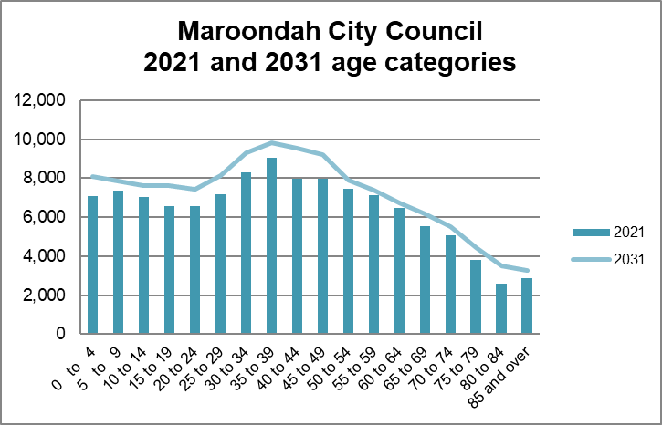

##### 4.2.3 Household structure and income

In 2021, 34.1% (15,070) of catchment households comprised ‘couples with children’, which was similar to Greater Melbourne (33.1%). The catchment had slightly more ‘couples without children’ than Greater Melbourne, 24.6% (10,875) compared with 23.5%. There were also more people living alone in the catchment (24.3% (10,723) compared with 23.3% in Greater Melbourne).

Over 50% (56%, 20,217) of catchment households reported a household income (equivalised quartiles) in the medium lowest ($495 to $864) and the medium highest ($865 to $1,392) ranges. In the EMR this proportion was 49%. Less catchment households were in the highest household income (equivalised quartiles) ($1,244 and over) than the EMR, 23.3% (8,418) compared with 29.3%.

The household income (equivalised quartiles) in Maroondah were similar to Greater Melbourne, with close to 50% of residents in the medium lowest ($882 to $1,756 per week) and medium highest ($1,75 to $2,946 per week) quartiles. Interestingly, there is an increase in the lowest quartile ($0 to $881 per week), with 21.3% or 9,447 residents in 2021, compared to 21.8% or 7,959 residents in 2016.

##### 4.2.4 Employment and individual income

Amongst catchment residents employed (96%, 58,980), 57.4% were employed full time, 32.7% were employed part time and 5.9% reported being employed but away from work. The unemployment rate in 2021 was 4% (2,475), which was lower than it was in 2016 (5.2%) and Greater Melbourne (2.6%).

Individual income in Maroondah in 2021 was very similar to Greater Melbourne.

##### 4.2.5 Cultural diversity

Maroondah has a significantly higher proportion of residents born in Australia than Greater Melbourne (71.8% compared to 59.9%).

Of residents reporting being born overseas, the most common countries reported were the United Kingdom (5,025 which is down from 6,078 in 2016), China (4,285 which is up from 1,468 in 2016), India (2,531 which is up from 1353 in 2016) and Burma (1,874 which is up from 832 in 2016).

##### 4.2.6 Transport

Maroondah (57.4%) had a higher percentage of people who owned two or more cars than Greater Melbourne (51.4%). Interestingly, Maroondah had the same percentage of residents without a motor vehicle as Greater Melbourne (4.7%).

##### 4.2.7 Summary of findings

The population of Maroondah, and the Eastern Region, is increasing. Council needs to consider how this will impact on their ability to meet the demand for stadium sports going forward.

The increase in population across all age ranges means that it will be important for stadium sports in Maroondah to be varied, and to cater for all groups.

Residents from China increased significantly from 2016 to 2021. With table tennis and badminton being traditional sports, it will be important to monitor whether the needs for these sports is being met going forward.

# SECTION 5: SUPPLY AND DEMAND ASSESSMENT

#### 5.1 Sports participation

Participation data in this section was provided by clubs, who were asked to provide the number of players in their club from 2018 to 2021, along with projected players for 2025.

Five-year projections were calculated using a range of methods. Where possible, SSA projections for each sport were overlayed onto existing participation and population projections. Where this was not available, or where this varied to LGA participation data, club projections were compared to previous growth trends and then ‘reality checked’ by overall sporting trends, state and regional sporting bodies and Council staff.

##### 5.1.1 Badminton

Figure 10: Badminton participation – AusPlay (adults)

P491#yIS1

**Figure 10** represents adult participation in badminton from 2017 to 2021. This shows strong growth in the sport over this period of time with 1.1% of the adult population and 0.4% of children playing. The gender breakdown was 1.7% males and 1.3% females, with 69% of players being aged between 18 and 44.

Data collected from Badminton Victoria showed 8,201 members in August 2022 (up from 6,500 in 2017). Of these only 151 live in Maroondah.

There are no badminton clubs located in Maroondah. Mountain District Badminton Club is based in Yarra Ranges (Pinks Reserve) and is the largest club in the area with 148 members (down from 307 in 2017). Also in Yarra Ranges is the Badminton Academy of Victoria with 100 members (down from 123 in 2017). In Whitehorse, Infinity Badminton Association (located in Mitcham) is the closest to Maroondah with 178 members. There are two smaller associations in Nunawading (51 and 39).

Social badminton is run in Manningham (Mullum Mullum Stadium and Manningham DISC) and Maroondah (Maroondah Nets). These players are generally not associated with a club and therefore not registered with Badminton Victoria.

Badminton has shown stronger growth for 2021 than anticipated in 2017, with projections being 949 players in Maroondah (compared to 2021 AusPlay figure of 1,419).

Based on AusPlay participation rates this means that there will be 1,772 adults living in Maroondah in 2025 that play badminton.

**Figure 11** on the following page provides an overview of five-year projections between 2021 and 2025.

Figure 11: Badminton – five-year projections

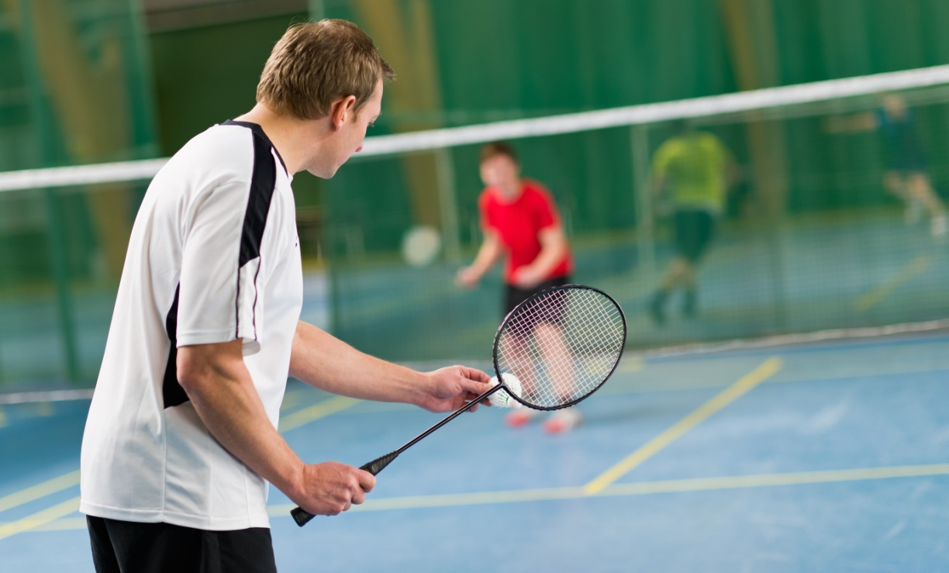P501#yIS1

##### 5.1.2 Basketball

Figure 12: Basketball participation rates 2018-2021 (AusPlay and Maroondah)

P510#yIS1

**Figure 12** shows that basketball participation in Maroondah has recovered and is higher than pre-COVID, despite a decline in AusPlay participation levels. Basketball Victoria attributes the overall drop in participation levels to the closure of some regional basketball associations as a result of COVID, as they say that basketball in metro Melbourne is showing strong growth (approximately 10% per year).

Recent Victorian data from AusPlay rated basketball as the ninth most popular activity for adults (compared to the tenth in 2017), the fifth most popular club sport for adults (same as 2017), and the third most popular activity for children (same as 2017).

Basketball had a total participation figure in 2021 of 5.9% for adults (8.8% males and 3.3% females) and 11.5% for children (12.4% males and 10.4% females) with 3.2% people playing basketball as a club sport. This adult participation is higher than the 4.6% participation rate in 2017, with the growth for adults being male players. The children’s participation rate is slightly lower than 2017 (12.2%). Interestingly, with the children’s participation, there has been an increase in the number of girls playing (from 9.5%) and a decrease in the number of boys playing (from 14.8%).

At a local level Maroondah had the highest participation in the under 15 age category (42%), followed by the 15 to 24 (26%) and 24 to 35 (14%) year old age groups.

At a state level Basketball Victoria had approximately 450,000 registered participants 170,000 in Vic Country and 280,000 in metro), 161 Affiliated Associations and 550 clubs.

There are 225,000 registered basketball players living in the eastern suburbs of Melbourne.  The City of Maroondah has approximately 7000 players and is ranked fifth when compared to the seven eastern-region Councils.  Approximately ​​21% of basketball players in Maroondah (​1500) are registered with the Kilsyth Basketball Association.

The two main basketball associations that are based in Maroondah are the RBA and VBBA. In 2021, the RBA had 5,694 players with the VBBA having 234 players.

**Figures 13** to **15** provide a breakdown of RBA and VBBA membership between 2018 and 2021 as well as projections for 2025.

Figure 13: Basketball – female participation in Maroondah (2018-2021)

P523#yIS1

Figure 14: Basketball – male participation in Maroondah (2018-2021)

P525#yIS1

Figure 15: Basketball – gender diverse participation in Maroondah (2018-2021)

P533#yIS1

**Figure 16** provides five-year projections for basketball between 2021 and 2025. This growth will only be realised with additional court space available.

Figure 16: Basketball – five-year projections

 P537#yIS1

##### 5.1.3 Netball

Figure 17: Netball participation rates 2018-2022 (AusPlay and Maroondah)

P544#yIS1

**Figure 17** shows that the netball participation rate in Maroondah is significantly lower than AusPlay rates, but Maroondah has shown a slight increase in participation from 2018 to 2021, where AusPlay has not increased.

Recent Victorian data from AusPlay rated netball as the ninth most popular activity for children (down from fourth in 2017), 11th most popular organised activity for adults, and sixth most popular club sport for adults (same as 2017).

Netball had a total participation figure in 2021 of 3.3% for adults (0.7% males and 5.8% females) and 5.7% for children (0.3% males and 19.5% females) with 2.7% people playing netball as a club sport (down from 3.1% in 2017). This adult participation is slightly lower than the 2.9% participation rate in 2017. The children’s participation rate is lower than 2017 (9.7%).

At a local level Maroondah had the highest participation in the under 15 and 15- to 24-year-old categories (67% and 32% respectively).

Netball Victoria saw a 4.2% increase in netball participation between 2017 and 2022. In 2022 they had 103,940 members, 181 associations and 964 clubs (this does not include school, social and other participation).

Their membership profile was 53.3% juniors (11 and 17 years), 34% seniors (18+) and 11.12% NetSetGO (5 to 10 years), 0.65% all abilities, 0.75% off the court and 0.18% walking netball.

Data provided by Netball Victoria for 2021 highlights that 2,549 members live in Maroondah, and 3,954 people participate in netball. This is down from 2019 (2,651 and 4,464 respectively).

Netball participation in Maroondah through MENA and Ariels VCNA increased by 11% between 2018 and 2021 (from 1,973 to 2,183) with 98% of participants in 2021 being female.

**Figures 18** to **20** provide a breakdown of club membership between 2018 and 2021 as well as club predictions for 2025.

Figure 18: Netball – female participation in Maroondah

P556#yIS1

Figure 19: Netball – male participation in Maroondah

##### P559#yIS1

Figure 20: Netball – gender diverse participation in Maroondah

P567#yIS1

**Figure 21** provides an overview of five-year projections between 2021 and 2025.

Figure 21: Netball – five-year projections

P571#yIS1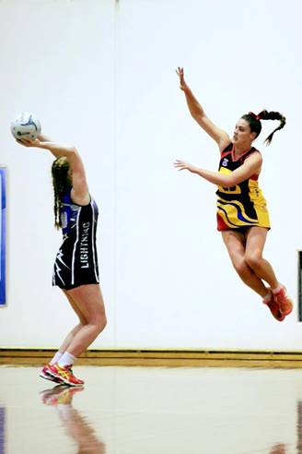

##### 5.1.4 Pickleball

Pickleball was introduced in Australia in 2017 and now has more than 5,000 members, and 20,000 participants. The average age of members is 58, with 70% of members being over the age of 50. The gender split is 55% female, 44% male and 1% non binary.

In April 2023, Pickleball Australia reported growth of around 77 members per week. By 2025 they predict that they will have 15,000 members, and that 250,000 Australians will participate in pickleball at least once a year.

Similar to sports like badminton and table tennis, pickleball is often unaffiliated. This means that a large percentage of players are not registered with Pickleball Victoria or Pickleball Australia.

Pickleball Victoria recorded 650 members in March 2023. This is up from 293 members in October 2022.

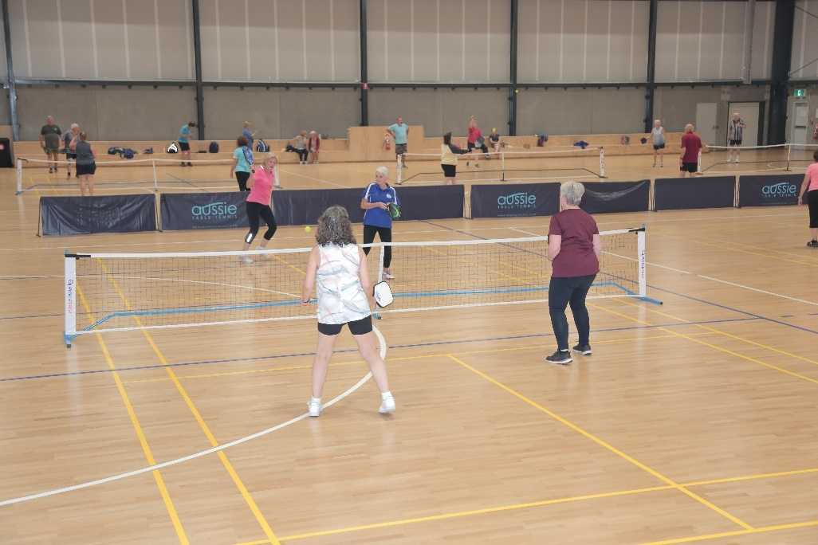

At a local level, Maroondah Nets runs both day and night pickleball sessions, competition, round robins and tournaments. These are held on both the indoors and outside courts, although the main demand is for indoor courts due to the court surface.

Pickleball was launched at Maroondah Nets just prior to the first COVID lockdown with just 72 participants in 2019/20. Numbers grew in 20/21, despite another prolonged lockdown, and have further increased in 2021/22. The total participation for 2022 for Pickleball was 5,836 (number of total participants, not individual participants).

Both Manningham and Whitehorse run pickleball but there are currently no venues running this in Yarra Ranges. There is a current demand for additional timeslots in Maroondah to grow the sport.

There is currently no formal participation data relating to pickleball. For the purpose of forward projections, the actual participation for 2022 at Maroondah Nets has been used to work out a participation rate, which has then been applied to the 2025 population.

**Figure 22** on the following page provides an overview of five-year projections between 2021 and 2025. This growth will only be realised with additional court space.

Figure 22: Pickleball – five-year projections

P587#yIS1

##### 5.1.5 Table tennis

Recent Victorian data from AusPlay shows that 0.7% of adults and 0.2% of children played table tennis, with 73% females and 27% males.

Data collected from Table Tennis Victoria indicated that they had 3,850 members in 2022 from more than 62 clubs. 135 members lived in Maroondah in August 2022 (compared to 143 in 2017), the majority of which were members of Croydon & Districts Table Tennis Association (based out of Kilsyth stadium). No projection data was available.

No table tennis clubs currently exist in Maroondah with the closest being Croydon and Districts Table Tennis Association.

The Kilsyth competition is the largest table tennis competition in Melbourne with 364 members at the end of 2022. They are expecting to increase back to pre-COVID numbers of between 400 and 500 in 2023. They have 25 table tennis tables in two halls and run multiple competitions. 119 Maroondah residents play for the Croydon and Districts Table Tennis Association.

Table tennis group sessions are also run indepenently out of Kilsyth Stadium by a private coach. They run as a ‘show up on the day’ session on a Saturday morning, with numbers ranging between 16 and 25 on average.

Sportlink in Vermont has 11 tables and runs a weekly table tennis competition which has 78 players and 66 weekly participants. This comprises of 70% adults and 30% juniors. This competition has been running for the past 10 years, with the competition being at capacity, with a waiting list, for the past five to six seasons.

Mullum Mullum stadium and Manningham DISC both run social table tennis. Similarly to badminton, a significant amount of social players are not registered with Table Tennis Victoria.

Locally, Maroondah offer social table tennis but have had no requests for a competion to be run at any of their venues.

Based on 2021 population data for Maroondah and AusPlay participation rates, 929 people that live in Maroondah played table tennis.

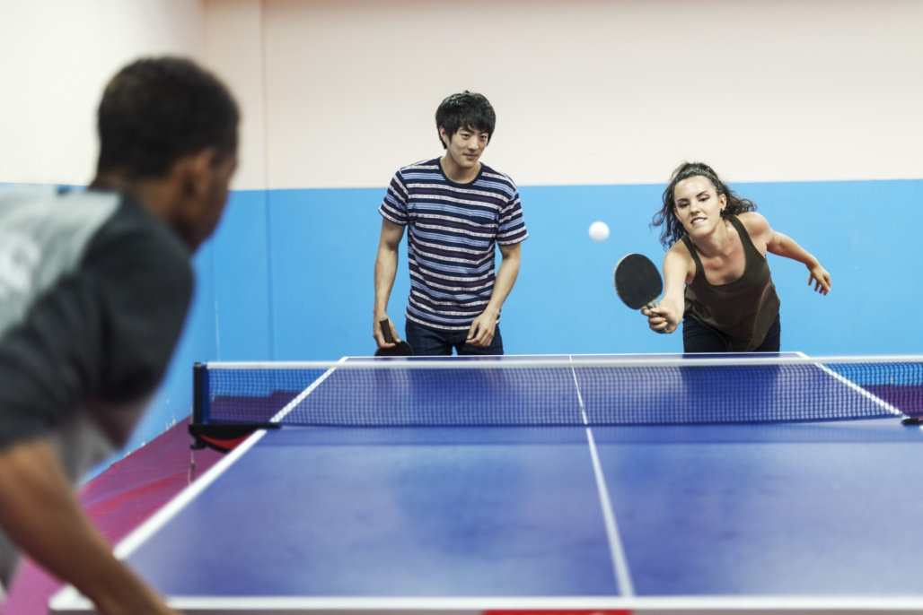

**Figure 23** on the following page provides an overview of five year projections between 2017 and 2021.

Figure 23: Table tennis – five-year projections

P616#yIS1

##### 5.1.6 Volleyball

Figure 24: Volleyball Victoria members (2017-2022)

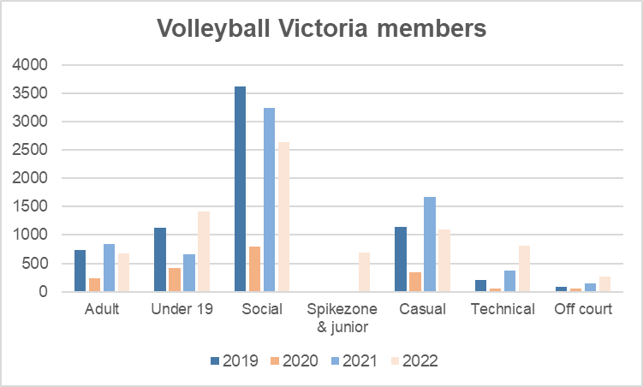

**Figure 24** provides an overview of volleyball membership numbers between 2019 and 2022. These numbers show a slight decrease in adults and social, with an increase in under 19 and the introduction of Spikezone and junior programs.

Recent Victorian data from AusPlay rated volleyball as the 13th most popular club sport for adults with 0.6% people playing volleyball as a club sport, 0.4% of which were through an organised club/association. *It should be noted that these figures are based on indoor and outdoor volleyball.*

Data collected from Volleyball Victoria indicates that they had 7,567 members overall in 2022, which is an increase of 9% from 2019 (an additional 643 members). Only 5% of their overall membership lived in Maroondah in 2022 (246 members) of which 61% were male.

At a local level, the Maroondah Volleyball Association are the only volleyball association in Maroondah. In 2021 they recorded 1,026 members which is an increase of 117% from 2016. 49% of these members were female.

They are projecting significant growth between 2021 and 2025 (103% or an additional 1,059 members). This growth will only be realised with additional court space.

In addition to the Maroondah Volleyball Assocation, the Yarra Ranges Volleyball Association runs out of Yarra Valley Grammar.

**Figure 25** provides a gender breakdown of volleyball in 2021.

Figure 25: Maroondah Volleyball Association participation 2021

P630#yIS1

**Figure 26** provides an overview of five year projections between 2021 and 2025.

Figure 26: Volleyball – five-year projections

##### P634#y1P634#yIS1

##### 5.1.7 Breakdown of participation (2021)

**Table 2** provides a breakdown of age and gender in participation for basketball, netball and volleyball in Maroondah in 2021. The information to calculate this breakdown is not available for badminton, pickleball or table tennis.

Table 2: 2021 breakdown of sports participation

P649#yIS1

#### 5.2 Current capacity of school sporting facilities in Maroondah

Schools in Maroondah play an important role in the provision of stadium sport facilities for clubs. **Table 3** provides an overview of current and potential school sporting facilities that are currently used by, or have the ability to be used by Maroondah clubs. It also shows Maroondah school facilities that are used by non-Maroondah clubs.

Table 3: School sporting facilities in Maroondah

P654#yIS1

*\* Ringwood Secondary College has a single court stadium that is not full sized. This is used by a Phillipino Basketball Club that is not part of any association.*

#### 5.3 Non-Maroondah sporting facilities

There are a number of sports that are currently practiced or played at sporting facilities outside of Maroondah. These facilities help to meet the demand for these sports.

Table 4: Non-Maroondah sporting facilities

P659#yIS1

#### 5.4 Facility provision

##### 5.4.1 Facility provision in Maroondah

**Table 5** below provides a comparison of the population to facility ratio for basketball, netball and volleyball from the 2017 Sports Demand Analysis to current provision in 2023, and then 2026 provision if no other facilities become available in this time.

While the 2023 ratios show a far better provision of facilities in each sport for Maroondah residents, the following should be noted:

* **Basketball** – 10 of the 27 courts included in this ratio are currently used by KBA, and are therefore not available to the RBA. There are four additional schools in Whitehorse and Manningham that are being used by Maroondah clubs for basketball training
* **Netball** – there are four of the school sites below that have the ability to cater for additional training. Netball also use a number of school facilities outside of Maroondah to train at
* **Volleyball** – the reduction in ratio from 2017 is due to Maroondah Nets opening. Volleyball has actively tried to find additional venues to train and play at, with limited success

Table 5: Facility provision comparison (2017-2023-2026)

P669#yIS1

**Table 6** on the following page provides a detailed breakdown of facilities available for each sport in Maroondah, including private and school facilities that clubs are currently using.

Table 6: Facility provision to population ratio (2023 to 2026)

Refer to the following page. The facilities in red italics represent those that are used by a Yarra Ranges club and are unavailable to Maroondah clubs.

##### P675#yIS15.4.2 Benchmarking with other LGA’s

Benchmarking was undertaken with Whitehorse, Knox, and Yarra Ranges Council’s to understand each Council’s provision of stadium sport facilities.

**Table 7** below provides the facility provision ratio for stadium sports in each of the LGA’s.

Table 7: Population to facility provision (ratio)



**Notes:**

* **General** – the figures in red include Council facilities only. Information about school facilities that clubs use was not available. This means that these figures are inflated and not a good comparison to Maroondah
* **Knox**
  + The ratio for basketball courts includes Council basketball courts available at the time that the data was collected, and school sites that are used by the Knox Basketball Association. *By the end of 2023, there will be an additional 12 basketball courts at the State Basketball Centre, but six existing courts will be closed. This will change the ratio for basketball to 1:4,833*. Going forward the Knox Basketball Association are speaking to St Joseph’s Secondary College about use of a 2-court stadium that they are trying to get funding for
  + There are no volleyball courts in Knox
* **Maroondah** – this includes Council and school facilities that are used by Maroondah or non-Maroondah clubs for these sports
* **Whitehorse** 
  + Plan to build an additional 2 netball/basketball courts at Sportlink and the same at Aqualink Box Hill, although no funding has been committed to these projects at this time
  + A Master Plan of East Burwood Reserve is currently out for consultation (June 2023) which recommends an additional six basketball courts at the Nunawading Basketball Stadium
* **Yarra Ranges** – Council is planning to undertake a Stadium Sport Strategy in the near future which would help to ascertain information about school facilities used by clubs
  + Council is about to build an additional basketball court at the Kilsyth Basketball Stadium
  + Of the netball courts, 2 are indoor, 6 are covered and 48 are outdoor (6 at Pinks Reserve and 42 at other locations). 49 of the outdoor courts have some kind of lighting but many don’t meet standards
  + The volleyball courts are at the Yarra Centre. These are available for hire but there is no competition

# 

# SECTION 6: CONSULTATION

#### 6.1 Consultation overview

A number of consultation methods were used in the development of this strategy:

* Club and association data was collected by sending surveys out to Maroondah basketball, volleyball and netball associations. These surveys collected information around previous, current and projected membership numbers as well as facility requirements, both current and future
* State and regional sporting bodies for each of these sports were also contacted to understand the current and projected participation for their sport both in Maroondah, and more broadly across the state
* Discussions were held with local associations around challenges and barriers of growth, as well as facility feedback
* Broad community consultation to seek feedback from players and non-players of stadium sport in Maroondah
* Discussions with other Councils

#### 6.2 Consultation with Associations

Conversations were held with each of the netball, basketball and volleyball associations. It should be noted that there are no local associations for badminton, pickleball or table tennis. This section provides an overview of information collected from these discussions.

##### 6.2.1 Netball (MENA)

* Competition feedback:
  + Team numbers are lower post COVID which leads to more forfeits. They have adjusted rules around borrowing players from other teams to reduce this number
  + Open age group has lower numbers
  + They have enough umpires but lots of new ones without as much experience
  + They have enough space for current training and competition but would need to schedule more byes if there were more teams
* Future needs:
  + 2 more courts at the same location (indoor or outdoor), or move volleyball so that they can have additional days/times. They said that there are too many administration costs if they are across two sites
  + There is not enough space to run rep tournaments
  + They have to restrict numbers for club tournaments
* Issues with existing facilities:
  + Court surface (both indoor and outdoor)
  + Dust coming in from outside
  + Parking
  + They said that the café has been hard work. They are going to undertake a review to make sure it’s viable for them

**Netball (Ariels)**

Ariels VNCA indicated that they need additional courts at Maroondah Nets on a Monday night so that they have all four courts.

**Netball (others)**

The EFNL also uses Maroondah Nets from 6.45pm until 10.30pm.

##### 6.2.2 Basketball

**RBA**

* Competition feedback:
  + Numbers are strong post COVID, lots of kids wanting to play (10–15year-old boys) and influx of senior teams
  + They have enough referees now, there was a shortage post COVID. There is a waiting list in schools of people wanting to do the referee’s course
  + They are turning kids away from representative basketball (Friday night competition) as they don’t have enough room (200 kids on waiting list)
  + Want to run development programs for girls (eight to 10-year-olds) but don’t have space
* Future needs:
  + They have spoken to Ringwood Secondary College about joint use of a new three to four court stadium (no capital, long term hire basis with sole use out of school hours)
  + They have spoken to Council about the possibility of expanding The Rings to include additional courts
  + They need a new show court that meets NBL 1 requirements. They are currently using Norwood and The Rings for these games
* Issues with existing facilities:
  + Insufficient run offs and lack of seating means that they can’t run professional competitions
  + Storage is insufficient and dangerous where it is currently located at the end of the courts
  + Plans to draw up viewing area

**KBA** – SYSC Scorpions currently train at the John Frost Stadium (Cheong Park) from 5pm to 9pm Monday to Thursday nights. They have 45 basketball teams and are planning to grow. The club will have a long term need for a stadium to train in.

The KBA does not have any plans to build additional courts at this stage that would cater for this club. Discussions were also held with Yarra Ranges Council about the need to assist with the growth of the club. Further discussions with Yarra Ranges Council and the KBA will be necessary to discuss future needs of the SYSC Scorpions when the current stadium is no longer fit for purpose.

##### 6.2.3 Volleyball (Maroondah Volleyball Association)

The Maroondah Volleyball Association have shown very strong growth since the opening of Maroondah Nets and exceeded participation projections that were supplied in 2017 as part of the Sports Demand Analysis.

As an association, they run a diverse range of programs that cater from toddler to adults, as well as participating in the state league competition. They have an even mix of male and female participants, and feel that they cater well for gender diverse.

* Competition feedback:
  + COVID has had a positive impact on numbers (increase from netball, basketball and gymnastics)
  + They cater well for males, female and gender diverse, and have been able to attract youths from netball and basketball
  + They have waiting lists for their local league, programs and social Sunday
* Future needs:
  + Additional stadium space to meet the current and future demand
  + They would like Council to enclose the 3 outdoor netball courts to provide 4 more volleyball courts
  + 2 beach volleyball courts. They see this as an unmet need at the moment. They would be the only beach volleyball courts on this side of the city and believe the courts would get used for Commonwealth Games and Paralympic training as well as the Volley All program and general hire
* Issues with existing facility:
  + Wasted space (netball bookings that are not being used, they feel that volleyball could use that space)

#### 6.3 Community consultation

A community survey was put out for consultation for a four-week period in August 2022. This consultation period included collecting feedback from both users and non-users of Council stadiums. Methods of collecting feedback included: on site surveying at Maroondah Nets and The Rings during program times, link on Council’s website, eDM’s to Maroondah Leisure members, email with link to members of all clubs and associations, signage at Maroondah Leisure sites, Maroondah News, Eastern FM and internal staff communications.

348 responses were received during the consultation period, of which more than 50% were Maroondah residents.

Current participants included:

* Badminton (18 players)
* Basketball (30 players, representing 189 people that currently play, including juniors)
* Netball (70 players, representing 213 people that currently play, including juniors)
* Pickleball (32 players)
* Volleyball (32 players, representing 86 people that currently play, including juniors)

Similar to the sporting associations, respondents of this survey were asked to rate the facilities at The Rings and Maroondah Nets. Key areas for improvement identified included:

* The Rings (car parking and public toilets)
* Maroondah Nets (car parking and court surface)

Interestingly, the community rated the facilities at both facilities a lot higher than the sporting associations.

# SECTION 7: IDENTIFIED NEEDS

This section of the report includes five-year projection data at a sport level and relates this back to facility provision for the population for both 2021 and 2025. It also outlines key needs for each sport that have been identified through the consultation phase and other elements of the project.

#### 7.1 Five-year participation projections

The five-year projections were calculated using a range of methods. Badminton and table tennis projections have come from AusPlay participation rates and the Maroondah population. Basketball, netball and volleyball have come from an analysis of local data and projections, which has been cross checked at an association and state level. Pickleball projections have been determined by Council staff, based on previous and current usage, and forward projections.

It should be noted that basketball, pickleball and volleball projections for 2024 and 2025 are dependent on additional stadium space being available for these sports. A lack of additional space will see numbers capped at 2023 participation.

**Table 8** provides a snapshot of five-year participation data and identifies whether there will be a need for additional facilities at an individual sport level between 2021 and 2025.

It should be noted that the percentage change for each sport does not necessarily translate into a requirement for additional facilities. This requirement is based on capacity of existing facilities.

Table 8: Projected change in estimated participants for stadium sports in Maroondah (2021 to 2025)

P781#yIS1

*\* The numbers represented in red will not be able to be achieved unless additional facilities become available.*

#### 7.2 Breakdown of basketball and netball projected participants

State participation projections have been calculated using 2021 AusPlay data as a basis, then overlaying these figures with Maroondah population data, and then looking at existing participation and projected growth by clubs, associations and state bodies.

Basketball and netball are the only two stadium sports that include a breakdown of adults and children. This is due to the way which the volleyball data is captured locally. Refer to **Tables 9 and 10** for this breakdown, and projected participation from 2021 to 2025.

Table 9: Projected change in estimated participants by activity for adults (2021 to 2025)

#### P789#yIS1

**Table 9** shows that basketball is predicting very strong growth in the over 15 age groups. This is due to a new competition that Basketball Victoria is planning to launch.

Table 10: Projected change in estimated participants by activity for children (2021 to 2025)

P792#yIS1

**Table 10** shows strong growth projected for basketball with netball growth expected to be the same for adults and children.

#### 7.3 Individual sporting needs

##### 7.3.1 Badminton

With strong clubs in Yarra Ranges and Whitehorse, and social badminton in Maroondah and Manningham, there does not appear to be a need for a badminton club in Maroondah in the short term.

##### 7.3.2 Basketball

Basketball in Maroondah has seen strong growth following COVID restrictions. During this time new stadium facilities have been developed in Maroondah, four courts at Melba College that are used by the KBA, and two courts at Norwood Secondary College that are used by the RBA.

Data provided by Basketball Victoria suggests that 21% of Maroondah residents that are registered with Basketball Victoria play for the KBA, rather than the RBA.

The mapping in **Section 3** shows that there are 11 basketball courts in Maroondah that are used by the KBA. This includes Council’s single court stadium at John Frost Stadium (Cheong Park). This stadium is very old and does not meet run off standards. Discussions with Yarra Ranges, Council and the KBA will need to continue in the medium to long term to discuss a possible location, in either Maroondah or Yarra Ranges, for this club when this building has reached the end of its useful life.

The research undertaken in this strategy has found an immediate need for additional compliant courts to meet the future needs of the RBA. It is expected that growth of basketball will be restricted unless additional facilities become available.

In addition, Council will need to continue to work with the RBA in regard to future planning for improved facilities and amenities at The Rings. Any possible future expansion of The Rings would support Council’s position of advocacy.

##### 7.3.3 Netball

Unlike basketball and volleyball, who are prepared to play at any venue, as long as it meets their requirements, MENA have voiced a strong preference to be based out of one venue. While some of their netball clubs train at school facilities, a large number of clubs have a preference to train at Maroondah Nets, and all games are scheduled at Maroondah Nets.

There is still room for some growth at Maroondah Nets. Based on projections to 2025, court space at Maroondah Nets would meet the needs of netball, but they may need to make some changes to their scheduling of games.

Ariels VNCA indicated during consultation that they required additional court space on a Monday night as they require four courts for their VNL training and only have 2.5 courts. They have indicated that this is insufficient. There are currently no other indoor courts available on a Monday night that could meet this need for them.

##### 7.3.4 Pickleball

With the current way that Pickleball is organised, it needs to be run at a staffed facility or a community run club, a school stadium is not an option. It is expected that by the end of 2023, growth of Pickleball will be restricted unless additional facilities become available.

There is a short term need for additional court space for Pickleball.

##### 7.3.5 Table tennis

Although specific data relating to Maroondah was not available, there does not appear to be a demonstrated need for a club to be established or access to additional facilities in Maroondah, with strong clubs in Yarra Ranges and Whitehorse, and social table tennis offered in Maroondah and Manningham.

##### 7.3.6 Volleyball

Current volleyball facilities in Maroondah do not meet the needs of Maroondah Volleyball. The strong growth in volleyball over the past four years has seen them significantly increase their participation, far more than was anticipated in the 2017 Sports Demand Analysis, and outgrow their allocated days and times at Maroondah Nets.

They are currently using facilities at Heathmont College one night a week, and training at The Rings on Sunday afternoons, but the lack of additional stadium space in Maroondah sees them with a long waiting list and the inability to run all of the programs that they would like to run.

There is an immediate need for volleyball to access additional courts. Lack of additional courts will mean that they are unable to achieve the participation forecasts outlined in **Section 5.1**.

#### 7.4 Overall needs for stadium sports

With a short term need for additional stadium space for basketball, volleyball and pickleball, it is evident that there is a need for additional stadium facilities in Maroondah. To ensure that the needs for all of these sports can be met through new facilities, and to enable Council to apply for government funding for these facilities, they will need to be multi-sport facilities that are managed by Council, as per Council’s existing stadium facilities.

# SECTION 8: FUTURE OPPORTUNITIES

This section of the report identifies potential opportunities that exist to maximise capacity and increase participation at existing facilities, as well as opportunities for Council to partner with schools and other Councils.

#### ­8.1 Opportunities to maximise capacity and increase participation

Existing stadium facilities in Maroondah that are available to be used or hired are close to capacity. There is limited capacity at Maroondah Nets, and a few single outdoor school netball courts that could be used for netball training. These are identified in **Section 6.2**.

#### 8.2 Opportunities to partner with other Councils

This strategy has clearly demonstrated the crossover of usage for facilities across surrounding LGA’s. With each Council facing the challenge of having limited land to develop, and limited funding, a key consideration for Council going forward should be to continue to discuss opportunities to partner with neighbouring Councils.

This will be particularly relevant with Yarra Ranges Council, given the significant cross over of netball and basketball, and the future relocation of SCYC Scorpions from John Frost Stadium (Cheong Park).

#### 8.3 Opportunities to partner with schools

With Melba College and Norwood Secondary College both having undertaken stadium redevelopments over the past few years, Ringwood Secondary College is the only public secondary school in Maroondah that is yet to have a multi-court stadium.

Ringwood Secondary College has been lobbying for years for a multi-court stadium at the school. Based on existing facilities and the number of students at the school, the principal believes that they are entitled to a two-court stadium under the Victorian School Building Authority (VSBA). The School Council has for years, wanted a four-court stadium on site.

A high-level Master Plan of the school has been completed, which includes a multi-court stadium. The RBA has expressed interest in out of hours use of a multi-court stadium, and Basketball Victoria is supportive of a four-court facility at this school. The principal has met with the Education Department, and State and Federal members about the school interest in such a facility, and has expressed interest in working with Council to understand the feasibility for a four-court stadium that would be available for community use out of school hours.

It would be important that any stadium facilities built at Ringwood Secondary College cater for multiple sports, to meet community needs, and also to attract government funding.

#### 8.4 Opportunities with Council facilities

There are opportunities to explore enhancing both of Council’s stadium facilities to better cater for future growth of stadium sports in Maroondah.

At Maroondah Nets, there is the possibility of covering the outdoor netball courts to increase usage of these courts.

At The Rings, there is the possibility to explore the feasibility to improve existing facilities, look at expanding to cater for more courts, and to look at how this facility will integrate with the golf course.

# SECTION 9: RECOMMENDATIONS

The recommendations in this strategy support many of Council’s strategic documents, as well as regional and State Government strategies. This includes:

Maroondah 2040 – “*increasing the proportion of residents who undertake adequate physical exercise*”, “*providing a range of integrated recreation and leisure facilities that meet the needs of all ages and abilities*”, and “*increasing the proportion of community members who are involved in organised sport and have access to recreational leisure facilities*”.

Maroondah Liveability, Wellness and Recreation Strategy and the key action of “*provide and enhance accessible open spaces, active travel infrastructure, sporting precincts and integrated recreation facilities, to increase opportunities for and participation in physical activity*”.

Maroondah Physical Activity Strategy and Council’s commitment to “*prioritise the development and/or improvement of environments to support physical activity*”.

Access and equity of use is a key factor in future provision of stadium sports and is supported through: The Maroondah Equally Active Strategy (“*Council will continue to improve facilities to support women and girls to undertake sport and recreation…*”), Maroondah Disability Action Plan (“*provide and support leisure and community services that are engaging for people of all abilities and ages*”), Maroondah Youth Strategy (“*provide high quality accessible services and activities that support young people to develop their health and well-being in all aspects of their lives*”) and Maroondah Positive Ageing Framework and Action Plan (“*continue to create and develop public spaces that encourage intergenerational participation and connection”*).

The 2017 Sports Demand Analysis highlights that “*with limited additional land left for sporting infrastructure, it is important that Council make considered decisions which maximise the use of existing facilities and sport reserves*”.

Recommendations around possible sites for future stadium facilities are supported by: Maroondah Golf Strategy (*“develop a Maroondah Golf facilities master plan…to accommodate a possible future expansion of The Rings”),* the Melbourne East Regional Sport and Recreation Strategy (specific priorities include: “*develop additional indoor sports courts to address capacity and access requirements identified within state facility strategies for basketball, netball and volleyball*” and “*explore with schools in the delivery of regional/sub-regional level sport and recreation facilities, including indoor stadiums (3-4 courts) and sports fields to address areas of facility provision shortfall*”) and the Basketball Victoria Facility Infrastructure Priorities document for 2022 which supports a multi-court stadium at Ringwood Secondary College.

Active Victoria – A Strategic framework for sport and recreation in Victoria states the importance of “*maximised use of existing spaces (for example Parks Victoria land, school land, government surplus land…)*”, “*integrated school and community sport and recreation infrastructure*”, “*better connection of schools and health providers with the sport and recreation system*” and “*female-friendly sport and active recreation infrastructure and facilities*”.

**Table 11** on the following pageincludes recommendations at an individual sport level as well as a multi-sport level. These have been categorised as short term (1 to 3 years), medium term (4 to 6 years) and long term (7 to 10 years).

Table 11: Recommendations



* *to be considered for further advocacy*.