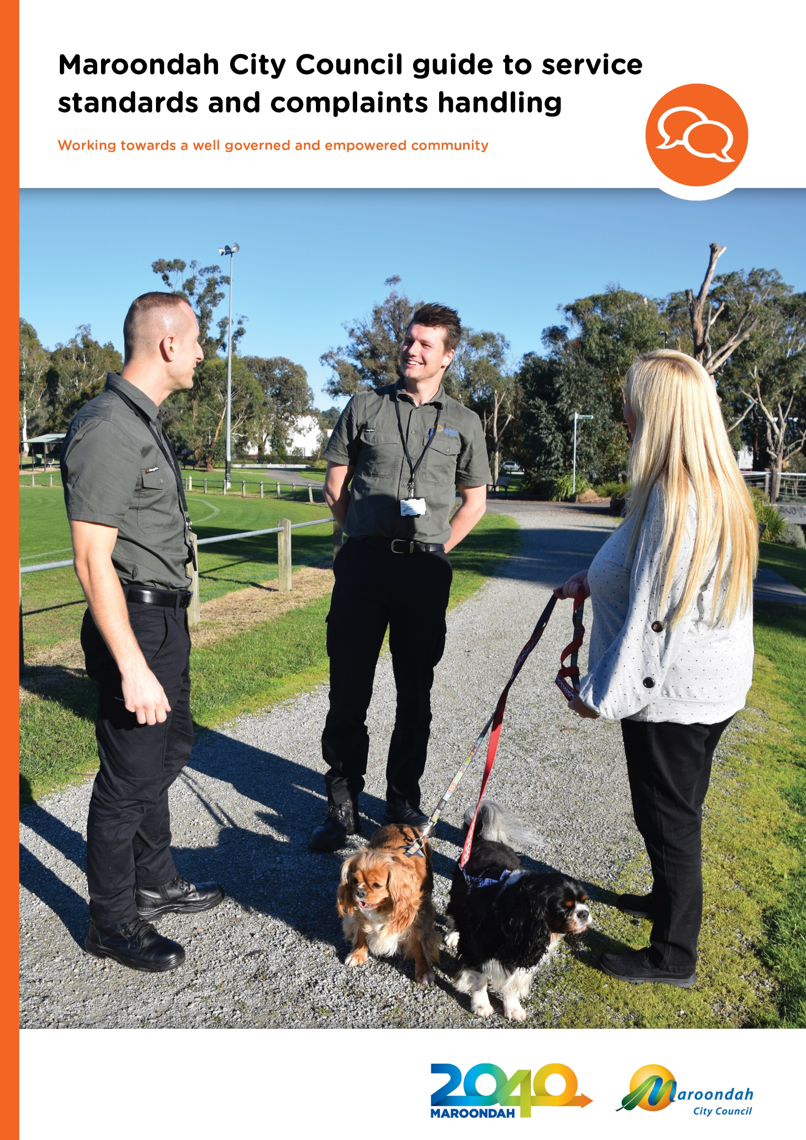

Contents

A message from the CEO 5
Section 1 - Why are service standards and complaint handling important? 6
Delivering the Maroondah experience 6
Related documents 6
One Maroondah 7
Customer Service Standards 8
Presentation and service image 8
Public service environments 8
Vehicle presentation 8
Name badges 8
Staff identification cards 9
Attire and personal presentation 9
Communicating with customers 9
Handling complaints and Compliments 11
What is a complaint? 12
What is not a complaint? 12
Who can make a complaint? 12
Where can complaints come from? 13
Submitting a complaint 13
Who can receive a complaint? 13
Receiving a complaint 13
Employees with access to Council’s Customer Request System 14
Employees who do not have access to the Customer Request System 14
Receiving a complaint on a social media channel 14
Office of the Mayor and Office of the CEO 14
Councillors 14
How to respond to a complaint when in person or on the phone 15
Listen without interrupting 15
Welcome the feedback 15
Express empathy 15
Confirm understanding 15
Explain what you can do and explore alternatives 15
How long should a complaint take to reach resolution? 16
Tracking complaints on Council’s Customer Response System 16
Reporting 16
Suggestions, feedback and comments 16
What to do if you receive a compliment 17
Challenging behavior 17
Unreasonable Complainants 17
What is an Unreasonable Complainant? 17
Unreasonable complainants may include complainants who: 17
What are the steps in dealing with an Unreasonable Complainant? 18
Unreasonable Complaints/Complainants on social media 18
Manager Revenue, Property and Customer Service 18
Complaints process summary 19
1. Complaint received and logged 19
2. Initial assessment and acknowledgement 19
3. Investigation and tracking 19
4. Response and communicating decision 19
5. Closure and review 20
Complaints process workflow 20
Roles and responsibilities 21
All employees 21
Customer Service Officers and actioning employees 21
Customer Service Coordinator 21
Customer Service Team Leaders 21
Service Area Coordinators and Team Leaders 21
Managers and Directors 22
Chief Executive Officer 22
Further information 22

Introduction
A message from the CEO

Maroondah City Council aims to achieve service excellence for every customer across all service areas. Over many years, we have achieved great results from the Local Government Community Satisfaction Survey, showing we are committed as an organisation to the highest service standards.

Our reputation for responsive service and consistent standards has allowed us to lead and support the community with conduct to be proud of. This document provides guidance on our Service Standards and customer complaint procedures, so we can continue to do so.

Please use this guide as a tool to help and support you in ensuring a positive customer service experience first time, every time.

Steve Kozlowski
CEO
Maroondah City Council

Background

The City of Maroondah is home to over 120,000 residents, 9000 businesses and
welcomes thousands of visitors to the municipality each day.

Maroondah has developed into a thriving regional centre, home to progressive educational
facilities; world-class sporting and leisure facilities; green, leafy open spaces; public
transport hubs; arts and cultural centres; and a range of high quality commercial, industrial,
community, and retail hubs.

Delivering the Maroondah experience

Increasingly, customers expect local governments to provide services that use modern technology; to be convenient and accessible; and that customer service delivery matches the offerings of other private and government organisations.

Technology is evolving at a rapid pace and customers expect Council to respond and deliver in line with changing demands.

Our previous service commitments have delivered a foundation that influences an exciting organisational customer service direction – one that is agile and evolves with changing times and customer expectations.

Achieving consistently high levels of customer service across the entire organisation has been an ongoing objective and this guide is a tool for all staff to achieve and deliver this standard into the future.

Connecting Maroondah’s many services to a customer experience is essential and plays an important role in supporting Maroondah’s brand and reputation.

An emphasis on highly responsive customer service across the whole organisation that matches Maroondah’s world class facilities and services continues to be a focal point across all Council service areas.

Related documents

- Maroondah 2040 - Our future together
- Council Plan 2021 - 2025
- Maroondah Customer Service Strategy 2021-2025
- Good Practice Guide to Dealing with Challenging Behaviour, Ombudsman Victoria, May 2018
- Complaints: Good Practice Guide for Public Sector Agencies, Victorian Ombudsman, September 2016
- Councils and complaints - A good practice guide 2nd edition, Victorian Ombudsman, July 2021
- Complaints Policy 2021
- Employee Code of Conduct HR06-06.

Our values

In 2040, Maroondah will be a vibrant and diverse city with a healthy and active
community, living in green leafy neighbourhoods which are connected to
thriving and accessible activity centres contributing to a prosperous economy
within a safe, inclusive and sustainable environment.

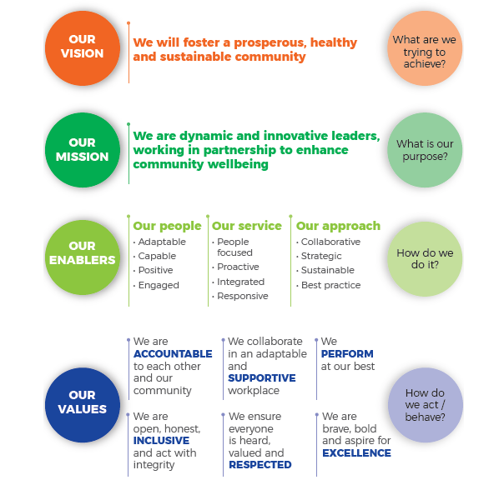

Customer Service Standards

Customer service at Maroondah City Council involves employees at all levels
across all areas. Every customer contact is an opportunity to enhance a
customer’s experience with Council.

This guide outlines the way we present ourselves to customers and ensures a positive
service experience at each interaction. The procedures apply to all Council employees,
contractors, volunteers and service providers that deliver services across the community
on behalf of Council.

Presentation and service image
Customers will form their impression of you and Council in the first few seconds and then
spend the next two minutes confirming that first impression.

The way we present ourselves is critical to how customers perceive Council. The aim of
these standards is to maintain an impression that is welcoming, professional and
communicates a sense of pride in all we do.

Public service environments
- Ensure the areas are easy to access and signage is clear.
- Entrances are accessible and welcoming.
- Everything in public view is clean, tidy and professionally presented.
- Doors to adjoining areas are kept closed and secure.
- Signage is consistent, informative, clear, and readable at eye level.
- Information displays are neat, are logically grouped, accessible, well-stocked and current.
- Desk areas are clear, tidy and documentation is out of public view.
- Public wall and glass areas are clean and free of taped poster. All signage is clean.
- Signage, posters and display material comply with the Maroondah City Council branding guidelines.
- Display of personal items does not compromise the professional image of the environment and is in keeping with Council’s image and brand.

Vehicle presentation
- Council vehicles and equipment are branded where appropriate and are clean and
maintained in good order.

Name badges
- Name badges are worn by all employees and can be easily read by customers.
- For formal occasions, name badges worn by the CEO, Directors and Managers contain their full name and title.
- Name badges for employees who do not have regular in-person contact with customers may contain their first name at a minimum.
- For security reasons, name badges for staff who have regular in-person contact with customers contain their first name only.

Staff identification cards
- Field employees are to carry standard identification cards with photographs. These cards are available through the Assets service area.

Attire and personal presentation
Where uniforms are provided:

- Complete, well-presented, current uniform only, with no items not in the current uniform range.
- Uniform logo is placed in accordance with Maroondah City Council branding guidelines.

Where uniforms are not provided:

- Employees to wear neat business wear in line with Council’s Employee
Code of Conduct HR06-06.
- The appearance of employees is professional and neat and tidy. Work attire is to be clean
and ironed.

Communicating with customers

When customers visit us

The customer can expect:

- to be acknowledged in a timely way with a proactive, friendly, and helpful attitude
- that employees have a good general knowledge of Council’s services.

When customers email or write to us

The customer can expect:

- that their email will receive an auto reply within one business day
- that their written enquiry will be responded to within 10 working days, even if the response is only a further acknowledgement of actions required.

When customers phone us

The customer can expect:

- the phone to be answered within four rings
- to be greeted with “Good morning/afternoon/evening”, and for the employee to identify themselves by name, and to offer to assist in resolving the enquiry.
- all service areas to be contactable during business hours (by phone) unless special arrangements are made with Maroondah’s Customer Service Team.
If calls to the Call Centre need to be transferred to the relevant employee and they are unavailable, Customer Service will take a message and relay it via email. The relevant employee should contact the customer as soon as possible within 24 hours.

Where an employee is likely to be unavailable for more than one business day, it is expected that an alternative employee will be assigned for any telephone enquiries.

When customers contact us via social media

The customer can expect that their query will receive a reply within a maximum of one business day, even if the response is only a further acknowledgement of actions required.

A final resolution should be communicated within a maximum of 10 working days.

Handling complaints and compliments

Maroondah City Council employees must ensure complaints are captured by the
Customer Request System and managed in accordance with current protocols and
procedures.

Wherever possible these complaints will be managed and resolved at the first point
of contact.

Complaints can be more complex than they first appear. However, Council is committed
to having processes to deal with all complaints received, and to improve or implement
processes that ensure customers’ needs are met in an equitable way, mindful of
individual nuance.

Complaint’ Compared to a ‘Service Request’
- requesting something additional or new (a service request)
- reporting what they believe to be a failing or a shortfall (a complaint)
- complaining about a Council’s response to a service request (a complaint)

The table below provides some context of a complaint compared to a service request.

Complaint/Service request examples
Complaint | Service request
My bin was out but wasn’t collected this morning. Can you pick it up?  (complaining that Council did not provide a service) | I forgot to put my bin out, can someone collect it?  (requesting a service because of their own mistake)
Council’s investigation into noise from a business wasn’t rigorous and didn’t look at peak times. More investigation is needed. | My neighbour’s business is very noisy. Can you make it stop?
A pothole I reported to Council two months ago hasn’t been fixed and is getting worse. | Could Council fill in a pothole in my street?
You haven’t sent my rates notice. | Can you tell me when my next rates payment is due?

What is a complaint?

Complaints are an opportunity for the customer to tell us when their experience with Council has not met their expectations.

We see complaints as customer dissatisfaction requiring a response and a resolution. The complaint may relate to a decision, service experience or behaviour of a Council employee.

A customer complaint occurs when a customer considers:

- the Council service is being delivered in an unsatisfactory manner
- the communication process has been unsatisfactory
- the policy deployment of Council is unacceptable or unsatisfactory
- the service experience provided by the council employee, volunteer or contractor
- has been unsatisfactory
- an employee’s behaviour or attitude has been inappropriate or unprofessional.

Complaints made about Council’s decisions are also important. They provide
information about how the community views our actions and help to ensure our ongoing responsiveness to the community’s needs.

It is important to note that the complaint does not need to be made in writing to be deemed a complaint.

Many issues are called ‘complaints’ because a customer is unhappy about a situation and is requesting something to be done, when it may be outside service parameters.

What is not a complaint?

Under these operating guidelines, a complaint does not include initial service or work requests; requests for information; suggestions, comments or feedback, or any other contact that does not meet our definition of a complaint.

The following are not considered complaints:

- a request for service (unless there has been no response to an initial request)
- a request for information or an explanation of a policy or procedure
- disagreement with a policy and/or decision of the Council
- reports of damaged or faulty infrastructure.

Who can make a complaint?

Any stakeholder of Maroondah City Council can make a complaint. This includes residents, customers, and organisational partners. It can include people who live, work, study or conduct business in the municipal area, or those who visit, use, or enjoy the services, facilities, and public places of Maroondah.

Where can complaints come from?

Council has many channels by which a complaint can be received, including:

- phone
- interpreter service
- face-to-face
- email
- online forms
- downloadable forms on our website
- live chat
- written letter
- social media.

Submitting a complaint

Submitting a complaint must be easy.

All employees receiving complaints must enter them into the Customer Request System as
a request, or if this is not available, they can be forwarded via email to maroondah@maroondah.vic.gov.au.

All anonymous complaints received will be treated in the same way as identified
complaints.

All reasonable effort should be made to assist complainants with specific needs. This may
include providing an interpreter or translator, ensuring customers can be represented by
an advocate of their choice, and providing straightforward and easy to read information in
plain language.

Who can receive a complaint?

Any Council employee can receive a complaint. Complaints can also be made to Councillors and the Mayor.

Please note that only social media administrators trained by Communications and Engagement will receive and respond to identified complaints on social media.

Receiving a complaint
If you receive a complaint from a customer:

- Record the details of the complaint as well as the contact details of the person making the complaint. Use these details to ask for more information if necessary, and to notify them of the outcome.

- Provide your own name and contact details in case the person making the complaint needs further information from you. The complaint should be acknowledged as a complaint, whether verbally (phone, face-to-face) or in written form (letter, Facebook, email) and a reference number should be provided to the complainant once recorded in Council’s Customer Request System.

The complaint should be recorded in Council’s Customer Request System as soon as possible, or passed on to the Customer Service team for entry. If the complaint can’t be recorded in the system at the time it is made, the customer should be made aware of how they can lodge a formal complaint.

Employees with access to Council’s Customer Request System
Employees with access to Council’s Customer Request System are responsible for ensuring that the complaint is recorded accurately, flagged as a complaint and, if possible, resolved at first point of contact.

If the complaint can’t be resolved at the first point of contact, the receiving officer will be responsible for recording details of the complaint.

Employees who do not have access to the Customer Request System
Employees who receive a complaint but do not have access to the Customer Request
System should relay the complaint to the Customer Service Centre at the first opportunity, where:

- the complaint will be logged accurately

- the customer will be contacted by the Customer Service Team at the earliest opportunity to acknowledge its receipt. At this point, more information can be gained if required.

Receiving a complaint on a social media channel
Responses to complaints received on Council’s social media channels are to be saved in eClip by the social media administrators.

Office of the Mayor and Office of the CEO
All complainants who directly contact the Office of the Mayor or the Office of the CEO will be forwarded to a Director to investigate and provide a resolution back to the complainant via the most appropriate level of management. These complaints are also to be saved in eClip or Council’s Customer Request System.

Councillors
Councillors may be the first point of call for a complaint.

If a complaint is received by a Councillor of Maroondah City Council, it will be passed on to a Director to investigate and provide a resolution back to the Councillor or directly with the complainant.

Any officer who is requested to investigate by the Director should:

- record in the Customer Request System

- process as usual if it is a typical customer request.

Wherever possible these complaints will be managed and resolved at the first point of contact.

How to respond to a complaint when in person or on the phone

If receiving a complaint in person, assess the best location to discuss further, depending on
whether discretion is required, for example you can choose the service counter or move to
a small meeting room. Think about whether the person should remain standing or do they
need to sit down. Is it appropriate to offer water? Should someone else be called to assist
the enquiry or mediate the discussion?

Listen without interrupting

Listening without interrupting will assist in diffusing the customer’s emotions.

Listen for vital information and ensure permission is given before taking any notes and let
the customer finish before asking questions to clarify the situation.

Always avoid denying or arguing any points.

Welcome the feedback
Communicate with empathy and welcome the feedback. For example, “I appreciate you bringing this to our attention. I’m sorry for the inconvenience this has caused.”

Later, if the problem is our mistake, then an apology may be necessary.

The time taken for this will depend on the complainant’s demeanour and approach.

Express empathy
- Reassure the customer by communicating empathy – show an understanding of the customer’s anger, frustration, or disappointment.

- Once you have communicated that you appreciate the customer’s issue and acknowledge their feelings, they may be more willing to participate calmly in working on a solution to the problem.

Confirm understanding
- Summarise the information you have obtained, ask any additional questions, and confirm an understanding of the issue.
- Record the notes in Customer Request System (or alternative location).

Explain what you can do and explore alternatives
- Focus on what you can do for the customer.
- Discuss alternative courses of action and the benefits or drawbacks for the customer of the alternatives.
- Reach an agreement on a course of action.
- Give the customer confidence that something will be done by explaining to them who will do what, by when and how.

How long should a complaint take to reach resolution?

Complaints should be resolved immediately when possible.

If not possible, once all the details have been recorded and forwarded to the
actioning employee, the complaint should reach a resolution as early as possible, and
no longer than 7 to 10 working days depending on the complaint. High risk
complaints should be dealt with directly and should be resolved as soon as possible.

Where complaints cannot be resolved within expected timeframes, the complainant should be contacted and advised of the new expected resolution date; the current progress; and the reason it cannot be resolved within the expected timeframe.

Complaint resolution timeframes are regularly reported to Council management. It is the responsibility of individual Managers and Coordinators to ensure employees understand and comply with these complaint guidelines and service levels.

Tracking complaints on Council’s Customer Response System

Each step of the complaint resolution will be tracked on Council’s Customer Request System and will be part of an escalation and reporting process.

This allows customers to enquire on the progress of their complaint at any time.

It is important to provide the customer with a Customer Request reference number when the complaint is made, to ensure this can occur.

Reporting

Regular reports will be generated for Service Areas and Managers. This enables monitoring of changing customer expectations and needs; assessment of how well our resolution processes are working; and identify improvements to our service delivery.

The reports will also assist in building a complaints database to further monitor complaint trends, and to identify complaint duplication across Council.

Suggestions, feedback and comments

Although Maroondah City Council does not consider suggestions, feedback or comments as complaints, they are encouraged and valued as a component of Council’s commitment to continuous
improvement and innovation.

The feedback can be directed to the appropriate employee who will decide what action, if any, should be taken.

What to do if you receive a compliment

Compliments are also important. While a complaint helps us understand what we are not doing well, a compliment helps us appreciate what we are doing well. Both assist in understanding the expectations and needs of Council’s customers.

It is important that compliments are tracked and reported - especially to the person or Service Area with which they are concerned. When a customer contacts us with a compliment, details should be logged in Council’s Customer Request System:

- take as much detail as possible, such as name/service area, what they did, why the customer was happy about it, etc.
- where the compliment is about a Council employee, the receiving employee should email the compliment to the employee’s direct manager. Where the compliment relates to a service area or Council in general, the details should be forwarded to the Service Area, Manager, Director, and/or the CEO, as appropriate.

Challenging behavior

People who work with customers in government often say the hardest part of their job is
handling the behaviour of people who complain.

Unreasonable Complainants
While most customers have legitimate concerns and genuinely seek resolution, there will be a small number of customers that demonstrate unreasonable concerns and challenging and uncooperative behaviour.

Council employees are expected to apply the utmost professionalism and a calm communication manner to anyone asking a question or expressing a concern.

What is an Unreasonable Complainant?
We define Unreasonable Complainant conduct as any behaviour by a complainant which, because of its nature or frequency, raises substantial health, safety and resource or equity issues for Council, staff, other customers, or the customer himself/herself.

Unreasonable Complainant conduct can be divided into five categories of behaviour:
- persistent
- demanding
- uncooperative
- argumentative
- unreasonable.

Unreasonable complainants may include complainants who:
- make frivolous or irrelevant complaints
- make complaints without basis
- are abusive or threatening
- are persistent
- are overly demanding.

What are the steps in dealing with an Unreasonable Complainant?
Complaints that escalate from reasonable to unreasonable:

• will be forwarded to the Service Area’s Coordinator/Team Leader for initial assessment
• may be delegated to a dedicated responsible officer at the Coordinator’s discretion
• will be flagged as an Unreasonable Complainant in Maroondah City Council’s Customer Request System.

All complainants, including Unreasonable Complainants, who contact the Office of the Mayor or CEO directly will be forwarded to the appropriate Service Area for resolution by the most appropriate level of management.

While the usual complaint handling process should be adhered to when dealing with Unreasonable Complainants, the procedure may be varied to deal more effectively with an Unreasonable Complainant:

- This may include providing the complainant with a set of ground rules from the outset, which will help to set and maintain clear expectations of the complainant’s behaviour.
- This will include providing the details of the responsible officer and limiting the complainant to contact the specified officer only while their complaint/s is being addressed.

Unreasonable Complaints/Complainants on social media
Unreasonable Complaints/Complainants on social media are to be dealt with in accordance with Council’s Social Media Policy. Social media administrators are to contact the Manager Communications and Engagement if there is any uncertainty surrounding responding to an unreasonable complaint on social media.

Manager Revenue, Property and Customer Service
For unreasonable complainants who have exceeded all usual organisational resolution processes, the Manager Revenue, Property and Customer Service will become directly involved.

Complaints process summary

1. Complaint received and logged

Once received, the complaint will be logged in Council’s Customer Request System, selecting the appropriate complaint category. The complaint will be acknowledged, and a reference number given to the customer to allow reference at any stage.

2. Initial assessment and acknowledgement

After the complaint has been logged, if it can’t be resolved at first point of contact, it
should be forwarded to the Council employee or service area responsible.

The customer should receive an acknowledgement the complaint has been
received, including:

- expected timeframes
- the assigned Customer Request reference number
- using the same communication method as it was received, i.e. if the complaint was emailed to Council, an acknowledgement should be sent via email. Complaints received via Council’s social media channels will be responded to by the social media administrators.

3. Investigation and tracking

After the customer has been advised of the expected timeframes, the complaint should be investigated as quickly as possible. Personal information should only be disclosed during this process for the purpose of investigating the complaint within Council.

Both the customer and Customer Service team can track the progress of the complaint using the Customer Request reference number, however the customer should be contacted as soon as possible if the given timeframe will not be met, with a new expected resolution date.

4. Response and communicating decision

Once the complaint has been resolved, the decision should be relayed to the customer.

The decision should include:

- a summary of the complaint
- steps taken to investigate it
- the outcome of that investigation.

It may also include future actions that will be taken to improve the customer’s experience with Maroondah City Council if that is known.

Final notification of the complaint resolution must always be provided via a written response to the customer.

5. Closure and review

Once the decision of the outcome has been relayed to the customer via their preferred method of communication, the complaint must be closed and noted.

Complaints process workflow

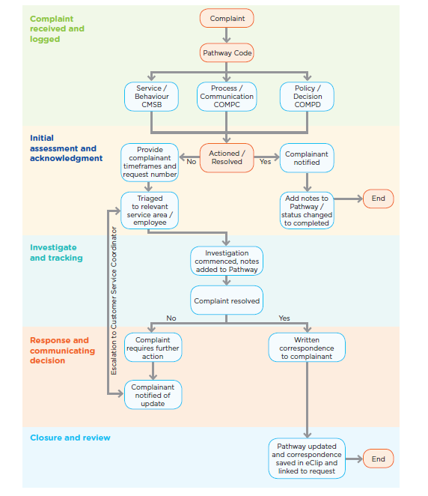

Roles and responsibilities

All employees

As a Council employee, your role is straightforward. If you become aware of a
customer complaint it is your responsibility to ensure that the customer knows how to
have it resolved, or whether you are able to resolve it yourself.

If the complaint cannot be resolved at the first point of contact, the person’s complaint
and contact details should be taken and recorded in the Customer Request System
and forwarded to the appropriate employee that will action the request.

If this is not possible, the details should be forwarded to the Customer Service team.

Customer Service Officers and actioning employees

Customer Service Officers will be the main point of contact for customer complaints
(excluding social media). It is their responsibility to resolve the complaint at the first point of contact, if possible, or forward the relevant information to the actioning employee.

Complaints received by the Customer Service Officer must be flagged as a complaint in the Customer Request System, to ensure accurate reporting and relevant staff can be made aware of it.

Customer Service Coordinator

The role of the Customer Service Coordinator is to monitor the number and type of complaints being received by Council, to monitor the expectations of customers.

The Customer Service Coordinator will ensure that the infrastructure to effectively monitor and act on customer complaints is in place and operating well.

Customer Service Team Leaders

It is the responsibility of the Customer Service Team Leaders to ensure awareness of the complaint handling process and that it is being applied consistently throughout Council.

The Customer Service Team Leaders are available to Service Areas and Managers to assist in managing and actioning any complaints they receive.

Service Area Coordinators and Team Leaders

Both Service Area Coordinators and Team Leaders are responsible for ensuring the Customer Service team have a clear understanding of the complaint handling process and ensure it is consistently applied.

In most situations, Service Area Coordinators are responsible for resolving complaints relevant to their area. While they may delegate this duty, they will be responsible for any identified actions and their implementation in response to a complaint.

Managers and Directors

Managers and Directors are responsible for complaints requiring cross-program/service area resolutions, and complaints that are not able to be resolved at the service area level.

They are also responsible for ensuring their leaders have a clear understanding of the complaint handling process, and ensure it is consistently applied across their portfolio.

Chief Executive Officer

The Chief Executive Officer (CEO) is responsible for complaints on all matters that pose a high-risk threat to employees, Council and the reputation of Council. The CEO is also responsible for routine complaints where the customer has not been satisfied with Maroondah City Council’s initial response.

The CEO will appoint a representative to consult with the appropriate Council areas involved to ensure a resolution is achieved.

Further information

If you are unsure how to respond to a complaint, you can:

- Contact the Coordinator Customer Service, who can assist with the appropriate process and response.
- Speak to your Manager. They have a responsibility to ensure all staff in their area are aware of, and have a clear understanding of, the complaints handling process. Your immediate manager should be able to help you with any training needed to ensure the process is understood and applied consistently across all Council service areas.
If the customer’s complaint falls outside of Council’s jurisdiction, you may need to refer them on to an external agency. This may include the Ombudsman or their local State or Federal Member of Parliament.

