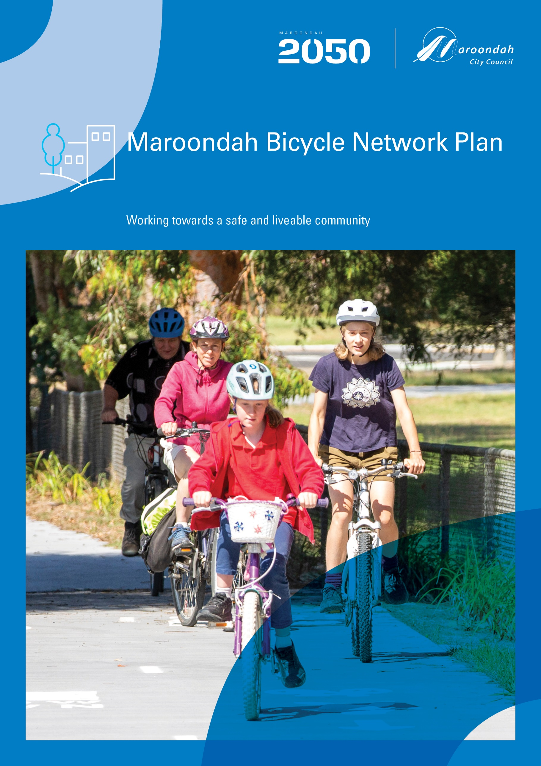
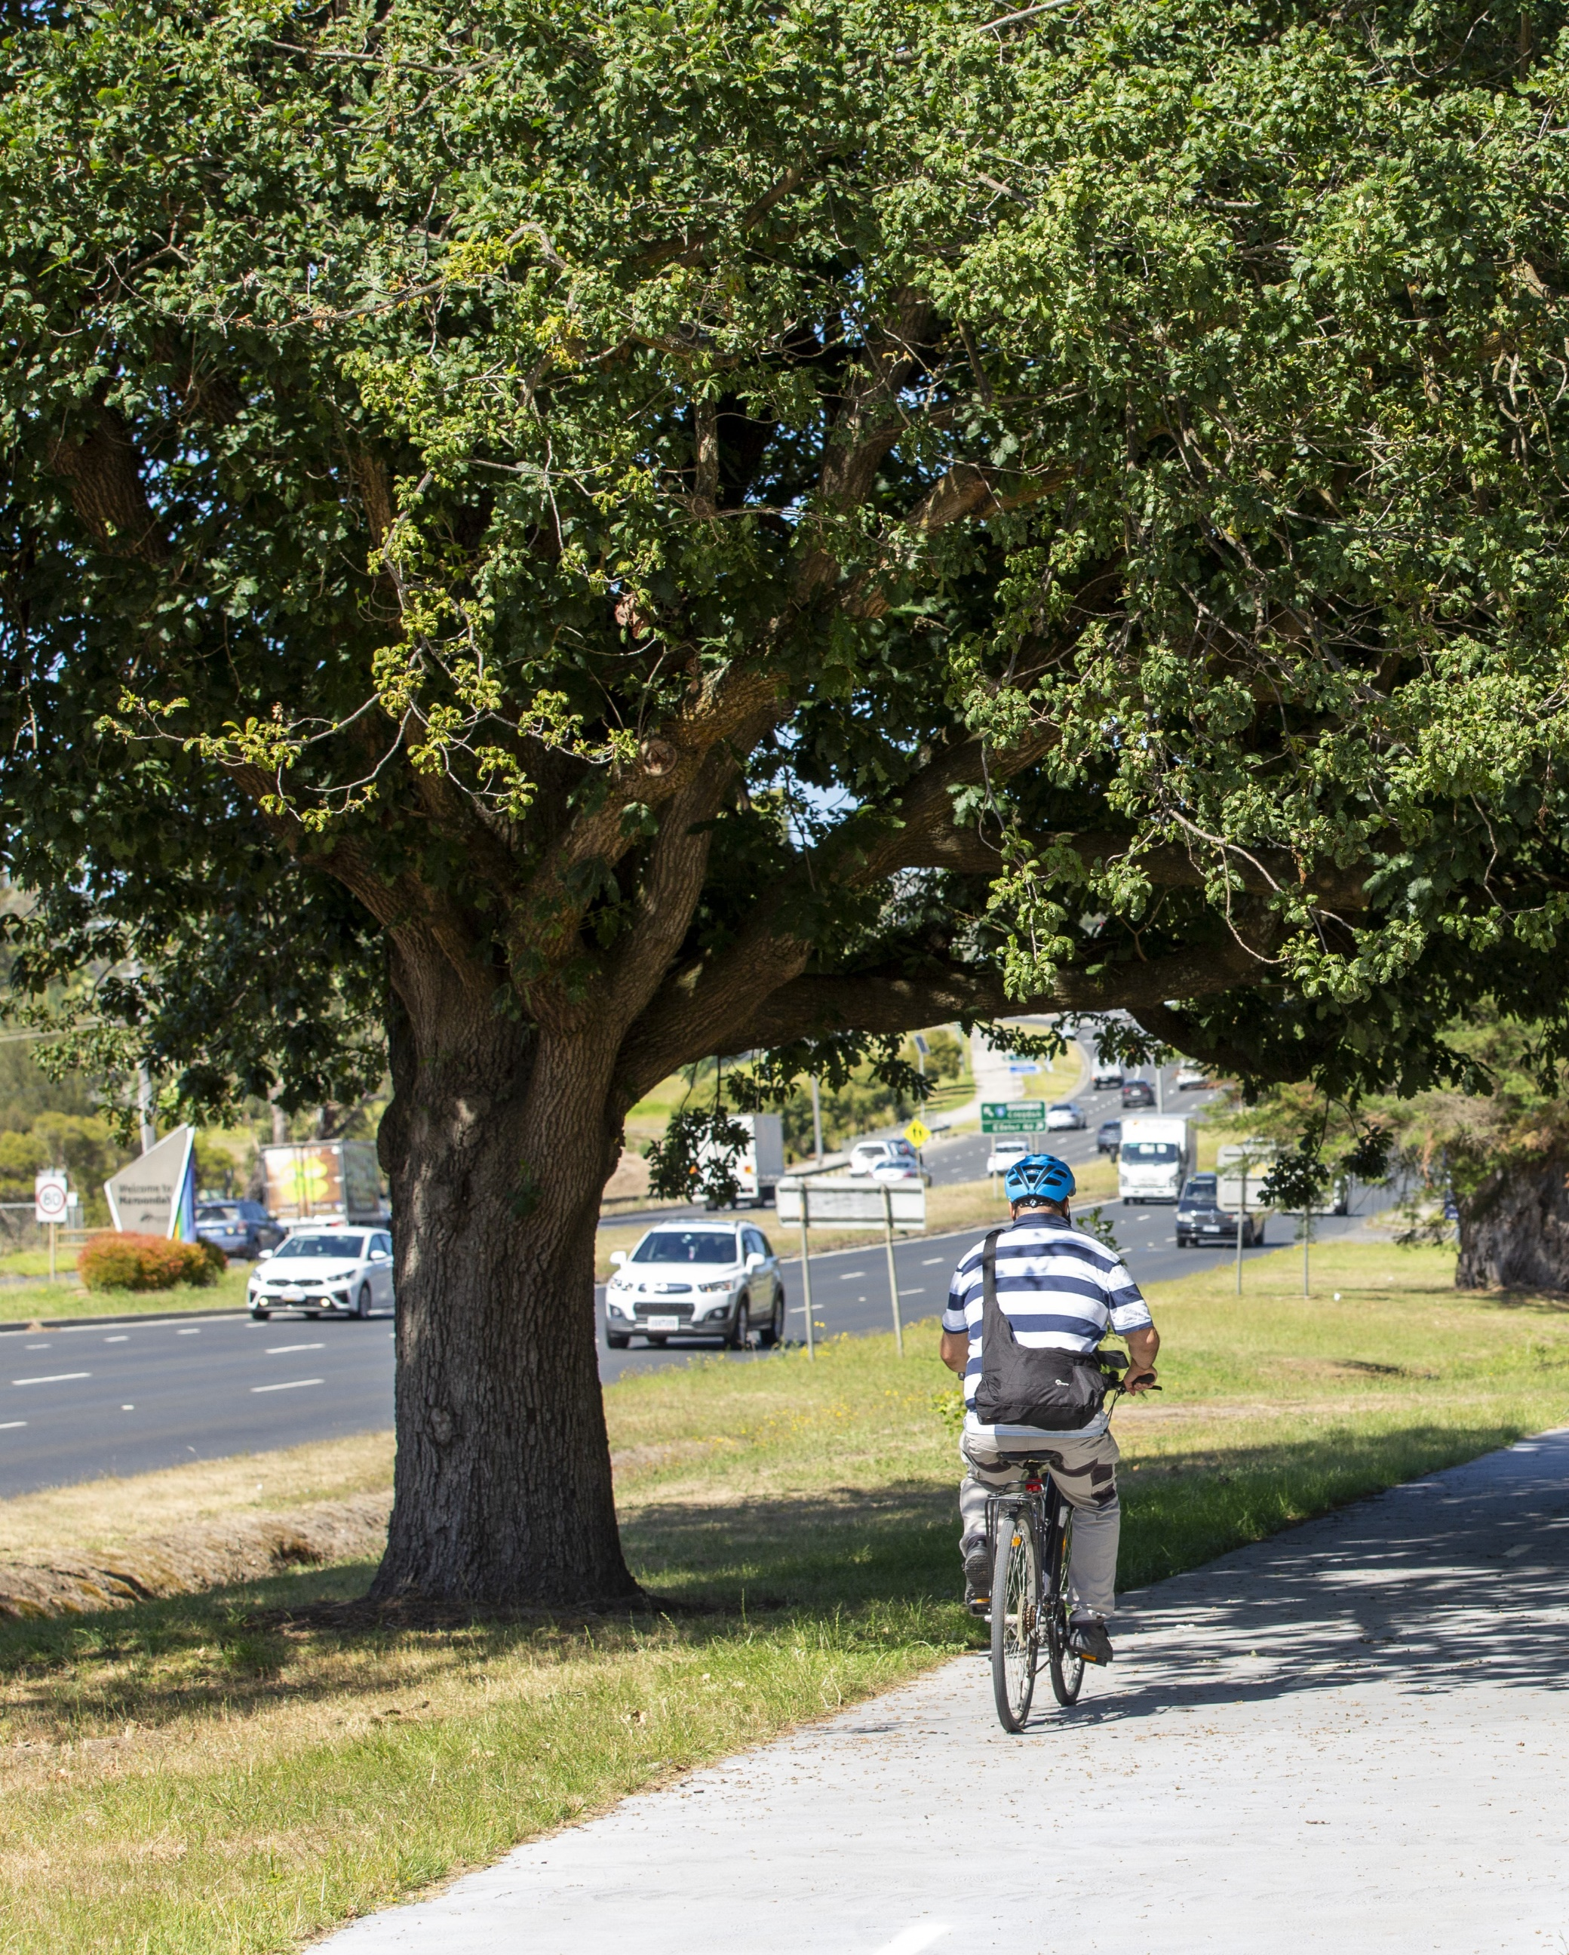

Contents
Introduction 5
Purpose 5
Methodology 6
Policy Context 7
Recently Completed Projects 10
Maroondah Cycling Overview 13
Existing Cycling Networks 13
Principal Bicycle Network (PBN) 14
Strategic Cycling Corridors (SCC) 14
Topography 15
Bicycle Ownership and Sales 16
Cycling Interest 17
Cycling Participation, Movement and Experience 17
Cycling for Transport 17
Cycling for Sport or Recreation 20
Combined Cycling 21
Crash Statistics 23
Engaging Our Community 26
The Cycling Community - What We Discovered 27
Cycling Design Principles 29
Cycling Network Infrastructure 30
Off-road cycling infrastructure 30
Separated Paths 30
Shared Paths 31
On-road cycling infrastructure 31
Protected Bike Lanes 32
Bicycle Streets 33
Intersections and Crossings 34
Crossings 34
Protected Intersections 35
Supporting Infrastructure 36
Wayfinding Signage 36
Bike Parking 36
Repair Stations 37
Drinking Fountains 37
Data Capture 37
End of Trip Facilities 37
Road and Street Type Considerations 38
Managing the Network 38
Supporting the Community to Ride 39
Regional Collaboration 40
Aspirational Maroondah Bicycle Network 41
Project Opportunities 43
Implementation 43
Monitoring and Evaluation 44
Glossary 45

Introduction

Purpose
The Maroondah Bicycle Network Plan 2025–2035 outlines a comprehensive framework to guide the development of cycling within the municipality over the next decade. Cycling is recognised as a legitimate and integral mode of transport and has the potential to realise public health benefits and reduce dependency on cars. Cycling will sustain and support growth in activity centres by helping people access housing, jobs, shops, education and services through a healthy and low-cost alternative to private vehicle use.
The Plan acknowledges the need to shift perceptions and address concerns around cycling to attract new riders through a balance of high-quality routes, targeted education and ongoing maintenance. Council aims to make cycling a safe, convenient, and appealing choice for people through a range of initiatives to complete the network and a foster a supportive cycling culture.
The Maroondah Bicycle Network Plan aligns with the community vision, Maroondah 2050: Our Future Together, by improving and expanding cycling infrastructure across the municipality and offering programs to equip people with bike riding skills and awareness to ride confidently and safely. In doing so, it plays a vital role in realising two key outcomes for the future:
- A safe and liveable community
- A green and sustainable community
The Plan is designed to ensure the connectivity and integration of the Maroondah bicycle network, addressing existing gaps, drop-out points, and missing links for people on bicycles, scooters, and low-powered mobility devices. It includes a list of cycling and pedestrian project opportunities to enhance active transport connections within the municipality and beyond, prioritising safe, comfortable, and accessible infrastructure for everyone. Council will continue to advocate, plan and deliver infrastructure and programs to increase participation in bike riding in collaboration with the Federal, Victorian and our local government neighbours.
By taking a forward-thinking and inclusive approach, the Maroondah Bicycle Network Plan sets a clear direction for cycling to evolve as a central part of daily life supporting healthier lifestyles, reducing traffic congestion, and creating a more vibrant, connected, and sustainable community.

Methodology
The Bicycle Network Plan has been developed using the methodology below.

Policy Context
The following provides a summary of key policies and strategies that have informed the preparation of this Plan.

Victoria’s Active Transport Plan 2026
Victoria’s Active Transport Plan sets out the State Government’s vision for making walking and riding safe, accessible, and preferred options for all Victorians. The Plan brings together policies and actions to guide coordinated investment in infrastructure and behaviour change programs, aiming to boost active travel across the state.
Key actions include:
- Introducing Neighbourhood Active Transport Networks to guide future planning and investment.
- Developing well-connected walking and cycling routes through Strategic Cycling Corridors and new Strategic Walking Connections.
- Using precinct plans to prioritise walking and riding links to key destinations.
- Partnering with local councils to address barriers and gaps in the active transport network.
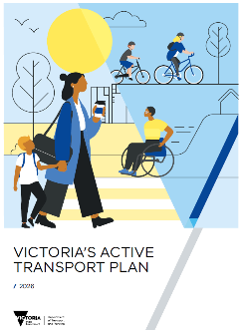
The Plan focuses investment on locations with the greatest potential to increase walking and cycling, working closely with local government to deliver better active transport connections.
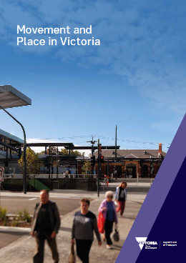
Movement and Place Framework 2019
The State Government Movement and Place Framework aims to bring to life the strategic objectives of both transport and planning in Victoria to achieve movement and place goals in the context of road safety and environmental outcomes.
The purpose of the Framework is to recognise that streets perform multiple functions in that they move people and serve as key places and destinations themselves.
Cycling falls under a mode of movement where a score can be placed based on level of traffic stress faced by cyclists as determined by infrastructure and speed limits. The classified cycling routes make up the Principal Bicycle Network and Strategic Cycling Corridors.
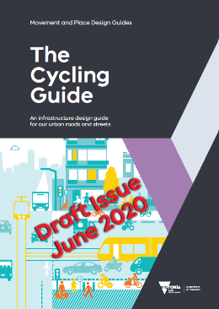
Movement and Place Cycling Guide Draft 2020
The State Government Cycling Guide is a Movement and Place Design Guide that establishes the overarching approach to creating Victoria’s cycling network. It outlines the design principles and infrastructure options to achieve a safe, comfortable and connected cycling network. The document provides guidance on the selection of suitable cycling infrastructure treatment for certain environments, and details on how to apply these in planning and design.

Plan for Victoria
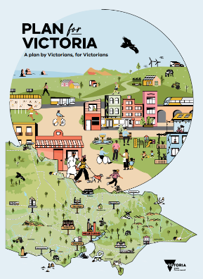
Plan for Victoria is the Victorian Government’s long-term plan to accommodate Melbourne’s future growth in population and employment. This involves a series of principles, outcomes and directions to specify key land use and movement corridor policies.
This includes the following policies relevant to cycling:
- Support cycling for commuting;
- Create a network of cycling links for local trips;
- Locate schools and other regional facilities near existing public transport and provide safe walking and cycling routes and drop-off zones.
Maroondah 2050 Community Vision

The Maroondah 2050 Community Vision provides a ‘roadmap’ for the community, Council organisations and business, as well as other levels of government, to partner to create a future that enhances Maroondah as a great place to live, work, play and visit. The vision is:
‘In 2050, Maroondah is a safe, inclusive and vibrant community, striving for a green, prosperous and sustainable future for all.’
Supporting cycling as a choice for more people contributes to the following community aspirations and realisation of the vision:
A Safe and Liveable Community:
Local neighbourhood and activity centres that are easy to move around and enable people of all ages and abilities to enjoy high levels of social, emotional, and physical wellbeing.
A Green and Sustainable Community:
Preserve and enhance a greener and more sustainable Maroondah with a community supported to make sustainable choices and is actively working to reduce emissions, waste, enhance local amenity, and support a healthier environment for current and future generations.
Council Plan 2025 - 2029
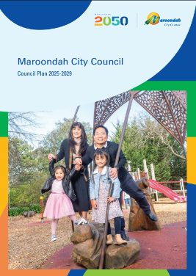
The Council Plan is the medium-term strategy that sets key directions and priority actions to work towards the goals of Maroondah 2050.
Key directions outlined in the Council Plan relating to cycling include:
- Work in partnership to facilitate a safe, accessible and efficient integrated transport network that enhances liveability and facilitates living locally;
- Work in partnership to facilitate increased use of sustainable and active transport modes within the community;
- Enhance Maroondah’s walking and cycling shared path network to promote walkability and strengthen connections with the wider metropolitan Melbourne network.

Maroondah Transport Strategy 2025-2035
The Maroondah Transport Strategy guides the future of transport in the City of Maroondah and provides guidance on local bicycle routes and improving the cycling experience.
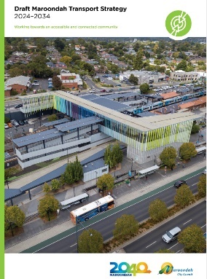
The Strategy sets the strategic direction and outcomes for transport in the City of Maroondah from 2025 to 2035.
It focuses on addressing the transport challenges, opportunities and needs of our diverse community, including supporting people to walk and cycle more for local journeys.
The Strategy concentrates on key focus areas to meet transport needs and includes a 10-year action plan. Priority actions to encourage more active transport trips to school and work include:
- Facilitate cycling and pedestrian safety education programs and events;
- Construction of a Ringwood to Croydon pathway;
- Construction of a Greenwood Avenue pathway, and
- Completion of the Maroondah Highway Boulevard Extension.
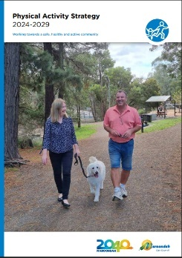
Maroondah Physical Activity Strategy 2024 - 2029
One of the four outcome areas from the Maroondah Physical Activity Strategy 2024 -2029 is to increase active transport. The Strategy acknowledges that people can obtain the recommended amount of physical activity through a range of physical activities, including active transport. It seeks to promote and entice more people to choose to walk, run, ride and play more often as a regular part of their daily life. Council is committed to work with other partners to enhance our streets, trails and neighbourhoods to be more walkable and rideable.

Eastern Regional Trail Strategy 2018
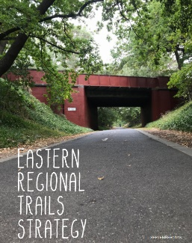
The Eastern Regional Trails Strategy guides local government and other land management authorities working together towards an interconnected and well-used trail network over the long-term.
It identifies new priority trails and existing upgrades that provide a range of social, health, environmental, economic and tourism benefits.

Recently Completed Projects
The following recently completed projects have resulted in improved bicycle infrastructure within the City of Maroondah. These have delivered new pedestrian and cycling facilities that improve connectivity, integration and safety.
Carrum to Warburton Trail
The Carrum to Warburton Trail is a major active transport route through Melbourne’s south-eastern suburbs and the Yarra Valley. Spanning over 80 km, the trail connects communities such as Patterson Lakes, Dandenong, Belgrave, Lilydale, and Warburton. The trail services commuter and recreational users. It is popular with cyclists, walkers, and joggers of all ages.
The Trail was fully connected when the 10 km Bayswater to Lilydale section was completed in 2018. This included upgrades to the Tarralla Creek Trail around Croydon. The Reimaging Tarralla Creek, Stage 1 Project delivered further trail improvements with shared pathway upgrades and a new bridge over the Croydon Wetlands delivered in 2022.
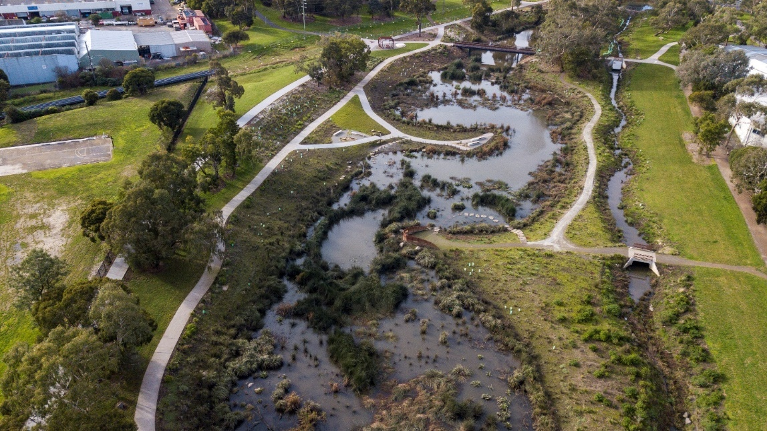
Croydon Wetlands including the new bridge and trail upgrades.

Box Hill to Ringwood Trail
This 10 km urban trail follows the rail line east-west through Box Hill, Blackburn, Mitcham, and Ringwood. Completed in December 2020, this shared pathway provides a new link enabling access to train stations and activity centres along the Belgrave/Lilydale line. It is also well-used by walkers and joggers.
Ringwood to Croydon Trail
A new section of the Ringwood to Croydon Trail was completed in 2025 as part of the Coolstore Road Level Crossing Removal Project and the development of the new Croydon Transport Hub. This upgrade includes a new shared cycling and pedestrian path running east-west through the transport precinct, along with a direct link to Main Street, Croydon. The new elevated Croydon Station provides improved connections between retail precincts and enhanced safety for all users. The pathway features a combination of shared and dedicated bicycle paths, as well as improved end-of-trip facilities and bike parking at the station.
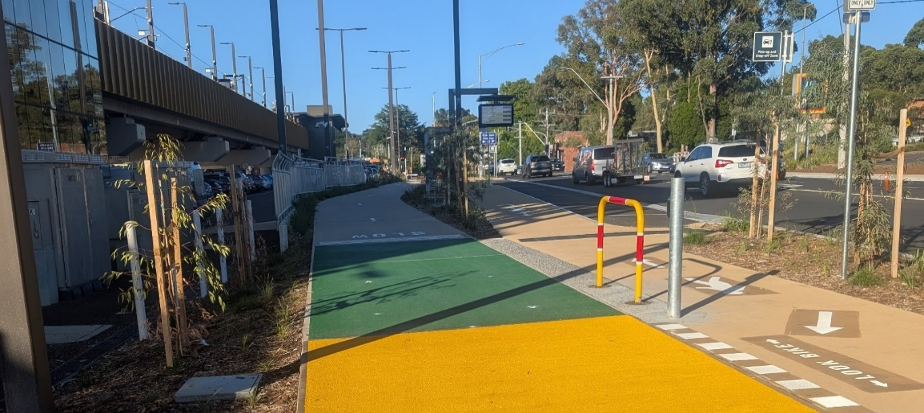
The new dedicated pedestrian and bicycle pathway at Croydon Station

The Ringwood East Level Crossing Removal Project (LXRP) incorporates an additional section of the Ringwood to Lilydale Pathway. The new off-road cycling path alongside the railway line/Railway Avenue, completes the shared pathway from Ringwood Lake to the Ringwood East shops. The upgraded Ringwood East Station features end of trip facilities and bike parking.

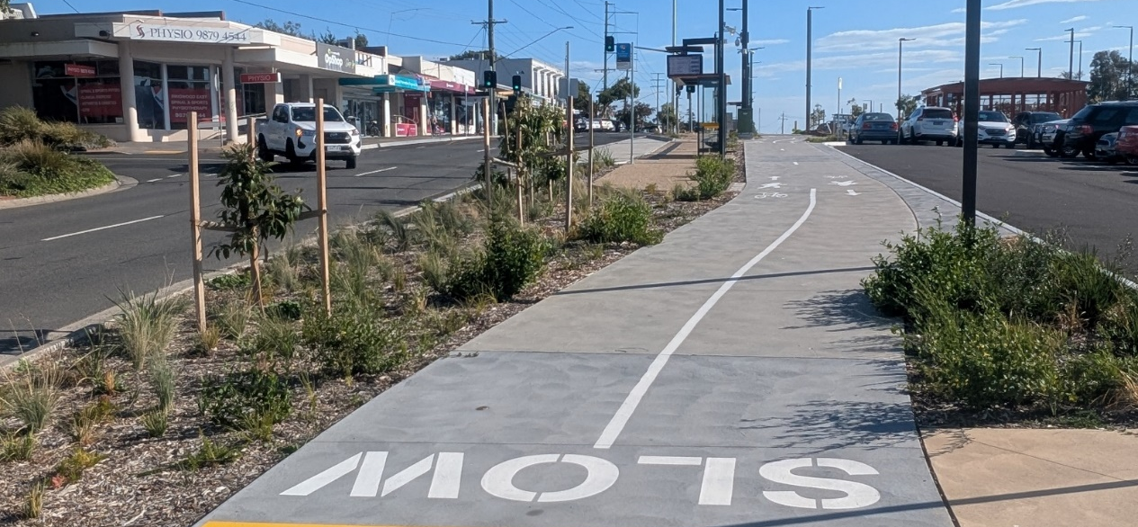
The new shared pathway along Railway Avenue, Ringwood East.
The Ringwood to Belgrave Trail
An extension of the Ringwood to Belgrave Trail section known as the Heathmont Rail Trail to Bedford Road and into Bedford Park was completed in 2024. It was delivered as part of the Bedford Road Level Crossing Removal Project.
It includes a new shared pathway along the rail corridor and pedestrian / bicycle signals at the Bedford Road and Great Ryrie intersection and completes the Heathmont Rail Trail, removing the need to travel on-road on Lena Grove, Ringwood. In time it will connect into the planned Bedford Road bike and pedestrian pathway extension from Ringwood Station to Ringwood Secondary Collage. This extension is a section of the Ringwood to Lilydale Pathway.

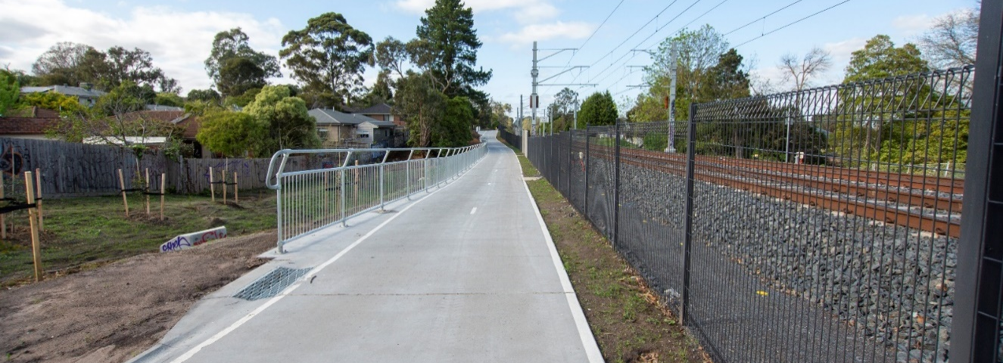
The shared pathway extension of the Heathmont Rail Trail, part of the Belgrave to Ringwood Trail

Maroondah Cycling Overview

Existing Cycling Networks
The Maroondah Bicycle Network includes on-road and off-road bike lanes and paths, bicycle parking, repair stations, and wayfinding signage.
In general, Maroondah provides a good network of on-road bicycle lanes and off-road bicycle paths across the municipality, as seen in Figure 5. Existing infrastructure is mostly focussed on the activity centres and south-western section of the municipality, with some missing connections or lack of services toward the north and northeast.
The larger gaps between the routes means that some function independently from nearby routes. The gaps limit the ability of the routes to work together and become greater than the individual routes.
Smaller severance or dismount points are common at road crossings and intersections. These micro gaps and dismount points decreases the overall level of service and effectiveness of the routes and increases journey time.
Off-road cycling infrastructure includes the following trails: Eastlink Trail, Dandenong Creek Trail, Heathmont Rail Trail (part of the Heathmont to Belgrave Rail Trail), Tarralla Creek Trail (part of the Carrum to Warburton Trail) and Mullum Mullum Creek Trail.
On-road bike lanes are currently provided along segments of roads including: Heatherdale Road, Bedford Road and Mount Dandenong Road.
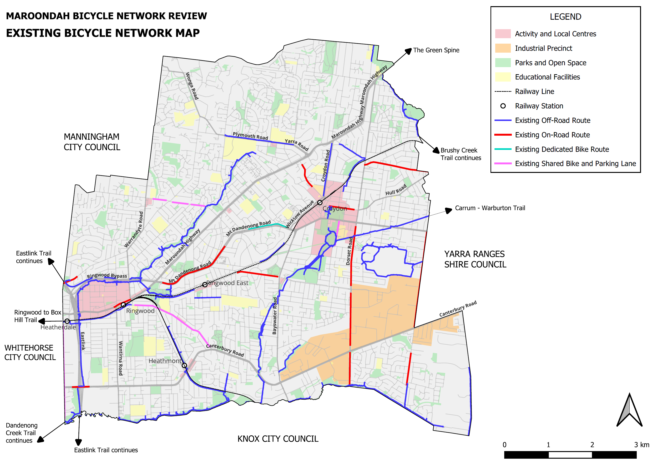
Existing bicycle network

Principal Bicycle Network (PBN)
The PBN is a network of existing and proposed bicycle routes that provide access to key destinations across metropolitan Melbourne. It was developed by VicRoads for the purpose of guiding investment in bicycle facilities that support cycling.
The Maroondah PBN includes the majority of the arterial road network, along with off-road trails, as shown in Figure 6. This includes the Mullum Mullum Creek Trail, Taralla Creek Trail, Maroondah Highway, Mount Dandenong Road, Canterbury Road and the railway corridor.
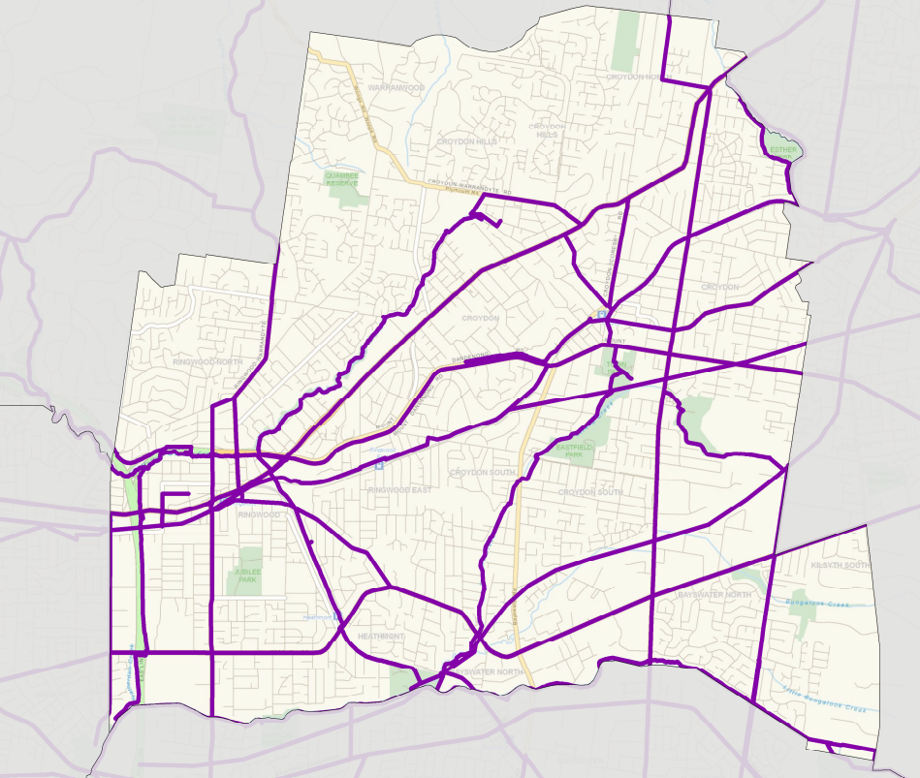
Principal Bicycle Network

Strategic Cycling Corridors (SCC)
Strategic Cycling Corridors are a subset of the PBN that support trips to employment, stations, shops and schools. The SCC network incorporates on and off-road paths on municipal and state roads to help provide a safer and lower-stress cycling environment.
The Movement and Place Framework has been developed to assist with designing, planning and delivering our transport system. The Framework includes classifications applicable to cycling, of which C1 and C2 make up the SCC as described below:
- C1 – Primary Routes provide a core network of Strategic Cycling Corridors that connect places of state significance including the central city, Metropolitan Activity Centres (MACs) and National Employment and Innovation Centre (NEICs) within metropolitan Melbourne.
- C2 – Main routes are Strategic Cycling Corridors that provide additional connections to state significant destinations, as well as connections to major activity centres and key railway station within metropolitan Melbourne.
Within Maroondah, most of the SCC comprises C2 with the exception of the Eastlink Trail to the Ringwood Metropolitan Activity Centre, as seen in Figure 7.
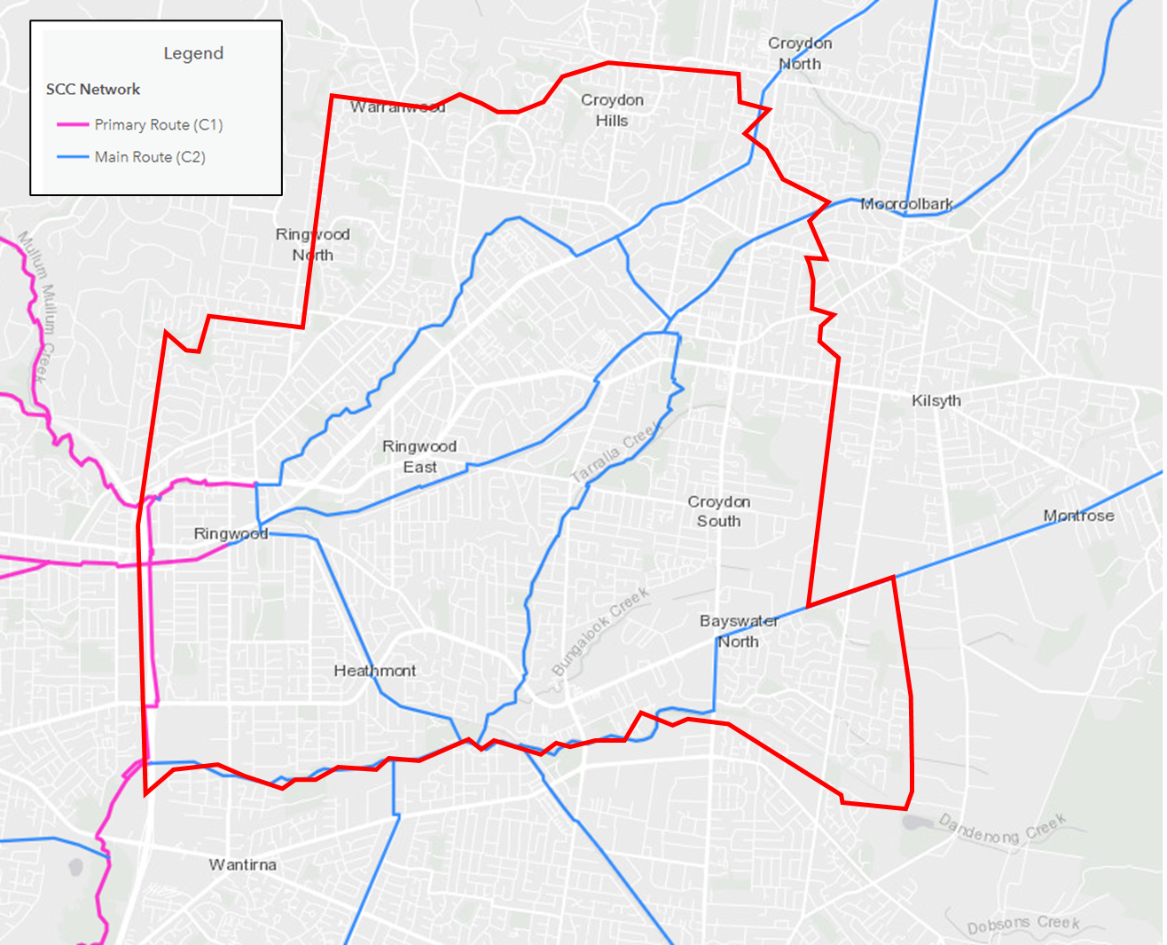
Strategic Cycling Corridor

Topography
In addition to the provision of cycling infrastructure, the natural topography of the land can be a key influencer or barrier to cycling participation and travel patterns.
Bicycle routes that are flat are better suited to cycling in terms of the ease of the ride. However, recently electric bikes have become more popular and available as a cycling option for people of all fitness levels.
The topography of Maroondah is generally consistent. It does, however, contain hilly terrain in the vicinity of the Wicklow ridgeline in Croydon and secondary ridgelines in Ringwood North as depicted in Figure 8. These ridgelines are a factor in the planning of a bicycle network.
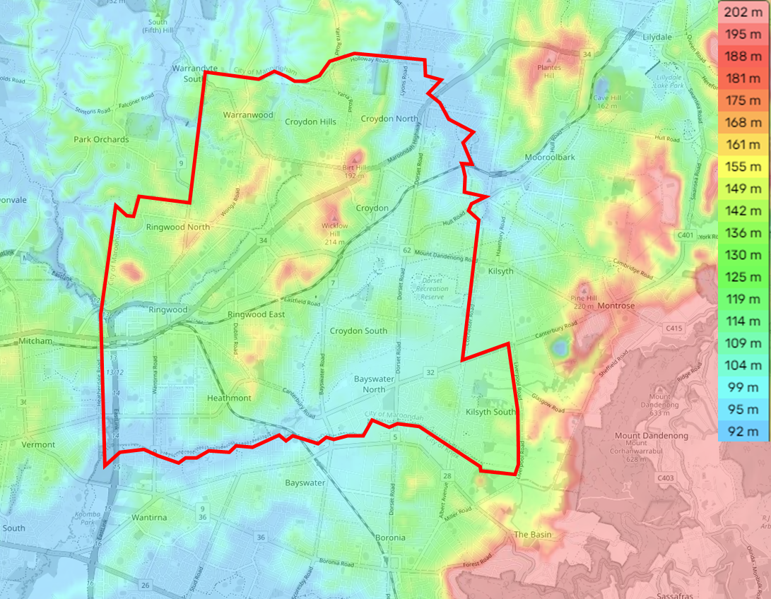
Maroondah topography map

Bicycle Ownership and Sales
Monash University’s report into ‘Cycling Typologies in Victoria’ (2022) found that 51% of participants from Maroondah owned a bicycle. The Victorian Integrated Survey of Travel and Activity (VISTA) collects data about household bicycle ownership, including distinguishing adult and children’s bikes. The survey data was for 2012 to 2020.
The data for participating Maroondah households found that 54% owned one or more bicycles. Ownership of adult bikes was twice as common as children’s bikes. Of those households owning bicycles, 55% only had adult bikes, 14% children’s bikes only and 31% owned both. Only 16% of households that own a bicycle are car free. Based on the research and survey, it is reasonable to estimate that approximately half of Maroondah households own at least one bicycle.
Maroondah City Council’s 2025 consultation with cyclists provided insights into the types of bicycles and scooters being used. Of the 210 survey respondents, the distribution of bicycle and scooter types is shown in Figure 9. The findings suggest that, after standard bikes, e-bikes are particularly popular, especially among older adults (aged 55 and over). Cargo bikes, while having a smaller user base, are favoured by middle-aged people and are used by a diverse group. The variety of bike and scooter types indicates a shift away from exclusive reliance on standard bicycles.
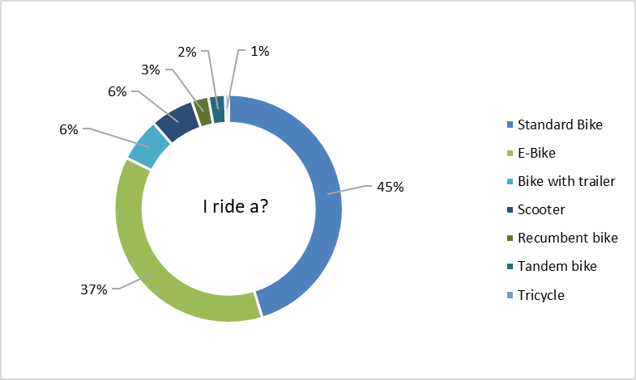
The types of bicycle or scooters ridden by survey respondents.
There is no direct, published data on bicycle sales specifically for Maroondah, yet the rate of bicycle ownership suggests a healthy and active bicycle market.

Cycling Interest
Monash University’s report, Cycling Typologies in Victoria (2022), established the likely distribution of Maroondah’s population across the Geller Typology Groups. The Geller Typology is a widely used framework that segments people into distinct groups based on their cycling interest and capabilities, ranging from “No Way, No How” to “Strong and Fearless.” These typologies provide insight into the types of cycling infrastructure and road environments that people feel comfortable using. According to the research, the estimated distribution of Maroondah’s population across the Geller Typology Groups is shown in Figure 10.
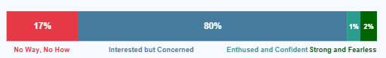
Geller Typology Continuum and Population Cohorts for Maroondah (2022)
The distribution of Maroondah’s population across the Geller Typology Groups has important implications for network planning, infrastructure, and bicycle education programs. With 80% of residents classified as “Interested but Concerned,” there is a clear need to prioritise the development of safe, accessible, and connected cycling infrastructure, such as protected bike lanes and off-road paths to address their concerns and encourage greater participation.
Network planning should focus on creating routes that feel comfortable for less confident riders, while also ensuring connectivity for more experienced cyclists. Additionally, bicycle education programs should be tailored to build confidence and skills among the “Interested but Concerned” group, while also promoting road safety and awareness for all users.

Cycling Participation, Movement and Experience

Cycling for Transport
The method of travel to work by Maroondah residents in 2021 and 2016 is illustrated in Figure 11. This shows that car (as a driver) is the most popular mode of travel.
Cycling makes up 0.3-0.4% of trips to work by Maroondah residents. Of this group, the large majority (89%) were male and 78% were aged between 30-49 years.

Method of travel to work
Of note, the proportion of the population who worked from home increased dramatically from 4% in 2016 to 29% in 2021 explained by the fact that the Census was conducted on 10 August 2021, during the COVID-19 government lockdown period.
Figure 12 illustrates the main destinations (place of work) of cyclist commute trips undertaken by Maroondah residents in 2021. A comparison of this data from 2016 is provided in Figure 13. Smaller proportions of residents travelled to other regions.
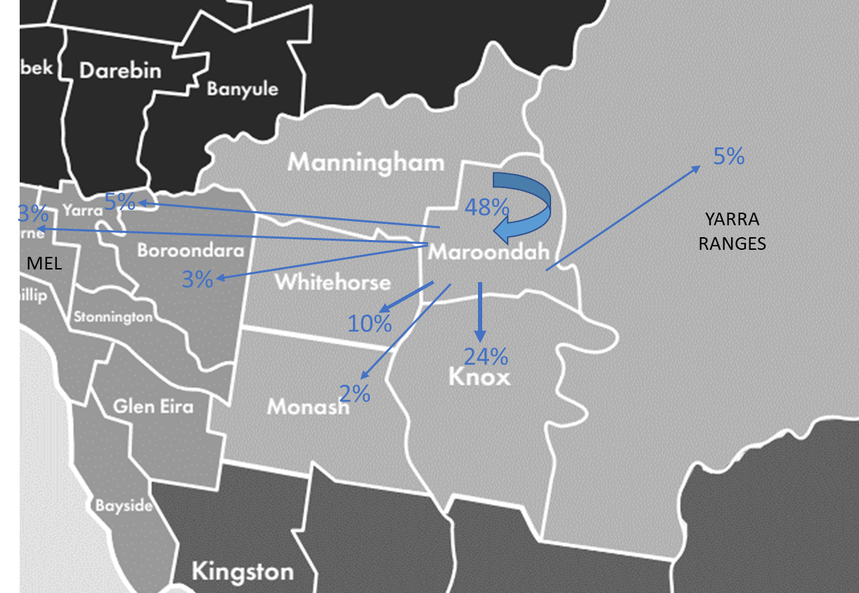
Cyclist commute trips from Maroondah (2021)

Cycling commute trips 2021 and 2016
This data shows that of Maroondah residents cycling to work, the majority work within the City of Maroondah. Knox is also a high trip generator for cycling commuter trips. Several Maroondah residents’ cycle to the City of Melbourne for work, however this has declined since 2016.
Strava Metro is a dashboard, map, and data platform that displays fitness, sports, and recreational bike riding as well as walking metrics, drawing on crowdsourced data from Strava app users. Analysis of Strava Metro data for 2025 provides the following insights into bike riding for transport:
- A total of 21,323 trips for transport are undertaken, with a combined distance of 326,100 kilometres. These trips constitute 31% of overall bike riding activity on the network.
- The origin of most transport-related trips are from Ringwood, Ringwood East, Kilsyth and Bayswater.
- Ringwood, Kilsyth and Bayswater are also major destinations within the municipality. Further afield, Box Hill, Blackburn, and Mitcham emerge as the principal destinations.
The recent occupancy counts for Parkiteer bike cages at train stations in Maroondah reveal a trend of overall underutilisation, with capacity levels much higher than actual observed demand across all sites. There remains availability of secure bicycle parking at Croydon, Heatherdale, Ringwood, and Ringwood East. Ringwood stands out as the best performing station, maintaining the highest and most stable levels of usage.
Additionally, the data show that these facilities are predominantly serving traditional bicycles, with very limited scooter usage recorded.
This suggests the infrastructure is adequate for current cycling needs and there remains significant potential to boost overall demand through awareness campaigns, integration with local cycling networks, or targeted promotion to both cyclists and future micro-mobility users. Effectively leveraging these secure parking assets could help support more sustainable, active transport choices among train commuters in Maroondah.

Most of the bikes parked in Parkiteers are standard bicycles, with a small number of e-scooters also present.
Station | Total Capacity | August | September | October | Average Occupancy
Croydon | 26 | 18 | 14 | 6 | 12
Heatherdale | 38 | 11 | 10 | 7 | 9
Ringwood | 26 | 16 | 17 | 15 | 16
Ringwood East | 26 | 12 | 8 | 5 | 8
Total | 121 | 57 | 49 | 33 | -
Number of scooters |  | 0 | 4 | 2 | -
Parkiteer occupancy over 3 months in 2025.
There is limited available data and information in relation to riding to education institutions. Both the VISTA and National Ride2School Day suggest that riding for educational purposes is very low in Maroondah.
Council has observed a considerable decline in the number of schools participating in National Ride2School Day and offering Bike Education programs since 2020. In 2017, 17 schools participated in National Ride2School Day, but in 2023 only 6 schools took part.

Cycling for Sport or Recreation
According to "Cycling Typologies in Victoria" (2022), 52% of the trips made by Maroondah participants are for recreational purposes, and 11% identify as both recreation and transport.
Analysis of Strava Metro data for Strava app bike riders provides the following insights into recreational riding for 2025:
- A total of 46,912 recreational trips are undertaken, covering a combined distance of 3.1 million kilometres. This represents 69% of all bike riding activity on the network.
- The origins of the most recreational cycling trips are from Ringwood, Ringwood North, Ringwood East, Croydon, Kilsyth, Kilsyth South, and Heathmont—mostly neighbourhoods well serviced by trails.
- The suburbs containing the most favoured destinations are Ringwood, Ringwood North, Ringwood East, Croydon, Kilsyth, and Heathmont.
Trends for recreational cycling in 2025 indicate a decline in activity from August to December of between 100 to 300 trips compared to 2024.
VISTA data for the 2023/24 year indicates an average of 5,687 bike rides per day taken for recreation in the municipality. The average trip distance is 1.5 kilometres, with an average travel time of 7 minutes, suggesting that many trips are local.
Periodically, Council engages Bicycle Network to conduct its Super Tuesday and Sunday Counts across 22 sites on the bicycle network. These counts provide active travel data and information, including mode, gender time and direction of flow.
Bike riders account for the highest proportion of network users on Sundays, comprising 46% of all users according to the 2024 Super Sunday Counts. Of these riders, 2% use e-bikes..
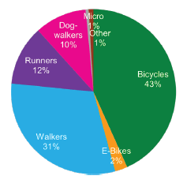
Proportion of user types on the network from Super Sunday (2024)
The activity mix from individual site counts during Super Sunday 2024 also shows that all trails are used for a diverse range of activities, although the mix varies across different trails. The Eastlink Trail, Mt Dandenong Creek Trail, and Heathmont Trail carry a greater proportion of bike riders; while walking and jogging are more prominent on the Mullum Mullum Creek Trail, Tarralla Creek Trail, and Brushy Creek Trail.

Combined Cycling
The following section combines information from multiple sources to provide insights into total bike riding participation in the community.
According to Strava Metro data for the full 2025 year, there were a total of 68,265 bike trips, with 22,200 trips occurring on weekends. Cyclists rode a total distance of 3.52 million kilometres. Riding activity is busiest in the mornings between 6:00 and 9:00 am. The afternoon peak is smaller and shorter, from 4:00 to 6:00 pm. On weekends, riding activity has a less pronounced but more sustained peak from 10:30 am to 2:00 pm, with steady activity continuing until 6:30 pm.
These activity volumes and peaks are validated by VISTA for the full 2023/2024 year, which shows similar patterns for the outer Melbourne region. Furthermore, Super Tuesday (2017) recorded a peak between 7:45 and 8:30 am, while Super Sunday (2024) indicates that the busiest Sunday period is from 9:00 to 10:00 am.
VISTA also shows that weekday cycling peaks are predominantly linked to education, personal business, work, recreation, and pick-up/drop-off trips. On weekends, recreation and shopping are the major purposes for bike trips.
Cycling activity is consistent across the days of the week, with slightly higher activity on Saturdays, Sundays, and Tuesdays. Mondays and Fridays have the lowest levels of activity.
The Department of Transport and Planning's counters for the Box Hill to Ringwood Trail indicate that the average travel speed during weekdays in 2024 is around 21 km/h, dropping slightly to 19 km/h on weekends. This represents an increase in average speed of 5 km/h since 2015. Council’s own counters on the Tarralla Creek Trail show an average speed of 13.2 km/h for 2024. Speeds above 40 km/h are extremely rare on both trails.
Up until 2020, the Box Hill to Ringwood Trail saw year-on-year growth in activity. Growth was highest in 2020 and 2021, with annual volumes of 24,000 and 23,000 riders respectively. For this trail, eastbound movement is slightly higher than westbound. Daily volumes are consistent, with between 50 and 60 riders per day.
The Tarralla Creek Trail has also experienced consecutive years of growth since 2022. The year 2024 is the busiest so far, with annual volumes around 42,000. Data for 2025 indicates even higher use, with 49,000 trips already counted by October. The trail carries more southbound traffic (average 1,057 riders per day) than northbound (772 riders per day).
Figure 16, an extract from the Strava heat map, shows that cycling activity within and through the municipality is concentrated on the trails, streets, and roads with cycling facilities. Popular routes include the Mullum Mullum Creek Trail, Eastlink Trail, Heathmont Trail, Dandenong Creek Trail, Tarralla Creek Trail, Brushy Creek Trail, Mt Dandenong Road, Kent Avenue, Colchester Road, Oban Road, Plymouth Road, and Yarra Road. Major arterial roads such as Maroondah Highway, Canterbury Road, Bayswater Road, and Dorset Road have low activity, suggesting they are generally avoided by cyclists.
Cycling participation in 2025 is seasonal, reaching its peak between January and March, and dropping to its lowest levels in June and July.
In 2025, the overwhelming majority (95.9%) of rides are on standard bikes, with the remaining 4.2% on e-bikes. A small increase in e-bike use up to 4.1% is projected for 2025.
A total of 6,203 people logged rides using Strava. Most of these cyclists (76%) are aged between 18 and 54 years.
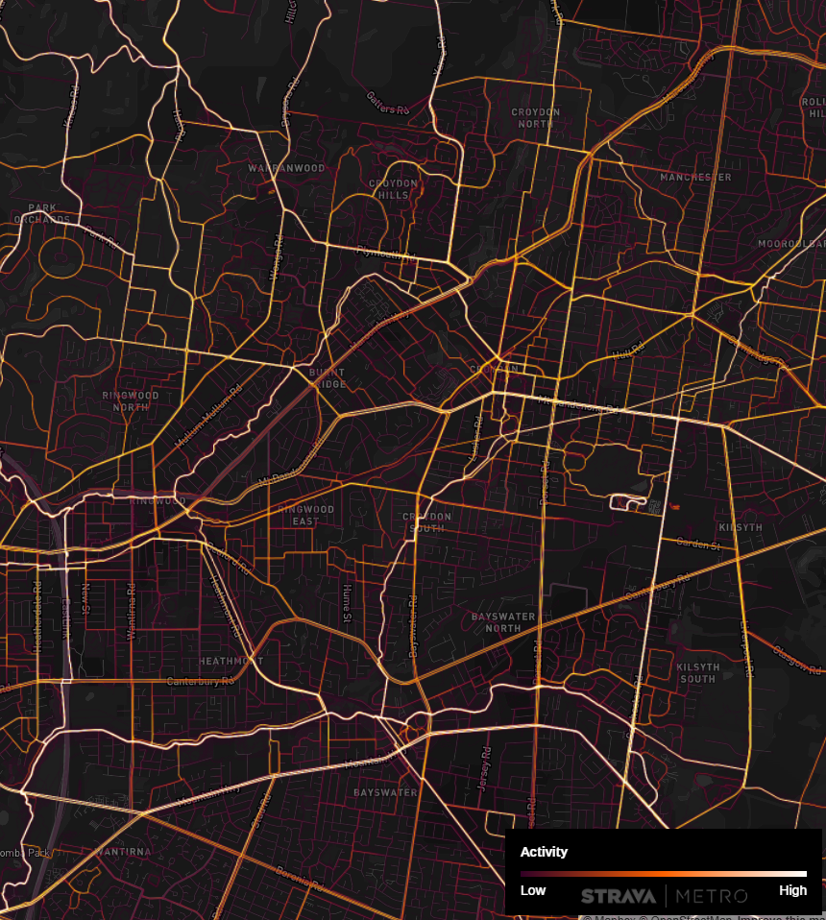
Strava Heatmap of cycling activity over from September 2024 to August 2025.
From the 2017 Super Tuesday counts, female rides represented 15% of riders across the network on a Tuesday. This is below the 24% average for female ridership in Victoria.

Crash Statistics
An assessment of the crash history data from across the municipality between 2019 and 2023 was obtained from the VicRoads Road Crash Information database. The database contains all reported casualty crashes, which include the categories of Fatal, Serious Injury and Other Injury crashes. Non-injury or property damage only crashes are not included in this database.
The categories of crash severity are defined as follows:
- Fatal Injury – one or more persons are killed in the crash or die within 30 days from injuries sustained in the crash. It is noted that no crashes resulted in the loss of life of a cyclist within Maroondah for the 5 years, so this category is not included in the maps and tables;
- Serious Injury – one or more persons are admitted to hospital because of injuries sustained in the crash; and
- Other Injury – one or more persons are given medical treatment for injuries sustained in the crash.
In this case, the data has been filtered for crashes involving a bicycle to identify ‘hot spots’ and locations to which particular attention may be required in the updated Bicycle Network Plan.
All recorded crashes within the municipality between 2019 and 2023 are shown in Figure 17, with further information summarised over the page.
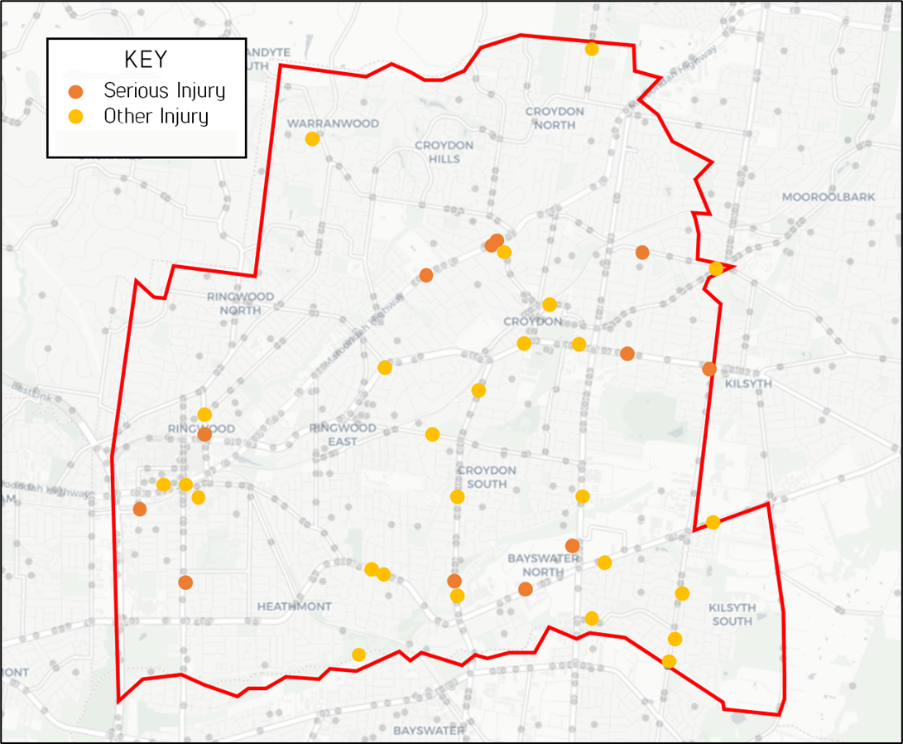
Crash statistics map

Crashes by Definition for Classifying Accidents (DCA) code
DCA Crash Type | Fatal | Serious Injury | Other Injury | Total
Right / through collision with vehicle (121) | 0 | 1 | 4 | 5
Vehicle strikes another vehicle when emerging from driveway (147) | 0 | 3 | 2 | 5
Rear end collision with vehicle (130) | 0 | 1 | 3 | 4
Vehicle off footpath strikes vehicle on carriageway (148) | 0 | 1 | 3 | 4
Left near collision with vehicle (116) | 0 | 1 | 2 | 3
Head on collision with vehicle (120) | 0 | 0 | 2 | 2
Left turn side swipe (137) | 0 | 0 | 2 | 2
Pedestrian near side, pedestrian hit from the right (100) | 0 | 1 | 0 | 1
Pedestrian far side, pedestrian hit from left (102) | 0 | 1 | 0 | 1
Bicycle struck pedestrian (109) | 0 | 0 | 1 | 1
Cross intersection collision with vehicle (110) | 0 | 0 | 1 | 1
Right far collision with vehicle (111) | 0 | 0 | 1 | 1
Two right turning vehicles (114) | 0 | 0 | 1 | 1
Other adjacent collision with vehicle (119) | 0 | 1 | 0 | 1
Right turn side swipe (136) | 0 | 0 | 1 | 1
Leaving parking collision with vehicle (142) | 0 | 0 | 1 | 1
Overtaking out of control (151) | 0 | 1 | 0 | 1
Bicycle strikes door or parked / stationary vehicle (163) | 0 | 1 | 0 | 1
Other accident off straight, no collision or object struck (179) | 0 | 0 | 1 | 1
Unknown details (199) | 0 | 0 | 1 | 1

Most crash incidents recorded took place on roads and intersections within the municipality. Few incidents were recorded on off-road bicycle paths.

The types of crash incidents included:
- Cyclists emerging from a footpath, laneway or driveway and colliding with a vehicle.
Notably, 5 of these crashes involved cyclists aged 13 to 18, three (3) of which resulted in serious injury. This suggests drivers failing to give way when emerging from a driveway or not being able to see cyclists on the footpath (for example when there are high front fences or vegetation either side of the driveway).
However, people of this age typically feel safer when riding on a footpath versus using the roadway, where bicycle lanes are either lacking or are not physically separated from the adjacent vehicle lane (i.e., the cyclists would feel too exposed to vehicle movements). Counter to this, riding on the footpath increases the risk of being struck by emerging vehicles.
- Cyclists making a right turn at an intersection and being struck by an oncoming vehicle.
This is a common crash type that can occur for various reasons.
- Cyclists involved in a rear-end collision.
This would typically occur when a cyclist is travelling within the vehicle lane. It may involve a lack of attention from either the cyclist or vehicle driver.
- Cyclists or vehicles turning left onto a roadway and being struck by a vehicle or cyclist.
This may typically occur because of inattention from either party, or obscured sight lines.
The information and evidence gathered by review of historical crash history will inform the application of a Safe System approach to lower the risk of incidents from occurring involving a cyclist. The Safe System has been adopted as part of the 2021-2030 Victorian Road Safety Strategy, which sets a vision for no deaths or serious injuries on our roads.
The principles underpinning the Safe System approach are that:
- People make mistakes.
- People have a limited tolerance to injuries.
- Safety is a shared responsibility.
The Bicycle Network Plan considers treatments for safer cycling that are aligned with the Safe System Approach, as far as practicably possible.

Engaging Our Community
Community and key stakeholders were engaged at various points during the development of this Plan. The consultation commenced in 2023 and continued into 2025. It was broad in scope and asked people, authorities, interest groups and clubs about cycling and walking participation, attitudes, network conditions, rider experiences and desired infrastructure. The consultation was designed to overcome the known information gaps in in these areas. Table 17 outlines the engagement and the extent of the stakeholder and community participation.
2023
Bike Spot Survey | Issues and Opportunities Survey
Pinpoint Map | Your Say Maroondah Platform - Online Survey | Your Say Maroondah Platform - Pinpoint Map | Intercept Surveys | Maroondah Advisory Committees Workshops
107 self-reported individual sites  95/% of sites reported as unsafe. | 326 submissions  322 individual contributors  6 formal submissions  Mostly male contributors (66%)  46% self-reported as ‘Enthused and somewhat confident’ rider.  21% self-reported as ‘Strong and fearless’ rider. | 257 self-reported individual sites.  33 individual contributors  85% of sites reported as unsafe. | 40 responses | Council advisory committees engaged:  - Liveability, Amenity and Safety  - Community Health and Wellbeing
2025
Public exhibition
Your Say Maroondah Platform - Survey |  |  | Maroondah Advisory Committees Workshops
268 submissions  3 formal submissions from stakeholders  Male respondents (63%)  83% live in Maroondah.  Span of ages 18 to 75+, with 35 to 64 being the largest cohort.  6% of respondent did not ride a bike.  50% self-reported as Enthused and Somewhat Confident’ rider  33% self-reported as ‘Strong and fearless.’ rider. |  |  | Council Advisory Committees engaged:  - Liveability, Amenity and Safety
Overview of community engagement and participation rates.

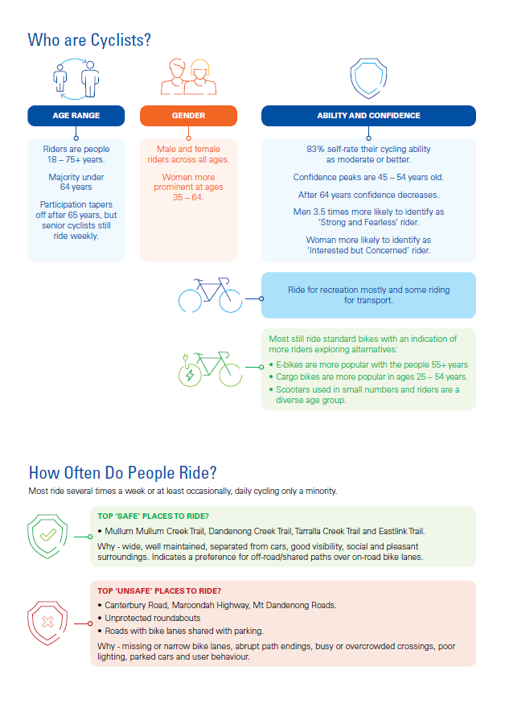
The Cycling Community - What We Discovered
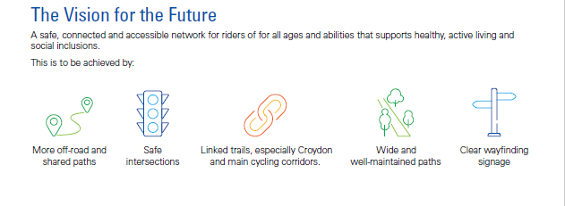

Cycling Design Principles
Key design principles have been prepared to inform the provision and maintenance of cycling infrastructure as follows:
- Aspire to deliver off-road facilities that are separated from vehicle traffic, as these are the safest, most attractive and comfortable routes for riders of all ages and abilities.
- If sufficient space, deliver separate facilities for pedestrians and people on bicycles, scooters and mobility devices.
- If facilities must be on-road, ensure the safest options for all road users is delivered.
- Give people the most direct route possible, were feasible. Recognising that in some cases physical constraints or other factors may require alternative alignments.
- Enable people to reach destinations easily through complete and seamless routes.
- Maximise connectivity to major cycling routes by upgrading substandard access points as part of all major cycling projects, ensuring seamless and inclusive access for users from surrounding streets and paths.
- Enhance the comfort, convenience, and security of riders by integrating supportive infrastructure such as wayfinding signage, drinking fountains, seating, repair stations, end-of-trip facilities, and secure parking within all major cycling projects and council building projects.
- Incorporate flexibility in design to accommodate changes in user needs and demand over time.
AustRoads and the Department of Transport and Planning (formerly VicRoads) have prepared a comprehensive range of best practice designs and standards for on and off-road facilities. Council will endeavour to apply these in specific network, local and community contexts.
Council will consider and give regard to the Victorian Movement and Place Design Guidelines – The Cycling Guide which has been developed (draft issue dated June 2020) to establish the design options to create Victoria’s cycling network. These outline a range of design principles and infrastructure options to help achieve a safe, comfortable and connected cycling network and are summarised below:
- People first – creating a safe, inclusive and comfortable cycling environment considering the needs of all people and their bikes;
- Integrated network – creating simple, connected journeys across different layers of the cycling network;
- Design for the future, deliver today – setting the long-term vision to help guide actions today;
- Safe – eliminating the likelihood, consequence and severity of potential injuries to people who ride bikes;
- Connected and direct – addressing all gaps and severance points; and
- Comfortable and attractive – making cycling an attractive, appealing and enjoyable option.
The Draft Cycling Guide provides information on the fundamental infrastructure options including how and where to implement appropriate cycling infrastructure. This draft information has been considered along with AustRoads Engineering standards and safe design practice in the development of the Maroondah Bicycle Network Action Plan. Typical infrastructure options to support bicycles in Maroondah are detailed below.

Cycling Network Infrastructure

Off-road cycling infrastructure

Separated Paths
Separated paths are a form of off-street cycling infrastructure, with separate space provided for cyclists and pedestrians. By having an exclusive space, cyclists can better maintain their speed while the path type is able to accommodate a higher volume of users and reduces potential conflict with pedestrians.
Separated paths are typically two-way and physically separated from both the pedestrian footpath and the vehicle carriageway. A width of 2.5-4m supports comfortable cycling on a separated or exclusive path.
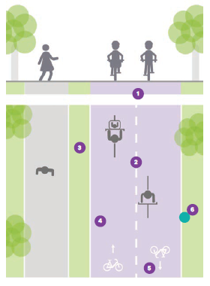
Separated off-road paths diagram
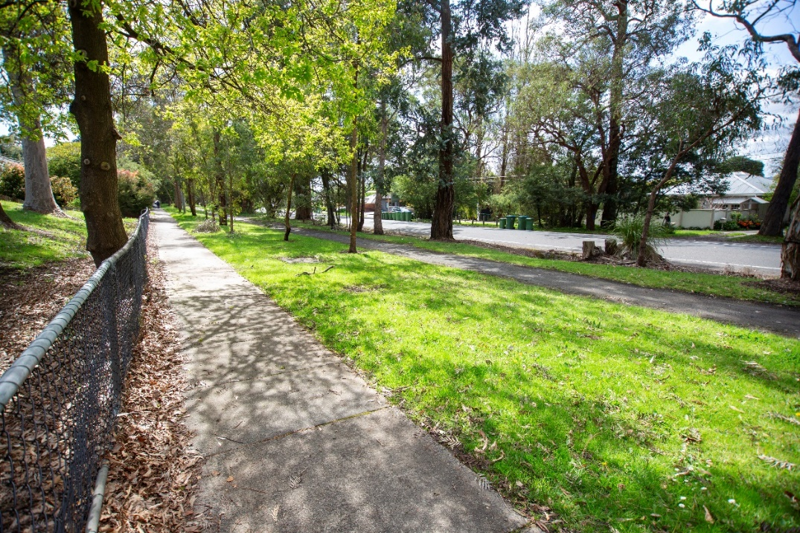
Separated off-road path example along Croydon Road, Croydon

Shared Paths
Off-road shared paths provide complete separation between cyclists and vehicles. The path is shared between cyclists and pedestrians. This significantly improves the safety of cyclists, removing the risk of conflict with vehicles.
Shared paths are typically two-way with line marking arrows and occasionally a centre line to guide users.
A width of 3-4m is desirable for off-road shared paths to allow cyclists to overtake pedestrians while allowing for a range of users (such as recreational users, skateboards, pets etc).
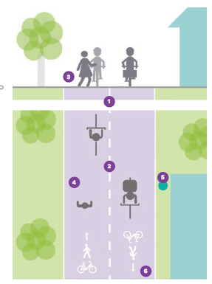
Shared paths
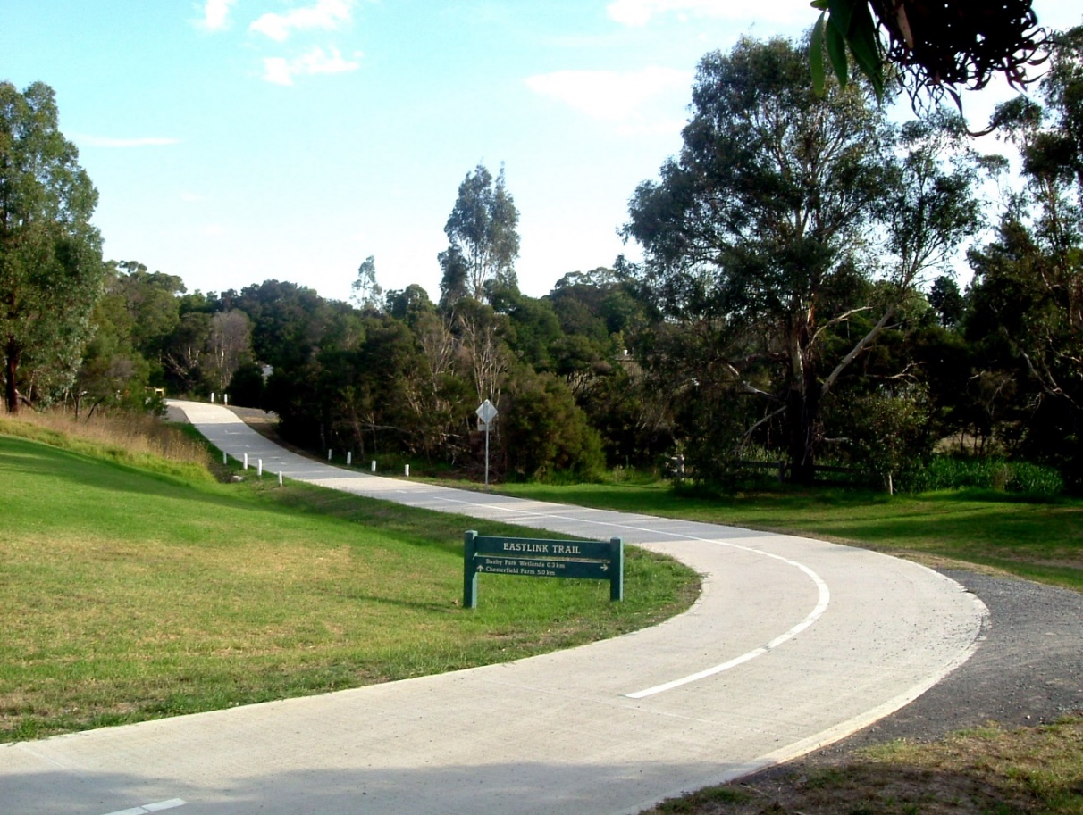
Off-road shared path, Eastlink Trail

On-road cycling infrastructure

Protected Bike Lanes
On-road protected bike lanes provide a designated cycling space, physically separated from vehicles. This improves the safety of cyclists, protecting them from high-speed moving vehicles, and the opening of parked car doors. This may encourage those less confident to ride.
On-road protected bike lanes are one-way or two-way and may be raised from vehicle lanes. These facilities are appropriate to implement in locations on roads with vehicle speeds over 30km/hr and less than (or equal to) 60km/hr.
A minimum width of 1.8m is necessary for people to pass and this supports safer movement in low vehicle volume environments. A greater width should be adopted where possible to improve the safety and comfort of cyclists.
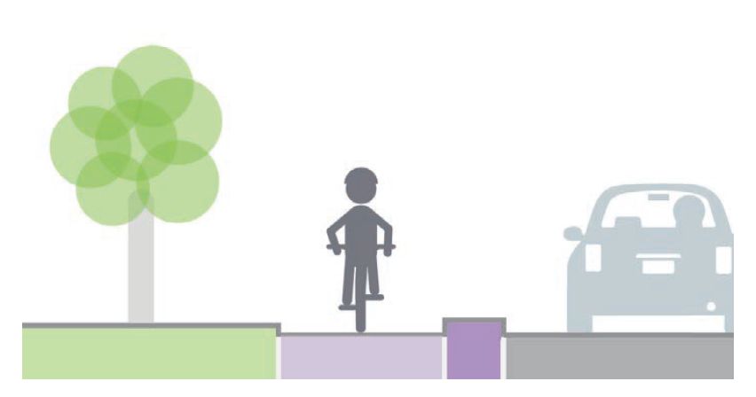
Protected bike lanes
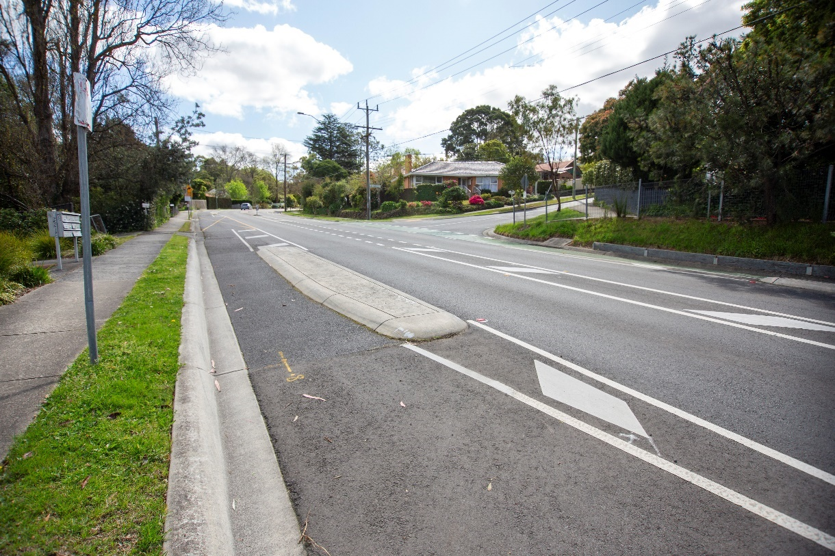
Protected bike lanes, Kent Avenue, Croydon

Bicycle Streets
Bicycle Streets (or Shared Streets) have no physical separation between bike and vehicles and are designed to encourage low vehicle volumes and speeds of less than 30km/hr, suitable for sharing with cyclists. They are designed to support cyclist dominance within the roadway through visual and physical cues.
These facilities can be implemented where low vehicle demand and low vehicle speeds can be achieved, such as on local street and laneways. They typically play a role in connecting other existing (and future) cycling infrastructure such as off-road cycling paths and on-road bike lanes.
Bicycle Streets should incorporate traffic calming treatments such as speed humps, chicanes / pinch points, and line marking to advise road users of the shared nature of the road.
For example, Lena Grove in Ringwood provide a bike street connecting the on-road bike lanes on Bedford Road and the Heathmont Rail Trail. Line marked bike sharrows are provided to encourage cyclists to use the centre of the road.

Bike street
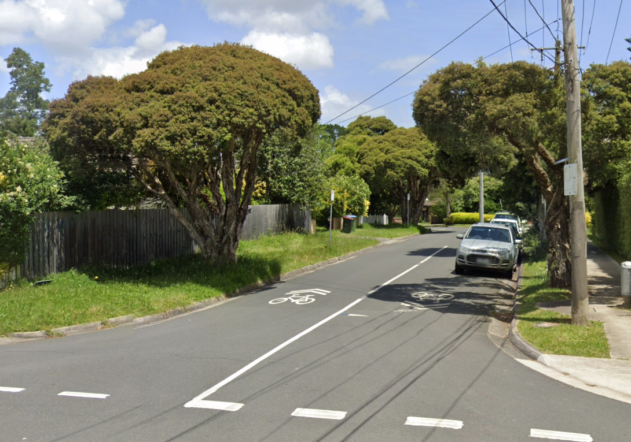
Bike street, Lena Grove, Ringwood

Intersections and Crossings

Crossings
Where off-road bike paths intersect roads, safety for cyclists can be improved by incorporating design features to provide cyclists (and pedestrians) with priority over vehicles.
Features such as grade separation, pavement marking, and signage can be used to enhance visibility and give priority to active transport users.
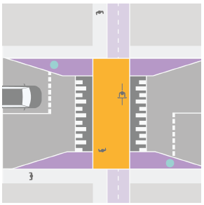
Bike path crossing
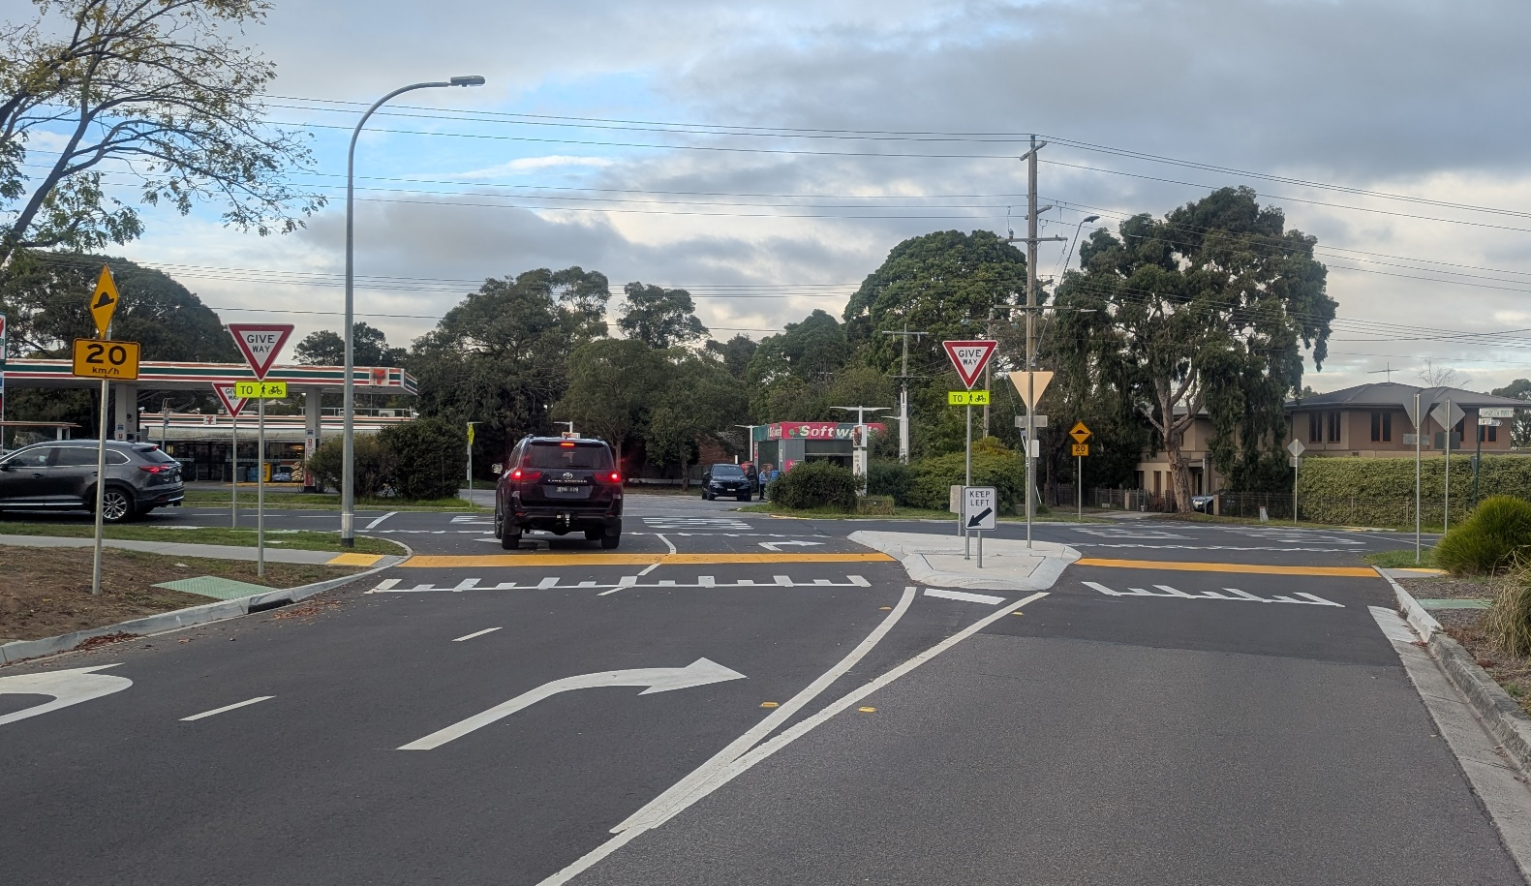
Shared path priority crossing, Golden Ridge Drive, Corydon Hills

Protected Intersections
Protected intersections give protection to drivers and cyclists through high conflict areas. They extend safety features for cyclists into the intersection, rather than losing such features on approach to the intersection, reducing the risk of collisions.
Intersection treatments should be designed to allow the bike lane to continue through the intersection, with kerb separators and other design features.
All types of intersections including signalised intersections and roundabouts can be provided with features to protect cyclists. Treatments are a design consideration for strategic bicycle routes on main roads. These projects need to be developed and implemented through consultation and partnerships with community, transport authorities and other stakeholders to determine the best design for intersections. This collaboration can include codesign and using feedback to refine designs to ensure the best network and community outcomes.
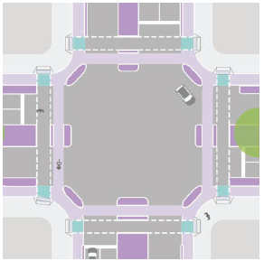
Protected intersection
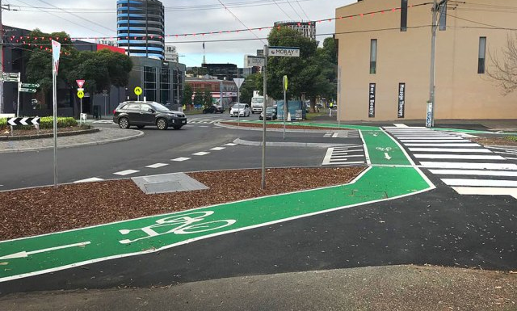
Protected intersection (roundabout) Moray Street, South Melbourne

Supporting Infrastructure
An effective bicycle route is more than just the facility type and surface of the trail, pathway or lane. The following supporting infrastructure features allow users to walk or ride with awareness, confidence and comfort and are important when scoping, planning and designing bike projects.

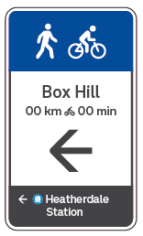
Wayfinding Signage
Wayfinding signage supports people to make clear and legible navigation decisions without the need for a map or mobile phone. The strategic placement of wayfinding throughout a network allows users to easily and quickly arrive at a destination and explore along the way.
Good wayfinding can promote cycling by raising awareness of the region's network. This helps increase the visibility of the network to users, which can encourage more people to take up cycling. Additionally, it helps allow users to overcome barriers and constraints including safety concerns and severance, through a lack of knowledge of the area.
Good wayfinding is achieved by providing prompts such as signage and maps, as well as landmarks and symbols along the routes.
Wayfinding signage example

Bike Parking
Bicycle parking supports riders by providing secure and convenient places to leave their bikes at key points. Well-designed bike parking facilities encourage cycling by making it easy for people to combine riding with other activities, such as shopping, commuting, or using public transport. A mix of short-term and long-term parking options across the network ensures that the needs of both daily commuters and casual riders are met.
Strategically located facilities, such as Parkiteer cages, offer secure, weather-protected parking at train stations, making it easier for people to integrate cycling with public transport. Currently, Parkiteer is available at all stations except Heathmont, highlighting an opportunity to advocate for its installation as part of a station upgrade. In addition, exploring the provision of e-bike charging stations in public spaces can further support the growing number of electric bike users.
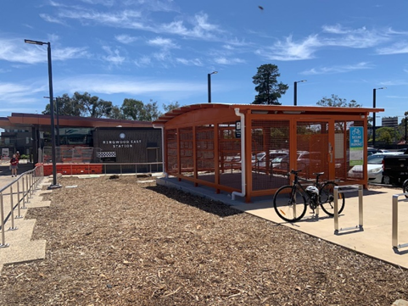
: Parkiteer facilities at Ringwood East Station

Repair Stations
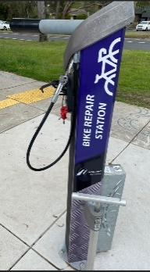
Bike repair stations providing riders with the tools and resources needed to perform basic maintenance and repairs while on the go. These stations typically offer tools and tire pumps to address common issues like flat tires or loose components quickly and independently.
Strategic placement of repair stations at key locations, such as major intersections, transport hubs, and popular cycling routes can ensure that help is readily available when needed. The repair stations increase rider self-sufficiency, confidence and convenience to reduce the risk of minor mechanical problems discouraging people from cycling.

Bicycle repair station.

Drinking Fountains
Drinking fountains should be a common amenity along bicycle routes, helping users stay hydrated during their journeys. Conveniently located fountains along popular routes, at rest stops, and near key destinations provide users with easy access to fresh water, encouraging longer and more frequent rides, walks or runs.
To maximise their benefit, drinking fountains should be accessible, easy to use, and regularly maintained. Including bottle refill stations and accessible designs ensures that all riders, including children and people with disabilities, can use them comfortably.

Data Capture
Information about pedestrian and bike rider movements is increasingly available from data companies that aggregate mobile phone and device data. Collecting data through open and crowdsource data sets can provide accurate and up-to-date information about how the network is being used and performing.
Crowdsourced data collected through mobile apps and online platforms offers real-time information on usage patterns. To ensure accuracy, this data must be validated through manual counts at key locations across the network.
Open source datasets, such as those made publicly available by the Victorian Government and other agencies, further enrich the picture by providing access to maps, data, and visualizations.
A Pedestrian and Bicycle Data Collection Framework will identify and propose a cost effective, accurate and scalable approach to guide Maroondah Council to monitor walking and cycling trends across the entire network in near real-time and reduce reliance on fixed counters.

End of Trip Facilities
End of trip facilities at key destinations provided comfort, convenience, and security for riders and encourage more people to choose active transport.
Strategically located hubs, featuring shelters, drinking stations, toilets, and bicycle repair stations at known stopping points along the network support users. These amenities allow people to rest, rehydrate, make minor repairs, and continue their journey with independence and confidence.
End of trip facilities should be considered in all major Council building projects. Providing secure bike parking, showers, changing rooms, and lockers supports employees, volunteers and the broader community, making cycling a more practical option for all.
As urban intensification continues in activity centres, there is a significant opportunity to embed bicycle-facilities into both new buildings and public spaces. This includes the provision of bike parking, lockers and change facilities within developments. These measures not only support cyclists but also contribute to safer, more vibrant, and accessible urban environments.
The Maroondah Planning Scheme includes standards that apply across Victoria to encourage end of trip facilities and support the needs of both pedestrians and cyclists.

Road and Street Type Considerations
In selecting the right cycling infrastructure and design for a place, the role of the road within the broader network is one of several important factors, along with value for money, community consultation and design safety all requiring consideration. The network roles of cycling routes are as follows:
- Primary routes (C1): A core network of Strategic Cycling Corridors connecting places of stage significance;
- Main Routes (C2): Strategic Cycling Corridors with additional connections to state significant destinations, major activity centres and key railway stations;
- Municipal Routes (C3): Support mostly local and short trips to activity centres including train stations and other interchange, and feed to C1 and C2 routes; and
- Neighbourhood and Local Links (C4): Short connections to C1-C3 routes and nearby activity centres and are often the origin links from residential areas.
The Movement and Place Design Guide to Urban Roads and Streets defines several road and street types which can be grouped into the following ‘street families’ where they share similar features and roles:
- Exchange: Places where people can meet, interact and converse to thrive. These streets support communities to access goods and services;
- Connect: Move people and goods across the city. They are places where trams, buses, bicycles, pedestrians and cars interact to connect people and places;
- Live: Places people inhabit, supporting people to live their lives, relax, play, sleep and build a sense of community; and
- Serve: Places of service and production. These are working streets where goods are made, stored, delivered, sold and distributed.
Based on the above, the Movement and Place Cycling Guide identifies the ideal cycling facility for each street type. The application of cycling facilities will be tailored for each project to achieve optimal mobility, safety and community benefit.

Managing the Network
Building a bicycle network is only part of the investment to ensure bicycle rides are safe and can reach destinations easily by connected routes.
Equally important is continuous facility reviews and the maintenance of existing facilities to ensure that all routes remain in good condition throughout their lifespan. Proper maintenance includes timely repairs, cleaning, resurfacing of trails, pathways or lanes, as well as the upkeep of supporting infrastructure, such as wayfinding signage, bike parking, drinking fountains and repair stations.
Although not an explicit objective or initiative of the Plan, Council will continue to monitor, respond and conduct maintenance across the entire network. Acknowledging that as the network expands, so too does the demand on maintenance resources. Each new facility adds to the long-term maintenance expenditure. Without adequate funding and planning for maintenance, the quality and safety of the entire network can deteriorate, undermining the initial investment and discouraging use.
Therefore, all bicycle infrastructure projects must be planned with a clear understanding of their lifecycle costs. Maintenance budgets should be carefully assessed and allocated to ensure that both existing and new facilities can be properly managed. This requires integrating maintenance considerations early in the design process, selecting durable materials, and designing for ease of upkeep. Additionally, decision-makers must balance the desire to expand the network with the practical limitations of available maintenance funding, prioritising investments that maximise both network connectivity and long-term sustainability.

Supporting the Community to Ride
Supporting people to embrace cycling is about more than just building infrastructure, it’s about creating a culture where all road users respect and look out for one another. While dedicated or separated bicycle routes are ideal, they are not always feasible due to physical and financial constraints. This means that interactions between cyclists and other road users are a reality, and shared responsibility is essential for everyone’s safety.
To support bike riders, Council is committed to improving rider skills, increasing awareness of road rules, and promoting positive etiquette for sharing space. This includes maintaining a dedicated Council website with up-to-date information on cycling road rules, legal rights, and providing practical advice for safely sharing roads and paths. The website also promotes the legally mandated safe passing distances that protect cyclists on all streets and provide clear maps of the safest and most convenient routes across the network.
Education is a cornerstone of safe cycling, particularly for vulnerable riders such as school children, women, and seniors. Council works collaboratively with road safety authorities, Victoria Police, local bike shops, schools, and cycling clubs to deliver bike education programs and events. These initiatives focus on building rider confidence, understanding road rules, and learning practical skills to ride in a range of places and conditions.
Community events play a key role in promoting and normalising bike riding as a legitimate mode of transport. Council supports and promotes events like Biketober, Ride2Work Day and cycling activities at other major gatherings. Bicycle parking is also provided and promoted at significant events to make it easy and convenient for people to choose to ride.
Recognising that some riders may benefit from extra support, Council will explore options to offer regular classes for novice riders, including women-only sessions to encourage more women to ride. Additionally, Council will seek opportunities to partner with schools to maintain and expand ride-to-school initiatives, ensuring safe routes and connections right to the school gate.

Regional Collaboration
The Maroondah Bicycle Network is an integral part of the broader regional and metropolitan cycling network. Routes extend beyond municipal boundaries, making it essential to ensure consistency in facility provision, route naming, and ongoing maintenance across the entire network. This approach helps create an improved experience for all riders, whether they are commuting, exercising, or exploring the region.
To achieve this, Council works collaboratively with the Eastern Regional Trails Strategy Group to deliver on the actions outlined in the Eastern Regional Trail Strategy 2018. Key priorities include:
- Advocating for Investment: Actively advocate for funding commitments to construct the missing links in the regional trails network. Completing these gaps will enable safer, more direct, and more accessible journeys for all cyclists.
- Coordinated Promotion: By working together, we can promote the entire trail network as a unified network, making it easier for residents and visitors to discover and enjoy the full range of opportunities available across the region.
- Consistent Branding and Wayfinding: Improve whole-of-trail branding and signage, ensuring that cycling routes are easily identifiable and consistent from one municipality to the next. This includes clear route names, wayfinding markers, and information boards at key locations.
By fostering strong partnerships and a shared vision, we can ensure that our cycling network supports the needs of the entire community and contributes to a vibrant, connected, and active region.
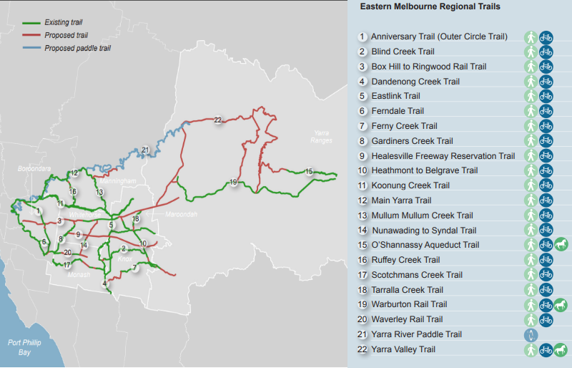
Map and listing of the Eastern Melbourne Regional Trails

Aspirational Maroondah Bicycle Network
Based on research undertaken as part of this Plan and informed by community consultation, an aspirational Maroondah Bicycle Network Plan has been developed (Figure 35) that includes all existing and proposed cycling infrastructure. In preparing this consideration was given to local links and regional connections to provide access to shops, schools, major community hubs and parks.
The aspirational bicycle network includes several potential projects to provide new or improved cycling infrastructure to expand connectivity for cyclists. The type of facilities selected for the projects consider the road / carriageway spatial factors and design principles to maximise safety, accessibility and connectivity for cyclists.
The Maroondah Aspirational Bicycle Network Map shows the existing and proposed routes. The facility type for the existing routes are shown at the time of plan development. The existing routes are one of the following facility types:
- Shared Pathway - Shared paths allow people to ride with complete separation from vehicles. The path is shared between people who ride and pedestrians;
- Dedicated Bike Lane - Bike lane or bicycle lane, refers to an on-road facility with dedicated space for people to ride on;
- Existing Dedicated Path - Dedicated cycle path or exclusive cycle paths provide connection for people on bikes completely separated from other modes and separate to the roadway;
- Existing Bike and Parking Lane - A bike lane or lane that allows people to ride on road and motorist are allowed to park a vehicle in the lane,
Proposed routes and facilities identified as opportunities to expand, connect or enhance the safety of the existing network are shown as either:
- Bridges and Underpasses – includes new or improved bridges or underpasses to extend safety features for people to ride through the bridge or underpass;
- Crossing and Intersections– includes new or improved crossing or intersection to extend safety features for people to ride to, into or cross at intersections;
- Dedicated Bike Lanes - definition as above;
- Shared Path - definition as above;
- Dedicated Path - definition as above;
- Bike Street - Bike streets or cycle streets allow people on bikes and in cars to mix and share the entire carriageway. Cycle streets incorporate traffic calming elements to lower vehicle speeds and volume to create an environment where drivers expect to regularly stop and to enhance safety and comfort for vulnerable road users;
- Aspirational Route (Feasibility to be confirmed) - Indicative route that requires a feasibility study to determine the suitable bike facility type.

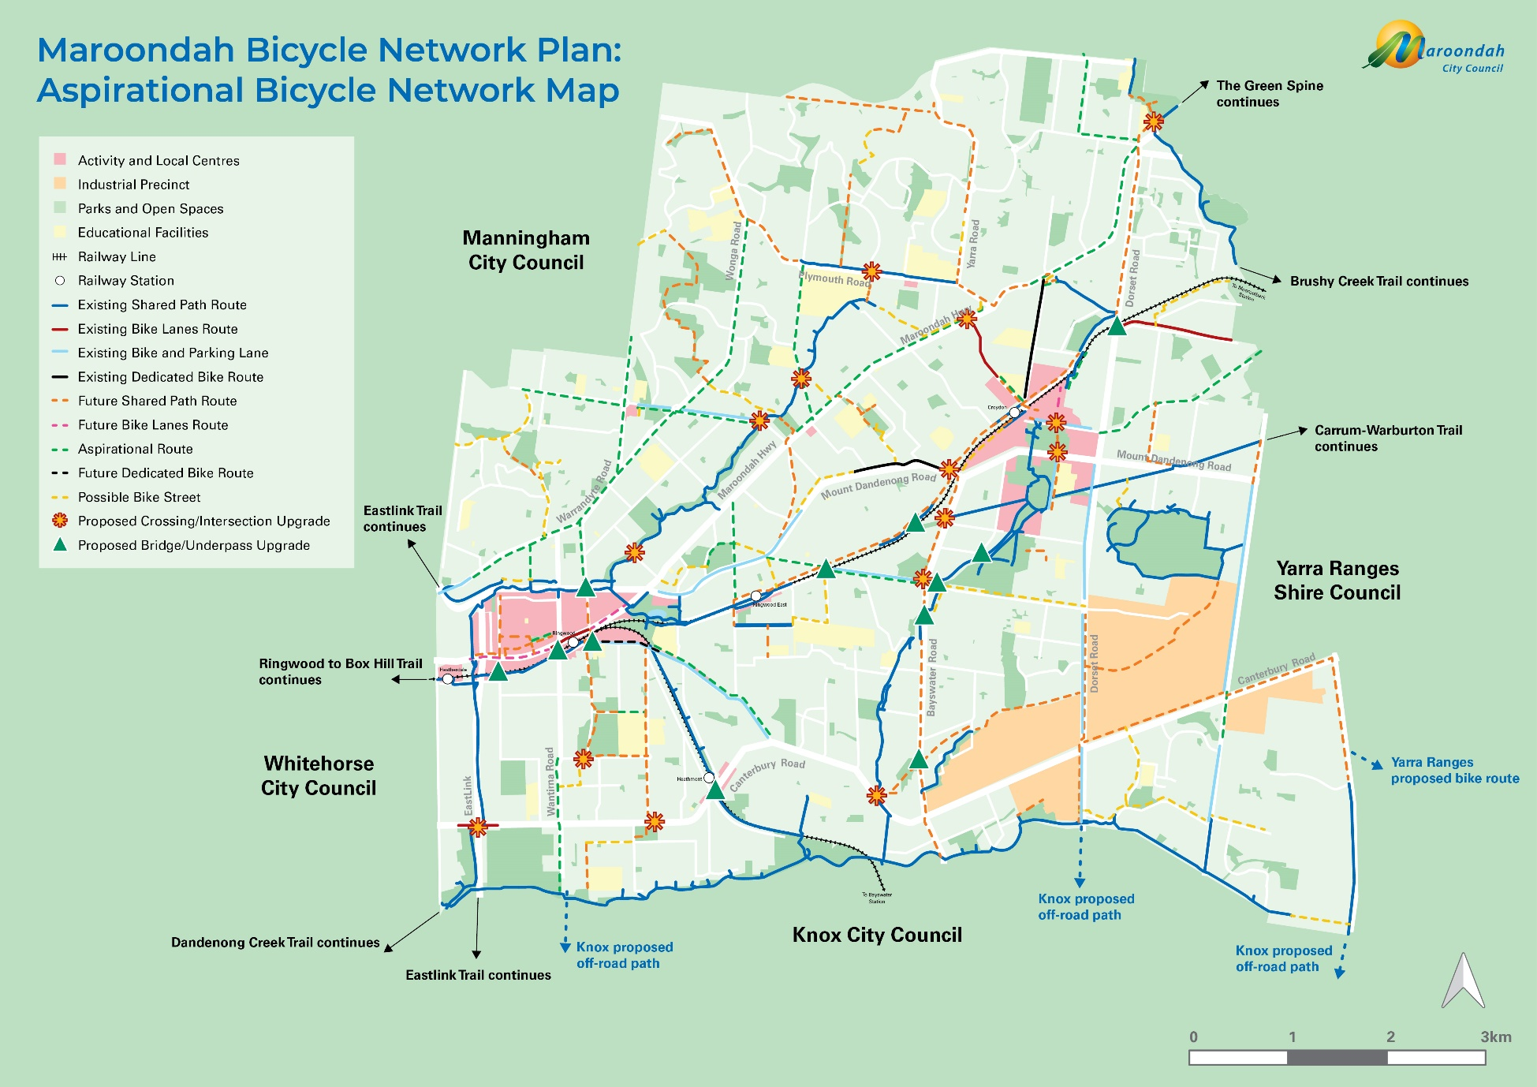
Aspirational bicycle network

Regional trails and strategic cycling corridors are prioritised with reference to Victorian Government priorities, policy alignment, network value, potential ridership as well as corridor availability.
Local routes are prioritised based on funding availability, ability to service local schools, activity and recreation centres with a known dense local catchment, and alignment with other Council strategies and master plans.

Project Opportunities
The Maroondah Bicycle Network Plan is supported by a Project Opportunities 2026 - 2036 document, that lists cycling and pedestrian infrastructure opportunities to progress toward the aspirational network over the next 10 years.
A mix of opportunities are included and range from new routes and connections to expand the bicycle network to cycling infrastructure improvements on existing routes. For each opportunity a high-level description is provided outlining the status, key stakeholders involved, level of priority and anticipated outcome of the opportunity.
The level of priority relates to the transport benefit ranking. The transport benefit rank was generated from a range of metrics, such as strategic cycling route classification, known safety issues, strategic alignment, destinations served and effect on parking. There are three ranks, low, medium, and high, as outlined below:
- High: The projects are major or main cycling routes with demonstrated safety benefits, a significant level of service to destinations, ready / close to being built and no to low impact on street parking. These elements make them good candidates for advocacy to funding bodies.
- Medium: The projects are commonly main or municipal cycling routes with some safety benefits, a moderate level of service to destinations and low or moderate impacts on parking. With further project development, they can be ready for construction and advocacy to funding bodies.
- Low: These projects are typically local cycling routes with limited safety benefits, low level of service to destinations, are still under feasibility or early design stages and may have a significant impact on street parking.

Implementation
This Plan is aspirational with regards to an improved Maroondah bicycle network. An extensive range of identified project opportunities over the next 10 years leaves Council well placed to advocate to external funding bodies in association with Council’s capital works program. Recent Maroondah level crossing removal projects, railway and station upgrades and major road upgrades are examples of projects that incorporate new and improved cycling infrastructure.
The scale of the identified future projects means that the delivery of much of the aspirational network is beyond the remit and resources of Council. Implementation is subject to transport policy, transport jurisdictions and a wide range of landowners. Accordingly, securing the approvals and investments from a range of stakeholders is key to the implementation of the network, especially for larger and more complex projects.
Advocacy is core to securing the necessary commitments to deliver on priority projects in this Plan. Council’s advocacy plan contains prioritised cycling infrastructure projects, such as the Ringwood to Croydon Pathway and the Greenwood Avenue Shared User Pathway. Council will continue to engage with Federal and State government, transport authorities, operators and advisory groups in this regard.
Decisions about cycling infrastructure will be subject to consultation and engagement with stakeholders, especially residents and road users. Engagements will occur at key decision points in the project development cycle consistent with Council’s Community Engagement Policy. Council will listen and work in partnership with stakeholders to ensure it understands and considers issues and works towards a balanced design response to the range of requirements. A clear explanation of the project and framing of the problem and benefits at each engagement will deepen community understanding for the proposal.
The design of cycling infrastructure is to be adaptable to account for the nuances of urban and suburban environments. This will be considered in response to changes in land use, transport mix and parking demands over time. Incorporating flexibility into design may involve the trial of facilities and treatments to test the function and scale of usage. Based on available evidence the facilities and treatments can be refined over time to better account for user experiences.

Monitoring and Evaluation
Monitoring and evaluation are essential to ensure the ongoing success and improvement of cycling infrastructure and programs across Maroondah. Projects will be evaluated not only on their timely delivery, quality of infrastructure but also on their effectiveness in growing cycling participation.
A key focus will be the collection and analysis of both quantitative count data, such as the number of cyclists using new or upgraded routes, and qualitative user data, including feedback from riders before and after project implementation. This dual approach will provide a comprehensive understanding of which projects are most successful and why. The evaluation methodology is to be considered at the scoping stage of projects.
By capturing both the numbers and the experiences of users, Council will be better positioned to identify what works, address any challenges, and replicate successful strategies in subsequent projects and plans. This evidence-based approach will also strengthen applications for funding from partner agencies by demonstrating clear outcomes and community benefits.
Progress on the Project Opportunities document will be monitored and reported to Council every three years. These reports will detail investments made in planning, designing, and constructing new cycling infrastructure, as well as upgrades or renewals to existing facilities. Outcomes and impacts, including changes in cycling participation and user satisfaction will be highlighted to provide a transparent picture of progress. This process will also help identify any project delays or issues, allowing for timely corrective actions.
The Project Opportunities document will be regularly updated, with completed projects removed and newly identified opportunities added. This ensures the document remains current, flexible, and transparent. The Bicycle Network Plan itself will undergo a formal review after eight years to inform the next Plan refresh at the end of the 10-year period.

Glossary

Active Transport - Physical activity undertaken as a means of transport. It includes walking, cycling and other physical human-powered means.
Bicycle Lanes - Bicycle lanes are a part of the road that is separated by a line (or barrier) from the rest of the road, for the use of people riding bicycles.
Bicycle Paths - Bicycle paths are a type of cycleway that is separated from motorised traffic and dedicated to cycling or shared with pedestrians and other non-motorised users.
Bicycle Street- Bicycle Streets are roads and streets that carry low traffic volumes and speeds that have been optimised for bicycle traffic.
Chicanes - Chicanes are bends in the road (in the shape of an S) added by design such as kerb outstands that compel drivers to travel more slowly.
Integrated Transport - Integrated transport involves the combining of different modes of transport to maximise ease and efficiency for the user in terms of time, cost, comfort, safety, accessibility and convenience.
Mobility Devices - Mobility devices are designed to help individuals with mobility impairments to walk or improve their overall mobility. It includes wheelchairs, walkers and other power-driven devices for example.
Pedestrians - A pedestrian is a person travelling on foot, whether walking, running or using a mobility device.
Shared Paths - Shared paths are separated from motorised traffic for use by both pedestrians and cyclists (including scooters, skateboards, those using mobility devices etc).
Trails -Trails are an off-road path or marked route that is intended for use by people riding bicycles, and pedestrians. They are often unpaved paths.
Walkable Neighbourhood - A Walkable Neighbourhood is one that provides essential amenities within a 15–20-minute walk. It should include pedestrian-friendly infrastructure, mixed-use development, access to public transport, sense of community and safety consideration.



