Customer Service Strategy

2021-2025

Acknowledgment of Country
We, in the spirit of Reconciliation, acknowledge the Wurundjeri People of the Kulin Nation as Traditional Custodians of the land now known as the City of Maroondah, where Indigenous Australians have performed age old ceremonies. We acknowledge and respect their unique ability to care for Country and their deep spiritual connection to it. We pay our respects to their Elders, past, present and emerging.

Introduction

Customers expect local government to provide services that use modern technology — to be convenient and accessible and that customer service delivery matches the offerings by banks, retail, airlines and hotels.

Maroondah City Council’s Customer Service Strategy 2017-2020 guided the organisation to achieve a higher standard of customer service delivery across all areas of council.
The objectives set during the past three years assisted Council to advance its Customer Service commitment and deliver a foundation which influences an exciting organisational customer service direction – one which evolves with shifting times and customer expectations.

Connecting Council’s many services to a customer experience is essential as it has a direct influence on Council’s brand and reputation.

An emphasis on highly responsive organisational customer service that matches Council’s world class facilities and services must continue to be a focal point across all council service areas into the future.

Defining a new customer strategy will align both Council's objectives and customer’s value – delivering a strategy that meets customer needs today and into the future.

The future looks bright for Council with a commitment to evolve its customer service delivery to align with changing community expectations.

Key focus and deliverables for Council’s Customer Service Strategy include:

- Customer Service ‘One Council’ Program
- ‘Digital Services and Engagement’ Program
- Customer Relationship and Experience Program
- Customer Service Partnerships Program

Background

Maroondah City Council is home to over 120,000 residents and 9000 businesses.

We welcome thousands of visitors into our municipality each day – these are just some of the customers we interact with.
Maroondah has developed into a thriving municipality in Melbourne’s east, hosting progressive educational facilities, libraries, arts and cultural centres, and a range of high-quality community centres, programs and activities.
Maroondah is also home to a range of world-class sporting and leisure facilities, green leafy open spaces, public transport hubs and growing commercial and retail areas.
The previous Customer Service Strategy (2017-2020) and associated action plans raised awareness around change, set organisational customer interaction standards and helped Council deliver effective customer service.
Council’s customer satisfaction scores, using Local Government Victoria’s Annual Survey has consistently seen Maroondah’s scores above or well above statewide industry standards for the past four years.

Technology is evolving at a rapid pace; the world is a different place, and customers expect Council to respond and deliver a quality service in line with changing demands and customer expectations.

Connecting the Maroondah experience

Research identifying leading practice in customer service throughout local government reveals a need to deliver a more integrated service approach.

Evolving multichannel customer contact centres; website redevelopments; appropriate information and communication technologies (ICT) infrastructure; and co-habitation of customer service centres with library services, aid in delivering improved customer connections and enriched experiences.
With an evolution towards integrated service centres, Maroondah is leading the way within the Victorian local government sector and is committed towards a fully integrated regional approach into the future across community hubs located in Ringwood and Croydon.
In October 2020, Maroondah Council’s Customer Service team unveiled its new customer service model, commencing work on a ‘One Team’ modal set to support the changing needs of the community and accompanying other council services to redefine the customer’s experience at Realm in Ringwood.
Realm’s development over the past five years has allowed Council the opportunity to lead the way into an innovative and progressive world, delivering a contemporary customer experience that shifts from ‘traditional’ counter customer service to a unique experience during broader opening hours inspiring new and progressive service partnerships for the future.

Strategic context

The Customer Service Strategy 2021-2025 is aligned to Council’s Integrated Planning Framework and seeks to ensure that customer service delivery activities are aligned with community expectations.

As seen in the diagram below, the strategy is aligned to 2040 Community Vision and the Council Plan.

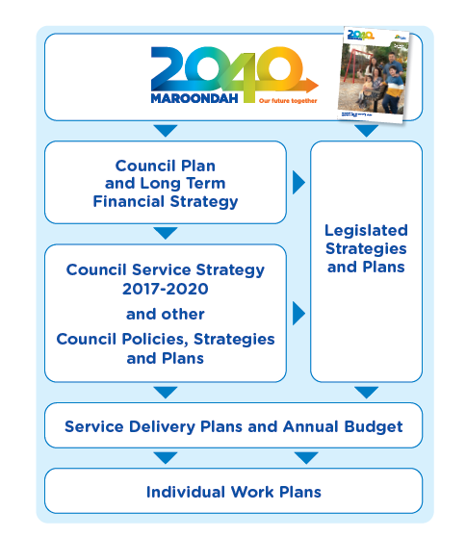

Local government customer trends

Increasingly, customer expectations are shifting and there is rapidly increasing use of newer technologies.

Customers are looking to communicate and carry out transactions in time and cost-effective ways.

The road to the future for Council involves learning from and leveraging from our COVID-19 responses to improve customer centricity, enhance digital and workforce enablement, re-think services and how they’re supported by assets and infrastructure, and become more agile and responsive as an organisation. The year 2021 will be one of continuing change and challenge as we adapt to the new normal in service delivery.

KPMG Australia have conducted a range of LG transformation activity and surveys in the past six months and the results reflect interesting findings:

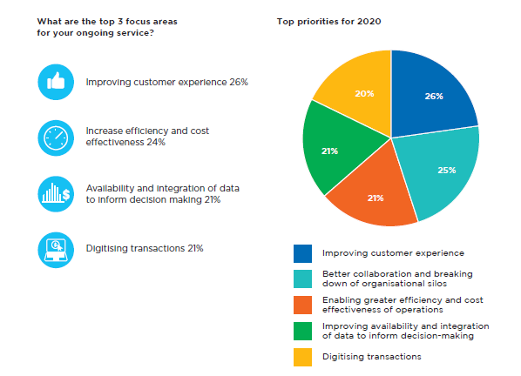

Our strategic principles and aspirations

Customer service and organisational wide actions and projects align across four areas of customer service – Quality, Experience, Culture, and Engagement.

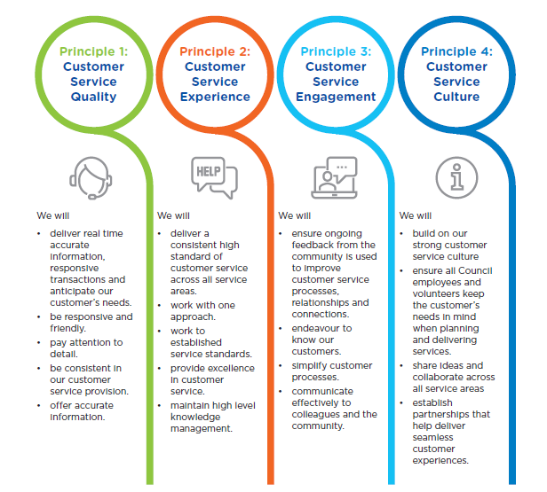

Our priority actions and projects

A series of cross council priority actions and projects will assist to showcase Council’s ongoing commitment to delivering high level customer service across a diverse range of services and facilities.

Key areas and themes

- Customer Service ‘One Council’
- Digital Services and Engagement
- Customer Relationship and Experience
- Customer Service Partnerships

Customer Service ‘One Maroondah’

Service Transformation enhancement and Activity areas:

- Customer Service objectives with ‘One Maroondah’ goals and aspirations.
- Service Standards Review - Organisational-Wide
- Complaint Handling Review - Organisational-Wide
- Customer Service team alignment with organisational change
- Customer Process efficiencies - Changing ways of working
- Organisational Sector best practice (Leader) in Customer Service Delivery
- Service Level Benchmarking and support for professional services
- Establish and drive internal ‘Customer Experience’ steering committee
- Service area information page updates on SmartNet
- Data and Reporting enhancements

- ‘Digital Services and Engagement’

The increasing demand for easy, effective and engaging personal service is changing customer service technology priorities across local government.

Maroondah City Council’s Customer Service Strategy 2021-2025 and future direction harnesses a distinct connection with changing customer expectations, advancing technology, and the need to maintain strong customer engagement and rich customer experiences.

Service Transformation enhancement and Activity areas:

Online engagement

- Accelerate and advance digital online engagement
- Live Chat
- Virtual Assistant
- Social Media Monitoring
- Video chat/CX videos
- Continue our ‘Cloud’ enablement for customer connectivity
- Strengthen digital service integration and service area partnerships
- Customer Payments and Barcoding project
- Standardised email and communication Letters
- Explore increase Business Analyst support to achieve digitaliation best practice and change

Telephone / Call Centre

- Supporting service partnerships and consistent Maroondah experiences

Customer Relationship and Experience

Our customer relationships and experience will always be a focus across a range of interactions and help to build an organisational framework to support and deliver ongoing customer experiences.
A range of initiatives will underpin the ongoing delivery of seamless and consistent customer service across all service areas and centres of Maroondah City Council:

Service Transformation enhancement and Activity areas:

Post Service Feedback

- Customer Response Program review
- Connection Comments (service centre polling and surveys)
- Customer Journey and Profile Mapping
- Segmentation and Audience profiling
- Outbound customer contact (telephone)
- post-service feedback (email)
- Courtesy program (SMS)
- ‘Welcome to Maroondah’ outbound activity

Organisational Standards and Complaint Handling

- CRM (Pathway) efficiencies and development
- Organisational customer service standards review
- Complaint handling process review/update
- customer service action plans - All service area
- All employee training and development – E-learning

Customer Service Partnership

Council has opportunity to lead the way into an innovative and progressive world, delivering a contemporary customer experience that shifts from ‘traditional’ government counter customer service and embraces a new innovative service model.

We are committed towards an integrated service approach into the future and the delivery of further regional activity and council services to the community into the future.

Maroondah City Council’s Customer Service team supports the extension of service delivery, for all service areas. How effective the interactions are with the customers and how well we perform this extension of service, is the basis for building our internal service partnerships.
Customer service partnerships will focus on enabling the continued development of cross-Council relationships; improving lines of communication; and fostering an understanding of the day to day functionality of all service areas.

Service Transformation enhancement and Activity areas:

- Internal service area partnership development
- External service area partnership development
- Service level agreements
- Activity Space Program and support
- Strategic and operational understanding of service area activity and needs.
- Communicate Customer Service team’s strategic and operational activities
- Create opportunities for continuous improvement enhancements or modifications.
- Customer Response Program Review
- Complaints handling Update and enhancements
- Customer Service Standards
- Service Area Training and action plans.

Implementation, monitoring and review

The Maroondah City Council Customer Service Strategy 2021-2025 forms part of Council’s response to delivering on Council 2040: Our future together. It will be implemented with a whole-of-Council approach and will involve regular review.

This strategy outlines key priority actions and projects to be undertaken to deliver on the strategic aspirations for customer service in Maroondah.

These actions and projects will be incorporated into departmental service delivery plans over the 2021-2025 period. Additional priority actions and projects that support this vision and adapt to the changing needs of the Council community may be identified and resourced over time.

Progress towards delivery on priority actions and projects will be monitored and reported upon annually through Council’s reporting processes.

A full review of the strategy will be undertaken in 2025/26.

