Maroondah City Council
Public Lighting Guidelines
Prepared for
Maroondah City Council
Version | Author | Date | Description of changes
V0a – V0d | Hannah Snape, Paul Brown, Ross McKirdy, Keith Harwood, Nick Cody | 16/12/2017 – 8/1/2018 | First draft and review
V1a | Ross McKirdy | 28/3/2018 | First draft for Council comment
V1b-d | Cara Doherty, Hannah Snape, Lei Zhong and Ross McKirdy | 13/05/2018 | Updates to include comments/changes from Council
V2a | Ross McKirdy | 23/5/2018 | Second draft provided to Council
V2b | Ross McKirdy | 30/5/2018 | Update to Appendix 3
V2c | Keith Harwood | 14/8/2019 | Updates to reflect community feedback
V2d | Keith Harwood | 26/8/2019 | Updated cross referencing of document dates

Prepared by
Ironbark Sustainability
Suite 8, 70-80 Wellington St, Collingwood 3066
ABN: 51 127 566 090
Ph: 1300 288 262 | info@realaction.com.au | www.realaction.com.au
© 2019 Ironbark Group Pty. Ltd.
The information contained in this document produced by Ironbark Group Pty. Ltd is solely for the use of the client identified on this page for the purpose for which it has been prepared and Ironbark Group Pty. Ironbark undertakes no duty to or accepts any responsibility to any third party who may rely upon this document. All rights reserved. No section or element of this document may be removed from this document, reproduced, electronically stored or transmitted in any form without the written permission of Ironbark Group Pty. Ltd.
About Ironbark Sustainability
Ironbark Sustainability is a specialist consultancy that works with government and business around Australia by assisting them to reduce energy and water usage through sustainable asset and data management and on-the-ground implementation.
Ironbark has been operating since 2005 and brings together a wealth of technical and financial analysis, maintenance and implementation experience in the areas of building energy and water efficiency, public lighting and data management. We pride ourselves on supporting our clients to achieve real action regarding the sustainable management of their operations.
Our Mission
The Ironbark mission is to achieve real action on sustainability for councils and their communities.

Contents
1. Introduction 6
1.1 Objectives of Public Lighting in Maroondah City Council 6
1.2 Purpose of the Public Lighting Guidelines 6
1.3 Who Should Use These Guidelines 7
1.4 Using These Guidelines 7
2. Definition of Public Lighting 8
2.1 Street lighting 8
2.2 Open Space Lighting 9
3. Responsibility for Public Lighting in Maroondah City Council 11
4. Responsibility for Approving New Public Lighting in Maroondah City Council 13
4.1 Standard Unmetered Lighting 13
4.2 Non-standard Unmetered Lighting 13
4.3 Metered Lighting 14
4.4 Aesthetic Lighting 14
5. New Public Lighting in Maroondah City Council – Principles and Process 16
5.1 Guiding Principles for Public Lighting in Maroondah City Council 16
5.2 Design Process for the Lighting of Public Spaces 17
6. Establishing the Need for Lighting 18
7. Determining the Site Type and Site-Specific Considerations 19
7.1 Control of Light Pollution 26
8. Determining the Lighting Category 32
8.1 Assigning Lighting Categories Using the Standard 32
8.2 Recommended Lighting Categories for Specific Site Types 33
9. Determining the Luminaire and Pole Type 34
9.1 Requirements for Unmetered Public Lighting Assets 34
9.2 Requirements for Metered Public Lighting Assets 34
9.3 Luminaire and Pole Types in Key Precincts 37
9.4 Solar Lighting 37
9.5 Lighting in areas of Environmental Importance 37
10. Complaints/Requests Procedures 38
10.1 Requests for New Street Lighting (Existing Lighting) 38
10.2 Requests for New Street Lighting (No Existing Lighting) 38
10.3 Requests for Removal of Street Lighting 38
10.4 Complaints About Overlighting or Light Spill 38
10.5 Complaints About Shading of Lighting by Trees 39
11. Glossary 40
12. Policy Context 42
13. Checklists and Specific Requirements for New Public Lighting 43
13.1 Checklist 1 – Design Considerations 44
13.2 Checklist 2 – Requirements for Standard Unmetered Installations 46
13.3 Checklist 3 – Requirements for Metered Installations 47
Appendix 1 – Train Stations 50
Appendix 2 – Bike Paths 54
Appendix 3 – Principle Pedestrian Network 55
Appendix 4 – Maroondah Hospital 56
Appendix 5 – Higher Order Roads 57
Tables
Table 1: Responsibility for public lighting 12
Table 2: Guiding principles for installation of public lighting in Maroondah City Council 16
Table 3: Lighting requirements for specific types of locations in Maroondah 19
Table 4: Site-specific lighting category requirements 33
Table 5: Requirements for unmetered assets 34
Table 6: Requirements for metered assets 35
Table 7: Summary of checklists required for submission with lighting proposals 43

Figures
Figure 1: Diagrams of street lighting 9
Figure 2: Examples of open space lighting 10
Figure 3: Approval process for standard unmetered lighting installations 13
Figure 4: Approval process for metered lighting installations 14
Figure 5: Figure 2.1 from AS/NZS 1158.3.1 2005 32
Figure 6: 800m radius around Ringwood Station and Heathmont Station 50
Figure 7: 800m radius around Croydon Station 51
Figure 8: 800m radius around Heathmont Station 52
Figure 9: 800m radius around Ringwood East Station 53

Introduction
Public lighting helps make many public spaces more usable and enjoyable for all.
Maroondah City Council is committed to providing sustainable public lighting in public areas and has developed these Public Lighting Guidelines to guide new installations, replacements and upgrade programs.

Objectives of Public Lighting in Maroondah City Council
Public lighting in Maroondah City Council is designed to:
- Make better use of open space
Allow for public spaces to be used by the community at appropriate times
- Create a safer night time environment for the community
Safety and security is about “good” lighting and not necessarily “more” lighting
- Embrace Council’s commitment to sustainability
Providing better lighting systems will reduce greenhouse gas emissions
- Improve the look and the feel of the City
Consistent approaches to delivering attractive lighting
- Be assets that can be managed over their lifetime
Long lasting, consistent and affordable infrastructure used when and where required

Public lighting in Maroondah City Council should be installed and managed with a view to:
- best practice asset management
- sustainability
- financial responsibility
- adherence to community expectations
- innovation

Purpose of the Public Lighting Guidelines
These guidelines define the following:
Where, when and what: inform and guide Council’s decision making for public lighting, to decide where and when public lighting is needed, and if so, what sort of lighting should be installed.
Consistency: help Council staff, lighting design consultants and others consistently apply sustainable lighting principles to new public lighting installations, replacements and repair programs.
Performance levels: communicate Council’s public lighting minimum efficiency and standard design requirements.

Who Should Use These Guidelines
These guidelines should be used by internal Council staff, and any external contractors with a formal role in the design and management of public lighting in Maroondah City Council, including:
- engineers
- asset planners and managers
- landscape architects
- urban designers
- place managers
- lighting designers
- developers
- maintenance staff and contractors

All public lighting in Maroondah must follow these guidelines.

Using These Guidelines
Maroondah City Council staff should use these guidelines when:
- installing new lighting in a previously unlit area
- replacing/upgrading existing lighting in an area

Maroondah City Council staff can use the guidelines to inform their briefs for lighting design and installation tenders, as well as to assess submitted tenders to ensure they meet the required minimum Australian standards for lighting in different circumstances and meet Maroondah City Council’s style and technical specifications. Staff should use the completed checklists to assist with the tender assessment process.
The guidelines should be provided to external lighting design contractors, developers, urban designers and engineers as part of brief documents, to guide their tender submissions for public lighting design and installation. The appropriate completed checklists (refer to Section 13) should be included as part of tender submissions.

Definition of Public Lighting
Public lighting in Maroondah City Council is made up of street lighting and a variety of other external lighting types collectively referred to as “open space lighting”.

Street lighting
Street lighting can be found in residential streets and main roads and has a variety of pole types, each containing the same basic parts. Street lights may also be attached via brackets to power distribution poles.
Luminaire (lantern) – A device that distributes, filters or transforms the light given by a light source and which includes all the items necessary for fixing and protecting the light source.
Examples of luminaire technologies include high pressure sodium (HPS), metal halide (MH) and light emitting diode (LED).
Light source – The light source (a lamp or globe in a traditional luminaire, or LED chips) emits light and is located within the luminaire (lantern).
Photoelectric (PE) Cell – A device that is normally incorporated in a luminaire that detects outside light levels to automatically switch the luminaire on and off as required.
Pole - Used to mount luminaires onto, poles are typically made of steel, aluminium, wood or concrete. Components of a pole include:
- Base – the lower section of the pole that is secured to the ground
- Bracket (outreach arm) – the supporting connection from the pole to the luminaire
- Electrical access door – provides access to internal wiring and fuses

Figure 2 present some example images of street lighting.
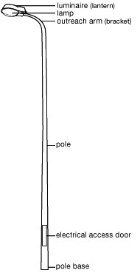 | 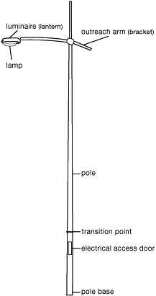 | 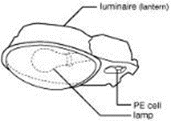  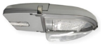
Standard pole | Non-standard pole | Luminaire
Figure 1: Diagrams of street lighting

Open Space Lighting
Open space lighting includes:
- Council car park lighting
  - standalone car parks
  - public facility or recreation reserve car parks
- park lights and other pole-mounted open space lights
  - pedestrian path lighting
  - off street bicycle path lighting
  - wayfinding lighting (bollards and in-ground path markers)
- under-awning and shop window lighting
- aesthetic lighting
  - building façade lighting
  - tree up-lighting
  - lighting related to sculptures and public art
- laneway lighting
- external building lighting
  - perimeter lighting
  - external entrance lighting

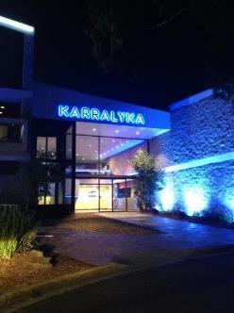
Figure 2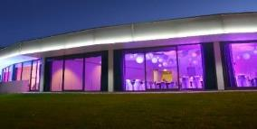
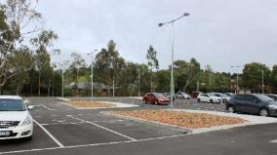
Figure 2: Examples of open space lighting

Responsibility for Public Lighting in Maroondah City Council
Responsibility for management, maintenance and capital projects related to public lighting in the Maroondah City Council is split between different Council departments. Table 1 summarises these areas of responsibility.

Table 1: Responsibility for public lighting
Type of Lighting | Strategic Planning | Operation and Maintenance | Asset Renewal | Capital Works | Pole & Light Ownership
Parks and Open Space lighting (generally metered lighting) | Traffic Engineering  Open Space  Leisure | Operations  Asset Management (when attached to a building) | Asset Management | Asset Management | Council or AusNet
Street lighting – standard unmetered (majority of lighting) | Traffic Engineering | AusNet | AusNet (maintenance) | Sustainability (bulk changeovers)  Traffic Engineering (ad-hoc replacements) | AusNet
Street lighting – non - standard unmetered | Traffic Engineering | AusNet | AusNet (maintenance) | Sustainability (bulk changeovers)  Traffic Engineering (ad-hoc replacements) | Council
Car park lighting (generally metered lighting) | Traffic Engineering | Operations | AusNet (maintenance) | Traffic Engineering  Open Space | Council or AusNet
External building lighting | Asset Management  Traffic Engineering | Asset Management  Facilities | Facilities | Facilities | Council
Aesthetic lighting | Site specific but may include:  Business development  Open space  Traffic Engineering  Arts and Cultural Development  Local businesses | Site specific but may be:  Operations  Local businesses | Site specific but may be:  Asset Management  Local businesses | Site specific but may be:  Asset Management  Local businesses | Site specific but may be:  Council  Local businesses
Lighting of shared public-private spaces (“quasi-private” e.g. Town Square) | Site-specific

Responsibility for Approving New Public Lighting in Maroondah City Council
Public lighting in Maroondah City Council is generally owned and managed by Council and/or the Distribution Network Service Provider (DNSP) that operates in the municipality – AusNet Services. There are three different management structures for this public lighting, which are discussed in Sections 4.1 to 4.3.
Council may also consider aesthetic or feature lighting under special circumstances. The approval and management of such lighting is discussed in Section 4.4.

Standard Unmetered Lighting
Most street lighting in Maroondah is standard unmetered lighting. Unmetered standard lighting is owned and managed by AusNet and Council pays a service charge to AusNet to maintain the light and pole over its life.
Figure 3 describes the process whereby Council has oversight of the design/preparation phase and AusNet has control of the installation, commissioning and ongoing management of the asset.
The Checklists referenced in Figure 3 are found in Section 13.

Figure 3: Approval process for standard unmetered lighting installations

Non-standard Unmetered Lighting
Non-standard unmetered lighting is owned by Council and managed by AusNet. Council pays a service charge to maintain the light and pole over its life and Council is responsible for purchasing replacement poles and lights.

Council does not currently allow the installation of new non-standard street lighting assets. Exceptions may only apply in key precincts or activity centres within the municipality where place-making is of a high priority, and only at metered supply points.

Metered Lighting
Metered lighting is owned and managed by Council. Commonly sports facilities, car parks and open space reserves are connected to a meter to measure energy taken from the electricity network. These lights can have their own meter or be connected to a building, BBQ or other electrical load (which has its own meter).
Figure 4 describes the process whereby Council has oversight of the design/preparation phase as well as the installation, commissioning and ongoing management of the asset.
The Checklists referenced in Figure 4 are found in Section 13.
Figure 4: Approval process for metered lighting installations

Aesthetic Lighting
Council may consider approval of aesthetic lighting. Aesthetic lighting is typically metered and is not installed for the purposes of maintaining functional lighting levels in an area. Examples of aesthetic lighting may include uplighting, feature lighting or façade lighting.
Where aesthetic lighting is public (i.e. proposed by Council), it may be considered where the installation:
- contributes to place making
- assists with reducing vandalism and/or increasing public safety

Where aesthetic lighting is private (i.e. proposed by a private entity), it may be considered where the installation:
- is not to be installed on public assets where maintenance of that asset might be affected (e.g. bud lighting in trees is not permitted)
- is temporary
- does not impact negatively on existing functional lighting
- contributes to place making
- is to be installed, operated and maintained by the person/body making the request
- does not require the installation of any permanent supporting infrastructure

New Public Lighting in Maroondah City Council – Principles and Process
When planning for public lighting in Maroondah City Council, Council staff should apply the following principles and process.

Guiding Principles for Public Lighting in Maroondah City Council
All public lighting in Maroondah City Council will consider the guiding principles outlined in Table 2.

Table 2: Guiding principles for installation of public lighting in Maroondah City Council
Making better use of open space
Most people use public space during the day and early evenings. Lighting should support positive evening use and selective all-night lighting should be provided only where required

Assisting walking, cycling, public transport and safe driving
Appropriate lighting will allow for higher visibility and encourage people in Maroondah to walk, cycle and take public transport.

Improving safety
Council will avoid creating a false sense of security by not installing lighting in remote or poorly surveyed locations. Lighting will be discouraged in sites where it promotes inappropriate behaviour after hours in accordance with principles of the Crime Prevention through Environmental Design Guidelines.

Ensuring economically sustainable assets are installed and managed
At the scoping stage, a high-level business case analysis should be conducted to ensure that only lighting assets that are easy to install, have low maintenance requirements and are cost effective over the life of the asset are deployed.

Protecting habitat value areas
In some cases lighting (or some types of lighting) can be harmful to biodiversity (in particular insects and nocturnal animals). Lighting in these areas should incorporate controls and/or techniques to minimise this impact.
Showcasing urban features in an effective way
When people are visiting Maroondah, they should see and enjoy our urban features; for example, monuments, signs, and public art. Lighting can be an effective way of doing this in key locations at selective times.

Design Process for the Lighting of Public Spaces
To ensure that public lighting is designed and installed in compliance with these guidelines designers should use the following step-by-step decision-making process to determine if, when, where, and how lighting should be installed:

- establish the need for lighting (Section 6)
- determine site type and site-specific considerations (Section 7)
- determine the appropriate lighting category (Section 8)
- determine the appropriate luminaire and pole type (Section 9)

Each of these steps is described in further detail below.

Establishing the Need for Lighting
The first step of the decision-making process is to establish the need for lighting. Reasons that new lighting may not be required include:
- adequate lighting is already available from an alternate source such as street, public transport zone, car park, building or any other adjacent lighting (in some locations this can reduce the number of new lights installed)
- the area is one where lighting is not recommended (as identified in Table 3)
- Council has identified the lighting purpose as not recommended (e.g. daytime recreation areas)

There may also be safety reasons that new lighting is not needed. Whilst this may seem contradictory, it is important to not light spaces that may be inherently dangerous with or without lighting. Reasons include:
- an area does not have sufficient natural (passive) surveillance looking into the space from houses facing the space or passing vehicular and pedestrian traffic
- an area/pathway leads to a dead end or otherwise unsafe area with little natural (passive) surveillance

New lighting should also only be considered if one or a combination of the following apply:
- there is a pedestrian path that provides a legitimate shortcut or thoroughfare
- there is a ‘critical link’ as per Council’s Bicycle Strategy and/or Pedestrian Strategy
- new lighting will increase outdoor activity
- the site allows for passive security

Other consideration should include an assessment of whether:
- activity or traffic will be all night or only for a portion of the night
- a new metered supply will be required
- the area/location can support the required infrastructure

Determining the Site Type and Site-Specific Considerations
Once the need for public lighting has been established, the second step of the decision-making process should determine the site type and any site-specific considerations such as:
- the aim of lighting in the area: for example, aesthetic, to create atmosphere, for safety or to guide preferred usage patterns
- whether the area is a ‘high risk’ security area, or vandalism risk area, based on evidence
- the type of users and usage function, as well as usage patterns for the area, as this may indicate particular lighting controls that can be applied

Table 3 provides guidance on how the guiding principles in 5.1 can be applied to different lighting sites and applications.

Table 3: Lighting requirements for specific types of locations in Maroondah
Site/Application | Requirements | Controls (e.g. dimming, switching, sensors)
Large Parks | - light only paths and thoroughfares through parks, not lawns  - avoid lighting dead-ended paths, unless the path provides access to a facility within the park that is used during night time hours  - lighting should only be considered for large parks under the following circumstances:  - if there is a thoroughfare for pedestrians/ cyclists  - if it promotes night time physical activity (e.g. a running track)  - a public benefit or demand exists (e.g. for a dog park) | Use dimming and timers to turn lights off or down when usage levels drop off or no longer exist, or where activity is no longer desired after certain hours.  Switch off/dim: between 11pm and 1am  Switch on/brighten: 5am
Small local “pocket” parks | - in general, lighting should not be considered for local “pocket” parks  - lighting should only be considered if there is a thoroughfare for pedestrians and/or cyclists | If lighting is installed, use dimming and timers to turn lights off or down when usage levels drop off or no longer exist, or where activity is no longer desired after certain hours.
Nature reserves | - in general, lighting should not be considered for nature reserves as it may disrupt local flora and fauna  - lighting should only be considered if there is a ‘critical link’ as per Council’s Bicycle Strategy and/or Pedestrian Strategy  - where lighting is installed, the use of a lower CCT (around 3000K) is required to ensure a lower impact on local fauna. In addition, the following should be considered (in order of preference):  - lights with site-specific optics (to minimise light spill) or baffles and the use of dimming or switching after hours of use  - Bollards or solar path markers  - The design solutions outlined in Section 7.1 to control light pollution should be considered when selecting luminaire and pole types in nature reserves  - reference should also be made to Council’s Habitat Corridor Strategy. | If lighting is installed, use dimming and timers to turn lights off or down when usage levels drop off or no longer exist, or where activity is no longer desired after certain hours.  Switch off/dim: between 11pm and 1am  Switch on/brighten: 5am
Recreation areas | - for basketball courts lighting should not be installed unless used for organized competitive sporting activities  - for skate parks lighting should be considered on an as needs basis  - for BBQs, gazebos etc. lighting should be considered on an as needs basis | If lighting is installed, timers must be used, with lighting to be switched off no later than 10 pm and dimmed over a short shoulder period (e.g. 15 min) to allow safe departure from the area.
Playgrounds | - lighting is not appropriate as playground activity is better suited to daylight hours
Train stations | - lights may be installed with timers and/or dimmers linked to operating hours of public transport  - defined areas or routes around or leading to train stations shall be lit to a higher level than the surrounding area (refer to Appendix 1 – Train Stations)
Bus routes/stops | - lighting may be installed with timers and/or dimmers linked to operating hours of public transport  - lighting should be installed on every pole along bus routes (for PTV bus routes refer to: https://goo.gl/MZgcvN)
Bike paths (off road) | - lighting may be installed on popular commuter routes (refer to Appendix 2 – Bike Paths) | Lights may be installed with timers and/or dimmers  Switch off/dim: between 11pm and 1am  Switch on/brighten: 5am
Bike paths (underpass) | - lighting may be installed on popular commuter routes (refer to Appendix 2 – Bike Paths)  - underpasses may be lit throughout the whole day and during part of the night to minimise the effects of daytime dark/light transitions | Lights may be installed with timer controls and/or dimmers  Switch off/dim: between 11pm and 1am  Switch on/brighten: 5am
External building lighting | External building lighting may be considered if the building is adjacent to and/or within:  - a Council car park (e.g. lighting on the building provides light for the car park)  - a Council reserve (e.g. lighting on the building provides light for the reserve)  - a Council footpath or shared path, including a path to a Council building (e.g. lighting on the building provides light for the path that leads to the building entry or lighting on the building provides light for shared path that runs adjacent to the building)  - a Council public art project  For the above scenarios the following arrangements would occur:  - any existing lighting on a building shall be included as part of any existing lighting condition assessment (i.e. the external building lighting is contributing to the public lighting)  - the external building walls may be used to support lighting as part of a new lighting design/scheme for a metered lighting supply | Controls to be applied depending on the nature of the adjacent public space (e.g. car park). Refer to relevant section of this table for controls to be applied.
Car parks | - consideration should be given to lighting any pedestrian linkages to the facility that the car park services | Lights may be installed with timers set to the hours of operation of the associated site or building or dimmers set to the usage levels of the car park over the course of the night
Laneways | - lighting may be installed where the laneway provides a logical shortcut for pedestrians or if it is a key thoroughfare for pedestrians and/or cyclists  - lighting should be avoided wherever there is poor passive surveillance  - where lighting is installed, the design process should consider the need for light spill control (i.e. the use of glare shields/baffles) and/or site-specific optics  - consideration should be given to space constraints such as the ability to install and protect infrastructure whilst maintaining a trafficable laneway, the ability to supply power to this infrastructure, operational and maintenance issues due to the infrastructure being located in the laneway and excessive light spill within the rear of properties that are adjacent to the laneway  - if a suitable alternative pedestrian path exists that requires minimal additional travel time and distance, then pedestrians should be encouraged to walk on the existing footpath network where there is sufficient existing street lighting available | For metered connection points, dimming/switching is encouraged where usage patterns allow, or where activity is not desired after certain hours  Switch off/dim: between 11pm and 1am  Switch on/brighten: 5am
Shopping strip lighting schemes – additional lighting to street lighting | - in general, lighting is not considered appropriate if unmetered street lighting already exists  - additional lighting may be considered in some circumstances if the existing street lighting scheme is not deemed appropriate for the area  - where place-making/urban renewal is planned for a shopping strip, Council will explore options to remove existing unmetered street lighting and install metered lighting | For metered connection points, dimming is encouraged where usage patterns allow, or where activity is not desired after certain hours. Switching is not recommended for shopping strip lighting
Aesthetic lighting (e.g. uplighting/feature lighting of signs, trees, buildings, monuments, art) | - lighting may be installed with timers based on a needs assessment  - the installation of a lit artwork (contributing modest illumination to the public space) may be considered as a means of addressing public perceptions of safety in places where there is no other justification for lighting | Timers are to be installed linked to operation hours of the associated site or building
High risk areas - this includes entertainment precincts (e.g. the Ringwood MAC) | - lighting should be provided all night in these locations at an appropriate standard | Lights are to be installed in these locations.  Where risk is specific to hours of operation of a specific site or building, timers are to be installed and linked to the hours of operation of the relevant site.
Areas of high vandalism | - lighting may be installed, subject to trial in the following order:  - turning lighting off to deter vandalism  - using motion sensors  - CCTV cameras  - increase lighting in accordance with the Crime Prevention through Environmental Design Guidelines
Lighting in new streetscapes | - street lighting, trees and other elements of a streetscape should be designed at the same time  - the design process should consider the following principles:  - the locations of street trees and light poles should be coordinated to minimise shading (shadowing)  - where street trees and poles are co-located, luminaires should be located below the canopy (if possible)  - where necessary, lighting may be placed nearer the centre of streets, out of reach of foliage  - supplementary lighting may be considered where street trees or verandahs would otherwise produce shadowing

Control of Light Pollution
Light pollution can be controlled in the following ways in order of effectiveness:

- Avoid lighting where it is not needed | Lighting is not always a necessary component of the built environment. Consider whether night-time usage is desired and/or prioritise areas of environmental importance and apply restrictions to lighting.
- Avoid over-lighting | Do not over-light. Over lighting is a major cause of light pollution. Recommended lighting levels exist for most outdoor lighting applications. Consultation of relevant Standards should be carried out to ensure suitable lighting levels are applied.
- Switch off or dim lights during periods when lighting is not required. | Most people use public space during the day and early evenings. Lighting should support positive evening use and all-night lighting should be provided only where required. Where switching lights off is deemed unreasonable, consideration of changes to usage patterns over time should be carried out, with opportunities to dim lighting levels applied wherever viable.
- Reduce or eliminate light spill | Wherever possible, direct light downwards, not upwards, to illuminate the target area. Where unwanted light spill into areas is still occurring, use shields, baffles and louvres to further reduce light spill

Table 3 in this section provides guidance on where lighting is not needed and how to apply dimming and switching when lighting is no longer needed during night time hours; Section 8 provides guidance on appropriate lighting levels; and Table 6 makes reference to the requirement that new lights should have a maximum upward waste light spill ratio of less than 1%.
The following section provides guidance on acceptable solutions to further control light pollution. These solutions should be considered during the design process of any new lighting scheme and are of particular importance to any lighting schemes in or around areas of environmental importance.

Solution | Description | Examples | Limitations
Choose appropriate optics configurations | Luminaires with a range of optics configurations should be selected. LED technology provides the ability to direct lighting where it is needed via adjustments to the individual optics of each LED chip. This provides options during the design phase to reduce light spill beyond the area that needs to be illuminated. Each space will be unique so any number of optic configurations may need to be employed to minimise light spill. | - Most LED fixtures available today will offer a range of optics options. Examples of common optics configurations and their suitable applications are provided below. | - The majority of luminaires designed for unmetered street lighting applications do not offer variations in their optics configurations.

Solution | Description | Examples | Limitations
Employ the use of baffles, shields and louvers | Where unwanted light spill into areas is anticipated to occur despite the use of nuanced optics; shields, baffles and louvres should be used to further reduce light spill. Shields are particularly useful in reducing side-spill into native vegetation at bends in roads and paths. | - Optional attachments are available with numerous luminaires on the market  - On Council controlled lights, the option exists to develop bespoke shields or apply paint if deemed necessary  - Examples of baffles, shields and louvers are provided below | - A limited availability of baffles/shields/louver are available on the AusNet network.  - The impact of baffles/shields/louvers on compliance with AS/NZS 1158 needs to be considered.
 | 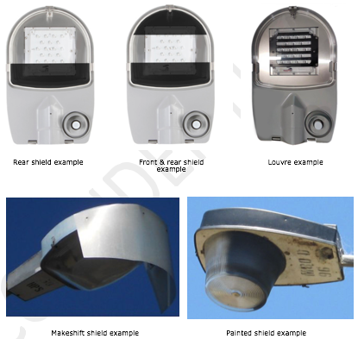

Solution | Description | Examples | Limitations
Use lower luminaire mounting heights | During the design phase of a new lighting scheme, an emphasis should be placed on lowering mounting heights to a scale that minimizes the spill and scatter of artificial lighting into areas that do not need to be lit. | - Pole heights should allow for luminaires to be mounted at heights below tree canopies and fauna movement infrastructure.  - Pole heights should allow for luminaires to be mounted at heights that allow surrounding barriers (buildings, trees etc) to block light spill into areas where it is not needed. | - High pole mounting heights paired with higher powered luminaires will typically result in less poles and luminaires being used and consequently lower energy and maintenance costs.
Consider low-output bollard or in-ground lighting | Where lighting must be installed in an area of environmental importance, bollard lighting and in-ground path markers should be considered before pole mounted luminaires. | - Where bollard lighting is selected, no glare and no upwards light spill should exist and appropriate optics should be chosen that directs light on to design area with minimal back and/or forward spill.  - Where in-ground path lighting is selected, ‘cat eye’ style lights shall be used to minimize the visibility of the lights from above. | - Whilst it is difficult for these lighting types to achieve compliance with Australian Standards (AS/NZS 1158) they are still able to provide a basic illumination of a pathway whilst minimizing light spill into areas of environmental importance.
 | Bollards with no upwards or backwards light spill and minimal forward spill should be used
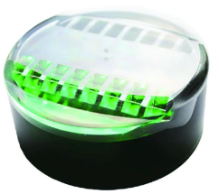
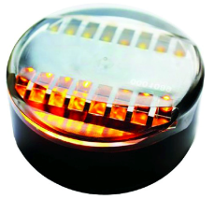
 | ‘Cat eye’ style ground-lights shall be used to minimize the visibility of the lights from above.
Configure pole location to direct light onto the design area | Minimise pole set-back: The setback of a light pole from the design area shall be kept to a minimum (but no less than 0.5m for paths). This will ensure less back spill and make the shielding of back spill easier if it is required. | - In most cases, it is desirable for the luminaire to ‘overhang’ into the area that is intended to be lit. This can be done by placing the pole within, or otherwise as close to, the design area as possible. | - Pole set back must be considered in conjunction with the potential dangers of pole proximity to moving traffic
 | Increase outreach: Where the pole set-back is not able to be minimized due to the physical constraints of a site, longer bracket arms should be used to position the luminaires closer to/over the design area. | - Pole outreach arms can be used to extend the ‘overhang’ of a luminaire into the area that is intended to be lit. | - Torque created by longer outreach arms may limit the achievable overhang for certain poles.

Determining the Lighting Category
Once the need to light and any site-specific requirements have been established in accordance with Sections 6 and 7, the third step of the decision-making process should determine the required lighting category (light level).

Assigning Lighting Categories Using the Standard
A framework for selecting the appropriate lighting category for a given type of open space or road is provided in the Australian and New Zealand Standard Lighting for Roads and Public Spaces (AS/NZS 1158).
Figure 5 (Figure 2.1 from AS/NZS 1158.3.1) summarises what categories may apply to different space types. In most situations, the appropriate lighting category can be determined by application of the following process:
- Define the function and busy-ness of the road/space via consultation with relevant Council staff
- Match the definition of the road/space with the guidance provided by:
  - Maroondah City Council’s Public Lighting Policy and these guidelines
  - the Australian Standard (AS/NZS 1158)
  - lighting schemes in similar roads/spaces in other local government areas
- Assign the most appropriate lighting subcategory to the road/space

Under certain circumstances a lighting category that differs to that determined by application of AS/NZS 1158 is required. These exceptions are outlined in Section 8.2.
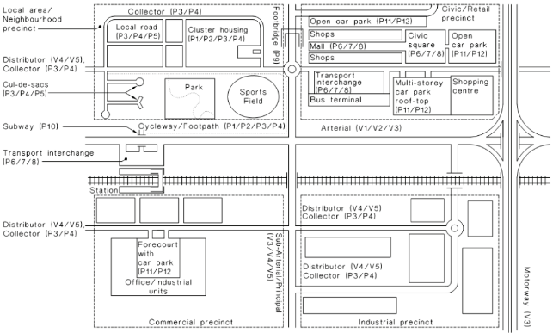
Figure 5: Figure 2.1 from AS/NZS 1158.3.1 2005

Recommended Lighting Categories for Specific Site Types
The site types or specific locations presented in Table 4 are areas where lighting categories other than those that may be specified by strict application of AS/NZS 1158 shall apply.

Table 4: Site-specific lighting category requirements
Site/Application | Required Lighting Category | Additional Information
Bus routes | Light to P4 category (or a light on every pole) | - For PTV bus routes refer to: https://goo.gl/MZgcvN
Taxi ranks | Refer to guidance in ATIA Taxi Rank Design Specification (April 2012) | - ATIA Taxi Rank Industry Specification, Table 7.19.3, provides illumination specifications for taxi ranks.
Principal Pedestrian Network (PPN) | Light to P3 (or a light on every pole) | - Refer to map in Appendix 3 – Principle Pedestrian Network
Key pedestrian routes around train stations | Light to P3 (or a light on every pole) | - Refer to map in Appendix 1 – Train Stations
Key pedestrian routes around Maroondah Hospital | Light to P3 (or a light on every pole) | - Refer to map in Appendix 4 – Maroondah Hospital
Higher order roads | Light to P3 (or a light on every pole) | - Refer to map in Appendix 5 – Higher Order Roads
Local streets and roads | Where lighting is installed on electricity distribution poles, light to P5  Where lighting is installed in new estates on URD poles, light to P4

Determining the Luminaire and Pole Type
Once the need for lighting as well as any site-specific requirements and the lighting category have been established in accordance with Sections 6, 7 and 8, the fourth step of the decision-making process should determine the luminaire and pole type.

Requirements for Unmetered Public Lighting Assets
Unmetered lighting installations must meet the requirements outlined in Table 5.

Table 5: Requirements for unmetered assets
Feature | Requirement
Luminaires
AusNet approval | Must be approved as a standard fitting by AusNet Services  AusNet approved non-standard or “decorative” fittings are not permitted
CCT | Preferred = 4000K  Note that Council would prefer AusNet to offer a colour temperature range between 3000K to 4250K. Currently only ~4000K LED street lights are approved for use
“Smart City” compatibility | Must include a 7-pin NEMA base wired as per the requirements of ANSI C136.41-2013 to a variable output control gear (for dimming/brightening)
Entry type | Must be side entry
Energy efficiency | Must have a minimum luminaire efficacy rating (LER) of 100 lumens per watt
Poles
Mounting height | Must have a mounting height of not less than 5.5m
Surface finish | Must be uncoated galvanised steel
Entry type | Must be side entry
AusNet approval | Must be approved as a standard fitting by AusNet Services  AusNet approved non-standard or “decorative” fittings are not permitted

Requirements for Metered Public Lighting Assets
Metered lighting installations must meet the requirements outlined in
Table 6.

Table 6: Requirements for metered assets
Feature | Recommended requirement
Luminaires
Design | Luminaire design should be contemporary, with clean, minimalist lines and no decorative detailing
Surface finish | A galvanised finish is preferred.  If a paint finish is used, then this:  - must be black  - must use a durable method of coating (e.g. a heavy-duty zinc protective coating or two pack adhesion promoting primer over a sand blasted, galvanised steel pole to prevent corrosion, followed by two coats of two pack aliphatic polyurethane)
Protection against dust/water ingress and mechanical impact | Must have minimum IP65 (ingress) and IK06 (mechanical impact) ratings
Energy efficiency | Must have minimum LER of 100 lm/w
Upward Waste Light Ratio (UWLR) | Must have maximum UWLR of less than 1%
Minimisation of glare | Must comply with glare requirements of AS/NZS 1158
Correlated colour temperature (CCT) | Preferred = 4000K  Acceptable colour temperature range (only applies in special circumstances) = 3000K to 4250K
Colour rendering index (CRI) | Must have minimum CRI = 80
Entry type | Must be side entry
Compliance with relevant standards | Must comply with requirements of SA/SNZ TS 1158.6
“Smart City” compatibility | Must include a 7-pin NEMA base wired as per the requirements of ANSI C136.41-2013 to a variable output control gear (for dimming/brightening)
Design life | Must have minimum design life of 20 years
Poles
Design | Pole design should be contemporary, with clean, minimalist lines and no decorative detailing
Surface finish | A galvanised finish is preferred.  If a paint finish is used, then this:  - must be black  - must use a durable method of coating (e.g. a heavy-duty zinc protective coating or two pack adhesion promoting primer over a sand blasted, galvanised steel pole to prevent corrosion, followed by two coats of two pack aliphatic polyurethane)
Compliance with relevant standards | Must comply with AS 4100
Entry type | Must be side entry
Mounting height | Luminaire mounting height of any pole should be of an appropriate scale for the space it is in, with a minimum height of 5.5m.
Offset from pathways | Where the purpose of lighting is to illuminate a pathway, the minimum offset of the pole from the pathway shall be 0.5m, with a preferred offset of 1m
Design life | Must have minimum design life of 35 years

Luminaire and Pole Types in Key Precincts
In key precincts (e.g. the Ringwood MAC or select suburban shopping strips) the requirements outlined in
Table 6 shall apply, however Council may consider variation to the following requirements:

Colour – greater variation in luminaire and/or pole colour (other than those specified in
- Table 6) may be considered to suit the particular site.
- CCT - a CCT of less than 4000K may be considered (however consistent CCT throughout a given area must be applied)
- Surface Finish - for luminaires and poles to be Dulux Anotex XT Dark Grey Matt for all lighting infrastructure in the Ringwood MAC

This acknowledges that lighting can be an effective way to highlight particular spaces and provide contrast to the surrounding “standard” lighting in such a way as to enhance the night-time experience and attract pedestrian activity. This approach also aligns with the broader Council objective of enhancing the night time economy.

Solar Lighting
The installation of solar lighting is generally not supported by Council but may be considered in circumstances where connection to the grid is not considered viable.

Lighting in areas of Environmental Importance
The installation of lighting in areas of environmental importance is generally not supported by Council but may be considered in circumstances where nighttime pedestrian or vehicle activity is present and desired. In these instances, a CCT of around 3000K is required. The design solutions outlined in Section 7.1 to control light pollution should be considered when selecting the luminaire and pole types.

Complaints/Requests Procedures
The following procedures will be applied to the assessment of complaints and/or requests received by Council in relation to public lighting.

Requests for New Street Lighting (Existing Lighting)
Where Council receives requests for the installation of additional street lighting in areas where some street lighting already exists, the request will be assessed using the following process:

- on-site light level analysis utilising a high-quality light meter to determine the existing levels of lighting
- comparison of existing lighting levels against the requirements of the AS/NZS 1158 Lighting for Roads and Public Spaces
- report developed detailing the outcomes of the analysis including advice on whether additional lighting is or is not merited

Based on this analysis a final decision will be made as to the merits of the request.

Requests for New Street Lighting (No Existing Lighting)
Where Council receive requests for the installation of street lighting on roads where there is currently no street lighting, such requests will be assessed on a case-by-case basis.
Assessment of requests will consider (but not be limited to) the viability of installing lighting and the existence of a legitimate need for lighting.
Consideration will be given to the level of community support for the installation of a lighting scheme.
Where a genuine need is identified and provision of lighting is considered viable, lighting will be provided in accordance with these guidelines (refer to Sections 7 to 9).

Requests for Removal of Street Lighting
In general, requests for removal of street lighting will not be supported.

Complaints About Overlighting or Light Spill
Where Council receives complaints about over lighting or light spill into properties from existing street lighting, park lighting or sports lighting, the request will be assessed using the following process:

- on-site analysis utilising a high-quality light meter to determine the existing levels of lighting on the window of a habitable room in a dwelling
- a comparison of existing lighting levels against the requirements of the AS 4282 Control of the Obtrusive Effects of Outdoor Lighting
- report developed detailing the outcomes of the analysis including advice on whether light spill control is or is not merited

Based on this analysis a final decision will be made as to the merits of the complaint. Should a complaint be deemed valid, the issue may be resolved via one of the following:
- installing shielding on or within the luminaire
- installing a different luminaire (lower output or more directional photometrics)
- relocating the luminaire
- dimming the luminaire
- recommending a new window treatment e.g. block out blinds

Complaints About Shading of Lighting by Trees
Where Council receives complaints about shading of lighting by trees, the complaint will be assessed using the following process:

- on-site analysis utilising a high-quality light meter to determine the existing levels of lighting 40 metres on either side of the tree
- comparison of existing lighting levels against the requirements of the AS/NZS 1158
- report development detailing the outcomes of the analysis including advice on whether tree pruning or tree/light relocation should be investigated further

Glossary
Term | Definition
CCT | Correlated colour temperature (CCT) describes the colour of a light source, and is measured in degrees Kelvin (K). Blue-white lamps have a high colour temperature (e.g. 4000K). Yellow lamps have a low colour temperature, (e.g. 2000K)
CRI | Colour rendering describes the degree to which natural colours can be perceived under different kinds of artificial light. It is measured on a colour rendering index (CRI). A CRI of 100 indicates that colours are depicted accurately. A CRI of less than 30 indicates colours are distorted and difficult to recognise. A CRI of 80 or above provides an acceptable standard for outdoor lighting.
Decorative lighting | Refer to ‘non-standard’
DNSP | Distribution Network Service Provider, also known as Energy Distribution Business (EDB), also known as distributors.
HPS | High pressure sodium lamps or luminaires
IK rating | Measure of protection against mechanical impact (vandalism)
IP rating | Measure of protection against ingress by water and solid objects
Lamp | The light bulb in a luminaire
LED | Light emitting diode
Luminaire | The light source (lamp or LED module), fitting and control gear of the light
LER | The luminaire efficacy rating (LER) is a measure of the efficiency with which a luminaire converts electrical energy into light, measured in lumens per watt
MAC | Metropolitan Activity Centre
MH | Metal halide lamps or luminaires
Non-standard lighting | Lighting that is typically not held in stock by DNSPs, sometimes also referred to as ‘decorative’ (typically found in URD areas)
PPN | Principal Pedestrian Network
Standard lighting | Lighting that is typically held in stock by DNSPs, and is found on their list of products approved for use
Street lighting | Street lighting found in residential streets and main roads
URD | Underground Residential Developments
UWLR | Upward waste light ratio (UWLR) is a measure of the light output of the luminaire that is emitted above the horizontal

Policy Context
These guidelines have been designed to comply with all relevant Australian laws and legislation, and to comply with and complement the following standards, policies, codes and strategies.
External references:
AS/NZS 1158 Lighting for roads and public spaces
AS 4100 Steel Structures
AS 4282 Control of the Obtrusive Effects of Outdoor Lighting
Victorian Public Lighting Code (2015, ESC Vic)
ANSI C136.41-2013 (Dimming receptacles)
Crime Prevention Through Environmental Design Guidelines - https://goo.gl/w46PTM
ATIA Taxi Rank Design Specification (April 2012)
Maroondah City Council plans, policies and strategies:
Public Lighting Policy 2019 (TBC)
Ringwood Transit City Lighting Strategy November 2007
Ringwood Urban Design Manual December 2014
Road Management Plan 2013-2017
Carbon Neutral Strategy & Action Plan 2014/15-2020/21

Checklists and Specific Requirements for New Public Lighting
Council will support lighting installations that meet these guidelines.
When proposing a new public lighting scheme in Maroondah City Council, please submit the relevant checklists as specified in Table 7.

Table 7: Summary of checklists required for submission with lighting proposals
Installation Type | Requirement
Unmetered installation | Submit checklist 1 and 2
Metered installation | Submit checklist 1 and 3

Checklist 1 – Design Considerations
All new public lighting installations must address the following requirements:
Applicant Name
Site Name
Site Details
(intended use of site)

Attachments
Has a lighting plan been submitted?
Have “as built” drawings including details of make and model numbers of luminaires been submitted (to be submitted upon completion of project)?

All new lighting installations in Maroondah City Council must address the following requirements:
Needs assessment, site-specific requirements and lighting category selection
Is there a need for lighting according to the AS/NZS 1158 and Section 6 of Maroondah’s Public Lighting Guidelines 2018?
Does the lighting scheme meet any site-specific requirements outlined in Table 3, Section 7 of Maroondah’s Public Lighting Guidelines 2018 (including application of controls)?
Has the design used the correct lighting category (i.e. not lighting above the necessary level required for a particular area) as per AS/NZS 1158 and Sections 8.1 and 8.2 (where applicable) of Maroondah’s Public Lighting Guidelines 2018?
Life cycle considerations
Can the proposed materials (luminaires and poles) be recycled or reused at end of life?
Additional Information
If the proposed lighting scheme is not aligned with these guidelines, then an application needs to be made to Council identifying a clear need for the variation.

Submissions will be considered more favourably if the following criteria are addressed:
- best practice energy efficiency
- community need
- potential for generation of onsite renewable energy to match lighting energy needs

Where applications do not follow the requirements set out in these guidelines, applicants may be required to provide
- itemised estimate of annual energy consumption arising from the project
- itemised estimate of annual maintenance costs arising from the project

Comments
Internal Use Only
Facilities Management Approval Yes / No
Signed
Date

Project Manager Approval Yes / No
Signed
Date

Checklist 2 – Requirements for Standard Unmetered Installations
All new standard unmetered installations must address the following requirements:
Pole design |  | Luminaire requirements
 | Is the mounting height for bracket installation no less than 5.5m above ground level?  Increasing the pole heights, increases pole spacing (particularly when road reserve widths are over 18m). Light numbers can be reduced resulting in reduced maintenance costs, energy costs and greenhouse emissions.  Light spill into areas outside road reserves is undesirable and needs to be evaluated in areas that are sensitive to this, including narrow road reserves or laneways and areas of ecological significance  Increasing the pole heights also reduces vandalism. |  | Does the lamp provide a colour temperature at or around 4000K?  Whilst 4000K is preferred in most cases, an allowable range of 3000K to 4250K exists. Currently, only 4000K LED lamps are approved by AusNet Services, however this may change in the future.
Are the PE cell bases compatible with 7-PIN NEMA PE Cells and are drivers dimmable?
This ensures future proofing for use of smart lighting controls.
 | Is the pole approved as a standard URD pole by AusNet Services? |  | - Does the luminaire have an efficacy of no less than 100 lumens per watt?
 | Is the pole side entry? |  | - Are the luminaires approved as standard fittings by Ausnet Services?  Proof can include a copy of the approval letter for luminaire.
Pole coating systems
- Will the pole be unfinished galvanized steel?

Uncoated galvanised steel is the only permitted pole finish for standard street lighting installations
Internal Use Only
Engineering Department Approval Yes / No

Signed
Date
Project Manager Approval Yes / No

Signed
Date

Checklist 3 – Requirements for Metered Installations
All new metered installations must meet the following requirements:
Pole design |  | Luminaire requirements
 | Is the mounting height for brackets at least 5.5m and in keeping with the surrounding environment?  Consider existing and future tree canopies, building awnings and existing lighting infrastructure.  Increasing the pole height increases pole spacing and thus reduce the required pole and luminaire quantities. This needs to be balanced, however, with the features of the surrounding environment.  Light spill into areas the design area is undesirable and needs to be evaluated in areas that are sensitive to this, including narrow road reserves or laneways and areas of ecological significance |  | Does the luminaire comply with the requirements of SA/SNZ TS 1158.6?
 |  |  | Is the luminaire contemporary, with clean, minimalist lines and no decorative detailing?
Has the luminaire been approved by AusNet?
Proof can include a copy of the approval letter for luminaire.

 | If the pole is adjacent to a pathway, is it offset from the pathway by a minimum of 0.5m? |  | Is the luminaire side entry?
 | Is the pole contemporary, with clean, minimalist lines and no decorative detailing? |  | Does the luminaire have an efficacy of not less than 100 lumens per watt
 | Is the pole modular in construction with at least three main components – the base, straight pole and bracket arm?  The base and straight pole will be the same across Councils asset base and the bracket can be used to differentiate different design sectors.  If a section of the pole is damaged, it can easily be replaced, reducing future maintenance costs and material wastage. |  | Does the lamp provide a colour temperature at or around 4000K?  Whilst 4000K is preferred in most cases, an allowable range of 3000K to 4250K exists. For areas of environmental importance or night time retail/dining, a colour temperature closer to 3000K should be considered.
 | Does the pole allow compatibility for a side entry installation for the light fitting?  Side entry poles allow for a wider range of light fittings (luminaires) including fitting standard energy efficient LED luminaires in the future should a move away from non-standard fittings be desired.  Modular poles with removable outreach arms can allow refitting of a top entry arm to allow side entry lights. |  | Does the luminaire have a minimum IK06 rating and minimum IP65 rating?
 |  |  | Does the luminaire have an upwards light spill ratio of no greater than 1%?
A galvanised finish is preferred. However, if a paint finish is desired, is the coating finished with one of Council’s approved list of luminaire colours?
Councils current approved list includes black.

 |  |  | Does the luminaire have a colour rendering index (CRI) of not less than 80?
Does the luminaire feature a 7-pin NEMA base wired as per the requirements of ANSI C136.41-2013 to a variable output control gear?

This ensures future-proofing for use of smart lighting controls.

 |  |  | Does the luminaire comply with glare limits specified in AS/NZS 1158?
Pole Coating systems
A galvanised finish is considered lowest maintenance and is therefore preferred.

Will the coating system ensure a long service life with reduced maintenance?

A heavy-duty zinc protective coating or two pack adhesion promoting primer over a sand blasted, galvanised steel pole to prevent corrosion, followed by two coats of two pack aliphatic polyurethane

Surface scratches can be repainted with the recommended finishing coat. If rust is present, it must be removed and the affected area repainted in accordance with the recommended method for new poles.

If a paint finish is desired, is the coating finished with one of Council’s approved list of pole colours?

Councils current approved list includes black.

 |  |  | Is the pole compliant with AS 4100?
Internal Use Only
Engineering Department Approval Yes / No

Signed
Date
Project Manager Approval Yes / No

Signed
Date

Appendix 1 – Train Stations
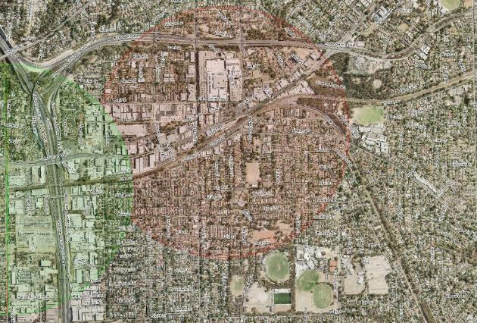
Figure 6: 800m radius around Ringwood Station and Heatherdale Station

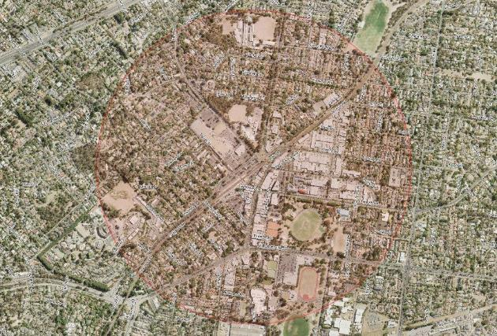
Figure 7: 800m radius around Croydon Station

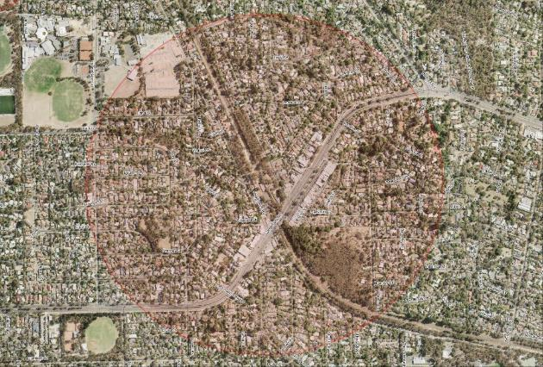
Figure 8: 800m radius around Heathmont Station

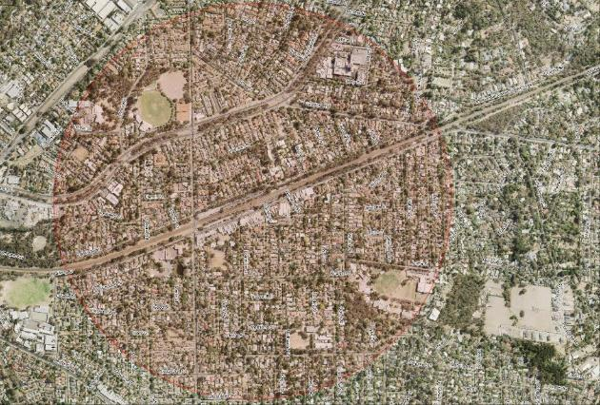
Figure 9: 800m radius around Ringwood East Station

Appendix 2 – Bike Paths
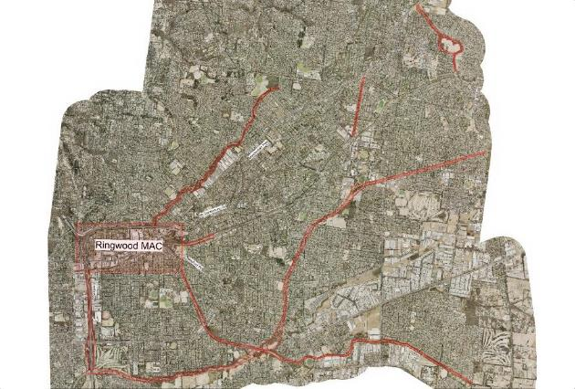

Appendix 3 – Principle Pedestrian Network

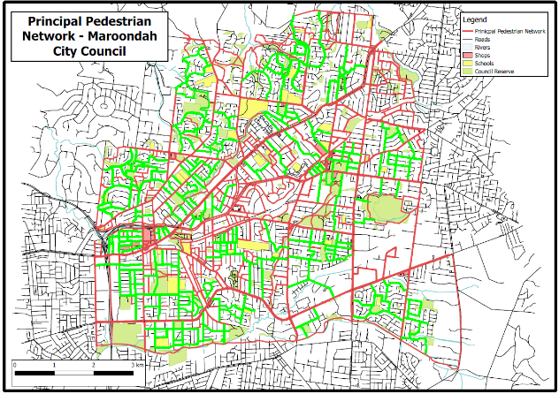
Those streets highlighted green in the above PPN Map should be lit to P3, or a light on every pole (as per the guidance in Section 8.2).

Appendix 4 – Maroondah Hospital

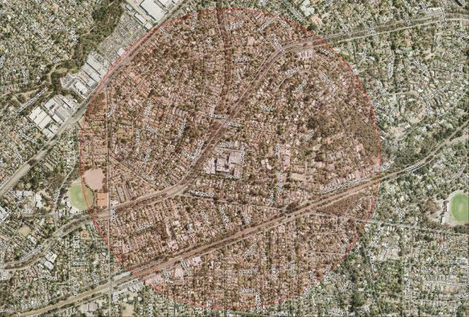

Appendix 5 – Higher Order Roads

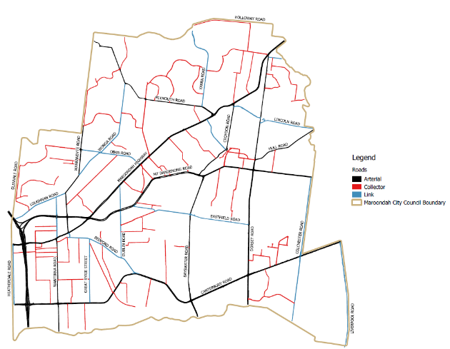
“Higher order” roads can be considered those “link” roads (marked blue) in the above map, and any roads classified as “major” and “collector” roads by Melways.

Limited (and decreasing) in number.
Maintenance is limited to lamp (if applicable) and PE cell replacements, and cleaning. Upon failure, replacement luminaire and/or pole must be provided by Council.
Limited (and decreasing) in number.
Where controls such as dimming or switching are implemented, consideration should be given to the need for public signage alerting the public to when lights will be turned off or dimmed.

