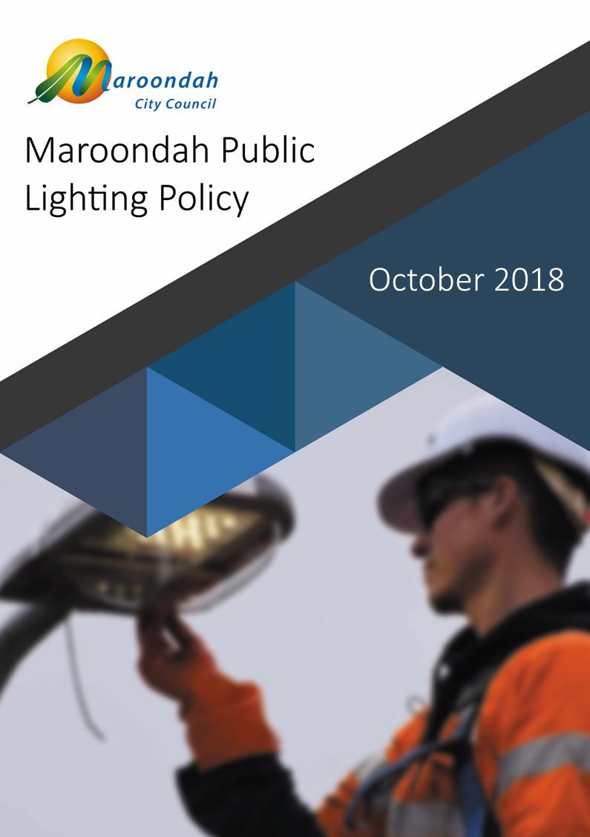
September 2019
Contents
What is the purpose of this policy? 1
Why was this policy was prepared? 1
What are we seeking to achieve through this policy? 1
Why is public lighting important? 2
How does public lighting help Council become carbon neutral? 2
What did our community say? 3
Link to Council’s Integrated Planning Framework 4
Council Plan 5
Maroondah Health and Wellbeing Plan 6
Sustainability Strategy 6
Physical Activity Strategy 6
Open Space Strategy 6
What is our strategic response and how will this be applied? 7
Policy Statements 7
Policy Implementation 8
Supporting documents 8

What is the purpose of this policy?
The Maroondah Public Lighting Policy 2019 provides guidance on the design, installation and management of public lighting within the City of Maroondah. It is Council’s intention for the policy to promote a consistent approach to public lighting in Maroondah that reflects best practice and contributes to the sustainability and amenity of the municipality. The policy applies to public lighting within a Council-managed road, Council reserve, Council car park and adjacent to Council buildings.

Why was this policy was prepared?
The Road Management Act 2004 (Vic) establishes Council’s authority to consider the provision of public lighting in roads and road-related areas – such as carparks. As the land owner or manager, Council is also authorised to manage public lighting at Council reserves and buildings.
In the past, a general approach was applied to the management of road lighting in Maroondah. Typically, overhead streetlights were installed on every second power pole along roads in urban areas, consistent with lighting schemes adopted by most councils at the time. A different approach was taken to lighting in reserves and car parks, which were usually only illuminated in response to user-group or community requests. In the absence of a uniform framework, lighting schemes at these locations varied significantly from one site to the next.
With increasing attention on energy efficiency and environmental sustainability, past approaches to public lighting are being replaced by schemes that make better use of energy resources; minimise the impact lighting has on the environment; and produce superior safety and amenity outcomes. At the same time, electricity suppliers have sought to shift public lighting for reserves and car parks from the unmetered network grid onto metered supplies, effectively transferring ownership – and with it, the obligation to meet ongoing maintenance and running costs – to Council.
This policy has been produced to help ensure a consistent approach is applied to the development, installation and maintenance of public lighting in Maroondah. While any new public lighting installation must comply with Australian Standard AS/NZS:1158 Lighting for roads and public spaces, this policy provides further guidance on the approach to be taken to public lighting in Maroondah and the need for lighting schemes to demonstrate best practice; sustainability; financial responsibility; innovation; as well as responding to community expectations.
Council engaged Ironbark Sustainability to develop a Public Lighting Position Paper and Public Lighting Guidelines, which have informed the development of the position statements presented at pages 7-8 and Council’s requirements of lighting schemes within the municipality.

What are we seeking to achieve through this policy?
This policy is intended to achieve the following objectives, each of which contributes to the quality, consistency and sustainability of public lighting in Maroondah:
- Ensure Council fulfils its statutory obligations for lighting within road reserves, car parks, Council reserves and around Council buildings;
- Establish the assessment approach that Council will take in relation to public lighting;
- Minimise the environmental impact of public lighting;
- Balance Council and community interests in traffic safety, pedestrian safety and amenity with the cost to install, operate and maintain Council’s lighting assets;
- Ensure public lighting is delivered in an appropriate, consistent and fair manner.

Why is public lighting important?
Public lighting plays an important role in the safety and amenity of our municipality. By illuminating public areas, we can reduce the risk of accidents and injuries, as well as extending the hours in which community activities can take place.
In road reserves, lighting is used to improve the visibility of intersections, kerbs, bends, islands, pedestrian crossings and other road users. International studies have shown how appropriate street lighting can reduce the severity of night-time collisions by around 30 percent; even the colour of streetlights can influence driver reaction time.,
At Council buildings and community facilities, lighting plays in a role in both security and amenity. Properly designed lighting schemes improve visual appeal and accessibility, while motion-activated security lights can help to deter vandalism and other antisocial behaviour.
Given the range of applications and variety of outcomes public lighting can deliver, it is important for lighting schemes to be well planned and implemented. The development of new or replacement public lighting schemes should be informed by this policy, together with the Public Lighting Position Paper and Public Lighting Guidelines.

How does public lighting help Council become carbon neutral?
Climate science tells us that the concentration of greenhouse gases – principally carbon dioxide – in the atmosphere has increased as a direct result of human activity. This build-up of greenhouse gases has accelerated changes in the Earth’s climate.
In response to this global challenge, Maroondah City Council set a corporate goal during 2008 to achieve carbon neutrality by 2020. This goal is reflected in Council’s Carbon Neutral Strategy & Action Plan 2014/15 – 2020/21, which identifies actions to be taken by Council as it strives to become carbon neutral. As most greenhouse gas emissions are released through the burning of fossil fuels for energy production, energy efficiency measures will play a key role in reducing our carbon footprint.
In 2013/14, around 37 percent of Council’s total greenhouse gas emissions was attributable to street lighting alone; this represents around 5,380 tonnes of carbon dioxide entering our atmosphere each year. When carbon emissions attributable to other public lighting – such as sports grounds – is added to this figure, the impact is even greater.
Council has been systematically replacing energy-intensive mercury vapour and incandescent lighting with more efficient light emitting diode (LED) and compact fluorescent alternatives, which are estimated to cut greenhouse gas emissions by 40 percent from the 2010/11 baseline year. Council is now in the final phase of its bulk changeover program, which will see around 5,720 streetlights replaced with high-efficiency LED alternatives. It is expected that rapid improvements in LED technology will lead to further energy savings and associated reductions in carbon emissions across as high-efficiency LED lighting options become available across a wider range of public lighting applications.
The design standards and performance criteria included in the Public Lighting Position Paper and Public Lighting Guidelines are intended to promote the use of high-efficiency LED lighting wherever possible. This approach is expected to make an important contribution to the achievement of Council’s carbon neutral goal.

What did our community say?
Consultation data gathered through the development of Maroondah 2040: Our future together during 2013 and 2014 underscores the value that our local community places on public lighting and the contribution it makes to the achievement of our future vision for the municipality.
In developing this community vision, community members placed great importance on the safety and accessibility of public spaces in Maroondah – from activity centres and transport hubs to reserves and trails. The potential for public lighting to contribute to the safety and accessibility of public spaces was recognised, as was the need to take a sustainable approach to new infrastructure. In this context, it is important to consider the impact of artificial lighting on local fauna, habitat corridors and our carbon footprint.
Our community also emphasised the value of public transport and the availability of sustainable transport modes that offer viable alternatives to the car. The role of effective and efficient public lighting schemes in promoting transport mode-shift is significant; opportunities to support the use of sustainable transport options through the installation of public lighting schemes that facilitate access to transport nodes were seen as a key priority.
The need for infrastructure to support walking and cycling in urban neighbourhoods was highlighted as a way to increase levels of physical activity. It was also suggested that infrastructure to increase visitations at reserves and open spaces could help to address concerns about personal safety in these places. The role of infrastructure – including public lighting – in creating vibrant activity centres that attracted visitors over extended hours was also a clear theme.
The community views and ideas provided through the Maroondah 2040: Our future together community engagement process emphasise the need for Council to ensure it delivers efficient and effective public lighting schemes that contribute to the safety and accessibility of our municipality in an environmentally sustainable manner.
A Draft Public Lighting Policy was presented to the community in 2018. One of the most common themes of feedback related to Council’s draft policy position of replacing non-standard decorative street lights with standard street lights. Many of the submissions received via the consultation process did not support the removal of existing decorative lighting. In response to this, Council has revised its policy to ensure that alternative solutions are explored that will allow decorative lighting to be retained.
Another common theme of the feedback related to a requirement within Council’s Draft Public Lighting Guidelines that specifies that light sources on metered and un-metered lighting schemes must have a correlated colour temperature (CCT) at or around 4000K. The main reason for this feedback related to concern that a colour temperature value of 4000K will have negative impacts on the health of humans.
More broadly, the community, including members of the International Dark Sky Association requested that Council to place more emphasis on mitigating the impact of artificial light at night on the natural environment as well as human health.
In response to this, Council has expanded its range of permittable colour temperatures, added guidance within its Public Lighting Guidelines around how artificial light at night can be controlled and committed to advocating for a wide range of environmentally sensitive products be made available by AusNet Services.

Link to Council’s Integrated Planning Framework
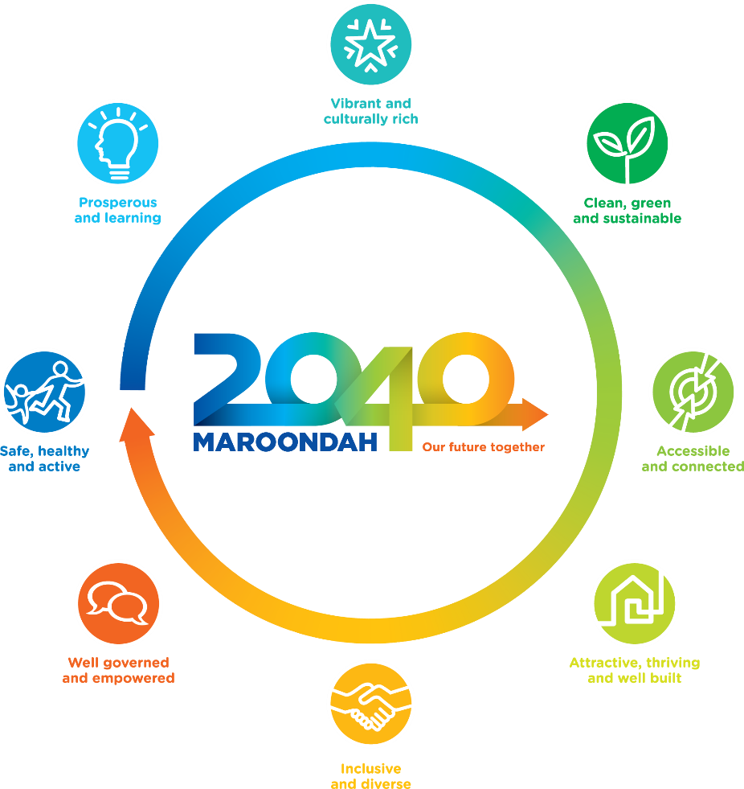
The Maroondah 2040 Community Vision is for “…a vibrant and diverse city with a healthy and active community, living in green leafy neighbourhoods which are connected to thriving and accessible activity centres contributing to a prosperous economy within a safe, inclusive and sustainable environment.” This vision is an expression of our community’s aspirations for the City of Maroondah, founded on eight future outcomes that reflect ideas and input from thousands of community members.

Figure 1 - Maroondah 2040 Community Vision is founded on eight future outcomes.

Maroondah 2040: Our future together is intended to guide Council, members of our community and other levels of government as we work towards the future outcomes identified in the vision. Given the important role public lighting plays in the safety, amenity and accessibility of our city, it can be seen how Council’s approach to public lighting schemes contributes to the future outcomes identified in Maroondah 2040, as Figure 2 illustrates.

“Maroondah is a safe, healthy & active community with local opportunities provided for people of all ages & abilities to have high levels of social, emotional & physical wellbeing.”
Effective public lighting along roads, around public transport, in activity centres and public spaces can improve safety and increase opportunities for community use.
“Maroondah is a green leafy community with high levels of waste diversion & sustainable approaches to infrastructure development, urban design & management of natural resources. Our community is resilient & has the knowledge, capacity & resources to make sustainable lifestyle choices.”
Careful use of energy efficient public lighting schemes reduces our carbon footprint and minimises environmental impacts, including from light spill-over
“Maroondah is an accessible community for all ages & abilities with walkable neighbourhoods, effective on & off-road transport networks & access to a range of sustainable transport options.”
Well-designed public lighting schemes promote access to different modes of transport and make our neighbourhoods more walkable.
“Maroondah is an attractive community with high quality residential & commercial areas incorporating infrastructure that meets the needs & aspirations of all ages & abilities. A diverse range of housing options are available & thriving activity centres provide a broad range of facilities & services to meet community needs.”
Public lighting installations can add to the aesthetics of activity centres and community spaces, while well-designed lighting infrastructure contributes to the visual appeal of our streetscapes.

Figure 2 - Council's approach to public lighting contributes to our future outcomes.

Maroondah 2040: Our future together is intended to serve as a roadmap to guide Council, members of our community and other levels of government as we work towards the future outcomes identified in the vision. This work is also guided by Council plans and strategies, which can help inform the approach we take to public lighting management.

Council Plan
The Maroondah City Council Plan 2017-2021 (2018/19 Update) sets key directions and priority actions for the medium-term as we work towards the future outcomes identified in Maroondah 2040: Our future together. The plan establishes key directions for the 2017-2021 period that include work to become a ‘carbon neutral’ Council through the implementation of energy efficiency initiatives. The proportion of streetlights converted to LED lamps is identified as a key indicator of Council’s progress towards the achievement of carbon neutrality.
As Council considers the development of new lighting schemes and infrastructure to update old installations, it will be important to consider the contribution these schemes make to the achievement of Council’s identified environmental goals.

Maroondah Health and Wellbeing Plan
It is important to consider the contribution public lighting can make to the achievement of community health and wellbeing outcomes identified in the Maroondah Health and Wellbeing Plan 2017-2021. The Plan reflects the ‘environments of health’ framework adopted by the Victorian Department of Health, which recognises how poor outcomes in each of the Built/Physical, Social, Economic and Natural environmental realms can influence health and wellbeing outcomes.
While public lighting schemes have an obvious role in promoting positive outcomes in our built environment, public lighting also makes a positive contribution to the social connectedness, economic prosperity and sustainability of Maroondah. Council’s approach to public lighting management should, therefore, consider the relationship between effective public lighting schemes and positive health and wellbeing outcomes for our community.
Carbon Neutral Strategy
Council’s Carbon Neutral Strategy and Action Plan 2014/15 to 2020/21 recognises the substantial environmental benefits to be realised by moving to energy efficient lighting. The strategy estimates that Maroondah will cut greenhouse gas emissions from streetlighting by 40 percent per annum through its changeover to high-efficiency LED lamps. The need for lighting schemes to keep pace with developments in energy efficient lighting technology across a range of applications is also recognised.

Sustainability Strategy
Council’s Sustainability Strategy 2016-2020 contributes to the clean, green and sustainable vision established in Maroondah 2040: Our future together. In relation to public lighting, the rollout of high-efficiency LED streetlights is recognised as a priority action for Council. The initiative is expected to reduce greenhouse gas emissions by nearly 450kg for each mercury-vapour light that is changed to LED, as well as delivering efficiencies through an extended operating lifetime and reduced maintenance needs. The role of public lighting as an enabling factor in the uptake of alternative modes of transport is also acknowledged.

Physical Activity Strategy
The relationship between effective public lighting schemes, safety and accessibility is recognised in Maroondah’s Physical Activity Strategy 2015 – 2020. The strategy acknowledges that ineffective lighting may inhibit access and contribute to fear of crime in public places; conversely, appropriate lighting schemes in activity centres plays a part in deterring antisocial behaviour, improving access and maximising use. It is recognised that public lighting can help drive participation in recreational activities by improving access and perceptions of safety, as well as increasing the availability of open spaces beyond daylight hours.

Open Space Strategy
The need for appropriate public lighting in reserves and along main trails used for commuter travel is identified in Maroondah’s Open Space Strategy 2016. The strategy promotes the use of energy efficient lighting that is visually appealing and sensitive to the environment in which it is installed, with consideration for infrastructure that makes use of renewable energy sources.

What is our strategic response and how will this be applied?
Council’s approach to public lighting management will ensure that appropriate consideration is given to its statutory responsibilities to road users; safety and amenity outcomes; opportunities to improve accessibility; and environmental considerations. Our approach will reflect best practice and advances in lighting technology in a manner that is sustainable, financially responsible, innovative and responds to community expectations. The lighting schemes we implement will incorporate appropriate asset management strategies.
Council acknowledges the high level of influence public lighting schemes can have on public transport use and the rate of uptake of alternative modes of transport. We will endeavour to support transport mode-shift and encourage behaviour change through the development of lighting schemes that make our neighbourhoods more walkable and bicycle friendly.
Public lighting will be used to promote positive health and wellbeing outcomes for our community by increasing opportunities for participation in physical activity. Lighting schemes will be deigned to encourage visits to activity centres and recreational facilities over extended hours by improving the safety, amenity and accessibility of these spaces. Council will apply principles of Crime Prevention Through Environmental Design (CPTED) to avoiding creating a false sense of security or encouraging antisocial behaviour with inappropriate lighting installations in isolated locations.
Council will ensure public lighting assets are identified and registered; inspected with appropriate frequency; and maintained in accordance with established standards. Our approach to lighting Maroondah’s open space will take account of the manner in which these spaces are intended to be used, as well as the potentially negative environmental impacts of artificial lighting on native fauna. Environmental sustainability will be a key consideration for all lighting schemes, with preference given to lighting installations that minimise power consumption and maintenance requirements, while achieving the intended safety and amenity outcomes.

Policy Statements
Council’s policy is founded on a set of key position statements that are intended to guide the planning, implementation and improvement of public lighting in Maroondah.
- Council will engage a third-party designer as required to review designs proposed by developers for unmetered standard street lighting installations (where the road-related assets will be vested to Council) and metered lighting assets.
- Council will not stock decorative (non-standard) luminaires and poles for maintenance of unmetered public lighting.
- Council will undertake proactive maintenance of metered public lighting assets that includes visor cleaning and either annual operation audits OR four-yearly condition assessments.
- Council will continue to replace unmetered mercury vapour street lights with more efficient LED street lights. Over time and where appropriate, Council will proactively explore additional renewal opportunities to achieve environmental benefits and cost savings and will consider options for the replacement of non-standard unmetered street lighting with standard street lighting.
- The use of solar lighting will be permitted only where grid-connected lighting is not considered viable.
- Characteristic data will be collected by Council for any new non-standard unmetered street lighting assets that are installed. Characteristic data relating to existing non-standard unmetered street lighting will be collected opportunistically during bulk LED street lighting upgrade works.
- Council will determine the location and times of operation for metered public lighting assets, as well as the type of control that should be installed, such as dimmers, switches or sensors.
- Council will require contractors tendering or quoting for public lighting works to demonstrate best-practice recycling and waste disposal standards. Where relevant, this will include the requirement for contractors to provide evidence of appropriate recycling or disposal of waste materials.
- This policy and the accompanying Public Lighting Guidelines will be subject to review every three to five years.
- Council will advocate to AusNet services to make a broader range of technologies and products available for use on the unmetered network. This includes a broader range of colour temperature for LEDs and a broader range of approved non-standard decorative LEDs.

Policy Implementation
This policy will be applied by Council officers having consideration to the position statements and recommendations presented in the accompanying Public Lighting Position Paper and the guiding principles contained in the Public Lighting Guidelines. The policy will apply to the installation of new public lighting; replacement of existing public lighting; and public lighting upgrades within the City of Maroondah.
Given the breadth of public lighting contexts and applications in Maroondah, there are many Council Officers in different departments that have a role in the management of public lighting schemes and infrastructure across the municipality. A description of the roles and responsibilities related to strategic planning functions; operation and maintenance; asset renewal; and capital works associated with public lighting infrastructure can be found in Table 2 of the Public Lighting Position Paper that accompanies this policy.
In addition to these roles, Council has statutory planning, engineering and traffic management responsibilities related to public lighting installations in new subdivisions where the road-related assets will vest in Council. As recommended in Section 5 of the Public Lighting Position Paper, Council’s traffic engineers will consider engaging third-party experts to review the design of lighting schemes proposed by developers prior to approval.
In implementing this policy, Council has committed to undertake the following priority actions during the period 2018-2025:
- Council will create a register of public lighting assets in Maroondah that reflects the expected service-life of lighting infrastructure and establishes an information framework in which to log the asset’s location; age and condition; characteristics; maintenance history and scheduled maintenance requirements.
- Council will collect information about new and existing public lighting infrastructure that includes the recommended data fields, as well as information related to the AusNet luminaire classification; photographs; mounting height data; power supply type; meter number and location; and descriptions of other co-located pole infrastructure, such as CCTV cameras or wayfinding signage.
- A comprehensive action plan will be developed to guide work across Council towards the implementation of this policy.

Supporting documents
This policy should be read in conjunction with the accompanying Public Lighting Position Paper 2019 and Public Lighting Guidelines 2019.
Ironbark Sustainability 2019, Maroondah City Council – Public Lighting Guidelines, Ironbark Group, Collingwood.
Ironbark Sustainability 2019, Public Lighting Position Paper, Ironbark Group, Collingwood.

Plainis, S., Murray, I. J., & Pallikaris, I. G. (2006). Road traffic casualties: understanding the night‐time death toll. Injury Prevention, 12(2), 125–128. http://doi.org/10.1136/ip.2005.011056
Fors, C., & Lundkvist, S. O. (2009). Night-time traffic in urban areas: A literature review on road user aspects. Statens väg-och transportforskningsinstitut.
Maroondah City Council (2014). Carbon Neutral Strategy & Action Plan 2014/15 – 2020/21, p13.
Maroondah City Council (2014). Carbon Neutral Strategy & Action Plan 2014/15 – 2020/21, p25.

