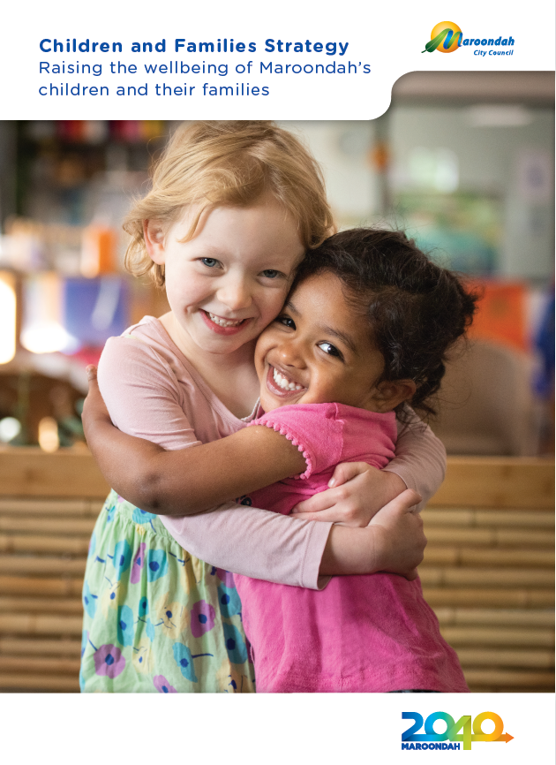
The Maroondah City Council Children and Families Strategy was adopted on August 17 2020.

Acknowledgment of Country
We, in the spirit of Reconciliation, acknowledge the Wurundjeri People of the Kulin Nation as traditional custodians of the land now known as the City of Maroondah, where Indigenous Australians have performed
age-old ceremonies. We acknowledge and respect their unique ability to care for Country and their deep spiritual connection to it. We pay our respects to their Elders, past, present and emerging.

Welcome

Maroondah City Council wants every child in Maroondah to be happy, healthy and thriving. We value our children and their families, and we are committed to ensuring they all have the opportunities and support they need to make that aspiration a reality.

Fulfilling this commitment will require collective effort, hard work, investment, and above all a dedication to prioritising the best interests and wellbeing of our children and their families.

Council’s Children and Families Strategy intends to make children and their families a priority in Maroondah. This Strategy is Council’s commitment to creating a connected community where all children and their families thrive.

Developing the Children and Families Strategy

The development of the Children and Families Strategy was informed by extensive community consultation, service reviews, service infrastructure needs analysis and research from 2018 to 2020. This has established a strong evidence base with the needs and strengths of Maroondah’s children and their families at its heart.

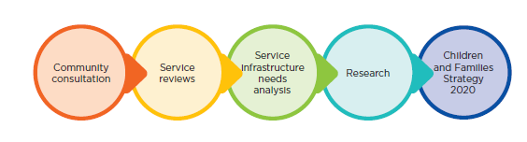

Purpose

The Children and Families Strategy provides clear strategic direction to guide and focus Council’s work with and for children aged 0 to 12 and their families who live, work, study or play in the City of Maroondah. It is Council’s key strategic document regarding children and their families.

The Children and Families Strategy seeks to:
- Support Council to raise the wellbeing of Maroondah’s children and their families
- Actively engage children and their families in the development of the Strategy and its Action Plans
- Utilise a strong evidence base to help Council meet the needs and aspirations of Maroondah’s children and their families
- Guide and focus Council’s work with and for children and their families into the future

Scope
The Children and Families Strategy is a Council-wide strategic document that:
- Encompasses all children aged 0 to 12 years and their families who live, work, study or play in the City of Maroondah
- Sits alongside Council’s Youth Strategy to provide continuous and aligned strategic planning for children and young people from birth to 25 years and their families
- Aims to guide Council’s partnerships and collaboration with organisations or groups outside of Council, while not directing their work
- Commences in 2020 but does not have a set end-date and will instead be reviewed every two years and renewed as and when required.

Our role with children and families

At Maroondah City Council, our role is to:
- Deliver services that meet the needs and expectations of the Maroondah community
- Advocate on behalf of community needs to other levels of Government
- Facilitate the delivery of outcomes by working in partnership with residents, businesses, community organisations and key stakeholders.

The Municipal Association of Victoria describes the role of Councils across the early years as largely focusing around five main areas:
- Planning and coordination - acting as a key coordination point and community planner in early years
- Service provision - delivering a range of early years programs, activities and initiatives
- Facility planning - planning, providing and maintaining a range of early years infrastructure
- Advocacy - lobbying and advocating to state and federal governments and other key stakeholders on behalf of early years programs, young children and their families
- Strengthening community capacity - facilitating community connections and community participation in decision-making, including vulnerable families.

Council embraces each of these roles in our work with and for children and their families, and extends them beyond the early years to cover all children aged 0-12 years and their families.

Our guiding principles

Council’s range of services for children and families is guided by a number of different practice frameworks and research, including the Early Childhood Australia Code of Ethics, the Maternal & Child Health Framework, the National Quality Framework, and the science of positive psychology.

Our guiding principles underpin all of Council’s work with and for children and their families:
- Best interests - The best interests and wellbeing of the child are paramount.
- Diversity and Culture - Diversity and culture are recognised, respected, valued and celebrated, and all children and their families belong.
- Equity and Inclusion - All children and their families are able to benefit from accessible and inclusive services, opportunities and assistance. The needs of vulnerable children and their families will be prioritised in all services.
- Engagement - Children and their families are actively engaged and consulted as equal citizens whose views are respected and valued
- Family-centred - Families and loving healthy relationships are recognised as central to children’s health and wellbeing. Families are all different and are valued as critical to a healthy community. respected and supported in their diversity.
- Strengths-based - The strengths of children and their families are recognised, understood and leveraged.
- Play - Play is recognised as a fundamental element of healthy development and learning.
- Sustainability - Respect for the environment and our interconnection with nature is fostered.
- Safety - All children have the right to be and feel safe, in all settings.
- Holistic approach - Children live within a broader community of interconnected systems and services, and all parts must work together to effectively support children, their families and each other.

Our community vision

Maroondah 2040 - Our future together identifies a range of preferred future outcomes for the
community looking ahead to the year 2040. The Children and Families Strategy links to all eight of the
Maroondah 2040 outcome areas:

In 2040, Maroondah will be a vibrant and diverse city with a healthy and active community,
living in green leafy neighbourhoods which are connected to thriving and
accessible activity centres contributing to a prosperous economy within a safe, inclusive
and sustainable environment³

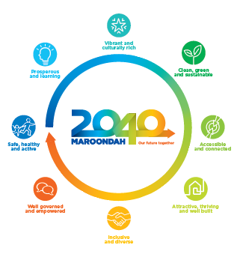

Our context

Council’s work with and for children and their families is shaped and influenced by a number of key government plans, policies and reforms at the National, State and local level.

National
- United Nations Convention on the Rights of the Child ratified by the Australian Government in 1990

State
- The Early Childhood Reform Plan 2017 - Education State
- Supporting Children and Families in the Early Years - A Compact between Department of Education and Training, Department of Health and Human Services) and Local Government 2017-2027
- Roadmap for Reform: Strong Families, Safe Children (DHHS, 2016)
- Family Violence 10 Year Plan
- Maternal and Child Health Memorandum of Understanding 2017-2020
- Maternal and Child Health Service framework, incorporating standards and guidelines
- Australian Children’s Education and Care Quality Authority (ACECQA) National Quality Framework
- Child Safe Standards
- Reportable Conduct Scheme
- Charter of Human Rights and Responsibilities Act 2006
- Victorian Aboriginal and Local Government Action Plan
- Child Friendly Cities and Communities
- The introduction of funded 3-year-old kindergarten

Local
- Maroondah 2040 ‘Our future together’
- Council Plan and Budget
- Related Council plans and strategies, including the Municipal Public Health and Wellbeing Plan (Liveability and Wellbeing Strategy - in progress) and the Youth Strategy

Children and their families in Maroondah

Our city

- The City of Maroondah sits in Melbourne’s outer east, 22 kilometres from the central business district.
- The Traditional Owners of the land now known as Maroondah arrived approximately 40,000 years ago. European settlers arrived in the 1830’s and commenced using the land for grazing cattle.⁴
- The City of Maroondah includes the suburbs of Bayswater North, Croydon, Croydon Hills, Croydon North, Croydon South, Heathmont, Kilsyth South, Ringwood, Ringwood East, Ringwood North and Warranwood. The City also includes small sections of Kilsyth, Park Orchards, Vermont and Wonga Park.

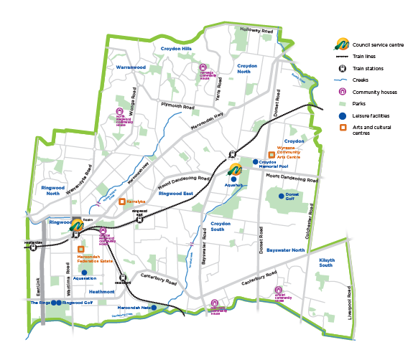

Our community

- An estimated 118,558 people live in Maroondah, as at June 20195
- In 2020, approximately 20,077 children aged 0-12 years live in Maroondah (1 in 6 residents)⁶
- By 2040, this number is estimated to increase to approximately 22,628 children (+12.7%)⁷
- In 2016, 136 Aboriginal and Torres Strait Islander (ATSI) children aged 0-11 years were living in Maroondah (24% of the ATSI population in Maroondah)⁸
- In 2016, 1160 or 6.9% of children in Maroondah were born overseas - an increase of 839 since 2011⁹
- In 2016, 3200 or 18.9% of children in Maroondah spoke a language other than English at home - an increase of 1431 since 2011¹º
- In 2016, 8,092 people in Maroondah provided unpaid care for children other than their own.¹¹
- In 2016, 3629 children aged 0-14 living in low income households.¹²
- Rate of children in Victoria who were the subjects of substantiated child protection notifications in 2018-19:
  - < 1 year - 27.8 per 1000
  - 1-4 years - 14.1 per 1000
  - 5-9 years - 13.1 per 1000
  - 10-14 years - 13.4 per 1000¹³
- In 2018-19, 1156 family violence incidents in Maroondah were reported to Victoria Police, a rate of 970.9 per 100,000 population - compared to 1,253.3 for Victoria. Across the state, children are present at approximately 31% of incidents.¹⁴
- In 2018, of the Maroondah children measured in their first year of full-time school:
  - 17.8% were developmentally vulnerable in one or more domains (compared to 19.9% for Victoria)
  - 8.2% were developmentally vulnerable in two or more domains (compared to 10.1% for Victoria)
For each individual domain:
Physical health and wellbeing: 82% were developmentally on track (compared to 81% for Victoria)
Social competence: 81% were developmentally on track (compared to 77.3% for Victoria)
Emotional maturity: 78.5% were developmentally on track (compared to 77.7% for Victoria)
Language and cognitive skills (school-based): 85.5% were developmentally on track (compared to 84.6% for Victoria)
Communication skills and general knowledge: 83.8% were developmentally on track (compared to
79.4% for Victoria)¹⁵

- In 2013, 21.1% of children in Outer Eastern Melbourne had special health care needs (compared to 18.1% for Victoria)¹⁶

- In 2017, 72.5% of children in Maroondah attended the 3.5 year MCH ages and stages visit (compared to the Victorian average of 62.9% for Victoria)¹⁷
- In 2013, 63.0% of children in Outer Eastern Melbourne did the recommended amount of physical activity every day (compared to 62.2% for Victoria)¹⁸
- In 2017, 59.4% of children in Victoria were active for 60 minutes a day, down from 62.2% in 2013.¹⁹
- In 2017-18, across Australia almost one quarter of children aged 5-17 years were overweight or obese²º
- In 2018, 18.2% of children in Victoria exceed recommended screen time, up from 17.7% in 2013)²¹
- In 2018, the kindergarten participation rate in Maroondah was 92.6%, (compared to 92.1% for Victoria)²²
- In 2018, 4.9% of children at school entry had emotional or behavioural difficulties (compared to 5.6% for Victoria)²³
- In 2013-14, across Australia: 13.6% of children aged 4-11 years had experienced a mental disorder in the previous 12 months (10.6% of females and 16.5% of males). For both females and males, attention-deficit/hyperactivity disorder (ADHD) was the most common mental disorder overall, followed by anxiety disorders, major depressive disorder and conduct disorder.²⁴
- In 2015, 89.2% of children in grades 5 and 6 in Maroondah reported feeling connected to school (compared to 84.8% for Victoria). This decreased to 63.8% for students in years 7-9 (compared to 62.3% for Victoria)²⁵
- In 2015, 77.3% of children in grades 5 and 6 in Maroondah felt socially connected and get along with their peers (compared to 69.4% for Victoria)²⁶
- In 2018, 11.5% of children in grades 5 and 6 in Maroondah reported being bullied, down from 15.5% in 2017 (compared to 15.9% for Victoria, also down from 19.5% in 2017).²⁷

Our consultation

What we did

Across the range of consultation methods, Council engaged with over 3000 children, parents and carers, school staff and service providers. Comprehensive reports ²⁸ ²⁹ detailing the full findings of these consultations are available on Council’s website.

*Wellbeing Surveys were conducted in partnership with the Victorian Department of Education and Training and The University of Melbourne’s Centre for Positive Psychology.

What we found

What our children told us

What makes our children happy?  - Animals  - Playgrounds  - Nature play and access to nature spaces  - Being with friends and family  - Kindness or helping behaviour | What makes our children feel sad?  - Antisocial behaviour and conflict  - Rubbish and pollution  - Sad events or emotions  - People being hurt or injured  - Loneliness and not having friends | Challenges faced by our children  - Friendships  - Being alone  - Managing emotions  - Bullying  - School or study problems
What does wellbeing mean to our children?  - Being happy  - Feeling safe  - Having good mental heath  - Being physically healthy  - Having friends to share the ups and downs of life | Measuring our children’s wellbeing  - Our upper primary school children have high cognitive, economic, psychological and social wellbeing  - Areas for improvement are physical wellbeing including poor sleep, and high levels of emotional wellbeing risks including depression, anxiety, stress and anger | How can we improve life for our children and their community?  - Community support, showing kindness, acceptance and respect  - Places to play sport  - Nature spaces and caring for the environment  - Pets and experiences with native and domestic animals

What our parents and carers told us

What are the best things about being a parent / carer in Maroondah?  - Watching children develop and grow  - Local green spaces  - Social connection and support groups  - Love of the family | Challenges of being a parent / carer  - Managing mental health - their own and their children  - Time demands  - Sleep deprivation  - Financial challenges  - Social isolation  - Language barriers | What does wellbeing mean to our parents and carers?  - Having good mental health  - Being physically healthy  - Spending quality time with friends and loved ones
Measuring parent and carer wellbeing  - Around 1 in 5 experience high levels of depression  - Around 1 in 5 report high levels of stress  - More than 1 in 5 experience high levels of loneliness  - Male parents and carers report lower levels of wellbeing | What supports would you find helpful as a parent/carer in Maroondah?  - Accessible activities in the local area  - Affordable and accessible childcare  - Information about services available  - Wellbeing support and education  - Support groups for parents | What could be improved in Maroondah to help raise the wellbeing of children, young people and families?  - Support groups / Support for families, children and young people  - Affordable/accessible activities and community events  - Information about services available and local areas for families  - Improved infrastructure - buildings, playgrounds, paths, public safety  - Education and information for parents

What our service providers told us

What are the strengths you see in the children and families you work with?  - Resilience and perseverance  - Help-seeking behaviours  - Connections and relationships  - Kindness, prosocial behaviour  - Sense of, and engagement with, the community | What are the challenges faced by the children and families you work with?  - Mental health issues  - Lack of information about services available  - Family/Domestic violence and family breakdown  - Language barriers for CALD communities | What could be improved in Maroondah to help raise the wellbeing of children, young people and families?  - Free events for families  - Accessible mental health services  - Support for vulnerable families  - Funding of services  - Support groups

A strategy for the future

Using our strong evidence base, Council has developed the following strategic framework which outlines the focus for our work with and for children and their families in Maroondah into the future.

Our Vision for Maroondah’s children and their families

Our vision describes our desired future for Maroondah’s children and their families:

Maroondah is a connected community where all children and their families thrive.

Our Mission

Council’s core purpose for our work with and for children and their families is:

To raise the wellbeing of all children and their families in Maroondah through collaboration, advocacy and service delivery.

Our THRIVE Strategic Outcomes

Through the development process, Council has identified six strategic outcomes that we seek to achieve through the Children and Families Strategy:
- Transformed Service Systems and Spaces
- Health and Wellbeing
- Respect and Inclusion
- Informed and Connected Communities
- Valuing the Voices of Children
- Education and Learning for Life

The Key Directions for each Strategic Outcome describe how Council will work towards these outcomes.

Our Action Plans

The Children and Families Strategy will be supplemented by a sequence of separate two-year action plans that will sit alongside the Strategy and outline the actions Council will undertake.

These action plans will be developed based on current evidence and consultation, which will ensure that Council is responsive to changes in the needs and aspirations of children and their families in Maroondah while maintaining a clear and consistent strategic focus.

Our THRIVE Strategic Framework

Our Vision:

Maroondah is a connected community where all children and their families thrive

Strategic Outcome 1 – Transformed Service Systems and Spaces

Maroondah's service systems and spaces will be optimised for the benefit of all children and their families.

Key directions
  - Establish Maroondah as a Child Friendly City and Community, where the voices, needs, priorities and rights of children are an integral part of public policies, programs and decisions
  - Strengthen and support the children and family services sector in Maroondah
  - Ensure that Council's infrastructure and open spaces are well planned and placed to meet the changing needs of Maroondah's children, their families and service providers

Strategic Outcome 2 – Health and Wellbeing

The health, wellbeing and development of all children and their families in Maroondah will be supported and fostered.

Key directions
  - Provide accessible local services and opportunities that foster the health, wellbeing and development of children and their families
  - Expand opportunities to support the health, wellbeing and development of children and families in Maroondah experiencing vulnerability or disadvantage
  - Increase community capacity to build the health, wellbeing and development of children and their families

Strategic Outcome 3 – Respect and Inclusion

All children and their families in Maroondah will be respected, safe and included.

Key directions
  - Respect, value and celebrate the diversity of children and their families in Maroondah
  - Enhance accessibility and inclusion for children and their families in Maroondah
  - Support children and their families to develop and maintain safe, healthy and respectful relationships

Strategic Outcome 4 – Informed and Connected Communities

All children, their families and the professionals who work with them will be informed and connected.

Key directions
  - Effectively promote and provide information about the range of services and opportunities available to children and their families in Maroondah
  - Facilitate the provision of places and opportunities for children and their families that promote community connection and a sense of belonging
  - Facilitate networking and information sharing opportunities for professionals who work with children and their families in Maroondah

Strategic Outcome 5 – Valuing the Voices of Children

All children and their families are equal citizens of Maroondah who are valued and respected.

Key directions
  - Advocate for children to be treated as equal stakeholders in the community, whose knowledge, experience and views are valued and respected
  - Actively and effectively engage and consult with children and their families on matters that affect them and their communities
  - Advocate for the needs and aspirations of all children in Maroondah

Strategic Outcome 6 – Education and Learning for Life

All children and their families in Maroondah will have opportunities for high-quality education and learning throughout life.

Key directions
  - Equip children and their families with the knowledge and capabilities to successfully navigate life’s opportunities and challenges
  - Enhance opportunities for children in Maroondah to access high-quality local education and care services that meet community needs

Tracking our progress

The Children and Families Strategy will be reviewed every two years to track progress on implementation, evaluate initiatives, support continuous improvement and innovation, and identify when further review and renewal of the Children and Families Strategy is required.

In line with each review, a new two-year Action Plan will be developed based on current evidence and consultation.

Action Plans will be reviewed annually to track progress and results will be reported to Council.

Council will continue to actively engage with children and stakeholders throughout the implementation of the Children and Families Strategy, ensuring that children and their families are always at its core.

Acknowledgements

Council would like to acknowledge the invaluable contributions of the following groups to this project:
- The 3000+ children, parents and carers, school staff and service providers who participated in the consultation and generously shared their experiences, stories and desires for Maroondah.
- The Victorian Department of Education & Training
- The University of Melbourne’s Centre for Positive Psychology
- Original artwork by Ashley Wallace

References

1. Maroondah City Council (2019), Maroondah City Council Plan 2017-2021 - 2019/20 Update 2. Municipal Association of Victoria (2018), MAV Resource Guide to Municipal Early Years Planning 3. Maroondah City Council (2014), 2040 Maroondah - Our future together 4. Maroondah City Council (2019), Maroondah City Council Plan 2017-2021 - 2019/20 Update 5. Australian Bureau of Statistics (2020). Regional Population Growth, Australia. Canberra: Australian Bureau of Statistics 6. .id (2019). Population and household forecasts, 2016 to 2041, accessed 12 May 2020 from http://forecast.id.com.au/maroondah/population-age-structure-map 7. .id (2019). Population and household forecasts, 2016 to 2041, accessed 12 May 2020 from http://forecast.id.com.au/maroondah/population-age-structure-map 8. Australian Bureau of Statistics (2011 and 2016). Census of Population and Housing. Canberra: Australian Bureau of Statistics. Complied and presented by .id 9. Australian Bureau of Statistics (2011 and 2016). Census of Population and Housing. Canberra: Australian Bureau of Statistics. Complied and presented by .id 10. Australian Bureau of Statistics (2011 and 2016). Census of Population and Housing. Canberra: Australian Bureau of Statistics. Complied and presented by .id 11. Australian Bureau of Statistics (2011 and 2016). Census of Population and Housing. Canberra: Australian Bureau of Statistics. Complied and presented by .id 12. Australian Bureau of Statistics (2011 and 2016). Census of Population and Housing. Canberra: Australian Bureau of Statistics. Complied and presented by .id 13. Australian Institute of Health and Welfare Child Protection Collection (2019), accessed 12 May 2020 from https://www.aihw.gov.au/reports/child-protection/child-protection-australia-2018-19/data 14. Crime Statistics Agency (2019). Data Tables – Victoria Police, accessed 8 May 2020 from https://www.crimestatistics.vic.gov.au/family-violence-data-portal/download-data-tables 15. Australian Government, Australian Early Development Census (2018), Australian Early Development Census Community Profile 2018, Maroondah, Vic 16. State of Victoria, Victorian Child and Adolescent Monitoring System, accessed 12 May 2020 from https://www.education.vic.gov.au/about/research/Pages/vcamstableau.aspx 17. State of Victoria, Victorian Child and Adolescent Monitoring System, accessed 12 May 2020 from https://www.education.vic.gov.au/about/research/Pages/vcamstableau.aspx 18. State of Victoria, Victorian Child and Adolescent Monitoring System, accessed 12 May 2020 from https://www.education.vic.gov.au/about/research/Pages/vcamstableau.aspx 19. State of Victoria, Department of Education and Training (2019), Victorian Child Health and Wellbeing Survey Summary Findings 2017 20. Australian Bureau of Statistics (2018), National Health Survey: First Results 2017-18, accessed 12 May 2020 from https://www.abs.gov.au/ausstats/abs@.nsf/Lookup/by%20Subject/4364.0.55.001~2017- 18~Main%20Features~Children’s%20risk%20factors~120 21. State of Victoria, Department of Education and Training (2019), Victorian Child Health and Wellbeing Survey Summary Findings 2017 22. State of Victoria, Victorian Child and Adolescent Monitoring System, accessed 12 May 2020 from https://www.education.vic.gov.au/about/research/Pages/vcamstableau.aspx 23. State of Victoria, Victorian Child and Adolescent Monitoring System, accessed 12 May 2020 from https://www.education.vic.gov.au/about/research/Pages/vcamstableau.aspx 24. Lawrence, D., Johnson, S., Hafekost, J., Boterhoven, De., Haan, K., Sawyer, M., Ainley, J. and Zubrick, SR., (2015). The Mental Health of Children and Adolescents: Report on the second Australian Child and Adolescent Survey of Mental Health and Wellbeing. Canberra: Department of Health. 25. State of Victoria, Victorian Child and Adolescent Monitoring System, accessed 12 May 2020 from https://www.education.vic.gov.au/about/research/Pages/vcamstableau.aspx 26. State of Victoria, Victorian Child and Adolescent Monitoring System, accessed 12 May 2020 from https://www.education.vic.gov.au/about/research/Pages/vcamstableau.aspx 27. State of Victoria, Victorian Child and Adolescent Monitoring System, accessed 12 May 2020 from https://www.education.vic.gov.au/about/research/Pages/vcamstableau.aspx 28. Chin, T-C., Stevenson, I., Jacques-Hamilton, R., & Vella-Brodrick, D.A. (2019). Wellbeing in the Maroondah Network of Schools: Understanding the wellbeing needs of students, staff, parents and carer in Maroondah. Parkville: The University of Melbourne. Commissioned by The Department of Education and Training, Victoria. 29. Maroondah City Council (2020), Children and Families Strategy - Raising the wellbeing of all Children and their Families: Community Engagement Report

