Community Engagement Report
Climate Adaptation – Maroondah’s Story
February 2017

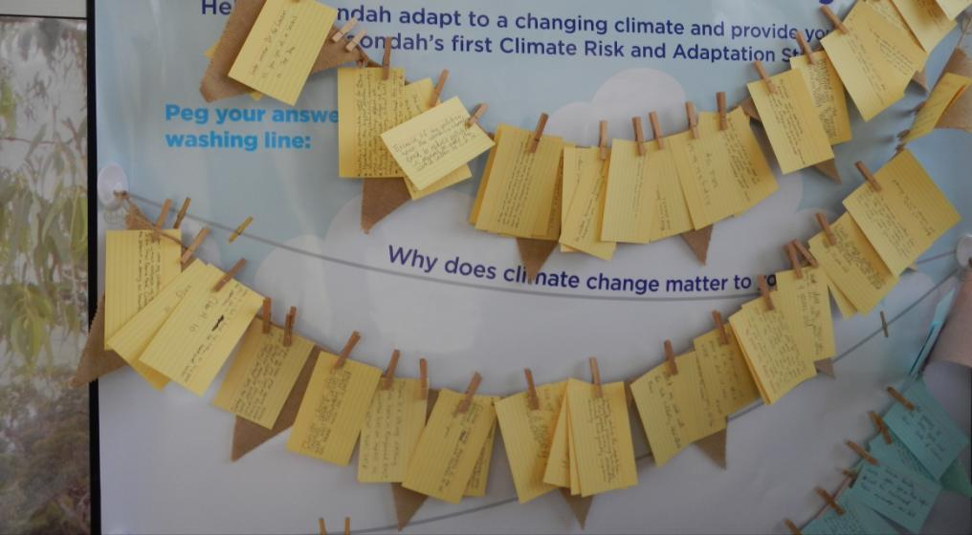
2 Executive Summary
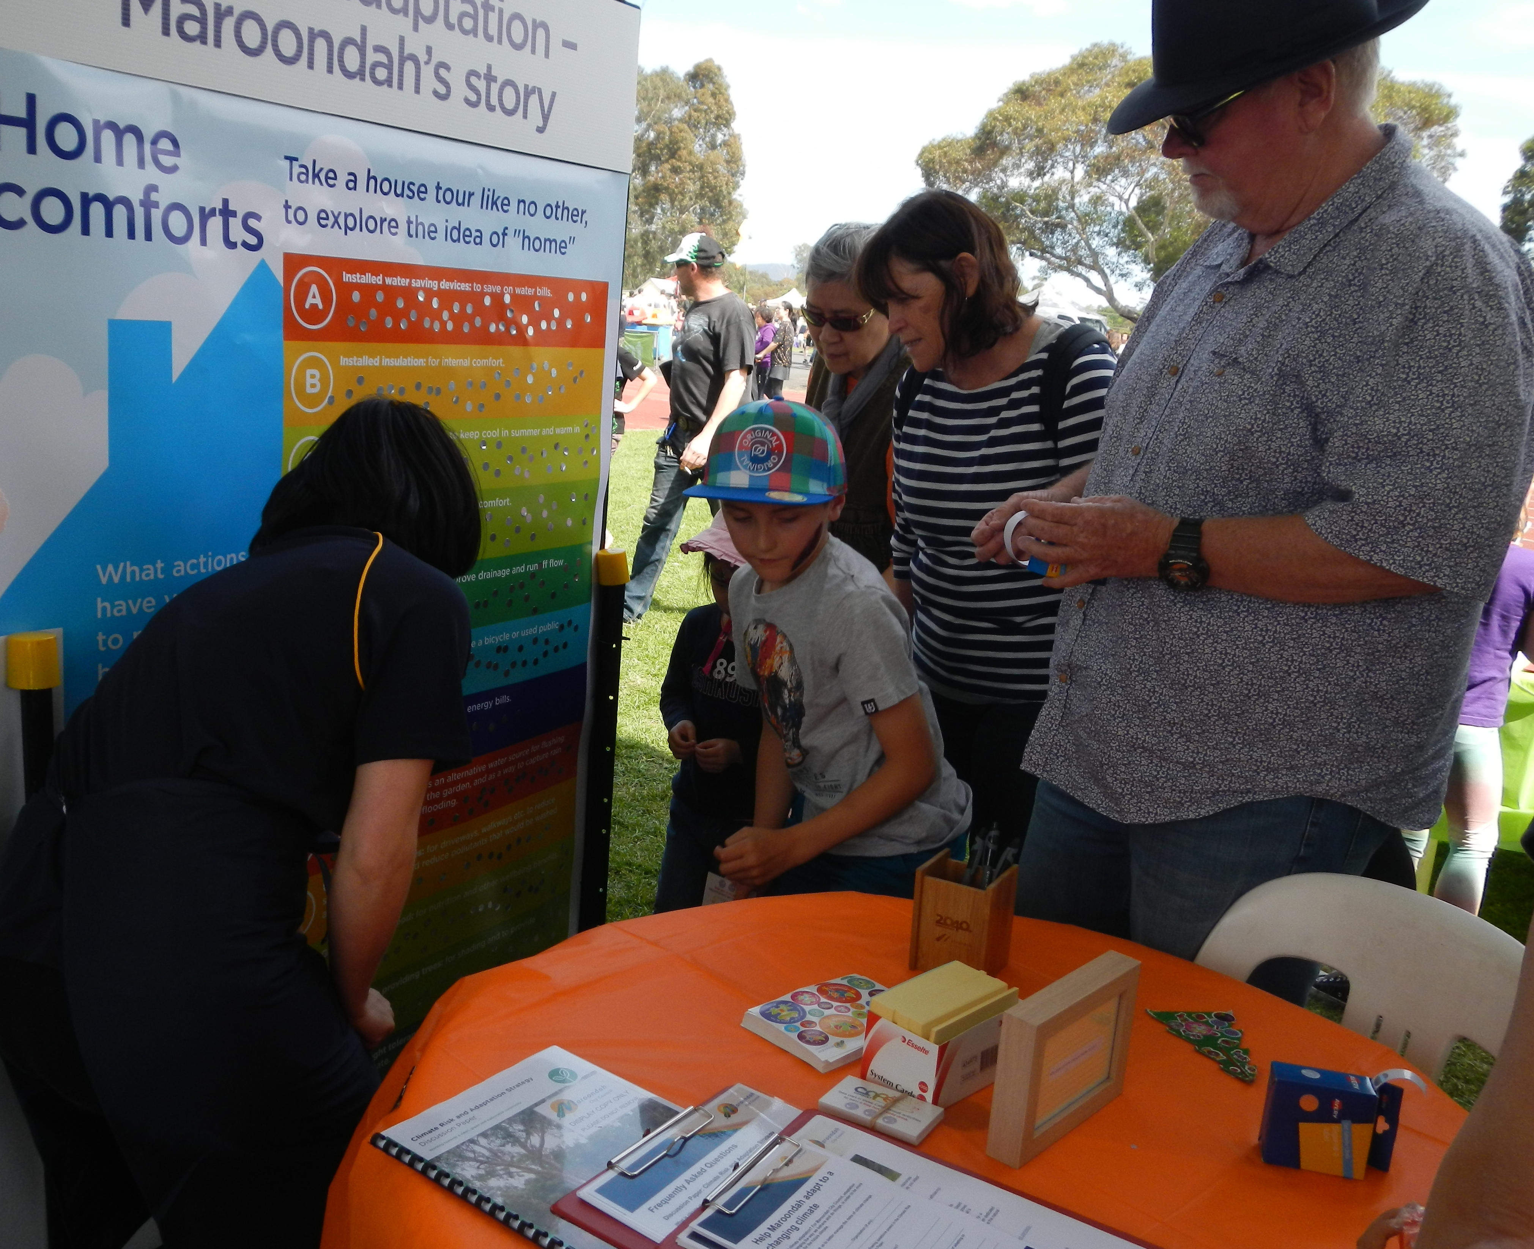
Community engagement on climate change adaptation at the 2016 Maroondah Festival

In alignment with our strategic objectives for sustainability and a well governed and empowered community, Maroondah City Council has undertaken community consultation for ‘Climate Adaptation – Maroondah’s Story’. This engagement was received positively with many people wanting to join the conversation about climate change adaptation in Maroondah. This document outlines the findings of the Council initiated climate adaptation conversations carried out with the community in November 2016.

Council recognises there are risks associated with climate change. Climate change adaptation allows us to better manage the risks of climate change and potentially save on future expenditure; small investments today will avoid larger costs in the future. The municipality faces significant climate impacts in the coming decades that will need to be carefully and proactively managed.

The developing Climate Risk and Adaptation Strategy will make clear Council’s commitment to climate change adaptation. It will set out a vision of a climate resilient Maroondah that both demonstrates leadership and is tailored to being performed. An anticipated outcome is that adapting Council’s operations, assets and service delivery will effect change in the community. Leadership is about embracing and sharing great ideas and opportunities.

The developing Strategy is being prepared in conjunction with the Climate Risk and Adaptation Strategy Discussion Paper (Maroondah City Council, 2016) and this community engagement report. The discussion paper draws together a range of research and data concerning climate adaptation in Maroondah, and the views of the community are presented in this document.

This document provides a summary of feedback received from the community and stakeholders on the discussion paper and supporting action research elements for ‘Climate Adaptation – Maroondah’s Story’ project execution. At the planning and other stages of the project, presentation and feedback also occurred with the Maroondah Environment Advisory Council (MEAC). The MEAC was established to inform and advise Council on environmental and sustainability issues and Council’s role in improving the environment in Maroondah. The group comprises eight community members and three Councillors.

Maroondah 2040 Community Vision: Our Future Together sets out a vision for a clean, green and sustainable community. The document sets out a key platform for change – mitigate and adapt to the effects and impacts of climate change.

There were a number of key themes identified during community consultation for the ‘Climate Adaptation – Maroondah’s Story’: |  | How did the community respond to the discussion paper?

3 What we did for ‘Climate Adaptation – Maroondah’s Story’

At the 2016 Maroondah Festival, Council held participatory engagement with the community using Council’s Café Consult marquee along with other traditional mediums. These interactions generated over 500 unique responses from the community wanting to take part in the conversation about climate adaptation in Maroondah.

The Climate Risk and Adaptation Strategy Discussion Paper (Maroondah City Council, 2016) was also available for feedback at Council’s Café Consult marquee. Council officers from the Strategic Planning and Sustainability team facilitated the engagement and were available for one-on-one conversations with interested people. Other traditional mediums used included website and online survey, social media, local newspaper advertisement, and on display at service centres.

In both the discussion paper and in one-to-one conversations at Council’s Café Consult marquee, participants were asked to respond to two key questions:
- Why does climate change matter to you? and/or
- What does a climate resilient neighbourhood look like to you?
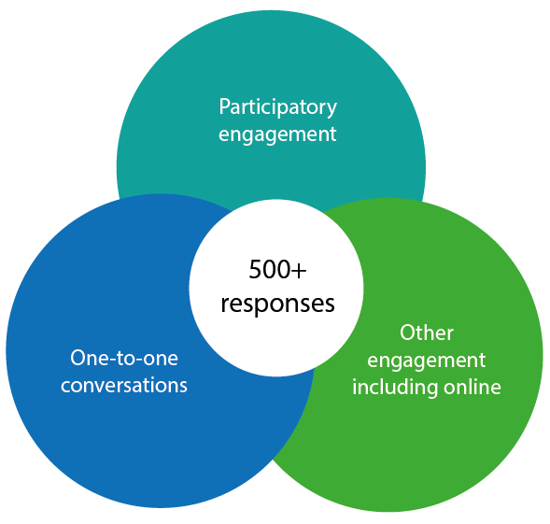
The engagement program aimed to:
- Cultivate positivity and gain stories and narratives: localising and personalising climate change information, in effect reducing psychological distance
- Make visible actions being undertaken by the community, to foster social diffusion
- Act as a vehicle for public consultation and invite comment on the discussion paper.
Activities:
- Established steering committee to guide the project, evaluate research and monitor results
- Built an engagement operations team
- Designed a survey and analysis process for action research element
- Established a Maroondah Festival Café Consult marquee site including developing a schedule, logistics, and engagement protocols
- Developed supplementary material (e.g. printed displays and other supporting material)
- Liaised with stakeholders – including MEAC, Corporate Management Team (CMT), media
- ‘Climate Adaptation – Maroondah’s Story’ project execution (November 2016)
- Research analysis and production.

4 What we were told during the action research element

We asked two key questions during the consultation with our community. This is what they said:

- The community have noticed the effects of climate change in their own lifetimes:
  - “As the world gets warm and our environment gets drier. The local fauna and flora become affected, this threatens their ability to cope which may lead to them disappearing which may also affect our living conditions”.
  - “[I am] Part of a walking group. Heatwave impacts leisure activities”.
  - “It affects my health and wellbeing and lifestyle. We need to reduce pollution”.
  - “Climate change adds to how much water we use and how much power we use. Which is more on both”.
- Feedback was received on vulnerable communities: “Effects my work with the sick and elderly. Heat effects them”. As well as “I am an age pensioner, in an old weatherboard home. Can Council give advice/financial help to make my house more climate resilient and able to cope better in the hotter/colder climate to come?”.
- The community support Council taking action on climate change: “…concentrate on things that make lives better and more comfortable – stormwater – growing own food, planting greenery, developing solar and wind power, improving infrastructure, reward people for their improvements”.
- The community have some understanding of how climate change could directly affect them and the things they love about Maroondah: “It is important to do ‘green’ as you save money as well as the area”.
- Community members want “Neighbourhood working together with local government on biodiversity to provide shade and protection” and also “More open space that helps cool the environment” and more.
- The community are taking action on climate change: “I am always mindful of helping the environment so I’ve changed some things at home to play my part. I’ve got water-saving shower heads and solar panels for electricity. I also try to walk as often as possible rather than taking the car. I also have ceiling fans and insulation”.
- Suggestions were made to emphasise the benefit of community connectivity: with support for “Neighbours looking out for each other”.
- It was acknowledged that we all have a role to play, at a variety of scales: “Planning for climate change at the individual, community, school level can make a difference”.

Participants were asked to respond to two key questions. For this element, a total of 138 responses were received. The responses received were grouped into “like” themes so as to be able to more easily identify similar and repeated comments.
The most popular reasons why climate change matters to the community can be grouped into the themes of:  - Natural environment  - Health.  The list is not necessarily exhaustive.  In the ‘Health’ category there was also a strong sense of inter-generational equity and responsibility for planning for future generations. | The most popular answers from the community about what a climate resilient neighbourhood looks like, can be grouped into the themes of:  - Upscale of stormwater reuse, energy efficiency and integrated transport  - Urban greening and more.  The list is not necessarily exhaustive.  In the ‘Other’ category, education, better promotion, and neighbour caring initiatives, were also important.

5 What we were told about the multi-vote count

At Council’s Café Consult marquee, interested people were also asked to place a “hot-dot” (multi-vote count) against actions they have taken to make their home more comfortable and adaptable to climate change. For this element, a total of 378 responses were received (with multiple allowed per participant).

Popular actions being undertaken by residents in accordance with their self reporting included the following: installed window shading (41); grown your own food (41); installed insulation (39); left the car at home – walked, rode or used public transport instead (39); installed water saving devices (38); and planted drought tolerant plants (34). Again, this shows that the community are already taking action.
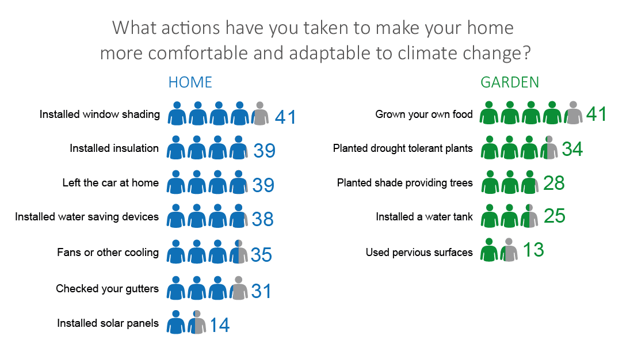

6 What else we were told on the discussion paper

The community were invited to read the Climate Risk and Adaptation Strategy Discussion Paper (Maroondah City Council, 2016) and provide their input on the key directions and outcome areas outlined in the document via a survey available online and at service centres. Targeted engagement also included but was not limited to listening to the partners and community leaders identified in the Maroondah Sustainability Strategy. The Discussion Paper was on public exhibition from 31 October 2016 until 28 November 2016. For this element, a total of 15 survey responses were received. This included responses from members of the following natural environment community groups: First Friends of Dandenong Creek; Transition Towns Maroondah; and Heathmont Bushcare.

Key discussion points are as follows. Feedback on the main themes from the discussion paper:
- Section 1 – Research: understanding the effects and impacts in our local context

- The vast majority of respondents thought this is an important issue, and it is essential to have a strategy in place to manage the issue of climate change.
- Some respondents have adopted an attitude where they are choosing to act locally and be more proactive in their local area, especially from the perspective of revegetation of indigenous plants and the creation of habitat for local fauna.
- Stormwater reuse, energy efficiency, integrated transport planning and urban greening initiatives were mentioned as important elements of climate resilient communities.
- The adaptation benefits of health, safety, happiness and vibrancy were mostly supported.
- Section 2 – Potential: adapt (modify the risk through mitigation)

- The vision (proposed) was supported by the vast majority of respondents and described as strong and proactive by some, whilst others urged for focus on its implementation.
- For Council to lead by example, it was observed that this necessitates that the community be interested and engaged also.
- Similarly it was encouraged that community action needs to be part of the solution, for example – in weed management.
- ‘Lead by example’ and ‘work together’ were the goals that generated most discussion.
- There was a want for better promotion from Council: both on what Maroondah residents can do and on what Council is doing about climate change.
- It was reinforced that there is a want to see Council continue to emphasise the need to reduce the municipality's carbon footprint as a way of reducing our contribution to the problem. Mitigating climate change and adapting to the effects were seen as equally important strategies.

7 Implications and recommendations

The implications of the engagement process to be addressed in the developing Climate Risk and Adaptation Strategy:

- There is great community and stakeholder support for Council’s strong commitment to the management of climate change risk, and the community want strong Council leadership for climate change adaptation.
- Respondents encouraged Council to develop the Climate Risk and Adaptation Strategy with a focus on seeing Council ‘lead by example’ and ‘work together’ with others. A simplification of the goals proposed in the discussion paper is recommended for the Strategy, and by extension a simplification of the adaptation-shaping principles should be considered.
- Many comments advocated for management of natural environment and health impacts with the inter-relationship referenced by many respondents. It is recommended to make clear that the outcome areas (people > places > enable climate resilience) recognise the intersection of the built, natural and social landscape.
- At Council’s Café Consult marquee, the climate hazards referred to by respondents had the most focus on hotter and drier conditions. It is recommended that the climate change risks are themed by climate variable in the Strategy.
- Many respondents thought that the Climate Risk and Adaptation Strategy could benefit from the upscale of stormwater reuse, energy efficiency and integrated transport planning as well as through urban greening initiatives. It is recommended to undertake further research to determine if these items or similar could be elevated in the Strategy to key actions that offer co-benefits for the municipality.
- Building community capacity through increasing awareness, education and encouragement are important opportunities to improve climate adaptation in Maroondah. It is recommended that an important risk management response should be around education, in concert with collaborative networks where appropriate, and it is also important to illustrate how the Strategy benefits all Maroondah residents.
- Stakeholder feedback supported emphasis on the ‘enabling architecture’ to aid implementation. It is recommended to make clear in the Strategy that climate change adaptation is both an outcome and a process.

8 Next steps

Adoption of the Climate Risk and Adaptation Strategy will be an essential first step in proactive management for the effects and impacts of climate change in Maroondah.
The developing strategy is expected to be released by mid-2017. Following release, Council will:

- Work with others to provide opportunities for partnerships and collaboration with stakeholders, including to foster community involvement and support for climate change adaptation, and
- Provide feedback to stakeholders about how the engagement was utilised in the development of the strategy.
Council thanks the community and stakeholders for their enthusiasm and interest in helping to develop the first edition of Maroondah’s Climate Risk and Adaptation Strategy.
It is expected that the draft Strategy will be publicly exhibited for comment in mid-2017 (at the ‘broadening the conversation’ stage), prior to finalisation and recommendation for adoption by Council.
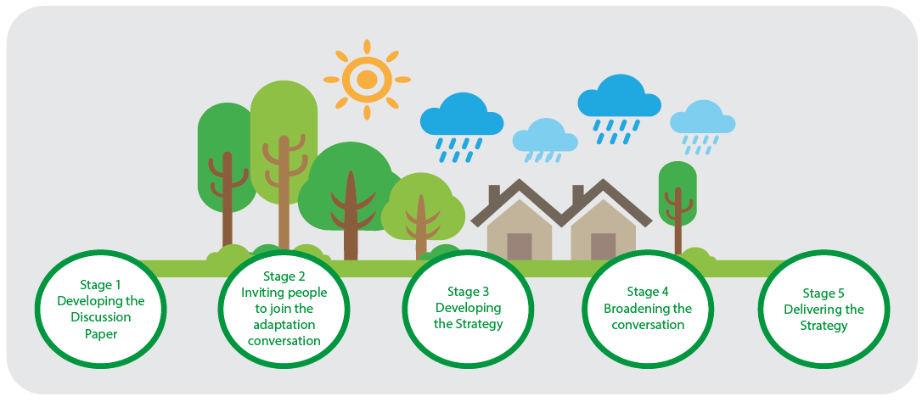
For further information, contact Council’s Strategic Environment Planner on 1300 88 22 33 or visit the website at www.maroondah.vic.gov.au

To contact Council
- telephone 1300 88 22 33
- visit our website at: www.maroondah.vic.gov.au
- email maroondah@maroondah.vic.gov.au

Translating and Interpreter Service
13 14 50

National Relay Service (NRS)
13 36 77

www.facebook.com/MaroondahCityCouncil
@CityofMaroondah
www.youtube.com/CityofMaroondah

