–
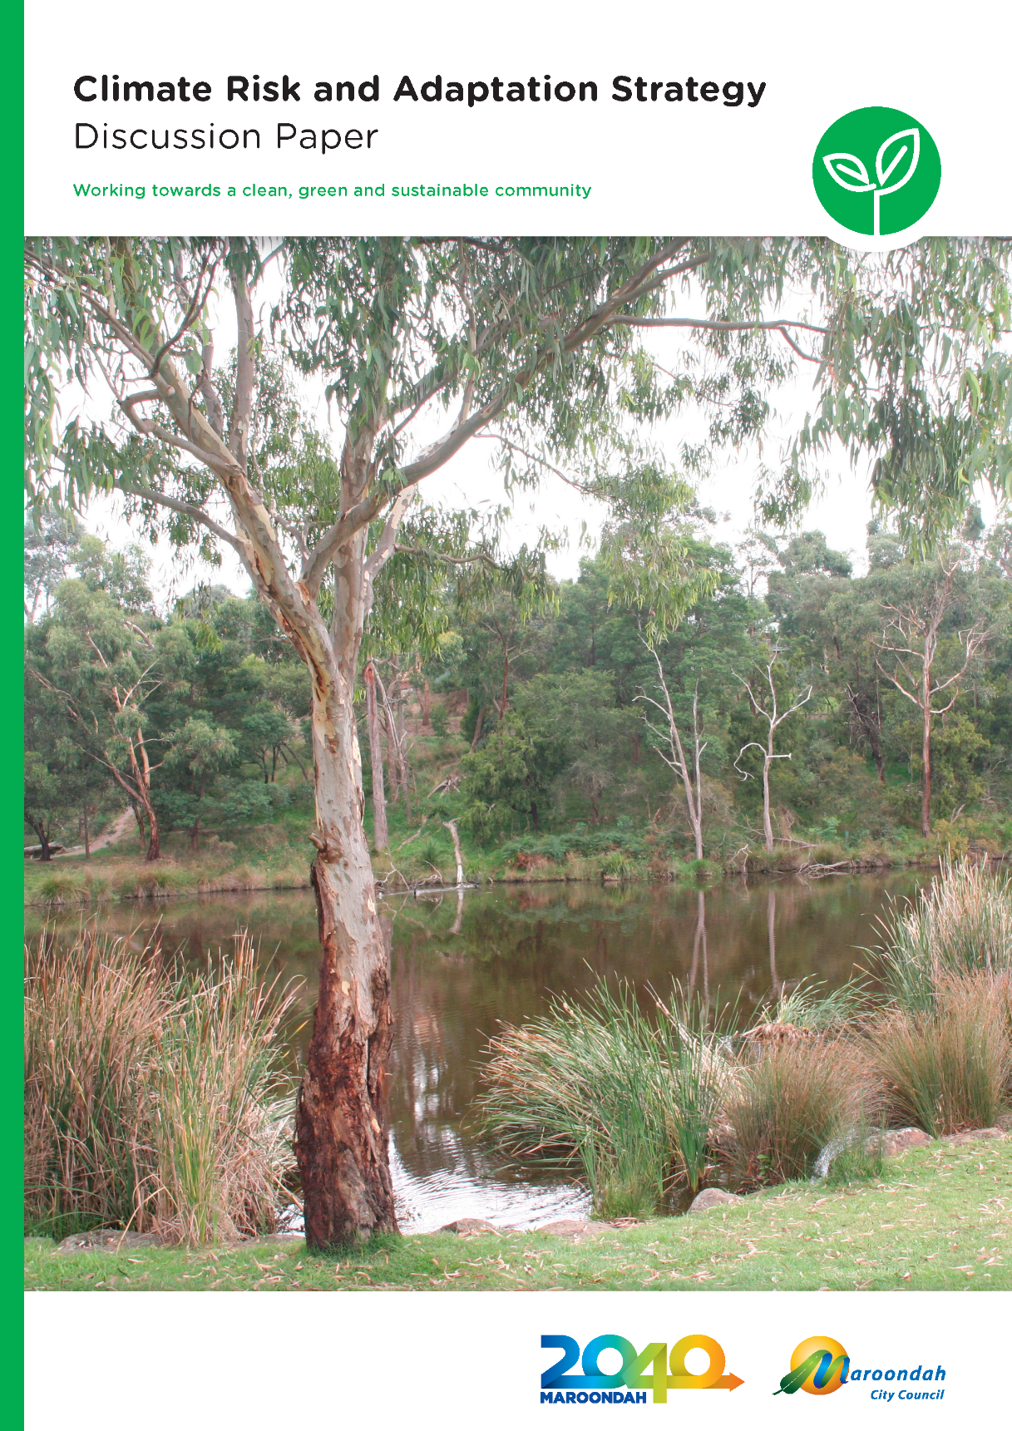
Ringwood Lake Park
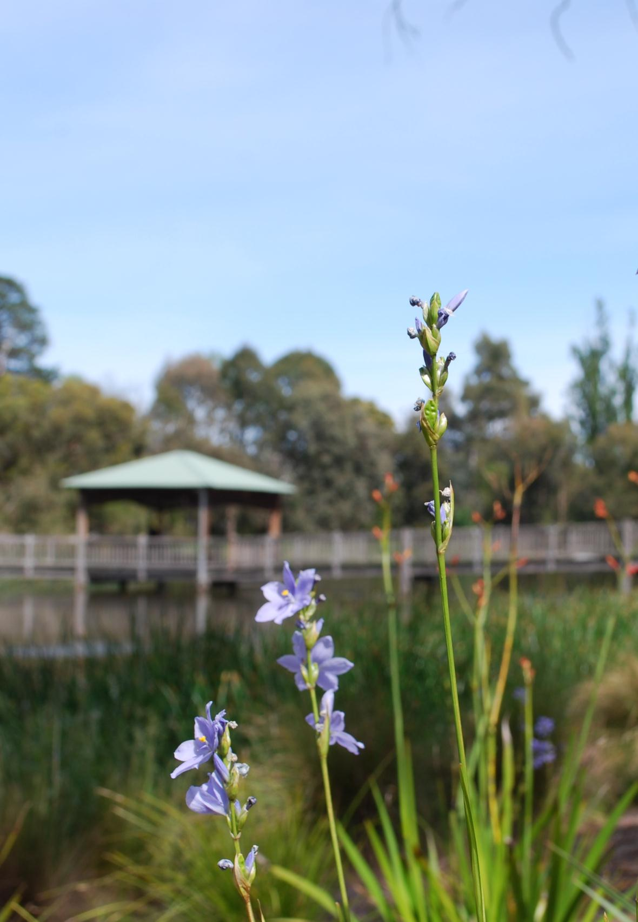

Towards climate resilient people and places in Maroondah

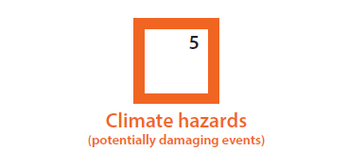

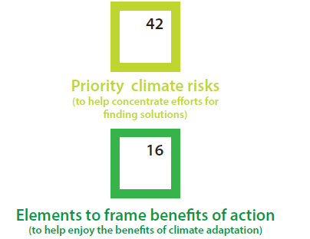

Foreword

What is climate adaptation?

For Maroondah, adaptation means changing the way we behave and do things, in order to be more appropriate for the future climate.
Adaptation allows us to better manage the risks of climate change.

Have your say

By taking a risk based approach and through early action, Maroondah has the opportunity to meet the challenges and act on the opportunities of extreme weather events and climate change.
Climate change has the potential to disrupt various aspects of our lives – with effects and impacts on the special places we love in Maroondah.
The good news is that addressing climate risks can improve Maroondah in many ways.
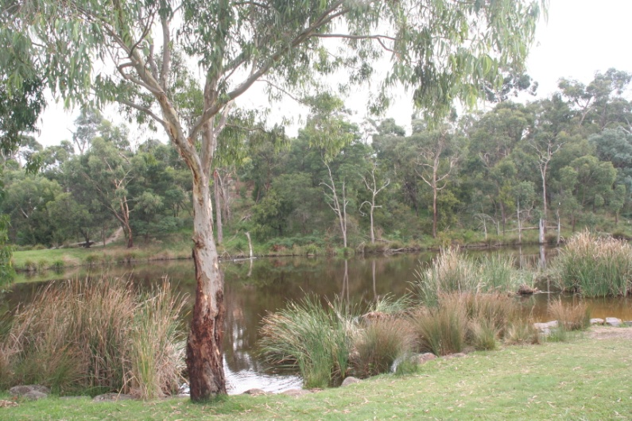
Figure: Candlebark Walk Reserve in Croydon Hills

The first edition of the Climate Risk and Adaptation Strategy will have an emphasis on Maroondah City Council’s operations, including service delivery to the community and infrastructure, and actions to address significant and high risks. The developing strategy builds on and progresses adaptation work that has already been done by Council.

This document has been prepared by Council following evidence provided by staff from across service areas and initial consultation with key stakeholders and the community. It outlines:
- Our climate risks: with impacts and effects for Council across service areas, some of which interface with the community
- Our goals: to move towards climate resilient people and places in Maroondah
- Our adaptation-shaping principles: what best practice adaptation means for Maroondah
- Our key directions and priority action areas: to reduce vulnerability of the people and places at risk of climate change and embed Council’s commitment to climate adaptation in Maroondah.

As a vehicle for public consultation, questions are posed throughout this document and comment is invited.

Contents

Climate affects many things Maroondah residents value 7
Strategies to manage climate risk 8
Adaptation is a shared responsibility 9
Maroondah’s approach: working with others 12
Our climate adaptation methodology 13
Section 1 – Research: understanding the effects and impacts in our local context 14
What are our climate risks? 16
Section 2 – Potential: adapt (modify the risk through mitigation) 26
What are our goals? 26
What are our adaptation shaping principles? 28
What are our key directions and priority action areas? 32
Appendix 1 – Priority climate risks 36
Frequently asked questions and glossary 41

Climate affects many things Maroondah residents value

What our community said when asked to imagine life in Maroondah in the year 2040...

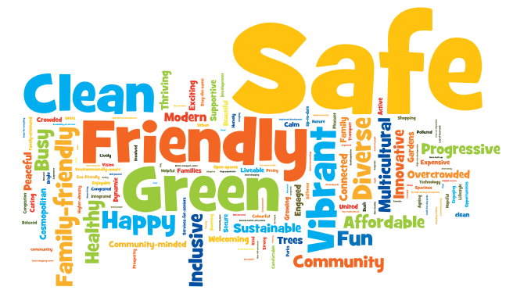

Climate change at a basic level will affect our natural environment, health, leisure activities and costs.

Strategies to manage climate risk

There are two strategies to manage climate risk. Maroondah defines them as:
- Climate change mitigation – actions that avoid or reduce greenhouse gas emissions, and
- Climate change adaptation – changing the way we behave and do things, in order to be more appropriate for the future climate.

Council is strongly committed to both types of action. Our mitigation response is outlined in our Carbon Neutral Strategy – which is guiding Council to 2020 and 2025 reduction targets. This discussion paper will focus on our adaptation response. While we acknowledge that mitigation is necessary to avoid or reduce greenhouse gas emissions (to avoid the risk we might see in our climate), we also acknowledge that some of the impacts of climate change are already locked in, due to past emissions – no matter what we do. The climate risks posed will need to be addressed. Therefore adaptation is required as well.
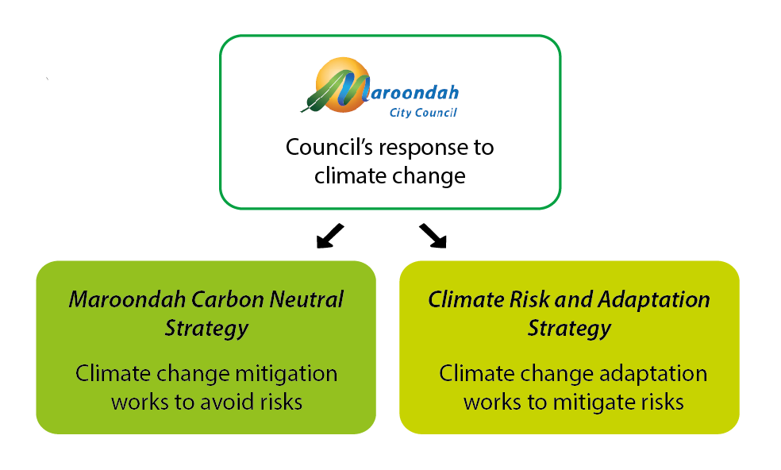
Figure: Strategic direction on climate change

At a local level, a key direction of the Maroondah 2040 Community Vision is to ‘Mitigate and adapt to the effects and impacts of climate change’.
Council has acknowledged in the Maroondah Sustainability Strategy the need to complete the developing strategy.
In particular, we need to plan for the likelihood of more intense rainfall and storm events, flooding, prolonged drought conditions, and more heatwaves. By taking action now, we will be well placed to respond to climate change now and in the future – building a stronger and better Maroondah together.

Adaptation is a shared responsibility

International action

The Paris Agreement acknowledged adaptation as needed, and for the first time, the temperature and adaptation goals were linked. It acknowledged that there is a relationship between the concentrations in the atmosphere and the adaptive actions that are needed.
Federal Government

In 2015, the Federal Government released the National Climate Resilience and Adaptation Strategy. The strategy sets out how Australia is managing climate risks, identifies a set of principles to guide effective adaptation practice and resilience building, and sets a vision for the future and principles to shape adaptation practice.
State Government

The Climate Change Act 2010 addresses both climate change adaptation and mitigation. The Act requires the Victorian Government to take climate change into account when making decisions under the Public Health and Wellbeing Act 2008 and other key legislation affecting Local Government.
The Victorian Government is currently working to update its Climate Change Adaptation Plan which will be released in early 2017.
Australia’s first city resilience strategy

The Resilient Melbourne Strategy brought Melbourne’s 32 metropolitan councils together to work in partnership to build the resilience of Melbourne. Developed with the support of 100 Resilient Cities (100RC) – pioneered by the Rockefeller Foundation – the strategy sets out actions to build the resilience of Melbourne to a wide range of shocks and stressors – of which climate change is one.
It represents a starting point that brings together various representatives to develop new ways to deal with chronic stresses and acute shocks. Flagship actions include a metropolitan urban forest strategy, an emergency management community resilience approach for Victoria and a metropolitan cycling network.
Productivity Commission highlights the need to adapt to climate change
The Productivity Commission’s investigation into the barriers to effective climate change adaptation suggests barriers may result from one or more of the following:
- Market failures – conditions that prevent markets from allocating resources to the uses or areas where they are most highly valued.
- Policy and regulatory barriers – regulation (or an absence of regulation) that inhibits effective adaptation. For example, a lack of integration of building and planning regulation could create a barrier to adaptation where neither system appropriately manages a particular risk to property (such as flooding).
- Governance and institutional barriers – poor governance arrangements impede coordination between governments and agencies, reduce accountability or lead to authorities being allocated responsibilities that they do not have sufficient capacity to carry out effectively.
- Behavioural and cognitive barriers – the way people process information and make decisions could act as a barrier to effective adaptation.

Governments’ role in securing effective adaptation to climate change may include:
- Managing climate change risks effectively in their own activities
- Ensuring regulatory and policy frameworks do not impede private risk management
- Correcting market failures
- Managing the consequences of climate change for disadvantaged and vulnerable groups.
Local Government

Local Government is leading the way on climate change adaptation, in Victoria, Australia and internationally – a fact recognised at the COP 21 climate negotiations in Paris in 2015.
Maroondah states in the Maroondah Community Wellbeing Plan how it has regard to climate change, in order to demonstrate that it has met its obligations under the Climate Change Act 2010. In addition, Maroondah has specific responsibilities for prevention strategies (such as for flood, other natural events, or fire) under the Emergency Management Act 2013 and the Country Fire Authority Act 1958.
Important Council areas affected by climate change are:
- Open space and water security
- Assets and infrastructure (green and grey)
- Community wellbeing and emergency management
- Planning, building and regulation
- Council service delivery.

In recognition of this it is important that relevant strategies and plans consider climate change and respond in an appropriate way. At Maroondah there are various strategies that already consider climate change and include adaptation action.

Existing Council plans and strategies most relevant to climate change adaptation:
- Council Plan
- Community Wellbeing Plan
- Maroondah Sustainability Strategy
- Municipal Emergency Management Plan and related sub-plans (municipal heatwave plan and storm and flood emergency plan).
The developing strategy represents the useful combining of projects, to efficiently achieve the targets in the Maroondah Sustainability Strategy, Water Sensitive City Strategy, Open Space Strategy and more.
While Council can take the lead in preparing a Climate Risk and Adaptation Strategy, in order to be meaningful and effective, it needs to be aligned with State and Federal Government policy and community values.

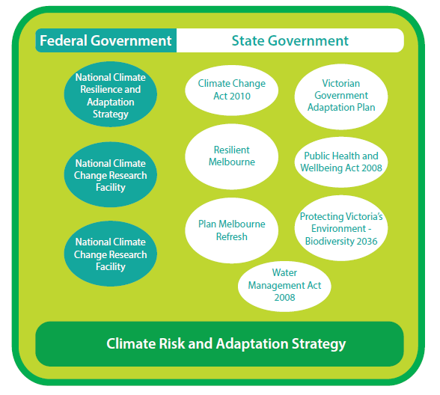
Figure: Links to State and Federal Governments strategic direction on climate change

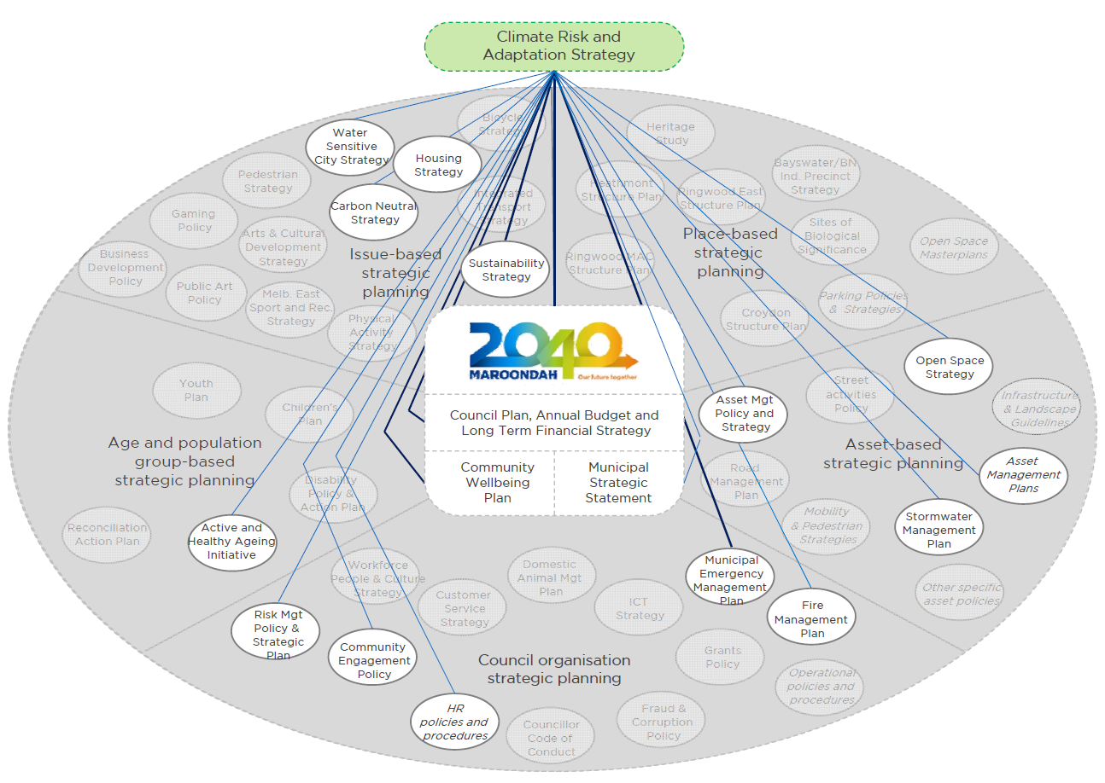
Figure: Links to other Maroondah City Council policies, strategies and plans

Maroondah’s approach: working with others

Various forums exist to connect Local Government officers to their counterparts in other councils.
Melbourne’s eastern councils are also seeking to adapt. In 2008, the Eastern Alliance for Greenhouse Action (EAGA) began as an informal network of councils committed to addressing climate change issues through the delivery of community programs. Since then, EAGA has grown to a formal collaboration of seven councils including City of Boroondara, City of Knox, Maroondah City Council, City of Monash, City of Stonnington, City of Whitehorse and Yarra Ranges Council.
The group work together on regional programs that reduce greenhouse gas emissions and facilitate regional adaptation.
Identify risks

The developing strategy is informed by a risk assessment. This will include long term projections for our climate out to years 2030 and 2055 to help plan for different future scenarios in a changing climate.

Council is an active participant with the EAGA municipalities.
In 2014, EAGA produced the Climate Change Adaptation Roadmap for Melbourne’s East: A guide for decisions makers in the EAGA Councils. The document is informed by a regional climate risk assessment, and identifies priority actions to address the impacts of climate change on council operations, assets and service delivery responsibilities as outlined in the Roadmap. Priority regional actions were identified and councils are taking actions on these in their own municipalities. Priority actions included:
- Regional vulnerability assessment
- A Cool East Strategy
- Solar rates for low income households heatwave preparation and response
- Adapting strip shopping precincts
- Improving electricity network reliability
- Maximising alternative water sources
- Regional capacity building program
- Biodiversity monitoring framework and responses
- Strengthen and diversify the regional food economy.

Council is now preparing its specific adaption strategy in accordance with this Roadmap.
The developing strategy makes use of the data from the before mentioned risk assessment workshop carried out by Council in partnership with the EAGA. The workshop, held in 2014, engaged staff from all service areas across Council, to gain a wide cross-section of input. The process identified a wide range of potential adaptation actions that Council could implement.
This was supplemented by research into adaptation measures undertaken by other municipalities. Independent peer review has enhanced the robustness of the work completed to date.
Take action and embed Council’s commitment

The developing strategy is tailored to understand vulnerabilities and build resilience, lead by example and demonstrate climate adaptation performance.

Council is an observer council as part of the Western Alliance for Greenhouse Action (WAGA) Victorian Adaptation and Sustainability Partnership (VASP) project ‘How well are we adapting?’.
The project is developing a regional monitoring and evaluation framework to understand climate vulnerabilities and the effectiveness of adaptation actions. As part of this pilot project, Council has undertaken data collection on various indicators.

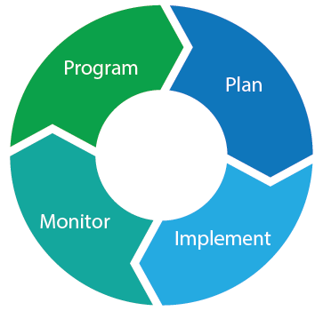
Our climate adaptation methodology

Climate change adaptation is an ongoing process, and there's no single recipe for success, with different approaches to different situations. The broader program can be thought of as having four stages, the development of the strategy ‘planning’ is just one of the stages:

Figure: The planning cycle

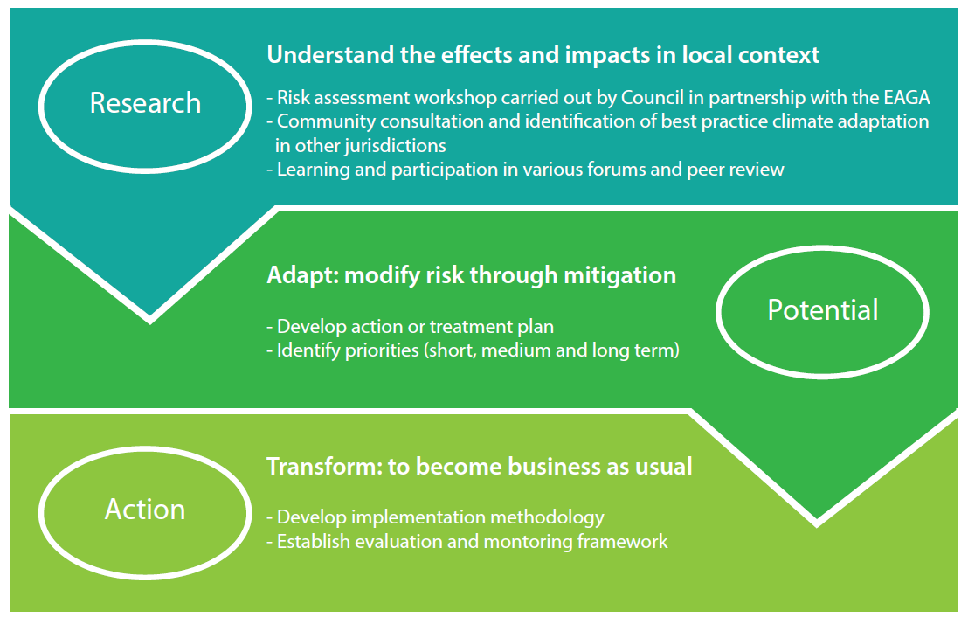
Figure: Methodology and fitting together different levels of detail

Section 1 – Research: understanding the effects and impacts in our local context

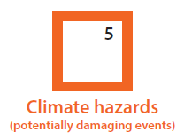 | For our region, we need to plan for the likelihood of:  - Heat (including number of hot days and heatwave events)  - Drought  - Bushfire weather conditions  - Severe weather (storms etc.)  - Flooding.

Over the past 20 years, Maroondah has experienced many climate events that have affected things that the community values. Many of the risks we face are not new, but their duration, frequency and severity will change.
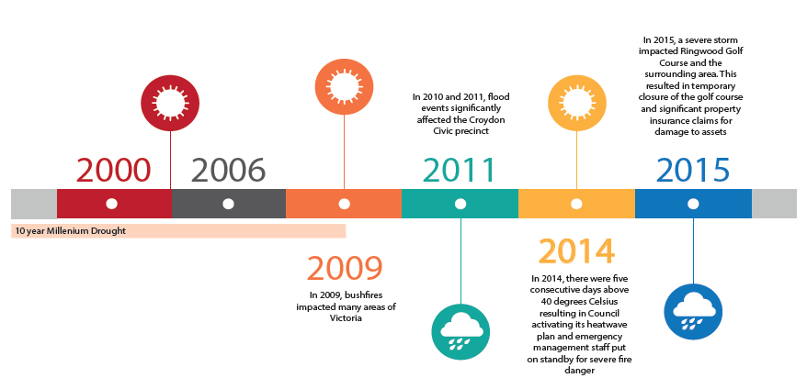
Figure: Illustrative chronology

Each of these events has affected different components of our City and our community and caused significant costs.
Furthermore, there are legacy impacts. For example – natural environment impacts of the Millennium Drought may still be seen today.
In a changing climate, it is likely that more of these events will occur with greater intensity or at a greater frequency, or both.
In particular, we need to plan for the likelihood of more intense rainfall and storm events, flooding, prolonged drought conditions, and more heatwaves.
The hotter drier conditions combined with an increase in the frequency, severity and extent of extreme weather events is likely to multiple existing risks and associated costs faced by Council.
There are also secondary impacts. Secondary impacts include:
- Impacts on health and wellbeing
- Impacts on species and ecosystems
- Energy costs
- Insurance costs
- People seeking refuge from extreme impacts, such as heatwaves.

The economic and health impacts of heatwaves
The Climate Council’s report 2015, The Silent Killer: Climate Change and the Health Impacts of Extreme Heat found that heatwaves have been shown to dramatically affect patient pressure on health services. During the heatwave in southeast Australia in January/February 2009, emergency call-outs increased 46 per cent; cases involving heat-related illness increased 34-fold; and cardiac arrests almost tripled in Victoria. In total, 374 excess deaths were recorded, a 62 per cent increase on the previous year.

What are our climate risks?

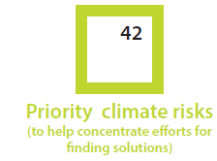 | To effectively develop a strategy that responds to climate risks for Maroondah, the highest priority risks are those that fall in the significant and high categories in the 2030 scenario.

The task is to help understand and then manage likely climate change impacts in the local context.

Council faces significant community, environment and economy impacts from climate change across a number of sectors, including water security, bushland and urban biodiversity management, urban communities, and infrastructure.

The majority of identified risks for Council across service areas are related to combinations of climate hazards occurring either simultaneously or separately, and some risks are related to all five hazards occurring.

In total, 54 risks were identified in the risk assessment. To optimise research and management efforts, the low-level risks have been excluded from this document.

To help concentrate efforts for finding solutions, the priority risks (those that fall in the highest categories in the 2030 scenario) are available in full at Appendix 1.

For ease of ownership, risks have been categorised by department. Some risks will overlap across a number of different service areas, however each risk has a lead department to make it easier to track, monitor and record against.

The following figure illustrates Council’s risk profile and the change in ratings between 2015, 2030 and 2055. In reviewing the risks, taking early action is important to avoid the worst impacts and associated costs.

Existing actions to reduce risk were considered in the assessment to determine the rating (i.e. these are residual risks). Featured adaptation is discussed overleaf.

Did you know?

Maroondah has a Risk Management Framework that outlines Council’s arrangements for designing, implementing, monitoring, reviewing and continually improving risk management.

Case studies of what we are already doing

Actions to address extreme weather events and climate change have already been undertaken by Council, however, not necessarily under the umbrella of ‘climate change’ adaptation.
The developing strategy is intended to build on and progress adaptation work that has already been done by Council.
Featured adaptation work:

“Service criticality” review

Council has been undertaking a “service criticality” review, identifying which buildings provide the most critical services to the community, to help prioritise decision making.

Managing our stormwater
Investigations into our stormwater drainage system are continuing, including detailed catchment analysis and flood mapping of the most flood prone areas. We are gradually introducing new techniques to manage stormwater by filtering it before it reaches local waterways and providing storage areas that will help to reduce the risk of flooding.
Water Sensitive Urban Design
Council has constructed a number of raingardens in the municipality. Examples:
- Larissa Avenue, Ringwood raingarden
- Ringwood North Community Centre
- McAdam Square car park, Croydon Hills
- Bayview Rise, Bayswater North.

Street trees registered
Over recent years, Council has been working towards the completion of a street tree asset register so that a dollar value can be created for these assets to help reduce risk and achieve multiple benefits.

Rare plant program
Council has commenced a program with the local community nurseries to grow rare indigenous plants or plants with declining populations. The program will see these rare species planted in local bushland reserves in a bid to promote growth of these species.
Heatwave planning
The impacts of higher temperatures are already being seen. It should be remembered that heat is a climate impact that affects all municipalities across the state, and one that all Victorian Councils currently address through their heatwave plans. Compliance with Occupational Health & Safety (OH&S) responsibilities remains a high priority – for example, staff members are trained to identify and treat heatstroke at leisure centres to ensure health and wellbeing. Any additional activities undertaken in ‘having regard’ to climate change will build on the good work already being done by Maroondah in this area.
Participate in the Eastern Metropolitan Council’s Emergency Management Partnership
Council is a signatory to the Eastern Metropolitan Council Emergency Management Partnership which primarily focuses on the provision of staff from eastern metropolitan councils to set up and assist in the operation of Emergency Relief Centres (ERCs).
Collaborate with the EAGA
Council has continued its membership and active collaboration in the Alliance and the hosting of the Regional Coordinator position within its offices.

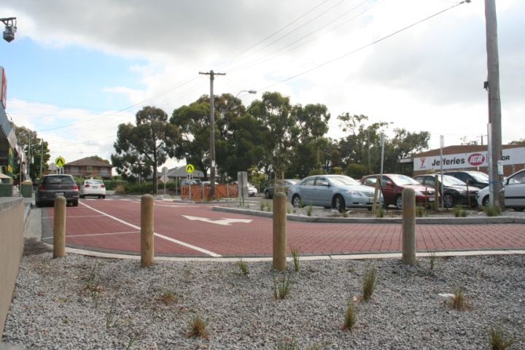
Figure: Water Sensitive Urban Design at McAdam Square car park, Croydon Hills

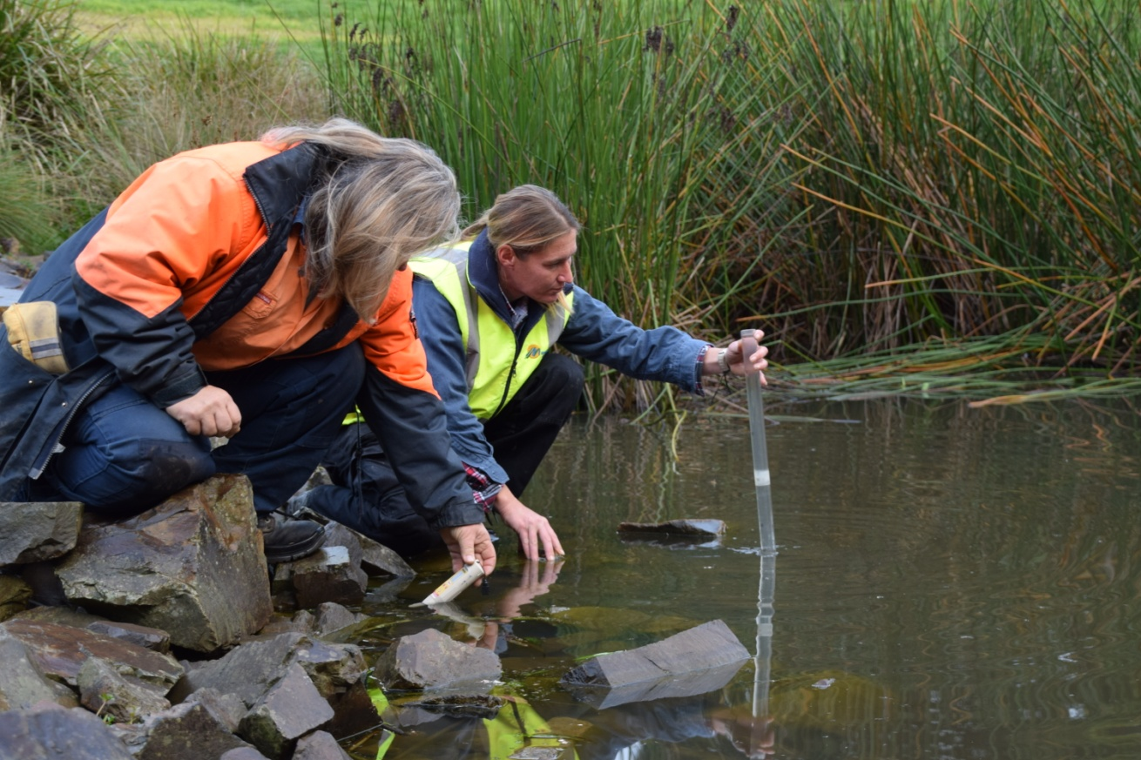
Figure: Wetlands help to improve water quality and this leads to a healthier environment

Issues

The overarching issue is changing climate conditions characterised by more intense rainfall and storm events, flooding, prolonged drought conditions, and more heatwaves.

- People

While everyone is likely to feel the effects of climate change, there are some people that will be more vulnerable than others.
The vulnerable members of the Maroondah community, as identified in the Municipal Emergency Management Plan are:
- People with English as a second language
- Refugees from overseas
- Children and the elderly
- People with disability, and
- Those displaced by or recovering from an emergency event.

The elderly, isolated and very young are the highest risk groups within our community. By 2020, 40 per cent of Maroondah’s population will be aged 45+. There is increased illness and mortality risk to vulnerable populations during heatwaves. Temperature increases lead to increased energy demand from cooling. Energy prices are expected to rise in the future so energy efficiency programs that reduce greenhouse gas emissions and energy bills will help the Maroondah community prepare for some of the impacts of climate change.
Culturally and Linguistically Diverse (CALD) communities are also at risk due to different cultural knowledge and restricted access to information.
In addition, the following specific locations and groups are vulnerable to the effects of climate change in Maroondah:
- Areas susceptible to flooding
- Areas with a wildfire management overlay, and
- People who work or are physically outdoors (some staff are especially exposed).

- Places

There are some places that will be more vulnerable to climatic events than others.
Council owns assets which cater for vulnerable populations and which themselves may structurally be more vulnerable to climatic events and/or in locations most vulnerable to such events. Such assets include:
- Child care centres
- Kindergartens
- Senior citizens centres
- Playgrounds
- Trees, gardens, lawns
- Sporting pavilions and complexes
- Community houses
- Emergency relief centres.

Key risk areas for Council around stormwater runoff and flooding include damage to and loss of land and assets, impacts are likely to be short term and episodic.
Rainfall and flooding cause infrastructure damage and pollution.
Our drainage system is made up of ageing infrastructure. This is a risk as reduced asset life spans and degredation during more intense rainfall and storm events is an issue, which will be exacerbated under climate change.
Infrastructure-related emergencies are related to extreme weather events and climate change.
Extended dry periods over summer and wet periods over winter have continued to impact severely on the condition of local sporting fields, which in turn reduces their capacity and availability for user groups.
Temperature increases have led to demand for and costs of irrigation.
Recent years have seen a continued loss of canopy trees in Council’s bushland reserves and streets. Whilst investigations continue, the reason for their decline have not yet been determined.
Dieback also raises problems with increased fuel loads and safety issues with falling trees and increased undergrowth.
Extreme weather patterns have impacted on bushland areas with vegetation and plant species declining and extended fire seasons have also been experienced.
There are increasing infill development pressures. Most at risk are small remnant flora and fauna sites and more isolated biodiversity sites across the municipality – a product of our modified urban landscape.
There are many drivers impacting on invasive species, including weed spread (e.g. landscape change, disurbance and climate change).
Climate change is likely to affect all parts of living systems and to multiply and compound existing pressures.

Immediate risks associated with climatic events:
- Loss of power, water and sewerage services
- Building damage
- Falling/flying debris
- Overheating of buildings
- Fire (caused by lightning, damage to electrical wires, bushfire)
- Inundation by flood waters
- Damage to parks, gardens, roads from drought.

- Other

Other issues include:

- The need to advance Maroondah’s climate resilience
- Understanding of risks and potential response options, as well as awareness in different contexts
- The need to fund and resource
- The ability of a service or asset to cope with and recover from the impact of extreme weather
- Business continuity and risk management is likely to be impacted by rising costs of insurance policies and increased need for proactive risk management
- The need to improve knowledge, staff training etc.
- We are operating in a data limited situtation.

Setting the context

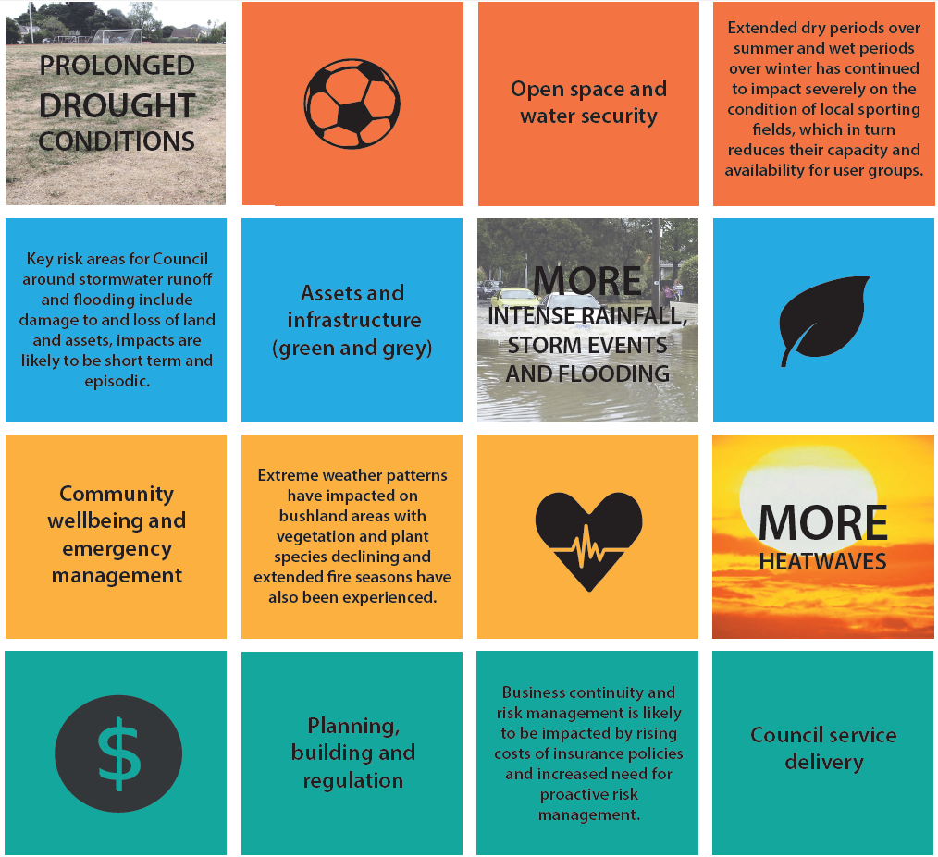
Figure: Climate change effects and impacts, including important Council areas affected by climate change

Values

The community engagement for Maroondah 2040 Community Vision made it clear that our community values liveability, our natural environment, safety and services. The community love connectedness, open space and trees and want more. All these things could be affected by climate change, so the developing strategy is shaped around building the resilience of our municipality so our community can continue to enjoy the things they value.
Service delivery assets under the control of Council (road and drainage networks, parks and garden’s assets, major leisure facilities, and Council buildings) leave fingerprints of our values, and our ability to adapt. So do the remaining assets outside the control of Council – such as existing commercial buildings and housing.
We are constantly adapting to change in an ever changing environment.
The tap leaks, and we replace the sink. A street tree deteriorates beyond repair during an unseasonable hot spell, and we plant a new one. The challenge is finding appropriate adaptation actions. If a new tree dies after the next prolonged period without rainfall, perhaps a different species should be selected.
Selecting a variety of tree species in public realm improvements will optimise resilience to climate change and disease.
While ﬁne-grain design details are not resolved in this document, including tree species selection for planning to maintain our distinctive leafy profile, the nature of interventions, including street tree asset enhancement and management planning are introduced.
It should also be mentioned that personal experiences shape our values, for example – education and community engagement activities and citizen science initiatives can help residents to become involved in climate adaptation.
However, what is most important is listening to the community and shaping their values into the places they love.
We will ask people to think deeply about what makes a great place.

Question
Why does climate change matter to you?
Question
Do you have a story to tell about your own experience of adapting to climate change?
Question
What does a climate resilient community look like to you?

Benefits framework

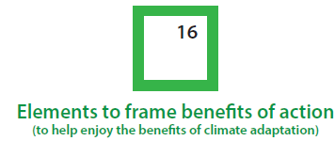 | There are likely many more benefits of climate adaptation. However, these are a good starting point to help us think from an integrated perspective (to help bring things together).  Key message: The benefits of taking action should be achievable and demonstrated through our climate adaptation performance.

There are a range of social, economic, environmental and political benefits of climate adaptation. For Maroondah, there are social adaptation benefits (such as health, safety and happiness) of for instance working to improve resilience of the built environment. Similarly, investment in tree health under a changing climate, will not only protect/improve ecological values, it will support community values and add to the vibrancy of Maroondah.

Did you know?

Ecosystem and social resilience: “Biodiversity helps to improve the resilience of ecosystems, boosting their ability to adapt to climate change and moderating the impacts of disasters. It also helps create societies that are more resilient to disasters and change.”

When benefits are aggregated to include a liveable and climate-adapted Maroondah, the benefits clearly outweigh the cost of inaction.
With regards to access to nature (including in a changing climate), it should also be acknowledged that while all population groups can benefit, specific groups benefit in different ways, particularly children. For example – access to parks is particularly relevant for children who may be in families experiencing social or economic disadvantage.
Social | Economic | Environmental | Political
Health | Prosperous | Clean | Inclusive
Safety | Vibrant | Green | Thriving and well built
Happiness | Connected | Sustainable | Well governed
Diverse | Accessible | Active | Empowered
Figure: Benefits framework for integrated planning

Question

Are the adaptation benefits of health, safety, happiness and vibrancy important for Maroondah in climate adaptation? Are any of these benefits more important to you than others? If so, please tell us why.

Section 2 – Potential: adapt (modify the risk through mitigation)

The developing strategy makes clear Council’s commitment to climate change adaptation in Maroondah. It undertook a risk assessment and highlighted key priority areas for adaptation actions.
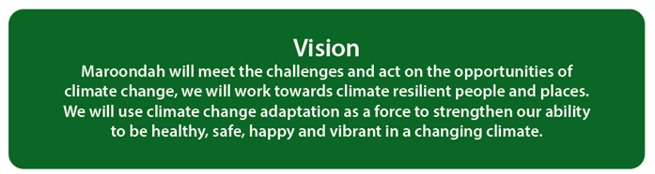

What are our goals?
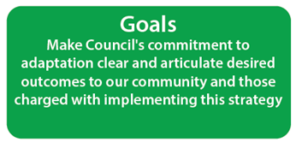

The following goals for the developing strategy build on and progress adaptation work that has already been done by Council and will drive action over the next four years and beyond.

“A vision of a climate resilient Maroondah that both demonstrates leadership and is tailored to being performed.”
Question
Do you support the vision?
Question
Will the goals set us up to acheive a climate adapted Maroondah? Are any of the goals more important to you than others? If so, please tell us why.
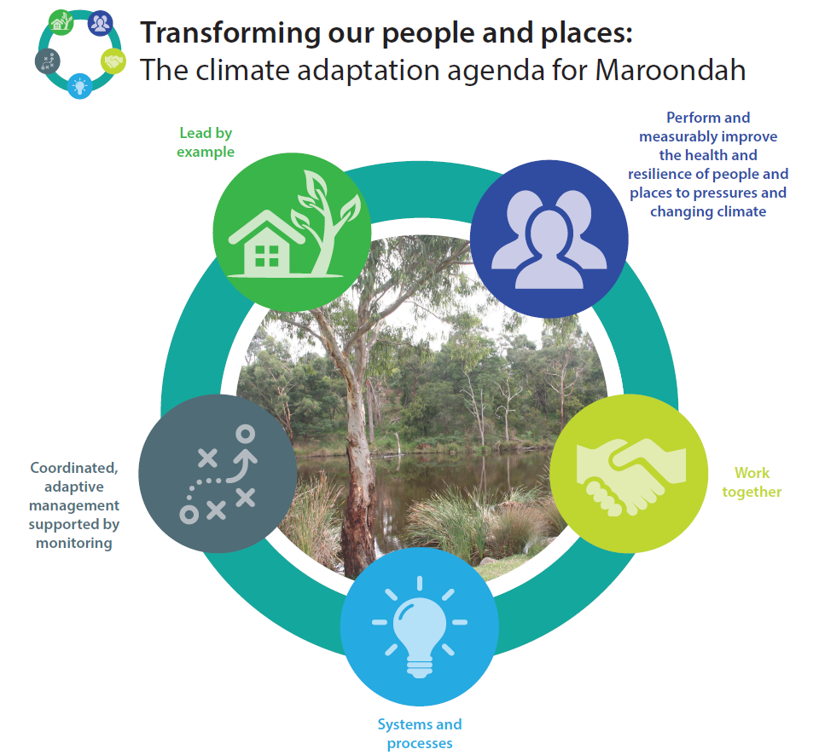
Building on our existing sustainability commitments, Maroondah’s climate change adaptation response spans five key goals:
- Lead by example: through integrated planning and strategic interventions we will enjoy the benefits of integrating climate risks and embedding mitigation into open space and water security, assets and infrastructure (green and grey), community wellbeing and emergency management, planning, building and regulation and Council service delivery.
- Perform and measurably improve the health and resilience of people and places to pressures and climate change: through building the adaptive capacity/resilience of our community and natural environment. Each generation should ensure that the health, diversity and productivity of the environment is maintained or enhanced for the benefit of future generations (inter and intra-generational equity). Council will continue to demonstrate its commitment to sustainability through integration of economic, social and environmental (triple bottom line) factors.
- Work together: we all have a role to play. Empowered and educated communities are required to effect more sustainable societies. Council will continue to demonstate its commitment to sustainability by forming partnerships where needed for the best outcomes.
- Systems and processes: enable Maroondah to adapt to climate change impacts and avoid unintended consequences (maladaption). Council will continue to demonstrate its commitment to sustainability by concentration of efforts into areas where the most significant change can be effected.
- Coordinated, adaptive management supported by monitoring: minimise greater cost burdens in the future and best manage the uncertainty associated with climate change, for management effectiveness and to make decisions about whether goals should be revised. Council will continue to demonstrate its commitment to sustainability through ongoing monitoring which indicates the effectiveness of our decisions and facilitates continual improvement.

What are our adaptation shaping principles?
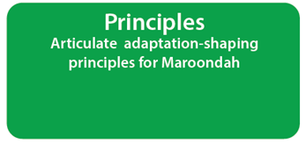
What best practice adaptation means for Maroondah:

- Listen to the community and shape their values into the places they love

- Perform under a number of different future scenarios

- Consider all climate hazards when developing adaptation actions

- Do not increase vulnerability of people and places to climate risk

- Measurably improve the health and resilience of people and places to pressures and climate change

- Tailor actions and treatments to being performed

- Prioritise actions according to cost and impact, both short and long term

- Do not create unintended consequences (maladaptation)

- Consider co-benefits through adaptation action rather than single outcomes

- Meet planned budgets

- Be flexible and iterative

- Improve and invest in knowledge improvement.

These principles will inform the implementation of the developing strategy.

Risk based approach

What is a risk based approach?
A risk based approach involves considering the likelihood and consequences of impacts, to make decisions in relation to a range of issues that pose actual or potential risks. This means:
- Focusing resources where there are potential risks and using a robust management approach
- Identifying and understanding risks
- Targeting priorities, for risk action or treatment.

Why do we need a risk based approach?
Risk assessment is fundamental to getting risk management right. There are plenty of sources of risk analysis models. The central dynamics of some popular models include the following. Key terms:
- Hazard = the potentially damaging event.
- Exposure = the people and places exposed and their degree of exposure.
- Vulnerability = the people and places most at risk.

Sometimes these three stages have been represented as a “Risk Triangle”.
Vulnerability is a function of exposure, sensitivity and the adaptive capacity of the system. Climate change vulnerability refers to susceptibility to impacts resulting from climate change.
A standard risk assessment methodolgy was used for the project in line with AS/NZS ISO 31000:2009 Risk Management – Principles and Guidelines on Implementation.
The importance of modifying risk through mitigation
When a risk is established, the most important task is to reduce it. This is the role of mitigation.
When mitigation is added to either of the key terms mentioned above, you can potentially modify (hopefully reduce) the identified risk.

Creating an effective framework for climate adaptation

Working towards climate resilience... | Going nowhere...
Council leadership in climate adaptation, to community satisfaction | Liability and reputational risks to Council
Include climate risks in strategic risk assessments (proactive management) | Only base planning on past risks (reactive management)
Service vulnerability or resilience: understand service vulnerability or resilience (where appropriate, also measure action effectiveness) | Insufficient attempt to understand service vulnerability or resilience
Work with neighbouring councils and other service providers and asset managers, and help build institutional capacities: as catalyst for climate change planning, management and adaptation | Lack of appropriate networks, structures, institutions, processes or frameworks to respond
Business continuity and benefits to operations of improved climate resilience, both short and long term | Reduction in capacity or loss of Council service delivery during an un-planned for extreme weather event. Is this a sustainable approach?
Budgeting and finance: actions and processes to address climate change are costed, budgeted and financially provided (where appropriate, also understand financial impacts of changing climate) | Funding and resourcing not proportionate to risk
Participation and awarenesss: involves all relevant stakeholders, provides opportunities in climate adaptation (where appropriate, also evaulate stakeholder awareness) | Communities that are incompatible with a changing climate

Aims and objectives of this developing strategy

Adaptation strengthens our ability to be safe, healthy, happy and vibrant in a changing climate. These benefits will be widely recognised and valued. The developing first edition of the Climate Risk and Adaptation Strategy, aims to guide and focus Council’s work to integrate climate change risk management and adaptation strategy and implement recommendations. The developing strategy builds on and progresses adaptation work that has already been done by Council.
“Adaptation cannot be technology centred. It is about the quality of life.”
Christiana Figueres, Executive Secretary of the United Nations Framework Convention on Climate Change
Building on what we have heard from the community, the developing strategy recognises four overarching objectives:
Objective one: To plan for and manage the risks of climate change, in particular the potentially damaging events of more intense rainfall and storm events, flooding, prolonged drought conditions, and more heatwaves.
Objective two: To protect our natural environment, the health of our biodiversity and working waterways and the usability of our open spaces and help manage impacts and associated costs in a changing climate.
Objective three: To provide opportunities for partnerships and collaboration with stakeholders and community involvement and support for climate adaptation.
Objective four: To “future proof” policy and decision making so that operations, including service delivery to the community and infrastructure, remain viable under the widest possible range of climate scenarios and to support all of the objectives above.

Did you know?
Green infrastructure and modified urban environments: “Green infrastructure also ‘value adds’ by linking and connecting existing green assets, which provides benefits both for people, by enhancing public use opportunities, and for the environment by improving urban ecosystem health and countering habitat fragmentation.”

To achieve these long term objectives, Council aims to take an adaptive management approach to action over the next four years and beyond. The developing strategy maps out our approach for adapting to a changing climate.
The foundation strategies focus on:
- Use of a hybrid approach which involves cross departmental support and action, for clear, workable responsibilities across service areas within Council and to build institutional capacity and inform budgets and finance
- Design for best environmental practices in buildings, streets and open spaces to minimise their contribution to the urban heat island effect and contribute to urban cooling, potential for urban greenery, catch stormwater runoff, reduce flooding and support for wildlife etc.
- Reduce service vulnerability and improve service resilience to ensure the ability of a service or asset to cope with and recover from the impact of extreme weather
- Strengthen flood risk protection through the Maroondah Planning Scheme, to ensure land use planning takes into account future flood conditions
- Use the natural environment to build our adaptive capacity through a green infrastructure approach and to achieve multiple benefits, including at the landscape scale
- Priority support for vulnerable people and places
- Work in partnership with relevant stakeholders, including with partners and community leaders, as well as with other service providers and asset managers to avoid and reduce climate risks etc.
- Strengthen risk management and climate adaptation performance.

Use of a hybrid approach
The Australian Centre For Excellence in Local Government’s resource, Climate Adaptation Manual for Local Government: Embedding Resilience to Climate Change includes a step-by-step framework for effectively embedding climate risk into council operations. The hybrid approach is one of the most widely used embedding approaches, in the context of consideration of the full array of climate hazards and risks, rather than one climate issue or event.

What are our key directions and priority action areas?

Key Direction 1: Reduce vulnerability of the people and places at risk in Maroondah

By taking a risk based approach and through early action, Maroondah has the opportunity to meet the challenges and act on the opportunities of climate change.
We want to minimise greater cost burdens in future and best manage the uncertainty associated with extreme weather events and climate change.
To enable the intent of Key Direction 1 to be achieved, Council’s adaptation response will involve wide ranging improvement processes as well as capital works projects. Key Direction 2 will better ensure the enabling architecture is in place to make this happen.

Key Direction 2: Embed Council’s commitment to climate adaptation

Action will involve driving partnerships in responding to climate change and inclusion of climate risks in Council’s corporate risk register and project planning, and will create and sustain local solutions through appropriate planning and operations, finance and resourcing.
We want climate adaptation to become ‘business as usual’.

Priority action areas:

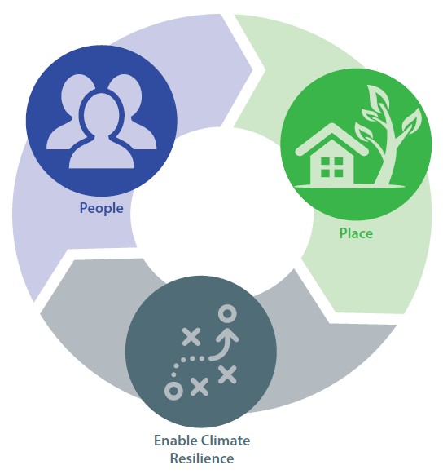

People

People are at the heart of Maroondah. Adaptation strengthens our ability to be safe, healthy and happy in a changing climate. Through Council’s multiple roles and functions we will help our community adapt to climate change.
Adaptation action will be taken to build community preparedness and resilience to the impact of extreme weather on people and the services they access, especially in the community wellbeing and emergency management area.
The developing strategy will help the community adapt through facilitating distribution of communications and education material. The developing strategy will highlight the link between climate change and health, and support communities to address climate risks posed and improve Maroondah in many ways.
Continuing to foster resource sharing in emergency situations (in concert with regional partners) will allow Maroondah to participate in joined-up approaches to managing the effects and impacts of climate change.
The developing strategy will help identify existing and emerging community needs in a changing climate. Behavioural change and support programs will be developed based on barriers and benefits, and will be community-driven.
The developing strategy will foster research partnerships to improve resilience and sustainability into the future.

Places

Adaptation strengthens our ability to be vibrant and prosper without a reduction in service levels. Adaptation action will be taken to build resilience to the impact of extreme weather on places and users/visitors of those places, in the built and natural environment areas.
Many of the assets we own and manage on behalf of our community provide these services. Our Asset Management Policy outlines how asset management will be undertaken across Council. It sets the broad framework for undertaking asset management in a structured and coordinated way, and ensures that this is undertaken using a Total Life Cycle strategy.
The Asset Management Strategy addresses Asset Management Policy goals, and provides a structured set of procedures that are optimised, appropriate and offer agreed service delivery potential using best practice principles.
This is an important area for action and we must ensure our infill development and infrastructure are resilient to climate change as it is much more cost effective to get it right from the start.
Council is continually looking for ways to achieve enhanced environmental resilience within its built environment. As well as in the assets and infrastructure (green and grey) and open space and water security areas.
The developing strategy will drive action to ‘future proof’ or extend the life of the most vulnerable (and high-use/value) assets, including nominated emergency relief centres. The developing strategy will drive updates of land use planning instruments and support policy and decision making to provide proactive risk management. This includes review and update of the special building overlay to take into account future flood conditions.
Actions will also focus on the use of the right water for our green spaces in line with the Water Sensitive City Strategy.
The developing strategy will also focus on actions that support adaptation for the health of the Maroondah area’s natural environment, complementary to the Habitat Corridors Strategy. The developing strategy will see Council adapt management practices in response to landscape change in a changing climate. Investing further in existing long term monitoring sites, as well as establishing new ones, will be an important step in climate adaptation.
Council is committed to protecting the unique features of Maroondah’s landscape, including our ridgelines, waterways, canopy vegetation, green open space, indigenous and planted streetscapes and bushland reserves.
While at risk itself, the natural environment can also be used to help us in climate adaptation management. Green infrastructure has been shown to make us healthier, happier and more productive, catch stormwater runoff, reduce flooding, clean the air and cool our cities. Using a green infrastructure approach, water is a resource. It is important for keeping places healthy and resilient.
Water and greening are two closely linked components, important for us to leverage in our adaptation response. Through a green infrastructure approach, we will reframe climate challenges as opportunities.

Enable climate resilience

Actions will focus on driving strong partnerships in responding to climate change; some risks have broader impacts and will require a coordinated response with others. This will include but not be limited to listening to, and working with, the partners and community leaders identified in the Maroondah Sustainability Strategy.
Close collaboration will also be needed with other service providers and asset managers, particularly Yarra Valley Water, Melbourne Water, VicRoads, Public Transport Victoria etc., especially given the critical nature of some of these assets or services, for which Council does not control.
Climate change is a complex issue that requires embedding adaptation into Council. Council will use a risk based approach to mitigate the risks posed by climate change.
Council will continue to comply with legislative requirements and strengthen risk management processes with priority climate risks embedded in Council’s corporate risk register and project planning. This will help Council build resilience in operations and service delivery and by extension, meet the needs and expectations of our community.
For climate adaptation, additional upfront capital works will be necessary and these need to be adequately resourced. Council has a role to play to minimise greater cost burdens in future and best manage the uncertainty associated with climate change. The developing strategy will be used to leverage finance for adaptation measures to ensure actions and processes to address climate change are costed, budgeted and financially provided.
The developing strategy will also focus on improved business continuity, underpinned by a resilience framework.
The developing strategy will drive action to improve guidance and training to build the knowledge and adaptive capacity of those charged with implementation, the engineers, assets team, planners and other service providers.
The developing strategy will establish monitoring and evaluation arrangements to help us understand our climate adaptation performance to meet our objectives.

The developing strategy will see us advocate for (and where possible undertake in concert with regional partners) effective policy action on climate change at the State and Federal Government level.
Question
We want to know what you think. Are we on the right track and where are the opportunities to work together?
“A climate resilient City maximises opportunities to take adaptation action.” |  | “This initiative will enable more and better adaptation activity for a ‘step change’ towards climate resilience.”

Appendix 1 – Priority climate risks
Legend:
AS Assets
CS Community Services
EN Engineering and Building Services
FG Finance and Governance
HR Human Resources
IP Integrated Planning
L Leisure
OP Operations
P Planning, Health and Local Laws
Outcome Area | Risk Reference | Risk Name & Description | 2015 | 2030 | 2055
1 People | CS1 | Mortality risk to vulnerable populations  Risk of mortality to vulnerable members of community during heatwaves. | Significant | Significant | Significant
 | CS2 | Increased demand on council support services  Increasing number of heatwaves impacts on community leading to greater council demand on support services. | Significant | Significant | Significant
 | CS5 | Reduced council services put vulnerable at risk  Reduced council services during heatwave events pose health risks to vulnerable members of community | Significant | Significant | Significant
 | HR1 | Increased injuries to staff  Increased physical injuries to community and council staff from extreme weather events | Significant | Significant | Significant
 | L1 | Demand on pools pose safety risk  Heatwaves place greater demand on council swimming pools posing risks to staff and public safety. | Significant | Significant | Significant
 | CS7 | Inadequate communication  Lack of adequate communication to community during extreme weather events | Moderate | Significant | Significant
 | CS8 | Increase in water borne diseases  Potential increase in water borne viruses from pollution due to flooding | Moderate | Significant | Significant
 | CS9 | Dust storms leading to public health issues  Increase in dust storms leading to public health issues | Moderate | Significant | Significant
 | IP5 | Hot days reduce mental wellbeing  Increasing temperatures and hot days reduce mental wellbeing in community | Moderate | Significant | Significant
2a Places (Built environment) | AS1 | Bushfire leading to property damage  Increased bushfire danger leads to more losses or damage to council buildings. | Significant | Significant | High
 | AS2 | Climate increases cost of maintaining infrastructure  More extreme climate conditions and weather events damage Council and community infrastructure increasing maintenance and operating costs and reduce asset lifespans and degradation. | Significant | Significant | Significant
 | EN1 | Rainfall and flooding cause infrastructure damage and pollution  Severe rainfall events overwhelm existing drains and retarding basins causing overflow events, localised flooding, damage to infrastructure and environmental contamination. | Significant | Significant | High
 | EN2 | Higher maintenance costs on transport infrastructure  Damage to transport infrastructure during heatwaves leading to higher maintenance and replacement costs and mobility issues | Significant | Significant | Significant
 | IP1 | Increased energy demand from cooling  Increasing temperatures leads to increased energy demand from cooling leading to higher financial costs and GHG emissions. | Significant | Significant | Significant
 | AS3 | Damage to underground infrastructure  Reduced soil moisture levels lead to increase soil movement damaging underground infrastructure such as drains and building foundations | Moderate | Significant | Significant
 | EN3 | Increased rainfall damages infrastructure  Damage to road and drain infrastructure burst water supply pipes and collapse of drains due to increased intensity of rainfall events | Moderate | Significant | Significant
 | IP3 | Reduced water leading to economic impacts  Reduced water availability leads to increased water and fresh food costs leading to broad economic impacts on community | Moderate | Significant | Significant
 | IP4 | High energy costs lead to economic slowdown  Higher energy costs lead to reduced disposable income leading to regional economic slowdown | Moderate | Significant | Significant
 | IP6 | Community concerns about water supply  Inadequate alternative water supply for community and community concerns over reuse and storage | Moderate | Significant | Significant
 | OP11 | Less flushing of roads and waterways  Lack of cleaning, flushing effect of waterways and roads due to reduced rainfall | Moderate | Significant | Significant
 | P2 | Building design standards inadequate  Current building design standards not adequate for projected climate conditions | Moderate | Significant | Significant
2b Places (Natural environment and open space) | FG2 | Increased cost of irrigation  Reduced water availability leads to greater demand for and costs of irrigation | Significant | Significant | Significant
 | OP5 | Pest visitation range changes  Temperature increases leading to changes in pest visitation ranges | Significant | Significant | High
 | OP7 | Increased weed spread  Increased weed spread from flooding events lead to increased costs of weed management and revegetation | Significant | Significant | Significant
 | L2 | Hardening of sportsgounds  Drier and hotter conditions lead to increased hardening of sports grounds leads to higher rate of injuries and rate of claims | Moderate | Significant | Significant
 | OP1 | Loss of biodiversity due to heat  Hotter and drier conditions lead to loss of biodiversity reducing amenity and environmental values. | Moderate | Significant | Significant
 | OP2 | Extreme bushfires lead to biodiversity loss and require increased management  More extreme bushfires lead to loss of biodiversity and long term recovery impacts requiring more management interventions. | Moderate | Significant | Significant
 | OP3 | More damaged and fallen trees  Increased extreme weather events leads to more damaged and fallen trees posing risk to safety, loss of services and increased maintenance costs. | Moderate | Significant | Significant
 | OP4 | Increased environmental management costs  Increasing temperatures lead to loss of biodiversity and increased environmental management costs | Moderate | Significant | Significant
 | OP8 | Higher tree mortality and reduced biodiversity  Reduced water availability leads to higher tree mortality and reduction in biodiversity leading to tree failure and less green areas | Moderate | Significant | Significant
 | OP10 | Conditions favour spread of weeds  Weeds favoured due to drier and hotter conditions increasing competition against native species | Moderate | Significant | Significant
 | P1 | Bushfire leading to increase in chemical contamination  Increased risk of chemical contamination and loss of industrial assets in Bayswater North precinct due to increased bushfires | Moderate | Significant | Significant
 | P3 | Greater fire risk management around reserves  Higher fire risk requires greater management of interface between council reserves and private land | Moderate | Significant | Significant
3 Other | CS3 | Inadequate resources  Council emergency and recovery facilities unable to cope with increased frequency and severity of extreme weather events | Significant | Significant | High
 | CS4 | Reduction in council service  Power and communication outages during heatwaves leads to loss of council service and ability to respond to extreme events | Significant | Significant | Significant
 | FG1 | Emergency response disrupts business continuity  More bushfire danger days lead to more council staff working on emergency response disrupting business continuity | Significant | Significant | Significant
 | FG5 | Changing weather increase property insurance  Increased rate of claims from damage to property and people from extreme storm events and bushfires | Significant | Significant | Significant
 | OP6 | Service delivery failure in extreme weather  Council unable to meet increased demand on council services during extreme weather events | Significant | Significant | High
 | FG3 | Increased climate events reduce council service delivery  Increased resources required to manage and mitigate increasing frequency of climate events reduce other areas of council service delivery | Moderate | Significant | High
 | FG4 | Less staff can attend work due to transport disruption  Transport disruptions during extreme weather events lead to reduced staff able to attend work | Moderate | Significant | Significant
 | FG6 | Insurance premium increase  More extreme weather events reduce public safety and lead to increased rate of claims | Moderate | Significant | Significant
 | OP9 | Extreme weather events require increased costs from recovery  Increased cost of cleanup and recovery from increased frequency and severity of extreme weather events | Moderate | Significant | Significant

Consequence Ratings

Impact Rating Table
1. | Insignificant | - An event where the impact can be absorbed through business as usual.
2. | Minor | - An event where the consequence can be absorbed but management effort is required to minimise the impact.
3. | Moderate | - An event that can be managed under normal circumstances, however additional resources maybe required.
4. | Major | - An event that with proper management can be endured. Additional resources are required and a change in management, processes or system may be required.
5. | Extreme | - An event serve in nature could lead to significant restructure of the organisation or a change in the management structure.

Likelihood Ratings

Likelihood Rating Table
1. | Rare | - Not likely to occur in the next 5 years.  - <25% chance of occurring.
2. | Unlikely | - Could occur at sometime within the next 4 years.  - 25% chance of occurring.
3. | Possible | - May occur at sometime within the next 3 years  - 25%-40% chance of occurring.
4. | Likely | - Will probably occur at sometime within the next 2 years  - >40%-70% chance of occurring.
5. | Almost Certain | - Will probably occur at sometime within the next 1 year.  - >70% chance of occurring

Risk Matrix
Likelihood | Consequence
 | Insignificant | Minor | Moderate | Major | Extreme
Almost Certain | Moderate | Significant | Significant | High | High
Likely | Moderate | Moderate | Significant | Significant | High
Possible | Low | Moderate | Significant | Significant | Significant
Unlikely | Low | Moderate | Moderate | Moderate | Significant
Rare | Low | Low | Low | Moderate | Moderate

Frequently asked questions and glossary

Frequently asked questions

What is climate change?
Change of weather patterns which are attributed directly or indirectly to human activity that alter the composition of the global atmosphere and are in addition to natural variability observed over time.
How does climate change impact City of Maroondah?
Climate change has the potential to disrupt various aspects of our lives – with effects and impacts on the special places we love in Maroondah.
Over the past 20 years, Maroondah has experienced many climate events that have affected things that the community values. Many of the risks we face are not new, but their duration, frequency and severity will change.
Each of these events has affected different components of our City and our community and caused significant costs.
What are the identified climate change hazards for the City of Maroondah?
For our region, we need to plan for the likelihood of:
- Heat (including number of hot days and heatwave events)
- Drought
- Bushfire weather conditions
- Severe weather (storms etc.)
- Flooding.
What is risk?
The chance of something happening that will have an impact upon objectives. It is measured in terms of consequences and likelihood. In emergency management – a concept used to describe the likelihood of harmful consequences arising from the interaction of hazards, communities and the environment.
What do you mean by climate adaptation?
For Maroondah, adaptation means changing the way we behave and do things, in order to be more appropriate for the future climate.
Adaptation allows us to better manage the risks of climate change.
What is mitigation?
When a risk is established, the most important task is to reduce it. This is the role of mitigation.
What are adaptation actions?
Actions/treatments designed to respond to an identified climate change risk. An adaptation action could involve using green infrastructure to reduce flooding and cool our cities or increasing the capacity of a drainage system to cope with more intense rainfall and storm events.

What is adaptive capacity?
Adaptive capacity is the ability of a system to adjust to climate change by undertaking action to reduce impacts.
What is resilience?
Resilience is the capacity of a system to deal with change and continue to develop.
Melbourne is made up of hundreds of interdependent systems that support our critical services (e.g. transport, healthcare, energy, local support networks). An interruption to one of these systems can have cascading impacts across Melbourne.
What is a risk assessment?
Risk assessment is fundamental to getting risk management right. There are plenty of sources of risk analysis models. The central dynamics of some popular models include the following. Key terms:
- Hazard = the potentially damaging event.
- Exposure = the people and places exposed and their degree of exposure.
- Vulnerability = the people and places most at risk.

Sometimes these three stages have been represented as a “Risk Triangle”.
Vulnerability is a function of exposure, sensitivity and the adaptive capacity of the system. Climate change vulnerability refers to susceptibility to impacts resulting from climate change.
A standard risk assessment methodolgy was used for the project in line with AS/NZS ISO 31000:2009 Risk Management – Principles and Guidelines on Implementation.
What does adapting to climate change look like for the City of Maroondah?
The impacts of climate change are already occurring and the rate is increasing. In particular, we need to plan for the likelihood of more intense rainfall and storm events, flooding, prolonged drought conditions, and more heatwaves. By taking action now, we will be well placed to respond to climate change now and in the future – building a stronger and better Maroondah together.
What are some of the actions that the City of Maroondah has taken already?
Actions to address extreme weather events and climate change have already been undertaken by Council, however, not necessarily under the umbrella of ‘climate change’ adaptation.
The developing strategy is intended to build on and progress adaptation work that has already been done by Council.
Featured adaptation work includes:
- Council has been undertaking a “service criticality” review, identifying which buildings provide the most critical services to the community
- Investigations into our stormwater drainage system are continuing, including detailed catachment analysis and flood mapping of the most flood prone areas
- Council has captured street tree asset register data
- Heatwave planning is well established
- Participation in the Eastern Metropolitan Council’s Emergency Management Partnership
- Collaboration with the Eastern Alliance for Greenhouse Action (EAGA).

Glossary

Citizen science
Collection and analysis of data relating to the natural environment by members of the general public, typically as part of a collaborative project with professional scientists.
Climate change
Change of weather patterns which are attributed directly or indirectly to human activity that alter the composition of the global atmosphere and are in addition to natural variability observed over time.
Climate change adaptation
For Maroondah, adaptation means changing the way we behave and do things, in order to be more appropriate for the future climate.
Adaptation allows us to better manage the risks of climate change.
Climate change mitigation
Actions that avoid or reduce the production of greenhouse gas emissions, such as via renewable energy, energy efficiency and behaviour change.
Climate hazards
Potentially damaging events.
Best practice
A method or technique that has consistently shown results superior to those achieved with other means, and that is used as a benchmark.
Biodiversity
The term given to the variety of life on Earth. It is the variety within and between all species of plants, animals and micro-organisms and the ecosystems within which they live and interact.
Direct and indirect health impacts
Direct health impacts occur at the same time and place as a weather event – for example, floods may cause injury or death, and heatwaves can cause physiological effects. Indirect health impacts caused by climate change can be triggered by weather events but occur later in time or farther removed in distance – for example, flooding may cause respiratory illness due to increased exposure to air pollutants from moulds, and an indirect health impact of drought may be increased anxiety and depression in communities where incomes and social networks are affected.
Eastern Alliance for Greenhouse Action (EAGA)
The Eastern Alliance for Greenhouse Action is a formal collaboration of seven Councils in Maroondah’s east, working together on regional programs that reduce greenhouse gas emissions and facilitate regional adaptation.
Emissions
The act of producing or sending our something (such as energy or gas) from a source.
Green infrastructure
There are various descriptions for green infrastructure. At Maroondah we use the term to describe the network of green space and/or blue space (in the case of water) in our municipality and multiple benefits associated with the principles relevant to establishing green infrastructure (e.g. connectivity, multi-functionality). Also important in the provisioning of green infrastructure is the careful consideration of factors such as accessibility, facilities and safety in order to yield optimal outcomes. Examples of green infrastructure in Maroondah include; wetlands, rain gardens, tree pits, green roofs and green walls which can mitigate some development impacts and improve local amenity. Of note, different forms of green infrastructure fill different roles. Tree canopy cover is for instance critical to temperature regulation, whilst shrubs may provide a better wildlife habitat.
Greenhouse gases
The six major greenhouse gases are water vapour, carbon dioxide (CO2), methane (CH4) (these three occur naturally in the atmosphere), nitrous oxide (N2O), hydro fluorocarbons (HFCs) per fluorocarbons (PFCs), sulphur hexafluoride (SF6) (these last ones are synthetic).
Liveability
Liveability is the sum of the factors that add up to a community’s quality of life – including the build and natural environments, economic prosperity, social stability and equity, educational opportunity, and cultural, entertainment and recreational possibilities.
Resilience
Resilience is the capacity of a system to deal with change and continue to develop.
Stormwater
Rainfall runoff from all types of surfaces. Stormwater is mostly generated in urban catchments from hard surfaces such as buildings, roads and pavements.
Urban heat island effect
The urban heat island effect is the additional heating of the air over a metropolitan area as the result of the replacement of natural, vegetated surfaces with asphalt, concrete and rooftops.
Water Sensitive Urban Design (WSUD)
A broad term for achieving water efficiency, stormwater treatment to improve water quality, and the capture and reuse of alternative water sources such as rainwater, stormwater and wastewater.

To contact Council telephone 1300 88 22 33
visit our website at: www.maroondah.vic.gov.au
or call in to one of our service centres:

City Offices Service Centre
Braeside Avenue
Ringwood

Realm Service Centre
179 Maroondah Highway
Ringwood

Croydon Service Centre
Civic Square
Croydon

Translating and Interpreter Service
13 14 50

National Relay Service (NRS)
13 36 77

www.facebook.com/MaroondahCityCouncil
@CityofMaroondah
www.youtube.com/CityofMaroondah

maroondah@maroondah.vic.gov.au
www.maroondah.vic.gov.au

www.maroondah.vic.gov.au/CarbonNeutralStrategy.aspx
www.environment.gov.au/climate-change/adaptation/strategy
www.melbourne.vic.gov.au/SiteCollectionDocuments/resilient-melbourne-strategy.pdf
The Productivity Commission is the Australian Government’s independent research and advisory body. Its role is to help governments make better policies in the long term interest of the community.
www.pc.gov.au/inquiries/completed/climate-change-adaptation
https://eaga.com.au/projects/climate-change-adaptation-roadmap/
www.climatecouncil.org.au/silentkillerreport
Healthy refers to trees that are growing as expected for the conditions.
www.healthybydesignsa.com.au/wp-content/uploads/2016/07/healthy-parks-healthy-people-gen.pdf
Refer to strategy principles available in the Maroondah Sustainability Strategy
www.healthybydesignsa.com.au/wp-content/uploads/2016/07/healthy-parks-healthy-people-gen.pdf
www.climatechange.vic.gov.au/__data/assets/pdf_file/0012/321051/ACELG_Climate_Adaptation_Manual-Vol1.pdf

