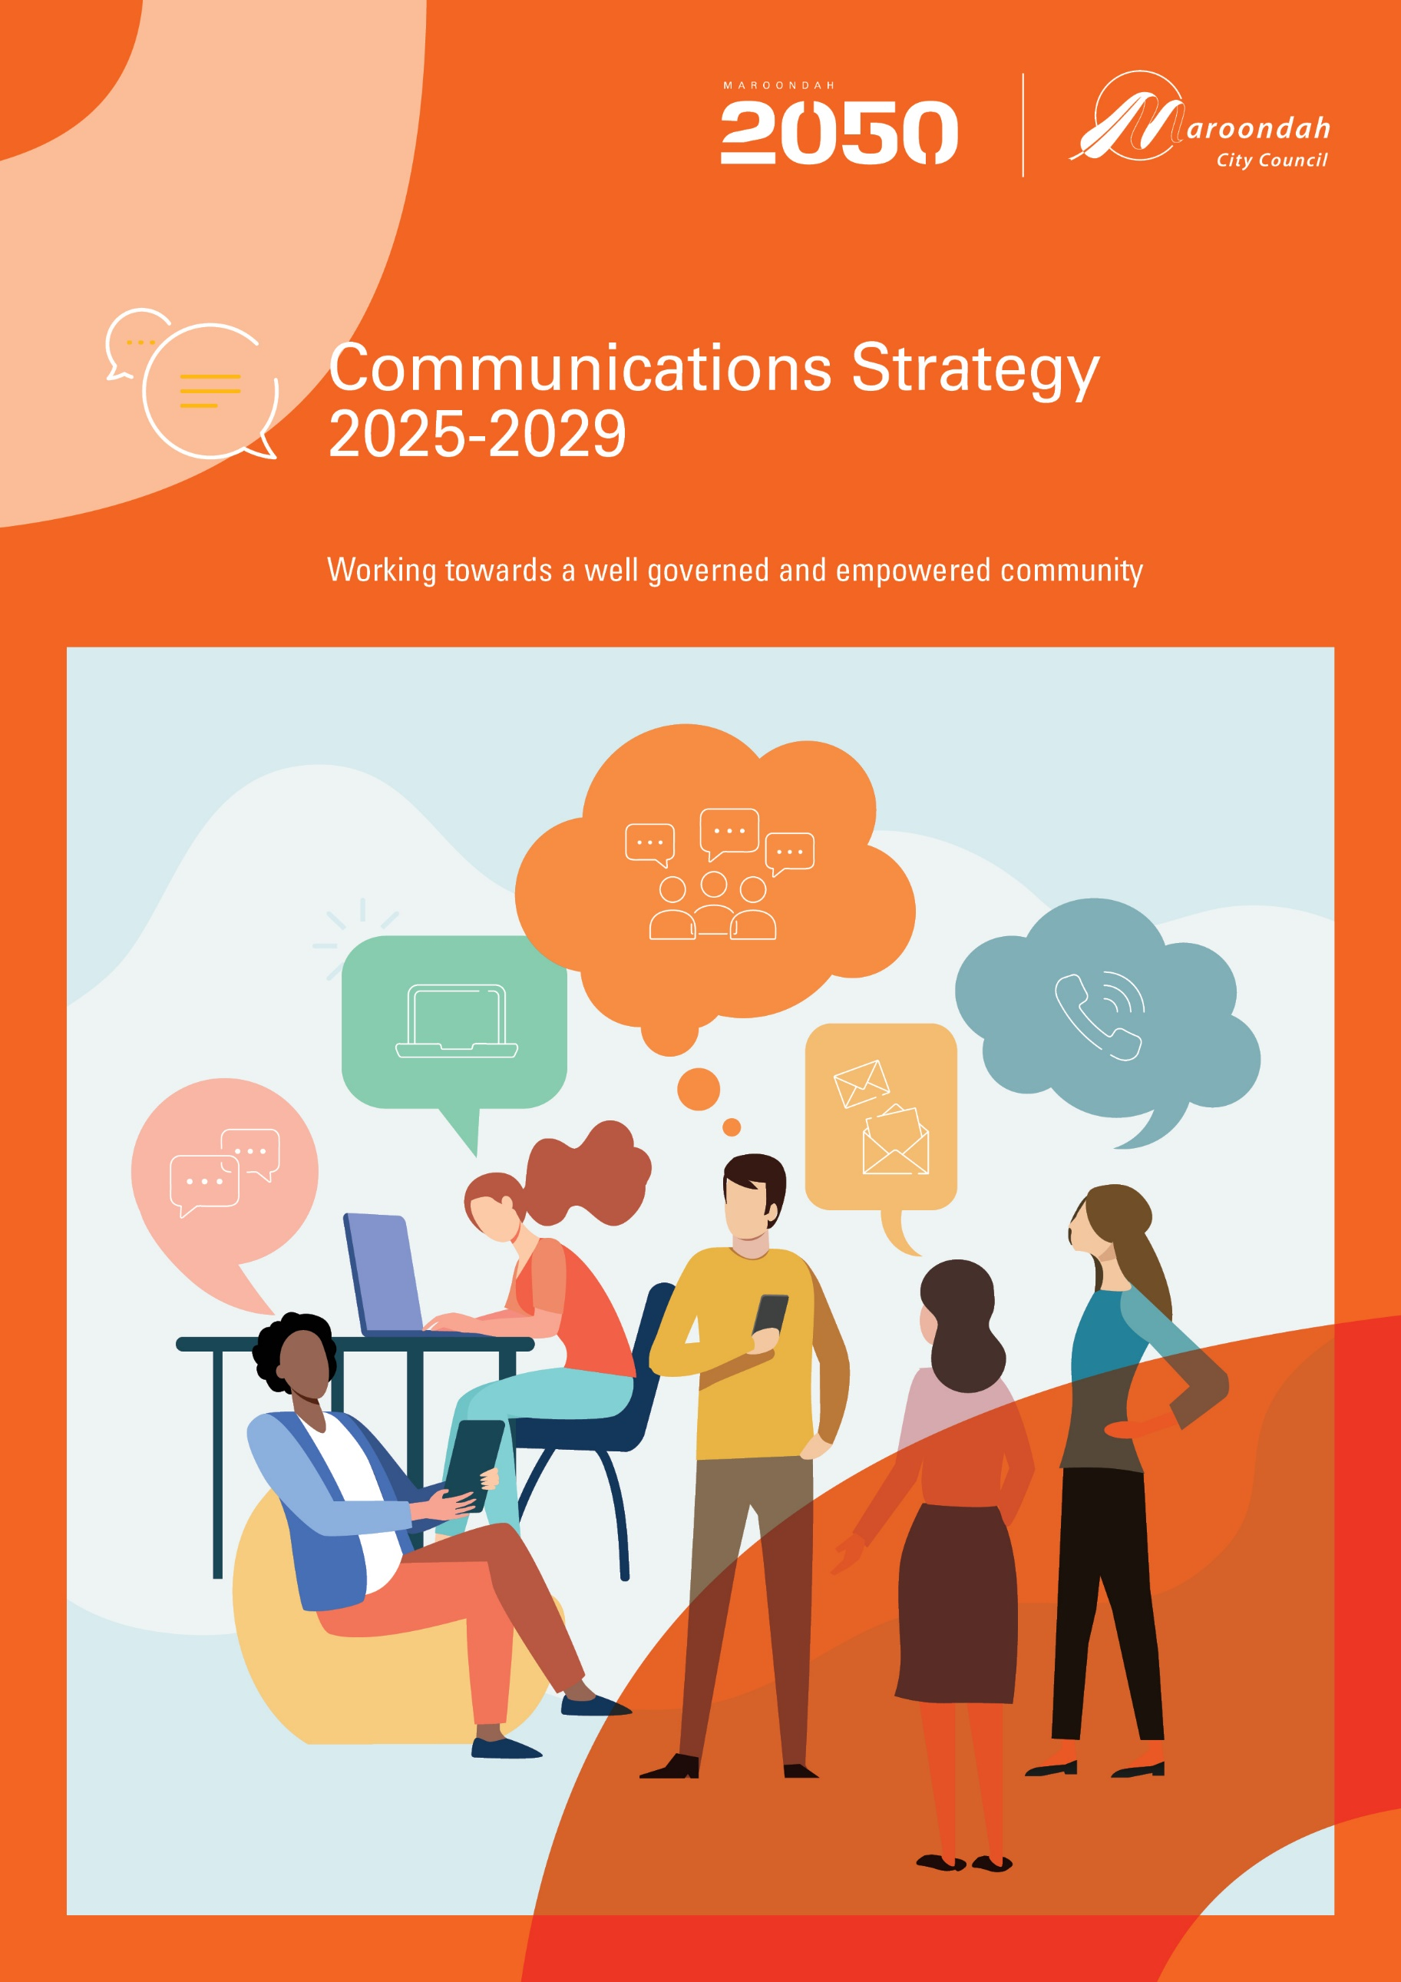

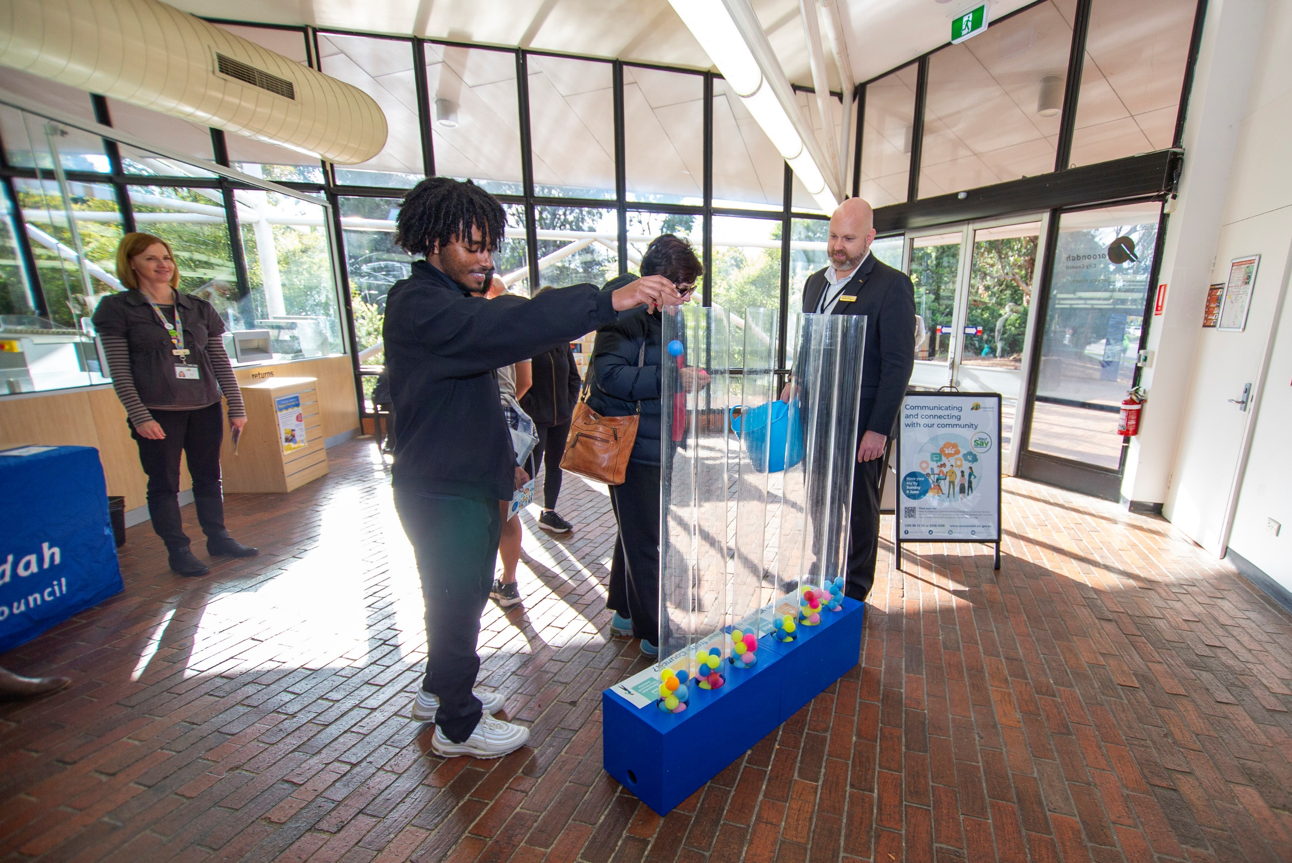

## Contents

Executive Summary 4

Why is communication important? 5

What does the evidence say? 7

What we did and what you told us 9

A plan for the future 11

Our strategic principles and aspirations 11

A vision for communications in Maroondah 11

Strategic principles 11

Guiding principles 12

Outcome area 1 - Accessible and inclusive 14

Vision statement / Outcome description 14

What the evidence tells us and what the community told us 14

Key directions 14

Priority actions 14

Indicators of progress 15

Outcome area 2 - Engaging and effective 16

Vision statement / Outcome description 16

What the evidence tells us and what the community told us 16

Key directions 16

Priority actions 16

Indicators of progress 17

Outcome area 3 - Timely and trusted 18

Vision statement / Outcome description 18

What the evidence tells us and what the community told us 18

Key directions 18

Priority actions 18

Indicators of progress 19

Outcome area 4 - Relevant and responsive 20

Vision statement / Outcome description 20

What the evidence tells us and what the community told us 20

Key directions 20

Priority actions 20

Indicators of progress 21

Tracking our progress 22

References and Glossary 23

References 23

Glossary 23

# Executive Summary

Maroondah City Council's *Communications Strategy 2025-2029* aims to provide strategic guidance and direction for communication with the Maroondah community, ensuring that all residents are informed, engaged, and able to participate in Council services and activities. It aims to capture what is currently being done well in the communications space at Maroondah, as well as outlining new goals, key directions and priority actions to achieve over the next four years.

The Strategy aligns with the *Maroondah 2050 Community Vision* and focuses on four key outcome areas:

* accessible and inclusive
* engaging and effective
* timely and trusted
* relevant and responsive.

Council is dedicated to ensuring accessible, effective, and engaging communication across various channels to keep the community informed and involved.

The need for timely and inclusive communication has grown, leading to expanded print newsletters and digital channels. This Strategy aims to assess and enhance communication methods to ensure they meet the evolving needs of Maroondah residents, focusing on key actions to maintain best practices and promote Council's offerings.

The Strategy focuses on improving Council’s communication and reach by addressing barriers such as language, technology, emergencies, appropriate content, and reputation. It includes updating communication channels for digital literacy, engaging diverse community groups, and consulting with stakeholders.

Community consultation reveals a need for clear, engaging, and accessible content through various digital and print channels and to explore new ways of working and ensuring we keep progressing with the ever-changing technology space.

The Strategy outlines priority actions and projects to be incorporated into departmental service delivery plans, with annual reviews and reporting on progress. A full renewal of the strategy will be undertaken in 2029/2030 to ensure it continues to meet the evolving needs of the Maroondah community.

# Why is communication important?

**What is communication?**

Communication is commonly defined as the transmission of information. Communication is vital, it enables people to connect, understand and collaborate with one another and can take various forms. Effective communication requires messaging to be clear, simple, able to be understood and presented in a way that works for the recipient.

The Communications team at Maroondah City Council understand the importance of accessible, effective and engaging communication.

Council’s Communications and Engagement team are responsible for ensuring effective communication across Council and keeping the community and employees informed and engaged. They also look after the management of communication and engagement strategy and planning to support all service areas across Council; the management, coordination and distribution of printed publications; media and public relations; internal communications; and supporting the communications and campaigns of seven leisure facilities.

Council’s Digital and Online team are responsible for graphic design, ensuring Council’s brand is consistent and accessible, and the management and content development for all online, digital and social media channels; photography and videography and content development.

**History of communications at Maroondah City Council**

Communication with the community is a core requirement of Council to ensure Maroondah residents are aware of and can access Council’s 120 services that are provided to the community.

Communications has always been an important service of Council, however the need for timely, accessible and engaging content is more important than it ever has been.

Council expanded its print community newsletter offering in 2022 due to local print news publications (such as Maroondah Leader) ceasing production during COVID-19. This expansion was also due to Councillor and community feedback that more accessible print publications were needed to continue to communicate with all members of the community, no matter their digital literacy levels, along with the prolific worldwide real time demand for communication/content.

Eleven editions of print publication Maroondah *news* are produced each year. Four of these editions are 20 pages and delivered to all households and businesses in Maroondah each quarter, providing Council updates on events, activities, programs and projects. The other seven editions are 8 pages and delivered to various Council facilities, service centres, shopping centres and community facilities.

Websites, social media and electronic direct mail (EDM’s) have also developed significantly in the past five years, with the community consuming content via different channels and formats. Council has redeveloped its main website as well as the Maroondah Leisure and Karralyka websites, expanded its social media offerings to 23 channels, and expanded its direct email newsletters, covering 16 key areas of interest including nature, waste, sustainability, children’s and families events and more with a subscriber base of over 16,000.

This work showcases Council’s dedication to continually improving how, when and where we communicate with Maroondah residents and the community on important issues, news and updates.

Both print and digital communication channels are required to successfully communicate with the Maroondah community, ensuring this communication is timely, engaging and accessible.

**Why is a Communications Strategy needed?**

A Communications Strategy (Strategy) will help understand if Council’s current communications channels and formats are appropriate, accessible and engaging for the community, as well as looking to the future to ensure we can continue to develop our communications and channels over the next four years.

This includes focusing on key actions that will help ensure Council’s communications continue to strive for best practice outcomes and look to improve in areas where needed to ensure that Maroondah residents, visitors, businesses and the wider community are aware of and engaged with Council and all it offers.

This Strategy will help provide direction and set goals to achieve over its lifetime, focusing on things that are important to the community and ways to further promote Council and its programs, services, events, projects, consultations and activities.

**What does the Strategy include?**

This Strategy focuses on incorporating what we have currently achieved in the communications space at Council, while also strategically focusing on ways to improve Council’s communication offerings.

This includes concentrating on ways to break down barriers to ensure as many people in the community as possible can learn more about Council and its offerings.

These barriers include:

* language (including translations, Easy English, social scripts and transcripts/closed captions).
* technology (print, digital, frequency and channels).
* emergencies (continuing to establish Council as a source of emergency information).
* appropriate content (community news focused with a local voice; creating content suitable for the correct channels; utilising channels for their purpose).
* reputation (being a trusted source within the community).

# What does the evidence say?

**Who are we communicating with?**

Council has a vital role to play in providing important information in relation to Council activities, programs, events and consultations to all members of the community, taking into account the range of barriers faced by individuals to access information.

With the digital news space now so prolific and available at the click of a button via mobile devices, there is a greater need to keep Council’s communication channels up-to-date with the fast-paced news cycle.

People are more digitally literate than ever before; however, they are also consuming more information and content than ever before. This requires communication to be direct, engaging and provided in ways that works for them.

However, not all members of the community are digitally literate, and it is important to ensure that these people can access information via a platform that they feel comfortable with and can access easily.

Maroondah is home to 117,434 people who live across 12 suburbs *(idcommunity, 2024)*. The largest age group is between 35 to 54 years of age. Maroondah is also lucky to be a diverse community, with 734 First Nations people residing in Maroondah and approximately 22,750 people identifying as non-English speaking *(idcommunity, 2024).*

Mandarin, Cantonese, Hakha Chin, Burmese and Zomi are the top five languages spoken in Maroondah by those with low or no English-speaking proficiency (*ABS, 2021*). Hakha Chin, Burmese and Zomi are three of the seven dialects spoken by the Burmese community in Maroondah, who make up nearly 10% of the Maroondah population *(idcommunity, 2024).* These dialects are all unique and completely different from one another.

Australia wide, approximately 1 in 6 (18%) of people have a disability *(Australian Institute of Health and Welfare, 2024)*. This could be physical, mental or behavioural. Those that identify as having a disability or neurodivergent can require alternative communication methods or mediums.

Maroondah also has a large number of community groups who are representative of the population. These groups include sporting clubs, scout groups, volunteer organisations, churches of varying faith, employment and disability agencies, community houses and theatre and musical groups.

Over 20,200 people are over the age of 65 years old in Maroondah *(idcommunity, 2024).* It is important to ensure that their communications needs are addressed and considered.

There is a strong and ongoing need to provide ways to communicate effectively with those in Maroondah who are not confident with written or spoken English materials, those who do not comprehend information in what is considered a ‘standard’ way, as well as those who are not digitally proficient.

If strategic goals are set and adequate resources and funding are set aside to tackle these issues, processes can be implemented to address them and improve communication with those who need it.

**Keeping up with current trends**

It's essential to reach digitally savvy individuals on popular communication platforms and ensure easy access to Council communications. To effectively engage the target audience, information needs to be not only engaging, accessible, and timely but also visually appealing, distinctive, and tailored to key demographics.

On average, an adult’s attention span is eight seconds *(Kirk, 2019)*. This means that information must capture a person’s attention immediately or there is a risk of losing their attention and information will not be absorbed.

The average Australian spends 10 hours and 19 minutes a day on electronic media, with the majority utilising social media channels *(Mccrindle, 2024)*. Content must be distinctive and tailored to the specific channel to be memorable and prompt action.

Council must keep up to date with emerging trends in the communication space to ensure Maroondah residents are receiving important information.

**Community consultation**

Engaging with the community is a vital part of Council’s work, with community consultation shaping strategies, projects and programs into services that reflect the community values, needs and aspirations. Ensuring that all voices are heard, and not just the vocal majority or those who always provide feedback provides for more well-rounded engagement.

Community engagement is a crucial aspect of the Council's responsibilities, to ensure the community's values, needs, and aspirations are met. It is essential to ensure that everyone’s opinions are considered, not just those from the vocal majority or habitual respondents, to achieve more comprehensive and balanced participation.

# What we did and what you told us

**Overview**

Community consultation was undertaken from 6 May to 11 June 2024 to help inform the creation of this Strategy. This consisted of:

* In-person pop ups with interactive activities at Council’s Ringwood and Croydon customer service centres
* online and paper survey (including translated materials)
* meetings with key stakeholder groups in Maroondah including Maroondah Disability Advisory Committee, CALD Leaders network, Wurundjeri Elders and Maroondah Youth Wellbeing Advocates.

The consultation was promoted via Council’s various print and digital channels including:

* Maroondah *news* (print and digital)
* eNewsletters including Nature news, Waste & Sustainability, Children’s and Families, Active eDM
* Social media (including targeted social media ads to reach those not currently connected with Council)
* Direct email via Council’s *YourSay Maroondah* platform
* Postcards
* Posters

**Survey**

Respondents were asked a series of questions in relation to how they currently consume content; where they find content; and what Council does well and what could be improved in relation to communicating with the community. A summary is detailed below:

* 159 survey responses were received across a broad range of Maroondah suburbs.
* Over 70% of respondents were female.
* The 35 to 44 year age group had the highest response rate, with over 27% of responses.
* 76% use their phone when consuming content online.
* 6pm to 9pm is when they are most likely to consume content.
* Email, Facebook, SMS, Instagram and radio are channels that are used more than once a day.
* Council’s Maroondah *news* eNewsletter is Council’s most well-known channel, followed by Facebook and Maroondah *news* print newsletter.
* Respondents currently use Council’s website the most to find Council information.
* 59% of respondents do not visit Council channels for information in the event of a local emergency. Instead, they visit the VicEmergency app, Facebook, BOM weather app, ABC and community groups on Facebook.
* 67% would prefer digital as the mode of receiving Council information.
* The top ten topics respondents want to hear about are:

1. Leisure, recreation and events
2. Planning and development
3. Parks, playgrounds and open space
4. Capital works projects
5. Community engagement
6. Waste and sustainability
7. Health and community safety
8. Community development (volunteering, wellbeing)
9. Arts and culture
10. Natural environment and biodiversity

* The majority (or most) of respondents don’t experience any barriers when accessing information from Council. However, some noted that they:
  + find the information too confusing
  + don’t see Council information where they consume content
  + don’t see information in their language.
* When asked how we can better support their communication needs, respondents identified the following ways (in order form highest to lowest):
  1. Closed captions on videos
  2. Offer materials in plain English
  3. Offer more social stories for neurodiverse people
  4. Hearing accessibility
  5. Vision accessibility
  6. Offer translated materials

Feedback on what is done well with Council’s communications includes:

* A range of topics are covered
* Informative, regular updates
* Quality visuals and surveys
* Clear and engaging content
* Clear branding and consistent style
* Length and frequency of communications
* Simple and easy to understand
* Detailed and interesting content
* Variety of topics

Feedback on what can be done to improve our communications includes:

* Translated materials.
* More digital content on social media
* More succinct newsletters
* More community-focused stories
* More engaging content on Maroondah Leisure social media
* Facebook graphics and newsletter design could be refreshed
* Post more in local Facebook groups
* Shopping centre noticeboards
* Report back and close the loop on consultations
* Cross promotion across Council social media channels
* Include a postal address in Maroondah *news* for those who are not digitally literate
* Ensure publication timeframes align with consultations and events

**Meetings with key stakeholders**

Consultation was undertaken with key stakeholders who provided detailed feedback based on specific needs of their group. These stakeholders were:

* Maroondah Youth Wellbeing Advocates
* Maroondah Disability Advisory Committee
* CALD Leaders Network
* First Nations Wurundjeri Elders

In person pop ups were also hosted across the consultation at Realm in Ringwood, and Croydon Library.

# A plan for the future

## Our strategic principles and aspirations

### A vision for communications in Maroondah

Our vision is to provide relevant, effective and engaging communications for our community that are accessible and inclusive now and adapting into the future.

We create communications that inform Maroondah residents on Council’s projects, programs, activities, events and services and empower them to be involved in Council’s activities and consultations.

We are adaptive and creative, using communication channels appropriately and in a format that is accessible for all different members of our diverse community.

### Strategic principles

The *Communications Strategy 2025-2029* is underpinned by Maroondah 2050’s vision of a well-governed and empowered community.

*Council continues to be a transparent, accountable, and future-focused leader that collaborates locally and regionally and actively champions local needs. Everyone in Maroondah is informed about matters that affect them and are provided with opportunities to meaningfully engage regarding Council decision making.*

As part of Council’s Maroondah 2050 Community Vision, to work towards a well-governed and empowered community, we will focus on providing the Maroondah community with timely and accessible information on matters important to them.

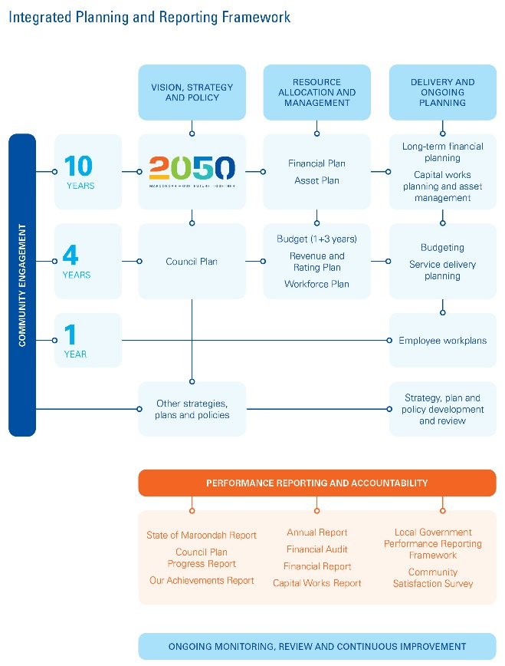The *Communications Strategy 2025-2029* is aligned to Council’s Integrated Planning Framework and

seeks to ensure that communications activities are aligned with community expectations.

As seen in the draft diagram, the strategy is aligned to 2050 Community Vision and the Council Plan.

### Guiding principles

The key guiding principles that will be used throughout the Strategy and are of major importance to the communications at Maroondah are:

* Relevant
* Timely
* Accessible
* Responsive
* Inclusive
* Respectful
* Engaging
* Effective

These principles underpin the outcome areas and their key directions and priority actions within this Strategy.

# Outcome area 1 - Accessible and inclusive

## Vision statement / Outcome description

Continue to provide and look at ways to increase communication offerings in accessible formats to ensure all Maroondah residents feel included, are aware of Council services, facilities, events and programs and can actively participate in consultation activities. Ensure Council’s channels meet accessibility requirements for websites, digital and print collateral.

## What the evidence tells us and what the community told us

Maroondah is a diverse community. As of 2024, Mandarin, Cantonese, Hakha Chin, Burmese and Zomi are the top five languages spoken in Maroondah by those with low or no English-speaking proficiency. Other languages spoken in Maroondah include Persian, Vietnamese, Korean, Karen and Khmer *(ABS, 2021).*

Feedback received from community consultation told us that some residents can’t find information or that the information can be confusing if not in their language. When asked how Council can better support their communication needs, respondents identified the following ways:

1. Closed captions on videos
2. Offer materials in plain English
3. Offer more social stories for neurodiverse people
4. Hearing accessibility
5. Vision accessibility
6. Offer translated materials

This feedback provides Council with a deeper understanding of communications gaps that people in the community might currently be experiencing and provides important direction to understand the focus in this space over the next four years.

## Key directions

* 1. Continue to produce translated and Easy English materials, increasing collateral in languages that reflect Maroondah’s CALD community.
  2. Consider the use of local translators to ensure translated material is in an accurate dialect for those living in Maroondah.

1.3 Consider the use of social stories for relevant communication campaigns to meet the needs of neurodivergent people.

1.4 Continue to provide alternative text on images in electronic mail distributions, captions on videos and transcripts when appropriate

1.5 Consider the needs of blind, deaf or disabled people when preparing communications.

1.6 Improve Council’s consultation platform, Your Say Maroondah, to ensure it is accessible and inclusive.

## Priority actions

1. Work with local translators that can be used to assist with translating materials for Council communications.
2. Work with relevant organisations to understand best practice for social stories.
3. Implement a Council-wide best practice translation guide.
4. Investigate the use of Viber communication tool to reach CALD community groups.
5. Consider a new Council consultation platform that improves accessibility and offers translation options.
6. Continue to ensure Council’s websites are accessible through WCAG 2.1 guidelines.
7. Continue to ensure Council’s digital designs are accessible through WebAim Contrast Checker.
8. Explore the use of new and emerging AI platforms and how they can assist with translated materials
9. Conduct a biennial review of population and English language proficiency data to ensure language and translation materials reflect Maroondah’s CALD community.

## Indicators of progress

1. Increase in production of translated materials, in languages that reflect the Maroondah community.
2. Implement a consultation platform that provides increased accessibility and translation options.
3. Increase the use of key local translators for checking translations to ensure they are understood by the CALD community.
4. Enhanced usability for the CALD community on Council’s website, including Your Say Maroondah.
5. Greater connections with CALD communities in Maroondah through Council communication channels.

# Outcome area 2 - Engaging and effective

## Vision statement / Outcome description

Deliver Council information through a variety of channels suited to Maroondah’s diverse community, ensuring it is engaging and able to connect and engage with the target audience and Maroondah community. Continue to provide high quality materials that are eye catching, for the right audience and include all relevant information.

## What the evidence tells us and what the community told us

On average, an adult’s attention span is eight seconds *(Kirk, 2019)*. This means that information must capture a person’s attention immediately or there is a risk of losing their attention and information will not be retained.

The average Australia spends 10 hours and 19 minutes a day on electronic media *(Mccrindle, 2024)*. Content must be distinctive and tailored to the specific channel to be memorable and prompt action.

Feedback received from community consultation told us that Council produces clear and engaging content with clear branding and consistent style. They also noted that some graphics and design could be refreshed. 76% of respondents use their phone when consuming content, and 67% would prefer digital as the mode of receiving Council information.

Of those over the age of 55 years of age who provided feedback, over 50% prefer to receive information in both print and digital format or just print format. It is important that Council continues to meet the needs of Maroondah’s smaller population groups, such as older people in Maroondah, CALD groups and those with a disability.

This information provides important guidance in relation to what is working well and what could be improved in ensuring Council content engages with all members of the community and is effective in grabbing the attention of the targeted audience.

## Key directions

* 1. Produce high quality and well-designed print news publications (Maroondah *news*) at an appropriate frequency that provides information for all cohorts of the Maroondah community and reflects the work undertaken by Council.
  2. Produce high quality digital news publications at an appropriate frequency that cover a broad range of topics that interest various groups in Maroondah.
  3. Produce engaging and fit for purpose digital content on Council’s social media channels that captures the interest of relevant audiences.
  4. Continue to utilise Council’s digital channels to promote Council services, programs, events and activities.

## Priority actions

1. Consider frequency and page length of Maroondah *news* print publication in line with community needs and expectations.
2. Re-design Maroondah *news* and other Council branding in line with Maroondah 2050 Community Vision brand.
3. Investigate the feasibility of merging Ringwood Golf and Dorset Golf Facebook pages.
4. Consider the use of Facebook community noticeboards to reach more residents with Council information.
5. Investigate the use of AI and its appropriateness for use by Council to create engaging and effective content.
6. Undertake a review of the use of social media platform X (formerly Twitter) as a communication channel and consider its continued use.
7. Identify and investigate new platforms and technology that can assist with targeting key audiences and demographics in Maroondah.

## Indicators of progress

1. Implementation of new Maroondah *news* branding that is engaging and in line with Maroondah 2050 branding.
2. Increased use of Facebook community noticeboards for appropriate promotion of Council services, events or activities.
3. Increased use of mobile-friendly digital and social media platforms to ensure content produced is engaging and effective on mobile.
4. Continue to build the audience of Council’s eNewsletters that are fit for purpose for the relevant audiences including children and families, young people, older people, people interested in waste, sustainability, natural environment, arts and health and fitness.

# Outcome area 3 - Timely and trusted

## Vision statement / Outcome description

Provide timely and accurate information and updates as a trusted and reliable voice in the community for Council and local news, including emergency information. Continue to build Council’s reputation through strong, consistent branding, tone and voice and uphold Council’s high level of customer service standards.

## What the evidence tells us and what the community told us

Council’s role in providing information in a timely, consistent and accurate manner is important to build a well-informed, well-equipped and capable community. Council has a legislated responsibility under the *Emergency Management Act 2013* to prepare, respond and support the community to recover from emergencies.

Feedback from the community has offered valuable insights regarding the optimal times for content consumption and preferred communication channels. Consequently, information can be strategically targeted and developed with these considerations in mind.

59% of respondents do not currently visit Council channels for information in the event of an emergency. Instead, they visit the VicEmergency app, Facebook, Bureau of Meteorology Weather app and the ABC. This information helps Council improve emergency communications and leverage trusted channels for sharing and using emergency information.

Respondents also noted that Council has simple and easy to understand information that is consistent, informative and covers a range of topics. This assists with knowing what is currently being done is working, and to now look towards ways to continue to improve communications and reach in the community.

## Key directions

3.1 Continue communications in relation to Council’s role in emergency management, using appropriate communication channels.

3.2 Provide information and updates from Council in a timely manner, ensuring the content is accurate, consistent and able to be understood by the community.

3.3 Maintain a consistent tone, voice, and appearance across all Council channels and platforms to ensure Council becomes a trusted and recognised brand within the community.

3.4 Support the Mayor and Chief Executive Officer (CEO) as Council’s official spokespeople to ensure consistent and accurate messaging on Council channels and through media and community networks.

## Priority actions

1. Update Council’s organisation-writing style guide to improve language consistency across all forms of Council communications including letters, strategies and collateral.
2. Continue to share relevant emergency information on Council digital and social media channels from trusted sources (VicEmergency, BOM, Department of Health) in a timely manner.
3. Ensure Council’s website contains up-to-date emergency information that is clear, accurate and accessible.
4. Expand emergency management communications, including creating translated information packs to support our CALD community groups.
5. Review Council’s branding style guide to reflect 2050 Community Vision.
6. Annually review Council’s Heat Health, Emergency event and Relief Centre communications plans to ensure information is accurate and templates can be implemented quickly and efficiently when required.
7. Uphold’s Council’s reputation by maintaining efficient media management processes including developing timely and accurate proactive and reactive media releases and statements.

## Indicators of progress

1. Clearer and more consistent language used across Council channels.
2. Increase in emergency information shared across Council channels, including website, social media, EDM’s and print publications.
3. Implementation of communication requirements under the Australian Government’s Disaster Ready Fund.
4. Implementation of updated branding for Maroondah 2050.
5. Maintain communications representation on the Municipal Emergency Management Planning Committee.
6. Maintain working relationships with key media agencies and journalists. Provide timely updates on Council’s channels following Council meetings or decisions.

# Outcome area 4 - Relevant and responsive

## Vision statement / Outcome description

Ensure Council’s communications are relevant to the community and respond to community needs and interests. Report on decisions and provide updates from Council to enable residents to live supported, active, and connected lives within our community.

## What the evidence tells us and what the community told us

Results from the 2024 Victorian community satisfaction survey found that Maroondah City Council ranks higher than the state-wide average for:

* Consultation and engagement
* Informing the community
* Community decisions
* Customer service

Respondents who provided feedback during community consultation said that Council provides regular updates that are appropriate in length and frequency, however some noted that they would like more reporting back on community consultations that they participate in and that they’d like to hear more stories with voices from the community.

They also told us that the top 10 topics they want to hear about are:

1. Leisure, recreation and events
2. Planning and development
3. Parks, playgrounds and open space
4. Capital works projects
5. Community engagement
6. Waste and sustainability
7. Health and community safety
8. Community development (volunteering, wellbeing)
9. Arts and culture
10. Natural environment and biodiversity

## Key directions

* 1. Continue to showcase relevant community and Council news, reporting on key outcomes from Council meetings, ensuring information is accurate and timely.
  2. Ensure topics covered are broad, feature a range of Council areas and facilities, as well as highlighting important community achievements.
  3. Close the loop on consultation activities, providing respondents with updates in a timely manner with key information on how their feedback shaped the consultation.
  4. Respond to community queries, comments and feedback on our communication channels, including social media and email.

## Priority actions

1. Utilise the business partner communications model to provide updates from across Council, including project updates and progress, strategy development, arts exhibitions, leisure activities, events for seniors, children, young people and families.
2. Solidify Council’s role in the community by including testimonials from community members working with Council or accessing Council services to provide relevant insight for other community members.
3. Create consistent and easy to understand consultation reports that are published on the relevant projects’ Your Say Maroondah webpage.
4. Ensure a strategic lens is applied to all communication campaigns when selecting appropriate channels to promote Council’s services, programs, activities and events.
5. Update Council’s Social Media Policy to ensure engagement on Council’s social media channels is moderated with clear House Rules to promote respectful discussion and exchange of ideas.
6. Develop a Digital Strategy to ensure a structured plan for how we are utilising communications channels now and into the future.

## Indicators of progress

1. Continued variety of Council news and information in Council publications such as Maroondah *news*, eNews, social media and website.
2. Feature community voices in key publications such as Maroondah *news*, including quotes and interviews from community members who have worked with Council or are
3. Improved reporting on Council consultations, ensuring they are completed in a timely manner using Council’s succinct consultation template, including all relevant information.
4. Implementation of strong moderation processes in line with Council’s Social Media Policy on Council’s social media channels.
5. Implementation of priority actions of Maroondah’s Digital Strategy.

# Tracking our progress

The *Communications Strategy 2025-2029* forms part of Council’s response to delivering on Maroondah 2050 - Our future together. It will be implemented with a whole-of-Council approach and will involve regular review.

This strategy outlines key priority actions and projects to be undertaken to deliver on the strategic aspirations for communications in Maroondah. These actions and projects will be incorporated into departmental service delivery plans over the 2025 to 2029 period and reported on yearly in the Council Plan. Additional priority actions and projects that support this vision and adapt to the changing needs of the Maroondah community will be identified and resourced over time.

Progress towards delivery on priority actions and projects will be monitored and reported upon annually through Council’s reporting processes. A full review of the strategy will be undertaken in 2029/2030.

# References and Glossary

## References

Australian Bureau of Statistics 2021, *Population: Census*, ABS, <https://www.abs.gov.au/statistics/people/population/population-census/latest-release>

Government, A. (2024) *People with disability in Australia, prevalence of disability - Australian institute of health and welfare*, *People with disability in Australia*. Available at: <https://www.aihw.gov.au/reports/disability/people-with-disability-in-australia/contents/people-with-disability/prevalence-of-disability>.

Kirk, H. (2019) ‘Are we really in an attention crisis, or are digital technologies getting a bad rap?’, *ABC News*. Available at: <https://www.abc.net.au/news/health/2019-08-18/are-you-paying-attention/11417188>

Mccrindle, U. (2024) ‘Australia: The Digital Media Nation’, *Mccrindle research*. Available at: <https://mccrindle.com.au/article/australia-the-digital-media-nation/#:~:text=While%20the%20growth%20of%20these,each%20day%20on%20electronic%20media>

Unknown, A. (2023) *Home | City of Maroondah | community profile*, *City of Maroondah Community profile*. Available at: <https://profile.id.com.au/maroondah/>

## Glossary

AI (Artificial Intelligence): The field of computer science that focuses on creating systems capable of performing tasks that typically require human intelligence, such as visual perception, speech recognition, decision-making, and language translation.

EDM (electronic distribution mail): A method of sending emails to a large group of recipients, often used for marketing or informational purposes. It allows for targeted communication with a specific audience.

Easy English: A form of simplified English that is designed to be easily understood by people with learning disabilities, cognitive impairments, or those with low proficiency in the language. It uses clear and simple vocabulary, short sentences, and avoids complex grammar to ensure accessibility for a wider audience.

CALD (culturally and linguistically diverse): Refers to individuals or communities with varied cultural backgrounds and languages other than the dominant one in a particular country or region. This term highlights the multicultural and multilingual nature of societies and the need for inclusive policies and practices to support diverse populations.

Closed captions: Text displayed on a screen to provide additional or interpretive information to individuals who are deaf or hard of hearing. Closed captions typically include not only dialogue but also non-speech elements such as sound effects, speaker identification, and other relevant audio information, ensuring accessibility for a wider audience.

Social Scripts: Predefined, structured interactions that people use to guide their behaviour and communication in social situations. Social scripts can help individuals, especially those with autism or social anxiety, to navigate social interactions more confidently and effectively by providing clear expectations and reducing uncertainty.

WCAG 2.1 guidelines: The Web Content Accessibility Guidelines (WCAG) 2.1 are a set of recommendations designed to make web content more accessible to people with disabilities. These guidelines cover a wide range of disabilities, including visual, auditory, physical, speech, cognitive, language, learning, and neurological disabilities.

WebAim Contrast Checker: A tool designed to help ensure that web content is accessible by measuring the contrast between text and background colors. It evaluates whether the contrast levels meet the Web Content Accessibility Guidelines (WCAG) standards, making it easier for users with visual impairments to read and interact with digital media.

