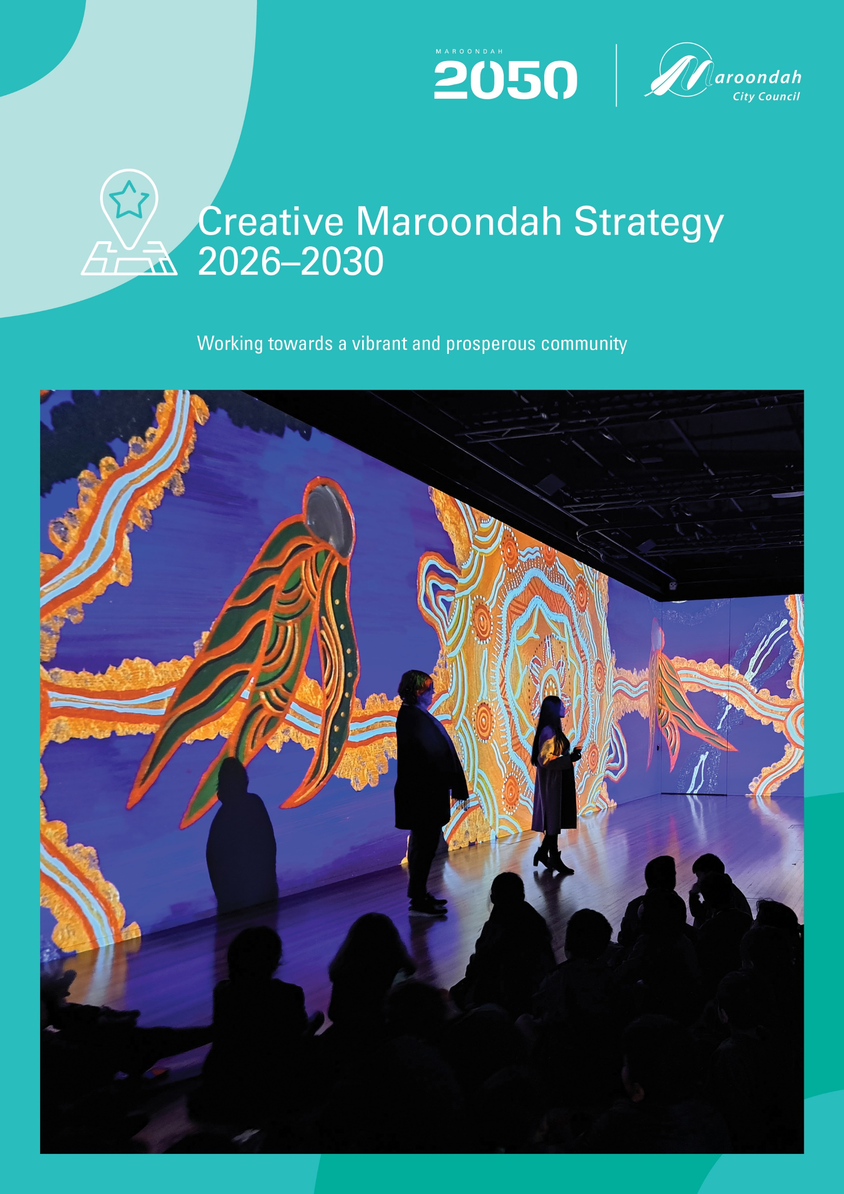

Contents
Executive Summary 3
Introduction 4
About our Creative Services & Spaces 4
What the Evidence Tells Us 5
The Benefits of Arts Participation 5
Evidence of Local Demand 6
Our Creative Industry is Growing 7
Victorians Value the Arts 7
Community Consultation 7
What We Did 7
Key Community Indicators - What You Told Us 8
A Strategy for the Future 9
Strategy Vision 9
Our Guiding Principles 9
Strategic Context 9
Council Plan 10
Maroondah 2050 10
Industry Context 10
Key Strategy Outcome Areas & Actions 11
Strategy Action Plan 12
Outcome Area One: Creative Community 12
Outcome Area Two: Creative Places 13
Outcome Area Three: Creative Programs 14
Outcome Area Four: Creative Partnerships 16
Outcome Area Five: Creative Industry 17
Outcome Area Six: Creative Communications 18
Tracking our Progress 19
Annual Action Plan Measures 19
Service Performance Measures 19
References & Glossary 20
References 20
Glossary 20

Executive Summary
The Creative Maroondah Strategy 2026–2030 presents a bold and inclusive vision for the future of arts, culture, and creativity in Maroondah. Building on our city’s proud tradition of artistic excellence and cultural diversity, this strategy outlines a clear roadmap to nurture creativity, foster innovation and ensure that everyone in Maroondah can engage with the arts.
With a vision of “A vibrant, creative and connected community” shaped by extensive community consultation and informed by industry data and trends, the strategy recognises creativity as a powerful driver of community wellbeing, economic growth, and social connection, and is structured around six key outcome areas:
- Creative Community: Empower and engage our diverse community through creative expression, collective projects and opportunities for arts participation.
- Creative Places: Activate and enhance public spaces and cultural venues to reflect Maroondah’s unique identity, improve accessibility and foster a sense of belonging, pride and cultural identity.
- Creative Programs: Innovative, high-quality arts and cultural programs that inspire participation, social connection and lifelong learning within our diverse community.
- Creative Partnerships: Strengthen collaboration with artists, organisations, businesses, and the broader community to grow Maroondah’s creative sector.
- Creative Industry: Nurture a sustainable and thriving creative economy and cultural tourism in Maroondah by supporting opportunities with creative businesses, artists and industry led initiatives.
- Creative Communications: Creative services, venues and initiatives are highly visible, accessible and engaging for our diverse community, and we seek feedback often to help guide continuous service improvements.
Together, these outcome areas provide a comprehensive framework of priority actions to guide Maroondah’s creative future. The Creative Maroondah Strategy 2026–2030 reaffirms our commitment to making arts and culture accessible to all and invites our diverse community to join us in bringing this vibrant vision to life.

Introduction
The Creative Maroondah Strategy 2026–2030 provides a framework for the delivery of priority areas for creative services in partnership with the Maroondah community over the four-year period from July 2026 to June 2030.
Informed by extensive community consultation, current policy directions, and best practice, this strategy recognises the transformative role of creativity in shaping vibrant, resilient, and inclusive communities.
Our approach is anchored in the six strategic outcome areas of Creative People, Places, Programs, Industry, Partnerships and Communications, whereby Council commits to a range of priority actions that aim to achieve the strategy vision of “A vibrant, creative and connected community.”
This strategy provides a clear roadmap for Council to enhance its role as service provider, partner and supporter of creative community development, and demonstrates a commitment to investing in our creative services, spaces, programs, people and sector.

About our Creative Services & Spaces
The Creative Maroondah Strategy informs the service priorities for Council’s Creative Places Services, whose role it is to promote a vibrant, connected, and creative community through delivering and supporting a wide range of creative programs, projects, services, exhibitions, activations, public art, grants, and arts venue management across Maroondah. The Service consists of three key service pillars:
Arts and Cultural Services
- Wyreena Community Arts Centre venue and program management – classes, events, play spaces, tenancies and projects
- Exhibitions, collections and gallery management and programs – Art Space at Realm, Maroondah Federation Estate Gallery and Arts Lounge Wyreena
- Arts activation and cultural development – socially engaged arts events, installations and projects
- Public art and creative placemaking initiatives – public art commissions and public programs
- Creative industry development – annual grant program, network events, professional development and learning.
Creative Precincts, Policy and Planning
- Realm Precinct & Ringwood Town Square Activation Framework
- Croydon Community Wellbeing Precinct Planning
- Maroondah Arts Advisory Committee, industry networks and panels
- Creative Places policies, planning and strategies.
Karralyka & Venue Services
- Karralyka Centre management
- Council presented Theatre Season
- Community and Professional theatre programs
- Theatre and Function rooms hire and hospitality and event services
- Meals on Wheels food production services
- Maroondah Federation Estate venue management
- Community halls facility management.

What the Evidence Tells Us

The Benefits of Arts Participation

General Wellbeing and Mental Health
- Reduced Stress and Anxiety: A 2019/20 World Health Organization (WHO) report found that participation in the arts can reduce stress and anxiety and improve overall wellbeing.
- Mental Health: Creative Australia ‘Creating Wellbeing” Report 2021 research into social impacts and wellbeing reports that 98% of people who engage in the arts say it makes them feel happy and 1 in 5 people engage in the arts for mental health benefits.
- 100 + hours of engagement in arts and cultural activities has been shown to result in better health benefits and outcomes according to a report by VicHealth – Promoting Everyday Creativity at a Local Level.

Education and Cognitive Development
- Academic Performance: Arts participation enhances academic achievement and school engagement for young people and children, improving confidence and school retention, as reported within the research paper by Creative Australia "Next Generation Now", 2025
- Cognitive Skills: A study published in the 2022 Editorial: Psychological and Physiological Benefits of the Arts in ‘Frontiers in Psychology’ found that students who participate in music and arts have improved memory, attention, and critical thinking skills.

Social Benefits
- Community Engagement: 73% of people surveyed by the Creative Australia National Arts Participation Survey 2023 agreed that the arts help bring people together and foster a sense of community.
- Social Skills: Participation in group arts activities increases social tolerance and empathy, according Creative Australia "Next Generation Now", 2025

Physical Health
- Active Ageing: Older adults who participate in arts programs show improved mobility, fewer doctor visits, and better overall health according to Creative Australia ‘Creating Wellbeing” Report 2021
- Recovery and Rehabilitation: Arts engagement has been linked to faster recovery rates in hospital settings, with patients experiencing less pain and shorter hospital stays, as research through Creative Australia ‘Creating Wellbeing” Report 2021

Economic Impact
- Employment: In Australia, the creative arts sector employs over 600,000 people and contributes billions to the economy (Key Economic Indicators, Australian Bureau of Statistics, 2023).
- Economic Contribution: In 2023, cultural and heritage tourism contributed approximately $16 billion to the Australian economy (Tourism Research Australia 2023).
- Visitor Economy: 44% of international visitors to Australia participated in at least one cultural or heritage activity during their trip (Tourism Research Australia, 2023).
- Tourism: Cultural tourists spend on average, 20% more per trip than other tourists (Creative Australia National Arts Participation Survey 2023).

Evidence of Local Demand
As part of the Maroondah Council Plan and Maroondah 2050 Visual Community Survey, our community provided the following feedback about the importance of a Creative Community:
- High Value on Arts and Culture: Art Centres and libraries were identified by our community as the top performing service area of Council for the past three years, according to the VLGA Community satisfaction survey | Maroondah City Council. 30% of survey respondents took the time to provide specific commentary on their satisfaction and aspirations for the arts, with particular enthusiasm for affordable arts programs, and support for public art and placemaking to improve vibrancy, activation and connection within local spaces.
- High levels of engagement with strategy consultation: High interest in the creative services was further highlighted by the impressive level of engagement with the Creative Maroondah Strategy consultation activities, where nearly 2,000 residents and stakeholders opted to complete the survey, attend meetings and workshops to provide ideas and explore the future of creative service delivery.
- High level of community participation in the service: The current participation and engagement rates within the Creative Services portfolio is one of the highest rates for participation across all Maroondah services, refer below.
- High level of local arts industry engagement: Council services have an increasing level of engagement with local artists as partners, stakeholders, contractors or network members indicating the service is highly relevant to their practice.

Participation & Engagement Summary

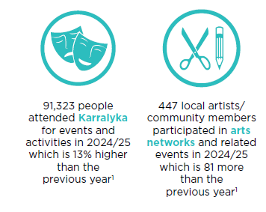

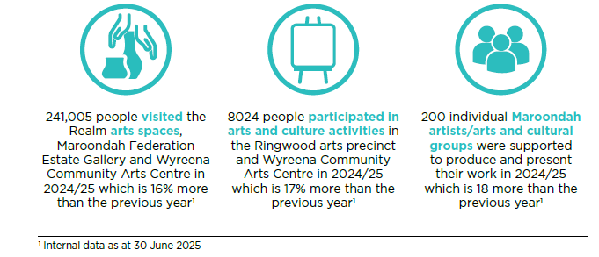

Our Creative Industry is Growing
According to the 2021 ABS Census, approximately 1,800 people in Maroondah are employed in creative and cultural occupations such as visual arts, design, media, performing arts, writing, architecture, digital and technical arts support services, most with tertiary qualifications.
Creative industry jobs make up about 2.4% of Maroondah’s total workforce. This is slightly below the Greater Melbourne average, reflecting Maroondah’s suburban profile according the 2021 ABS data.
There are currently over 300 registered businesses in Maroondah classified under creative industries according to ABS Industry Classification - ANZSIC with local creative industry development rising over the past three years. This provides an opportunity for Council to connect and support new businesses and support their success within Maroondah in partnership with our Business Support services.

Victorians Value the Arts
The Creative Australia Creating Value: National Arts Participation Survey 2023 provides a detailed analysis of the Victorian feedback on the value and need for the arts within community life. The Survey found that:
- 97% of Victorians aged 15 years and over, engage in creative and artistic events, with 62% ensuring children and young people have access to creative experiences to support learning and development.
- 84% of Victorians acknowledge the significant positive impact of the arts and creativity on areas such as wellbeing and happiness, child development, cultural awareness, community identity, lifelong learning and employment.
- 68% of Victorians acknowledge that cost may be a barrier for some people and believe that ensuring accessibility for all is the highest priority.

Community Consultation

What We Did
The development of the Creative Maroondah Strategy 2026–2030 was shaped by extensive and community engagement resulting in extremely sold data that directly shapes this strategy, hearing from our diverse community through several deliberative consultation practices:
- Your Say Community Consultation: Through the Your Say Consultation Survey, we gathered input from over 167 residents of all ages, backgrounds, and abilities. A second round of consultation enables the community to provide feedback on the draft strategy.
- Targeted Stakeholders: Engagement with local artists, creative businesses, cultural organisations, and educators provided sector-specific insights.
- Café Consult: Interactive sessions at the Council Cafe and Maroondah Festival enabled us to connect with families, young people, and culturally diverse groups in a relaxed, accessible setting receiving a total of 4,680 contributions from around 1,306 people.
- Council Advisory Committees: Feedback was sought through workshops with five of Maroondah’s Advisory Committees, including the Arts, Disability, Environment, Liveability, Safety and Amenity, Community Health and Wellbeing Advisory Committees; plus, the Youth Wellbeing Advocates Group and the Reconciliation Partnership Group.

Key Community Indicators - What You Told Us
Across all levels of engagement, several key themes consistently emerged as important to the Maroondah Community forming the key “Community Indicators” to guide the strategy and action plan framework.
- Accessibility and Inclusion: Provide creative programs, collections and places that are accessible to all, including people with disabilities, older adults, young people, and CALD communities.
- Celebration of Diversity and Local Identity: Celebrate Maroondah’s unique cultural identity, neighbourhood character, history and First Peoples stories through creative projects, programs and collections.
- Support for Local Artists and Creative Industry: Nurture local talent, provide affordable creative spaces for artists to practice and present their work, steward networking, training and employment opportunities to grow the local creative sector.
- Activation of Public Spaces and Creative Placemaking: Invest in public art and other initiatives such as public performances, cultural tours and art play that enliven neighbourhoods and reflect local histories and future visions.
- Creative Programs for our diverse community: Create opportunities for creative engagement, participation, learning and leadership for all, and key demographics such as Youth, Disability and Older Adults, with opportunities for intergenerational engagement.
- Sustainability and Innovation: Commitment to environmentally responsible creative practices, enviro-arts initiatives, and the use of new sustainable technologies in the arts.
- Partnership and Collaboration: Strong partnerships between Council, community groups, schools, and businesses are seen as essential for a vibrant creative sector.
- Communication and Engagement: Need for better communication about available arts opportunities and events and more regular opportunities to give feedback.

A Strategy for the Future

Strategy Vision
A Vibrant, Creative and Connected Community.
The vision that underpins this strategy reflects Council and Community aspirations for creative services. The vision supports a thriving community where the arts is part of everyday life, with equitable access to creative participation opportunities for our diverse community, driving community wellbeing, innovation, life-long learning, community identity and creative industry growth.

Our Guiding Principles
Maroondah’s Creative services are delivered in line with the following arts and cultural development principles, as follows:
- Creativity comes in many forms: Creative disciplines are wide in scope, from visual arts to performance arts, music, dance and theatre, new and digital media, literature and storytelling - and all play a pivotal role in community wellbeing.
- Enable Inclusivity and Accessibility: Ensure creative opportunities are accessible for all members of the community to participate and engage with, regardless of age, ability, background, or socioeconomic status.
- Foster Collaboration and Partnership: Foster partnerships between local artists, community groups, educational institutions, and businesses to strengthen the creative ecosystem.
- Celebrate Diversity in all its forms: The arts provide a platform for diverse voices and stories, reflecting the richness of Maroondah’s diverse community.
- Enhance Innovation and Experimentation: Encourage innovative thinking, risk-taking, and experimentation in creative practices and programming.
- Promote Placemaking and Community Identity: Use creativity to enhance public spaces, build a sense of belonging, and reflect the unique identity of Maroondah.
- Encourage Community Wellbeing and Connection: Participation in the arts is linked to improved mental health, resilience, and social inclusion.
- Generate Creative Industry Growth: Creative industries generate jobs, attract investment, and stimulate local economies.
- Inspire Lifelong Learning: Arts engagement fosters curiosity, critical thinking, and innovation across all ages.
These principles guide strategy development, service methodology and underpin the value placed on a Creative and Connected Maroondah.

Strategic Context
The Creative Maroondah Strategy 2026–2030 follows the former Arts and Cultural Development Plan (2020-2025) and is a key enabler of Council’s long-term vision and strategic plan, delivering tangible actions that make Maroondah a more creative, connected, and future-ready city.

Council Plan

Key Outcome Area: A Vibrant and Prosperous Community

Our community’s aspiration
Maroondah is a vibrant and prosperous destination. Creative precincts, placemaking, and experiences make Maroondah a culturally rich place to live, work, play and visit. Our strategic location and competitive strengths facilitate economic development, and local businesses are supported to be successful and sustainable.

Key Council goals and directions
- Facilitate vibrant places and spaces through placemaking initiatives and events, including public art and arts activations.
- Enhance cultural precincts and venues as vibrant places where the community can connect, learn and create.
- Facilitate and program a diverse range of arts and cultural initiatives and experiences through engagement with the local creative sector.

Maroondah 2050
The Maroondah 2050 vision supports the Council Plan for a vibrant and prosperous community where creative services facilitate places and spaces through placemaking initiatives and events, enhancing cultural precincts and venues, and delivering a diverse range of arts and cultural initiatives and experiences including:
- A range of creative events and entertainment
- Diverse range of arts that express the community’s unique cultures, heritage and characteristics
- Enhancement and revitalisation of spaces in Maroondah through the arts.
The Creative Maroondah Strategy reflects this community vision and focus areas through a range of key outcomes and deliverables over the four-year plan duration.

Industry Context
The Creative Maroondah Strategy is informed and guided by National and State policies, regulations, and funding priorities, ensuring it links local needs to the broader industry.
Creative Australia: Revive Cultural Policy (2023–2027) sets a national framework for supporting arts, culture, and creativity, First Peoples arts, and creative industries as drivers of economic and social wellbeing. There is an emphasis on the importance of local government in fostering cultural participation and creative economies.
NAVA (National Association for the Visual Arts) is the peak body advocating for best practice in the visual arts across Australia and provides a Code of Practice for Visual Arts, Crafts and Design that informs best practice in wages and conditions of employment within local government.
Creative Victoria: Creative State Strategy (2028) is the state vision for the sector, and Creative Maroondah aligns with many of the priority areas including growing the creative industries, supporting artists, and increasing access and affordability of arts and culture within local communities. This alignment is beneficial for future funding opportunities and partnerships.
Victorian Local Government Act 2020 requires councils to develop community-focused strategies, including cultural and creative plans, that reflect local needs and aspirations, and encourages alignment with state priorities in arts, diversity, and community wellbeing.

Victorian Aboriginal Affairs Framework sets out commitments to supporting Aboriginal self-determination and cultural expression, which informs local strategies’ focus on First Peoples arts and engagement.
Industry related Regulations and Laws including Copyright Act 1968: Governs intellectual property right; Safe Work Act 2011: Regulates workplace health and safety; Child Safety Standards: Informs legislative child safety practices and screening; and National Building Codes: Governs building construction, accessibility, emergency regulations.

Key Strategy Outcome Areas & Actions
Six key outcome areas emerged from consultation data and are well aligned with Council Plan and Maroondah 2050 priority areas and industry strategic directions. The key outcome areas and are defined in the below diagram, and form a framework for the Action Plan, which offers a suite of measurable deliverables for each outcome area, alongside a clear timeframe.

Strategy Action Plan

The following action plan provides a suite of measurable deliverables across the life of the Creative Maroondah Strategy and will be delivered in partnership with our community and industry stakeholders.

Timeframe key: Year 1 = 2026/27; Year 2 = 2027/28; Year 3 = 2028/29; Year 4 = 2029/30

Outcome Area One: Creative Community
Vision: To empower and engage our diverse community through creative expression, collective projects and opportunities for arts participation.
Key Community Indicators:
- Celebration of Diversity and Local Identity
- Partnership and Collaboration
- Accessibility and Inclusion

Creative Community Priority Actions
Action | Timeframe | Measure
- Support First Peoples’ creative and cultural expression by embedding culturally safe participation pathways, removing access barriers and enabling community-led creative initiatives. | Year 1 - 4 | Number and impact of First Peoples initiatives
- Provide an equitable, well governed Arts and Cultural Grants Program that enables artists and community groups to initiate innovative, ambitious socially engaged projects that deliver measurable community outcomes. | Year 1 - 4 | Number and impact of arts projects funded
- Review Arts Operational Grants to ensure all Council funding is in line with public funding is equitable and reflects best practice and Council’s adopted grants policy framework. | Year 1-2 | Review completed and actioned
- Connect local art and cultural community groups through creating pathways for collective programming, promotions, tenancies and events to support community cultural development and engagement. | Year 1 - 4 | Number and impact of joint initiatives
- Strengthen engagement with local community health and social support services through creating pathways for participation and engagement that support community health and wellbeing outcomes. | Year 1 - 4 | Number and impact of joint initiatives
- Engage young people and LGBTQI+ communities through responsive arts initiatives, training and mentorship programs that support social inclusion, wellbeing, leadership and participation. | Year 1 - 4 | Number and impact of youth initiatives
- Engage CALD communities in activities that strengthen cultural development, cultural safety and celebration, and promotes cross-cultural exchange through accessible and diverse arts participation. | Year 1 - 4 | Number and impact of joint initiatives
- Engage people with disability in creative activities through developing accessible pathways for participation in activities that strengthen community engagement, wellbeing and connection. | Year 1 - 4 | Number and impact of joint initiatives
- Celebrate positive ageing through providing creative programs and services that enable connectedness and participation for inter-generational and older adults through arts participation and engagement. | Year 1 - 4 | Number and impact of joint initiatives
- Recognise and celebrate creative achievements and excellence locally and beyond through annual award and acquisition programs such as the Mayoral Exhibition Awards, and the McGivern Art Prize. | Year 1 - 4 | Engagement and impact of arts prizes and awards
- Engage with the local performing arts community (theatre, dance, music etc) through creating accessible pathways for performance, new work, residencies and networking opportunities within Karralyka and other major arts venues. | Year 1 - 4 | Number and impact of joint initiatives

Outcome Area Two: Creative Places
Vision: Activate and enhance public spaces and cultural venues to reflect Maroondah’s unique identity, improve accessibility and foster a sense of belonging, pride and cultural identity.
Key Community Indicators:
- Activation of Public Spaces and Creative Placemaking
- Accessibility and Inclusion
- Support for Local Artists and Creative Industry

Creative Places Priority Actions
Action | Timeframe | Measure
2.1 Continue to optimise Karralyka as a regionally significant performing arts and function centre through facility optimisation, program development, performing arts partnerships, quality service delivery and diverse audience engagement. | Years 1-4 | Delivery of service planning initiatives
2.2 Continue to realise the Wyreena Master Plan, including completion and re-activation of the upgraded Conservatory Café to position this regional community arts centre for future success. | Years 1-2 | Progress on masterplan.
2.3 Promote, enhance and preserve the Maroondah Art Collection through increased exhibitions in civic spaces, selective acquisitions, suitable storage, digital database management and virtual website galleries. | Years 2-4 | Well managed civic collection.
2.4 Embed public art within village and activity centre revitalisation projects through integrated planning and resourcing modelling, to help strengthen a unique village identity, community safety, visitation and connection to place. | Years 1-4 | Number and impact of projects.
2.5 Commission new public art within existing Council owned venues and precincts to enhance vibrancy, visibility, identity and improved visitor experiences. | Years 1-4 | Number and impact of projects
2.6 Introduce public art within select major new and upgrade infrastructure projects through collective planning and resource modelling to deliver impactful creative placemaking outcomes within major civic site developments. | Years 1-4 | Number and impact of projects
2.7 Deliver the ‘Arts in the Park’ program of unique, small-scale creative events and experiences that support accessibility, diverse participation, site activation and visitation to major arts venues and precincts. | Year 1 | Number and impact of projects.
2.8 Undertake an accessibility audit within all major arts facilities (e.g. accessible wayfinding, wheelchair access, braille, Auslan, assisted listening systems, neuro-diverse spaces etc) to remove barriers to participation. | Year 3 | Audit complete and actioned
2.9 Facilitate greater connections between major arts facilities within Maroondah through cross-promotion and collective programming. | Year 2-4 | Number of joint initiatives
2.11 Develop a Revitalisation Plan for Maroondah Federation Estate (MFE) including measures to improve identity, visibility, purpose, tenancy optimisation and community engagement within this major cultural venue. | Year 1-4 | Plan developed and actioned
2.12 Delivery of series of ‘quick wins’ to activate MFE, including café tenancy, courtyard public art, pop up events and artist residency opportunities. | Year 1-2 | Actions delivered within budget.
2.13 Undertake service demand analysis for community halls and MFE to inform asset planning and facility optimisation that responds to local demand. | Year 1 | Optimisation of assets
2.14 Realise the vision for the Croydon Community Wellbeing Precinct and Cultural Hub through effective planning and delivery of the operational, programming, public art and activation of this significant new precinct. | Yeas 1-4 | Building complete
2.15 Review the K-Café service delivery model and healthy choices program to ensure the best fit for café services is applied with Councils Aquatic facilities. | Year 1-2 | Reviewed and actioned.
2.16 Review and update the current Public Art Policy and Civic Art Collection Policy to align with best practice, optimise impact and inform programming. | Year 1 | Reviewed and actioned.
2.17 Identify spaces across the municipality that might support creative practitioners through affordable studios, co-working, pop up activations and residencies across all art forms. | Year 2-4 | Number of creative residencies.

Outcome Area Three: Creative Programs
Vision: Deliver innovative, high-quality arts and cultural programs that inspire participation, social connection and lifelong learning within our diverse community.
Key Community Indicators:
- Creative Programs for our diverse community
- Accessibility and Inclusion
- Support for Local Artists and Creative Industry

Creative Programs Priority Actions
Action | Timeframe | Measure
3.1 Continue to host and deliver a diverse mix of high quality, accessible and engaging performing arts programs within Karralyka in partnership with professional, touring and community performing arts groups. | Years 1-4 | Number, diversity and impact of programs
3.2 Explore development pathways to support new work, mentorships, arts incubators, commissions and accessible rehearsal space for emerging performing artists, primarily within Karralyka. | Year 2 | Number, diversity and impact of programs
3.3 Secure local interest and tenancies for performing arts program delivery within the new Croydon Community Wellbeing - Black Box Theatre. | Years 2-3 | Number of new partnerships
3.4 Continue to expand and diversify the range of high quality and engaging visual arts programs including exhibitions, arts incubators and arts development programs that reflect local interests. | Years 1-4 | Number, diversity and impact of programs
3.5 Expand the offering of low-cost and free arts initiatives such as educational arts classes, theatre programs and arts events that target and support arts engagement by those with financial barriers to participation, with a key focus on local families and children. | Years 1-2 | Number, diversity and impact of programs
3.6 Further evolve digital and hybrid arts programs that support increased participation by young people and those interested in emerging arts technologies. | Years 2-4 | Number, diversity and impact of programs
3.7 Engage with local schools through joint programs that deliver learning outcomes and invite regular participation by students in local arts and cultural activities and events. | Years 2-4 | Number, diversity and impact of programs
3.8 Explore an ongoing framework for children and young people to inform creative programming for their peers within arts venues. | Years 2-4 | Number, diversity and impact of programs
3.9 Support youth-led initiatives, mentorship programs, and youth representation on arts working groups and committees. | Years 1-4 | Number, diversity and impact of programs
3.10 Further develop creative opportunities for older adults to engage with community through inclusive, inter-generational creative programs. | Year 1 | Number, diversity and impact of programs
3.11 Continue expanding creative programs that are accessible and of interest to people living with disabilities or other barriers to participation. | Years 2-4 | Number, diversity and impact of programs
3.12 Align with environmental and sustainability priorities through eco-arts programs, partnerships, education and venue management practices. | Years 2-4 | Number, diversity and impact of programs
3.13 Deliver creative programs that support cultural development, celebrate diversity and cultural heritage and encourage cross-cultural engagement. | Years 1-4 | Number, diversity and impact of programs
Action | Timeframe | Measure
3.14 Expand support for community-led arts initiatives through providing expert advice, training, industry resources, partnership opportunities and best practice modelling to guide new, innovative work within community. | Years 2-4 | Number, diversity and impact of programs
3.15 Further develop civic, heritage and public art public programs including guided tours, talks and self-guided digital maps to promote engagement with the arts, history and natural environment. | Years 1-4 | Number, diversity and impact of programs
3.16 Explore joint exhibition programs with local arts groups where there is a broader community benefit upheld by an equitable engagement process. | Years 2-4 | Number, diversity and impact of programs
3.17 Engage with local historical societies to help preserve, share and celebrate local history through arts and cultural initiatives. | Years 2-4 | Number, diversity and impact of programs
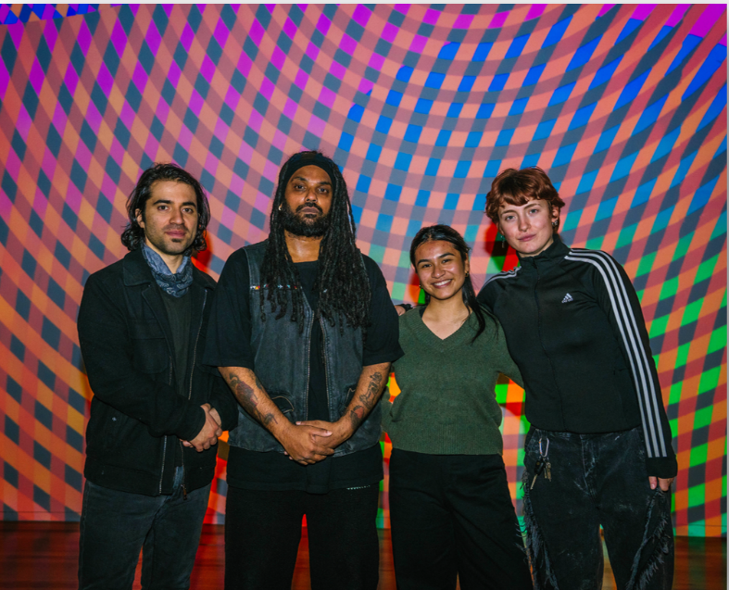
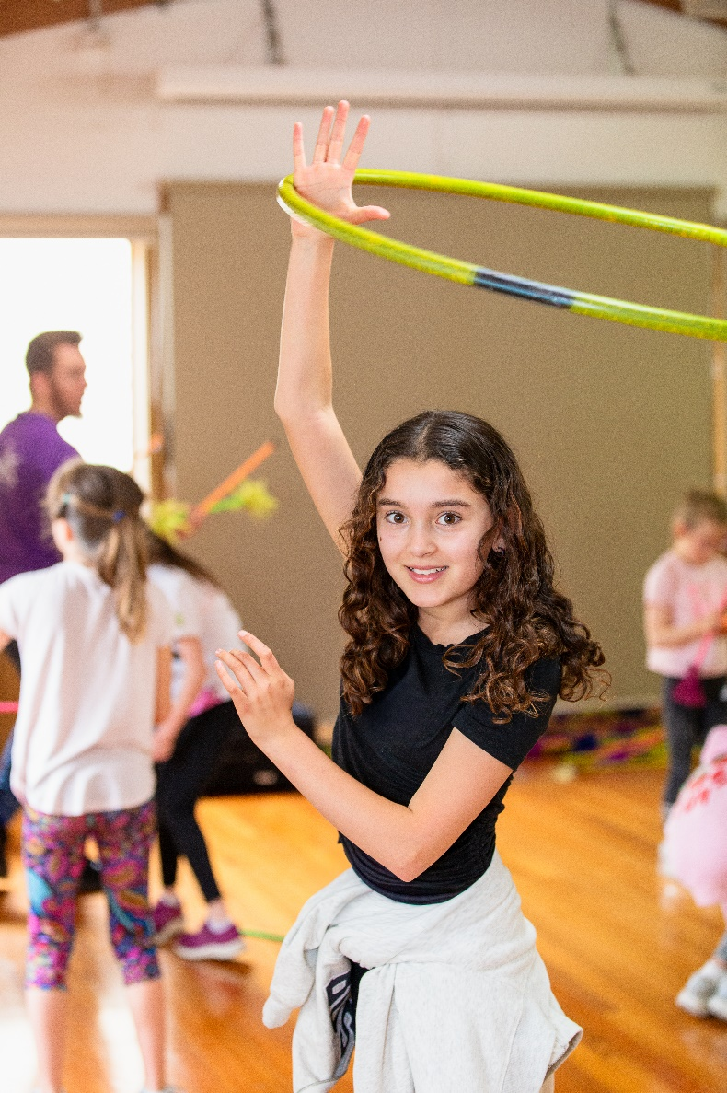
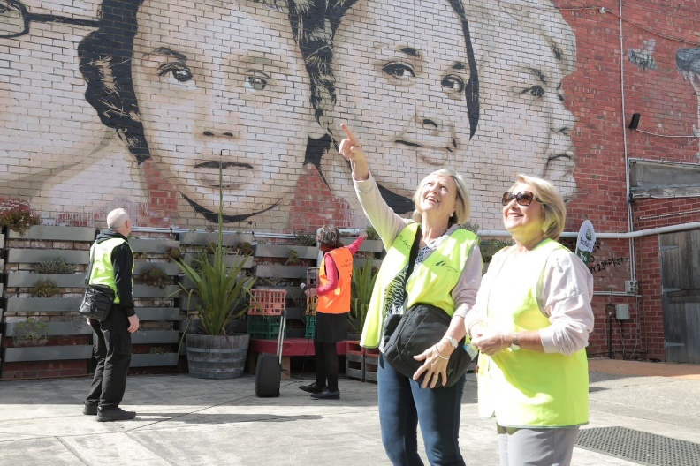
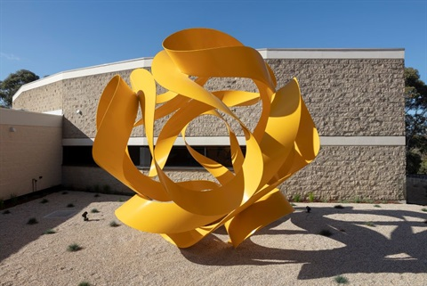

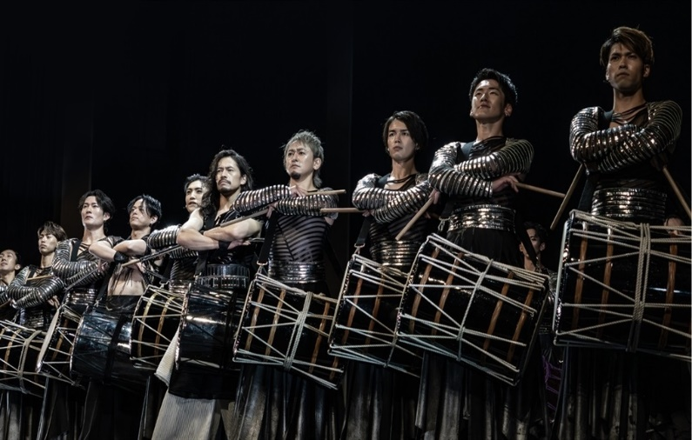
Outcome Area Four: Creative Partnerships
Vision: Strengthen collaboration with artists, organisations, businesses, and the broader community to grow Maroondah’s creative sector.
Key Community Indicators:
- Partnerships and Collaboration
- Creative Programs for our diverse community
- Support for Local Artists and Creative Industry

Creative Partnerships Priority Actions
Action | Timeframe | Measure
4.1 Continue to work with the Maroondah Arts Advisory Committee (MAAC) Industry and Community members to identify priorities, opportunities and sector trends to guide future service planning. | Years 1-4 | MAAC impact on service development.
4.2 Continue to develop the Maroondah Arts Collective network to connect artists, arts workers, creative businesses, services and arts enthusiasts through relevant and engaging networking and training opportunities. | Years 1-4 | Number, diversity and engagement with network
4.3 Develop strategic partnerships with local businesses, arts organisations, and service providers to co-deliver projects, events and initiatives through a shared resourcing model. | Year 1 | Number and impact of partnerships
4.4 Seek increased funding partnerships through State and Federal grants, sponsorship and commercial investment for arts programs, projects and venues that support Council Plan objectives. | Year 1-4 | Successful funding partnerships and outcomes.
4.5 Deliver a range of targeted arts and cultural development program partnerships with local groups and services that utilise the arts as a means for engagement participation. | Years 1-4 | Number and impact of partnerships
4.6 Encourage program partnerships with local arts and cultural groups across other key Council service areas including Festivals and Events, Community Services and Community Wellbeing. | Years 1-4 | Number and impact of partnerships
4.7 Continue to work in partnership with Mullum Mullum Aboriginal Gathering Place, Reconciliation bodies and other First Peoples service providers to enable First Peoples led arts and cultural initiatives through resource sharing, joint initiatives and industry partnership networks. | Years 1-4 | Number and impact of partnerships
4.8 Collaborate with the Eastern Regional Councils to identify opportunities for regional arts project development, cultural tourism and co-funding opportunities. | Years 2-4 | Number and impact of partnerships
4.9 Further develop exhibition partnerships with local arts groups and artists that support community arts display across Council facilities and precincts. | Years 2-4 | Number and impact of partnerships
4.10 Investigate industry partnership pathways for local businesses to connect with local artists to display and sell their work. | Year 3 | Number and impact of partnerships
4.11 Working in partnership with Your Library, continue to explore and deliver collective programs that support learning and engagement with arts- literature initiatives. | Years 1-4 | Number and impact of partnerships
4.12 Continue to develop local community arts partnerships by enabling access to affordable spaces, joint initiatives and funding, training programs and audience development strategies. | Years 1-4 | Number arts groups in Maroondah

Outcome Area Five: Creative Industry
Vision: Nurture a sustainable and thriving creative economy and cultural tourism in Maroondah by supporting opportunities with creative businesses, artists and industry led initiatives.
Key Community Indicators:
- Support for Local Artists and Creative Industry
- Communication and Engagement
- Partnership and Collaboration

Creative Industry Priority Actions
Action | Timeframe | Measure
5.1 Facilitate professional development opportunities for creative practitioners, services and organisations through a training programs, industry networks and masterclasses to help build local skills, capacity and sector growth. | Years 1-4 | Number and diversity of training programs
5.2 Advocate for affordable creative workspaces and studios within Maroondah, including co-working and maker-space models that support creative industry development. | Year 1 | Number of creative workspaces filled
5.3 Continue to offer individual artists the opportunity to apply for funding through Councils Arts Grants program to deliver projects that support arts engagement and professional development. | Years 1-4 | Funded arts development projects
5.4 Encourage the employment and commissioning of local artists, arts suppliers and services within Councils procurement framework. | Years 1-4 | Number of local artists procured
5.5 Foster innovation and entrepreneurship by linking local arts organisations, groups and artists with industry initiatives such as creative and business awards, forums and cross sector networking events. | Years 1-4 | Number of artists engaged in industry activities
5.6 Collect and share data on the value and impact of the creative industries in Maroondah to inform advocacy and future planning, including the use of industry programs such as Culture Counts to support regional benchmarks. | Years 1-4 | Quality data is shared and deemed useful
5.7 Develop and deliver artist-in-residence and mentoring programs within major arts facilities, prioritising local and emerging artists to help grow and strengthen their practice. | Year 1 | Residency program established
5.8 Foster volunteer and student placement opportunities within creative services to enhance future sector capacity and pathways to arts employment. | Years 2-4 | Volunteer & Student program established
5.9 Participate in cross Council Eastern regional joint initiatives and Victorian based creative sector developments that secure collective interest and investment creative industries and positions Maroondah as a prime arts destination. | Years 2-4 | Successful regional projects delivered
5.10 Incentivise major arts organisations and commercial arts touring companies to present major work and locate their services within Maroondah to enhance creative sector development and boost cultural economy. | Years 3-4 | Number and value of commercial arts presentations
5.11 Continue to consult industry and community representatives of the Maroondah Arts Advisory Committee to guide local creative service priorities, harness opportunities and discover emerging trends. | Years 1-4 | MAAC consultation delivered
5.12 Continue to connect with tertiary institutions in the development of industry-based learning, employment and mentoring pathways to support students accessing industry experience. | Years 2-4 | Number and impact of partnerships

Outcome Area Six: Creative Communications
Vision: Creative services, venues and initiatives are highly visible, accessible and engaging for our diverse community, and we seek feedback often to help guide continuous service improvements.
Key Community Indicators:
- Communication and Engagement
- Partnership and Collaboration

Creative Communications Priority Actions
Action | Timeframe | Measure
6.1 Continue to evolve strategic communications and engagement campaigns through enhanced service branding and design, multi-channel platforms, engaging content and high-visibility approaches effectively reaches diverse audiences and inspires participation. | Years 1-4 | Increased audience engagement levels
6.2 Review all creative venues for effective entry and wayfinding signage that promotes visibility and purpose for all major arts venues. | Year 2-3 | Effective signage delivered
6.3 Tap into local and regional marketing channels such as local school E-News, community groups, businesses, arts and cultural organisations and media organisations to promote and extend reach into new market segments and regions. | Year 1 | Increased audience engagement levels
6.4 Review all communications content across all promotional platforms for readability, accessibility and multi-lingual options. | Year 2 | Accessible content delivered
6.5 Use data-metrics and data collected from attendance, participation, sales, social media and feedback mechanisms to continuously refine and improve creative services and reach. | Years 1-4 | Data informs engagement planning
6.6 Develop communications pathways to cross-promote local community arts activities, industry news and special interest stories within arts media channels. | Year 1 | Community channels activated
6.7 Establish easy to use feedback loops such as surveys, polls, online engagement platforms etc that encourage quick and easy ways to provide feedback on creative services at events and arts venues. | Years 1-4 | Feedback channels activated
6.8 Continue to seek service improvement feedback directly from industry stakeholders, user groups, partners and community using strategic engagement strategies and platforms, to inform future service improvements. | Years 1-4 | Feedback informs service planning
6.9 Undertake annual evaluation of this strategy and provide updates to the community on progress and delivery of the actions. | Years 1-4 | Feedback informs service planning

Tracking our Progress

Annual Action Plan Measures
Each priority action will be assessed against the stated measures within the action plans, and outcomes reported to Councillors, key stakeholders, partners, Maroondah Arts Advisory Committee and those following the Your Say Creative Maroondah Strategy updates.

Service Performance Measures
Creative Places Services will collect annual data across all service areas, as part of the strategy annual reporting, and in line with the Council Plan measures. This will provide macro trends on the Community attendance, creative sector support, and overall satisfaction with services and venues, as follows:

- Creative places and precincts (Council owned) attendance at all venues

- Karralyka attendance
- Artists and creative groups supported to present their work
- Community satisfaction with arts centres and libraries
- Community satisfaction with community and cultural activities
Community Satisfaction Measures

State of Maroondah 2025 Community Satisfaction Survey results indicate that in 2024/25:

- 72% of survey responses indicated community satisfaction with community and cultural activities, rated above metro and state-wide council averages)

- 77% of survey responses indicated community satisfaction with arts centres and libraries (Council’s top performing and most well-regarded service area, rated above metro and state-wide council averages)

This strategy commits to Council seeking regular feedback on community satisfaction levels, allowing services to respond and adapt to the changing community interests and needs for Creative Services within Maroondah, reflected in these satisfaction levels continuously improving.

References & Glossary

References
- Maroondah City Council Plan 2025-2029
- Maroondah 2050
- Maroondah Council Community Satisfaction Survey 2024/25
- Maroondah Arts and Cultural Development Strategy 2020-2025
- World Health Organization (WHO) Health Report 2020
- Creative Australia ‘Creating Wellbeing” Report 2021
- VicHealth – Promoting Everyday Creativity at a Local Level.
- Creative Australia "Next Generation Now", 2025
- Frontiers in Psychology Editorial: The Psychological and Physiological Benefits of the Arts 2022
- Creative Australia Creating Value: National Arts Participation Survey 2023
- Key Economic Indicators, Australian Bureau of Statistics, 2023
- Tourism Research Australia Report 2023
- 2021 ABS Census
- ABS Industry Classification - ANZSIC

Glossary
Creative Programs: Encompasses all forms of arts and cultural expression including but not limited to visual arts (painting, drawing, sculpture, print & digital media, murals etc), performing arts (dance, theatre, music, comedy etc), literature, film, crafts, design, and new media.
CALD: Culturally and Linguistically Diverse peoples.
Creative Industry: Businesses and individuals engaged in the production, distribution, and promotion of creative goods and services, including design, digital media, publishing, and the performing and visual arts. This strategy focuses upon initiatives that support the growth, sustainability, and innovation of the creative sector.
Creative Placemaking: The process of activating and enhancing public spaces through Council and Community arts led interventions including public art, installations and design elements.
Creative Venues: Facilities managed by Creative Services including Wyreena Community Arts Centre, Maroondah Federation Estate, Maroondah Federation Estate Gallery, ArtSpace at Realm, Karralyka Centre and Community Halls.
Impact: A measure of stakeholder and participant feedback on an initiative where they express that the activity met shared goals and delivered measurable positive outcomes.
Inclusion: Ensuring equitable access and participation in arts and culture for all members of the community, regardless of background or ability.
Partnerships: Collaborative relationships between Council, artists, organisations, businesses, and the community to deliver shared outcomes.
Programs: Structured activities, events, workshops, and initiatives that engage the community in arts and culture.
Public Art: Artworks of a temporary or permanent nature created for public spaces, often reflecting local stories, history, or identity. These might include outdoor or indoor spaces with a range of applications including freestanding sculpture, digital projections, murals, lighting and temporary activations.

