Equally Active Strategy summary document 2019
An active participation strategy or women and girls

What the community told us

Women and girls need to feel safe, supported and encouraged to undertake regular physical activity, improving their physical and mental health and social confidence.

Making a positive impact on participation rates will take more than just encouragement and provision of opportunities, it requires social and attitudinal change by women and girls and by those who can support them to have the time and freedom to be regularly active.

Australia’s Physical Activity and Sedentary Behaviour Guidelines recommend that adults undertake 2.5 to 5 hours of moderate, or 1.25 to 2.5 hours of vigorous, physical activity per week.

A Maroondah resident survey undertaken in 2014 highlighted that only 40% of girls aged 15 to 17 years meet these guidelines, decreasing to 14% of 35 to 44-year-old women, underlining a definitive need to address these rates of participation.

On the flip side, girls’ participation rates in traditionally male-dominated sports such as AFL, soccer and cricket have seen an unprecedented surge.

This positive trend will require a strategic approach to ensure that the physical, the social and the attitudinal environment supports these girls to continue long-term participation through teen years into adulthood. Council will continue to improve facilities to support women and girls to undertake sport and recreation and explore initiatives to support clubs to undertake actions to create inclusive, gender equitable club environments and empower women to take up coaching and decision-making roles.

In Maroondah, between 2014 - 2017 women’s and girls’ participation in soccer increased by 22%, in cricket 27% and in AFL by 316%.

Challenges and opportunities

The Equally Active Strategy seeks to understand the current situation within Maroondah, who is or isn’t participating in regular physical activity and why, and to develop targeted strategies to address low participation in specific population cohorts.

The strategy highlights the challenges and opportunities being experienced within three specific sub-populations in order to target specific actions which will have a positive impact on participation. In reviewing the participation rates for women and girls in Maroondah it was determined to focus actions towards the following target groups:

- Women and girls from culturally and linguistically diverse (CALD) backgrounds
- Young women aged 10 to 17 and 18 to 26 years.
- Women with care responsibilities.

Different female population cohorts within Maroondah experience different challenges to being as active as they should be, or would like to be, to maintain optimal health and wellbeing.

Current issues affecting the participation of women and girls include:
- a systemic fear of judgment of appearance, ability and/ or priorities
- gender inequality in recreation and sporting settings
- care giving responsibilities
- limited female-friendly amenities
- cultural differences.

Women are more likely to participate in sport or physical activity for physical and mental health reasons, and to lose or retain weight, than men.
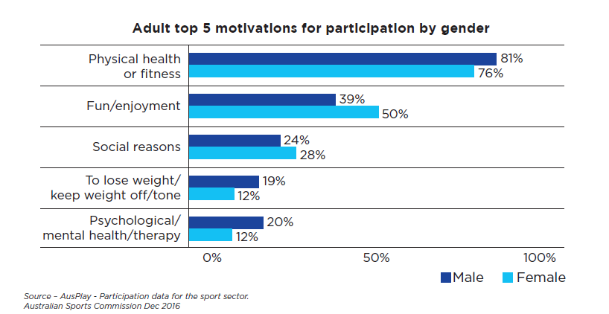

Our vision

The vision driving this active participation strategy for women and girls in Maroondah is as follows:

In Maroondah, women and girls will have equal opportunity to undertake sport and recreational physical activity in environments where they feel welcomed, supported and safe.

The Strategy contains 24 priority actions which will involve a wide range of Council service areas. The strategy will be reviewed in two years to evaluate the progress and effectiveness of the actions. The results will inform the development of Council’s next Physical Activity Strategy. A snapshot of targeted priority actions include:

Outcome area 1: Gender Equality in Sport
Develop a mid-season reporting mechanism to monitor clubs’ progression in the equitable scheduling of training and matches and implement initiatives to support positive change.
Work with local clubs and associations to pilot the delivery of the social and modified versions of their code initiatives such as Walking Netball, Soccer Mums and Walking Cricket.

Outcome area 2: Women of CALD backgrounds
Deliver a CMY Good Practice Principles training session for relevant Sport & Recreation and Maroondah Leisure staff.
Review Maroondah Leisure recruitment processes and introduce positive actions to recruit people from under-represented groups in order to increase the diversity of staff.

Outcome area 3: Young Women
Create targeted education/awareness programs explaining the role that supportive family, friends and school can play to ensure girls stay active.

Investigate trialing a 6-week Quidditch program - a physical activity which is social, new to everyone and has current appeal to this age bracket.

Outcome area 4: Women with Care Responsibilities
Provide a fully enclosed playground option which incorporates play and fitness equipment
Extend the frequency and sustainability of the Pathway for Carers Program and investigate a gymnasium option.

