Equally Active Strategy 2019

An active participation strategy for women and girls

Executive summary

Women and girls need to feel safe, supported and encouraged to undertake regular physical activity, improving their physical and mental health and social confidence.

Making a positive impact on participation rates will take more than just encouragement and provision of opportunities, it requires social and attitudinal change by women and girls and by those who can support them to have the time and freedom to be regularly active.

According to the current VicHealth campaign, This Girl Can, 52% of women worry about being judged while exercising, and for over 40%, this feeling of embarrassment or intimidation is so strong they think it unlikely they will start at all. These numbers add up to an alarming three in five (or 60%) of Australian women are not sufficiently active, and one in five women don’t do any physical activity in a typical week.

Participation rates for women and girls is currently increasing at an unprecedented rate in traditionally male-dominated sports such as AFL, soccer and cricket and Maroondah City Council recognises the need to have a strategy to ensure that these new participants have the provisions and the infrastructure to encourage and support their continued involvement.

The Victorian Government’s 2014 Inquiry into Women and Girls in Sport and Active Recreation found that in sport there is a need for change and that collaboration is needed if change is to happen. Therefore, while continuing to improve the infrastructure to support women and girls to undertake sport and recreation, Council will also explore initiatives to support clubs to undertake actions to create inclusive, gender equitable club environments and empower women to take up coaching and decision-making roles.

The Equally Active Strategy builds on the recommendations of Council’s 2015 - 2020 Physical Activity Strategy which highlighted women as a specific population which will require targeted actions to make a positive impact on the current low physical activity levels.
There are different factors that affect the physical activity levels of specific populations and therefore different strategies are required to overcome these challenges. The Equally Active Strategy highlights the challenges and opportunities being experienced within three specific sub populations in order to target specific actions which will have a positive impact on participation. In reviewing the participation rates for women and girls in Maroondah it was determined to focus actions towards the following target groups:

- Women and girls from Culturally and Linguistically Diverse (CALD) backgrounds
- Young women aged 10-17 years and 18-26 years
- Women with care responsibilities.

The vision driving this active participation strategy for women and girls in Maroondah is as follows:

In Maroondah, women and girls will have equal opportunity to undertake sport and recreational physical activity in environments where they feel welcomed, supported and safe.

The Strategy contains 24 priority actions which will involve a wide range of Council service areas. The strategy will be reviewed in two years to evaluate the progress and effectiveness of the actions. The results will inform the development of Council’s next Physical Activity Strategy.

Why is there a need to support girls and women to get active?

Regular sport and active recreation participation leads to a healthy lifestyle which can result in longevity due to the social, physical, and psychological benefits it provides.

Evidence tells us that women know that they should be physically active however it also shows that knowledge alone is not a major influencing factor. Simply encouraging women to be active will not see change occur. Changing the physical, the social, and the attitudinal environment that supports women to be active will instigate change.

Why focus specifically on women and girls?
- significantly fewer women than men do enough physical activity each week
- significantly more women than men do no physical activity at all
- women are much less likely to participate in organised sport than men
- women’s participation in sports and exercise declines substantially as they get older
- women are less likely to do strength training than men.

Australia’s Physical Activity and Sedentary Behaviour Guidelines recommend that adults undertake 2.5 to 5 hours of moderate, or 1.25 to 2.5 hours of vigorous, physical activity per week.

A Maroondah resident survey undertaken in 2014 highlighted that only 40% of girls aged 15 to 17 years meet these guidelines decreasing to 14% of 35 to 44-year-old women, underlining a definitive need to address these rates of participation.

On the flip side, girls’ participation rates in traditionally male-dominated sports such as AFL, soccer and cricket have seen an unprecedented surge. This positive trend will require a strategic approach to ensure that the physical, the social and the attitudinal environment supports these girls to continue long-term participation through teen years into adulthood.

Purpose

This strategy seeks to understand the current situation within Maroondah, who is or isn’t participating in regular physical activity and why, and to develop targeted strategies to address low participation in specific population cohorts. Furthermore, to support and sustain the current increase in women and girls’ participation in traditionally male-dominated sports, the strategy will identify actions to assist Maroondah clubs to provide safe, inclusive, gender equitable environments.

Scope

This Strategy addresses both sports and leisure participation and refers to both organised and non-structured activities. While the Strategy will acknowledge the services of private providers, priority actions will only pertain to activities provided by community organisations utilising Council facilities and Council provided services.
This strategy does not specifically address gender diversity, however acknowledges that in achieving a safe, inclusive and gender equitable environment the needs of trans and gender diverse people should always be considered.
In 2017, a situation analysis, Getting Females Active In Sport, was undertaken to inform the planning and direction of this strategy.

The recommendation of this analysis was that while sport was acknowledged as an important focus, to increase participation, research indicates that women and girls are more likely to participate in non-sport and non-organised activities that are flexible in delivery and address some of the barriers to participation. Since Maroondah has a large number of women and girls that are not likely to participate in traditional sports, to achieve a genuine increase in participation across the entire female demographic of Maroondah, a holistic approach was recommended to make a positive impact.

Key terms
- Sport: ‘structured, organised & scheduled activity’
  - Active Recreation: ‘leisure time, non-competitive, physical activity’

What is Council’s role?

In 2018, Council adopted a Gender Equity Policy endorsing Council’s commitment to working towards a community where everyone is valued and enjoys equity of opportunity and outcomes.

Increasing opportunities for physical activity for all women and girls in Maroondah is a complex issue requiring the collaboration of many areas of Council and the wider community. Reducing barriers, improving amenities, supporting inclusive environments and ensuring the equitable distribution of facilities will require a clear strategic approach and measurable actions to influence change and gauge impact.

Council has many roles in influencing participation in physical activity and is directly responsible for a wide range of services. Roles include:
- maintenance and development of the physical outdoor environment
- maintenance and development of community sports and recreation infrastructure
- provision of Maroondah Leisure facilities and programs
- provision of active participation programs and events
- advocacy for specific age cohorts – children, youth and seniors.

Council has recently adopted a Gender Equity Policy which will assist Council to promote equal and respectful attitudes in the workplace and community through leadership on gender equity.

The document highlights the importance of gender equity, summarises input from the staff engagement process and articulates a set of gender equity policy directions for Council. A range of future activities are also identified, aimed at working towards the effective implementation of these policy directions

Increasing women’s participation in sport and physical activity has been a state and national priority for
several years now and relevant planning and prioritisation at an LGA level will become an integral part of achieving government funding going forward. Given the focus on increasing female participation across many traditionally male-dominated sporting codes and the successful development of elite level women's AFL, there is a pressing need for Council to determine a consistent position on the equitable distribution of sportsgrounds.

Council’s Physical Activity Strategy highlights that there are limited open space opportunities for sportsground development, and the current allocation process affords priority to the past tenant with the ground being allocated for both training and games on a seasonal basis. This leaves little opportunity for new users within Maroondah. Usage strategies and infrastructure improvements are required to extend usage and allow greater access for new users.

The Physical Activity Strategy highlighted women as a specific population which will require targeted actions to make a positive impact on the current low physical activity levels. With more than 20% of residents having an equivalised household income of less than $494 per week, more than 20% being born overseas and more than 50% being female, Maroondah has a large percentage of women and girls who are not likely to participate in traditional sports and therefore a key focus of the Strategy will be to improve access and opportunities for participation in other physical activity options.

The Strategy directly relates to the following key directions of the Maroondah 2040 Community Vision:

An active community 1.19 Provide a range of integrated recreation and leisure facilities that meet the needs of all ages and abilities
1.21 Support and empower local community groups, sporting clubs and special interest groups across Maroondah
An empowered community 8.2 Undertake inclusive engagement and consultation using accessible and tailored approaches to consider the needs and aspirations of different age and population groups
An inclusive community 7.2 Encourage programs and initiatives that raise the awareness of accessibility issues and deliver improved access to facilities and services for all ages and abilities
A diverse community 7.10 Promote and create opportunities for community connectedness, learning, mentoring and social interactions for people from all life-stages and cultural backgrounds

What does the evidence say?

Evidence highlights that there is no one approach to addressing the gender disparity in physical activity participation among Maroondah residents. Different female population cohorts within Maroondah experience different challenges to being as active as they should be, or would like to be, to maintain optimal health and wellbeing.

Current issues affecting the participation of women and girls include:
- a systemic fear of judgment of appearance, ability and/ or priorities,
- gender inequality in recreation and sporting settings,
- care giving responsibilities,
- limited female friendly amenities and
- cultural differences.

Maroondah’s diversity is not unique however the recent increase in cultural diversity has highlighted a need to improve understanding and awareness of the needs of Maroondah’s emerging culturally and linguistically diverse (CALD) communities.

Women in Maroondah

According to the 2016 Census, 51.6% or 56,979 of Maroondah residents identified as female.

Employment
Fifty-nine percent, or 26,489 women living in Maroondah aged 15+ are in employment, of this 45% worked full-time and 54% part-time

Women as carers
Maroondah has an increasing proportion of carers providing unpaid assistance to a person with a disability, long term illness or old age due to our aging population, cost of out of home care and a lessening of hospital centred care for acute psychiatric illness.

In Maroondah, 6,690 women aged 15+ provide assistance to a person with a disability, long term illness or old age and 16,012 women aged 15+ reported that they undertake unpaid childcare as their primary role and of this 4863 indicated that this included care for children other than their own.

Cultural diversity
Maroondah has a growing diverse population with two-thirds of Maroondah’s recent population growth attributed to migration. Between 2006 and 2011 Maroondah’s non English-speaking population increased by 45.3%.

Seventeen percent of Maroondah residents (18,744) spoke a language other than English at home and 81.8% of recent overseas arrivals in Maroondah come from countries where English was not their first language.

Religions with specific dress requirements for women have limited representation in Maroondah with Hinduism 2.9% of men and women in Maroondah, Islam 0.6% and Sikhism 0.5%.

Participation

In 2015, more than two-thirds of adult Australian females were classified as being sedentary or having low
levels of exercise with 9% of females choosing organised physical activity and 44% non-organised physical
activity. Female participation through sporting or recreational clubs is lower compared to males.

The VicHealth indicators survey in 2015 showed that the three most popular non-organised physical
activities in Maroondah were walking (51.7%), cycling (13.2%) and gym or fitness (11.6%) indicating a preference for active pursuits that can be undertaken in one's own time.

A Maroondah resident survey undertaken in 2014 highlighted that only 40% of females aged 15 to 17 years meet the National Physical Activity Guidelines of 30 minutes of moderate physical activity a minimum five days per week. This figure decreases to 14% of women aged 35 to 44 years. Furthermore, the disparity in participation rates between genders for 15 to 24-year-olds is alarming and demonstrates a definite need for intervention.

While within the 25 to 44 years age group, the gender divide is far less, both sexes had an exceptionally low rate of respondents meeting the recommended levels. A triannual study by Cancer Council and National Heart Foundation, the National Secondary Students’ Diet and Activity Survey, studied 9,000 Australian Year 8 to Year 11 secondary school students in 2012/2013 and found that: 18% of students achieve the recommended 60 minutes of physical activity a day, 24% of boys and only 11% of girls met the guidelines.

In 2017, Maroondah City Council completed a Sports Demand Analysis to ascertain current and projected sports participation in Maroondah. In 2017, females made up 41% of total participants across 28 different sports and this is expected to increase to 47% by 2021 based on club self-reporting. Significant increases in female participation have been projected for hockey, lawn bowls, baseball, AFL and cricket. Furthermore, the report identified that 78% of existing facilities at Council’s sporting grounds do not adequately cater for female participation and the projected increases and sustained growth of female participation will be dependent on improved female facilities, changing governance structures, sport scheduling and club environments.

Key motivators to being active

Women are more likely to participate in sport or physical activity for physical and mental health reasons, and to lose or retain weight, than men.

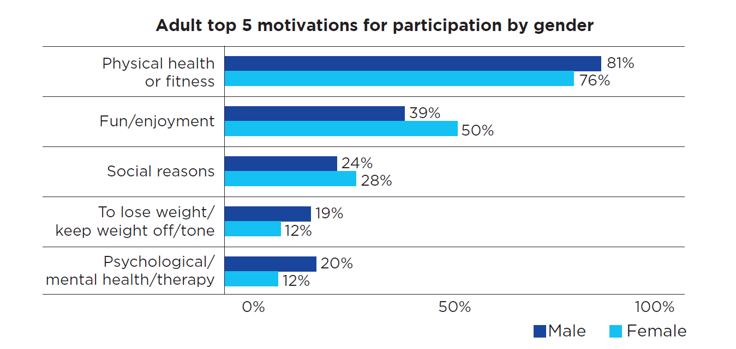

In 2014, the Victorian Minister for Sport established a panel of industry representatives to undertake an Inquiry into Women and Girls in Sport and Active Recreation to highlight practical actions that the sport and active recreation sector could adopt to enhance participation by women and girls and to increase their engagement in leadership and governance roles.
The overwhelming finding was that women are under-represented in leadership roles in a sports sector that is still predominantly male-centric and dominated.
The report also highlighted a growing movement of women and girls keen to showcase their talent and desire to contribute to the sport and active recreation sector, but the opportunities to participate and lead were either elusive or not readily evident.
Highlights included:
- Leadership, clear goals, and measurement are the first necessary ingredients to create and support change.
- Changes to traditional structures and ways of working are essential to developing new participation and leadership opportunities.
- New ways of ‘thinking’ and ‘doing’ need to be nurtured through education and training.
- Visibility is important. Promotion of female sport and active recreation opportunities, pathways, and role models – whether they focus on participation or leadership – provide an opportunity for inspiring and engaging more women and girls.
In 2015, VicHealth commissioned research which identified five life stages for which there are common themes and attributes relating to people’s attitudes, motivations and barriers to physical activity.

Findings common to all life stages included:

Knowing is not enough
Victorians know the health benefits of physical activity but that knowledge is often not compelling enough to get them to be active, particularly for those who are inactive. Active adults said they need to ‘experience’ the benefits in order to believe them and convince them to be regularly active.

A little bit of activity is self-reinforcing
Experiencing the benefits of physical activity, even in small amounts (30 minutes), usually leads to a desire to do the same amount again, or more.

Weekly routine is critical
A weekly routine is a form of pre-commitment and is critical to achieving regular, sustained engagement in physical activity.

Winter is a major barrier
Winter is both a physical and psychological barrier to being active outdoors, or before and after work. More Victorian adults are likely to be physically active during the warmer months and longer daylight hours. The impact of the weather and daylight is particularly pronounced for those who do walking as their main form of activity.

What our community has told us

From April 2017 to December 2018, Council utilised a wide range of methodologies to understand the current participation situation for women and girls in Maroondah, their needs and potential opportunities to improve participation rates.

Sports Club Engagement

Sports Demand Analysis 2017. In February 2017 Council undertook a comprehensive data collection exercise with sports clubs and sporting associations to gain a clear picture of current sports participation and five-year participation projections in Maroondah. This information was used to inform decision-making around resource allocation, facility improvement priorities and forward planning. The data from this analysis was further mined to develop a situation analysis for women and girls’ sport participation which demonstrated significant increases in women and girls’ participation in the traditionally male-dominated sports of AFL, cricket and soccer and continued predicted growth.

Council also facilitated and or participated in discussions with local sporting clubs at the 2017 and 2018 Maroondah Winter & Summer Club Forums, 2018 EASE Into Female Cricket Workshop. 2018 Women Leading Change Forum, 2018 Equality Is the Game Workshop and the 2017 Be the Change Forum.

2017 Our Codes, Our Clubs Initiative

‘Our Codes, Our Clubs: Changing the Story to Promote Gender Equality Together’ was a 9 month project
funded by the Municipal Association of Victoria. The project was delivered in partnership with
Maroondah, Knox and Yarra Ranges Council's, Inspiro, Together For Equity and Respect Evaluation
Working Group and, the Outer East Children and Youth Area Partnership.

The project purpose was to identify and promote the practical actions sporting clubs can undertake to create family friendly, inclusive and equitable environments. Interviews were conducted with nine clubs who had all undertaken change initiatives. The clubs were asked to reflect upon the actions they had undertaken to improve gender equity in their club environments and what had been their catalyst for change. As part of the project, a ‘gender equity audit tool’ was developed and distributed to all local sporting clubs within the three municipalities to obtain a baseline measurement of clubs’ current understanding of, and implementation, of gender equitable practices.

The audit was completed by 99 sporting clubs across the three municipalities who represented a large cross section of sporting codes and recreational groups. The clubs who completed the self -assessment, responded positively to their awareness of, and commitment to ensuring a gender equitable club culture, with 96% of respondents stating that their club leadership demonstrated respectful relationships between women and men. Of the 99 sporting clubs that completed the audit it was noted that there was a total of 585 male committee members and 444 female committee members.

Peak Sporting Associations

Website reviews and face-to-face interviews were undertaken with peak sports to understand current participation barriers, initiatives and opportunities for collaboration with Council. Undertaking this exercise demonstrated that there are in fact significant resources being invested in growing and supporting increased women’s and girl’s participation both on and off the field and a willingness to collaborate with Council for greater outcomes.

Migrant Information Centre – Eastern Branch

Discussions were held with a range of staff at the Migrant Information Centre highlighting a primary need for flexible options to enable women and girls from culturally diverse backgrounds to participate. Caring and home responsibilities make ongoing commitment to a program or team a major barrier preventing many women and girls from these opportunities. It was also highlighted that the predominant communities in the Maroondah area do not culturally require segregated programs however for young teen girls as with most teens they are most comfortable with participating with friends and offering come-and-try activities within established groups had seen the greatest uptake.

Maroondah City Council Maternal & Child Health Ages and Stages Mothers’ Survey

Sixty-five mothers of young children, 3 years and under, completed a survey about their physical activity levels and preferences. 49% described themselves as active, 44% used to be active pre-children, and 6% described themselves as never really being active. 84% of respondents expressed a desire to increase their level of regular physical activity. They indicated a preference for undertaking activity outdoors with others but without their children and saw their greatest barrier to be time constraints. Programs needed to be fun and social to be appealing.

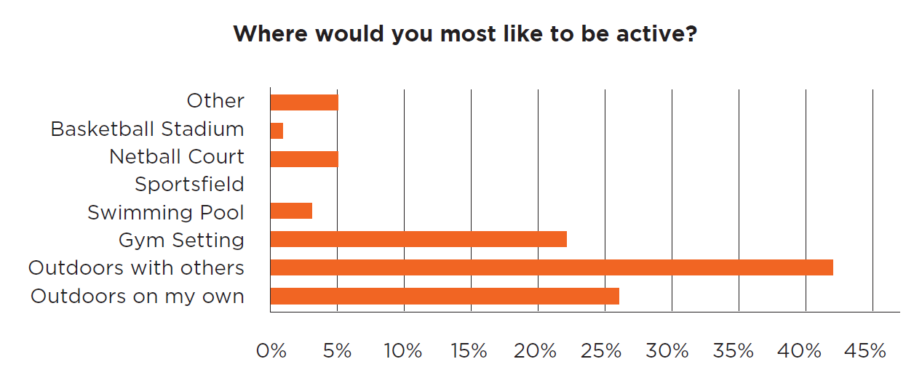

Maroondah Pathway for Carers Survey

To better understand the needs facing carers in Maroondah, consultation was undertaken with participants of the Maroondah Pathway for carers group who meet twice monthly to walk and talk. The group offers carers of people with a disability or mental health illness an opportunity to socialise, share experiences and gain information from guest presenters while gaining valuable exercise.

Group fitness programs and gymnasium were two of the most popular choices of activities they would like to undertake other than walking, highlighting an opportunity to explore duplicating the Pathways program in a gym setting.

Maroondah Youth Wellbeing Advocates

The draft strategy was presented to the Maroondah Youth Wellbeing Advocates group to garner discussion and feedback around the documented factors making participation in physical activity difficult for young people. The group validated the needs highlighted in the draft strategy and discussions focussed around the importance of targeted and appropriate information provision. The group highlighted the need for detailed information to be readily available through google search, including venue information, cost, attendance commitment, equipment and attire required. It was noted that if this information was not present or clear, the young people were not inclined to phone or visit to find out the required details.

A strategy for the future

In October 2015, Council endorsed the Physical Activity Strategy 2015-2020 which comprises of 45 Council actions to address barriers to participation, make incidental exercise more accessible and provide further opportunities to participate in physical activity programs and activities.

In addition to these actions, the strategy recommended undertaking further targeted initiatives that are responsive to the needs of identified low participation cohorts. Council has also been involved in two joint Council projects which have sought to address the prevention of violence women against women through the creation of safe equal and respectful environments within a sporting setting. These projects have seen the development of the Gender Lens for Leisure research paper, Our Codes, Our Clubs findings report, and Equality is the Game! resources which have all further affirmed the need for a strategic approach to impact positive change.

In reviewing the participation rates for women and girls in Maroondah it was determined to focus actions towards three specific cohorts within the female population to achieve the greatest impact on participation. These target groups are:

- women and girls from Culturally and Linguistically Diverse (CALD) backgrounds
- Young women aged 10 to 17 years and 18 to 26 years
- Women with care responsibilities.

Additionally, a fourth outcome area, Gender Equality in Sport was highlighted as imperative to developing an informed and strategic approach to supporting the current and projected growth of women and girls’ participation in sport.

Council needs to be prepared to capitalise on the plethora of current programs, campaigns and funding initiatives being offered by local organisations, peak sporting bodies and government providers, in order to deliver immediate and sustained benefit to the community.

A vision for more active women and girls in Maroondah

In Maroondah, women and girls will have equal opportunity to undertake sport and recreational physical activity in environments where they feel welcomed, supported and safe.

Strategic Framework

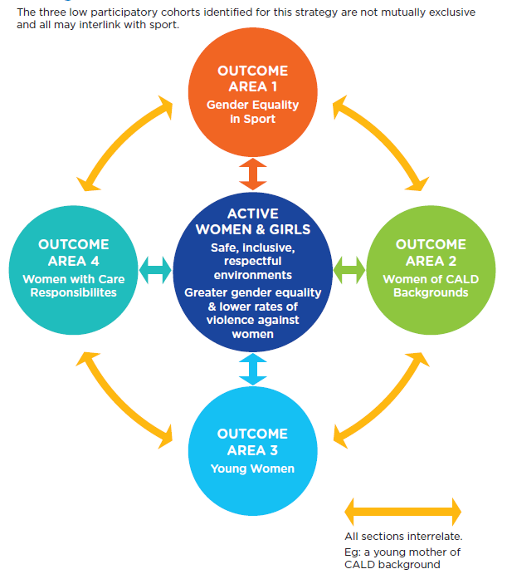

Outcome area 1: Gender Equality in Sport

Outcome description
Council will prioritise the continued improvement of sporting infrastructure to accommodate and further enhance the growth of women’s and girl’s participation in sport. Council will support clubs and associations to increase opportunities for women and girls and advance gender equality both on and off the field of play.

What the evidence tells us

Local, national, and international research shows that violence against women is caused by attitudes, beliefs, roles, and environments that support gender inequality. Sporting Clubs can positively influence change by creating environments where everyone feels equal and respected, thus building a club culture that is strong, united, inclusive, family friendly, supportive and representative of the local community.¹⁶

VicHealth research shows that among Victorian women aged 25 and over with no dependent children, nearly half believe that sporting clubs are intimidating, and a third believe that sporting clubs are not welcoming to people like them.

Good governance and strong leadership are crucial to creating gender equality in sport, where women and girls have equal opportunities to males and boys, to participate in all sporting codes, both on and off the field.

Women often feel reluctant to participate in boards, committees, and other leadership roles in strongly male-dominated environments. Even women holding leadership positions often reported feeling intimidated or treated in a dismissive way.⁸

The recommendation from the 2015 Victorian Inquiry into Women and Girls in Sport and Active Recreation encouraged facility owners and managers to review access and usage policies to ensure females have a fair share of access to the highest quality facilities at the best and most popular times. Usage policies need to consider not just competition time, but training times, and the distribution between traditional competition and other participation opportunities, as well as different sports.

In Dec 2017, VicHealth provided funding to eight State Sporting Associations to create new innovative sporting opportunities to meet women’s needs and interests, and address reasons why women aren’t able to get active, such as time, cost and inflexible opportunities for physical activity. As part of the new program, all funded sporting organisations signed a VicHealth Gender Equality in Sport Leadership Pledge, demonstrating their commitment to achieving gender balance in all their public events and marketing of their organisation, and prioritising access for women and girls in all facilities they use

What the community has told us

Feedback from recent workshops, forums and discussions with Maroondah’s local sports clubs has highlighted a genuine desire to increase participation opportunities for women and girls both on and off the field. Clubs that have been actively undertaking gender equity and cultural change initiatives have reported experiencing growth in membership, a much greater uptake of social functions and increased pool of volunteers.

Increasing the participation of women and girls is a current priority for the key peak sporting bodies in Maroondah and is expressed as such in their strategic plans. Discussions with Cricket Victoria, Eastern Football League and Football Federation Victoria, who have all been traditionally male-dominated sports, have detailed the current work being undertaken, the resources dedicated to increasing opportunities for women in leadership roles, social sport opportunities and competition and elite pathways for women and girls.

The work undertaken is transposing into increased participation. All three codes plan further work to maintain participation growth and address sport scheduling challenges.

Participation growth in traditionally male-dominated sports
Maroondah has experienced unprecedented growth in women and girls’ participation in traditionally male-dominated sports of soccer, AFL and cricket due to increased media, campaigns and investment in programs and infrastructure at a Federal, State and local level.

In Maroondah, women’s participation in soccer 2014 to 2017, increased by 22%, AFL participation increased by 316% (87 girls in 2014; 362 in 2017) and saw the establishment of the Eastern Region Girls League and women’s and girls’ participation in Cricket from 2014 -to2017 has seen an increase of 27% in women’s and girl’s participation.

In 2017, 26 Maroondah Clubs participated in a Gender Audit of their club as part of a Gender Equity initiative, Our Codes Our Clubs. While the clubs self-reported that they were inclusive of women and girls in all aspects of their clubs only 42% reported that women felt safe and welcomed when using the facilities highlighting work is required by both Council and clubs to address the physical and attitudinal environments to improve this.

With Council’s seasonal allocation process, sports field usage is not prescribed within the times allocated to Maroondah Sports Clubs allowing the clubs discretion to allocate teams, age groups and genders. Council does not currently have a mechanism to gauge whether clubs are utilising this autonomy to be fair and equitable in the scheduling of training and matches, particularly of their premier grounds and optimal times.

Key directions

- Document Council’s position in relation to the gender equitable usage of sporting infrastructure and commitment to supporting gender equity initiatives.

- Assist traditionally male-dominated sports clubs to undertake change initiatives to create inclusive, welcoming environments which encourage women and girls’ participation on field and in leadership and decision-making roles.

- Ensure that investment in sporting infrastructure prioritises demand for female-friendly facilities.

- Develop initiatives to influence the equitable usage of Council sporting infrastructure.

- Support clubs to provide social and modified sport options to cater for a wider range of women and girls.

Priority actions

1.1
Develop a high-level policy articulating Council’s position in relation to advancing gender equity in sport.

1.2
Develop a Community Facilities Liquor Policy to support the creation of family-friendly environments and the inclusion of culturally diverse participants.

1.3
For Council’s Capital Works for Community Groups Program and submissions to the Community Sports Infrastructure Fund introduce the eligibility requirement for all applicants to undertake the Creating Places for Women in Sport gender self-assessment tool and create an action plan.

1.4
Work in collaboration with peak sporting bodies and allied health to develop a community of practice and/or other initiatives to support clubs seeking to undertake cultural change initiatives

1.5
Develop a mid-season reporting mechanism to monitor clubs’ progression in the equitable scheduling of training and matches and implement initiatives to support positive change.

1.6
Work with local clubs and associations to pilot the delivery of the social and modified versions of their code initiatives such as Walking Netball, Soccer Mums and Walking Cricket.

Indicators of progress

Comparison of 2019 and 2020 data to measure positive change in the gender distribution of sportsgrounds for training and match play.

Development of liquor policies within sports clubs that align with Council’s position. Policies will articulate agreed times and circumstances when alcohol can and cannot be consumed to support welcoming environments for families and CALD participants.

Continued increase in women’s and girls’ participation in sport and representation in coaching and decision-making roles.

Outcome area 2: Women of Culturally and Linguistically Diverse (CALD) Backgrounds

Outcome description
Maroondah City Council is home to an increasingly culturally diverse community and has been a Refugee Welcome Zone since March 2013. Council has made a firm commitment through the Physical Activity Strategy to engage people who are less active and acknowledge that people from Culturally and Linguistically Diverse backgrounds may experience the greatest barriers to participation.

It is Council’s intention to identify initiatives that could be undertaken to improve the accessibility of, and participation in, physical activity and to assist activity providers and sporting clubs to provide environments which are welcoming and supportive of females of diverse backgrounds.

What the evidence tells us

Young CALD women may experience specific issues that differ from those experienced by women from non-CALD backgrounds. For some, contradictory attitudes to gender roles in their families and communities may limit their access to activities or events outside of the home, and strict domestic responsibilities may be demanded of them.

Newly arrived young women can experience additional settlement challenges including increased family responsibilities and duties, negotiation of different cultural expectations about gender roles, economic disadvantage, social isolation, lack of experience and knowledge about services and lack of confidence to engage with services.

The Victorian Government’s Gender Equality Strategy 2016 highlighted that girls and women from culturally diverse communities face additional barriers to education and employment. In particular, migrant and refugee women are overrepresented in insecure and low paid work demonstrating that cost of participation may also be an influencing factor.

In 2007, the Australian Government Office for Women in the Department of Families, Community Services and Indigenous Affairs (FaCSIA) engaged the Social Policy Research Centre (SPRC) at the University of New South Wales to research how culturally and linguistically diverse (CALD) women participate in sport and recreation, and the factors that may limit their involvement. The study included the facilitation of twelve focus groups with CALD women conducted in NSW, Victoria, & South Australia.
Findings included:
- Informal physical activities, like walking or participating with family and friends were particularly important to most women.
- An unequal distribution of childcare and household responsibilities was seen to make it easier for men than women to participate, and the leisure time of women with dependent children or grandchildren was particularly limited.
- English language skills were perceived as major barriers for CALD women, especially for those who had not been in Australia for long.
- Without a personal connection women did not know what to expect and did not necessarily have the self-assurance to join programs unsolicited.
- Providing information to CALD women about activities and facilities would help them and other CALD women to participate. Information should portray sport as culturally diverse and welcoming; reinforce the health benefits of exercise; and explain what participating in sport involves.
- Overcoming financial barriers were seen as essential in getting more women from CALD backgrounds to participate in sport and recreation
- The women also identified that role modelling and promoting diversity would help encourage women to participate.

What the community has told us

Council met with representatives from the Migrant Information Centre Eastern Melbourne (MIC) to discuss the Maroondah local migrant and refugee communities and actions we could undertake to influence greater participation by women and girls of CALD backgrounds. Notable findings included that for newly arrived young people, participating in sport can provide social support and assist in their settlement.

While other municipalities have introduced women only programs to suit the cultural sensitivities of their communities, the dominant CALD communities within Maroondah do not necessarily seek to attend segregated activities for cultural reasons. In certain instances, however, women may have a preference for single gender spaces or programs for social engagement and/or confidence reasons as has been highlighted by women in general.

Migrant Information Centre Eastern Melbourne has seen success in attracting young women to attend physical activity programs when targeting an existing group through school or church communities and had greater retention when the young women felt it permissible to attend intermittently due to family and household responsibilities.

Swimming lessons have been a popular program for the migrant and refugee community however the duration of the current funded model is not long enough for the participants to feel confident in accessing the pool independently.

Key directions

- Promote to sporting clubs the value in providing flexible options particularly around training to allow greater access for women from CALD backgrounds to participate.

- Investigate opportunities to provide ongoing supported swimming for women and girls of CALD background.

- Ensure that Maroondah Leisure marketing imagery reflects cultural diversity.

- Support applicants from CALD backgrounds through Maroondah Leisure recruitment processes.

- Encourage the development of and/or the promotion of family participation opportunities

- When designing, and promoting new programs, consider the Centre for Multicultural Youth Good Practice Principles for working with newly arrived young women.

- Explore creative initiatives which involve physical activity however is not the main focus such as the Arts.

Priority actions

2.1 Deliver a CMY Good Practice Principles training session for relevant Sport & Recreation and Maroondah Leisure staff.
2.2 Review Maroondah Leisure recruitment processes and introduce positive actions to recruit people from under-represented groups in order to increase the diversity of staff.
2.3 Collaborate with the Melbourne East Netball Association to offer social and beginner Netball programs at Maroondah Nets to provide introductory casual, social netball opportunities which will be promoted in adherence to the CMY Good Practice Principles.

2.4 Investigate the provision of a swimming instructor one evening a week to provide informal support to CALD families who have undertaken the funded 6 week learn to swim program but have limited confidence in the water.

2.5 At the winter and summer Maroondah Sporting Clubs’ forums include a presentation on the engagement of CALD women into sport and provide supporting documentation.

Indicators of progress

Audit current Maroondah Leisure staff cultural diversity and aim to increase by 5% over the next two years, ensuring representation at all venues.

Culturally diverse representation within the new netball programs at Maroondah Nets.

Where available, source local membership data from peak sporting organisations to gauge increase in cultural diversity.

Outcome area 3: Young Women

Vision statement/outcome description

Maroondah City Council will support the provision of a range of social and/ or non-competitive options for women and girls which are available in safe, non-judgemental spaces.

What the evidence tells us

Australian guidelines recommend children aged 5-18 years have at least one hour of moderate to vigorous physical activity every day and, at least three days a week, this should include activities that strengthen muscles and bones.

Youth is a crucial period for establishing positive health and social behaviours. It is a time when young people are undergoing rapid emotional, physical and intellectual changes, and when they begin the transition from childhood to adolescence to independent adulthood.

The VicHealth Key Life Stages Report, 2017 highlighted that transitioning to and from secondary school are key life stages to influence behaviors for lifelong healthy habits. Self-esteem and confidence are key in this life stage peer influence is paramount and most seek support from their close friends.

The findings report found that:
- 63% of girls wish they had more time to do more exercise.
- 74% of girls think it is easier to exercise with someone else.
- 44% reported that they would be more active if more sports and activities were available in their area.

Almost half (49%) of young women feel embarrassed exercising in public. Embarrassment and intimidation is a real barrier for young women, with young women in particular less keen to expose their bodies to the scrutiny of their peers.

Plan International Australia commissioned a survey of 1,742 Australian girls aged 10 to 17 years old to gain rare insight into how this group experiences their world. Sports and media were the places where girls felt inequality the most profoundly. As girls entered the late teens, only 6% and 7% of girls surveyed (respectively) thought men and women were always treated equally in these settings.

What the community has told us

In 2016, the Maroondah Wellbeing Survey in Schools was conducted in partnership with The University of Melbourne, and surveyed 4777 students between the ages of 10 to 20 years from 19 different education settings (primary schools, secondary schools and TAFE). Results from the survey highlighted that all aspects of physical well-being appear to decline from Years 7 to 12 (Chin et al., 2016a).
The graphs below show the 2016 results across year levels. The horizontal axis shows the year levels of the young people, from Grade 5 to Year 12. The vertical axis shows the average scores, on a scale of 1 to 7, with 4 as the mid-point.

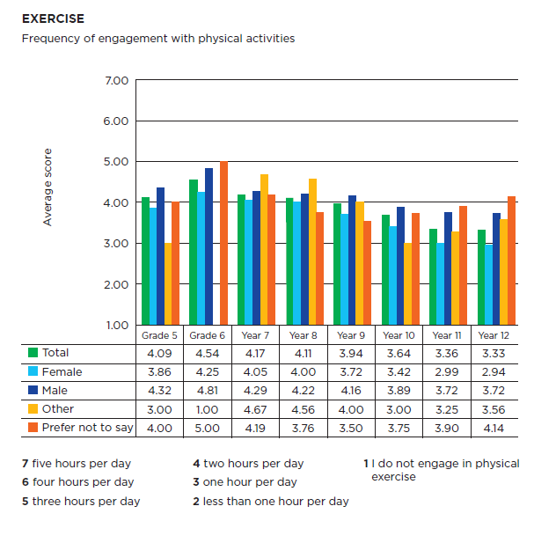

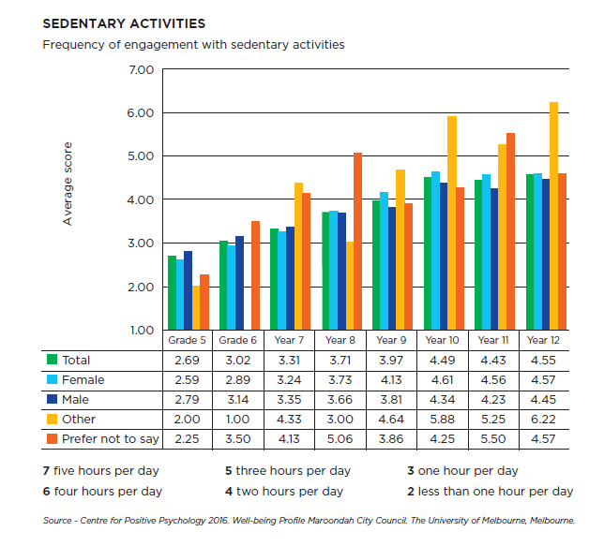
Broad consultation was also undertaken for the development of the 2015 - 2020 Physical Activity Strategy highlighted the following needs:

- Provision of safe, non-judgemental spaces for independent exercise
- Fun, social and non-competitive
- Flexible & low cost
- Provision of comprehensive information about activities to minimise apprehension. Young adults are particularly open to workplace activity initiatives.
- Timing of activities needs to be conducive to the preferences of young people e.g. not early mornings
- Screen time and/or homework affecting level of restorative sleep to have energy for exercise.
- Require sports to promote and support entry level at any age not just juniors. Difficult to be a beginner.

Key directions
- Connect with girls when transitioning to secondary school to influence behaviours prior to the key life stage of 15 years where their physical activity typically drops off, potentially leading to an inactive life.
- Work with recreation providers to ensure that activities of interest to young women are available in safe and welcoming environments.
- Promote and/or support the creation of active opportunities other than competitive sport.
- Create targeted education/awareness programs explaining the role that supportive family, friends and school can play to ensure girls stay active.
- Encourage schools to offer social sport opportunities for students who do not have the interest, confidence or perceived level of skill to continue with competitive sport. In addition, encourage schools to reduce the focus of success being on sporting wins and elite achievements and more on level of participation in physical activity.

Priority actions

Girls aged 10-17
3.1 Work with sports and recreation clubs and schools to offer and promote beginner, non-competitive opportunities to participants of any age not just juniors.
3.2 Create targeted education/awareness programs explaining the role that supportive family, friends and school can play to ensure girls stay active.
3.3 Convene a workshop with youth worker professionals and providers to develop initiatives to promote and encourage regular physical activity such as walking, as a key activity to improving mental health.

Young women aged 18 - 26
3.4 Investigate trialing a 6-week Quidditch program - a physical activity which is social, new to everyone and has current appeal to this age bracket.
3.5 With a focus on Maroondah City Council’s leisure facilities, explore tailoring new or existing opportunities to young women and consider the suitability of times and location to fit to their lifestyle and commitments.
3.6 Explore opportunities to utilise safe and welcoming spaces to offer accessible recreational activities for young women.
3.7 Develop a strategy, in consultation with young people, to promote the active opportunities available in Maroondah, providing the right information via effective mediums.
3.8 Trial facilitated pop culture themed walk’n’talk sessions.

Indicators of progress

Increased physical activity levels and reduction in sedentary behaviour in comparison to baseline data collected through the 2016 Maroondah Student Wellbeing Survey

Increased active opportunities targeting young women aged 18 - 26 in comparison to current offering.

Outcome area 4: Women with Care Responsibilities

Outcome description

When designing active spaces and programs, Maroondah City Council will be cognisant of factors which may affect the inclusion of women with caring responsibilities and devise strategies to make participation easier.

What the evidence tells us

Parents of dependent children are a population sub-group with one of the lowest levels of physical activity. Maroondah’s Physical Activity Strategy identified the lowest levels of regular physical activity in women aged between 25 – 44 years which can in part be attributed to the parenting responsibilities of dependent children.

Evidence suggests that the physical activity levels of parents have a strong influence over the activity levels of their children and can impact lifelong physical activity behaviors.

These findings highlight the importance of understanding the factors that constrain mothers of dependent children from being more physically active and to identify initiatives that will support regular participation. “Declines in physical activity across the transition to parenthood, particularly for mothers are well documented. Parents face numerous barriers including family responsibilities, scheduling constraints, guilt, lack of energy”.

In 2015, VicHealth commissioned research to identify key segments of Victorians based on their levels and type of physical activity. This research involved online surveys of 3145 Victorians aged 12 and over across Victoria, as well as focus groups with Victorian adults aged 18 and over. VicHealth identified parenthood as a lifestage characterised by ‘busy-ness’.

A focus on child raising combined with multiple, competing priorities leads to reduced free time, which becomes a highly valued commodity. Almost two-thirds of Victorian parents (62%) wish they had more time for exercise. Where physical activity is not part of their current weekly or daily routine, fitting it in can be seen as a major hurdle. Within the study 53% of inactive mums felt embarrassed exercising in public, and 71% were intimidated by gyms and fitness centres (71%).

Furthermore, women who take on a primary carer role of adults with a disability, debilitating illness or old age also experience very low levels of regular physical activity and recreational respite due to time, guilt and financial constraints. The National Disability Scheme, introduced in July 2016, has had substantial repercussions on the health and wellbeing of carers.

Funding previously allocated to carers support groups and respite care has been diverted into the scheme which has impacted negatively the health and wellbeing of carers. The severity of mental and physical health implications for carers has recently emerged and has highlighted an urgent need to support the provision of opportunities suited to their needs.

Suggested interventions

- Structure children’s physical activities in a way that enables parents to fit physical activity in with their children or during their children’s activities.¹⁸
- Focus promotions on the benefits relevant to their role as parents such as having the energy to enjoy time with their children.
- Consider targeting mothers and fathers in tandem to create an optimally supportive environment in the home. ¹⁸
- Ensure consistent up to date detailed information including care availability, change facilities, what sort of clothing is required, level of ability required etc.
- For structured activities, remove cancellation fees and provide flexible payment options
- For working carers offer flexible hours that physical activity is available and range of physical activity activities which fit into the work day to optimise existing care arrangements.
- Provide resources which support physical activity at home, such as exercise programs, health and diet information, pedometers and activity trackers.

What the community has told us

Women caring for young children

- Greater number of footpaths suitable for prams and walking.
- Opportunities to participate with children, for example, swimming, Bowling Babies, and yoga.
- After hours childcare options.
- Fenced playground options.
- Flexible, casual options for participation.
- Lunchtime options for working parents.
- Provision of low-cost options.
- Safe, well-lit and activated open space.
- Promote activities that mothers can undertake while supervising children.
- Gain support from family members to encourage and assist women to undertake regular activity.

Women caring for dependant adults

- Council’s monthly Pathways for Carers Program has had an enormous impact on the wellbeing and motivation of participants. Increased frequency will increase physical benefits.
- Require greater detail in information about the program and venue to feel prepared and confident to attend.
- Fun and social, low cost and flexible, pay-as-you-go payment options were the key priorities for carers.

Key directions

- Consider opportunities for parents to be active while supervising children in Council-run programs.

- Develop interventions to promote the mental health benefits of prioritising physical activity amidst the demands of parenthood and the benefits for their families.

- Target promotional initiatives towards partners and other family members encouraging and supporting mothers taking time out of care giving responsibilities to exercise.

- Promotion of open space opportunities where parents and children can exercise and play in one location eg: Cheong Park Playground and outdoor fitness stations and provision of a fully fenced option for carers of young children and carers of persons with a disability.

- Continue to improve accessibility of the built environment to support walking and active transport eg: pram crossings, pedestrian crossings and footpaths.

- Understand the needs of Carers with dependant adult children and advocate for social and respite support to enable carers to undertake physical activity.

Priority actions

4.1 Provide a fully enclosed playground option which incorporates play and fitness equipment.

4.2 Work in collaboration with local clubs to trial the Heart Foundation Walking Program in a minimum of two community sporting venues.

4.3 Develop a promotional initiative to assist mothers or carers to plan and commit to 30 minutes of physical activity in their day. This will include family-friendly activities and the promotion of open space.

4.4 Extend the frequency and sustainability of the Pathway for Carers Program and investigate a gymnasium option.

4.5 Collaborate with local sports clubs to pilot and/ or promote initiatives such as Bowling with Babies and Mums and Bubs Netball which encourage parents and carers to participate with their children.

Indicators of progress

- Track usage of the play and fitness equipment pre-and post-fencing addition.

- Support the training of a minimum of two Heart Foundation Walk Organisers and evaluation of a three-month pilot at each venue.

- Maintain or increase participation in the Pathways for Carers Program.

- Pre-program and three-month evaluation of Change of Game Initiatives.

Tracking our progress

The strategy will be reviewed in two years to track progress on its implementation, evaluate initiatives and report on results to Council and stakeholders. The results will inform the development of the 2020- 2025 Physical Activity Strategy.

Priority actions summary
These actions have been identified as a priority activity to fulfil the outcome area key directions.
HIGH - To commence by 2020 MEDIUM - To commence by 2021

Action | Priority
Outcome area 1: Gender Equality in Sport

1.1 Develop a high-level policy articulating Council’s position in relation to advancing gender equity in sport. | High
1.2 Develop a Community Facilities Liquor Policy to support the creation of family friendly environments and the inclusion of culturally diverse participants. | High
1.3 For Council’s Capital Works for Community Groups Program and submissions to the Community Sports Infrastructure Fund, introduce the eligibility requirement for all applicants to undertake the Creating Places for Women in Sport gender self-assessment tool and create an action plan. | High
1.4 Work in collaboration with peak sporting bodies and allied health to develop a community of practice and/or other initiatives to support clubs seeking to undertake cultural change initiatives. | High
1.5 Develop a mid-season reporting mechanism to monitor clubs’ progression in the equitable scheduling of training and matches and implement initiatives to support positive change. | Medium
1.6 Work with local clubs and associations to pilot the delivery of the social and modified versions of their code initiatives such as Walking Netball, Soccer Mums and Walking Cricket. | Medium
Outcome area 2: Women of CALD Backgrounds

2.1 Collaborate with the MENA to offer social and beginner Netball programs at Maroondah Nets to provide introductory casual, social netball opportunities which will be promoted in adherence to the CMY Good Practice Principles. | High
2.2 At the winter and summer Maroondah Sporting Clubs’ forums include a presentation on the engagement of CALD women into sport and provide supporting documentation | Medium
2.3 Deliver a CMY Good Practice Principles training session for relevant Sport & Recreation and Maroondah Leisure staff. | Medium
2.4 Review Maroondah Leisure recruitment processes and introduce positive actions to recruit people from under-represented groups in order to increase the diversity of staff. | Medium
2.5 Investigate the provision of a supported swimming session one evening a week to provide informal support to CALD families who have undertaken the funded  6-week learn to swim program but have limited confidence in the water. | Medium

Outcome area 3: Young Women

3.1 In consultation with young people, develop a strategy to promote the active opportunities available in Maroondah, providing the right information via effective mediums for young people. | High
3.2 Work with sports and recreation clubs and schools to offer and promote beginner, non-competitive opportunities to participants of any age not just juniors. | Medium
3.3 Create targeted education/awareness programs explaining the role that supportive family, friends and school can play to ensure girls stay active. | Medium
3.4 Convene a workshop with youth worker professionals and providers to develop initiatives to promote and encourage regular physical activity such as walking, as a key activity to improving Mental Health. | Medium
3.5 Investigate trialing a 6-week Quidditch program - a physical activity which is social, new to everyone and has current appeal to this age bracket. | Medium
3.6 Through Maroondah Leisure Facilities, explore tailoring new or existing opportunities to young women and consider the suitability of times and location to fit to their lifestyle and commitments. | Medium
3.7 Explore partnership and/ or funding opportunities to create and /or promote recreational activities for young women in safe and welcoming spaces. | Medium
3.8 Trial facilitated pop culture themed walk ’n’ talk sessions. | Medium
Outcome area 4: Women with Care Responsibilities

4.1 Work in collaboration with local clubs to trial the Heart Foundation Walking Program in a minimum two community sporting venues. | High
4.2 Provide a fully enclosed playground option which incorporates play and fitness equipment. | Medium
4.3 Develop a promotional initiative to assist mothers or carers to plan and commit to 30 minutes of physical activity in their day. This will include family-friendly activities and the promotion of open space. | Medium
4.4 Extend the frequency and sustainability of the Pathway for Carers Program and investigate a gymnasium option. | Medium
4.5 Collaborate with local sports clubs to pilot and/ or promote initiatives such as Bowling with Babies and Mums and Bubs Netball which encourage parents and carers to participate with their children. | Medium

References

Australian Sports Commission, (2017). Women and Girls Participation - AusPlay Focus

Brown P, Brown W, Miller Y & Hansen V (2010). Perceived Constraints and Social Support for Active Leisure Among Mothers With Young Children, Leisure Sciences Volume 23, 2001 - Issue 3, Pages 131-144

Centre for Multicultural Youth, (2013) Girls’ Space: Good Practice Principles, UPDATED 4 SEPTEMBER 2013

Chin, T-C., Jiang, J., & Vella-Brodrick, D. A. (2016). Understanding the needs of young people in Maroondah: Findings from the student well-being survey. The University of Melbourne, VIC, Australia

Mailey E, Huberty J, Dinkel D & McAuley E (2014) Physical activity barriers and facilitators among working mothers and fathers. BMC Public Health

Maroondah City Council (August 2017) Maroondah City Council Health and Wellbeing Statistical Profile

Maroondah City Council (2017) Getting Females Active in Sport Situation Analysis.

Maroondah City Council, Yarra Ranges City Council Knox City Council & Inspiro. (2017) Equality is the Game! Sporting Club Resource

Plan International (2017) The Dream Gap: Australian girls’ views on gender equality. Plan International

Muir K, Cortis N & Sawrikar P, Social Policy Research Centre, University of New South Wales (2008) Participation in Sport and Recreation by Culturally and Linguistically Diverse Women. Social Policy Research Centre, University of New South Wales

Sport England (2014) Go Where Women Are – Insight on engaging women and girls in sport and exercise.

VicHealth (2017) Female participation in sport & physical activity Snapshot of evidence

VicHealth (2018) This Girl Can Website, VicHealth

VicHealth (2017) Victorians’ physical activity across life stages, VicHealth Factsheet

VicHealth (Jan 2016) VicHealth Letter 42nd Edition Kicking Goals for Women In Sport. VicHealth Page 13,14
Victorian Government (2015) Inquiry into Women and Girls in Sport and Active Recreation

Yarra Ranges Council (2018) Creating a Place for Women in Sport Gender equity self- assessment tool.

This Girl Can Website, VicHealth 2018
Maroondah City Council Health and Wellbeing Statistical Profile August 2017
Female participation in sport and physical activity – Vic Health 2015
AusPlay Participation data for the sport sector Australian Sports Commission Dec 2016
Inquiry into Women and Girls in Sport and Active Recreation – A Five Year Game Plan, Victorian Government 2015
Equality is the Game! Sporting Club Resource Maroondah City Council et al. 2017
Inquiry into Women and Girls in Sport and Active Recreation 2015
VicHealth Letter 42nd Edition Women In Sport Jan 2016
Centre for Multicultural Youth, 2013
Girls’ Space: Good Practice Principles, UPDATED 4 SEPTEMBER 2013
Muir K, Cortis N & Sawrikar P, Social Policy Research Centre, University of New South Wales (2008) Participation in Sport and Recreation by Culturally and Linguistically Diverse Women. Social Policy Research Centre, University of New South Wales
Australia’s Physical Activity and Sedentary Guidelines, The Department of Health, Australian Government 2017
Young Australians: Their Health and Wellbeing Australian Institute of Health and Welfare 2011
Youth 12-17 Physical activity insights, VicHealth 2017
Young Adults 18 – 24 Physical Activity insights VicHealth January 2017
The Dream Gap Australian girls’ views on gender equality. Plan International Plan International 2017
Physical activity barriers and facilitators among working mothers and fathers E Mailey, J Huberty, D Dinkel & E McAuley
Victorians’ physical activity across life stages. VicHealth 2017
Physical activity barriers and facilitators among working mothers and fathers E Mailey, J Huberty, D Dinkel & E McAuley
Go Where Women Are – Insight on engaging women and girls in sport and exercise. Sport England 2015
Female participation in sport & physical activity Snapshot of evidence VicHealth 2017

