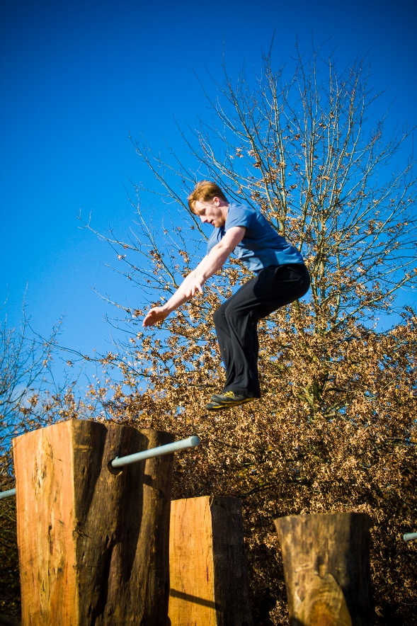
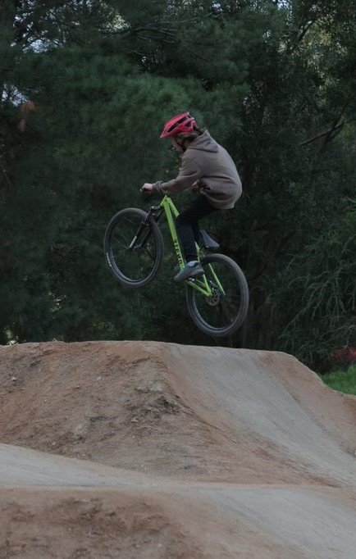
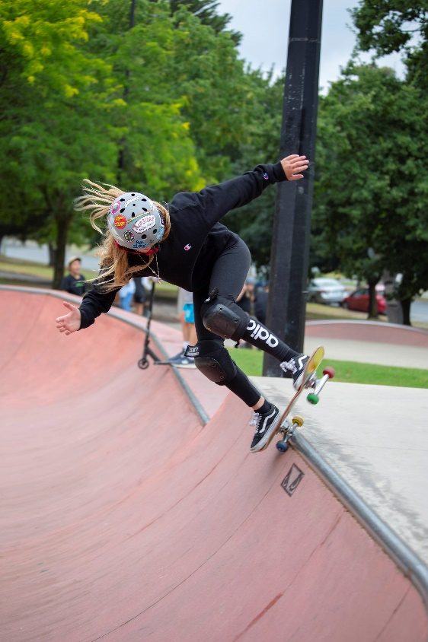
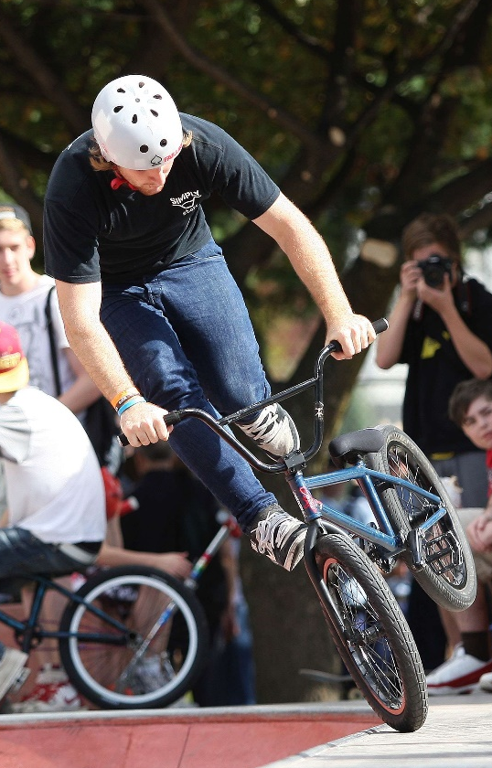
Maroondah Extreme Sports Strategy
Working towards a safe, healthy and active community

Contents
EXECUTIVE SUMMARY 4
Introduction 5
PARTICIPATION 6
EXISTING PROVISION 7
Bicycle Motocross (BMX) 8
Skate Facilities 9
Parkour 10
Mountain Biking 10
Extreme Sports Facilities bordering Maroondah (within 5km) 11
KEY CONSIDERATIONS 12
Challenge versus Risk 12
Unauthorised Bushland Jumps 12
Infrastructure Management 12
Eastfield BMX Racing Track Location 12
RMAC OpenSpace Plan and Staley Gardens Enhancement 12
Global Growth, Increased Diversification and Competitive Sport Focus 13
Active Transport 13
Supporting Users to have a voice 13
Section 2 – What does the evidence say? 16
Related Council Strategic Documents 16
The Situation Analysis 17
Consultation Summary 18
Engagement Methodology 18
Consultation Key Findings 19
Section 4 – A strategy for the future 20
A vision for Maroondah’s Extreme Sports Facilities 20
Outcome area 1 - Engagement & Promotion 21
Outcome description 21
What the evidence tells us 21
Outcome area 2 - Planning 24
Outcome description 24
Key directions for future planning 25
Site specific priority actions 26
Outcome objectives 27
Priority actions for Management 31
Outcome area 4 - Programs, Events and Site Activation 32
Why activate? 32
Priority actions 35
Tracking our progress 35
Implementation process 35
Reporting 35
Priority Action Summary 36
Section 5 – References 38
Appendices 38
Appendix 1 - Parks and Recreation Consulting A situation analysis for skate, BMX & parkour in Maroondah, April 2020 38
Appendix 2 - BMX Concept Plan - Arrabri Canterbury Gardens 38
Appendix 3 - Final Design - Yarrunga Bike Jumps 38

Maroondah City Council acknowledges the support of
the Victorian Government

EXECUTIVE SUMMARY

Extreme sports are defined as activities perceived as involving a degree of inherent risk and for the purpose of this strategy include skate, scooter, BMX and mountain bike and parkour. These activities can meet the need for challenge, risk-taking and to conquer new skills and can lead to peer acceptance and social connectedness. The challenge for Council is to find the right balance between supporting and encouraging participation and providing an environment which minimises risk and manages community expectations about safety. The scope of the strategy includes an assessment of the nine (9) existing sites across Maroondah, their usage, whether they are meeting community need and whether there are gaps in provision.

The strategy explores the key considerations affecting participation in extreme sports, including:

- Challenge versus risk
- Unauthorised bushland jumps
- Infrastructure management
- Eastfield BMX racing track location (currently located within Yarra Ranges)
- Ringwood Metropolitan Activity Centre (RMAC Open Space Plan) and Staley Gardens Master Plan
- Global growth, increased diversification and competitive sport focus
- Active transport
- Supporting users to have a voice
- Increasing women’s and girls’ participation

Engagement Findings
Throughout late 2021 and early 2022, Council utilised a range of methodologies to reach over 530 users and non-users of the nine (9) Extreme Sport Facilities on Council land. Overall results indicated that there was not a huge demand for more sites within Maroondah, if Council was able to improve the maintenance regime for existing sites and upgrade and expand the existing facilities to meet community need. The one area that was consistently mentioned as a gap in provision was North Ringwood, with suggested locations of Parkwood and/or Quambee Reserve for additional bike jump and trail facilities. There was also significant support for the upgrade of amenities and/or ultimate relocation of the Eastfield BMX Track to within Maroondah’s boundaries.

Strategy Framework

To provide a clear direction, Council has developed a vision to guide planning to support and grow participation in the activities categorised as Extreme Sports, in Maroondah.
Council will partner with our community to plan, upgrade, maintain and activate suitable Skate, Bike and Parkour facilities to facilitate social connectedness and improved physical activity. The planning and management of these facilities will aim to balance the variables of risk, level of challenge, the preservation of natural bushland, and the needs of the wider community.
The Strategy outlines the following four outcome areas which each have key directions and 1 - 5 year priority actions to address the key findings.

- Engagement and Promotion
- Planning
- Management
- Programs and Events

Introduction

The purpose of this document is to gain a clear understanding of the current and projected participation, trends and issues impacting outdoor skate, BMX and mountain biking and parkour in Maroondah. This information together with public engagement will guide the development of a plan which provides for the needs of these participants over the next 10 years.

For the purpose of this strategy, extreme sports are defined as activities perceived as involving a degree of inherent risk. These activities often involve speed, height, a high level of physical exertion and highly specialised gear. Activities for which Council provides infrastructure include BMX racing, Freestyle BMX and Mountain Biking, Skateboarding, Scooter and Parkour.

Skate, and BMX freestyle, jumps and racing, are growing sports globally, reflected in their recent inclusion into the Olympics schedule. Parkour was also set to gain inclusion into the 2022 Paris Games however it has been recently excluded due to governance issues with the two peak bodies claiming rights to the sport.

The Benefits

BMX, Skate and parkour provides a different offering than traditional organised physical activity, appealing to an alternative demographic to many sports. These activities provide action, performance, creativity and culture in the community and deliver a range of social, physical and mental health benefits. The pursuits can be relatively low cost and flexible, do not necessarily require formal instruction or membership, and often require limited adult supervision. These factors and the inherent level of challenge and risk make extreme sports attractive to young people who may not otherwise engage in organised sports.

Research and observations have challenged the negative perceptions frequently associated with skate parks, finding young people who regularly use these spaces practise a range of positive social behaviours and learn life skills important for social development and resilience.

Just over 1 in 10, 15-17 year olds are sufficiently active for their age (recommendations being 420 minutes per week). With the proportion higher among males (16%) than among females (5.3%)-. Over half, 55% of all 18–24 year olds were sufficiently active for their age, with similar proportions among males (59%) and females (52%) however this higher rate is largely due to the reduced physical activity requirements for this age group being 150 minutes per week. As BMX, skate and parkour have seen continued appeal to the older age bracket of young people, Council is actively wanting to increase and retain participation in these activities as a strategy to prevent younger adults decline in regular physical activity which may lead to lifelong sedentary behaviours.
Additionally, Council plans to seek feedback from young women and girls and ensure that their needs are considered when planning facilities and /or programs to increase their participation.
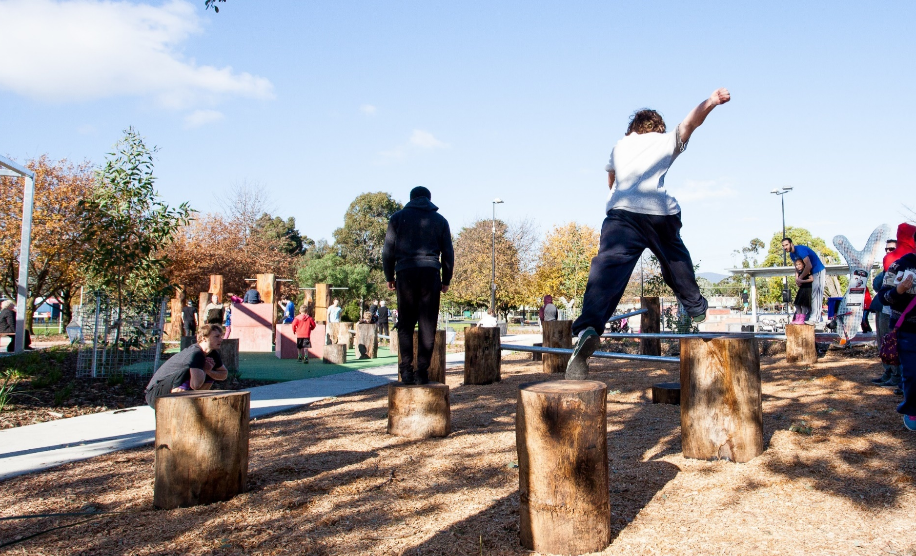
Youth Population

Approximately 22,200 young people
aged 10 to 25 live in Maroondah.
This represents approximately 20% of Maroondah’s population.

By 2027, this number is estimated to increase to over 23,500, and the area with the greatest forecasted increase in young people between 2017 and 2027 is Ringwood (.id, 2015).

Young people form a significant portion of the Maroondah community, and Council is committed to investing in both their present and their future as valued members of the Maroondah community.

Updated ABS data will be released in late 2022 which will provide further clarity on current population, forecasts and demographical changes.

PARTICIPATION

Nationally, the annual AusPlay survey results for the period between January 2021 and December 2021, which were released 29 April 2022, illustrated the following National participation:

Adults 15+ All Participation  BMX 18,400  Mountain Bike 470,800  Parkour 4,100 (estimate)  Skate 275,000  of which 65% are skateboarders  Scooter 29,400 | Children’s Organised Participation  (Registered in a formal program or competition)  BMX 28,600  Mountain Bike 22,100  Parkour 20,400  Skate 22,700  Scooter 13,000

78% of adult skate participants reported that their participation was not through an organisation or venue
54% of participants aged 15+ participated in skate at least once per week.

EXISTING PROVISION

Maroondah Council has nine (9) Skate, BMX or Parkour sites that it currently recognises as formal sites and provides some form of maintenance or asset oversight at these venues. The nine (9) sites vary greatly, from extensive concrete constructions to simple mounding of dirt to form a track. The sites are listed below.

Facility | Primary Use | Main User Level | Age cohort observed | Estimated Annual Usage
Croydon Y Space Skate Park - Croydon Park, Croydon | Informal Skate and BMX | Public / Regional | Age 4 - 17 | >35,000 visits
Grayswood Skate Park - Grayswood Reserve, Kilsyth South | Informal Skate and BMX | Public / Local | Age 11 & 12 | <1,000 visits
Ringwood Skate Park - Staley Gardens, Ringwood | Informal Skate and BMX | Public / Regional | Age 15 - 20. | >5,000 visits
Croydon Y Space Parkour Site - Croydon Park, Croydon | Informal Parkour | Public / Regional | Age 4 - 17 | >4,000 visits
Glen Park Playspace Parkour - Glen Park Reserve, Bayswater North | Informal Parkour | Public / Local | Age 12  (estimate) | <50 visits
Eastfield BMX Track, Colchester Road, Kilsyth South | Formal BMX | Club & Public / Regional | Age 4 – 19 | >5,000 visits
Yarrunga BMX Jumps - Yarrunga Reserve, Croydon Hills | Informal BMX | Public / Local | Age 12 - 24* | >6,000 visits*  (anticipated)
HE Parker BMX Jumps - HE Parker Reserve, Heathmont | Informal BMX | Public / Local | Age 12 - 24* | <500 visits*
Arrabri BMX Jumps - Canterbury Gardens, Bayswater North | Informal BMX | Public / Local | Age 8-12  (estimate) | <100 visits
Table 1 - Source: A situation analysis for skate, BMX & parkour in Maroondah, April 2020
*Amended estimate based on consultation results
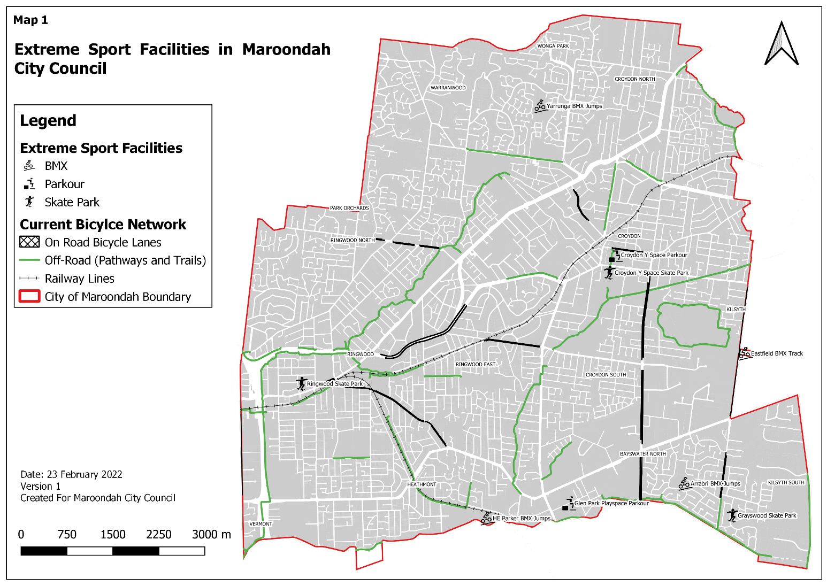

Bicycle Motocross (BMX)

Maroondah Council has formalised oversight of four (4) BMX sites within the municipality where BMX activities are authorised. Each site is reviewed in section 2.1 of the Situation Analysis in Appendix1

Maroondah Council maintains and manages a formal purpose-built BMX racing site in Colchester Road in Kilsyth, known as Eastfield BMX. The site, which is adjacent to the boundary between Maroondah and Yarra Ranges Councils, is set on land owned by VicRoads, within Yarra Ranges, and leased to Maroondah Council to sublet to Maroondah (Eastfield Eagles) BMX Club. This arrangement is the result of a negotiated relocation from their former site in Norton Road, Croydon in 1991. The Colchester Road site has a mix of club aligned event or training activities as well as informal usage as a Maroondah public open space reserve. In 2020, the membership of the Club was at 71 with the majority of these members residing in Yarra Ranges or Maroondah. As a BMX site that is compliant for formal competition, the Colchester Road site has an active Club environment that provides coaching and officiating to Club members and hosts events on site or visits other Clubs for events. The scheduling of national, state and regional level championships level events is highly competitive across Clubs as these events are revenue generating opportunities for Clubs. Currently the starting hill gate is not State level compliant due to recent changes to regulations. The membership of the Club consists of a majority of male members however, 14% percent of its members are female.

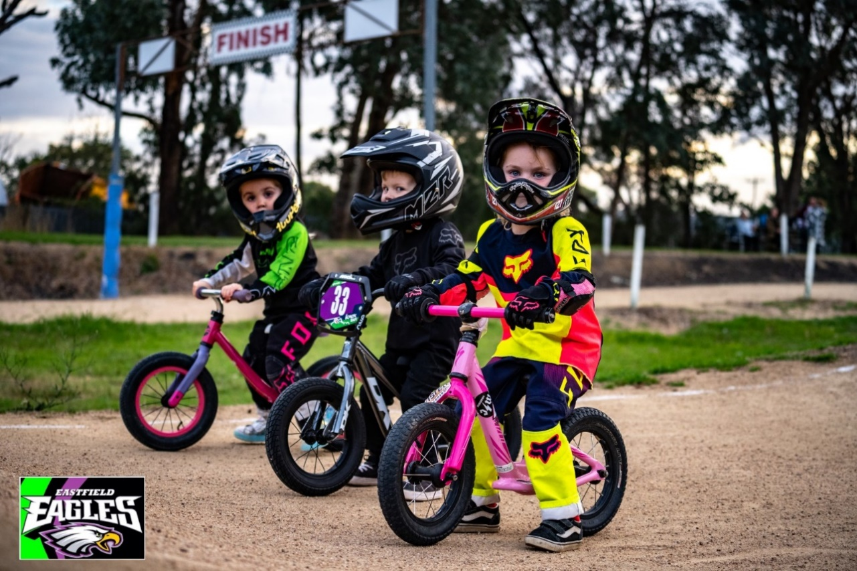

In addition to the Colchester Road track, there are three (3) informally used BMX layouts in Maroondah where activity is encouraged. These are located within Council parklands and have shaped trail, jump and berm (banked/sloped turn) positions. Of these, the jumps course at Yarrunga has recently been redeveloped and expanded to provide facilities for both beginner and intermediate level competency. The HE Parker and Arrabri sites are effectively a shaped trail circuit where bikes can move around the course with several jump mounds along the course.

Apart from these formal locations, unauthorised pop-up jumps and/ or circuits continue to present in bushland reserves. The issue of illegal trails and jumps, particularly in high value conservation areas, has been an ongoing issue for many years, however the frequency of occurrences was exacerbated by the 18 months of restrictions and lockdowns caused by the COVID 19 global pandemic.

Skate Facilities

Maroondah Council maintains three (3) skate park sites within the municipality where skate activities are encouraged. These sites include both traditional bowl and ramp features as well as urban layout features with rails and box elements. Each site is reviewed in section 2.2 of the Situation Analysis in Appendix1.

The most extensive of the three (3) skate sites is Y Space in Croydon Park, which together with the adjoining parkour elements and ‘X Space’ junior playground, is considered a regional play space. This site is the most recent of Council’s skate facilities and has high occupancy across a wide range of activity times including evening use under lights.

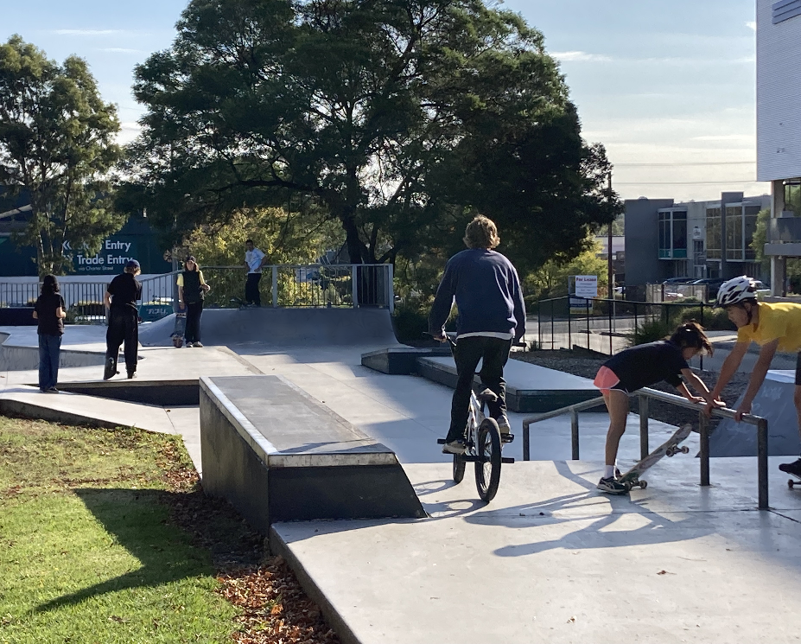
A second large skate park is located in Staley Gardens in Ringwood. This parcel of open space was gifted to the city of Maroondah by the Staley family. It is a site that has significant historical meaning for Ringwood as it was owned by the family who established the Holeproof hosiery company in Australia in the late 1920s, by Staley & Staley Ltd. The site is one of the largest open green spaces within the Ringwood Metropolitan Activity Centre, which is designated by the State Government as a centre for commerce, employment, housing and service delivery. The skate park was originally set adjacent to Ringwood market with a large range of speciality shops, however more recently this has been replaced by the significant Costco building, which now adjoins the skate park. The park design includes a traditional bowl and urban elements. The facility is predominantly used by an older cohort of young adults for skateboarding, with younger teen users observed utilising scooters and skateboards. A review of the skate park design and usage will form part of a wider review of Staley Gardens as an action of the Ringwood MAC Open Space Strategy.
Ringwood ‘Staleys’ Skate Park

The third of the Maroondah skate facilities is a small facility at Grayswood Reserve in Kilsyth. The facility targets learners, with a few urban elements incorporated into a flowing contoured pathway with low raised berms and rollovers. The current facility was originally built as a narrow concrete trail suitable only for skateboarders, in-line skaters and scooters. Following the development of the Grayswood Reserve Landscape Plan (2003) the trail was modified in 2006 to provide a larger area with rails for skaters. Planning for a site redesign and upgrade has commenced, with feedback received during the Strategy consultation illustrating a preference for a mix of bike and skate elements. Public consultation for the final design is scheduled to occur in the second half of 2022.

Skate Park Activity Types

Each of the skate facilities is utilised for a range of activity types. This includes skateboards, BMX bikes, scooters and in-line skates and to a lesser extent, mountain bikes, junior balance bikes and quad-skates. Each of the user groups has their own identity, culture and associated spatial needs. Of these activities,’ skateboards are used by 75% of all participants, 20% are BMX & Mountain bike riders, with the 5% make up consisting of the scooters and in-line skaters. Within Maroondah, all activities at each skate site are used informally by individuals, with no club or formalised group occupancy. Events are arranged occasionally, particularly by Council’s Youth Services, to ‘activate’ the sites and to engage with young people in the 10-26 age groups, however primarily within the ages 12- 18.

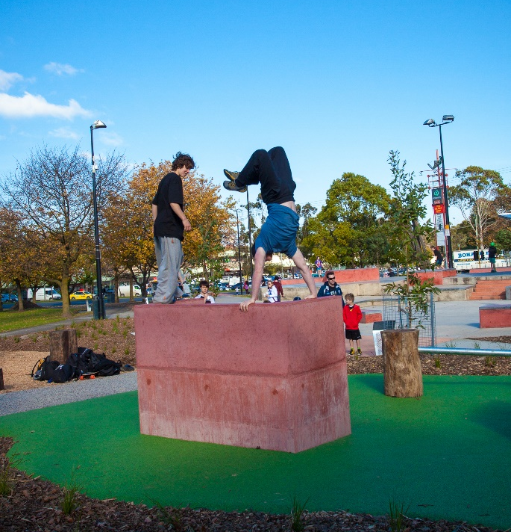
Parkour

Parkour is a discipline that encompasses moving through an environment with physical and mental challenges as efficiently as possible. It requires balance, strength and determination to overcome barriers like walls, gaps and narrow ledges.

The recognition of parkour as a recreation activity is reflected in the development of two (2) sites within Maroondah. The largest site is located at Croydon Park adjacent to, and integrating with, the skate park to form the Youth ‘Y Space’. The site has a range of elements that provide opportunities to progress from beginner level activity and balance challenges through to more strength and skill-based elements. The second site, at Glen Park Reserve in Bayswater North, is suitable for beginner level, with elements targeting a younger age group of users. The two (2) sites are reviewed in section 2.3 of the Situation Analysis in appendix 1.
Croydon Y Space

The challenges for parkour are similar to those of skateboarding in its early years. The use of public urban sites such as carparks and shopping precincts were discouraged due to damage and the lack of safety consideration in those environments. The provision of designated well designed formal spaces, social media influence and film depiction has led to the growth and recognition of this skilled pursuit.

Mountain Biking

Whilst designated mountain bike facilities are not directly part of the scope of Extreme Sports in Maroondah, the growth in participation in this activity overlaps into the sites Maroondah has established for BMX and skate. For example, at the new Yarrunga jumps location, greater numbers of participants were observed using mountain bikes than BMX.

Maroondah has a network of trails that are utilised for recreational mountain bike riding and participation along this network has increased considerably in the last 10 years. This is particularly important, given the range of age groups that are engaged in trail riding activities and that in many instances the trail network is situated near Maroondah’s BMX and skate sites making accessibility to those locations easier for young people. There is demand for greater provision of bushland mountain bike trails however limited bush areas, mostly with protected indigenous flora, and relatively flat topography in available open space sites, has limited its provision in Maroondah. It should also be noted that the neigbouring municipality of Yarra Ranges has, in recent years, received significant State and Federal funding towards the development of extensive mountain bike trail infrastructure, which has been designed to position Yarra Ranges as a national destination for mountain biking. Planning is underway to develop a mountain biking hub in and near Warburton, with stage one involving the development of 100+ kilometres of new mountain bike trails and connections. A further eight (8) pump tracks are in the planning stages for delivery across Yarra Ranges, including a mountain bike racing facility located at Wesburn.
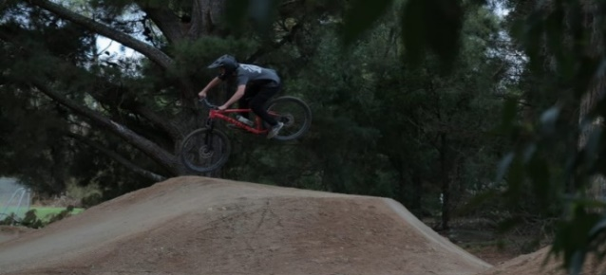

Yarrunga

Extreme Sports Facilities bordering Maroondah (within 5km)

The provision of skate, BMX, mountain biking trails and parkour facilities in close proximity to Maroondah should be taken into consideration when planning future development priorities. The table below highlights some of the facilities.

Venue | Access | Details
CITY OF KNOX
Bayswater Park | <1km from Bayswater Station  Dandenong Creek Bike Trail | Metal parkour structure and several street skate elements
SHIRE OF YARRA RANGES
Lilydale Skate Park, Hardy Street, Lilydale | <1km from Lilydale Station | Skate bowls suitable for BMX, scooters and skateboarding. Suitable for all ages and abilities.
Lilydale BMX Track | 2.2km from Lilydale Station | Coaching, club competition and public use.
Lillydale Lake Parkour & MTB Skills track | <1km from Lilydale Station | Metal pole parkour structure over a sand surface. Small MTB skills trail then an open area with several elements, a roller coaster and a berm
CITY OF MANNINGHAM
Warrandyte Skate Park | Road access only | The skate facility has street style skating.
Stintons Reserve BMX Track | Road access only | This BMX facility is home to Park Orchards BMX Club but is also available to the public use outside club operation hours. The facility is a single-lap race track and a dirt race course made of various jumps.
Wonga Park BMX facility | Mullum Mullum trail | Dirt bike track with three jump circuits of varying skill levels are provided and jumps should not be modified to exceed 1.5 metres.
CITY OF WHITEHORSE
Vermont South Skate Facility | Bus access. | The has a vertical half pipe suitable for advanced skaters, not suitable for beginners or scooters.
Heatherdale Reserve Pump Track | Train Access | This pump track is suitable for younger riders. As well as the BMX track there is also a mountain bike skills loop.

In a recent community engagement initiative (October 2021), Yarra Ranges identified Brickworks Reserve in Montrose and Kilsyth Reserve as possible locations for a new bike facility and are exploring a number of different facility types which are suited to different BMX and mountain bike styles of use and proficiency.
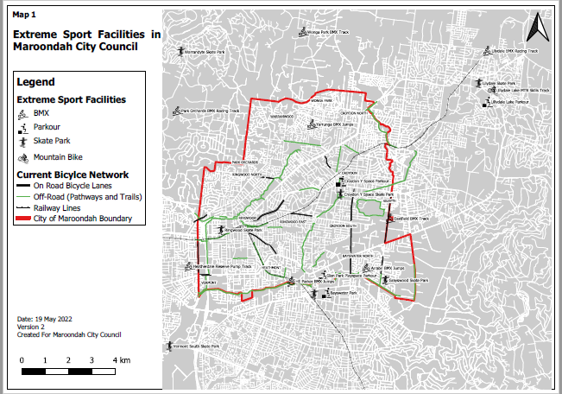
Extreme Sports Facilities within 5km of Maroondah Boundaries

KEY CONSIDERATIONS

Challenge versus Risk
BMX and skating activities involve inherent risk of injury. The activities however present a sense of
adventure and challenge and can meet the need for risk-taking, which appeals to those wanting to conquer new and difficult skills. Mastering these skills can result in much sought-after peer acceptance and social connectedness. The challenge for Council is to find the right balance between supporting and encouraging participation and providing an environment which minimises risk and manages community expectations about safety.

Unauthorised Bushland Jumps
Throughout 2020 - 2021 continued COVID19 restrictions exacerbated an existing concern involving the unauthorised construction of jumps in Maroondah’s bushland reserves. These jumps and circuits posed risk to community safety but also caused significant detrimental effect on the bushland vegetation with the removal of vegetation, damage to tree roots and littering occurring also. This activity, if not managed appropriately, may significantly change the ecology of the areas and impact on the life expectancy of the bushland.

Infrastructure Management
Only some of our existing BMX, Skate and Parkour assets are governed by management plans. Therefore, these assets are being managed and maintained in different ways with different levels of service. There is a need to review existing documentation and ensure all assets are being maintained and inspected in accordance with an appropriate management plan. An assessment of our current assets is required in relation to condition, utilisation, fit for purpose and risk analysis. Works need to be scheduled based on priority with an understanding of the scope of works required and the associated estimated costs. Surrounding infrastructure also requires review (i.e. lighting, waste etc) to ensure these assets are providing the desired service for the user groups.

Eastfield BMX Racing Track Location
Eastfield BMX track is currently located within the Yarra Ranges’ municipality on a VicRoads owned site, with Maroondah Council leasing the land and subleasing to the Club. This arrangement was put in place to assist the club when in 1991, the club was moved from Maroondah Council land due to the site’s sale to Swinburne TAFE. In accordance with the head lease from VicRoads, improvements to the licenced area must be removable and therefore the BMX clubrooms are located in two converted, site sheds with ageing shipping containers for storage. The assets at this site have been managed largely by the Club and Council needs to assess whether the current facilities are safe, compliant and meet the needs of the users. Furthermore, the VicRoads land on which the BMX track resides is reserved for the proposed Healesville Freeway/Arterial. At the present time there are no active plans for this road infrastructure or forward budget indications however development of a relocation strategy will enable long term stability and growth of the BMX club.

RMAC OpenSpace Plan and Staley Gardens Enhancement
Staley Gardens is a vital parcel of open space in the heart of the Ringwood Metropolitan Activity Centre. Council is currently assessing the longer-term enhancement of Staley Gardens, including the existing skate park facilities. Stakeholder consultation will be undertaken to understand the needs of all users to determine whether the skate park’s location and the design meets community needs and aspirations now and into the future.

Global Growth, Increased Diversification and Competitive Sport Focus
The activities of BMX and Skateboarding have grown and diversified due to both social media influence and greater competitive pathways. There is increased BMX activity within skate facilities and greater dirt jumping activity observed in Council reserves. There is also greater demand for street plaza style facilities for both skate and BMX. COVID 19 lockdowns saw an unprecedented spike in mountain bike, BMX and skateboard sales with demand exceeding available supply.

The 2020 (2021) Tokyo Olympic Games further spotlighted the competitive avenues of BMX and skateboarding with Australian male and female success highlighting the sports rapid progression as a genuine competitive sport option. This focus will undoubtably have an impact on participation both recreationally and competitively.

There was recent discussion surrounding Parkour being included in the Olympics Games Program for Paris 2024 however contention over the sport governing body resulted in its withdrawal. It has been included in the program for the 2022 World Games and is tipped for inclusion in the 2028 Olympics, so its growth as a sport may well progress.

Active Transport
BMX, Skateboarding, Scooters and Mountain Biking are a legitimate form of transportation. These activities offer considerable benefits to users and to the broader community. Encouraging active transport contributes to the physical health and mental health of individuals and to environmental sustainability.

The needs and responsibilities of all stakeholders must be considered in order to minimise the risk of injury as well as minimising the conflicts between skaters, riders and other road and path users. These needs should be integrated into design and asset planning processes.

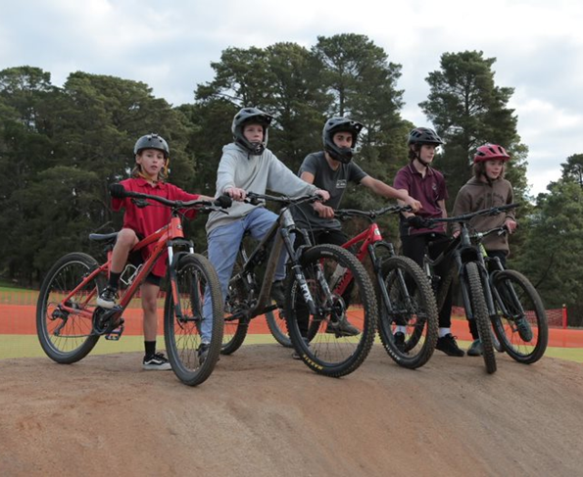
Supporting Users to have a voice
The recent national Ausplay data shows that 92% of cycling and 78% of skate sports participation is not through an organisation or venue, and parkour did not have enough responses to provide an accurate estimate but is unlikely to have significant organised participation locally. This illustrates that the key users of extreme sports facilities may not have a local collective voice to advocate for facility improvements or new developments. Council must therefore have established engagement approaches, and feedback mechanisms that are appropriate for the users to ensure that they have the ability to provide feedback and / or participate in future facility planning.
Yarrunga BMX Jumps

Increasing Women’s and Girls’ Participation
Currently female participation in organised BMX activity across Victoria is at 21% of the total membership and the sport has made a commitment to improve this number. In skate, Ausplay data includes roller skating and blading and indicates that women and girls represent 41% of participation, however, through facility observations it is evident that for skateboarding, the percentage would be significantly less.

VicHealth research has found that fear of judgement is the one barrier to physical activity that is consistent across all female life stages. This finding is relevant to designated activity spaces such as skate and BMX facilities which are public open spaces where young women may feel exposed or ‘watched’ when learning.

Council’s Equally Active Policy and Strategy illustrates Council’s commitment to improving environments to support women’s and girls’ participation in regular physical activity and seek to engage with young women to understand their needs and provide environments which will support and encourage their increased active participation in extreme sports. Provision of programs to support skill development have proven to shift the gender balance and will be an important addition to support participation. Additionally, Council may be required under the Gender Equality Act 2020 to undertake Gender impact assessments (GIAs) on services and programs that significantly impact the public. The purpose of the assessments is to create better and fairer outcomes, and to make sure all genders have equal access to opportunities and resources.
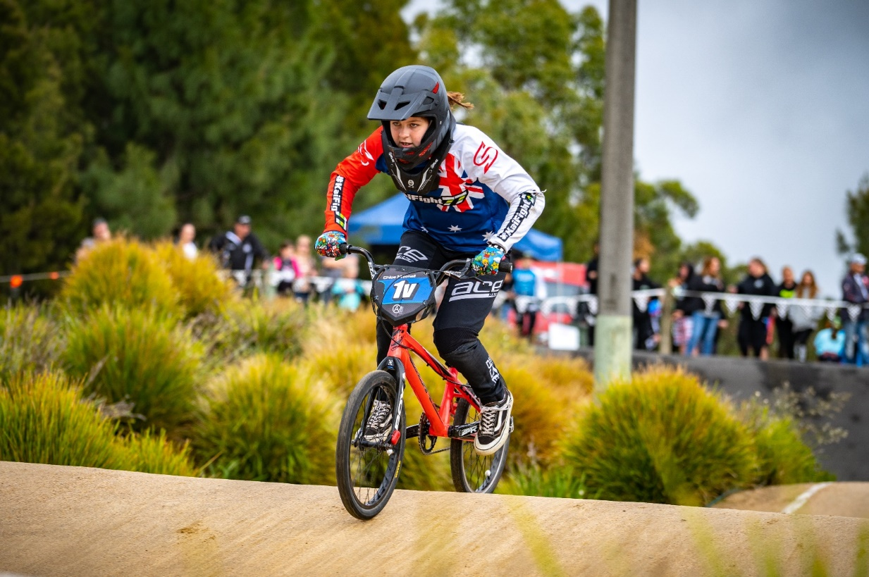

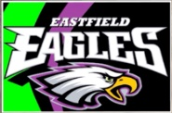

Protecting Children and Young People from Abuse and Harm

Victorian organisations who provide services or facilities for children and young people aged 0 to 18 years are required by law to implement the Child Safe Standards to protect children and young people from abuse and harm.

Maroondah City Council is committed to ensuring the safety and wellbeing of children and young people, and has zero tolerance for child abuse. As a child safe organisation, Council is committed to providing welcoming, safe and accessible environments where all children and young people feel valued, are listened to, and are genuinely considered and involved in decisions that affect their lives.

Council will need to ensure Child Safe Standards are a key consideration in the design, management and activation of its extreme sports facilities.

Section 2 – What does the evidence say?

To inform the development of this strategy, Council has recently undertaken a situation analysis, community engagement, facility audits, facility participation counts and have drafted and trialled an asset procedure and management plan.

Council recently updated the Maroondah Youth Strategy action plan for 2021- 2023. A key direction (1.4.2) for this plan is to undertake a needs analysis for a range of Council-owned open spaces used for formal and informal BMX, skate and parkour, by engaging with both users and non-users of the spaces.

Related Council Strategic Documents

This Strategy is influenced by a range of Council documents including but not limited to:

- Maroondah 2040
- Council Plan
- Asset Management Policy and Strategy
- Open Space Strategy
- Risk Management Policy
- Maroondah Liveability, Wellbeing and Resilience Strategy 2021-2031
- Maroondah Children’s Plan
- Physical Activity Strategy
- Maroondah Youth Strategy Action-Plan-2021- 2023
- Community Engagement Policy
- Draft Sustainability Strategy 2022 - 2031

In addition, the Strategy has been developed by taking account of the information contained within the following:
- A situation analysis for skate, BMX & parkour in Maroondah, Parks & Recreation Consulting April 2020
- Draft Extreme Sports in Public Places Management Plan, Parks & Recreation Consulting, 2021
- Draft Melbourne East Regional Sport and Recreation Strategy 2022, Inside Edge, April 2022

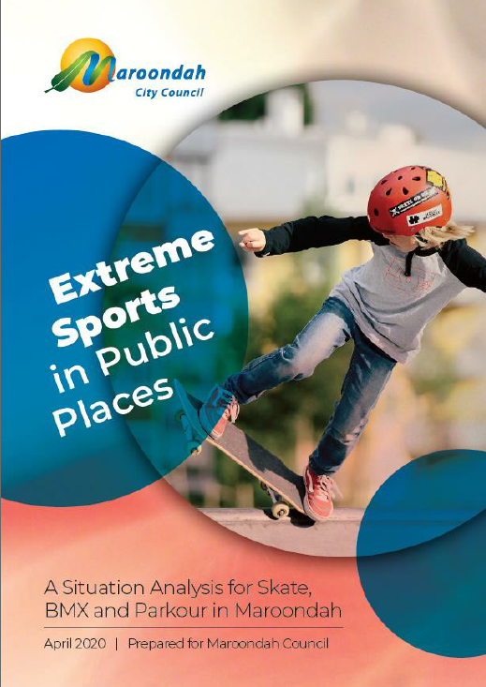
The Situation Analysis

A situation analysis was undertaken in 2020 by Parks and Recreation Consulting and is an appendix to this strategy, appendix 1. The Situation Analysis made a number of key site observations and assessments, identified a range of current sport and recreation trends for BMX, skate and parkour, highlighted the current legal and risk environment and recognised the current standards and compliance requirements. The situation analysis identified a number of changes to how Councils are addressing BMX, skate and parkour provisions.

A summary of key findings is detailed below:

- Maroondah Council has nine (9) Skate, BMX or Parkour sites that it currently recognises as formal sites and provides some form of maintenance or asset oversight at these venues. The nine (9) sites vary greatly, from extensive concrete constructions to simple mounding of dirt to form a track. The sites are positioned in locations relatively well spread across the municipality. The observations and usage projections for each site are detailed in appendix 1.

- There is a high level of participation in recreational skate and BMX activities in Maroondah as reflected in the usage figures of Maroondah’s regional skate and BMX facilities.
- The current local level BMX and skate facilities in Maroondah do not meet community needs or expectations and require upgrading and additional formalisation to encourage and facilitate active participation across Maroondah.
- There is a shift in management philosophy within local government towards the formalisation of BMX jumps and park trails sites to minimise risk and establish more accountable management situations. This shift is being encouraged by municipal insurers and facility designers.
- Whilst there remains interest in the more extreme elements of BMX jumps, this activity must be monitored and managed to minimise potential for incidents and litigation risk.
- Management Plans for existing Maroondah skate and BMX sites should be developed to document and resource agreed levels of service, monitoring responsibilities and maintenance activities.

Consultation Summary

Engagement Program Dates - Oct 2021 - May 2022

Number of engaged participants - 536

Engagement Methodology

Yarrunga Reserve BMX Jumps Redesign Engagement Process
Methodology | Dates | Engagements
Your Say Platform via Council’s Website | 1/11/2021 - 29/11/2021 | 44 Contributors
3 X On Site Pop Ups - Concept Design & Feedback forms | 10,13,17 /11/2021 | 43 Contributors
Promotion - Onsite Signage Service Centre Screens, Social Media

Evelyn Reserve Pump Track Proposal
Methodology | Dates | Engagements
Your Say Platform via Council Website | ??/11/2021 - 21/12/21 | 163 Contributors
3 On Site Pop Ups | 26/11/21,11/12/21,15/12/21 | 72 Contributors
Promotion - Direct Mailout, Service Centre Screens, Social Media

Wider Extreme Sports Engagement
Methodology | Dates | Engagements
Your Say Platform via QR Code & Council’s Website | 31/3/22 - 29/4/22 | 209 Contributors
Promotion - social media, footpath decals, signage, service centre screens and Maroondah Youth Services | 31/3/22 - 29/4/22

Direct User Engagement
Methodology | Dates | Engagements
Croydon Y Space Onsite Pop Up | Wednesday 13 April | 20 Contributors
Ringwood Staleys Onsite Pop Up | Friday 22 April | 14 Contributors
Yarrunga Onsite Pop Up | Friday 22 April | 25 Contributors

Potential Users and Segmented Cohort Engagement
Cohort | Methodology | Dates | Engagements
Primary Age | Vacation Care Wheels Day Engagement Activity | Wed 20 April | 13 Contributors
Secondary Age | Youth Services Drop In Program participants
Young People 18-26 | Survey link forwarded to Swinburne student union
CALD | Focus group Victorian Chin Community Youth | Fri 22 April | 5 Contributors
Indigenous | Survey Link forwarded to participants of Mullum Mullum Indigenous GP

Other stakeholders

Maroondah (Eastern Eagles) BMX Club
On site consultation with Council Officers and Maroondah BMX Club executive committee,16 March 2022

Consultation Key Findings

Key Issues

Maroondah BMX Club
- Amenities require significant upgrade, do not meet the club’s needs and does not provide a welcoming environment.
- Imminent need for more coaches in the sector particularly female coaches
- Starting gate no longer compliant for State competition
- Oz Cycling has taken over the administration of the sport, the transition has presented both positives and challenges. Introduced Dirt Licence for insurance.
- Require greater volunteers to run club level meets for beginners
- Informal mountain bike usage 50% but the track is not suitable for mountain bike competition racing
- Temporary nature of current Vic Roads reservation location, current track layout and raised spectator viewing is highly valued by users and would want to retain this design if relocated.

Extreme Sports Survey and Onsite feedback
- Residents local to Evelyn Reserve were not supportive of the proposed pump track in the reserve siting environmental and amenity impacts and impacts to young children’s use of the space.
- Lighting hours and inconsistent lighting levels (X Space)
- Unsuitable paint causing slippery, unusable skate surface (Staleys)
- Unmaintained BMX Jumps leading to unauthorised construction (HE Parker)
- Unmaintained BMX circuit affecting usage (Arrabri)
- First hill impedes speed and momentum (Yarrunga)
- Removal of deteriorating poles has affected the connectivity of elements (X Space Parkour)
- Cracking of surface at Grayswood
- Lack of awareness of available facilities
- Public toilets required at Yarrunga Reserve

Key Aspirations and Priorities

Maroondah BMX Club
- Improved venue signage
- Enhanced amenities including club rooms, storage, accessible, unisex toilets and shelter
- Elevated starting hill
- Compliant starting (barrel) gate to meet State level competition requirements & to reduce risk of entrapment
- Additional carparking
- Advanced freestyle BMX elements, removable, lockable to allow for club supervision

Extreme Sports
- Additional elements/expansion of Croydon YSpace Skate and YSpace Parkour
- Improved Lighting (Croydon X Space Skate)
- Younger children’s skate elements at Staleys
- Learn to skate Programs and Risky Kids parkour program collaboration with Council
- Redesigned pump track and jumps at HE Parker
- Provision of jumps for advanced riders
- Directional signage (HE Parker)
- New water fountain (Staleys)
- Preference (60%) for pump track & skate elements at Grayswood
- Desire for pump track and BMX jumps at Quambee or Parkwood Reserve (12 responses)
- More facilities designed for mountain bikes
- Extreme Sports Facilities Webpage and Map

The full findings are detailed in the Extreme Sports Strategy Engagement report, May 2022

Section 4 – A strategy for the future

A vision for Maroondah’s Extreme Sports Facilities

Council will partner with our community to plan, upgrade, maintain and activate suitable Skate, Bike and Parkour facilities to facilitate social connectedness and improved physically activity. The planning and management of these facilities will aim to balance the variables of risk, level of challenge, the preservation of natural bushland, and the needs of the wider community.

Outcome Areas

To support and grow participation in the activities categorised as Extreme Sports in Maroondah, and to balance challenge, risk and the protection of amenity, Council needs to undertake codesign actions which will address the following four (4) outcome areas:

Outcome area 1 - Engagement & Promotion

Outcome description

This outcome area focuses on effective communication with all stakeholders in the planning, management and usage of public facilities which support extreme sports. Getting this communication right will assist the development of extreme sports facilities, facilitate greater usage and improved conduct, and therefore support a wider catchment of ages and abilities.
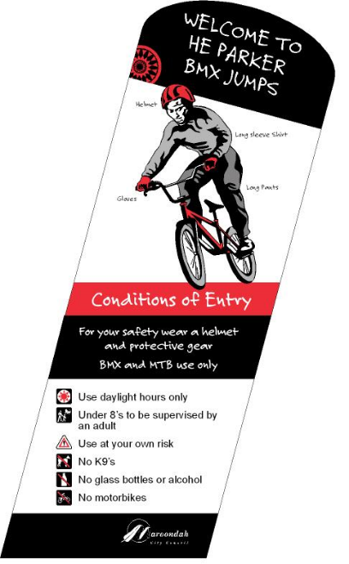

What the evidence tells us

While the provision of accurate information and promotion of facilities is an important part of the community knowing what facilities are available in Maroondah, young people will organically promote facilities that meet their needs through social media platforms, reaching their peers and social networks. The key for Council is to get the facility design right for young people to attend and utilise Youth Services connections and media platforms to present the programs information for young people to share amongst their peer groups.

The engagement program for the Strategy asked respondents to indicate which of the nine (9) facilities they use. It was evident through discussions with participants at the pop-up engagement sites that greater promotion is required for the nine (9) sites to encourage greater use. Council will seek to facilitate a positive messaging approach to the promotion of activities and facilities and use direct and indirect dialogue with users to showcase good news stories, positive behaviours, and appropriate use. Eg. protective wear.

Site Signage Requirements

The Extreme Sports in Public Places Management Plan developed by Parks and Recreation Consulting 2020 advised that as the Maroondah skate, BMX and parkour sites have no on-site supervision, signage plays a significant role in informing users of the associated risks, and setting boundaries for user behaviour. For Maroondah, since each Skate, BMX and parkour site presents a different scenario of users, safety aspects and site situation, signage content should be developed through site specific review.
All Maroondah sites should be reviewed in consideration of the following signage elements:

1. Conditions of Use or General Rules  2. Activities that are Prohibited  3. Regulations in relation to Hours of Operation  4. Notes on degree of Supervision  5. Recommended or required use of Protective Equipment | 6. Illustration of user safety information & etiquette  7. Notation of use of site at your own risk  8. Statement on consideration of own competence/skill levels and limits  9. Emergency contact information  10. General Council Contact information.

Facility Planning - Stakeholder Engagement

When undertaking a service needs assessment, it is integral that the needs of all stakeholders are taken into consideration and is determined through genuine engagement using a variety of methodologies to reach the varied groups.

Stakeholders will be site specific however, would typically include:

Key Stakeholders  - Participants  - Other open space users  - Interested potential participants  - Neighbouring residents  - Internal Council Stakeholders  - Industry experts | Other stakeholders  - Sports’ Governing Bodies  - Private providers  - Youth support services  - Victoria Police  - Schools  - Surrounding businesses

Y Space Codesign - A case study

The success of Maroondah Y Space and X Playspace has been depended on the continual engagement with Council stakeholders, sports clubs, residents, Police and Service Organisations in addition to the young people of Maroondah. From the outset a Steering Group was formed that included representatives from a wide range of Council departments and the local Police Crime Prevention Officer. To establish key design elements for the initial concept design, Council’s Youth Services Team facilitated extensive consultation with young people at secondary schools, at the 3-Ply skateboarding program, Swinburne students and during the 2010 Maroondah Festival. Service providers and support organisations within the CALD, youth and disability sectors were instrumental in shaping the design and ongoing management of the site, including the Migrant Information Centre, Centre for Multicultural Youth and Maroondah’s FreeZA group to ensure it met required needs. Specific design workshops, site pop ups, surveys and feedback via Facebook, websites etc. were used with young people for the detailed design of the X and Y Spaces and Parkour training area.
The comprehensive engagement has resulted in Council widely being praised for providing a unique and challenging facility that provides reasonable levels of risk to a wide range of users. It attracts many spectators and comments about the design. It was a runner up in the Victorian Government Community Sport and Recreation Awards for Innovative Facility Design and the Parks & Leisure Australia Vic/Tas Region’s 2012 Play Space Award of Excellence. Most notably, the facility has continued to have very high usage from a wide demographic with an estimated >35,000 visits per annum.

Education - Behaviour & Conduct

Creating a culture of responsibility and a sense of involvement by users in the management of facilities will contribute to respectful behaviours, harmony with other park users and ultimately increase participation. Sport and Recreation Victoria’s Skate Facility Guide states that the success of a skate park will be determined largely by the level of involvement and ownership felt by two main groups: skaters and local residents. Ongoing dialogue with skate facility users is necessary to keep track of this diverse, changing community and its needs. A skate park where no one skates is a liability no one wants. Council must therefore have established engagement approaches, feedback mechanisms and grievance procedures appropriate to all users to ensure that they have the ability to provide feedback and be afforded the opportunity to express concerns and/ or address other park users concerns.

Promotion of Extreme Sport Opportunities

Mechanisms to promote and connect with young people will include the provision of information on Council’s and Maroondah Youth Services Website, social media platforms and other appropriate publications. Council is looking to trial the use of emerging social media platforms to further connect with young people. Facility Information should include clear, useful information stating access, amenities, hours of operation, facility features, targeted proficiency level and permitted activities. Maroondah Youth Services’ Maroondah Youth Wellbeing Advocates group will be an ongoing reference for event and program promotion and the review and development of engagement approaches and feedback mechanisms.

Key Priorities

Key Direction | Priority Actions | Responsibility | Timeframe
1.1 Develop and promote welcoming channels for ongoing dialogue between Council and users, to ensure that their concerns and /or aspirations are heard and responded to. | 1.1.1 Review, monitor and adapt engagement approaches and feedback mechanisms to ensure that they remain the most appropriate platforms for key target groups.  1.1.2 Visit facilities in a planned and ongoing way to build relationships with facility users  1.1.3Utilise QR codes on facility signage to foster communication with Council | Youth and Children’s Services, Asset Planning, Communications  Sport & Rec | Ongoing
1.2 Improve promotion of extreme sports opportunities to maximise usage. | 1.2.1 Utilise the Maroondah Youth Wellbeing Advocates to support the effective review of facilities, events and program information about extreme sports.  1.2.2 Develop a communication plan to ensure children and young people are aware of extreme sports opportunities | Youth and Children’s Services  Sport & Rec | Dec 2023
1.3 Ensure facility signage remains relevant, in good condition and includes all recommended elements | 1.3.1 Ensure that appropriate facility signage is designed and included in Asset project delivery plans | Assets | 2023 onwards

Outcome area 2 - Planning

Outcome description

Council will have an evidenced-based approach to the planning of extreme sports facilities that considers current and potential user needs, the needs of the wider community, environmental impacts and lifecycle management.

This outcome area will guide the key planning considerations for Council in the delivery of Extreme Sports facilities and will highlight priority projects and developments required to service identified community need.

Framework for the planning of new or upgraded facilities

When undertaking initial planning for a new or enhanced skate, bike or parkour facility on Council land the following key elements will be considered:

- Demographic factors
- Demand
- Critical needs
- Levels of proficiency
- Life cycle costs
- Environmental Impact
- Impact on the use of the wider reserve
- Codesign opportunities
- Participant/resident/stakeholder expectations
- Opportunities for funding for facility development
- Risk analysis process, risk mitigation and safety approach

Risk Mitigations
- Adherence to any industry regulations and/ or construction or maintenance advice
- Development and maintenance of appropriate user signage
- Consideration of the four typical risks associated with this BMX and Skateboard facility: collisions, design issues, condition of the facility, and systems for identifying and assessing risk.

The above mitigations align with the objectives from Maroondah City Council’s Risk Management Policy 2019, including:
- Facilitate the achievement of strategic, operational and project objectives and priorities by reducing threats and maximising opportunities
- Provide assurances that critical risks are being managed effectively

Planning Principles

When designing a new Extreme Sports Facility, or enhancing an existing site, the following design principles will be adhered to:

1. Extreme elements and/or facility developments in public open space will be designed to cater for a competency level range of beginner through to intermediate. |  | 2. The provision of elements and/or facility developments that are focused on encouraging advanced and extreme risk skill development will be confined to facilities where there is capacity for supervision to be provided.
3. Facilities will be constructed using appropriate materials selection in accordance with design guidelines and principles. |  | 4. Deliberative engagement practices will be undertaken in accordance with Council’s Community Engagement Policy.

Key directions for future planning

- Assess and quantify lifecycle costs considering planning, development, monitoring, maintenance and renewal of Extreme Sports Facilities

- Incorporate into the unauthorised bike facilities management process, a system for recording and assessing the location, frequency & types of unauthorised jumps to understand patterns and assess whether the occurrences are a demonstration of an unsatisfied need.

- Develop a framework for the inclusion of extreme sports elements within public open space areas as part of Maroondah’s Play Planning In Open Spaces scheduled for 2022/2023.

- Incorporate Planning Principles into future planning.

Site specific priority actions

In response to consultation findings and facility site audits, the following actions have been prioritised for short to medium term implementation over the next 1 - 5 years.

Facility |  | Priority Action | Priority | Lead | Budget
 | EXISTING SITES
Croydon Y Space  - Croydon Park |  | Undertake a detailed performance assessment of all Y Space elements. | 1-3 yrs | Assets | Operating
 |  | Review lighting levels and timing to ensure the continued provision of a safe environment. | 1-3yrs | Assets | Operating
 |  | Source opportunities for funding for a learn to skate activation which supports greater participation of girls | 1-3yrs | Sport & Rec | Subject to External Funding
 |  | Complete detailed assessment of pine poles to ensure no rot or change to condition. | 1-3yrs | Operations | Operating
Grayswood Skate Park - Grayswood Reserve |  | Using the concept designs, engage with users to finalise the detailed design to renew the facility including consideration of all wheeled activities. | 1-3yrs | Assets | $100,000  Capital
Ringwood Skate Park - Staley Gardens |  | Explore the most appropriate surface to ensure safety and improve usability for participants. | 1-3 yrs | Assets | Operating
 |  | Review the surrounding infrastructure to ensure it supports usage including the upgrade of the drinking tap | 1-3 yrs | Assets | $10-15,000 Capital
 |  | Investigate the long-term future of skate facilities within the RMAC as part of the RMAC Open Space Strategy. | 1-3 yrs | Assets/  B&ACD. | $50-60,000 Operating
Glen Park Playspace Parkour - Glen Park |  | Investigate the long-term direction of fitness elements within the Glen Park Playspace precinct. | 3-5yrs | Assets | Operating
Eastfield BMX Track, Kilsyth |  | Address site amenities and destination facility deficiencies, including an assessment of the feasibility to relocate the temporary toilet/ change facility currently residing at Ainslie Park. | 1-3 yrs | Sport & Rec | Operating
 |  | Continue to seek out opportunities for land repurpose to secure the long-term future of the BMX track within Maroondah. | Ongoing | Sport & Rec | Subject to External  Funding
 |  | Support Maroondah BMX to source funding to install a compliant starting (barrel) gate to meet State level competition requirements & to reduce risk of entrapment | 1-3yrs | Sport & Rec | Subject to External  Funding
 |  | Undertake a feasibility study in conjunction with the Club, to assess the capacity of the site to service alternate user groups (eg: Advanced BMX Jumps / Mountain bike pumps) as a broadening of service offering | 1-3yrs | Sport & Rec | Subject to External  Funding
Yarrunga BMX Jumps - Yarrunga Reserve |  | Using engagement feedback, continue to review usage and where possible, modify design to improve safety and to cater for a wider range of ages and abilities. | 1-3yrs | Assets | Operating
 |  | Review the provision of accessible public amenities in Yarrunga Reserve | 3-5yrs | Assets | Operating
 |  | Upgrade signage to include safety aspects, conditions of use and prohibition of self-constructed jumps | 1-3yrs | Assets | Operating
HE Parker BMX Jumps - HE Parker Reserve |  | Review potential for relocation to site in surrounding area, with improved visibility, better topography and potential to provide support amenities to users. | 1-3 yrs | Assets | Subject to external funding
Arrabri BMX Jumps - Canterbury Gardens |  | Review existing site in conjunction with Canterbury Gardens enhancement planning and feasibility of inclusion of concept design appendix 2 | 3-5yrs | Assets | Subject to External  Funding
NEW SITE
Proposed North Ringwood Bike Facility |  | Investigate the feasibility to create a facility to support wheeled activities. | 1-3yrs | Assets | Subject to External  Funding
Outcome area 3 - Management

Outcome objectives

Council will continue to review and refine the Extreme Sports in Public Places Management Plan.
Council will communicate and maintain an integrated, cross-council process for the lifecycle management of extreme sports infrastructure to maintain optimal safety and ensure longevity of the asset.
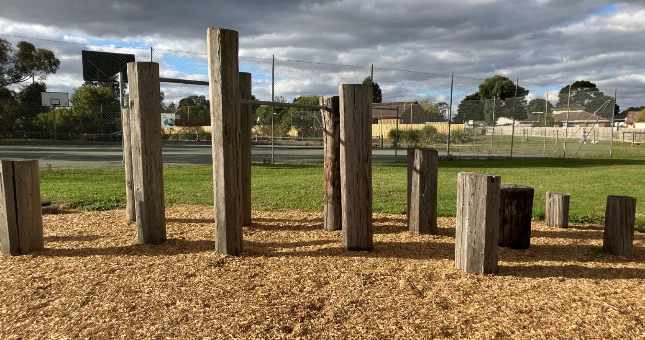
Council will follow a process for the prompt management of unauthorised bike facilities in Council owned or managed open space.
Glen Park Parkour

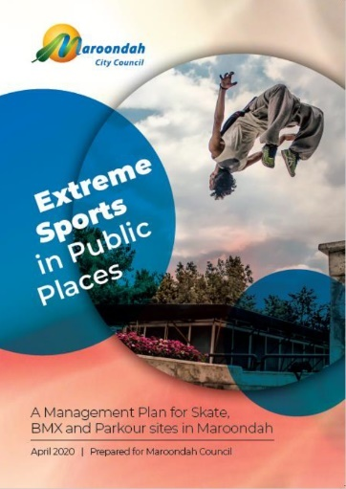
Management Plan
In April 2020, Council commissioned consultant Parks & Recreation to draft an Extreme Sports in Public Places Management Plan. The purpose of the Plan was to provide guiding principles for management and processes for maintenance, promotion, safety and use of the formal Maroondah sites. It is also to provide clarity as to responsibilities attributed to various parts of the Council organisation. The development of the plan has prompted further engagement, discussion and trialling of processes for the ongoing management of designated Extreme Sports sites in Maroondah.

The seven key responsibility areas which were highlighted and detailed in the Management Plan were:

1. Overall Management Responsibilities | 5. Monitoring user behaviours and rules compliance
2. Monitoring facility condition | 6. Researching use and promotion
3. Monitoring amenity conditions | 7. Planning and design examination
4. Assessing facility compliance
Overall Management Responsibilities

The overarching obligations and responsibilities of Council in relation to the management of Council’s extreme sports infrastructure are guided by the following position statements;

1. Council is obligated, responsible and committed to the management of skate, BMX and parkour sites in a manner to ensure the safety of all community users | 2. Council is committed to the provision of a range of opportunities for the community to be active and engaged within Council’s open space environments.
3. Council is committed to effective community engagement and planning in relation to the development and use of open space environments | 4. Council is committed to the protection of significant natural environments for the future use and enjoyment of residents and visitors of Maroondah open spaces

Management Principles

As a result of the statements defined above, the four key management principles for Council owned extreme sports facilities are:
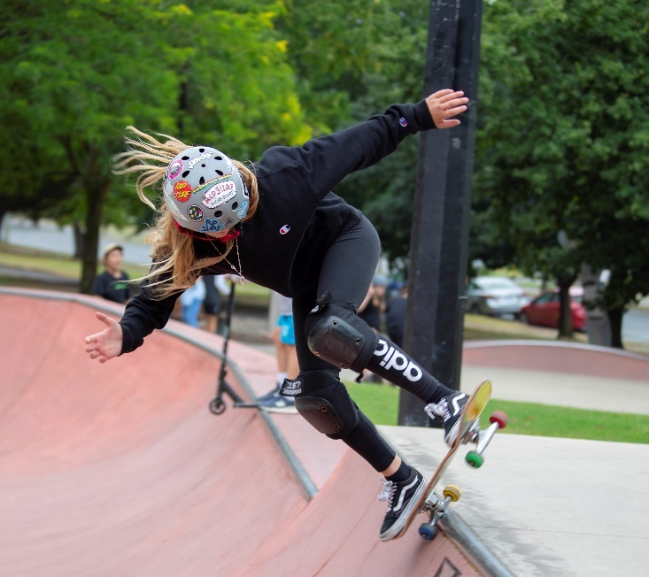
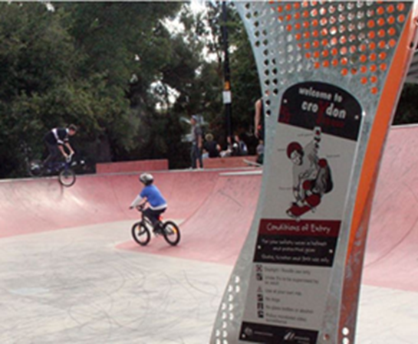
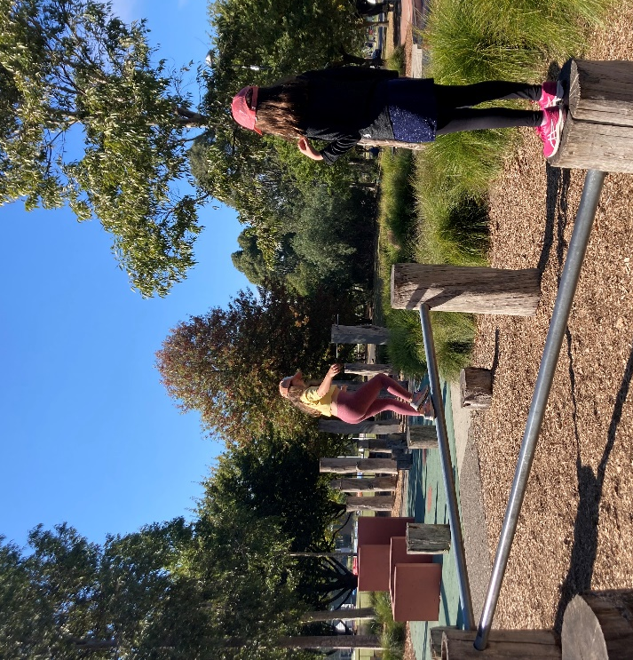
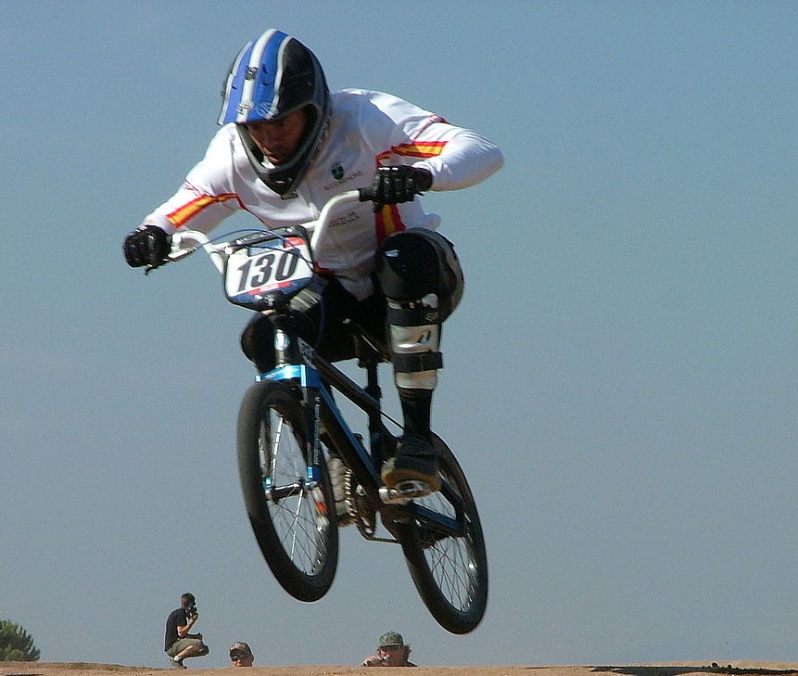
Equitable access

Challenging \ and stimulating

Clean and
well-maintained environments

Safe infrastructure, equipment and surroundings

Lifecycle Management

Council should ensure that the following is considered and established prior to the development of Extreme Sports Assets, or on the occasion that unauthorised BMX components are assessed and accepted as Council assets:

- Sufficient allocation for maintenance and renewal has been attributed as part of the budget process
- Monitoring and reporting structure
- Procedure for reporting and assessing incidents and safety concerns at facilities

Further to this, an asset lifecycle has 4 phases each with considerations

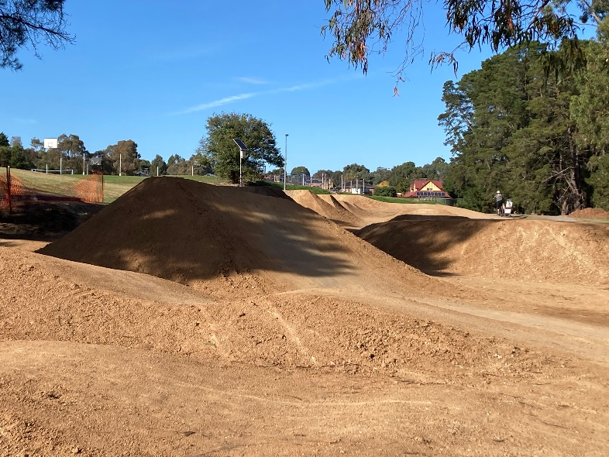
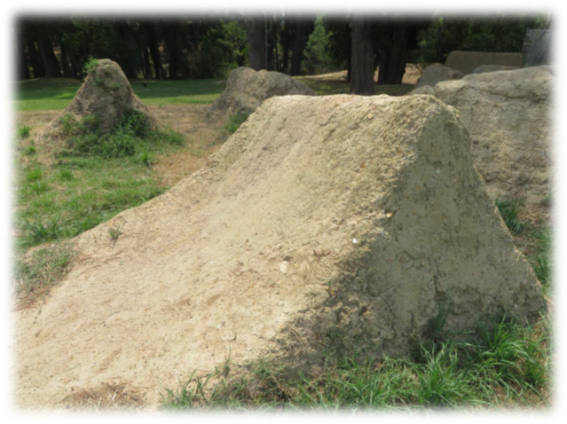
Yarrunga BMX Jumps 2019 Yarrunga BMX Jumps 2022
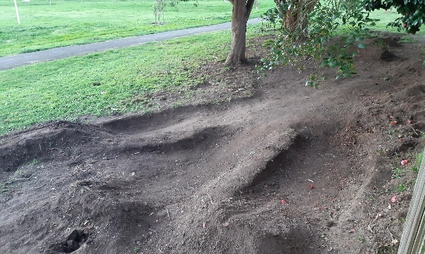
Management of unauthorised bike facilities on Council Land.
The unauthorised creation of bike facilities on Council land, and their subsequent/associated issues, have become proliferate. The issues/concerns include:
- Damage to the natural and built environment
- Safety concerns, hazards and conflicts with other community users of Council land.

To address this issue, Council has developed, tested and implemented a procedure to either formalise the trails through engagement with users, remove components causing environmental impacts or with high risk, and improving & monitoring acceptable components.

Principles of the unauthorised bike facilities management process.
- So far as is practicable, Council is obligated, responsible and committed to the management of Council land in a manner which is safe for all community users
- Council is committed to the protection of the natural and built environment for the enjoyment of residents and visitors
- Council is committed to the provision of a range of opportunities for the community to be active and engaged in physical activities within Council’s municipal reserves
Unauthorised BMX bike Facilities - Management Procedure
Council’s Local Laws prohibit people from interfering with its public spaces, including undertaking building works or construction activities. However, for unauthorised bike facility works, Council will assess the work against a set criteria which considers:
- Impact on the natural environment
- Impact on the built environment and ‘intended use’ of the land
- A safety and risk assessment
- Examination of the design and construction methodologies
- Impact on the community
When the site does not align with the above, Council may remove components or the full site. Users will be informed via signage and invited to speak further to Asset staff regarding the removal and/ or future options. Where elements are deemed to have minimal impact, the remaining elements may continue to be monitored for their use, safety and environmental impact.

Priority actions for Management

Key Direction | Priority Actions | Responsibility | Timeframe
3.1 Ensure a sufficient allocation for maintenance has been attributed as part of the budget process | 3.1.1 Undertake a review of costings for the required service levels for the Extreme Sports sites | Operations - Lead  Asset Projects | April 2023
3.2 Ensure that Council maintains an overarching management plan and individual plans for each extreme sports site | 3.2.1 Review and update the draft Extreme Sports Management Plan for internal endorsement and integration into service area work plans | Sport & Rec | Dec 2022
3.3 Ensure expertise and knowledge is transferred from the contractor to optimise safety & participation | 3.3.1 Ensure that site specific maintenance information is relayed to Operations as part of the build. | Asset Projects | Prior to opening of upgraded or new facility

Outcome area 4 - Programs, Events and Site Activation

While for many users a well-designed facility that meets their needs is enough to encourage participation, for disengaged young people, or those who are hesitant to attempt new skills in public, or those with other social or physical barriers, an introductory program can be very valuable. Additionally, public events that showcase participation is an opportunity to introduce the facilities to new prospective participants. Public events can promote positive media coverage, provide the opportunity for participants to demonstrate their skills and gain recognition and increase the profile/perception of their sport.

Why activate?

Running or supporting programs, clinics or events have proven to increase the age range of participants, imbed desired behaviours through education, reduce the risk of injuries through skill development, and ensure that participants stay engaged longer through the development of skills and social networks.

In September 2020, Council partnered with Women’s Health East to recruit a diverse group of 14 women to undertake a walk-through of Croydon Park. The aim of the walk was to elevate and utilise the lived experience of local women to inform a gendered approach to planning and design of public places. Skate Park key feedback included the recommendation to determine need, and increase activation of girls at the skate park if necessary noting the benefit that “Programming for girls will increase their skateboarding confidence and potential for using this space as active participants.”

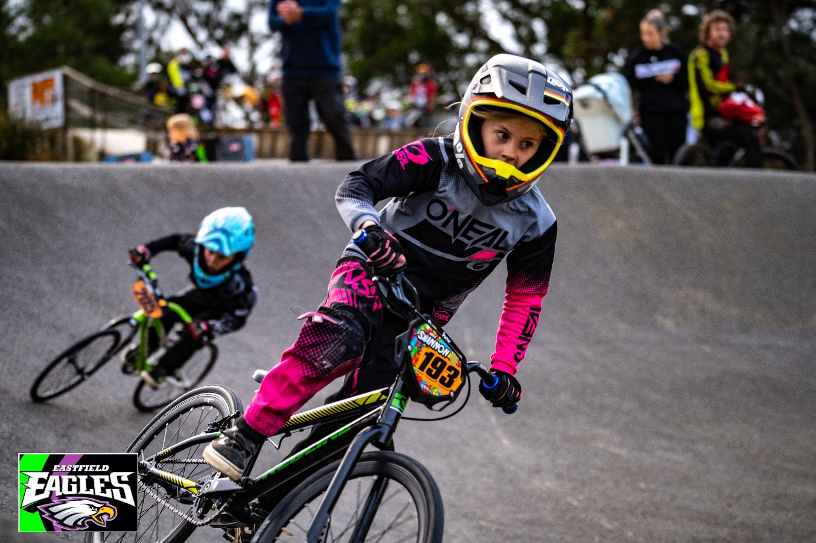

Council’s 2007 Skate and BMX Plan highlighted the need to expand the provision of skate and BMX opportunities beyond facilities, to include programming and sports development activities. Some examples of Council initiatives are detailed below.
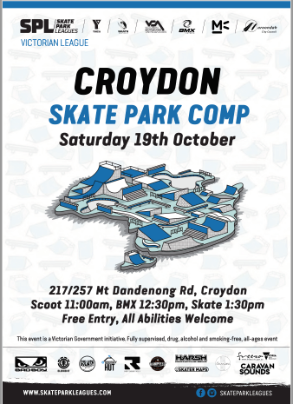
In 2010, Simply Skateboarding received funding from Eastern Industry Education Partnership (EIEP) to deliver an initiative that involved youth trainees receiving training (both vocational and accredited) to plan and deliver events and programs for their peer 16 – 19 age bracket; and introductory clinics at Croydon and Ringwood which were attended by younger children (primary school aged).

In 2019, Council’s FReeZA program which is a Victorian Government Funded initiative, supporting young people to facilitate drug, alcohol and smoke-free events for other young people, hosted an event as part of the YMCA & Victorian Skateboarding League’s Melbourne Metro Series. The event saw skate, scooter and BMX competitions take place at the skate park. The event was a collaboration between YMCA VIC, Victorian Skateboarding Association (VSA), BMX Victoria (BMXV), Skate Australia, FReeZA and Maroondah City Council.

Knox City Council’s newest Skate and BMX Park in Gilbert Reserve caters for beginners, intermediate and advanced riders and skaters. Council, in partnership with the YMCA, offer free skate, scoot and BMX lessons weekends & school holidays over the Summer Period. Scoot lessons and BMX lessons are available on alternate days. The facility is also promoted as available for hire for events. YMCA also run girls skate programs at City of Melbourne and Manningham. The programs provide a safe and supported environment for beginners to gain confidence and basic skills before accessing the facilities independently.

Events/ Filming requests
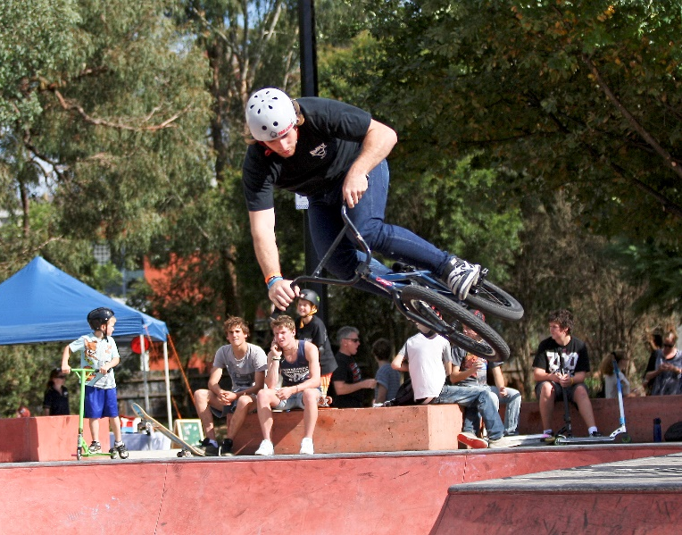
From time to time, Council receives requests for use of extreme sports facilities for events and or filming, or photo shoots for public display. Applicants must follow Council’s Events on Council Land process and or the Low Impact Filming Approval process both available on Council’s Website. The two (2) processes ensure public space are used safely and in accordance with all applicable legislation, local laws and regulations. At the same time, it ensures any disruption is minimal, facilities are managed effectively and that anyone who may potentially be impacted is notified. Additionally, the process provides an opportunity for relevant Council teams, such as Community Planning and Development, Youth Services, Sport & Recreation and Communications and Citizen Experience, to collaborate and support the activities.
Croydon Y Space

It is unlikely that the two (2) regional skate facilities would have the infrastructure to support a State level competition. Temporary amenities and traffic management could support Regional level competition, however amenities and spectator facilities required for State level competition would not currently be feasible. Eastfield BMX track has previously held State and National Titles however the venue’s existing starting gate does not meet current requirements to host state or national level competition. Council will support Eastfield Eagles BMX club to source funding for its upgrade.

Priority actions

Key Direction | Priority Actions | Responsibility | Timeframe
4.1 Facilitate activation initiatives in new or redeveloped sites to encourage desired behaviours and support a range of proficiency levels | 4.1.1 Build a business case for specific initiatives for use in future grant submissions and /or budget proposals  4.1.2 Schedule a Celebrate Maroondah event at Yarrunga Reserve and other relevant facilities where upgrades occur | Sport & Rec  Sport & Rec | 3-5yrs  Ongoing
4.2 Support and/ or deliver parkour, skate and /or bike activation programs or events that encourage a wider catchment of participants | 4.2.1 Council to support and/or deliver a minimum one activation per financial year  4.2.2 Encourage FReeZA Program participants to consider skate and biking facilities as venues for planned youth events. | Sport & Rec -Lead YACS  Youth and Children’s Services | Ongoing  Ongoing
4.3 Source funding opportunities for beginner programs for minority cohorts | 4.3.1 Develop community partnerships, and apply to Change Our Game Funding Program or other relevant funding sources to deliver a girls’ skate and/ or BMX program | Sport & Rec -Lead  YACS | 1-3 yrs

Tracking our progress

Implementation process

The Extreme Sports Strategy forms part of Council’s response to delivering on Maroondah 2040: Our future together. It will have a staged implementation with further investigation required to inform future actions. The Strategy identifies key priority actions which Council seeks to deliver within the next 5 years
It is anticipated that additional priority actions and projects may be identified over time which will support changing community need and emerging trends in the provision of extreme sports facilities.

Sport & Recreation will lead the implementation of the strategy and will establish a cross council working group to develop an Implementation Plan which will guide the delivery of actions. Implementation will be monitored and reported back to the working group on an annual basis, with an annual meeting prior to service delivery and budget planning processes. The Plan will address each of the outcome areas and provide details regarding how and when Council will deliver on each of the priority actions.
Priority Actions are summarised on the following page.

Reporting

An interim review will be undertaken at year three of the strategy which will be presented to Council’s Corporate Management Team (CMT) and Councillors. Amendments and /or new priority actions will be recommended for the further seven years of the strategy.

Priority Action Summary

Priority Action | Responsibility | Timeframe
Outcome Area 1 - Engagement and Promotion

1.1.1 Review, monitor and adapt engagement approaches and feedback mechanisms to ensure that they remain the most appropriate platforms for key target groups.  1.1.2 Visit facilities in a planned and ongoing way to build relationships with facility users  1.1.3Utilise QR codes on facility signage to foster communication with Council | Youth and Children’s Services, Asset Planning, Communications  Sport & Rec | Ongoing
1.2.1 Utilise the Maroondah Youth Wellbeing Advocates to support the effective review of facilities, events and program information about extreme sports.  1.2.2 Develop a communication plan to ensure children and young people are aware of extreme sports opportunities | Youth and Children’s Services  Sport & Rec | Dec 2023
1.3.1 Ensure that appropriate facility signage is designed and included in Asset project delivery plans | Asset Projects | 2023 onwards
Outcome Area 2 - Planning *

Croydon YSpace
2.1 Undertake a detailed performance assessment of all Y Space elements. | Assets | 1-3 yrs
2.2 Review lighting levels and timing to ensure the continued provision of a safe environment. | Assets | 1-3yrs
2.3 Source opportunities for funding for a learn to skate activation which supports greater participation of girls | Sport & Rec | 1-3yrs
2.4 Complete detailed assessment of pine poles to ensure no rot or change to condition. | Operations | 1-3yrs
Grayswood Skate Park
2.5 Using the concept designs, engage with users to finalise the detailed design to renew the facility, including consideration of all wheeled activities. | Assets | 1-3yrs
Ringwood Skate Park
2.6 Explore the most appropriate surface to ensure safety and improve usability for participants. | Assets | 1-3 yrs
2.7 Review the surrounding infrastructure to ensure it supports usage including the upgrade of the drinking tap | Assets | 1-3 yrs
2.8 Investigate the long-term future of skate facilities within the RMAC as part of the RMAC Open Space Strategy. | Assets | 1-3 yrs
Glen Parkour Playspace
2.9 Investigate the long-term direction of fitness elements within the Glen Park Playspace precinct. | Assets | 3-5yrs
Eastfield BMX Track
2.10 Address site amenities and destination facility deficiencies, including an assessment of the feasibility to relocate the temporary toilet/ change facility currently residing at Ainslie Park. | Sport & Rec | 1-3 yrs
2.11 Continue to seek out opportunities for land repurpose to secure the long-term future of the BMX track within Maroondah. | Sport & Rec | Ongoing
2.12 Support Eastfield BMX to source funding to install a compliant starting (barrel) gate to meet State level competition requirements & to reduce risk of entrapment | Sport & Rec | 1-3yrs
2.13 Undertake a feasibility study in conjunction with the Club, to assess the capacity of the site to service alternate user groups (eg: Advanced BMX Jumps / Mountain bike pumps) as a broadening of service offering | Assets | 1-3yrs
*Refer to page 25 for indicative budget
Priority Action | Responsibility | Timeframe
Yarrunga BMX Jumps
2.14 Using engagement feedback, continue to review usage and where possible, modify design to improve safety, reduce environmental impacts and to cater for a wider range of ages and abilities | Assets | 1-3yrs
2.15 Review the provision of accessible public amenities in Yarrunga Reserve | Assets | 3-5yrs
2.16 Upgrade signage to include safety aspects, conditions of use and prohibition of self-constructed jumps | Assets | 1-3yrs
HE Parker BMX Jumps
2.17 Review potential for relocation of the site in the surrounding area, with improved visibility, better topography and potential to provide support amenities to users. | Assets | 1-3 yrs
Arrabri BMX Jumps
2.18 Review existing site in conjunction with Canterbury Gardens enhancement planning and feasibility of inclusion of concept design appendix 2 | Assets | 3-5yrs
Proposed North Ringwood Bike Facility
2.20 Investigate the feasibility to create a facility to support wheeled activities at an appropriate location | Assets | 1-3yrs
Outcome Area 3 - Management

3.1.1 Undertake a review of costings for the required service levels for the Extreme Sports sites | Operations - Lead  Asset Projects | April 2023
3.2.1 Review and update the draft Extreme Sports Management Plan for internal endorsement and integration into service area work plans | Sport & Rec | Dec 2022
3.3.1 Ensure that site specific maintenance information is relayed to Operations as part of the build. | Asset Projects | Prior to opening of upgraded or new facility
Outcome Area 4 - Programs, Events and Site Activation

4.1.1 Build a business case for specific initiatives for use in future grant submissions and /or budget proposals  4.1.2 Schedule a Celebrate Maroondah event at Yarrunga Reserve and other relevant facilities where upgrades occur | Sport & Rec  Sport & Rec | 3-5yrs  Ongoing
4.2.1 Council to support and/or deliver a minimum one activation per financial year  4.2.2 Encourage FReeZA Program participants to consider skate and biking facilities as venues for planned youth events. | Sport & Rec -Lead YACS  Youth and Children’s Services | Ongoing  Ongoing
4.3.1 Develop community partnerships, and apply to Change Our Game Funding Program or other relevant funding sources to deliver a girls’ skate and/ or BMX program | Sport & Rec -Lead  YACS | 1-3 yrs

Section 5 – References

@Leisure Maroondah Skate and BMX Plan 2007
Australian Bureau of Statics 2017 National Health Study Survey December 2018
Australian Institute of Health and Welfare (aihw.gov.au) Australia's youth: Physical activity -accessed 4/10/2021
Clearing House for Sport AusPlay Survey January 2021 - December 2021, Released 29 April 2022
Dr Lisa Wood, Dispelling Stereotypes… Skate Parks as a Setting for Pro-Social Behaviour among Young People Centre for the Built Environment and Health, School of Population Health, The University of Western Australia, Perth, Australia 2014

Inside Edge Melbourne East Regional Sport and Recreation Strategy (Draft 2022)
Maroondah City Council Asset Management Policy and Strategy May 2021
Maroondah City Council Community Engagement Policy 2021
Maroondah City Council Council Plan 2021-2025 2021
Maroondah City Council Equally Active Strategy 2019
Maroondah City Council Maroondah 2040 June 2021
Maroondah City Council Maroondah Liveability Wellbeing and Resilience Strategy 2021-2031
Maroondah City Council Open Space Strategy 2016
Maroondah City Council Physical Activity Strategy 2015 - 2020 Oct 2015
Maroondah City Council Risk Management Policy February 2006
Maroondah City Council Youth Strategy Action-Plan-2021- 2023
Parks and Recreation Consulting A situation analysis for skate, BMX & parkour in Maroondah, April 2020
Parks and Recreation Consulting Supporting Extreme Sports in Public Places Draft Management Plan 2021
Victorian Government, Department for Victorian Communities. Sustaining Local Assets, 2003
Victorian Government, Sport and Recreation Victoria The Skate Facility Guide February 2001
Women’s Health East, Croydon Women’s Safety Walk Key Findings, September 2020

Appendices

Appendix 1 - Parks and Recreation Consulting A situation analysis for skate, BMX & parkour in Maroondah, April 2020

Appendix 2 - BMX Concept Plan - Arrabri Canterbury Gardens

Appendix 3 - Final Design - Yarrunga Bike Jumps

To contact Council telephone 1300 88 22 33
visit our website at: www.maroondah.vic.gov.au
or call in to one of our service centres:

Realm Service Centre
Maroondah Highway
Ringwood

Croydon Service Centre
Civic Square
Croydon

Translating and Interpreter Service
13 14 50

National Relay Service (NRS)
13 36 77

www.facebook.com/MaroondahCityCouncil
@CityofMaroondah
www.youtube.com/CityofMaroondah

maroondah@maroondah.vic.gov.au
www.maroondah.vic.gov.au

Dispelling Stereotypes… Skate Parks as a Setting for Pro-Social Behaviour among Young People Dr Lisa Wood, Centre for the Built Environment and Health, School of Population Health, The University of Western Australia, Perth, Australia
2017 National Health Study Survey
Australia's youth: Physical activity - Australian Institute of Health and Welfare (aihw.gov.au) accessed 14 October 2021.
AusPlay survey January 2021 - December 2021 Released 29 April 2022
@Leisure Maroondah Skate and BMX Plan 2007
Parks and Recreation Consulting, Extreme Sports in Public Places Management Plan. 2020
Sport & Recreation Victoria, The Skate Facility Guide. 2001
Sport and Recreation Victoria The Skate Facility Guide 2001
@Leisure Maroondah BMX and Skate Plan 2007
Sustaining Local Assets, Department for Victorian Communities. 2003
The Skate Facility Guide SRV 2001 p36
Women’s Health East, Croydon Women’s Safety Walk Key Findings, September 2020
@Leisure Maroondah Skate and BMX Plan 2007

