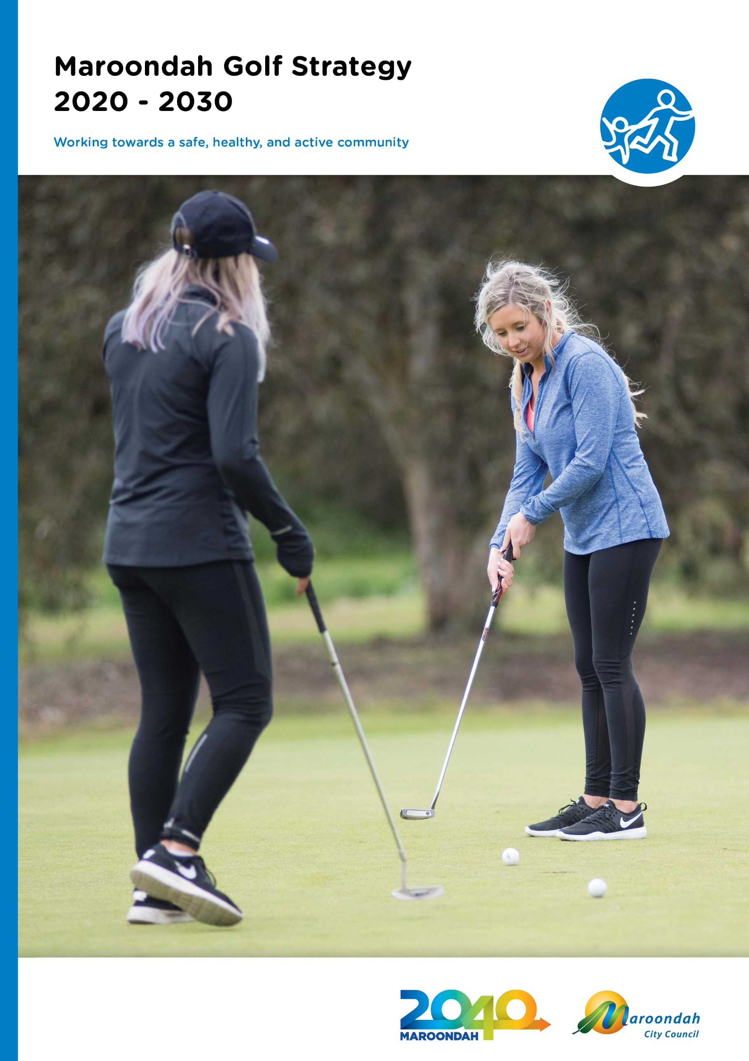

Executive summary

Maroondah City Council owns and operates two 18 hole public golf courses, Dorset Golf Course (Dorset) and Ringwood Golf Course (Ringwood) which are collectively known as Maroondah Golf.
These courses provide a valuable social meeting place and active recreation pursuit for approximately 152,000 visits annually. Both facilities are located within 500 meters of three municipal borders drawing a catchment beyond the municipality.
The net overall financial position for Maroondah Golf has declined in recent years, and the modest operational surplus the courses provide has typically not been sufficient to fund the required annual capital improvements associated with the courses. The large reliance on green fees as the key income stream leaves Maroondah Golf reliant on favourable weather conditions to ensure player numbers and income remain sufficient. This reliance places significant risk to the ongoing financial sustainability of Maroondah Golf and a strategic approach to developing diverse revenue streams is required.

In 2016, Council engaged WellPlayed Golf Business Consultancy to undertake a strategic review of Maroondah Golf. The aim of the review was to understand the changing landscape and opportunities for golf in Maroondah. In March 2019 Council, determined to take the recommendations of the report out to the broader community, to understand their support for the proposed contemporary elements, and gain a greater understanding of value of the two courses to the Maroondah Community. The feedback illustrated strong support for the retention of the two golf facilities and resistance to proposed changes which would impact the current 18-hole formats.

In order to balance the financial requirements and community feedback, Council identified a need to develop a 10-year strategy, outlining key priority actions that will enable golf within Maroondah to remain financially sustainable, achieve performance targets and see participation levels continue to increase and diversify. A strategic, evidence based approach to future planning will ensure that any changes consider community need, community benefit and financial sustainability, to facilitate any continued long term Council investment in two 18 hole golf courses.

The Strategy identifies three key planning principles which will guide future decisions for Maroondah Golf. To provide a clear direction, a vision statement has been developed in alignment with Maroondah City Council’s overarching Maroondah 2040 Community Vision.

Maroondah Golf will continue to evolve and improve its offering to the community to ensure that Golf remains sustainable and appeals to a diverse demographic.

To deliver this vision, the planning of all programs, initiatives and expenditure will be underpinned by the following key principles:

- Achieve an operating surplus greater than capital expenditure requirements and sufficient to mitigate risks that may hinder financial performance.

- Set operating targets and report annually to the community

- Continue to monitor usage, evaluate and evolve to meet the changing community needs.

Additionally, strategy key directions and priority actions have been attributed to four key focus areas.

These focus areas are:

- Enhancing facilities

Council will prioritise facility maintenance and enhancement over the next ten years to increase visitation and/ or user experience and demonstrate positive financial return to Council.

- Marketing, engagement and pricing

Council will improve data capture methodologies and continue to engage with both users and non-users to understand visitation, improve marketing potential and review pricing logic.

- Diversifying opportunities

Council will maximise use of facilities through the expansion of golf programs and the exploration of other innovative uses beyond traditional golf.

- Greater inclusion of under-represented groups

Council will engage with women, children, the CALD community and people with disabilities to prioritise the continued improvement of golf programs and facilities to meet their needs and interests.

The Maroondah Golf Strategy will have a staged implementation with further research and master planning required to inform future actions. It is anticipated that additional priority actions and projects may be identified over time which will also support the vision and the changing needs of the Maroondah community.

An Implementation Plan will be developed to accompany an adopted Maroondah Golf Strategy which will establish timeframes and required resources to deliver the 18 key priority actions. An annual ‘State of Play’ will be reported to Council.

Section 1 - The current state of play

Maroondah City Council is in the unique position of owning and operating two 18 hole public golf courses, Dorset Public Golf Course (Dorset) and Ringwood Public Golf Course (Ringwood). There are few, if any, municipalities within Victoria that own and operate two 18 hole golf courses.

The facilities are collectively known as Maroondah Golf and form part of Council’s enviable Maroondah Leisure membership offering. Maroondah Leisure encompasses two high ball stadiums, two aquatic/health club facilities, an outdoor 50 metre pool and the two golf courses.

Both Maroondah Golf facilities cover approximately 80 hectares (approximately 198 acres), equating to 1.34% of the municipality’s total open space. These courses provide a valuable social meeting place and active recreation pursuit for approximately 152,000 visits annually. Given the level of investment Council affords to the delivery of public golf in Maroondah it is of high importance that a strategic approach be established and regularly reviewed to understand and balance Council’s objectives of achieving both positive social and financial outcomes.

In 2016, with new trends emerging for social golf participation in Maroondah, and with competition golf remaining steady, Council engaged WellPlayed Golf Business Consultancy to undertake Stage One of the Maroondah Golf Strategic Review. The aim of the Review was to understand the changing landscape and opportunities of golf to inform the development of a medium-term strategy.

The net financial position for golf has been negative for the past eight years. Ringwood and Dorset Golf has cost Council on average $536,000 annually during that time. This is largely due to the significant capital expenditure program required to improve the course conditions. The modest operational surplus the courses provide has not been sufficient to fund the capital improvement investment. Dorset Golf has only produced an operating surplus to Council for four out of the past eight years.

While the attendance for both courses is considered to be high the yield-per-visit is low due largely to the heavily discounted Maroondah Leisure membership offer. Although the membership offer supports high attendance, it has a significant impact to the financial performance of the facilities. The membership offer, and distribution of the membership income, will need to be reviewed to ensure the Golf facilities do not continue to have a financial burden on Council and the community.

The large reliance on green fees as the major source of income and lack of diversity of income streams leaves Ringwood and Dorset Golf overly reliant on favourable weather conditions to ensure player numbers and income remain sufficient. The over reliance on green fee revenue is considered a significant risk to the ongoing financial sustainability of Maroondah Golf and diverse revenue streams need to be considered going forward to ensure the financial position is more reliable.

Expenditure at both courses needs to be managed. The costs associated with the marketing of the facilities continues to increase and needs to be reconsidered to enable low cost direct marketing that is engaging, effective and nimble that grows revenue and participation to ensure a positive return on investment.

If changes are not made to the capital expenditure program, diverse and additional revenue investigated, membership offer, distribution of membership income and overhead costs reviewed, then the financial burden of Council owning and operating two 18 holes golf course will continue to increase.

Stage One review

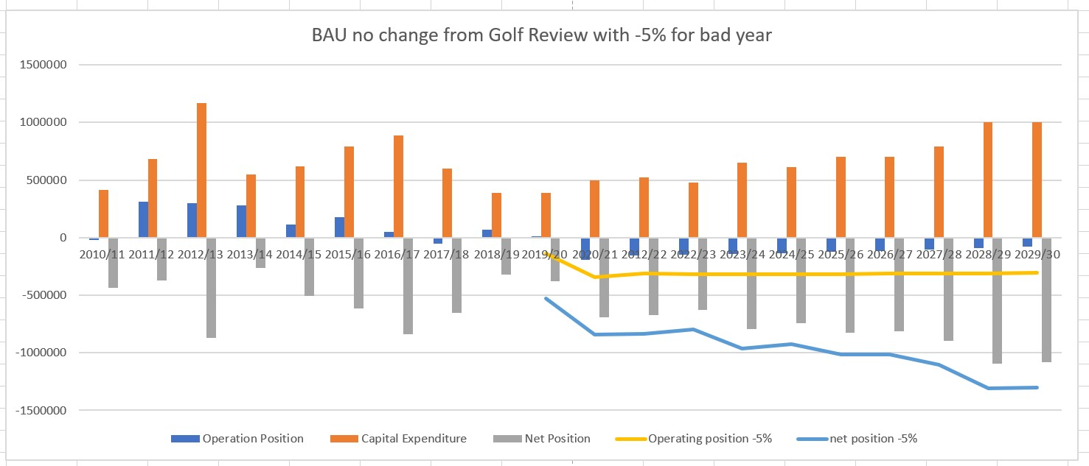

The Stage One review forecast an unsustainable financial position for Maroondah Golf as illustrated in the above graph. The was due to the large ongoing capital investment, underperforming secondary spending and historical Maroondah leisure membership income distribution model resulting in a poor yield per membership round. The graph illustrates that both the operational and net position are both negative, in addition to this the scenario for years adversely affected by bad weather (yellow and blue lines) would mean a significant ongoing financial burden to Council and the community.

The Stage One review was presented to Council in March 2019 with Council endorsing the strategy directions contained in the report. A comprehensive consultation process was undertaken in late 2019 (section 3 provides further details on the process) and in March 2020 Council received the Maroondah Golf Strategic review stage 1 community and stakeholder consultation report and determined “given the ongoing and forecast unsustainable financial position of Maroondah Golf proceeds with the development of stage 2 of the Maroondah Golf Strategic review”.

The details the opportunities and key priority actions that Maroondah Council will undertake over the next 10 years to ensure that golf within Maroondah remains financially sustainable by developing and reporting on performance targets. These targets will ensure that Golf in Maroondah is self-funded (including capital works), participation levels continue to increase, and that the two public courses continue to provide a highly valued open space asset for the community. While the Strategy may acknowledge the services of private providers, actions will only pertain to activities provided by community organisations utilising Council facilities and Council provided services.

Section 2: What does the evidence say?

Golf is a popular recreation offering and is important to the Maroondah Community for so many reasons. Participation in the sport of golf is a positive contributor to maintaining:

- Good physical health
- Good mental health
- Social connectivity
- The provision of public open space.

Golf is a relatively unique sport/physical activity where participation rates increase with age, with peak participation occurring at 65+ years of age. More than half of all Adult Golf participants were aged 55 and over (59%).

By 2030, Australia will have nearly 9 million residents aged 55+ (2 million more than today). Between 2016 and 2031, the age structure forecasts for the City of Maroondah indicate a 30.4% increase in population of retirement age. making recreation opportunities for older residents more important than ever before.

The 2018 Sport Australia report on Older Australians’ Participation in Sport and Physical Activity reported that golf is in the top 10 sports and physical activities for Older Australians – Men = 14% (rank = 3 (with cycling)) and Women = 4% (rank = 7 (with bush walking and tennis).

The report recognises that the health of the increasing number of Older Australians (aged 55+) is an important social and economic challenge facing Australia. Extending a lifetime of good health enables Older Australians to continue to contribute socially, culturally and economically to the wider community and sport and physical activity offer physical and mental health benefits for Older Australians and can be an enabler of their on-going community engagement.

Conversely, Golf facilities must look to provide a diverse range of offerings within inclusive and welcoming environments. This is of particular importance for women and children who are currently under-represented in golf at 20% and 3.5% of club membership respectively.

International context

Golf today is more international than any time in its history. The sport has reportedly gained some momentum after its return to the 2016 Rio Olympic Games, allowing for worldwide broadcasting of the event. Though the sport has traditionally been associated with private clubs where play is essentially restricted to members, golf worldwide is overwhelmingly played at facilities where non-member play is possible, with 75% of courses open to the public in some form or another on a “pay per play” basis. The sport is geographically concentrated to the Western Hemisphere, with 74% of the world supply of courses located in the top 10 golfing countries: The United States, Canada, Japan, England, Australia, Germany, France, Scotland, Sweden and South Africa.

Golf innovations

There are a number of key trends affecting the golfing landscape globally. Many initiatives and innovations have been designed to entice younger players onto the course introducing technological elements to enhance player experience and / or modifications to reduce the time commitment. Facilities have introduced on-range games and increased diversity of tuition formats, including clinics and children’s activities. Practice fairways are seeing the addition of targets to encourage both more refined practice and create competition amongst groups.

Golf is also making an impact away from the traditional fairway. One example is Topgolf which is a golf driving range entertainment complex achieving extraordinary sales and growth in the USA and internationally. Featuring sports bar, function spaces and lounge facilities at each driving range bay, Topgolf takes the driving range experience and converts it into an entertainment venue. A key innovation behind Topgolf and its success is the technology allowing it to create a series of golf-game experiences for golfers and to attract demographics often considered as ‘lost’ to golf.

Based on WellPlayed’s Stage One report observations it is evident the traditional driving range experience is evolving from a focus on game improvement (practice and tuition) to become a form of golf play and golf entertainment. The golf simulator, indoor golf centre market is also rapidly evolving with many examples of successes both internationally and within Australia, however within Australia fairway golf has the enviable capacity to be played outdoors all year round as opposed to our Northern Hemisphere counterparts.

National context

Golf Australia Strategic Approach

Growing the Game of Golf in Australia 2018-2021
Golf Australia is the governing body for golf in Australia which has a 2018 - 2021 strategic plan which aims to inspire more people to play golf. The related strategic priorities for Golf Australia are:
Leadership and governance
Establish a unified governance structure.
Clubs and facilities health
Improve the capability and sustainability of clubs & facilities.

Participation
Make golf easier for all Australians to access, learn and play.

Women
Lead the transformation of golf for women and girls.

Customer engagement
Engage and connect with all golfers and potential golfers.

To further advance strategic priorities two and four, Golf Australia has released two new strategies - the National Golf Facilities Plan and Vision 2025: The Future of Women and Girls in Golf.
Golf Australia’s National Golf Facilities Plan provides a structure for the future planning and development of golf facilities across the country and to assist in the delivery of a consistent approach to the sustainability and viability of these facilities. The Plan is provided in two parts:

Part 1: National Golf Facilities Framework refers to the strategic pillars and directions that will guide Golf Australia’s future planning for facilities and venues:

Sustainability
Improve the quality, functionality of existing golf sites.

Growth areas
Assist the planning, funding, development and appropriate long-term modelling of golf facilities in key growth areas.

Inclusion
Ensure all existing and new golf facilities cater for a diversity of participants.
Partnerships
Develop relationships with all levels of government and industry partners in the planning and provision of golf facilities.

Golf and community hubs
Investigate opportunities to create accessible community and regional golf hubs.

Part 2: Facility Planning Tools and Resources identifies the key resources that Golf Australia will deliver to support the implementation of the framework including the development of Golf Facility Development Guidelines. This document will outline preferred facility requirements for each defined level of the golf facility hierarchy detailed within the Plan. The hierarchy is separated into three tiers of 1. Professional, 2. Competitive and 3. Community Focus, to more clearly define facility classifications. Both Maroondah Golf courses would be categorised as being Tier 3, Community Hub and Public Golf Courses.

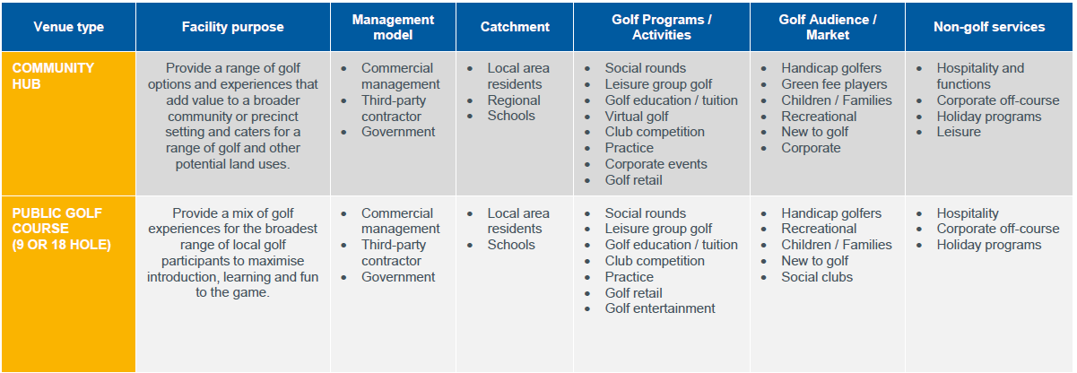

Golf Australia’s Vision 2025: The Future of Women and Girls in Golf aims to position golf as a sport where women and girls are inspired to participate, feel welcomed and nurtured throughout, and empowered to achieve their goals.
The strategy’s key initiatives aim to influence four key areas of golf: Culture & Leadership; Grassroots participation; High Performance Pathways & Coaching; and Marketing & Positioning.
Vision 2025 responds to the decreasing number of women and girls taking up golf and acknowledges the need to change how golf has historically been delivered to now address the changing needs of women and girls. Shorter formats, more social golf, and cheaper access to learning the game need to become the norm. As part of this strategy, Golf Australia has partnered with the Australian Human Rights Commission to develop Guidelines for the promotion of equal opportunity for women and girls in golf.

Golf participation in Australia
According to the AUSPLAY Golf State of Play report release in April 2019, the annual population estimate for Adults 15+ participating in Golf was 986,479 (or 4.9% of the Adult 15+ population).
Adult participation was heavily skewed towards males (797,943 or 8.0% of the male population), with males accounting for 81% of participation.

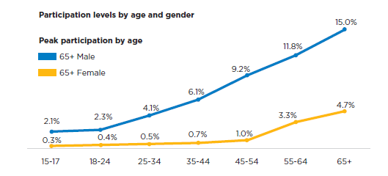

The 2019 Ausplay data highlighted that across all ages and genders the top three motivators for playing golf were:

- fun/enjoyment
- social reasons
- physical health/fitness.

The golf market of 1.16m participants comprises golfers affiliated with Golf Australia, i.e. ‘golf club playing members’ (course-based and social golf club members) and ‘casual golfers’ (non-affiliated golfers). Golf club playing members only represent 34% of the overall golfer market. The market size of the ‘casual golfer’ and ‘swung a golf club’ combined = 1.71m (over 4x the size of golf club paying members).

It is clear Australians are now participating in golf in a variety of ways, and not just on golf courses. Driving ranges, mini-golf facilities and the emerging virtual golf centres all have an important role to play in providing golf participation opportunities to a broader audience.

Local situation analysis

Who is visiting Maroondah Golf courses?

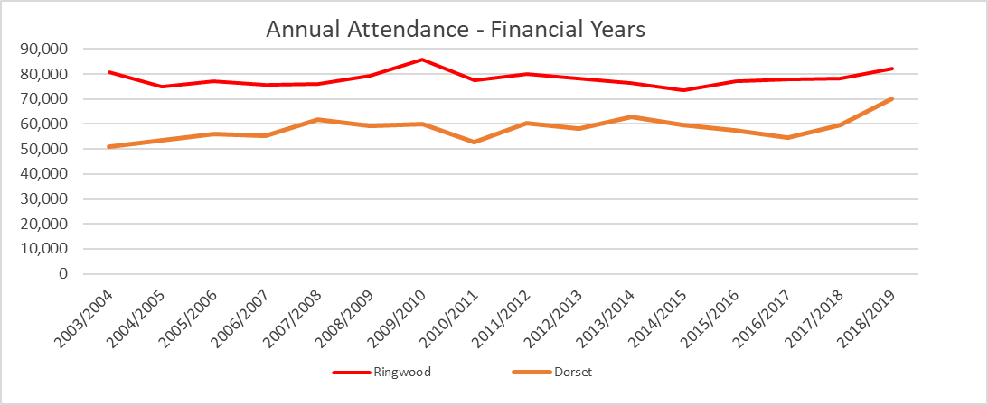

In the last two years, there has been an increase in the total attendance at both courses. Ringwood has seen an increase of 5% and Dorset Golf has increased by 28% over this period. At Ringwood Golf, attendance over the long-term - 16 years - has remained steady with the last five years experiencing growth. At Dorset Golf, attendance over the long-term -16 years - has increased significantly.

From market experience, the primary catchment for public golf facilities is within a 10km radius. Using this rationale, it is expected that 80% or more of users would reside within this catchment. Both courses are located in close proximity to neighbouring municipalities, with Dorset within 250 metres of Yarra Ranges and Ringwood located within 500 metres of Whitehorse and abutting the boundary of Knox, drawing the assumption that the catchment extends beyond Maroondah and can be considered of regional value.

This is corroborated by Maroondah Leisure member data for Ringwood and Dorset visitations in the preceding 12 months (dated May 2020). From this data, we note that the catchment was predominantly local with 79% of Maroondah Leisure members who played at either facility, living in suburbs within 10km of Ringwood Golf and 72% living within 10km of Dorset Golf.

Maroondah Leisure members
The average age of Maroondah Leisure members who attended either golf facility was 56 years of age. The breakdown of the top 30 suburbs (along with their visitation to the golf courses) is shown below:

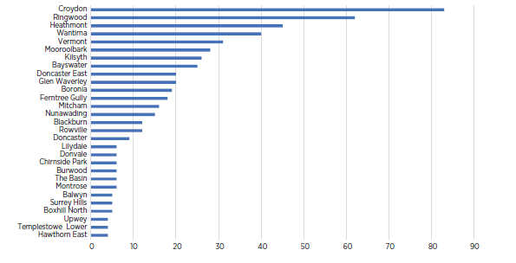

There has been a significant trend away from casual games towards Maroondah Leisure membership games. In 2015 member games made up 43% of total games played, in 2020 the member games has now grown to 60% of total games played. The yield per green fee for a membership versus casual is significantly less (65% of casual yield) than casual green fee, whilst it is expected that the yield per membership green fee is less than a casual it is important to ensure that the distribution of the membership revenue reflects what is actually occurring in the facilities.

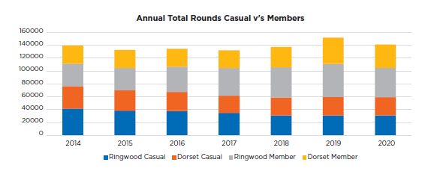

Casual visitation
The data on casual games played has highlighted the under representation of juniors playing golf. It also highlights that the shorter 9 hole option is the most popular format to play mid-week. Overall, for all days of the week, 58% of all games played are 9 hole games.

It has been identified that Maroondah Golf does not currently have the ability to capture demographic data for casual visitation. It is intended that this current reporting gap will be addressed as part of the strategy’s priority actions.

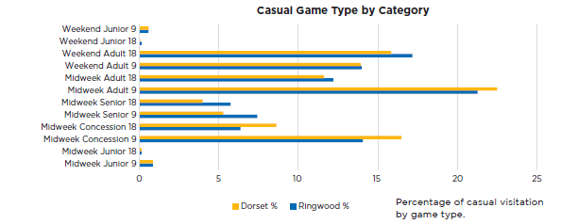

Resident clubs
At Dorset and Ringwood Golf courses, there are four resident clubs at each facility with differing playing habits. Data is not recorded on specific golf rounds played by resident clubs’ members (noting that many would be expected to hold Maroondah Leisure memberships given their frequency of attendance), however based on data provided by the resident clubs and their regular bookings, it is estimated that resident club players account for approximately:

- 18% of all rounds at Dorset (10,600 rounds per annum)
- 30% of all rounds at Ringwood (22,800 rounds per annum)

The resident clubs are clearly significant user groups and therefore represent an important stakeholder in future planning for both facilities.

Stage One review of Maroondah Golf

In 2016, Council engaged WellPlayed Golf Business Consultancy to undertake Stage One of the Maroondah Golf Strategic Review. The aim of the Review was to further understand the changing landscape in, and opportunities for golf, to ensure that the sport within Maroondah remains sustainable into the future.

Stage one of the Review included detailed site assessments of both Ringwood and Dorset Golf, an
in-depth analysis of current performance and an analysis of golf market insights and industry trends more broadly. Consultation with key user groups, Council Officers and the community was also undertaken during this stage. A Stage One report was prepared for Council in March 2019 which identified the current situation, the challenges and opportunities for the future of golf in Maroondah.

The Stage One report recommended two key strategic directions for Maroondah Golf:

- Strategic Direction 1 – Improving Sustainable Performance
- Strategic Direction 2 – Building Contemporary Experiences

Strategic Direction 1 – improving sustainable performance
Dorset and Ringwood golf courses experience high levels of golf rounds visitation, with Ringwood considered a high-volume facility and likely to be ranked amongst the busiest courses in metropolitan Melbourne.

At the time of the Stage One report, both courses had experienced a small decline in annual rounds since 2012 however this position has improved, and Council has seen a positive increase in visitation.

The Stage One report recommended that short to medium-term effort from Council be focused on improving and delivering sustainable performance via maintaining and growing golf rounds visitation and yield by implementation of the following actions:

Marketing and promotion
- Establish a system to capture customer and potential customer contact information to enable
low-cost direct marketing.
- Increase social media activation, including generating content, monitoring the posts that perform well and benchmarking of online social reach.
- Continue leveraging Maroondah Leisure’s membership database and advertising within Council’s owned media and channels.
- Promote better integration between the resident clubs at each course.
- Other complimentary activities that drive visitation to Maroondah Golf facilities and diversify its offerings should continually be explored e.g. ideas such as food-truck gatherings, community markets and live music.
Green fees and pricing
- An evolution of pricing towards a more dynamic approach that adopts principles of value-based pricing.
- A system be implemented to better track golf rounds by resident club members to maximise utilisation of the in-demand tee times typically reserved for resident club use .
Maroondah Leisure membership
- Ongoing review of the membership offer to ensure the growth of players in this category does not cannibalise higher-margin public green fee revenue.
- Revenue allocation be closely matched to actual performance (in terms of golf rounds by Maroondah Leisure members) and a reasonable internal price be allocated per-round.

Golf course
- Prioritise drainage improvements at Dorset golf course to improve cooler and wet-period conditions.

Golf retail
- Continue to improve the golf retail offer.

Finance
- Review of internal overhead charge to ensure it is accurate and reflects the true overhead costs applicable to the golf facilities.

Strategic Direction 2 – building contemporary experiences

Traditional trends within sports participation are being challenged and contemporary golf facilities are responding in innovative ways. There are many examples of golf facilities that have diversified and broadened their offerings, and successfully engaged with a wider audience.

With Council owning and operating two 18-hole golf courses, the stage one review identified opportunities to explore maintaining a ‘traditional’ golf experience at one facility and creating ‘contemporary’ and golf entertainment experiences at the other.

Evolving and diversifying Maroondah Golf’s facilities, services and experiences will increase visitation and deliver improved financial outcomes. The proposed considerations were detailed in the Stage One report, Executive summary page 4.

Some possible facilities identified in the Stage One Report for consideration in the Maroondah Golf Strategy:

- New short-format golf course
- Driving range
- Premium mini-golf
- New golf pavilion precinct
- New virtual golf lounge

Section 3 – What we did and what you told us

To support the development of the strategy, Council has undertaken two rounds of consultation. Initial key stakeholder and community engagement was undertaken by Council and Wellplayed Consultancy to inform the stage one strategic review. In March 2019, Council determined to take the recommendations of the report out to the broader community, to understand their support for the proposed elements, and gain a greater understanding of value of the two courses to the Maroondah community.

Stage One stakeholder consultation: customer and community

In November 2016, detailed research, via online and manual survey, was undertaken to better understand relevant behaviours, opinions and the facility aspirations of Maroondah Golf’s current customers and immediate local community. There were 389 respondents in total; 287 had visited either Ringwood or Dorset to play golf in the preceding 12 months.

The objectives of the survey were to obtain insights into customers’ and the local community’s current attendance activity at each Maroondah Golf facility, participation drivers, satisfaction / importance with current facilities and services, and facility and service aspirations. The Survey provided information on the following areas:

- Respondent profile  - Motivators for playing golf  - Use of competing golf facilities  - Perceptions of quality of the golf experience  - Priority mapping of features of each facility | - Golf retail behaviours  - Café visitation  - Golf round preferences 9-holes or 18-holes  - Potential facility upgrade preferences

A detailed breakdown of findings is provided in the Maroondah Golf Strategic Review, Stage One report.

Key stakeholder meetings
To develop the initial stage one report, the consultants undertook meetings with key stakeholders which included Maroondah Golf leadership team, Maroondah Golf user groups and service contractors.

The feedback from each stakeholder consultation was captured via a SWOT analysis, the combined results are listed below.

Strengths | Weaknesses
Dorset  • Course: good greens, flat land, suits all standards, more 'interesting' layout  • Operations: good availability of tee-times (less busy)  • Facilities: availability of community room and outdoor BBQ  • Setting: picturesque, adjacent to 'mountain', lakes on-course | Dorset  • Course: poor winter conditions, poor drainage  • Location: ‘back-street’, difficult to find, poor signage  • Hospitality: poor F&B offer and supporting facilities  • Market: poor perception and reputation  • Precinct: car-parking capacity is low
Ringwood  • Course: established setting, mature vegetation, consistently good condition, continued course improvements  • Hospitality: hi-quality F&B via café,  • Market: good course reputation, no nearby F&B competition, no local event spaces  • Location: premium, residential and accessible | Ringwood  • Course: mature vegetation, requires more maintenance, hilly terrain  • Operations: poor pace of play, too many user-group entitlements (tee-time dominant)  • Practice: poor facilities, no long-game area, no short-game area, small-sized putting greens  • Facilities F&B: only 1 dedicated events space (restricted size - not reaching full potential), restricted kitchen facilities  • Customer: golfers not purchasing as much F&B e.g. Ringwood GC members use clubrooms  • Precinct: car-parking capacity is low (mostly weekends)

Opportunities | Threats
Dorset  • Course: develop all-year playing conditions, improve drainage  • Facilities F&B: improve F&B offer, seating and social areas, kitchen facilities, difficult location for ‘standard’ café - create ‘destination’ offer e.g. micro-brewery, challenging to create functions/events areas (view to vegetation not ‘sweeping’)  • Customer: promote better integration b/w clubs e.g. group tournament and matches  • Market: increase advertising and awareness  • Community: improve engagement, create community hub, increase community 'space'  • Programs: develop junior golfers | Dorset  • Course: poor winter conditions  • Facilities: not providing a contemporary F&B offer  • Competition: from driving ranges, member-based clubs (competing for public players), more challenging golf courses
Ringwood  • Course: continue drainage program  • Golf shop: improve layout, create golf-feel and create repairs workshop adjacent  • Functions: "clearly demand" for increased functions & events e.g. weddings 140-170pax  • Facilities golf: upgrade indoor coaching facilities (carpet and paint), create outdoor teaching area (driving range), improve short-game practice area and putting green, create high-quality short-game practice area  • Facilities F&B: create flexible space and diversify F&B revenue (cafe, bar and functions)  • Facilities F&B: enhanced kitchen facilities - wider offer - more pax  • Facilities events: lawn area (function pad) for outdoor events e.g. outdoor cinema  • Facilities: create golf & community hub (location, location, location...)  • Club: improved clubrooms e.g. promote functions, create outdoor deck with views and encourage community use e.g. multi-purpose space  • Marketing: encourage off-peak play  • Market: engage with young families and other diverse community groups | Ringwood  • Course: constrained property e.g. fairways, creek, houses and boundaries  • Club: membership decline  • Competition F&B: Ringwood GC - biggest competition for on-site café  Maroondah Golf  • Trends: less-time, ageing population, diminishing golf relevance, not engaging with younger audience  • Participation: declining kids interest in golf (no junior program), perceived to be expensive, perceived lack of ‘time’  • People: maintaining quality leadership, management and staff

Strategy development community engagement program

From 10 November 2019 to 26 January 2020, Council undertook a comprehensive community engagement program to understand the views of our community in relation to the stage one report and their views on the consideration of other potential uses including basketball and soccer.

Engagement was undertaken with key stakeholders, surrounding residents and the wider community. The findings from this engagement program have been developed into a consultation report which together with the Stage One Maroondah Strategic Golf Review, have been utilised to inform the development of the Maroondah Golf Strategy 2020 - 2030.

A mix of qualitative and quantitative processes were used to gauge the level of support on proposed key elements identified in the stage one report. Surveys, community drop-in sessions and meetings with key users and residents, were provided to ensure the views of our community were captured.

Overall results:
- A total of 1,125 submissions were received online and in hardcopy
- 53 submissions were received via email
- 4 petitions were received containing 76, 207, 371 and 67 signatures.

Community feedback key themes:

Positives of Maroondah Golf
- Ringwood and Dorset Golf courses are viewed as among the best in Victoria
- Recent upgrades and maintenance of the facilities has been excellent
- Both courses provide valuable open space for the community
- Both courses support healthy, active ageing for senior members of the community
- Golf provides substantial health and wellbeing benefits to participants.

Suggestions to improve Maroondah Golf
- Café improvements/expansion
- Implement an on-line booking system
- Improve parking and local traffic management at existing courses
- Redevelop parts of the courses for water sensitive and urban design elements
- Do not consider Maroondah Golf facilities for the expansion of basketball and soccer.

Community concerns with the Stage One report and proposals
- Changes could negatively impact the health and wellbeing of seniors
- The stage one report did not reflect the true picture of golf participation at both courses
- Changes could see members go elsewhere to play
- Loss of open space for Maroondah
- Impacts to wildlife and habitat
- Mini golf and virtual golf are over represented in Maroondah
- Driving range has previously featured at Dorset Golf
- Sports such as soccer and basketball are over represented in Maroondah
- Proposed changes would result in traffic congestion for local street.
Overall community feedback
- Strong support for Council to maintain two 18-hole golf courses
- Support for café improvements
- That most of the proposed contemporary elements were not supported
- Multipurpose function rooms and space for community scored closely in the levels of support as compared to other proposed key elements.
- Changes to golf to accommodate growing demands in basketball, soccer and/or other sports were not supported, based on the impact on the courses.

Section 4: A plan for a sustainable future

Where we want to be

The vision for the Strategy aligns with a number of key directions outlined in the Maroondah 2040 Community Vision relating to physical and mental health, the provision and preservation of open space, and the provision of active recreation opportunities that meet the needs of all ages, abilities and genders.
Our vision:
Maroondah Golf will continue to evolve and improve its offering to the community to ensure that Golf remains sustainable and appeals to a diverse demographic.

Planning principles

The planning of all new programs, initiatives and expenditure will be underpinned by the following key principles:

- Achieve an operating surplus greater than capital expenditure requirements and sufficient to mitigate risks that may hinder financial performance.

- Set operating targets and report annually to the community.

- Continue to monitor usage, evaluate and evolve to meet the changing community needs.

Council will utilise these principles to guide future strategic planning to achieve the overarching performance target.

Should ongoing performance monitoring and analysis highlight a significant deviation from this, then further review will be required to consider the long-term viability associated with the retention of two 18-hole golf courses, at least in their current form.
.
Planning Framework

To support the delivery of Maroondah Golf’s vision, a planning framework has been developed which encompasses the three principles, financial sustainability target and four focus areas under which the key directions and priority actions have been categorised.

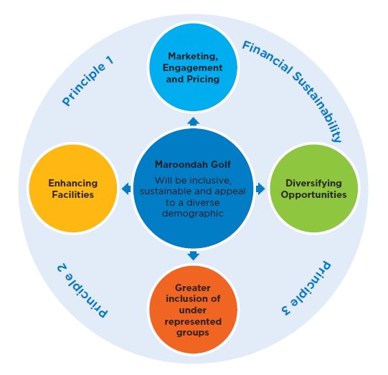

What have we done?

Since the development of the Stage One report, Council has commenced the identification and planning associated with a number of new initiatives and projects with a focus on improving the sustainable performance. These initiatives and projects are directly related to the Maroondah Golf Review Stage One report ‘Strategic Direction 1 - Improving sustainable performance and Council’s Business planning process’.

It was identified that there was potential to improve the net financial position of Maroondah Golf, within the following focus areas:

- Growing golf rounds and visitation
- Marketing and promotion
- Capital expenditure
- Maroondah Leisure Membership offer and income distribution.
- Secondary spending.

To date, some of these initiatives have been able to be implemented to address the focus areas identified and to contribute towards improving the financial performance of Maroondah Golf. Initiatives have included the development of a draft 10-year financial plan (refer table below) that provides a net positive position, based on:

- Offering golf carts for hire
- Improvements to the retail offer
- Introduction of clinics for juniors, ladies and schools
- Renegotiated golf coaching service agreements;
- Review of Maroondah Leisure membership income distribution
- Annual marketing and customer engagement plan development
- The purchase online booking software (to be implemented spring 2020).

The new initiatives will require continual review to ensure the desired targets are achieved.

Due to the impact inclement weather can have on income at the golf facilities it was important to understand what this means for the ongoing financial sustainability.

Modelling on a 5% reduction (blue line below in the graph) in income scenario has been included in the table to highlight the financial impact this could have in any given year. As can be seen in the graph the projected trend/target is for operational surplus to increase gradually over time, that will ensure any additional capital improvement expenditure is funded to support program and income diversification, without a negative impact on the net financial position (and without requiring community subsidy).

Both Ringwood and Dorset Golf are currently in a favourable position in relation to course conditions due to the investment by Council over the past 15 years into the capital improvement program.

Both courses have reaped the benefits of this long term investment and are now in a position to investigate opportunities to diversify the business to look at new opportunities and reduce the level of capital investment to ensure the net financial position remains positive without having a detrimental impact on the course conditions and customer experience.

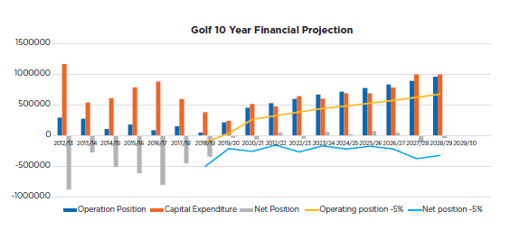

The way forward

Focus area 1: enhancing facilities

Outcome description
Council will develop an evidenced-based facility plan which aligns with Golf Australia recommendations, Council strategic planning and community feedback, to prioritise facility maintenance and enhancement over the next 10 years. Enhancement proposals will increase visitation and/ or user experience and demonstrate positive financial return to Council.

What the evidence tells us

In relation to Maroondah Golf needs, the Stage One report and community consultation highlighted the following facility improvement priorities:

Dorset Golf
- Car-parking: increase number of car-parks.
- Golf building: improve facilities to allow for improved facilities for community groups to promote a social community hub, improved food and beverage, retail and golf coaching.
- Golf course: improve playing conditions in winter with improved fairway drainage and cart path network.
- Practice range: potential better use of land area.

Ringwood Golf

- Golf building: create a new and larger multi-use golf pavilion and precinct.
- Golf course: continue with course upgrades and drainage improvements.
- Precinct car parking.
- Provision for potential future expansion of The Rings.
- Practice range: potential better use of land area.
- Bike/pedestrian connections: create improved connections; consider connection to Dandenong Creek Trail through the golf course.

What the community has told us

With over 1,182 responses and submissions to the stage one report, there is a clear indication that the Maroondah Community support and value Maroondah Golf’s two public golf facilities.

The community was supportive of measures to enhance the quality and offerings at the two courses however there was limited support for these measures should they impact the existing 18 hole course format or the current provision of open space. Improvements to course drainage at Dorset had the highest preference rating and a new café at Dorset was also well supported. Increasing and enhancing car parking facilities at both courses was also highlighted as a priority.

Your Say Maroondah sample of feedback:

“I would not like to see a reduction in holes at either of Maroondah's 2 golf courses. With the increased density of housing and retail/commercial development in Maroondah the preservation of green spaces is vital for health of the whole community, not just golfers.”

“I would like to see the accessibility via non-car methods improved - e.g. ride/walk path access, and public transport options.”

“I would like to see better warm up facilities at Ringwood. If that is better nets or a driving range, it would prevent less chance for injuries during game play.”

“Modernisation of the golfing experience to include driving ranges and better cafe would be welcomed.”

“Parking is a major issue in Trawalla Road and need to be addressed, especially on weekends and special golf days.”

Key directions

Ensure that facility planning and priorities for Maroondah Golf align with both Golf Australia facility guidelines and Council’s strategic priorities.

Use research and consultation data to guide the development of an overarching golf facilities master plan which will inform a long-term capital expenditure program. The Plan will ensure the facilities remain relevant, functional and provide financial sustainability through diverse offerings.

Priority actions

  - Develop a Maroondah Golf facilities master plan that demonstrates both social and financial positive outcomes for Council and community and considers modification to part of Ringwood, without reducing the number of holes, to accommodate a possible future expansion of The Rings

  - Develop feasibility study and comprehensive business case/s to support master plans

  - Develop a long-term (10+ years) capital expenditure program.

Indicators of progress

- Master plan is developed and endorsed by Council by Dec 2021
- 10 year capital expenditure program developed and endorsed by Council
- Financial modelling developed to demonstrate financial sustainability over next 10 years.

Focus area 2: marketing, engagement and pricing

Outcome description

Council will improve data capture methodologies and continue to engage with both users and
non-users to understand visitation and improve marketing potential to a wider demographic. A regular review of pricing logic will be undertaken to ensure that prices remain accessible and encourage participation while ensuring the continued viability of products and services.

What the evidence tells us

Marketing and engagement

The Maroondah Golf Strategy Stage One report detailed in section two, recommended actions in relation to improved data collection, enhanced marketing and customer engagement.

Pricing

The Maroondah Golf Strategy Stage One Report stated that both Dorset and Ringwood Golf operate with a traditional ‘rack-rate’ approach where green fees are set annually by Council and adjusted for midweek/weekend days. The report recommended an evolution of pricing towards a more dynamic approach that enables management to vary prices to better target the different value that customers place on tee-times.

In 2018, Council undertook a review of Maroondah Leisure pricing frameworks and processes developing a policy position for consistent future pricing decisions across Maroondah Leisure. The situation analysis report reaffirmed the Stage One report recommendation of a move to a dynamic pricing model.

In response to these recommendations the Maroondah Leisure Pricing Policy (2018) includes the following pricing principle:
Where relevant, a scale of different price options / dynamic pricing will be made available, considering customer needs and market orientation.

What the community has told us
Many Maroondah Leisure members acknowledged their support for the ability to package golf with the facilities of Aquanation and / or Aquahub and recognised the quality and affordability of the Maroondah Golf offering in comparison to private providers.

The Stage One Consultation Report highlighted that Dorset stakeholders felt that a weakness of the facility was its poor perception and reputation and reflected that the location of the Dorset facility was ‘back-street’, difficult to find and had poor signage.

Your Say Maroondah sample of feedback:

“Playing 9 holes golf is becoming more popular. There is a large number of people that do not have the time available to play 18 holes and are unaware that the 9 hole game is available. Both Golf courses are currently set up to facilitate this format.”

“Schools could be offered a discounted rate for classes to play mid-week.”

“Online golf booking would be a welcome addition for members with 7 days advance booking format.”

“Make the 9 holes after 4pm less cost - will increase players.”

“Golf courses can be great community spaces. Allowing maybe afternoons when normally quiet where people can play outside of normal rules i.e. 4 people only. Selling summer only memberships. Many things can be done to attract more people that may not see themselves as golfers.”

Key directions

  - Ensure the continued engagement with both users and non-users to improve marketing potential to a wider demographic.

  - Utilise a planned evolution of pricing towards a more dynamic approach that adopts principles of value-based pricing.

  - Enhance stakeholder communication and engagement through the ongoing review and refinement of staff training, website content and external partnerships.

Utilise data and engagement feedback to inform a strategic marketing approach.

Priority actions

  - Implement online booking platform that captures customer data and has the functionality to provide dynamic pricing

  - Implement a system to capture customer and potential customer contact information

  - Develop and regularly review a golf marketing plan to ensure it is relevant and engaging

  - Analyse data to identify opportunities to maximise yield through a demand based pricing structure

  - Benchmark, review and set pricing to ensure competitive neutrality principles are met

  - Review membership offering to ensure offerings are relevant and maximum yield is achieved

  - Develop a stakeholder engagement framework to ensure a consistent process for communication and collaboration with residing golf groups and external partners.

Indicators of progress

- Customer database of 3,000 by 2022

- Online bookings available by 2021

- Dynamic pricing in place by 2021

- Continual increase in Yield per green fee has increased

- Review of membership offer has been completed end of 2020

- Golf financial position is positive.

Focus area 3: diversifying opportunities

Outcome description

Council will expand its golf programs, to meet the interest and needs of a wider demographic and to experience a sustained increase in overall visitation. Diversifying opportunities will not be limited to just traditional golf and will look at exploring other innovative ways to maximise use of facilities.

What the evidence tells us

The global golf narrative suggests that there is increasing demand for the introduction of contemporary elements to golf to attract a more diverse demographic.

While initiatives proposed through the Maroondah Strategic Golf Review stage one consultation were not well supported by the Maroondah community, visitation data confirms that the current golf offering has a narrow market and that the provision of different options will expand the level of interest from a wider demographic.

Golf Australia’s National Facilities Plan states that in order to grow the game, there is an identified need to focus on different market segments and to ensure golf’s “places to play” are aligned to the needs of these markets. Golf facilities must provide a diverse range of offerings within inclusive and welcoming environments. This is of particular importance for women and children who are currently under-represented in golf at 20% and 3.5% of club membership respectively.

Additionally, in recent years, Ringwood Golf has partnered with other internal and external stakeholders to utilise the course facilities for broader events such as Maroondah Night Run and a Movie Night under the stars. These and other events have enabled the facilities to be enjoyed by a new cohort that may never have previously visited the course.

The Maroondah Strategic Review Stage One report summarised six key challenges and opportunities for the contemporary golf facility, three of these relate to the diversification of services and facilities.

- Golf facilities must be market-focused and adapt to stay relevant to succeed in today's changing sport, recreation and leisure market.
- Golf facilities should focus less on competition golf and introduce social, short-format and other golf-entertainment participation options.
- Evolving and diversifying Maroondah Golf’s facilities, services and experiences will increase visitation and deliver improved financial outcomes.

Council’s 2015 -2020 Physical Activity Strategy reported lack of time as the primary reason given by Maroondah residents that they do not undertake enough regular physical activity or are as active as they would like to be.

The strategy proceeds to advise that sports need to be aware that there is a shift in the motivation for people to play sport, and to embrace new ways of delivering sport to those who want to be involved. Increased participation should be encouraged through an emphasis on social opportunities, casual visitation and the availability of modified and /or non-competitive options.

What the community has told us

The stage one report was presented to the community for feedback as well as a series of questions relating to the key recommendations.

The consultation report highlighted that the community did not support the suggested contemporary golf entertainment innovations and of particular concern was the reduction of holes from the existing 18 hole format to accommodate the proposed contemporary elements. Respondents to the survey were predominantly current golf participants and/ or neighbouring communities who were seeking to preserve their local open space.

This feedback can be used as evidence that there is no need to make modifications or enhancements to programs and facilities to increase their access and inclusion however change is required to diversify the programs/facilities offered.

Your Say Maroondah sample of feedback:

“A program should be set up to encourage younger people to get involved with golf.”

“For post war baby boomers in particular a 9 hole casual competition would greatly aid increased participation much like the shorter T20 cricket competition.”

“Golf needs to be more accessible to the young and the time poor. Providing facilities that cater for the whole family for 2-3 hours and enable all abilities to improve their games.”

“I aim to play more golf in the future but at this stage I do not have enough time. A driving range would be good to be able to participate in golf but without using up too much time.”

“Council should consider operational measures to better utilise the existing holes (e.g. more bookings, improved speed of play, offering rounds of 6 holes).”

“As a beginner it’s intimidating to play a social game knowing more experienced players will need to come through. Some designated times for beginners would be great - as would a driving range at the courses.”

“Adding disc golf which can co-exist alongside ball golf is a great way to increase usage and reach a younger more casual audience as well as schools and scouts in the area.”

Key directions

Keep abreast of industry challenges, trends and successful innovations and continue to review service delivery methods to optimise customer experience and visitation.

Continue to ‘think outside the square’ and foster innovative partnerships and opportunities

Seek to understand the needs, interests and motivations of Maroondah residents to ensure that golf has the ability to cater for a wide catchment.

Priority actions

  - Identify and implement programs and services that diversify participation and income generation.

  - Investigate opportunities with complimentary businesses and services that would assist in providing new and diverse revenue

  - Explore the feasibility of implementing Mini Golf at either course.

Indicators of progress

- Revenue generation is more diverse and reliable
- Revenue increase beyond fee price increase
- Increased range of programs and service delivery options which cater to different markets.

Focus area 4: greater inclusion of underrepresented groups

Outcome description

Council will engage with women, children, the CALD community and people with disabilities to prioritise the continued improvement of golf facilities to meet their needs and to undertake programs and initiatives which will increase their participation in the sport of golf. Furthermore, Council will support the resident golf clubs to increase opportunities for underrepresented groups and advance gender equality in club governance.

What the evidence tells us

In 2019, Maroondah Council endorsed the Equally Active Policy which endorsed Council’s position in relation to creating supportive environments and inclusive opportunities to support women and girls to be more physically active. Women and girls are less active than men and boys particularly in organised sports. In the latest AUSPLAY national golf participation data, males account for 81% of golf participation (Sport Aus, AUSPLAY Golf State of Play Report April 2019).

Fear of judgment of appearance, ability and/or priorities and cost are a major inhibitor to women undertaking sport. Providing a greater diversity of low cost golf programs to support participants new to the sport to learn and gain confidence in playing golf will greatly assist their increased participation. Additionally, focussed marketing to women and girls and increased use of diversity in promotional imagery will assist in visitation.

Learn to play programs such as MyGolf have seen proven success in increasing participation. Ringwood and Dorset have both recently introduced the term based Junior Golf Program, MyGolf which has seen a steady increase in enrolments since its inception. The cost for the weekly sessions equates to less than $20 per lesson which is an equivalent hourly rate to many sports including the Council’s very popular learn to swim and gymnastics programs. Targeted marketing for the MyGolf program can assist in improving the perception that golf is an expensive extracurricular activity.

In 2019, Golf Australia partnered with Play by The Rules to develop a Clubs and Facilities Action Plan. The plan encourages facilities to engage members and the local community in golf participation programs as an effective way to retain the enthusiasm of existing members and to attract new participants and, in particular, those who are marginalised. Golf Australia has a number of programs designed to increase participation in golf and the Action Plan outlines an inclusion framework to review, adapt or modify facilities, programs and services to increase access and inclusion.

Council’s Physical Activity Strategy 2015 - 2020 and Disability Action Plan 2019-2021 have actions relating to considering inclusion and accessibility requirements to create active participation opportunities for the inclusion of people with a disability. The recent Inclusion Action Plan will provide guidance to Maroondah Golf in achieving this action.

Maroondah Golf have recognised the need to provide a range of program options to support beginner adults or for those returning from a long hiatus. Both, Ringwood and Dorset Golf have commenced monthly beginner clinics which they intend to review and expand.

What the community has told us

Council’s Maroondah 2040 Community Vision captures the aspirations and priorities of the community looking ahead to the year 2040 and beyond. The document articulates that there is a strong desire to ensure vulnerable groups have access to services and pathways that meet their needs. Responding to our changing demographic is a crucial issue for the future as well as ensuring that Maroondah evolves as a City that is friendly and accessible for all ages and backgrounds.

Your Say Maroondah sample of feedback:

“Most female golf activities are during the week which does not cater for those women that work.”

“Try encouraging more women into golf.”

“I feel more emphasis should be placed on encouraging more juniors to play. A person can then play golf forever whereas players have a limited window of time for soccer and basketball due to age and more risk of injuries.”

“We need to have schools golf programs to encourage younger golfers.”

“I would recommend that council consider purchasing a couple of paragolfers like Sandhurst Golf Club to promote those with disabilities playing golf or at least having the opportunity to see if they would like to do it.”

Key directions

Partner with Golf Australia, allied health agencies, CALD groups and individuals from underrepresented community cohorts to understand their specific needs in facility program and marketing design and delivery.

Utilise Golf Australia inclusion resources, Council’s Disability Action Plan and Equally Active Strategy to inform initiatives to include and support Maroondah’s marginalised communities to play golf

Priority actions

  - Capture and analyse participation data to identify under represented segments of the community

  - Develop an engagement strategy to consult with underrepresented groups, to plan for the provision of facilities, programs and engagement activities to meet their needs and promote ongoing participation

  - Develop facilities to ensure they cater for and are more appealing to underrepresented segments of the community

  - Implement Golf Australia programs and other initiatives to target underrepresented segments of the community

  - Develop a participation plan that address underrepresented segments of the community and ensures financial sustainability.

Indicators of progress

Participation plan developed by August 2021 and 6 monthly reporting plan implemented.

Implement and review a minimum two initiatives per annum to address identified barriers to participation and / or targeted programming to increase the inclusion and participation of underrepresented groups.

Diverse representation in marketing and promotional imagery.

Tracking our progress

Implementation process

The Maroondah Golf Strategy forms part of Council’s response to delivering on Maroondah 2040: Our future together. It will have a staged implementation with further research and master planning required to inform future actions. The Strategy identifies key priority actions which support the overall vision for Maroondah Golf to continue to evolve and improve its offering to the community while remaining sustainable.

It is anticipated that additional priority actions and projects may be identified over time which will also support this vision and the changing needs of the Maroondah community.

An Implementation Plan will be developed to accompany an adopted Maroondah Golf Strategy. This Plan will establish timeframes and outline the resources required to deliver the actions in the Strategy.

Actions will be prioritised taking into account further research and planning required, cost effectiveness and the ability to deliver within timeframes. The Plan will address each of the focus areas and provide details regarding how and when Council will deliver on each of the priority actions.

Priority Action | Priority | Indicative Completion
Focus Area 1 - Enhancing Facilities

1.1 Develop a Maroondah Golf facilities master plan that demonstrates both social and financial positive outcomes for Council and community. | HIGH | Dec. 2021
1.2 Develop feasibility study and comprehensive business case/s to support master plan | HIGH | Continuing
1.3 Develop long term (10+years) capital expenditure program | HIGH | Feb. 2021
Focus Area 2 - Marketing, Engagement & Pricing

2.1 Implement a system to capture customer and potential customer contact information | HIGH | Dec 2020
2.2 Develop and regularly review a golf marketing plan to ensure it is relevant and engaging | MEDIUM | Apr 2021
2.3 Implement online booking platform that captures customer data and has the functionality to provide dynamic pricing | HIGH | Sep 2020
2.4 Analyse data to identify opportunities to maximise yield through a demand based pricing structure | HIGH | Ongoing
2.5 Benchmark, review and set pricing to ensure competitive neutrality principles are met. | HIGH | Ongoing
2.6. Review membership offering to ensure offerings are relevant and maximum yield is achieved | HIGH | Dec 2020
2.7 Develop a stakeholder engagement framework to ensure a consistent process for communication and collaboration with residing golf groups and external partners | MEDIUM | Feb 2022
Focus Area 3 - Diversifying Opportunities

3.1 Identify and implement programs and services that diversify participation and income generation. | HIGH | Jun 2021
3.2 Investigate opportunities with complimentary businesses and services that would assist in providing new and diverse revenue | MEDIUM | Dec 2021
3.3 Explore the feasibility of mini golf. | MEDIUM | 2022
Focus Area 4 - Greater Inclusion of underrepresented groups

4.1 Capture and analyse participation data to identify under represented segments of the community | MEDIUM | Jun 2021
4.2 Develop an engagement strategy to consult with unrepresented groups, to plan for the provision of facilities, programs and engagement activities to meet their needs and promote ongoing participation | HIGH | Dec 2021
4.3 Develop facilities to ensure they cater for and are more appealing to under represented segments of the community | MEDIUM | Dec 2022
4.4 Implement Golf Australia programs and other initiatives to target underrepresented groups. | MEDIUM | Jun 2021
4.5 Develop a participation plan that addresses under represented segments of the community and ensures financial sustainability | HIGH | Jun 2021

Monitoring and reporting

The specific priority actions and projects outlined in this strategy will be monitored as they are implemented and reported to Council on an annual basis in an Annual State of Play report. Council will continue work with key stakeholders and local communities in helping to shape the enhancement of Maroondah Golf and in the implementation of the priority actions outlined in this strategy.

Section 5: references

Australian Human Rights Commission (2019) Guidelines for the promotion of equal opportunity for women and girls in golf.
Australian Sports Commission, (2017). Women and Girls Participation - AusPlay Focus
Golf Australia (2018) Growing the Game of Golf In Australia 2018-2021
Golf Australia (2020) National Facilities Plan
Golf Australia (2018) Vision 2025: The Future of Women and Girls in Golf
Maroondah City Council (2019) Equally Active Strategy
Maroondah City Council (2014) Maroondah 2040 Community Vision
Maroondah City Council (2019) Maroondah Golf Strategic Review Consultation Report
Maroondah City Council (2018) Maroondah Leisure Pricing Policy
Maroondah City Council (2018) Maroondah Leisure Pricing Situation Analysis
Maroondah City Council (2015) Physical Activity Strategy 2015 - 2020
R&A (2017) Golf around the World 2017
Sport Australia (2019) AUSPLAY Golf State of Play Report April 2019
Play By The Rules (2019) Golf Australia - Clubs & Facilities Inclusion Action Plan
VicHealth (2019) Females and physical activity: What the research shows
Victorian Government (2015) Inquiry into Women and Girls in Sport and Active Recreation
WellPlayed (2019) Maroondah City Council - Maroondah Golf Strategic Review, Stage One report
Yarra Ranges Council (2018) Creating a Place for Women in Sport Gender equity self- assessment tool.

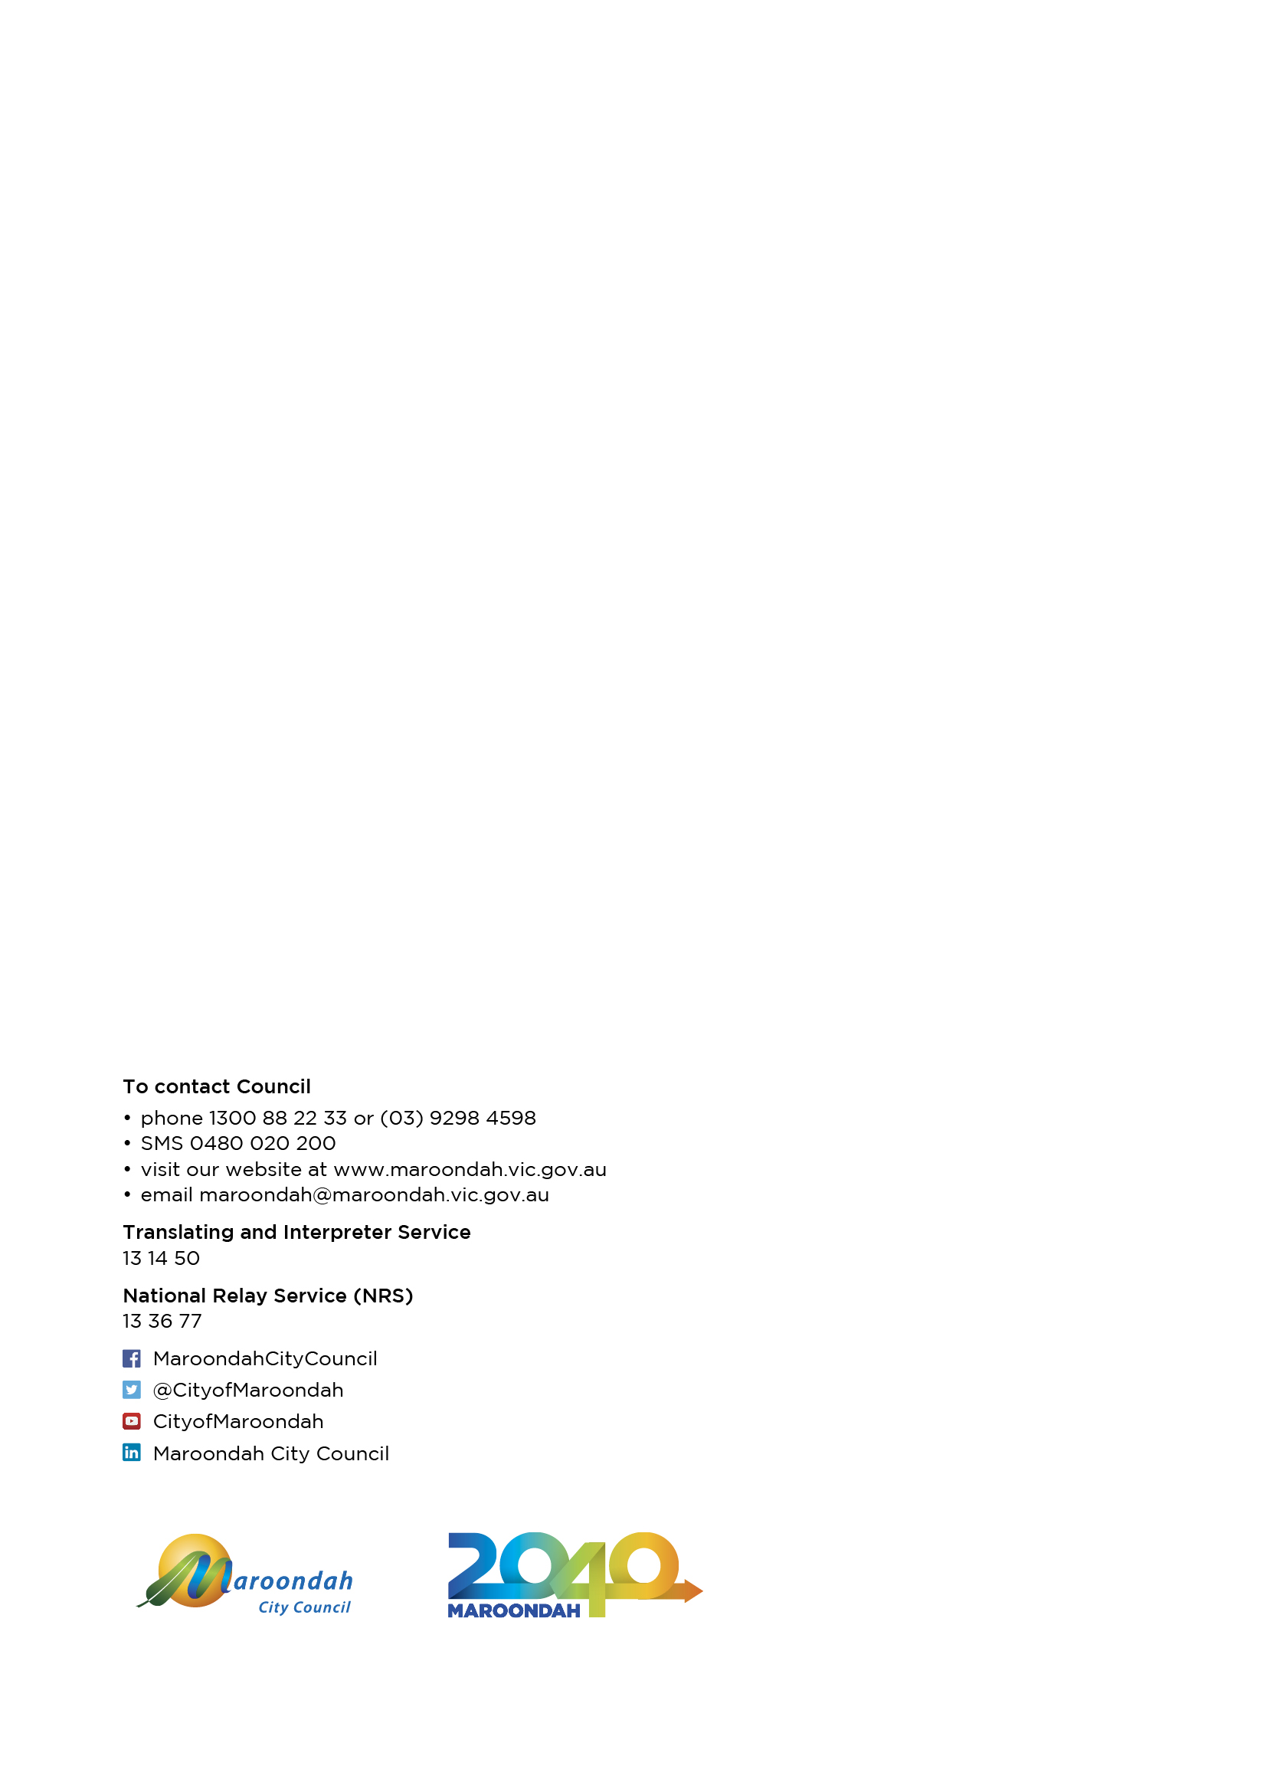

Sport Australia (2019) AUSPLAY Golf State of play report April 2019
Population and household forecasts, 2016 to 2041, prepared by .id , June 2019.
Golf Australia (2020) National Golf Facilities Plan
R&A (2017) Golf Around the World 2017
Golf Australia (2018) Growing the Game of Golf In Australia 2018-2021
Golf Australia (2020) National Facilities Plan
Golf Australia (2018) Vision 2025: The Future of Women and Girls in Golf
Sport Australia (2019) AUSPLAY Golf State of play report April 2019
Wembley Golf Course - Source: https://aussiegolfer.com.au/are-these-the-15-best-mini-golf-courses-in-australia/
Wembley Golf Course Source: https://www.mondoluce.com.au/projects/civic/wembley-mini-golf/
Maroondah City Council (2014) Maroondah 2040 Community Vision
Maroondah City Council (2019) Maroondah Golf Strategic Review Consultation Report
Golf Australia (2020) National Facilities Plan
VicHealth (2019) Females and Physical Activity -What the research shows
Play By The Rules (2019) Golf Australia - Clubs & Facilities Inclusion Action Plan
Maroondah City Council (2014) Maroondah 2040 Community Vision

