Maroondah Housing Strategy 2016
A Summary

# Introduction

Access to housing is a key attribute that affects almost every aspect of a person’s life. Access to suitable accommodation not only offers shelter and security, it provides a stable foundation and space from which to build family life and a sense of belonging. It also acts as a springboard to developing other aspects of people’s lives, including access to education and employment.

The City of Maroondah covers a land area of 61.4 square kilometres in Melbourne’s outer east, 22 kilometres from the Central Business District. Maroondah has the strategic advantage of being located at the north-eastern junction of the Eastern Freeway – EastLink corridor. There are two train lines and a large number of bus routes linking the City with other region

The *Maroondah Housing Strategy 2016* was formally adopted by Council on 27 June 2016. The Strategy establishes future policy directions and will guide future residential development to protect and enhance the places we live. It has been developed to ensure that the municipality will meet its housing requirements through to the year 2040 and beyond.

The Strategy also supports the delivery of the Maroondah 2040 Community Vision, as articulated in *Maroondah 2040: Our future together*. It outlines a vision for housing in Maroondah that will assist Council to continue enhancing the liveability of our community.

The *Maroondah Housing Strategy 2016* updates the previous *1997 Maroondah Housing Strategy* and responds to the latest social, economic and environmental trends and aspirations of the community.

# Why a Housing Strategy?

The landscape of Maroondah and the challenges we face today have changed dramatically since the last Housing Strategy was developed in 1997. The existing *1997 Maroondah Housing Strategy* was successful in directing residential developments in the municipality, however, it is important that Council’s directions relating to housing are updated to reflect changing community needs and aspirations.

A variety of factors have led to a review and update of the strategy:

* Significant development projects have made Maroondah a more accessible and desirable place to live and work;
* We are growing older and the number of people living in a household is becoming smaller;
* Housing has become more expensive making it difficult for some people to remain in the municipality, and
* There is a need to respond to housing issues that were identified in *Maroondah 2040: Our future together*, the long-term community vision for the municipality.

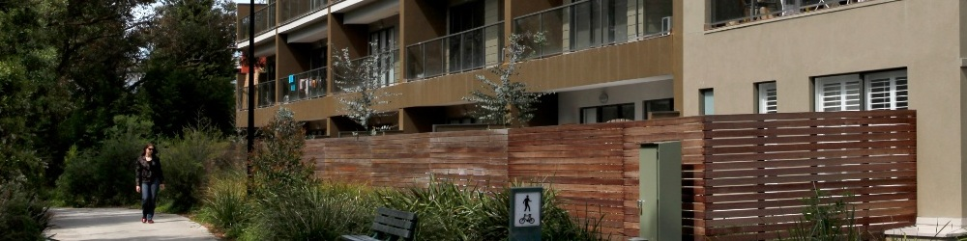

# How has the strategy been developed?

The Maroondah Housing Strategy was developed on the basis of inputs from Maroondah residents and businesses, technical experts. The process involved a number of stages which are outlined below.

### Stage 1 – Building an evidence base

The first stage of the process involved project scoping and the preparation of a number of background technical reports designed to build an evidence base for decision making. These reports were peer reviewed and used to inform the Strategy.

### Stage 2 - Seeking input from the community and stakeholders

The second stage involved a range of community engagement activities to seek the views of community and key stakeholders on housing needs, services and facilities, housing issues and ways to address these issues.

### Stage 3 - Considering key issues and options

The third stage of the process involved the preparation of an Issues and Options Paper, based on the technical evidence as well as community and industry inputs. The Issues and Options Paper summarised the evidence and laid out the key issues arising out of the background research and community consultations.

### Stage 4 - Developing a Maroondah Housing Strategy

Development of the draft Maroondah Housing Strategy was the fourth stage of the project. The draft Strategy was been prepared based on the preferred options identified in the Issues and Options Paper.

### Stage 5 – Implementing the Maroondah Housing Strategy

The final stage of the process will involve the preparation of a planning scheme amendment to ensure relevant strategy key directions and priority actions are included in the Maroondah Planning Scheme.

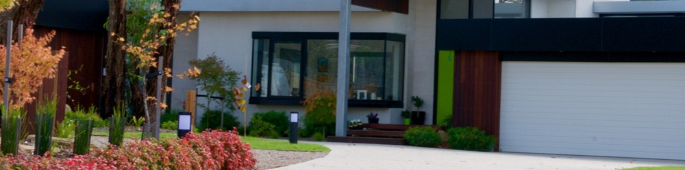

# What did the research tell us?

As a part of the first stage of the preparation of the Housing Strategy, a number of background research studies were completed.

### Housing Supply Analysis – Charter Keck Cramer, May 2015

This paper outlined new housing development activity and identified its spatial distribution across Maroondah. The report also examined the types of housing being developed, pricing dynamics, purchaser profiles, and time required to bring new housing to the market. It made a number of recommendations relating to monitoring of the housing market, the merit of infill development near smaller activity centres, and the role of Council land in providing housing.

### Housing Demand Study – Maroondah, Spatial Economics, May 2015

This study identified housing market areas in Maroondah based on a range of factors. It set out population projections and examined their implications on housing demand. The study concluded that the municipality will have a requirement for approximately 500 dwellings per annum or a total of 14,970 dwellings between 2011 and 2041, with a greater proportion of future development taking place in designated activity centres.

### Sustainable Communities Discussion Paper – Maroondah City Council, 2015

This paper examined current trends towards more liveable and sustainable communities. It examined relevant case studies and made recommendations for consideration in the housing strategy. The paper recommended a focus on how to make Maroondah’s housing stock more sustainable to improve both resilience and liveability.

### Maroondah Municipal Housing Strategy 1997 Review – Maroondah City Council 2014

This paper considered the existing Housing Strategy 1997 strategy and assessed the extent to which it achieved its objectives. While the strategy underestimated future population growth and issues such as affordability and housing insecurity still persist, a range of measures, such as overlays and other strategies were successfully introduced to address the issues identified.

### Maroondah Housing Strategy Housing and Environmental Sensitivities Paper – Maroondah City Council, May 2015

This paper described and analysed potential environmental sensitivities and impacts, with a view to protecting the environment as well as enhancing residential amenity. The paper identified issues including neighbourhood character, ridgelines, views, flooding, water quality, trees and natural habitat, heritage, cultural sensitivity, contaminated land and climate proofing.

### Physical and Community Infrastructure Background Paper – Maroondah City Council, May 2015

This paper incorporated a high level analysis of the existing state and performance of Maroondah’s infrastructure across 12 networks, including electricity, gas, potable water, waste water, stormwater, rail, buses, roads, pathways and trails, national broadband network, education and open space. The paper acknowledges that the city’s infrastructure networks are expected to come under increasing pressure as a result of population increase and climate change over the coming decades.

### Opportunities for Residential Development Report – Maroondah City Council & Swinburne University, February 2016

This report provided a snapshot of current housing capacity throughout the municipality. A range of factors were considered in determining capacity, including market pressures, age of existing buildings, average new lot sizes, as well as minimum lot sizes applicable due to zoning requirements. Once a theoretical maximum capacity was calculated, the likelihood of lots being developed was considered to arrive at a final capacity figure. The capacity analysis confirmed that there is sufficient zoned land available to cater for current demand.

# What did the community tell us?

From October to December 2015, Council focused on creating a dialogue with the local community and key stakeholders on a range of topics including:

* Current and future housing needs
* Housing issues and how they can be addressed
* Priority community infrastructure and services
* A ‘greening the greyfields’ pilot project (being undertaken in conjunction with Swinburne University)

Input was sought through community open house events, stakeholder focus groups and an online survey. The purpose of these activities was to create a platform to engage and educate the broader community on housing issues impacting Maroondah.

* Three stakeholder focus groups held in October 2015
* Open House events in Ringwood and Croydon, 673 community members took part
* An online survey addressing current and future priorities, 115 responses taken

The community identified that balancing development and the natural environment, managing population growth, and the lack of affordable and social housing are priority housing issues for Council to consider looking ahead. Protecting and enhancing our vegetation, ridgelines and landscapes was identified as the highest community priority response in addressing these issues. This was followed by encouraging high quality and innovative development, and advocacy for more affordable and social housing. The community indicated strong support for walkable neighbourhoods with a desire to have close proximity between their home and a range of amenities such as transport options, local shopping strips, small parks and shared trails.

Through the findings of this engagement process, three key housing priorities were identified in Maroondah:

* Need for greater housing choice

**What is liveability?**

Liveability is the sum of the factors that add up to a community’s quality of life—including the built and natural environments, economic prosperity, social stability and equity, educational opportunity, and cultural, entertainment and recreation possibilities.

* Affordability of housing
* Quality of the places we live

All of the community and stakeholder aspirations point to liveability being the most important factor in housing in Maroondah. The research emphasises the challenges of growth impacting on our ability to maintain and enhance this most valuable feature of Maroondah: liveability. The places we live should be diverse, comfortable, accessible and affordable and have a reduced environmental footprint.

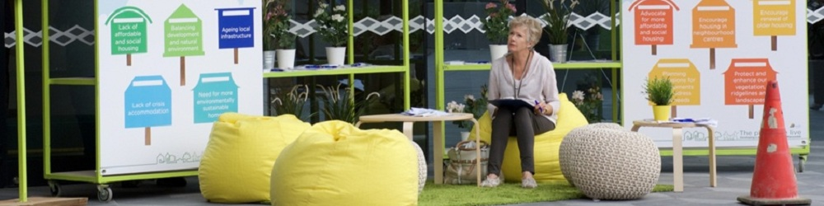

# A strategy for the future

### Our vision for housing in Maroondah

In 2040, Maroondah will have high quality housing environments in appropriate locations that meet the community’s diverse and changing needs. There will be a wider range of living options and housing will increasingly be revitalised in affordable, sustainable and well-designed ways. Maroondah’s activity centres will be more accessible and provide a broader range of services that meet community needs. In partnership with the community, Council will continue to plan for housing growth strategically backed by a strong evidence base.

### Focus Area 1: Respond to social, economic and demographic change

The extensive research, analysis and consultation that informed this Strategy tell us that the world is changing and it is important to change with it. Population growth and ageing, changing family formations, changing lifestyles, new technologies and a changing workforce and economy all mean that in order to maintain and enhance liveability, Council needs to respond to these changes and use them as opportunities to improve Maroondah.

**DID YOU KNOW…**

An additional 12,500 dwellings will be required in Maroondah over the next 25 years to meet anticipated population growth

Key directions include:

* Setting a target for new residential dwellings to be within activity centres of Ringwood, Croydon, Ringwood East and Heathmont by 2040
* Encouraging greater development in lower order neighbourhood activity centres and dwellings above shops in smaller strip shopping areas

### Focus Area 2: Manage growth and changing housing needs

By 2036, Maroondah will undergo significant urban change as Melbourne grows. Our challenge is to ensure that an appropriately planned, well designed supply of diverse housing stock is able to be delivered by the development industry. The 'Greening the Greyfields' initiative is one of the tools that will assist to facilitate this outcome.

**DID YOU KNOW…**

40% of local community members surveyed identified that greyfield renewal was one of their top 3 housing priorities

Key directions include:

* Working with the Victorian Government and Swinburne University on the concept in the *Plan Melbourne Refresh* and ‘Greening the Greyfields’ to deliver better development outcomes.

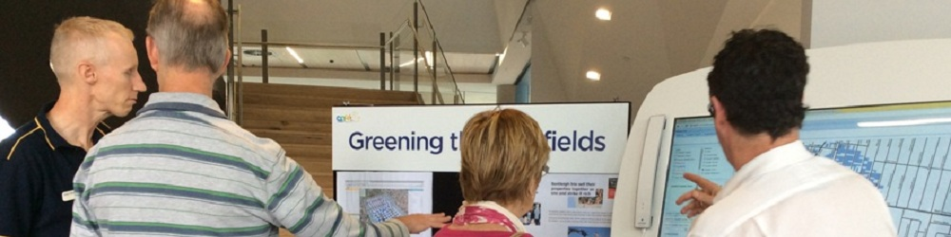

### Focus Area 3: Protect and enhance our environment and neighbourhoods

While growth and development occur, it is important to maintain the character of our neighbourhoods and increase sustainability. Protecting key attributes of Maroondah, such as our vegetation, ridgelines, landscapes and neighbourhood character is important to the community. Existing controls such as the ridgeline policy are working well. Council will reaffirm and enhance these controls while at the same time working towards increasing our sustainability across the whole of Maroondah.

**DID YOU KNOW…**

Almost 12% of Maroondah is biologically significant. These areas provide important habitat for our flora and fauna

Key directions include:

* Reviewing and enhancing the commitment to areas of special environmental quality in Maroondah.
* Strengthening the Maroondah Planning Scheme to promote housing that is environmentally sustainable, diverse and reflects the character of local neighbourhoods.

### Focus Area 4: Improve affordability, accessibility and social housing opportunities

In order to maintain liveability, Council will do everything possible to maintain affordable housing options. Furthermore, Council we will work with providers to enable special needs housing not to be squeezed out by the marketplace. In order to help maintain housing affordability and accessibility, Maroondah will develop planning concessions to increase community benefits and continue advocacy efforts.

**DID YOU KNOW…**

78% of Maroondah’s new housing supply costs less than the median house price for the municipality

Key directions include

* Finding ways to encourage and implement planning concessions that increase community benefits such as affordable or social housing, open space, off street parking, sustainability or design excellence.
* Continuing to promote affordable housing, social housing and age-friendly accommodation through regional collaboration, advocacy to higher levels of government, and policy development.

### Focus Area 5: Building on and improving the Planning framework

Council will continue to advance the core planning framework as provided by the 1997 Housing Strategy - building on its successes and making adjustments where changing population growth and technology have outpaced the 1997 plan. Additionally, Council will implement the Maroondah 2040 Vision outcomes and key directions and the Active and Healthy Ageing Initiatives as they relate to housing in Maroondah.

**DID YOU KNOW…**

The community ranked the current age friendliness of Maroondah's housing stock in lowest amongst the eight World Health Organisation age friendly domains

Key directions include:

* Implementing the Maroondah 2040 Vision and Active and Healthy Ageing Initiative key directions for an attractive, thriving and well built community.
* Reviewing the reformed residential zones and any unintended consequences of these zones.
* Developing an ongoing consultation and facilitation role for Council to work with key housing sector players to provide clarity and certainty in the planning system that will help deliver our housing vision.

### Housing Framework

Future housing development in Maroondah will be guided by the objectives of the Housing Strategy as represented in the diagram below. This illustrates:

* The hierarchy of centres to be the focus for growth in Maroondah between 2016 and 2040
* Areas of ridgeline protection and landscape protection from significant new development
* Key infrastructure that connects Maroondah to the region and metropolis
* Identified housing market areas to engage with the community to guide future development

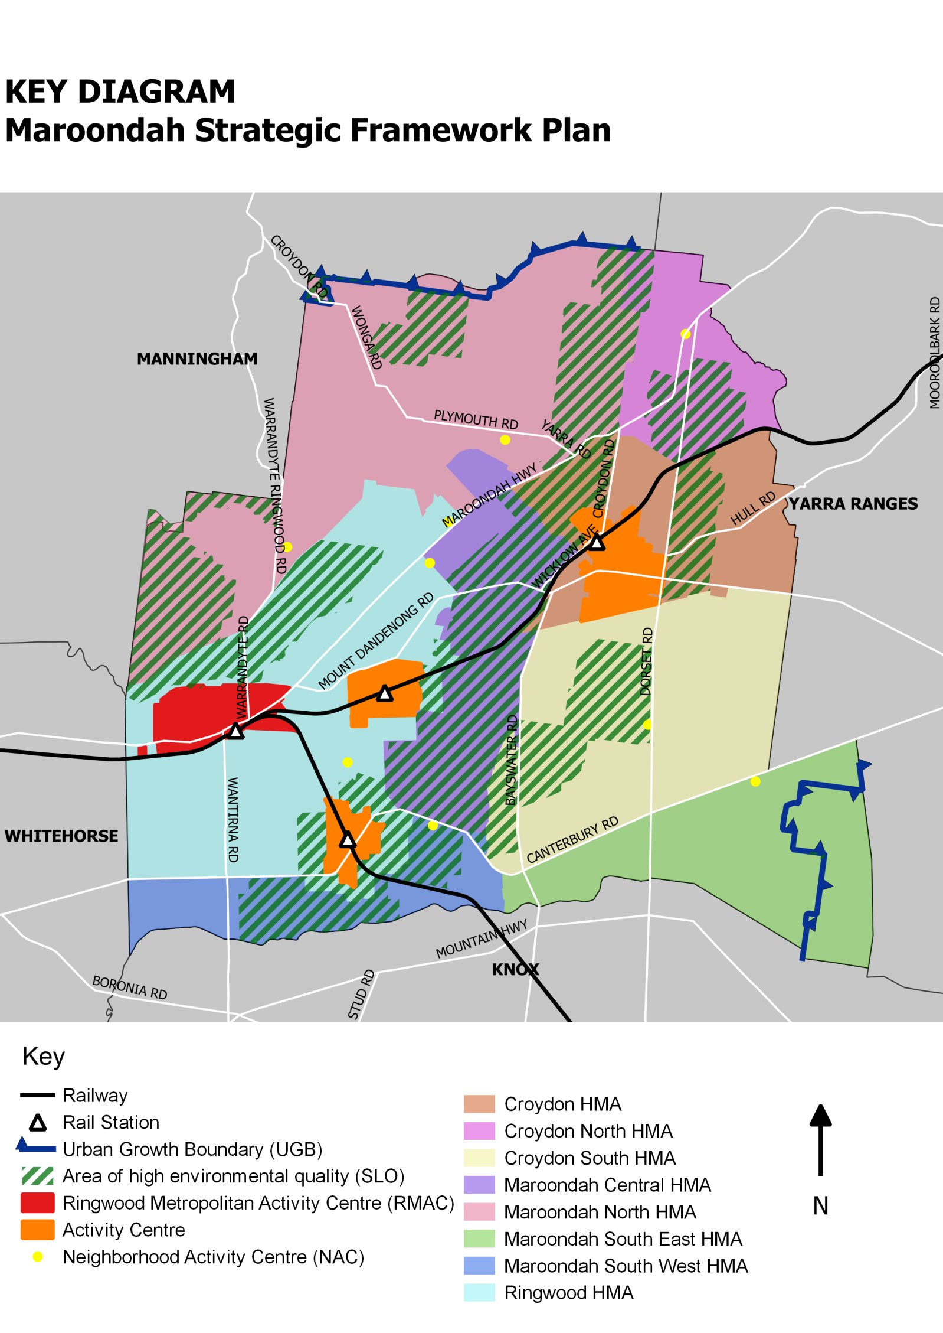

**A**

Apartments

**A**

**A**

**What is Greening the Greyfields?**

As populations and land values increase, land owners are demolishing their houses and subdividing their lots to accommodate more dwellings. In many cases this is resulting in less than optimum outcomes. Community concerns with this current approach include overdevelopment of smaller lots, poor design outcomes (unattractive/ bland buildings with minimal landscaping) and loss of vegetation. It also leads to more people living in the area without corresponding improvements in local infrastructure, such as parking and open space.

'Greening the Greyfields' is a federally funded project aimed at resolve this by at promoting sustainable housing regeneration in the middle suburbs. However, rather than working at the lot-by-lot level, the project aims to promote collaborative redevelopment precincts; where landowners work together, and with the local government, to design better housing outcomes for their land.

By amalgamating lots, and developing designs at a precinct-scale, the potential exists to increase the quantity, quality and diversity of housing while also integrating development better into the existing neighbourhood. Where land owners work together in precincts, redevelopment can:

* Achieve better design and sustainability outcomes
* Respect current and future neighbourhood character;
* Direct how the area will look in the future
* Locate redevelopment more appropriately
* Improve financial returns for landowners
* Provide areas with more utilities and services

A precinct based approach requires not just the cooperation of a number of landowners, it also requires commitment from all levels of government to come up with a model that works for everyone, including the community, landowners and investors. The methods currently being proposed to pioneer this type of development incorporate:

* Computer modelling that shows potential redevelopment precincts as well as the social, environmental and financial benefits of precinct based development.
* Legal and financial instruments that allow landowners to work together
* Zones and overlays that allow landowners to work with Councils more effectively
* Community engagement activities to involve local residents while allowing landowners to get the best use of their land.

Greening the Greyfields has featured in the *Plan Melbourne Refresh Discussion Paper* and there are plans for it to roll it out first in key locations locally and then federally. It is seen as a critical component in addressing the challenge of developing a sustainable future for our cities.

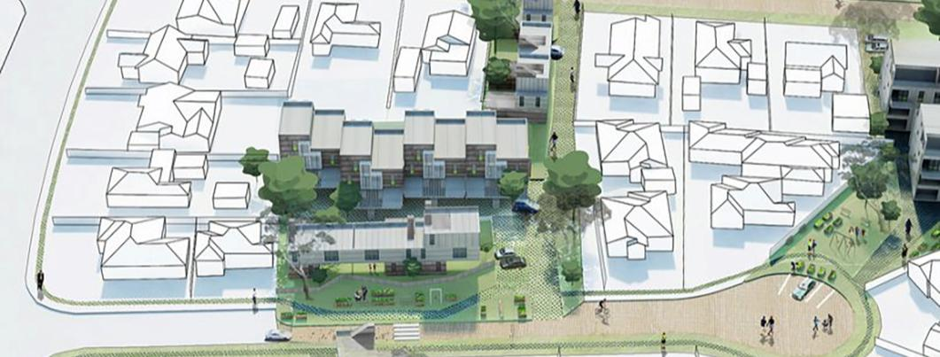

Possible ‘Greening the Greyfields’ precinct redevelopment

# What happens next?

The *Maroondah Housing Strategy 2016* was formally adopted by Council on 27 June 2016. Over the next 12 months, Council will commence implementation of the Strategy. This will include the preparation of a planning scheme amendment to introduce the *Maroondah Housing Strategy 2016*, along with the vision and community outcomes of Maroondah *2040: Our future together*, into the Maroondah Planning Scheme.

` An Implementation Plan will be developed to accompany an adopted Housing Strategy. This Plan will include indicators to measure performance, establish timeframes and outline the resources required to deliver the actions in the Strategy. Actions will be prioritised taking into account Council policy, cost effectiveness and the ability to deliver within timeframes.

The specific priority actions and projects outlined in the Housing Strategy will be monitored as they are implemented and reported to Council on an annual basis. An interim review of the Strategy will be undertaken every five years with a full review to be undertaken in approximately 10-15 years.

Some of the proposed priority actions for 2016/17 and 2017/18 are outlined below:

* Prepare guidance on locations and form of greyfield renewal, building on the top rated housing needs from the community consultation as well as technical research.
* Develop a planning scheme mechanism that can be used to deliver greyfield development on large or amalgamated lots.
* Undertake a municipal wide vegetation review and ensure consistency of supporting planning controls.
* Review Neighbourhood Character elements, including heritage, of the Jubilee Park area.
* Prepare a planning scheme amendment to introduce the Housing Strategy, along with the vision and community outcomes of *Maroondah 2040: Our future together* into the Maroondah Planning Scheme.
* Prepare a planning scheme amendment for the rezoning of residential land in the Ruskin Park and Wonga Park precincts from General Residential Zone to Neighbourhood Residential Zone.

# Contact us

If you have any questions regarding the development of the new Maroondah Housing Strategy, please contact the Strategic Planning and Sustainability team on **1300 88 22 33.**



|  |  |
| --- | --- |
| **To contact Council**   * phone 1300 88 22 33 or (03) 9298 4598 * visit our website at www.maroondah.vic.gov.au * email maroondah@maroondah.vic.gov.au   **Translating and Interpreter Service**  13 14 50  **National Relay Service (NRS)**  13 36 77 | MaroondahCityCouncil  http://www.conslosangeles.esteri.it/NR/rdonlyres/7A2D0DDE-0A09-40F9-819B-CDEE679C4B37/70635/twitter1.png@CityofMaroondah  CityofMaroondah  http://socialmediab2b.com/wp-content/uploads/2014/04/b2b-LinkedIn-Logo.png Maroondah City Council |