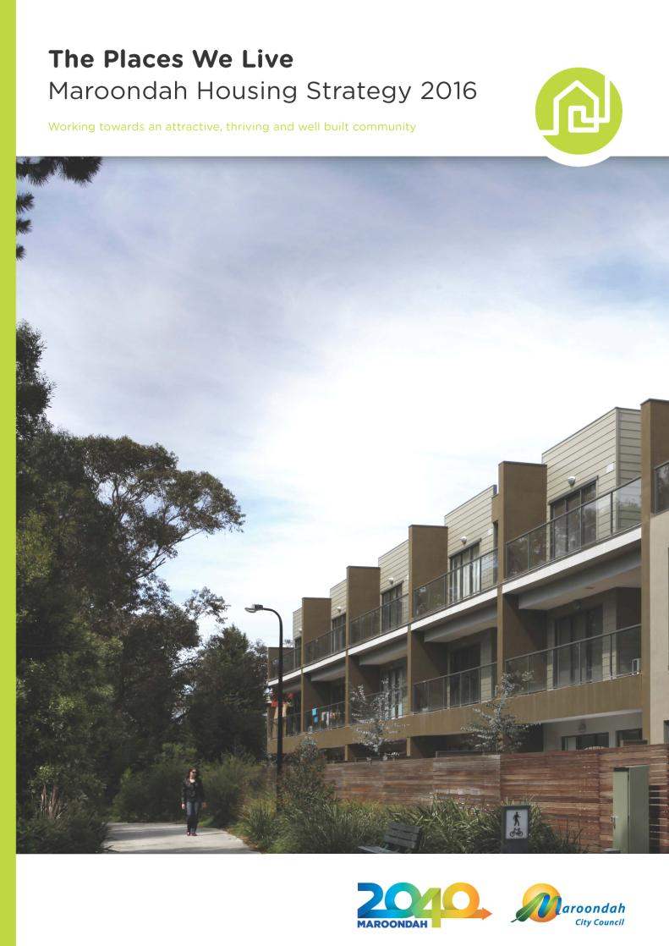

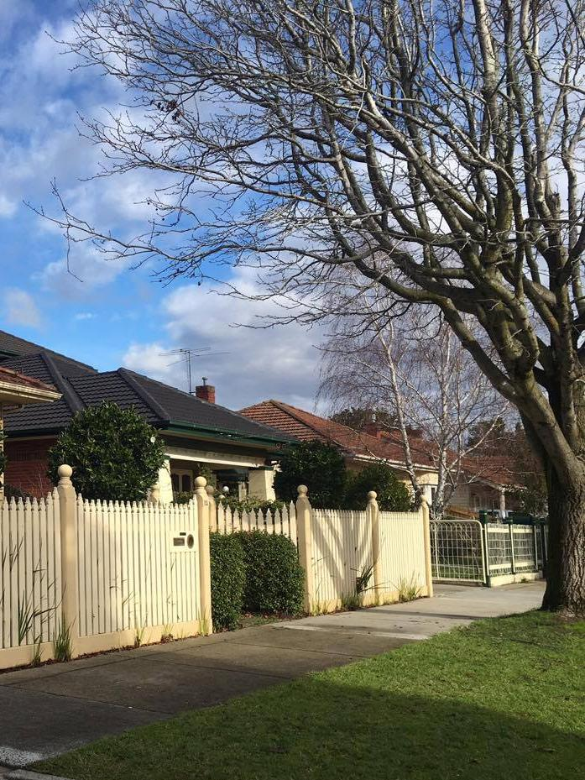

# Table of Contents

1. Introduction 4

1.1 Overview 4

1.3 Existing Policy Context 7

1.4 The process to develop the Strategy 12

1.5 Integrated approach 13

2. Housing Context 14

2.1 Maroondah in context 14

2.2 Social and Economic context 18

2.3 Households 20

3 Community aspirations: What matters to the community? 21

3.1 Key Themes 22

3.2 Summary of key issues and responses 23

4. Liveable housing 25

4.1 Key challenges 25

4.2 Key issues 26

4.3 Delivering liveable housing 31

5. Our strategic response 34

5.1 The Vision for housing in Maroondah 35

5.2 Our five key focus areas that will enable us to achieve this vision 35

5.3 Housing framework plan 40

6. The Way Forward 42

Focus Area 1. Responding to social, economic and demographic change 42

Focus Area 2. Managing growth and changing housing needs 46

Focus Area 3. Protecting and enhancing our environment and neighbourhoods 48

Focus Area 4. Improving affordability, accessibility and social housing opportunities 50

Focus Area 5. Building on and improving the planning framework 53

7 Implementation and Review 57

7.1 Implementation Process 57

7.2 Monitoring, Review and Reporting 59

8. Glossary 60

**Acknowledgements**

***The Maroondah Housing Strategy has been developed by Council in partnership with Spatial Economics. A range of other partners have also assisted; notably Charter Keck Cramer, and Marcus Spiller from SGS Economics and Planning (peer review capacity).***

# 1. Introduction



Working towards an attractive, thriving and well built community

## 1.1 Overview

The Maroondah Housing Strategy supports the delivery of Maroondah 2040 Community Vision. It outlines a vision for housing in Maroondah that supports key directions within *Maroondah 2040: Our future together*; and will assist Council to continue enhancing the liveability of our community.

### The vision for housing in Maroondah is:

In 2040, Maroondah will have high quality housing environments in appropriate locations that meet the community’s diverse and changing needs. There will be a wider range of living options and housing will increasingly be revitalised in affordable, sustainable and well-designed ways. Maroondah’s activity centres will be more accessible and provide a broader range of services that meet community needs. In partnership with the community, Council will continue to plan for housing growth strategically backed by a strong evidence base.

The objectives of the Maroondah Housing Strategy are:

* To establish future policy directions and guide future residential development to protect and enhance the places we live; and
* To ensure that the municipality will meet its housing requirements through to the year 2040.

Housing has two key attributes:

* The individual dwellings as home for residents; and
* The overall housing stock which forms a large part of our living environment.

Access to housing is a key attribute that affects almost every aspect of a person’s life. Access to suitable accommodation not only offers shelter and security, it provides a stable foundation and space from which to build family life and a sense of belonging. It also acts as a springboard to developing other aspects of people’s lives, including access to education and employment.

High quality, appropriately scaled and diverse housing is an essential part of a liveable neighbourhood and local community. As a commodity, housing has a long life-span, often over 50 years. Given this long life span, as well as the significant time lag associated with developing new housing, it is critical to plan for anticipated population and demographic changes and their resultant impact on housing requirements now.

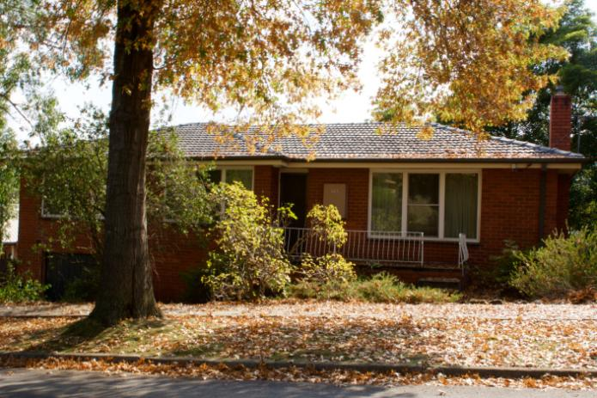 *Much of Maroondah comprises traditional forms of low density detached housing*

The landscape of Maroondah and the challenges faced today have changed dramatically since the last Housing Strategy was developed in 1997. The *1997 Housing Strategy* was successful in directing residential development in the municipality. It served the community well, however it is important that Council’s strategic directions relating to housing are updated to reflect changing community needs and aspirations.

Independent research has forecast that there will be a demand across Maroondah as a whole, representing a 1.0% average annual growth in private residential dwellings from 2016 to 2041. This equates to an average of 499 dwellings per annum or a total dwelling requirement of around 12,500 additional dwellings.

This housing strategy has been developed to ensure that new dwellings can be built while maintaining and improving the liveability of Maroondah.

The development of this strategy has involved detailed background research and community engagement. The community and stakeholder views and ideas helped Council to understand and plan for the housing needs of the community and informed this strategy for housing in Maroondah. Both the background research and community engagement undertaken has emphasised the importance of maintaining and enhancing the quality of life in Maroondah.

The Maroondah Housing Strategy updates the *1997 Housing Strategy* and responds to the latest social, economic and environmental trends and aspirations of the community.

A variety of factors have led to a review and update of the strategy:

* Significant development projects have made Maroondah a more accessible and desirable place to live and work;
* We are growing older and the number of people living in a household is becoming smaller;
* Housing has become more expensive making it difficult for some people to remain in the municipality; and
* There is a need to respond to housing issues that were identified in *Maroondah 2040: Our future together*, the new long-term community vision for the municipality.

The Strategy also updates the current planning context for Maroondah, in particular supporting *Maroondah 2040: Our future together* and aligning Council strategic directions with the current State Government planning context, as set out in *Plan Melbourne* and the *Plan Melbourne Refresh*.

Through the findings of the background research and community consultation, Council identified three key future housing challenges in Maroondah:

* Affordability of housing;
* Diversity - a need for greater housing choice; and
* Infrastructure - quality of the places we live.

The Maroondah Housing Strategy provides a roadmap for Council to deliver on initiatives and projects that will guide Council towards our vision for housing (see Section 5.1) and the broader community vision contained in *Maroondah 2040: Our future together*.

There are five key focus areas to achieve our vision and actions:

1. Responding to social, economic and demographic change
2. Managing growth and changing housing needs
3. Protecting and enhancing our environment and neighbourhoods
4. Improving affordability, accessibility and social housing opportunities
5. Building on and improving the planning framework

The Maroondah Housing Strategy details the key directions and actions within each of these focus areas which will deliver our vision for housing.

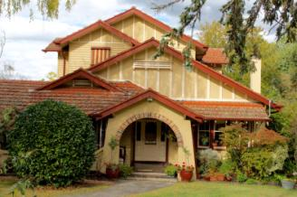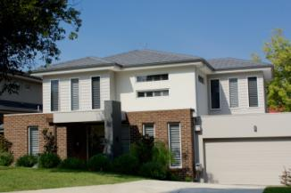

*Maroondah has a diverse range of housing forms representing many eras*

## 1.2 Existing Policy Context

### Plan Melbourne

*Plan Melbourne* was released by the Victorian Government in 2014 and outlines the vision for Melbourne’s growth looking ahead to the year 2050. It seeks to define the kind of city that Melbourne will become and identifies the infrastructure, services and major projects which need to be put in place to underpin the City’s growth. It is a blueprint for Melbourne’s future prosperity, liveability and sustainability. The Victorian Government is currently undertaking an update to *Plan Melbourne*, known as the *Plan Melbourne Refresh*. This review will address important issues of housing supply, diversity and affordability and climate change, and will also reflect current transport network priorities.

Additionally, current State Government, Swinburne University and the federally funded 'Greening the Greyfields' initiatives, which are seeking to help deliver better development outcomes than existing subdivisions, will help provide a broader context for and inform the Maroondah Housing Strategy.

Age-friendly urban design initiatives are referenced under the '20-minute neighbourhoods' section of the *Plan Melbourne Refresh* (page 21).

This broader strategic planning context has also informed the development of the Strategy and as such the Strategy is aligned with these directions. It includes direct actions to help us develop initiatives identified in *Plan Melbourne* and being developed and promoted by the federal and state governments.

In particular, *Plan Melbourne Refresh* emphasises these key concepts:

* The need to strengthen housing affordability and choice through strategic planning;
* The importance of people in Melbourne’s identity and place, and
* Recognising and reinforcing the importance of partnership with government in sub-regional planning.

### Maroondah 2040: Our future together

The *Maroondah 2040: Our future together* captures the aspirations, desires, dreams, and priorities of the community looking ahead to the year 2040 and beyond.

Many of the areas covered in the *Maroondah 2040: Our future together* are also supported in *Plan Melbourne* and the *Plan Melbourne Refresh* document

This long term community vision provides a ‘roadmap’ for the community, Council and other levels of government to partner together and create a future that enhances Maroondah as a great place to live, work, play and visit.

The vision provides a blueprint for the future of and hopes of our community.

Our community vision is:

In 2040, Maroondah will be a vibrant and diverse city with a healthy and active community, living in green leafy neighbourhoods which are connected to thriving and accessible activity centres contributing to a prosperous economy within a safe, inclusive and sustainable environment.

From the community vision engagement process, a number of preferred future outcomes have been identified as community priorities looking ahead to 2040 and beyond.

These future outcomes will drive our shared vision:

#### Safe, healthy and active

Maroondah is a safe, healthy and active community with local opportunities provided for people of all ages and abilities to have high levels of social, emotional and physical wellbeing.

#### Prosperous and learning

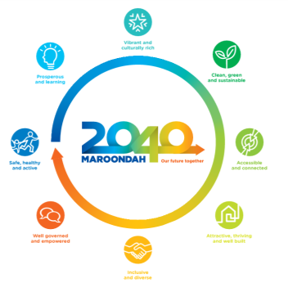Maroondah is a thriving centre of economic activity and opportunity within the eastern region where the sustainability and growth of local businesses is supported. All community members, groups, education providers and local businesses have access to a wide range of quality learning resources and facilities.

#### Vibrant and culturally rich

Maroondah is a creative cosmopolitan community recognised for its celebration and promotion of arts and culture. There are a broad range of engaging entertainment options, diverse cultural activities and the creation and display of traditional and contemporary forms of art.

#### Clean, green and sustainable

Maroondah is a green leafy community with high levels of waste diversion and sustainable approaches to infrastructure development, urban design and management of natural resources. Our community is resilient and has the knowledge, capacity and resources to make sustainable lifestyle choices.

#### Accessible and connected

Maroondah is an accessible community for all ages and abilities with walkable neighbourhoods, effective on and off-road transport networks, and access to a range of sustainable transport options.

#### Attractive, thriving and well built

Maroondah is an attractive community with high quality residential and commercial areas incorporating infrastructure that meets the needs and aspirations of all ages and abilities. A diverse range of housing options are available and thriving activity centres provide a broad range of facilities and services to meet community needs.

#### Inclusive and diverse

Maroondah is an inclusive community where social connections are strong across generations and diversity is embraced and celebrated.

#### Well governed and empowered

Maroondah is an empowered community that is actively engaged in Council decision making through processes that consider the needs and aspirations of all ages and population groups. Council provides strong and responsive leadership, ensures transparency, while working with the community to advocate for and ‘champion’ local needs.

In addition to *Maroondah 2040: Our future together*, there are a wide range of other strategic documents that have a significant influence on Council service delivery and the Maroondah community. These include:

* The *Municipal Strategic Statement* which provides a clear, concise statement of land use issues and directions, and outlines a vision for the future development of the municipality.
* The *Maroondah Community Wellbeing Plan* which provides directions and guidelines for working towards the improved health and wellbeing for the Maroondah community.
* The *Municipal Emergency Management Plan* which addresses the prevention of, response to and recovery from emergencies within the municipality of Maroondah.

There are also many other strategies and plans that contribute to the delivery of outcomes and key directions within *Maroondah 2040: Our future together* and the Council Plan. Figure 1.1 shows the inter-relationships between the Housing Strategy and many of the other strategic documents adopted by Council.

Figure 1.1 - Relationship of Housing Strategy to other Council policies, strategies and plans

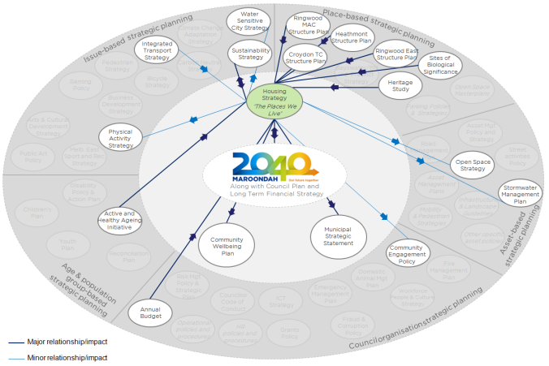

Source: Maroondah City Council, 2016

### Need for a new housing strategy

This Maroondah Housing Strategy has a primary focus on five key directions that enable Council to plan and facilitate the development of a community where everyone can live, work and play locally.

It specifically helps Council to:

* encourage and support the provision of a diverse range of housing across Maroondah, that meets the needs of current and future residents;
* encourage high density development in activity centres where there is access to high quality facilities, services and amenities; and
* implement an urban form that enhances the desirable attributes of Maroondah to protect and value ridgelines, vegetation, neighbourhood character, local history and cultural heritage.

The process of developing the Maroondah Housing Strategy included a re-examination of the key questions addressed in the *1997 Housing Strategy* and established the extent to which it achieved its objectives. The review of the *1997 Housing Strategy* also identified where gaps have emerged due to changing circumstances.

The review concluded that Council acted on the recommendations of the housing strategy. Two of the key strategic initiatives in the *1997 Maroondah Strategy* focussed on areas of high environmental quality and areas with good tree canopy coverage outside of these areas. The *1997 Maroondah Strategy* has been successful in protecting these features and will continue to be enhanced.

A range of other measures, such as zoning overlays and other strategies were introduced to address the issues identified. However, the strategy underestimated future population growth, whilst issues such as affordability and housing insecurity still persist. As time passes, infrastructure ages and additional dwelling growth results in more demand being placed on existing infrastructure. The Maroondah Housing Strategy will build on this success and implement knowledge gained from changes in the external environment (State Government planning and demographic changes).

### Planning Zones

Planning zones in Victoria were reformed in 2014 to ensure that they are relevant and adequately reflect the aspirations of all Victorians. The reformed residential and commercial zones were integrated into the Maroondah Planning Scheme through a ‘policy neutral’ amendment C93, gazetted in June 2014. The following zones are currently in operation within Maroondah and have the capability to accommodate residential development:

#### Commercial 1 Zone (C1Z)

The purpose of the C1Z is to create vibrant mixed use commercial centres comprising commercial, community and residential uses. In Maroondah, it applies primarily to activity centres and facilitates commercial activity with possible residential uses on upper stories. Residential uses at ground floor level are restricted through controls on frontage. Two percent of land in Maroondah is in the C1Z.

#### Mixed Use Zone (MUZ)

The mixed use zone is a part of the residential suite of zones and can accommodate a range of uses, including residential, commercial, and some lighter industrial uses. The MUZ is not widely used in Maroondah with less than 1% of land in the MUZ. Maroondah operates two schedules to the MUZ.

#### Low Density Residential Zone (LDRZ)

The purpose of the LDRZ is to provide low-density residential development on lots that are large enough to treat and retain wastewater. Maroondah accommodates a limited quantity of LDRZ (1% of overall land area), primarily along the border with the City of Manningham. Minimum lot sizes of 0.2 hectares apply where access to reticulated sewerage is available and 0.4 hectares where it’s not available. Maroondah doesn’t vary the LDRZ through schedules.

#### Residential Growth Zone (RGZ)

The purpose of the RGZ is to provide increased housing densities and diversity in locations offering good access to transport and services. In Maroondah, the residential growth zone has only been applied in the Ringwood Metropolitan Activity Centre Area. One percent of land in Maroondah is in the RGZ. Maroondah operates a single schedule to the RGZ.

#### General Residential Zone (GRZ)

The purpose of the GRZ is to encourage development that respects neighbourhood character and provides a diversity of housing and moderate housing growth. Maroondah currently operates a single schedule to the GRZ that applies across much of the municipality. Forty percent of land in Maroondah is in the GRZ.

#### Neighbourhood Residential Zone (NRZ)

The NRZ applies to 29% of land in Maroondah. Its purpose is to recognise and protect areas of predominantly single and double storey residential development and to ensure that any new development respects identified neighbourhood character, heritage, environmental or landscape characteristics.

The following schedules to the NRZ are currently in operation in Maroondah:

### Schedule 1 – The Neighbourhood Residential Zone (NRZ1) applies to Ridgeline Protection Area A. A minimum lot size for subdivision of 2,000m2 applies. Two percent of land in Maroondah is zoned NRZ1.

### Schedule 2 – The Neighbourhood Residential Zone (NRZ2) applies to Ridgeline Protection Area B. A minimum lot size for subdivision of 864m2 applies. Ten percent of land in Maroondah is zoned NRZ2.

### Schedule 3 – The Neighbourhood Residential Zone (NRZ3) applies to the canopy cover ridgeline protection areas. No minimum subdivision size is specified. Sixteen percent of land in Maroondah is zoned NRZ3.

### Schedule 4 – The Neighbourhood Residential Zone (NRZ4) applies to sites of biological significance. No minimum subdivision size applies. One percent of land in Maroondah is zoned NRZ4.

## 1.3 The process to develop the Strategy

The Maroondah Housing Strategy was developed on the basis of inputs from Maroondah residents and businesses, technical experts. The process involved a number of stages which are outlined below.

### Stage 1 – Building an evidence base

The first stage of the process involved project scoping and the preparation of a number of background technical reports designed to build an evidence base for decision making. These reports were peer reviewed and include:

* Review of the Maroondah Housing Strategy 1997 – Maroondah City Council, 2014
* Housing Demand Study – Spatial Economics, May 2015
* Housing Supply Analysis – Charter Keck Cramer, May 2015
* Sustainable Communities Discussion Paper – Maroondah City Council, 2015
* Maroondah Housing Strategy Housing and Environmental Sensitivities Paper – Maroondah City Council, May 2015
* Physical and Community Infrastructure Background Paper – Maroondah City Council, May 2015
* Opportunities for Residential Development Report – Maroondah City Council and Swinburne University, February 2016

### Stage 2 - Seeking input from the community and stakeholders

The second stage involved a range of community engagement activities to seek the views of community and key stakeholders on housing needs, services and facilities, housing issues and ways to address these issues. This included:

* an online survey;
* face-to-face engagement activities at the Maroondah Festival in Croydon and Realm in Ringwood; and
* three stakeholder focus groups held at Maroondah Federation Estate.

The extensive consultation process including residents, service providers and developers was consistent with key directions outlined in *Maroondah 2040: Our future together*.

Additionally, a suite of ten fact sheets and periodic newsletters were prepared to keep community members and key stakeholders informed on progress, identify findings arising from the evidence base and to summarise the outputs of the engagement activities. The *Community Engagement Report: Developing a new housing strategy for Maroondah, February 2016* provides a summary of the findings arising from this engagement process.

### Stage 3 - Considering key issues and options

The third stage of the process involved the preparation of an Issues and Options Paper, based on the technical evidence as well as community and industry inputs. The Issues and Options Paper summarised the evidence and laid out the key issues arising out of the background research and community engagement.

### Stage 4 - Developing a draft Maroondah Housing Strategy

Development of the draft Maroondah Housing Strategy was the fourth stage of the project. The draft Strategy was prepared based on the preferred options identified in the Issues and Options Paper.

### Stage 5 – Implementing the Maroondah Housing Strategy

The final stage of the process involved the preparation of a planning scheme amendment to ensure relevant strategy key directions and priority actions are included in the Maroondah Planning Scheme.

## 1.4 Integrated approach

The Maroondah Housing Strategy details focus areas, key directions and priority actions aimed at working towards achieving the vision for housing in Maroondah, whilst also supporting the preferred community outcomes outlined in *Maroondah 2040: Our future together.*

The Maroondah Housing Strategy is informed by the evidence based research and community engagement. It builds on the previous *1997 Housing Strategy* by seeking to maintain the key elements of the 1997 strategy whilst responding to changes that have occurred over the last two decades. It also responded to the strategic planning initiatives from the State Government as outlined in *Plan Melbourne* and the Plan Melbourne Refresh.

The Maroondah Housing Strategy seeks to complement other initiatives to deliver on a wide range of key directions arising from *Maroondah 2040: Our future together*. The strategy seeks to deliver an integrated approach to enhance and maintain the liveability of Maroondah.

While Council does not typically provide direct service provision in relation to housing, there is capacity and responsibility to make a difference in planning for and supporting the orderly, equitable and sustainable development of housing within the municipality. Council has a role in facilitating, supporting and partnering with a range of stakeholders to ensure the best housing outcomes for local residents. Council also has a role in advocating on behalf of residents for appropriate policies and planning frameworks at higher levels of Government to guide future housing development.

Delivering the desired housing outcomes for Maroondah requires a whole of Council approach. A wide range of Council functions are linked to the ultimate vision of this Strategy which involves creating liveable communities. Some of these include: assessing planning and building applications, developing and renewing community facilities, providing and maintaining infrastructure utilities, advocating on behalf of the local community, and delivering a wide range of services for different life-stages.

# 2. Housing Context

## 2.1 Metropolitan Context

The broad context for Metropolitan Melbourne is one of changing growth patterns over the past 40 years. Whilst the directions laid out by the former Melbourne Metropolitan Board of Works (MMBW) in the 1954 plan (the growth corridor approach) established the pattern for growth, there has been strong inner city revival and established suburb infill growth. The population growth rate has waxed and waned throughout this period, but has been marked by strong growth since the turn of the 21st century.

Melbourne’s population grew strongly at a rate of 1.8% per annum between 2001 and 2011 and 2.1% per annum from 2011 to 2013 (preliminary figure). This strong growth, totalling more than 740,000 people, was driven by both strong net overseas migration and a previously unanticipated rise in births. Interstate migration was fairly neutral with some years of net loss and some years of net gain.

During periods of high population growth across the metropolitan area, the majority of growth tends to manifest in demand for new dwellings firstly on the urban fringe (i.e. growth areas) and secondly redevelopment and infill housing particularly in the inner city. However, high (more than 1.0% per annum) metropolitan population growth has been located in established areas such as Maroondah with flow on demand for housing in areas with established services and amenities.

The City of Maroondah is located in the middle of the outer eastern region of metropolitan Melbourne. The outer eastern region comprises Whitehorse, Manningham, Monash, Maroondah, Knox and Yarra Ranges municipalities. The Maroondah municipality does not operate independently, people and products more into, through and out of Maroondah every day, with little regard for municipal boundaries.

During the period from 2003 to 2013, this outer eastern region of Melbourne grew by over 61,000 people. This accounted for 8.3% of the growth for Metropolitan Melbourne and saw the outer eastern region of Melbourne decline proportionately from 23.0% (2003) to 20.4% (2013) of the total population of Melbourne. While other regions are growing more quickly than the outer east, this region still has strong population growth.

The change in the various household types was mixed through the six municipalities of this eastern region of metropolitan Melbourne. However, some clear patterns have emerged. In particular, the three strongly growing municipalities (Whitehorse, Monash and Maroondah) all saw increases in *couple families with children*, while the three lower growth municipalities (Manningham, Yarra Ranges and Knox) saw losses in this family type. This data further reinforces the idea that these latter three municipalities have passed their early, rapid growth phases and family households are ageing and shrinking. This is further illustrated by the strong growth in *couple family with no children* households in these three municipalities. In contrast, the three strong growth municipalities are more mature and are seeing strong regeneration and increasing numbers of *couple family with children* households.

Households rarely consider municipal boundaries when making decisions about where to live. At a broad scale, locational choices are much more likely to be based on selection of a preferred sector of Melbourne (inner, north, south, east, west), then a region (inner, middle, outer, fringe) and then a specific suburb. Individual suburbs within a region are often fairly interchangeable or are chosen on the basis of a hierarchy of preferences. Few households would be expected to choose to live in ‘the City of Maroondah' rather than middle to outer 'eastern Melbourne' or 'Ringwood' or 'Croydon' or close to Eastland or the Ringwood train station or Eastlink. The inter-connectedness of the region is well illustrated by looking at where people who move into Maroondah are coming from. Housing demand in Maroondah is heavily influenced by migration and housing supply opportunities across the local region.

## 2.2 Maroondah in context

The City of Maroondah covers a land area of 61.4 square kilometres in Melbourne’s outer east, 22 kilometres from the Central Business District as can be seen in Figure 2.1. Maroondah has the strategic advantage of being located at the north-eastern junction of the Eastern Freeway – EastLink corridor. There are two train lines and a large number of bus routes linking the City with other regions.

Figure 2.1 - City of Maroondah

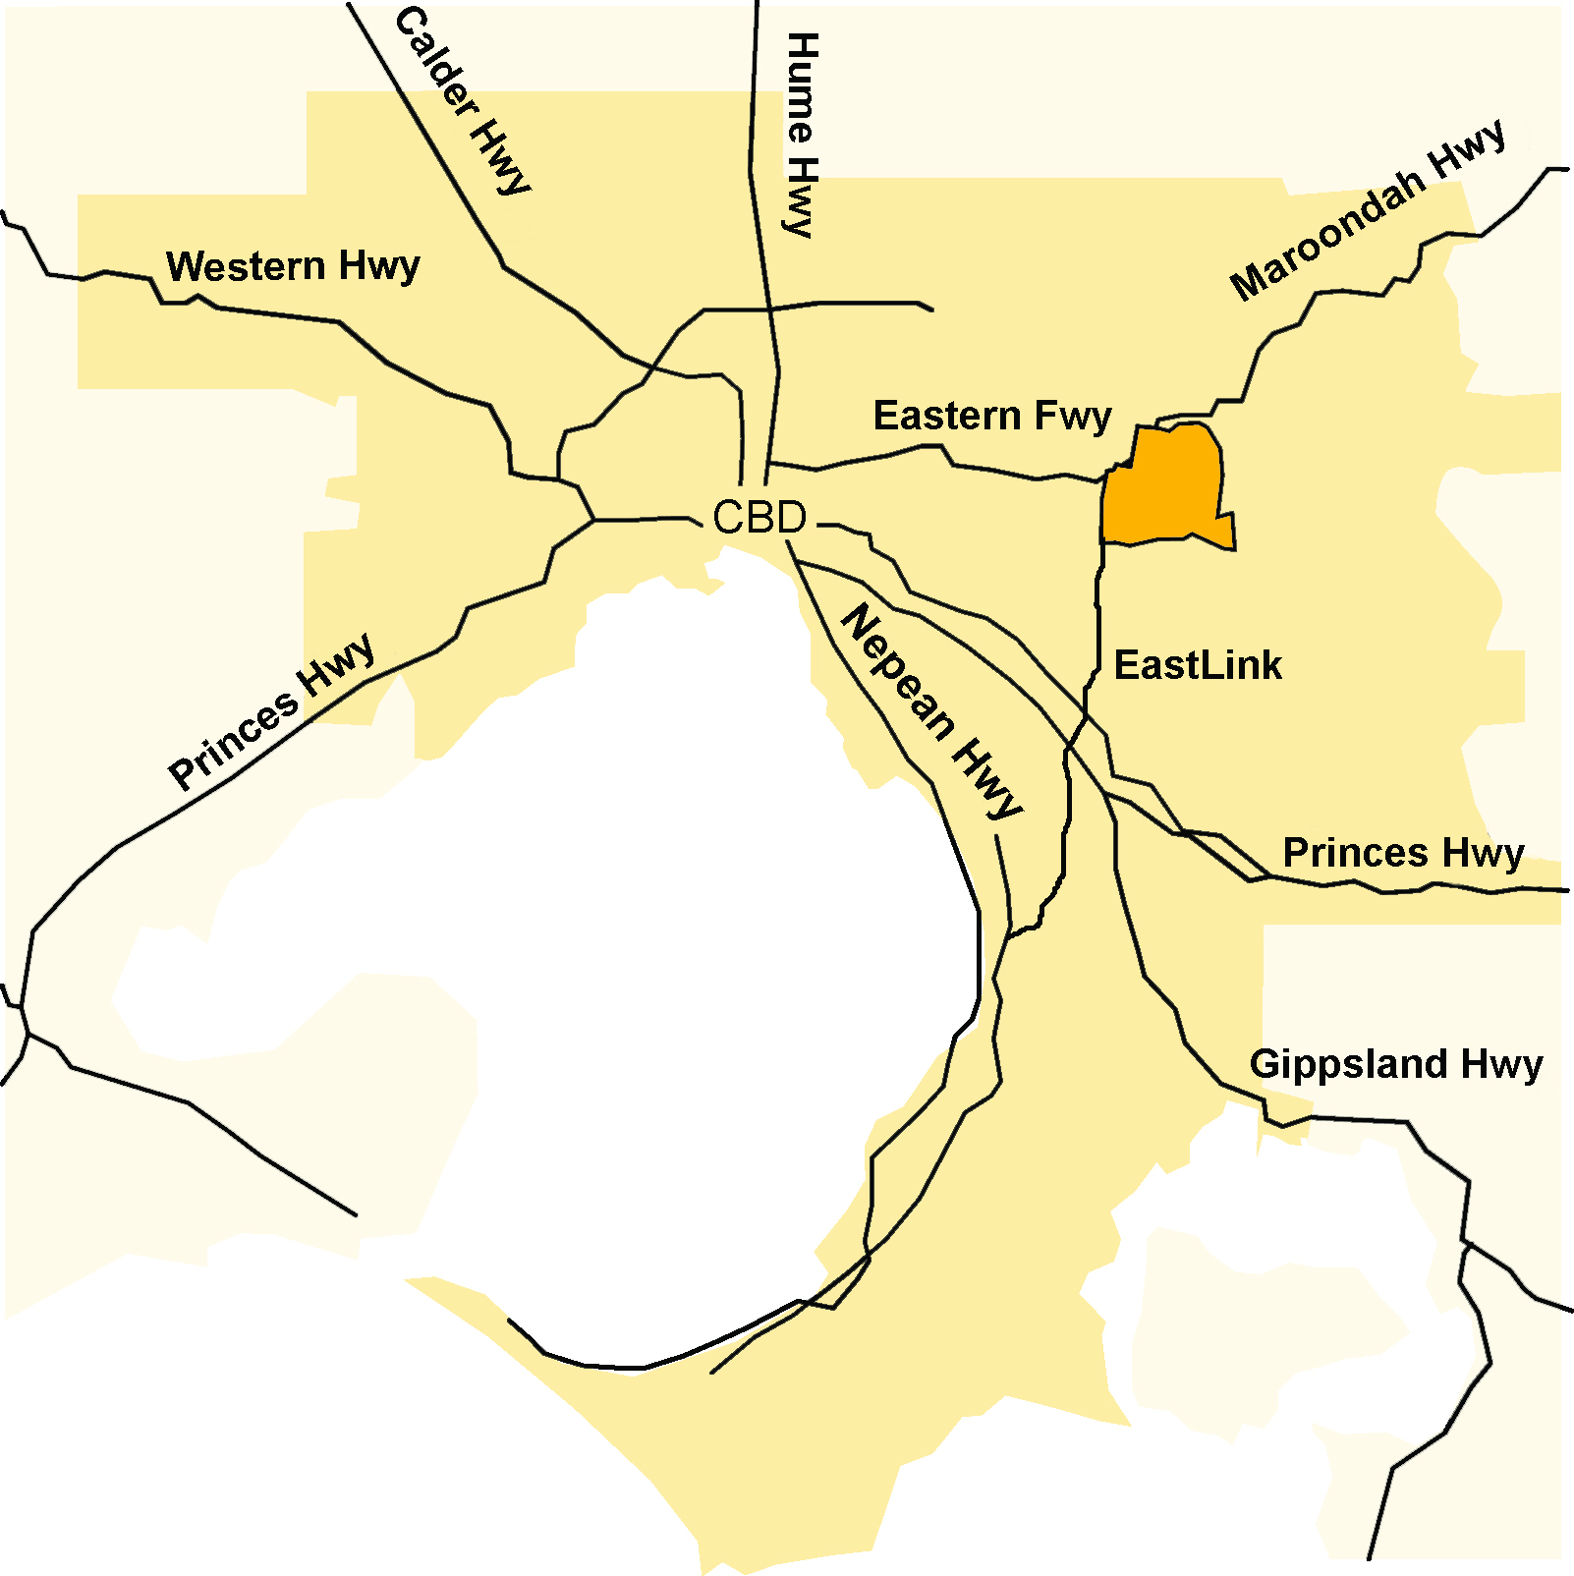

Housing market areas have been developed for Maroondah to allow small area analysis of housing trends and related housing demand characteristics. These housing market areas will facilitate small area policy responses and allow the identification of nuances and differences in housing needs and opportunities at a sub-LGA level.

To determine local housing markets a combination of factors were used. Factors included geographic features such as the major ridgelines; major transport corridors; the location of activity centres and other barriers such as industrial areas. These permanent features were combined with current socio-economic and housing data including income, house prices, household type and education levels. This process resulted in preliminary definition of local housing markets which were revised through a consultation process. The housing markets are shown in figure 2.2.

Figure 2.2 - Local Housing Markets and Activity Centres - Maroondah, 2015

**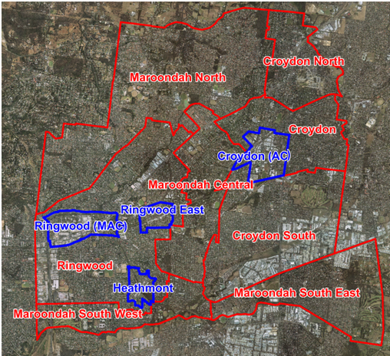**

**Note:** ‘MAC’ refers to Metropolitan Activity Centre, ‘AC’ refers to Activity Centre

Source: Spatial Economics Pty Ltd

Figure 2.3 - Historical Migration Flows, Maroondah, 2006 to 2011

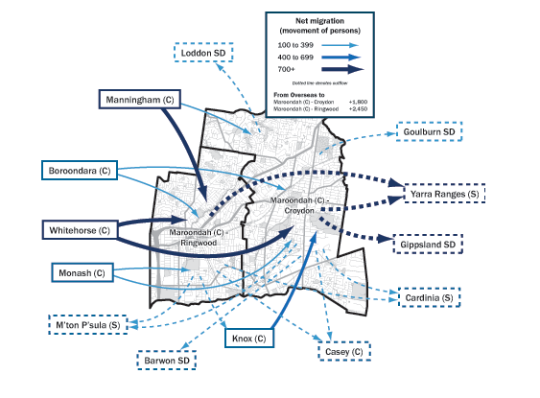

Source: Id Consulting, 2015 (based on ABS Census 2011)

Figure 2.3 shows that the largest net inward movements to Maroondah between 2006 and 2011 were from Manningham, Whitehorse, Knox and Monash and the largest net out- movements were to Yarra Ranges, the Gippsland Statistical Division and the south-east growth areas of Casey and Cardinia. The majority of inward migration demand comes from Maroondah’s neighbouring municipalities. Table 2.1 shows anticipated population growth in Maroondah, the eastern region and Melbourne in the period up to 2041.

Table 2.1 - Population and Dwellings in Maroondah, 2001 to 2041

|  |  |  |  |  |  |
| --- | --- | --- | --- | --- | --- |
|  |  | **2001** | **2006** | **2011** | **2041** |
| Maroondah | Dwellings | 38,063 | 40,005 | 41,961 | 60,184 |
|  | Population | 94,620 | 99,163 | 103,880 | 137,426 |
|  | Average Household Size | 2.5 | 2.5 | 2.5 | 2.3 |
|  | Population Average Age | 35 | 37 | 38 | 43 |
| Eastern Region | Dwellings | 358,247 | 373,675 | 389,489 | 502,197 |
|  | Population | 908,476 | 955,857 | 988,435 | 1,240,785 |
|  | Average Household Size | 2.5 | 2.6 | 2.5 | 2.5 |
|  | Population Average Age | 36 | 37 | 39 | 42 |
| Melbourne | Dwellings | 1,361,429 | 1,492,748 | 1,638,512 | 2,416,941 |
|  | Population | 3,330,249 | 3,644,704 | 3,999,727 | 5,929,435 |
|  | Average Household Size | 2.4 | 2.4 | 2.4 | 2.5 |
|  | Population Average Age | 35 | 36 | 36 | 40 |

Source: ABS Census 2001, 2006 & 2011. Note: Average Ages for 2041 are estimated

## 2.3 Social and economic context

The City of Maroondah is a substantially developed municipality, with most of the land for new housing developments being built-out. In 2016, Maroondah’s estimated population was 112,310 residents. The population is forecast to grow by 19% to 133,526 in 2036.

Maroondah’s age structure (based on Census 2011) demonstrates that 22.7% of the population was aged between 0 and 17 years, and 20.3% were aged 60 years and over. The largest increase by age group will be in the 70 to 74 age group by 2036. It is expected that over the period 2011-2036, there will be a 44% increase in number of retirees living in Maroondah.

Over 9,000 businesses operate within the City providing employment for almost 37,000 people. The largest industry employers are the manufacturing, retail trade and health care sectors.

The Bayswater North Employment Precinct is a regional economic hub where many national and international firms have established their headquarters. Maroondah also has major retail centres in Croydon and Ringwood, and a further 21 neighbourhood shopping centres throughout the municipality.

Figure 2.4 shows the projected changes for the largest industry sectors within Maroondah by numbers employed. Significant growth is projected in the health sector, in retail and in ‘knowledge intensive’ jobs. Construction and education jobs will increase more modestly – more closely aligned with population growth. By contrast, manufacturing is projected to decline significantly from over 9,500 jobs in 2011 to approximately 3,000 jobs by 2041.

Figure 2.4 – Projected changes in Maroondah’s employment industries 2001-2041



Source: ABS Census 2001 & 2011 and SGS Economics & Planning

Data gathered through the 2011 Census show that in the inter-censal period of 2006-2011, the proportion of people using the train and bus to travel to work increased while the number of people walking or cycling to work fell. The data demonstrated that by far the greatest proportion of people are commuting by car (> 70%) and that Maroondah’s travel patterns are marginally less sustainable than the greater Melbourne average, with fewer people using public transport, cycling or walking.

As can be seen in Figure 2.5, the City of Maroondah already enjoys access to a relatively wide catchment for services and facilities by car. From Ringwood East, roughly the geographic centre of the local government area, a large proportion of Melbourne’s east and southeast can be accessed within 20 minutes. A 20 minute public transport journey from the same location, however, allows access to a much smaller area.

Figure 2.5- Ringwood East catchments: Morning peak by car (7am-9am)

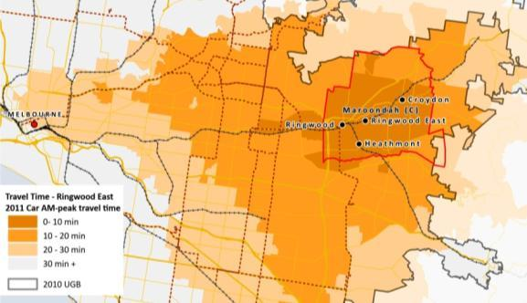

Source: SGS Economics and Planning, 2013

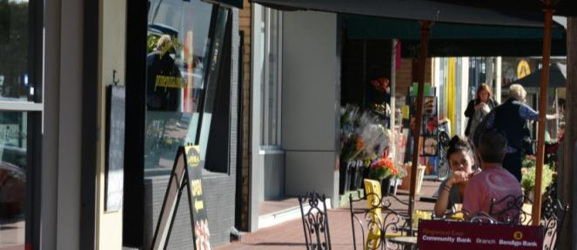

*Railway Ave, Ringwood East Activity Centre*

## 2.4 Households

There are an estimated 43,663 households in Maroondah in 2016 with this number forecast to increase to 53,045 households by 2036. Average household size (number of persons per household) is expected to decrease over this period.

|  |  |
| --- | --- |
| DSC_3000.jpg | DSC_2973.jpg |

*Maroondah is anticipating steady demand for new households in future*

As can be seen in Table 2.2, couples with children are the predominant type of household in Maroondah. There are a higher proportion of lone person households and couples without children in Maroondah compared to Metropolitan Melbourne. It is expected that lone person and couple family without children households will contribute to the majority of extra households in Maroondah by 2036.

In 2016, the population density in Maroondah stood at 18.12 persons per hectare, although this varied between suburbs from a low of 9.06 persons per hectare in Kilsyth South to a high of 21.71 persons per hectare in Croydon Hills. The overall density is expected to increase by 2036 with an increase in townhouses and apartments.

The study of household and dwelling demand concluded that the municipality will have a requirement for around 500 dwellings per annum or a total of 12,500 dwellings between 2016 and 2041.

Table 2.2 - Total household change by Household and Family Composition, Maroondah LGA, 2001 to 2011

|  |  |  |  |  |  |  |
| --- | --- | --- | --- | --- | --- | --- |
|  | **2001** | | **2011** | | **Total Growth**  **2001-2011** | **Average annual growth rate 2001-2011** |
|  | *# of households* | *% of total households* | *# of households* | *% of total households* | *# of households* |
| Couple family with no children | 8,564 | 23.8% | 9,508 | 24.2% | 944 | 1.1% |
| Couple family with children | 13,106 | 36.4% | 13,319 | 33.9% | 213 | 0.2% |
| One parent family | 3,976 | 11.0% | 4,547 | 11.6% | 571 | 1.4% |
| *Family Total* | *26,079* | *72.4%* | *27,809* | *70.9%* | *1,730* | *0.6%* |
|  |  |  |  |  |  |  |
| Lone person households | 8,173 | 22.7% | 9,492 | 24.2% | 1,319 | 1.5% |
| Group households | 1,045 | 2.9% | 1,083 | 2.8% | 38 | 0.4% |
| ***Total\**** | **36,021** |  | **39,236** |  | **3,215** | **0.9%** |

Source: ABS Census 2011 (\* Total includes Other Family and Other Households that are not shown in table)

# 3 Community aspirations

Development of the Maroondah Housing Strategy involved direct engagement with a wide range of community members and key stakeholders in Maroondah. Building on the community's vision for Maroondah as a whole, as detailed in *Maroondah 2040: Our future together*, the key themes emerging from the community engagement process were used to inform the development of the Strategy. The *Community Engagement Report: Developing a new housing strategy for Maroondah, February 2016* provides details on these findings.

Council conducted a range of community engagement activities to seek the views of community and key stakeholders on housing needs, services and facilities, housing issues and ways to address these issues. These comprised:

* an online survey;
* face-to-face engagement activities at the Maroondah Festival in Croydon and Realm in Ringwood; and
* three stakeholder focus groups held at Maroondah Federation Estate.

Through these engagement activities, it was identified that balancing development and the natural environment, managing population growth, and the lack of affordable and social housing are priority housing issues for Council to consider looking ahead. Protecting and enhancing our vegetation, ridgelines and landscapes was identified as the highest community priority in addressing these issues. This was followed by advocacy for more affordable and social housing.

The community engagement process made it very clear that people were aware that the key changes that will affect housing development in Maroondah over the next 25 years, will be quite different to the changes experienced over the last 25 years. Many see that Maroondah, and Australia as a nation, is at a crossroads. The economy and new technology such as the National Broadband Network make the future of work - be it the type of jobs or their location or future work hours - uncertain. The scale of Melbourne’s population growth and the extent and impacts of climate change are other notable ‘big picture’ issues that will impact on the demand for housing and on the ways that demand can be best met.

|  |  |
| --- | --- |
| Picture1.png | Nar Maen Wetland2.jpg |

*Community consultation in the Café Consult tent at the 2015 Maroondah Festival highlighted the importance of the natural environment*

## 3.1 Key Themes

Liveability is the most important factor in housing in Maroondah arising from the community engagement process. As a community, we want the places we live to be liveable.

The term ‘liveability’ can be defined as:

Liveability is the sum of the factors that add up to a community’s quality of life—including the built and natural environments, economic prosperity, social stability and equity, educational opportunity, and cultural, entertainment and recreation possibilities.

Planning has always been challenged by change and uncertainty; the *1997 Maroondah Housing Strategy* addressed these issues, however, many of the external influences on Maroondah have continued to grow and change. The community recognised this and identified a range of key issues for a housing strategy to consider and a strong desire to maintain and enhance the liveability of Maroondah.

Emerging from the engagement process were three key themes of affordability, diversity and infrastructure. In order for a place to be highly liveable, the three components need to be addressed and balanced:

**Liveability**

The community prominently identified issues associated with affordability as key priorities for the future. The lack of both affordable and social housing in Maroondah was the third most prominent housing issue identified by respondents to the issues and policy options survey. People suggested that international models of housing where the rental sector is more viable and affordable should be considered. Both the cost of rental properties and housing insecurity (short term leases) were identified as issues. The limited quantity of community and social housing was also seen as an urgent issue.

Issues related to diversity were strongly identified by respondents to the issues and policy options survey. A key factor related to housing diversity is the ageing of Maroondah’s population, which was the fifth most prominent issue identified by community members. Housing was seen as needing to be more flexible and adaptable for the different needs of families over time. It was felt that Maroondah needs a better mix of housing – low and medium density, owner occupied, private and public rental.

The development of the Ringwood Metropolitan Activity Centre was seen as an opportunity for Maroondah due to the wider range of services and potentially employment created. Other activity centres with railway stations are also important for accessing services. However, community engagement indicated that many local shopping strips are in need of renewal and may be suitable for some future housing development. Assets such as creeks, reserves and parks were identified as taking on even greater significance and value as housing and population densities increase. Roads, parking, drainage and utilities will also have to be improved as the population grows. Sporting and leisure facilities were also a key issue for those who participated in the services and facilities engagement activity.

In terms of addressing the above issues, it was suggested that Council could both advocate for improvements at a State level as well as looking at local policy change. The use of planning concessions for developments that address local needs, such as affordable and social housing, was also seen as a potential policy option

.

## 3.2 Summary of key issues and responses

During the community engagement process, community members were asked to identify their top three housing issues and priority policy responses to address these issues. Table 3.1 ranks them (highest to lowest) in order of number of responses:

Table 3.1 – Housing issues and priority responses

|  |  |
| --- | --- |
| Priority housing Issues\* | Priority responses to these issues\* |
| Balancing development and the natural environment | Protect and enhance our vegetation, ridgelines and landscapes |
| Population growth | Advocate for more affordable and social housing |
| Lack of affordable and social housing | Encourage high quality and innovative development |
| Need for more sustainable homes | Encourage renewal of older housing |
| Ageing population | Encourage more adaptable and accessible homes |
| Ageing infrastructure | Planning concessions for developments that address local needs |
| Lack of crisis accommodation | Provide more one and two bedroom dwellings |
| Lack of two bedroom dwellings | Encourage housing in neighbourhood centres |

*\*Ranked by number of participants identifying the issue or response in their top 3*

**Housing - an active and healthy ageing priority in Maroondah**

The *Active and Healthy Ageing Initiative – Towards an Age-friendly Maroondah 2015-2020* provides the framework to adapt to the changing needs and expectations of the community as they age in the municipality. The framework uses the eight age-friendly domains identified by the World Health Organisation (WHO) there that influence the health and quality of life of people as they age. One of these is ‘housing’.

In preparing this initiative, Council undertook significant consultation with the community to assess Maroondah’s strengths and deficiencies and to rate Maroondah’s current age 'friendliness' and provide their ideas as to how the municipality can become more age-friendly in the future.

The Maroondah community ranked the current age friendliness of Housing in Maroondah in last position of the eight domains. It was prioritised in equal third position as issues of remaining independently in family homes as they age will be a growing concern.

The initiatives within the *Active and Healthy Ageing Initiative – Towards an Age-friendly Maroondah 2015-2020* reflect our community’s desire to continue living in Maroondah but having access to housing stock that suits their changing needs whilst still ensuring that facilities and amenities are conveniently located and accessible so that they can continue to actively participate in all aspects of Maroondah life. Decreased mobility and confidence as people age requires considerations and encouragement towards more flexible and adaptable housing options based on universal design principles that are conveniently located.



A series of stakeholder focus groups were held in October 2015 to seek input on development of the draft Maroondah Housing Strategy.

# 4. Liveable housing

## 4.1 Key challenges

All of the community and stakeholder aspirations point to liveability being the most important factor in housing in Maroondah. As a community, we want the places that we live to be liveable. The research emphasises the challenges of growth impacting on our ability to maintain and enhance this valuable feature of Maroondah.

The places we live should be diverse, comfortable, accessible and affordable and have a reduced environmental footprint. Sustainable communities protect and enhance the local and natural environment. They encourage people to be healthy, participate in community life and lifestyles and help people to feel more connected socially and to the natural environment.

The places we live and the housing we occupy greatly affect our wellbeing. Our wellbeing is influenced by our ability to realise our potential, enjoy our environment, work or study meaningfully and contribute to our community. Good housing offers a stable foundation from which to build a home, a place that should provide shelter, security, space for family life, privacy, identity, and development. Having a home helps to develop other aspects of our lives, including education and employment. Given the impact that obtaining suitable housing and building a home has on education and employment prospects, it has a fundamental ripple effect on society and the economy. A lack of a home, or homelessness, greatly reduces peoples’ potential to be productive in the community and the economy.

The development pressures that are currently being experienced as a result of population and demographic change as well as increases in land prices can also represent opportunities to improve liveability. This includes the potential for ecologically sustainable developments, an uplift in economic activity and local employment options as well as opportunities to fast track infrastructure development, such as the National Broadband Network (NBN).

The key challenge for this housing strategy is how to create, encourage and maintain liveable communities in Maroondah. To better define what that means, key issues can be identified which, when addressed, will help us to maintain and promote liveability in Maroondah.

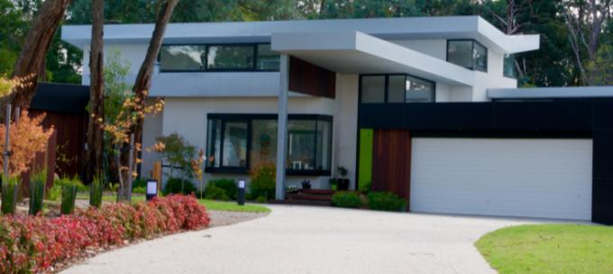

## 4.2 Key issues

Through all of the research there have been three key issues emerge. By addressing each of these, the Housing Strategy can achieve our desired vision of liveability. They are:

* Affordability
* Diversity
* Infrastructure

### Affordability

Affordability means that housing is accessible to a wide range of people on varying incomes. While some housing will be more or less affordable, there needs to be affordable options for everyone. In particular, it is important to ensure that low to moderate income households have options to rent or buy and that very low income households, often in social housing, have housing security and continue to have realistic housing options within our community. Figure 4.1 shows a framework for housing affordability.

Our definition of affordable housing is "that which does not cost (in rent or mortgage payments) more than 30% of gross household income for households in the bottom two quintiles of area (i.e. Greater Melbourne) median income." (Transforming Housing: Affordable Housing for All, Whitzman, Newton, Sheko, 2015).

Figure 4.1 – Framework for housing affordability



Source: Whitzman et al, 2015

However it is important to distinguish between the issues of ‘housing affordability’ and ‘affordable housing’. ‘Housing affordability’ relates to the general affordability of housing, including access to home ownership, for the broader population. It impacts on the wider economy as it affects the proportion of people’s income that is spent on housing and their resultant disposable income. Meanwhile, ‘affordable housing’ refers to the availability of secure and appropriate housing for those in the lowest 40% (bottom two quintiles) of income earners.

Council has a vital role in housing affordability, as it effectively controls the supply of development sites through the planning scheme. This influence must be used wisely to ensure a competitive housing market while balancing community expectations of protecting the environment and liveability.

Council’s role in affordable housing is more limited. Typically, State and Commonwealth Governments are expected to carry the major burden of supplying non-market housing and income support. Nevertheless, Council can make a significant contribution if it recognises this need in the community. An example of this is the Abbeyfield house in Croydon - the first purpose built Abbeyfield house in an outer suburb of Melbourne on land provided by local government. The house was funded under the Local Government Community Housing Program (LGCHP) with substantial contributions from charitable trusts. It opened in 1986 shortly after the opening of the first Abbeyfield house.

With an ageing and a growing population, it is important to identify opportunities to provide additional housing in Maroondah, to meet overall demand (number) as well as changing preferences (dwelling type and size). Maroondah is dominated by detached family housing, which has served the community well for a long time.

Figure 4.2 shows a map of the City of Maroondah which highlights that lone person and couple without children households are the predominant household in many of the municipality’s suburbs.

Figure 4.2 - Predominance of household types in Maroondah

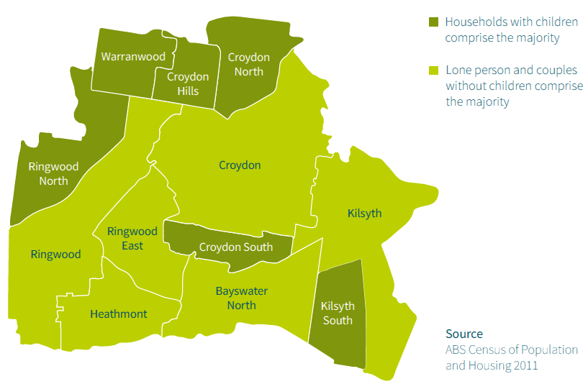

Source: Plan Melbourne Discussion Paper, 2015

This may suggest greater numbers of semi-detached and apartment dwellings are desirable, however, not all smaller households are likely to prefer smaller dwellings. Many older Australians prefer to maintain extra space for family and hobbies and regard their dwelling as well utilised. Research indicates that three-bedroom townhouses are the main source of Maroondah’s new housing.

The ABS Census 2011 also shows many young couples with children moving to Maroondah, most likely attracted to the municipality’s plentiful detached dwellings. As a result, Maroondah’s detached and semidetached dwellings provide choice for households within the municipality but also for households within the eastern region.

Typically, municipalities like Maroondah go through a number of development phases. The first phase of development occurred many decades ago when the municipality was first subdivided and developed. As the housing stock ages and houses become run down, difficult to maintain and obsolete, a second phase of development is experienced as lots are redeveloped and reused. Many homes in Maroondah are reaching this stage of the cycle and there is now an opportunity to plan for new and more diverse housing styles, including smaller dwellings for smaller households.

As demonstrated in Figure 4.3, as people grow from children to adults and into old age, they change the type of households that they live in. A traditional path has been to start as a child in a family household, move into a group or lone person household as a youth, becoming a part of a couple relationship within 5-10 years. Bringing up a family with dependent children is followed by an ‘empty-nester’ period. The final stage may involve a lone person household, as partners die.

Figure 4.3 – Household lifecycle

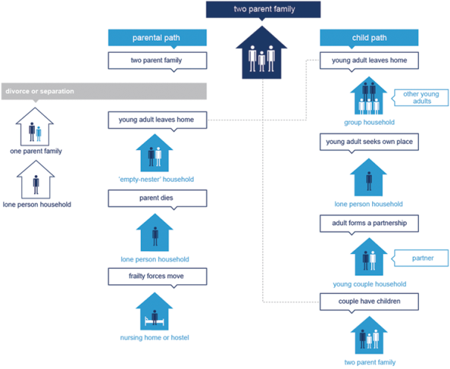

Source: id Consulting, 2015

There is an ever increasing demand for crisis housing and increasing homelessness. According to the Rental Stress in the East Report prepared by the Eastern Community Legal Centre, while Melbourne’s East is sometimes perceived as affluent, four municipalities have rental stress significantly higher than Melbourne’s average (24.9 %): Maroondah (26.8%), Monash (27.8 %), Whitehorse (27.8%) and Yarra Ranges (30.3%). Council needs to partner with housing services providers to increase Maroondah's capacity to support some of the most vulnerable members of our community.

### Diversity

Diversity relates also to affordability in that the Maroondah community wants a diverse range of housing which leads to varying prices and thus affordability. Diversity also extends to the types of housing (houses, town houses, apartments etc.) and the size of the dwellings (studios, one and two bedroom or large family homes with a back-yard). There is demand for all types of dwellings but limited supply of smaller dwellings. Again, Council has the opportunity to address this need.

A lack of housing diversity means that it is difficult for people to go through all of life’s stages without leaving Maroondah. If a person is born into a traditional detached dwelling, it is unlikely that they will be able to purchase a similar property as a first home. Instead, they may purchase a 1-2 bedroom apartment in their 20’s or 30’s, move into a townhouse when they find a partner and have children and subsequently into a traditional detached dwelling as their family grows. In the event of relationship breakdown, they may subsequently wish to move into a smaller dwelling at some point. As they age, their needs will also change and they may wish to move into age friendly accommodation. It is currently difficult to do this in Maroondah, giving the lack of diversity in the housing market.

It is clear from the evidence gathered that the housing needs of Maroondah are rapidly diversifying as the community ages, and as wider societal shifts, including increasing numbers of single person households and the rise of ‘blended families’, take hold. Single person households are projected to grow at nearly three times the rate of general housing growth. A small cluster of development hotspots alone cannot accommodate this diversified demand, while leaving the majority of Maroondah in a state of residential stability.

Maroondah currently has a small number of development hot-spots, but planning controls over much of the municipality are geared towards preservation of existing housing form, amenity and values, which is in keeping with the State government’s 2014 residential zone reforms.

There is a challenge in meeting housing demand at the same time as maintaining other aspects valued by the community, in particular the environment of Maroondah. This challenge will require identification of the preferred locations where new development should be located, and the areas where the current character should be maintained. This provides an opportunity to simultaneously both protect and provide housing in the right locations.

### Infrastructure

Over the next 25 years, Maroondah will undergo significant urban change as Melbourne grows. Our challenge is to ensure that Maroondah’s infrastructure can meet the needs of anticipated housing development.

Underpinning our existing housing make up and critical to any further development is the need to plan for and provide the right infrastructure that will ensure Maroondah maintains and improves its liveability. In fact the demand that housing development places on infrastructure also provides the opportunity to refit and upgrade existing infrastructure to achieve higher standards.

Maroondah has a relatively mature housing stock and relatively ageing infrastructure. Aside from the redevelopment hot spots, such as Ringwood and Croydon, significant re-investment can be expected to occur in housing across all neighbourhoods as dwellings reach the end of their life. The infrastructure background paper identifies location-specific factors and capacity limits in regard to infrastructure issues such as open space, drainage, walk/cycle and the road network. For example, Croydon, Croydon South and Ringwood East are most at risk of extreme intensity storm events. Three major influences are causing infrastructure networks to exhibit ‘growth pains’

Population growth is causing peak electricity demand consumption to increase, growth in student enrolment across all education sectors, key intersections of the road network to approach capacity within 5 years and rail to reach capacity within 20 years.

Changing lifestyles of residents is resulting in a transition away from organised sports to solo physical activity, increased demand for community gardens and non traditional sports facilities, increased walking and cycling in activity areas and increased demand for high speed broadband (NBN).

The changing climate is causing weather patterns that affect the asset lifespan, a greater frequency in high intensity storm events with the potential to overwhelm stormwater and sewage systems, and heatwaves/bushfires that impact on both residents and local infrastructure.

Through the community engagement process, the Maroondah community indicated strong support for walkable neighbourhoods with a desire to have proximity between their home and a range of amenities such as transport options, local shopping strips, small parks and shared trails.

The cyclical redevelopment and renovation process within local neighbourhoods in Maroondah presents an opportunity to refit community infrastructure for greater environmental sustainability and future proofing.

To achieve this opportunity requires a joined up approach to infrastructure planning, building approvals and infrastructure contributions. Without deliberate steps in this direction, a business as usual approach will see less than sustainable infrastructure systems persist for another 50 years – the general lifespan of a residential dwelling.

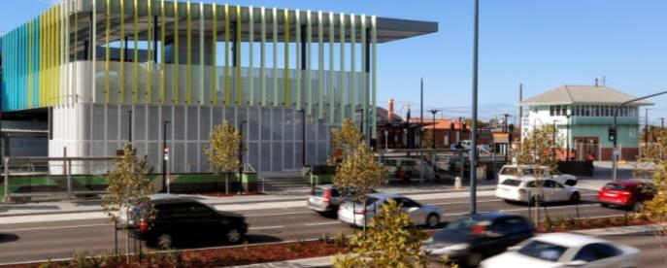

Infrastructure improvements will be required to be delivered alongside housing

## 4.3 Delivering liveable housing

The vision for an attractive, thriving and well built community in *Maroondah 2040: Our future together* gives us a clear vision for housing. This strategy responds to the challenges of balancing population growth, changing household formation, an ever-changing economic setting with maintaining and enhancing our key values of liveability and the environment.

The three identified key issues of affordability, diversity and infrastructure highlight a range of competing lower level issues and challenges. To address these competing issues and challenges, there are five key priorities that the Maroondah Housing Strategy addresses:

1. Having a flexible and responsive housing landscape to respond to our ever-changing population;
2. Creating more housing diversity and choice to manage growth;
3. Maintaining and enhancing the sustainability of our neighbourhoods to maintain and enhance one of our most valuable assets;
4. Supporting and contributing to housing affordability and accessibility; and
5. Delivering an integrated planning approach that builds on our existing planning framework.

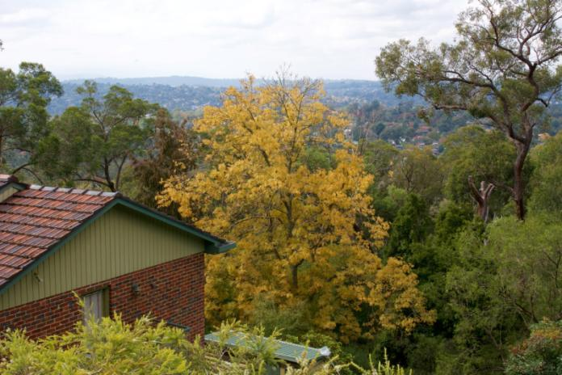

*Maroondah is characterised by a number of important ridgelines*

Maroondah has the capacity to meet the projected future housing demand, however the provision of supply and demand will be continually monitored to ensure that enough supply opportunities remain available so as not to restrict the market. The background technical work prepared for the housing strategy indicates that there is currently at least 6-7 years supply of developable sites at current demand levels, based on current residential zonings, rates of development and economic viability. However, this figure will increase over time as more properties age and become candidates for redevelopment as outlined in the *Opportunities for Residential Development Paper 2016*. The aim is to do more than just provide *enough* dwellings, there should also be an increase in diversity and choice, offering more options for an ageing population. Ensuring adequate supply opportunities will contribute to both affordability and diversity.

Council will work with the housing sector and will influence the market with the tools available, as to where and how developers and housing providers can deliver this supply. Council will make interventions where necessary and let the market do what it does best when intervention is not required.

The actual physical provision of housing is ultimately delivered by the development industry, who are largely represented by ‘mum and dad’ type developers in Maroondah, and housing agencies. Community engagement discussions with local estate agents during the development of this strategy have highlighted that there is a growing number of ‘mum and dad’ investors who are accessing the equity in their properties. This is often achieved by either developing a townhouse at the rear of the existing dwelling or simply subdividing it and selling to one of the numerous small-scale residential development companies who then construct and sell the townhouse. Research data indicates that 69% of all residential development projects in Maroondah are small scale, resulting in either one or two net additional dwellings. Despite the high levels of project activity, small scale projects accounted for only 29% of all net additional dwellings during 2013-14. It is important that land use policy in Maroondah considers this trend and ensures that liveability objectives are not compromised.

Council will keep abreast of changing markets and social conditions, not only in Maroondah but across Melbourne and the outer eastern region of Melbourne. Understanding the housing markets across our region will help Council to better plan for different housing solutions in different areas and to meet diverse needs.

With liveability being one of the foremost concerns of our community, Council has the opportunity to not only influence the new housing stock that will be added to Maroondah over the coming years, but also enhance the existing housing stock. The ‘Greening the Greyfields’ (see overleaf) initiative gives Council tools and strategies for making the most of what already exists. Rejuvenation and repurposing of existing housing stock is one of the key strategies by which housing diversity and choice within Maroondah can be increased.

To achieve the housing vision for Maroondah, five focus areas for action have been identified- one for each of the above priorities that will form key directions and priority actions for the Maroondah Housing Strategy to deliver on. Section 5 outlines the vision and focus areas. Section 5.2 sets out a specific key direction to address each of the five priorities listed above.

**What is Greening the Greyfields?**

As populations and land values increase, land owners are demolishing their houses and subdividing their lots to accommodate more dwellings. In many cases this is resulting in less than optimum outcomes. Community concerns with this current approach include overdevelopment of smaller lots, poor design outcomes (unattractive/ bland buildings with minimal landscaping) and loss of vegetation. It also leads to more people living in the area without corresponding improvements in local infrastructure, such as parking and open space.

'Greening the Greyfields' is a federally funded project aimed at resolve this by at promoting sustainable housing regeneration in the middle suburbs. However, rather than working at the lot-by-lot level, the project aims to promote collaborative redevelopment precincts; where landowners work together, and with the local government, to design better housing outcomes for their land.

By amalgamating lots, and developing designs at a precinct-scale, the potential exists to increase the quantity, quality and diversity of housing while also integrating development better into the existing neighbourhood. Where land owners work together in precincts, redevelopment can:

* Achieve better design and sustainability outcomes
* Respect current and future neighbourhood character;
* Direct how the area will look in the future
* Locate redevelopment more appropriately
* Improve financial returns for landowners
* Provide areas with more utilities and services

A precinct based approach requires not just the cooperation of a number of landowners, it also requires commitment from all levels of government to come up with a model that works for everyone, including the community, landowners and investors.

Current housing redevelopment patterns compared

to a ‘Greening the Greyfields’ outcome.

The methods currently being proposed to pioneer this type of development incorporate:

* Computer modelling that shows potential redevelopment precincts as well as the social, environmental and financial benefits of precinct based development.
* Legal and financial instruments that allow landowners to work together
* Zones and overlays that allow landowners to work with Councils more effectively
* Community engagement activities to involve local residents while allowing landowners to get the best use of their land.

‘Greening the Greyfields’ has featured in the *Plan Melbourne Refresh Discussion Paper* and there are plans for it to roll it out first in key locations locally and then federally. It is seen as a critical component in addressing the challenge of developing a sustainable future for our cities.

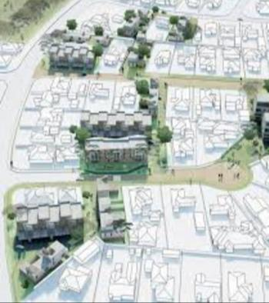

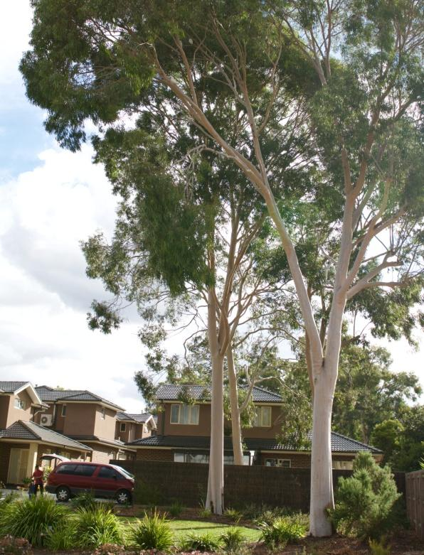

*Canopy trees retained in a townhouse style development*

# 5. Our strategic response

## 5.1 The vision for housing in Maroondah

With the key housing-related concerns of the community being balancing development and the environment while maintaining liveability, and the key issues that this raises of affordability, diversity and infrastructure, the vision for the Maroondah Housing Strategy is:

In 2040, Maroondah will have high quality housing environments in appropriate locations that meet the community’s diverse and changing needs. There will be a wider range of living options and housing will increasingly be revitalised in affordable, sustainable and well-designed ways. Maroondah’s activity centres will be more accessible and provide a broader range of services that meet community needs. In partnership with the community, Council will continue to plan for housing growth strategically backed by a strong evidence base.

To deliver this vision and support the overall vision of *Maroondah 2040: Our future together*, five focus areas have been developed that will create a framework for key directions and priority actions that Council will undertake to achieve this vision.

## 5.2 Our five key focus areas that will enable us to achieve this vision

➀

➁

➂

➃

➄

These five focus areas are of equal importance and have the breadth to address the key issues of affordability, diversity and infrastructure that relate to future housing demand. They provide the framework to develop twelve key directions and priority actions supporting these directions.

## Focus Area 1 Responding to social, economic and demographic change

The extensive research, analysis and consultation that informed this strategy tell Council that the world is changing and it is important to change with it. Population growth and ageing, changing family formations, changing lifestyles, new technologies and a changing workforce and economy all mean that in order to maintain and enhance liveability, Council needs to respond to these changes and use them as opportunities to improve Maroondah.

**DID YOU KNOW…**

An additional 12,500 dwellings will be required in Maroondah over the next 25 years to meet anticipated population growth

Maroondah is no longer just a suburban community. The Ringwood Metropolitan Activity Centre is one of only nine designated Metropolitan Activity Centre’s in Melbourne. Located at the meeting of major rail and road connections, the City of Maroondah has an important role to play in the housing and economic future of Melbourne, particularly the outer eastern region. Maroondah will increasingly become a hub for activity and it is important that all of Maroondah can grow and prosper without compromising highly valued liveability and natural environmental attributes.

The community has called for flexibility and adaptability to enable Council to respond to unforeseen circumstances. Strategic planning processes need to be regularly reviewed in light of new data and ongoing dialogue with the community.

Of the 115 community members who participated in the online survey, *“Balancing development and the natural environment”* was ranked as the number one issue by respondents, with 53% listing it amongst their ‘top three’ issues. In terms of ways to address the eight issues listed, *“Protect and enhance our vegetation, ridgelines and landscapes”* was ranked number one, with 56% of respondents listing it in their ‘top three’.

*“Closeness to public transport including buses and train stations”* and *“closeness to local shops, parks and playgrounds”* were respectively ranked as the first and second most important current housing issues in the survey. These were also ranked as the top two most important future housing issues. Part of this planning for growth will be setting specific goals for the amount of new housing development and redevelopment that will be directed towards the larger activity centres of Ringwood and Croydon and the neighbourhood activity centres of Ringwood East and Heathmont.

Figure 5.1 is a heat map identified in *Housing Supply Analysis – Charter Keck Cramer, May 2015* and shows the intensity of new housing projects across Maroondah 2013-2014**.**

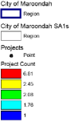Figure 5.1 - Intensity of New Housing Projects – Maroondah LGA (2013-14)

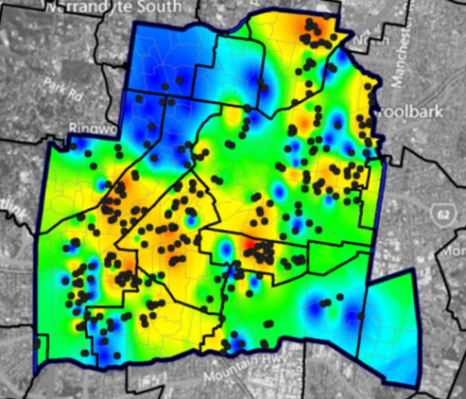

Source: Charter Keck Cramer, 2015

Council will also work towards encouraging greater development in smaller neighbourhood centres and promoting shop-top housing in smaller strip shopping areas to accommodate residential growth. Locating additional housing in these areas will give people easy access to existing and improving amenities. Support was also expressed during community engagement for centralising apartment living around train stations and activity centres.

## Focus Area 2 Managing growth and changing housing needs

By 2036, Maroondah will undergo significant urban change as Melbourne grows. Our challenge is to ensure that Maroondah’s infrastructure can meet the needs of anticipated housing development.

Good infrastructure is essential to the construction of new homes, strong communities and areas of high amenity. Its importance is encapsulated in *Maroondah 2040: Our future together* vision statement for the attractive, thriving and well built community outcome:

“…attractive community with high quality residential and commercial areas incorporating infrastructure that meets the needs… of all ages and abilities”

To realise this vision statement it is essential to plan for where new housing can be sustained. The extent to which infrastructure can accommodate the impacts of increased densities, changing climate and lifestyles is key. Understanding existing infrastructure challenges will inform sound planning, investment and the necessary partnerships with a range of infrastructure network authorities.

To do this, Council will look at the whole housing landscape, knowing what should be want to protected and identify key areas where the appropriate level of development can help deliver a wider range of housing types, while increasing our overall capacity. In particular, Council will plan for a managed increase in dwellings to meet social and market needs. And this need to be tailored to the different need of various parts of Maroondah - our major, neighbourhood and local activity centres and our suburban areas will all need unique approaches. This will further enhance Maroondah's diversity of housing choice with different market segments being catered to in different ways and locations.

While new housing has a role to play, the 'Greening the Greyfields' initiative has the potential to unlock significant additional housing capacity. This can be achieved through the retro-fitting of existing housing stock which through renovation and modification, rather than complete renewal can be adapted to meet a wider range of housing needs for our growing and changing population.

**DID YOU KNOW…**

40% of local community members surveyed identified that greyfield renewal was one of their top 3 housing priorities

The main way that growth can be managed is to ensure an appropriately planned, well designed supply of diverse housing stock can be delivered by the development industry. The 'Greening the Greyfields' initiative is one of the tools that will assist to facilitate this outcome.

## Focus Area 3 Protecting and enhancing our environment and neighbourhoods

While growth and development occur, it is important to maintain the character of our neighbourhoods and increase sustainability. Protecting key attributes of Maroondah, such as our vegetation, ridgelines, landscapes and neighbourhood character is important to the community and striving for quality developments. The demand for change and growth provides the challenge of maintaining these characteristics that are valued, but also provide the opportunity to guide development that will enhance the preferred future character for the whole of Maroondah from the busiest shopping centre to the leafiest residential street.

**DID YOU KNOW…**

Almost 12% of Maroondah is biologically significant. These areas provide important habitat for our flora and fauna

Existing controls such as the ridgeline policy are working well. Council will reaffirm and enhance these controls while at the same time working towards increasing our sustainability across the whole of Maroondah.

A recurring factor of success in many of the case studies reviewed in the development of the Housing Strategy was the existence of clear guidance and a framework that enabled the Council to foster more sustainable outcomes. Accordingly Council will review the available tools with a view to helping us build our capacity to make the transition towards more sustainable communities through new residential development.

## Focus Area 4 Improving affordability, accessibility and social housing opportunities

In order to maintain liveability, Council will do everything possible to maintain affordable housing options. Furthermore, Council will work with providers to enable special needs housing not to be squeezed out by the marketplace.

**DID YOU KNOW…**

78% of Maroondah’s new housing supply costs less than the median house price for the municipality

In order to help maintain housing affordability and accessibility, planning concessions will be developed to increase community benefits such as affordable or social housing, open space, off street parking or design excellence.

Council will also advocate to State and Federal Governments on affordable and social housing and work closely with affordable housing service providers and developers to achieve more affordable housing outcomes in Maroondah.

## Focus Area 5 Building on and improving the Planning framework

Council will continue to advance the core planning framework as provided by the 1997 Housing Strategy - building on its successes and making adjustments where changing population growth and technology have outpaced the 1997 plan.

Additionally, Council will implement the *Maroondah 2040: Our future together* vision outcomes and key directions and the *Active and Healthy Ageing Initiative* as they relate to housing in Maroondah. The *Active and Healthy Ageing Initiative* seeks to create an age-friendly city which encourages active ageing by optimising opportunities for participation, health and security in order to enhance the quality of life as people age in our community. Local governments that plan and take action to accommodate the changing needs of older residents can ensure that their communities remain attractive places to live with features that not only benefit seniors but support the health, safety and participation of residents of all ages.

In specific response to the State planning framework, Council will review the reformed residential zones and uncover any unintended consequences of the new zones.

**DID YOU KNOW…**

The community ranked the current age friendliness of Maroondah's housing stock in lowest amongst the eight World Health Organisation age friendly domains

The overall improvement and integration of the planning system will include process review, and Council will act in a strategic manner integrating key directions and relevant priority actions from other Council strategies into the planning scheme which will enhance housing and the liveability of the community. Some of these other strategies may include: *Water Sensitive City Strategy*, *Active and Healthy Ageing Initiative*, and the *Community Wellbeing Plan*. Council will continue to update its evidence base, develop partnerships with other agencies and the private sector, and will take a more significant role as facilitators of change to secure more sustainable patterns of residential development.

## 

## 5.3 Housing framework

Future housing development in Maroondah will be guided by this Strategy.

These are represented in figure 5.2 and show:

* The hierarchy of activity centres as the focus for growth in Maroondah between 2016 and 2040
* Areas of ridge protection and landscape protection from significant new development
* Key infrastructure that connects Maroondah to the region and metropolis
* Identified housing market areas to engage with the community to guide future development

Figure 5.2 - Housing Framework

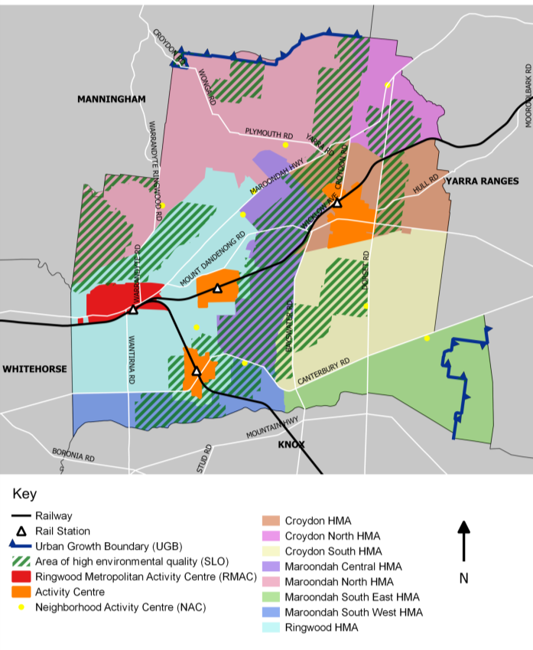

**A**

Apartments

**A**

**A**

# 6. The Way Forward

## Focus Area 1. Responding to social, economic and demographic change

Our changing population is leading to changing preferences and needs for housing. Ageing, different household formation and changing lifestyles means a greater variety of housing will be required to meet these needs. Council will ensure that all new housing aligns with the vision of increasing liveability in Maroondah. Wherever new development occurs it will be delivered through an integrated approach to planning and to increasing standards of quality, not just for dwellings individually, but increased benefit to the wider community.

### Key Direction 1.1

Set a target for new residential dwellings to be within activity centres of Ringwood, Croydon, Ringwood East and Heathmont by 2040

*Plan Melbourne Refresh* has established a target of 70/30 where 70% of new housing is to occur in established areas, with only 30% to be in Greenfield. This puts a lot of pressure in middle ring municipalities such as Maroondah to ensure that the increase in residential development within established areas is targeted and strategically located.

Research identified in the *Housing Supply Analysis – Charter Keck Cramer, May 2015* indicated that between 2013 and 2014 “54% of the major residential projects identified have occurred within Activity Centres (Ringwood Metropolitan Activity Centre and Croydon Major Activity Centre)”.

It is forecast that there will be a demand across Maroondah as a whole for a 1.0% average annual growth in private residential dwellings from 2016 to 2041. This equates to an average of around 500 dwellings per annum or a total dwelling requirement of 12,500.

The projected average annual growth in family types to 2041 include:

* Couple families with dependents - 0.7% or 103 households per annum;
* Couples without dependents - 1.2% or 140 households per annum;
* Group households - 1.1% or 15 households per annum;
* Lone person households – 1.3% or 155 households per annum; and
* One parent family – 1.0% or 56 households per annum.

As demonstrated in the figure 6.1, this projected dwelling growth will be spread across Maroondah’s housing markets, with particular growth expected in the Ringwood and Croydon housing market areas.

Figure 6.1 - Average annual projected change in dwellings by housing market, 2011 to 2041

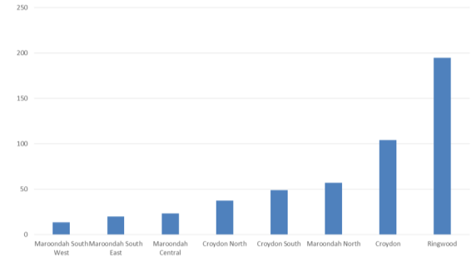

Source: Spatial Economics, 2016

*Plan Melbourne* and the *Plan Melbourne Refresh* support the idea of the 20-minute neighbourhood, with a range of amenities all located within short travel distance. The concentration of residential development within activity centres helps to achieve this objective, as it reduces travel time and provides ready access to facilities and services. While the 20-minute neighbourhood concept applies primarily to Melbourne’s approximately 900 neighbourhood centres, similar benefits can still be achieved in larger centres by concentrating housing and services within a defined geographic area.

The *Plan Melbourne Refresh Discussion Paper, October 2015* addresses issues relating to the location of new residential development. At a broader level, it encourages a focus on existing suburbs to accommodate the greater share of the growth, as compared with the growth areas. It also makes reference to clarifying locations that support population growth and new housing. Greyfield renewal is discussed and supported along with an objective to investigate the planning scheme mechanisms that can be used to achieve the coordinated and sustainable renewal of suburbs.

|  |  |
| --- | --- |
| Churchill Street Ringwood#2.jpg | New Street Ringwood.jpg |

*Medium density housing in the Ringwood Metropolitan Activity Centre*

The community has indicated a preference for a more strategic and managed approach to development, rather than a market-led, laissez-faire approach. The community identified that the Ringwood Metropolitan Activity Centre, with ready access to transport and services, is suitable for higher density development. However, it has also indicated that while Ringwood needs to be a hub, other parts of Maroondah should also take their fair share of development.

Encouraging smaller developments in Neighbourhood Centres can, if properly planned and incentivised, increase greater diversity in housing stock and provide more affordable housing options for people to live and stay in Maroondah.

A shift away from construction in established suburbs and towards activity centres will result in a greater proportion of the growing population living in proximity to public transport and existing services which will reduce reliance on the use of the private car. It will make better use of existing infrastructure investment and continue to protect what residents’ value most about Maroondah, including vegetation, natural assets and the tree canopy cover.

To deliver on this key direction, the following list of priority actions will be implemented:

**1.1a** Undertake additional strategic work to introduce into the Municipal Strategic Statement a stated target for the proportion of new housing in activity centres.

**1.1b** Review the alignment of the capital works program with the residential hierarchy of the Housing Strategy to address local infrastructure and public realm needs.

**1.1c** Investigate the feasibility of preparing developer contribution plans for activity centres.

**1.1d** Undertake a review of activity centre structure plans.

### Key Direction 1.2

Encourage greater development in lower order neighbourhood activity centres and shop-top housing and mixed use developments in smaller strip shopping areas to accommodate residential growth

Changing demographics mean that demand for different housing forms is increasing. While not all the new households in Maroondah will be looking for new dwellings, existing residents may be looking for other housing opportunities – a first home, to downsize, or move closer to a job or public transport. Spreading this increasing diversity of housing choice into smaller neighbourhood centres will provide a better spread of housing across Maroondah. In particular, older residents have indicated a preference to be located near services, but prefer smaller activity centres, rather than larger ones.

Newly constructed housing typically enters the market at a lower price point than existing housing in established areas. This is often because new houses are smaller in size and on less land. The expansion of medium density housing in lower order neighbourhood activity centres could therefore assist in the provision of affordable housing. The introduction of diverse housing typologies, such as shop-top housing will help introduce a different population demographic into local centres and could also aid in the provision of more age friendly housing within walking distance of shops and services.

The community's views on maintaining housing affordability were clear. The engagement process indicated strong support for diversity in the municipality, ranging from people, to the design of housing, including new housing being designed to be adaptable. The community also highlighted concerns about vacant shops in some centres. The opportunity to contribute to increasing the supply of more affordable housing is enhanced by the inclusion of carefully planned neighbourhood activity centres. It will also bring in more local residents making local businesses more viable with more potential customers within easy walking distance.

The distribution of this forecast household growth across the municipal area, by housing market is disparate. The Croydon and Ringwood housing market areas are forecast to grow fastest (at about 1.2% per annum). The housing market areas of Croydon South, Maroondah Central and Croydon North are forecast to grow at similar rates to Maroondah as a whole at around 1.0% per annum. Maroondah North, Maroondah South East and Maroondah South West are forecast to grow at 0.6%, 0.6% and 0.8% respectively.

This key direction seeks to change the planning controls and prepare structure plans for lower order neighbourhood centres that have the capability to accommodate, albeit limited, residential and mixed use development.

The designation of additional neighbourhood centres across the municipality will enable development to proceed in a more balanced fashion, rather than being focused exclusively on the existing Activity Centres. Facilitating additional medium density housing at these locations may aid in the provision of affordable housing or enable ageing in place, close to services. While the small number of neighbourhood centres means that their total contribution to additional housing stock will be less than the major activity centres, it is an important piece of the overall plan to increase diversity and affordability and provide well-located choices for Maroondah residents.

To deliver on this key direction, the following priority actions will be implemented:

**1.2a** Prepare a study to examine and assess the suitability and capacity of local shopping centres and adjacent areas to accommodate additional residential development.

**1.2b** Consider the development of a local planning policy to encourage shop top housing to accommodate residential growth.

**1.2c** Where appropriate, rezone residential land adjacent to lower order neighbourhood centres to the General Residential Zone and default to ResCode provisions.

## Focus Area 2. Managing growth and changing housing needs

### There are detailed initiatives that can support the managing of population growth and change, and the resulting change in housing needs. In particular, Council has identified the federally funded ‘Greening the Greyfields’ project as a major initiative to manage growth through housing regeneration in the middle suburbs in a sustainable way.

### Key Direction 2.1

Work in partnership with State Government and Swinburne University on the concept of ‘Greening the Greyfields’ in Plan Melbourne Refresh to deliver better development outcomes than existing subdivisions

The term ‘Greyfields’ is a housing redevelopment term for development that is occurring in areas with ageing populations and housing stock, as opposed to greenfield (urban fringe) and brownfield (ex-industrial land).

The *Plan Melbourne Refresh* contains a statement of support for greyfield renewal along with an objective to investigate planning scheme mechanisms to achieve coordinated and sustainable renewal of greyfield areas.

Typical redevelopment in greyfield areas is currently done on an ad hoc, lot-by-lot basis, with suboptimum outcomes and no additional land provided for social amenity/utility. ‘Greening the Greyfields’ seeks to take an active approach to housing growth, dealing with issues of ageing-in-place, downsizing, sustainable and affordable housing development. It seeks to manage growth more strategically and incorporate benefits from good design and technology use.

This approach is both highly relevant and beneficial for Maroondah. Maroondah's housing stock is mature and ageing. The housing market has seen this and responded, but only in ad-hoc fashion, without guidance and with no sense of creating functioning places. The *Housing Supply Analysis – Charter Keck Cramer, May 2015* indicated that in Maroondah “69% of all projects are small scale, resulting in either one or two net additional dwellings”. Furthermore, the community engagement process highlighted the need for areas other than the larger activity centres to take their fair share of development, but also wants to maintain the character of the suburbs of Maroondah and maintain affordability. Furthermore, transport and accessibility were identified as the major infrastructure concerns of the community and designed and located greyfield development should be able to cater to these housing needs.

Given that major developers are not yet looking at the opportunities in the greyfields, this adds further incentive to plan and promote the right type of redevelopment in certain parts of Maroondah rather than allow ad-hoc development to continue.

In delivering on this key direction, Council will firstly implement the objectives of ‘Greening the Greyfields’ within the Maroondah Planning Scheme. The second stage will be to identify pilot precincts and work on a site specific amendment to implement the greyfield renewal.

Implementing the objectives of ‘Greening the Greyfields’ into the Planning Scheme will provide additional support for the greyfield renewal. The second stage will allow Council to proceed with a site specific amendment that includes community engagement.

To deliver on this key direction, the following list of priority actions will be implemented:

**2.1a** Prepare guidance on locations and form of greyfield renewal, building on the top rated housing needs from the community consultation as well as technical research.

**2.1b** Seek expressions of interest from the community to participate in a pilot program. This could involve larger landholdings or a given area where interest exists.

**2.1c** Develop a planning scheme mechanism that can be used to deliver greyfield development on large or amalgamated lots.

**2.1d** Partner with the State and Federal Governments in relation to possible facilitating greyfield development.

**2.1e** Work with infrastructure and utility providers to assist modeling of future infrastructure needs according to our residential hierarchy.

## Focus Area 3. Protecting and enhancing our environment and neighbourhoods

Balancing development and the natural environment was the most commonly stated priority housing issue for our community. Continuing to maintain the leafy green image of Maroondah while enhancing liveability across the municipality must be balanced with catering for the demand for new dwellings. With careful planning, this should be achievable and a minimum expectation.

### Key Direction 3.1

Review, evaluate, reaffirm and enhance the existing commitment to areas of special environmental quality in Maroondah

One of the key features of *1997 Housing Strategy* was to protect the Wicklow Hills and Loughnan Warranwood ridgelines. The Maroondah Planning Scheme protected and enhanced these ridgelines through subdivision restrictions and vegetation controls.

The *Community Engagement Report: Developing a new housing strategy for Maroondah – February 2016* identified “Balancing development and the natural environment” as ranked the number one issue by the community. In terms of ways to address the issue, “Protect and enhance our vegetation, ridgelines and landscapes” was ranked number one. This supports the current approach to protecting ridgelines and restricting development in biologically sensitive areas.

The *Maroondah Housing Strategy Housing and Environmental Sensitivities Paper* – *Maroondah City Council, May 2015*, describes and analyses potential environmental sensitivities and impacts relevant to the development of this strategy, with a view to protecting the environment as well as enhancing residential amenity. The paper concludes that the housing strategy should consider a range of issues including neighbourhood character, ridgelines, views (to and from), flooding, water quality, trees and natural habitat (both flora and fauna), heritage, cultural sensitivity, contaminated land and climate proofing. The paper goes on to state that careful consideration of these sensitivities combined with sympathetic incorporation into the design of new development provides an opportunity to achieve good planning outcomes if it addresses housing in a strategic manner via structure plans, concept plans and initiatives such as ‘Greening the Greyfields’.

In particular this fits within *Maroondah 2040: Our future together* vision statement for the clean, green and sustainable community outcome key direction 4.8: *Create and foster a culture within our community that is committed to protecting the unique features of Maroondah’s landscape, including our ridgelines, waterways, canopy vegetation, green open space and bushland reserves.*

Council will take a lead role in areas such as; ensuring an adequate supply of land; a diverse range of housing to meet the needs of a changing community; directing housing to appropriate locations with adequate servicing; preparing strategies and concept plans relating to urban form on key sites as well as development responses to opportunities; and constraints such as protection of ridgelines, tree canopy, natural hazards, etc.

To deliver on this key direction, the following priority action will be implemented:

**3.1a** Undertake a municipal wide vegetation review and ensure consistency of supporting planning controls.

**3.1b** ReviewNeighbourhood Character elements, including heritage, of the Jubilee Park area.

### Key Direction 3.2

Strengthen the Local Planning Policy Framework to enhance environmentally sustainable design

An element of protecting and enhancing our environment is the design and operation of homes for reduced and ideally neutral, or positive environmental impact. This includes reducing energy, water use and the embodied energy of a building, as well as adequate private and public open space. *Plan Melbourne* acknowledges the impacts of climate change and the need to reduce emissions, a whole of water cycle approach and the protection of waterways and biodiversity and to reduce noise and air pollution. *Maroondah 2040: Our future together* echoes similar desires for the municipality.

A framework that could improve sustainability outcomes for all housing densities is the Sustainable Design Assessment in the Planning Process. This was developed by the Council Alliance for a Sustainable Built Environment and seeks to provide a consistent approach across Councils to requesting information about and assessing the sustainability of planning applications. This process involves recommended assessment tools such as Built Environment Sustainability Scorecard and Green Star.

The *Sustainable Communities Discussion Paper – Maroondah City Council, 2015* indicates that many stakeholders will need to work together to create sustainable communities. This includes residents, builders and developers and initiators and sustainers of relevant partnerships. This will include those with a passionate long term commitment to more sustainable homes and communities. Council’s role in creating sustainable communities is as a long term planner and service provider, developer of some community facilities and infrastructure, creator of long term partnerships and an advocate and facilitator. In addition, council is one of the drivers of the community vision and can help identify opportunities to attract implementers.

Council can also provide training internally and externally so that desired sustainable communities outcomes are better understood, learnings are shared and retained and co-ordination and flexibility are possible.

To deliver on this key direction, the following priority actions will be implemented:

1. Strengthen the sustainable design assessment within the planning process by providing ecological sustainable design and sustainability assessment tools and training, and investigate membership of the Council Alliance for a Sustainable Built Environment.
2. Investigate the use of the Built Environment Sustainability Scorecard to improve sustainability outcomes in future residential development.
3. Work with the State Government to prepare a planning scheme amendment to introduce an ecologically sustainable development policy into the Maroondah Planning Scheme.

|  |  |
| --- | --- |
| DSC_0033.jpg | N:\Photos\Maroondah Climate Photos Feb 2014\DSC_0031.jpg |

*Solar and rainwater capture are two key ways to make homes more environmentally sustainable*

## Focus Area 4. Improving affordability, accessibility and social housing opportunities

The background research found that “if housing is unaffordable and there is a lack of diversity of housing, residents in the Maroondah LGA will be priced out of the market.” In contrast, a diverse housing stock helps to provide more affordable housing options.

### Key Direction 4.1

Find ways to encourage and implement planning concessions that increase community benefits such as affordable or social housing, open space, off street parking, sustainability or design excellence

The *Housing Supply Analysis – Charter Keck Cramer, May 2015* found that “if housing is unaffordable and there is a lack of diversity of housing, residents in the Maroondah LGA will be priced out of the market.” In contrast, a diverse housing stock helps provide more affordable housing options. Similarly a lack of diversity in housing stock usually goes hand in hand with a less diverse community.

For the City of Maroondah, 9.5% of all households (a total of 3,400 low income households) can be deemed to be in housing stress i.e. paying more than 30% of household income in either rent or mortgage repayments. Among Australian states and territories, Victoria has the lowest percentage of its total housing stock provided as social housing. A 2013 analysis by Terry Burke of Swinburne University showed the percentage of social housing in Victoria at 3.4%. At the 2011 census, social housing as a percentage of the total housing stock was 2.8% in Maroondah.

Affordability has decreased with the proportion of household income required to purchase the average house increasing substantially. As at 2011, 34% of households owned a dwelling outright with 44% paying off a home and 22% of households were renting. Affordability for middle income households in 2014, was largely the domain of couples with children families; these households have the highest median incomes.

The *Plan Melbourne Refresh Discussion Paper* identifies the concept of ‘incentive zoning’ whereby floor space ratio bonuses can be achieved by developers in return for providing social and affordable housing units within developments. The Refresh paper notes that these concepts should be carefully considered and should not compromise amenity for residents and neighbours.

One of the ways that Council is seeking to encourage housing diversity and affordability is through the targeted and careful use of the planning system by way of development controls that contribute to housing diversity and affordability. Also housing quality such as environmentally sustainable design features that make houses more comfortable and cheaper to run. This starts from siting on the block, location of windows and construction materials that have better insulation standards, or efficient lighting.

An example of this key direction was identified by developers as being able to be achieved on larger lots where a height bonus in the middle of the site would not significantly impact on neighbouring properties.

Council will investigate the introduction of a system of bonuses and incentives for development that meets an identified housing need (e.g. affordable housing). This approach will introduce additional flexibility into the planning system and give Council officers additional scope to negotiate with development proponents.

To deliver on this key direction, the following list of priority actions will be undertaken:

**4.1a** Investigate the potential to vary development controls where; a proportion of dwellings are affordable; and the development incorporates best practice environmentally sustainable design principles.

### Key Direction 4.2

Continue to promote affordable housing, social housing and age-friendly accommodation through regional collaboration, advocacy to higher levels of government and policy development

Affordable and accessible housing remains a key issue for the community, developers and service providers. These groups recognise the impacts of rising house prices and increase in demand for and falling supply of affordable rentals. There is little affordable accommodation available for lower income families with children and when a household breaks down, families and children often have to move away from the area to find affordable housing, which breaks social connections and affects wellbeing. The proportion of affordable new rental lettings has dramatically declined in the City of Maroondah, from a total of 38% of all new lettings in 2006 to 11% in 2008. It declined further to 4% of all new lettings in 2010 and has since remained relatively constant.

Furthermore, there is a lack of access to affordable age-friendly housing for the ageing population and this is becoming an increasing source of housing and general life stress. If suitable accommodation and care isn’t available, relatives often have to cut back on their work commitments to provide assistance. The Maroondah population is ageing. The fastest population growth of all age categories being in the 70 to 84 year age group, averaging around 2.3% per annum.

Taking action at the local planning level is the key tool for Maroondah City Council to achieve this focus area, however, both State and Federal Governments also have a role to play as well.

In addition to the private home buyers market, there is a critical need for social and special needs housing across Melbourne. Part of a liveable and accessible Maroondah includes access to social and special needs housing and social and affordable housing, especially in areas close to transport, employment clusters and community services, provide support to the most vulnerable members of our community.

Maroondah is already working with other local government authorities. The Eastern Affordable Housing Alliance (EAHA) was formed in 2010 in response to diminishing investment in social housing in the region by the State and Federal Governments. The EAHA comprises of seven local governments; Boroondara, Knox, Manningham, Maroondah, Monash, Whitehorse and Yarra Ranges. The EAHA aims to increase social and affordable housing within the region by:

* Developing partnerships with researchers around specific strategies that are being trialled globally;
* Identifying practical and creative ways that local government can influence the generation of more social and affordable housing; and
* Advocating to State and Federal Government to invest more in social housing.

Council’s ability to directly influence achievement of these objectives is limited, however, it is important to recognise the critical role of the social and special needs housing sectors. Council wishes to engage more fully with its stakeholders in the implementation of this Strategy and advocate to the State and Commonwealth Governments in relation a need for increased funding to service providers. Council can also investigate where it can assist the provision of social and affordable housing by looking at how zoning mechanisms or Council land holdings may be able to assist.

In delivering on this key direction, Council will develop a policy on affordable and social housing. Given the extent to which the issue was highlighted in all aspects of community engagement and consultation, it can be concluded that this is a central issue for the community, both currently and into the future. The development of an affordable and social housing policy will allow Council to take the initiative in this area and initiate contact and partnerships with community and service organisations.

To deliver on this key direction, the following list of priority actions will be implemented:

**4.2a** Develop a Council policy position on affordable and social housing that considers the introduction of additional measures and advocacy activities.

**4.2b** Work with the Eastern Affordable Housing Alliance to identify opportunities to achieve more social, affordable and special needs housing.

**4.2c** Support housing associations seeking to develop social and affordable housing projects.

**4.2d** Develop a land register of all Council, Crown and public land and underutilised/vacant land and identify strategic redevelopment opportunities in accordance with the objectives of this strategy through the application of a Design and Development Overlay for strategic sites.

## Focus Area 5. Building on and improving the planning framework

Council balances a broad number of strategic planning objectives within the Municipal Strategic Statement including transport, accessibility, heritage, open space, retail and commercial activity, industrial land use. These objectives will be balanced with increasing need for residential development of housing that is diverse and affordable.

The *1997 Housing Strategy* helped establish the core planning framework principles within the Maroondah Planning Scheme, which remain relevant today:

1. Ringwood and Croydon Activity Centres
2. Wicklow Hills and Loughnan Warranwood Ridge lines
3. Neighbourhood character and amenity

The future for the municipality indicates continuing strong demand for housing with growth of around 500 new dwellings per annum projected through to 2041. All household types will grow strongly particularly *lone person* and *single parent* families. However, due to their significant current numbers and projected growth rate, there will be a significant increase in *couple families with children* households. This household type typically desires housing with higher levels of space (internal and external). Within Maroondah the land supply available for this type of housing is effectively fixed. The significant rate of growth of *lone person* households will likely see a rise in the demand for smaller and affordably priced dwellings. This trend is compounded by the ageing of the population, which leads to higher proportions of one and two person households.

Focus groups demonstrated strong support for the existing subdivision restrictions and protection of ridgelines. Protecting and enhancing vegetation and landscapes emerged as the highest priority issue overall throughout the engagement activities.

Key Direction 5.1

Implement the *Maroondah 2040: Our future together* key directions for an attractive, thriving and well built community and the *Active and Healthy Ageing Initiative*

The *Maroondah 2040: Our future together* community vision provides a ‘roadmap’ for the community, Council and other levels of government to partner together and create a future that enhances Maroondah as a great place to live, work, play and visit. Many of the areas covered in the community vision are also supported in *Plan Melbourne* and the *Plan Melbourne Refresh*.

The community vision applies to all of Maroondah and is the primary driver on the future direction of all Council strategy. Accordingly the *Municipal Strategic Statement* will need to be reflective of the land use components of the community vision. As demonstrated in Figure 1.1 a strong link will need to be established between the *Maroondah 2040: Our future together* community vision, the *Municipal Strategic Statement* and the Maroondah Housing Strategy. The housing and land use elements of all the eight community outcomes will be considered but particular attention will be given to referencing the attractive, thriving and well built community outcome within a planning scheme amendment to the *Municipal Strategic Statement*.

In relation to housing the *Active and Healthy Ageing Initiative* states:

*“The initiatives reflect our community’s desire to continue living in Maroondah but having access to housing stock that suits their changing needs whilst still ensuring that facilities and amenities are conveniently located and accessible so that they can continue to actively participate in all aspects of Maroondah life. Decreased mobility and confidence as people age requires considerations and encouragement towards more flexible and adaptable housing options based on universal design principles that are conveniently located.”*

The importance of being able to age in place was stressed by the community engagement process for this Strategy, along with the *Healthy and Active Ageing Initiative*. The community and service organisations group also strongly support adaptable housing that allows people to age within their own community. People build up social connections over time in their community as well as connections with service and medical providers. Moving to another area breaks these connections and impacts on people’s well being.

The Maroondah population is ageing. The fastest population growth of all age categories being in the 70 to 84 year age group, averaging around 2.3% per annum. This has implications in terms of ageing in place service delivery, the potential ‘churn’ of housing stock (i.e. older households seeking to downsize their dwellings) and the need for aged care housing (both independent and dependent housing/accommodation).

Planning across all housing markets within Maroondah should therefore provide for a diversity of housing stock and the ability of the stock to be progressively modified as households needs and preferences change. The Australian Government Department of Industry has produced *Housing of the future, the liveable and adaptable house guide*. Flexible design enables housing to adjust to changing needs over time. These needs might be an expanding family, the onset of old age, or the need to upgrade technology. Flexible housing has social benefits where the house can easily adapt to suit the different life stages of the household.

When building a new home, people anticipate spending a number of years, if not decades, living in it. Others may conceive of a shorter stay. Whatever the intention, any new home is likely to have to accommodate changing needs over its lifetime. A liveable and adaptable house is one that is able to respond effectively to these needs without requiring costly and energy intensive alterations.”Introducing the vision and community outcomes of *Maroondah 2040: Our future together* will help to align the Maroondah Planning Scheme with the aspirations of the community and Council’s Integrated Planning Framework. The introduction of objectives to address the needs of the ageing population of Maroondah is in keeping with Council’s approach to being an age-friendly city.

To deliver on this key direction, the following priority action will be implemented:

**5.1a** Prepare a planning scheme amendment to introduce the Housing Strategy, along with the vision and community outcomes of *Maroondah 2040: Our future together* into the Maroondah Planning Scheme.

**5.1b** Investigate the incorporation of universal design principles into current Design and Development Overlays to ensure accessibility and community safety for all ages and abilities.

Key Direction 5.2

Review the reformed residential zones and any unintended consequences of the new zones.

In 2014 the State Government introduced reformed Residential zones. State Government reformed residential zones are intended to “identify areas with development potential and those where retaining existing character is a priority”. The RGZ is intended to increase housing supply within locations such as the Ringwood Metropolitan Activity Centres.

The zones are also intended to assist with urban renewal in identified strategic locations. Council may receive representations to apply the NRZ in areas that are currently in the GRZ. This could limit the potential for urban renewal in these areas.

Implementing the Reformed Residential Zones into the Maroondah Planning Scheme was done in alignment with Maroondah’s Strategic Framework Plan alongside support from the *Department of Transport, Planning and Local Infrastructure’s Housing Development Data Analysis October 2013* and in accordance with the Planning Practice Note 78. Planning Practice Note 78 provides information and guidance about the purposes and features of the residential zones including how to apply them, and the options available for schedules.

Overuse of the NRZ is cautioned by *Plan Melbourne Refresh*, however it does identify that “over time, different densities and dwelling types will emerge in each residential zone, with higher density outcomes in the RGZ, greater medium-density development in the GRZ and low-density housing retained within the NRZ. When applied on the basis of sound strategic planning, the zones can facilitate housing diversity.”

The full impact on the market of the new residential zones is not yet known and almost a quarter of new residential production in recent years was located in areas NRZ. NRZ3 and Significant Landscape Overlay Schedule 3 (SLO3) land account for over 26% of all new supply project activity and land within the GRZ and Significant Landscape Overlay Schedule 4 (SLO4) account for over 51% of all net new dwellings within Maroondah.

The development community has stated that the impact was felt in the market within a month of the new zones being implemented, with a significant change in pricing evident and they feel that the impact on affordability of zoning and zoning changes is not always appreciated or acknowledged by government.

There was also concern that NRZ had been applied across the municipality in a blanket fashion and that there are areas zoned NRZ that may be appropriate for higher density housing. In addition, the existing 864m2 minimum lot size in NRZ2 areas arises from the need to accommodate septic tanks on site and is no longer relevant where access to the reticulated network is available. By contrast, Council has received representations from community groups regarding development pressures being experienced in their locales. Council has accordingly written to the Minister for Planning with regards to the area bounded by Hull Road, Ruskin Avenue, Mt Dandenong Road and the Maroondah municipal boundary concerning uncoordinated small scale infill development that has delivered suboptimal outcomes for the local community. In locations such as these, and similarly the land bounded by Wonga Road, Warrandyte Road and North Ringwood Reserve, there is an argument to consider rezoning land from the GRZ to the NRZ.

A State Government appointed Advisory Committee is considering the residential zones. Any actions to respond to the residential zones will need to be further developed after the outcomes of the Advisory Committee are known. Then Council can then undertake further strategic work as recommended and in the context of this Housing Strategy and other supporting studies.

To deliver on this key direction, the following priority actions will be implemented:

**5.2a** Develop criteria to assess rezoning requests from NRZ to GRZ, GRZ to NRZ, commercial to residential (or vice versa).

**5.2b** Undertake a review of the NRZ, in conjunction with a review of vegetation controls.

**5.2c** Prepare a planning scheme amendment forthe rezoning of residential land in the Ruskin Park and Wonga park precincts from GRZ to NRZ.

**5.2d** Review the residential zones once the Advisory Committee appointed to consider the residential zones has released its report and Council undertake an ongoing Housing Monitoring Data review.

### Key Direction 5.3

Develop an ongoing consultation and facilitation role for Council to work with key housing sector players to provide clarity and certainty in the planning system that will help deliver our housing vision.

Delivery of this housing strategy will require participation from all players in the process - a whole of council approach and working with stakeholders such as the community, businesses, the development industry and service and housing providers.

This Strategy has been developed including extensive consultation with stakeholders from the community and the development sector. In particular, the developer focus group expressed a strong desire for a regular mechanism for Council to engage the industry on housing issues.

Council will continue partnerships with key players and in particular focus on facilitation of our desired outcomes. In particular, Council will seek to provide brokering or facilitation services to for projects and will provide greater certainty through developing site specific aspirational ‘concept’ plans.

Council will look to use the housing market areas as a framework to engage with the community.

To deliver on this key direction, the following priority action will be implemented:

**5.3a** Develop an annual housing forum to engage with developers, community groups and housing providers.

**5.3b** Prepare housing area profile statements to engage local communities in helping to realise the objectives of the Maroondah Housing Strategy.

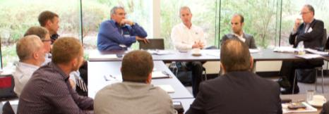

A series of Housing Strategy stakeholder focus groups were held during October 2015

# 7 Implementation and Review

## 7.1 Implementation Process

The Maroondah Housing Strategy forms part of Council's response to delivering on *Maroondah 2040: Our future together*. It will be implemented with a whole of Council approach to housing and will involve regular review.

The Strategy outlines key priority actions to be undertaken to deliver on the focus areas which support the overall vision for housing in Maroondah. It is anticipated that additional priority actions and projects may be identified over time which will also support this vision and the changing needs of the Maroondah community.

An Implementation Plan will be developed to accompany an adopted Housing Strategy. This Plan will include indicators to measure performance, establish timeframes and outline the resources required to deliver the actions in the Strategy. Actions will be prioritised taking into account Council policy, cost effectiveness and the ability to deliver within timeframes.

The Plan will address each of the focus areas and provide details regarding how and when Council will deliver on each of the priority actions.

Priority actions for 2016/17 and 2017/18 are outlined below:

|  |  |
| --- | --- |
| Key Direction | Priority Action |
| 2.1 Work in partnership with State Government and Swinburne University on the concept of ‘Greening the Greyfields’ in Plan Melbourne Refresh to deliver better development outcomes than existing subdivisions. | **2.1a** Prepare guidance on locations and form of greyfield renewal, building on the top rated housing needs from the community consultation as well as technical research.  **2.1c** Develop a planning scheme mechanism that can be used to deliver greyfield development on large or amalgamated lots. |
| 3.1 Review, evaluate, reaffirm and enhance the existing commitment to areas of special environmental quality in Maroondah. | **3.1a** Undertake a municipal wide vegetation review and ensure consistency of supporting planning controls.  **3.1b** ReviewNeighbourhood Character elements, including heritage, of the Jubilee Park area. |
| 5.1 Implement the Maroondah 2040: Our future together Vision key directions for an attractive, thriving and well built community and the Active and Healthy Ageing Initiative. | **5.1a** Prepare a planning scheme amendment to introduce the Housing Strategy, along with the vision and community outcomes of *Maroondah 2040: Our future together* into the Maroondah Planning Scheme. |
| 5.2 Review the reformed residential zones and any unintended consequences of the new zones. | **5.2d** Prepare a planning scheme amendment forthe rezoning of residential land in the Ruskin Park and Wonga Park precincts from GRZ to NRZ. |

The specific priority actions and projects outlined in this Strategy will be monitored as they are implemented and reported to Council and the community on an annual basis.

In accordance with Council’s *Community Engagement Policy 2016*, Council will continue work with local communities in helping to shape housing development throughout the municipality and in the implementation of the priority actions outlined in this Strategy.

An interim review of the Strategy will be undertaken every five years with a full review to be undertaken by 2031.

## 7.2 Monitoring, Review and Reporting

One of the issues arising from the review of the *1997 Housing Strategy* was the fact that the planning and population conditions changed significantly compared to what they were when the strategy was written. It is important that this Strategy is flexible enough to adapt to changing conditions. A system of monitoring and review will be implemented so that Council is aware of when these conditions begin to change.

### Changing population, housing and economic data

The majority of population, households and dwelling data come from the 5-yearly Census. However, five years is a long time in today’s ever-changing world. Council will undertake two updates to our data every five years, with one following each Census being a major update of all data and minor updates in the intervening two and a half year period.

These updates will include updates for Metropolitan, Outer Eastern Regional and Maroondah in the following areas:

* Population change
  + Growth rates
  + Ageing (Census years only)
  + Household composition and formation (Census years only)
* Housing change
  + Numbers of dwelling approvals and completions
  + The composition of the new housing: dwelling types and locations
  + Households and dwellings analysis (Census years only)
  + Migration – where household are coming from and going to (Census years only)
* Housing market data
  + Median house prices (and change) for different dwelling type and by location
  + Median rents (and change) for different dwelling type and by location
  + Affordability calculation
* Economic data
  + Broad economic indicators
  + Local employment and industry data

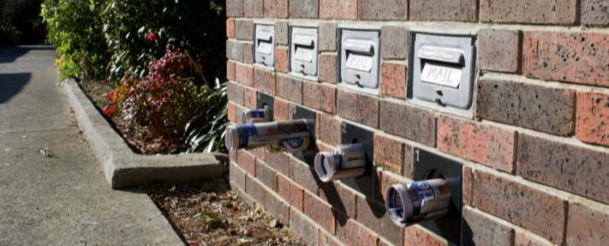

# 8. Glossary

**Activity centres:** Suburban centres that provide a focus for services, employment, housing, transport and social interaction.

**Advisory committee:** Specialist appointees who form a committee that provides advice and recommendations to Maroondah City Council on matters relating to the delivery of strategies, services and activities.

**Affordable Housing:** That which does not cost (in rent or mortgage payments) more than 30% of gross household income for households in the bottom two quintiles of area (i.e. Greater Melbourne) median income.

**Age friendly accommodation:** accommodation that has been designed or retrofitted/ adapted with the needs of aged people in mind.

**Ageing in Place:** Aging in place is a term used to describe a senior living and remaining in the residence of their choice as they age, while being able to have services (or other support) they might need over time as their needs change, for as long as they are able.

**Best practice:** To adopt or develop standards, actions or processes for the provision of goods, services or facilities which are equal to or better than the best available on a state, national or international scale.

**Canopy Tree:** A tree with a mature form (if reached or not) which allows activity below the height of the tree branches.

**Capital works:** Projects undertaken to establish, renew, expand, upgrade and dispose assets owned by Maroondah City Council in the community.

**Community engagement:** The process of Council working with residents, businesses and community groups to address issues that impact their well-being.

**Council:** The collective group of nine Councillors that set the strategic direction for Maroondah City Council, monitor organisational performance, liaise with stakeholders and ensure operational compliance.

**Demographic changes:** Changes to population characteristics based on factors such as age, race, sex, economic status, level of education, income level and employment, etc.

**Diversity:** Types and cost of housing (houses, town houses, apartments etc.) and the size of the dwellings (studios, one and two bedroom or large family homes with a back-yard).

**Dual occupancy:** Two dwellings on a lot.

**Ecologically Sustainable Development:** Development which achieves ecological sustainability while striving to meet society's other needs

**Greenfield:** Undeveloped land identified for residential or industrial/commercial development, generally on the fringe of metropolitan Melbourne.

**Greening the Greyfields:** A federally funded project aimed at promoting sustainable housing regeneration in the middle suburbs. Usually concerns sites where residential building stock is failing (physically, technologically and environmentally) and energy, water and communications infrastructure is in need of regeneration.

**Heritage:** Heritage is that which is inherited. Heritage significance is usually defined in terms of historical, scientific, cultural, social, archaeological, architectural, natural or aesthetic value.

**Homelessness:** A person is considered homeless if their current living arrangement is in a dwelling that is inadequate, has no tenure (or if their initial tenure is short and not extendable) or does not allow them to have control of, and access to space for social relations (based on Australian Bureau of Statistics definition). Includes ‘rooflessness’, also known as ‘primary homelessness’ where a person typically lives on the street.

**Household types:** The makeup of the household. Couples with children, couples without children, one parent families, lone person, group households, etc.

**Housing Associations:** Not for profit organisations which are registered providers of social housing.

**Housing market area:** Areas defined within the municipality to assist with the preparation of the technical work feeding into the housing strategy. Housing market areas were defined based on a number of factors including zoning, topography, and characteristics of the local housing market.

**Housing Stress:** Defined when individuals and households who earn less than 80% of the median income pay more than 30% of weekly household income on housing.

**Inclusionary Zoning:** Relates to the mandatory contribution of development toward social housing needs through planning controls and provisions in the Planning Scheme.

**Infrastructure:** Constructed assets required for the functioning of the community, such as roads, drains, footpaths, lighting, paths, play equipment, public buildings, signage, streetscapes and waste systems.

**Integrated Planning Framework:** A hierarchy of strategic documents and processes that ensure all of Council’s activities and financial resources are aligned.

**Liveability:** Liveability is the sum of the factors that add up to a community’s quality of life—including the built and natural environments, economic prosperity, social stability and equity, educational opportunity, and cultural, entertainment and recreation possibilities.

**Local planning policy:** Guides decision-making in relation to a specific discretion in a zone or overlay. It helps the responsible authority and other users of the scheme to understand how a particular discretion is likely to be exercised.

**Maroondah 2040 Community Vision:** The long term community and Council vision for the City of Maroondah identifying the preferred future outcome areas and key directions for Maroondah.

**Metropolitan Activity Centre:** Higher-order centres with diverse employment options, services and housing stock, supported by good transport connections. Existing centres include Box Hill, Broadmeadows, Dandenong, Epping, Fountain Gate/Narre Warren, Frankston, Ringwood and Sunshine. Future centres will include Lockerbie and Toolern.

**Municipal Strategic Statement (MSS):** The key land use and development objectives and strategies for the municipality. The MSS provides the basis for zones, overlays and particular provisions.

**Municipality:** A geographical area that is delineated for the purpose of local government.

**Native Vegetation:** Native vegetation is defined in the Victoria Planning Provisions as ‘plants that are indigenous to Victoria, including trees, shrubs, herbs and grasses’.

**Neighbourhood Character:** Neighbourhood character is essentially the combination of the public and private realms. Every property, public place or piece of infrastructure makes a contribution, whether great or small. It is the cumulative impact of all these contributions that establishes neighbourhood character.

**Plan Melbourne:** The metropolitan planning strategy prepared by State government.

**Plan Melbourne Refresh:** Discussion paper released by State government in 2015 seeking inputs on proposed changes to Plan Melbourne.

**Planning and Environment Act 1987:** The legislation that governs planning in Victoria.

**Planning concessions:** An increase in development yield permitted in return for the provision of community infrastructure (public open space, etc).

**Planning framework** The existing policy context within which the housing strategy has been prepared. Includes Plan Melbourne and the Maroondah Planning Scheme.

**Planning scheme mechanism:** A planning control that can be used to achieve a given outcome e.g. a schedule to a planning zone or a design and development overlay, etc.

**Reformed residential zones:** The suite of residential zones introduced into the Victorian Planning Provisions in July 2014 and currently in operation across the State.

**Ridgeline:** A physical feature where landform drops away steeply on one or two sides.

**Social housing:** A type of rental housing that is provided and/or managed by the government or by non-government organisations. Social housing is an overarching term that covers both public housing and community housing.

**Structure Plans:** A means to provide precinct-specific direction on the extent, form and location of land use and development.

**Sustainability:** The principle of providing for the needs of the present community without compromising the ability of future generations to meet their own needs. The principle seeks to achieve long-term health and well-being across social, economic, environmental and cultural domains.

**Universal design principles:** Broad-spectrum ideas meant to produce buildings, products and environments that are inherently accessible to people of all abilities.

**Urban design**: The design of towns and cities, streets and spaces. It is the collaborative and multi-disciplinary process of shaping the physical setting for life in cities, towns and villages; the art of making places; design in an urban context.

**Urban Renewal:** The improvement or rehabilitation of urban areas. Urban renewal can build on an area’s existing strengths to make better use of underutilised land located close to jobs, services and transport.

**Victorian Planning Provisions (VPP):** A statutory device that provides a state-wide template from which planning schemes are constructed. The Victorian Planning Provisions provide planning tools such as zones and overlays for individual planning schemes to guide land use and development.

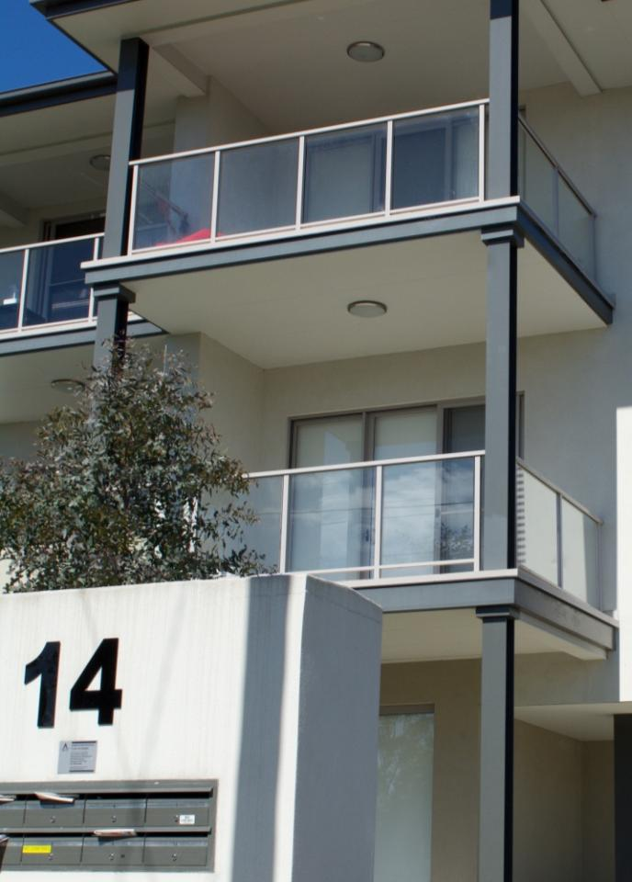



**To contact Council**

* phone 1300 88 22 33 or (03) 9298 4598
* visit our website at www.maroondah.vic.gov.au
* email maroondah@maroondah.vic.gov.au

**Translating and Interpreter Service**

13 14 50

**National Relay Service (NRS)**

13 36 77

 MaroondahCityCouncil

http://www.conslosangeles.esteri.it/NR/rdonlyres/7A2D0DDE-0A09-40F9-819B-CDEE679C4B37/70635/twitter1.png@CityofMaroondah

 CityofMaroondah

http://socialmediab2b.com/wp-content/uploads/2014/04/b2b-LinkedIn-Logo.png Maroondah City Council