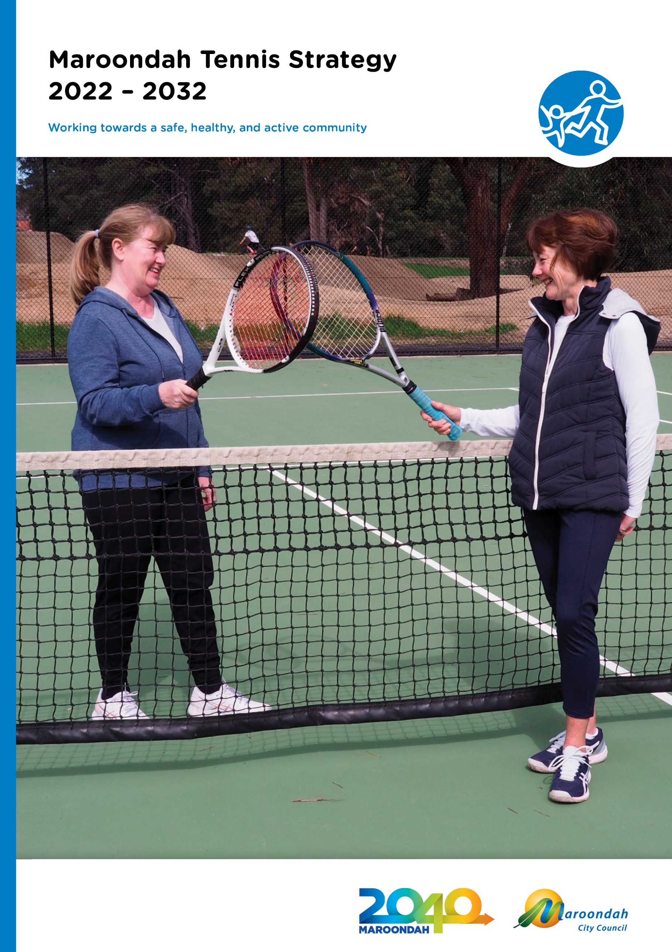

Contents

Supporting Tennis to Thrive in Maroondah 3

Executive Summary 3

Section 1 - Methodology & Strategic context 4

Section 2 - Tennis Participation & Provision 8

Existing Tennis Opportunities in Maroondah 9

Club Governance 12

Section 3 – What does the evidence say? 13

Tennis Facility Audit 13

Regional Tennis Governance Project 14

Tennis Victoria Thriving Tennis Communities Project 15

Section 4 – Community Engagement 16

Club Consultation 16

.Section 5 – A plan for the future 18

Where we want to be. 18

Our Vision 18

**Outcome area 1 - Participation & Access** 19

**Outcome area 2 - Club Governance** 21

**Outcome area 3 - Infrastructure Planning & Prioritisation** 22

**Outcome area 4 - Management & Leasing** 23

Tracking our progress 24

Section 6 – References and Glossary 24

References 24

Glossary 24

# Supporting Tennis to Thrive in Maroondah

## Executive Summary

**Tennis is an activity which can be competitive or very social. It can be mixed gender, be multigenerational and can be enjoyed in many different formats. Council would like to strengthen our partnership with Tennis Victoria and local tennis clubs to offer a wide range of opportunities for residents to enjoy tennis in the way that’s right for them.**

|  |  |
| --- | --- |
| In Maroondah, there are 84 Council owned courts, 11 tennis clubs (10 on Council land and 1 on private land) and four public access facilities. Additionally, Council owns a 6-court complex at Hughes Park, which has been converted to a multipurpose facility for use by the Chin community for multiple sports including tennis.  Tennis clubs within Maroondah have long played a valuable role in the overall sport and recreation options available to the community and have also provided a social hub for local neighbourhoods. Most facilities were constructed between 35 and 50 years ago, with limited renewal or upgraded infrastructure since inception. For Maroondah’s Council owned facilities, tennis clubs occupy the facility under a formal Council lease and are responsible for maintenance and renewal of court infrastructure and court fencing, venue operations, club membership and casual public usage. Through an independent audit, it was identified that a significant number of tennis facilities are in need of renewal or upgrade to remain safe, accessible and to maximise participation, including floodlighting, court surfaces, fencing, access paths, and landscape surrounds.  In recent years, with increasing sport options, the work week expanding to 24/7, and many other competing priorities, tennis as an overall sport has seen a decline in membership, volunteers and sport participation. In contrast, the recent global coronavirus pandemic has seen tennis as one of the few sports that has been able to operate with less disruption, due to the ability to social distance and based on it being undertaken in an outdoor environment. **An estimated 185,000 more Australian adults participated in tennis in 2020 compared with 2019**[1]. Council would like to support the sport of tennis to capitalise on one of the few positives of this detrimental situation and move forward with a strategic approach to improve sustainability and growth of tennis participation over the next 10 years**. The 10 year duration will align with the forthcoming lease term and allow time for the actioning of key infrastructure priorities.** | The development of an evidence based strategic approach involving all key stakeholders, will provide a framework for supporting clubs, improving accessibility to the sport, determining capital priorities, co-ordination of improved maintenance and increasing overall active participation. Furthermore, in instances where facility usage is not to capacity, the strategy will explore and identify opportunities to collocate complementary activities which will maximise use of community facilities and encourage the broadest possible community participation in sport and recreation.  The four key focus areas to guide Council’s support are:  Diagram  Description automatically generated  Each area will outline a vision for the outcome area, key directions and priority actions that will work towards their achievement over the period of the strategy. Quantifiable measures of progress towards the desired outcomes and the impacts of these actions.  The successful implementation of the Maroondah Tennis Strategy is subject to strong partnerships with local tennis clubs, collaboration with Tennis Victoria, State and Federal grant programs and available funding as part of Council’s annual budget process. While investing resources to support the sustainability of tennis clubs will be a key priority of the strategy, supporting opportunities for social and casual play will also be a key priority to ensure that tennis as a sport continues to **thrive** in Maroondah. |

# Section 1 - Methodology & Strategic context

**Methodology**

The Strategy development involved the following methodology:

|  |  |  |
| --- | --- | --- |
| **Stage 1 - Research and Data**   * Tennis Facility Audit and Situation Analysis * Background Research and local provision review * Eastern Region Council Collective Community Tennis Club Governance Review * Tennis Victoria Thriving Tennis Communities Pilot Project Partner | **Stage 2 - Consultation**   * Maroondah Tennis Club Forum 2021 * 1:1 Key Stakeholder consultation (Tennis Victoria, local Clubs) * Internal stakeholder workshops to address highlighted issues and priorities * Assessment of Regional approach | **Stage 3 - Strategy Development**   * Draft strategy developed and circulated internally * Presentation to Maroondah Tennis Forum 2022 * Stakeholder feedback sought * Public Exhibition * Final Strategy for adoption by Council |

**Strategic Context**

The Strategy aligns with a number of key directions from the **Future Outcome Area** - A safe healthy and active community outlined in Council’s **Maroondah 2040** visioning document and our Council Plan 2021 – 2025. They are:

**Key Direction - A healthy community**

1.9 Promote community wellbeing by supporting and empowering local community groups, sporting clubs and special interest groups across Maroondah

**Key Direction – An Active Community**

1.14 Work in partnership to increase opportunities and create welcoming, supportive and accessible environments for all community members to undertake physical activity

The Strategy will also support Council’s **Equally Active Policy and Strategy** which highlights Council’s commitment to creating safe, and welcoming opportunities for women and children to be involved in sport and active recreation and Council’s **Physical Activity Strategy** which guides Council’s commitment to supporting Maroondah Residents to undertake regular physical activity

**Tennis Victoria Strategy 2024**

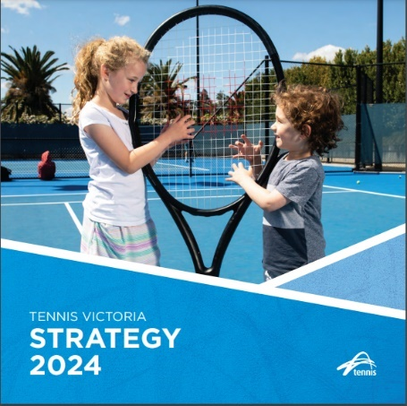The development of the strategy will be guided by the new **Tennis Victoria Strategy 2024.** This new strategy has been developed in consultation with Tennis Victoria’s affiliated clubs, centres, associations together with coaches, Local Government, State Government and Tennis Australia. The strategy closely aligns with the priorities of Tennis Australia and compliments the Victorian State Government’s Active Victoria Framework.

The Tennis Victoria Strategy 2024 was released in June 2021 and focuses on four (4) key pillars to achieve their purpose of *creating safe and inclusive thriving Victorian tennis communities, enabling more people to play more often.[2]*

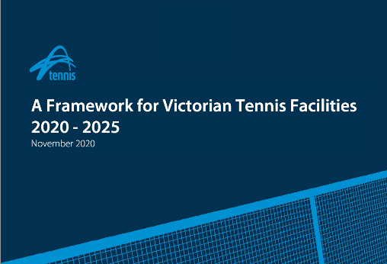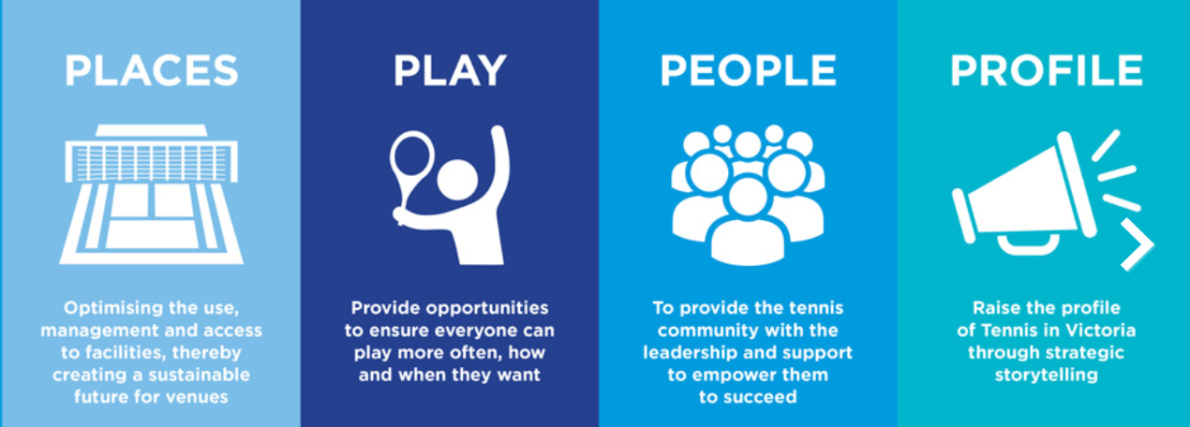

The strategy makes reference to partnering with local government to drive the overall health of Victorian tennis venues which complements Tennis Victoria’s ***A Framework for Victorian Tennis Facilities 2020 - 2025*** *(*released in November 2020) and states ***“The Facilities Framework 2020 - 2025 strongly reinforces the need for greater engagement with all levels of government, in particular the sport’s greatest facility sponsor - local government.” [3]***

The framework has four (4) strategic imperatives, three (3) of which detail a direct collaboration with local government:

|  |  |  |
| --- | --- | --- |
| **Grow Venue Capacity** | ***Build management capacity*** | ***Investment and advocacy*** |
| *We will continue to work in collaboration with local Councils, clubs and venue managers to conduct regular infrastructure, participation and operational audits to identify needs, monitor trends and provide action planning advice.* | *We will continue to work in collaboration with local Councils, clubs and venue managers to embed aligned management practices and outcomes into occupancy agreements* | *We will continue to conduct a biennial local government survey to identify and monitor trends and changes in need and priorities* |
| *We will continue to promote the benefits of LED lighting technology and support clubs, venues and Councils to implement lighting projects p14* |  | *We will start development a Local Government engagement plan that clearly articulates our approach to relationship building and communications with local government (as our primary sponsor of community tennis*) |
| *We will start completing facility audits of all Victorian tennis venues using the nationally adopted venue audit software.* |  |  |

**Regional Context**

Council has recently partnered with Parks & Recreation Consulting and our neighbouring Eastern Councils to undertake an **Eastern Region Council Collective Community Tennis Club Governance Review**. The review highlighted an urgent need to support clubs with governance structures, strategic planning and facility planning to maintain a sustainable future. In addition, in June 2021, Council engaged a consultant to undertake a visual infrastructure audit to obtain a basic understanding of current asset condition and compliance levels and establish a financial estimate of liabilities and future capital priorities. The key findings of the **Tennis Facility Audit and Situation Analysis** are detailed further in section 3 and highlight a need to develop a robust plan for the delivery of tennis infrastructure upgrades and renewal over the next 10 years.

To complete the review, Council has also partnered with Tennis Victoria to pilot their latest initiative the **Thriving Tennis Communities Project**. The Thriving Tennis Communities Project is a health audit tool, that helps Tennis Australia, Tennis Victoria, Council and local Clubs to review their current practices and procedures to identify areas of concern, so that all stakeholders can work together to target direct needs for the respective tennis communities. The project provided Council with a Venue Sustainability Rating report for Maroondah highlighting that significant investment is required to support both tennis infrastructure needs and club sustainability.

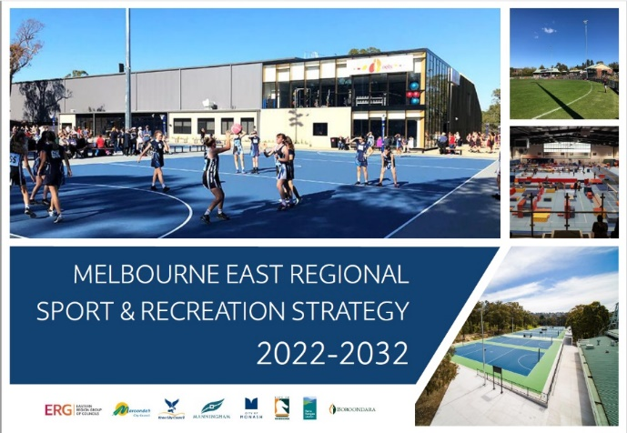

**The Melbourne East Regional Sport and Recreation Strategy** **- Updated 2022**

The Melbourne East Regional Sport and Recreation Strategy was established in 2016 to be the region’s first coordinated and collaborative approach to sport and recreation planning. The regular network of seven (7) Councils has continued to be a strong regional alliance, and the strategy has undergone a recent review and update.

The updated strategyhighlights that the North-East Link construction will see the closure of the Boroondara Regional Tennis Centre and relocation to the City of Monash. The move will impact the capacity for tennis events in the Boroondara and Manningham localities and furthermore, may impact Maroondah Clubs who previously provided satellite venues to support the larger Boroondara Regional Tournaments. The two key regional facilities listed in the MERSRS Strategy are the proposed Glen Waverley Sports Hub (18 courts) (to replace the Boroondara Tennis Centre) and the Notting Hill Pinewood Tennis Club (12 courts). Maroondah has two venues with 12court facilities and an 11court facility, however accessibility, lighting constraints and International Tennis Federation (ITF) baseline and safety run off requirements restrict our venues’ capacity to host Regional and high-level pennant events.

**Yarra Ranges Tennis Plan 2014 - 2024**

Not dissimilar to Maroondah, Yarra Ranges reported a steady decline in tennis club membership however strong junior lesson participation. The Plan highlighted an oversupply of courts in some suburbs and some clubs with extremely low membership and utilisation. The recommendation was to consider consolidation of these memberships to support a more sustainable combined club, or a number of small clubs using one venue and/or providing a multiuse surface and line marking to accommodate other sports. The plan also proposed a hierarchy of facilities based on Tennis Australia classifications to support future capital planning and maintenance levels.

**Knox City Council - Guidelines for Developing Sports Facilities Policy - March 2019**

Policy Section 6.5.1 Tennis - *Tennis facilities located on Council land will be classified as either (local junior or lower-level senior) or municipal (senior level predominantly municipal catchment) level only. There are 6 local and 8 municipal tennis facilities.* There are no regional level facilities within the municipality, due to a total of nine or more same surface courts being

required to hold regional tournaments

**Manningham Active For Life Recreation Strategy 2010 - 2025**

The Recreation Strategy has included the consolidation of a number of sports strategies including the 2003 Tennis Strategy. These strategic documents have been incorporated into the Action Plan. A key action for tennis was to develop a guiding document, however upon review, tennis was incorporated into Manningham’s Sports Facility Development Plan (SFDP). Facility Provision Analysis identified a total of 132 tennis courts with 78 being Council owned courts across the 9 local clubs. Participation had decreased significantly, with a 16.97% decline between 2015/16 and 2019/20. Facility provision calculations, endorsed by an independent consultant, considered the need for 1 court per 25 club members, using a 1.61% penetration rate. Furthermore, using a 1:1500 population ratio the report highlighted a need for an additional 16 public access courts by 2036 based on population ratios, however, taking into account private and school facilities a surplus was still evident.

**Whitehorse Recreation Strategy 2015 - 2024**

Within this strategy, Tennis did not feature as a sport requiring priority actions. The only reference to tennis was the opportunity to collaborate with Tennis Victoria on expanding sport participation pathways.

**Monash Tennis Plan 2020**

The Monash Tennis Plan highlights 3 key guiding principles which were used to develop actions:

1. Optimising use of tennis facilities *Prioritise bigger and more vibrant tennis venues that have a minimum of 6 courts.*
2. Inclusive and accessible tennis clubs *Provision of inclusive and flexible participation opportunities*
3. High quality and successful tennis venues *Tennis facilities are renewed and maintained to meet minimum standards and ESD design principles.*

*Notable financial obligations -*

|  |  |  |
| --- | --- | --- |
| **Tennis element** | **Financial Responsibility** | |
| Court base renewal | 100% Council (subject to Council adoption) | NIL Clubs |
| Court surface renewal | NIL Council | 100% Clubs |
| Court Floodlighting to minimum standards  (new installation or upgrade) | 50% Council | 50% Clubs |

Yarrunga Reserve multipurpose public courts - refurbished June 2022

# Section 2 - Tennis Participation & Provision

Nationally, Tennis is ranked 8th in the top 20 sports and physical activities, based on the participation of adults 15+ and organised out of school participation of children 0-14 years[4]. In Maroondah, the 2014 resident consultation for the Physical Activity Strategy[5] highlighted that tennis is the 10th most popular sport or recreation activity, ahead of individual recreation pursuits and the sports of AFL, Golf and Soccer.

The Thriving Tennis Communities Project reported 137,773 total annual visits to Maroondah Tennis Clubs with an average of 1606 visits per court. Data was recorded between mid to late 2021.

The breakdown for annual participation was as follows:

|  |  |
| --- | --- |
| COACHING | 56% |
| COMPETITION | 29% |
| SOCIAL | 10% |
| EVENTS | 3% |
| SCHOOL | 2% |

Note: School visits refers to students attending club courts i.e., holiday programs/before & after school care tennis programs, or schools booking of club courts as school competitions and in-school coaching did not occur during covid.

Tennis is an **intergenerational** sport with families able to participate together and participants generally ranging from 3 years to 80 years. Tennis is also a sport that can be played socially and competitively with mixed gender. Recent AUSPLAY data illustrates that in comparison to many other sports there is a marginal difference between the gender breakdown in participation, particularly in junior participation.[6]

AUSPLAY 2021 - National Tennis Participation by percentage of the population

This trend is similar in Maroondah where most Clubs have a balance of genders across their membership and committee roles. Additionally, in Maroondah tennis has seen huge growth in the number of culturally diverse participants particularly from Chinese backgrounds. This is significant as this cohort has been reportedly somewhat difficult to reach based on feedback from local basketball, AFL, soccer and cricket clubs

Organised tennis opportunities are available seven days per week with weekday, weeknight and weekend social play, private coaching and club competitive options, as well as four (4) free public access courts.

## Existing Tennis Opportunities in Maroondah

Tennis Victoria has responded to participation data and the needs analysis by developing a number of new products to adapt to the changing needs of their market and have a focus on social, introductory and /or casual participation. Tennis Victoria supports local clubs with both starting up these new programs and ongoing promotion and referral.

Current opportunities available within Maroondah include the following:

|  |  |
| --- | --- |
| **Free public access** | Open courts provided and maintained by Council at Canterbury Gardens, Glen Park, Belmont Park and Yarrunga Reserve |
|  |  |
| **Online casual court hire** | Online public hire booking systems which provides hirers with a code to a keypad or lock to independently access the courts. Currently offered by five (5) Maroondah Clubs. |
|  |  |
| **Private Coaching** | All Maroondah clubs host tennis professionals who provide coaching for all ages in both a group and private setting. Fees are paid directly to the coach through a private business arrangement. |
|  |  |
| **School Holiday Children’s Programs** | Maroondah City Council offers indoor tennis holiday programs at Maroondah Nets Stadium. Clubs intermittently offer programs through their coaching programs. |
|  |  |
| **Club Membership** | Membership enables participants to access social play, junior, senior, midweek and night competitions where offered, and access to courts for independent play when available. Offered by all Maroondah Clubs. Not all clubs require membership for night competition. |
|  |  |
| **Tennis Victoria Hot Shots** | A staged introductory program for children ages 3 - 12 years, played on smaller courts with modified equipment, including lighter racquets, lower nets and low compression balls. Currently available at 11 Maroondah clubs and 13 schools with 8 offering Match play. |
|  |  |
| **Tennis Victoria Cardio Tennis** | A 45 - 60 min tennis workout program catering to all fitness levels combining a variety of cardio workouts and a range of fun tennis drills. Currently available at 8 Maroondah tennis clubs and 3 primary schools |
|  |  |
| **Tennis Victoria Tennis4Teens** | A new social non-competitive program designed by teens, for teens aged 12 -17 years of all abilities. Sessions typically run for 1 to 1.5 hours for a 6–8-week term. Maroondah clubs did not offer a program in 2022. |
|  |  |
| **Tennis Victoria Open Court Sessions** | A social 90-minute session, with social tennis and off court socialisation. Currently offered by 2 Maroondah clubs. |
|  |  |
| **Culturally & Linguistically Diverse Communities (CALD)** | Chokhlei Tennis Club in partnership with Croydon Tennis Club has received Council funding to deliver coaching for the Chin community. All tennis clubs have reported an increase in junior players from CALD backgrounds, in particular Chinese. |
|  |  |
| **Disability** | Gracedale Park Tennis Club advertises PWII coaching (Players with an intellectual impairment). Hot Shots coaching is offered at Croydon Special Development School and Ringwood Central offer a monthly program for participants with autism and is gauging interest in a special Olympics program. |
|  |  |
| **Night Tennis Competition** | Lilydale & District Night Comp. is the second largest night tennis association in outer eastern Melbourne and offer adult night tennis competitions catering for all player standards Monday - Thursday. Participants are not required to be a member of a club to join a team. Knox District Tennis Association has 4 Maroondah clubs currently participating with a total of 17 teams. |

**Current Tennis Infrastructure Provision**

The Tennis Victoria has previously recognised a benchmark for the provision of tennis courts of 1 per 2,000 people. Maroondah has a total population of 115,043 recorded in the 2021 Census highlighting that given this former benchmark Maroondah should have a minimum of 58 courts to cater for our population numbers. Current courts numbers are 88 with 73 of these being lit. Tennis Victoria has shifted away from this benchmark towards use of supply and demand data and region demographics compared to propensity to play tennis demographical data. Greater examination of demographical data is required to fully understand this for the Maroondah population.

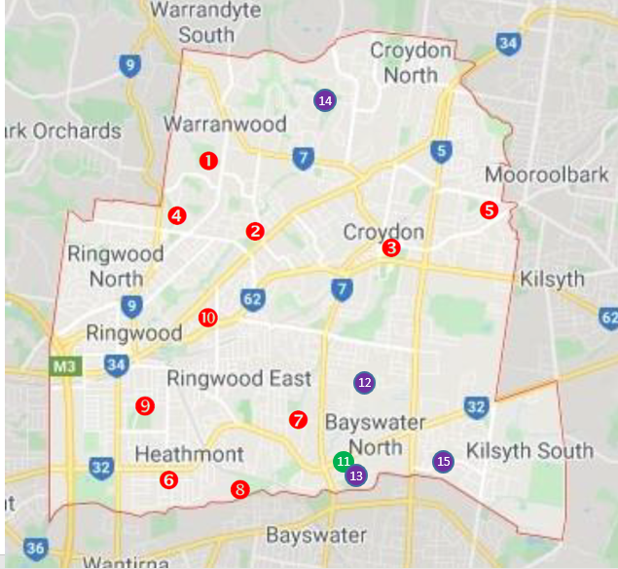

**Map of Tennis Court Locations**

|  |  |  |  |  |  |  |
| --- | --- | --- | --- | --- | --- | --- |
| **Map**  **Number** | **Venue location** | **Suburb & Ward** | **Venue Type** | **# Of courts** | **Surface type** | **Floodlit courts** |
| **1** | **Quambee Reserve** | **North Ringwood**  **YARRUNGA** | **Club & Online Public Hire**  **Parkwood Tennis Club** | **12** | **6 x En-tout-cas**  **6 x Artificial Grass** | **12 (6 currently not operational)** |
| **2** | **Peter Vergers Reserve** | **Ringwood**  **MCALPIN** | **Club & Private Coaching**  **Burnt Bridge Tennis Club** | **6** | **En-tout-cas** | **6** |
| **3** | **Croydon Park** | **Croydon**  **WICKLOW** | **Club, Private Coaching**  **Book A Court Public Hire**  **Croydon Tennis Club** | **8** | **4 x En-tout-cas**  **4 x Artificial Clay** | **8** |
| **4** | **North Ringwood**  **Tennis** | **North Ringwood**  **WONGA** | **Club & Private Coaching**  **North Ringwood Tennis Club** | **11** | **En-tout-cas** | **6** |
| **5** | **Charles Allen Reserve** | **Croydon**  **WICKLOW** | **Club & Private Coaching**  **East Croydon Kilsyth Tennis Club** | **6** | **2 x En-tout Cas**  **4 x Artificial Grass** | **6** |
| **6** | **Heathmont Reserve** | **Heathmont**  **JUBILEE** | **Club & Private Coaching**  **Heathmont Tennis Club** | **7** | **En-tout-cas** | **7** |
| **7** | **Gracedale Reserve** | **East Ringwood**  **TARRALLA** | **Club & Private Coaching**  **Book A Court Public Hire**  **Gracedale Tennis Club** | **6** | **En-tout-cas** | **6**  **(2 LED)** |
| **8** | **HE Parker Reserve** | **Heathmont**  **JUBILEE** | **Club & Private Coaching**  **Heathmont Parker Reserve Tennis Club** | **6** | **Synthetic** | **6**  **(2 LED)** |
| **9** | **Jubilee Park** | **Ringwood**  **JUBILEE** | **Club & Private Coaching**  **Ringwood Central Tennis Club** | **8**  **2** | **En-tout-cas**  **Synthetic** | **10**  **(6 LED)** |
| **10** | **East Ringwood Reserve** | **East Ringwood**  **WOMBALANO** | **Club, Private Coaching & Online Public hire East Ringwood Tennis Club** | **6** | **En-tout-cas** | **6** |
| **11** | **Bayswater Nth - Private Land\*** | **Bayswater Nth TARRALLA** | **Club & Private Coaching**  **Bayswater North Tennis Club** | **4** | **En-tout-cas** | **2 LED** |
| **12** | **Belmont Park** | **South Croydon**  **TARRALLA** | **Free Public Access** | **1** | **ACRYLIC HARD COURT** | **0** |
| **13** | **Glen Park** | **Bayswater Nth**  **BUNGALOOK** | **Free Public Access** | **1** | **ACRYLIC HARD COURT** | **0** |
| **14** | **Yarrunga Reserve** | **Croydon Hills**  **YARRUNGA** | **Free Public Access** | **2** | **ACRYLIC HARD COURT** | **0** |
| **15** | **Canterbury Gardens** | **Bayswater Nth**  **BUNGALOOK** | **Free Public Access** | **2** | **ACRYLIC HARD COURT** | **0** |

**Club occupancy of Council owned facilities**

Under the existing lease agreements, which are due to expire on 31 December 2022, tennis clubs pay a nominal lease fee under the Community Facilities Pricing Policy lease category - Groups that are responsible for specialised maintenance. Under the policy there are several community groups in Maroondah that are responsible for the specialised maintenance of areas within their Leased or Licensed facility, i.e., tennis courts, bowling greens, and croquet rinks. Council will charge a nominal rental fee for each specialised sporting area and a pavilion rental which is 50% of the total rental for the specialised sporting area. Under the 2020 leases and licences schedule, tennis courts are a $200 fee per court with a 2.5% increase per annum. This fee structure is similar to most neighbouring Councils, with a nominal charge in exchange for the club taking full responsibility for the maintenance and renewal of court surfaces, court lighting, fencing and other supporting tennis infrastructure.

**Court Surfaces**

En-tout-cas which is derived from reclaimed red brick, remains the predominant court surface in Maroondah tennis facilities (73%). These porous courts are quite labour intensive to maintain, require significant amounts of water and have high maintenance costs, which is particularly challenging for local clubs, however, the expected asset lifespan remains greater than the newer technologies. Many clubs indicated a continued preference for en-tout-cas, professing that it is the best surface for play both in terms of playability and safety and have offset the high water use by the installation of water tanks, Clubs that have invested in synthetic grass courts or artificial clay have appreciated the improved look of the courts and the reduced weekly maintenance pressures, however, have noted that deep court cleaning costs, required to improve the lifespan of the surface, can be extensive. In discussions with Tennis Victoria, it has been clarified that there is no one size fits all approach to preferred court surfaces, rather the surface should meet the usage needs of the venue. For high level tournament facilities, all courts should be the same surface and recommend a cushioned acrylic hard court surface.

All of Council’s public courts are acrylic hard-court surfaces which allow for year-round multi-sport use and require reduced regular maintenance.

Due to mixed feedback through the club engagement process, Council does not wish to take a rigid position on prioritising one type of court surface due to the varying preferences and needs of Maroondah Clubs. It is, however, unlikely that Council would fund the redevelopment of an en-tout-cas surface, given the environmental impact of high water requirements, high initial capital outlay and difficulty in the long-term sourcing of the en-tout-cas clay. There are a range of higher quality red porous surfaces which could be explored however these will incur a premium cost outlay and higher ongoing maintenance costs for the club to incur.

HE Parker Reserve Tennis Club - Synthetic poly clay surface installed in 2008

**Court Lighting**

**Court lighting is essential to the sustainability of tennis.** The changing usage patterns for tennis has seen the demand for night tennis continue to build and weekday daytime use decline. The provision of lighting enables a club to schedule tennis participation year-round without light limitations during the winter months.

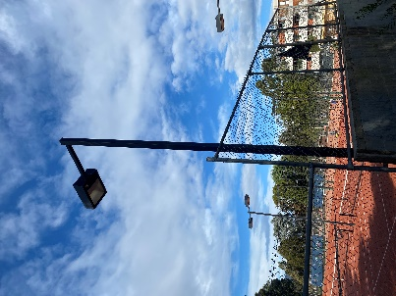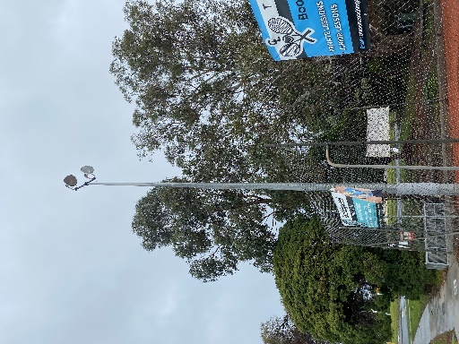66% of club courts are currently floodlit however ageing infrastructure and cost of maintenance has led to many clubs waiting until multiple lights are inoperable before investing in costly repair or upgrade. Furthermore, the visual condition of ageing poles and footings is a public safety concern and requires a further comprehensive assessment to determine longevity. 53% of court lighting is over 20 years old and are mostly high mast poles with halogen globes. A further 37% are the more recent low mast boxed lighting and 10% of courts (7) have newly installed LED lighting supported through Council’s Capital Funding for Community Groups funding scheme. LED lighting has benefits of durability, energy efficiency, and the potential to be programmed via online platforms allowing casual bookings to expand to evening play.

High mast LED

Ringwood Central TC

Low mast halogen

Croydon TC

High mast halogen

East Ringwood TC

## Club Governance

Maroondah adopts a similar management model to most Victorian municipalities, with not for profit, incorporated Club Committees occupying and managing tennis facilities with a hybrid of club memberships and private coaching occurring at the facility. In NSW and Queensland, there have been examples of a move towards the creation of larger venues servicing a wider catchment which are directly managed by Council or commercial contract. Consultation with Maroondah clubs indicated a preference to retain the localised club model as it fosters community connectivity and lifelong association.

In a recent report by the Australian Sports Foundation into the Impact of COVID-19 on Community Sport, September 2021, the report revealed that **42% of sporting clubs reported a decline in volunteering** - in large part due to an increase in the workload, pressures and responsibilities of implementing COVID-19 protocols. Consultation with Maroondah Clubs has revealed that this has not been the case with most clubs retaining all committee members. While the long-term effects of COVID-19 on Community Sport are yet to be realised, a strategic approach to volunteer management would be advantageous. As a response to supporting COVID recovery, Council recently ran an optional series of workshops for Maroondah’s volunteer-based organisations. 36% of participating clubs attending the Recruitment and Retention of Volunteers workshop were Maroondah Tennis Clubs, demonstrating their desire to learn strategies to address this vital area of governance.

In club consultation findings, the clubs who have developed and follow a strategic plan have reflected that this plan has been the best investment that the club has made, supporting forward planning, capital priorities, cost forecasting and supporting new committee to understand the decisions and vision of the club. All Maroondah clubs without a current plan expressed interest in receiving assistance with the development of a strategic plan.

# Section 3 – What does the evidence say?

## Tennis Facility Audit

From September to December 2021, a visual review of the ten (10) Council owned tennis club facilities was undertaken by an independent contractor. The key objective was to gain a thorough understanding of current asset condition, compliance levels, participation barriers and club lease condition performance, with the aim of guiding future decision making in relation to planning for asset development and improvement.

**Condition assessment criteria**

|  |  |
| --- | --- |
| * + Court surface condition | * + Pavilion building condition |
| * + Fencing condition | * + Amenities condition (toilets etc) |
| * + Support infrastructure condition (taps, seating etc) | * + Lighting tower condition |
| * + Access pathways, surrounds and line of travel condition |  |

**Key Review Findings of the audit**

* The Maroondah Tennis Club sites were predominantly established in the 1970’s & 1980’s
* Whilst there is clear expectations and delineation of responsibilities within the lease agreements, the line between asset maintenance and asset replacement is less clear.
* A wide range of tennis specific assets are at a point where maintenance will not serve to greatly extend the asset life.
* Overall club participation has declined by an estimated 30% since the mid 90’s and while junior tennis lessons has remained steady, conversion to club membership and competition has declined, impacting the pool of potential volunteers, membership funds and fundraising opportunities.
* The tennis specific infrastructure at many of the tennis club sites will require significant investment in the next 5–15-year period.
* The cost to replace, repair or renovate the tennis court and lighting infrastructure is estimated in the order of $5,615,000 for the next 15–20-year period.
* All of the tennis pavilion buildings are in a functional and structurally sound condition however accessibility limitations are a concern at all facilities, and many will require renewal in the future.
* Subsurface investigation would be required to understand court surface base and lighting pole lifespan.

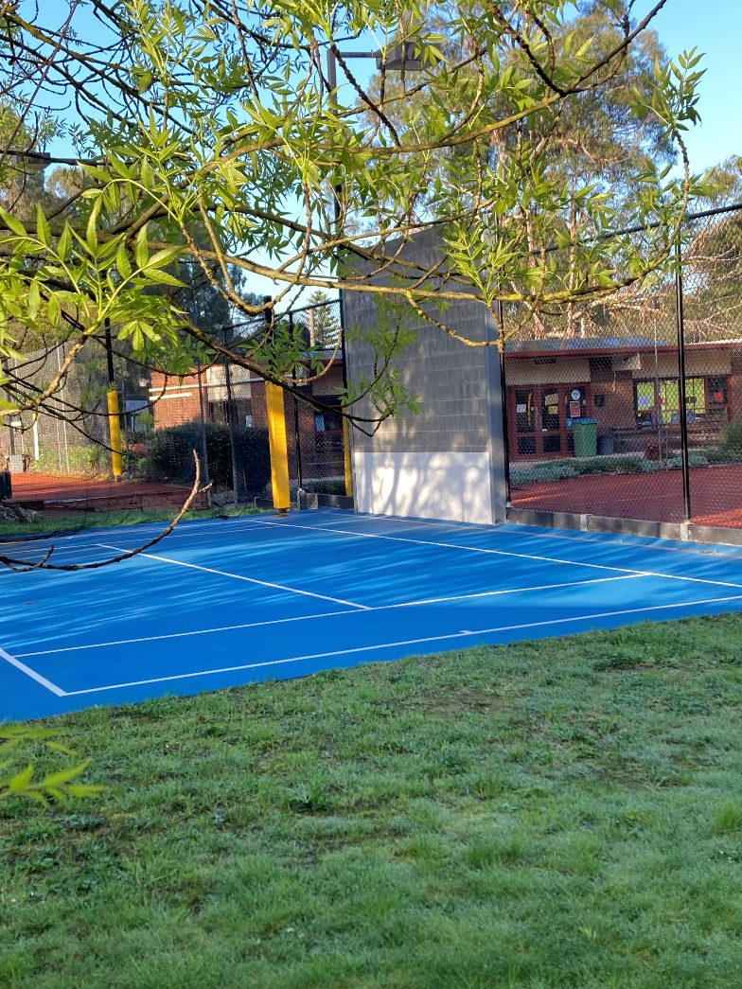

## Regional Tennis Governance Project

Council recently partnered with Parks & Recreation Consulting and our neighbouring Eastern Councils to undertake an *Eastern Region Council Collective Community Tennis Club Governance Review*.[7] The review was commissioned to obtain a clearer understanding of the mode of governance, decision making and operational issues within the community tennis club setting. The research project involved on site face to face interviews with an eighteen (18) club sample across the six (6) partnering Eastern Region Councils.

The report findings highlighted some particular shortfalls in good governance practices at a number of the surveyed tennis clubs relative to club planning, facility planning, governance process, coach partnership arrangements and facility programming. Most of these shortfalls related to a **lack of process or policy and a lack of documentation to demonstrate accountability and transparency**. The ever more complex requirements placed onto club volunteers, and the challenge in activating new volunteers with key skills, is contributing significantly to the time required to effect good volunteer club governance. The report recommended the provision of governance tools such as templates, process diagrams, standardised policy, shared systems, or comparative information.

The report addressed the notion that the traditional volunteer model for management of community tennis sites will most likely see some change in the future. If club membership and volunteer involvement continue to decline in the tennis club setting, the delegation of responsibilities and of ownership of decisions may shift to the coach, as the person within the environment with the financial motive. The research found coaches held decision making committee roles in a number of the clubs examined. The report recommended that Council review this emerging situation and develop a strategic approach which will positively affect the sustainability of both the facility and the club for the long term.

The report acknowledged that the club and coach partnership is an integral component of club sustainability. The contribution of the coach to membership, to facility occupancy and to competition participant development is vital, however only 20% of interviewed clubs had undertaken a formal advertised and/or evaluated process to engage a club coach. In Maroondah, there were several clubs that did not have a formal agreement in place with the coach and most clubs were yet to seek a reasonable financial contribution towards costs associated with their commercial use. Committees have been encouraged to review costs associated with coach use in order to establish a reasonable fee. To support clubs to determine an **appropriate fee structure for commercial usage**, the Eastern Collective of Councils have continued to meet to discuss the situation and establish a common position as well as liaison with Tennis Victoria. The discussions have led to the development of a tool to help clubs identify costs associated with tennis lessons and usage such as court wear and tear, lighting and loss of community recreation access.

A related area of concern was that in the majority of club managed tennis facilities, the clubs had **no contact points for lesson participants or night tennis participants**. The details for lesson participants are held by the coach and night tennis registrations are held by the association. As lessons and night tennis are the predominant programs at most facilities, this is a problematic situation from both a governance, safety and sustainability perspective. Without a connection to key regular users of the facility, safety and conduct protocols may not be adequately relayed, membership promotion impeded as well as volunteer recruitment and fundraising opportunities. This concern was a key point of discussion between Council and clubs during the club engagement process with clubs acknowledging the deficiencies of this current practice and a willingness to rectify this going forward to improve sustainability and safety.

## Tennis Victoria Thriving Tennis Communities Project

The Thriving Tennis Communities pilot project was coordinated and managed by Tennis Victoria with Maroondah selected alongside Boroondara and Geelong City Councils to trial the audit framework.

Thriving Tennis Communities is an approach by Tennis Victoria to better understand clubs and their local communities and work using a new framework that addresses the specific needs of each club.

The data was a self-reported by the clubs during 2021. Unfortunately, the bulk of the data was received during COVID19 restrictions which will have had an impact on participation data. Clubs however have been requested to update their data with Tennis Victoria to ensure that decision making is based on current data.

**Key Review Findings**

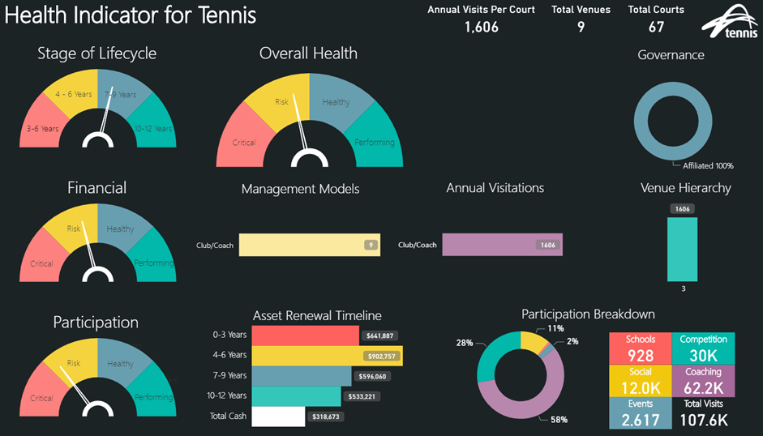

Source: Tennis Victoria, October 2022

Of the pilot findings 35% of Maroondah clubs received a sustainability rating of RISK.However, given that the study was undertaken in the height of the pandemic further discussions and work with clubs has seen a more positive outlook and a willingness from clubs to improve their long term sustainability.

A key concern and priority area for Tennis Victoria is to work with clubs to address child safety processes and protocols. A clubs’ Safeguarding Workshop is in development and all clubs have been provided with resources and support to appoint a safeguarding officer.

It is pertinent to note that usage of the four (4) public courts was not measured as part of this project which would impact the overall participation picture of tennis in Maroondah. Furthermore, the installation of online booking court lock componentry will assist in measuring casual court usage. Increasing the availability of this new technology is a priority of Tennis Victoria as Victorian venues who have invested in the technology have reported an average 25% increase in social tennis visits.

**This data, the facility audit results, and governance findings formed the basis of 1:1 Council & Club Committee discussions to establish a clear picture of the status of clubs in Maroondah and key future priorities for investment and support.**

# Section 4 – Community Engagement

# Club Consultation

In February 2022, Council’s Sport and Recreation Team met in person with the executive committee of each individual Maroondah tennis club. The meetings provided clubs with an opportunity to express how their club was operating, their concerns and their future plans and priorities. It also provided Council officers an opportunity to discuss lease arrangements, possible Council support and ideas for increasing tennis participation in Maroondah.

Key findings from the club consultation were as follows:

**Current Status**

Overall, children are in large numbers, continuing to participate in coaching programs to learn the sport of tennis. For most facilities, the junior coaching program was by far the largest component of programmed activities demonstrating that there remains enormous potential for tennis to thrive. Clubs were also planning to expand their social tennis offering to meet the changing needs of current members and to attract new members who are not currently interested in competition.

**Key issues and concerns**

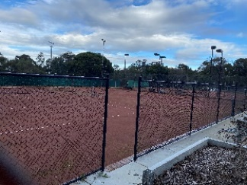**Lighting maintenance** and **LED conversion** were a key concern for all Maroondah Clubs. Evening coaching, evening social play and night competition are the predominant midweek activities for a tennis club and is when the majority of participation occurs. Clubs are finding it extremely difficult to locate the ballast and globes required for the ageing halogen lights. Additionally, many of the poles were designed to fold down for globe changes however ageing mechanisms and/or surrounding trees have obstructed the folding action therefore requiring an expensive ‘cherry picker’ or ‘scissor lift’ to be hired. The expense has led to many clubs waiting until multiple globes are blown to make the cost of the cherry picker hire worthwhile. Additionally, the integrity of poles is deteriorating, exacerbated by both en-tout-cas and the water saving crystals utilised during the droughts of early 2000’s. All clubs expressed a desire to install LED lighting to lessen light globe maintenance, improve light coverage and to benefit from the reduced electricity costs, however the current ageing poles are not suitable to carry the LED componentry. Currently, Council requires clubs to invest up to $5,000 for qualified engineering and electrical investigation to be undertaken prior to consideration of LED conversion.

**Fencing upgrades** was a key priority for many clubs with fences requiring substantial investment to replace. Clubs that had invested in sections of top and bottom rail fencing remarked on the difference it made to the overall appearance of the facility in addition to the improved safety of the facility.

**Accessibility** was a priority of all clubs, raising non-compliance with parking, amenities, pavilion access and pathways. Most clubs had accessible components which had been addressed as part of previous capital improvements, but no Maroondah club is currently fully accessible. In relation to wheelchair tennis participation, currently there is no known local demand and Tennis Victoria take a regional approach to this provision. It remains a consideration to be monitored by clubs, Council and Tennis Victoria to ensure facilities are available within the Region and locally should demand arise.

**Toilet Amenities** was aconcern raised by many clubs. Those that ran tournaments did not have the capacity to meet the needs of the increased number of participants and spectators. A number of clubs have only one or two toilets in the women’s and a single toilet and a urinal in the men’s amenities. While amenities meet building code, no club has an accessible toilet compliant with current standards.

**Succession planning** was a recognised need in most clubs however most conceded that they did not undertake it or, were having limited success with current initiatives.

**Bayswater North Tennis Club (BNTC)** recognised that the declining number of members and small committee represented limited long-term sustainability for the private, not for profit club. They indicated that they would continue to liaise with Council over the forthcoming period regarding their future viability and possible options for the creation of a BNTC legacy, should the club decide to wind up operations. Initial, and positive, discussions have centred around sale of the land and the possible distribution of proceeds to upgrade another Maroondah club to support the merge of membership.

**East Ringwood Tennis Club** discussions highlighted a concerning situation, in which the club has been unable to retain a full executive committee. Club membership has continued to decline to an unsustainable level resulting in no competition play and courts with limited usage outside of private lessons, run by a commercial entity who does not pay a fee for court usage. It is difficult to envisage a sustainable future for the East Ringwood Tennis Club as the current governance structure does not have the required capacity and capabilities to deliver on its purpose.

**North Ringwood Tennis Club** highlighted a desire to explore possible new locations for the expansion and upgrade of their facilities. The current landlocked facility is not located as part of a larger Council reserve, and a number of residential properties are immediately adjacent to the courts. This creates lighting limitations, ongoing issues with en-tout-cas dust and limited opportunity to expand the footprint of the clubrooms to improve accessibility and functionality.

**Aspirations and Key Priorities**

All clubs aspired to expand their membership and to achieve greater retention of juniors transitioning into senior age groups. The gap indicated by all clubs was in working age adults, predominantly 18 - 65 years.

Clubs also aspired to reinvigorate their social program recalling previous successful events and how they assisted in connecting members and recruiting volunteers.

**Court Surfaces**

The surface preference for clubs was varied, with clubs having either a strong position on retaining en-tout-cas or moving to a full synthetic facility. However, several expressed a desire to have a mix of surfaces to cater for the varying needs of the club. Burnt Bridge and Parkwood Tennis Clubs acknowledged that they had several courts with surfaces that were no longer fit for purpose.

**Committee Support**

Clubs were predominantly looking to Council for **financial support** to achieve their priority capital upgrades. While many are in the processing of developing sinking funds, the reality of their financial situation is that most club funds will not extend to funding the total cost of the renewal of court surfaces.

Clubs were receptive to attending a **strategic planning** workshop and receiving individual assistance with the development of a Strategic Plan and several clubs also requested assistance with **social media training** indicating that current committee did not have the knowledge to fully utilise social media platforms.

**Lease Arrangements**

# Council Officers discussed with each committee the current lease arrangements and, that given all tennis leases expire on 31 December 2022, there was an opportunity to review the lease model. Clubs were open to exploration of alternative lease arrangements which would see an increased contribution in exchange for Council taking on greater renewal responsibilities. Primarily the conversation centred around fencing and lighting with court surface renewal remaining the responsibility of the tenant club due to the extensive cost. Council would however support clubs in advocacy for external funding to assist court renewal.

# Section 5 – A plan for the future

Burnt Bridge Tennis Club, Peter Vergers Reserve

# Where we want to be.

# Our Vision

**Council will support access to informal, organised social and competitive tennis opportunities and support local clubs to develop a long-term sustainable model of operation.**

The four (4) key outcome areas to guide Council’s support are:

Each area will outline a vision for the outcome area, key directions and priority actions that will work towards their achievement over the period of the strategy.

**Outcome area 1 - Participation & Access**

**Outcome description**

Residents of Maroondah, regardless of background, age, gender or ability will be able to access tennis facilities in Maroondah. Tennis opportunities will ensure a mix of casual, social, coaching and competition to suit the interests and proficiencies of all participants.

|  |  |  |  |
| --- | --- | --- | --- |
| **Key Direction** | **Priority Actions** | **Lead Responsibility** | **Timeframe** |
| **1.1** Improve access to opportunities for social play and create flexible participation options | **1.1.1** Clubs to establish flexible membership options, to meet the needs of the local community    **1.1.2** Provide an integrated online booking and payment system, to improve access to casual play opportunities outside of the traditional membership model  **1.1.3** Provide assistance with Local Area Marketing (LAM) tools & resources for clubs to promote broadly | Clubs  Tennis Vic.  Tennis Vic. | June 2023  Ongoing  Ongoing |
| **1.2** Support clubs to create safe, welcoming and inclusive environments to engage new participation and retain participants | **1.2.1** Digitise promotion of tennis activity at clubs; websites, social media & council communication channels  **1.2.2** Provide a range of tennis programs to meet the diverse needs of the local community  **1.2.3** Develop strategies to ensure that clubs provide safe and inclusive tennis environments such as *the Equality in action in our club* *toolkit*, supported use of the club gender self-assessment tool and gender equality action plan template and child safety, workshops and governance support.  **1.2.4** Ensure imagery promoting tennis activity across communication channels will be gender inclusive and challenge age, ability, and cultural stereo types. | Clubs  Clubs, Tennis Vic  MCC  Tennis Vic  MCC | Ongoing  Ongoing  Dec 2023  Ongoing |
| **1.3** Improve access to tennis participation for those with a disability | **1.3.1** Collaborate with Tennis Vic. to offer inclusive programs.  **1.3.2** Create PD opportunities to upskill Maroondah coaches to deliver programs to diverse groups | MCC  Tennis Vic  Tennis Vic.  Coaches | Ongoing  Ongoing |
| **1.4** Support clubs to be flexible to the diverse needs of our community, encourage diversity and inclusion. | **1.4.1** Invite CALD community leaders and/ or Migrant Information Centre speak at the tennis forum on the experiences and needs of their communities.  **1.4.2** Develop a Diversity and Inclusion Tennis Plan for Maroondah Clubs  **1.4.3** Support clubs to apply for funding for females to become accredited coaches | MCC  Tennis Vic.  Tennis Vic.  MCC | Dec 2023  June 2023  Ongoing |

|  |  |  |  |
| --- | --- | --- | --- |
| **Key Direction** | **Priority Actions** | **Lead Responsibility** | **Timeframe** |
| **1.5** Encourage greater use of tennis facilities by the wider Maroondah community | **1.5.1** Support the implementation of Tennis Vic’s Club Spark online bookings, installation of Book a Court or Igloohome online booking lock systems  **1.5.2** Support clubs to engage with local schools.  **1.5.3** Support the promotion of Hot Shots and Cardio Tennis in Maroondah | Tennis Vic.  MCC  MCC  Tennis Vic.  Clubs | June 2024  Ongoing  Ongoing |
| **1.6** Greater understanding of usage demographics | **1.6.1** Encourage clubs to utilise Tennis Vic’s Club Spark resources to collate data to inform future tennis planning at a club, municipal and regional level. | MCC  Tennis Vic. | Dec 2022 |
| **1.7** Create pathway link between local school to the club & coach | **1.7.1** Support transitioning primary and secondary school students from their school to their local club | Coaches  Tennis Vic  Club | Ongoing |

**Indicators of progress**

Increased club membership, by offering a variety of membership package options to players and high retention rates at all clubs

Ongoing accessible programs available to Maroondah residents

Development of a Maroondah Tennis Clubs Diversity and Inclusion Plan by June 2023

CALD tennis students and their families welcomed as club participants/members

Increased casual usage measured and reported by the online Tennis Victoria systems - uplift in club revenue generated from casual play bookings, via Book a Court/ Igloohome online booking lock systems

Maroondah Festival

**Outcome area 2 - Club Governance**

**Outcome description**

Council will seek to establish and foster a partnership between local tennis clubs, Tennis Victoria and Council to develop and support a sustainable model of operation which will see clubs thrive both now and into the future.

|  |  |  |  |
| --- | --- | --- | --- |
| **Key Direction** | **Priority Actions** | **Responsibility** | **Timeframe** |
| **2.1** Improve Council’s communication with local clubs and foster collaboration between clubs for the benefit of tennis. | **2.1.1** In partnership with Tennis Victoria deliver an annual tennis club forum | MCC  Tennis Vic | Ongoing |
| **2.2** Assist clubs to navigate, understand and capitalise on the existing strategic planning resources designed to support clubs to improve and sustain effective governance. | **2.2.1** In partnership with Tennis Victoria deliver a strategic planning workshop  **2.2.2** Provide 1:1 support to work with individual clubs to draft a strategic plan | MCC  Tennis Vic  MCC | July 2022 |
| **2.3** Support Clubs to improve sustainability/ succession planning | **2.3.1** In partnership with Tennis Victoria and/or other providers promote and/ or provide access to resources and training for committee roles | MCC  Tennis Vic | Ongoing |
| **2.4** Provide guidance to enable mutually beneficial coach / club relationships. | **2.3.1** Support all clubs to have a formalised Coach/Club Agreement  **2.3.2** All coaches are required to be Tennis Australia Coach Affiliates  **2.3.3** Provide guidance on coach agreement structure and key considerations. | Clubs  Tennis Vic  Coaches  MCC  Tennis Vic  Eastern Council Collective Tennis Vic | Jan 2023 |

**Indicators of progress**

All eligible clubs to have a signed lease agreement in place by 1 January 2023

All clubs to have an endorsed strategic plan in place by June 2023

Annual Tennis Forum to occur from 2022, with Tennis Clubs provided with the opportunity to influence the agenda and provide post event feedback

**Outcome area 3 - Infrastructure Planning & Prioritisation**

**Outcome description**

Council will adopt an evidenced based approach to the distribution of resources to support Maroondah’s tennis participation. Resourcing decisions will be based on priorities in order of safety, access, social and competitive participation, and finally commercial coaching needs.

|  |  |  |  |
| --- | --- | --- | --- |
| Key Direction | **Priority Actions** | **Responsibility** | **Timeframe** |
| 3.1 Work towards installation of LED lighting infrastructure at all Maroondah clubs to maximise evening court usage for social and competitive play. | **3.**1.1 Review Leasing Model to determine if lighting renewal can become a council responsibility  3.1.2 Advocate for, and source funding opportunities to upgrade lighting infrastructure to support LED. | MCC  Clubs  MCC  Clubs | Dec 2022  Ongoing |
| **3.2** Continue to review the capital works program to ensure that resources are allocated on evidenced based need. | * + 1. Add court infrastructure to Council’s Proactive Asset Assessment Schedule.     2. Ensure that participant’s experiences and views of personal safety are considered when undertaking evidence-based infrastructure planning.     3. Continue to progress physical access at all tennis facilities and prioritise works to ensure that Maroondah has a fully accessible tennis facility available to the community     4. Develop a strategy for advocacy and funding opportunities     5. Advocate for the needs of tennis in the Quambee Reserve Enhancement Plan. | MCC  TV | Dec 2023  Ongoing  Ongoing  June 2023  2023/2024 |
| **3.3** Support all clubs to develop an appropriate sinking fund to meet capital renewal goals. | **3.3.1** Work with Tennis Vic and local clubs to utilise Tennis Aust. tennis infrastructure lifecycle calculator to realise lifecycle longevity and costs. | MCC  Tennis Vic  Clubs | Dec 2023 |
| 3.4 Adopt appropriate best principles in the planning and delivery of tennis infrastructure | **3.4.1** Adopt environmentally sustainable principles for the renewal, upgrade and installation of new tennis infrastructure  **3.4.2** Support clubs to develop an infrastructure plan and seek funding for court surface renewals  **3.4.3** Consider CPTED (crime prevention) principles in all capital planning. | Clubs  MCC  TV | Ongoing |

**Indicators of progress**

All clubs have adequate lighting to meet evening demand

Updated capital works program incorporating prioritised tennis requirements with a 5-year comprehensive court infrastructure audit undertaken Dec 2027

Development of an accessibility prioritisation plan for clubs to meet current and future needs of the community by June 2024

**Outcome area 4 - Management & Leasing**

**Outcome description**

Maroondah will have a leasing model which supports the sustainability of clubs and allows volunteer committees greater opportunity to focus on club operations.

|  |  |  |  |
| --- | --- | --- | --- |
| **Key Direction** | **Priority Actions** | **Lead**  **Responsibility** | **Timeframe** |
| **4.1** Ensure that there is clear separation between commercial use of facilities and club decision making. | **4.1.1** Review lease agreement clause regarding commercial business use of community facilities. Ensure that the amendment reflects that all users provide an equitable contribution towards upkeep of facilities and that commercial providers do not hold executive committee positions. | MCC  TV  Clubs | Feb 2023 |
| **4.2** Provide guidance to clubs on the management of commercial operator usage | **4.2.1** Develop an evidenced based guidance table recommending indicative pricing for commercial usage. | Eastern Region Council Collective  TV | Aug 2022 |
| **4.3** Review the current leasing model to ensure that it fosters sustainability and a safe physical environment | **4.3.1** Develop a business case proposal for an increased court lease fee as an offset for transferring fencing and court lighting renewal to become Council responsibility  **4.3.2** Support clubs to develop a financial plan to support future investment in facility renewal | MCC  Clubs  TV | Sep 2022 |
| **4.4** Develop new lease agreements with all eligible clubs occupying Council owned facilities | **4.4.1** Commence engagement by October 2022 regarding proposed new leasing model options  **4.4.2** Gain consensus on most suitable model and develop individual lease agreements | MCC  MCC  Clubs | Feb 2023 |
| **4.5** Facilitate collaboration between clubs to procure bulk quantities of maintenance supplies | **4.5.1** Circulate a presurvey to assist facilitate discussions at the annual tennis forum | MCC | 1 month prior to forum |
| **4.6** Support Clubs to integrate safeguarding policy and processes into club operations | **4.6.1** Support adoption of Tennis Australia Member Protection Policy & Safeguarding Children Code of Conduct  **4.6.2** Incorporate Child Safeguarding into occupancy agreements | TV  Clubs  MCC | 2022/2023 |

**Indicators of progress**

Finalised updated tennis lease template

All eligible clubs to have endorsed leases by early 2023

Implementation of pre-forum survey

Implementation of annual tennis club forum by end 2022

Completion of a Leasing Options paper.

100% club attendance at the proposed Safeguarding Workshop in 2022/23 and all clubs to have appointed a safeguarding officer

# Tracking our progress

The specific priority actions and projects outlined in this Strategy will be monitored as they are implemented and reported to Council on an annual basis. Council will continue to work with Tennis Victoria, local clubs and other key stakeholders to shape the enhancement of tennis in Maroondah and in the implementation of the priority actions outlined in this Strategy.

# Section 6 – References and Glossary

## References

International Tennis Federation (2020) *ITF Facilities Guide*

Maroondah City Council (2019) *Equally Active Strategy*

Maroondah City Council (2014) *Maroondah 2040 Community Vision*

Maroondah City Council (2019) *Community Facilities Leases and Licence Schedule*

Maroondah City Council (2015) *Physical Activity Strategy 2015 -* 2020

Monash City Council (2020) *Monash Tennis Plan 2020*

Parks & Recreation Consulting (2021) *Eastern Region Council Collective Tennis Club Governance Review*

SportAus (2021) AusPlay: A focus on the ongoing impact of COVID-19 on sport and physical activity participation

SportAus (accessed 1 Nov 2021) *The Sport and Physical Activity Landscape*,

Tennis Australia (2017) National Court Surface Policy

Tennis Australia (2018) *Tennis Infrastructure Planning - Planning, Design & Delivery Resource*

Tennis Victoria (2001) *Tennis Victoria Strategy 2024*

Tennis Victoria (2021) *A Framework for Victorian Tennis Facilities 2020 - 2025*

Whitehorse City Council (2015) *Whitehorse Recreation Strategy 2015 - 2024*

Yarra Ranges Shire Council (2014) *Yarra Ranges Tennis Plan July 2014 - 2024*

## Glossary

**CALD** Culturally and Linguistically Diverse - Refers to communities that originate from different countries, may speak languages other than English and represent different cultural backgrounds.

**Commercial** An organisation, including incorporated body, co-operative, partnership or sole trader conducting activities for the purposes of deriving a financial return to the owner or shareholders.

**Child** The Safeguarding Children Code of Conduct has been developed by Tennis Australia to provide **Safeguarding** clear guidance to all Personnel in relation to the treatment of children within tennis.

**CPTED** Crime Prevention through Environmental Design - with four main principles of natural surveillance, access control, territorial reinforcement and space management.

**Igloohome**  A smart padlock system where the club can grant access PIN codes remotely without Wifi.

**Lease**  A contract under which a tenant (or lessee) is granted exclusive possession of property for an agreed period, usually in return for rent.

**Not for Profit** An organisation that exists exclusively for charitable purposes or as an amateur sporting group, or other special interest group established for the benefit of the community.



1. Sport Australia, AusPlay-COVID-19-update-June 2021
2. Tennis Victoria Strategy 2024
3. Tennis Victoria *A Framework for Victorian Tennis Facilities 2020 - 2025,* 2021 p4
4. SportAus, *The Sport and Physical Activity Landscape*, accessed 1 Nov 2021
5. Maroondah City Council *Physical Activity Strategy 2015- 2020 - Consultation & Engagement Report* 2014
6. AUSPLAY
7. Parks & Recreation Consulting *Eastern Region Council Collective Community Tennis Club Governance Review,* Oct 2021