1.0 Introduction
Maroondah City Council (Council) has a strong commitment to risk management. The Risk Management Framework has been developed to formalise Council’s approach to continuously improve its risk management practices consistent with AS/NZS ISO 31000:2018 Risk management-Principles and guidelines (the Standard).

The Standard is driven by a set of principles. In summary these principles are focused on risk management creating value, being an integral part of the organisation’s processes, supporting decision making, explicitly addressing uncertainty and facilitating continual improvement.

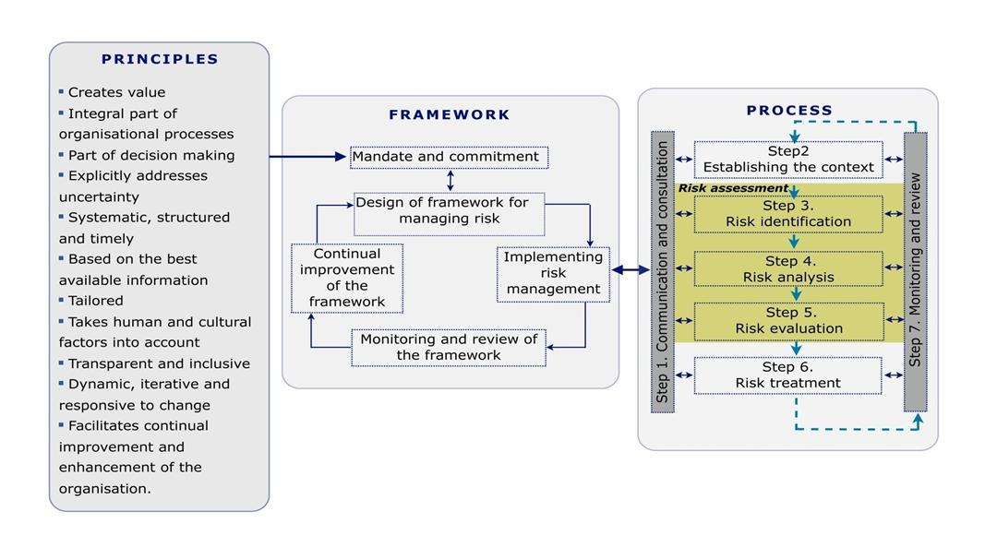
Figure 1 – Relationship between risk management principles, framework and process

1.1 Purpose
The purpose of the Risk Management Framework is to outline Council’s arrangements for designing, implementing, monitoring, reviewing and continually improving risk management.

1.2 Mandate and Commitment
Council is committed to maturing their approach to risk management. This commitment is expressed through the Risk Management Policy (21/127391), Risk Process and Criteria (Attachments 1 through to 6) and Risk Management Strategic Plan (21/133381)

1.3 Risk Appetite
Risk appetite is defined as the amount and type of risk Council is willing to accept in pursuit of its objectives. Council’s appetite is expressed through the organisation’s governance structure, legal and regulatory requirements, strategic and business plans, policy and procedures and through the risk process consequence rating table.

The risk management framework outlines how Council organises, manages and links risk management processes within Council to be consistent and integrated into Councils strategic and operational day to day activities. The key elements of the Risk Management Framework are:
- Risk Management Policy
- Risk Process and Criteria, and
- Risk Management Strategic plan

2.0 Risk Management Policy

Refer to the Risk Management Policy (21/127391).

3.0 Risk Process and Criteria
Risk management is effective when it drives growth, creates value and supports decision making. This is achieved when responsibilities for the management of risk are clearly understood by all employees. Employees are able to manage risk within Council operations, understanding when to drive, promote and harness opportunities and when to protect services and projects.
Risk management is effective when it is embedded in existing processes. This is achieved when risk management is linked with strategic and Council planning and aligned with key performance indicators.

Communication and Consultation (Step 1)
The purpose of identifying and assessing risk is to support decision making and therefore should be embedded with Council’s Planning and Performance Cycle.

Item | Review activity | Timing
1 | Corporate Management Team (CMT):  The strategic risk profile prior to the annual review of the service delivery plan (SDP) | Output of this review should be an input to the SDP.
2. | Service Area Managers  Review of the risk treatment plans to determine if resources to complete treatments are required. | Output of this review should be an input to the Service Delivery Plans priority setting considerations.
3. | Service Area Managers  Review the Operational Risk Profile by considering risk to delivering the outcomes of the annual SDP. | Risk profiles should be reviewed quarterly by Service Area Managers with the Coordinator Risk Integrity and Information Management. Following these reviews, risk profiles should also be reviewed by the relevant Director. These reviews must occur before reporting to CMT and the Audit and Risk Committee.

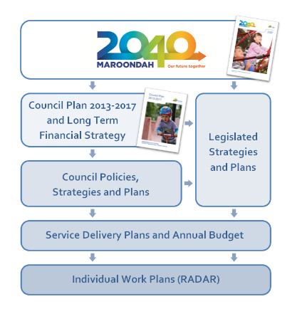
Establishing the Context (Step 2)
The purpose of identifying and assessing risk is to support decision making. Council identifies risks at two levels, strategic and operational.
- Strategic risks are the risks that relate to the strategic outcomes or objectives. Maroondah City Council’s strategic risk profile is linked to the eight outcome areas identified in the 2040 Maroondah plan – (insert link to Maroondah 2040 plan)
- Strategic risks should be an input to the development of Council’s annual Service Delivery Plans.
- Operational and Organisational risks are risks that relate to the corporate objectives or organisational outcomes and should be considered after the annual priorities have been determined and before annual budgets are finalised.
Operational risks should be linked to the most relevant strategic risks

SR-1

Maroondah City Council’s risk criteria has been developed by Service Area Managers, and supported by the Risk Management Advisory Group and endorsed by the Corporate Management Team and Audit and Risk Advisory Committee. The Risk Criteria enables the Council to have a systemic and consistent approach to risk management.
Link to establishing the context template (See Attachment 1)
Risk Identification (Step 3)
Risk identification aims to reveal what, where, when, why and how something could happen or occur and the effects this could have on objectives. The purpose of risk identification is to identify the sources of risk, and to describe the risk by the events, cause of the event and impact.
Links to sources of risk and risk identification templates (See Attachment 2)
Risk Analysis (Step 4)
Risk analysis is the process to comprehend the nature of the risk and to determine the level of the risk. Risk analysis provides the basis for risk evaluation and decisions about risk treatment. (SA/SNZ HB436:2013 companion to ISO 31000:2018)
Links to ratings tables (See Attachment 3)

Risk Evaluation (Step 5)
The purpose of risk evaluation is to assist decision making based on the outcomes of risk analysis and determine which risks need treatment and the priority for treatment implementation.
Maroondah City Council has both consequence and likelihood rating tables which are to be applied to analysing strategic and operational risks. The process for calculating the risk is a simple multiplication following the steps outlined below:
- Using Council’s consequence tables, determine the consequence rating. Refer to the Consequence Definition Table
- Using Council’s likelihood rating tables, determine likelihood rating. Refer likelihood definition table
- Ascertain the risk rating by multiplying consequence rating and likelihood rating.

Links to risk evaluation criteria (see Attachment 4)
Risk Treatment (Step 6)
The Service Delivery Plans outline the strategies, programs, projects, services, partners and suppliers to be delivered within the financial year. Where a risk treatment has been identified, this treatment should either (a) link to an existing strategy and this link is documented or (b) a risk treatment plan is developed and incorporated into the relevant Service Delivery Plan to actively consider and deal with the risk.
Links to risk treatment template (see Attachment 5)

Risk Monitor and Review (Step 7)
Strategic risks should be reviewed the outcome for which becomes a key input to the Service Delivery Areas review and development of Service Delivery Plans. Operational risks should be reviewed quarterly and considered by all Service Areas as part of their Service Delivery Planning process. Operational risks are reviewed after service delivery priorities are set and prior to the finalisation of the annual budgets. Risk treatments should be costed and incorporated into the annual budget process. All Operational risks are to be reported to CMT and the Audit and Risk Committee every quarter. Organisational risks are risks which affect all Service Areas ( such as fraud / corruption, Child safety, cyber security etc) but have different impacts. Organisational risks once considered and assessed for part of a Service Areas operational risk profile.
The Risk Register is a database that allows Managers, Directors and Chief Executive Officer to register and monitor risks associated with Council operations. Coordinators and Team Leaders have the delegated responsibility to review and monitor risks as determined by their Service Area Manager.
Risks need to be regularly reviewed according to their risk rating. The review dates for the different levels of risk are listed below, the review date for risks need to be realistic and linked to those employees who are accountable. The appropriate review schedule is shown below.
Links to Risk Reporting Calendar and Risk Register (See Attachment 6)

4.0 Work Plan 2021-2023
Key Area 1: Culture
Focus: The behaviour of the people within the organisation supports risk management practice.

Current Culture | Foundation | Developed
Councils Leaders are committed to risk management (1.1) |  | - Council’s risk manager drives risk management activity.  - There is evidence risk management is considered in some decision making processes in the organisation.  - Council’s Directors and Senior Managers lead and champion risk management.

Desired Culture
1. 1: Councils leaders are committed to risk management.
 | - Council’s Directors and Senior Managers lead and champion risk management.  - Council’s risk management approach and practice is visible.  - Council has developed contingency plans for potential adverse consequences.  - Council’s resources reflect the priority of risk management. | Ongoing- Key Success Factors  Council will mature the championing of risk management through:  - Standing Agenda items to discuss risk issues at all departmental meetings.  - A quarterly Manager risk management case study and discussion of this at Management Group Meetings.  - Nominating departmental employees as risk champions and developing a community of practice.  Ongoing – Key Success Factors  Council will mature the championing of risk management through:  - Developing contingency plans for potential adverse consequences and via ongoing annual delivery of risk training for managers,  - Ongoing annual awareness training for Councillors and managers.

1.2: Council values employees’ contributions to risk management.
 | - Council employees are rewarded and recognised for their contribution to risk management. | Ongoing- Key Success Factors  Council will mature their approach to valuing employees’ contributions to risk management by:  - Incorporating risk management into the existing Recognising Extra Value program.
 | - Council recognition and reward systems actively encourage employees to manage risks and take advantage of opportunities.  - Council management is committed to learning from positive and negative outcomes.  - Council information on risks are shared and there is a strong indication of team work across the organisation. | Ongoing – Key Success Factors  Council will mature its approach to valuing employees’ contributions to risk management by:  - Recognising employees who work together across Council Service Areas and demonstrate how risk management has created value through supporting decision making, driving growth and strengthening controls.  - Documenting project learnings, communicate learnings and incorporate these into organisational reporting so trends are tracked over time.  - Ensuring the Risk Management Advisory Group is maintained and developed to consider risk strategically. For example, by reviewing the World Economic Forum’s top ten risks for Australia: Asset Bubble, Fiscal Crisis, Unemployment or Underemployments, Energy Price Shock, Failure of National Governance, Cyber Attacks, Extreme Weather, Terrorist Attacks, Data Fraud, and determine the implications of these risks for Council.

1.3: Council’s risk management practices are linked to the ethics and values of the organisation.
 | - Council has an organisational approach to linking risk management practices with its ethics and values that have been agreed and communicated. | Ongoing- Key Success Factors  Council will mature its risk management practices and approaches and link these with its ethics and values by:  - Articulating how risk management links to ethics and values (Cooperation, Commitment, Communication, Continuous Improvement and Innovation).
 | - Council’s ethics and values enable management to take a balanced approach to risk management. | Ongoing - Key Success Factors  Council will mature its risk management practices and approaches and link these with its ethics and values by:  (a) Developing strategic risk appetite statements which are communicated to all employees and which can be measured and reported, for example:  - Council has a very low risk appetite for the risk of failure of processes resulting in harm or which might result in harm to the safety and wellbeing of employees, contractors, volunteers or members of the public.  - Council has a high risk appetite for operational efficiencies resulting in reducing administrative burden and costs to the operational budget.

Key Area 2: Governance
Focus: The approach for developing, supporting and embedding risk strategy and accountabilities.
Current Governance | Foundation | Developed | Integrated
Council’s risk management governance is aligned to the Corporate Governance Framework |  | - Council’s risk management governance practices have been documented and are aligned with the organisation’s Corporate Governance Framework.  - Council’s risk management responsibilities are aligned with an individual’s authority and documented in the organisation’s delegated authorities.
Council has documented individual roles, responsibilities and accountabilities |  | - Individual’s roles, responsibilities and accountabilities for risk management are outlined in the organisation’s risk management policy and/or plans. | - Council’s risk management roles and responsibilities for employees have been documented, approved and included in position descriptions.

Desired Governance
2.1: Council’s risk management governance is aligned to the Corporate Governance Framework.
 | - Council employees are aware of risk management governance principles and practices.  - Council risk management governance practices and accountability are embedded in organisation planning and performance. | Ongoing - Key Success Factors  Council will continue to mature its risk management governance alignment to the Corporate Governance Framework by:  - Reviewing the risk management principles and describing how these apply in practice to Maroondah City Council.  - Incorporating the review timeline into the risk policy outlining when Departments are required to have completed risk profile reviews.  - Requiring Managers to critically reviewed their Service Area risk profiles each quarter and ensure the key risks to their business are on the risk register.  Ongoing -Key Success Factors  Council will continue to mature its risk management governance alignment to the Corporate Governance Framework by:  - Developing key performance indicators so risk management principles can be measured and reported to the Corporate Management Team and the Audit and Risk Committee each quarter.

2.2: Council’s Audit Committee demonstrates its role and responsibility through the receipt and consideration of regular risk reports.
 | - Council Audit Committee regularly receives written risk reports that specifically address its risk management responsibilities. The reports identify emerging risks and changing context of the organisation’s risk profile.  - Committee members consider reports and identify actions required. | Ongoing- Key Success Factors  Council will mature risk reporting to the Audit Committee by:  - Linking the reporting of risk to Council objectives.  - Providing some analysis of risk rating and trends.  - Developing a reporting cycle so the Audit Committee is clear on the information it will receive for each reporting period. Ensure there is a variety of information for each report.  - Presenting case studies to the Audit and Risk Committee outlining the risk and management of the risk.  - Incorporating emerging risks into the reporting schedule.  Ongoing- Key Success Factors  Council will continue to mature its risk reporting to by:  - Ensuring reports are supported by data analytics programs with dashboard or traffic light reporting capability.

2.3: Council has process for ensuring key legal and regulatory compliance obligations are met.
 | - Council’s legal and regulatory compliance framework, consistent with ISO 19600, has been documented and approved. | Ongoing - Key Success Factors  Council will mature its approach for ensuring legal and regulatory compliance obligations are met by:  - Reviewing Council’s compliance approach against ISO19600 and determining recommendations to address gaps. Provide a copy of this review to the Audit Committee for noting.
 | - Council’s legal and regulatory compliance framework has been documented, approved and effectively deployed to employees across the organisation.  - Council’s legal and compliance framework is readily accessible by employees.  - Council has a process so corrective actions are taken to address areas of non-compliance. | Ongoing - Key Success Factors  Council will mature its approach for ensuring legal and regulatory compliance obligations are met by:  - Implementing recommendations and reporting on progress of implementation through to the Audit and Risk Committee.

Key Area 3: Resources
Focus: The Resources and Planning Allocated to the Management of Risk.
Current Resources | Foundation | Developed
Council has enabling technology |  | - Council’s risk management framework is supported by technology.

3.1: Council has human resources to support risk management system and processes.
 | - Council’s risk management capabilities have been established and skill gaps identified.  - Council risk management awareness sessions are carried out regularly. | Ongoing- Key Success Factors  Council will support the human resources required to support maturing of the risk management system by:  - Continuing to review the appropriate service delivery model that will support Council in maturing enterprise risk management.  - Continue to determine the appropriate training needs for Service Area Managers, Risk Officer / Managers, and Risk Management Team.
 | - Council’s risk management capabilities and training are integral to individual learning plans.  - Council employees are trained and skill gap are addressed.  - Council’s risk management training is an integral part of departmental training programs. | Ongoing - Key Success Factors  Council will continue to support and provide the human resources required to support maturing of the risk management system by:  - Establishing a risk management training register.  - Linking risk management and special risk areas training to employee learning plans.  - Implementing appropriate training courses (including for Councillors and managers).

3.2: Council’s risk management tools and templates are developed.
 | - Council’s enterprise-wide risk management tools and templates have been agreed and approved.  - Council’s risk management tools and templates are coordinated to ensure consistency of application across the organisation. | Ongoing - Key Success Factors  Council will continue to enhance risk management tools and templates by:  - Reviewing the tools and templates to assess how these support an integrated approach to risk management and update as required.  - Determining when the tools are applied and when they are not applied.  - Linking the risk criteria to the enterprise risk management system technology (ref 3.4a).  - Publishing the risk management tools and templates on the intranet.
 | - Council’s enterprise risk management tools and templates are readily available, understood and consistently applied by employees across the organisation.  - Council’s risk management tools and templates assist employees to perform their risk management responsibilities and are easy to use. | Ongoing - Key Success Factors  Council will continue to enhance the risk management tools and templates by:  - Keeping the tools current, up to date and endorsed by CMT and the Audit Committee  - Ensuring, where appropriate, these are included as procurement requirements.  - Incorporating and linking these to existing processes and systems.

3.3: Council’s risk management plan explicitly addresses uncertainty.
. | - Council has an organisation-wide risk management plan that has been documented and approved and terminology is consistent with AS: ISO 31000:2018. | Ongoing - Key Success Factors  Council will continue to explicitly address uncertainty through its risk planning and risk profile identification process by:  - Developing an enterprise risk management plan that specifies actions to be undertaken by Departments and incorporates information from the specialist risk areas (e.g. fraud control, procurement, project management).
 | - Council’s organisation-wide risk management plan has been documented, approved and effectively deployed to all employees. | Ongoing- Key Success Factors  Council will continue to explicitly address uncertainty through its risk planning and risk profile identification process by:  - Linking Council’s risk management plan to service level agreements and its business planning cycle, where possible.

Key Area 4: Process
Focus: The process for Identifying, assessing, evaluating, treating and monitoring risk.
Current Process | Foundation | Developed
Council objectives are defined for managing risk and have a defined risk rating criteria. |  | - Council has a defined risk criterion to evaluate the significance of risk. This criterion is documented and accessible to all employees.
Council considers specialist risk and develops profiles. |  | - Council has a process in place for identifying specialist risk areas (e.g. emerging risk, project risks, project risks, procurements risks, fraud risk, environmental risk, tree risk).

4.1: Council has established communication and consultation processes in place.
 | - Council has some documented evidence to support communication and consultation activities with stakeholders during the risk management process. | Ongoing - Key Success Factors  Council will continue to mature risk management communications and consultation processes by:  - Regular reviewing risk profiles (Strategic and operation)  - Inviting key stakeholders to participate in their risk identification and profile report  - Linking risk to planning process  - Widely sharing lessons learnt  - Ensuring reporting is meaningful and supports decision making.
 | - Council has some documented evidence of communication and consultation with relevant stakeholders for key steps in the risk management process. | Ongoing - Key Success Factors  Council will continue to mature risk management communications and consultation processes by:  - Developing and documenting resources to support communication and consultation with key stakeholders.

4.2: Council has a defined risk appetite.
 | - Council’s risk appetite and tolerance has been documented, approved and incorporated into agreed risk management language, likelihood and consequence scales, a risk rating matrix, risk aggregation processes, risk reporting and escalation criteria. | Ongoing- Key Success Factors  Council will continue to mature its approach to defining risk appetite by:  - Corporate Management Team articulating a strategic risk appetite statements endorsed by Council.
 | - Council’s risk appetite and tolerance has been documented, approved and effectively deployed to employees across the organisation.  - Council organisation-wide risk appetite and tolerance is accessible to employees and aligned with organisation objectives. | Ongoing - Key Success Factors  Council will continue to mature its approach to defining risk appetite by:  - Developing key risk indicators at a Service Area level and link the KRA to service level plans.

4.3: Council objectives are defined for managing risk and have a defined risk rating criteria.
 | - Council has a defined risk criterion to evaluate the significance of risk. This criterion is documented and accessible to all employees.  - Council’s enterprise wide risk methodology is documented, approved, reviewed and effectively deployed to employees. It includes the following elements: sources, events, causes, consequences. | Ongoing- Key Success Factors  Council will define the objectives for managing risk and mature its risk rating criteria by:  - Streamlining Council’s risk methodology by simplifying instructions and ensuring language in documentation is consistent. For example, Absolute risk and Inherent risk.  - Ensuring risk definition is aligned to ISO 31000:2018: Risk is the effect of uncertainty on objectives, and risk controls are identified (and their effectiveness rated and captured) as part of the operational risk landscape.
. | - Council risks are explicitly linked to business planning and budget setting processes and explicitly linked to the risk management process.  - Council’s risk process identifies controls and rates control effectiveness.  - Consequence and likelihood ratings are considered in context to the risk and control environment. | Ongoing- Key Success Factors  Council will define the objectives for managing risk and mature its risk rating criteria by:  - Linking operational risk to the business planning and budget setting processes.  - Corporate Management Team finalise their strategic risk profile.  - All Service Areas shall finalise the review and or development of their operational risk profiles linked to business objectives and strategic risk.

4.4: Council consider specialist risks and developed profiles.
 | - Council employees are aware of the process for identifying and documenting specialist risk areas. | Ongoing- Key Success Factors  Council will mature its approach to specialist risk and developed profiles by:  - Incorporating information about specialist risk areas into the risk management plan.  - Incorporating specialist risk areas reporting requirements into the enterprise risk management integrated report.

Key Area 5: Assurance
Focus: The process of establishing integrity and validity to bring confidence and support decision-making.
Current Assurance |  | Foundation
5.1: Council has an established assurance program
 | - Council’s assurance program (internal audit program) is aligned to the risk profile. |  | Ongoing - Key Success Factors  Council’s assurance program will continue to be matured by:  Linking assurance to the strategic and operational risk profile.  Ongoing – Key Success Factors  Council’s assurance program will continue to be matured by:  - Developing assurance mapping within all Service Areas and linking this process to the Service Level Plans.
 | - Council has a clear documented link between the validation and assurance program and the risk profile of the organisation.  - The validation and assurance program incorporates techniques including:  - predicative indicators  - use of read time data  - dashboard reporting and  - measuring against target levels of compliance. |  | Ongoing - Key Success Factors  Council’s assurance program will be matured by:  - Demonstrating the link between risk profiles and assurance by developing assurance plans and regular reporting.  - Each Service Area developing Key Risk Indicators (via their respective risk profiles).

Key Area 6: Interagency
Focus: Risks which are shared and unmitigated by one agency increases risks to another agency
Current Resources | Foundation | Developed | Integrated
Council manages interagency risk (6.1) |  | - Council has developed some relationships to identify and manages interagency risks.

6.1 Council manages inter-organisation and Interagency risk
 | - Council’s relationships have been developed and a process has been documented to identify interagency risks.  - Council has formal mechanisms to regularly consult with organisations on the identification and management of risk and rewards.  - Council has an approach to evaluate and treat interagency risks. | Ongoing - Key Success Factors  Council will mature interagency risk by:  - working with key Interagency partners to develop an interagency a risk profile. This requirement will be included in Council’s risk management plan and the interagency risk profile will be reported to CMT and Audit Committee through the Integrated Risk Management Reporting process.

Attachment 1: Establishing the Context
When undertaking a formal risk management process, it is important to be clear on the purpose and focus of the activity.
When considering strategic risks, risks must be considered in the context of Maroondah 2040.
When considering operational risks, operational risk must be linked to Service Delivery Plans. The relationship between Strategic and Operational risks is required to be documented throughout the activation of the Risk Management Framework.
Often, in organisations, risks profiles are also developed for fraud control, procurement, compliance, emergency management, business continuity and security, safety, insurance and conduct. These areas are also relevant to the operation of the Council and often developed in addition to the operational risks linked to the service area outcomes outlined in the annual Service Delivery Plans.
When considering project risks, the project lifecycle should be considered.
Environmental scanning tools are varied; some examples are provided below.

1.1 Strategic Planning
PESTLE
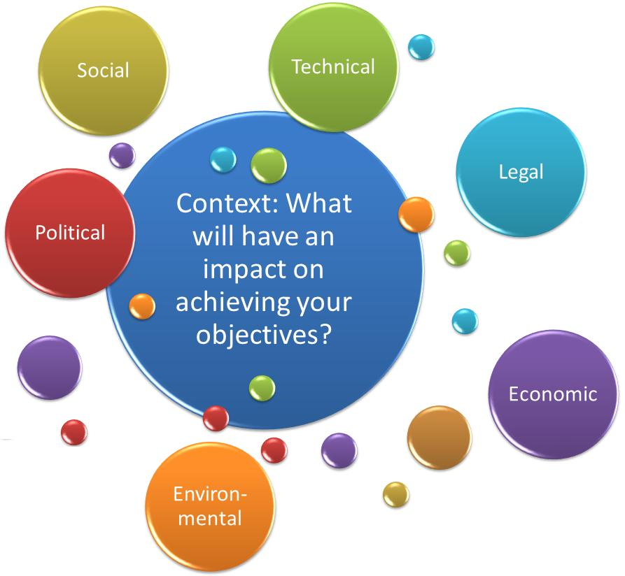
Participants will need to consider the:
- Political influences which may impact your organisation from achieving its objectives.
- Economic influences which may impact your organisation from achieving its objectives.
- Socio-culture influences which may impact your organisation from achieving its objectives
- Technical and technological influences which impact your organisation from achieving its objectives.
- Environmental influences which may impact organisation from achieving its objectives.
- Legal influences which may impact your organisation from achieving its objectives.

1.2 Annual Planning
Prior to identifying risk, the service delivery objectives should be stated and clear. When preparing a Service Delivery Plan, over the next 12 months, consider the following questions:
- What will constrain your and other Directorates in meeting Service Delivery objectives?
- What will enable your and other Directorates in meeting Service Delivery objectives?
- What will your Directorates and other rely on to deliver your objectives?
- What may your Directorates and other encounter in the next 12-24 months?

Attachment 2: Risk Identification

2.1 Sources of Strategic and Operational Risk
Risk sources are the elements that, alone or in combination, have the intrinsic potential to give rise to risk. Below the tables identified a number of risk sources relevant to Council aligned to the category.
- Governance & Legal
- Planning, programming & service delivery | - Assurance | - Board & committee effectiveness |  | - Delegations & authorities
- Fraud control | - Policy management | - Project management |  | - Legislation & regulation
- Complaints management | - External reporting | - Service level agreements |  | - Joint management
- Commercial management | - Partnerships | - Frameworks |  | - Internal controls
- Policy Framework | - Industrial relations | - Committees of management |  | - Enforcement policy
- Strategy and planning process | - Leadership
- Economic & Financial
- Financial | - Budgeting & planning allocation | - Expenditure management | - Efficient & effective administration
- Financial accounting & reporting | - Funding arrangements | - Purchasing | - Funding sources
- Financial management & grant administration | - Asset management | - Community assets | - Built asset management
- Change of government (state or federal) | - Government policy and change to legislation | - Service level agreements | - Contract management
- Cost competitiveness

- People & Safety

- Labour market (availability of skilled & competent employees | - Workforce management and engagement | - Industrial relations | - employee health and safety
- Succession planning | - Training & recruitment | - Qualifications as required by government policy | - Government regulations
- People management | - Visitor safety | - Change management | - Restructure
- Learning & development & capabilities | - Leadership
- Corporate
- Information management | - Data, Information & Knowledge | - Research & ethics |  | - Internal communications
- Emergency management and response | - Critical incidents | - Business continuity management |  | - Benchmarking
- Public relations (external information) | - Business systems | - Systems integrity |  | - Cost competitiveness
- Complex systems | - Operational agility | - Streamlined processes |  | - Frameworks
- Process, products and services | - Supplier relationships & partnerships
- Stakeholder Engagement Service Delivery
- Government relationship | - Community engagement | - Businesses | - Regulators
- Politicians | - Community organisations | - Committees | - Contractors
- Suppliers | - Corporations | - SME | - Micro business
- Volunteers | - Partnerships | - Traditional owners | - Reputation
- Social networking | - Ratepayers | - Residents | - Information technology
- Visitors | - Stakeholder management | - Public land neighbours | - Visitors
- Patrons | - Aged | - CALD committee | - Lobby groups
- Councillors | - Stakeholder confidence | - Community reach

- Assets
- Built assets | - Natural assets | - Safety | - Utility failure
- Environmental sustainability | - Property damage | - Tree management | - Systems
- Infrastructure | - Emergency management and response | - Project management | - Compliance with legislation & Standards

2.2 Risk Identification
As outlined in the ISO 31000:2018, a risk is defined as the effect of uncertainty on objectives.
- An effect is a deviation from the expected – positive and/ or negative.
- Objectives can have different aspects (such as financial, health and safety, and environmental goals) and can apply at different levels.
- Risk is often characterized by reference to potential events and consequences or a combination of these.
- Risk is often expressed in terms of a combination of the consequences of the event including changes in circumstances and the associated likelihood of occurrence.
- Uncertainty is the state, even partial, of deficiency of information related to, understanding or knowledge of an event, its consequence, or likelihood’
(ISO 31000:2018)
Risk Source: | Risk Description: To identify your risk, consider the following three elements.
Nominate most relevant risk source category  - Governance & Legal  - Economic & Financial  - People & Safety  - Corporate Management  - Stakeholder Relations  - Asset Management  A list of risk sources is outlined in section 2.1 risk source | - The event (something may happen)  - Caused by (threat or opportunity)  - Resulting in… (impact to Council)

At the end of this process the following elements of risk profile will be completed.

Attachment 3: Risk Analysis

Risk rating tables and heat map
3.1 Controls
A control is a measure that is modifying the risk. Controls include any process, policy, device, practice or other actions with modify the risk (ISO Guide 73:2018).
There are layers upon layers of controls within Council. Identify the key (organisational) controls which will support you in modifying this risk.
3.1.1 Control effectiveness
Control effectiveness is determining how a control or a group of controls are modifying the risk. Effectiveness considerations include control design, documentation, communication and execution.
3.1.1 Control rating

Council is rating controls in the risk process by assigning the following three ratings.
1-Effective | 2-Partially Effective | 3-Not Effective

3.1.2 Control owner
A control owner is the person within Council who has responsibility for administering the control. For example, the Governance area may be the control owner for the Policy and Procedure Framework, however another Service Area Manager responsible for a specific policy. After you have identified and rated the controls, assign a control owner.

3.2 Consequence Ratings
Impact Rating Table
1. | Insignificant | - An event where the impact can be absorbed through business as usual.
2. | Minor | - An event where the consequence can be absorbed but management effort is required to minimise the impact.
3. | Moderate | - An event that can be managed under normal circumstances, however additional resources maybe required.
4. | Major | - An event that with proper management can be endured. Additional resources are required and a change in management, processes or system may be required.
5. | Extreme | - An event serve in nature could lead to significant restructure of the organisation or a change in the management structure.
Council has developed categories of impact and indicators of impact in the areas of Financial Sustainability, Workforce, Service Delivery or Reputation, See attached on A3 at Attachment 6.

3.3 Likelihood Ratings
Likelihood Rating Table
1. | Rare | - Not likely to occur in the next 5 years.  - <25% chance of occurring.
2. | Unlikely | - Could occur at sometime within the next 4 years.  - 25% chance of occurring.
3. | Possible | - May occur at sometime within the next 3 years  - 25%-40% chance of occurring.
4. | Likely | - Will probably occur at sometime within the next 2 years  - >40%-70% chance of occurring.
5. | Almost Certain | - Will probably occur at sometime within the next 1 year.  - >70% chance of occurring

3.4 Risk Consequence and Likelihood Rating and Heat Map
Likelihood | Consequence
 | Insignificant  (1) | Minor  (2) | Moderate  (3) | Major  (4) | Extreme  (5)
Almost Certain  (5) | Moderate  (5) | Significant  (10) | Significant  (15) | High  (20) | High  (25)
Likely  (4) | Moderate  (4) | Moderate  (8) | Significant  (12) | Significant  (16) | High  (20)
Possible  (3) | Low  (3) | Moderate  (6) | Significant  (9) | Significant  (12) | Significant  (15)
Unlikely  (2) | Low  (2) | Moderate  (4) | Moderate  (6) | Moderate  (8) | Significant  (10)
Rare  (1) | Low | Low  (2) | Low  (3) | Moderate  (4) | Moderate  (5)

At the end of this process the following elements of risk profile will be completed.
Risk | Controls | Control effectiveness | Consequence category | Consequence rating | Likelihood ratting | Risk  rating

Attachment 4: Risk Evaluation

Risk Strategy
After the risk has been assessed by taking into account the control effectiveness and by multiplying consequence and likelihood ratings, the service area must decide on the most appropriate risk strategy. Risk strategy options are listed in the table below.
4.1 Risk Strategy Options
Risk Strategy Options | Required Actions
Avoiding the risk is achieved by deciding not to start or continue with the activity that gives rise to the risk | - Report to appropriate level of management
Taking or increasing risk in order to purse and opportunity | - Outline the benefits, document and seek approval  - Identify key risk indicators (KRI)  - Identify desired target risk rating
Changing the likelihood or consequence of the risk. | - Develop a risk treatment plan. Identify KRI  - Identify desired target risk rating
Sharing the risk is to share the management of the risk with another party or parties (including contractors and suppliers). | - Determine how risk will be shared (contract, insurance, BCP) and document)  - Develop KRI
Retaining the risk by informed decision, | - Document and monitor.

4.2 Overall Risk Rating Guidance Table
If the overall risk rating per the heat map is either high or significant a risk treatment plan must be established and endorsed by the Line Manager.
High  (17-25) | Needs Active Management | A risk treatment plan must be established and implemented and endorsed by line manager.
Significant  (10-16) | Needs Regular Monitoring | A risk treatment plan must be established and implemented and endorsed by line manager.
Moderate  (4-9) | Needs Periodic Monitoring | A risk treatment plans is optional depending of the risk strategy and overall control ratings.
Low  (1-3) | No Major Concerns | A risk treatment plans is optional depending of the risk strategy and overall control ratings.
At the end of this process the following elements of the risk profile will be completed.

Attachment 5: Risk Treatment

All risks which have been assessed (after controls are identified and rated) as attracting a risk rating of Significant or High are required to have a risk treatment plan. If the risk is being treated through the Service Delivery Strategy annual priorities, then the risk treatment should be clearly documented and linked to this priority.
If the risk does not link to an existing priority, then a separate treatment plan needs to be developed and attached to the Service Delivery Plan.
A risk treatment is a mitigation strategy aimed at reducing the likelihood or consequence of the risk. An example of the elements a risk treatment plan covers is provided below.

Risk Treatment Plan Template
Risk Ref |  |  | Responsible Officer:
Risk Description |  | Risk rating | Additional Resources
Proposed Action |  |  | If additional resources are required, briefly outline the requirements.
- Input: xx
- Output: xx
- Outcome: xx
Reporting requirements |  | Date
- Director
- CMT
- Audit and Risk Committee
Prepared by:
Supported by:
Endorsed by:
Reviewed by:

Attachment 6: Monitoring and Review

Risk Reporting Calendar and Risk Register Business Rules

6.1 Reporting Calendar
There is a structured approach to risk reporting. The matrix below details which information will be reported throughout the organisation together with the reporting frequency. The Risk Management Team is responsible for coordinating the reports.
Summary of risk information | Audit & Risk Advisory Committee | Corporate Management Team | Director | Service Area Manager | Risk Management Advisory Group
Strategic risk profile | Annually | Biannually | Communicate to Managers after CMT Annual Review | Communicate to team leaders and coordinators after Director Communication post CMT biannual review | Biannually
Operational risk profile | Significant and High risks to be reported yearly (only) | Quarterly | Quarterly | Quarterly | Quarterly
Risk trends | Annually | Biannually | Biannually | Quarterly | Quarterly
Risk Management Framework | Quarterly | Quarterly | Quarterly |  | Quarterly

6.2 Risk Register Business Rules
All operational risks are to be stored on the Master Risk Register. This register is stored on the shared drive of the Risk Management Team. The Senior Risk Management Advisor is responsible for coordinating reviews and maintaining the master file. All Service Area Managers are required to provide reviews to the Senior Risk Management Advisor as required.

At the end of this process, the following elements of the profile will be completed the
Risk | Controls | Control effectiveness | Consequence category | Consequence rating | Likelihood ratting | Risk  rating
Risk Treatment |  | Monitor and review

