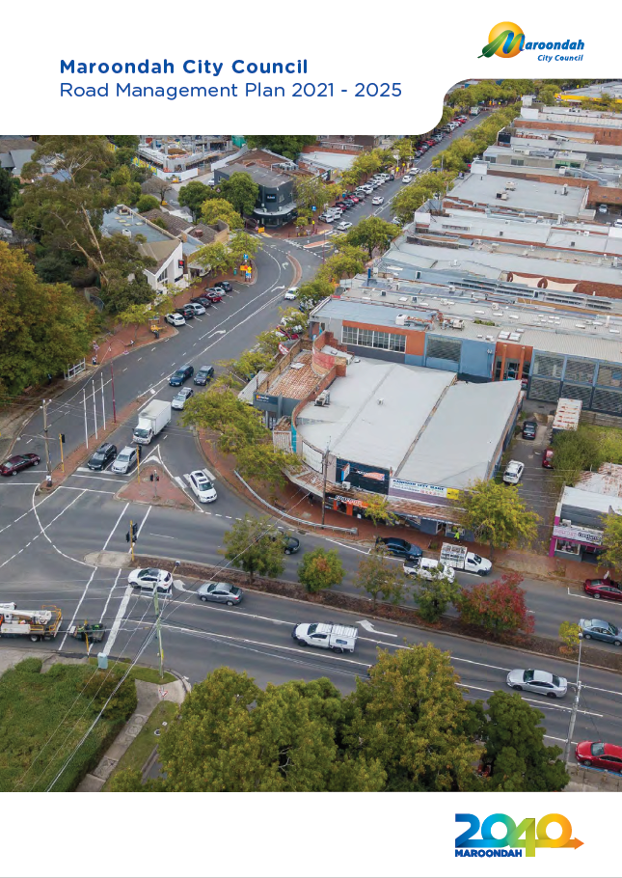

Schedule of version and adoption

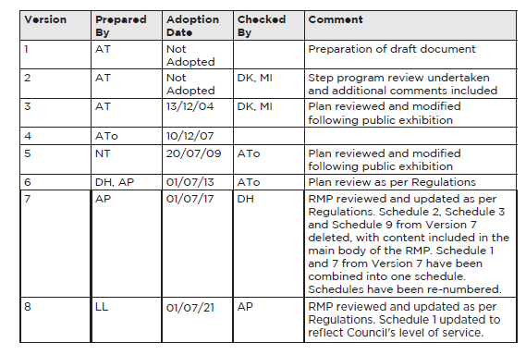

Introduction

Maroondah City Council’s Road Management Plan 2021 – 2025 outlines Council’s commitment to providing a safe local road and pathway network. The RMP is prepared in accordance with the Road Management Act 2004 (the Act) and documents the maintenance service standard and management systems.

Council is the responsible authority for an extensive network of infrastructure assets within the municipal area, which includes a local road network of 486 km, a car park network of 283,910 sqm and a pathway network of 765 km.

The RMP also supports the delivery of Maroondah 2040 Community Vision to be a vibrant and diverse city with a healthy and active community, living in green and leafy neighbourhoods which
are connected to thriving and accessible activity centres contributing to a prosperous economy within a safe, inclusive and sustainable environment.

Background
Council has a statutory obligation to inspect, maintain and repair a public road. Council’s Road Management Plan (RMP) has been developed to set reasonable standards in relation to the performance of road management functions for the maintenance of its public roads and associated road infrastructure.

The Act also requires that Council keep a register of public roads in respect of which
it is the coordinating road authority.

Council has developed criteria for inclusion of a road in the register around the scenario, “is the road reasonably required for general public use”.

While the development of a RMP is not compulsory, Maroondah City Council has taken the view, that the establishment of a RMP is based on sound asset management principles and practices that will provide a long-term community benefit.

In establishing the RMP, Council has reviewed its maintenance standards and management systems required to deliver an effective service in the context of what is reasonable, affordable and achievable considering Council’s limited resources and competing priorities.

Purpose of the road management plan

Section 50 of the Act states:

The purposes of a road management plan are having regard to the principal object of road
management and the works and infrastructure management principles:
- to establish a management system for the road management functions of a road
authority which is based on policy and operational objectives and available resources.

- to set the relevant standard in relation to the discharge of duties in the performance of those road management functions.

Function of the road authority
Section 34 of the Act states:

A road authority has the following general functions:

a. to provide and maintain, as part of a network of roads, roads for use by the
community served by the road authority

b. to manage the use of roads having regard to the principle that the primary purpose of a road is to be used by members of the public and that other uses are to be managed in a
manner which minimises any adverse effect on the safe and efficient operation of the road and on the environment

c. to manage traffic on roads in a manner that enhances the safe and efficient operation of roads; to design, construct, inspect, repair and maintain roads and road infrastructure

d. to coordinate the installation of infrastructure on roads and the conduct of other works in such a way as to minimise, as far as is reasonably practicable, adverse impacts on the
provision of utility or public transport services

e. to undertake works and activities which promote the functions referred to in paragraphs (a), (b), (c) and (ca) and to undertake activities which promote the function in paragraph (d).

Statutory duty

Section 40 of the Act States:
1. A road authority has a statutory duty to inspect, maintain and repair a public
road:

a. to the standard specified in the road management plan for that public road or a specified class of public roads which includes that public road.

2. The statutory duty imposed by subsection (1) does not create a duty to upgrade a road or to maintain a road to a higher standard than the standard to which the road is constructed.

3. The statutory duty to inspect applies to any part of a public road which is:
a. a roadway
b. a pathway
c. a shoulder
d. road infrastructure.

Strategic direction

Council plan
Maroondah City Council’s Council Plan 2017-2021 details what Council must do to work towards achieving the long term vision described in Maroondah 2040. The Council Plan sets out strategies for the next four years and considers what Council needs to undertake in these four years to achieve that vision. The RMP underpins the strategic directions contained within the Council Plan.

The following key directions are supported by the RMP:

- Work in partnership to facilitate a safe, accessible and efficient integrated transport network that enhances liveability and facilitates living locally within 20-minute neighbourhoods.

- Ensure responsible and sustainable management of Maroondah’s resources, assets, infrastructure and natural environment.

- Embrace emerging technology, the digital economy and opportunities for innovation in the delivery of services, enhancement of assets, and engagement of the community.

Asset management plan

Council’s Asset Management Plan (AMP) provides a strategic long term plan for the maintenance and development of Council’s assets, including but not limited to roads
and pathways.

The levels of service specified in the AMP, the data collected from routine inspections, and the four-yearly cyclic condition assessments undertaken as part of the pavement management system form a critical relationship in the ongoing maintenance of infrastructure, the development of works programs and the refinement of existing asset strategies.

Long term financial strategy
Council has established a 10 year Long Term Financial Strategy to set Council’s strategic direction. The strategy ensures the long term financial viability of Council and includes the review of expenditure on the renewal and maintenance of Council’s assets in the context of Council’s total
budget.

Emergency management plan
Council's Municipal Emergency Management Plan (MEMP) has been produced pursuant to Section 0 of the Emergency Management Act 1986. The MEMP addresses the prevention of, response to and recovery from emergencies within the municipality and is the result of the co-operative efforts of Municipal Emergency Management Planning Committee (MEMPC) which consists of response and recovery agencies and organisations, Council members and local business and community representatives.

The RMP takes into consideration the requirements of the Emergency Management Plan and the need to ensure that emergency events are factored into the standards established through the RMP.

Assets

Assets included in the RMP
While the Road Management Act is limited to a road authority’s obligations within a road reserve, Council also voluntarily applies the same standards in this RMP to its road, car park and pathway asset classes, within road reserves and public open space.

Following asset classes are included as part of the RMP.

- Council (or local) roads
- Car parks (including laneways)
- Traffic management devices
- Kerb and channel
- Stormwater pits (on or abutting roads
- and pathways)
- Pathways (footpath, reserve paths,
- shared paths)
- Structures (bridges or underpasses)
- Street trees (trees within a road reserve)*
* Where the street tree impacts the function of a pathway
in accordance with Schedule 1. Street Trees impacting the
function of a road will be identified and actioned as part of
Council’s cyclical Tree Inspection program.

Further detail regarding inspection frequencies and intervention levels can be found in Schedule 1 and Schedule 4.

Each of Council’s asset classes are identified spatially in Council’s Geographical Information System (GIS). The GIS system in conjunction with Council’s Asset Management System forms Council’s asset register.

Assets excluded in the RMP
The following assets or areas are not included in the RMP, as they are not the responsibility of Council.

- VicRoads (or Arterial) roads
- EastLink
- Body Corporate (private) driveways
- Vehicle crossings/driveways
- Service authority (utility) assets

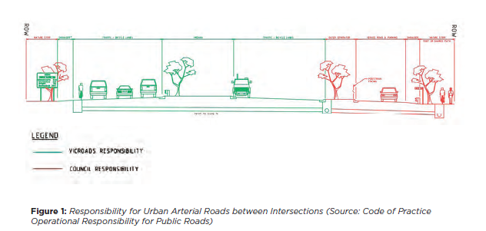

Asset hierarchy

Road hierarchy
For this section, a road is limited to the area subject to vehicular traffic. The area not subject to vehicular traffic does not form part of the road.

To establish appropriate levels of service for the inspection and maintenance of the road asset class the following road hierarchy has been adopted.

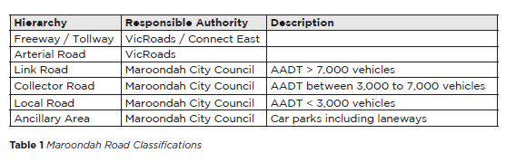

Pathway hierarchy
To establish appropriate levels of service for the inspection and maintenance of the
pathway asset class the following pathway hierarchy has been adopted. This hierarchy is
applicable to all pathways including paths on road reserve and public open space.
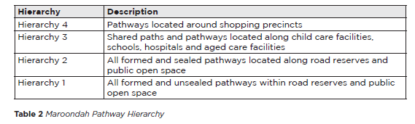

Level of service

Adopted level of service

The level of service stated in the RMP has been set taking account of user safety, resourcing (labour and material) and repair techniques. Council has established the
RMP to meet its statutory duty stated in the Act:

- Inspection frequencies (Schedule 4) to satisfy the duty to inspect a public road

- Intervention levels (Schedule 1) to satisfy the duty to maintain and repair a public road.

This level of service assumes that Council’s assets are safe for ordinary use and that a
user will exercise reasonable care for their own safety.

Proactive inspections (scheduled inspection)

The Act provides that Council has a statutory duty to inspect a public road and pathway to the standard specified in the RMP. In determining the applicable standard Council has made a policy decision that the standards are reasonable.

The proactive inspection frequencies have been documented in the RMP and are attached in Schedule 4. Council’s Asset Management Team undertakes these inspections on a programmed basis, in accordance with the intervention levels

Reactive inspections (unscheduled inspection)

A reactive inspection is a defect or issue reported to Council which results in a reactive or unscheduled inspection. The report can be lodged by a member of the public or staff via Council’s various communication methods, including but not limited to phone, letter, email or social media. In these cases, Council will inspect and respond to all reports within the timeframes stated in Council’s Customer Service Charter.

Council practices

To allow for better management of Council’s assets, its Asset Management team also identifies some condition (asset preservation) and amenity related items.

These items are identified in accordance with Schedule 1.

Asset protection inspections

As part of the building works approval process, Council requires the owner/builder to undertake an assessment of the condition of the adjacent Council infrastructure prior to building works, to ensure that any new damage is repaired.

Following the building works Council inspects the condition of its assets and ensures that all reinstatement works are undertaken to Council’s satisfaction.

Council will undertake inspections of Service Authority (Utilities) works in accordance with the requirements of the Ministerial Code of Practice for Management of Road Utility Infrastructure in Road Reserves, and the associated Regulations.

Asset condition assessment

Council’s Asset Management team commissions external contractors to undertake a condition assessment of Council’s road and associated road infrastructure on a minimum four-yearly cyclical basis. The condition assessments assist Council’s Asset Management team to undertake total life-cycle asset management associated with its assets. The data collected is utilised in the development of future works programs and funding applications.

These inspections look at the general overall condition of the network and as such are not intended to identify individual defects that might exceed stated intervention levels. This is done via Council’s proactive and reactive inspections.

The frequency of the asset condition assessments is detailed within Schedule 4 of the RMP.

Maintenance intervention levels

Council’s statutory duty under the Act extends beyond the duty to inspect a public road. Once a proactive inspection has discovered a defect or a defect is reported by the public or through reactive inspections, Council has a duty to assess the defect against its stated intervention levels to determine whether repair works are required and where applicable that this is done within the specified period of time.

Council has developed and documented minimum intervention levels for its road and pathway assets that it considers are reasonable in the context of what is affordable, and achievable within current budgets, available resource levels, and the adopted risk profiles.

The intervention levels specified in the RMP has a corresponding response times to mitigate the risk posed. The intervention levels have been determined based on what is considered reasonable in the context of Council’s available resources and allocated budgets.

Reactive inspection response times are aligned with Council Customer Service Charter and is not specified in the RMP.
As Council develops a greater understanding of its assets and work practices through the implementation of the RMP, the levels of service and budgets will be further refined.

The criteria utilised for determining appropriate levels of service for an asset include:

- Existing and proposed resource levels
- Risk principles/considerations
- Available budgets, expenditure profiles and existing financial strategies
- Road related asset maintenance strategies and policies and overall organisational funding priorities
- Community and social expectations
- Road users’ obligations under the Road Safety Act and based on common law principles to exercise reasonable care for their own safety.

Maintenance activity prioritisation

Council will prioritise its maintenance activities in accordance with the specified intervention levels in Schedule 1 and inspection frequencies in Schedule 4. The decision making process and establishment of policy decisions in respect of maintenance activities will take into account factors such as available resources, budgets, social, political and environmental factors.

Road management limitations

Council will make every endeavour to comply with all aspects of its RMP. However, in the event of natural disasters and other events, as listed but not limited to those below, Council reserves the right to prioritise its response to works in certain situations.

In determining the priorities for works there will be occasions where the standards set are not achievable. These may be for a variety of reasons that could not have been reasonably foreseen or managed such as:
- Emergency and disaster events: such as but not limited to storms, floods, fire, essential services disruption, widespread disease, terrorist attack, civil unrest or disobedience, major substance spillage or leak.

- Financial and resource constraints: such as but not limited to labour disputes and labour shortages, lack of suitably qualified contractors, unavailability of consumables needed for works, price fluctuations in consumables, unforeseen variations to Council’s revenue sources including external funding or the amount of a particular type of work exceeds Council’s reasonable budgetary allowance for that work.

- Statutory obligations: The RMP has been established in the context of Council’s current statutory obligations, service delivery priorities based on local community needs and available resources. If significant additional statutory obligations or demands for services are placed on Council without adequate funding of those obligations then that may constitute an intervening event.

When the above situations occur, Council may suspend or adjust some or all of the specified service and intervention levels, works priorities and any other activities under the RMP until such time as Council has recovered sufficiently from the intervening event to return in part or whole to normal operations. The RMP may also be reactivated as a whole or in stages.

Whenever Council’s RMP is suspended or adjusted or reactivated under this clause, then Council’s Chief Executive Officer (or equivalent position or anyone acting in this position or equivalent position) will issue written directions to Council staff to confirm the scope, timing and reasons for such direction. In issuing any direction under this clause the relevant Council Officer is to take into account the considerations contained in section 83 of the Wrongs Act 1958 (Vic). Council will maintain a register of these directions.

Register of public roads

Section 19(1) of the Act imposes a statutory duty upon Council to keep a register of all
municipal roads that are public roads. For a road to be included in the register Council
has to decide whether ‘… the road is reasonably required for general public use...’
Section 17(3).

What is a public road?
The Act does not provide an exhaustive definition of what a road is. Section 3 provides that a road includes any public highway (defined to mean a common law highway); any ancillary area (such as a car park adjacent to a public road); and any land declared to be a road by a road authority.

Of roads relevant to Council (municipal roads), the legislation provides that the following municipal roads are public roads: roads declared under the Local Government Act 1989; and roads which VicRoads declare to be a municipal road.

Of the remaining municipal roads only those roads that Council makes a decision are reasonably required for general public use become public roads.

Where the legislation dictates or Council has made a decision that a municipal road is
a public road, this road must be included on Council’s Register.

Register content
The following information must be included in the Register in accordance with the provisions of Schedule 1 of the Act:

(a) the name of each public road
(b) if a road becomes a public road after 1 July 2004, the date on which the road became a public road
(c) if the public road ceases to be a public road, the date the road ceased to be a public road;
(d) the classification of the public road
(e) the reference of any plan or instrument made on or after 1 July 2004 that fixes or varies the boundaries of a public road
(f) any ancillary areas
(g) the reference to any arrangement under which road management functions in respect of any part of a public road or ancillary area is transferred to or from another road authority
(h) any other matter required to be included by this Act, the relevant road Minister, or which is prescribed.

Required considerations

Is the area of land a road?
The following criteria should be considered when deciding whether an area of land is a
road:

• Is it a public highway including a highway at common law?
• Is it an ancillary area?
• Has the land been declared to be a road, or forming part of a public highway or ancillary area?
• Has Council previously been deemed to be the responsible authority for it?
• Has the land been developed or constructed for use as a road?
• Any other relevant matter brought to Council’s attention?

Is the road reasonably required for general public use?
The following criteria should be considered when deciding whether a municipal road is reasonably required for general public use:

• Has it been developed or constructed for use by the general public?
• Does it serve a defined purpose or function for the general public?
• Is there evidence that it is currently being used by the general public?
• Is there unrestricted public access?
• What are the consequences if public access was removed?
• Can the needs for public use of this land be readily accommodated with alternatives?
• Any other relevant matter brought to Council’s attention?

Availability of register of public roads
Council’s Registers of Public Roads contains lists of roads, car parks, rights of ways
(ROW) and shared paths. The Register can be view on Council’s website or at any
Council Service Centre.

Demarcation of responsibility

Arterial roads

The operational responsibility for arterial roads is shared between Council and VicRoads.
While VicRoads is the coordinating road authority for arterial roads, Council is the
responsible road authority for aspects of the arterial road behind the kerb and channel
such as footpaths. The figure below describes the most common operational demarcation
scenario found for the arterial road network.

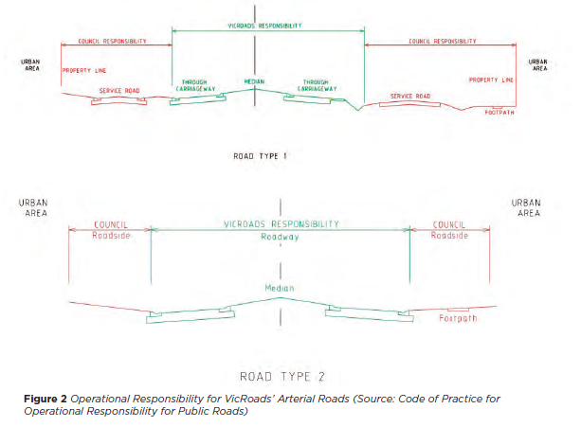

Rights of way

A right of way (ROW), also known as a laneway, is typically identified as ‘Road’ on title. All
ROWs are included in the Register of Public Roads and an appropriate maintenance and
inspection regime applied to the area of land that reflects the expected frequency of use
by the public and the associated risk.

In some instances, land maybe subject to a carriageway easement. Where the carriageway
easement has the potential to provide property access, or form part of the public
infrastructure network, or has dedicated and demonstrated long-term use by the public
and is constructed, or developed for use by the general public, Council will generally
consider it to be a public road and therefore be included in the Register and become
Council’s responsibility.

Body corporate driveways/private roads

Body corporate common property is privately owned land that does not form part of the municipal road network and is the responsibility of the body corporate to maintain.

Ancillary assets

An ancillary asset is owned or managed by Council but is not part of the road. Typically
ancillary assets would be a car park, rest stop or scenic lookout. The following criteria are to be considered in determining whether an area can be considered an ancillary area:

- Is it under Council’s ownership or management?
- Required by Council or the public for use other than as a road?
- Can a dedicated and demonstrated long-term use by the public can be shown?
- No prior owner is exercising any rights of private ownership over the land?
- Any other relevant matter brought to Council’s attention?
- Council will manage ancillary assets in accordance with the RMP.

Boundary roads

Where Council’s municipal boundary has been established on a road, the boundary is the centre line of the road reservation. In such cases a single road will have two coordinating road authorities who are responsible for the portion of road within their own municipal district.

Council has formalised agreements with each of its adjoining municipalities agreeing to transfer road management functions for each boundary road to a single responsible road authority.

The current agreements are listed within Schedule 5 of the RMP.

Crown land or freehold title

Council is responsible for the care and maintenance for roads, pathways and car parks that are located on crown land and freehold title. These can include reserve access tracks that are formed and provide access to car parks and shared pathways that have been constructed by Council, or have been historically maintained by Council, and therefore require consideration for inclusion in the register of public roads.

It is considered that roads, car parks, pedestrian pathways or access tracks located on crown land or separate freehold title, that Council accepts are a common law public highway, are constructed and developed for use by the public, and are reasonably required for general public use, will be included in the Register of Public Roads and managed in accordance with the RMP.

Vehicle crossings

A vehicle crossing is a point next to a road to enable a person using the road to have access to land on the other side of a pathway (footpath, reserve path or shared path) or channel (kerb and channel or table/open drain).

Schedule 10 and Section 225 of the Local Government Act, gives Council the power to equire the property owner to maintain or reconstruct the crossing to Council’s approved standard at the property owner’s cost. Council’s Local Law 11, Clause 25 further supports this provision.

If the property owner wishes to construct a new vehicle crossing or renew an existing vehicle crossing, consent must be obtained from Council. Council will not contribute funds towards the construction of the pathway or channel sections in these situations.

Pathway
A pathway forms part of Council’s pedestrian network which is integral to the connection and accessibility of pedestrians throughout the municipality. Where a vehicle crossing intersects a pathway, Council is responsible for the inspection, maintenance and renewal of the pathway network which traverses a vehicle crossing as shown in red in Figure 3 and Figure 4.

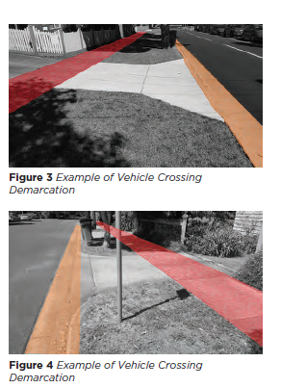

Channel

A channel forms part of Council’s stormwater system and is integral for the management of surface stormwater flows.

Where a vehicle crossing, intersects the channel, Council is responsible for the inspection, maintenance and renewal of the channel network which traverses a vehicle crossing as shown in orange in Figure 3 to Figure 6.

All other components of a vehicle crossing are the responsibility of the relevant
property owner to inspect, maintain and renew.

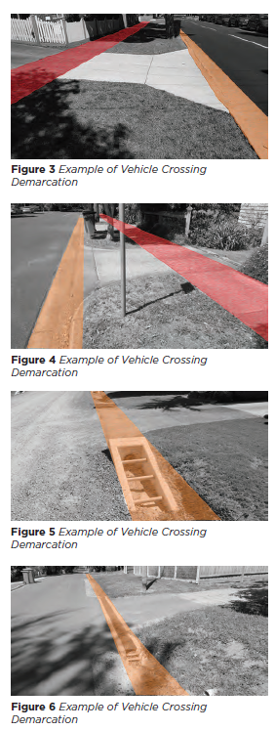

Stormwater connection

Council has deemed that each property’s private stormwater system up to and including the connection to a public (Council or Melbourne Water) stormwater asset to be the responsibility of the relevant property owner to inspect, maintain and renew.

In many instances, the public stormwater asset is located outside of the property boundary, within the road reserve. In these cases, the property owner continues to be responsible for their private stormwater system up to and including the connection point. This is shown in blue in Figure 7 to Figure 9.

If the property owner wishes to construct a connection or renew an existing connection to a public (Council or Melbourne Water) stormwater asset, consent must be obtained from Council.

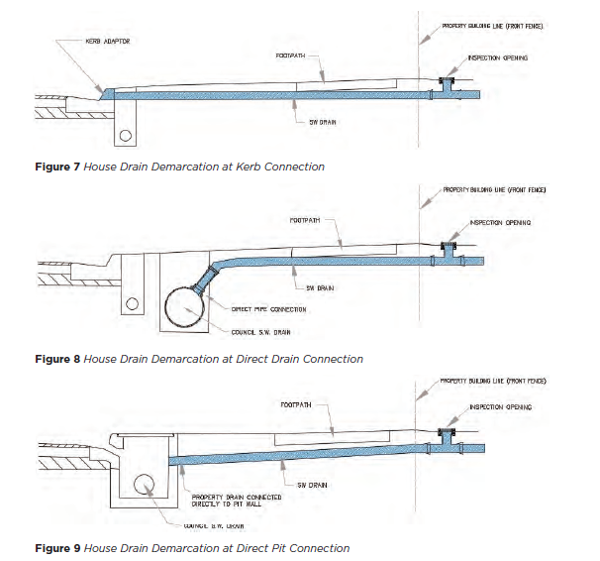

Assets in private area

In some instances, Council may become the responsible authority for road and associated road infrastructure within private property. For this to occur the infrastructure must form part of the public infrastructure network and have dedicated and demonstrated long-term use by the general public.

A typical example of Council infrastructure on private property can be found along shop fronts. In some instances, the footpath along the shop front is partially or completely located within private property.

In many of these instances, Council would be the responsible authority for the full extent of the footpath as it forms part of the public pathway network.

Naturestrip

Naturestrips are the piece of land situated between the edge of a road and the property boundary (excluding any kerb and formed pathway). Nature strips form part of the road reserve and:
• provides a space for authorities to house their assets
• may contain trees for shade and beautification of a street.

While a resident does not own the naturestrip in front of their homes, they are encouraged to maintain it. Maintenance carried out by the resident typically involve regular mowing, weeding, cutting the edges and picking up litter.

In accordance with the Road Management Act, sections 40 and 107, Council does not
have a statutory or common law duty to inspect, maintain and repair the naturestrip.

Modifications or landscaping of naturestrips must be undertaken in accordance with Council’s Naturestrip Landscaping Guidelines.

RMP actions and responsibilities

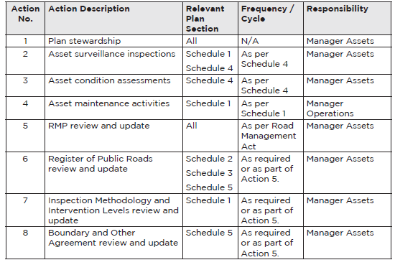

Appendices

The following appendices are attached to the plan:

Schedule 1 – Inspection Methodology and Intervention Levels

Schedule 2 – Road Classification Map

Schedule 3 – Pathway Hierarchy Map

Schedule 4 – Inspection Areas and Frequencies

Schedule 5 – Demarcation Agreement Register

Schedule 1:

Inspection Methodology and Intervention Levels

Schedule of version and adoption

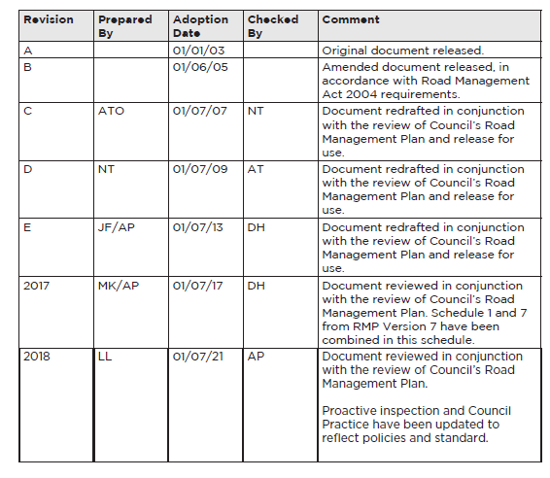

Introduction

This document sets out the requirements for Maroondah City Council’s inspection methodology (Asset Surveillance Function) and intervention levels.

It details the requirements for the Asset Surveillance Officers including details relating to
inspection frequency, type of defects and defect intervention levels.

Asset Surveillance Function

Team structure

The asset surveillance function consists of four (4) officers with two (2) dedicated
inspectors with the title of Asset Surveillance Officer.

Asset Surveillance Officer

Maroondah City Council is obligated to provide and maintain, so far as practicable, a safe working environment for its employees and safe public spaces for members of the community.

The Asset Surveillance Officers are to carry appropriate identification (as provided) and are required to: wear high visibility tops in accordance with applicable Council Policies; wear comfortable walking shoes; and required to follow corporate occupational health and safety policies and procedures.

The Officers conduct their inspections using mobile computing devices (iPads) which have access to Council’s infrastructure asset databases and map bases.

Inspections can be conducted ‘on foot’ or via ‘vehicles’ taking account of the typical use of the asset class and safety. ‘On foot’ inspections are the preferred inspection method and are typically used to inspect pathways, signs and road furniture.

This type of inspection allows the inspector to review the asset from the perspective of
the user and at a safe speed away from road traffic.

‘Vehicular’ inspections are only used to identify defects located within the roadway. When a defect is identified, the Officer is required to stop and turn off their vehicle in a safe and legal manner before using their mobile computing device.

Inspection area and frequency

The municipality has been segregated into 20 areas to adequately program the
surveillance activities. Further details of the segmentation and inspection frequency is
detailed in Schedule 4. Sc

Defect table

The following table outlines the defects identified as part of Council’s inspection of roads
and pathways, including Council’s response to a defect.

The table is divided into 6 sections:
• Proactive Inspections – Roads and Carpark
• Council Practice – Roads and Carparks;
• Proactive Inspections – Pathways
• Council Practice – Pathways
• Proactive Inspections – All
• Council Practice – All.

Please refer to Road Management Plan for further information about Proactive Inspections and Council Practice.

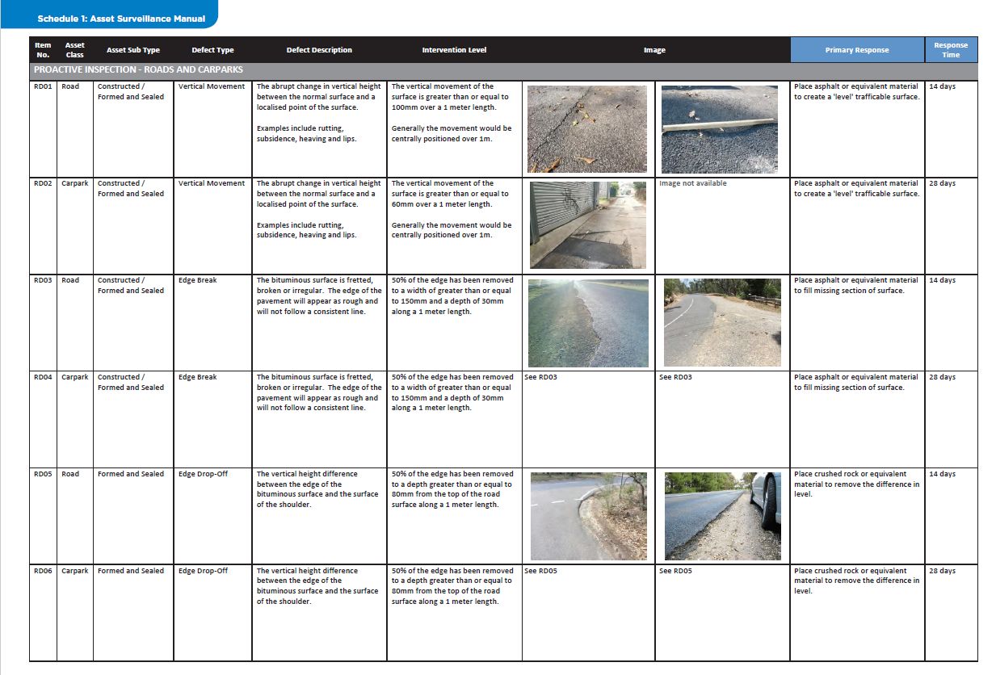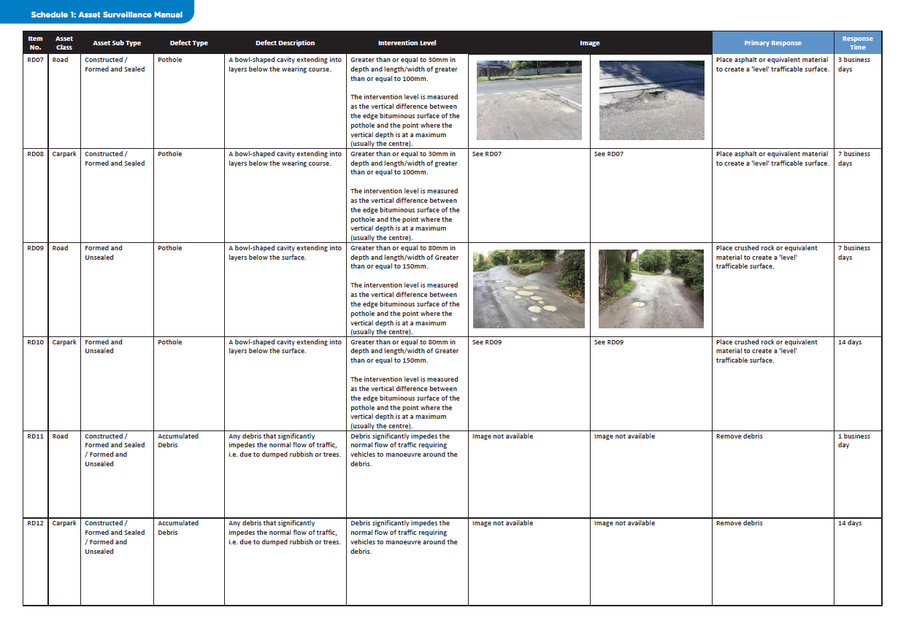
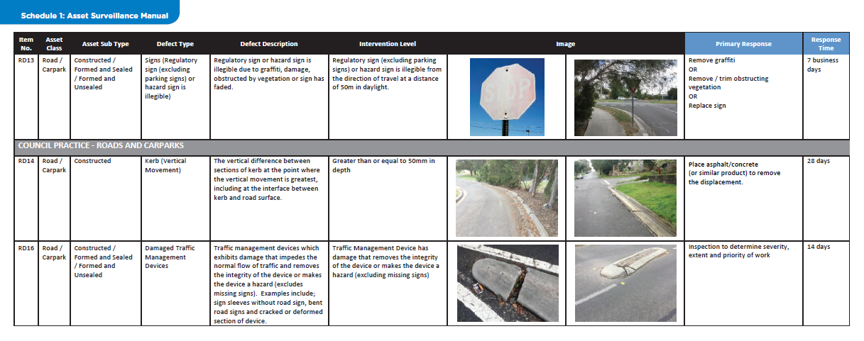

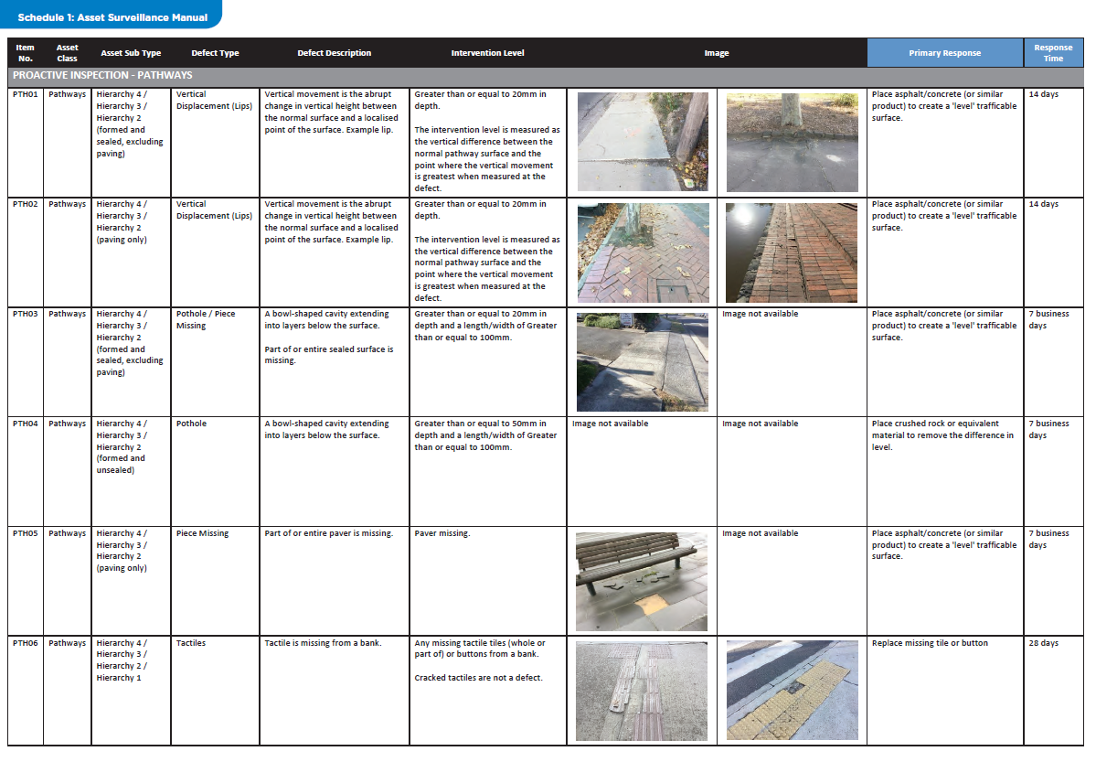
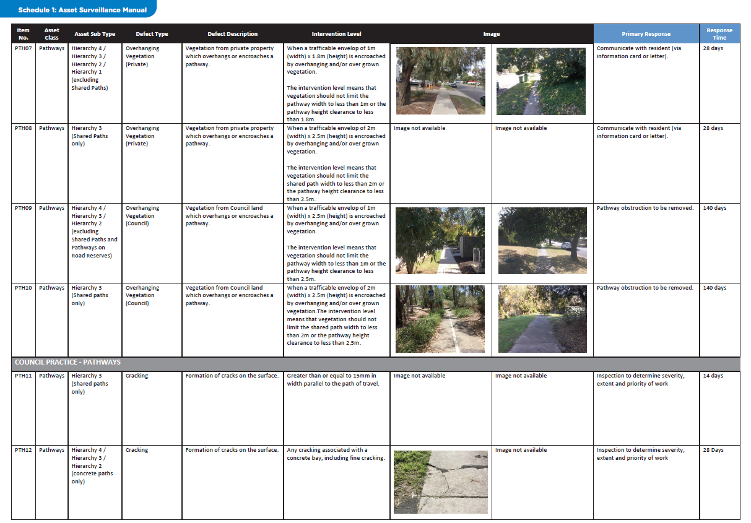
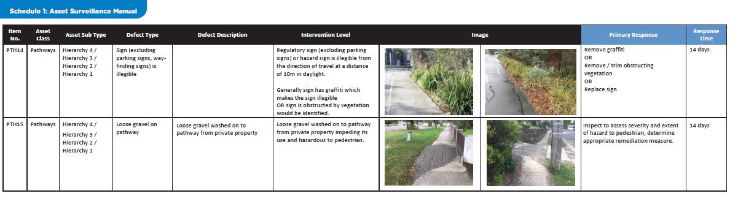

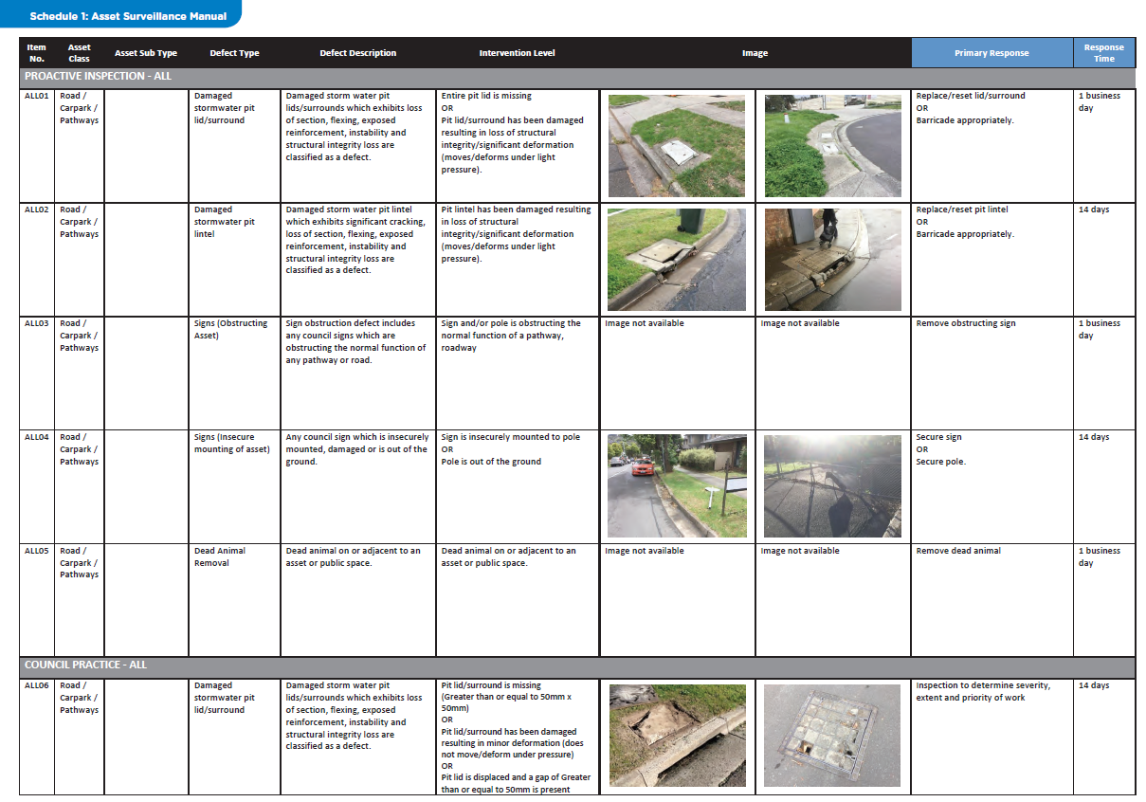
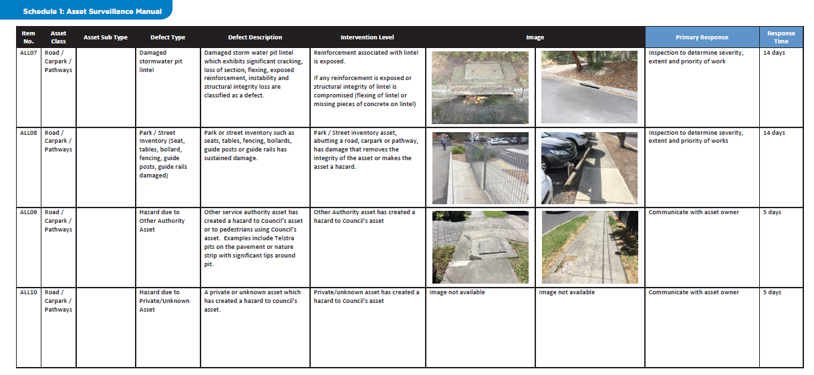

Schedule 2: Road Classification Map

Road Classification Map

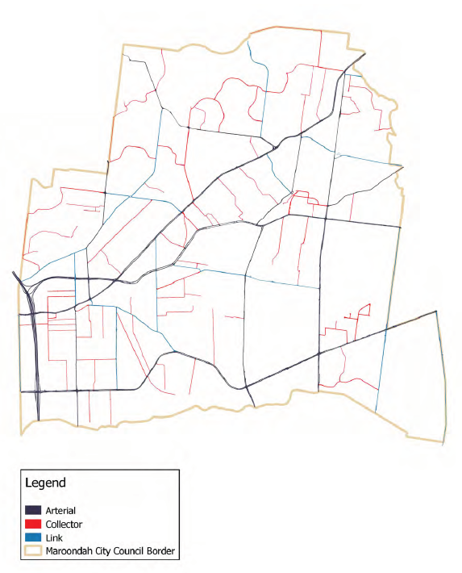

Schedule 3: Pathway Hierarchy Map

Pathway Hierarchy Map

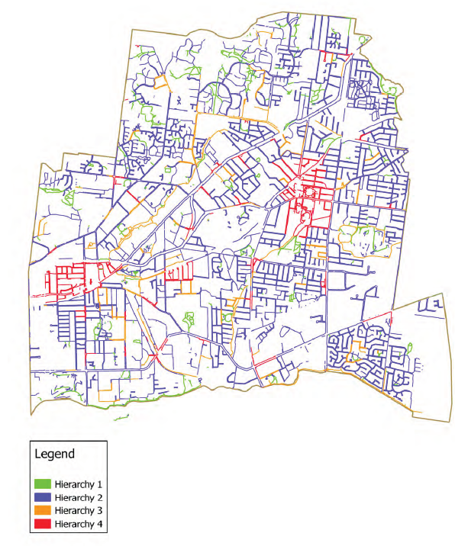

Schedule 4: Inspection Areas and Frequencies

Inspection areas

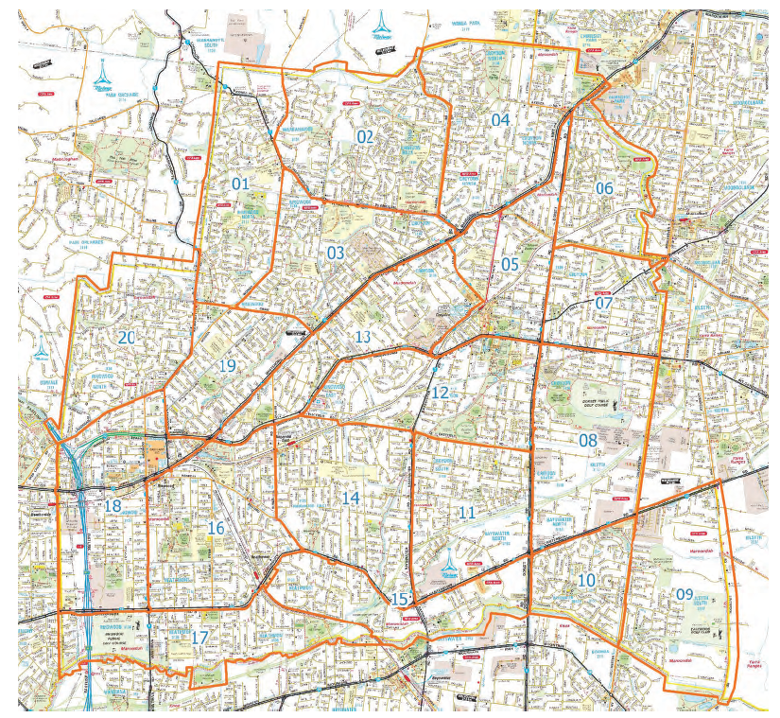

Inspection Frequencies

Council undertakes Proactive Inspections and Asset Condition Assessments on various asset classes to identify and priorities maintenance activities and develop future capital works programs.

Asset Condition Assessment

Council undertaken a rolling four-year program for the collection of condition data relating to roads and road associated assets. Please refer to the Road
Management Plan for further information about Asset Condition Assessment.

Proactive Inspection

Proactive inspections are undertaken in accordance with Schedule 1. The timeframe for undertaking the inspection is shown in the Proactive Inspections Schedule section, below.

Please refer to the Road Management Plan for further information about Proactive Inspections.

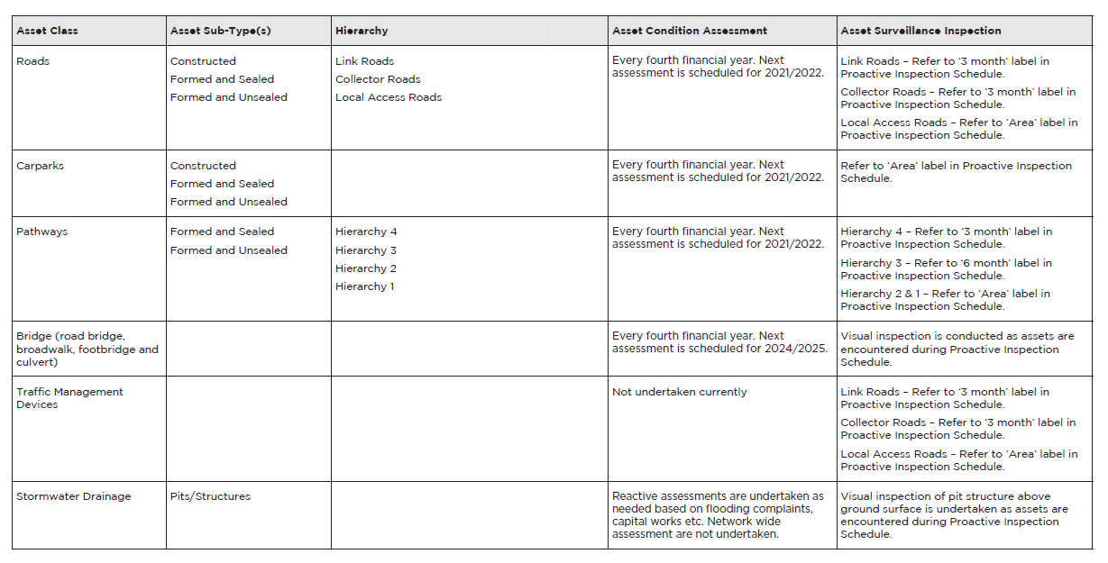

Proactive Inspection Schedule

3 Month

Inspection identified as 3 Month are high use road, carpark and pathway assets throughout the municipality. The inspection of this group occurs every 6 months. The assets listed as 3 Month are scheduled to be inspected by the dates identified in the calendar (i.e. 30 June and 30 December). The inspection start dates are scheduled, however the inspection may start a maximum of 6 weeks before the scheduled end date.

3 & 6 Month

Inspection identified as 3 & 6 Month are high and medium use road, carpark and pathway assets throughout the of this group occurs every 6 months. The municipality. The inspection of this group occurs every 6 months. The assets listed as 3 & 6 Month are scheduled to be inspected by the dates identified in the calendar (i.e. 30 March and 30 September). The inspection start dates are scheduled, however the inspection may start a maximum of 6 weeks before the scheduled end date.

Area

Inspection identified as Area are regular use road, carpark and pathway assets. The municipality is divided into 20 areas, see Inspection Areas map above, with each area inspected every 12 months. The assets listed in each Area has a scheduled inspection completion date as shown in the calendars. The inspection start dates are scheduled, however the inspection may start a maximum of 6 weeks before the scheduled end date.

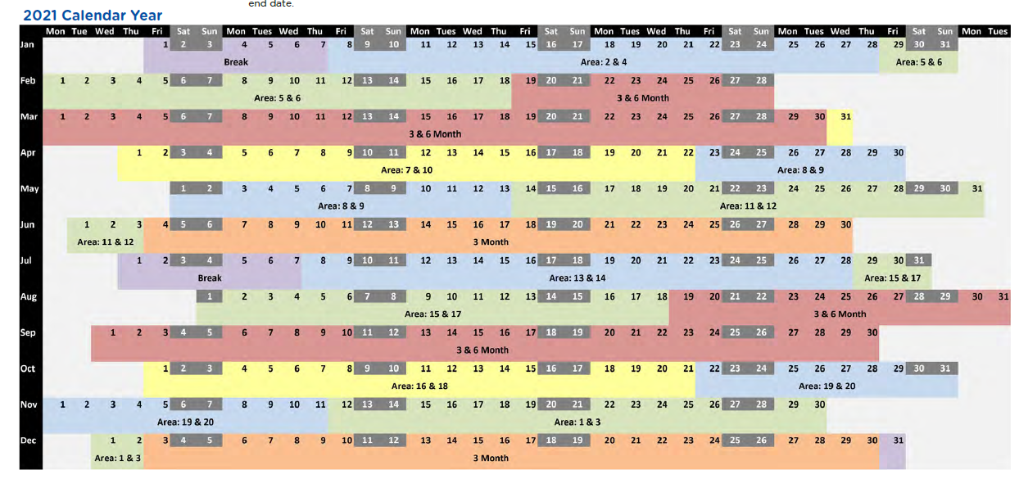

Proactive Inspection Schedule - 2022 Calendar Year

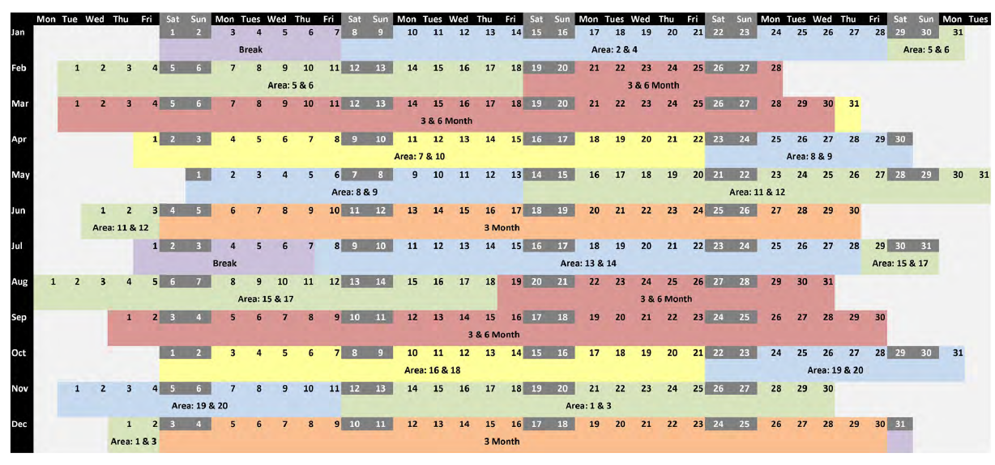

Proactive Inspection Schedule - 2023 Calendar Year

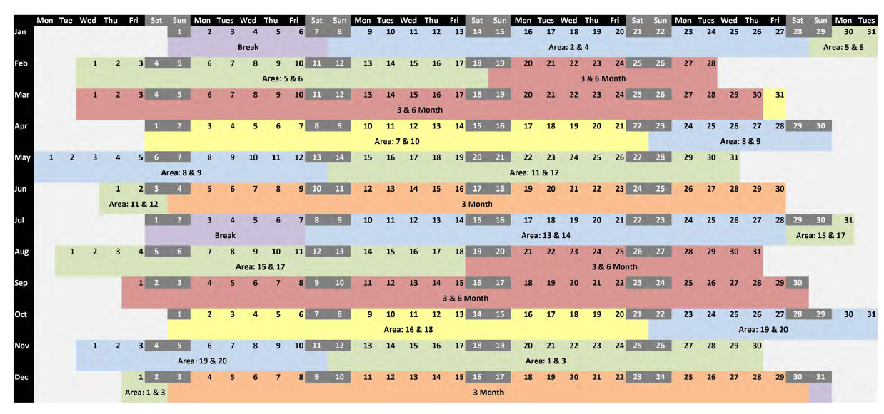

Proactive Inspection Schedule - 2024 Calendar Year

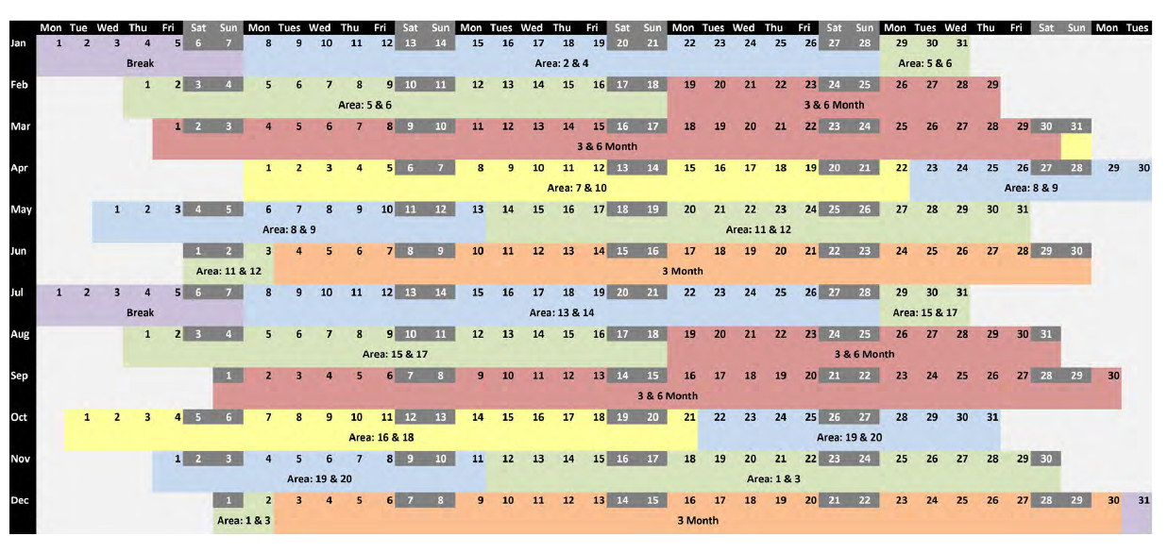

Proactive Inspection Schedule - 2025 Calendar Year

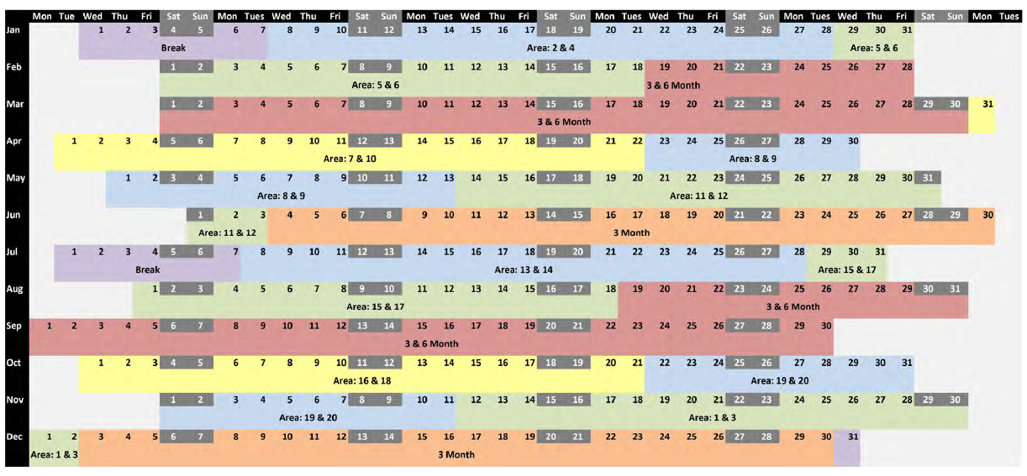

Proactive Inspection Schedule - 2026 Calendar Year

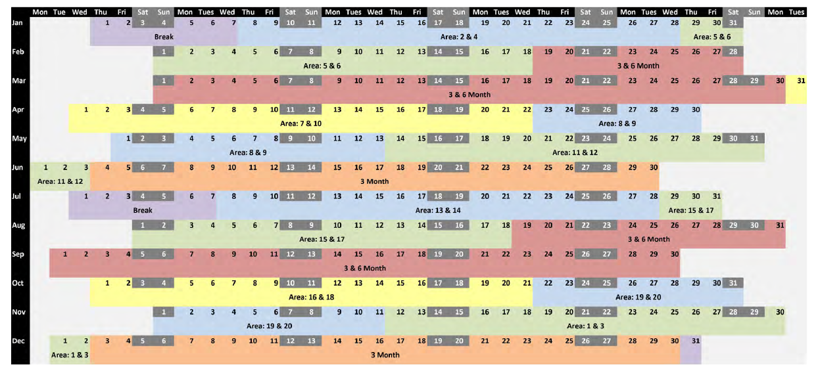

Schedule 5: Demarcation Agreement Register

Demarcation Agreement Register

