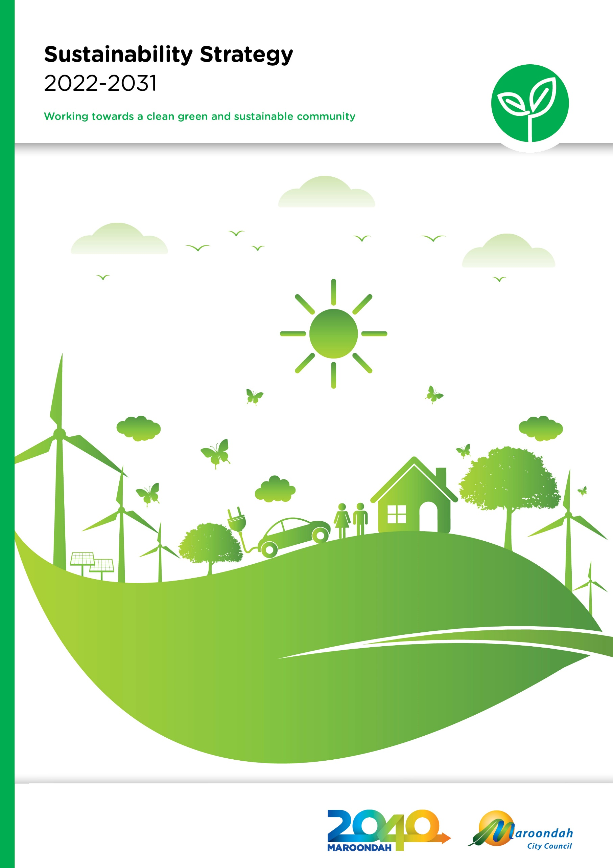
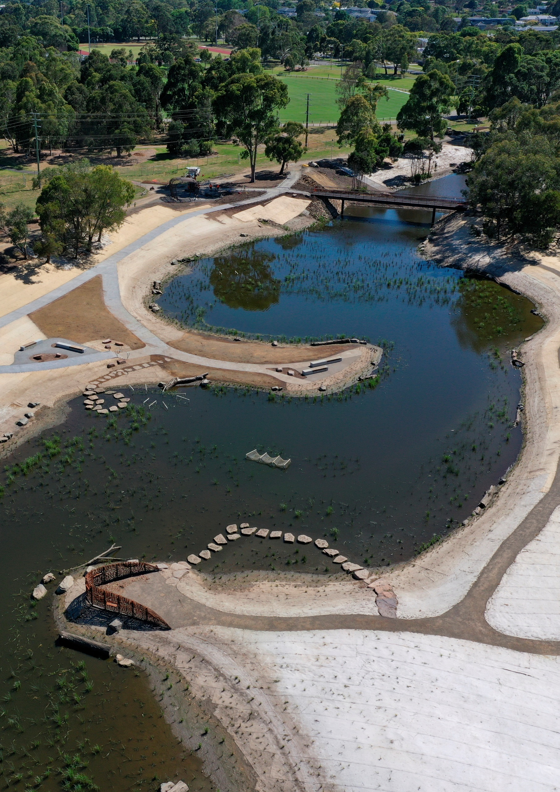

Contents

Executive Summary 4
Section 1 - Why is sustainability important? 6
Section 2 – What does the evidence say? 12
Section 3 – What we did and what you told us? 13
Section 4 – A strategy for the future 15
Outcome area 1 - Built Environment 17
Outcome area 2 - Climate Change 19
Outcome area 3 - Community Connections 21
Outcome area 4 - Green Economy 23
Outcome area 5 - Green Infrastructure 26
Outcome area 6 - Governance, Evaluation and Improvement 28
Tracking our progress 30
Section 5 – References and Glossary 31

Executive Summary

The Sustainability Strategy 2022-2031 presents a vision of an environmentally, socially and economically sustainable Maroondah. The Strategy supports the eight visions from Maroondah 2040 - Our Future Together, along with the UN Sustainable Development Goals, to support a holistic approach to sustainability.

The definition of sustainability used in the development of the Sustainability Strategy is:

Sustainability means balancing economic, social and environmental factors. It is concerned with how we can manage resources to ensure future generations have the same opportunities that we enjoy today.

It recognises the interrelationships between environmental, social and economic factors of sustainability, however highlights that all social and economic systems rely on a strong and healthy environment. Addressing issues like climate change, and vegetation and biodiversity loss will play a central role in supporting the ongoing health and wellbeing, and economic vibrancy of Maroondah.

The Strategy focuses on six outcome areas that will provide the foundation to support Maroondah’s environment and social and economic systems over the next 10 years. These outcome areas are the Built Environment, Climate Change, Community Connections, Green Economy, Green Infrastructure, and Governance, Evaluation and Improvement.

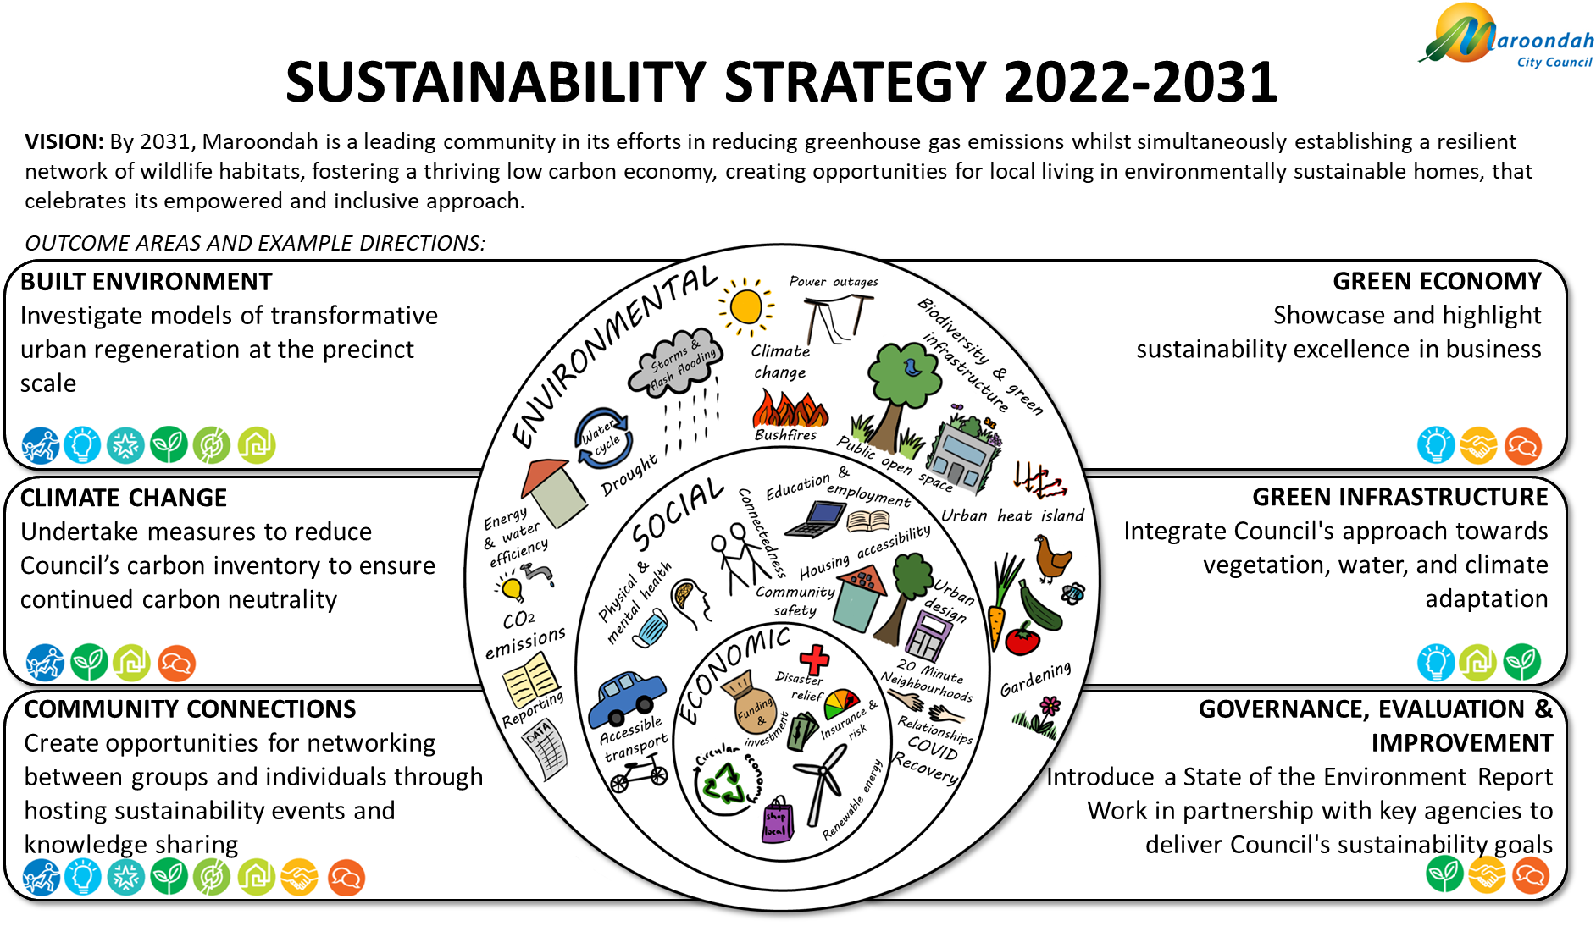

To give effect to each outcome area are a number of key directions that will guide Council’s actions over the coming 10 years. Three action plans will be developed over the course of the Strategy period to outline the specific actions that will be undertaken to implement these key directions.

Outcome Area | Key Directions
Outcome Area 1 - Built Environment | 1.1 Undertake an assessment of best practices in urban design  1.2 Use evidence drive design and monitoring to maximise sustainability outcomes in Council buildings and infrastructure  1.3 Advocate for ambitious ESD targets through partnerships such as CASBE, and support developers and property owners to incorporate sustainable construction and ESD practices  1.4 Investigate models of transformative urban regeneration at the precinct scale  1.5 Promote and facilitate the use of public and active transport to support liveable activity centres
Outcome Area 2 - Climate Change | 2.1 Undertake measures to reduce Council’s carbon inventory to ensure continued carbon neutrality status  2.2 Undertake advocacy and climate action through continued participation and hosting of the Eastern Alliance for Greenhouse Action (EAGA)  2.3 Adapt Council’s practices to future climate scenarios  2.4 Further embed climate change thinking into Council projects, operations, planning and strategies, using climate science to act with urgency  2.5 Improve climate education across Council staff and community
Outcome Area 3 - Community Connections | 3.1 Use the 20 Minute Neighbourhoods framework to enable community and neighbourhood planning at the local level  3.2 Investigate opportunities to make sustainability accessible and easy for all  3.3 Investigate the creation of sustainable communities with active community leaders to develop locally-led sustainability initiatives  3.4 Create opportunities for networking between groups and individuals through hosting sustainability events and knowledge sharing
Outcome Area 4 - Green Economy | 4.1 Continue to support local businesses in implementing green economy principles through programs such as EAGA’s Solar Savers and Energy Upgrade Agreements  4.2 Support businesses in making sustainable decisions through the provision of advice and incentives  4.3 Showcase and highlight sustainability excellence in business  4.4 Define and explore opportunities for enhancing the green economy in Maroondah
Outcome Area 5 - Green Infrastructure | 5.1 Integrate Council’s approach towards vegetation, open space, water and climate change adaptation  5.2 Partner with other government agencies, businesses and community members to advocate for and deliver green infrastructure within projecting in Maroondah  5.3 Improve data collection, spatial planning and GIS capacity to assist in identifying priority areas where green infrastructure can deliver the most environmental, social and economic benefits in areas of greatest need
Outcome Area 6 - Governance, Evaluation and Improvement | 6.1 Collate environmental monitoring information to report to Council and the community  6.2 Improve data capture, availability and accessibility for use across Council projects and reporting, and to support evidence-based decision-making for sustainability goals  6.3 Work in partnership with key agencies to deliver Council’s sustainability goals

Section 1 - Why is sustainability important?

The Sustainability Strategy 2022-2031 replaces the existing Sustainability Strategy 2016-2020 and seeks to build on the achievements and outcomes delivered during this period. The Strategy recognises the importance of taking a holistic approach to planning for the future of Maroondah, including the environmental, social and economic aspects of our community.

The world has changed since the previous strategy was developed in 2016, with COVID-19 significantly impacting our lives, supply chains, and shifting focus to living locally. We have also experienced first-hand the impact of significant weather events causing property and infrastructure damage and power outages, some coinciding with COVID lockdowns. The Sustainability Strategy has been developed to place Maroondah in a strong position to address issues of sustainability, including climate change, enhancing Maroondah’s vegetation and biodiversity, supporting the transition to a green economy, building social connections, and recovering from COVID-19 in a manner that is just and within environmental limits.

What is sustainability?
Sustainability means different things to different people, however this Strategy embraces the following definition:

Sustainability means balancing economic, social and environmental factors. It is concerned with how we can manage resources to ensure future generations have the same opportunities that we enjoy today.
(City of Melbourne, 2016, p. 156)

Looking beyond environmental sustainability enables a focus on building resilience into our community. Resilience can be defined as "the capacity of individuals, institutions, businesses and systems within a city to adapt, survive and thrive no matter what kind of chronic stresses and acute shocks they experience" (City of Melbourne, 2016, p. 11). Resilience and sustainability work together to build and support a strong and diverse community that has the capability to respond to challenges, whether it be natural disaster, or unforeseen social or economic change.

The triple bottom line comprising of environmental, social and economic pillars is a common representation of sustainability, where a sustainable and resilient community relies on strength across and between all three pillars. The Sustainability Strategy acknowledges that our social and economic systems exist within and rely upon the sustainability of the environment. For example, climate change will see more extreme weather events that may cause power outages, property damage, bushfires and flash flooding. This has flow on social and economic impacts, such as productivity loss, access issues and social isolation, rising insurance costs and increasing health risks. For this reason, it is essential that we consider the impact our actions have on the environment to also support the ongoing sustainability of our social and economic systems.

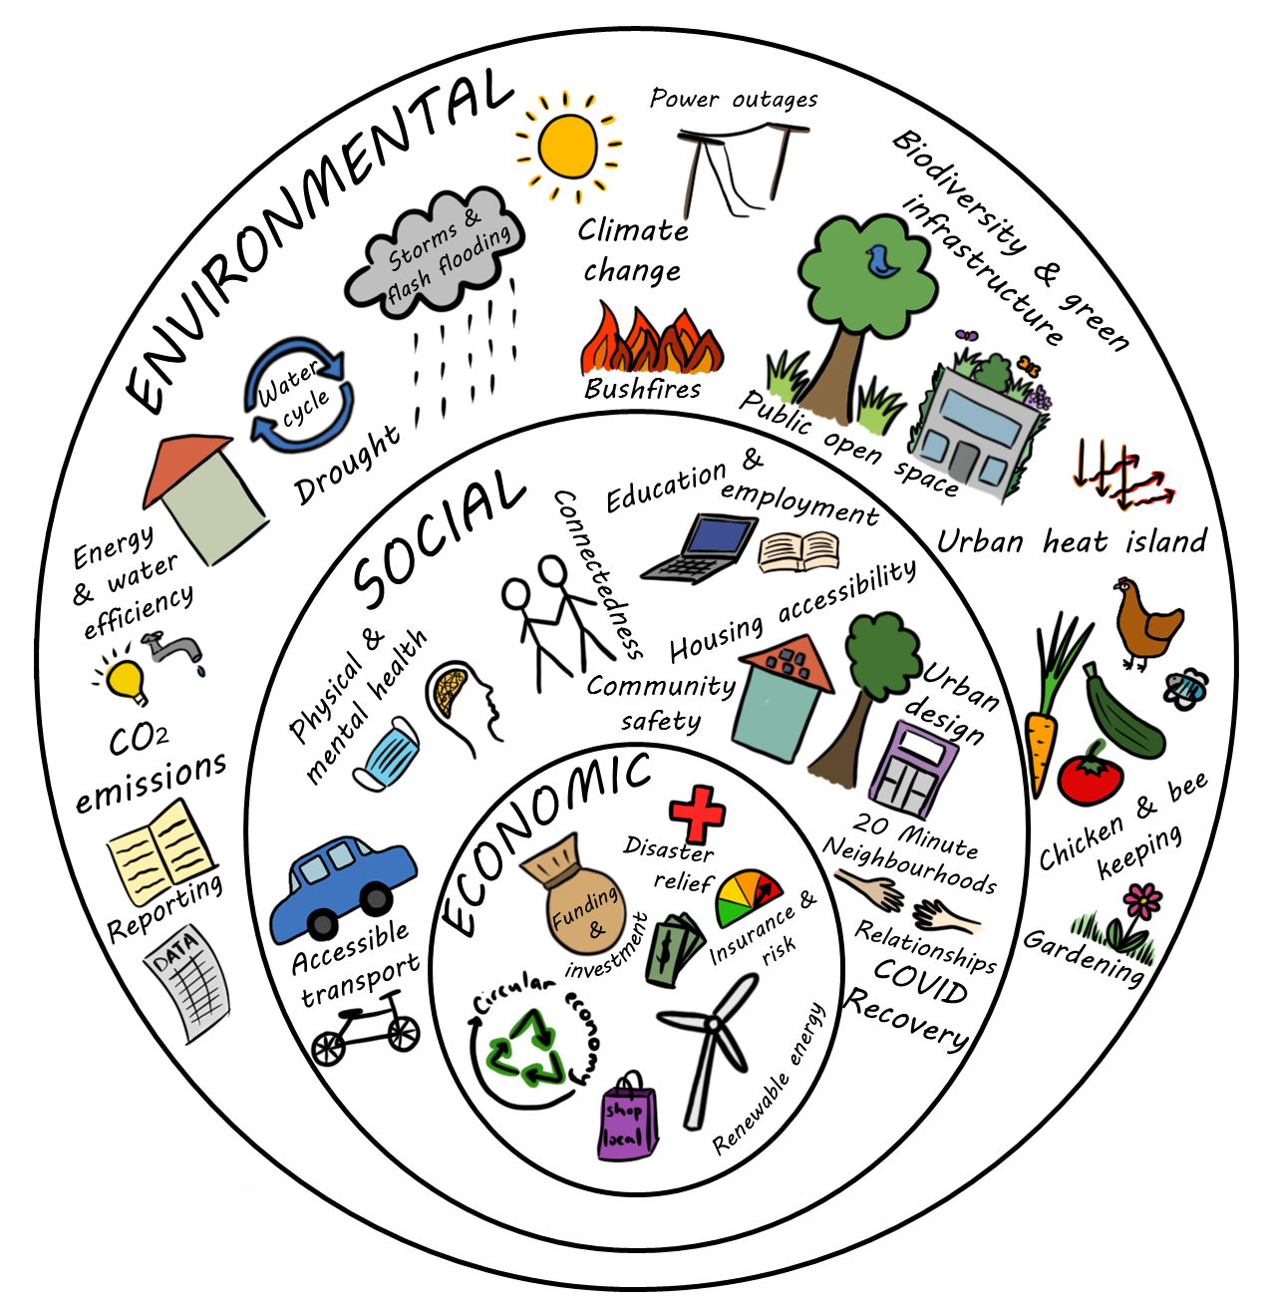

Maroondah context

The City of Maroondah covers an area of 61.4 square kilometres in outer eastern Melbourne, including suburbs of Bayswater North, Croydon, Croydon Hills, Croydon North, Croydon South, Heathmont, Kilsyth South, Ringwood, Ringwood East, Ringwood North and Warranwood. The City also includes small sections of Kilsyth, Park Orchards, Vermont and Wonga Park suburbs.

The traditional owners of the land on which the City of Maroondah now sits are the Wurundjeri People of the Kulin Nation. The Wurundjeri People have lived on this land for approximately 60,000 years and have a deep spiritual connection and care for Country.

The City of Maroondah is home to 117,484 people. Almost one in four residents were born overseas, with most common countries of birth including England, China, India, Myanmar and New Zealand.

Maroondah is known for its leafy green suburbs, with a higher proportion of vegetation cover when compared to many other Melbourne local government areas. The municipality is predominantly urban residential land use, with pockets of commercial and industrial areas, including the Bayswater Business Precinct. There is very little land available for greenfield development in Maroondah, with future population growth expected to be driven by the redevelopment of existing properties.

The City of Maroondah boasts good transport connectivity with 2 train lines, numerous bus lines, approximately 40 kilometres of shared walking and cycling paths including the Mullum Mullum Creek, Eastlink, Tarralla Creek and Dandenong Creek Trails, and the Eastern Freeway and Eastlink corridor junction. Other community facilities include 3 aquatic centres, 3 skate parks, 2 golf courses, 1 theatre and function centre, and 2 libraries.

The City of Maroondah includes Ringwood Metropolitan Activity Centre, Croydon Major Activity Centre, and Bayswater Business Precinct, along with 31 community and local shopping centres. Maroondah is home to approximately 9,500 businesses, with the most employing less than 20 people.

Council’s role in sustainability

Council’s responsibilities regarding sustainability and climate change action are legislated under the Local Government Act 2020 (Vic) and the Climate Change Act 2017 (Vic).

The Local Government Act 2020 sets out the following:

8. Role of a Council
(1) The role of a Council is to provide good governance in its municipal district for the benefit and wellbeing of the municipal community

9. Overarching governance principles and supporting principles
(2) The following are the overarching governance principles—
(a) Council decisions are to be made and actions taken in accordance with the relevant law;
(b) priority is to be given to achieving the best outcomes for the municipal community, including future generations;
(c) the economic, social and environmental sustainability of the municipal district, including mitigation and planning for climate change risks, is to be promoted;
(d) the municipal community is to be engaged in strategic planning and strategic decision making;
(e) innovation and continuous improvement is to be pursued;

The Climate Change Act 2017 sets out the following:

22. The policy objectives of this Act are—
(a) to reduce the State's greenhouse gas emissions consistently with the long-term emissions reduction target and interim emissions reduction targets; and
(b) to build the resilience of the State's infrastructure, built environment and communities through effective adaptation and disaster preparedness action; and
(c) to manage the State's natural resources, ecosystems and biodiversity to promote their resilience; and
(d) to promote and support the State's regions, industries and communities to adjust to the changes involved in the transition to a net zero greenhouse gas emissions economy, including capturing new opportunities and addressing any impacts arising from the need to reduce greenhouse gas emissions across the economy; and
(e) to support vulnerable communities and promote social justice and intergenerational equity.

Policy Context

The Sustainability Strategy works together with other Council policies, strategies and plans to set the strategic direction for Council over the coming years.

The chart below demonstrates how the Sustainability Strategy will work with Maroondah 2040, the Council Plan 2021-2025, the Maroondah Liveability, Wellbeing and Resilience Strategy, and numerous other Council strategies and plans.

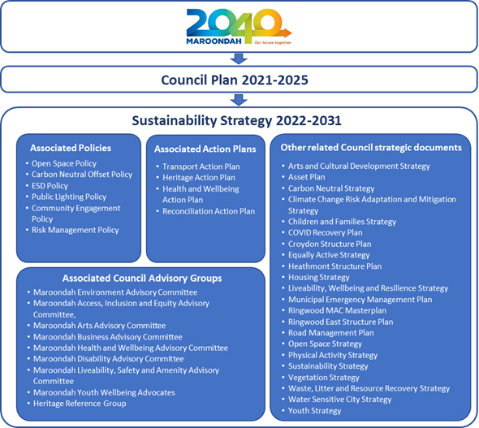

Maroondah 2040
Maroondah 2040 - Our Future Together sets out a clear community vision. Each of the eight individual visions included in Maroondah 2040 have been incorporated into the Sustainability Strategy 2022-2031 to ensure a holistic and interdisciplinary approach to sustainability.

- A safe, healthy and active community
- A prosperous and learning community
- A vibrant and culturally rich community
- A clean green and sustainable community
- An accessible and connected community
- An attractive, thriving and well built community
- An inclusive and diverse community
- A well governed and empowered community

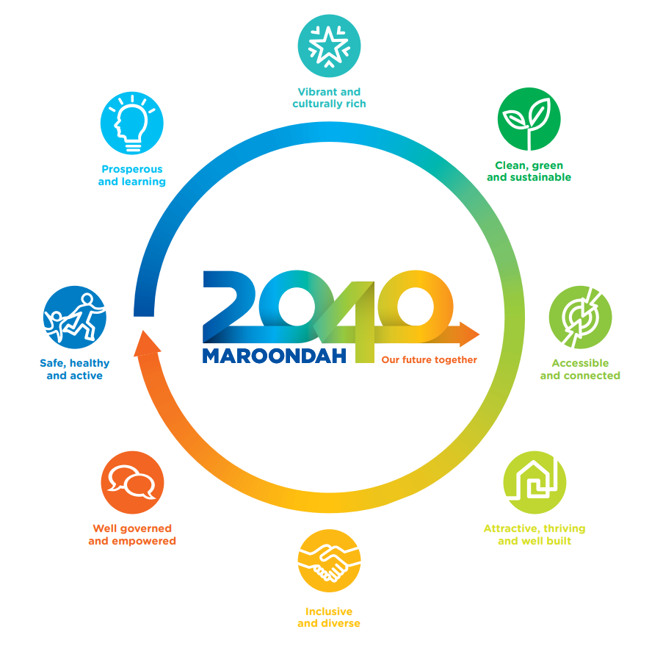

Maroondah Liveability, Wellbeing and Resilience Strategy
Council’s Liveability, Wellbeing and Resilience Strategy presents a vision for the future social environment of Maroondah and plays an important role in working towards the community aspirations presented in Maroondah 2040. The Maroondah Liveability, Wellbeing and Resilience Strategy fulfils Council’s health planning requirements in response to the Public Health and Wellbeing Act 2008 and is a key component in supporting the ongoing social sustainability within the Maroondah community. The Strategy includes six focus areas that establish a framework for identification of priority issues, policy directions and priority actions that Council will undertake to achieve this vision. The six focus areas are comprised of: healthy lifestyles, liveable neighbourhoods, safe communities, social inclusion, embracing diversity, and social harms. The Strategy also acknowledges the role of partnerships across community service agencies, community organisations and groups, and community members to achieve each vision. Environmental sustainability and community engagement are embedded into the Maroondah Liveability, Wellbeing and Resilience Strategy guiding principles, and the Sustainable Development Goals have been identified as a guiding framework, highlighting the close connections between the Maroondah Liveability, Wellbeing and Resilience Strategy and the Sustainability Strategy.

Reconciliation Action Plan
Central to sustainability within Maroondah is the acknowledgement and appreciation of the longstanding connection to country that Aboriginal and Torres Strait Islander peoples have had for approximately 60,000 years. As traditional owners, they have a deep heritage and connection to Country, and a unique perspective on how to value and respect the environment. As custodians of Country, there is a responsibility to care for the land and water to maintain balance that allows life to flourish.

The Indigenous view to value the environment, people and places of significance underpins this Strategy. It provides guidance on how to reconnect with the natural world, live in balance and preserve resources for generations to come. Embracing Indigenous values to become a common shared view by non-Indigenous peoples will help to shift people towards a sustainable mindset, connect with Indigenous culture and apply Indigenous techniques to live more sustainably.

In 2018, Maroondah City Council released the first Maroondah Innovate Reconciliation Action Plan (RAP) in support of the 2040 vision; Working towards a vibrant and culturally rich community. The RAP recognised Council’s role in the national reconciliation journeys between Aboriginal and Torres Strait Islander peoples and non-Indigenous peoples, and presents a vision for reconciliation within Maroondah:

Maroondah City Council is committed to working collaboratively on a journey of meaningful and sustainable reconciliation between Aboriginal and Torres Strait Islander peoples and non-Indigenous Australians. Our vision for Maroondah is that we will be a municipality that
- fosters and promotes equality, openness, trust, mutual respect and opportunities
- strives to enhance health (physically, emotionally and spiritually), social, cultural, economic, education and employment outcomes for Indigenous Australians
- recognises and celebrates traditional and contemporary Aboriginal and Torres Strait Islander people’s cultures, knowledge, customary practices and Aboriginal and Torres Strait Islander peoples’ deep relationship to land, kinship and country.

Council’s reconciliation planning will soon be updated to reflect and build upon the achievements of the last 3 years and present an updated plan for reconciliation within Maroondah. The Sustainability Strategy acknowledges that the next Plan will form a central foundation on which to base environmental, social, cultural, and economic sustainability across Maroondah over the course of the strategy period.

UN Sustainable Development Goals
It is common for sustainability to be considered an environmental issue. Mitigating climate change, deforestation and biodiversity loss are all central to sustainability, but it is also important to recognise the social and economic aspects and implications of sustainability. Environmental, social, and economic factors all impact our ability to respond to change and cannot be isolated from one another. For this reason, the UN Sustainable Development Goals provide a strong and holistic framework to address sustainability.

The UN Sustainable Development Goals include 17 goals that recognise the interlinked nature of many of the environmental, social and economic issues we face globally. They seek to address inequality and poverty worldwide, while also addressing urgent environmental issues such as climate change and biodiversity loss. The Sustainability Strategy has been developed with all 17 Sustainable Development Goals in mind, focusing on creating and supporting social, environmental, and economic sustainability outcomes.

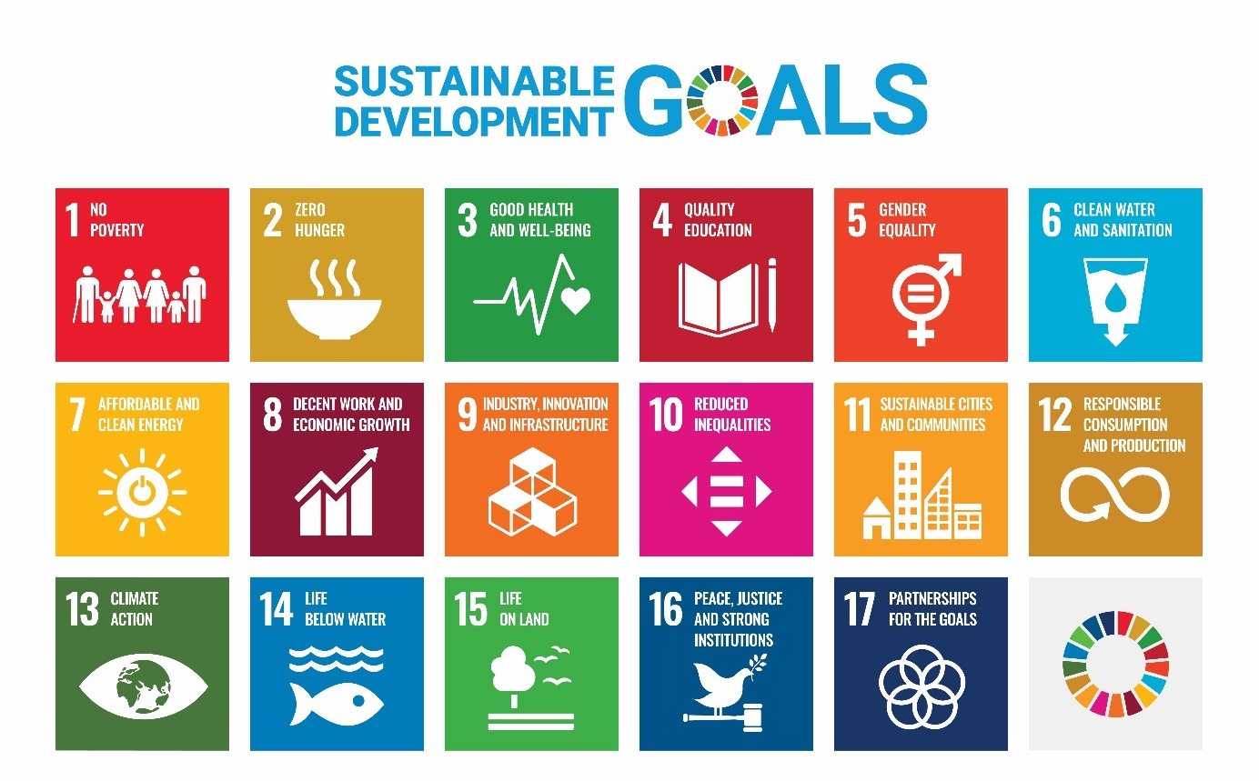

Section 2 – What does the evidence say?

What sustainability challenges does Maroondah currently face?

Maroondah faces a broad range of challenges along the path to environmental, social, and economic sustainability. Some of the biggest challenges addressed by the Sustainability Strategy have been detailed below.

COVID-19
Since 2020, COVID-19 has significantly impacted the Maroondah community, with lockdowns, travel limits and restrictions affecting much of our day-to-day lives. Throughout the development of the Sustainability Strategy, the pandemic has evolved, with restrictions, lockdowns and vaccination used as mechanisms nationally reduce mortality and morbidity, which have subsequently had a range of both positive and negative economic and social impacts. The ongoing social and economic impacts of COVID-19 will likely affect our community for years to come. Council has developed the Maroondah COVID-19 Recovery Plan in consultation with the community to address these impacts; however, COVID is also recognised as an influence on the sustainability and the capacity of our community to respond to other challenges.

Climate Change
Climate change poses a significant threat to our way of life and all aspects of environmental, social, and economic sustainability in Maroondah. Predictions show that climate change will bring more extreme weather events, including heatwaves, droughts and storms, risking Council and community assets, putting community health at risk, and increasing costs associated with adaptation, clean-ups following weather events or the rising cost of living. Council recognises the importance of acting swiftly to address climate change mitigation and adaptation to reduce Maroondah’s contribution to global emissions and the associated impacts of climate change.

Biodiversity Decline
Maroondah has some of the highest tree canopy cover across Melbourne municipalities (Hurley, Saunders, Amati, Boruff, Both, Sun, Caccetta and Duncan 2019), however a large portion of vegetation is located on private property and remains vulnerable to development. Major causes of biodiversity loss include habitat loss and deterioration, climate change, and invasion of non-native species. The Maroondah Vegetation Strategy addresses the key issues of biodiversity decline currently facing Maroondah. It is important to recognise the diverse sustainability benefits of vegetation within the urban environment.

Population Growth, Housing Affordability and Transport
Forecasts predict that by 2041, the number of people living in Maroondah will increase by almost 18% to 146,335 (Forecast.id, 2022). Population growth will also increase housing demand, putting pressure on housing affordability and challenging the existing neighbourhood character, as well as increased pressure on transport and community facilities and services.

Social Chronic and Acute Stresses
The Resilient Melbourne Strategy (2016) identifies a number of chronic stresses and acute shocks that can impact the sustainability of a community, many of which Maroondah currently faces. Chronic stresses include increasing social inequality, pressure on nature, unemployment, and increasing rates of alcoholism and family violence. Acute shocks include events such as heatwaves, storms and floods, infrastructure-related emergencies, and cyber-attacks, each of which can put pressure on our community and available resources.

Section 3 – What we did and what you told us?

Developing the Sustainability Strategy

Community feedback played a central role in identifying sustainability priorities and opportunities across Maroondah for the outcome areas and key directions of the Sustainability Strategy. The Sustainability Strategy 2022-2031 was developed following two years of review, research, and stakeholder consultation. The Strategy takes an evidence-based approach to identify and inspire holistic opportunities to further improve sustainability within Maroondah.

What the community told us

The consultation process included the release of an Issues and Options Paper for community feedback in August 2021 and Draft Sustainability Strategy in April 2022, along with engagement with the Maroondah Environment Advisory Committee, Maroondah Community Health and Wellbeing Advisory Committee, and the Maroondah Youth Wellbeing Advocates. Community feedback regarding environmental, social and economic sustainability was also captured from consultation processes for the Children and Families Strategy, Liveability, Wellbeing and Resilience Strategy, and COVID 19 Recovery Strategy.

The Sustainability Strategy Issues and Options Paper was released for public comment in August 2021. Due to COVID restrictions, feedback was exclusively online via the Maroondah Your Say website and email. Overall, 31 community members provided feedback, with key topics including vegetation and biodiversity, sustainable urban design and environmentally sustainable design, sustainable or low-carbon transport, community engagement, and environmental education. The Draft Sustainability Strategy was released for exhibition in April 2022, with feedback collected through 20 responses through the YourSay page, numerous written responses, and face-to-face meetings with interested community groups. Responses from the Issues and Options Paper and Draft Sustainability Strategy highlighted key issues to be addressed by the Strategy, including:
- The importance of maintaining Maroondah’s leafy green suburbs and canopy cover to support biodiversity and climate change adaptation.
- The role of green space in recreation, relaxation and mental health.
- A demand for high quality and connected active transport infrastructure, such as walking and cycling paths to reduce congestion and provide the community with low carbon and low-cost transport options.
- Application of urban design principles and environmentally sustainable design (ESD) are essential to reducing both building and transport emissions, while also adapting to climate change.
- Council should take a greater role in supporting the community to live more sustainably, whether that be in homes, businesses or community organisations. Some survey participants highlighted a need for Council to provide sustainability resources, such as how to grow vegetables at home or choose plants to support local biodiversity, and how to reduce energy and water consumption at home.

Community feedback from consultation for the preparation of the COVID-19 Recovery Plan and the Maroondah Liveability, Wellbeing and Resilience Strategy were also considered. Feedback highlighted the importance of further building connectedness and increasing participation within the community, particularly as we recover from the COVID-19 pandemic. Spending time in nature and gardening were also identified as coping mechanisms during periods of lockdown to maintain an active lifestyle and support mental health. Responses from the Liveability, Wellbeing and Resilience Strategy recognised the importance of responding to climate change through both the built and natural environments, as well as supporting behaviour change that will improve environmental outcomes.

Section 4 – A strategy for the future

A vision for a sustainable Maroondah

By 2030, Maroondah is a leading community in its efforts in reducing greenhouse gas emissions whilst simultaneously establishing a resilient network of wildlife habitats, fostering a thriving low carbon economy, creating opportunities for local living in environmentally sustainable homes, that celebrates its empowered and inclusive approach.

Strategic Framework

The Sustainability Strategy presents six key outcome areas that will work together to support environmental, social and economic aspects of sustainability within Maroondah. The Strategy recognises that social and economic sustainability relies upon and is enhanced by a strong and healthy environment; however, it is also important to acknowledge the impact of social and economic factors on the ability to invest time, resources and money to addressing environmental sustainability.

The Strategy seeks to provide guidance for integrating sustainability into everything we do, shifting business-as-usual approaches both within Council and the Maroondah community.

Strategy Scope

Maroondah City Council acknowledges the complex relationships between the environmental, social and economic aspects of the Maroondah community. For this reason, the Sustainability Strategy has been developed to assist the integration of sustainability thinking into everyday processes and goals across both Council and community.

Many of Council’s existing strategies provide detail and targets on topics covered by the Sustainability Strategy. These include:
- Asset Management Strategy
- Carbon Neutral Strategy
- Children and Families Strategy
- Climate Change Risk and Adaptation Strategy
- Health and Wellbeing Action Plan
- Maroondah COVID-19 Recovery Plan
- Maroondah Liveability Wellbeing and Resilience Strategy
- Open Space Strategy
- Positive Ageing Framework and Action Plan
- Public Lighting Policy
- Vegetation Strategy
- Waste, Litter and Resource Recovery Strategy
- Water Sensitive Cities Strategy
- Youth Strategy

The Sustainability Strategy has been developed with these strategies in mind and does not propose any further targets in these areas. Instead, the Sustainability Strategy seeks to provide an overarching direction using a holistic approach to integrate and embed environmental, social and economic sustainability across Council and the broader Maroondah community.

Strategy Principles

Council will demonstrate its commitment to sustainability by following these principles:

- Whole of Council approach - Pursue a ‘whole of Council’ approach with the root-and-branch adoption of a suitable sustainability framework.
- Engage with and empower the community and key stakeholders - Listen and respond to the needs of the community. Empowered and educated communities are required to effect more sustainable societies. Form partnerships where needed for the best outcomes.
- Inter and Intragenerational equity - Each generation should ensure that the health, diversity and productivity of the environment is maintained or enhanced for the benefit of future generations. Furthermore, economic, social and environmental (triple bottom line) factors should be integrated.
- Evidence-based decision making - Learning from the successes and failures of previous actions and programs increases understanding of best practice. Ongoing monitoring indicates the effectiveness of our decisions and facilitates continual improvement.
- Deliverable and funded/realistic activities - Focus on what is achievable within current resources. Concentrate efforts into areas where the most significant change can be affected.

Outcome area 1 - Built Environment

The built environment plays an important role in facilitating social, economic, and environmental sustainability across Maroondah. The application of sound urban design principles in harmony with our natural environment supports the community to live, work and play in a way that builds connections, health, and wellbeing. Encouraging public and active transport, when combined with environmentally sustainable design (ESD) and the inclusion of green infrastructure, supports the local economy, and reduces the environmental impacts of urbanisation.

In 2017, Council introduced the Environmentally Sustainable Design (ESD) Policy & Guidelines for Council Buildings and Infrastructure to ensure new buildings, renovations, fit outs and infrastructure meet sustainability objectives. In doing so, Council recognised the role it plays in leading the community by example. To further encourage ESD across the municipality, it will also be important to recognise and encourage design excellence within our community to demonstrate practical applications and transition from standard building practices to more sustainable building options.

Over the coming decade, it is expected that more transport options will become available and the way we use them will change. This will likely involve greater use of convenient, low carbon options such as electric bikes and scooters, in addition to walking and cycling, particularly in areas of higher density living. It is important that we start planning for these trends using an evidence-based approach to Council asset creation and management, focusing on delivering safer, easier and more convenient transport options. To achieve best practice, Council will work to enhance data collection and analysis to ensure infrastructure and services are prioritised based on holistic community benefits, using smart technology to do more with less.

What the community has told us

Community feedback from the Sustainability Strategy Issues and Options Paper highlighted the importance of good connectivity in neighbourhoods in providing low cost and low carbon transport options, which also supports active, healthy and safe communities. Feedback also recognised that well-designed community facilities not only consider accessibility for a wide range of users, but also address issues such as increasing temperatures due to climate change, while enhancing neighbourhood character, green space and permeability.

Some residents expressed concern regarding the impacts of higher density environmentally sustainable development on neighbourhood character, such as developments in the Ringwood Metropolitan Activity Centre (MAC). However, it is also important to acknowledge the benefits of the smaller footprint of higher density living. A sustainable Maroondah is one that provides choice for residents to meet their needs locally through a mixture of low, medium and high-density housing options across the municipality, while also retaining the character and sense of place loved by our community. For this reason, the Ringwood Metropolitan Activity Centre, the Croydon Major Activity Centre, and the Ringwood East and Heathmont Neighbourhood Activity Centres have been identified as areas for medium to high density development in the Maroondah Planning Scheme to deliver a measured approach to increased density given their proximity to public transport, shopping and community facilities.

Case Study: Greening the Greyfields

Maroondah’s Greening the Greyfields project seeks to address the business-as-usual approach to residential redevelopment to positively transform local centres and neighbourhoods. The business-as-usual approach characterised by sub-division of lots into units or townhouses results in significantly larger area covered by hard surfaces (predominantly driveways), smaller gardens and limited space to plant trees providing canopy cover.

Greening the Greyfields project applies a precinct wide approach that consolidates multiple housing lots into a single parcel. This larger landholding provides opportunities to carefully plan for redevelopment and incorporate elements of green infrastructure and water sensitive urban design (WSUD) at the precinct level. The approach encourages development in a way that reduces impervious surfaces, maximises access to green space, supports biodiversity, and improves local accessibility and connectivity. It requires future residential developments to consider active transport options, communal open spaces and sustainability at the precinct, site and dwelling level, providing opportunities for building social connections and creating a sense of place.

This project is a result of partnerships with the Centre for Urban Transitions at Swinburne University, the CRC for Low Carbon Living, FrontierSI, and the Department of Environment, Land, Water and Planning (DELWP). In 2021, Maroondah’s Greening the Greyfields project won the Planning Institute of Australia’s VIC Presidents Award.

Key directions

1.1 Undertake an assessment of best practices in urban design
1.2 Use evidence drive design and monitoring to maximise sustainability outcomes in Council buildings and infrastructure
1.3 Advocate for ambitious ESD targets through partnerships such as CASBE, and support developers and property owners to incorporate sustainable construction and ESD practices
1.4 Investigate models of transformative urban regeneration at the precinct scale
1.5 Promote and facilitate the use of public and active transport to support liveable activity centres

Associated strategies/plans:

- Asset Management Strategy
- Croydon South 20 Minute Neighbourhoods
- Croydon Town Centre Structure Plan
- Open Space Strategy
- Public Lighting Policy
- Ringwood East Structure Plan
- Ringwood Metropolitan Activity Centre Master Plan
- Transport Action Plans
- Water Sensitive Cities Strategy

Indicators of progress

- Percent of Maroondah residents who use active transport on a regular basis
- Average annual Built Environment Sustainability Scorecard (BESS) score
- Council buildings achieving ESD standards

Outcome area 2 - Climate Change

Climate change poses a significant environmental, social, and economic threat to the Maroondah community. Increasing atmospheric concentrations of greenhouse gases from human activities are leading to more extreme weather events (Department Environment, Land, Water and Planning 2019), with forecasts showing unless significant action is taken, we are growing closer to the tipping point.

Impacts of climate change are predicted to include:
- Increase in average annual temperatures by up to 2.4°C
- Double the number of very hot days, with more heat extremes and heatwaves
- Change in rainfall patterns with a reduction in annual rainfall and more rain coming in intense rainfall events
- Increase in the intensity and frequency of extreme weather
- Increase in the risk to human health, including heat induced morbidity and mortality
- Increase in the vulnerability of local biodiversity

In 2020 and 2021, Maroondah experienced multiple storms, each causing significant property damage and power outages across the municipality. Incidents such as heat waves and storms can have significant social and economic impacts on a community, whether it be from food going off in the fridge, social isolation, or inability to work or study due to power outages or localised flooding preventing access. Similarly, heatwaves can pose significant risk to the health of vulnerable communities, with heatwaves in 2009 leading to 374 excess deaths across Victoria (Department of Health and Human Services 2021).

Under the Climate Change Act 2017 and Local Government Act 2020, Council has a responsibility to embed climate change into decision-making and promote economic, social, and environmental sustainability, while also ensuring the best possible outcomes for current and future generations. The development of the Carbon Neutral Strategy in 2015 acknowledged the importance of acting on climate change, with Council pledging and achieving carbon neutrality by 2020. Council will continue to support increased action to mitigate and adapt to climate change, look for opportunities to integrate climate change action into business-as-usual, and support the community to move towards carbon neutrality.

The Carbon Neutral Strategy and Climate Change Risk and Adaptation Strategy are Council's guiding strategies to address climate change mitigation and adaption. These strategies are currently under review with the intention of combining the two into a single Climate Change Plan to best guide Council and the community. This Climate Change Plan will address climate change mitigation and greenhouse gas emissions, outlining actions Council will take to achieve emissions reduction targets. The plan will also highlight the role of climate change adaptation and risk management to ensure the safety and security for the municipality and include actions to further embed adaptation into Council’s operations and infrastructure, and support building community resilience to climate change.

What the community has told us

Feedback from the Sustainability Strategy Issues and Options Paper highlighted that the Maroondah community want to see Council do all it can to mitigate and adapt to climate change, including:
- Maintain Council’s carbon neutral status
- Provide support for residents and businesses to reduce their carbon emissions and adapt to the impacts of climate change through programs such as Solar Savers and Council’s Environmental Upgrade Agreements
- Enhance environmentally sustainable design (ESD) practices and guidance to reduce building emissions
- Recognise the mental health impacts of climate change.

Feedback from the Children’s and Families Strategy consultation, along with research conducted by the University of Melbourne, also identified climate change, environmental damage and pollution as a concern to many children and young people in Maroondah (Chin, Stevenson, Jacques-Hamilton & Vella-Brodrick 2019). This is supported by the Report Linking Climate Change and Health Impacts by Sustainability Victoria (2020) that found 75 per cent of Victorians felt some level of frustration about climate change, with up to one third of respondents feeling negative emotions regarding climate change either “a lot” or at an “overwhelming” level.

Case Study: EAGA

The Eastern Alliance for Greenhouse Action (EAGA) is a group of eight councils from Melbourne’s east, including Maroondah City Council. The alliance collaborates on projects that seek to reduce greenhouse gas emissions and support climate change adaptation across the region. In 2021, EAGA along with councils from other Victorian Council Alliances, entered into a contract with Red Energy to purchase electricity generated from wind farms located within Victoria. The Victorian Energy Collaboration (VECO) is “the largest emissions reduction project ever undertaken by the local government sector in Australia” (VECO, 2021), and enables Council to cut emissions, save money and support renewable jobs in Victoria. Other major projects undertaken by EAGA include implementation of an Energy Performing Contract (EPC) at five Council buildings resulting in saving 1,607 t CO2-e, an Electric Vehicle Business Case and Transition Plan, and the Recycled Content in Council Buildings and Infrastructure Project. These projects will provide valuable insight into opportunities for Maroondah and the wider eastern region to reduce both Council and community emissions.

Associated strategies/plans:

- Carbon Neutral Strategy
- Climate Change Risk and Adaptation Strategy
- Maroondah Liveability, Wellbeing and Resilience Strategy
- Public Lighting Policy

Key directions:

2.1 Undertake measures to reduce Council’s carbon inventory to ensure continued carbon neutrality status
2.2 Undertake advocacy and climate action through continued participation and hosting of the Eastern Alliance for Greenhouse Action (EAGA)
2.3 Adapt Council’s practices to future climate scenarios
2.4 Further embed climate change thinking into Council projects, operations, planning and strategies, using climate science to act with urgency
2.5 Improve climate education across Council staff and community

Indicators of progress

- Delivery of a Climate Change Plan and updated emissions reduction targets
- Retention of Council’s carbon neutral status

Outcome area 3 - Community Connections

The Maroondah 2040 vision and Sustainable Development Goals demonstrate that sustainability is more than just recycling and planting trees. A sustainable community ensures access to food, clean water, sanitation and employment, education, economic prosperity, and supports mitigation of and adaption to climate change and biodiversity loss prevention. Maroondah’s greatest asset in improving sustainability outcomes across all these areas is an engaged, enthusiastic and connected community that feels empowered to take action. The Sustainability Strategy will encourage greater accessibility to and participation in environmental education, community-led collaboration and partnerships across Maroondah.

Just as sustainability does not mean the same thing to everyone, the Sustainability Strategy recognises that people will find different ways to engage with the community and find their own pathways towards sustainability. The Strategy acknowledges that the Maroondah community has a wealth of existing knowledge and enthusiasm within community groups and associations, and it is Council’s role to provide support, encouraging diversity of participants and pathways to connect.

Through the implementation of this strategy, Council will strive to find new opportunities to engage with the community and improve the availability of sustainability resources and programs. This may be through the delivery of online or hard copy resources, connecting people with local interest groups and volunteering opportunities, training community sustainability leaders, improving community knowledge of available services through the community guide, or delivering interactive sustainability activities and events. Council will also look at developing a framework based on 20 Minute Neighbourhoods, community development, and deliberative panel methodology to enhance community engagement to ensure our actions are meeting the current needs of the community. These needs are expected to evolve over the Strategy duration, so any actions must be flexible and adaptable, appealing to broad audiences.

What the community has told us

Community feedback from the Sustainability Strategy Issues and Options Paper included Council should:
- Provide support and education resources to community members who would like to become more sustainable.
- Increase recognition of community groups or individuals demonstrating excellence in sustainability, including groups that may not traditionally be considered “sustainability” groups or organisations, but provide valuable services that support our community to become more sustainable.
- Raise awareness of existing resources, such as the community guide, for community members looking to participate or join an interest group.

Community engagement for the Children and Families Strategy and the Maroondah COVID-19 Recovery Plan highlighted the importance of nature in promoting positive mental health. Nature play and animals were also recognised as important to happiness for children from kindergarten age through to primary school, and conversely, bad environmental behaviour, such as pollution and climate change, contribute to unhappiness. Parents and carers highlighted the importance of building strong relationships and social connections when raising children in Maroondah, with some uncertain about what services are currently available.

Partnerships and Advisory Groups

The successful delivery of the Sustainability Strategy relies on building and maintaining strong partnerships with our community and local organisations and authorities.

To support ongoing community engagement, Council has advisory committees compiled of community members and Councillors who discuss and provide feedback on policy, strategy and actions relating to specific topics. Advisory Committees can ensure Council is meeting the needs and expectations of our community in line with Maroondah 2040. The Maroondah Environment Advisory Committee (MEAC) is involved in the development and implementation of environmental sustainability strategies, including the Carbon Neutral Strategy, Climate Change Risk and Adaptation Strategy, Vegetation Strategy and the Sustainability Strategy. Other advisory committees include:

- Maroondah Access, Inclusion and Equity Advisory Committee,
- Maroondah Arts Advisory Committee,
- Maroondah Business Advisory Committee,
- Maroondah Community Health and Wellbeing Advisory Committee,
- Maroondah Disability Advisory Committee,
- Maroondah Liveability, Safety and Amenity Advisory Committee

Council also recognises the important role of partnering with other local authorities and organisations to deliver projects and programs that benefit the community. These include:
- Ausnet
- Council Alliance for a Sustainable Build Environment (CASBE)
- Eastern Alliance for Greenhouse Action (EAGA) and associated councils
- Eastern Alliance for Sustainable Learning (EASL)
- Local universities, including Deakin University, Monash University, and Swinburne University of Technology
- Melbourne Water
- Yarra Valley Water

Key directions

3.1 Use the 20 Minute Neighbourhoods framework to enable community and neighbourhood planning at the local level
3.2 Investigate opportunities to make sustainability accessible and easy for all
3.3 Investigate the creation of sustainable communities with active community leaders to develop locally-led sustainability initiatives
3.4 Create opportunities for networking between groups and individuals through hosting sustainability events and knowledge sharing

Associated strategies/plans

- Children and Families Strategy
- Disability Policy and Action Plan
- Maroondah COVID-19 Recovery Plan
- Maroondah Housing Strategy
- Maroondah Liveability, Wellbeing and Resilience Strategy
- Positive Ageing Framework and Action Plan
- Reconciliation Action Plan
- Youth Strategy

Case Study: Living Maroondah Symposium

In February 2019, Maroondah held a free community symposium “Living Maroondah: a future for our plants, animals and us”. The event attracted 130 people and included expert speakers Bruce Pascoe, Professor Sarah Bekessy and Dr Graeme Lorimer, discussing the benefits that Maroondah’s vegetation provides and how Council and community can best protect and manage vegetation in the future. The symposium provided an opportunity for community members to engage in conversation around the value placed on vegetation and the natural environment, with community feedback provided used to develop the Maroondah Vegetation Strategy 2020-2030.

Indicators of progress

- Percent of Maroondah residents who actively volunteer or participate in local interest groups

Outcome area 4 - Green Economy

UNEP (2021) defines an inclusive green economy as “an economy [that] is low carbon, efficient and clean in production, but also inclusive in consumption and outcomes, based on sharing, circularity, collaboration, solidarity, resilience, opportunity, and interdependence”. A green economy shifts the thinking of environmental sustainability away from being an economic cost, to instead highlighting the relationship between good environmental outcomes and economic growth (Brennan 2019).

While there is no single definition of a green economy, key principles include:
- Use resources sustainably
- Minimise greenhouse gas emissions
- Adaptation to climate change
- Produce low impact goods and services
- Incentivise green investment and disincentivise brown investment
- Guide public and private consumption away from harmful practices
- Support environmental public education and socialisation
- Reduce environmental risks and ecological scarcity
- Improve human well-being and social equity
- Support economic growth and new jobs

Maroondah is made up of over 9500 businesses, with around 55% of these sole traders and 40% employing between 1-19 staff. Key activity centres within the municipality include Ringwood Metropolitan Activity Centre, Croydon Major Activity Centre and the Bayswater Business Precinct, along with 31 additional shopping centres and commercial precincts located around Maroondah. Approximately 59% of the Maroondah’s greenhouse gas emissions come from industrial and commercial activities (Snapshot 2021), which highlights the significant role businesses have in reducing Maroondah’s community carbon footprint. Council will seek to support businesses to make sustainable decisions and challenge the business-as-usual by leading by example, identifying opportunities to expand the green economy within Maroondah, highlighting sustainability excellence in business, and through programs such as EAGA’s Solar Savers and Environmental Upgrade Agreements.

It is important to recognise that the green economy is not limited to businesses who produce “sustainable” goods, but includes any business or consumer offering or using products and services that consciously support positive environmental outcomes. This may include practicing sustainable procurement, reducing waste and supporting a circular economy. Businesses, such as Cadbury’s factory in Ringwood, are already investing in renewable energy through group power purchase agreements, which play a big role in reducing the emissions of some of our community emissions. The green economy will also create new opportunities and demand for businesses such as those manufacturing solar panels and batteries or using recycled materials, sustainability communicators and educators, carbon offset and renewable energy brokers, sustainable or low waste food growers or sellers, and sustainable building specialists.

Encouraging a green economy in Maroondah supports environmental, social and economic sustainability across the community by:
- Supporting local businesses by encouraging a “shop local” approach
- Building resilience and social connections between buyers and sellers
- Reducing impacts on the environment by promoting the circular economy, process efficiency, reducing waste, and improving energy and water efficiency
- Reducing operational costs, including energy and water bills, and ongoing maintenance costs to improve business long term viability
- Creating local jobs, reducing travel time and associated travel emissions and improving work-life balance
- Supporting life-long learning, and creating and celebrating green economy leaders as role models within our community
- Embracing new technologies such as solar PV and battery storage, and electric vehicles

What the community has told us

Community feedback from the Sustainability Strategy Issues and Options Paper highlighted the importance participants placed on recycling and the circular economy to reduce resource consumption and associated greenhouse gas emissions, while also encouraging divestment to ensure all investments reflect Council’s organisational values. Community and consumer expectations are considered one of the key drivers in the move towards the green economy (Brennan 2012), as well as the costs of renewable energy, battery storage and electric vehicles, and addressing the risks associated with climate change.

Environmental Upgrade Agreements

In 2019, Council committed to supporting Maroondah businesses through Environmental Upgrade Finance, also known as an Environmental Upgrade Agreement (EUA). EUAs are agreements between building owners, Council, and a financial institution to provide funding for environmental upgrades. These upgrades can improve energy or water efficiency, or support building sustainability, resilience or climate change adaptation, resulting in reduced operating costs, improved asset value, resource efficiency, and quality of building stock. The funding mechanism of an EUA overcomes some of the challenges faced by businesses who may rent their premises, with the agreement tied to the property instead of the business or property owner. Council hopes to continue to expand this program over the coming years.

Case Study: 20 Minute Neighbourhoods

20-Minute Neighbourhoods is a Victorian Government initiative that has been developed to promote living locally in vibrant and healthy communities. 20-Minute Neighbourhoods are based around the idea that giving people the ability to meet most of their everyday needs within a 20-minute walk, cycle or local public transport trip of their home will vastly improve physical, social, economic, and environmental health in our neighbourhoods (Department of Environment, Land, Water and Planning 2019a). In 2018, Maroondah piloted the 20-Minute Neighbourhoods concept in Croydon South, working with local traders at Eastfield Shops and the local community to identify local needs and values which could support the delivery of a healthier, more connected neighbourhood. Following this work and the emergence of COVID-19, the project was expanded to support local place activation and recovery initiatives that directly met the needs of the community. The program included place activation activities such as a temporary pop-up park, prioritisation of walking and cycling initiatives in the area, a series of community events aimed at increasing connection to place and supporting local traders, participatory art projects, an active transport hub featuring bike parking and repair facilities, a mural chosen by the community, and a community noticeboard. The focus on enhancing local partnerships and shared community identity, accessibility to the local economy and building community capacity, as well as the promotion of independent businesses is central to both 20-Minute Neighbourhood and green economy principles. Council is now looking at opportunities to further apply the outcomes from the 20-Minute Neighbourhood pilot to other activity centres around Maroondah, incorporating green infrastructure and educational opportunities to further encourage the green economy across the city.

Key Directions:

4.1 Continue to support local businesses in implementing green economy principles through programs such as EAGA’s Solar Savers and Energy Upgrade Agreements
4.2 Support businesses and the community in making sustainable decisions through the provision of advice and incentives
4.3 Showcase and highlight sustainability excellence in business
4.4 Define and explore opportunities for enhancing the green economy in Maroondah

Associated strategies/plans:

- Environmentally Sustainable Design Policy for Council Buildings and Infrastructure
- Waste, Litter and Resource Recovery Strategy 2020-2030

Indicators of progress

- Number of businesses nominated for the Maroondah Business Sustainability Award
- Number of businesses accessing sustainability programs, including Solar Savers and Energy Upgrade Agreements

Outcome area 5 - Green Infrastructure

Maroondah’s leafy green suburbs and canopy cover are highly valued and central to the municipality’s character. It is important to recognise the significant value in vegetation and its role to support not only biodiversity and environmental sustainability, but to also promote positive social and economic outcomes. Green infrastructure refers to vegetation in an urban environment that provides environmental, social and economic benefits, including trees, nature strips, parks, public and private gardens, swales and rain gardens, wetlands, creeks and rivers, or green roofs and walls.

Green infrastructure recognises that many of the environmental, social and economic issues common to urban intensification can be addressed by adding vegetation and enhancing natural processes rather than using engineered solutions or grey infrastructure. As population density and urbanisation increases and the impacts of climate change are felt over the coming years, we have an opportunity to address many of the issues we may face using green infrastructure. Some of the benefits from green infrastructure include:

- Supports local biodiversity by providing suitable habitat and environmental conditions for Maroondah's indigenous flora and fauna
- Reduces runoff, peak stream flows and localised flooding, and improves water quality by slowing down water flow in high rainfall events, enabling infiltration into soils and absorption by plants, and removing pollutants
- Provides shade and cooling to the surrounding environment, reducing the impact of climate change, the urban heat island, and the health impacts of extreme heat, while also cutting energy consumption, costs, and emissions
- Improves air quality and reduces pollution
- Improves accessibility to home grown and healthy food through backyard or community gardens
- Provides recreation space and connection to nature, supporting physical and mental health
- Provides outdoor COVID-safe meeting spaces in local parks and gardens
- Green roofs and walls can insulate buildings reducing energy consumption, cost and emissions
- Increases liveability and reduces crime rates
- Increases productivity, economic activity and visitor numbers in retail areas
- Supports both physical and mental health benefits by facilitating recreation spaces and connection to nature

Green infrastructure will play an important role in the way that Council and the community manages environmental, social and economic challenges for the duration of the Sustainability Strategy and beyond. Access to suitable spatial data that enables identification of strategic locations to target where green infrastructure can provide multiple services, such as flood mitigation, local cooling, biodiversity and recreation space, is essential to ensure Council is maximising both capital investment and community benefit. Integration of green infrastructure with other Council programs such as 20-Minute Neighbourhoods, as well as delivering green infrastructure projects with other government agencies, developers and community members, will also provide an opportunity to demonstrate the benefits of further integrating nature into community spaces.

Our vegetation can be seen as ‘green infrastructure’ providing a range of benefits and services for our plants, animals, and us. As with other infrastructure, it needs to be:
- Planned for to ensure it takes account of expected growth and other changes into the future
- Designed to ensure it is providing the right services where they are needed most
- Installed/built to high standards to ensure effectiveness and longevity
- Maintained to ensure it retains a healthy condition and continues to provide the services
- Renewed when it reaches the end of its useful life

The concept of green infrastructure is relatively new to Maroondah and was introduced by the Maroondah Vegetation Strategy 2020-2030 through actions to:
- Establish arrangements that facilitate coordinated cross-council decision-making to achieve multiple benefits
- Use place-based precinct-scale planning (eg structure plans) to trial collaborative approaches to green infrastructure planning, design and implementation

An important step towards embedding the application of green infrastructure into Council decision-making, is expanding internal knowledge, capacity and confidence through training, trialling and demonstrating good examples. It will also be important to form external partnerships with organisations where the application of green infrastructure in Maroondah can contribute to their goals and objectives, for example the health and wellbeing sector. Council will develop a green infrastructure plan to streamline this process and identify opportunities to maximise the benefits of green infrastructure within Maroondah.

What the community has told us

Feedback from the Sustainability Strategy Issues and Options Paper highlighted the value placed on the natural environment by the Maroondah community. Benefits of green infrastructure, such as using vegetation to mitigate the impacts of climate change and urban heat island, and protecting biodiversity and existing vegetation were considered important by survey participants. Accessible open space and connection to nature was also acknowledged in its role of supporting physical and mental health while also providing COVID-safe meeting places.

Key directions

5.1 Integrate Council’s approach towards vegetation, open space, water and climate change adaptation
5.2 Partner with other government agencies, businesses and community members to advocate for and deliver green infrastructure within projecting in Maroondah
5.3 Improve data collection, spatial planning and GIS capacity to assist in identifying priority areas where green infrastructure can deliver the most environmental, social and economic benefits in areas of greatest need

Associated strategies/plans

- Open Space Strategy
- Water Sensitive Cities Strategy
- Vegetation Strategy

Indicators of progress

- Canopy coverage

Outcome area 6 - Governance, Evaluation and Improvement

The successful implementation of the Sustainability Strategy relies on embedding sustainability across Council and the Maroondah community, ensuring strong governance, partnerships and funding availability, as well as ongoing monitoring, evaluation, and reporting of sustainability outcomes.

Governance and risk
Responsible governance must consider the increasing risk of climate change to Council and community. Council’s risk register identifies risks associated with climate change, including failing to adequately prepare for the predicted impacts of rising temperatures, heat waves, droughts, and extreme rainfall events, along with the financial implications of rising insurance premiums, liability, and missing opportunities to act. The risk register is central to planning, adaptation, funding, and disaster management and links to the Climate Change Risk and Adaptation Strategy. Council will continue to ensure risks and associated actions reflect the current climate forecasts and covers asset, environment, social and economic risks appropriately.

The nature of sustainability means that it is the responsibility of all areas across Council and the community. For this reason, the development of the Sustainability Strategy has involved consultation across Council, and the identification of sustainability initiatives and principles that are already included in many of Council’s existing strategies, but there is still more to be done. Council will continue to integrate sustainability across Council and business-as-usual practices.

Data management, evaluation and reporting
The availability of strong utility, asset and environmental data is central to Council’s ability to plan, implement and report on sustainability actions. Council currently does not have a centralised utilities management system to support energy and water planning, management and reporting. Council will seek to identify the most appropriate option to streamline data management and reporting, improving process efficiencies and increasing the availability of Council officers to implement our sustainability goals.

Over the coming years, technology is expected to play a greater role in helping us deliver projects and services better tailored to the needs of the Maroondah community. Council will seek to use new technologies to collect data, assess and implement opportunities using a holistic approach to delivering environmental, social and economic outcomes. Council will also improve communication of sustainability and environmental achievements through regular State of the Environment reporting. In doing so, the community will have an opportunity to understand and provide feedback regarding the progress we are making to make Maroondah a more sustainable place.

Funding and Partnerships
Carbon Neutral Revolving Energy Fund (CNREF) was created in 2015/16 for projects that will reduce Council’s greenhouse gas emissions, with savings from avoided costs going back into the Fund to deliver further projects. The ongoing use of the CNREF will ensure there is an income stream dedicated to energy efficiency projects with excellent returns on investment, delivering both environmental and economic outcomes.

Council also works with external partners, such as Melbourne Water and the Department of Land, Water and Planning (DELWP), to deliver projects that achieve cross-institutional community benefits, such as the Re-imagining Tarralla Creek project. Working with partners increases the availability of funding, enhances community outcomes, and ensures cohesive planning and use of space and resources efficiently across authorities.

What the community has told us

Community feedback highlighted the importance of regular reporting and communication to ensure the Maroondah community can follow our progress as we implement the Sustainability Strategy and identify opportunities, challenges and successes. There were also some concerns regarding the availability and priority for funding sustainability projects and programs, while also recognising the value of partnering with other government authorities, organisations, and local businesses to deliver sustainability projects. Community feedback also recognised that Council’s investments, such as recommended superannuation fund, should reflect its values of being a carbon neutral organisation.

Case Study: Re-Imagining Tarralla Creek

The Re-Imagining Tarralla Creek project is a place-based transformation along Tarralla Creek in Croydon, co-funded and led by Melbourne Water, with Maroondah City Council, the Department of Environment, Land, Water and Planning and Yarra Valley Water in partnership with the local community.

The project focuses on a 2 kilometre stretch of the creek between Dorset and Eastfield Roads in Croydon with the intention of enhancing the natural environment, supporting local biodiversity and stormwater management, and creating valuable open space that promotes connection to nature and environmental education opportunities. The plan involves the extension and renewal of the Croydon wetland, ‘daylighting’ piped areas of the creek and re-naturalising the creek and stormwater harvesting to irrigate four adjacent sportsgrounds. Proposed works have been divided into four stages, with the first stage, the extension and renewal of the Croydon wetland, completed in mid-2022. The stormwater harvesting facility is expected to be completed by late 2022.

The Re-imagining Tarralla Creek project demonstrates the value of partnering with other groups and authorities to deliver a broad range of environmental and social benefits and funding opportunities. The Friends of Tarralla Creek group has become active in caring for the area and promoting community participation in citizen science along the creek precinct, demonstrating the important role of community guidance in this project.

Key directions

6.1 Collate environmental monitoring information to report to Council and the community
6.2 Improve data capture, availability and accessibility for use across Council projects and reporting, and to support evidence-based decision-making for sustainability goals
6.3 Work in partnership with key agencies to deliver Council’s sustainability goals

Indicators of progress

- Community perception of Council’s performance in relation to environmental sustainability

Tracking our progress

The Sustainability Strategy presents priorities and direction for sustainability action across Council and the Maroondah community over the next 10 years.

Key directions of the Sustainability Strategy will be delivered through a 4 year Action Plan, that will identify opportunities to implement each of the key directions outlined above. This will be supported by actions included in existing Council strategies, ensuring environmental, social and economic sustainability is embedded in business-as-usual across both Council and community. Council will seek to work closely with external partners, local interest groups and community members to maximise the benefits to Maroondah.

Strategy outcomes will be reported against indicators on a yearly basis and presented as an Activities Report, available on Council’s website, with the progress and outcomes of relevant key directions also be presented in the proposed Maroondah State of the Environment report.

The Maroondah Environment Advisory Committee will be engaged in identifying priorities and opportunities for implementation of the Sustainability Strategy, with regular updates provided on the progress of actions and activities.

Section 5 – References and Glossary

References

Brennan, T. 2012, Building a strong green and circular economy for Sydney, The City of Sydney, Sydney, Australia

Chin, T-C., Stevenson, I., Jacques-Hamilton, R., & Vella-Brodrick, D. A. (2019). Wellbeing in the Maroondah Network of Schools: Understanding the wellbeing needs of students, staff, parents and carers in Maroondah (draft). Parkville: The University of Melbourne. Commissioned by The Department of Education and Training, Victoria.

City of Melbourne 2016, Resilient Melbourne, viewed 26 November 2021, <https://resilientmelbourne.com.au/wp-content/uploads/2016/05/COM_SERVICE_PROD-9860726-v1-Final_Resilient_Melbourne_strategy_for_web_180516.pdf>

CSIRO 2021, Establishing a national agenda for urban green infrastructure, viewed 4 January 2022,
<https://www.csiro.au/en/research/environmental-impacts/sustainability/green-infrastructure>

Department of Health and Human Services 2021, Heat Health Plan for Victoria, viewed 7 February 2022, <https://www.health.vic.gov.au/environmental-health/extreme-heat-and-heatwaves>

Department of Environment Land, Water and Planning 2019, Victoria’s Climate Science Report 2019, viewed 26 November 2021, <https://www.climatechange.vic.gov.au/__data/assets/pdf_file/0029/442964/Victorias-Climate-Science-Report-2019.pdf>

Department of Environment, Land, Water and Planning 2019a, Croydon South - Our 20-Minute Neighbourhood, viewed 7 February 2022, <https://www.planning.vic.gov.au/__data/assets/pdf_file/0032/428909/Croydon-South-Our-20-minute-neighbourhood.pdf>

Forecast.id 2022, City of Maroondah Population Forecast, viewed 5 January 2022,
<https://forecast.id.com.au/maroondah/home>

Hurley, J., Saunders, A., Amati, M., Boruff, B., Both, A., Sun, C., Caccetta, P., and Duncan, J. (2019) Melbounre Vegetation Cover 2018, Eastern Region, Department of Environment, Land, Water and Planning, Melbourne, Australia

Snapshot 2021, Maroondah 2019 Municipal Emissions Snapshot, viewed 26 November 2021,
<https://snapshotclimate.com.au/locality/australia/victoria/maroondah/#>

Sustainability Victoria 2020, Linking Climate Change Health Impacts, viewed 26 November 2021, <https://assets.sustainability.vic.gov.au/susvic/Report-Climate-Change-Linking-climate-change-and-health-impacts-Research-Snapshot-2020.pdf>

UNEP 2021, What is an “Inclusive Green Economy?”, viewed 12 January 2022,
<https://www.unenvironment.org/explore-topics/green-economy/why-does-green-economy-matter/what-inclusive-green-economy>

VECO 2021, One big renewable energy contract, viewed 21 December 2021, <https://veco.org.au/>

Glossary

20-minute neighbourhood
The neighbourhood that meets your every day (non-work) needs locally; primarily within a 20-minute walk.

Best practice
A method or technique that has consistently shown results superior to those achieved with other means, and that is used as a benchmark.

Biodiversity
The term given to the variety of life on Earth. It is the variety within and between all species of plants, animals and micro-organisms and the ecosystems within which they live and interact.

Carbon neutral
Carbon neutrality refers to a situation where the net emissions associated with an organisation’s activities, product, services or events are equal to zero because the organisation has reduced its emissions, and acquired and cancelled carbon offsets for its remaining emissions.

Carbon Neutral Revolving Energy Fund
The Carbon Neutral Revolving Energy Fund is an alternative funding source established by Council. It reinvests savings from energy efficiency projects into additional projects that will also reduce energy and greenhouse gas emissions.

Climate change
Climate change is a large-scale, long term shift in the planet’s weather patterns or average temperatures.

Circular Economy
An economy that continually seeks to reduce the environmental impacts of production and consumption, while enabling economic growth through more productive use of natural resources.

DELWP
Victorian Government Department of Environment, Land, Water and Planning.

EAGA
The Eastern Alliance for Greenhouse Action is a formal collaboration of seven Councils in Melbourne’s east, working together on regional programs that reduce greenhouse gas emissions and facilitate regional adaptation.

ESD
Environmentally Sustainable Development. Using, conserving and enhancing the community’s resources so that ecological processes on which life depends are maintained, and the total quality of life, now and in the future, can be increased.

Greenhouse gas emissions
The seven major greenhouse gases emitted from burning fossil fuels such as coal and natural gas are water vapour; carbon dioxide (CO2); methane (CH4); nitrous oxide (N2O); hydro fluorocarbons (HFCs); per fluorocarbons (PFCs); and sulphur hexafluoride (SF6).

Green infrastructure
The European Union defines green infrastructure as a ‘strategically planned network of natural and semi-natural areas with other environmental features designed and managed to deliver a wide range of ecosystem services’. This is in contrast to traditional single functional ‘grey’ infrastructure such as stormwater drains.

Liveability
Liveability is a sum of the factors that add up to a community’s quality of life; including the built and natural environments; economic prosperity; social stability and equity; educational opportunity; and cultural, entertainment and recreational possibilities.

MEAC
The Maroondah Environment Advisory Committee has been established to inform and advise Council on environmental and sustainability issues and Council’s role in improving the environment in Maroondah. It comprises community representatives and councillors.

Power Purchase Agreement (PPA)
A power purchase agreement or PPA is a direct agreement between an electricity consumer, or group of consumers, and seller. They are increasingly used by organisations as a method of purchasing renewable energy to cover all their electricity consumption without having to install renewable generation, such as solar PV panels, on site. Meanwhile, solar and wind farm developers use PPAs to fund their projects to guarantee an ongoing income stream.

Resilience
Resilience is the capacity of a system to deal with change and continue to develop. Melbourne is made up of hundreds of interdependent systems that support our critical services (e.g. transport, healthcare, energy, local support networks). An interruption to one of these systems can have cascading impacts across Melbourne.

Sustainability
Sustainability encompasses the simple principle of taking from the earth only what it can provide indefinitely, therefore leaving future generations with no less than we have access to ourselves.

Sustainable Development
Development that meets the needs of the present without compromising the ability of future generations to meet their own needs.

Sustainable Design
The sustainable design of buildings seeks to provide a framework to include sustainability in the
whole of the building process including planning, design, construction, occupancy and decommissioning. The aim is to create comfortable and healthy indoor environments while reducing resource use (including energy and water consumption), waste, and operating costs.

Water Sensitive Urban Design (WSUD)
A holistic approach to water management that integrates urban design and planning with social and physical sciences in order to deliver water services and protect aquatic environments in an urban setting. A WSUD approach could include the integration of raingardens and wetlands in an urban area to manage stormwater.
