Youth Strategy 2017

Raising the wellbeing of Maroondah’s young people

Introduction
Maroondah City Council wants Maroondah to be a place where young people can flourish.

Young people are vital to a healthy and thriving community. When supported well, young people add life, colour and energy to the whole community. Adolescence and the transition to adulthood can also be a challenging time for young people, their families and their communities, and Council understands the importance of a holistic approach to our work with young people and their supporters.

Council’s Youth Strategy is designed with young people at its heart, and raising the wellbeing of Maroondah’s young people is its core mission. Council values our young people, and we are committed to supporting and empowering them to develop and thrive.

Purpose
The Youth Strategy provides clear strategic direction to guide and focus Council’s work with, and for, people aged 10 to 25 who live, work, study or play in the City of Maroondah. It is Maroondah City Council’s key strategic document in regards to young people.

The Youth Strategy seeks to:
- guide and focus Council’s work with and for young people
- ensure that Council delivers best practice services for young people and their families
- utilise a strong evidence base to help Council better meet the needs and aspirations of Maroondah’s young people
- ensure that Council is actively engaged with young people and responsive to their needs
- outline how Council will raise the wellbeing of Maroondah’s young people.

Scope
- The Youth Strategy covers people aged 10 to 25 years who live, work, study or play in the City of Maroondah.
- The Youth Strategy is a Council-wide strategic document.
- The Youth Strategy does not cover organisations or groups outside of Council, it does however aim to guide some of Council’s work with those organisations or groups.
- The Youth Strategy will commence in 2017, but does not have a set end-date. It will instead be reviewed every two years and renewed when required.

Action Plans
- The Youth Strategy will be supplemented by a sequence of two-year action plans that sit alongside, but separately from, the Youth Strategy, and that will outline the actions Council will undertake.
- These Action Plans will be developed based on current evidence and consultation, which will ensure that Council is responsive to changes in young people’s needs and aspirations while maintaining a clear and consistent strategic focus.

City of Maroondah
The City of Maroondah sits in Melbourne’s outer east, 22 kilometres from the central business district.

The first settlers to the area were the Wurundjeri people of the Kulin nation approximately 40,000 years ago. European settlement commenced in the 1830s with the land used for farming and orchards.

Maroondah is well connected, being located at the north-eastern junction of the Eastern Freeway - EastLink corridor, and with two train lines and a large number of bus routes linking it with other regions.

The City of Maroondah includes the suburbs of Bayswater North, Croydon, Croydon Hills, Croydon North, Croydon South, Heathmont, Kilsyth South, Ringwood, Ringwood East, Ringwood North and Warranwood.

Young people in Maroondah
Approximately 22,200 young people aged 10 to 25 live in Maroondah (.id, 2015).

This age range is inclusive of 25 year olds until they reach the age of 26.

This represents approximately 20% of Maroondah’s resident population, or one in five of our residents.

By 2027, this number is estimated to increase to over 23,500, and the area with the greatest forecasted increase in young people between 2017 and 2027 is Ringwood (.id, 2015).

Young people form a significant portion of the Maroondah community, and Council is committed to investing in both their present and their future as valued members of the Maroondah community.

Forecast changes (%) in the population of young people aged 10 to 25 in Maroondah between 2017 and 2027:

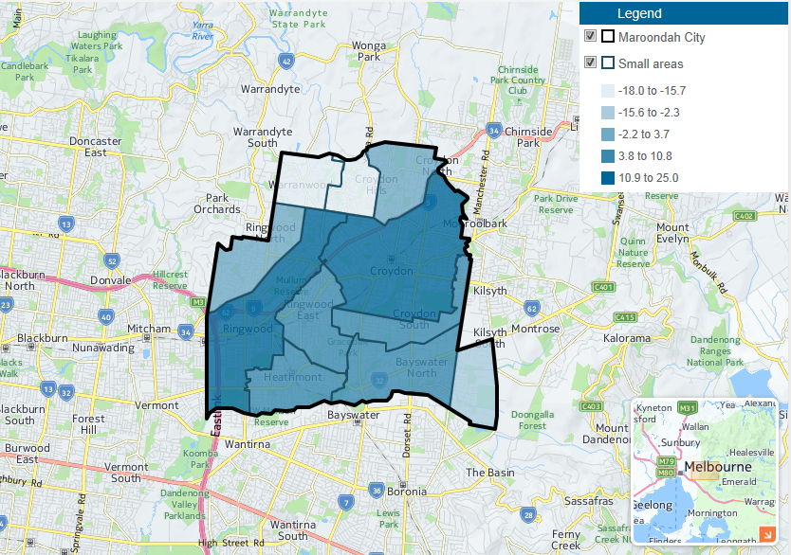

Source: Population and household forecasts, 2011 to 2036, prepared by .id, January 2015 (accessed 11/05/2017).

A focus on wellbeing
Council acknowledges the fundamental importance of wellbeing in young people’s lives, and embraces the role local government can play in helping to build the wellbeing of its community.

The Youth Strategy uses a wellbeing framework based on the multi-dimensional model of adolescent wellbeing developed by The University of Melbourne’s Centre for Positive Psychology.

This model includes six domains of wellbeing that cover multiple elements of a young person’s life, and each domain consists of a number of constructs (i.e. wellbeing indicators and wellbeing risk factors) that can be assessed to provide a measure of wellbeing (Chin, Jiang & Vella-Brodrick, 2016a).

A description of each of the domains is provided in the table below, along with the constructs that make up that domain.

This model informs Council’s understanding of the wellbeing of Maroondah’s young people, and our approach to raising it through the Youth Strategy.

Domain | Description | Constructs
Cognitive wellbeing | Young people’s perception of their quality of life, competence and accomplishments and their capacity to be mindful in the present moment. | Cognitive wellbeing consists of the following constructs:  - Attention regulation  - Mindful acceptance  - Accomplishment  - Life Satisfaction  - Competency  - Goal Striving
Economic wellbeing | Young people’s perception of economic stability in their home environment. | Economic wellbeing consists of the following constructs:  - Financial stability at home  - Responsibilities at home
Emotional wellbeing and strengths | Young people’s perceived ability to manage their emotions and their ability to use their strengths in their daily lives. | Emotional wellbeing and strengths consists of the following constructs:  - Emotion regulation (Reappraisal, Suppression and Rumination)  - Resilience  - Knowledge of personal strengths  - Use of personal strengths  - Happiness  - Anger  - Anxiety  - Depression  - Stress
Physical wellbeing | Young people’s perception of their general physical health, their physical appearance and their quality of sleep. | Physical wellbeing consists of the following constructs:  - General health  - Self-concept  - Sleep  - Exercise  - Sedentary activities  - Nutrition (Healthy and Unhealthy)
Psychological wellbeing | Young people’s beliefs and attitudes about what they value, their outlook on life, and their engagement with life. | Psychological wellbeing consists of the following constructs:  - Autonomy  - Engagement  - Gratitude  - Optimism  - Perseverance  - Hope  - Self-esteem  - Self-efficacy
Social wellbeing | Young people’s perceived quality of relationships with their parents, teachers, peers and community. This domain also taps into the presence of bullying, loneliness and  pro-social behaviours. | Social wellbeing consists of the following constructs:  - Peer connectedness  - Parent connectedness  - Perception of significant relationships  - Perception of school  - Connectedness to community  - Pro-social behaviour  - Negative peer pressure  - Bullying  - Cyber-bullying  - Loneliness

Source: Understanding the needs of young people in Maroondah: Findings from the student wellbeing survey. Chin, Jiang & Vella-Brodrick, 2016a

The evidence base

What we did
The development of the Youth Strategy was informed by extensive consultation, needs analysis and research from 2015 to 2017.

This involved four key components:
- The Maroondah Wellbeing Survey in schools, conducted in partnership with The University of Melbourne
  - 4777 students between the ages of 10 to 20 years completed the survey, from 19 different education settings (primary schools, secondary schools and TAFE).
- Broader youth consultation to reach those young people not able to access the school survey, conducted in partnership with young people through Council’s Peer Engagement Program
  - This included 11 youth focus groups, consultations at Maroondah Festival and an additional community youth survey.
  - Key target groups included young people aged 18 to 25, culturally and linguistically diverse young people, young people with disabilities, young parents, and disengaged and vulnerable young people.
- Stakeholder consultation, including youth service providers, school staff and parents/carers
  - This included a survey for parents/carers of young people, other family members of young people and community members, and three stakeholder consultation sessions
- Research, including demographics, social and wellbeing data, youth needs/issues, and best practice youth service delivery.

Across the range of consultation methods, Council engaged with over 5000 young people who live, work, study or play in Maroondah, as well as youth service providers, school staff, parents/carers, and community members.

What we found
Through this work, Council obtained a wealth of information both from, and about, Maroondah’s young people. A summary of key findings is outlined below. Full consultation and research reports can be found on Council’s website.

A key component of the evidence base were the results of the Maroondah Wellbeing Survey in schools in 2016, which utilised The University of Melbourne’s Wellbeing Profiler to provide Council with a comprehensive measurement of the wellbeing of 4777 Maroondah students aged 10 to 20 (Chin et al., 2016a).

This survey measured youth wellbeing in the six domains of cognitive; economic; emotional and strengths; physical; psychological; and social; and included measurement of a wide range of constructs (i.e. wellbeing indicators and wellbeing risk factors).

The graphs below show the 2016 results across year levels. The horizontal axis shows the year levels of the young people, from Grade 5 to Year 12. The vertical axis shows the average scores, on a scale of 1 to 7, with 4 as the mid-point. For wellbeing indicators, a higher score is better. For wellbeing risk factors, a lower score is better.

The results were quite positive overall. However, they also showed a general decline in wellbeing as young people transition from primary to secondary school, as well as across the secondary school years (Chin et al., 2016a).

Wellbeing indicators across year levels Wellbeing risk factors across year levels
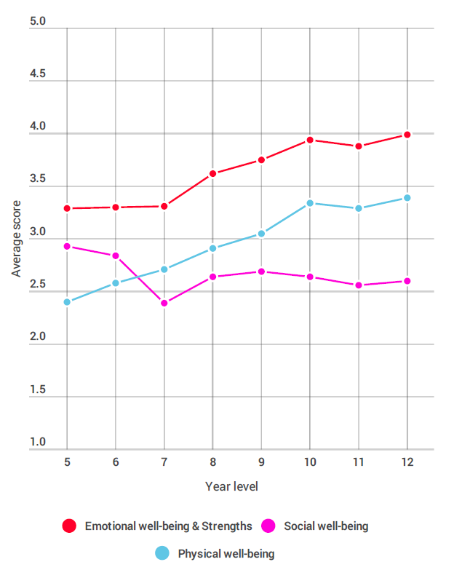
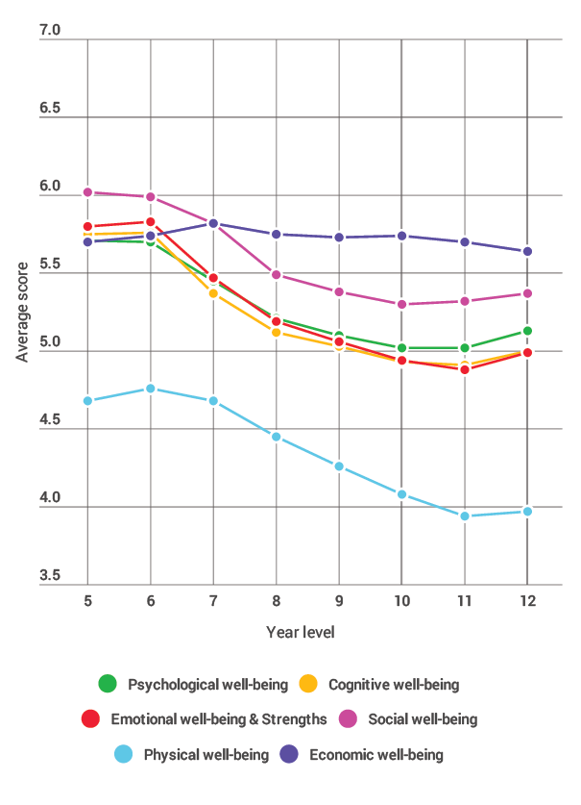

Source: Understanding the needs of young people in Maroondah: Findings from the student wellbeing survey. Chin, Jiang & Vella-Brodrick, 2016a

Overall, from the consultation and research undertaken to inform the Youth Strategy, five areas stood out from the evidence base. Key findings from these areas are outlined below.

Mental Health & Wellbeing
- In Maroondah, results from the 2016 Maroondah Wellbeing Survey in schools (Chin et al., 2016a) showed that:
- 78% of young people surveyed reported that life is going well for them.
- Half of the young people surveyed reported that they worry a lot and get stressed easily, with increasing symptomatic reports of anxiety and stress from Years 7 to 12.
- One in five young people surveyed reported that they are often unhappy, with experiences of depressive symptoms increasing from Grade 5 to Year 12.
- Maroondah’s young people reported relatively high levels of gratitude, with 87.6% of young people surveyed indicating that they have so much in life to be thankful for.
- Nationally, the Second Australian Child and Adolescent Survey conducted in 2013-14 (Lawrence et al., 2015) found that:
- Almost one in seven (13.9%) children and adolescents aged 4 to 17 years had experienced a mental disorder in the previous 12 months, which is equivalent to approximately 560,000 Australian children and adolescents.
- For young people aged 12 to 17 years, 14.4% had experienced a mental disorder in the previous 12 months (12.8% of females and 15.9% of males).
- For young people aged 12 to 17 years, anxiety disorders were the most common mental disorder overall at 7.0%, followed by attention-deficit/hyperactivity disorder (ADHD) at 6.3%, major depressive disorder at 5.0%, and conduct disorder at 2.1%.

Physical Health & Wellbeing
- Results from the 2016 Maroondah Wellbeing Survey in schools showed that all aspects of physical wellbeing appear to decline from Years 7 to 12 (Chin et al., 2016a).
- Council’s Physical Activity Strategy research found that for 18 to 24 year olds in Maroondah, only 25% of females are doing enough physical activity compared to 75% of males (Maroondah City Council, 2015).
- Results from the 2016 Maroondah Wellbeing Survey in schools showed the amount of exercise undertaken by young people declined from Grade 6 to Year 12 (Chin et al., 2016a).
- The school survey results also showed that the amount of time spent sitting still increased from Grade 5 to Year 10, with 52% of young people surveyed reporting that they spend four or more hours each day engaging in sedentary activities at home (Ibid., 2016a).
- The school survey results also showed that young people’s sleep quality peaked in Year 7 and declined from Year 7 to VCE, and that three in four young people surveyed reporting that they often feel sleepy and tired (Ibid., 2016a).

Relationships
- In both the 2016 Maroondah Wellbeing Survey in schools (Ibid., 2016a) and the 2016 Community Youth Survey (Chin, Jiang & Vella-Brodrick, 2016b), young people identified friends and family as the top two factors that make a good life for them.
- Results from the 2016 Maroondah Wellbeing Survey in schools (Chin et al., 2016a) showed:
  - High scores for young people’s perceptions of significant relationships, i.e. the presence of loving and supportive people in their lives.
  - Although connectedness to family and parents declined from Grade 5 to Year 11, three in four young people surveyed indicated that they like to spend time with their parents and that they feel loved.
  - One in two young people surveyed reported that they avoid talking to their parents about their problems, and 46% feel that their parents don’t understand what they’re going through.
  - Loneliness was an issue for many young people, increasing to its highest in Year 12. 44% of young people surveyed reported that they often feel misunderstood and alone, and one in four reported that they don’t have someone to go to when they have a problem.
  - Connectedness to the community appears to decline more rapidly for young people in Years 7 to 10, and is still low as young people are about to exit secondary school.
- Family violence is an issue in Maroondah. In 2015-16, Maroondah recorded the third highest rate of reported family incidents in the Eastern Metropolitan Region of Melbourne, with 1194 incidents reported to Victoria Police, equating to a rate of 1,047.09 per 100,000 population (Crime Statistics Agency, 2017).
- In both the 2016 Maroondah Wellbeing Survey in schools (Chin et al., 2016a) and the 2016 Community Youth Survey (Chin et al., 2016b) young people identified family as the most important aspect for the future.

Places and Spaces
- When asked what’s missing in Maroondah, many answers from young people were about facilities and spaces, both indoor and outdoor. These were also many of the things that young people loved about Maroondah.
- Through the 2016 Maroondah Wellbeing Survey in schools, one in five young people surveyed reported that they don’t feel safe in their neighbourhood (Chin et al., 2016a).
- Across the range of consultation methods, there were many suggestions from young people about safe places and spaces for young people, for things like social connection, recreation and support. Some wanted spaces to be youth-specific, whereas some wanted spaces for everyone where young people felt welcome.

Education and Employment
- Results from the 2016 Maroondah Wellbeing Survey in schools (Chin et al., 2016a) showed that:
  - Perception of school drops significantly between Years 7 and 8.
  - 63% of young people feel that their teachers don’t understand what they are going through.
- In 2016 the youth unemployment rate in the Outer Eastern Metropolitan Region of Melbourne was 12.7%, compared to 13.7% for Victoria and 12.0% for Australia (Australian Bureau of Statistics, 2016). Young people will also be facing a more competitive jobs market into the future (VicHealth & CSIRO, 2015).
- In both the 2016 Maroondah Wellbeing Survey in schools (Chin et al., 2016a) and the 2016 Community Youth Survey (Chin et al., 2016b), young people identified jobs (or jobs/work for the latter) as the second most important aspect for the future.

A strategy for the future

Our Vision for Maroondah’s young people
Our vision describes our desired future for Maroondah’s young people:

Maroondah’s young people are flourishing as part of a healthy and thriving community

It complements the Maroondah 2040 Community Vision, which captures the aspirations, desires, dreams, and priorities of the community looking ahead to the year 2040 and beyond (Maroondah City Council, 2014):

In 2040, Maroondah will be a vibrant and diverse city with a healthy and active community, living in green leafy neighbourhoods which are connected to thriving and accessible activity centres contributing to a prosperous economy within a safe, inclusive and sustainable environment

The Youth Strategy links to all eight of the Maroondah 2040 outcome areas, in particular:
- A safe, healthy and active community
- A prosperous and learning community
- An inclusive and diverse community
- A well governed and empowered community

Our Guiding Principles
Council embraces the Youth Work Principles from the Youth Affairs Council of Victoria’s ‘Code of Ethical Practice – A First Step for the Victorian Youth Sector’ (May 2008 revision) as the guiding principles for the Youth Strategy, and will therefore work towards enabling and ensuring:
- The empowerment of all young people
- Young people’s participation
- Social justice for young people
- The safety of young people
- Respect for young people’s human dignity and worth
- Young people’s connectedness to important people in their lives, such as family and community
- Positive health and wellbeing outcomes for young people
- The positive transitions and healthy development of young people.
(Youth Affairs Council of Victoria, 2008)

Council is an inclusive organisation that recognises and respects the diverse backgrounds, needs and aspirations of young people in our community, and is committed to proactively supporting and building the inclusion of all young people in Maroondah.

Our Strategic Framework
Utilising the strong evidence base, Council developed a Strategic Framework for the Youth Strategy that outlines our strategic focus for our work with and for young people over the coming years.

Our Mission:
Council’s core purpose for our work with and for young people is summed up by our simple mission:

To raise the wellbeing of Maroondah’s young people

This measurable goal provides clarity and focus to our work, and the ability for Council to assess our success against this goal through a cycle of measuring, planning, acting and evaluating.

Our Strategic Outcomes:
Through the development process, Council has identified four Strategic Outcomes that we seek to achieve through the Youth Strategy.

The Key Directions for each Strategic Outcome describe how Council will respond in order to achieve these outcomes.

Strategic Outcome 1 – Maroondah’s young people are healthy

Outcome description
Maroondah’s young people are empowered and supported to develop their health and wellbeing in all aspects of their lives. They are supported in this by their families, communities, schools, and community services, who in turn are supported by Council. Maroondah provides a safe and healthy natural and built environment in which young people can flourish now and into the future.

What young people want
“A bigger focus on mental health issues and to have them treated like physical illness, because they are just as serious.” (15 year-old female)

“Wider acceptance of stress and mental illness, because I know people very close to me who battle mental illness and feel as though they need to hide it from the world.” (17 year-old male)

“More education about healthy eating, exercise, wellbeing and how to cope with stress.” (13 year-old female)

“I would make more smoke free zones and make more parks because the health of young people is important.” (12 year-old female)

“Add more mental health and youth services that are easily available for younger people who are struggling and need someone to talk to.” (15 year-old female)

What we’ll do

Key directions
- Provide high quality accessible services and activities that support young people to develop their health and wellbeing in all aspects of their lives.
- Educate and empower young people to make positive choices about their health.
- Support young people to have safe and respectful relationships that protect and build their health and wellbeing.
- Ensure Maroondah provides a safe and healthy natural and built environment for young people now and into the future.
- Develop community capacity to effectively build and support the health and wellbeing of young people.
- Advocate for the provision of affordable, accessible, high quality and responsive services, resources and initiatives that effectively support the health and wellbeing of Maroondah’s young people.

Strategic Outcome 2 – Maroondah’s young people are connected

Outcome description
Maroondah’s young people are supported by positive connections with their peers, families and communities. They can connect effectively with places and opportunities, both physically and online. They are well informed about the wide range of services, opportunities, and information available to them, and feel confident to connect with these.

What young people want
“Everyone needs love and happiness. There should be more community things on to bring us all together like a family, so we feel like we have someone to lean on.” (18 year-old female)

“Actively setting up youth meetings and groups to help support teenagers with difficulties at home or school, sometimes sharing with people who have the same experiences helps.” (13 year-old female)

“Do things to help people going through tough times and bullying because I didn't have that and if Maroondah do have they need to advertise it more and make a known resource.” (14 year-old female)

“Safer public transport. I’d really like to go out with friends to Eastland and see a late movie but I don’t want to catch the train alone to go home late at night. With safer public transport it would make things more accessible to youth whose parents can’t be driving them around all the time.” (16 year-old female)

“Access to support systems without feeling embarrassed, and more outdoor sporting facilities and parks to promote the outdoors.” (15 year-old male)

What we’ll do

Key directions
- Build young people’s sense of belonging, inclusion and connection through the strengthening of positive relationships with their peers, families, caregivers and communities.
- Support young people to connect with the digital world in positive and safe ways.
- Provide, develop and advocate for safe and effective options that connect young people to places, spaces and opportunities.
- Work in partnership with stakeholders to ensure that young people and their families know about, and feel confident and safe to connect with, the range of services, opportunities, and information available to them.

Strategic Outcome 3 – Maroondah’s young people are engaged

Outcome description
Maroondah’s young people are empowered and actively engaged in matters that affect them and their communities. They have the skills, confidence, and opportunities to be active empowered citizens. They are able to engage in opportunities that have meaning and purpose to them, and are recognised and celebrated for their accomplishments.

What young people want
“To be included and have their voices heard, our opinions matter even if they are different from those older than us.” (23 year-old female)

“There could be more ways in which Maroondah Council and schools could work together so that school aged kids can have a say in what occurs and how it will affect their local area.” (17 year-old female)

“Provide more spaces specifically for teenagers (troubled or not) to go and maybe read, study, participate in various activities of their choice, and so on, because we seriously need it, and we need it to be for us specifically.” (15 year-old)

“More safe places for youth to spend time – but with youth input because I feel like too often its adults that plan these things and so young people don’t want to be involved, or aren’t interested. More safe and enjoyable areas for youth of all backgrounds, genders and interests would potentially keep them out of trouble and give many an escape to a safe place where they can feel supported and welcome.” (18 year-old female)

“I think young people in Maroondah need more things to do, more skateparks or public sporting precincts, social clubs, I think they need to be engaging with the community.” (20 year-old female)

What we’ll do

Key directions
- Ensure that young people are effectively informed and engaged on matters that affect them and their communities.
- Employ principles of youth participation and co-design to ensure young people are effectively .engaged and included in making decisions about themselves and their communities.
- Support young people to develop leadership and advocacy skills that assist them to be actively involved and engaged citizens.
- Provide, promote and advocate for a wide range of meaningful opportunities in Maroondah that are engaging for young people.
- Recognise and celebrate young people’s accomplishments to support their engagement and inclusion in the Maroondah community.

Strategic Outcome 4 – Maroondah’s young people are prepared

Outcome description
Maroondah’s young people are well prepared to thrive in an ever-changing world, both as adolescents and as they transition into adulthood. They are resourceful and resilient, and equipped to successfully navigate change and challenges in their lives.

What young people want
“Need to learn how to pick out the best and positive things in their lives instead of the bad.” (16 year-old female)

“Make education more appealing, because lots of young people don't see the point in it.” (17 year-old male)

“Hold annual wellbeing days where young people can attend and have free massage, relaxation tent, education on how to de-stress etc. “Treat yourself” / “love your soul” days where people learn skills of self-care.” (24 year-old female)

“Programs to perhaps help young people get part time jobs, as I have had great difficulty getting a part time job over the last few years, as have many other young people I know.” (18 year-old male)

“Hold more seminars about opportunity for employment and options when you leave school because it would help younger people know what they want to do and what they need to do to get there.” (15 year-old male)

What we’ll do

Key directions
- Equip young people with skills and knowledge that prepare them to successfully navigate change, grow from life’s challenges, and build their resilience.
- Leverage the use of character strengths to prepare young people to flourish throughout their lives.
- Support the development of positive learning environments in Maroondah that are engaging for young people and effectively prepare them for the future.
- Assist young people to be work ready and prepared for the changing landscape of employment.
- Support parents/carers, schools, and youth service providers to better understand young people and feel confident to prepare them to grow into adulthood.

Tracking our progress
The Youth Strategy will be reviewed every two years to track progress on its implementation, evaluate initiatives, support continuous improvement and innovation, and identify when further review and renewal of the Youth Strategy is required.

Following each review, a new two-year Action Plan will be developed based on current evidence and consultation.

Action Plans will be reviewed annually to track progress on actions, and results will be reported to Council.

Council will continue to actively engage with young people and stakeholders throughout the implementation of the Youth Strategy, ensuring that young people are always at its heart.

Acknowledgements
Council would like to acknowledge the invaluable contributions of the following groups to this project:
- All Maroondah City Council staff and Councillors who contributed to the project, with particular mention to the Youth Services team and the Youth Strategy Project Advisory Group.
- The University of Melbourne’s Centre for Positive Psychology.
- The fantastic participants of the Peer Engagement Program.
- The many, many young people, parents/carers, community members, school staff and youth service providers who generously shared their thoughts, feelings, and suggestions with us through the consultation for the Youth Strategy – we are incredibly grateful for your input, and we look forward to working with you to make this vision for Maroondah’s young people a reality.

We also want to thank the young people who took part in our ‘It Starts With Us’ photo campaign for 2015 National Youth Week. A selection of the images are showcased throughout this strategy, with each image representing a passion of the young person.

References
Australian Bureau of Statistics (2016). Labour Force Survey. Canberra: Australian Bureau of Statistics.

Chin, T-C., Jiang, J., & Vella-Brodrick, D.A. (2016a). Understanding the needs of young people in Maroondah: Findings from the student wellbeing survey. The University of Melbourne, VIC, Australia.

Chin, T-C., Jiang, J., & Vella-Brodrick, D.A. (2016b). Understanding the needs of young people in Maroondah: Findings from the Community Youth Survey. The University of Melbourne, VIC, Australia.

.id (2015). Population and household forecasts, 2011 to 2036, accessed 11 May 2017 from http://forecast.id.com.au/maroondah/population-age-structure-map

Lawrence, D., Johnson, S., Hafekost, J., Boterhoven, De., Haan, K., Sawyer, M., Ainley, J. and Zubrick, SR., (2015). The Mental Health of Children and Adolescents: Report on the second Australian Child and Adolescent Survey of Mental Health and Wellbeing. Canberra: Department of Health.

Maroondah City Council (2014), 2040 Maroondah: Our future together

Maroondah City Council (2015), Physical Activity Strategy 2015-2020: Getting Maroondah Moving – More Often

VicHealth & CSIRO (2015). Bright Futures: Megatrends impacting the mental wellbeing of young Victorians over the coming 20 years. Melbourne: Victorian Health Promotion Foundation

Crime Statistics Agency (2017). Data Tables – Victoria Police, accessed 20 June 2017 from https://www.crimestatistics.vic.gov.au/family-violence-data-portal/download-data-tables

Youth Affairs Council of Victoria (2008). Code of Ethical Practice – A First Step for the Victorian Youth Sector (May 2008 revision).

