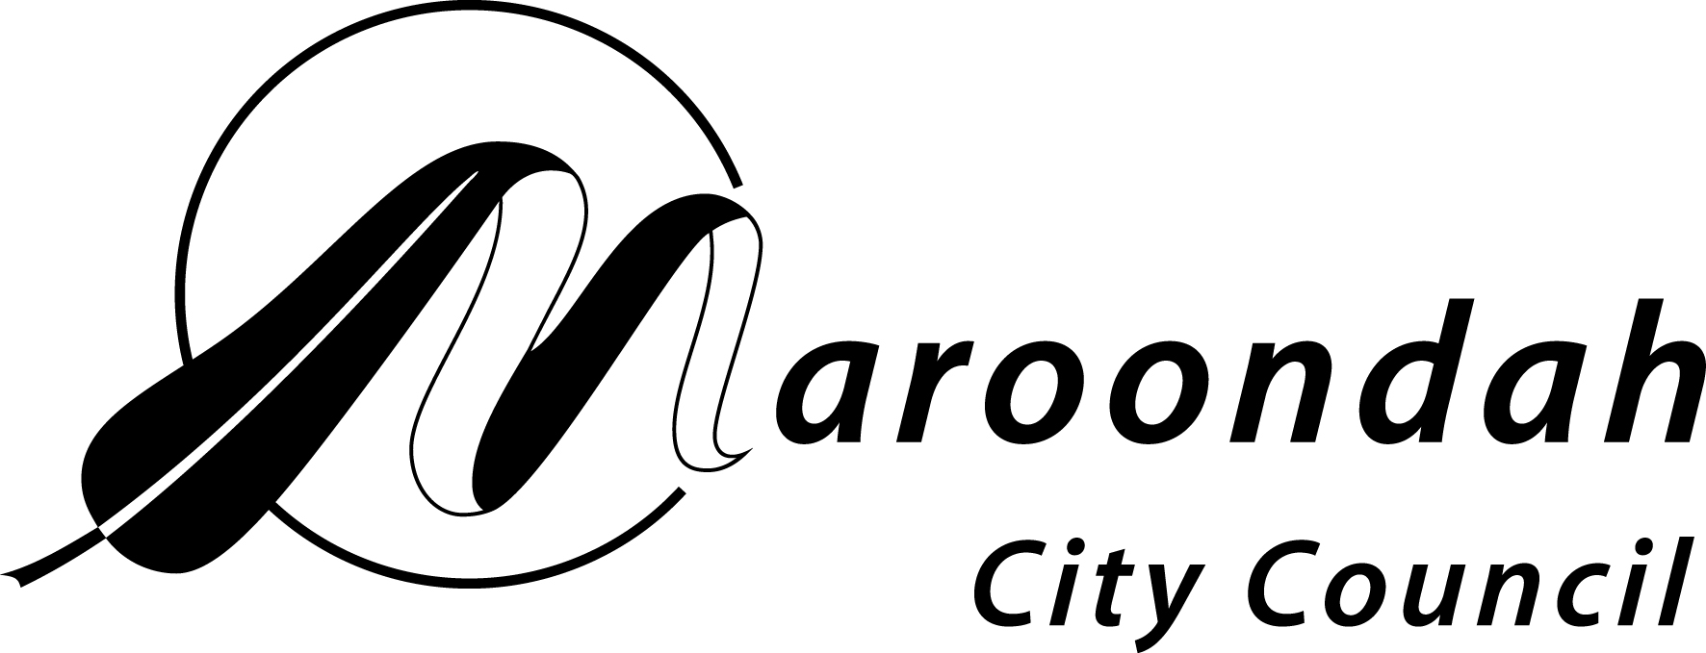
AUSTRALIA DAY AWARDS 2024

NOMINATION FORM

Community Event of the Year
Council is seeking nominations for the Community Event of the Year Award, which recognises an event held in the past year that best reflects the importance of strong Maroondah community values and ties. The event must have taken place in Maroondah between 1 January 2023 and 31 December 2023. Due to the impact of the COVID-19 pandemic, nominations for online and digital events are also being encouraged.

Details of event being nominated:
Event details:
Date of event:
Location of event:
Name of the group who organised the event (if applicable):
Contact name:
Contact number:
Contact address:
Contact email:
Community relevance for which the event is being nominated
(If insufficient room, please provide a separate sheet with details and include supporting material
eg press cuttings, references etc.)

Other relevant background information:
Other people that may be contacted for further information about the event:
Name: |  | Name:
Position: |  | Position:
Address: |  | Address:
Postcode: |  | Postcode:
Phone: |  | Phone:
Email: |  | Email:
To be completed by person submitting nomination:
Name:
Address:

Postcode
Organisation represented (if any):
Phone:
Email:
Signature:
Return forms:
Completed forms must be returned by SUNDAY 19 NOVEMBER 2023 to:
Councillor Support Officer
Maroondah City Council
PO Box 156
Ringwood. 3134

OR emailed to councillor.support@maroondah.vic.gov.au

