Table of contents

Table of contents 1
Be Kind - Celebrating kindness past initiatives 2020 2
Keeping Maroondah connected through letter writing 2
Knit one, warm one 5
Spotting the strengths of young people 6
Be Kind - Celebrating kindness past initiatives 2021 7
Acts of kindness stories 7
Acts of kindness stories 7
Postcards of kindness 19
Good food good mood with Joel Feren 21
Build your financial future workshops 22
The Suicide Conversation 23
Introduction to mindfulness workshops 24
The Sunflower Effect Project 25
Living life with anxiety with Sarah Wilson 25
Be Kind - Celebrating kindness past initiatives 2022 26
The Resilience Project 26
October - Mental Health Awareness Month 27
Let’s Get Neighbourly, Maroondah 28
Workshops 29
Gambling Harm and Young People – online session 29
The Maroondah Lift Project 30
Men’s Habits for Happiness 31
Mindful walking program - Yarrunga Community Centre 31
Addressing Anxiety workshop with Michelle Graeber 32
Mind Strength with Dr Jodie 33
The Suicide Conversation 34
The Science of Stress 34
Mental Health First Aid training for Maroondah carers 35

Be Kind - Celebrating kindness past initiatives 2020

Keeping Maroondah connected through letter writing
As part of Be Kind Maroondah, local school children and older Maroondah residents are keeping in touch through letter writing to help maintain social connections during the COVID-19 pandemic.
The heartfelt letters have helped to bring joy to older residents, particularly at a time when strict stay-at-home orders have been imposed and regular social activities are cancelled.
In times of uncertainty, the smallest act of kindness can make a world of difference. We want to share these stories with our community and inspire others to also be kind.
For more information on our Intergenerational project view our article - Children’s letters deliver happiness to older residents as part of intergenerational project.
Here are some sample letters that have been sent to Maroondah residents.

Archer
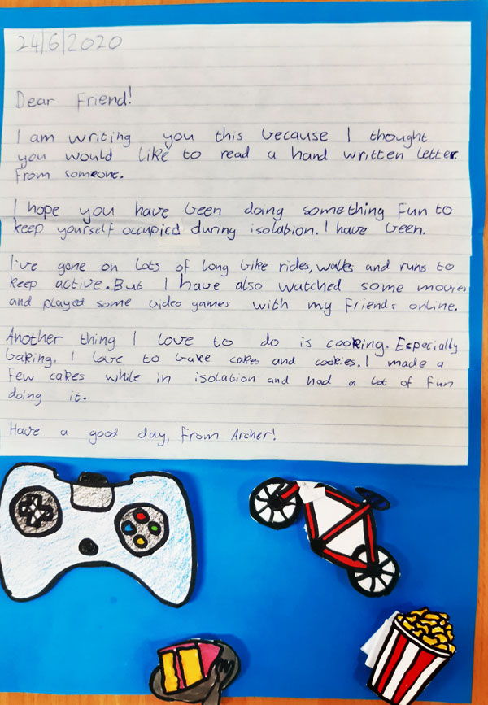

Declan
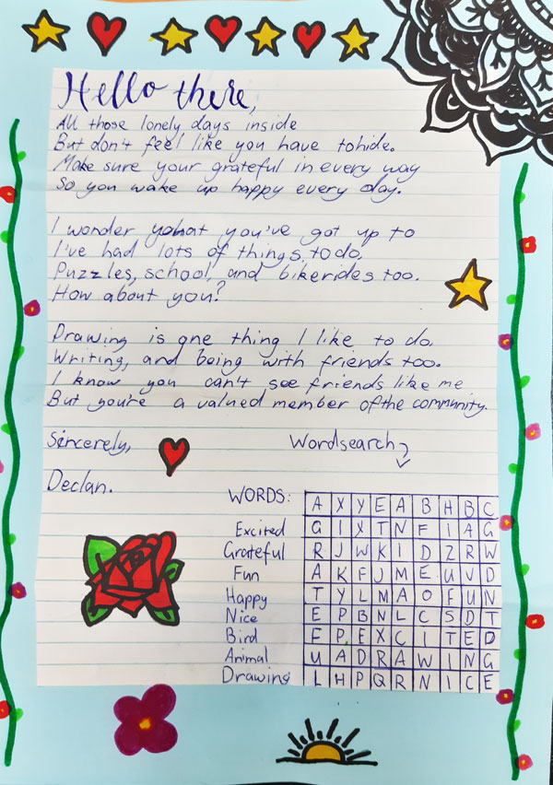

Emma
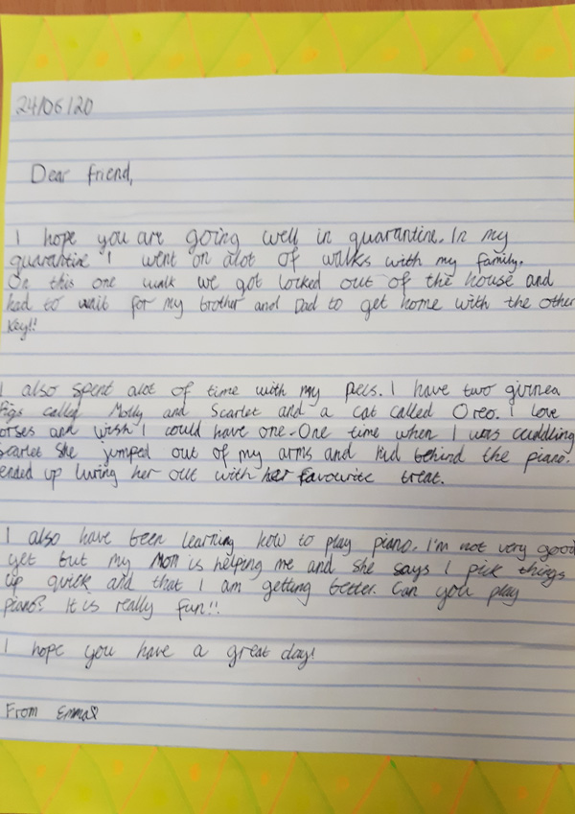

Amber
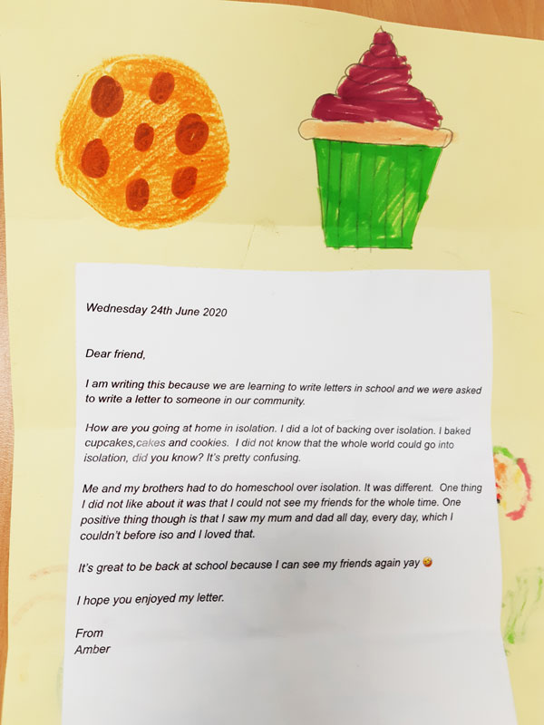

Siany
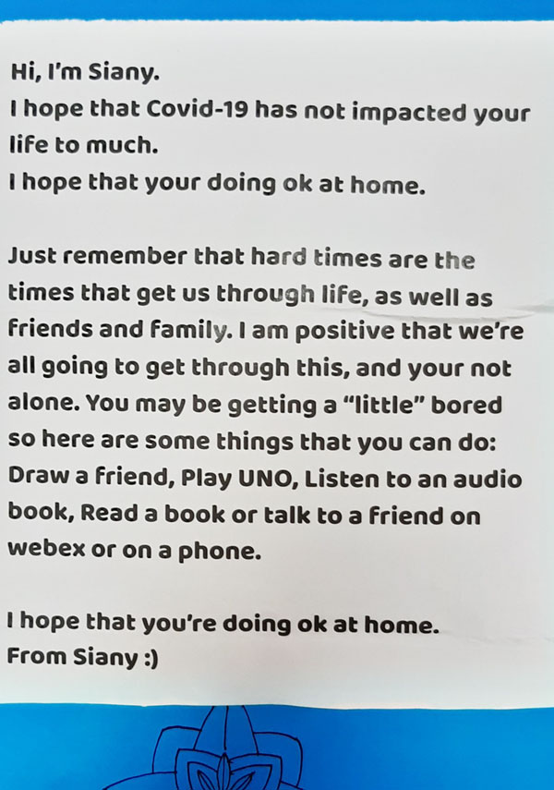

Holly
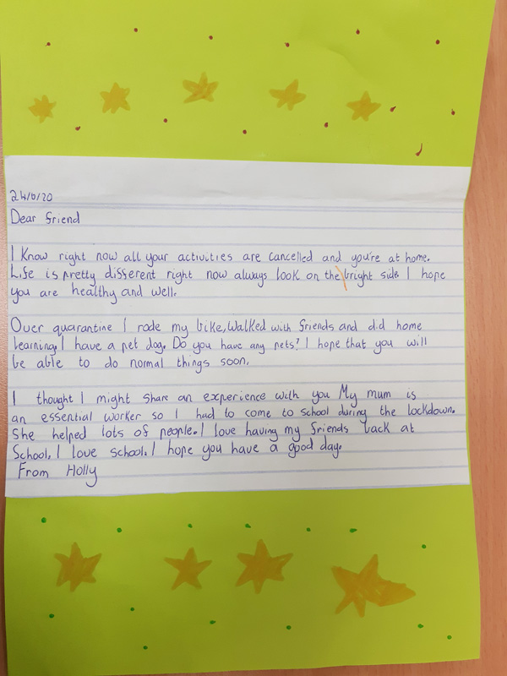

Gemma
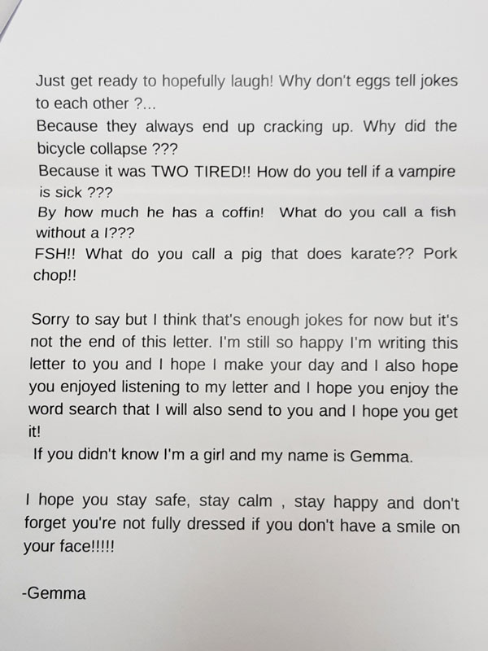

Georgia
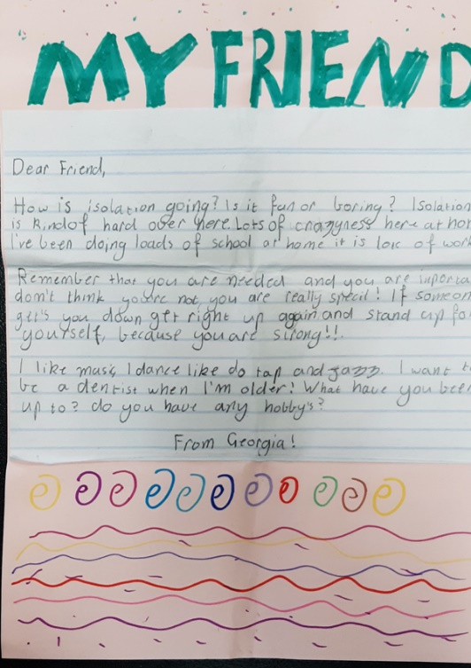

Knit one, warm one

We received an overwhelming response to knit one, warm one - thank you to everyone who participated!

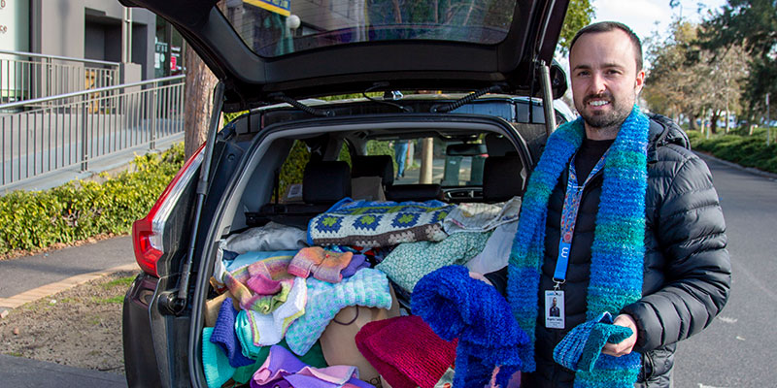
Council partnered with local community houses to offer our community the opportunity to be a part of the Knit one, warm one project.
Knit one, warm one built on the remarkable spirit and goodwill already shown by our community during the COVID-19 pandemic by offering a chance for knitters to help those sleeping rough or struggling financially.
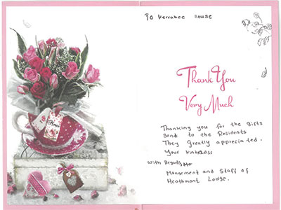
We received an overwhelming response to the project with hundreds of knitted scarves, beanies, gloves, mittens and blankets donated. This project enabled over 50 experienced knitters, past knitters and new knitters as well as some knitting groups to all band together to help others.
Items have been donated to a number of different agencies across Maroondah including Wellways, Uniting Crisis & Homelessness Service, Maroondah Community Meals programs, Maroondah Supported Residential Services, and the Safer Futures Foundation.
Read more about the Knit One Warm One project.

Spotting the strengths of young people
To celebrate Positive Education Day and in the lead up to Victorian Youth Week, we are taking the opportunity to acknowledge the amazing strengths that Maroondah’s young people have shown throughout a challenging 2020.
To participate all you need to do is submit a short clip sharing a strength you have seen in a young person (aged up to 25) this year. We will compile these in to some short videos to be shared far and wide!
Submit a clip and you will go in to the running to win that young person one of ten $50 gift cards.
Here are some strength spotting example:
- "This year I've noticed my daughter Emily's bravery as she's settled in to a new school"
- "This year I've noticed my friend Nguyen's humor. His jokes have helped me through some hard days!"
- "This year I've noticed my student Sara's kindness. She wrote me the most beautiful card at the end of learning from home"
Watch our callout video which includes some examples of strength spotting in action. A list of 24 character strengths that are common to all of us, and an explanation for each, can be found on the VIA website
So whether it’s your client, student, child, friend, nice/nephew or neighbour, please consider submitting a strength you’ve seen to be shared with the community.
You can read more about the program on our Youth website

Be Kind - Celebrating kindness past initiatives 2021

Acts of kindness stories

18 months on - Acts of kindness in Maroondah
Acts of kindness is a project aimed at showcasing the great community spirit of our locals. We are sharing community kindness stories to outline some of the good work being done voluntarily within our community. Stories are important as they help us connect to each other, restore order amongst chaos and share joy and happiness.
Many of our community members have stepped up to help others during these challenging times. We’d like to share these inspiring stories that have benefited our community.
We’d love you to share any community kindness stories that you’ve heard about or been involved in. All you need to do is add your story to social media using #bekindmaroondah or use our submission form below to send us a short video (20secs to 1min) or photo of the activity with a few sentences explaining what was done. These stories will be shared on Council’s social media platform or added to this page.
If you’re interested in one of our stories and would like more information on how you could participate, please call Fiona Burridge, Be Kind Maroondah Facilitator on 9294 5737 or email bekind@maroondah.vic.gov.au. You can also use our online form to submit a story.

Acts of kindness stories

Messages of hope - Larissa and Todd
Reaching out and connecting with others during lockdown gave Larissa and Todd purpose. Larissa volunteered her time documenting people’s lives by capturing a snapshot of their lockdown life. She plans to exhibit the portraits once restrictions ease. Todd sent letters and built a virtual gathering place on Facebook. By running social events he was able to connect people who otherwise wouldn’t be. Watch the video
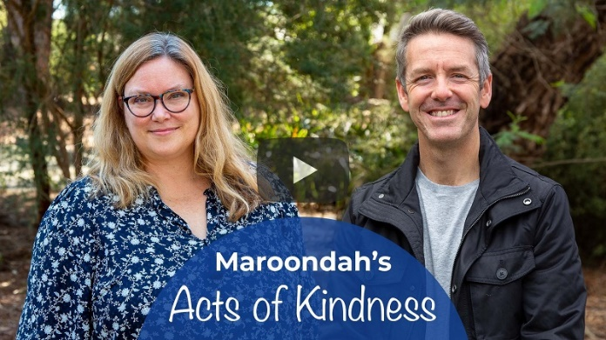

Building connections with neighbours - Adele and Richard
Connecting the community through small acts of kindness is second nature for Adele and Richard. Adele made a scarecrow for the front of her house to bring a smile to people’s faces, while Richard picked up some gnomes from his local op shop and now uses them as a tool to start social interaction with his neighbours. Watch the video
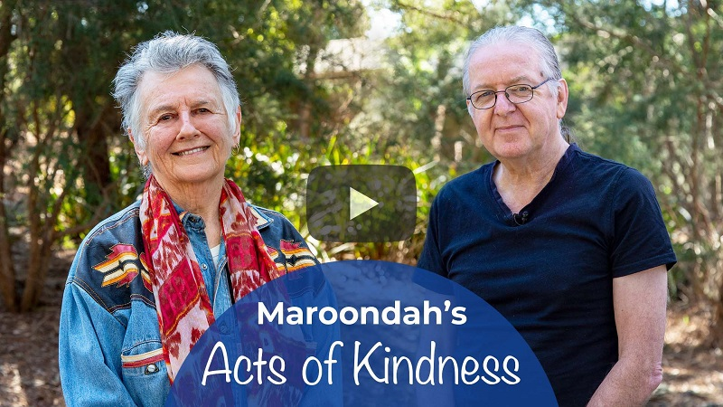

Sharing is caring -Naomi and Gavin
Two locals have been keen to help our community by supplying free goods to others. Listen to Naomi and Gavin as they explain their Acts of kindness in supporting their community, though both acknowledge that this has been a community effort with many others providing support for their activities. Watch the video
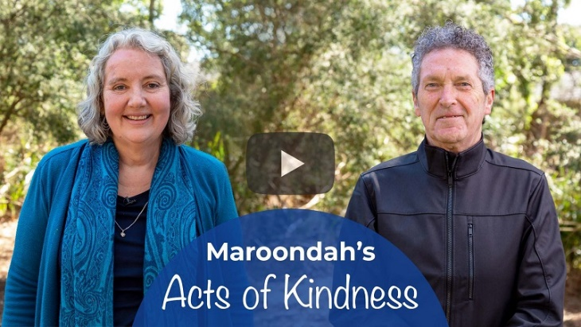

Take a book - it’s on us, Sally Real Library Branch Manager
The staff here at Realm library wanted to share a little Christmas cheer with our patrons, so rather than discarding good quality, pre-loved books that made their way into the library chute, we decided to give them a second life within our community. The books were gift wrapped and labelled fiction, or non-fiction, with an indication of the readers age. They were then made available as part of our ongoing Christmas display. Patrons were invited to help themselves to a surprise title to open at home and enjoy during the festive season. Many of the recipients expressed delight at their unexpected gift from the library and the fun of receiving a surprise read.
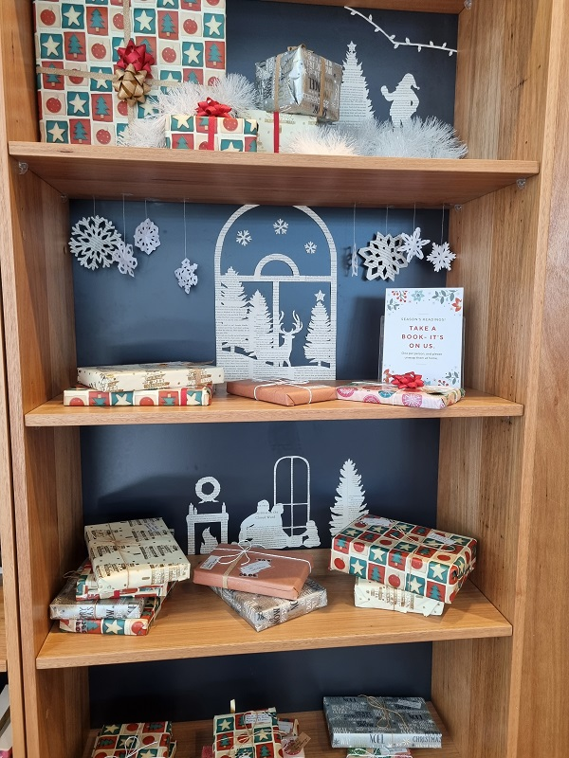

Multi-talented volunteer - Peter at Glen Park Community Centre
Peter is a wonderful edition to our volunteering community. He has volunteered in Glen Park’s Social Enterprise Café – Café on the Park since 2019 and quickly expanded his volunteer role to assisting with Glen Park’s fruit and vegetable collection, distribution of material aid in the Community Pantry and has recently taken on the task of creating an edible garden. All produce grown will be used in the cafe or in meals that are distributed in the Community Pantry.
Peter works tirelessly to ensure the edible garden is maintained and flourishing with delicious herbs and spices, as well as ensuring the Centre is always presentable. Peter is a wonderful addition to our team and we’re very grateful to have someone as hardworking and caring as Peter.
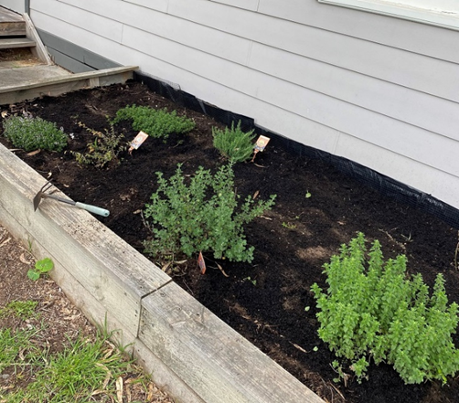

Musical instrument lending library - Peter
To support our wonderful Croydon U3A Musicology Group about a year ago during lockdown, we introduced a range of musical instruments for members, with support, to borrow for free and have a go at. It's a fun way to keep expanding our knowledge and skills as part of our supportive group.
Use it or Lose it we are told. Several of our members took up playing a musical instruments in their 70's or 80's. There is so much we can learn from each other. Long in the tooth Human Beings can learn new tricks. It's good for us too.

Spider-Man in action - Peter
It started out as a joke to run around the Croydon Hills area as Spider-Man, just for a bit of fun and a one-time thing during lockdown. I knew I’d get a bit of attention running in the suit but didn’t expect it to be anything bigger than I intended it to be.
I now go out for runs as Spider-Man once or twice a week to brighten everyone’s day and spread a little magic and wonder to the children and adults alike who often stop me for pictures.
I absolutely love going out in the suit and greeting everyone I pass; they all get a kick out of seeing Spider-Man run past. I also get really emotional hearing from people when out on my run or on Facebook that what I’m doing is making a difference and bringing excitement back into their lives. A silly joke grew into something much more, and I’m so happy it did. Just shows that anyone has the power to make a difference, and like a wise man once said ‘With great power comes great responsibility.
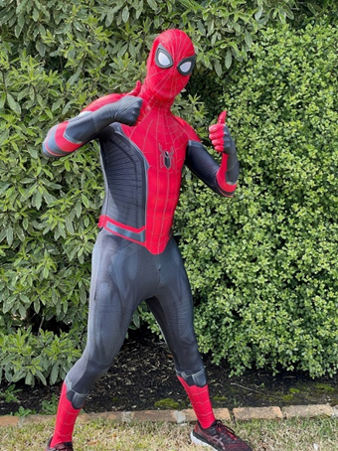

Winter shelter - a warm meal, a safe place to sleep and a welcoming smile
Winter Shelter is thankful for the donations of food from our volunteers, RACV club, Fareshare, All About Vending, Bulla IceCream, Cheeky Challa and so many others. Thanks to you all for helping us make a difference to lots of hungry people in Maroondah.
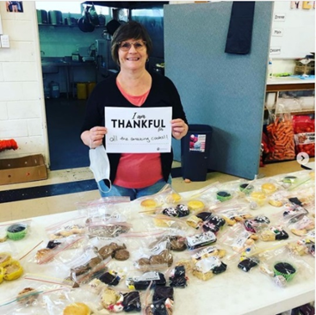

Hand painted rocks in Heathmont, Kj Rockt
When COVID hit last year, I was reluctant to hide rocks in playgrounds, given risk of passing on the virus, so I started placing a set of rocks on my fence each week. I have continued to do so each week of lockdown. Some rocks would stay all week, some would disappear quickly - either way I was happy they were giving people a reason to smile. Sometimes the theme matched an event (ANZAC day, Easter, RUOK day,) other times it was something suggested by a passer-by who commented to me. In lockdown 6 I've been putting out 2 sets a week as they are taken quite quickly. I have had some lovely chats with locals walking past, and have received donations of rocks, some art work and a few thank you cards - not the reason I do it, but lovely to read each time.
Comments from participants:
Lauren - I absolutely love seeing your rocks!
Kristy - I’ve been meaning to drop a note into your letter box for months and months: THANK YOU for brightening up my morning walks. You and you rocks are fabulous.
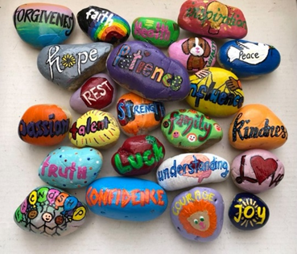

Rupert and Mooksi - Ru, Local artist
Kathy, Heathmont resident - Ru is a local artist helping keep the kids and adults of Heathmont entertained during this lockdown - she is regularly posting illustrations of a mouse, Rupert and its toy rabbit, Mooksi. Locals were encouraged to submit names, suggest adventures and create some chalk drawings in some of her earlier posts. I think these 2 characters might be our unofficial mascots at the moment.
Ru, local artist -Rupert started when I did a sketch of a mouse with a big piece of cheese just for fun, and then a follow up sketch af ter he’d eaten too much cheese. I put these up on our local Facebook page (Heathmont Neighbourhood) and asked for name suggestions for the mouse. I then just continued to do a drawing a day, developing the story as I went. Mooksi sort of appeared during the first story as a little rabbit hiding in each picture, but has now also developed a life of his own.
I have found it great doing the drawings every day - it’s given me something to work on throughout lockdown and provided contact with the local community.
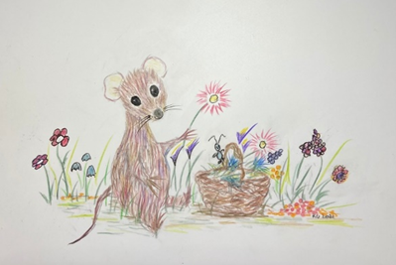

Free hand painted watercolours - Meredith, local artist
Lockdown had me feeling quite flat and creating makes me happy, especially creating for other people. So I thought I would post artwork to give away on the local Heathmont page in the hope that it could brighten someone else’s day along with my own. The responses I received were overwhelmingly positive and have made me feel so connected and supported by our lovely community.
Comment from participant:
Kathy, a recipient - Throughout August Meredith gave away her hand painted watercolurs to a random person who commented on her post. I was fortunate to be allocated one - mine sits above my desk and brings me joy each and every day. More recently, Meredith created a set of Aussie Animal paintings that she is having printed as Christmas Cards with all of the proceeds being donated to Neurobalstoma Australia 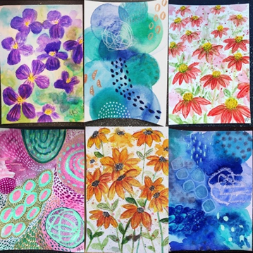to fund research because of another Heathmont family's experience with this disease.

Generous volunteer - Jacinta from Glen Park Community Centre
Jacinta has been a volunteer with Glen Park Community Centre since April 2019, volunteering with Emergency Relief programs. Jacinta's personality is the perfect match for Glen Park's emergency relief programs, and never fails to bring a smile to anyone who accesses our services.
Jacinta's generosity goes beyond volunteering, she not only donates her valuable time to Glen Park, but she also donates items to the Community Pantry on a regular basis. Glen Park Community Centre acknowledge and appreciate all of Jacinta's hard work and dedication to our volunteer program and emergency relief programs. Without Jacinta and her kind heart, Glen Park would not be able to offer the programs that we do.

The Garden of Wellbeing - Rebecca, Ringwood East
We are encouraging Maroondah schools and early learning centres to plant physical Gardens of Wellbeing by providing free sunflower seeds to them. The idea is to encourage these communities to look after themselves and others and remind each other to spark joy and kindness, one seed at a time. It takes everyone to grow the Garden of Wellbeing!
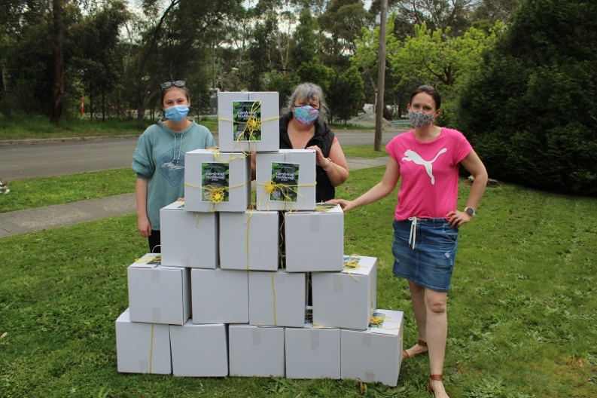

Where’s Wally in Heathmont -Sarah, Heathmont
Where's Wally 2021 was a wonderful success! Thank you all who came to find Wally. It was lovely to meet some of you and thank you for your kind words. I organised this because we need a break! A reset to life in lockdown and the weather was on our side to do so!
Comments from participants:
Laura - Had a great morning out searching for Wally!! Thanks so much for organising! You’re a legend.
Vanessa -What you did… the time, effort and thought into today was beyond AMAZING. You lifted up not only little kids spirits but all the parents that participated today! What an absolutely wonderful idea and experience my son and I had today! Thank you so much. What a joyful day in such a hectic world.
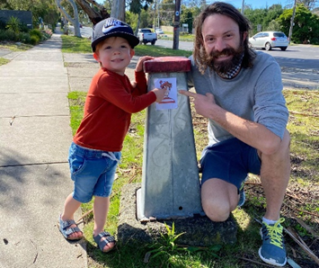
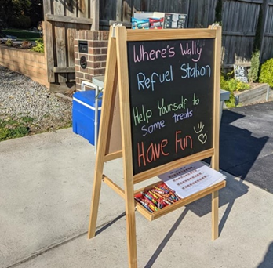

Spoonville - Croydon
A response Edith, a participant -I took this photo on my walk during lockdown in 2020. It was one of many Spoonville locations around Croydon and in fact Victoria as a whole. This one was just near the playground at the end of Parrs Road, Croydon. Lot’s of fun for all passers-by during several months of lockdown.
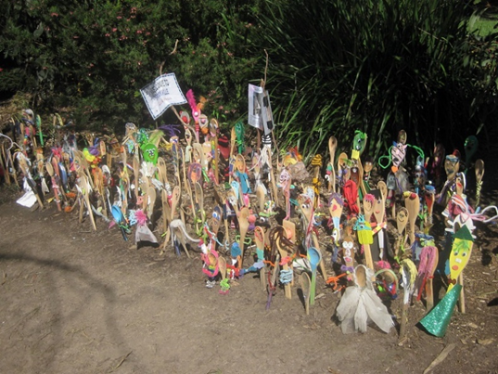

Treasure gardens -Sarah, Ringwood
Last year during the long lockdown I started putting a little visual treasure hunt in our front garden. When we went into lockdown this time and playgrounds were closed, I started this activity again. It has helped keep me sane.
I have received some lovelyThank youletters left in the mailbox. If people see me in the garden, a lot now yell out “thank you” and I often get told how much the kids love my garden. I change things weekly so there’s always something new to look out for.
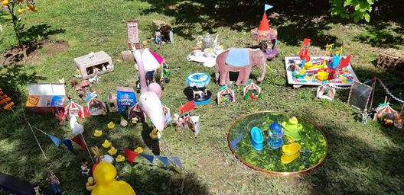

Chalk messages of hope
As I was walking this chalk drawing was one of five that sparked my delight that continued to grow as I came to each one.
I hope everyone else who saw this simple act of kindness experienced similar joy before the rain took them away.
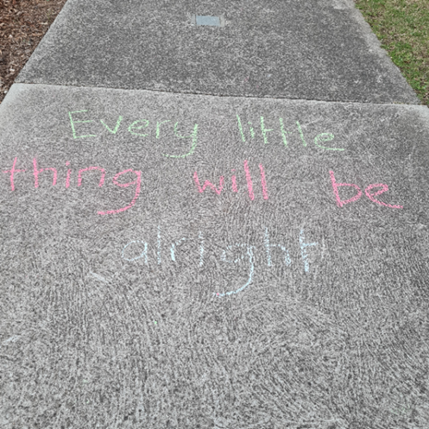

Free herbs for all - Edith, Croydon
While walking my dog around Croydon parks and residential streets, I find lots of these thoughtful gestures from gardener residents.

A carer caring for others - Mel, Different Journeys
Emily, one of our fabulous staff members at Different Journeys took it upon herself to send surprise care packages to some of our staff and volunteers. She did this unprompted and completely out of her own pocket. It was well received and totally unexpected. It’s great when someone takes the time to think of and support others. A great example of Be Kind.
Comments from participants:
Anon - One Monday morning during lockdown, my son and I received a care package from Emily, our Events Supervisor.What a gorgeous surprise for us both which made us feel valued and special. Every day we use our mugs and jot down work tasks to do in my notebook. The best part though was her thoughtful message inside the cover "Don't forget to Smile Today." We are grateful to work with an incredible team who look out for and lift each other up.
Darren - Getting the gift from Emily at Different Journeys was a great surprise and a welcomed one during lockdown. I use the mug pen and note book frequently and the chocolates have been eaten and enjoyed. I used the note book pen and mug during a recent MHFA course I completed.

Heathmont Dads group - Freddie and Scott
The Heathmont Dads Group was founded during the major COVID-19 lockdown of 2021 to provide Dads in the local Maroondah community with an opportunity to connect in a time when it was difficult to do so. We have a diverse range of Dad’s in both what they do for a living to where they are in their Dad journey which has created a really great group who support each other through sharing experiences, items and everyday life adventures through Facebook and Whats App. When we’re not in lockdown we meet fortnightly for coffees and hold events such as bowling, mini golf and organise family meetups in the local parks.
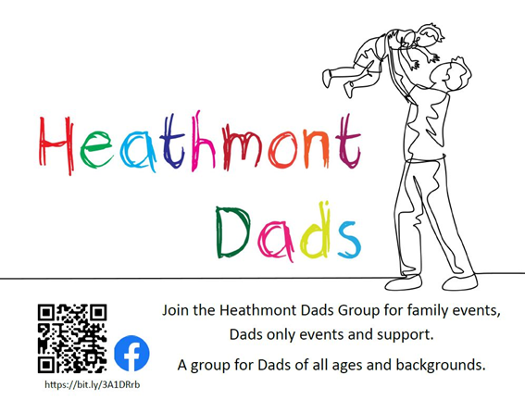

Free craft packages - Jess, Ringwood
We decided to make up little craft bags for our neighbourhood to help the little ones through lockdown and also to help parents who are constantly needing to find new and interesting ways to entertain their children while they work. We put together lots of bits and pieces we had accumulated in our craft draw, some for free play, and some with simple instructions should older siblings want to get involved. It was just something small, but we hadn’t considered just how special the kids would feel receiving their little packages, and my youngest just beamed at seeing all the happy little faces and warm thank yous. My kids really embraced this idea after the warm reception they received and so they went through their toys and books and games to see what else they could give to the neighbourhood kids. They put a whole table of items together out the front for contactless pick up. Another benefit of this little exercise was the surprisingly positive impact it had on my own kids wellbeing. Giving back and having this constructive outlets brought real joy. A little goes a long way!
Comments from participants:
Laura - My two loved the little craft pack from our neighbour Jess. They sat together and worked on them side by side with no arguments - a rare moment for a toddler. Our older one picked who he wanted to take his creations to, continuing to spread the love to our neighbours too! One neighbour was particularly touched to see his representation of her garden in his work!
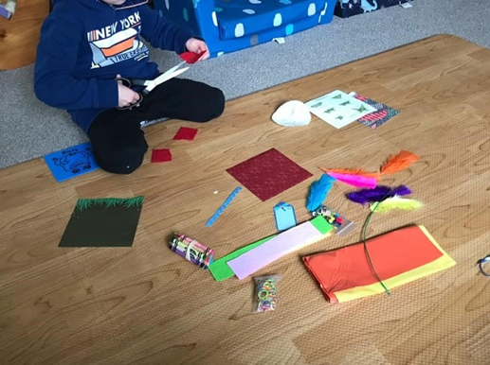

Free book along the Dorset Recreation trail - Rachael
We were walking the Dorset golf course track, and my son found a book saying "Congratulations, you found a book! These are difficult times, so I hope this surprise puts a smile on your face..."
Whoever did this I hope you see this message. Thank you for making my 4 year old's day.
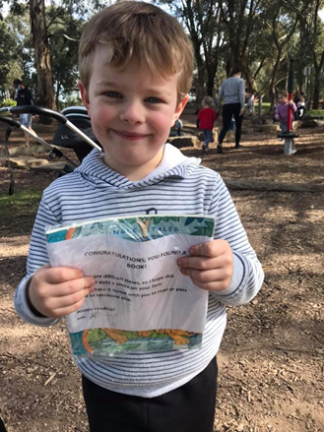

Free food packs - Kathy, Heathmont
Embers Grill and Burger offered 50 free meals a week for 8 weeks over August and September - this in itself is kindness at its best! The first four weeks were provided by Embers and Grill with the next four weeks by a 6 year old girl called Elise and her friend through their fund raising efforts.
From Embers Grill and Burger - Over the last 8 weeks we've given out 752 meals and food vouchers to those who need it. We would like to sincerely thank our community for digging deep to help each other out & a particularly big shout out to our regular customers who donated ingredients. You all made this happen, thank you from the bottom of our hearts.
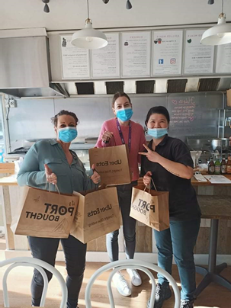

Heathmont Neighbourhood group
This group was created to help connect the community during the hard lockdown last year. It’s been a source of positivity and proof of the kind, generous and helpful neighbours we have in Heathmont.

Safe and sound - Liz, Heathmont
Mother duck and her six ducklings made it to the Dandenong Creek after traveling down Allen's Rd, The Boulevard, Anne court, crossing the railway line, along Heathmont Rd the via HE Parker reserve and finally to Dandenong creek. Local residents helped the ducks across Canterbury Rd and Bedford Rd, no mean feat, this is a very busy intersection.

Postcards of kindness
During Mental Health Month in October, Council is launching Postcards of Kindness. The project is aimed at promoting creativity and community connection through messages of kindness shared by people across the community.
We have designed four postcards featuring artwork by local artists and messages of kindness by the artists and local Wellbeing Champions participating in Maroondah’s Certificate of Creating Wellbeing program. The artworks include a range of styles including hand drawn, prints and computer-generated images expressing freedom, hope and strength.
You can help to spread kindness by writing your own message on the postcard and giving or posting them to family, friends, neighbours and local businesses.
How to participate:
- Postcards will be distributed through a range of Council services, community programs and services and local businesses or you can pick up a postcard from.
- Postcards can be picked up from the following locations:
- Caffe Stazione, Ringwood Town Square opposite Ringwood Station, 7am to 1pm daily
- The Conservatory Café, Wyreena Community Arts Centre, 13-23 Hull Road, Croydon, 10-2pm daily
- Write your own message of kindness to family, friends, neighbours or a local business that you want to support.
- Go for a walk and deliver your Postcards of Kindness. Or you can always put on a stamp and deliver it the old-fashioned way.
Did you receive a card?
If you were lucky enough to be given a postcard, please take a photo with your Postcards of Kindness and tell us what it meant to you. Tag @MaroondahCityCouncil and the person who sent it to you. Please use the #bekindmaroondah so we can share the appreciation.
Not on social media? You can also send your thoughts and photos to arts@maroondah.vic.gov.au.
“Kindness is contagious! The positive effects of kindness are experienced in the brain of everyone who witnessed the act, improving their mood and making them significantly more likely to ‘pay it forward’. This means one good deed in a crowded area can create a domino effect and improve the day of dozens of people!” - Dartmouth.edu
“The arts offer an evidence-based solution for promoting mental health. While practising the arts is not the panacea for all mental health challenges, there’s enough evidence to support prioritizing arts in our own lives at home as well as in our education systems.” - theconversation.com
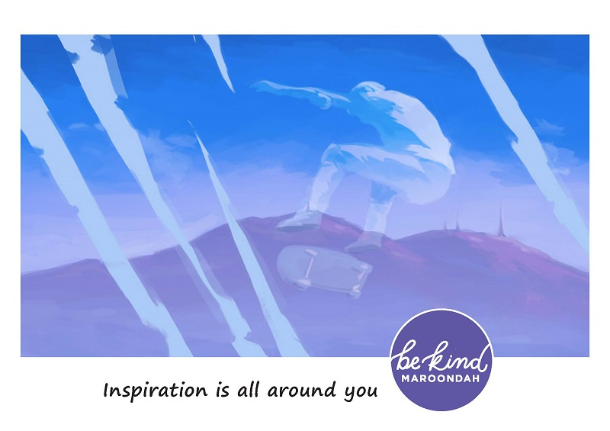
Adam Lane, untitled, 2021
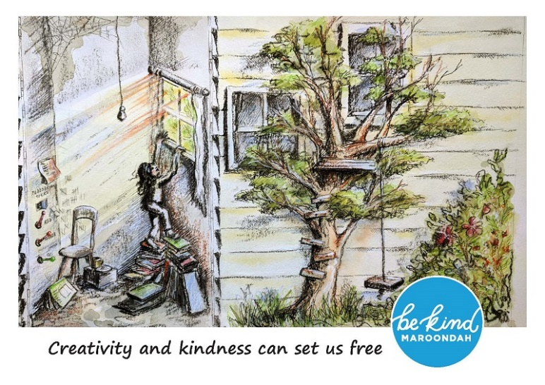
Katherine Masiulanis, Paint me out, 2021
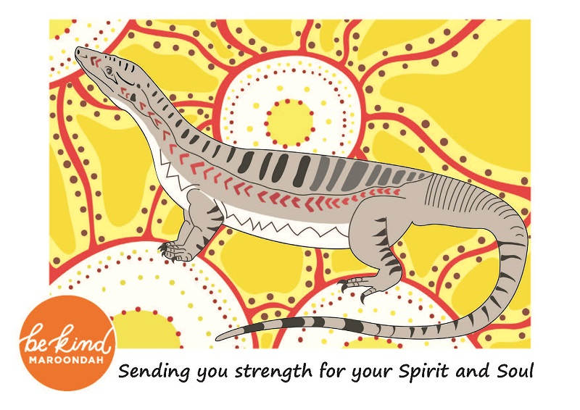
Wailwan and Mullum Mullum Indigenous Gathering Place Elder Aunty Irene Norman, Goanna Dreaming, 2015
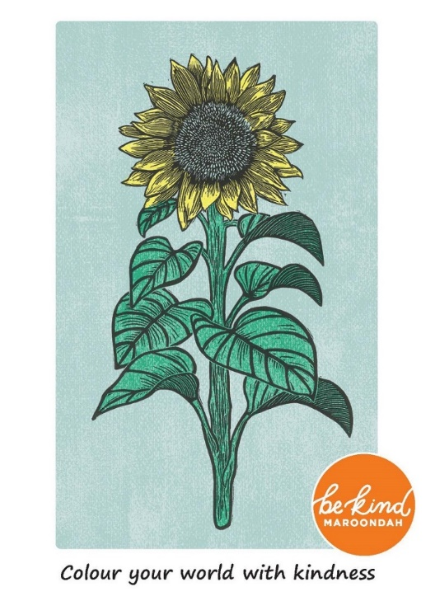
Gillian Nix, Sunflower, lino print, 2021

Good food good mood with Joel Feren
Join us online for an exciting and insightful evening with The Nutrition Guy aka Joel Feren followed by an online interactive cooking demonstration during the September school holidays!
Joel is an Accredited Practising Dietitian and Accredited Nutritionist as well as recipe developer and nutrition consultant. The Good food good mood presentation focuses on the importance of good nutrition and good mental wellbeing. The 40-minute presentation will be followed by 15 minutes of question and answer time. Questions can be sent in at the time of booking or on the night via the chat function. In addition to the Good food good mood presentation, Joel Feren will be delivering an online interactive live cooking demonstration. Joel will use simple and easily accessible ingredients to make family favourites with a twist, recipes include foods such as burgers, smoothies and pesto. Get the whole family involved and cook alongside Joel in the comfort of your own kitchen!
Sessions
Online presentation
Joel Feren’s Good food good mood presentation was on Tuesday 14 September, if you missed out on viewing it please watch below.
This event is proudly brought to you by Maroondah City Council in partnership with EACH, ERL, Neami National and Councils Boroondara, Kingston, Knox, Monash, Whitehorse, Yarra Ranges.
Online live cooking demonstration
- Date: Wednesday 22 September
- Time: 11:00am- 12:00pm
- Venue: Online

Build your financial future workshops

Start planning today so you can enjoy tomorrow.
Build your financial future - start planning today so you can enjoy tomorrow
Free session.
Are you worried about your finances? Do you want some professional advice to help you develop a plan for the future?
Learn how to take control over your finances by attending one of our workshops. These sessions will provide you with the knowledge to make informed decisions on improving your financial future.
Our free Build your financial future workshop will cover a variety of different finance topics that are often misunderstood or confused.
Topics include; how your values affect the management of your finances, earnings vs spending, budgeting, managing debt, superannuation, savings/investment.
After the workshop, attendees will have the opportunity to access Hope City Mission’s online interactive financial training modules for 6 months at a subsidised price of $30.
Online workshop
- Date: Tuesday 31 August
- Time: 7.30pm to 8.30pm
- Venue: Online. Link to access the workshop will be sent on the day
Face to face workshop - cancelled due to ongoing restrictions
- Date: Wednesday 25 August
- Time: 10am to 11am
- Venue: Realm, 179 Maroondah Hwy, Ringwood
This event is proudly brought to you by Maroondah City Council in partnership with Priority1 Wealth Management Group and Hope City Mission.

The Suicide Conversation

Don’t miss this opportunity to attend this free workshop on the suicide conversation facilitated by Victoria Carrier at LifeConnect.
Facilitator - Victoria Carrier, LifeConnect
Council is continuing to offer our community the opportunity to participate in training to help improve mental wellbeing. Don’t miss this opportunity to attend this free workshop on the suicide conversation facilitated by Victoria Carrier at LifeConnect.
Have you ever had concerns for the welfare of a family member or friend but didn’t know how to start that difficult mental health conversation? Then this is the workshop for you.
Victoria from LifeConnect will help build your confidence in having conversations about mental health and suicide and increase your awareness of where to find help and how to link people to support. The content is based on the latest research in suicide prevention and informed by lived experience.
Training covers:
- Skills to overcome the barriers that may prevent you from having difficult conversations
- Skills to promote connection and supportive communication
- Practical steps to start a conversation about suicide with someone who may be at risk
- Skills to assess the level of risk and support the person to seek help
- Knowledge about where to find support
- Self-care practices to support your own wellbeing
Workshop details
- Facilitator: Victoria Carrier
- Date: Monday 7 March
- Time: 10am to 11am
- Venue: Realm - Rooms 1/2

Introduction to mindfulness workshops
Join us for our introduction to mindfulness workshops.
Come along an explore a variety of mindfulness practices including the fundamentals of mindfulness and how to bring your practice into everyday life. Establish present moment awareness and be guided in mindful breathing techniques by experienced facilitator Narissa Doumani.
This is a free workshop. Bookings are essential.
- Friday, 23 April 2021 - 10.00am to 11.00am
- Tuesday, 30 March 2021 - 2.00pm to 3.00pm

The Sunflower Effect Project
Thank you to everyone who joined The Sunflower Effect Project and helped us spread hope and brightness into the streets of Maroondah.
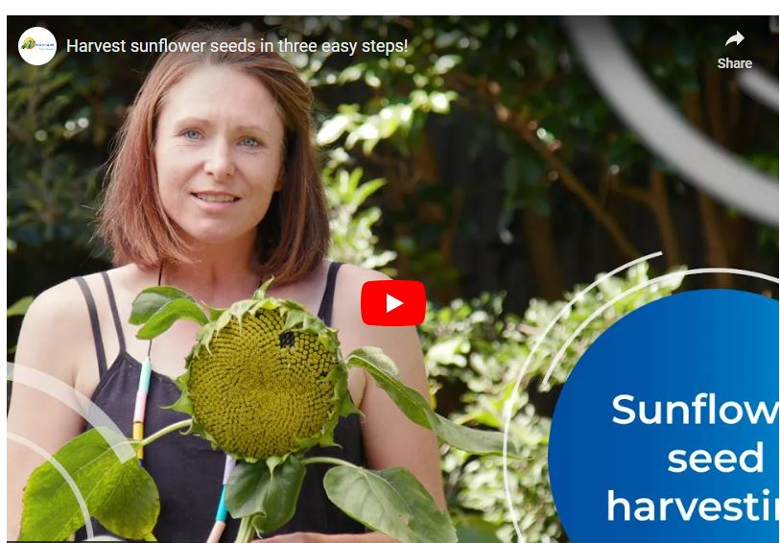
Sunflowers are the symbol of hope - all it takes is one seed, one thoughtful act, one kind word to bring brightness into someone else’s world.
As part of Be Kind Maroondah, we encouraged Maroondah residents to plant sunflower seeds in their front garden or in a pot to bring some hope and brightness into their street. Seed packets were also available to share with neighbours so they could plant them too resulting in streets of bright and cheerful sunflowers.
For those who planted sunflowers, we’d love you to share pictures of your sunflowers growing and blooming. You can send your photos to bekind@maroondah.vic.gov.au
As your flowers start to wilt, you can harvest the seeds hidden within the head of the sunflower. Each sunflower has hundreds of seeds so you have lots of seeds to plant later in spring. You could also share any excess seeds with family and friends. Watch our video to find out how to harvest your sunflower seeds.
To find out more about The Sunflower Effect please call Fiona Burridge, Be Kind Maroondah Facilitator on 9294 5737 or email bekind@maroondah.vic.gov.au

Living life with anxiety with Sarah Wilson

The presentation by Sarah Wilson is now complete.
Did you happen to miss the presentation on Tuesday 23 February 2021? Not to worry you have until Friday 5 March to watch the session!
So Be Kind to yourself and find an hour in your day to listen to Sarah Wilson talk about her own struggle with anxiety and how she has reduced anxiety in her life with simple tips and strategies. She also talks about the importance of building resilience to help with the ups and downs of life and how to turn anxiety into action!

Be Kind - Celebrating kindness past initiatives 2022

The Resilience Project
The Resilience Project is coming to Maroondah this November!
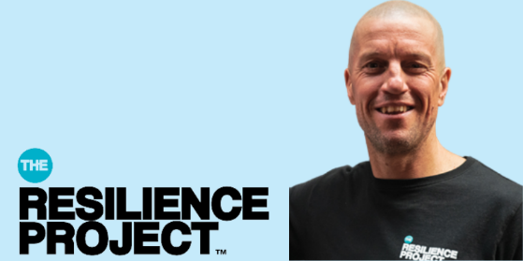
The Resilience Project explores evidence-based approaches to building resilience, in order to develop and sustain positive mental health.
The workshop outlines gratitude, empathy (kindness) and mindfulness strategies and discusses simple ways you can practice these in your daily life. The session will be presented by Martin Heppell, former AFL player and inspirational speaker.
Event details
- Date: Wednesday 30 November
- Time: 7pm to 8.30pm
- Location: Karralyka, Mines Road, Ringwood East OR livestreamed online
- Cost: Tickets are $10 per person for both online and in person

October - Mental Health Awareness Month
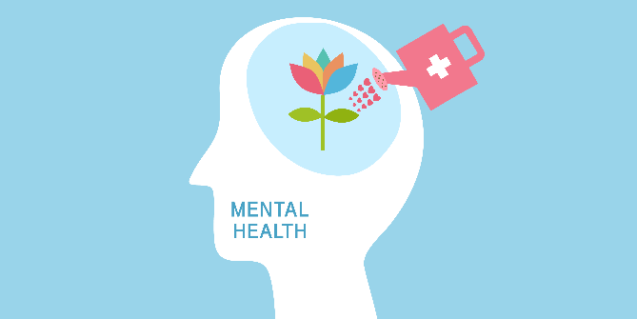
To celebrate Mental Health month we are offering a range of free wellbeing workshops.
Join us and learn new ways to live well even when things aren’t going to plan. Our LifeSkills workshops will teach you practical skills to help move through and grow from life’s experiences.
According to the National Study of Mental Health and Wellbeing 2020-2021, 2 in 5 Australians aged 16-85 years experience a mental health condition at some time in their life. That is over 8.6 million people. Council is committed to help improve the wellbeing of our community through a range of events, presentations and workshops throughout the month of October.
Week 1 - Science of Stress
Stress is a normal and natural part of our daily lives. But when does stress become a problem for us? What tools do we have to cope with it? ‘The Science of Stress’ aims to bolster resilience through enhancing our understanding of what stress is and how we might be able to manage it.
- Thursday 6 October - 10am to 11am
- Location - Realm - 179 Maroondah Hwy, Ringwood
- Facilitator - LifeConnect
Week 2 - Gratitude
Being thankful and appreciating the good things… it’s not always easy to do amid the stresses of daily life. Yet research shows that practising gratitude – even when times are tough – can increase happiness and wellbeing, reduce stress, improve relationships, and lower suicide risk. Learn what gratitude is and how we experience it including practical exercises for developing gratitude.
In-person session
- Wednesday 12 October - 10am to 11am
- Location - Realm - 179 Maroondah Hwy, Ringwood
- Facilitator - LifeConnect
- Bookings close Monday 10 October
Online session
- Wednesday 12 October - 7.30pm to 8.30pm
- Facilitator - LifeConnect
- Bookings close Monday 10 October
Week 3 - Responding to emotions
Our thoughts can take us lots of places – sometimes we can get caught in a train of worry, what-ifs, or sadness. This workshop discusses how common it is to have a wide range of emotions and how we can respond to them, freeing us up to live life in accordance with our values.
- Wednesday 19 October - 10am to 11am
- Location - Realm - 179 Maroondah Hwy, Ringwood
- Facilitator - LifeConnect
- Bookings close Monday 17 October
Week 4 - Finding your Super Powers
Ever wondered what makes you tick, why you react differently to others in different situations? Get to know the real you by finding your super powers. Knowing your super powers are a key to living your best life and understanding your true self making you happier, less stressed, more productive and better connected.
In-person session
- Friday 28 October - 10am to 11am
- Location - Realm - 179 Maroondah Hwy, Ringwood
- Facilitator - Edwina Ricci, Deputy Chair of Communities of Wellbeing
- Bookings close Wednesday 26 October
Online session
- Tuesday 25 October - 7.30pm to 8.30pm
- Facilitator - Edwina Ricci, Deputy Chair of Communities of Wellbeing
- Bookings close Sunday 23 October

Let’s Get Neighbourly, Maroondah
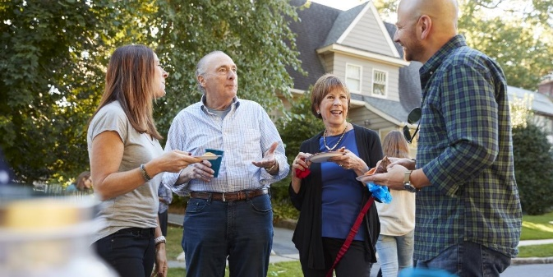
Become a Community Connector today
The last few years have shown us the importance of neighbours who are willing to help and support one another. Help build a community you’d like to live in while making new friends and meeting others with similar interests.
Maroondah City Council is offering training and support to local residents to start their own neighbourhood group or extend an existing group.
Come along to one of our workshops and:
- Learn how to become a Community Connector with training and one on one mentoring provided
- Develop new leadership skills
- Learn new ways to connect with your neighbours with lots of ideas, activities and helpful tips
- Meet other Maroondah Community Connectors.
It can be as simple as starting an online group, inviting neighbours in your street for a catch up or hosting a street activity.
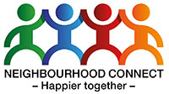
This program is run in partnership with Neighbourhood Connect and Maroondah’s Community Houses.

Workshops
Arrabri Community House
- Workshop 2: Saturday 12 November, 2pm to 4:30pm

Gambling Harm and Young People – online session
Join us for an online session on gambling awareness.

Gambling Harm Awareness Week runs from 17 to 23 October and encourages us to talk about the harms associated with gambling and the effects it can have on our communities.
Smartphones, online games and gambling ads on TV have changed the gambling landscape significantly. This workshop is an opportunity for parents, carers, young people and interested community members to learn more and to be aware of the harms associated with these forms of gambling.
The session will host a panel discussion lead by leading experts from ReSpin, Fred Rubinstein; lead researcher and advocate on gaming and harm prevention at Deakin University, Professor Samantha Thomas and Gamblers Help Counsellor, EACH, Melanie Marsh.
Event details
- Date: Thursday 20 October
- Time: 7.30 to 8.30pm
- Location: this session will be held online

The Maroondah Lift Project
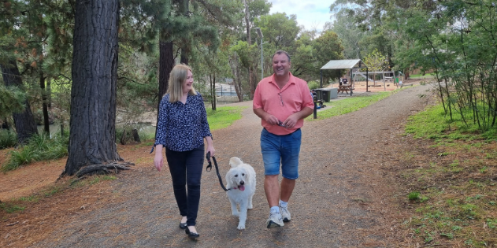
As we learnt, experienced, thought and shared (LETS) together, we have discovered simple and easy strategies to help improve our mental wellbeing.
The Maroondah Lift Project has been a great wellbeing adventure lifting our spirits during these cold winter months. We learnt about scientifically-proven wellbeing strategies from the exciting fields of Neuroscience, Positive Psychology and Lifestyle Medicine. With a focus on mental wellbeing, this project showed us how to increase our resilience and happiness no matter where we’re at!
Evaluation survey
Thank you to all participants who completed The Maroondah Lift Project Evaluation survey.
Evaluating our programs is an important part of our processes as the results are used to help inform future Council wellbeing programs.
Congratulations to the following winners:
- $100 Eastland voucher - Gregory N
- $100 Maroondah Leisure membership voucher – Kevin D
- 12-month subscription to The Lift Project so you can continue on your wellbeing journey - Lynne C
Thank you to everyone in our community who participated in The Maroondah Lift Program. We hope you found the videos and information inspiring and that it has encouraged you to continue to enhance your wellbeing and the wellbeing of those around you.
For more information on Council’s wellbeing programs please contact Fiona.burridge@maroondah.vic.gov.au or call 9294 5737.
This program was proudly brought to you by Maroondah City Council and EACH in partnership with Communities of Wellbeing, Different Journeys, Eastern Regional Libraries, Eastland, Maroondah Community Houses.

Men’s Habits for Happiness
Men are invited to join us for a presentation on how to live a happier existence.
Dr Tim Sharp
In this 90-minute presentation and interactive discussion Dr Tim Sharp will deliver the fundamentals of how to live a happier existence, complete with practical tools and easy-to-apply methods.
The presentation will cover:
- how to thrive, not just survive
- how to develop optimism and positivity
- ways to improve your happiness, health and wellbeing.
With the right approach, men can learn how to find opportunity and excitement in their lives again.
Event details
- Date: Thursday 16 June
- Time: 7.30 to 9pm
- Location: online event. A link to join the event will be sent closer to the date.

Mindful walking program - Yarrunga Community Centre

Booked out. Mindful walking can reduce stress and anxiety, improve sleep and overall mood, and improve mental health. Join our new Mindful walking program.
Mindful walking can reduce stress and anxiety, improve sleep and overall mood, and improve mental health. Join our new Mindful walking program, learn some of the important practices of mindfulness and get some exercise at the same time.
This is a four-part walking mindfulness series that will take you on a journey of connection and exploration. We will explore what it feels like to truly arrive in the moment and connect to our bodies, our minds, and the world around us.
Topics include:
- Introduction to Mindfulness
- Mindfulness of the Body
- Mindfulness and Compassion
- Mindfulness and the Senses
Workshop details
- Facilitator: Victoria Carrier
- Date: Monday 21 March, Monday 28 March, Monday 4 April, Monday 11 April
- Time: 9.30am to 10.30am
- Venue: Yarrunga Community Centre
Morning tea will be provided after each walk in the centre. A free gratitude journal will be supplied to participants.
This program will continue regardless of the weather. It may be moved inside each centre if needed.

Addressing Anxiety workshop with Michelle Graeber

Join one of our free workshops and learn ways to address anxiety with Michelle Graeber, CEO Anxiety Recovery Centre.
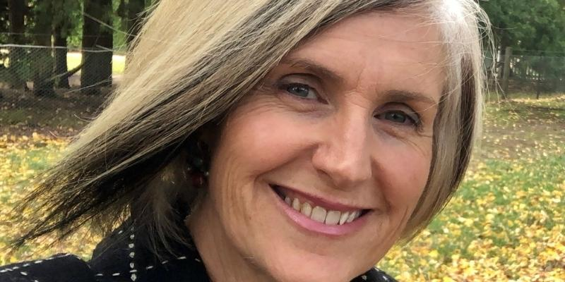
Michelle Graeber, CEO Anxiety Recovery Centre
Most people feel stress and anxiety and coping mechanisms vary from person to person. The aim of the Addressing Anxiety workshop is to enable people to better cope with feelings of anxiety in day to day life.
The workshop is run by Anxiety Recovery Centre Victoria (ARCVic), they are a unqiue state-wide community mental health organisation, providing support, recovery, early intervention and educational services to people and families.
This is an interactive workshop with time allowed for questions from participants.
Session details
- Presented by Michelle Graeber - CEO Anxiety Recovery Centre Victoria
- Wednesday 6 April - 10am to 11.30am, Realm OR
- Tuesday 26 April - 7pm to 8.30pm, Online workshop
- Free event - Bookings essential
Further information
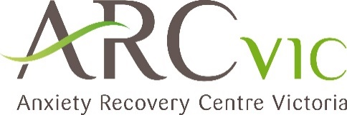
For more information please contact Fiona Burridge, Be Kind Maroondah Facilitator, 9294 5737 or email bekind@maroondah.vic.gov.au.
If you need urgent assistance contact Lifeline on 13 11 14 or visit lifeline.org.au.

Mind Strength with Dr Jodie
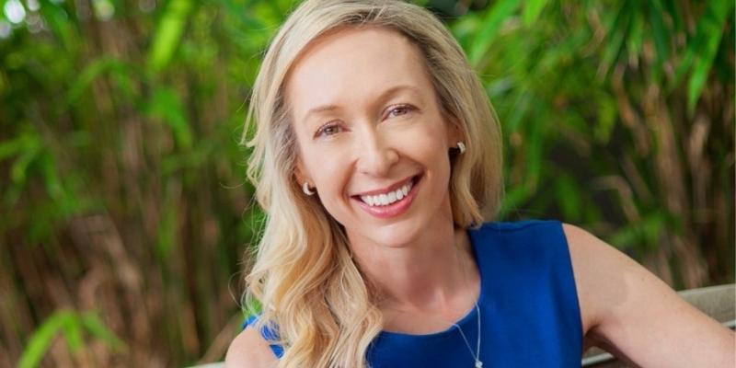
Join the free online session to learn Dr Jodie's four steps to curb anxiety, conquer worry and build resilience.
Facilitator - Dr Jodie Lowinger, Founder and CEO of The Anxiety Clinic
Dr Jodie will be talking on her Mind strength method - four steps to curb anxiety, conquer worry and build resilience. The Mind Strength Method has been transforming lives around the world, helping people to conquer anxiety and build happiness, resilience and wellbeing.
Session details
- Presented by Dr Jodie Lowinger
- Tuesday 22 March
- 7.30pm to 8.30pm
- Online session. Bookings essential
Following the 45-minute presentation, participants will have the opportunity to ask questions. Questions can also be sent in at the time of booking.

The Suicide Conversation
Don’t miss this opportunity to attend this free workshop on the suicide conversation facilitated by Victoria Carrier at LifeConnect.
Facilitator - Victoria Carrier, LifeConnect
Council is continuing to offer our community the opportunity to participate in training to help improve mental wellbeing. Don’t miss this opportunity to attend this free workshop on the suicide conversation facilitated by Victoria Carrier at LifeConnect.
Have you ever had concerns for the welfare of a family member or friend but didn’t know how to start that difficult mental health conversation? Then this is the workshop for you.
Victoria from LifeConnect will help build your confidence in having conversations about mental health and suicide and increase your awareness of where to find help and how to link people to support. The content is based on the latest research in suicide prevention and informed by lived experience.
Training covers:
- Skills to overcome the barriers that may prevent you from having difficult conversations
- Skills to promote connection and supportive communication
- Practical steps to start a conversation about suicide with someone who may be at risk
- Skills to assess the level of risk and support the person to seek help
- Knowledge about where to find support
- Self-care practices to support your own wellbeing
Workshop details
- Facilitator: Victoria Carrier
- Date: Monday 7 March
- Time: 10am to 11am
- Venue: Realm - Rooms 1/2

The Science of Stress
The Science of Stress aims to strengthen resilience through enhancing our understanding of what stress is and how we might be able to manage it.
Council is continuing to offer our community the opportunity to participate in training to help improve mental wellbeing. Don’t miss this opportunity to attend this free workshop on stress management facilitated by Victoria Carrier at LifeConnect.
The Science of Stress aims to strengthen resilience through enhancing our understanding of what stress is and how we might be able to manage it.
Join our workshop and explore:
- The core physiological processes of stress
- The difference between acute stress, chronic stress, and burnout
- Examples of practical skills to self-manage stress
- The importance of having productive self-care strategies
Workshop details
- Facilitator: Victoria Carrier
- Date: Monday 28 February
- Time: 10am to 11am
- Venue: Realm - Rooms 1/2

Mental Health First Aid training for Maroondah carers

Across two days, Maroondah City Council is offering carers in Maroondah the opportunity to participate in Mental Health First Aid training.
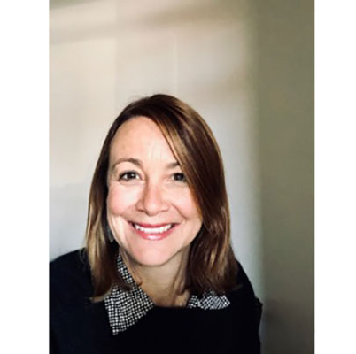
Mental health First Aid is presented by Nicole Turner who has over 25 years experience in mental health and is a qualified Mental Health First Aid trainer with Mental Health First Aid Australia. This training is for Maroondah carers of people with a disability or mental health issue/s.
The workshops will increase your knowledge of mental health first aid, including:
- how to recognise the signs and symptoms of mental health
- how to give appropriate initial help and support.
Please note, you must be aged 18 or over and available to attend both sessions to book for this training.
Upon completion of your training, you will receive a 3-year Mental Health First Aid Accredited Certificate from Mental Health First Aid Australia.
Date and Time
- Friday, 25 February 2022 - 9.30am to 4.00pm
- Friday, 18 February 2022 - 9.30am to 4.00pm

