Food Safety Risk Assessment Guide

Council’s role in food safety
Maroondah City Council is committed to achieving a safe, healthy and active community, through a preventative approach to food safety and public health.

Victorian Food Act 1984
The Food Act 1984 sets out the regulatory requirements for the sale of food in Victoria.
The Act ensures:
- food for sale is both safe and suitable for humans to eat
- all types of food businesses (fixed, home based, temporary and/or mobile) are registered with Council so they are regularly monitored
- staff are trained and food safety programs implemented
- the Food Standards Code in Victoria is applied to all food sales.
Council helps food businesses identify the areas where things can go wrong and provides guidance on what is required to prevent food from becoming unsafe or unsuitable.

Our Environmental Health Officers
Environmental Health Officers (EHOs) within Council are responsible for implementing the Food Act 1984 through registration, monitoring and education.
Council's EHOs:
- manage the registration, renewal and transfer of registration of food premises
- help new food business owners understand the food safety requirements for their business
- undertake food safety risk assessments of food businesses
- have food samples analysed to check compliance with food standards and labelling requirements
- investigate complaints of food safety risks or food poisoning
- provide food safety education across the community.

Food business risk classification

The Victorian Food Act 1984 classifies all food businesses according to their food safety risk. The classification system is risk-based, so that regulation is matched to the food safety risk that different food business activities pose to public health.
There are four classes of food business in Victoria, with Class 1 premises having the highest risk and Class 4 the lowest.

What is a food safety risk assessment?

Council’s food safety risk assessment program sets high standards of educating and assisting local food businesses to improve on food handling practices and reduce the incidence of food-borne illness.
The food safety risk assessment supports food businesses by:
- incorporating a risk management approach (assessing the likelihood and consequence of unsafe/unsuitable food)
- assessing the adequacy of current food safety controls the business has in place
- identifying any uncontrolled food safety risks
- assisting the business to put in place adequate controls to reduce the risk and ranks these actions in order of importance
- determining the impact if something were to go wrong. Consideration given to how serious the consequences could be for the consumer if controls are not put in place.
This table shows how the overall risk rating for each process is determined, by comparing the likelihood of unsafe/unsuitable food occurring with the expected consequences.

Certain | Medium | High | High
Likely | Medium | High | High
Unlikely | Low | Low | Low
 | Low | Major | Critical

Likelihood

Consequence

The EHO will evaluate the risk based on how likely it is that something could go wrong with the food.
Are there adequate controls in place?

The EHO will factor in the consequence of something going wrong with the food.
How many people could become unwell from consuming tis type of food? How severe could this be?

Some examples of likelihood and consequence:

Likelihood | Examples
Certain | Raw meat has contaminated ready to eat food  Food is contaminated with foreign matter  Food has been used past its ‘use by date’  Potentially hazardous food has not stored under temperature control for over four hours
Likely | Food is not protected during storage  Food is not stored under temperature control  Food premises is not clean  Food contact surfaces for ready to eat food are not being cleaned and sanitised  Food handlers are not washing their hands
Unlikely | Food is stored under temperature control  Food contact surfaces are clean and sanitised before use  Food is protected and date labelled in storage  Food handlers follow good hygiene practices  For more way to reduce the likelihood of food becoming unsafe or unsuitable: Refer to Appendix 1: How do I control food safety risks?
Consequences | Examples
Critical | Vulnerable people very likely to consume unsafe food  A high number of people very likely to consume contaminated food  People have become unwell or injured
Major | Possibility people may become ill or injured, if controls are not put in place
Low | No illness or injury likely

Based on the assessment result, a follow up inspection will be required to be undertaken within the following timeframes.

Overall Risk Rating | Follow up action required by Council
High (Critical) | Action taken to address critical risk immediately  Follow up inspection within 48 hours  Additional inspection costing $180, will be conducted within the three months prior to renewal of the Food Act registration (as required under the Food Act 1984)
Medium (Major) | Follow up inspection 2-10 working days
Low (Satisfactory) | Follow up inspection timeframe negotiable

An example of an assessment report
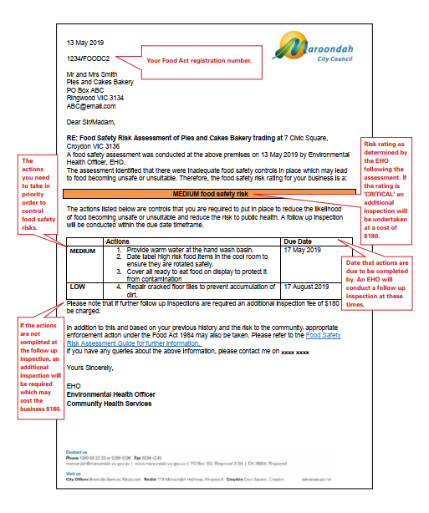

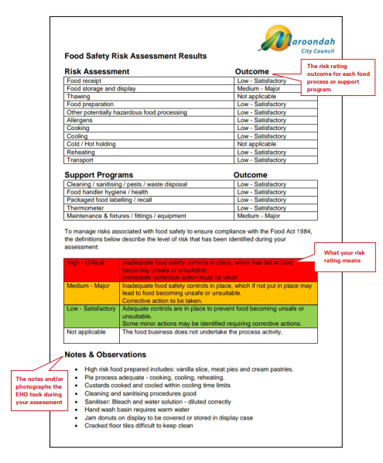

The Assessment process

What happens if my business does not control the food safety risks identified?

Council has a duty of care to the community to ensure that food safety risks identified within business are addressed. Council must take appropriate action to ensure businesses put in place controls to reduce the likelihood of food becoming unsafe or unsuitable.
The Food Act 1984 has a range of compliance tools to ensure enforcement is appropriately targeted to risk.
If a business does not implement the actions required to control food safety risks, the EHO may, depending on the business’s previous history and the assessed risk to the community, take the following action:

Overall Risk Rating | Council Action
Outcome | Business failure to comply | Outcome for business
High (Critical) | - Immediate control of the food safety risk | - Food and or equipment may be seized or discarded
 | - A further follow up inspection will be required | - An additional inspection fee of $180 will be charged for a further follow up inspection.
 | - EHO may prepare a brief of evidence and recommend prosecution in Court | - If prosecuted in Court, the business may face a large penalty and possible loss of reputation
 | - EHO may recommend to Council to force the temporary closure the business until adequate food safety controls are in place | - Business closure – loss of business
 | - Issue the business with an Order or Direction under Section 19 Food Act | - Failure to comply with a Section 19 Order is a Food Act offence and the EHO may prepare a brief of evidence and recommend prosecution in Court  - Failure to comply with a Section 19 Direction is ground for Council not to renew the business Food Act registration
 | - A Penalty Infringement Notice (PIN) may be issued | - A penalty infringement fine can cost business
Medium (Major) | - Extend the timeframe (within reason) in collaboration with the business to complete medium risk actions already requested to be completed. | - An additional inspection fee of $180 will be charged for a further follow up inspection.
 | - Issue the business with an Order or Direction under Section 19 Food Act | - Failure to comply with a Section 19 Order is a Food Act offence and the EHO may prepare a brief of evidence and recommend prosecution in Court.  - Failure to comply with a Section 19 Direction is grounds for Council not to renew the business Food Act registration.
 | - A Penalty Infringement Notice (PIN) may be issued | - A penalty infringement fine can cost business.
Low | - Extend the timeframe (within reason) in collaboration with the business to complete low risk actions. | - An additional fee of $180 may be charged for this additional inspection.

Next stage of the risk-based approach
The next stage of the risk-based approach in 2020 will be to analyse the assessment results and use this information to assist business in the areas that are highlighted as commonly high or medium risks areas.
For example: If the analysis shows the food storage is a common area for critical results, Council will focus on providing further information, education and resources to businesses in this area.

Questions or concerns about your risk rating
Should you have any questions or concerns regarding the decision of your risk rating, you are encouraged to discuss this with your EHO.
Following this, for further concerns, you may contact the Coordinator Community Health via email: communityhealth.customerservice@maroondah.vic.gov.au.

Your feedback is important to us. Please complete a sort online survey about this guide to help us ensure we provide the best resource possible: www.maroondah.vic.gov.au/fsra

Appendix 1: How do I control food safety risks?

The following checklist has been designed to assist food businesses to ensure they have adequate controls in place to prevent food becoming unsafe or unsuitable. Please note, this checklist is a guide only and information specific to your food business should be sought from an Environmental Health Officer or your Food Safety Auditor.

TO DO:
Food Receipt

- Only receive food from approved, registered food businesses
- Keep a list onsite of all your food suppliers
- Only accept frozen food if it is frozen solid
- Accept cold food delivered below 5⁰C
- Accept hot food delivered over 60⁰C
- Only accept clean eggs, not broken or cracked
- Only receive food in clean, intact and undamaged packaging
- Check food delivery vehicles are clean and within temperature
- Check food is labelled correctly according to Food Standards Australia and the New Zealand (FSANZ) Code
- Check food is within ‘best before’ or ‘use by’ dates
- Keep a record of food receipt

Food Storage and Display

- Check frozen food is stored below -15°C and frozen solid
- Monitor temperatures and keep a record of freezers, cold storage/display and hot holding unit temperatures
- Check food is protected from contamination and chemical contamination during storage including:
  - Cover all foods that are exposed to contamination
  - Store ready to eat foods above or away from raw food
  - Store all foods off the floor
  - Store foods in clean, suitable storage containers
- Check stock is being rotated on a first in, first out basis
- Check food is within its ‘best before’ or ‘use by’ date
- Check high risk foods are date labelled
- Keep chemicals stored separate to food storage areas
- Keep food storage areas clean
- Check for pest activity regularly

Thawing
- Only thaw food in the refrigerator or microwave
- Prepare food immediately after thawing in a microwave
- Protect food from contamination during thawing
- Check food is completely thawed before cooking

Food Preparation/ Other potentially hazardous food preparation

- Use tongs, scoops, clean gloves etc. to handle ready to eat food, to avoid touching food with bare hands (where possible)
- Check all fruit and vegetables are washed in clean water before use
- Only use clean eggs, not broken or cracked
- Check raw and ready to eat foods are separated
- Clean and sanitise equipment before each use
- Clean and sanitise chopping boards, slicers, juicers etc. during food preparation
- Never place ready-to-eat foods on an unclean surface
- Follow the 2hour/4 hour rule for potentially hazardous food at room temperature
  - less than two hours: food may be returned to a safe temperature below 5°C and above 60°C
  - more than two hours but less than four hours: food must be used immediately or discarded.
  - More than four hours in total: food must be thrown out.

Allergens

- Check staff are trained on allergens and ensure that they can provide accurate information to customers
- Retain packaging from products that are not made on the premises or keep details of the package information
- Provide information on food displays and menus to ensure customers are aware of the allergens
- Train staff preparing food to be aware of cross contamination and foods that contain hidden allergens
- Keep food in original packaging to identify allergens present
- Have a process in place to ensure allergen free food is provided to the correct customer

Cooking

- Cook potentially hazardous foods to a core temperature of 75°C or above
- Regularly check that the cooking process cooks the potentially hazardous food to 75°C or above
- Use a sanitised thermometer to check this temperature

Cooling

- Cool, cooked potentially hazardous foods from 60°C to 21°C within the first 2 hours and then from 21°C to less than 5°C within the next 4 hours

Hot/Cold Holding
- Keep hot potentially hazardous food above 60°C
- Keep cold potentially hazardous food below 5°C
- Check ready to eat food on display is protected from contamination.

Reheating

- Reheat cooked, potentially hazardous foods, such as soups, stews, sauces, gravies etc to a core temperature of 75°C or above

Transport

- Check foods transported are protected from contamination by storing in suitable containers
- Check temperatures of potentially hazardous foods is maintained below 5°C or above 60°C during transport

Cleaning/Sanitising/Pests/Waste Disposal

- Maintain premises and all fixtures, fittings and equipment in clean condition with no accumulation of garbage, recycled matter, food waste, dirt, grease or other visible matter
- Clean and sanitise utensils and equipment before each use
- Clean and sanitise other surfaces that food comes in contact
- Follow the six steps to cleaning and sanitising
- Pre-clean: Scrape, wipe or sweep away food scraps and rinse with water
- Wash: Use hot water and detergent to take off any grease and dirt. Soak if needed
- Rinse: Rinse off any loose dirt or detergent
- Sanitise: Use a sanitiser to kill any remaining bacteria (follow manufacturer’s instructions or Food Safety Program or chlorine solution).
- Rinse: Wash off sanitiser (if required by manufacturer’s instructions)
- Dry: Allow to air dry
- Seal all pest entry and harborage points (small cracks, holes, crevices)
- Keep doors leading outside closed when possible
- Protect food handling areas from pest entry (sliding doors, insect traps, fly strips)
- Keep food premises clean, and store food in clean containers with tight fitting lids
- Carry out regular inspections for pests and take corrective action when evidence of pests is found
- Provide an adequate number of waste bins
- Remove waste from the premises when the bin is near full or before
- Cover bins with tight fitting lids when not in use
- Regularly remove waste from the rubbish storage areas
- Dispose of wastewater through the sewer (or septic system)
- Do not dispose of wastewater via the storm water drain
- Dispose of waste oil, so that it does not contaminate waterways or land. A contract with a waste oil collection company should be in place.

Food Handler Hygiene/Health

- Advise and ensure food handlers to report gastrointestinal illness to their supervisor immediately and to:
  - Not engage in food handling whilst ill
  - Request advice from their medical practitioner when they are safe to handle food
- Advise and ensure food handlers to cover cuts and wounds on hands and arms with brightly coloured, waterproof bandages and ensure a disposable glove is worn and changed regularly.
- Advise and ensure food handlers follow good personal hygiene practices:
  - Outer clothing is clean and appropriate for the food handling being conducted
  - Tie long hair back
  - Keep fingernails short and clean
  - Limit jewelry (e.g. plain banded rings or sleepers)
  - Do not wear uniforms outside
  - Store personal items (phones etc.) away from food preparation areas
- Advise and ensure food handlers wash their hands:
  - Before commencing or re-commencing handling food
  - Immediately after going to the toilet
  - Immediately after smoking, coughing, sneezing, using a handkerchief or tissue, eating, drinking, or using tobacco or similar substance
  - Between handling raw and ready-to-eat food.
  - After touching hair, scalp, body or face
- Advise and ensure food handlers do not:
  - eat, sneeze or cough over unprotected food.
  - not spit, smoke or use tobacco in food preparation areas.
  - undertake any other unhygienic practices such as touching their nose, mouth or hair during food preparation

Packaged Food Labelling / Recall

- Check prepackaged food sold the food premises is labelled in accordance with ANZFA Food Standards Code labelling requirements.
- Be able to identify food recalled from sale, by keeping food in its original packaging or retaining the identifying information from the packaging
- Remove from sale/isolate any affected food from a Food recall and clearly label this “not for use”.

Manufacturers and Wholesalers:

- Label packaged food in accordance with the ANZFA Food Standards Code labelling requirements.
- Validate the expiry date, storage conditions and allergen declarations on food that you label through a food laboratory
- Be able to identify batches and suppliers of affected food product in accordance with ANZFA Food Industry Recall Protocol
- Have a food recall protocol on site at all times

Thermometer

- Check you have a digital probe thermometer onsite at all times
- Check thermometers are accurate by calibrating, (hot and cold temperature testing accurate to +/- 1.0°C)

Maintenance & Fixtures/Fittings/ Equipment

- Ensure the design, construction and space provided in the food premises is appropriate for the activities conducted in the business.
- Provide hand wash facilities that are always:
  - provided with warm water, liquid soap and paper towel at all times
  - adequate in size and designated for the sole purpose of washing hands, arms and face
  - easily accessible to food handlers at all times
- Provide food contact surfaces of fixtures, fittings and equipment that are:
  - able to be easily and effectively cleaned and if necessary
  - able to be sanitised
  - unable to absorb grease, food particles and water
  - made of a material that will not contaminate food
  - Do not allow for the harborage of pests
  - Keep all equipment and appliances, including utensils, crockery, cutlery and containers in a good state of repair
- Provide adequate lighting (natural or artificial) for activities conducted on the food premises
- Provide sufficient ventilation (natural or mechanical) to effectively remove fumes, smoke, steam and vapours from the food premises.
- Provide an adequate supply of hot and cold potable water to the premises always
- Provide additional handwashing facilities immediately adjacent to staff toilets
- Regularly check the grease trap is not causing an odour and arrange for it to be emptied as necessary (or as required by Yarra Valley Water)

Appendix 2: Where can I find more information?
These useful website links may assist you in finding the information you need about food safety.
Department of Health and Human Services Food business resources
https://www2.health.vic.gov.au/public-health/food-safety/food-businesses

Food Safety Supervisor (Mandatory Training Requirements)
https://www2.health.vic.gov.au/public-health/food-safety/food-businesses/food-safety-training-skills-knowledge/food-safety-supervisors

Free online Food Safety Training for food handlers
www.dofoodsafely.health.vic.gov.au

Food Standards Code and Food Labelling resources
www.foodstandards.gov.au

Information regarding Allergens
https://www2.health.vic.gov.au/public-health/food-safety/food-allergen-awareness

Additional food safety information
www.foodsafety.asn.au

Information regarding grease traps
https://www.yvw.com.au/help-advice/trade-waste/food-business/grease-traps

Information regarding tobacco retailers and smoking in outdoor dining areas
https://www2.health.vic.gov.au/public-health/tobacco-reform

Food recall protocol
http://www.foodstandards.gov.au/industry/

Kilojoule Labelling Scheme
https://www2.health.vic.gov.au/public-health/food-safety/food-safety-laws-local-government-and-auditors/food-safety-laws-and-regulations/kilojoule-labelling-scheme

Appendix 3: Definitions

Cleaning
Removing unwanted visible material such as grease, food, dust, stains and other contamination including smells and tastes.

Food handling
In relation to food, includes the making, manufacturing, producing, collecting. extracting, processing, storing, transporting, delivering, preparing, treating., preserving, packing, cooking, thawing, serving or displaying of food.

Potentially hazardous food
Food that is high in protein and moisture that will support bacterial growth. For example: meat, fish, poultry, eggs, dairy, cooked pasta, rice, pulses, noodles, cut up fruit and vegetables etc and products made from these foods. These foods must be kept at specific temperatures to minimise the growth of pathogenic micro-organisms or prevent the formation of toxins in the food

Ready-to-eat food
Food that is ordinarily consumed in the same state as it is sold. It does not include nuts in the shell and whole, raw fruit and vegetables that are intended for hulling, peeling or washing by the consumer.

Sanitise
Killing of food poisoning bacteria or reducing them to a minimum possible level.

Temperature control
Maintaining food at a temperature of:
- 5°C, or below or 60°C or above, if it is necessary to minimise the growth of micro-organisms in the food so that the microbiological safety of the food will not be adversely affected for the time the food is at the temperature.
Another temperature – if the food business demonstrates the maintenance of the food at this temperature, for the period of time at which it will be so maintained, will not adversely affect the microbiological safety of the food.

Unsafe food
Food that is likely to cause physical harm or injury to a person who may consume it.

