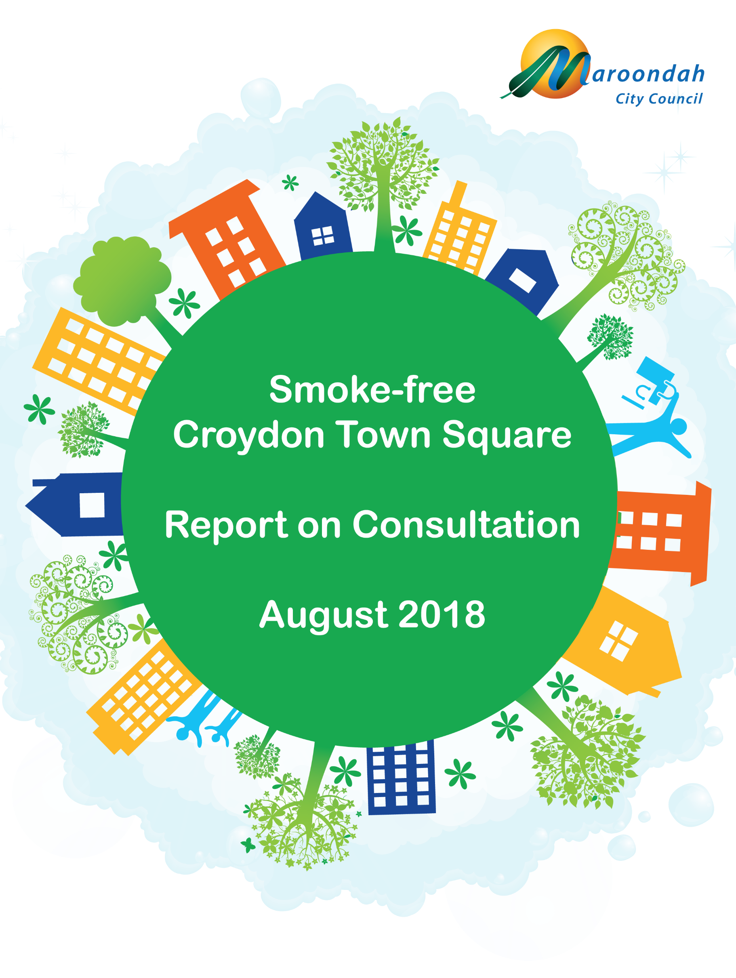

Table of Contents

Background 1
Consultation 1
Activations 1
Activation Session One – Tuesday 17 July 2018, 7am to 8.45am 1
Activation Session Two – Thursday 19 July 2018, 12pm to 2pm 2
Survey 2
Respondent Profile 2
Support for a Smoke-Free Croydon Town Square 3
Survey Comments 5
Social Media Comments 5
Consultation with Businesses 5
Issues for Consideration 5
Appendix A – Interactive Survey Board 7
Appendix B – Hard-copy Survey Form 8

Background
The Victorian State Government has been progressively strengthening bans on smoking in public places. The most recent changes to the Tobacco Act 1987 (Vic) came into effect on 1 August 2017, prohibiting smoking in many outdoor food-related areas. Consistent with this move toward broader smoking bans, some councils have prohibited smoking at places not yet captured by restrictions under state law.
In October and November 2017, Maroondah City Council undertook a series of engagement activities to gauge the level of community support for the introduction of a smoking ban in Ringwood Town Square. A total of 1,596 responses were gathered using a survey tool and through activations at Maroondah Festival and Ringwood Town Square, with more than 90 percent of respondents expressing support for a ban on smoking.
Given the strong support for a smoke-free Ringwood Town Square, Council undertook further consultation to establish the level of community support for Croydon Town Square also being smoke-free when it opens later in 2018. This report presents the results of the consultation program and identifies key themes and issues for further consideration.

Consultation
The consultation activities included two activations in central Croydon and an online survey that ran for nearly three weeks.
These activities elicited responses from a total of 700 participants, of whom 604 (86.3 percent) expressed support for Croydon Town Square becoming smoke-free when it opens later in 2018.
The survey was promoted on Maroondah City Council’s Facebook page and website, with hard-copy survey forms provided through Council’s customer service centres. The Croydon Main Street Traders Association promoted the survey on its Facebook page with a hyperlink to the online survey, which was also distributed to association members through a closed Facebook group. In addition, survey hyperlinks were sent to the Croydon Partners in Safety Committee and the Maroondah Youth Services Providers Network.

Activations
The first activation session ran from 7am to 8.45am on Tuesday 17 July 2018, outside Croydon Railway Station; the second ran from 12pm to 2pm on Thursday 19 July 2018, at the corner of Main Street and San Carlos Walk, Croydon. During these sessions, participants placed stickers on an interactive survey board to indicate whether they thought Croydon Town Square should become a permanent smoke-free space when it opens later in 2018. A copy of the survey board used during the activation sessions appears at Appendix A.

Activation Session One – Tuesday 17 July 2018, 7am to 8.45am
There were 140 responses received during this activation session; 116 respondents (83 percent) were in favour of a smoke-free Croydon Town Square; 10 participants (7 percent) gave a neutral response; while 14 (10 percent) were opposed to the introduction of a smoking ban. Figure 1 shows the responses received during this activation session.
Figure 1 – Summary of Responses: Activation Session One – Outside Croydon Railway Station, Tuesday 17 July 2018.

Activation Session Two – Thursday 19 July 2018, 12pm to 2pm
A total of 154 responses were collected during the second activation session, which was held at the front of the new Croydon Town Square site in Main Street. In all, 118 respondents (77 percent) supported the introduction of smoking bans; 19 respondents (12 percent) gave a neutral response; while 17 (11 percent) were opposed to a smoke-free town square. A summary of responses received during the second activation session is shown in Figure 2.
Figure 2 – Summary of Responses: Activation Session Two – Croydon Main Street, Thursday 19 July 2018.

Survey
A mixed-methods survey tool was developed to capture feedback from a total of 406 respondents, who were asked whether they supported the idea of Croydon Town Square being smoke-free. The survey also asked participants whether they were a business owner in the Croydon Town Square / Main Street area and, if so, how they thought the introduction of a smoking ban might impact their business. Respondents were asked how they currently felt about smoking in the Croydon Main Street precinct and whether they would be more likely to attend events or use Croydon Town Square as a meeting place if it was a smoke-free environment. The survey concluded by asking respondents their current smoking status, age (by category) and postcode. All respondents were given the opportunity to offer additional comments at the end of the survey. The survey was open for nearly three weeks and could be accessed online through Council’s website. A hard-copy survey form was also available at Council’s customer service centres, as shown at Appendix B.

Respondent Profile
Respondents by age were 0.7 percent (n=3) under 18 years old; 6.2 percent (n=25) aged 18 to 24; 30.6 percent (n=124) aged 25 to 34; 39.8 percent (n=161) aged 35 to 49; 14.1 percent (n=57) aged 50 to 59; and 8.6 percent (n=35) aged 60 years or older.
Only 3.7 percent (n=15) of respondents identified themselves as ‘smokers’, which is less than one-third of the acknowledged rate of adult smokers in Maroondah (13.7 percent) and well below the Australian national average smoking rate of 14.2 percent., Two survey respondents (0.5 percent) did not indicate their smoking status.
314 respondents (77.3 percent) were identified as residents of Maroondah, having nominated postcodes that fall entirely within Maroondah’s municipal boundaries. For the purpose of this report, a further thirty-four respondents (8.4 percent) who nominated postcodes that are partly within Maroondah’s municipal boundaries have been counted as residents of Maroondah. A summary of respondent profiles is presented in Figure 6.
Figure 1 – Profile of Survey Respondents

Support for a Smoke-Free Croydon Town Square
In total, 370 survey respondents (91.1 percent) were in favour of the introduction of a smoking ban when Croydon Town Square opens later in 2018. As Figure 7 shows, respondents who supported the introduction of a smoking ban also indicated that they would be more likely to attend events and use Croydon Town Square as a meeting place if the venue became smoke-free.
If Croydon Town Square was smoke-free, I would be more likely to…
Figure 2 – Summary of Responses: Survey

When survey participants from outside Maroondah were excluded from the analysis, the rate of support for a smoking ban remained constant at 91.1 percent; although there were differences in the rate of support expressed by respondents from one area of the municipality to the next, as Figure 8 shows.
Figure 3 - Rate of Support for a Smoking Ban by Maroondah Postcodes
The rate of support for a smoking ban at Croydon Town Square was slightly lower amongst survey respondents from postcodes 3137 (Kilsyth and Kilsyth South); 3153 (Bayswater and Bayswater North); and 3135 (Ringwood East and Heathmont), although this is likely to be a function of the relatively small number of survey responses received from residents in these postcodes. Similarly, the universal support for a smoking ban expressed by respondents from Vermont and Vermont South is most likely due to the very small number of responses from postcode 3133 (n=2). The rate of support expressed by survey participants from postcodes 3134 and 3136 (n=279) exceeded 91 percent.
Support for a smoking ban also varied with the age of respondents, as shown in Figure 9. Those aged under 18 or over 60 were most likely to support the move to a smoke-free Croydon Town Square (97.4 percent), while respondents aged from 18 to 34 years were somewhat less supportive of smoking bans (88.6 percent).
Figure 4 - Support for Smoking Restrictions by Age of Respondent
Some of the variation in levels of support for a smoking ban may be attributed to differences in smoking rates between age groups; 8 percent of respondents aged 18 to 24 years and 4 percent of participants aged 25 to 34 years identified as ‘smokers’; compared to less than 2 percent (n=8) of respondents outside this age range. Predictably, there was less support for a smoking ban amongst smokers than non-smokers; 80 percent of smokers (n=12) were opposed to a ban, compared to only 5.9 percent (n=23) of non-smokers.

Survey Comments
The survey allowed respondents to offer comments about smoking in the Croydon Main Street precinct and the introduction of a smoking ban at Croydon Town Square. A total of 340 survey participants offered comments, 85.8 percent of which expressed opposition to smoking in the Main Street precinct or directly supported Croydon Town Square being smoke-free (n=292).
Some non-smoking respondents did not support smoking bans (n=23) and commented that they either didn’t notice or weren’t bothered by people smoking outdoors (n=12); six respondents expressed the view that smoking bans should not be introduced while smoking was legal; and thirteen survey participants suggested a designated smoking area should be established. Over 9 percent of respondents (n=37) commented on cigarette butts and litter from smoking.

Social Media Comments
The survey was promoted on Council’s Facebook page. While social media comments alone are not a reliable means for determining the level of support for making Croydon Town Square smoke free when it opens later this year, there was a clear trend to the response Council’s posts on the topic received.
In total, three Council posts publicising the Smoke Free Croydon Town Square survey received one-hundred and forty-one Facebook ‘Likes’; four Facebook ‘Loves’; one Facebook ‘Wow’; and one Facebook ‘Hate’. The posts also received forty-eight comments, of which thirty-two supported a smoking ban; eleven made comments from which it was not possible to determine support or opposition to the introduction of smoking bans; two comments raised the issue of enforcement; and three comments expressed opposition to a smoke-free Croydon Town Square.

Consultation with Businesses
A relatively small number of responses (n=17) were received from participants who identified themselves as business owners in the Croydon Main Street precinct. Of these respondents, thirteen (76.5 percent) supported the idea of a smoke-free Croydon Town Square, while five (29.4 percent) expressed concern that the introduction of a smoking ban could negatively impact their business. It should be noted, however, that 76.6 percent of survey respondents (n=311) indicated that they would be more likely to use Croydon Town Square as a meeting place or to attend events if the venue was made smoke-free.
While it is acknowledged that survey responses received from participants who identified themselves as business owners in the Croydon Main Street precinct may not represent the views of other Main Street traders, there appears to be strong support for a smoke-free Croydon Town Square amongst local business owners. As the survey data gathered by Council relies on self-reporting to establish the ‘business owner’ status of respondents, further targeted consultation with businesses in the Main Street area could be considered ahead of the commencement of smoking bans.

Issues for Consideration
As shown in Figure 10, when all consultation activities are considered together, participants expressed strong support for the introduction of a smoking ban at Croydon Town Square (86.3 percent); a further 4.1 percent of participants expressed a neutral attitude; and 9.6 percent of participants were opposed to a smoke-free Croydon Town Square. This result is only slightly below the level of support expressed for a smoke-free Ringwood Town Square during consultation activities conducted in 2017.
Figure 10 - Support for Smoking Restrictions at Croydon Town Square

As previously identified, smokers appear to be under-represented in the current survey sample, which is likely to have reduced the level of opposition to a smoke-free Croydon Town Square captured through the current engagement activities. As such, the current survey results should not be interpreted as being an accurate representation of the views of the broader Maroondah community.
A small number of survey respondents commented that consideration should be given to establishing a designated ‘smoking area’ near Croydon Main Street, while others identified the need for proper enforcement if a smoking ban is to be effective. Both issues should be given further consideration in the event that a smoking ban is implemented at Croydon Town Square.
Given the relatively small response from survey participants who identified themselves as local business owners, Council should consider further targeted consultation with this cohort before the introduction of a smoking ban at Croydon Town Square.

Appendix A – Interactive Survey Board
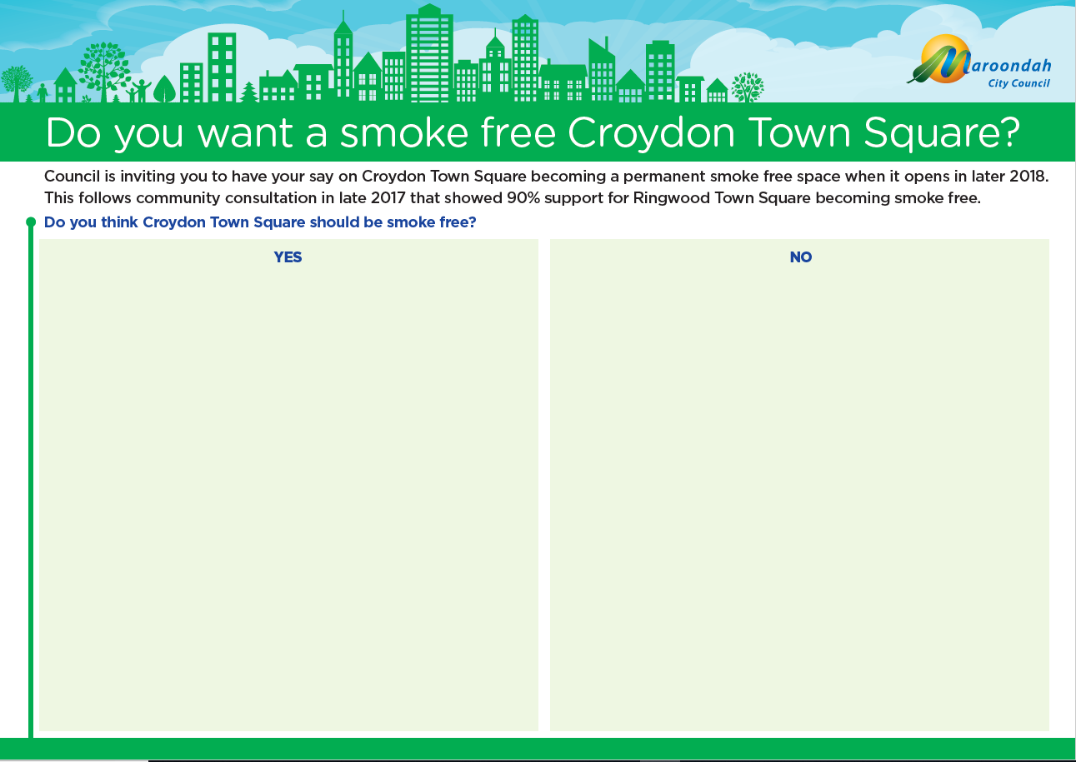

Appendix B – Hard-copy Survey Form
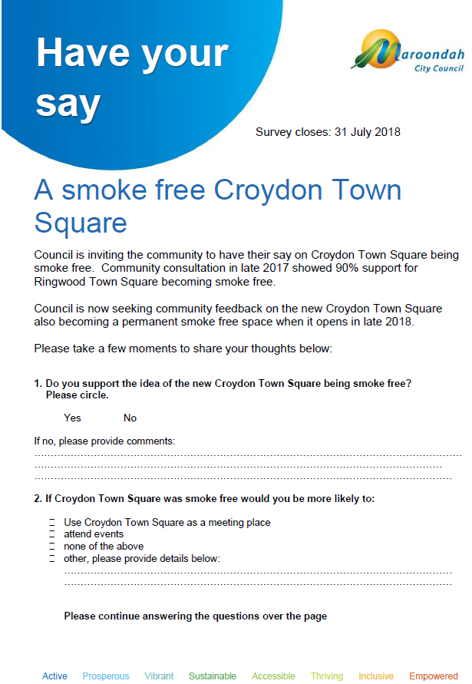
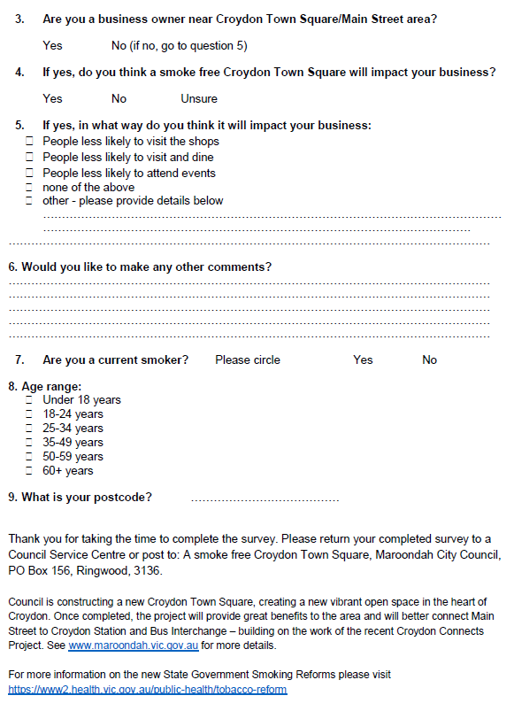

Changes implemented by the Tobacco Amendment Act 2016. Available from www.legislation.vic.gov.au
Scollo, MM and Winstanley, MH. Tobacco in Australia: Facts and issues. Melbourne: Cancer Council Victoria; 2017. Available from www.TobaccoInAustralia.org.au
Inner East Primary Care Partnership, Core Indicator Set for Inner East Catchment Planning 2017. Available from http://iepcp.org.au/resource/core-indicator-set-inner-east-catchment-planning-2/
Scollo, MM and Winstanley, MH. Tobacco in Australia: Facts and issues. Chapter 1, Section 3.1.
90 percent of participants supported the introduction of a smoking ban at Ringwood Town Square. The difference between the two results is partly attributable to the collection of ‘neutral’ responses during the Smoke-free Croydon Town Square activation sessions.

