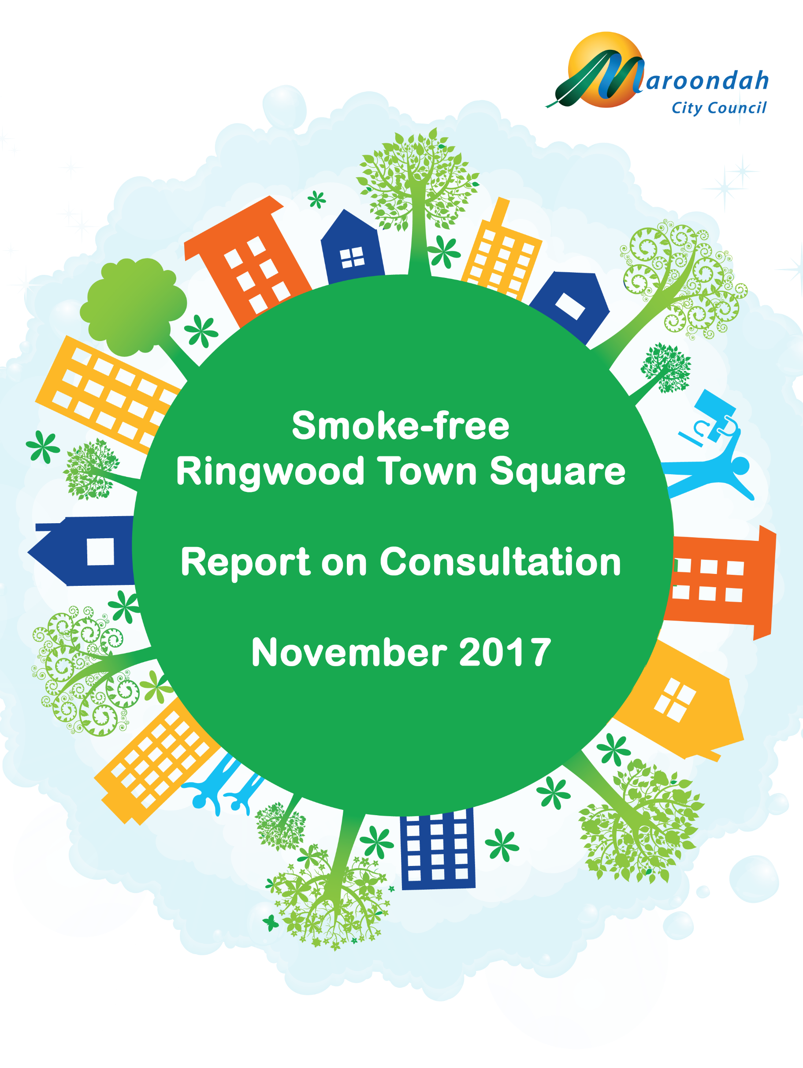

Table of Contents
Background 3
Consultation 3
Activations 3
Activation Session One - Saturday 21 October, 10am to 3pm 4
Activation Session Two - Thursday 2 November, 4pm to 6.45pm 4
Activation Session Three – Café Consult at Maroondah Festival, 12 November 2017 5
Survey 5
Respondent Profile 6
Support for a Smoke-Free Ringwood Town Square 6
Survey Promotion 9
Consultation with Businesses 9
Issues for Consideration 9
Appendix A – Café Consult Poster Board 11

Background
The Victorian State Government has been progressively strengthening bans on smoking in public places. The most recent changes to the Tobacco Act 1987 (Vic) came into effect on 1 August 2017, prohibiting smoking in outdoor areas within food venues; footpath dining areas; courtyards and beer gardens at times food is being eaten or is available to be eaten; all outdoor areas at food fairs; and within 10 metres of a food stall or food vendor at organised events.
Consistent with the move toward broader smoking bans, some councils have prohibited smoking at places not captured by restrictions under state law. For example, City of Port Phillip and Hobsons Bay City Councils have prohibited smoking on beaches; Monash City Council has banned smoking at designated council events, as well as around entrances to schools, sports grounds, council offices and community centres; and Melbourne City Council has implemented bans at Block Place, The Causeway, Howey Place, Equitable Place, QV Melbourne, City Square, Goldsbrough Lane, and along running tracks at the Tan and Princes Park.
Following a briefing on the commencement of smoking bans at food venues with outdoor dining areas, Councillors requested consultation be conducted to gauge the level of community support for Ringwood Town Square becoming a smoke-free zone. This report presents the results of the consultation program, and identifies key themes and issues for further consideration.

Consultation
The consultation program was comprised of two activations at Ringwood Town Square; one activation at Café Consult at Maroondah Festival; and a survey, available in both hard-copy and on-line formats. A total of 1,596 responses were received, with 90 per cent support for a smoke-free Ringwood Town Square. The results of the consultation program are discussed in more detail below.

Activations
Council ran two activations at Ringwood Town Square; the first ran from 10am to 3pm on Saturday 21 October 2017; the second was held between 4pm and 6.45pm on Thursday 2 November 2017. Using an interactive survey board, participants used stickers to indicate whether they supported the introduction of smoking bans in Ringwood Town Square, as well as how such a ban would be likely to influence their use of the space. Figure 1 shows the activation in place outside Realm.
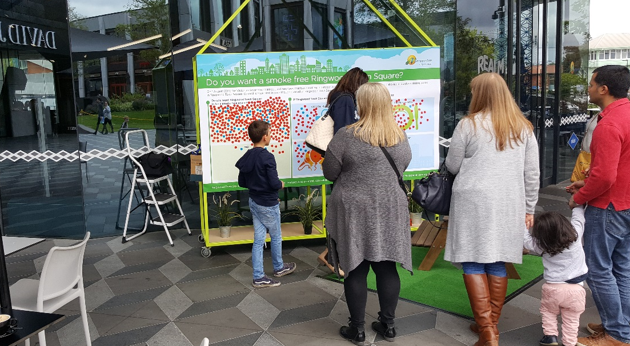
Figure 1 - Activation in Place Outside Realm in Ringwood Town Square

Activation Session One - Saturday 21 October, 10am to 3pm
There were 372 responses received during this activation session; 350 respondents (94 per cent) were in favour of a smoke-free Ringwood Town Square, while 22 (6 per cent) were opposed. Of those respondents who supported the introduction of smoking bans, nearly 40 per cent said that they would be more likely to dine out if the venue became smoke-free. Figure 2 summarises the responses received during this activation session.
If Ringwood Town Square was smoke-free, I would be more likely to…
Figure 2 – Summary of Responses: Activation Session One – Ringwood Town Square, Saturday 21 October 2017

Activation Session Two - Thursday 2 November, 4pm to 6.45pm
A total of 149 respondents took part in the second activation session, which was timed to coincide with the night market. It was noted that participants tended to be younger than those surveyed during the first activation session, with fewer families present; these differences may be reflected in the responses collected.
114 respondents (77 per cent) were in favour of the introduction of smoking bans in Ringwood Town Square, while 35 respondents (23 per cent) were opposed. Of those in favour of smoking restrictions, 47 respondents (41 per cent) indicated that they would be more likely to dine-out if the town square became smoke-free. Figure 3 presents the feedback provided during the second activation session.
If Ringwood Town Square was smoke-free, I would be more likely to…
Figure 3 – Summary of Responses: Activation Session Two – Ringwood Town Square, Thursday 2 November 2017

Activation Session Three – Café Consult at Maroondah Festival, 12 November 2017
A third activation session was held at Café Consult during the Maroondah Festival, as depicted in Figure 4. A total of 246 people provided feedback during this session, of whom 232 were in favour of a smoke-free Ringwood Town Square (94 per cent); and 14 were opposed to the introduction of smoking bans (6 per cent). A copy of the Café Consult poster-board appears at Appendix A.
Figure 4 - Activation Session Three: Cafe Consult at Maroondah Festival
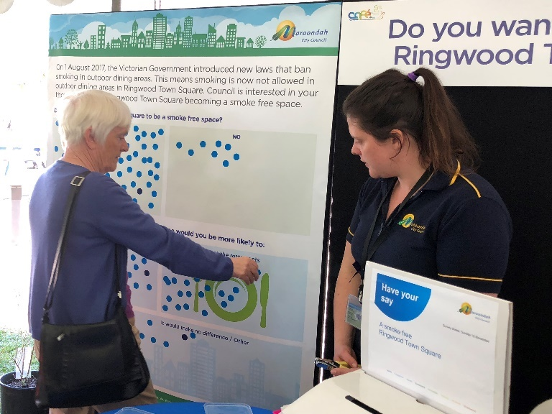
More than half of respondents (n=128) who supported the introduction of smoking restrictions also indicated that they would be more likely to dine-out in Ringwood Town Square if the venue became smoke-free; a further 25 per cent (n=58) said they would be more likely to attend events. A summary of responses received during activation session three is presented in Figure 5.
If Ringwood Town Square was smoke-free, I would be more likely to…
Figure 5 - Summary of Responses: Activation Session Three - Cafe Consult at Maroondah Festival

Survey
A mixed-methods survey design was used to capture information from 829 respondents. The survey asked participants their age (by category), postcode, and smoking status; whether they supported the introduction of a smoking ban in Ringwood Town Square; and to nominate the activities they would be more likely to engage in if the town square became smoke-free. Respondents were also asked how they currently felt about smoking in Ringwood Town Square; and those who did not support the introduction of a smoking ban were asked why they held this view. All respondents were given the opportunity to offer additional comments at the end of the survey.

Respondent Profile
Respondents by age were 2 per cent (n=16) under 18 years old; 13 per cent (n=103) aged 18 to 24; 26 per cent (n=215) aged 25 to 34; 38 per cent (n=313) aged 35 to 49; 10 per cent (n=84) aged 50 to 59; and 11 per cent (n=89) aged 60 or older.
Only 6 per cent (n=52) of respondents identified themselves as ‘smokers’; this figure is less than half the acknowledged rate of adult smokers in Maroondah (13.7 per cent), and is well below the Australian national average smoking rate of 14.2 per cent., Only 1.4 per cent (n=12) did not indicate their smoking status.
569 respondents (69 per cent) were identified as residents of Maroondah, having nominated postcodes that fall entirely within Maroondah’s municipal boundaries. An additional 63 respondents (7.6 per cent) nominated postcodes that are partly within Maroondah’s municipal boundaries; for the purpose of the current report, these respondents have also been counted as residents of Maroondah. A summary of respondent profiles is presented in Figure 6.
Figure 6 – Profile of Survey Respondents

Support for a Smoke-Free Ringwood Town Square
In total, 741 respondents (89 per cent) were in favour of the introduction of a smoking ban within Ringwood Town Square. As shown in Figure 7, survey respondents in favour of the introduction of smoking bans also indicated that they would be most likely to dine out more in Ringwood Town Square if the venue became smoke-free.
If Ringwood Town Square was smoke-free, I would be more likely to…
Figure 7 – Summary of Responses: Survey

While support for a smoking ban strengthened slightly (to 91 per cent) when respondents from outside Maroondah were excluded from the analysis, there were marked differences in the rate of support from one area of the municipality to the next, as shown in Figure 8.
Figure 8 - Rate of Support for a Smoking Ban by Maroondah Postcodes
The rate of support for a smoking ban at Ringwood Town Square was significantly lower amongst survey respondents from postcode 3153 (Bayswater and Bayswater North), although this is likely to be a function of the relatively small sample size (there were only 34 respondents from this postcode). Similarly, the universal support of a smoking ban amongst respondents from Vermont is most likely due to the very small number of responses from postcode 3133 (n=8). The rate of support across all other postcodes in Maroondah exceeded 91 per cent.
Support for a smoking ban also varied with the age of respondents, as shown in Figure 9. Those aged under 18 or over 49 were most likely to support a move to a smoke-free Ringwood Town Square (94 per cent), while respondents aged from 18 to 49 were somewhat less supportive of a smoking ban (88 per cent).
Figure 9 - Support for Smoking Restrictions by Age of Respondent
This variation was mirrored by differences in smoking rates between age groups; 7 per cent (n=44) of respondents aged 18 to 49 identified themselves as smokers, compared to only 4 per cent (n=8) of respondents outside this age range. Predictably, there was less support for a smoking ban amongst smokers than non-smokers; 67 per cent of smokers (n=35) were opposed to a ban, compared to only 7 per cent (n=50) of non-smokers.

Figure 10 - Support for Smoking Bans by Smoking Status of Respondent
As Figure 10 illustrates, respondents’ views on the introduction of smoking restrictions were not necessarily reflective of their smoking status. For example, some respondents (n=17) identified themselves as ‘smokers’ while supporting the move to a smoke-free town square; they offered the following comments in response to Council’s survey:
“Even though I am a smoker, there is nothing worse than having to share someone else’s smoke.”
“It's not right - too many kids and people in general have to walk through there, smoking around that many people shouldn't be allowed - have a designated smoking area down the road a bit or something.”
“I feel that public/family areas such as Ringwood Town Square should definitely be smoke free as a comfort for the majority of non-smokers…”
“I am a smoker and find smoking in the beautiful Ringwood Town Square disgusting…”
Conversely, some non-smokers raised concerns with the introduction of smoking restrictions at Ringwood Town Square. This cohort (n=50) tended to observe the usually respectful behaviour of smokers around food premises; noted that smoking is not an illegal activity; and identified the need to consider issues of equality and ‘discrimination’ before considering a ban on smoking:
“Smokers are actually respectful of the dining areas and move away when they want to light up.”
“…if it's not illegal then how far can you push smoking bans before they just become discriminatory…”
“…everyone should be entitled to use the area as they please…”
“…whenever I've been there they've (smokers) been courteous enough to smoke away from where people are walking or eating…”
Generally, the reasons offered by respondents who did not support the introduction of smoking restrictions at Ringwood Town Square (n=88) fell into four broad categories; those who felt such a ban would be discriminatory (36 per cent, n=32); those who identified the need to provide somewhere for people to smoke (27 per cent, n=24); respondents who noted that smoking is a legal activity (14 per cent, n=12); and those who felt further restrictions were unnecessary (13 per cent, n=11).

Survey Promotion
The survey was promoted on Council’s website; by targeted distribution; and on Council’s Facebook page. While it is not possible to determine rates of support or opposition to the introduction of a smoking ban at Ringwood Town Square from social media posts, there is some value to be gained from an analysis of the themes presented in comments from online visitors.
While most posts were supportive of the introduction of a smoking ban, those opposed to further restrictions were most likely to cite ‘discrimination’ and the ‘need to provide somewhere’ for smokers in their comments. These themes align with reasons offered by survey respondents for not supporting the introduction of a smoking ban in Ringwood Town Square.
It is also acknowledged that the distribution of a ‘hyperlink’ to promote participation in the survey may have skewed results marginally towards support for a smoking ban. By sending the hyperlink to local stakeholder organisations including Active Maroondah; Age-friendly Champions; Healthy Ageing Network; Community groups for the 50+ cohort; Community Houses in Maroondah; Partners in Wellbeing Committee; and Mullum Mullum Indigenous Gathering Place, it is possible that a greater number of responses were received from health-conscious individuals, who are less likely to be smokers – and more likely to support smoking bans – than the general population.
Evidence of this bias can be found in the lower than expected rate of smokers within the respondent sample. As previously mentioned, only 6 per cent (n=52) of survey respondents identified themselves as ‘smokers’, compared to an acknowledged adult smoker rate of 13.7 per cent in Maroondah; and an Australian national average smoking rate of 14.2 per cent. Although the effect of this biases is likely to be modest, it must be recognised that Council’s survey sample was not random and, as such, should not be relied upon as being an accurate representation of the views of the broader Maroondah community.

Consultation with Businesses
Council has worked closely with QIC Eastland throughout the current engagement program, and has commenced preliminary consultation with businesses operating in Ringwood Town Square. Letters have been sent to 20 town square retailers to gauge their views on the introduction of smoking restrictions; and Council’s Environmental Health Officer has visited food premises to discuss both the commencement of legislated smoking bans, and the concept of a smoke-free town square. Initial feedback is positive, with support from businesses for a consistent approach to smoking restrictions throughout the town square precinct. It has also been reported that some businesses have introduced their own smoking bans in dining areas.
While it is acknowledged that the response to date cannot be considered representative of the views of businesses in Ringwood Town Square, initial indications are that more businesses would prefer a smoke-free environment than may be opposed to a smoking ban. Understandably, some businesses have expressed concern that moving to a smoke-free Ringwood Town Square may negatively impact trade. However, it should be noted that most survey respondents (90 per cent, n=745) reported that they would spend more time at Ringwood Town Square if the venue became smoke-free.

Issues for Consideration
When all consultation activities are considered in combination, participants expressed strong support for the introduction of a smoking ban at Ringwood Town Square (90 per cent). The consultation program also identified issues requiring consideration ahead of the possible implementation of smoking restrictions.
As previously discussed, the composition of the current survey sample appears to marginally under-represent the views of smokers; correcting for this selection bias could be expected to result in a small increase in the rate of opposition to smoking bans. As such, the current survey results should not be interpreted as being an accurate representation of the views of the Maroondah community.
Respondents both in favour and opposed to smoking bans suggested that consideration be given to creating a designated ‘smoking area’ in close proximity to Ringwood Town Square, as a way to address issues of equity and perceived ‘discrimination’ against smokers. It was also observed that a ban on smoking will only be effective if it is properly enforced. Both issues will require further exploration, in conjunction with key stakeholders.
In relation to the extension of state government smoking bans to outdoor dining areas, it is noted that the recent Tobacco Act (1987) amendments distinguish ‘outdoor dining areas’ from ‘outdoor drinking areas’, with smoking still permitted in outdoor drinking areas that are separate from areas where food is served. Considering the built environment at Ringwood Town Square, it is conceivable that hospitality operators could designate areas at the front of their premises as ‘outdoor drinking areas’ without food service, in which case smoking may be permitted. A blanket ban on smoking within the precinct may ensure a more consistent approach.

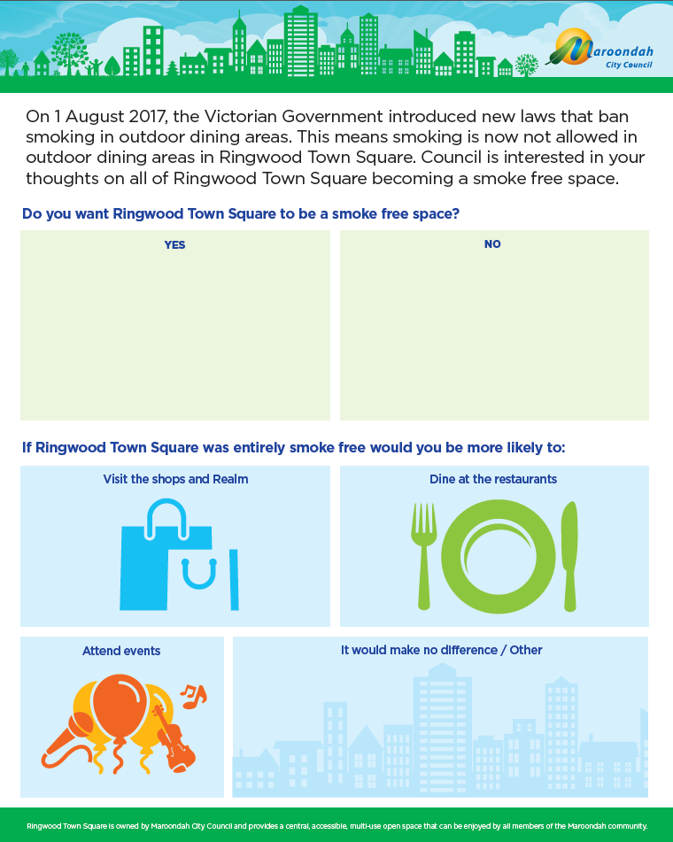
Appendix A – Café Consult Poster Board

Changes implemented by the Tobacco Amendment Act 2016. Available from www.legislation.vic.gov.au
Scollo, MM and Winstanley, MH. Tobacco in Australia: Facts and issues. Melbourne: Cancer Council Victoria; 2017. Available from www.TobaccoInAustralia.org.au
Inner East Primary Care Partnership, Core Indicator Set for Inner East Catchment Planning 2017. Available from http://iepcp.org.au/resource/core-indicator-set-inner-east-catchment-planning-2/
Scollo, MM and Winstanley, MH. Tobacco in Australia: Facts and issues. Chapter 1, Section 3.1.
63 respondents nominated postcodes that are partially within Maroondah, which is less than 8 per cent of all responses.

