Live a healthy lifestyle

The Good Food for Me program is aimed at helping Seniors gain knowledge to take charge of their
nutrition and maintain a healthy lifestyle.

The program includes:
- Information to help you make better choices to improve physical and mental health  - Learn how to read nutrition labels to make wise food purchases  - Budget-friendly meals, ideas to reduce food waste and save money  - Safe food handling and storage ideas  For residents aged 65+ (50+ for Aboriginal or Torres Strait Islander identity)  Refreshments provided | 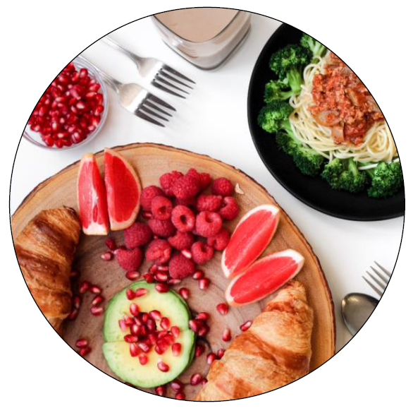
Enquire now:
We invite you to express interest in future sessions of the program.
Times, days and location are subject to confirmation.
Cost: Small materials fee, contact us to enquire
Contact: Gillian on phone 1300 88 22 33 or 9298 4598
or email OT@maroondah.vic.gov.au

