

EOI Brief - Terms and Conditions
Maroondah Federation Estate Café Trial Tenancy

About the Opportunity
Maroondah City Council invites expressions of interest from experienced caterers/café operators to take over a two-year trail tenancy of the café and commercial kitchen spaces within Maroondah Federation Estate (MFE), one of Council’s major arts facilities located within the heart of Ringwood Arts Precinct and activity centre.
This is a unique opportunity to succeed in your own catering business with exclusive use of the well-appointed commercial kitchen, tapping into catering opportunities within the venue, as well as activating the café space with a regular and high-quality hospitality service.
The café is set alongside Council’s primary art gallery and offers display and service area, food preparation and storage spaces, and indoor and outdoor seating for at least 50 people with the option to use existing furnishings. The space enjoys regular foot traffic with visitors to the gallery, and tenants and hire groups with activities throughout this busy community arts facility every day of the week.
If you are passionate about hospitality, excited about joining a community arts setting, keen to leverage opportunities for business growth, and have a vision for how your business might thrive within this unique setting, we welcome your submission for a trial tenancy period of up to 2years.

About the Venue
- A Thriving Cultural Hub: MFE is a dynamic centre for the arts and community activities, hosting a continuously changing program of exhibitions, workshops, and events, ensuring a steady flow of engaged visitors, with a diverse range of tenancy and hirer programs daily.
- A Captive Audience: Your customers will be gallery patrons, local artists, students and families on route to and from nearby schools, and the myriad of patrons attending daily arts and community hire activities within the building.
- A Historic & Inspiring Setting: The gallery is housed in a beautifully adapted heritage building, the former Ringwood Primary School art rooms, offering a unique and character-filled environment for a café.
- Community Connection: This is a chance to embed your business at the centre of Maroondah's creative and social life, building a loyal customer base.

Tenancy Service Scope
As the café and commercial kitchen tenant you will have access to a range of service opportunities:
- Café Service: Operating the café space as an exclusive tenancy, serving visitors, patrons and the public, attending to the food preparation, front of house service, clearing and orders, standard cleaning and setting of spaces alongside Food Safety regulations with the following service offerings:
  - Provide high-quality espresso coffee, teas, and a seasonal menu of fresh, simple food menu of sweet and savory options (menu scope negotiable).
  - Prices must be reasonable and reflect market value, with a variety of price points.
  - Deliver friendly, professional service that enhances the visitor experience.
  - Create a warm, inclusive, and aesthetically pleasing environment for all.
  - Operate the café with set hours within gallery opening times, ideally Monday to Friday 9am to 3pm - times and days negotiable but consistency is essential.
  - Happy to collaborate with Council and venue stakeholders through meetings and special events to achieve a collegial and mutually beneficial relationship and optimise venue activation.
- Venue Hire Catering (optional): For interested prospective tenants, the is an option to quote for the onsite catering for hire groups and Council meetings booked by Council at the venue. There is no guarantee of bookings during the trial tenancy period, however longer-term tenants may propose exclusive catering services within the venue where performance has been outstanding in this area.
- Your own Business Operations: The tenant may wish to utilise the commercial kitchen for offsite catering business operations and explore opportunities for catered special events and garden parties in the venue gardens. Business activities of this kind must not impact agreed café service delivery levels.

Tenancy Terms & Conditions
- Tenancy Type: This will be a written trial tenancy agreement using Councils standard Licence Agreement.
- Tenancy Term: The initial trial period will be a two-year period, with an annual review. A longer-term tenancy arrangement is optional for the right applicant after this 2-year period and by way of negotiation.
- Tenancy Fee: The commercial kitchen plus café occupation tenancy fee is $800 per month plus a percentage use of utilities for the trial period of 2 years. This represents a community rate that encourages success and growth over time with reasonable overheads during early-stage operations. Ongoing tenancy rates beyond the 2-year trial period will be negotiated where applicable.
- Tenancy Option: At this stage, Council is only offering tenancy to operators interested in both the commercial kitchen and café tenancy. If you are interested in only one of these spaces, please contact us to register your interest in a single space.
- Tenancy Exclusivity: The tenanted spaces are exclusive to the contracted operator, except for Councils’ occasional access to the commercial kitchen for scheduled maintenance and minor operations, as by prior arrangement to ensure minimal tenancy disruption. Onsite catering for meetings and events booked by Council can be quoted by the tenant without guarantee during trial period.
Please refer to:
- Schedule 1: Tenancy Terms & Conditions

Tenancy Area & Site Specifications
The tenancy area includes:
- Café space ready to activate including a small service counter, display fridges, food preparation bench, sinks and shelving, indoor patron seating area (approx. 30pax).
- Back of House (BOH) storage, benches, shelving, fridge/freezer.
- Courtyard Seating for outdoor patron café space (approx. 30pax)
- Commercial kitchen fully set up with essential appliances and equipment suitable for small to medium catering services. The kitchen is expansive enough to undertake catering operations beyond the servicing of the café alone.
Please refer to:
- Schedule 2: Tenancy Area Site Map; and
- Schedule 3: Commercial Kitchen Specifications

How to Apply
- Please read the EOI brief and terms thoroughly.
- Submit your online EOI form via Councils website link
EOI closes: 5pm Monday 9 February 2026.

For more information or to arrange a site tour, please contact:
Surith Nanayakkara
Venue Operations Coordinator - Creative Places
T: 03 9870 2888 | 0438227637
E: Surith.Nanayakkara@maroondah.vic.gov.au

Schedule 1: Tenancy Terms & Conditions
- Term | - Trial period 2 years with annual review.  Longer term tenancy will be considered after the trial period by negotiation where viable.  - The term will commence early 2026 by negotiation with preferred tenant.
- Licence Fee | - $ 800 per month for trial period 2 years.  Longer term tenancy fees beyond this period will be negotiated where viable.
- Outgoings/Utilities | - Based on a percentage usage with specifics by negotiation with preferred application
- Service Type | - Hospitality / Catering Services
- Insurance | - $20 Million Public Liability coverage
- Compliance | - All Food Safety and Health Compliances required, with standard site inspections by Health Officers.
- Tenancy Area | - Shaded areas in Schedule 2.
- Fit-out & Equipment | - The tenant will have full use of equipment and furniture in the café and kitchen (Schedule 3), and may wish to alter the patron seating and service area layout in consultation with Council, and with relevant permits as required.
- Repair and Maintenance | - Council responsibility for the floors, ceiling, walls and locks. All other maintenance and repairs are the responsibility of the tenant including the rangehood, grease trap and outdoor awning.
- Cleaning | - Exclusive zones (café, BOH, Commercial kitchen) at tenants’ expense. Shared zones (foyer, courtyard, amenities etc) at Council expense.

Schedule 2: Tenancy Area Site Map

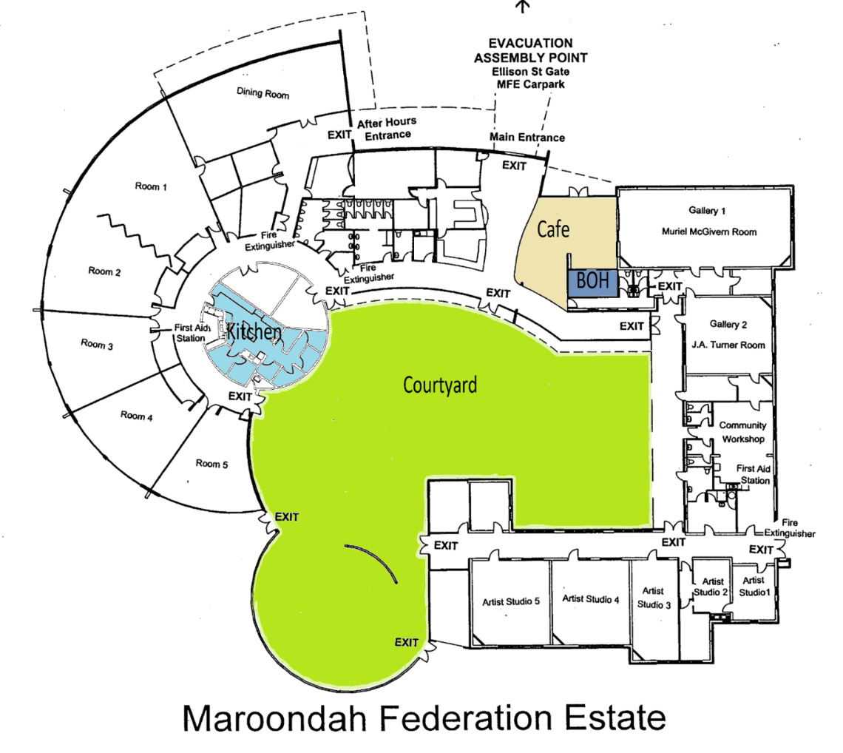

Tenancy areas are those shaded zones above.
- Café space ready to activate including a small service counter, display fridges, food preparation bench, sinks and shelving, indoor patron seating area (approx. 30pax).
- Back of House (BOH) storage, benches, shelving, fridge/freezer.
- Courtyard Seating for outdoor patron café space (approx. 30pax)
- Commercial kitchen fully set up with essential appliances and equipment suitable for small to medium catering services.

Schedule 3: Commercial Kitchen Specifications

Commercial Kitchen Description and Specifications Summary:

Size: Medium

Cooking Equipment:
- 6-burner stove with under-stove oven (2 tray capacity)
- Stand-up dry heat oven (5 tray capacity, no steam)

Dishwashing:
- Small commercial dishwasher

Cold Storage:
- 1 Cool room
- 1 Upright freezer

Food Preparation Space: Moderate
Onsite Food Service Ware:
- Plates & cutlery for approx. 100 guests

Limitations:
- No hot-holding equipment
- No loading dock, delivery via front door
- Limited food preparation benches

Please contact us to arrange a site visit to find out more about the space and scale of operations possible within this kitchen.

