Maroondah City Council Building Over Easement Technical Guidelines
Version – June 2018 (Updated due to Building Regulation 2018 changes)
DRAINAGE EASEMENTS
Drainage easements are typically needed when concentrated stormwater from one property travels into another property. These types of easements usually follow the natural fall of the land and are registered on a property’s title.
Councils are generally responsible for drainage easements and stormwater assets, along with Melbourne Water and Yarra Valley Water (as Maroondah’s regional sewer authority).
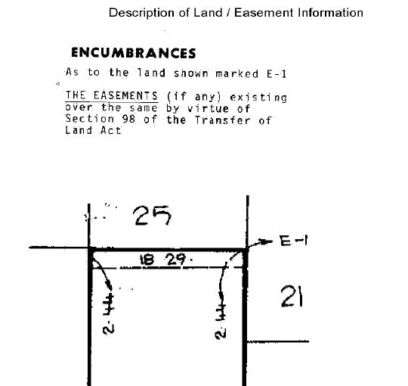
Figure 1- A cropped image from a title showing a 2.44m easement at the rear of a property (marked E-1)
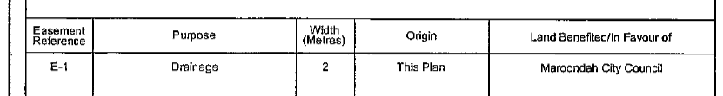

Figure 2 - A cropped image from a modern title showing the purpose, size, origin and who the easement (marked E-1) is in favour of
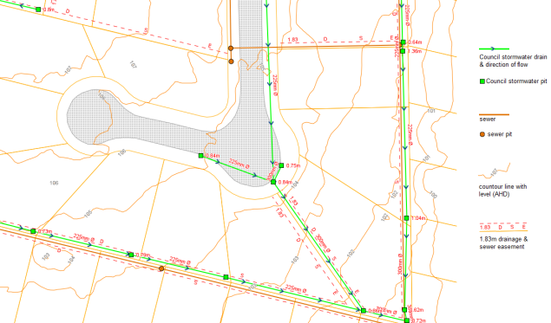
Figure 3 - – A typical snapshot from Council’s GIS asset layer showing easements, Council drains and pits, contour information and sewer

If there is a Council drain that runs within a property (but the drain is not within an registered easement) the drain may still protected by an ‘implied easement’ under the Subdivision Act 1988, and in any event the drain will be protected under section 198 of the Local Government Act 1989.
If there is a Council easement or drain within your property, Council may need to:
- Access your property to inspect a drain
- Undertake maintenance works on a drain, normally via a stormwater pit
- Excavate within the easement to uncover a drain
- Renew a drain if is damaged beyond repair
- Upgrade a drain and make it bigger (if there are attributable flooding or pipe capacity issues)
- Direct a property owner to remove any illegal structures or works over an easement
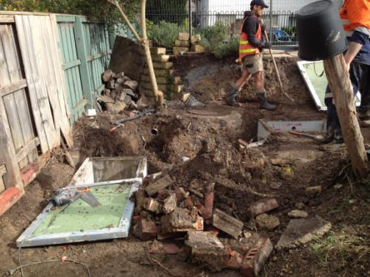
Figure 4 - Council contractors accessing a property to rebuild an old brick pit at the rear of the property
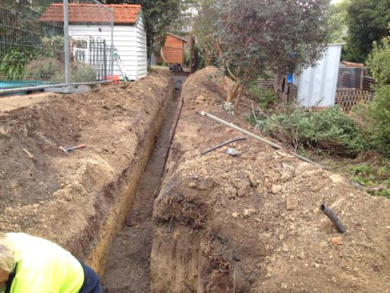
Figure 5 - typical easement drain trench along a side boundary
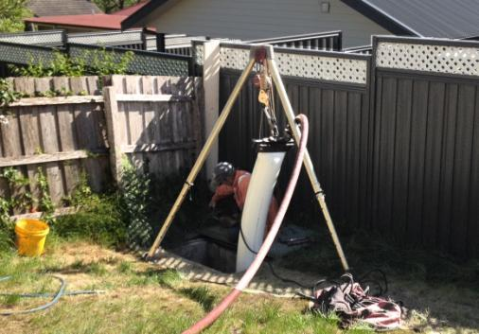
Figure 6 - Council contractor performing drainage relining works via a pit in an easement at the rear of a property
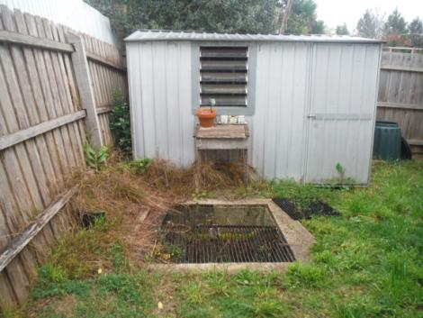
Figure 7 - a common type of non-approved structure over a Council easement at the rear of the property
OVERLAND FLOW
If a Council drain reaches its capacity during a significant storm event, the water may surcharge from the drainage system (typically at a drainage pit) and run overland. Given easements often follow the natural contours of the land, many drainage easements also act as overland flow paths. These easements need to remain clear of obstructions to allow for unhindered flow of stormwater.
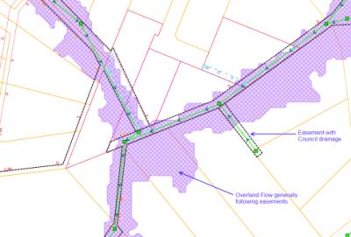
Figure 8 - Council’s flood modelling outputs showing an overland flow path, generally following the alignment of easements
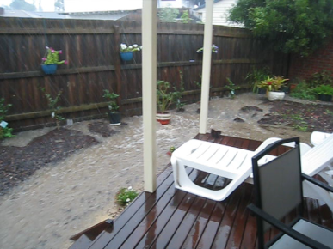
Figure 9 - an actual photo of overland flow flooding occurring along a property boundary containing a Council easement and drainage
COUNCIL’S ASSESSMENT CONSIDERATIONS
Council’s Building Over Easement Policy sets out Council’s considerations for assessing works over an easement.
When applying the policy principles, works are unlikely to be approved when either
  - the easement:
    - is required for future drainage or upgrade works
    - conveys overland flows or holds water during a storm event
    - contains a hydraulically critical drain
    - has a requirement for access for regular ongoing maintenance

  - the proposed works:
    - are permanent in nature and not easily demountable (such as brick structures or large retaining walls)
    - contains any part of a habitable dwelling (excluding eaves)
    - are likely to damage Council assets
    - do not meet Council’s minimum clearance requirements
    - will preclude or limit Council from undertaking any required drainage investigation, maintenance or renewal works
    - will preclude or limit Council’s ability to construct a future drain or reconstruct an existing drain in terms of cost and construction requirements
    - could be relocated elsewhere within the property rather than over the easement
    - for any other reason Council considers the building works should not be performed in, over, on or within the easement

MINIMUM CLEARANCE REQUIREMENTS
The following minimum clearance requirements must be achieved:

  - Angle of Repose - The base of any footings in or adjacent to the easement are founded 200mm below a line drawn at an angle of 45 degrees from the invert of any stormwater pipe.
  - Horizontal Clearance - Any footings in or adjacent to the easement have a minimum 600mm horizontal clearance from any stormwater pipe.
  - Minimum Cover - For any works within an easement, a minimum cover of 500mm to the top of Council’s drain must be maintained.
  - Vertical Clearance - Where eaves are proposed over an easement, a minimum of 2700mm vertical clearance must be maintained from the finished surface level.

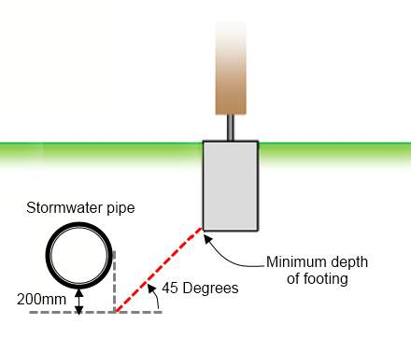
Figure 10 - Angle of repose requirements

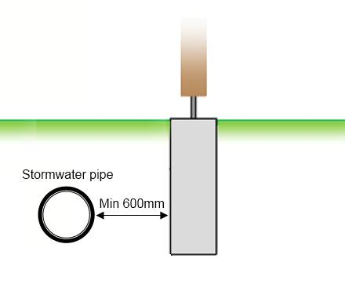
Figure 11 - Horizontal clearance requirements
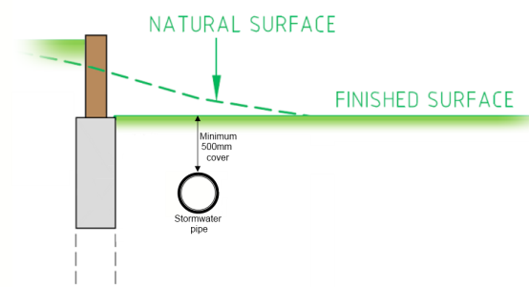
Figure 12 - Minimum cover requirements
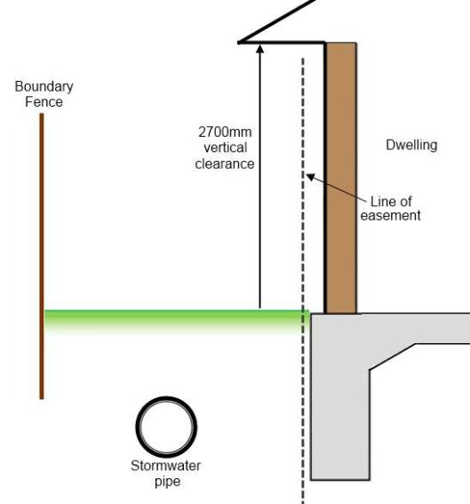
Figure 13 - Vertical clearance requirements
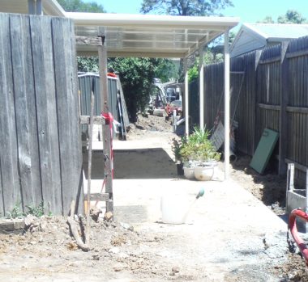
Figure 14 - a light weight, open and demountable verandah (typically approved). This location was subject to an easement drain renewal and the photo is during works.
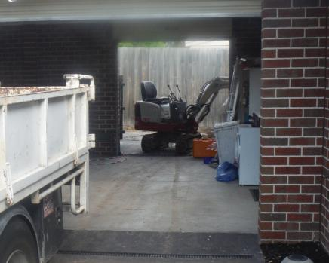
Figure 15 - access to Council drains for works or major maintenance often requires passage of machinery through structures occupying easements
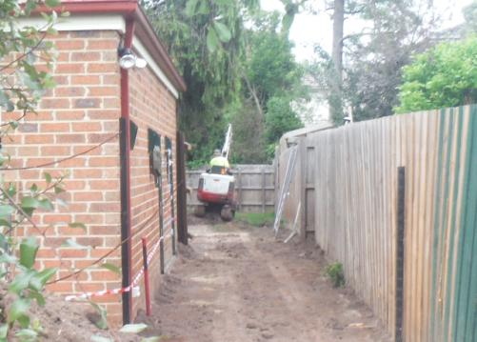
Figure 16 - excavator machinery often has a digging arm that raises, hence the need for height clearance under eaves

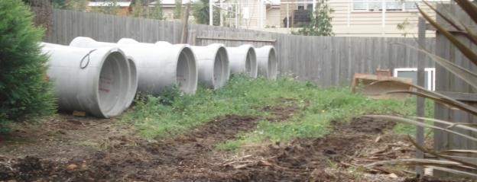
Figure 17 - large pipes placed ready for installation in a rear yard
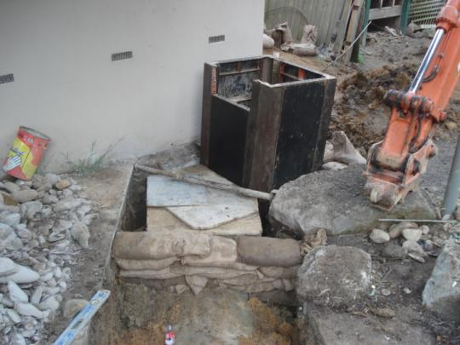
Figure 18 - major pit / pipe upgrade works in an established property (hard up against a building) in an easement
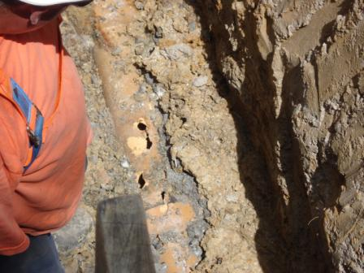
Figure 19 - a broken (old) terra cotta drain in an easement that needs replacing
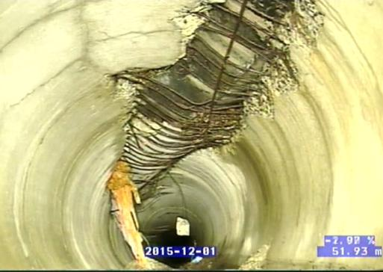
Figure 20 - an internal view of a drain that has failed and collapsed due to loading

TYPICAL CONDITIONS
The following are typical conditions that may be attached to an approval to Build Over an Easement:
- Stormwater drain locations are to be confirmed on site.
- The base of any footings in or adjacent to the easement are founded 200mm below a line drawn at an angle of 45 degrees from the invert of any stormwater pipe.
- Any footings in or adjacent to the easement have a minimum 600mm horizontal clearance from any stormwater pipe.
- The eaves of the proposed dwelling have a minimum of 2700mm vertical clearance from the finished surface level.
- A minimum 500mm cover must be retained over an existing drain
- The proposed structure can be easily removed, at the property owners cost, should Council require access to the drainage easement for future works or maintenance activities.
- Any section of concrete floor within the easement consists of removable slabs or has a construction join in the slab that coincides with the easement line.
- Prior to the issuing of the Certificate of Occupancy / Certificate of Final Inspection, a written statement from the Building Surveyor is to be provided to Council confirming that the foundations have been inspected, and that the foundations comply with the conditions outlined in the Build Over Easement Consent. Council reserves the right to inspect the drain before it is covered in.
- A section 173 agreement is to be lodged on the property owner’s title noting Council’s interest in the easement, and that the proposed structure may be removed at the property owners cost should Council require access to the drainage easement for future works or maintenance activities.
- The consent will lapse if building works are not commenced within 12 months of the date of the consent.

APPLICATION PROCESS & FEES
Council considers an application to Build Over an Easement under Regulation 130 (1) of the Building Regulations 2018.
Anyone wishing to Build Over an Easement must fill in the relevant Council application form and provide all necessary supporting information, including a current copy of title for which the application applies. Application can be made online or in person at one of Council’s Customer Service centres.
An application fee is payable when an application is lodged. The application fee is in accordance with Regulation 36 of the Building Regulations 2018. The application fee is non refundable.
Once an application is lodged and the application fee is paid, Council officers will assess the application in accordance with Council’s Building Over Easement Policy, and respond with 15 days working days.
If further information is required, the time for a response will be reset to when the further information is provided.
The application form, along with all supporting information (including Council’s Building Over Easement Policy), can be found and lodged online on Council’s website.
http://www.maroondah.vic.gov.au/BuildingOverEasement.aspx
In the case of a refusal, the process for appeal will be set out in Council’s letter.
Council’s Development Engineers are able to provide a property owner with preliminary advice prior to an application being submitted over the phone or in person by appointment at Council’s Braeside Avenue office in Ringwood.

