**Maroondah City Council**

**Engineering Development**

**Design Guidelines**

**2016**

## Document control

|  |  |  |
| --- | --- | --- |
| **Revision Number** | **Date Adopted** | **Changes** |
| A | July 2016 | NIL |

# Contents

1. Purpose 7

2. Scope 7

3. Guideline objectives 7

4. Engineering development objectives and strategic considerations 8

4.1 Maroondah Planning Scheme Objectives 8

4.2 Maroondah 2040 and other key objectives 8

4.3 Planning permit condition objectives 10

5. Engineering plans design process 11

6. Drainage connection to legal point of discharge (LPD) 11

6.1 Drainage connections to Melbourne Water assets 12

6.2 Drainage connections to Council assets 12

7. CCTV report requirements 17

8. Calculating permissible site discharge (PSD) 18

8.1 Rational method 18

8.2 Worked example: Rational method to determine PSD 20

9. Onsite detention 21

9.1 On site detention volume requirements 21

9.2 Onsite detention and PSD distribution 23

9.3 Treatment of uncontrolled runoff 23

9.4 Design requirements for detention systems 24

9.5 On site detention for basement car parks 27

9.6 On site detention additional considerations 27

10. Orifice size computations method 28

11. Pipe design criteria 30

11.1 Minimum pipe capacities for new Council drains 30

11.2 Pipe cover and backfill and preferred material for private drains 30

11.3 Pipe cover and backfill and preferred material for Council drains 31

11.4 Minimum pipe grades 31

11.5 Minimum velocities 31

11.6 Maximum velocities 31

12. Pit design criteria 32

12.1 Private pits 32

12.2 Council pits 32

12.3 Trench grates 32

13. Treatment of 100 year storm event within the development 33

14. External overland flow and land subject to flooding 34

14.1 Building on land liable to overland flow 35

14.2 Building on land liable to flooding 40

15. Building over an easement 41

15.1 Private drains in easements 41

16. Calculating pipe or open channel capacity 42

16.1 Pipe Flow 42

16.2 Channel Flow 43

17. Erosion and Sediment Control 44

17.1 Why is erosion and sediment control important? 44

17.2 When do erosion and sediment controls need to be in place? 44

17.3 Minimum required erosion and sediment controls 45

18. Water Sensitive Urban Design (WSUD) 46

18.1 Achieving best practice runoff requirements for development only (no subdivision) 46

18.2 Achieving best practice runoff requirements for residential subdivision. 46

18.3 Provision of WSUD elements to achieve best practice 46

18.4 Rainwater tanks 48

18.5 Payment of levies to Melbourne Water in lieu of achieving best practice 49

19. Driveway construction 50

19.1 Dimensions of driveways 50

19.2 Levels and grades of driveways 50

19.3 Driveway pavement composition 51

19.4 Low impact paving 51

19.5 Vehicle crossing details 52

http://www.maroondah.vic.gov.au/EngineeringStandardDrawings.aspx 52

19.6 Car park signage and linemarking 52

20. Required notes on paving and drainage plans 54

21. Lodging of drainage design plans to Council for approval 55

21.1 Payment of plan checking fee 55

21.2 Paving and drainage plans size and format 55

22. Construction works 56

22.1 Road/asset opening permit 56

22.2 Vehicle crossing permit 56

22.3 Traffic management/road and footpath closure permits 56

23. Inspection of completed works 57

24. Engineering Development Design Checklist 58

**Figures**

Figure 1 – Typical pipe to pipe connection 12

Figure 2 – Creation of a new pit over an existing drain 13

Figure 3 – Full height kerb adaptor 13

Figure 4 – Typical creek or table drain connection 14

Figure 5 – Typical drainage trench pipe bedding 16

Figure 6 – New pipe and pit construction 16

Figure 7 – Inspection of new pit formwork 16

Figure 8 – Extract from a CCTV report 17

Figure 9 – Formal trash gate 24

Figure 10 – Typical rainwater tank design 26

Figure 11– Typical tank slow release orifice 26

Figure 12 – Typical bike safe trench grate 32

Figure 13 – Typical overland flow paths 35

Figure 14 – Development impact on overland flow path 36

Figure 15 – Freeboard above flood level 39

Figure 16 – Typical silt fence installation 44

Figure 17 – Typical erosion control details 45

Figure 18 – WSUD rain garden concept 47

Figure 19 – Typical MUSIC model 47

Figure 20 – STORM calculator 48

Figure 21 – Rainwater tank used for reuse 48

Figure 22 – Typical driveway pavement detail 50

Figure 23 – Driveway construction 51

Figure 24 – An example of low impact pervious pavement 51

Figure 25 – Sample vehicle crossing 52

**Tables**

Table 1 – Runoff coefficient for vacant land based upon lot size 19

Table 2 - Time of Concentration based on lot size 19

Table 3 – Rainfall intensities to be used within Maroondah 19

Table 4 – Detention requirements 21

Table 5 – Worked example of onsite detention and PSD distribution 23

Table 6 – Minimum grades for detention purposes 25

Table 7 – Worked example of orifice size calculation 29

Table 8 – Minimum pipe capacities for new Council drains 30

Table 9 – Pipe cover and backfill and preferred material for private drains 31

Table 10 – Pipe cover and backfill and preferred material for Council drains 31

Table 11 - Minimum pit sizes to (AS3500.3:2015 7.5.2.1) 32

Table 12 – Minimum Council junction pit size 32

Table 13 – Requirements for developing on overland flow paths 37

Table 14 – Typical freeboard requirements 38

# 1. Purpose

The purpose of the guideline is to provide technical guidance and direction to Developers and Engineering Consultants for the preparation of paving and drainage plans to satisfy Town Planning Permit conditions for multi dwelling developments and subdivisions.

The aim of the guidelines is to ensure that Council’s technical requirements for preparing paving and drainage plans are understood up front by Developers and Engineering Consultants so that the paving and drainage plans can be prepared and endorsed efficiently without undue delay.

Furthermore, in accordance with Maroondah’s 2040 Community Vision, the requirements and principles set out in the guidelines aims to ensure that development within the City of Maroondah is *attractive thriving and well built* both now and into the future.

# 2. Scope

The guidelines applies to the Statutory Planning process for multi dwelling developments and subdivisions within Maroondah City Council to comply with the principles and requirements of the Maroondah Planning Scheme, Planning and Environmental Act 1987, Subdivision Act 1988, Local Government Act 1989, Water Act 1989 and Maroondah Local Laws.

The guidelines also provide direction for building works that may have an impact on Council infrastructure, or may be subject to various infrastructure related regulations prescribed under the Building Regulations 2006.

# 3. Guideline objectives

The guideline objectives are to:

* Ensure that development within Maroondah meets the statutory requirements of the Maroondah Planning Scheme and relevant Acts.
* Ensure that there is no negative impact on Council infrastructure as a result of development.
* Ensure that any new Council infrastructure is designed and constructed in accordance with Maroondah City Council’s standards and industry best practice.
* Ensure that any new private infrastructure is designed and constructed to the relevant industry standards, and in a way that does not create future problems for property owners, adjoining properties or the public, whilst allowing consideration for innovative and sustainable design approaches and new technologies.
* Provide high level advice back to engineers and developers, including clear and concise conditions when approval is granted and tangible and clear direction if amendments are required.
* Allow consultants/developers to expect appropriate consideration of paving and drainage plans that is fair and consistent.

# 4. Engineering development objectives and strategic considerations

When considering a planning permit for a development and/or subdivision, the objectives applied and conditions imposed emanate from the Maroondah Planning Scheme and the Maroondah 2040 Community Vision and other key Council strategies. Consideration is also given to the Planning and Environmental Act 1987, Subdivision Act 1988, Local Government Act 1989, Water Act 1989 and Maroondah City Council Local Laws.

## 4.1 Maroondah Planning Scheme Objectives

Clauses 55.02 & 56.07 of the Maroondah Planning Scheme outlines the following objectives:

* To ensure development is provided with appropriate utility services and infrastructure.
* To ensure development does not unreasonably overload the capacity of utility services and infrastructure.
* To provide for the substitution of drinking water for non-drinking purposes with reused and recycled water.
* To minimise damage to properties and inconvenience to residents from urban run-off.
* To ensure that the street operates adequately during major storm events and provides for public safety.
* To minimise increases in stormwater run-off and protect the environmental values and physical characteristics of receiving waters from degradation by urban run-off.

Further information regarding the planning schemes objectives and requirements are located at:

<http://planningschemes.dpcd.vic.gov.au/schemes/vpps/55_02.pdf>

<http://planningschemes.dpcd.vic.gov.au/schemes/vpps/56_07.pdf>

## 4.2 Maroondah 2040 and other key objectives

### 4.2.1 Maroondah 2040

The Maroondah 2040 Community vision is *In 2040, Maroondah will be a vibrant and diverse city with a healthy and active community, living in green leafy neighbourhoods which are connected to thriving and accessible activity centres contributing to a prosperous economy within a safe, inclusive and sustainable environment.*

The key directions of Maroondah 2040 that relate to the Engineering Development Guidelines include:

* Advocate for increased stormwater harvesting and greywater re-use by households and businesses.
* Work in partnership to improve walkability within and between neighbourhoods and activity centres, through effective urban design, open space planning, wayfinding signage, improved public lighting and accessible infrastructure.
* Encourage high quality urban design that provides for a healthy, attractive and desirable built form.
* Work in partnership to ensure development considers urban design principles that enhance the connection between the built environment and the natural environment.
* Facilitate, lead and educate the community in the use of environmentally sustainable design across all forms of infrastructure to limit carbon emissions and reduce resource consumption.
* Work in partnership to encourage the use of a water sensitive approach in the development and renewal of the built and natural environment.
* Ensure the management of infrastructure and prioritisation of capital works considers demographic change, the impacts of climate change, and accessibility for all ages and abilities.
* Work in partnership with other catchment authorities to ensure effective stormwater management across Maroondah, including the identification and implementation of appropriate strategies that increase the storage, re-use and re-direction of stormwater and provide flood mitigation for the community.
* Provide enhanced governance that is transparent, accessible, inclusive and accountable.

Further information regarding the Maroondah 2040 community vision can be found on Council’s website:

http://www.maroondah.vic.gov.au/Maroondah2040.aspx

### 4.2.2 Maroondah Water Sensitive City Strategy

Maroondah’s Water Sensitive City Strategy vision is *By 2040, Maroondah will be a water sensitive city. Positioned at the top of several creek catchments, Maroondah’s waterways will be clean, ecologically rich, and beautiful recreational corridors that define the character of Maroondah.*

*Our residents, workers and visitors will reassure water as a valued resource and enjoy green leafy neighbourhoods and high quality open spaces that are supported by sustainable water sources. Maroondah will have good water security and be resilient to drought and flood.*

*Our homes and other buildings will demonstrate good practice in water management and will benefit from well designed streets and green corridors where flood waters are conveyed safely.*

*In partnership with government, community and relevant authorities, Council will actively seek opportunities to deliver environmental, community and economic benefit through continual improvement of the local water cycle using an integrated approach.*

The key Water Sensitive City Strategy outcomes are:

**Healthy environments**

Healthy waterways

Green spaces

Trees and amenity

Recreation

**Water valued by all**

Responsible use by Council, resdietns and businesses

Fit for water purpose water resources

Reduced stormater pollution

Reduced wastewater pollution

**Collaborative culture**

Integrated approach

Seeking multiple benefits

Working with partners

Engaged communities and businesses

**Resilient places**

Flood resilient

Drought resilient

Cool microclimate

Good urban design

### 4.2.3 Maroondah Housing Strategy

Maroondah City Council has developed a new housing strategy which establishes future policy directions and will guide future residential development. The Maroondah Housing Strategy has been developed to ensure that the municipality will meet its housing requirements over the coming decades.

The Maroondah Engineering Development Design Guidelines and this Housing Strategy will assist Council to continue to maintain and enhance the liveability of our community. The strategy will identify future growth areas and will ensure that essential services such as drainage will be suitable for the proposed level of development.

### 4.2.4 Maroondah Open Space Strategy

Maroondah City Council has developed an Open Space Strategy to guide its planning, development and management of open spaces within the municipality. The Open Space Strategy will identify opportunities which would improve the accessibility, connectivity and functionality of Maroondah’s open spaces while giving consideration to strategic drainage improvements.

## 4.3 Planning permit condition objectives

Typical planning permit conditions that respond to the above objectives and in consideration of the abovementioned acts could include but are not limited to requirements to:

* Prepare drainage plans to connect the development to an appropriate legal point of discharge and to ensure that the development does not negatively impact Council’s or Melbourne Water’s drainage infrastructure.
* Prepare paving plans to demonstrate correct drainage function and to demonstrate that appropriate access and egress can be achieved to all proposed dwellings.
* Ensure that access and egress can be achieved to all proposed properties via the construction of vehicle crossings that meet Council’s standards.
* Ensure that the development is protected from flooding and neighbouring properties are not adversely affected.
* Undertake the required works in accordance with the endorsed paving and drainage plans.
* Ensure that during construction appropriate measures are implemented to control pollutants from the site.

# 5. Engineering plans design process

The following simple flow chart identifies a typical engineering plans design process that should be considered and followed:

1. Obtain LPD and property development information
2. Obtain Town Planning Permit and review specific conditions
3. Calculate PSD using Rational Method
4. Calculate detention volume
5. Design detention system
6. Complete paving and drainage design
7. Check provision for 100 year event for the development
8. Complete Engineering Development Design Checklist
9. Pay engineering plan checking fee
10. Submission of plans, computations and related documentation

# 6. Drainage connection to legal point of discharge (LPD)

A Legal Point of Discharge (LPD) is the point which is specified by Council where the stormwater leaves an individual property, and may include connection to:

* a Council underground stormwater pipe or pit within Council land, an easement, or within road reserve
* kerb and channel (with an approved kerb adaptor)
* a table (open/swale) drain
* a Melbourne Water major drain, subject to Melbourne Water conditions

A LPD statement is provided in accordance with section 56 of Council’s Local Law No. 8 and section 610 of the Building Regulations 2006. To apply for a LPD, please refer to Council’s website for the application process or for further information:

<http://www.maroondah.vic.gov.au/LegalPointOfDischarge.aspx>

**Please note: a copy of the LPD should be provided to Council with the paving and drainage plans.**

## 6.1 Drainage connections to Melbourne Water assets

Where connection is to be made directly to a Melbourne Water pipe drain or open waterway approval must be sort directly from Melbourne Water. including their requirements for connection.

Council cannot approve the drainage design plan until Melbourne Water approval is obtained and a copy of the approval is provided to Council.

Refer to Melbourne Water website for further information:

<http://melbournewater.com.au/Planning-and-building/Working-around-mains-drains-and-waterways/Connecting-to-the-stormwater-system/Pages/Connecting-to-stormwater-drains.aspx>

## 6.2 Drainage connections to Council assets

### 6.2.1 Connections directly to a Council pipe

Connection can be made to a Council stormwater pipe where Council’s pipe diameter is three times larger than the incoming pipe. For example a 100mm inlet pipe can only connect to a 300mm diameter or larger pipe. The connection must be made via an approved saddle adaptor in accordance with Councils engineering standard drawing: SD-E01 or SD-E01A.

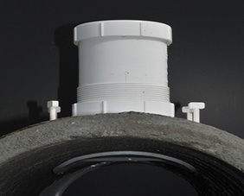

#### 

#### Figure 1 – Typical pipe to pipe connection

### 

### 6.2.2 Connections to an existing Council pit

Connection can be made to an existing Council stormwater pit in accordance with Council’s engineering standard drawing SD-E02, if the existing pit is greater than 600x900mm in dimension and in good condition. If the existing pit is less than 600x900mm or in poor condition, it must be reconstructed to Council’s satisfaction.

### 

### 6.2.3 Connections to a new Council pit

Connection can be made by constructing a new Council stormwater pit over an existing Council drainage pipe. The construction of a new Council pit must be in accordance with Council’s engineering standard drawing: SD-D06.

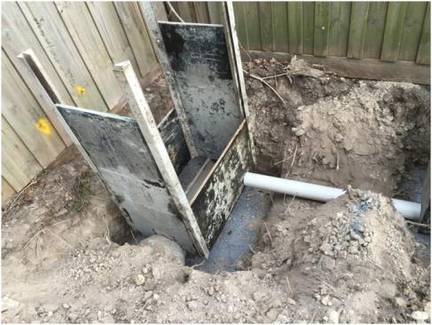

#### Figure 2 – Creation of a new pit over an existing drain

### 6.2.4 Connections to kerb and channel

Connection can be made to the kerb and channel using a full height kerb adaptor; however it must be located directly in front of the property, unless otherwise directed by Council. Consideration must be given to the overall drainage design to ensure that there is appropriate fall to the kerb and channel so that no pipes or pits hold water. If this cannot be reasonably obtained a new outfall drain may be required to be constructed within the road reserve or easement.

Connection to kerb and channel are not to be made within a vehicle crossing and are to be made to Council’s satisfaction.

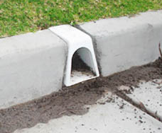

#### 

#### Figure 3 – Full height kerb adaptor

### 6.2.5 Connection to a table (open/swale) drain

Connection can be made to an existing Council table (open/swale) drain however rock beaching must be constructed to the invert to prevent scouring, to Council’s satisfaction.

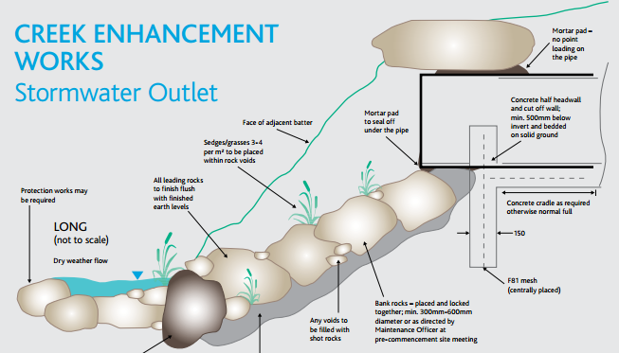

#### Figure 4 – Typical creek or table drain connection

### 6.2.6 Connection to existing drainage within a property

Connection can be made to a property’s existing LPD connection within the property, however a drainage report, including CCTV footage and report, must be provided from a suitably qualified plumber to verify that the existing stormwater drainage is connected to an appropriate Council asset and is in good serviceable condition to Council’s satisfaction.

Refer to section 7 for details of CCTV requirements.

It is suggested to install an inspection opening (I.O.) at the connection of the new to the existing stormwater pipes.

### 6.2.7 Connection to existing private drainage within an easement

If a Council asset is not within a reasonable distance from a property and an existing private drain is located within an easement, connection may be made to the existing private drain within the easement subject to the following conditions:

* A drainage report, including CCTV footage in accordance with the Water Services Association of Australia (WSA) 05-2008 2.2 Code of practice, must be provided from a suitably qualified plumber to verify that the existing private stormwater drain is connected to an appropriate Council asset and is in good serviceable condition, to Council’s satisfaction.
* 100 year ARI detention storage must be provided within the property to prevent flooding into neighbouring properties.

Refer to section 7 for details of CCTV requirements.

### 6.2.8 Construction of a new outfall drain

In the absence of an appropriate LPD being available, the construction of a new outfall drain within an easement or road reserve may be required.

Council has a number of mandatory requirements for constructing a new Council stormwater asset, including:

* Preparation and submission of a drainage design plan to Council’s satisfaction
* Payment of plan checking and supervision fees and lodgement of a works maintenance bond
* Hold point inspections
* CCTV footage and report
* As constructed plans.

In accordance with the Subdivision Act, the construction of assets that become Council’s responsibility incur a **plan checking fee** of 0.75% of the value of the works and a **supervision fee** of 2.5% of the value of the works. An estimate of costs for the drainage works will need to be submitted so that Council fees can be calculated in accordance with the Act. Please note that these fees are in addition to the standard engineering plan checking fees.

Furthermore, in accordance with the Subdivision Act, a three month defects liability period applies to the easement drainage works. Council requires the lodgement of a **works maintenance bond** to the value of 5% of the actual cost of the drainage works. The works maintenance bond will be returned to the payee at the end of the defects liability period provided that the works have been maintained and all defects are rectified to the satisfaction of Council.

During construction of a new Council drain, Council is required to inspect the works at various **hold points** including:

* Prepared drainage pipe bedding
* Prepared bedding for drainage pits
* Formwork and reinforcement (if required) for drainage pit walls
* Connection of existing or new subsoil (aggie) drainage into new stormwater pit (for works behind kerb and channel)
* Compacted drainage pipe haunching
* Compacted drainage backfill

Once construction is completed and prior to the commencement of the defects liability period, **footage and report** for all new Council drainage lines is to be provided to Council’s satisfaction and in accordance with the Water Services Association of Australia (WSA) 05-2008 2.2 Code of practice.

Furthermore, prior to the return of the works maintenance bond, **as constructed engineering plans** showing the location, type, depth and dimensions of the new Council stormwater drains and pits must be provided to Council’s satisfaction.

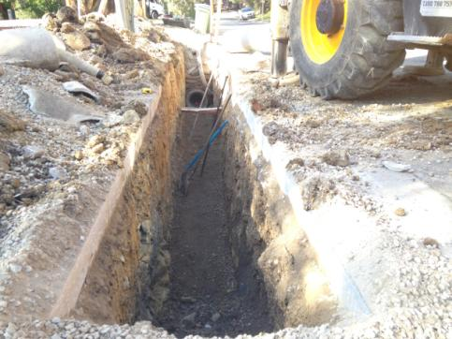

#### Figure 5 – Typical drainage trench pipe bedding

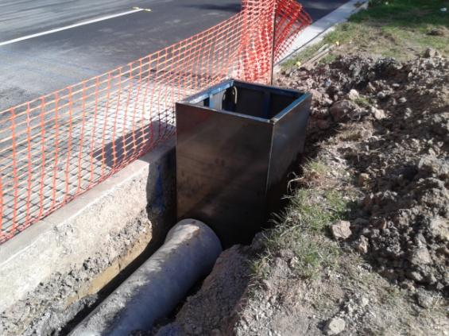

#### Figure 6 – New pipe and pit construction

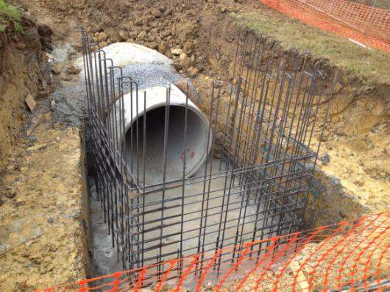

#### Figure 7 – Inspection of new pit formwork

# 7. CCTV report requirements

Maroondah City Council requires CCTV investigation to be undertaken when any new

Council drainage asset is constructed, after repairs or renewal of stormwater pipes, when

investigating the condition or capacity of existing stormwater assets or pre and post works where a development could damage a Council drainage asset.

The CCTV investigation must include CCTV footage and a report in accordance with the Water

Services Association of Australia (WSA) 05-2008 2.2 Code of practice.

**Note: Push rod camera footage does not meet the WSA code of practice and will not be**

**accepted.**

The CCTV footage must be separate files for each pipe length, so Council can allocate the footage against the particular asset. An annotated plan or map must accompany the report to show the corresponding sections of CCTV.

The CCTV report must provide the following information:

* Date of CCTV investigation
* Pipe location
* Pipe length
* Pipe diameter
* Pipe type
* Every joint and pipe connection must be fully reviewed by the camera
* Coding of defects in accordance with the WSA code of practice.

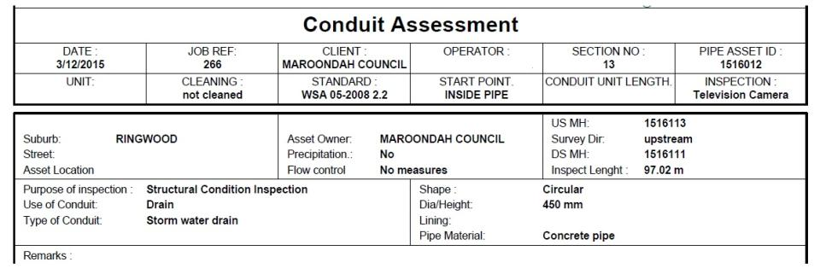

#### Figure 8 – Extract from a CCTV report

The CCTV report must be submitted to and reviewed by Council’s Engineering Department. If the report identifies unsatisfactory quality of work or defects within the drainage assets, rectification of the issues must be undertaken to Council’s satisfaction.

# 8. Calculating permissible site discharge (PSD)

The permissible site discharge (PSD) is the peak flow rate allowed to be discharged from a property to the nominated legal point of discharge, and must be limited to a **5 year ARI** flow rate.

In general, most Planning Permits will require the following:

*Limit the Permissible Site Discharge (PSD) to the equivalent of a 35% impervious site coverage, or the pre-developed discharge rate, if it is less than 35% impervious site coverage, to the satisfaction of the Responsible Authority.*

Council’s definition of “impervious site coverage” includes all hard surface areas where water is likely to run off rather that infiltrate into the ground. This includes, but is not necessarily limited to, all dwellings, garages, sheds, driveways, paved areas and paths, etc.

The rational method shall be adopted to calculate the PSD.

## 8.1 Rational method

The rational method is generally used to calculate design peak flow rates, and the PSD.

The peak flow rate resulting from a storm with an average recurrence interval (ARI) of Y (years) is calculated using the following formula:

$$Q= \frac{CIA}{360}$$

Where the parameters are:

**Q** = peak flow rate resulting from ARI of y (years) in (m3/s)

**C** = runoff coefficient for design event having an ARI of y (years).

**I** = rainfall intensity (mm/hr) corresponding to a particular storm duration and ARI.

**A** = area of catchment in hectares.

### 8.1.1 (C) - Runoff Coefficient

Run off coefficients must make allowances for the varying percentages and mixing of pervious and impervious surfaces.

Calculating the ‘C’ value for pre-developed flows assuming 35% site coverage:

**C = 0.51** 0.9 x 35% Area + 0.3 x 65% Area

Area

If the pre-developed site coverage is less than 35% then this lesser value should be used as the ‘C’ value for pre-developed.

**Example**: Calculating the ‘C’ value for pre-developed flows with 25% site coverage:

**C = 0.45** 0.9 x 25% Area + 0.3 x 75% Area

Area

Values given in table below are to be used to calculate the post development flow ratesfor developments where the extent of building works has not yet been determined under the Planning Permit. (i.e. vacant land subdivisions). The values are to be used:

|  |  |  |
| --- | --- | --- |
| **Land Use** | **C (5 Year ARI)** | **C (100 Year ARI)** |
| **Major open space** | 0.30 | 0.40 |
| **Residential (average lot size):** | | |
| >4000m² | 0.40 | 0.50 |
| >750m² | 0.60 | 0.75 |
| >500m² | 0.70 | 0.85 |
| >350m² | 0.80 | 1.0 |
| <350m² | 0.90 | 1.0 |
| **High Density Unit Developments** | 0.90 | 1.0 |
| **Major Road Reserves** | 0.80 | 1.0 |
| **Commercial/Industrial** | 0.90 | 1.0 |

### 

##### Table 1 – Runoff coefficient for vacant land based upon lot size

### 8.1.2 (I) - Rainfall Intensity

To determine the intensity (I), use the time of concentration table below to choose an appropriate TC (mins) relative to the **pre-developed** lot size and match the figure to the ARI table for the required storm event.

|  |  |
| --- | --- |
| **Land Use (Average Lot Size)** | **TC (mins)** |
| ≥4000m² | 12 |
| ≥750m² | 9 |
| ≥500m² | 8 |
| ≥350m² | 7 |
| <350m² | 6 |
| High Density Unit Developments | 5 |

##### Table 2 - Time of Concentration based on lot size

|  |  |  |  |  |
| --- | --- | --- | --- | --- |
| **Duration TC (mins)** |  | **ARI (mm/hr)** | | |
| **5 Year** | **10 Year** | **20 Year** | **100 Year** |
| **5 Mins** | 86.771 | 102.892 | 124.309 | 180.857 |
| **6Mins** | 80.898 | 95.801 | 115.610 | 167.820 |
| **7Mins** | 76.022 | 89.922 | 108.405 | 157.047 |
| **8Mins** | 71.878 | 84.930 | 102.294 | 147.925 |
| **9Mins** | 68.292 | 80.615 | 97.016 | 140.061 |
| **10Mins** | 65.146 | 76.833 | 92.393 | 133.185 |
| **12Mins** | 62.355 | 73.480 | 84.638 | 127.103 |
| **20Mins** | 46.270 | 54.219 | 64.838 | 92.438 |
| **30Mins** | 36.992 | 43.165 | 51.431 | 72.796 |
| **1 Hour** | 24.439 | 28.295 | 33.487 | 46.768 |

##### Table 3 – Rainfall intensities to be used within Maroondah

(Raw Data: 19.01, 4.32, 1.32, 37.95, 7.58, 2.41, skew=0.35, F2=4.28, F50=15) April 2013

### 8.1.3 (A) - Area of Catchment

Area (hectares) to include total lot size, including all pervious and impervious areas.

## 8.2 Worked example: Rational method to determine PSD

A typical 2 unit site of area 865m2 assuming 35% site coverage:

Formula: $Q= \frac{CIA}{360}$

Where: C = 0.51

I = 68.292 mm/hr

A = 0.0865 hectares

Q = (0.51 x 68.292 x 0.0865) / 360

= 0.00837 m3/s or 8.37 L/s

# 9. Onsite detention

The planning permit conditions will generally detail if the development requires on site detention storage. A typical planning permit condition would require the following:

*Limit the Permissible Site Discharge (PSD) to the equivalent of a 35% impervious site coverage, or the pre-developed discharge rate, if it is less than 35% impervious site coverage, to the satisfaction of the Responsible Authority, and*

*Provide appropriate stormwater detention storage to limit the maximum discharge rate to the PSD.*

## 9.1 On site detention volume requirements

All developments that require onsite detention must detain a minimum of 1 in 10 year storm event; however there may be cases where a property is required to store a 1 in 20 year or 1 in 100 year storm event. The following table outlines the detention requirements for various property situations:

|  |  |  |
| --- | --- | --- |
| **Slope of property &**  **LPD location** | **Treatment of overland flow path (Q100 from site)** | **Detention requirements**  **( 1 in x storm event)** |
| Forward or side sloping with LPD in road reserve | A safe overland flow path can be provided to the road reserve without detrimentally affecting other properties | 10 year |
| Forward or side sloping with LPD in road reserve | No safe overland flow path can be provided to the road reserve without detrimentally affecting other properties | 100 year |
| Rear or side sloping with LPD in rear or side easement | A safe overland flow path can be provided to the easement without detrimentally affecting other properties | 20 year |
| Rear or side sloping with LPD in rear or side easement | No safe overland flow path can be provided to the easement without detrimentally affecting other properties | 100 year |

##### Table 4 – Detention requirements

### 9.1.1 On site detention calculation using OSD4

Council **will only** accept detention calculations using the Swinburne OSD Methodology. A computer based program such as OSD4 or an equivalent package must be utilised to calculate detention storage given that it utilises the Swinburne OSD methodology.

When using OSD4, please note the following parameters:

* The nominated PSD must be the PSD calculated from first principles (refer section 8)
* “Zone-ARI flow” must equal Ringwood 5
* “Zone-ARI store” must equal Ringwood 10, 20 or 100 (refer section 9.1)
* “Storage type” must equal pipe or tank.

### 9.1.2 Worked example: OSD4 detention volume calculation

*** SUMMARY OSD DESIGN REPORT ***

=========================

Printed from *OSD4W* version 1.08.4

Licensed to : Example Consultant

Prepared by : User1

==================================================================

1. CLIENT DETAILS

Name : Mr Example (Input)

Address line 1 :

Address line 2 :

Address line 3 :

2. JOB NAME AND REFERENCE

Job Reference : OSD 4 (Input)

Job Name : 2 Units (Input)

Job Detail 1 :

Job Detail 2 :

Job Detail 3 : 1 Example Street, Croydon (Input)

3. AREAS (sq.m.) & RUN-OFF COEFFICIENTS

Total Site area : 865 (Input)

4. EXISTING SITE DETAILS

Aes1 : 303 Ces1 : 0.90 (Input pre-developed areas or

Aes2 : 562 Ces2 : 0.30 total area with weighted C value - Refer section 9.1.1)

Aes3 : 0 Ces3 : 0.15

Aes4 : 0 Ces4 : 0.12

Weighted C - site Cew : 0.51

5. PROPOSED SITE DETAILS

Aps1 : 419 Cps1 : 0.90 (Input total impervious area for developed site)

Aps2 : 446 Cps2 : 0.30 (Input total pervious area for developed site)

Aps3 : 0 Cps3 : 0.15

Aps4 : 0 Cps4 : 0.12

Weighted C - site Cpw : 0.59 (Resultant developed C value from imputed values above)

Uncontrolled portion(s) UPfrac : 0.00

6. CATCHMENT TIMES (minutes)

Time of concentration : 10.00 (These figures have no effect on Volume as a PSD has

Travel time from discharge point been nominated)

to catchment outlet : 5.00

7. OSD DESIGN

Flow Control Device : Orifice (Input description of Flow Control Device)

Storage type : Pipe (Select Pipe)

Rainfall zone : RINGWOOD

ARI for OUTFLOW (years) : 5 (Use Ringwood 5 for outflow)

ARI for STORAGE (years) : 10 (Use Ringwood 10, 20 or 100 for storage (Refer section 10.1)

Qptot (L/s) : 8.11

Qu (L/s) : 0.00

Qp (L/s) : 0.00

Calculated PSD (L/s) : 8.85

Nominated PSD (L/s) : 8.37 (Input Nominated PSD from Rational Method

Adopted PSD (L/s) : 8.37 (Refer section 9.2)

8. STORAGE DETAILS

Volume (cub.m.) : 3.51

Time to fill storage (mins) : 9.0

Time to empty storage (mins) : 12.9

Critical storm duration (mins) : 12.7

9. STORM DURATIONS & RAINFALL INTENSITIES

PSD ............... Duration : 10.0 min. Intensity : 66.2 mm/hr

MAX. STORAGE ...... Duration : 12.7 min. Intensity : 67.7 mm/hr

==================================================================

==================================================================

Generated at : 30/04/2014 3:56:26 PM

## 9.2 Onsite detention and PSD distribution

The onsite detention and PSD distribution must reflect the sites developed impervious areas. If separate detention types are used (a combination of above ground and underground storage) then the ratio of storage needs to be directly proportional to each area being drained.

**Note: A catchment plan must accompany or be included on the drainage design. Where rainwater tanks are used in design, area feeding each tank is to be shaded and labelled in m2 on the drainage plans.**

### 9.2.1 Worked example: On site detention and PSD distribution

If the total site is 865m2 and the total post development impervious area is 419m2, with a PSD of 8.37 L/s and a required detention volume of 3.51m3. The detention storage must be directly proportional to each area being drained.

|  |  |  |  |  |  |
| --- | --- | --- | --- | --- | --- |
| **Impervious catchment** | **Area (m2)** | **Percentage Impervious (%)** | **Maximum Volume (m3)** | **Allocated Volume (m3)** | **PSD (L/S)** |
| Unit 1 tank | 100m2 | 100/419 = 24% | 0.24 x 3.51 = 0.84m3 | 0.9m3 | 2.01 |
| Unit 2 tank | 150m2 | 150/419 = 36% | 0.36 x 3.51 = 1.26m3 | 1.3m3 | 3.01 |
| Underground detention | 169m2 | 169/419 = 40% | 0.4 x 3.51 = 1.4m3 | 1.4m3 | 3.35 |
| Total Detention Volume | | | 3.51m3 | 3.6m3 | 8.37 L/s |

##### Table 5 – Worked example of onsite detention and PSD distribution

## 9.3 Treatment of uncontrolled runoff

If circumstances arise whereby a portion of the developments impervious area cannot be captured into the onsite detention system the drainage calculations must reflect this.

The simplest way is to calculate the uncontrolled runoff volume, using **the detention storage storm event** (10, 20 or 100 year ARI). The calculated PSD must be reduced by the calculated volume of uncontrolled runoff flow rate. The modified PSD must then become the nominated PSD in OSD4.

### 9.3.1 Worked example: Treatment of uncontrolled runoff

A typical 2 unit site has a calculated PSD of 8.37 L/s (refer section 8.2) however 120m2 impervious area cannot be captured into the onsite detention system as such is considered uncontrolled runoff.

Formula: $Q= \frac{CIA}{360}$

Where: C = 0.9 (Impervious area coefficient of runoff)

I = 89.922 mm/hr (10 Year ARI for 7 min TC  (Average lot size ≥350m²))

A = 0.012 hectares (120m2 of uncontrolled runoff)

Q = (0.9 x 89.922 x 0.012) / 360 = 0.00270 m3/s or 2.7 L/s

The modified PSD (or nominated PSD in OSD4) is therefore = 8.37 – 2.7 = 5.67 L/s

## 9.4 Design requirements for detention systems

When designing a detention system the required detention volume can be either allocated to above ground storage (rain water tanks with a slow release orifice) or below ground storage (baffle pit with slow release orifice and pit/pipe system).

Note: Council does not allow multi cell units or on (above) ground storage on a driveway.

### 9.4.1 Below ground detention systems – baffle pits and pipes

Generally a below ground detention system will be required for all developments and must meet the following requirements:

* A **two chambered** baffle pit with slow release orifice in the weir wall (refer to section 10 for orifice size calculations).
* The **weir wall** must be minimum 100mm thick concrete with the slow release orifice cast into the wall. Note: Steel plates as a weir wall are not acceptable due to the potential for tampering. In circumstances where a two chambered pit cannot be built, a steel plate with slow release orifice must be fixed with tamper proof dyna bolts chem-set into the pit wall.
* There must be a minimum 50mm high **overflow** over the weir wall for the full width.
* There must be a **solid pit lid above the outlet chamber** of the baffle pit.
* There must be a **grated pit lid above the inlet chamber** of the baffle pit.
* A formal **trash grate** with 25x25mm maximum mesh must be provided to protect the orifice from blocking. It must be located in the inlet chamber of the baffle pit and must be securely fixed in place.

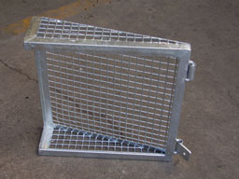

#### Figure 9 – Formal trash gate

* Each chamber of the baffle pit must meet minimum internal dimensions required by Australian Standard AS3500.3:2003 8.6.2.1 (refer to Section 12.1).
* Minimum orifice size is 40mm.
* The construction plan must show the length of detention pipe being used.
* Minimum grades for stormwater detention pipes include:

|  |  |
| --- | --- |
| **Pipe diameter (mm)** | **Minimum grade** |
| 150Ø | 1 in 150 |
| 225-450Ø | 1 in 250 |
| 525Ø or greater | 1 in 400 |

##### Table 6 – Minimum grades for detention purposes

**Below ground detention tanks** can be used where the LPD is deep enough to allow for drainage to the LPD.

Note: If the below ground tank is subject to traffic loading, a Certificate of Compliance - Design must be provided for the appropriate traffic loading to Council’s satisfaction.

### 9.4.2 Above ground detention systems –rainwater tanks

Rainwater tanks with a slow release orifice can be used for detention storage in addition to re-use functions and must meet the following requirements:

* **Minimum 2000L of re-use** for garden taps / toilets etc must be maintained in all rain water tanks beyond the allowable detention volume.
* Detention volume must be relative to the roof catchment area of rainwater tank (refer Section 9.2).
* **Show roof catchment area connected to tank** (hatch or colour on plan) and denote area in m² on the drainage design plan.
* A **slow release orifice** must be connected directly to the overflow pipe of the tank, must be tamper proof and a minimum diameter of 20mm (refer to section 10 for orifice size calculations).
* Only the volume above the slow release orifice can be considered for detention purposes.
* All **rainwater tank locations** are to be shown on the drainage design plans with details on down pipes to be connected to each tank and tank outlet information detailed. The location of the rainwater tank can be modified onsite, however the roof catchment must be unchanged.
* All **charged down pipes** connected to tanks to be 100mm diameter solvent cement jointed UPVC pipe.
* Rainwater tank **outlet pipe** to be 100mm diameter UPVC pipe (adaptor from 90mm diameter standard outlet on tanks required).
* The property owner is responsible for the **continuing operation, maintenance and replacement** of the rainwater tank system and must allow Council access to inspect the system.

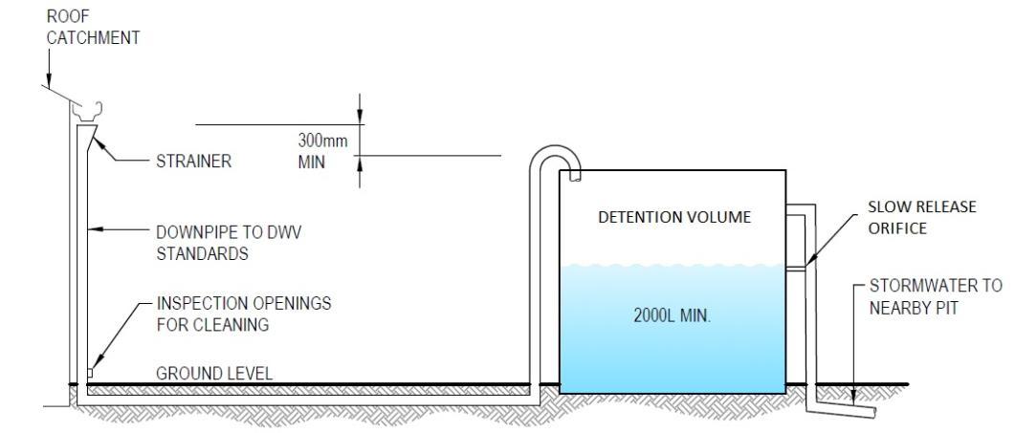

#### Figure 10 – Typical rainwater tank design

It is Council’s preference that for subdivisions where no building works are occurring, underground detention systems should be provided, however if this is not achievable and rainwater tanks are proposed, Council will require a Section 173 agreement to be obtained. The Section 173 Agreement will document and legalise the ongoing obligations of the property owner to ensure the future operation and maintenance of the rainwater tank as part of the detention system.

**Please note: The Section 173 Agreement must be drafted prior to the approval of the drainage plan and executed prior to the final Engineering inspection of the subdivision or development.**

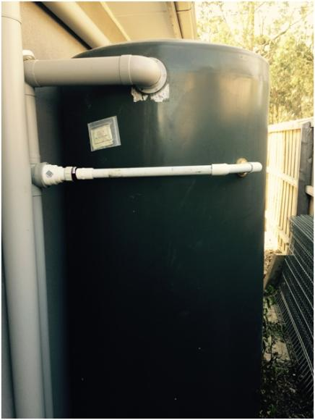

**Figure 11** – Typical tank slow release orifice

## 9.5 On site detention for basement car parks

For developments with basement car parks where a pump system is to be utilised, detention storage must be provided for a 1 in 100 ARI storm event for the catchment that enters the underground area (i.e. a ramp or any connected downpipes) for a minimum 60 minute duration. This is to protect the development against a worst case scenario where the pump is out of order during a 1 in 100 year ARI storm event.

Please note that this detention is in addition to the normal detention required for a development.

Alternatively, if a fully automatic backup pump and generator are provided, additional detention storage is not required. The automatic backup pump and generator must be fully installed and inspected prior during the compliance inspections.

### 9.5.1 Worked example: detention for basement car parks

A development with a basement car park and pump system has an external drainage catchment area of a 5.5m wide x 7.0m long length of basement ramp. No downpipes are connected into the basement.

Formula: $Q= \frac{CIA}{360}$

Where: C = 1.0 (critical impervious area coefficient of runoff)

I = 46.768 mm/hr (100 Year ARI for a critical 1 hour TC) (refer Table 3)

A = 0.00385 hectares (38.5 m2 of catchment area)

Q = (1.0 x 46.768 x 0.00385) / 360

= 0.0005 m3/s or 0.50 L/s

For 60 minute duration, the total volume of storage required within the basement car park will equal:

Volume = 0.0005 x 60 (minutes) x 60 (seconds) = 1.80 m3

## 9.6 On site detention additional considerations

* The detention systems must be within the development (preference to be in common property) and not on public land or within an easement.
* Ensure the detention system pits are not constructed under buildings or decks.
* A piped detention system can be constructed within a tree protection zone however it is not preferable. If it is unavoidable, it will need to be bored or dug with non destructive digging techniques.
* A piped detention system cannot be constructed within a trees structural root zone.
* Ensure system is easily accessible for maintenance and in a well ventilated area.

# 10. Orifice size computations method

For orifice sizing use the following formula to determine the area of the orifice:



Where the parameters are:

**A** = Area of orifice (m2)

**Q** =Permissible Site Discharge (PSD) (m3/s) (refer section 8)

**Cd** = 0.6 (coefficient for round shaped pipe)

**g** = 9.81 m/s2 (gravity)

**h** = height (m) (level difference between invert level of orifice and top of weir)

To determine the diameter of the orifice from the area calculated above use

$Diameter=2 × \sqrt{\frac{A}{π}}$ Where π = 3.142

### 10.1.1 Commercially available pipe sizes

For underground orifice pits, it is acceptable to choose the nearest pipe size which is commercially available for practical purposes. Typical commercially available pipe sizes include: 32Ø, 40Ø, 50Ø, 65Ø, 80Ø, 90Ø, 100Ø or 150Ø.

Note: 40Ø is the minimum orifice size acceptable for underground detention systems and 20Ø is the minimum pipe size for rainwater tank orifices.

### 10.1.2 Worked example: Orifice sizing

A typical 2 unit site has a modified calculated PSD of 5.95 L/s (refer section 9.3.1), a level difference of 0.80m from invert level of orifice to top of weir.

To calculate area, use the following formula:



Where: Q = 0.00335 m3/s

Cd = 0.6

G = 9.81 m/s2

H = 0.80 m

A = 0.00335/(0.6√2 x 9.81 x 0.8)

= 0.001409 m2

To calculate diameter from area use the following formula:

$$Diameter=2 × \sqrt{\frac{A}{π}}$$

Where: A = 0.001409 m²/s

π = 3.142

D = 2 x $\sqrt{\frac{0.001409}{3.142}}$

= 0.04236 m or 42 mm therefore adopt 40Ø  
  
Assuming ‘H” values of 0.67m and 0.80m for units 1 and 2 tanks respectively, the following orifice sizes can be calculated and table populated.

|  |  |  |  |  |  |  |  |
| --- | --- | --- | --- | --- | --- | --- | --- |
| **Impervious catchment** | **Area (m2)** | **Percentage Impervious (%)** | **Maximum Volume (m3)** | **Allocated Volume (m3)** | **PSD (L/S)** | **Head (m)** | **Orifice size** |
| Unit 1 tank | 100m2 | 100/419 = 24% | 0.24 x 3.51 = 0.84m3 | 0.9m3 | 2.01 | 0.67 | 34mm |
| Unit 2 tank | 150m2 | 150/419 = 36% | 0.36 x 3.51 = 1.26m3 | 1.3m3 | 3.01 | 0.80 | 40mm |
| Underground detention | 169m2 | 169/419 = 40% | 0.4 x 3.51 = 1.4m3 | 1.4m3 | 3.35 | 0.8 | 40mm |
| Total Detention Volume | | | 3.51m3 | 3.6m3 | 8.37 L/s |  |  |

##### Table 7 – Worked example of orifice size calculation

# 11. Pipe design criteria

Council has some minimum acceptable pipe design criteria including capacity, minimum cover requirements, and minimum slopes (grades) for pipes to be laid to maintain self cleansing velocities to help prevent blockages and maximum velocities to help prevent scouring. These are detailed below.

## 11.1 Minimum pipe capacities for new Council drains

|  |  |  |
| --- | --- | --- |
| **Property type** | **Treatment of overland flow path** | **Minimum pipe design capacity** |
| Residential areas | An adequate safe overland flow path can be provided without detrimentally affecting other properties | 1 in 5 year ARI |
| Commercial Industrial High density residential areas | An adequate safe overland flow path can be provided without detrimentally affecting other properties | 1 in 10 year ARI |
| High density industrial & commercial areas of central Ringwood and Croydon | An adequate safe overland flow path can be provided without detrimentally affecting other properties | 1 in 20 year ARI |
| All Areas | An adequate safe overland flow path **CANNOT** be provided without detrimentally affecting other properties | 1 in 100 year ARI |

##### 

##### Table 8 – Minimum pipe capacities for new Council drains

## 11.2 Pipe cover and backfill and preferred material for private drains

|  |  |  |  |  |
| --- | --- | --- | --- | --- |
| **Location** | **Minimum**  **Pipe Cover** | **Backfill** | **Preferred Material** | **Minimum Diameter** |
| Garden areas | 300mm | Normal excavated material | UPVC  RCP Polypropylene | 100mm |
| Under driveways or buildings | 300mm | Compacted fine crushed rock | UPVC  RCP Polypropylene | 150mm |

**Table 9** – Pipe cover and backfill and preferred material for private drains

**Please note: A minimum 100mm diameter sewer class UPVC pipe must be used for all charged downpipes and for any underground pipe systems.**

## 11.3 Pipe cover and backfill and preferred material for Council drains

|  |  |  |  |  |
| --- | --- | --- | --- | --- |
| **Location** | **Minimum Cover** | **Backfill** | **Acceptable Material** | **Minimum Diameter** |
| Easement drain | 450mm | Refer to Council standard drawing SD-B05 | RCP  UPVC Polypropylene | 225mm |
| Behind kerb | 500mm  *600mm | RCP  UPVC* Polypropylene* | 300mm |
| Under road pavement | 500mm | Class 4 RCP | 375mm |
| Municipal reserve | 450mm | RCP | 225mm |

##### Table 10 – Pipe cover and backfill and preferred material for Council drains

Council does not accept Fiber Reinforced Concrete (FRC) or vitrified clay pipes.

## 11.4 Minimum pipe grades

* 100mm diameter: 1 in 100
* 150mm diameter: 1 in 80

All other drains as per minimum velocity see below.

## 11.5 Minimum velocities

* Pipe running half full or greater: 0.75m/s
* Pipe running less than half full: 1.00m/s

## 11.6 Maximum velocities

* Pipe running full but not under head: 5.0m/s

Please note that maximum discharge velocity at a water way must comply with water way authority requirements. For outlets to Melbourne Water Waterways (refer to Section 6.1).

# 12. Pit design criteria

## 12.1 Private pits

|  |  |  |  |  |
| --- | --- | --- | --- | --- |
| **Depth to invert of outlet pipe** | | **Minimum Internal Dimensions (mm)** | | **Step Irons Required** |
| **Width** | **Length** |  |
|  | <600 | 450 | 450 | No |
| >600 | <900 | 600 | 600 | No |
| >900 | <1200 | 600 | 900 | Yes |
| >1200 |  | 900 | 900 | Yes |

##### Table 11 - Minimum pit sizes to (AS3500.3:2015 7.5.2.1)

All pits to have:

* Minimum 20mm fall between inlet/outlet inverts
* All grated pit lids in trafficable areas are to be medium or heavy duty **bike safe grates**
* No sumps in pits

## 12.2 Council pits

|  |  |  |  |
| --- | --- | --- | --- |
| **Depth to invert of outlet pipe** | **Minimum Internal Dimensions (mm)** | | **Step Irons**  **Required** |
| **Width** | **Length** |  |
| <1000 | 600 | 900 | No |
| >1000 | 900 | 900 | Yes |

##### Table 12 – Minimum Council junction pit size

Refer to Council Standard Drawings SD-D01 to SD-D12

## 12.3 Trench grates

* Trench grates must have a minimum internal width and depth of 150mm.
* Where driveway grades exceed 1 in 20, trench grates must have a minimum internal width and depth of 300mm.
* Outlet pipes from trench grates must be a minimum 150mm diameter.
* Trench grates must be medium or heavy duty **bike safe grates.**

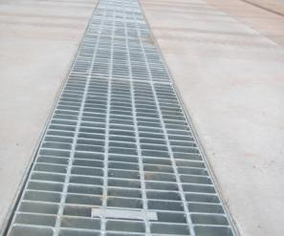

#### Figure 12 – Typical bike safe trench grate

# 13. Treatment of 100 year storm event within the development

All development designs mustcater for the 1 in 100 year storm event from within the development. Should underground drainage become blocked or exceeds design detention capacity the design must be able to manage what happens to the surcharging waters and overland flow. Large piped capacity or overland flow paths need to be designed and constructed to ensure overland flow will not impact on buildings and adjacent properties. Council will consider these requirements as part of their plan approval process.

Where **a safe overland flow** path can be provided to an appropriate point of discharge the overland flow path must be clearly shown on the plans. All overland flow paths must be designed within safety requirements set out by Melbourne Water. The safety requirement for flows overland is:

* Maximum allowable water depth is 0.35m
* Maximum allowable water velocity is 1.5m/s
* Melbourne Water safety ratio = Depth x Velocity = maximum of 0.35m²/s

Furthermore the design must demonstrate that the overland flow path levels do not affect any dwelling, garage or neighbouring properties.

Where **no safe overland flow** path can be provided, a larger pipe with 1 in 100 year capacity (for the development site catchment only) must be provided to an outlet at the lowest point of the property.

Calculations must be provided to demonstrate that the pipe has adequate capacity for the expected Q100 flow.

# 14. External overland flow and land subject to flooding

In addition to the changing weather patterns causing more frequent and severe storm events, run-off from increasing development intensity across Maroondah is causing an increased reliance upon overland flow paths to convey stormwater to major waterways such as Melbourne Water Creeks or pipelines.

A property may be subject to overland flow from external catchments and/or be land subject to flooding. Generally land subject to flooding from Melbourne Water drains or creeks will be covered by a Special Building Overlay (SBO) however this will not always be the case.

Council’s Engineers manage a flood model for Council’s drainage catchments and associated stormwater assets. Council’s flood model was produced in 2013 using LIDAR (Light Detection and Ranging) contour technology, Council’s detailed drainage asset information, Melbourne Water drainage and creek information and TUFLOW software. Council will rely upon this information when assessing a development proposal. Some developments may be identified as being subject to Council overland flow or inundation that are not currently covered by an SBO.

**If your property has a natural gully through it or an easement drain, it is suggested that you apply for a Property Information Certificate prior to formalising** **a planning permit application in order to determine if land is liable to flooding or overland flow.** Alternatively, you may contact Council’s Integrated Water Engineer on 9298 4229 for advice on whether a site may be subject to overland flow.

In accordance with Building Regulations 326(2), prior to a building permit being issued for building works, property development information will need to be obtained from Council to determine if the subject land is liable to flooding or overland flow.

Information regarding property development information can be obtained from Council’s website: <http://www.maroondah.vic.gov.au/PropertyInformation.aspx>

If the property development information identifies that the land is liable to flooding or overland flow, a property owner, or their representative, is required to obtain consent for the construction of a building/structure on the land. This is in accordance with Regulation 802 and 806 of the Building Regulations 2006.

Information regarding building on land liable to overland flow or flooding can be obtained from Council’s website:<http://www.maroondah.vic.gov.au/WaterProneLand.aspx>

## 14.1 Building on land liable to overland flow

### 14.1.1 Definition of overland flow paths

Council has classified land liable to overland flow into three broad categories, being:

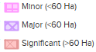

1. Minor overland flow paths,
2. Major overland flow paths, and
3. Significant overland flow paths.

The following map shows areas that are subject to minor, major and significant overland flow.

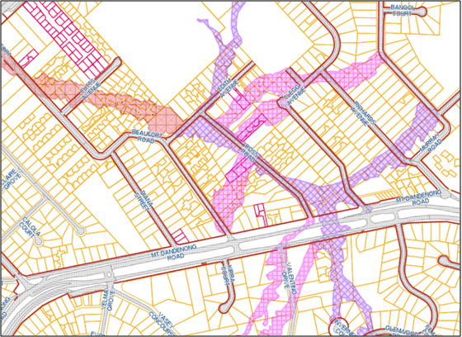

#### Figure 13 – Typical overland flow paths

Council’s definition of a **Minor Overland Flow path** is the inundation that occurs when the runoff from the catchment exceeds the capacity of the underground or piped drainage system and passes overland, and has a velocity times depth (V x D) less than 0.15 from a 100 Year storm event.

Council’s definition of a **Major Overland Flow Path** is the inundation that occurs when the runoff from the catchment exceeds the capacity of the underground or piped drainage system and passes overland, and has a velocity times depth (V x D) exceeding 0.15 from a 100 Year storm event.

Council’s definition of a **Significant Overland Flow Path** is similar to a major overland flow path but with a catchment greater than 60 hectares in area or attributed to by a Melbourne Water asset. A significant overland flow path will require a referral to Melbourne Water as part of any assessment and approval process.

Council’s Engineers can provide information as to the classification of an overland flow path.

### 14.1.2 Development impact on overland flow path

Council defines **Minor Impact** as development that encroaches an overland flow path, however is unlikely to deviate or block the flow of water as a whole.

Council defines **Major Impact** as development that partially blocks the overland flow path and is likely to deviate the flow of water causing the development, upstream, downstream and neighbouring properties to be negatively affected by the proposed changes.

Council defines **Significant Impact** as development that significantly blocks the overland flow path causing the development, upstream, downstream and neighbouring properties to be negatively affected by the proposed changes.

The following diagram provides an example of the various development impacts on the overland flow path.

### F:\Engineering & Infrastructure\Development Engineering\Drainage Guidelines\Flooding Example2.jpg

#### Figure 14 – Development impact on overland flow path

### 14.1.3 Treatment of overland flow paths

Each classification of overland flow path will require different degrees of assessment and treatment in order to ensure that the development, upstream, downstream and neighbouring properties are not negatively affected by the proposed changes.

The following matrix will provide guidance in regard to what assessment will be required as a minimum to be submitted to Council for assessment.

Note: Council does not guarantee that providing the following documentation or design outcomes will constitute approval of the development works, and reserves the right to request further information or refuse an application if it is deemed unacceptable with regard to the impact or risk associated with the overland flow.

|  |  |  |  |  |
| --- | --- | --- | --- | --- |
|  |  | **Development impact** | | |
|  |  | **Minor impact** | **Major impact** | **Significant impact** |
| **Overland flow path type** | **Minor** | - A safe unobstructed passage for overland flow path  - Freeboard | - A safe unobstructed passage for overland flow path  - Drainage report  - Drainage plans  - Freeboard | - A safe unobstructed passage for overland flow path  - Drainage report  - Drainage plans  - Freeboard ** |
| **Major** | - A safe unobstructed passage for overland flow path  - Drainage plans  - Freeboard | - Drainage report including flood modelling  - Drainage plans  - Freeboard **  **\*AU\*** | - Drainage report including flood modelling  - Drainage plans  - Freeboard **  **\*AU\*** |
| **Significant** | - A safe unobstructed passage for overland flow path  - Drainage plans  - Freeboard **  - Melbourne Water referral | - Drainage report including flood modelling  - Drainage plans  - Freeboard **  - Melbourne Water referral  **\*AU\*** | - Drainage report including flood modelling  - Drainage plans  - Freeboard **  - Melbourne Water referral  **\*AU\*** |

##### Table 13 – Requirements for developing on overland flow paths

** - In some instances of significant flooding, Council may require greater freeboard in accordance with Melbourne Water requirements.

**\*AU\*** - Approval Unlikely – It is unlikely that the proposed development works will be approved when there is major or significant impact of the overland flow path, even if the above information is provided.

### 14.1.4 Drainage report

If a development is proposed on land liable to overland flow or proposes to alter an overland flow path or pipe a Council overland flow path around or through the site, a formal drainage report and design including calculations must be prepared by a suitably qualified Civil Engineer, experienced in hydrology, and must be submitted to and approved by Council’s Engineers.

In some instances, Council’s Engineers may be able to provide a maximum volume of overland flow waters that is passing through the site. The drainage report must demonstrate that the proposed works on the site is designed to allow the overland flow to pass through the site and has adequate capacity for the volume of overland flow waters.

### 14.1.5 Drainage report including flood modelling

Further to the above drainage report, where there is major or significant impact on a major or significant overland flow path, the drainage report **must** include two-dimensional flood modelling using TUFLOW or an approved equivalent software product to demonstrate that the proposed works do not adversely impact the proposed development, adjacent, upstream and downstream properties or significantly change the current conditions.

The drainage report must provide depths and levels, in AHD datum, of the overland flow within the site and within neighboring properties prior to the development and after the proposed development has been modelled using the flood modeling software. This information will demonstrate the effectiveness of the proposed treatment and will provide level information to determine the required freeboard level for the dwellings and garages.

Council can provide data to the hydrology consultant, which will assist in the development of the flood modeling under a licensing agreement. Further information can be obtained from Council’s Integrated Water Engineer on 9298 4292.

Flood modelling works need to be completed to Melbourne Water’s best practice principles.

### 14.1.6 Freeboard

Freeboard is the difference between the floor level of a building and the 100 year flood level. Freeboard requirements are designed to ensure that valuable buildings and their contents and the people in them are safely above the 100 year flood level. Appropriate freeboard should be determined following consideration of the associated risks.

In most instances, unless otherwise agreed upon, Council will require freeboard to be provided as follows:

|  |  |
| --- | --- |
| **Building type** | **Freeboard above 100-year flood level** |
| Dwellings / buildings | 300mm |
| Outbuilding / garages | 150mm |

##### Table 14 – Typical freeboard requirements

Note: In some instances of significant flooding, Council may require greater freeboard in accordance with Melbourne Water requirements.

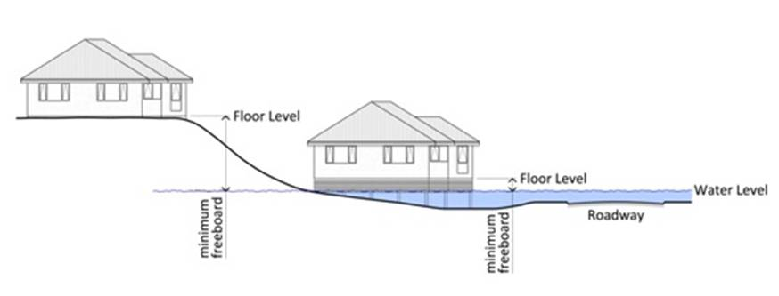

#### Figure 15 – Freeboard above flood level

### 14.1.7 Drainage plan requirements

If a site is liable to overland flow, a note or information MUST be provided on the drainage design plans showing the 'External Catchment Overland Flow Path'**.** The drainage plans must demonstrate that the requirements of the consent to build on land liable to overland flow has been met. This may include documenting any required earthworks, invert levels, floor levels, levy banks, retaining walls, catchment pits, pipes etc.

A copy of Council’s consent to build on land liable to overland flow, in accordance with Regulation 806 of the Building Regulations, must be provided with the paving and drainage plans unless the planning permit and development plans reflect and respond to the flooding matters.

### 14.1.8 A safe unobstructed passage for overland flow path

Where development works are occurring within an overland flow path, provisions must be made to allow the overland flow of water to pass through the site unobstructed. No structures such as retaining walls, sheds, roller doors or rainwater tanks should be constructed in a way that will block the flow of water through the site.

Provisions such as open fencing, large internal drainage or shaping the finished contours of the land to allow water to freely pass through the site should be designed and constructed to Council’s satisfaction. These measures should be included in the development plans, paving and drainage plans and landscaping plans as appropriate. It may also be required that the measures are protected indefinitely by requiring the creation of a Section 173 Agreement to title, that notes the measures and the ongoing need to protect them.

### 

### 14.1.9 Melbourne Water referral

Significant overland flow paths with a catchment greater than 60 hectares in size or attributed to by a Melbourne Water asset will require a formal referral to Melbourne Water as part of Council’s assessment process.

If a Melbourne Water referral is required, Council will notify the applicant of the statutory referral process to Melbourne Water, and the application will be put on hold until a response to the referral has been received.

### 14.1.10 Meetings with Council engineers

If an applicant/owner or their nominated civil engineer is unsure of the requirements and would like a meeting with Council’s engineers, a meeting can be arranged to discuss the proposed development. Please contact Council’s Engineering Administration Officer on (03) 9298 4292 to arrange such a meeting.

# 14.2 Building on land liable to flooding

In accordance with Building Regulations 326(2), prior to a building permit being issued for building works, if the property development information identifies that the land is liable to flooding, in accordance with Regulation 802 of the Building Regulations 2006, the property owner must apply to Council for consent to build on land liable to flooding.

Under Regulation 802 of the Building Regulations, Council is required to consult with the floodplain management authority, being Melbourne Water.

Upon receipt of Melbourne Water’s response, Council will issue a response to the report and consent application. Council may also impose conditions on the consent for properties that are subject to inundation. These conditions need to be considered as part of the design.

If development was referred to Melbourne Water under the Planning Permit within two years of the application under Regulation 802 of the Building Regulations 2006, and the proposal remains unchanged, Council is not required to re-refer the application to Melbourne Water.

**A copy of the consent to build on land liable to flooding, in accordance with Regulation 802 of the Building Regulations, must be provided to Council with the paving and drainage plans.**

Further information can be found on Melbourne Water’s website:

<http://melbournewater.com.au/Planning-and-building/Flood-and-planning-schemes/Pages/Flood-and-planning-schemes.aspx>

# 15. Building over an easement

In accordance with Regulation 310 of the Building Regulations 2006, a property owner, or their representative, is required to obtain consent for the construction of a building/structure, and for general construction works proposed over, or partially over an easement.

**Build Over Easement Consent must be obtained prior to approval of engineering plans and should be provided to Council with the paving and drainage plans.**

Build over Easement consent will be required from all authorities that have rights over that particular easement. For example: Council, Yarra Valley Water or Melbourne Water.

It is Council’s preference to avoid designing structures being built over an easement at the planning stage rather than applying to Council to obtaining consent to build over the easement.

Note: It is unlikely that Council will provide consent for the construction of major structures, such as garages, carports or pools over an easement.

A copy of Council’s Build Over Easement Policy, Technical Guidelines and application process can be found on Council’s website.

Refer to: <http://www.maroondah.vic.gov.au/BuildingOverEasement.aspx>

## 15.1 Private drains in easements

Private downpipe drains or drainage that are part of a development can be constructed within easements but should be avoided if at all possible (maximum pipe size 100mm diameter).

A below ground detention system **cannot** be located in an easement.

# 16. Calculating pipe or open channel capacity

## 16.1 Pipe Flow

Manning’s formula is the accepted method for determining pipe capacity (hydraulics).



Where the parameters are:

V = mean velocity of flow (m/s)

R = hydraulic radius (m) (D/4 for pipes flowing full)

D = internal diameter of the pipe (m)

S = hydraulic grade (as a decimal) (i.e. 1 in 80 = 0.0125)

n = roughness coefficient (0.013 for concrete pipes, 0.012 for PVC pipes)

Q = peak flow rate (m3/s)

A = Area of pipe (m2)

### 

### 16.1.1 Worked Example: of Manning’s formula to determine pipe capacity

A 150mm UPVC pipe running at a 1 in 80 grade



Formula:

Where: R = 0.015m

S = 1/80 = 0.0125

n = 0.012

A = πD2 / 4 (Where π = 3.142 & D = 0.15)

Q =

Q = 0.018448 m3/s or 18.448 L/s

## 16.2 Channel Flow

Check overland flow paths using the below formula:



Where the parameters are:

Q = peak flow rate (m3/s)

R = hydraulic radius (m)

S = slope (as a decimal) (i.e. 1 in 80 = 0.0125)

n = Manning’s No. = 0.03

A = Maximum flow area (m2)

P = Wetted perimeter (m)



Hydraulic Radius

For trapezoidal channels



### 16.2.1 Worked Example: of Manning’s formula to determine channel flow capacity

2.6 m

A 1 in 40 grade open channel with the following dimensions:



0.2 m

Formula:

0.5 m

Where: A = 2.6 m

B = 0.5 m

B = 0.5m

H = 0.2 m

A = 0.31 (2.6+0.5)/2 x 0.2

S = 1/40 = 0.025

n = 0.03

P = 2.64 m

R = A/P = 0.31 x 2.64 = 0.1174

Q =

= 3.285 m3/s

# 17. Erosion and Sediment Control

Council requires that all development designs must incorporate 'Best Practice Environmental Management Guidelines for Urban Stormwater'. Details of the techniques to be implemented **must be shown and noted on the paving and drainage plans** to Council’s satisfaction.

These controls will generally be required on a planning permit as follows:

***Control Sediment Laden Run Off***

During the construction of the development, methods to control sediment laden runoff as described under ‘Best Practice Environmental Management Guidelines for Urban Stormwater’ or similar must be implemented and used to minimise sediment laden runoff and stormwater pollution from leaving the land to the satisfaction of the Responsible Authority.

If the required sediment laden run off controls are not adhered to, the builder and owner may be subject to enforcement action by Council’s Planning Enforcement officers.

## 17.1 Why is erosion and sediment control important?

Soil erosion and sediment runoff from development sites is a major environmental issue. Sediments washed into waterways negatively impact the local ecosystems and the flora and fauna that inhabit them. Another result of sediment pollution is the blocking of stormwater drains which can lead to an increased risk of flooding.

The benefits of effective erosion and sediment control include; protection of the environment, improved wet weather working conditions and a reduction in clean up costs.

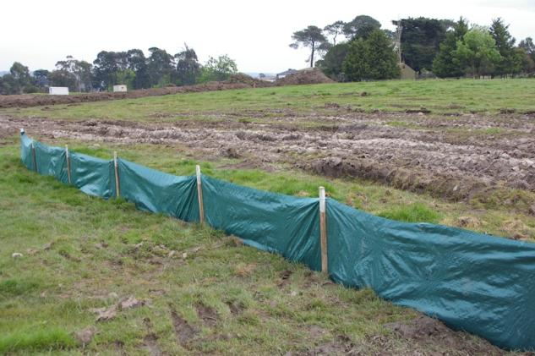

#### Figure 16 – Typical silt fence installation

## 17.2 When do erosion and sediment controls need to be in place?

Control measures need to be installed before excavation or site disturbance and need to be maintained in good working order throughout the duration of the construction or development works.

## 17.3 Minimum required erosion and sediment controls

Details of the techniques to be implemented must be shown and noted on the paving and drainage plans to Council’s satisfaction. Minimum details that must be demonstrated on the plans include:

* Install geotextile sediment fence(s) along the low side of the site. (Refer adjacent typical erosion control fence diagram)
* Provision of temporary property drainage outlet during construction.
* Protection of temporary property drainage outlet from sediment.
* Associated notes of how the provisions should be implemented during construction.

# 

#### Figure 17 – Typical erosion control details

# 18. Water Sensitive Urban Design (WSUD)

Council supports the principles of Water Sensitive Urban Design (WSUD) and requires the drainage design to incorporate these principles where applicable.

In general, for small developments (under 10,000m2 in area), complex WSUD treatments are not appropriate with the exception of rainwater tanks for reuse purposes.

If a WSUD system is approved within a private development, an appropriate Section 173 Agreement for ongoing operation and maintenance must be established by the owner and approved by Council.

## 18.1 Achieving best practice runoff requirements for development only (no subdivision)

Generally not required, unless otherwise specified in the Planning Permit. If specified in the permit, refer to section 18.3.

## 18.2 Achieving best practice runoff requirements for residential subdivision.

As noted in section 5.2 residential subdivisions shall be designed in accordance with Clause 56 of the planning scheme. Achieving best practice runoff can be done in several ways:

1. Provision of WSUD elements that achieve best practice (refer to section 18.3).
2. Payment of levies to Melbourne Water in lieu of achieving best practice. (These are only applicable to developments less than 10,000m2 OR any development within a MW regional scheme which has water quality provided within the scheme.)
3. A combination of both the above.

## 18.3 Provision of WSUD elements to achieve best practice

WSUD shall be prepared in consultation with Council's Engineering and Environmental Planning Departments and in accordance with the requirements of Melbourne Water's publication "WSUD Engineering Procedures". Designs should meet Urban Stormwater: Best Practice Environmental Management Guidelines, CSIRO 1999 and WSUD Engineering procedures Stormwater CSIRO 2005 to achieve the following water quality standards:

* 80% retention of the typical urban annual load for Total Suspended Solids (TSS)
* 45% retention of the typical urban annual load for Total Phosphorus (TP)
* 45% retention of the typical urban annual load for Total Nitrogen (TN)
* 70% retention of the typical urban annual load for Gross Pollutants (litter)

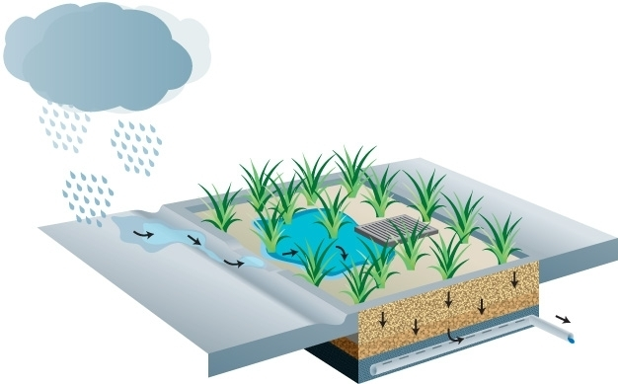

#### Figure 18 – WSUD rain garden concept

**Please note: Generally these elements are not appropriate for developments under 10,000m2 in area with the exception of rainwater tanks.**

WSUD computations from a WSUD design program such as MUSIC (or a similar program) must be submitted to Council to verify the overall WSUD design of the development.

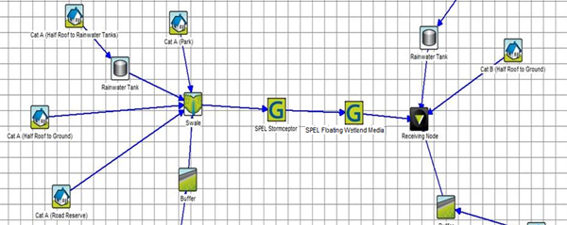

#### Figure 19 – Typical MUSIC model

The Melbourne Water online tool ‘STORM’ can be used to assess whether best practice water quality objectives have been achieved for your site.

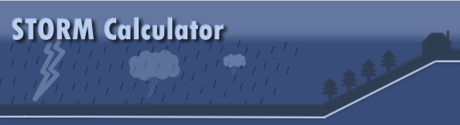

#### Figure 20 – STORM calculator

<http://storm.melbournewater.com.au/>

## 18.4 Rainwater tanks

Rainwater tanks that are for re-use (connected to garden taps, toilets and laundries) are considered part of a WSUD, however rainwater tanks that are for detention purposes only are not considered part of WSUD.

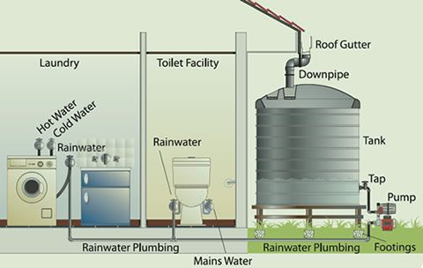

#### Figure 21 – Rainwater tank used for reuse

A tank can be used to perform both functions. This detail should be provided on the drainage design plan being submitted for Council approval. Additional details on the use of rainwater tanks can be found under section 9.4.2.

Note: Council’s Engineers will require **a minimum of 2000L of re-use** to be maintained in all rain water tanks beyond the allowable detention volume.

## 18.5 Payment of levies to Melbourne Water in lieu of achieving best practice

In accordance with Clause 56.07-4 of the Planning Scheme, if a residential subdivision is less than 10,000m2 in area, payment of levies to Melbourne Water in lieu of achieving best practice may be possible.

Monies collected by payment of levies are utilised by Melbourne Water to provide regional water quality works, undertaken elsewhere within the catchment, to offset pollution loads not treated within the development. Further information can be found on Melbourne Water’s website: www.melbournewater.com.au

# 19. Driveway construction

Details of the driveway construction must be shown on the paving and drainage plans. The details must include, but not be limited to, the dimensions, levels, grades and composition of the driveway construction. If a car park is part of the development, the signage and linemarking details must also be included on the plans.

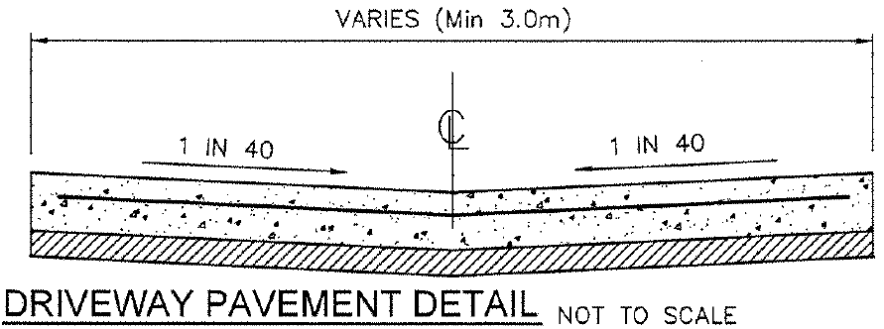

#### Figure 22 – Typical driveway pavement detail

## 19.1 Dimensions of driveways

Basic dimensions of the driveway must be shown on the paving and drainage plans to demonstrate consistency with the approved development plans and compliance with the Planning Scheme minimum dimensions and radiuses. Dimensions must be shown at least the following locations:

* Width of the driveway at the vehicle crossing
* Width of the vehicle crossing
* Width of the driveway at the garages/carports
* Width of the driveway at any narrow points
* Offsets from adjacent boundaries, buildings, infrastructure or established vegetation
* Radiuses of critical driveway curves.

Driveways and access ways are required to be a minimum of 3.0m in width.

## 19.2 Levels and grades of driveways

Levels and grades of the driveways must be provided to demonstrate how the driveway will operate from a drainage and functional perspective.

Driveway levels should be provided at garages; vehicle crossings; and at pits as required, to demonstrate the drainage of the driveway.

Where driveways are proposed to be constructed at steep grades, the grades of the pavements and vehicle clearance diagrams are required to demonstrate that a standard B85 vehicle would not scrape or bottom-out.

## 19.3 Driveway pavement composition

A typical pavement section must be provided to demonstrate the composition of the internal pavement.

Note: Council’s preferred minimum internal paving standard includes:

* 125mm depth concrete (25Mpa) with SL72 reinforcement centrally placed on a 50mm compacted depth 20mm class 3 crushed rock/crushed concrete
* 40mm compacted depth of 10mm nominal size type N asphalt on 150mm compacted depth 20mm class 2 crushed rock.

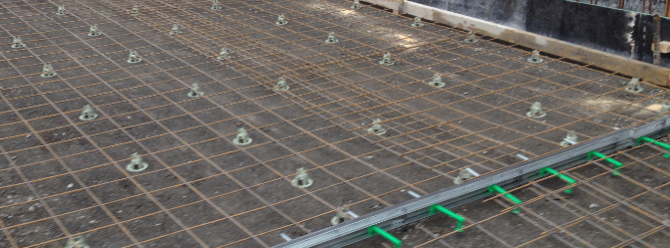

#### Figure 23 – Driveway construction

## 19.4 Low impact paving

Where low impact paving materials are proposed to be constructed on the development or landscape plans, the paving and drainage plans must show the location of the low impact paving and refer to the landscape plan for details of the materials, compositions and construction techniques.

A typical note must be placed on the plans as follows:

*“Refer to the Planning Permit and endorsed landscape plans for low impact paving construction methods.”*

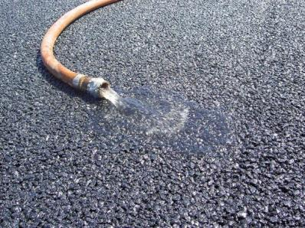

## 

#### Figure 24 – An example of low impact pervious pavement

## 19.5 Vehicle crossing details

If the planning permit requires the construction or reconstruction of a vehicle crossing, or if the Engineering department determines that the vehicle crossing is not in a suitable condition, the whole vehicle crossing must be shown to be constructed to Council’s standard SD-H05 on the paving and drainage plans. The plans must:

* Show the full vehicle crossing layout to Council’s standard SD-H05, including adjacent footpath panels.
* Note on the plans that the vehicle crossing must be constructed to Council’s standard SD-H05 or SD-H03 for industrial or heavy use applications.
* Show the removal of any redundant vehicle crossings including the reinstatement of the kerb and channel and naturestrip.

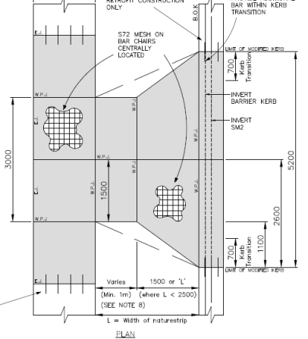

#### Figure 25 – Sample vehicle crossing

Further information regarding vehicle crossings can be obtained from Council’s website:

<http://www.maroondah.vic.gov.au/VehicleCrossing.aspx>

Vehicle crossing standards are available on Council’s website:

## <http://www.maroondah.vic.gov.au/EngineeringStandardDrawings.aspx>

## 19.6 Car park signage and linemarking

If a car park is being constructed, signage and linemarking details must be included on the plans to Council’s satisfaction. The signage and linemarking details must comply with the following standards:

All **off street** **car parking** spaces must comply with the requirements of AS2890.1:2004 - Parking Facilities - Off-street Car Parking and / or Clause 52.06 of the Maroondah Planning Scheme.

All **disabled parking** space dimensions and access to the spaces must comply with the requirements of AS2890.6:2009 - Parking Facilities - Off-street Parking for People with Disabilities.

All **internal Signage and Linemarking works** must be in accordance with AS1742.2:2009 Manual of Uniform Traffic Control Devices - Part 2: Traffic Control Devices for General Use and AS2890.1:2004 - Parking Facilities - Off-street Car Parking.

All **external Signage and Linemarking works** must be in accordance with AS1742.2:2009 Manual of Uniform Traffic Control Devices - Part 2: Traffic Control Devices for General Use and AS2890.5:1993 - Parking Facilities - On-street Car Parking.

All proposed **on-site loading facilities** must comply with the requirements of AS2890.2:2002 - Parking Facilities - Off-street Commercial Vehicle Facilities and / or Clause 52.07 of the Maroondah Planning Scheme.

All proposed **bicycle parking facilities** must comply with the requirements of AS2890.3:1993 - Parking Facilities - Bicycle Parking Facilities and / or Clause 52.34 of the Maroondah Planning Scheme.

## 20. Required notes on paving and drainage plans

The following minimum notes are to be provided on paving and drainage plans:

*“All works to be carried out in accordance with the Council approved plans”*

*“All external paving and drainage works to be in accordance with Maroondah City Council’s standards and specifications, to the satisfaction of Council”*

*“All internal drainage works to be in accordance with AS/NZS:3500.3 2003 – Part 3 Stormwater Drainage Systems & in accordance with the manufacturers specifications”*

*“All levels are in metres to Australian Height Datum (AHD”)*

*“Contractor to prove drainage outlet level prior to commencement of works”*

*“The property owner is responsible for the continuing operation, maintenance and replacement of the rainwater tank system in accordance with the approved plans and must allow Council access to inspect the system.”* (Use whenever a rainwater tank is installed).

*“Refer to the Planning Permit and endorsed landscape plans for low impact paving construction methods.”* (Use only where low impact paving is required).

# 21. Lodging of drainage design plans to Council for approval

When lodging drainage design plans for a development, the following should be provided to Council for approval:

* A completed copy of the design submission checklist (refer Engineering Development Design Checklist)
* 3 sets of drainage design plans
* 1 copy of drainage calculations including:
  + Rational method calculating the PSD
  + Drainage detention volume calculation (using Swinburne OSD Methodology)
  + Justification of how the detention volume storage is distributed
* Payment of plan checking fee
* A copy of legal point of discharge (refer section 6)
* A copy of other approvals (for example: a build over easement consent)

**Please note: At this stage Council does not accept drainage plans submitted electronically.**

## 21.1 Payment of plan checking fee

Council will require payment of Engineering plan checking fees prior to approving plans and suggests that cheques (made payable to "Maroondah City Council") be lodged with the plans.

The fee structure is available on Council’s website at:

<http://www.maroondah.vic.gov.au/EngineeringFees.aspx>

## 21.2 Paving and drainage plans size and format

Three hard copies of paving and drainage plans must be submitted to Council for approval. Council’s preference is that the plans should be submitted on standard A1 paper and folded to fit into an A4 folder.

If however the development is of a small scale then A3 plans are acceptable only if the number of A3 pages is 3 or less, the details are clearly legible and there is sufficient clear room to stamp the plans for approval.

**Please note: Council reserves the right to require different sized paving and drainage plans if the details are clearly illegible and there is insufficient clear room to stamp the plans for approval.**

# 22. Construction works

**A copy of the approved plans should be kept on site at all times during construction works.**

There may be a number of permits that will be required during the construction of the approved works, which will incur additional costs. These include:

## 22.1 Road/asset opening permit

A road/asset opening permit is required to be taken out by the property owner or representative prior to any opening up the footpath, naturestrip or kerb and channel, to connect to various services in the road reserve, Council reserve, or easement.

Details are available on Council’s website at:

<http://www.maroondah.vic.gov.au/RoadOpeningPermit.aspx>

## 22.2 Vehicle crossing permit

A vehicle crossing permit is always required when a new vehicle crossing or footpath is to be constructed, or an existing crossing is to be relocated or modified. Prior to a permit being issued, crossover works must be approved by Council.

Details are available on Council’s website at:

<http://www.maroondah.vic.gov.au/VehicleCrossing.aspx>

## 22.3 Traffic management/road and footpath closure permits

Builders and contractors planning to undertake works on Council-owned roads, footpaths or naturestrips, are required to have a road and/or footpath closure permit before works commence.

Works may include:

* Road openings
* Vehicle crossings
* Service connections
* Landscaping works.

Under the provisions of the Road Management Act, they will be responsible for the safety of motorists and pedestrians during the works, as well as during any reinstatement works.

Details are available on Council’s website at:

<http://www.maroondah.vic.gov.au/RoadFootpathClosurePermits.aspx>

# 23. Inspection of completed works

Before the development is occupied, the drainage and associated works shown on the approved plans must be constructed in accordance with the approved plans to the satisfaction of the Responsible Authority.

Within 14 days of the completion of the works, certification by a suitably qualified engineer registered with the Building Practitioners Board in the category of Civil Engineer, must submit a **Certificate of Compliance - Inspection** pursuant to the Regulation 1507 of the Building Regulations, to the Responsible Authority certifying that works have been completed in accordance with the paving and drainage plans.

In addition, and following the submission of the Certificate of Compliance - Inspection, an **Inspection by one of Council's Development Engineers** is required upon completion of all works and before the Statement of Compliance is issued for any approved building.

To book an engineering inspection, please contact Council's Engineering Department on 9298 4292, a minimum of 24 hours prior to appointment.

A Planning Infringement Notice may be issued if the works are not complete or in accordance with the approved planning and drainage plans.

# 24. Engineering Development Design Checklist

**Drainage**

* Copy of Legal Point of Discharge obtained
* PSD calculated using the Rational method
* Drainage detention volume calculated using OSD4
* Detention storage distributed proportionally between pipes, pits and tanks
* Orifice size calculated
* All drainage pits are a minimum size of 450x450mm (Aus. Standards)
* Bike safe grated pit lids are fitted to all pits in trafficable areas
* Pits for surface water collection are provided in the backyard of proposed new dwellings
* All pits and pipes are in accordance with Australian or Council Standards
* Silt control measures shown on plan
* Internal overland flow path for a 1 in 100 year ARI storm event shown on plan
* Appropriate flood mitigation measures show on plans in accordance with these guidelines (if required)

**Pavement**

* All pavement dimensions, grades and compositions shown on plan
* Ensure vehicle crossing is constructed to Council standards, it is noted and shape is shown on plan
* If low impact paving is shown on development and landscape plans, show extent and notes on plan

**General**

* Plans are consistent with approved development plans
* Copy of any other approvals provided (Build Over Easement / Land liable to Overland Flow etc)
* All required notes are shown on the plans
* 3 folded sets of plans
* Plan checking fee paid