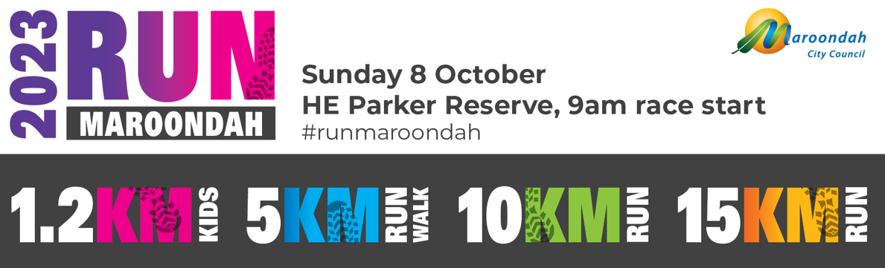

**Frequently Asked Questions**

1. What is Run Maroondah?

2. Where can I look at a map of the course?

3. What are the distances I can run/walk?

4. How long does the event take to complete?

5. Do we get times/places?

6. How do I enter?

7. What is the Agreement, Waiver & Acknowledgement form (Registration form)?

8. What is the minimum age required to participate?

9. What comprises a family entry?

10. How safe is Run Maroondah?

11. How do I identify a course Marshal?

12. Do I need any special equipment?

13. Where will I run/walk?

14. What if you have a medical or physical condition?

15. What does participation in Run Maroondah cost?

16. Is there a cut off date for registration?

17. Can I get a refund?

18. What happens if there are extreme weather conditions?

19. What should I bring?

20. What should I do before the day?

21. What should I do on the day?

22. What is the running schedule of the day?

23. Will my family & friends be able to watch me?

24. What do I do with my belongings?

25. What happens after the event?

26. Do I have to do any special training?

1. **What is Run Maroondah?**

Run Maroondah is a timed event that consists of a 15 km run, 10 km run, 5km run/walk and 1.2 kids dash walk/run organised by Maroondah City Council. The aim of this event is to encourage individuals, families and children to challenge themselves in physical activity together. It’s about having a go and enjoying yourself.

**2. Where can I look at a map of the course?**

Course map is available online at the Run Maroondah webpage.

**3. What are the distances I can run/walk?**

There are four race distances, 1.2 km kids dash, 5km, 10 km and 15km.

**4. How long does the event take to complete?**

It is estimated on average the 1.2km children’s run will take approx. 10 minutes, 5 km run will take approx 35 minutes and the 10 km run will take approx 1 hour and 15 minutes and 15km will take approx. 1 hour and 50 minutes. Please remember to participate at a level that is comfortable for you & your participating family members.

**5. Do we get times?**

Run Maroondah 5km, 10km and 15km is a timed event. Times will be available online, following the event. A results link will be provided on the Run Maroondah webpage.

**6. How do I enter?**

You can enter via online registration, available on the Run Maroondah web page.

**7. What is the Agreement, Waiver & Acknowledgement form (Registration form)?**

The agreement, waiver & acknowledgement form (registration form) is a document you must read carefully & understand before you sign it. It advises you the participant of your legal rights and Terms & Conditions of entry. If you are under the age of 18 on the event day your parent/guardian must sign it.

**8. What are the age requirements?**

**Age Requirements**

* All ages welcome for family registration provided one participant is 18 years.
* Kids 1.2km race, open to children 13 years of age and under.
* Individual registrations must be over 12 years of age.
* Children in prams who are not actively participating are free and not required to register.

**9. What comprises a family entry?**

A family entry is a **minimum** of one adult & one child. A family entry can however consist of up to 4 participants (extra participants are $10 each).

**10. How safe is Run Maroondah?**

Please pace yourself to ensure you do not over exert yourself & keep up your fluid intake during the event. A moderate level of fitness is required. A registered first aid provider, will be in attendance and marshals/volunteers are situated throughout the Run Maroondah course.

**11. How do I identify a course Marshal?**

The Marshals & Run Maroondah volunteers will be wearing highly visible vests. They are there to help you & instruct you if necessary. There is also qualified first aid provider in attendance with a registered pass and high visibility vest. Please listen & obey any instruction/direction they give you.

**12. Do I need any special equipment?**

Please refer to Question 19.

**13. Where will I run/walk?**

Please see a detailed course map online.

The 1.2 km will start at HE Parker reserve run a short distance along the Dandenong Creek Trail and finish with a lap of HE Parker Oval number 2. The 5 km, 10 km and 15km will also start at HE Parker Reserve in Heathmont and run along the Dandenong Creek Trail finishing on HE Parker Oval number 1.

**14. What if you have a medical or physical condition?**

On the entry form there is a section requesting details regarding medical & physical conditions you must provide all necessary details & if there is any doubt regarding your ability to participate speak to your GP to ascertain if you are fit to participate.

**15. What does participation in Run Maroondah cost?**

Entry fees

1.2km Kids Dash - $15 per child (under 14 years)

15km run - $36 per individual, $31 concession

10km run - $31 per individual $26 concession

5 km run/walk $26 individual, $20 concession, $57 per family* (family is up to 4 participants, additional family members $10 per extra participant)

**Late fee: Commences Saturday 30 September, $10 additional per entry**

*Family entry = minimum 1 adult and 1 child, maximum 4 people including one adult - extra participants $10 each. *Children in prams who are not actively participating are free and not required to register.

**16. Is there a cut-off date for registration?**

Registrations close online midnight Friday 29 September 2023

**17. Can I get a refund?**

No refunds will be issued, should you not be able to participate. Maroondah  
City Council will offer a transfer of name. In the event of cancellation, due to heat, extreme  
weather or fire policies by Maroondah City Council, the event may be rescheduled, if the event is not rescheduled, refunds will be issued to all entrants.

**18. What happens if there are extreme weather conditions?**

If there are extreme weather conditions all participants are advised to check the Run Maroondah event webpage, the day prior and on the morning of the event. All attempts will be undertaken to advise participants via email if the event is cancelled. Please ensure you check your email, prior to arriving at the event.

**19. What should I bring?**

* Running shoes. Shoes must cover your feet no sandals/thongs
* Sunscreen & a hat or a cap
* Bottle of water
* Warm clothes for after the event
* Medication if required
* Please label all items & do not bring any valuables. Maroondah City Council & associated volunteers with the event take no responsibility for loss/damage of entrant’s possessions.

**20. What should I do before the day?**

Before the day you should, if possible, familiarise yourself with the course and make sure your bag is packed the night before.

**21. What should I do on the day?**

Arrive on time; come wearing your race bib, ensure that you allow sufficient time to make your way to the start line and warm up prior to your run.

**22. What is the running schedule of the day?**

You will need to be registered and be assembled at the start line by no later than 10 minutes prior to your start time**.** A briefing will occur at the assembly area and the run will commence. After you have completed the run/walk a light breakfast will be served.

**23. Will my family & friends be able to watch me?**

Your family and friends will be able to support and cheer you on at the start and finish line to cheer on participants during the final stage of Run Maroondah. Viewing is not permitted around the Dandenong Creek Trail during run.

**24. What do I do with my belongings?**

A bag drop is available; however, it is strongly advised please do not bring any valuables to the Run Maroondah event. No responsibility will be taken for loss or damage to items/property.

**25. What happens after the event?**

Upon completion you will receive healthy refreshments and be issued with a medal of participation.

**26. Do I have to do any special training?**

It is advised you undertake training including some practice run/walks and in accordance with the entered event distance.

**On behalf of Maroondah City Council congratulations on your decision to participate in Run Maroondah, ENJOY! If you require further information, please do not hesitate to telephone the Leisure team on 1300 88 22 33.**