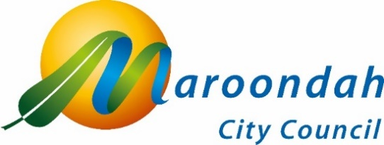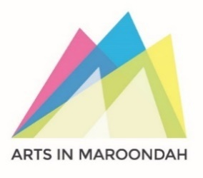

Artist Expression of Interest
CROYDON CULTURAL HUB
PUBLIC ART COMMISSION

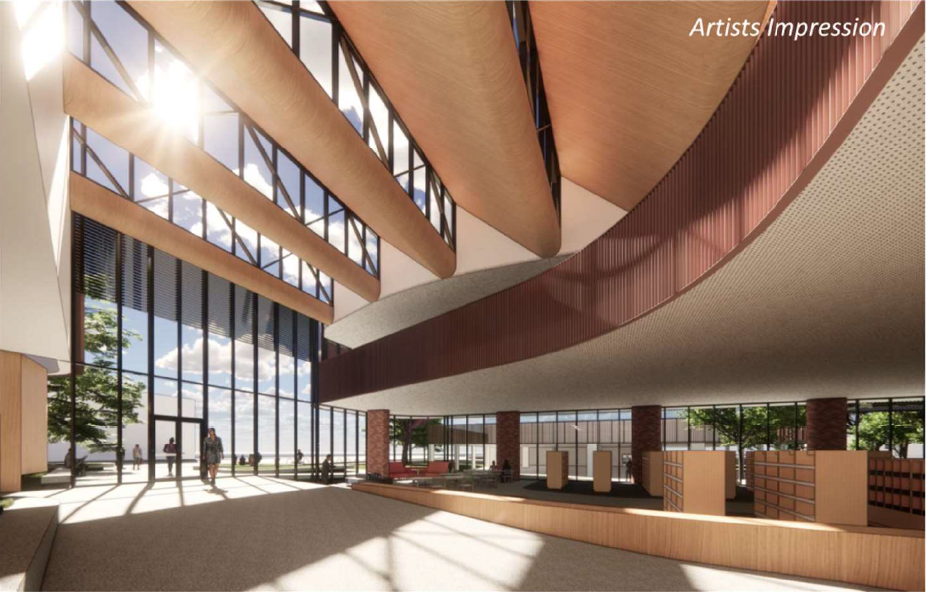
Image: Artist’s impression of the entry foyer for Croydon Cultural Hub.

Acknowledgement of Traditional Owners
We, in the spirit of Reconciliation, acknowledge the Wurundjeri People of the Kulin Nation as traditional custodians of the land now known as the City of Maroondah, where Indigenous Australians have performed age-old ceremonies. We acknowledge and respect their unique ability to care for Country and their deep spiritual connection to it. We pay our respects to their Elders, past, present and emerging.

Public Art Commission Opportunity
Council is seeking expressions of interest from suitably experienced contemporary public artists to develop and install works for the interior area of the forthcoming Croydon Cultural Hub. This new precinct in the heart of Croydon will include integrated indoor and outdoor spaces that provide activation, inspiration and empowerment. It will be a village of connection, belonging, safety and learning.
The Cultural Hub is the first major infrastructure development within this precinct and will be a contemporary mixed-use facility housing a 180-seat black box theatre and box office bar, a Café, Council’s customer services, a health and wellbeing co-working tenancy hub, bookable meeting spaces and new home for Your Library Croydon. The hub has been architecturally designed to maximise visitor experience and accessibility, offering ample natural light, creative features and rooflines and engaging spaces across two levels.
A total of $220,000 (excluding GST) is available for this public art commission. We encourage representation from a wide range of artists, and artists working collaboratively are also welcome.
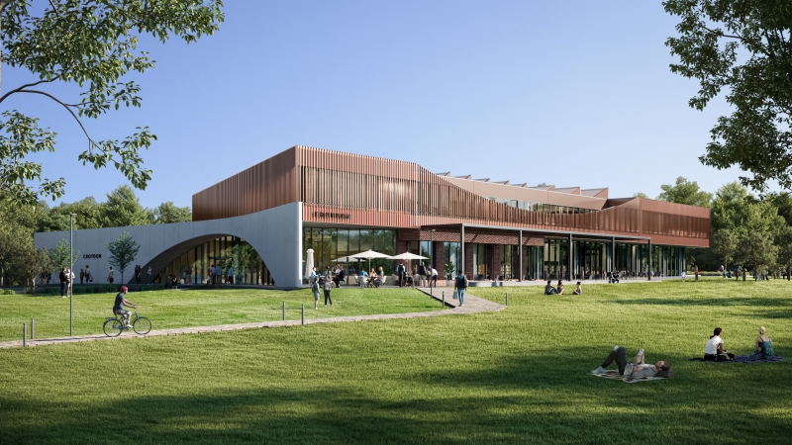
Image: Artist’s impression of exterior of Croydon Cultural Hub from rear of building

Background

Council’s support for public art in Maroondah
Maroondah City Council supports public art throughout the community as a way of enhancing the municipality’s cultural vibrancy and creative placemaking. Guided by Maroondah’s Public Art Policy, the Creative Maroondah Strategy 2026-2030 and the Maroondah 2050 vision for cultural vitality, public artworks respond to the community’s desire for traditional and contemporary art forms in public places. Maroondah’s growing collection of indoor and outdoor public art enriches the public realm and the community’s experience of and connection with these spaces.

What is the Croydon Cultural Hub?
The Croydon Cultural Hub will be built on the corner of Mt Dandenong Road and Civic Square. It will serve as a central gathering place, offering a range of services for the community including a state-of-the-art library, black box theatre and events space, multipurpose rooms, meeting spaces, Council Service Centre, café and more.
The hub will also retain the heritage frontage of EV’s Youth Centre, paying tribute to and celebrating Croydon’s history and character whilst ensuring the new spaces are modern, sustainable, inclusive and fit-for-purpose.
Council has received funding from the Australian Government to help fund this project. This funding will help ensure the black box theatre and event space will meet the needs of Maroondah's different community groups now and into the future.
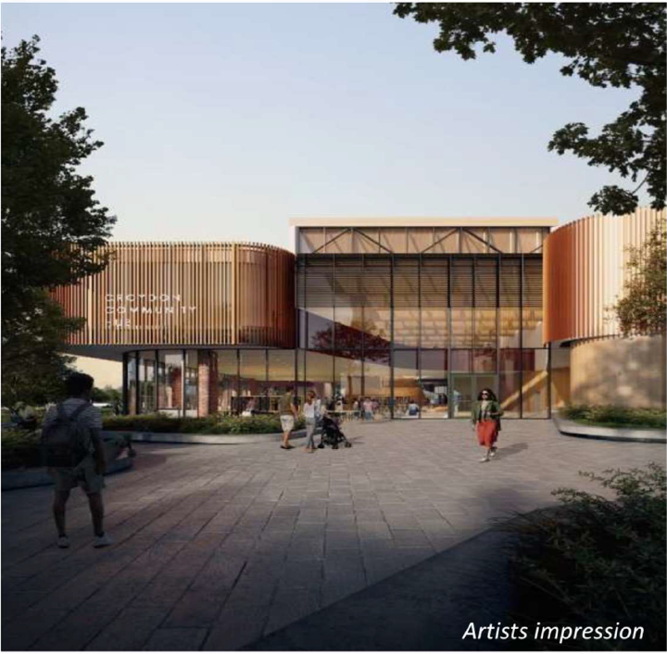

Image: Artist’s impression of the exterior of Croydon Cultural Hub.

About the Opportunity

Public Art Parameters
The follow design parameters exist for this project:
- The public artwork will be contemporary in design, will complement the building architecture and bring interest to the internal areas of this important cultural venue and community meeting place, connecting with the building, site and community.
- The artwork will be situated on the ground level of the building and be safe for public interaction, occupying space without reducing access or movement through space.
- Artists will be encouraged to consider the presence of the work at night and day and the possibility of lighting the work.
- Roofline, elevated or suspended works will need to comply with weight bearing capacities of the building, with heavy load bearing works discouraged.
- Artists are encouraged to consider the site information provided in below in order to provide a site responsive design proposal.
- Artists can propose one, two or more artworks as part of the overall commission.
- Supported mediums for this project include textiles, lighting, ceramics, glass, steel, perspex, paint, vinyl adhesives, wood and bronze.

Key Public Art Principles
The work will consider the principles for public art as provided by the Maroondah Public Art Policy, including:
- Structural Integrity and Safety: Public art will meet relevant engineering, safety, durability and maintenance requirements and comply with applicable regulations and standards.
- Site Responsiveness: Artwork will be place-based and respond to the site, environment and community in which it is located.
- Relevance: Public art will reflect the shared values, identity and aspirations of our community.
- Diversity, Equity and Inclusion: The public art program will support accessibility and representation of diverse artists, communities and perspectives.
- First Peoples Engagement: Public art will aim to support meaningful engagement with and celebration of First Peoples, including culture, storytelling, artistic practice and connection to Country.
- Sustainability: Environmental impacts will be considered across the artwork lifecycle, including material selection, installation, maintenance and decommissioning.
- Best Practice and Innovation: Council will apply leading methodologies and contemporary industry standards in the commissioning and management of public art.

Key Selection Criteria
- Innovation, creative excellence in previous work (include up to five examples)
- Ability to present a structurally sound, sustainable design that takes into account the site-specific logistics
- Ability to connect to the context of the location in ways that are accessible for a broad audience as demonstrated in previous works (this may take the form of architectural, historical, cultural, social, spiritual, landscape / open space or geographical references)
- Experience completing public art projects with a lifecycle of 20 years +
- Ability to work efficiently as part of a larger team and within the timeline and requirements of Maroondah City Council which includes:
- ABN and Public Liability Insurance of minimum $20 million
- Ability to deliver a workplan and maintenance manual using materials and methodology that minimises future wear and tear
- Ability to deliver a comprehensive risk assessment and safety plan for the project
- Ability to work to key timelines and budget parameters

Project Timelines
Key dates include:
Artist Brief distributed | Wednesday 26th August 2026
Recommended information session:  rsvp to publicart@maroondah.vic.gov.au | Tuesday 8th September 11.00am 2026  Saturday 12th September 11.00am 2026  Meeting Point:  Entry Foyer  Croydon Hub B, 7 Civic Square, Croydon VIC 3136
Artist expression of interests due:  to publicart@maroondah.vic.gov.au | Tuesday 22nd September 2026 11.50pm
Selection panel process | Wednesday 23rd September – Friday October 9th 2026
Shortlisted artists confirmed | Monday 12th October 2026
Concept Proposals due | Tuesday 3rd November 2026
Final commissioned artist confirmed | Tuesday 24th November 2026
Design Development | November 2026 – January 2027
Fabrication | February – April 2027
Installation | May 2027
Launch | TBC 2027

How to Apply
Applicants interested in applying for this opportunity are encouraged to attend the information sessions at the times listed above at Croydon Hub B, Civic Square, Croydon.
Expressions of interest must include:
- 1 page letter addressing Key Selection Criteria above
- CV demonstrating appropriate experience and skills delivering similar works/ projects
- Up to 5 x images of relevant previous ork, with emphasis on works in public space
- Contact details for two referees
Expressions of Interest to be sent to:
Jane O’Neill
Public Art Lead
Maroondah City Council
Email: publicart@maroondah.vic.gov.au
Any telephone queries can be made to 0436 442 036 from Monday to Thursday.
Applications close at 11.50pm on Tuesday 22nd September 2026.
Maroondah City Council adopts an inclusive approach. If there are challenges providing the above information for the EOI please contact the Public Art Department above.

Selection Process
A panel of Maroondah City Council representatives will assess Expressions of Interest to shortlist a number of artists based on the Selection Criteria. Shortlisted artists will be paid a $1,500 fee to develop a Concept Proposal including budget between August - September 2026 for consideration. The final artists will be confirmed and commissioned in November 2026.

Budget Provisions
Artists will only be required to submit a proposed budget if shortlisted for the Concept Proposal process. The fee will need to outline a detailed breakdown of costs including materials, artist fee, insurances and installation. In some cases, Maroondah City Council may be able to assist with circuitry costs in order to realise the work.
The total maximum fee available for the commission is $220,000 (excluding GST). Artists are welcome to propose one, two or more works as part of the total commission budget.

Appendix 1: SITE INFORMATION
Image: Artist’s impression of the exterior of Croydon Cultural Hub from rear of building.

SITE INFORMATION

When assessing the site information below, applicants are reminded to revise the design parameters on page 4, noting the requirements for contextually appropriate artworks

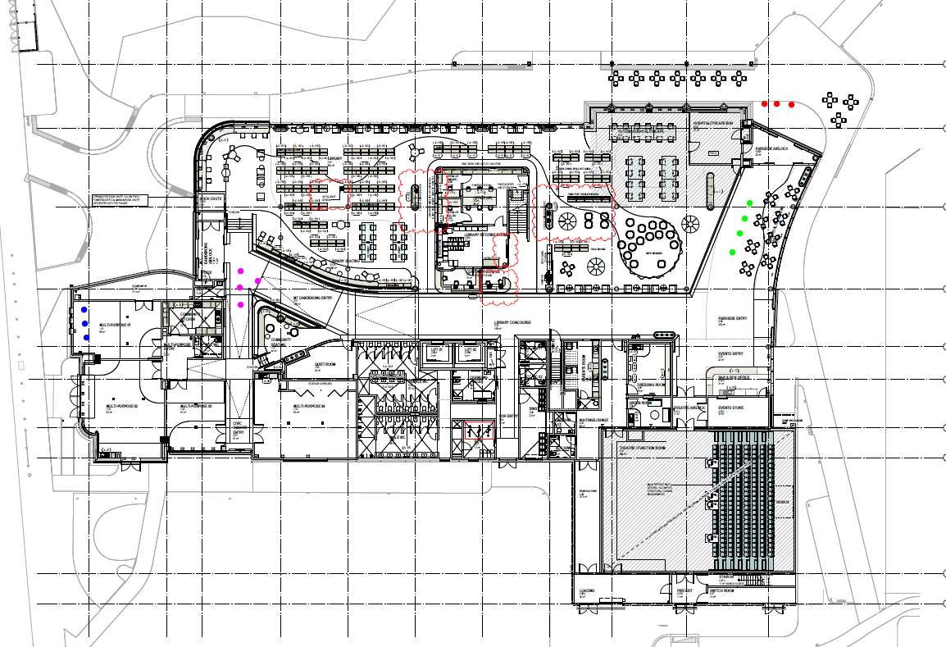
Image: Site plan with areas designated for public art highlighted in pink and greene. Entry via Mt Dandenong Road indicated in dark blue, rear entry indicated in red.
See below for related viewpoints for the area indicated in pink on the above site map. Architectural plans and measurements will be provided to shortlisted artists.

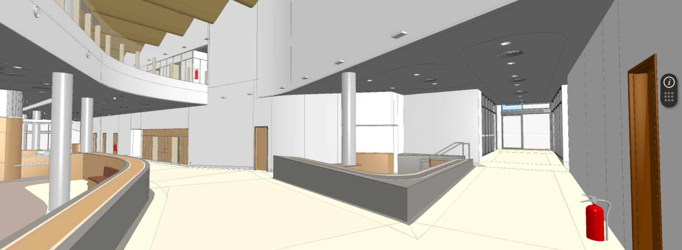Image: indicated in pink above on the site map, this is the interior view from the entrance to the building from Mount Dandenong Road. This site sits at the intersection between the Library, Customer Service and the Multi-purpose rooms.

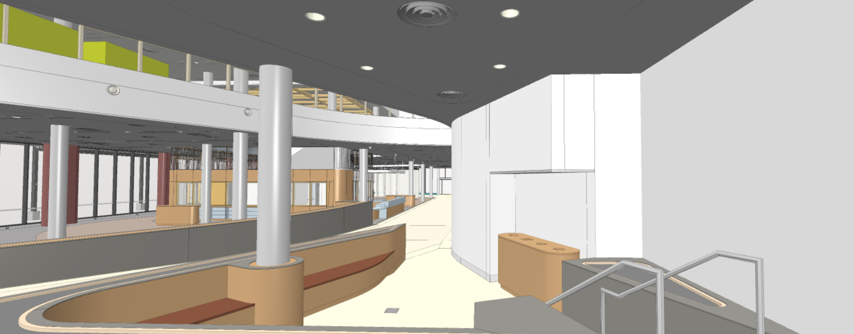
Image: indicated in pink above on the site map, this is the interior view from the entrance to the building from Mount Dandenong Road. This site sits at the intersection between the Library, Customer Service and the Multi-purpose rooms.
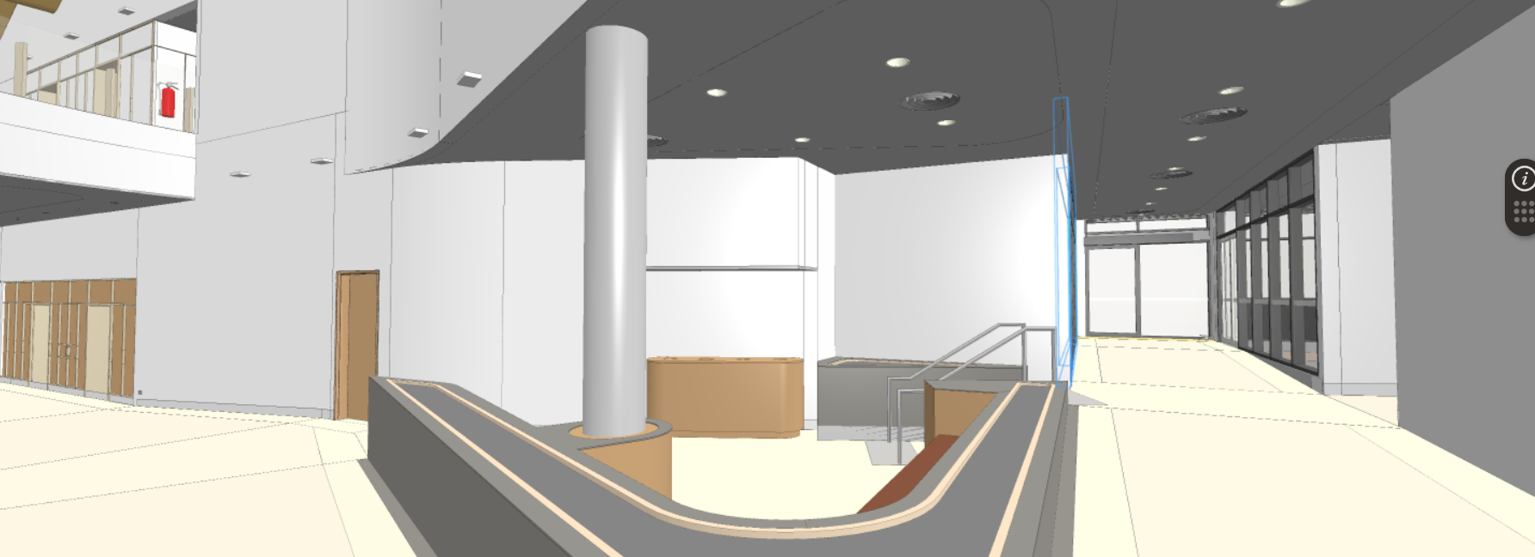
Image: indicated in pink above on the site map, this is the interior view from the entrance to the building from Mount Dandenong Road. This site sits at the intersection between the Library, Customer Service and the Multi-purpose rooms.
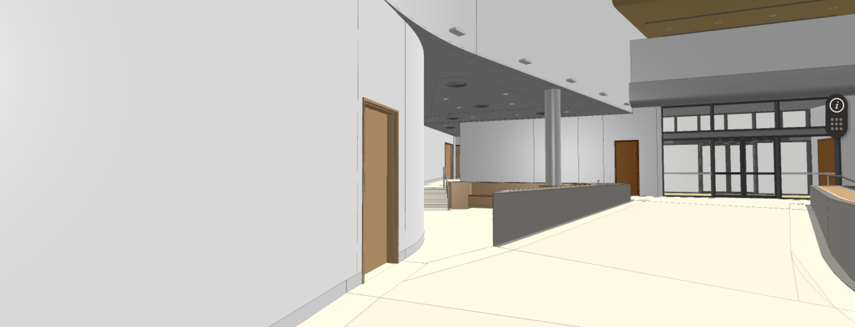
Image: indicated in pink above on the site map, this is the interior view from the entrance to the building from Mount Dandenong Road. This site sits at the intersection between the Library and Customer Service.
SITE INFORMATION
See below for related viewpoints for the area indicated in green on the above site map. Architectural plans and measurements will be provided to shortlisted artists.
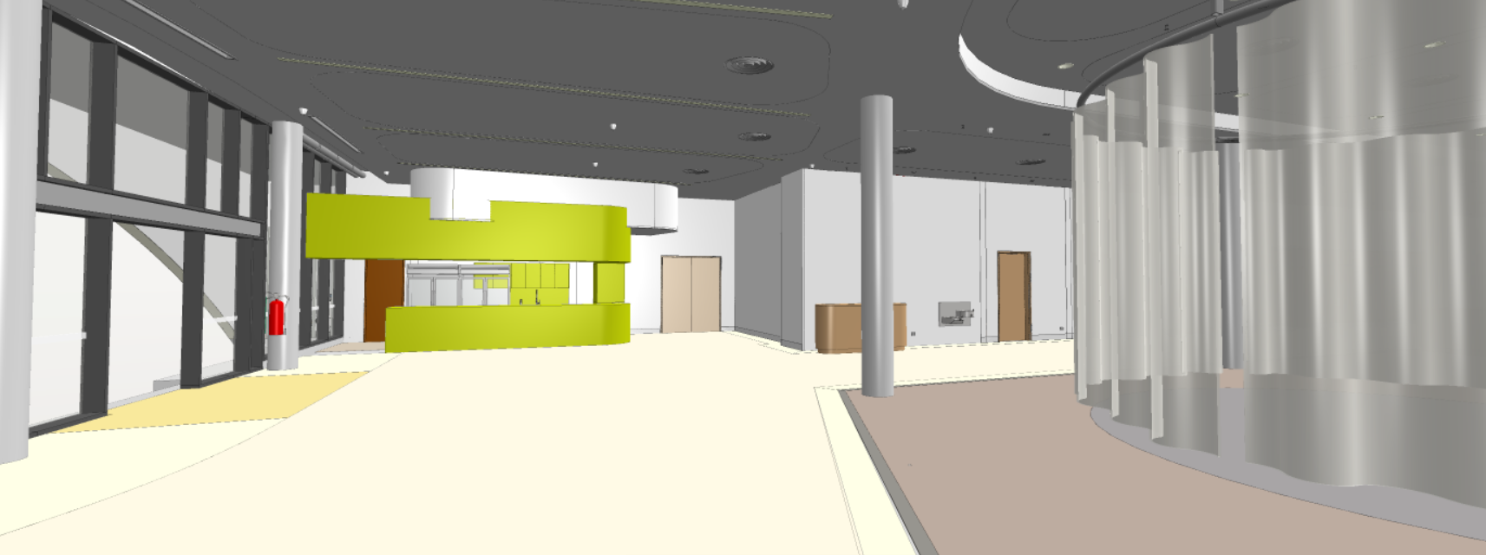
Image: indicated in green above on the site map, this is the interior view from the rear of the building. This site sits at the walkway from the Cafe to the Events Space.
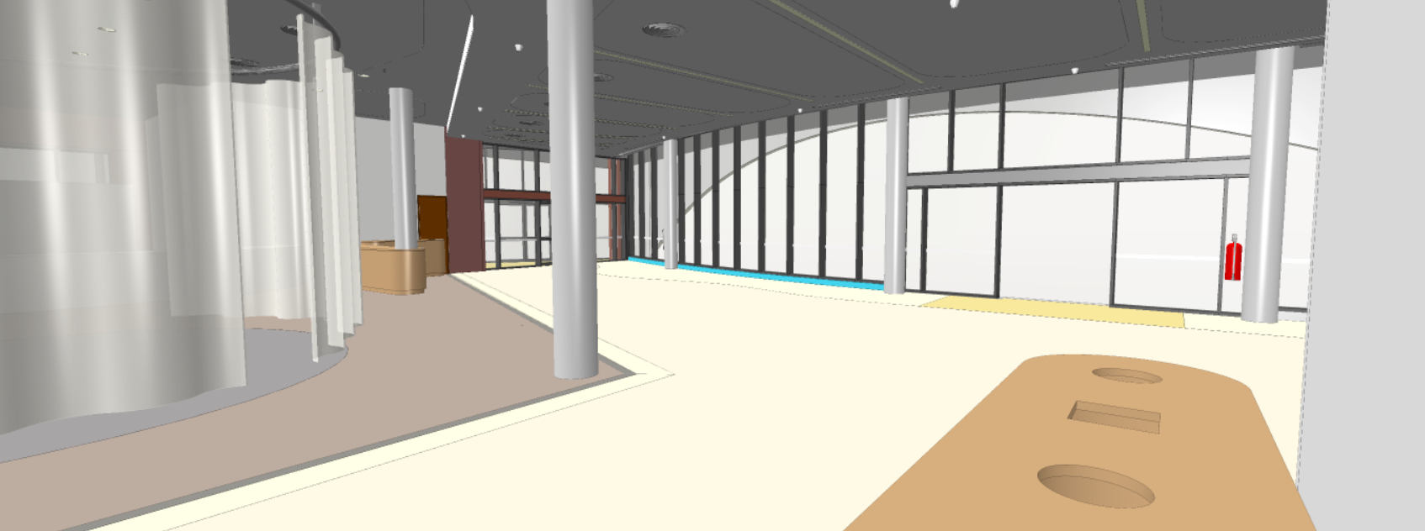
Image: indicated in green above on the site map, this is the interior view from the rear entry of the building. This site sits at the walkway from the Cafe to the Events Space.
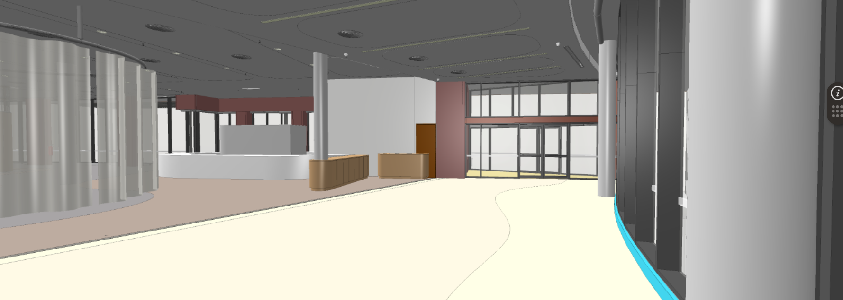
Image: indicated in green above on the site map, this is the interior view from the rear entry of the building. This site sits at the walkway from the Cafe to the Events Space.

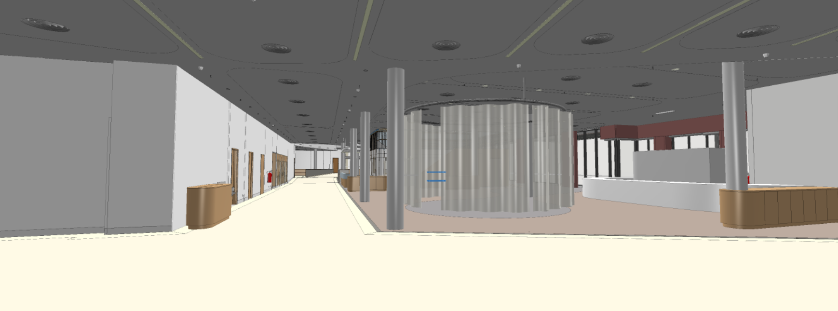
Image: indicated in green above on the site map, this is the interior view from the entry to the Events Space towards Customer Service.

