Exhibition Application Form 2026/27

MAROONDAH FEDERATION ESTATE GALLERY

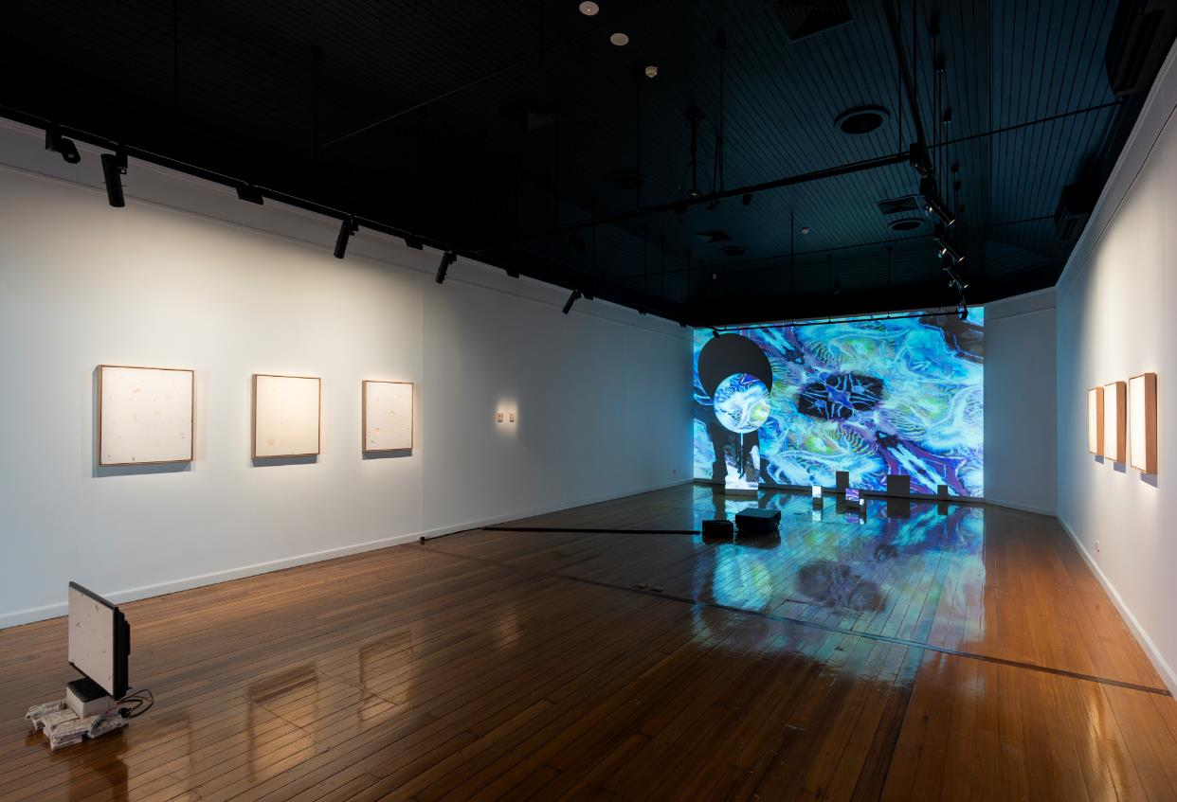

Hold Sway, Emma X Zhang and Rhys Cousins, 2024,
Gallery 1 at Maroondah Federation Estate Gallery. Photography by Astrid Mulder


ABOUT THE GALLERY
Established in 2001, the Maroondah Federation Estate Gallery is owned and managed by Maroondah City Council. The Gallery is an outstanding exhibitions venue with strong links to the local community and to Melbourne’s dynamic arts scene.

Maroondah Federation Estate Gallery (MFEG) is part of the City of Maroondah's network of arts sites and facilities within the Ringwood Arts Precinct. The gallery program encompasses a broad range of contemporary and traditional visual arts practice including painting, sculpture, ceramics, printmaking, drawing, photography, video, design, jewellery, installation as well as scope for performance and multi-media artworks.

The Gallery is situated prominently at the entrance of Maroondah Federation Estate, 32 Greenwood Avenue, Ringwood. Maroondah Federation Estate is a community and cultural facility within an attractive outdoor setting, with a wide range of user groups and visitors. There is car parking for visitors and signage marks the location clearly. The Gallery is easily accessible, including by wheelchair, and is close to public transport (Ringwood Station 650m). Admission to the Gallery is free.

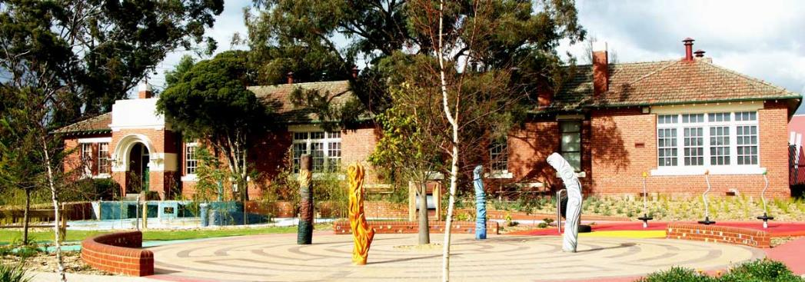
Exterior view, MFEG building, Playspace area designed by Robert Tickner

GALLERY ADDRESS
Maroondah Federation Estate
32 Greenwood Ave Ringwood VIC 3134
03 9298 4553
maroondah.vic.gov.au/MFEG
GALLERY HOURS:
Monday to Friday 9.00am – 5.00pm
Saturday 12.00noon – 4.00pm (when artist arranges to invigilate gallery)
Sundays and Public Holidays closed except by prior arrangement
GALLERY STAFF
Gareth Syvret, Curatorial Program Lead
Andrew Duong, Curatorial Program Officer

EXHIBITION SELECTION PROCESS
MFEG makes an annual callout for Exhibition Proposals from artists, curators, collectives, groups and organisations wishing to stage exhibitions.

Proposals will be assessed by a selection panel of Maroondah City Council representatives including Arts and Cultural team members and external arts professionals as relevant, according to the following criteria:
- Exhibitions that present a coherent body of work of high visual and conceptual quality to articulate a theme / idea / narrative
- Proposals that demonstrate understanding of local context or connection to local community
- Work that is professionally presented to deliver a high standard exhibition
- Proposals that demonstrate strong audience engagement and public program plans
- Exhibitions that contribute to a diverse and inclusive annual program, giving representation to Aboriginal and Torres Strait Islander artists, LGBTQIA+ artists, artists with disabilities and achieving overall balance of gender equity, cultural and linguistic diversity and emerging to established practices

Please be aware that MFEG receives a high number of applications and there are limited exhibition slots.

EXHIBITION SUPPORT INCLUDES
Gallery staff provide a range of supports and advice to the artist/exhibitor as follows:
- Advice and assistance with exhibition development and design
- Installation of the artworks by professional art technicians
- Advice regarding the artist/exhibitor’s planning and development of public programs and associated activities that complement and expand the potential audience for each exhibition/presentation
- Design and installation of exhibition signage including wall texts, labels or room sheet
- Use of the following equipment:
  - Audio-visual equipment including projection
  - Installation equipment
  - Sound system for the opening launch
  - Access to a variety of plinths and display cases

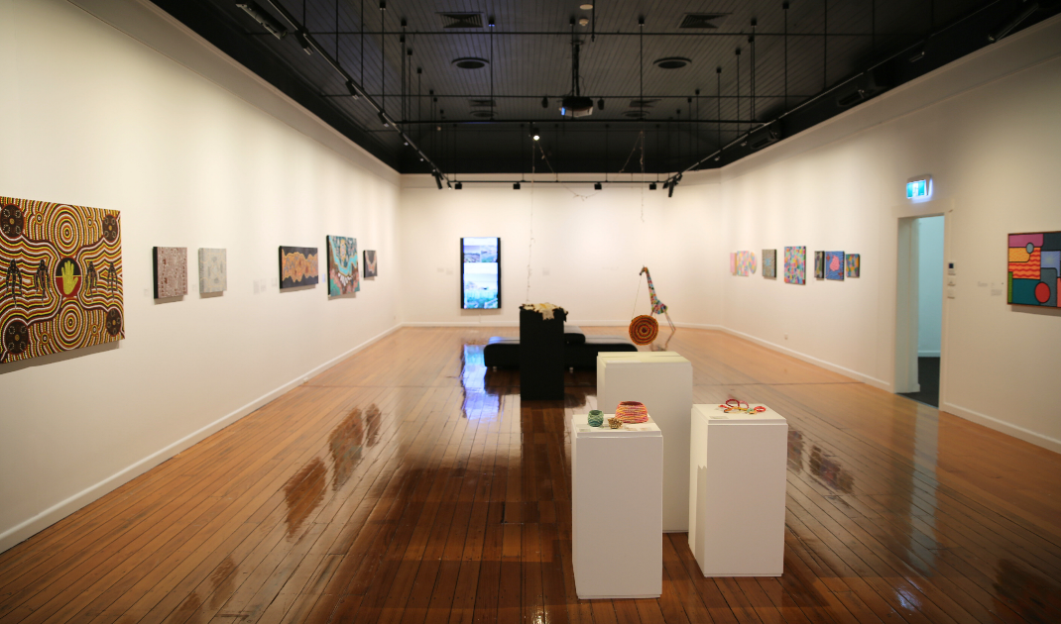

Arise, First Nations artists group exhibition, 2024, Gallery 1 at MFEG

MARKETING
The Gallery will provide the artist/exhibitor with:
- Design of e-invitation and distribution through our extensive networks
- Listings in Art Guide Australia
- Advice on other marketing and promotions for the exhibition
- Inclusion of exhibition details on Council's website and the ‘artsinmaroondah’ facebook page and Instagram
- Artists/exhibitors are responsible for all costs associated with advertising or promotional activities not stated above
- In addition to the gallery support outlined above, artists/exhibitors are expected to actively promote their exhibition through their own networks and channels. All marketing and communications must include approved use of logos and acknowledgements as determined by Council and must be provided to Council for approval prior to distribution

INSTALLATION
In order to limit down-time between exhibitions, the Gallery requires that artists/exhibitors adhere to strict schedules for installing and dismantling exhibitions. Schedules will be discussed and agreed upon with the gallery staff who will roster professional art technicians to provide up to three (3) days of hands-on support across both gallery spaces for the installation of works.
ARTIST/EXHIBITOR RESPONSIBILITIES
Artists/exhibitors are responsible for:
- Providing relevant information about the exhibition to Gallery staff for publicity purposes no later than four (4) months before the exhibition opening
- Providing digital images suitable for publicity and or reproduction purposes four (4) months prior to the exhibition
- Providing wall texts and artwork label information no later than six (6) weeks before the exhibition opening

EXHIBITION SALES
Work may be offered for sale by artist/exhibitor. Commission is not taken by the Gallery. All sales enquiries and sales made over the duration of the exhibition must be processed directly by the artist/exhibitor. Council will not be party to the negotiation or sale of artworks.

CARE OF ARTWORKS
Please note that whilst Maroondah Federation Estate is staffed and equipped with closed circuit surveillance, there is no direct invigilation of the Gallery space. Council holds Fine Arts insurance which covers the risk to artworks of physical loss, damage or fire. This insurance covers works of art on loan for exhibitions, insured for consignment value only.
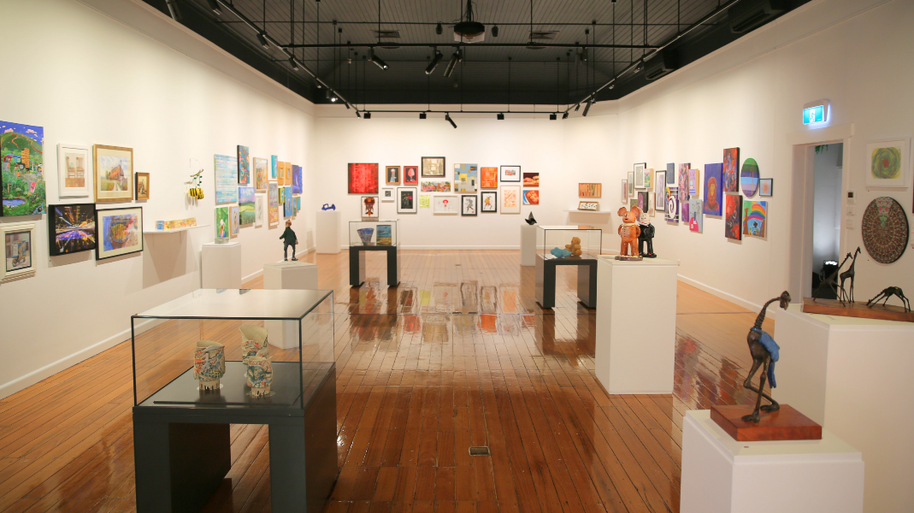
29th Annual Mayoral Art Exhibition, 2024, Gallery 1 at MFEG

EXHIBITION OPENING
All artists/exhibitors are required to hold an exhibition opening event. A small amount of catering service and non-alcoholic beverages will be provided. This may need to be suplemented by the artist/exhibitor. If desired, alcohol must be supplied by the artist/exhibitor. A certified RSA staff member is included to serve any alcoholic beverages if required.

EXHIBITION PERIOD
Exhibitions are open for approximately seven (7) weeks.

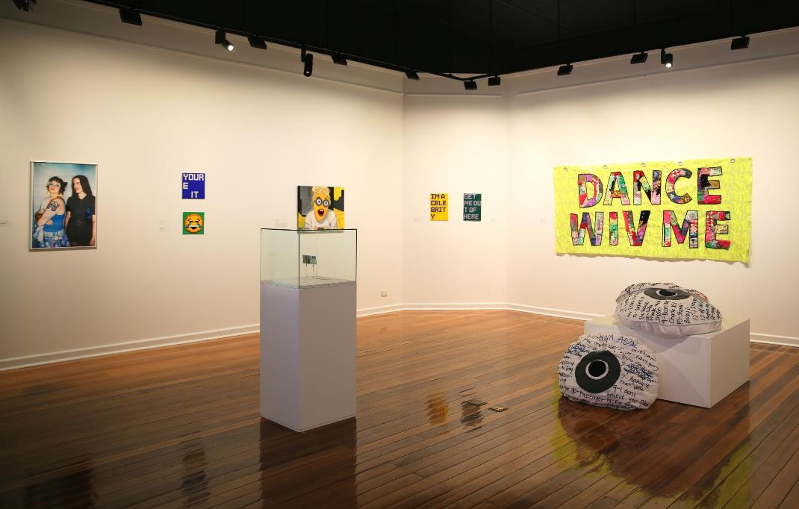

Worth 2 Billion I’m Told, 2 Halves as a Whole, 2024, Gallery 2 at MFEG

EXHIBITION FEES
There is no gallery hire charge to the artist/exhibitor for exhibiting at Maroondah Federation Estate Gallery. Any additional requirements over and above the benefits stated above are at the expense of the artist/exhibitor.

QUESTIONS AND SUPPORT
If you have any questions relating to this Application Form or require assistance completing the form, please contact the Gareth Syvret or Andrew Duong on 0417 915 347 or email:
gallery@maroondah.vic.gov.au
GALLERY 1 FLOORPLAN
(diagram not to scale)

7.2 metres x 16 metres or 115.2 metres square
Total = 38.8 running metres
Wall height = 3 metres
16.1m

1.8m

6.1m
Entry
Gallery 1
2.3m

1.5m
1.5m
5m
walkway 7.5m
1.5m
5.3m
1.5m

Gallery 2
6m
4.5m

1.1m
5.3m

GALLERY 2 FLOORPLAN:

(diagram not to scale)

7.2 metres x 8 metres or 57.6 metres square
Total = 25.5 running metres
Wall height = 3 metres

Application Form

Please complete all sections of this form

CONTACT DETAILS
Name (primary contact):
Names of all exhibiting artists:
Pronouns:
Address:
Email:
Telephone:
EXHIBITION DETAILS
Exhibition Title:

Preferred month for exhibition start (Between May 2026 and June 2027):

Description of exhibition including media and theme / idea / premise / narrative etc. explored (300 words max):

Physical description of work and proposed installation. If more than one artist, please state how the works relate, and how they will be exhibited together (300 words max):

Please state how your proposal demonstrates understanding of local context or connection to local community (300 words max):

Please describe any associated activities, events, public programs or audience engagement initiatives, e.g. floor talk, lectures, workshop (300 words max):

ARTWORK LIST
Please provide 6-10 high-res numbered jpeg images by email attachment or via web link (max file size 4mb each and max 10 images):

Are these works part of the exhibition?
Yes ☐ No ☐

No. | Artist’s Name | Title of Work | Year | Medium | Dimensions (cm)
1
2
3
4
5
6
7
8
9
10

FURTHER EXHIBITION/APPLICANT DETAILS:

- Which gallery space(s) are you applying for (please refer to above gallery floor plans)?
Gallery 1 ☐
Gallery 2 ☐
Galleries 1 & 2 (entire space) ☐

- Is your body of work complete or in progress?
Complete ☐
In progress ☐
- Is your proposed exhibition dependent on grant funding?
Yes ☐
No ☐

- If you answered yes to question 3 above, please provide details of any grant funding, including whether funding has been secured or proposed, and dates when outcomes will be known:

- Are you an artist/s living, working or studying in the City of Maroondah?
Yes ☐
No ☐

- How did you find out about this opportunity?
Facebook |  | ☐ |  | Email | ☐
Instagram |  | ☐ |  | ArtsHub | ☐
Maroondah Arts Collective |  | ☐ |  | Art Almanac | ☐
Council website |  | ☐ |  | Other:

- What is your gender identity?
Woman ☐
Man ☐
Prefer not to say ☐
Self-describe, please specify:

- Do you identify with any of the following groups or communities:

Aboriginal and/or Torres Strait Islander |  | ☐ |  | Living with a disability | ☐
LGBTQIA+ |  | ☐ |  | Young person (15-25) | ☐
Culturally and Linguistically Diverse |  | ☐ |  | Other:
Prefer not to say |  | ☐
- Anything else you would like to tell us about your application?

SUBMITTING YOUR PROPOSAL

Please return your completed application form, a current artist CV (for all artists included in the application) and sample images to:

gallery@maroondah.vic.gov.au
Subject line - ‘2026/27 MFEG Proposal’

OR hard copy by post to

MFEG Exhibition Applications 2026/27
Maroondah Federation Estate Gallery
PO Box 156
Ringwood Vic 3134

Applications close 5pm Thursday 27th November 2025

CHECKLIST BEFORE SENDING

Before sending please make sure you have included:

Application form ☐
Artist(s)’ CV ☐
Images ☐

All applications will be acknowledged by email upon receipt. Applicants will be notified of the outcome of their proposal by end of February 2026. A formal agreement/contract between successful artists/exhibitors and Council will be completed.

Please note due to number of applications received feedback will not be given on application outcomes.

