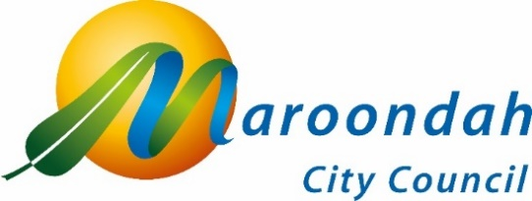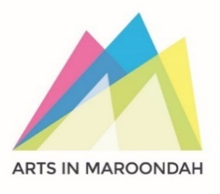

Artist Expression of Interest
PUBLIC ART – CROYDON MAIN STREET

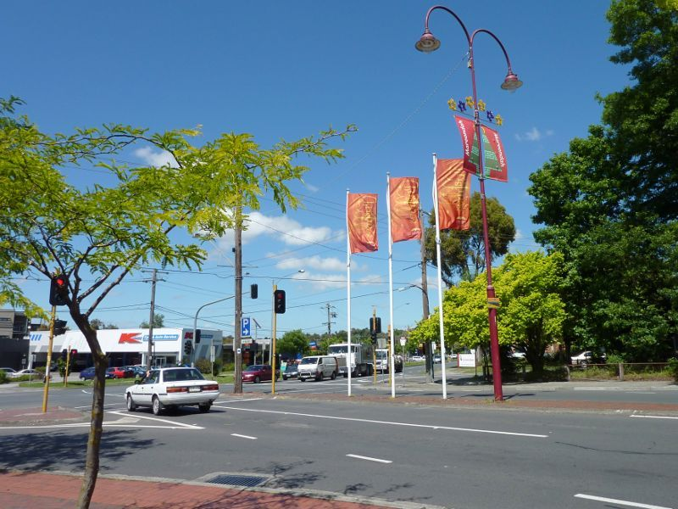
Image: View south along Main Street in Croydon, towards Mount Dandenong Road

COMMISSION OPPORTUNITY
Council is seeking expressions of interest from suitably experienced contemporary artists to develop and install applied works for up to three sites as part of Maroondah City Council’s Croydon Main Street Revitalisation Project. A total of $200,000 (excluding GST) is available for the commission. We encourage representation from a wide range of artists. Artists working collaboratively are also welcome.
Maroondah City Council reserves the right to not award this commission if no suitable proposals are received.

Acknowledgement of Traditional Owners
We, in the spirit of Reconciliation, acknowledge the Wurundjeri People of the Kulin Nation as traditional custodians of the land now known as the City of Maroondah, where Indigenous Australians have performed age-old ceremonies. We acknowledge and respect their unique ability to care for Country and their deep spiritual connection to it. We pay our respects to their Elders, past, present and emerging.

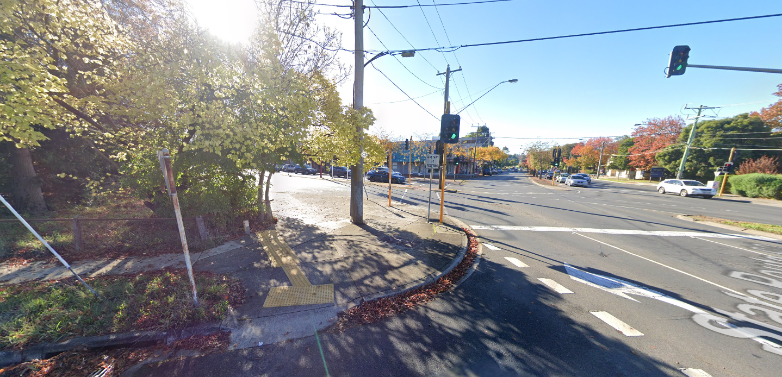Image: View of Gateway commission site from Mount Dandenong Road towards Main Street

PROJECT CONTEXT
Croydon is a suburb of Melbourne, Victoria, Australia, 30km east of Melbourne's Central Business District, located within the City of Maroondah local government area. The proposed activity focuses on a highly visible ‘Gateway’ commission at the entry to Main Street from Mount Dandenong Road and two smaller sculptural works in Main Street. As part of the $200, 000 budget there is the possibility to propose one large ‘Gateway’ commission; to propose both a ‘Gateway’ commission and two smaller related works; or to propose one or two smaller works to be located near the corner of Devon Street and Main Street. The commission for one or more works may be awarded to different artists (or collaborative groups), depending on locations. These works will accompany the revitalisation of Croydon Main Street as part of a major landscaping project which includes seating, lighting, footpaths and planting. The commission is undertaken by Maroondah City Council’s Arts and Culture Team. For more information about the project visit:
https://www.maroondah.vic.gov.au/Development/Developing-Maroondah/Maroondah-projects/Croydon-Main-Street-Revitalisation

Council’s Support for Public Art in Maroondah
Maroondah City Council supports public art throughout the community as a way of enhancing the municipality’s cultural vitality and creative placemaking. Guided by Maroondah’s Public Art Policy, the Arts and Cultural Development Strategy 2020 – 2025 and the Maroondah 2050 vision for cultural vitality, public artworks respond to the community’s desire for traditional and contemporary art forms in public places. Maroondah’s growing collection of indoor and outdoor public art enriches the public realm and the community’s experience of and connection with these spaces.

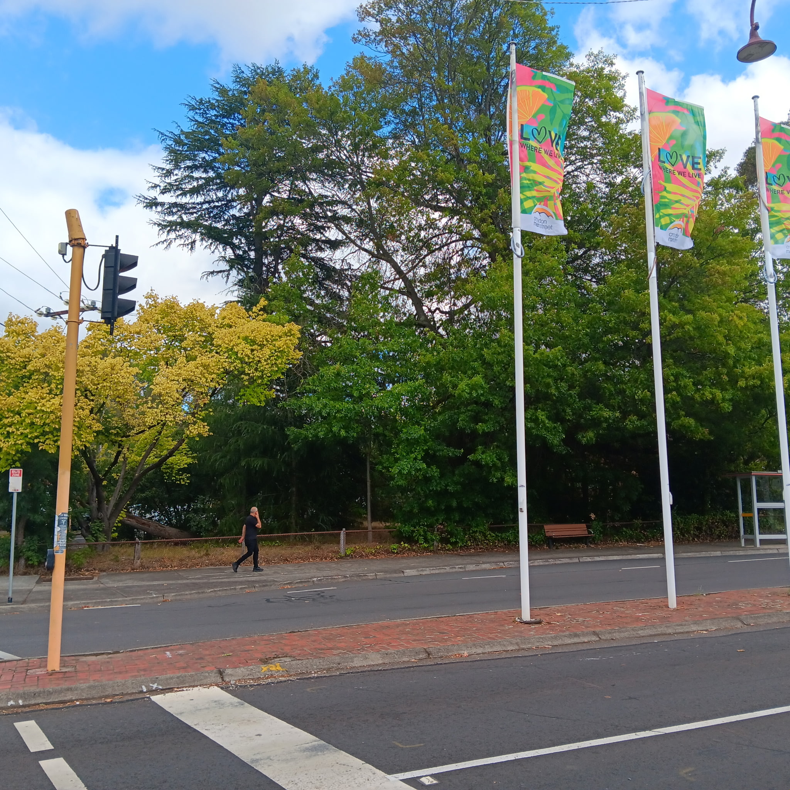
Image: View of Gateway commission site from south end of Main Street, Croydon

HISTORY AND CONTEXT
The first inhabitants and Traditional Owners of the area now known as Maroondah were the Wurundjeri people of the Kulin nation at least 40,000 years ago. The territory of the Wurundjeri lies within Naarm, now known as the inner city of Melbourne, and extends north to the Great Dividing Ranges, east to Mt Baw Baw, south to Mordialloc Creek and west to the Werribee River. The City of Maroondah was created through amalgamation of the former Cities of Ringwood and Croydon in 1994.
The land in the area now known as Croydon was prized for hunting both before and in the early days of European colonisation. The area was originally called White Flats after the abundance of silvery-white, Wallaby grass (scientific name: Rytidosperma setaceum). The land in White Flats supported sheep, beef cattle and dairy farming. Pea crops grew particularly well, and orchards produced excellent cherries, apples, pears, plums and peaches. Early industries included extraction of clay that was suited to ceramics; the production of charcoal which was carted to Melbourne; and the production of brooms at a factory that made use of the local grasses. The first shops in Croydon were built on land in Main Street from 1885; these included a general store, which later had a wine licence, a butcher, baker, grocer and timber merchant.
The first constructed road through the area led to Mount Dandenong and was known as Sawmill Road, probably named after a nearby sawmill that produced building timber. This road was later called Oxford Road, then given its current name of Mount Dandenong Road. The area became better known as bullock teams heading for the gold fields in Woods Point and the Great Dividing Range used this new road.
For further information about the history of Croydon, please visit the Croydon Historical Society Museum here: Croydon Historical Society Museum | Maroondah City Council To organise a visit to the museum please call the Croydon Library in advance to confirm opening times on 03 9725 4742.

- 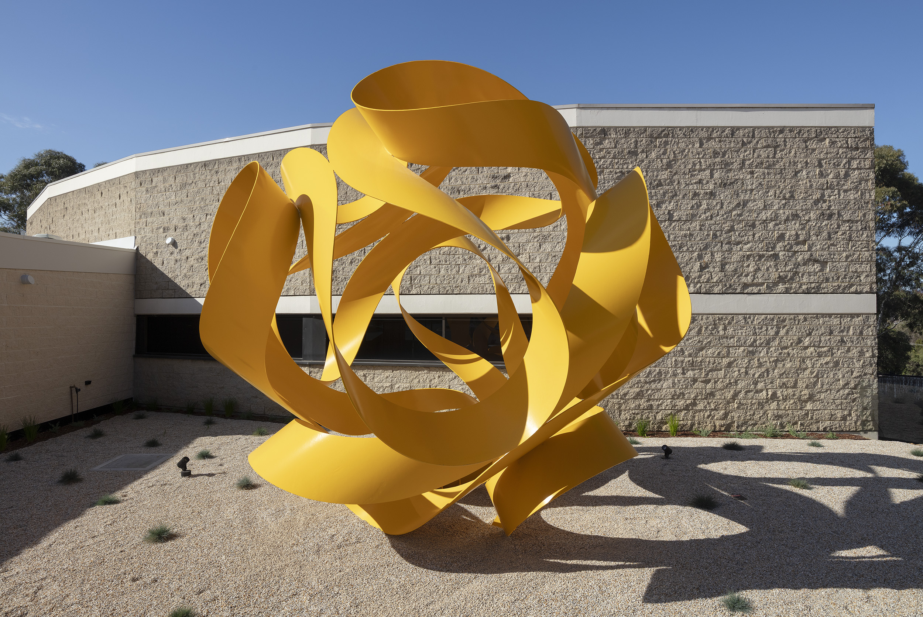Image: Charles Perry Cassini 1978 – 1980 Karralyka, Ringwood. Photo: Christian Capurro

PUBLIC ART ELEMENT
The key public art features of this project will be a sequence of up to three artworks situated at different points along Croydon Main Street. The commission will be awarded to up to three artists (or collaborative groups) for suitable proposals of up to three artworks, including one highly visible ‘Gateway’ sculpture at the entry to Main Street from Mount Dandenong Road and/or one or two smaller works along Main Street. Please note that each of the sites has different variables, refer closely to the information provided in the site details at the end of this document. Artists also have the option to propose one work for the Gateway site depending on scope and production costs.
The Gateway public art commission is intended to herald a sense of entry and connectivity to the revitalisation of Main Street with the option of smaller works connected thematically with the main artwork. Shortlisted artists will be provided with the final landscaping plans for Main Street so that the public art and landscape architecture components align. The artwork may take a variety of forms, including the following:
- Stainless steel
- Ceramic/mosaic
- Contemporary lighting
- Fibreglass/resins
- Shatterproof glass
- Stone
- Concrete
- Recycled materials
- Light-based works

Please note that neither bronze nor wooden sculptures will be considered as part of this project.

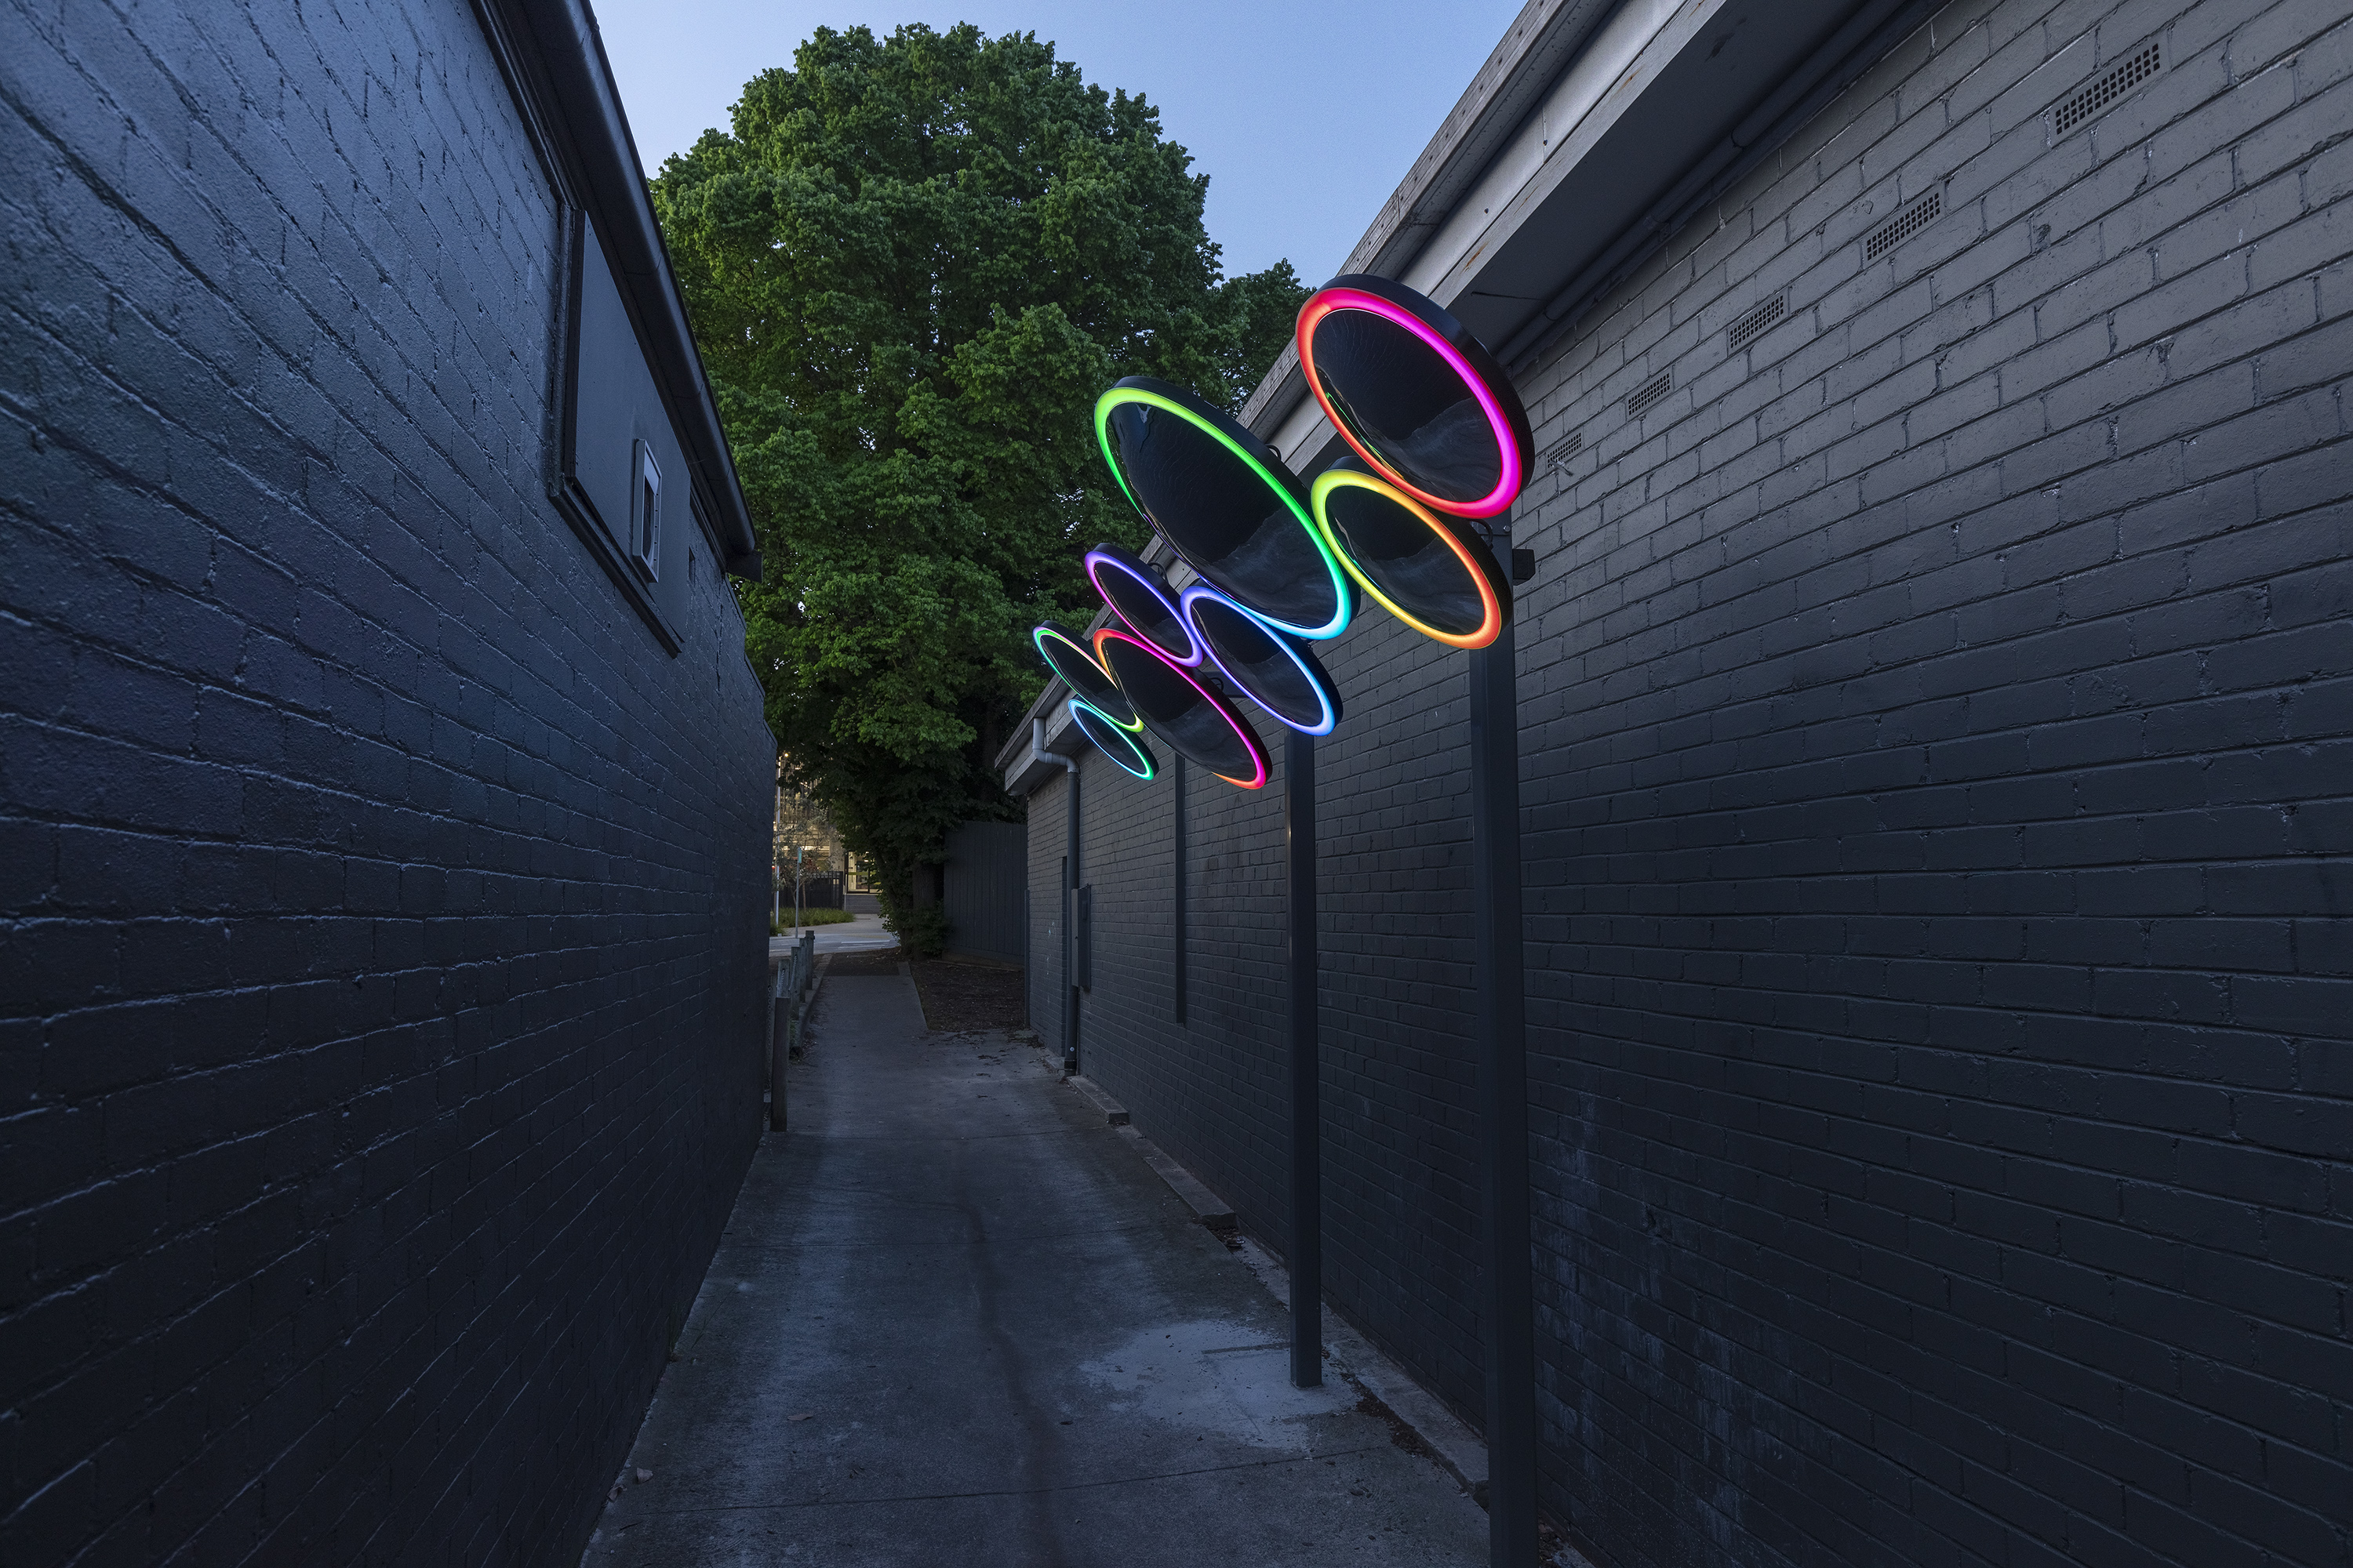Image: Jasmine Grace Life Reflected 2024, laneway adjacent to 147 Main Street Croydon (artwork located in vicinity of commission area near 147 Main Street) Photo: Christian Capurro

PUBLIC ART ELEMENT
Artists are encouraged to give consideration to the presence of the work at night and day. The sites include planting, decorative groundwork, seating and nearby existing public artworks. Final detailed landscape architectural plans for the site will be provided upon request to shortlisted artists only.
In collaboration with the selected artists, Maroondah City Council will provide the funding and resources for footings for each of the artworks. There will not be capacity to light or provide electricity to the ‘Gateway’ artwork. For the smaller works along Main Street, lighting is available at two of the potential sites. Please refer carefully to site details below for provisions for the individual sites.

KEY PUBLIC ART PRINCIPLES

Public art in Maroondah will align with the following principles, to guide the selection of works being commissioned and collected:

- Quality: Demonstrates artistic excellence, innovation and structural integrity, with work undertaken by artists and creative industry specialists in line with cultural sector benchmarks and standards.
- Relevance: Artwork reflects place-based themes that enhance the unique identity and diversity of Maroondah, reflecting shared values, history, natural and built environs, or the aspirations of our community.
- Accessibility: Artwork is physically, digitally and thematically accessible to our community, and opportunities for public art commission are accessible to a range of artists.
- Collaboration: Encourages and promotes collaboration between artists, community members, businesses, stakeholders and industry partners.
- Diversity: Embraces creative expression from artists of diverse cultures, genders, ages and socio demographics, and the creative messaging of works represents diverse expressions, perspectives, themes and styles.
- First Peoples: Enables First Peoples-led and collaborative expression of Culture, knowledge and storytelling through public art opportunities.
- Gender Equity: Supports gender equity in commissioned artists and representation in public art themes and associated programs or initiatives.
- Investment: Represents a good investment for Council, the work and lifecycle maintenance achieved in line with current industry benchmarks and available budgets.
- Sustainability: Considers minimisation of environmental impact at all stages of the work, such as sustainable materials, installation and maintenance processes.

SELECTION CRITERIA
- Innovation, creative excellence in previous work (include up to five examples)
- Ability to connect to the context of the location in ways that are accessible for a broad audience as demonstrated in previous works (this may take the form of architectural, historical, cultural, social, spiritual, landscape / open space or geographical references). This includes providing a sense of connectivity between the works if proposing multiple works.
- Ability to present a structurally sound, sustainable design that takes into account the site-specific logisticsExperience completing public art projects with a lifecycle of 20 years +
- Ability to work efficiently as part of a larger team and within the timeline and requirements of Maroondah City Council which includes:
- ABN and Public Liability Insurance of minimum $20 million
- Ability to deliver a workplan and maintenance manual using materials and methodology that minimises future wear and tear
- Ability to deliver a comprehensive risk assessment and safety plan for the project
- Ability to work to key timelines and budget parameters
TIMELINE
Key dates include:
Artist Brief distributed | Friday 10 April 2026
Site visits:  rsvp to publicart@maroondah.vic.gov.au | Meeting Point: outside Subway 147 Main Street Croydon  Wednesday 30 April 2.00pm  Saturday 9 May 10.00am
Artist expression of interests due:  to publicart@maroondah.vic.gov.au | Thursday 14 May 2026, 11.50pm
Selection panel process | 15 May - 3 June 2026
Shortlisted artists confirmed | Thursday 4 June 2026
Concept Proposals due | Tuesday 7 July 2026
Final commissioned artist confirmed | Tuesday 29 July 2026
Design Development | 29 July – 22 September 2026
Fabrication/Planning | 23 September ─ 24 November 2026
Installation | 4 February - 14 March 2027
Launch | TBC 2027

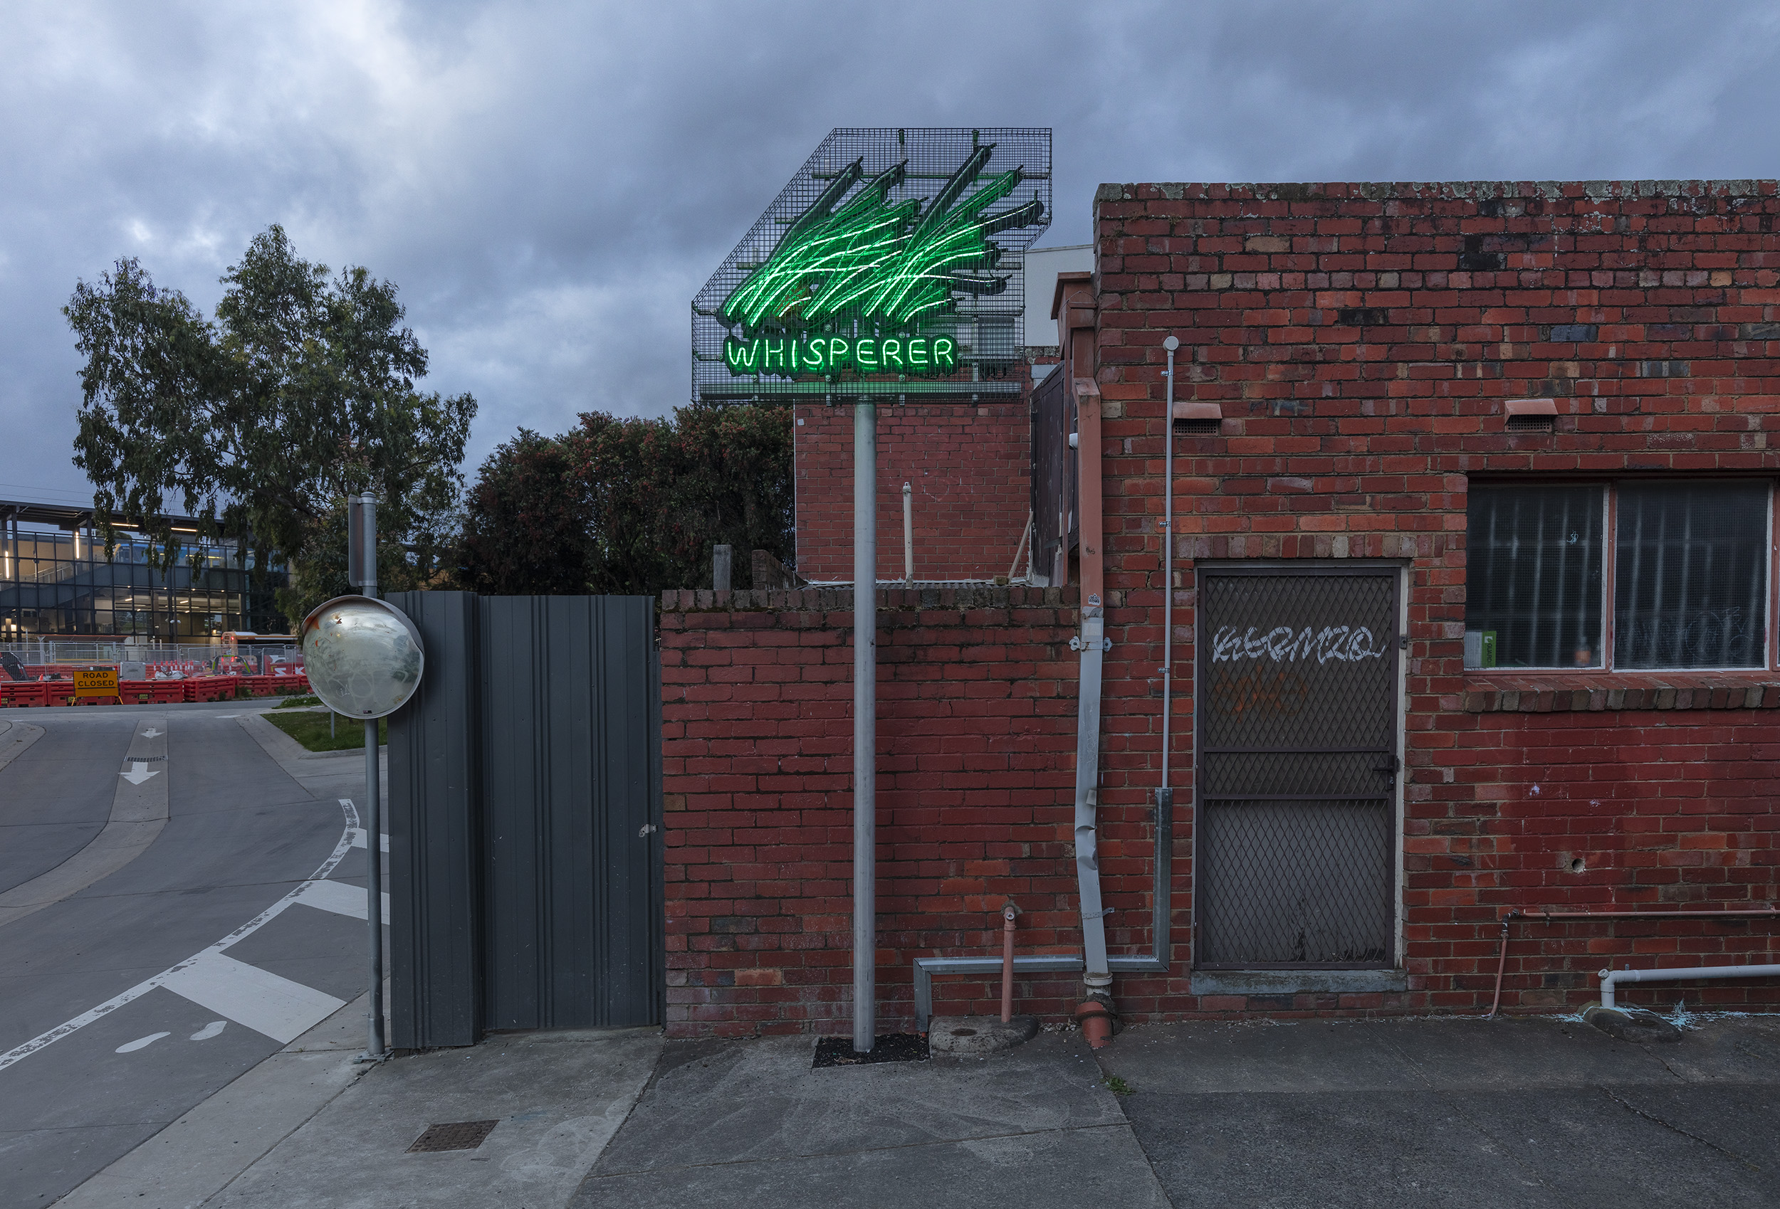Image: Alexander Knox Whisperer 2024, rear of 121 Main Street Croydon (artwork in vicinity of commission area) Photo: Christian Capurro

EXPRESSION OF INTEREST INFORMATION
Prior to sending an Expression of Interest in response to this Artist Brief, applicants interested in applying are encouraged to attend the site visits at 147 Main Street Croydon (outside Subway) on one of the dates listed above.
The Expression of Interest in response to this Artist Brief should include:
- CV demonstrating appropriate experience and skills delivering similar works / projects
- Contact details for two referees
- One page letter addressing the Selection Criteria above
- Up to 5 x images of relevant previous work, with emphasis on works in public space. Please send images as separate attachments
- Confirmation of attendance at site visit
Expressions of Interest to be sent to:
Jane O’Neill, Public Art Lead, Maroondah City Council at publicart@maroondah.vic.gov.au
Any telephone enquiries can be made to 0436 442 036 from Tuesday to Thursday.
Applications close at 11.50pm on Thursday 14 May 2026.
Maroondah City Council adopts an inclusive approach. If there are challenges providing the above information for the EOI please contact the Public Art Department above.

SELECTION PROCESS
A panel of Maroondah City Council representatives will assess Expressions of Interest to shortlist a number of artists based on the Selection Criteria. Shortlisted artists will be paid a $1,500 fee to develop a Concept Proposal including budget between 5 June — 7 July 2026 for consideration. Shortlisted artists will be provided with a copy of the final landscape architectural design for the project for reference. The final artist/s will be confirmed and commissioned by 29 July 2026.
BUDGET
Artists will only be required to submit a proposed budget if shortlisted for the Concept Proposal process. The fee will need to outline a detailed breakdown of costs including materials, artist fee, insurances and installation.
The total maximum fee available for the commission is $200,000 (excluding GST) which can include works in up to three different sites.
EXISTING PUBLIC ARTWORKS IN VICINITY OF COMMISSION AREAS
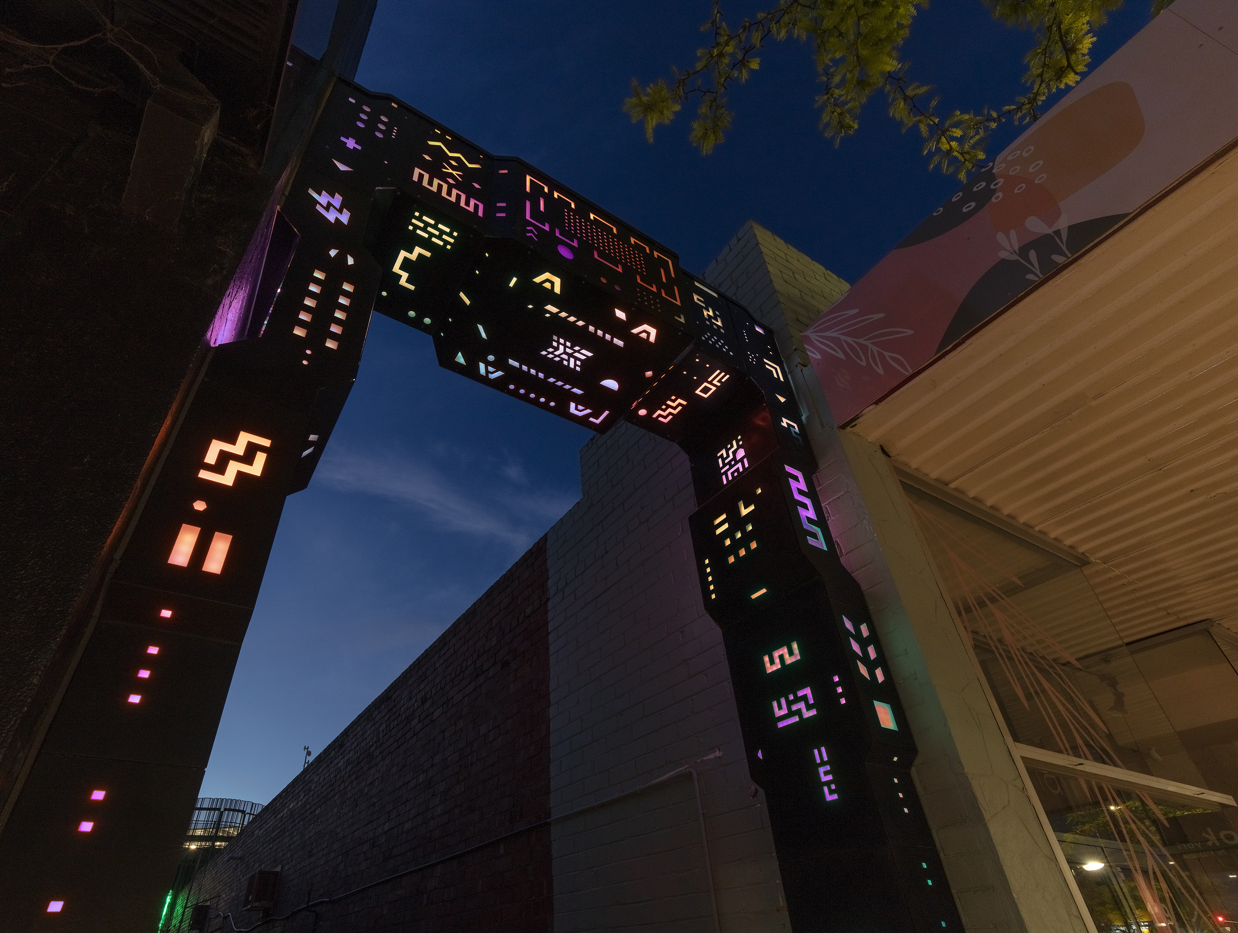Image: Sam Songailo Gateway 3.0 2024 (laneway running from La Bocca, 121 Main Street Croydon) Photo: Christian Capurro

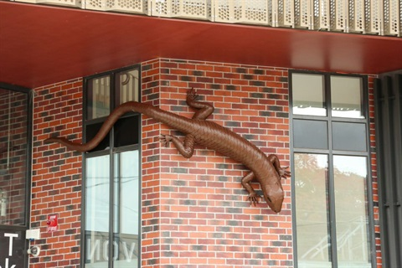
Images: Damian Vick, Hide and Seek, 2021 (Devon Street Carpark, Croydon)

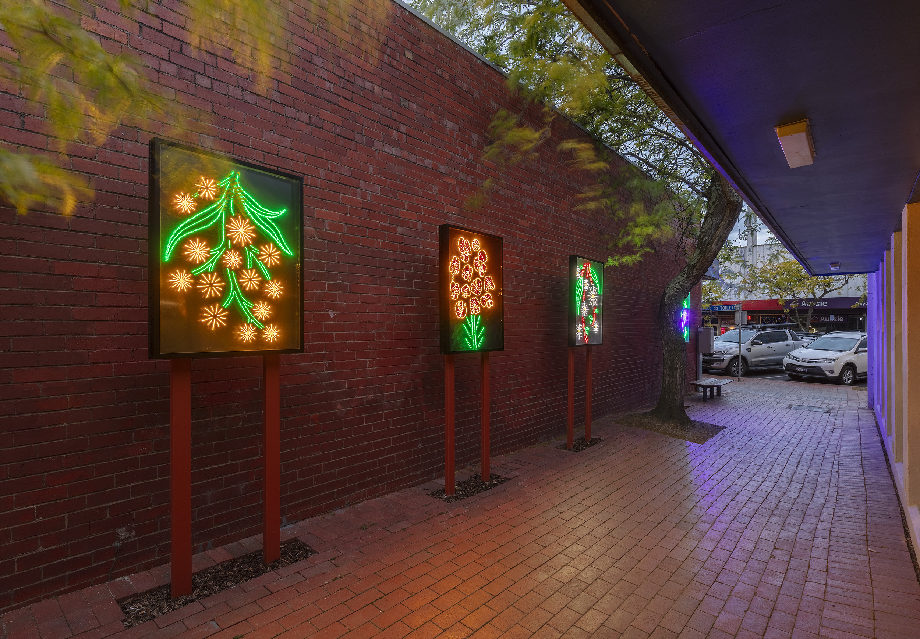 Image: Kirsten Baade and Alinta Koehrer Light Stitches: Illuminating Croydon’s Indigenous Flowers 2024 Laneway adjacent to 111 Main Street Croydon Photo: Christian Capurro

LINKS TO FURTHER EXISTING WORKS IN VICINITY OF COMMISSION AREA
Reignite Croydon - Laneway Lights project | Maroondah City Council
The Chemist | Maroondah City Council
Carnifex | Maroondah City Council
Croydon Town Square Screens | Maroondah City Council
San Carlos Art Box Project | Maroondah City Council
Croydon Station’s new sculptures take shape - Victoria’s Big Build
Murals - James Kerr Way | Maroondah City Council
Sound of Flight | Maroondah City Council
The Fruit Thief | Maroondah City Council

SITE MAP AND PHOTOS
Artists are strongly encouraged to visit the site at Main Street Croydon before submitting an application. The items indicated with coloured dots are the nominated locations for potential artworks. The commission will include up to three artworks in any of the locations cited below.
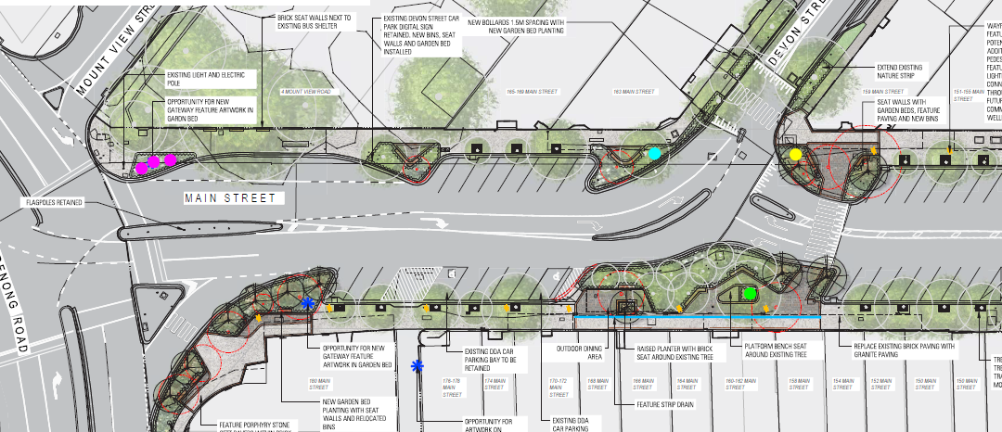Image: Site map of design plan with indicated public art sites in pink, aqua, green and yellow
SITE 1
SITE 2
SITE 3
SITE 4

Potential Public Art Sites

Site One: indicated in pink on Map, corner Main Street and Mount Dandenong Road.
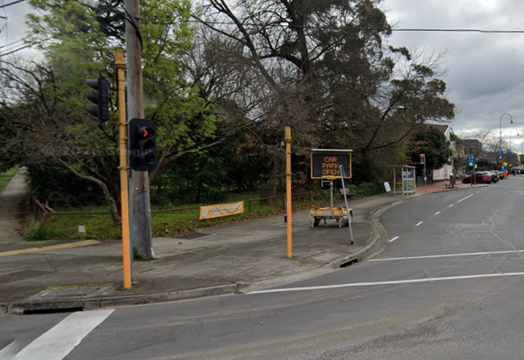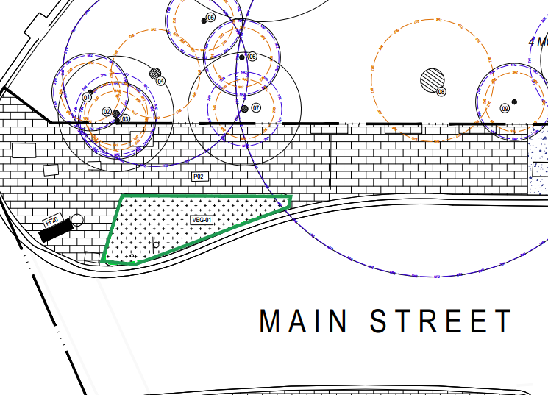
Images: Above left: recent image of site. Above right: design plan for Main Street with area in green indicated for main ‘Gateway’ commission
Details: This is the site for the Gateway commission, the main element of the commission. Approximately 20 square metres in total. No capacity for lighting.
Site Two: indicated in aqua on Map, outside former chemist at 161 Main Street
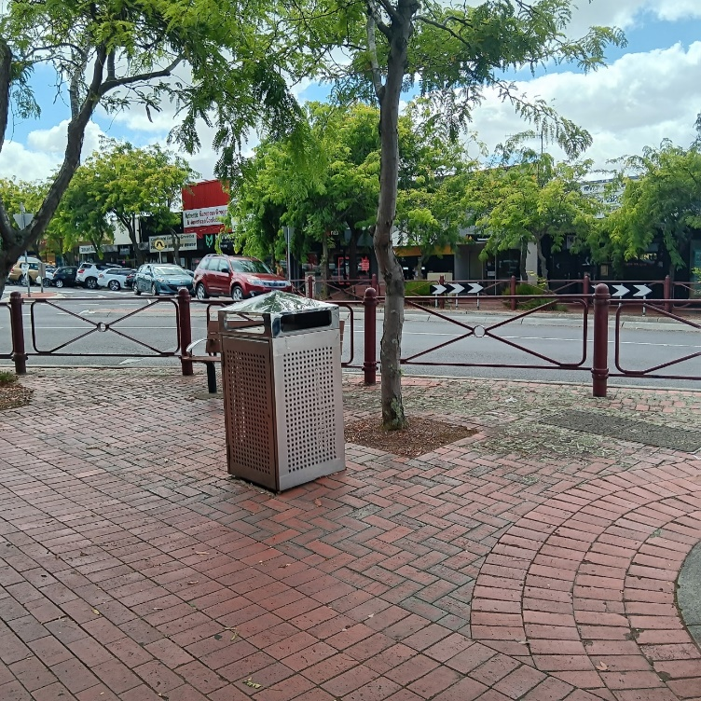 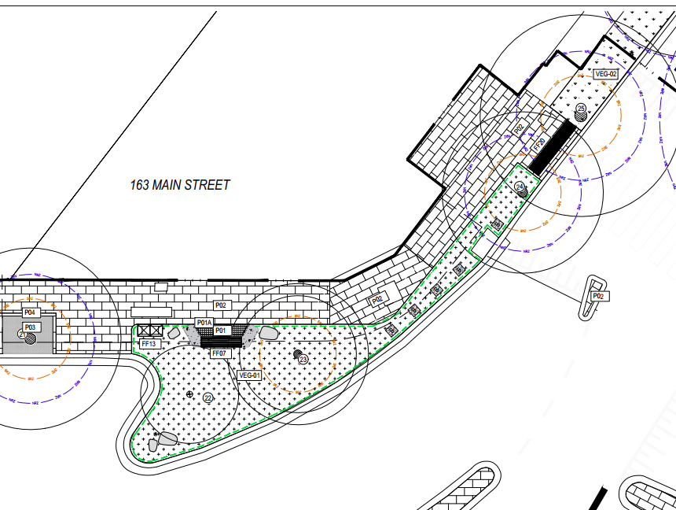Images: Above left: recent photo of site Above right: design plan
Particulars: smaller footing of up to one metre square permitted in this site abutting pavement to proposed garden area. Lighting is not available to be routed to this site.

Site Three: indicated in yellow on Map, outside 159 Main Street, near corner Main Street and Devon Street
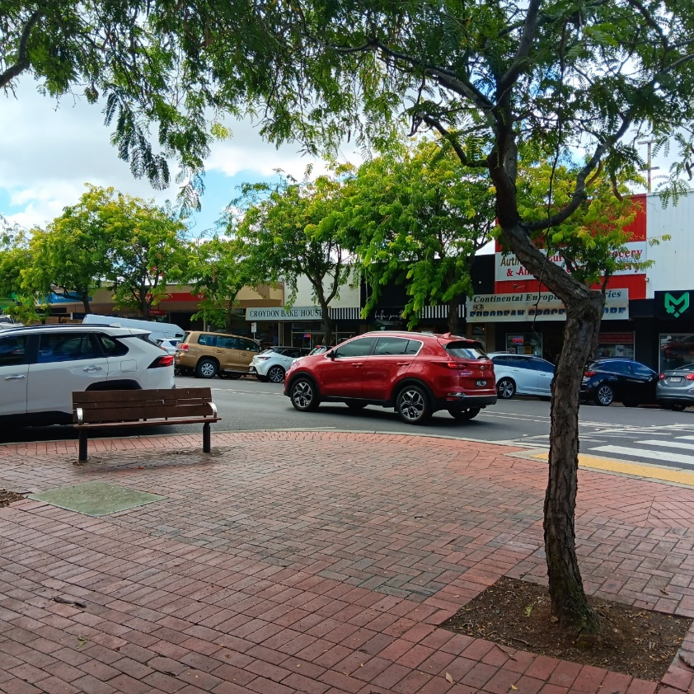 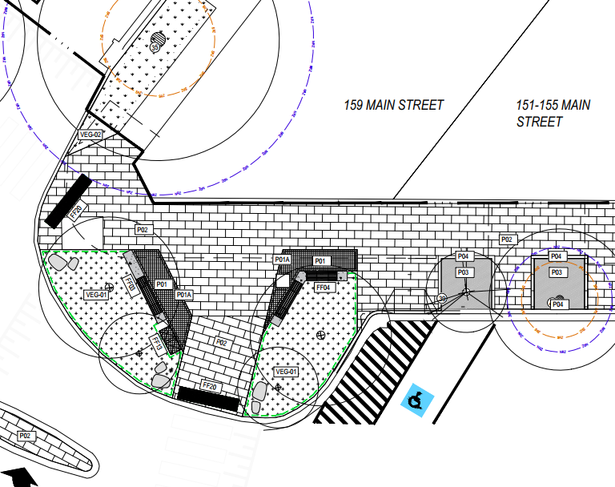Images: Above left: recent photo of site Above right: design plan
Particulars: smaller footing of up to one metre square permitted in this site abutting pavement to proposed garden area. Lighting is available to be routed to this site.

Site Four: indicated in green on Map, outside 160 Main Street
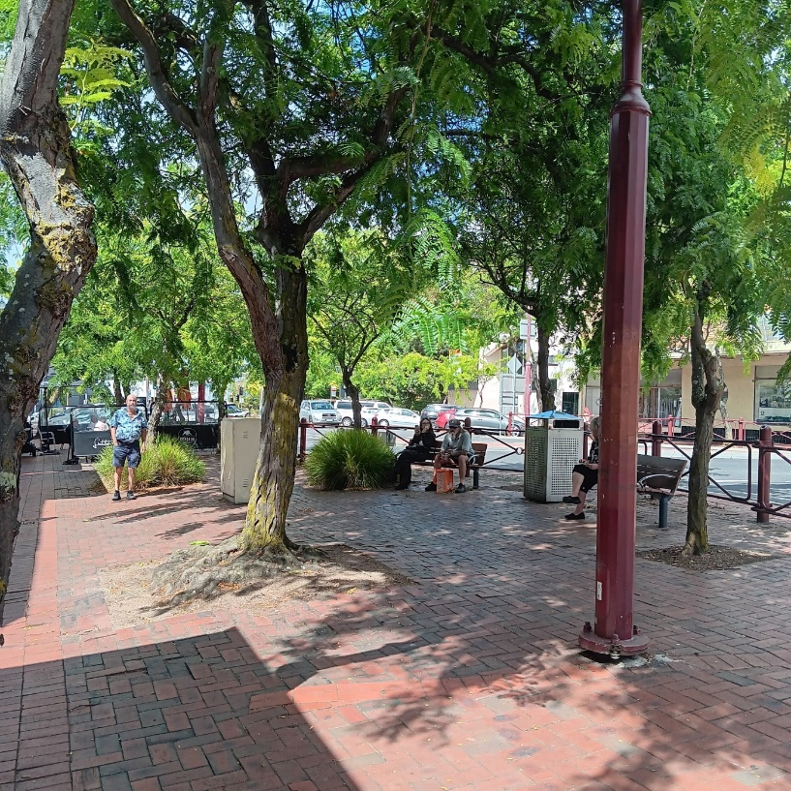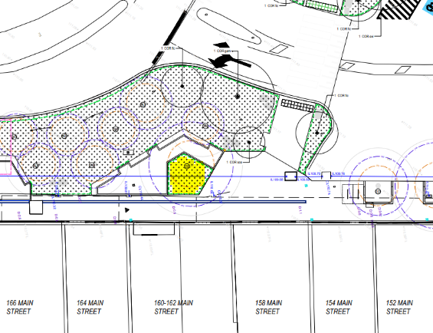
Main Street, outside Commonwealth Bank, 160 Main Street, Croydon.
Particulars: larger area available for sculptural work of up to nineteen square metres, however, please note that footing will be constrained due to drainage underground. Lighting is available to be routed to this site.

