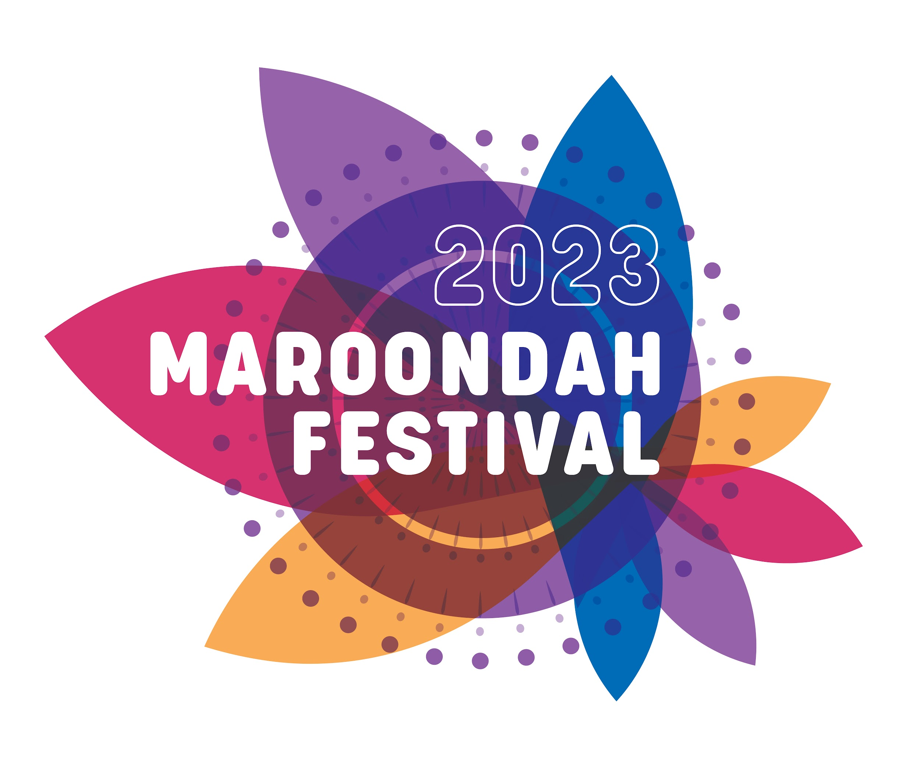

**COMMUNITY FOOD SITE POLICY**

|  |
| --- |
| **MAROONDAH FESTIVAL**  **SUNDAY 12 NOVEMBER 2023**    **10am - 4pm** |

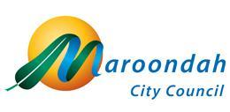

**C O N T E N T S**

**Page No**

**1. Introduction 3**

**2. Definition of a Community Organisation 3**

**3. The Process 3**

**4. Eligibility 4**

**5. Site Fees 4**

**6. Site Details 4**

**7. Council Controlled Food Products 4**

**8. Goods and Services Tax** **4**

**9. How to Apply 5**

**10. Site Listing 51. INTRODUCTION**

The Festival is once again upon us and we invite community groups who would like to fundraise to participate by conducting a food stall.

The stated aims of the festival include providing the community with value for money and quality. Food stalls at the festival must reflect the standards required by Council's health regulations and reflect good value for money for patrons.

**The 2023 Maroondah Festival will be held at Town Park, Croydon on Sunday November 12th from 10am to 4pm.**

Once again the guidelines have been reviewed to ensure that all Festival food stall operators are given every opportunity to maximise sales on the day whilst providing a quality product to the customers.

**2. DEFINITION OF COMMUNITY ORGANISATION**

In order to qualify for consideration for a food stall at the 2023 Maroondah Festival community groups must meet the following criteria:

* An association, registered charity or a group that is:

1. Based in the City of Maroondah
2. Established to meet a demonstrated need within the community
3. Non profit making
4. Not receiving significant funding from any State or Federal agency

Or:

* Any association, registered charity or group of residents, not falling within the above criteria, but identified by Council as being of significant value to the community.

**3. THE PROCESS**

Applications will be sought from Community groups located within the City of Maroondah to apply for a site at the Festival.

All groups requesting a food stall must return the application form by **5pm on Thursday 31st August.**

**No late applications will be considered.**

Food sites will have a predetermined size, menu parameters and type of food. Groups will be required to submit a menu around that theme. The menu and proposed prices will be subject to Council approval.

This year sites will be allocated via an internal ballot which will be conducted by Maroondah City Council.

Groups will only be granted one site each but may apply for up to three sites to ensure a better chance of selection. The group will be allocated the first site their name is selected against and their name will be withdrawn from any further ballot. The site numbers will be drawn at random.

This Ballot will be conducted internally at Maroondah City Council under supervision of Maroondah City Council Representatives.

In the case where only one group applies for a particular site, it shall be allocated to that group without a ballot.

If a site does not receive any applications then it may be offered for ballot again to unsuccessful groups.   
Council reserves the right to sell the site to a commercial trader if no community interest for the site can be found.

Food stalls are also permitted to run a Community Display Site.

Successful groups are permitted to swap site allocations amongst themselves; however no subletting of a site to other groups or commercial entities will be permitted.

**4. ELIGIBILITY**

To be eligible for a community food stall, groups must be located and focused solely in the City of Maroondah. Groups operating outside Maroondah will not be considered.

Successful community groups must adhere to the A Food Standards Code requirements and the Food Act 1984. Copies will be forwarded to the groups after the ballot meeting.

For the 2023 event, each food stallholder **MUST** participate in another component of the Festival. A site will be allocated at no charge for groups to promote their services thus adding further variety to the event. Please speak to Festival Organisers to discuss other opportunities for your group to be involved during the Festival program.

Council retains the right not to consider any application for selection.

**5. SITE FEES**

The site fees for the event have again been kept at a minimum and they reflect and include the cost of providing power to food stalls and the clean up of the event.

For those stalls located at Town Park the site fee for food stalls is $175.00 (G.S.T. inclusive), the site fee for confectionary and drink stalls is $135.00 (G.S.T inclusive).

**Site fees MUST be paid 14 days prior to the Festival.**

**If payment is not finalised by this date the site will be forfeited.**

**6. SITE DETAILS**

This year the number of sites is set at nineteen. Each site has a different location and menu associated with it. Council are open to suggestions regarding additional food sites.

**7. COUNCIL CONTROLLED FOOD PRODUCTS**

All community groups are welcome to purchase drinks from their own sources. In 2023 all community organisations that have been allocated a food stall will be not obliged to sell drinks but are encouraged to do so.

Council will provide a list of approved drinks and also provide a list of minimum set prices for both food items and drinks. To ensure that all food sites have a fair and equal opportunity to fundraise each stallholder (including commercial groups) must adhere to the minimum set price.

**8. GOODS & SERVICES TAX**

Cost of the site will be inclusive of G.S.T.

**9. HOW TO APPLY**

The attached application form sets out the process for the initial ballot. Items such as power access etc. will be clarified with successful applicants at a later date.

Groups are invited to nominate up to three preferred sites. This is not a preferential ballot. A group will be allocated the first site their name is drawn against.

Applications close on **Thursday 31st August** **at 5.00pm.** **No late applications will be accepted.** Please supply a copy of your G.S.T. and/or A.B.N. registrations plus a copy of your Public Liability Insurance (Certificate of currency), Trader number & Foodtrader registration/notification certificate with your application.

An internal ballot will be conducted internally at Maroondah City Council. Applicants are not permitted to attend this ballot. Those groups that are successful will be contacted by the festival staff.

Groups are advised that they must adhere to the conditions set down in this Food Policy Agreement and the Festival Terms and Conditions or their stall will be forced to close on the day. Council will not be held liable or compensate for any losses in these or any circumstances.

As stated in section 4 of this policy, all food stallholders must also participate in another area of the Festival (at no cost).

Please complete the enclosed application form.

If you have any further queries, please do not hesitate to contact the Festival Office on 1300 88 22 33.

**10. SITE LISTING**

|  |  |
| --- | --- |
| Site Number | Type of Stall |
| 1 | TBC - Main Arena |
| 2 | Hamburgers and Chips - Main Arena |
| 3 | Middle Eastern – Community Expo |
| 4 | Baked Potatoes |
| 5 | Confectionery & Drinks – Main Arena |
| 6 | Hot Dogs |
| 7 | Greek Souvlaki |
| 8 | Steak Sandwiches & Chips |
| 9 | Sausage Sizzle - Community Expo |
| 10 | Corn on the Cob |
| 11 | Sausage Sizzle - Kids Kingdom |
| 12 | Confectionery & Drinks - Kids Kingdom |
| 13 | Italian - Mini Pizza |
| 14 | Culture of your choice (multiple sites available) |
| 15 | Organic - Eco Village |
| 16 | Sausage Sizzle - Youth Space |
| 17 | Confectionery & Drinks - Youth Space |
| 18 | Egg and Bacon Sandwiches / Rolls |
| 19 | Other - please advise |