Our visit to Quambee Reserve

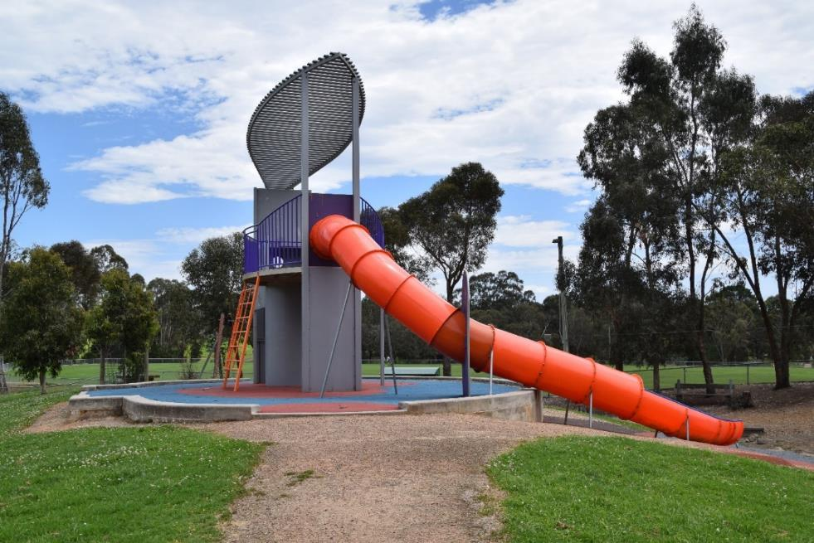
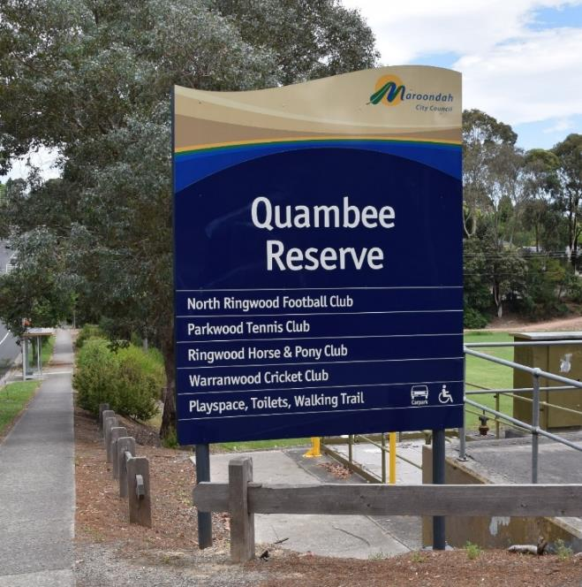

We are going to Quambee Reserve.
It has a large car park and a playground with a fence around it. The fence has a gate which does not lock but opens when you push or pull it.

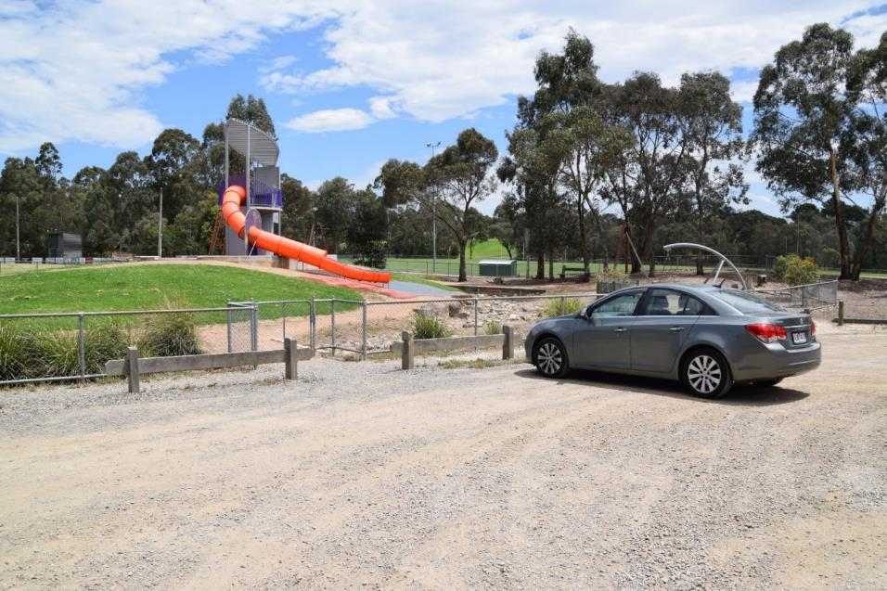

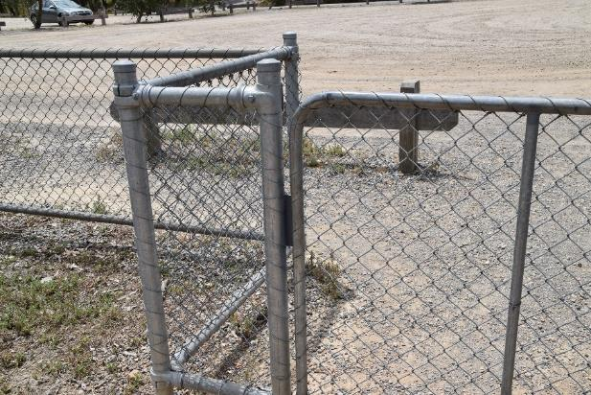

The playground has a climbing frame with a tunnel slide.
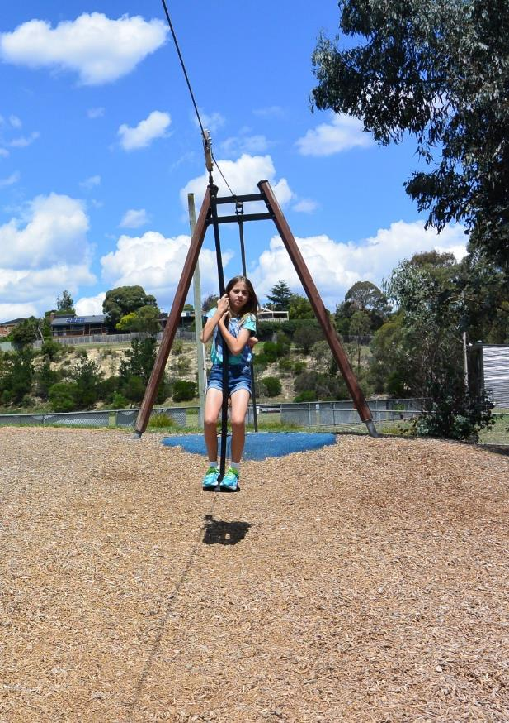
It also has a flying fox.
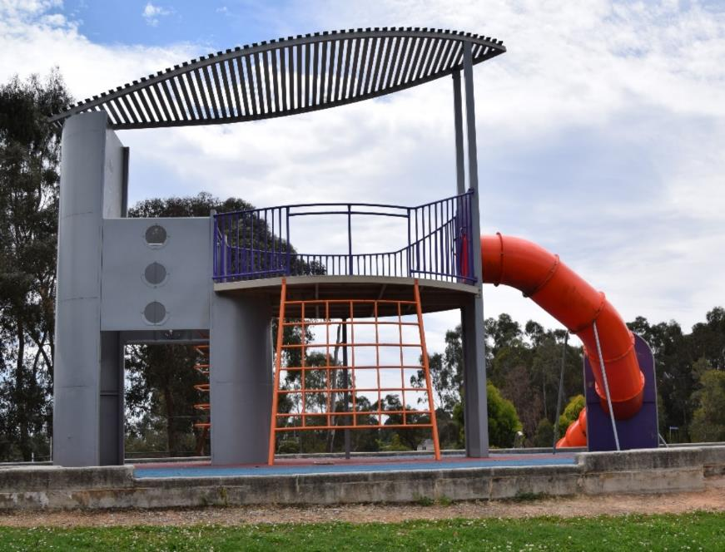

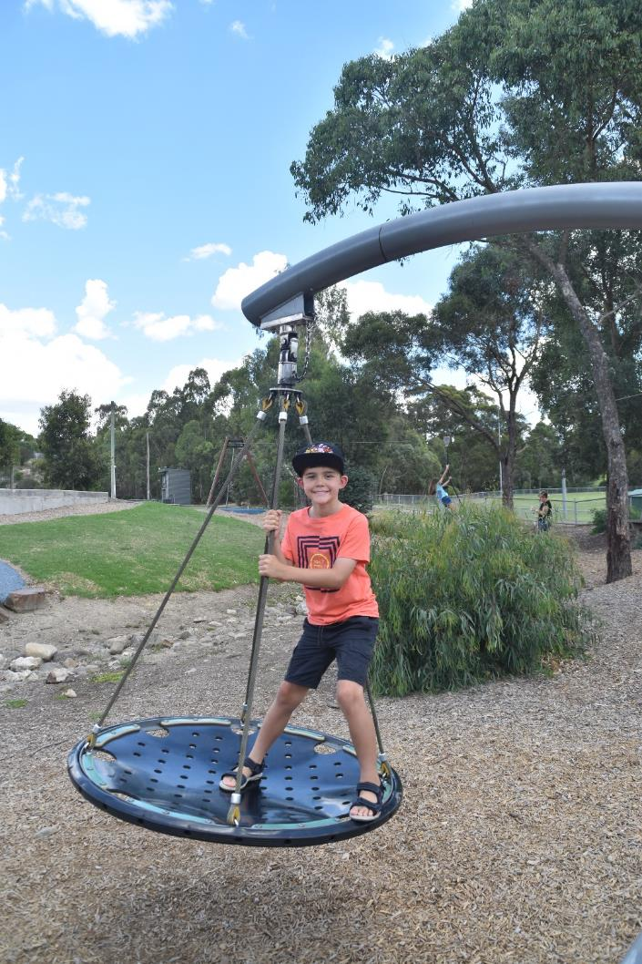
There is a swing at the playground.

You can use the swing by yourself or with someone else.

If you want a turn on the swing someone might already be playing on it and that’s ok. You can ask to have a turn but you might have to wait a few minutes.

If you have been on the swing for a little while and someone is waiting, you can have a few more minutes swinging and then need to share with others. You can always have another turn on the swing later.

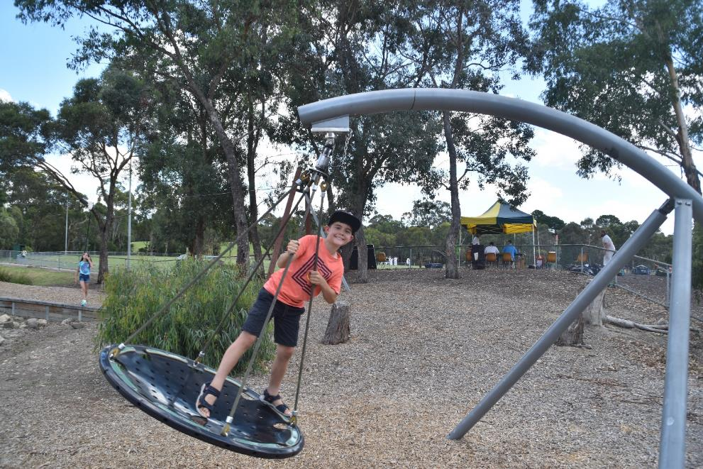

You can climb the frame using the orange steps. You can come down from the frame by the orange slide or by the orange steps.
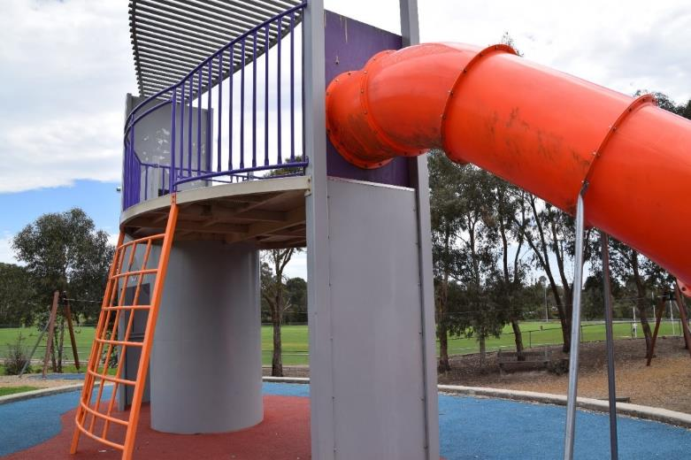
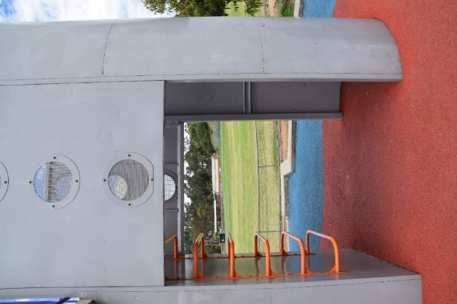

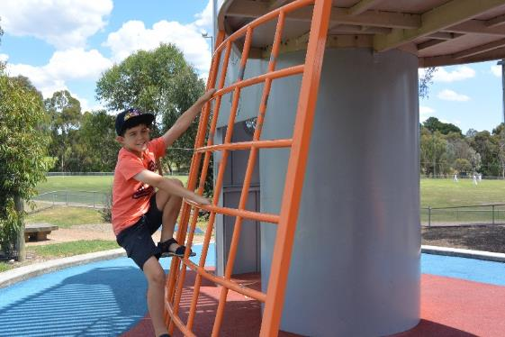
If you need help you
can ask your adult/carer.

You can see the playground and the car park from the platform at the top of the climbing frame.
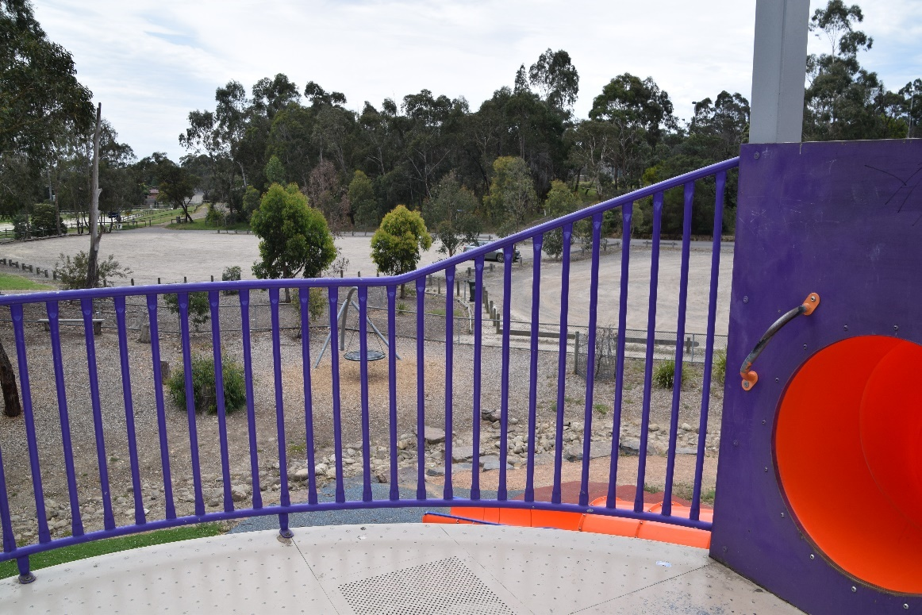
You may see people walking their dogs. If you want to go near a dog you need to ask your adult/carer first.
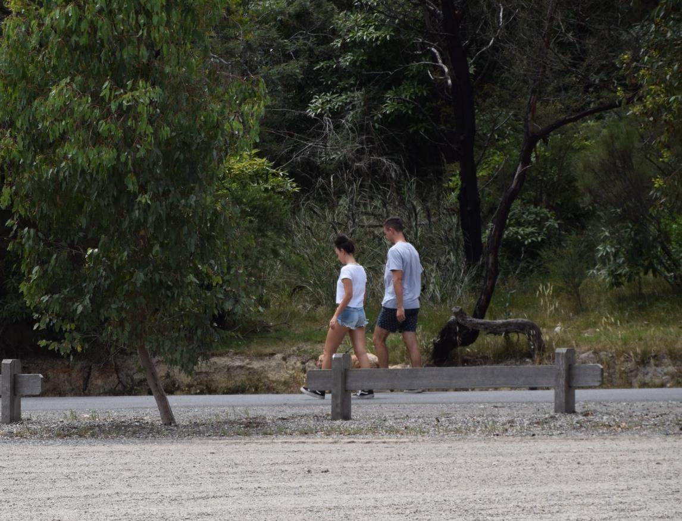

If you get tired, or need a break at the playground, you can sit down and have a rest. There are some seats under the trees and one out in the open.
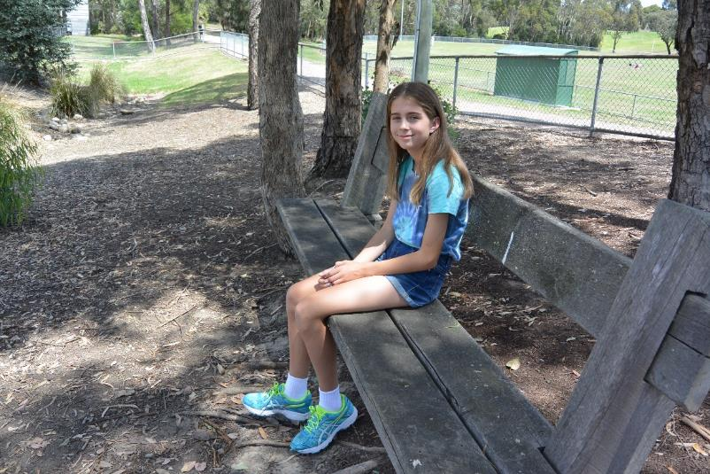

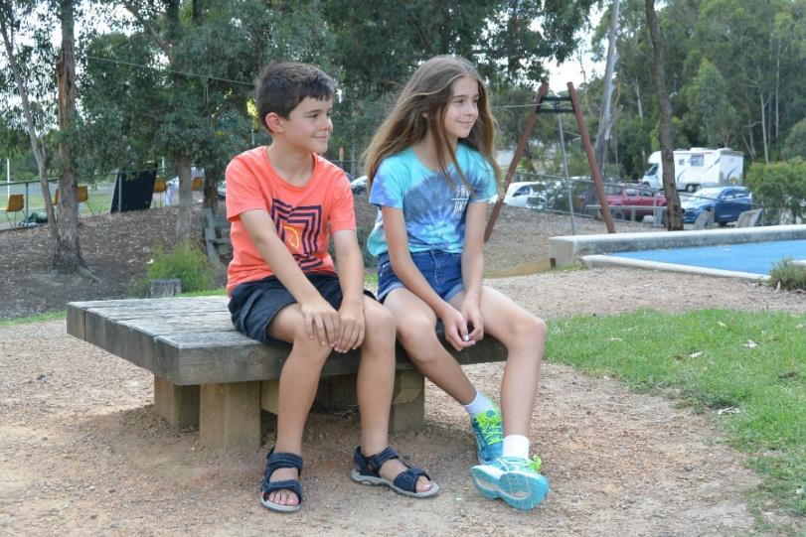

There are toilets near the playground. If you want to go to the toilet, you must ask your adult/carer to go with you.
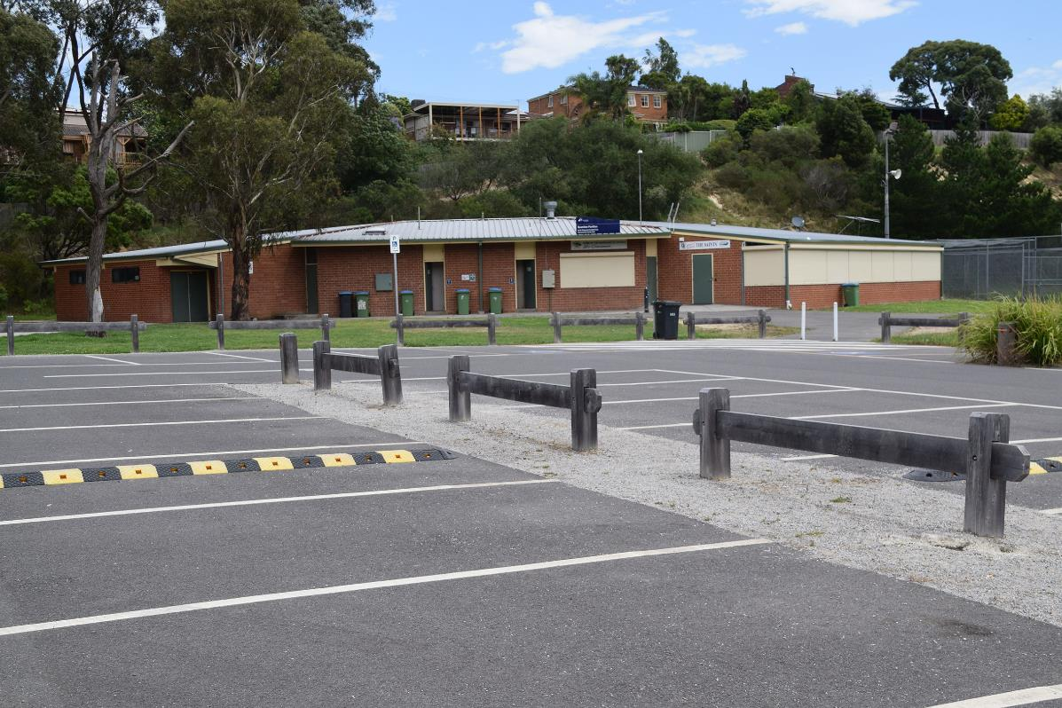

There is a rubbish bin close to the carpark. If you want to put rubbish in the bin you must ask your adult/carer first.
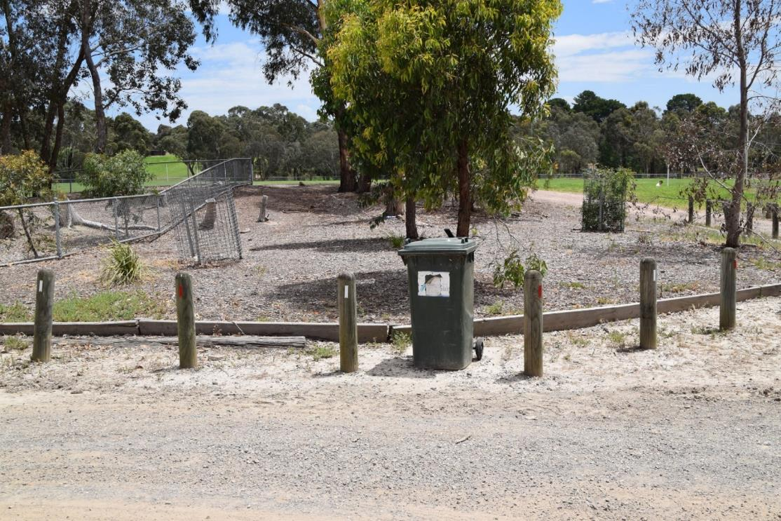

There are many things to see and do at Quambee Reserve.
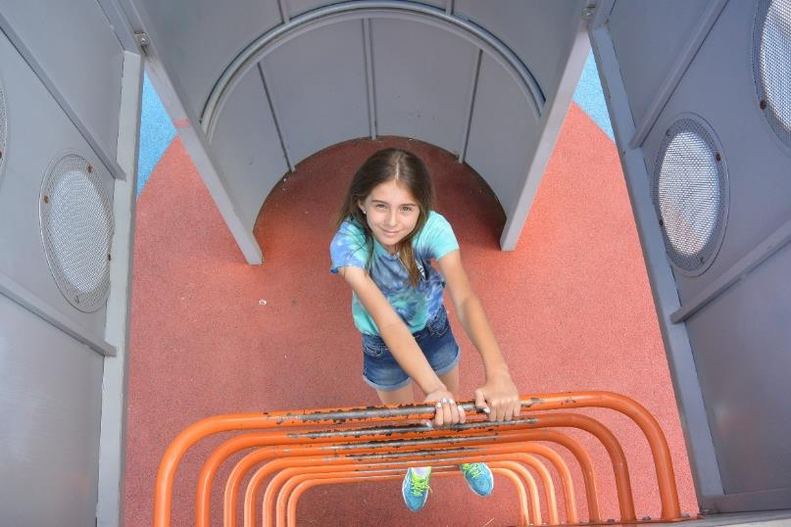
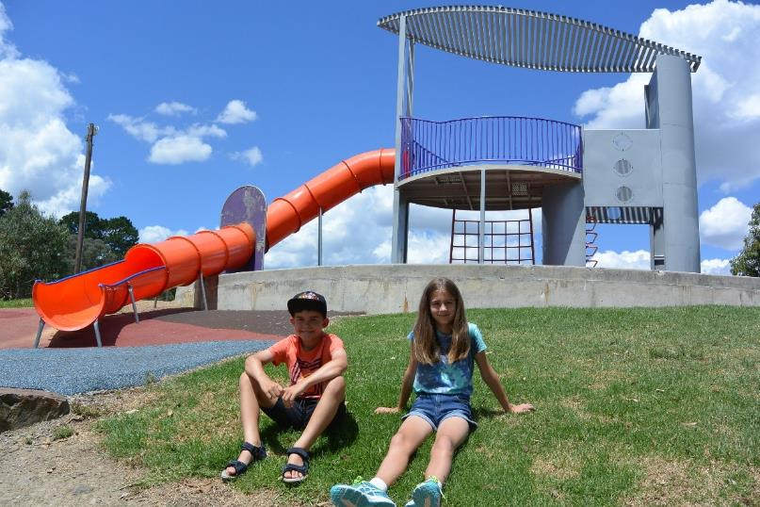

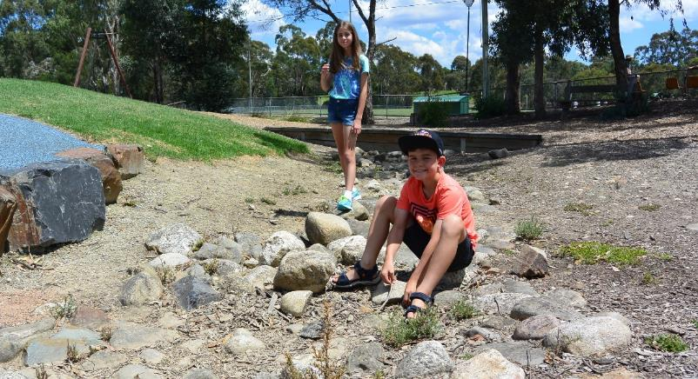
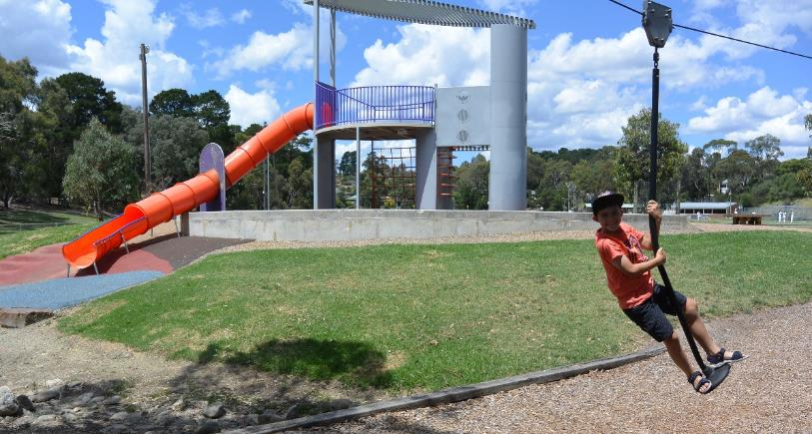

Optional pages

There are walking tracks near the playground. If you want to go for a walk on these tracks, you must ask your adult/carer first and go together. You may see other people walking too.
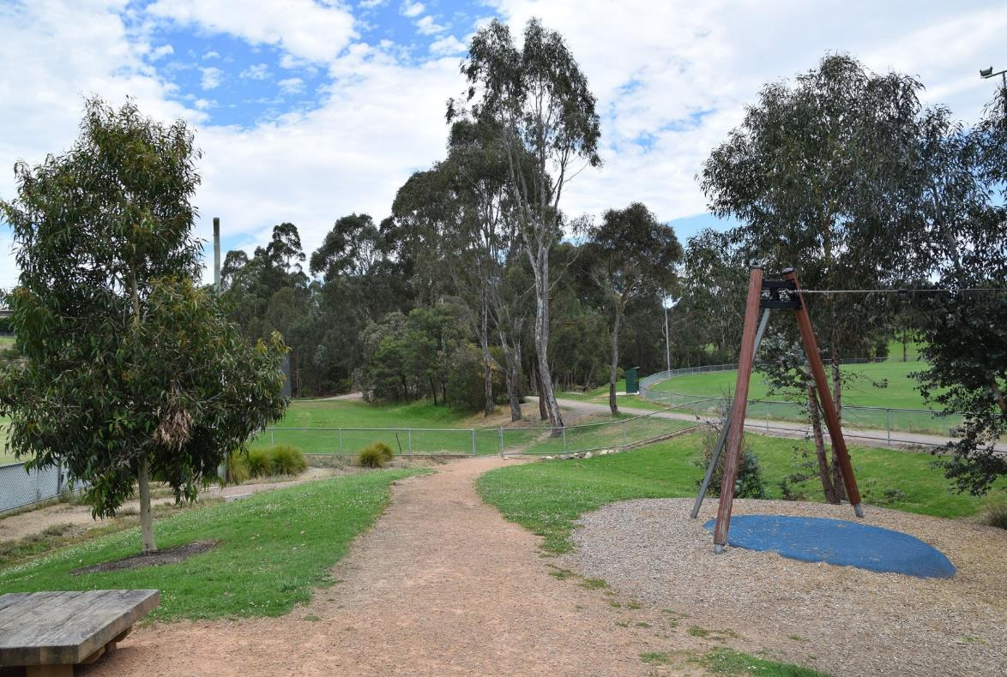

If you’re quiet when you’re walking, you may see and hear some birds.
Here are some of the birds you may see:-

Wattlebird Noisy miner Magpie
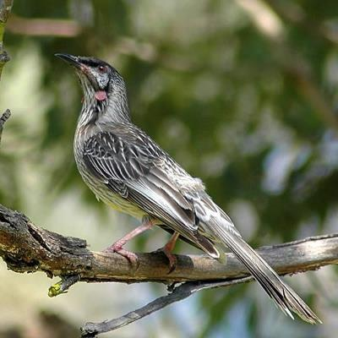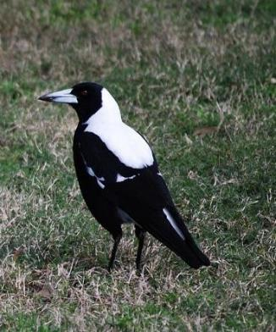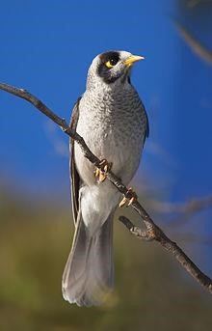

See if you can find other birds at the playground
Quambee Reserve
Wonga Rd, Ringwood North

Notes for parents
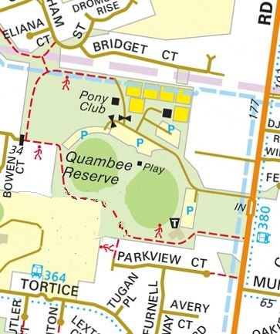
This park was chosen as it is a quiet park away from any main roads and is fully enclosed. However, the gates do not lock and are easily opened.
There is a toilet block a few minutes walk from playground.
There are two ovals around the playground so there is lots of space for other activities.
Please note the playground has very little shade so you are advised to take hats/sunscreen etc for your children and a drink.
There are many walking tracks around the playground but you may encounter dogs off lead. However, all dogs must be on lead around the playground area.

