Our visit to Warrien Reserve
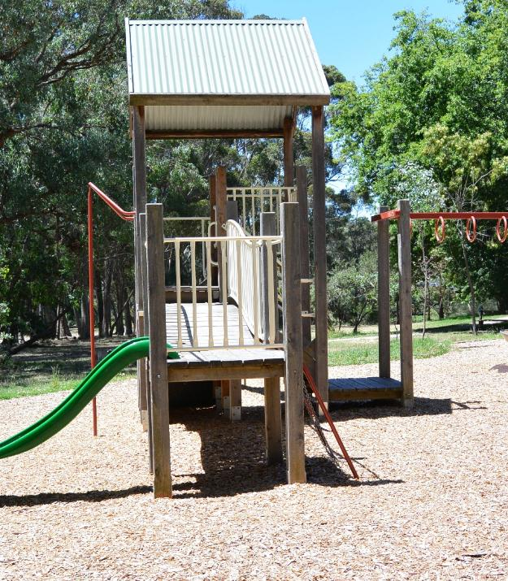
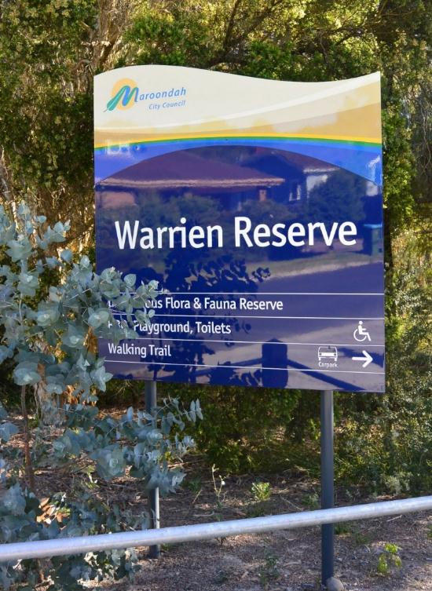

We are going to Warrien Reserve.
There is a playground, a walking track, and a picnic area.

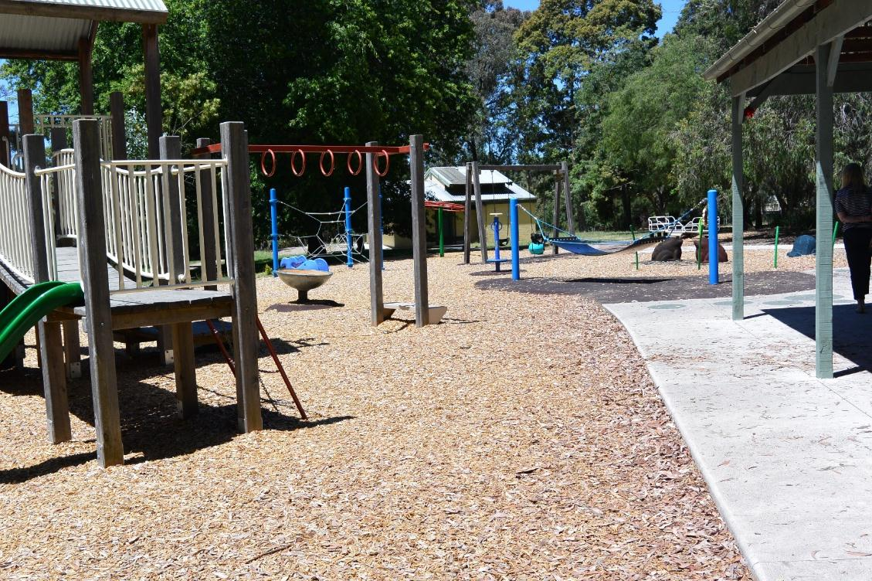
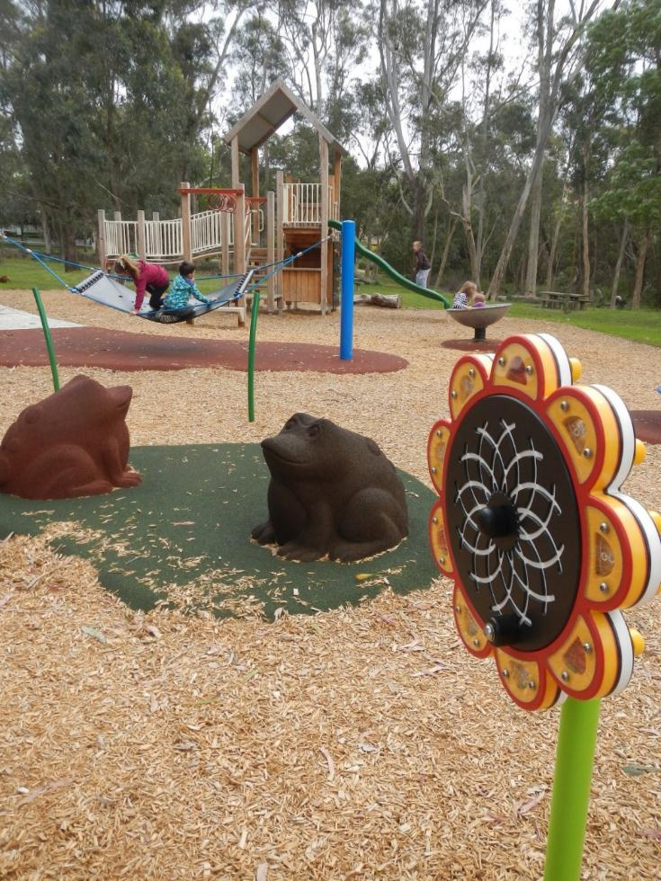
We can have fun at the playground using the play equipment.

There may be other people at the playground.

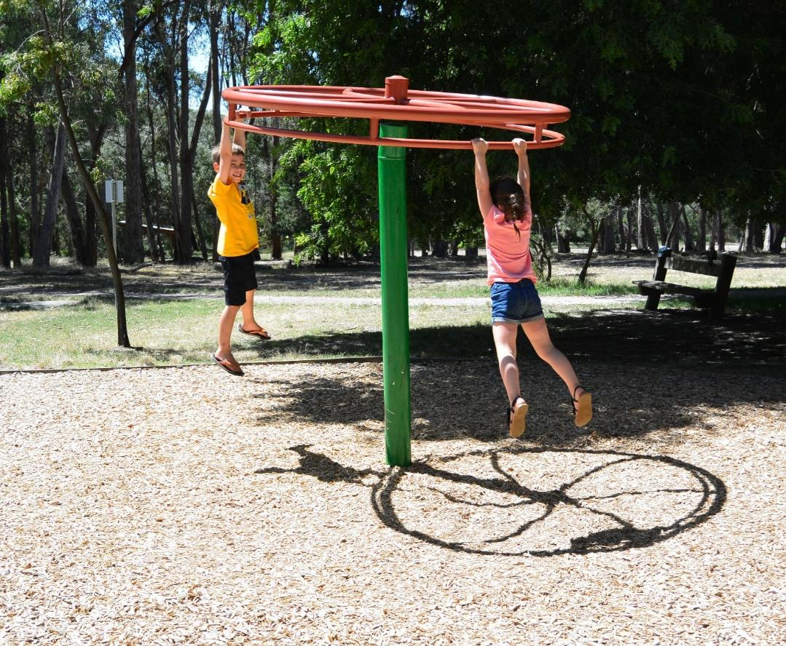
There is a hanging swing.

We can use the hanging swing with someone else or by ourselves.

It is fun to try the climbing wall and the magic mirror.
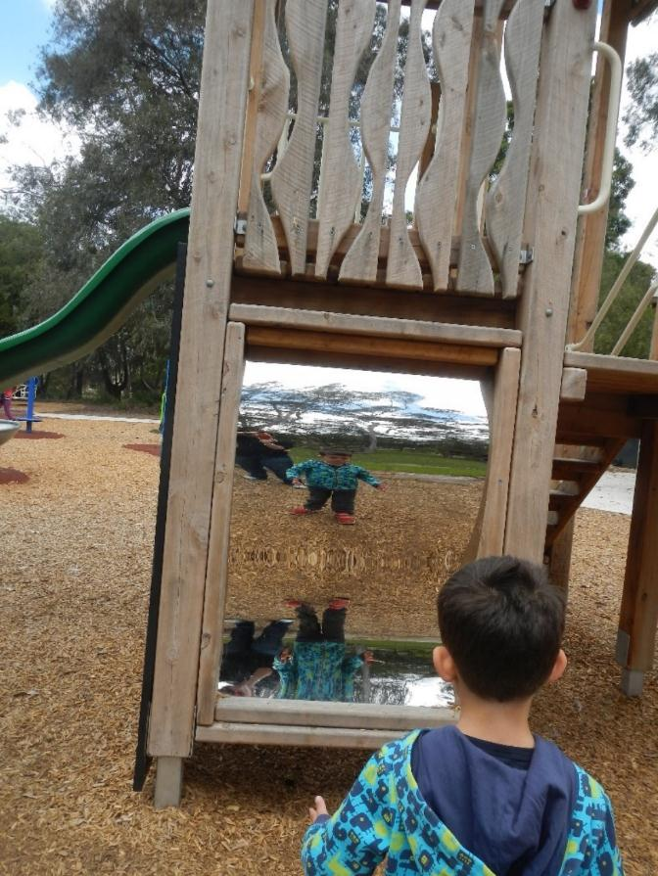
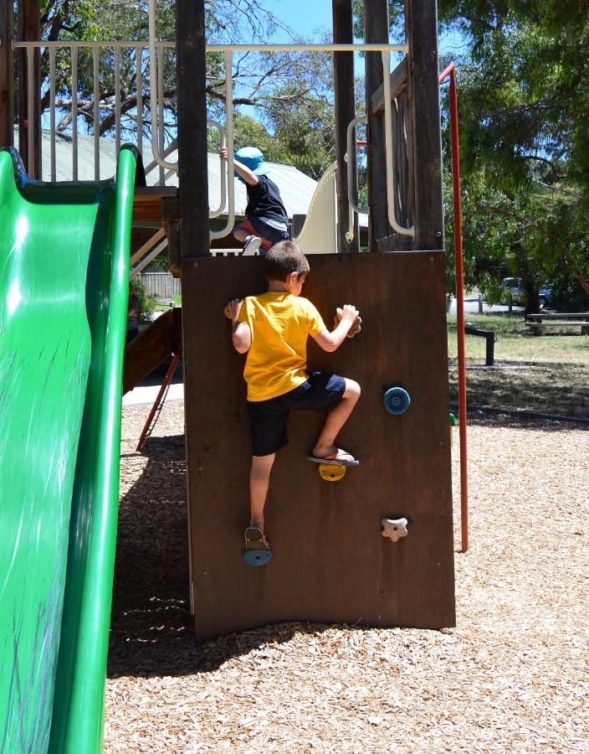

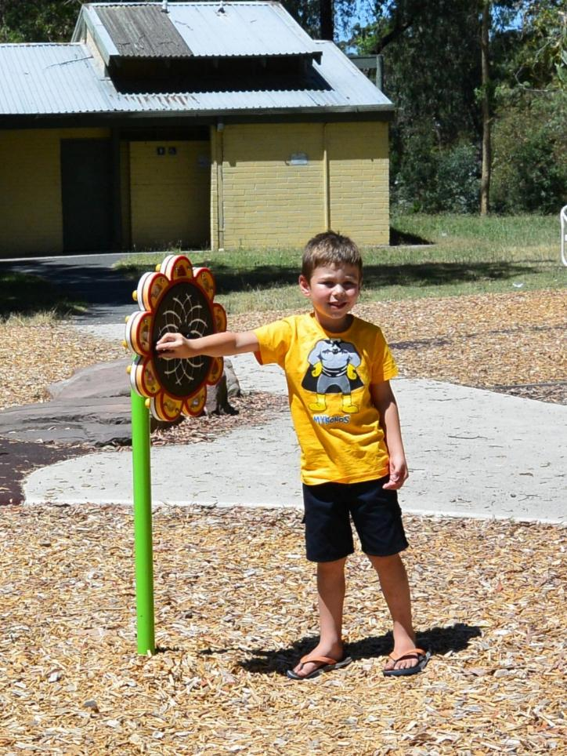
If you turn the handle
on the large flower,
the lights flash and
it makes a noise.

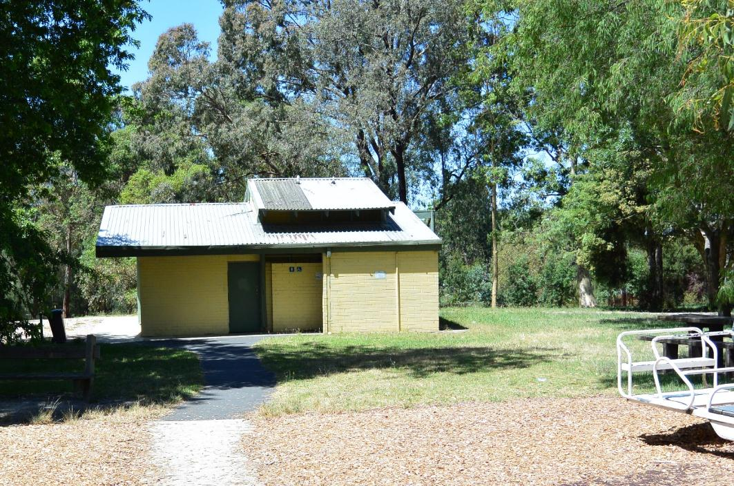
There are toilets near the playground with an accessible toilet too.

If you want to go to the toilet, you must ask your adult first.

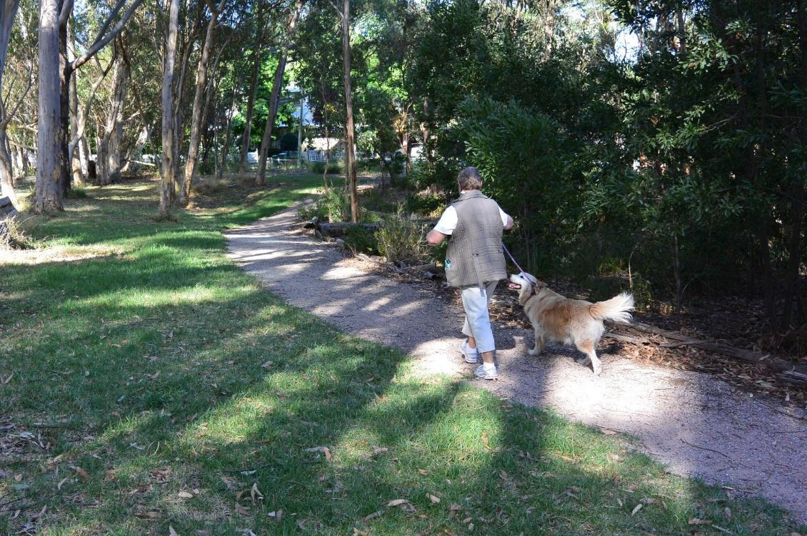
There may be dogs at Warrien Reserve.

If you want to go near a dog you need to ask your adult or the dog’s owner.

There is an area for dogs where they can play without their leads on.
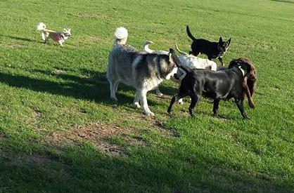
You can go to this area with your adult and watch the dogs playing.

You can walk along the path with your adult.
You may see other people walking too.
If you follow the path you will return to the playground.
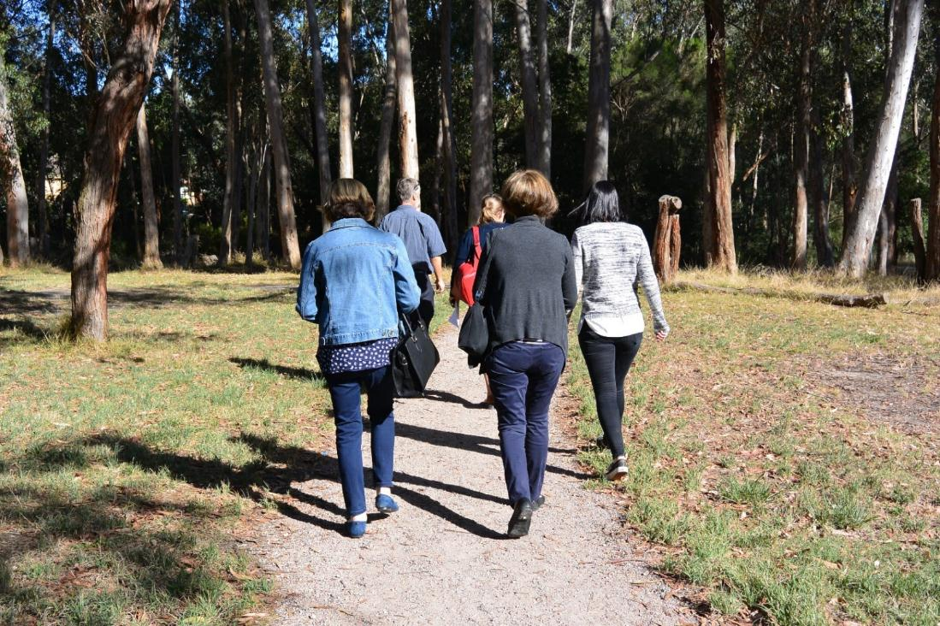
The park has many quiet places where you can sit among the trees. You could also build a cubby hut under the trees.
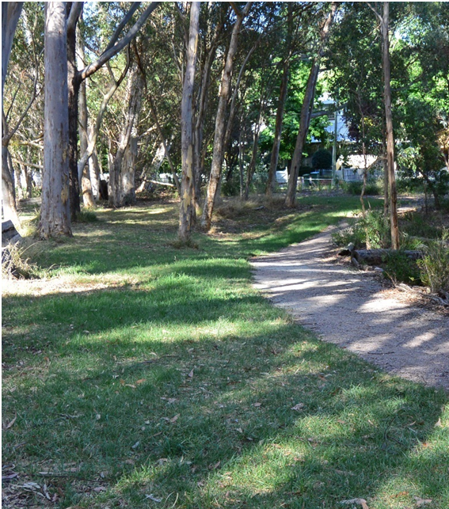
If you want to go to a quiet place in the park you must ask your adult first.

There is a drinking fountain at the playground. You can have a drink of water if you get thirsty.

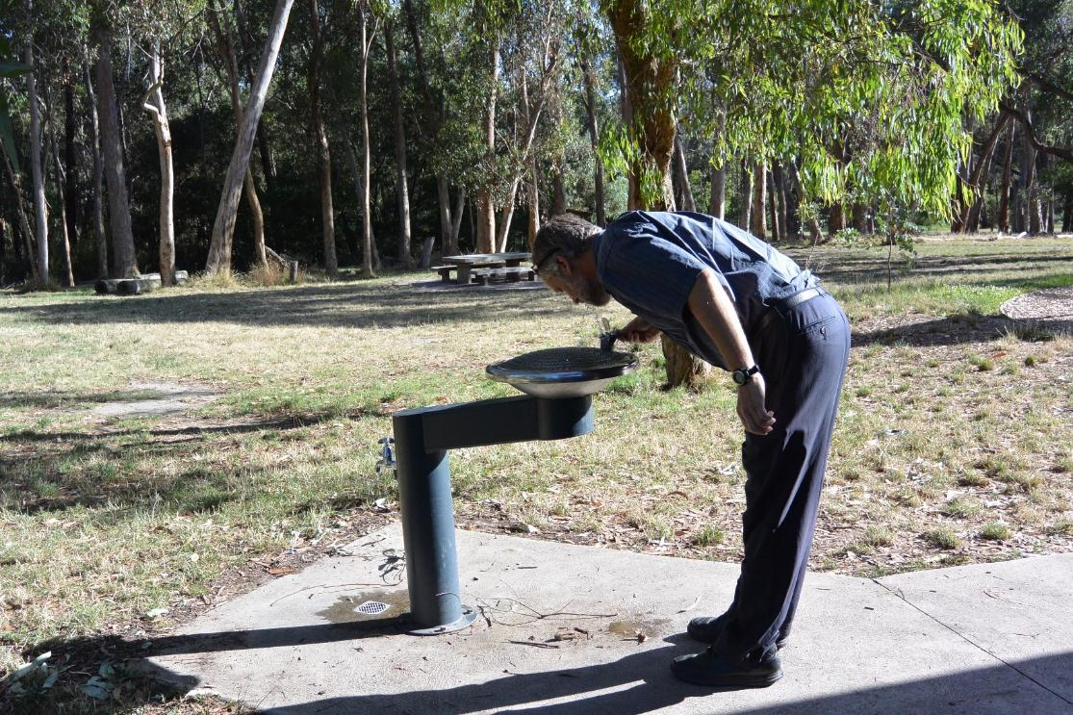
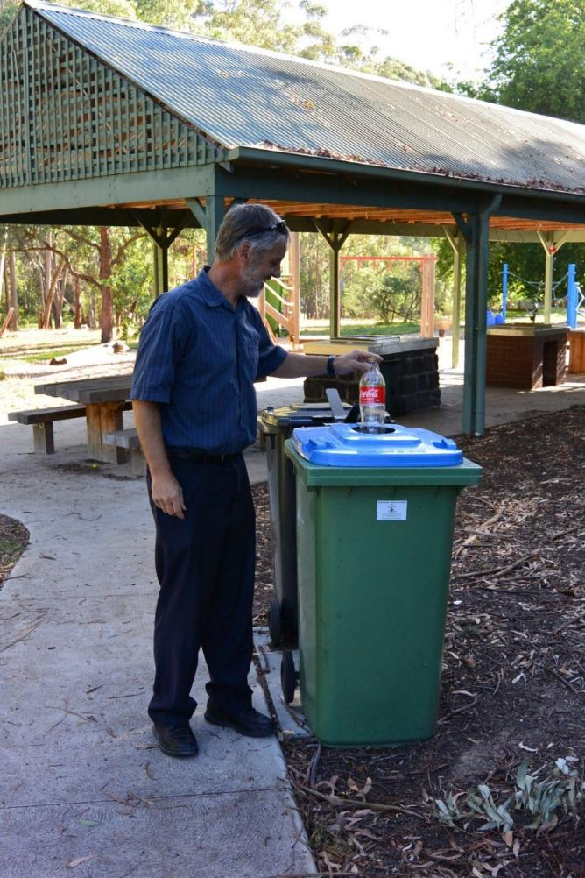
There are rubbish bins
at the playground for you
to put your rubbish in.

There are many things to see and do at Warrien Reserve.
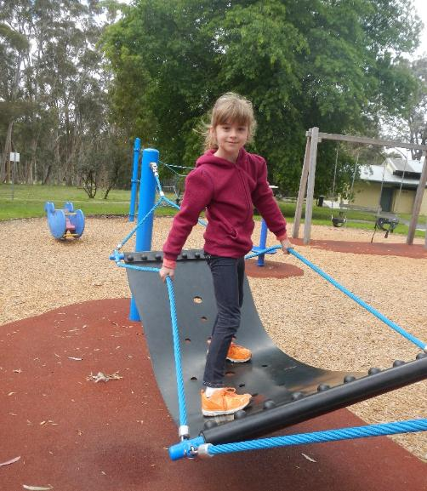
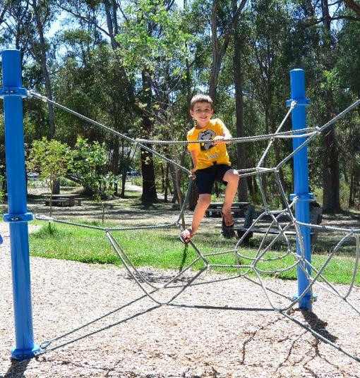

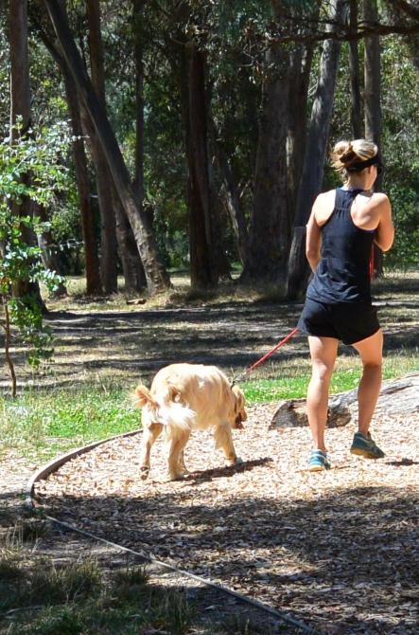

Optional pages

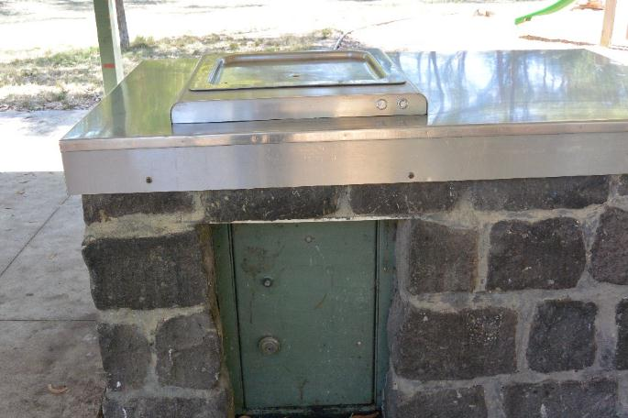
There is a bbq area and picnic tables for you to use.

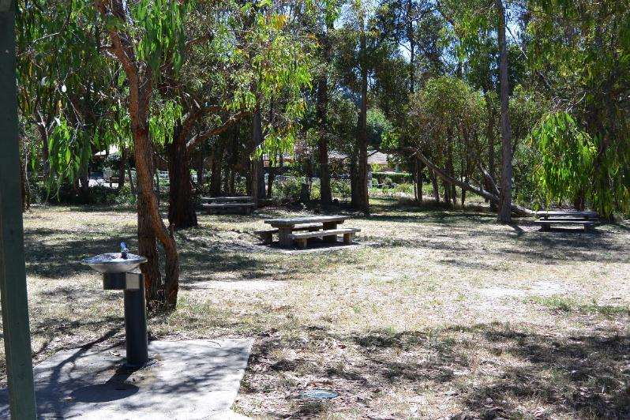

If you’re quiet when you’re walking, you may see and hear some birds.

Here are some of the birds you may see:-

Wattlebird Noisy miner Magpie
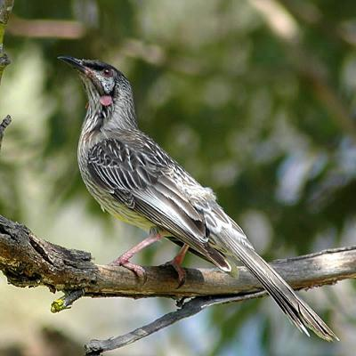
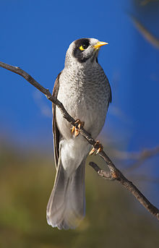
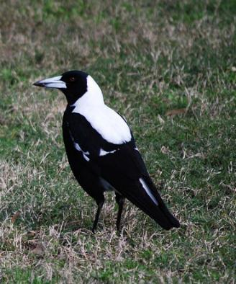

Notes for parents
Current map of Warrien Reserve

This park was chosen as it is a quiet park away from any main roads.
There is an accessible toilet near the playground.
The walk is a 20min round trip, starting and finishing at the playground.
Please note the playground has very little shade so you are advised to take hats/sunscreen etc for your children.
There is an off lead dog park near the walking track but all dogs must be on lead around the playground area.
There is a shaded picnic/bbq area for you to use. Please clean up all rubbish and the bbq after use.

