`q

bundang in the First Nations language of the Wiradjuri people means a blackish butterfly. The bundang art exhibition tells a story through reflection and leaves question about cultural identity around what and how it is shaped.

**Vandal - bundang**

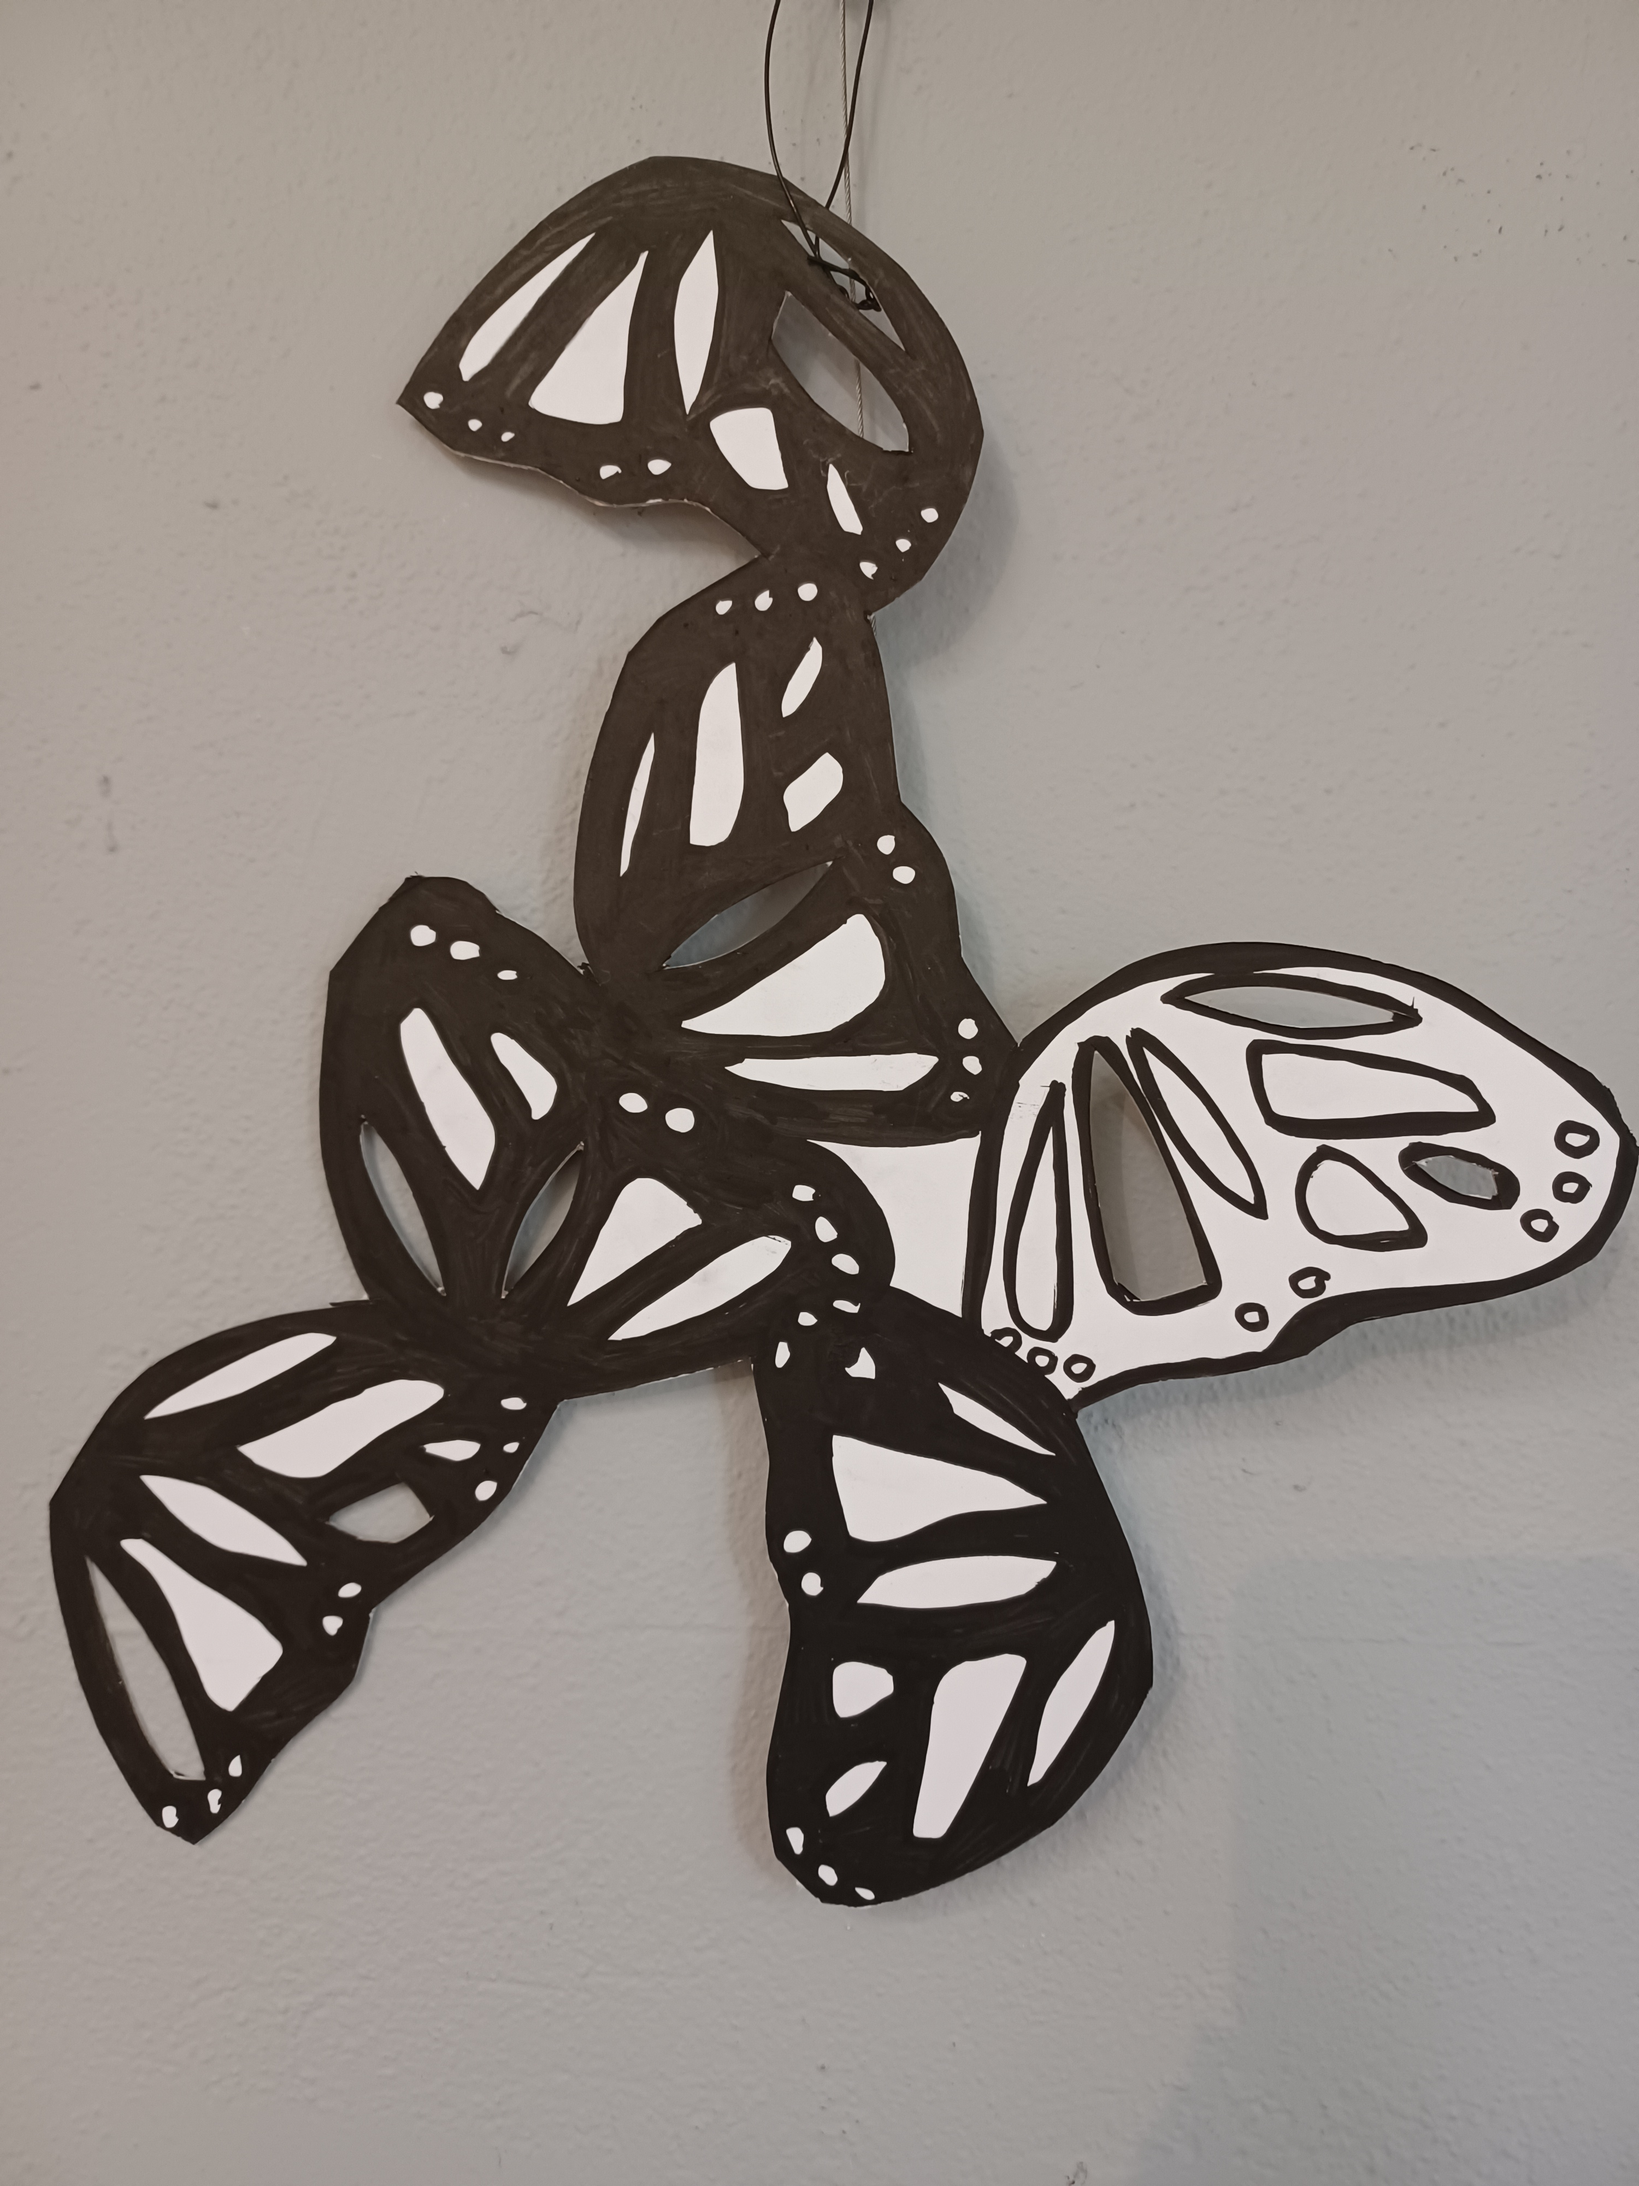

|  |  |  |  |
| --- | --- | --- | --- |
| V1 | We Are | mixed media | NFS |
| V2 | Monarch budyabudya | cardboard, texta | $1500 |
| V3 | walang Imperial | fabric | $2000 |

**14 June - 12 August 2023**

**Featured Artists**

**Linda R Bester**

|  |  |  |  |
| --- | --- | --- | --- |
| LRB229 | Eastern Whipbird - *Psophodes olivaceus* | watercolour paint | $1100 |
| LRB230 | Bilby – *Macrotis lagotis* | pencil | $1900 |
| LRB231 | Platypus – *Ornithorhynchus anatinu* | pencil | $1100 |
| LRB232 | Eastern Spinebill - *Acanthorhynchus tenuirostris* | pencil | $1300 |
| LRB233 | Sandplain Duck Orchid - *Paracaleana dixonii* | pencil | $750 |
| LRB234 | Leafy Greenhood, Coastal Form - *Pterostylis cucullata* | pencil | $750 |
| LRB235 | Koala - *Phascolarctos cinereus* | pencil | $1300 |
| LRB236 | Red-winged Fairy Wren, male - Malurus elegans | pencil | $1100 |
| LRB237 | White-breasted Woodswallows - *Artamus leucorynchus* | gouache, pencil | $1400 |
| LRB238 | Blue-faced Honeyeater - *Entomyzon cyanotis* | gouache, pencil | $1100 |
| LRB239 | Hooded Plover – *Thinornis rubricollis* | watercolour, pencil | $750 |
| LRB240 | Common or Bare-nosed Wombats - *Vombatus ursinus* | gouache, pencil | $1200 |
| LRB241 | Purple-backed Fairywren, female - *Malurus assimilis* | acrylic, pencil | $1100 |
| LRB242 | Dainty or Dingy Swallowtail butterfly - *Papilio anactus* | gouache, pencil | $750 |

Linda R. Bester is an Australian‐based ecologist who creates nature‐based artworks, often targeting threatened species, with the aim of spreading awareness about their existence and the environmental threats that impact thereon. Her scientific knowledge, combined with her industry-based connections to experts, allows her to maintain a high level of accuracy with regards to species morphology. She has spent the last 25 years studying and working in the

field of conservation and land management; and has now finally found her calling through showing and publishing her blend of scientific artworks and scientific information. Linda uses gallery quality coloured pencils for the most part, but occasionally adds detail using various paints, on Canson Moulin du Roy 100% cotton, hot pressed watercolour paper.

space and gallery door with her pop up murals, plus traffic signal boxes.  She has produced award-winning art on skateboard deck and has published her own distinctive colouring book range, inspired by her Aboriginal heritage. Vandal's artwork is distinctive, bold, energetic, and full of imagination, love, and whimsy.

Tricia "Vandal" Van Der-Kuyp is a proud Wiradjuri woman and Melbourne-based artist (Bundadhaany). A mixed media artist, with a focus on flora and fauna. Vandal has created augmented reality artwork and large-scale public artworks in and around Melbourne. She was chosen in 2019 as one of 8 Victorian Artists to have her artwork displayed on a Melbourne Art Tram.

Vandal's also produced artworks that appear on community art trails around Victoria that have decorated, a sculpture, seats, a barbecue, a car parking



The Arts Lounge at Wyreena is an art space for artists to exhibit their work in a vibrant, accessible setting.  The Arts Lounge offers exhibition space to 2D & 3D Artists in the beautiful environment of Wyreena.

The Arts Lounge

Catalogue

Wyreena Community Arts Centre

13 – 23 Hull Road Croydon 3136

9294 5590

wyreena@maroondah.vic.gov.au

http://www.maroondah.vic.gov.au/wyreena

www.facebook.com/wyreena

www.instagram/wyreena

Artists Featured in The Maker’s Windows

* Beatrix Mol Jewellery
* Jodie Westall Kimpton Jewellery
* Corina Horstra Ceramics
* Samantha Moon Jewellery

Artwork displayed within Wyreena

* Jodie Westall Kimpton Cards and prints
* Annie White Cards and prints
* Linda R Bester Cards and prints
* Susan Pepper Cards
* Meredith Simpson Cards and prints
* Susan Pepper Textile
* Joanne Everard Cards and prints

**Linda R Bester** (Room 1)

**Vandal** (Room 2)

Blue-faced Honeyeater Monarch budyabudya

Linda R Bester Vandal