**Table of Contents**

1. INTRODUCTION 5
   1. Purpose of Asset Plan 5
   2. Scope of Asset Plan 5
   3. Council’s Asset Portfolio 6
2. STRATEGIC CONTEXT 7
   1. Regulatory Framework 7
   2. Community Vision 9
   3. Council Plan 9
   4. Financial Plan 9
   5. Asset Plan 9
   6. Sustainability Strategy 9
   7. How Council’s Assets Support the Delivery of Services 10
3. FUTURE CHALLENGES AND OPPORTUNITIES 11
4. WHAT THE COMMUNITY SAID 14
   1. Council’s Approach to Community Engagement 14
   2. Key Outcomes 14
      1. Broad Community Stakeholder Engagement Outcomes 14
      2. Maroondah Community Panel Deliberative Engagement Outcomes 15
      3. Targeted Engagement Outcomes 17
      4. Advisory Committees Engagement Outcomes 18
5. HOW COUNCIL MANAGES ITS ASSETS 19
   1. Council’s Role in Managing Community Assets 19
   2. Asset Management Framework 19
   3. Asset Lifecycle Management 21
   4. Asset Investment/Expenditure Categories 22
   5. Asset Investment Strategy 22
6. STATE OF COUNCIL ASSETS 24
   1. Road Infrastructure 24
   2. Pathways 26
   3. Stormwater Drainage Assets 28
   4. Buildings 30
   5. Open Space Assets 32
7. FUNDING THE ASSET PLAN 34
   1. Capital Expenditure Projections 34
   2. Total Expenditure Projections 35
   3. Asset Management Financial Performance Indicators 37

Figures

Figure 1 - Integrated Planning Framework 8

Figure 2 - How Assets Support Service Delivery 10

Figure 3 - Key Challenges 11

Figure 4 – Community Values 15

Figure 5 – Importance Rating of Community Assets 16

Figure 6 – Council’s Asset Management Framework 19

Figure 7 – Asset Lifecycle Stages 21

Figure 8 – Asset Investment Strategy 23

Figure 9 – Ten-Year Capital Expenditure by Category 34

Figure 10 – Total Ten-Year Expenditure Projections 35

Figure 11 - Total Expenditure Projections by Category 36

Figure 12 – Summary of Ten-Year Expenditure Projections 36

Figure 13 – Performance Indicators for the Ten-Year Period 2025-2035 37

**Tables**

Table 1 - Asset Portfolio 6

Table 2 - Summary of Key Challenges and Opportunities 13

Table 3 – Community Asset Trade-offs 17

Table 4 – Feedback from Targeted Community Groups 18

Table 5 – Feedback from Advisory Committees 18

Table 6 - Council’s Asset Management Framework Documents 20

Table 7 – Asset Lifecycle Management Approach 22

Table 8 - Asset Investment/Expenditure Categories 22

Table 9 – Ten-Year Projected Expenditure by Asset Class 35

**Acknowledgement of Country**

We, in the spirit of Reconciliation, acknowledge the Wurundjeri People of the Kulin Nation as traditional custodians of the land now known as the City of Maroondah, where Indigenous Australians have performed age- old ceremonies. We acknowledge and respect their unique ability to care for Country and their deep spiritual connection to it. We pay our respects to their Elders, past, present and emerging.

# Introduction

Maroondah City Council (Council) is responsible for stewardship of approximately $2.2 billion in community assets. These include roads, pathways, bridges, buildings, drains, parks and recreation facilities and represent a significant investment made over many generations. This large and diverse asset portfolio plays an integral role in supporting the delivery of a range of services to the community such as transport, stormwater management, sports and recreation, community health and well-being services.

As the custodian of community assets, Council manages these assets responsibly, to ensure long-term sustainability and the continuity of service provision to the community. This is achieved through managing the assets lifecycle, from creation and acquisition, maintenance and operation, through to refurbishment and decommissioning. These actions are undertaken to ensure that assets continue to remain accessible, safe, sustainable and responsive to the current and future needs of the community.

This Asset Plan communicates the way Council manages the community’s assets to support the delivery of services. It provides a strategic and financial view of how Council will manage community assets over the next ten (10) years and beyond, to make progress towards the Maroondah 2050 Community Vision.

## Purpose of Asset Plan

This Asset Plan has been prepared to meet the requirements of Section 92 of the *Local Government Act 2020* and is part of Council’s integrated approach to meeting its long-term goals.

The purpose of this Asset Plan is to:

* Better inform the community on the type of assets under Council’s custodianship and the challenges associated with service levels, costs and financial capacity.
* Improve the effectiveness of asset management planning through enhanced engagement.
* Demonstrate how Council will responsibly manage assets to meet the service delivery needs of the community into the future in a sustainable and cost-effective way.
* Ensure that Council’s integrated approach to asset planning supports the Maroondah 2050 Community Vision.
* Ensure that Council complies with legislative obligations.

## Scope of Asset Plan

While Council manages an extensive portfolio of assets, this Asset Plan covers all fixed, physical and/or infrastructure that is under Council’s control and is recognised as an asset of Maroondah City Council. Council assets that are covered in this plan include:

* Road infrastructure
* Buildings
* Pathways
* Stormwater drainage
* Open space

This Asset Plan is an overview document that summarises the key elements of the more detailed asset management plans that Council has developed for each of the above infrastructure asset classes. It is also supported by an Asset Management Policy that guides Council’s future management of its assets.

## Council’s Asset Portfolio

Council’s community assets are currently valued at approximately $2.2 billion. This includes land, infrastructure assets and non-infrastructure assets. Council’s land portfolio is valued at $1.02 billion and underpins the various other asset categories. This Asset Plan provides guidance on all of Council’s assets, excluding non-infrastructure assets such as land, plant and equipment.

|  |  |  |  |
| --- | --- | --- | --- |
| **Asset Class** | | **Quantity** | **Current Value (on 30 June 2024)**  **($ ‘000)** |
|  | **Road Infrastructure** | * 473 km sealed roads * 4 km unsealed roads * 8 road bridges * 427 car parks * 491 km of kerb and channel | $305,271 |
|  | **Buildings** | * 6 neighbourhood houses * 2 multi-level car parks * 362 ancillary assets * 25 community halls * 28 early years facilities * 13 leased facilities * 24 major complexes * 18 public toilet facilities * 49 recreational facilities | $348,873 |
|  | **Pathways** | * 684 km footpaths * 68 km shared paths * 85 km reserve paths * 52 pedestrian bridges | $82,484 |
|  | **Stormwater Drainage Infrastructure** | * 787 km drainage pipes * 30,218 drainage pits | $370,662 |
|  | **Open Space** | * 133 public playspaces * 49 sports fields (turf) * 3 skate parks * 2 golf courses * 2 athletic tracks * 1,597 park furniture * 2108 park lighting * 128,275 street trees | $51,136 |
|  | **Plant and Equipment** | Fleet vehicles, major plant, minor plant, ICT equipment, etc supporting service delivery | $17,806 |
|  | **Land** | 649 hectares of Council owned/controlled land, including 578 parks and reserves | $1,024,751 |
|  | **TOTAL** | | **$2,200,983** |

*Table 1 - Asset Portfolio*

# Strategic Context

## Regulatory Framework

Council operates in a complex legislative and policy environment that directly influences the way it does business. Council’s principal governing legislation in Victoria is the *Local Government Act 2020*. This Act requires Council to develop an integrated, long-term and transparent approach to planning, organised around a ten (10) year community vision.

Council’s integrated planning and reporting framework, shown on the following page is underpinned by several key documents including the Maroondah 2050 Community Vision, Council Plan, Financial Plan and Asset Plan.

The framework seeks to ensure Council’s activities and resources are aligned, to meet the aspirations, needs and expectations of the community, as articulated in the Maroondah 2050 Community Vision ‘*Maroondah is a safe, inclusive and vibrant, community, striving for a green, prosperous, and sustainable future for all’.*

This Asset Plan is an important part of Council’s integrated planning and reporting framework and drives the approach to asset management. It ensures that Council’s infrastructure assets are appropriate for current and future strategies and plans, remain fit for purpose and that optimum use is achieved through appropriate maintenance, renewal and replacement programs.

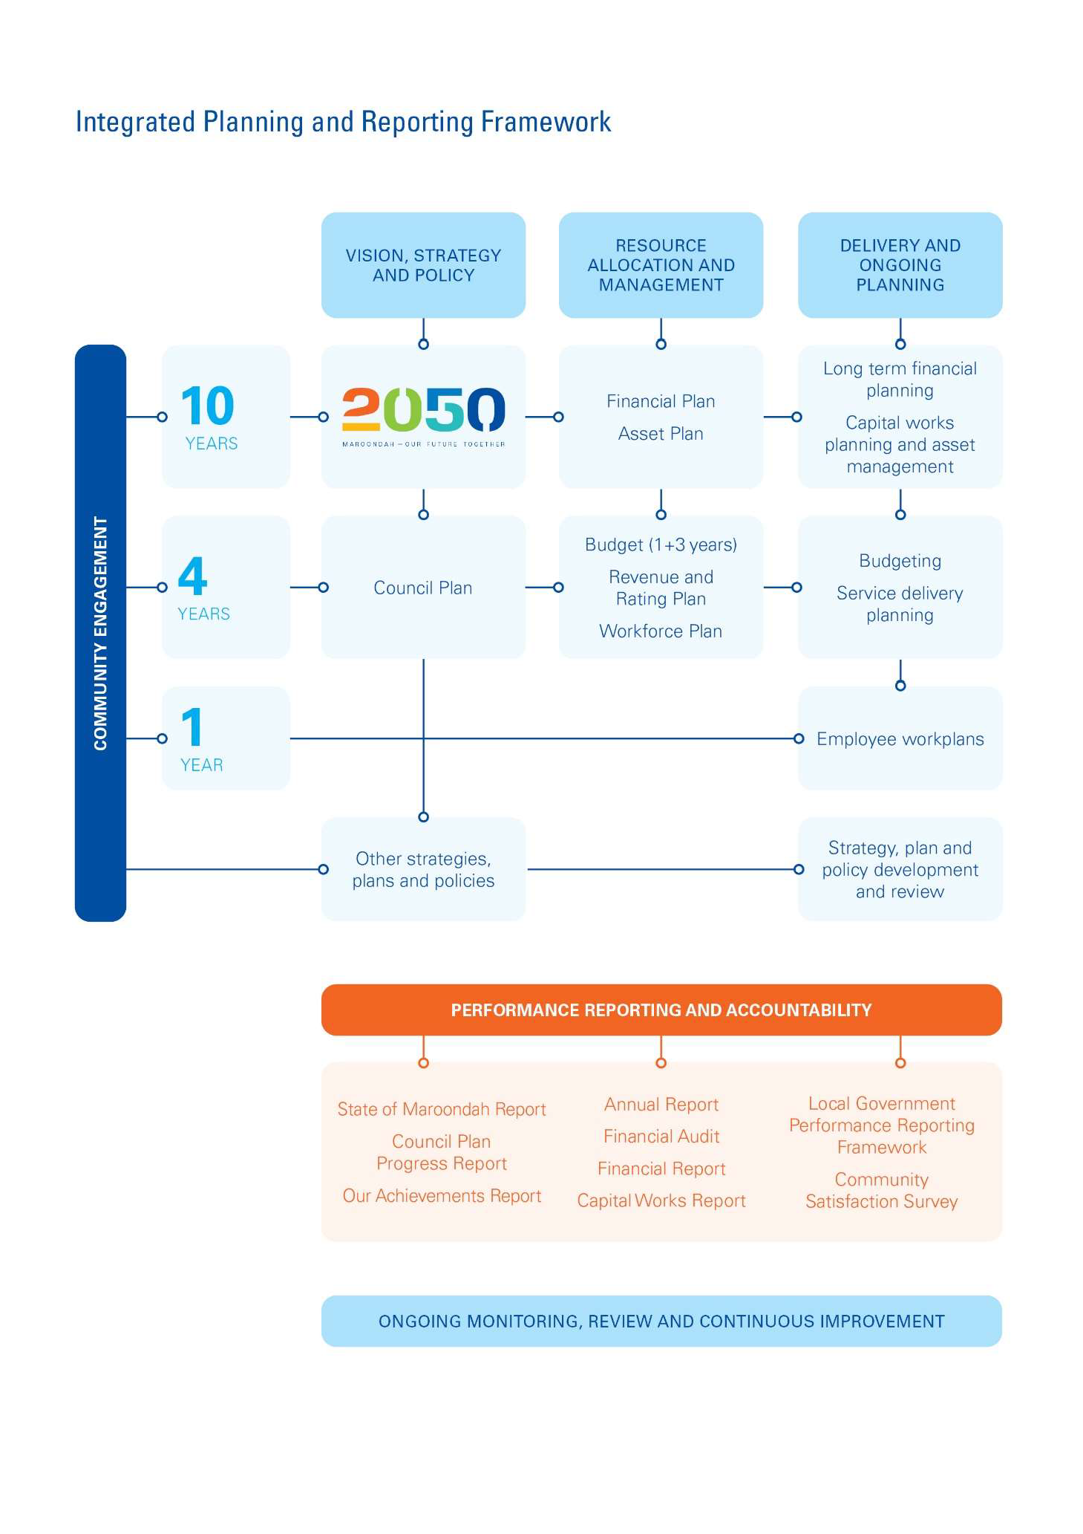

Figure 1 - Integrated Planning and Reporting Framework

## Community Vision

The Maroondah 2050 Community Vision sets out the community’s long-term aspirations, values, and priorities for the municipality. Council recognises its stewardship role in effectively managing the community assets and aims to provide sustainable assets and services aligned with the Maroondah 2050 Community Vision.

## Council Plan

The Council Plan sets out Council’s medium-term key directions over the next four (4) years and identifies how Council will contribute towards achieving the outcome areas of the Maroondah 2050 Community Vision and how success will be measured.

## Financial Plan

The Financial Plan provides a longer-term view of the resources that Council anticipates will be available, and how these will be allocated and prioritised over the next ten (10) years to achieve the Maroondah 2050 Community Vision. It identifies Council’s current and projected financial capacity to continue delivering quality services, facilities and infrastructure while identifying critical new capital investment, to support the community liveability.

This Asset Plan is linked with the budgets and projections outlined in the Financial Plan, to ensure affordability and ongoing financial sustainability of service delivery from Council’s infrastructure assets.

## Asset Plan

The *Local Government Act 2020* requires Council to develop an Asset Plan as a public-facing document to inform the community on how Council-owned and controlled infrastructure assets are to be managed to achieve the Maroondah 2050 Community Vision and supporting Council Plan directions.

This Asset Plan sets out how Council will deliver assets that support the Maroondah 2050 Community Vision, within the constraints of Council’s Financial Plan. It sets out how decision-making is informed by Council’s asset management systems and practices and provides information about the maintenance, renewal, acquisition, expansion, upgrade, disposal and decommissioning of the community assets over the next ten (10) years.

## Sustainability Strategy

The Sustainability Strategy presents a vision of an environmentally, socially and economically sustainable Maroondah and supports the Maroondah 2050 Community Vision, along with the UN Sustainable Development Goals, to support a holistic approach to sustainability. It focuses on key outcome areas relevant to assets, such as Built Environment, Climate Change and Green Infrastructure and articulates several key directions that will guide Council’s asset management actions over the next ten (10) years.

## How Council’s Assets Support the Delivery of Services

Assets play a critical role in the delivery of the goals and outcomes identified in the Maroondah 2050 Community Vision, by supporting the delivery of services such as sport, recreation and leisure, transport, stormwater management, community health and well-being. The table below provides an overview of service driven asset infrastructure aligned with the Maroondah 2050 Community Vision.

|  |  |  |  |  |  |
| --- | --- | --- | --- | --- | --- |
| **Maroondah 2050 Vision Outcome**  **Areas** | **Asset related Council Services and Programs** | **Assets Classes supporting Services and Programs** | | **Specific Asset Examples** | **How** |
| ***A healthy, inclusive and connected community*** | * Aged and disability services * Community health * Community well-being * Maternal and child health * Youth and children’s services * Leisure and aquatic services * Sport, recreation and events |  | * Buildings * Pathways * Open Space Assets | * Community Centres and Halls * Arts and Cultural facilities * Kindergartens and Maternal and Child Health Centres * Neighbourhood Houses * Aquatic centres and sports and recreation pavilions * Sports fields and sporting Infrastructure * Playspaces | Community centres, halls, arts and performing venues, neighbourhood houses and other building facilities provide inclusive and accessible spaces and programs for community gathering and social connections and promote health and well- being, build resilience and reduce vulnerability.  Parks, paths/trails, sporting facilities and aquatic centres provide inclusive and accessible opportunities for active and passive recreation. |
| ***A safe and liveable community*** | * Arts and cultural development * Precincts and cultural facilities * Infrastructure development * Engineering Services * Building maintenance * Asset management |  | * Road infrastructure * Open Space Assets * Pathways | * Local roads and kerbs * Public lighting * Footpaths and shared paths/trails * Bridges * Activity centres and community precincts * Parks and reserves * Trees * Streetscapes | Local roads, bridges and pathways provide safe, accessible, integrated and resilient transport and pedestrian networks to keep the community connected.  Local activity centres and community precincts provide opportunities for local businesses and social connection that meet the diverse needs of the community, while preserving and enhancing the green, leafy natural environment, local history and heritage. |
| ***A green and sustainable community*** | * Bushland and weed management * Environmental planning * Sustainability * Parks maintenance * Tree maintenance |  | * Open Space Assets * Stormwater Drainage Assets | * Parks and reserves * Bushland reserves * Street trees * Streetscapes * Stormwater drainage pipes and pits * Wetlands and retarding basins * Stormwater quality devices | Parks, bushland reserves and wetlands provide places for people to visit and recreate. They also provide areas for the protection and enhancement of biodiversity and habitat corridors.  Trees, vegetation and green infrastructure within the built environment actively support Council’s efforts to address climate change.  The stormwater drainage network and stormwater quality devices support the treatment of stormwater runoff prior to entering waterways, with stormwater harvesting reducing demand for potable water for irrigation and other uses. |
| ***A vibrant and prosperous community*** | * Bayswater Business Precinct * Ringwood Metropolitan Activity Centre * Corydon Major Activity Centre * Library services |  | * Road infrastructure * Buildings * Open Space Assets | * Realm * Karralyka Centre * Libraries * Local Roads * On and off-street car parks * Streetscapes | Cultural precincts and arts and performance venues are vibrant places for the community to connect, learn and create.  Local roads, car parks and streetscapes enhance accessibility and amenity of commercial and industrial precincts to facilitate thriving local and regional businesses. |
| ***A well- governed and empowered community*** | * Customer service * Property and valuations * Digital and online * Information management * Realm operations |  | * Buildings | * Realm Customer Service centre * Civic administration offices and depots | Customer service centres and other Council building facilities enable the delivery of timely, integrated, responsive, accessible and people-focused services to the Maroondah community. |

*Figure 2 - How Assets Support Service Delivery*

# Future Challenges and Opportunities

Council has built a comprehensive understanding of external factors that have the potential to impact service and asset provision, management and decision making, and these are outlined in figure 3 below, and table 2 on the following pages.

**Political & Legal**

* **Cost shifting from other levels of government**
* **Complex legislative and regulatory compliance**



* **Increasing litigation and costs**

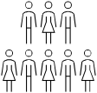

* **Revenue constraints**
* **Ageing infrastructure**

**Economic**

* **Increasing costs**
* **Tightening of grant funding**

**Social**

* **Population growth**
* **Changing demographics and cultural diversity**
* **Changing needs for access, social connections and physical and mental health and well-being**
* **Activating local neighbourhoods**

**Technology**

* **Online and connected services**
* **Automation, AI and emerging technologies**
* **Real time access to asset information**
* **Advanced analytics for decision-making**

**Environment**

* **Asset resilience to climate change**
* **Asset impacts on environment**
* **Enhancing tree canopy cover and biodiversity**

*Figure 3 - Key Challenges*

|  |  |  |
| --- | --- | --- |
| Key  Challenges | Description | Managing Impact on Assets/Service Delivery |
| Political & Legal | * Changes to government policies and cost shifting of services from other levels of government. * Increasingly complex asset-related regulatory compliance and reporting requirements. * Rising cost of public liability claims and expanded range of litigated matters. | * Council will continue to advocate to other levels of government for support, explore service delivery partnerships with other agencies and make considered decisions to manage competing funding demands of services and assets, ensuring Council’s financial sustainability is not materially impacted. * Council will ensure that its assets are inspected regularly and that a sound infrastructure risk management framework is implemented. |

|  |  |  |
| --- | --- | --- |
| Key  Challenges | Description | Managing Impact on Assets/Service Delivery |
| Economic | * Rate capping impact on Council’s revenue and ability to fund the continued provision of current levels of service. * Ageing assets and increasing financial liability for funding asset renewals to ensure sustainability of service delivery. * Cost of construction and maintenance of assets increasing at a rate greater than CPI. * Potential reduction in government grants and reliance on alternate income streams for financial sustainability. | * Council will need to continually investigate more efficient methods for maximising service delivery within its funding constraints and balance the affordable provision of services and assets against the needs of the community. |
| Social | * Maroondah’s population forecast for 2025 is 120,304 and is forecast to grow by more than 16% to 139,974 by 2046.1 * Future population growth will be mainly stimulated by housing consolidation and medium density development which will impact on the planning and upgrade of assets required for service delivery. * Need for infrastructure, amenities and services tailored to suit the forecast increase in population of retirement age. * The demographic and cultural diversity in the city, their preferences and popularity trends, particularly in sport and recreation aspects are also changing the demands and expectations for facilities and services. * Need to continue to focus on improving both the physical and mental health and wellbeing of the community and creating opportunities for social connections whilst also promoting inclusion accessibility, equity and equality. * Activation of local neighbourhoods and providing opportunities for increasing percentage of residents to live and work   locally (currently 25%). | * Council will need to expand its services and assets to cater for the growing community, be responsive to changing needs and ensure that subdivisional growth does not impact on the services currently being delivered to the community. * Council will need to review and optimise its asset portfolio and ensure that its facilities are able to adapt to changing community needs and be safe, inclusive, equitable and accessible. * Council will ensure that multi-purpose facilities and shared hubs are established with effectively utilised and universally accessible spaces and provide social connection and opportunities for arts and creativity to meet changing needs of the community. * Council will improve social connections and inclusion through urban design and reinforce the need for local neighbourhoods that are green, walkable and connected to local services and employment opportunities. |
| Technology | * Significant move to online and connected services throughout the world. * Emerging technologies, artificial intelligence (AI) and automation that are being adopted by smart cities for management of assets. * Internet of Things (IoT) facilitating real time asset information for capacity, utilisation and asset self-diagnosis. * Flexible working arrangements and real-time access to information in the field. | * Council will be adaptable to emerging technologies and make data more accessible to the community to interact with Council’s services digitally in a secure manner. * Council will also continue to implement efficient and effective asset management systems and processes to digitally monitor asset performance and ensure that the |

1 ID Community Demographic Resources (https://forecast.id.com.au/maroondah)

|  |  |  |
| --- | --- | --- |
| Key  Challenges | Description | Managing Impact on Assets/Service Delivery |
|  | * Reliance on technology to improve productivity and streamline processes. * Advanced analytics to assist with improved decision-making. | right assets are renewed at the right time and cost. |
| Environment | * Climate change impact on assets and resilience of assets to extreme weather events, such as bushfires, heatwaves, droughts and flooding. * Minimising the negative impacts of assets on the climate, natural environment and human health, and where possible maximising opportunities to deliver the services provided by green infrastructure. * Protecting and enhancing Maroondah’s tree canopy, sites of biological significance and habitat connectivity. | * Council will build resilience to climate change impacts into the design and construction of infrastructure and materials used, ensuring that financial sustainability is not materially impacted. * Council will implement the use of sustainable energy sources and materials to provide assets that are environmentally efficient, green the city to reduce heat effects, re-use stormwater and recycled water, recycle waste and resource recovery, etc. to minimise impact on the environment. * Council is committed to maintaining, protecting and enhancing the city’s natural environment and biodiversity and will continue to strengthen its partnerships with landcare agencies. |

*Table 2 - Summary of Key Challenges and Opportunities*

# What the Community Said

## Council’s Approach to Community Engagement

Community engagement for the development of the Asset Plan was undertaken between August 2023 and May 2024 in conjunction with the engagement for the Maroondah 2050 Community Vision and Council Plan 2025 - 2029.

## Community and stakeholder engagement - August to June 2023

Over a period of 10 months from August 2023, Council undertook an extensive community and stakeholder engagement process to provide all Maroondah community members with the opportunity to share their thoughts, aspirations, and ideas for the future of the municipality.

Engagement included surveys, workshops, pop-up events and online activities with the broader Maroondah community. Input was also sought from Council advisory committees, and harder to reach and underrepresented community members. These activities resulted in over 9800 contributions.

## Maroondah 2050 Community Panel - February to May 2024

After expressing their interest to be part of the Maroondah 2050 Community Panel, 34 demographically representative community members volunteered their time to provide input and make recommendations regarding the Maroondah 2050 Community Vision, Council Plan 2025-2029, and Council’s 10 year Financial and Asset Plans.

Over five sessions, the panel provided their thoughts and feedback on a future community vision for Maroondah, identified key areas of focus, and discussed the priority activities that needed to be undertaken to achieve the vision. The relevant outcomes from the engagement informed this Asset Plan and will also inform a range of future strategic work, projects and service delivery by Council.

## Key Outcomes

The key engagement outcomes relevant to the development of this Asset Plan are summarised below. These will be used to inform Council’s approach to the future planning, management and decision-making associated with assets over the life of this Asset Plan.

### Broad Community Stakeholder Engagement Outcomes

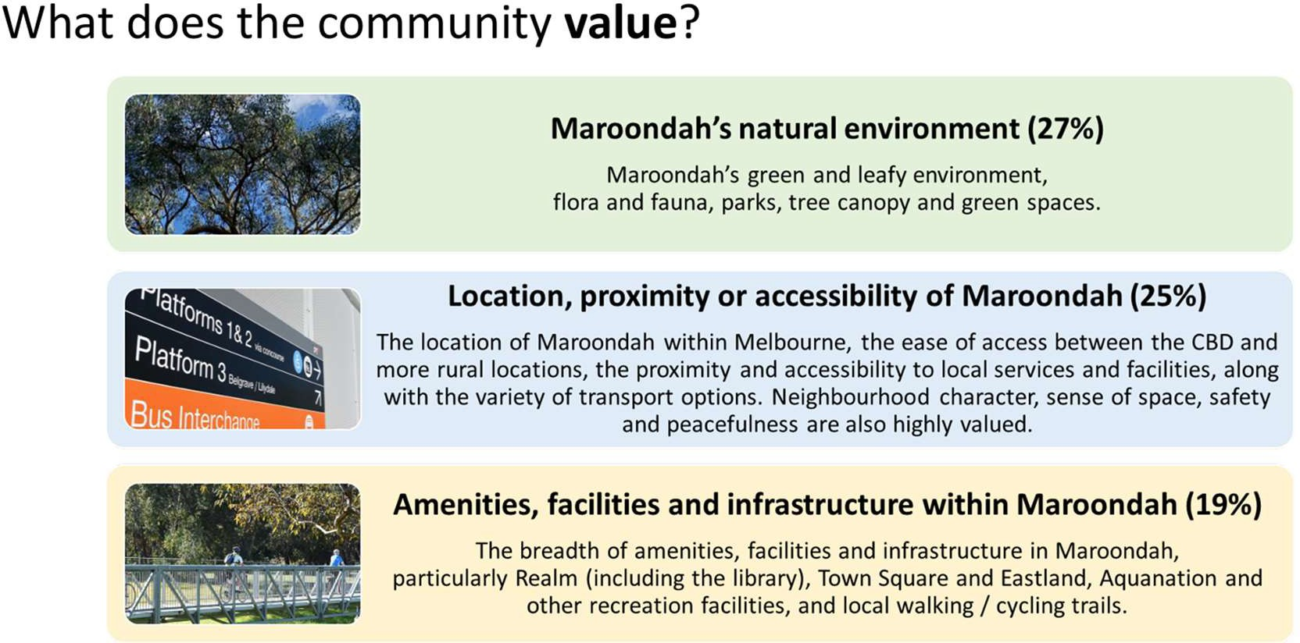

*Figure 4 – Community Values*

### What are the community’s aspirations for the future of Maroondah?

The top 5 community aspirations relate to:

* + - 1. Green
      2. Sustainable
      3. Inclusive
      4. Safe
      5. Connected

These aspirations are consistent with Council’s vision for managing community assets, which is stated below: *‘Council will provide assets that are accessible, safe, sustainable and responsive to the needs of the community and the contemporary environment’.*

### What are the community priorities?

The community’s top priorities are listed below. These relate to the importance that the community place on specific services and the assets that support service delivery.

1. Enhanced physical and mental health and wellbeing (17% of votes)
2. Social connection and inclusion (12% of votes)
3. Empowering and supporting people of all ages, abilities and backgrounds (11% of votes)
4. Sustainable resource use and climate resilience (11% of votes)
5. Connected, reliable and accessible transport (10% of votes)

### How does the community currently connect within Maroondah?

The community’s top priorities are listed below. These relate to how the community interact/connect with Maroondah and the assets that support service delivery.

1. Shopping (92%)
2. Natural environment (83%)
3. Leisure/fitness (81%)
4. Transport network (74%)
5. Gathering opportunities (71%)

The implications of the above findings are that:

* There will likely be increased demand and usage of community assets supporting above service delivery, especially with the forecast population growth in the municipality.
* These assets will require increased maintenance to minimise associated levels of risk.
* An increased community expectation that these assets will remain fit for purpose and continue to meet community needs and expectations.

### Maroondah Community Panel Deliberative Engagement Outcomes

The Maroondah Community Panel were briefed on Council’s approach to asset management, and the above engagement outcomes, and were requested to discuss the following aspects:

### What Council owned assets are you aware of?

There was good recognition of all Council assets, with the highest levels of recognition being for the following:

* + - 1. Libraries
      2. Parks
      3. Karralyka Centre
      4. Sporting facilities
      5. Swimming pools
      6. Playspaces
      7. Realm.

### To meet community needs over the next 10 years, how important will each of our community assets be?

#### The following diagram depicts the importance scores panel members selected on a 7-point rating scale, with 1 = we can’t decide, 2 = not important and 7 = critical:

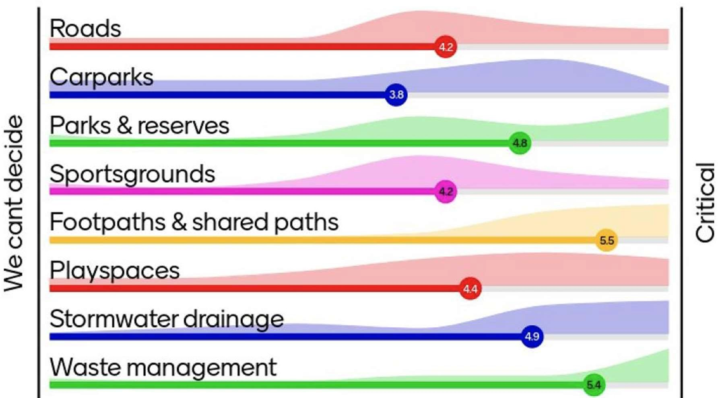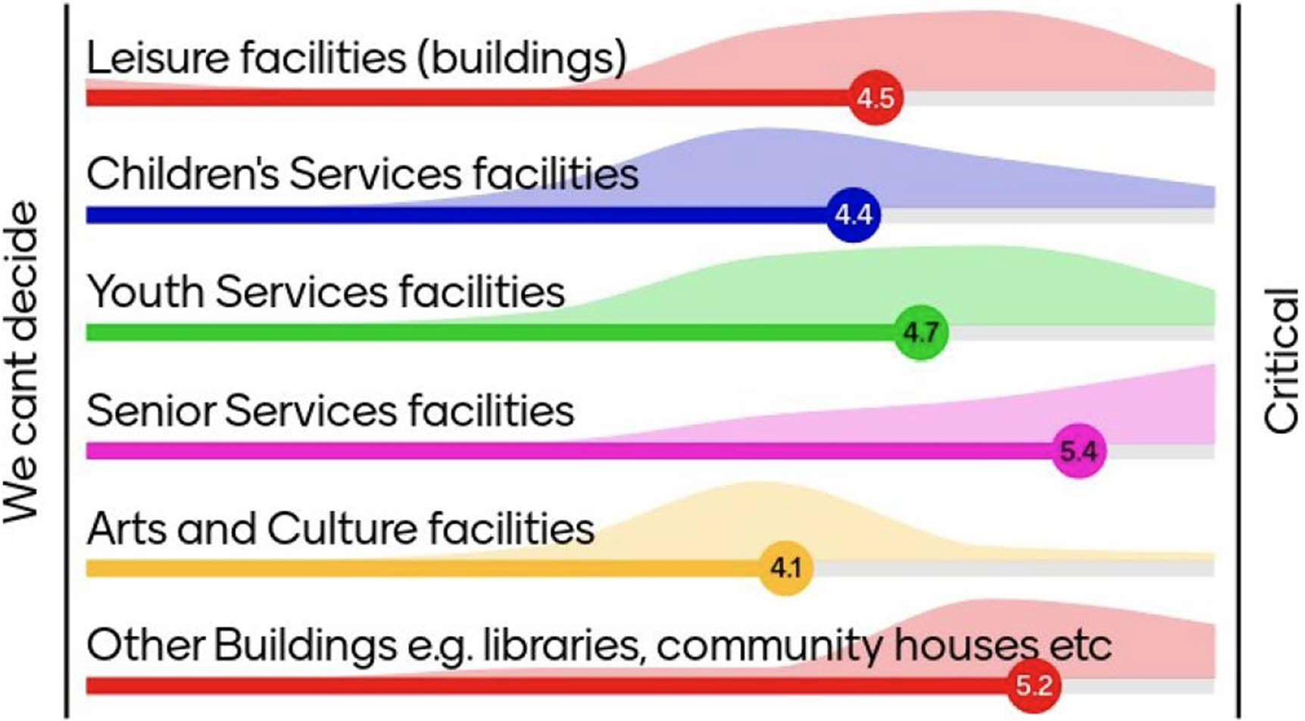

*Figure 5 – Importance Rating of Community Assets*

The Community Panel identified Senior Services facilities, footpaths and shared paths as very important given the ageing population and to facilitate people of all ages and abilities to undertake more passive recreation activities.

### To meet community needs over the next 10 years, what will be most important?

The following table summarises the most important community needs and related assets.

A question was posed for panellists to consider the trade-offs (or comparative choices) in relation to various services supported by community assets.

The preferred options for each service aspect are highlighted in the table below. Please note that where both options are highlighted in table 3, these were deemed equally preferred by panellists.

|  |  |  |
| --- | --- | --- |
| **Service Aspect** | **Community Assets - Option 1** | **Community Assets – Option 2** |
| For moving around the local neighbourhood | Walking/cycling paths | Car parking facilities |
| For moving across and outside the municipality | Improved road networks | Public Transport connections & facilities |
| To prepare for environmental sustainability | Ensure sustainable behaviour | Residents make their choices |
| For community facilities | Renewing single use facilities | Multi-use shared hubs |
| For community well-being facilities and services | Mental health and social connect | Physical activity |
| For recreation facilities | Informal (walk, cycle, play) | Organised sport |
| For Open Space | Providing local pocket parks | Enhancing larger suburb level parks |

*Table 3 – Community Asset Trade-offs*

### Targeted Engagement Outcomes

The following table summarises the priorities and aspirations relating to community assets that were identified by specific under-represented groups that were consulted:

|  |  |
| --- | --- |
| **Target Groups** | **Priorities and Aspirations** |
| Young People | * 32% considered Maroondah’s built environment as most important. This mainly related to the need to provide accessible multi-purpose community facilities and spaces, improvements to the public transport network, especially accessibility, reliability and safety and appearance and   cleanliness. |
| Culturally and Linguistically Diverse people | * 33% identified priorities in the built environment, including public transport, safety, community spaces/hubs and active transport. * Ideas listed relating to the built environment, included reducing traffic, centralised places to connect, accessibility to amenities and shopping centres, improvements to public transport, consideration of urban/natural balance in future   planning, etc. |
| People with a disability and carers of people with a disability | * Almost 60% of responses related to the built environment, including need for better public/active/sustainable transport |

|  |  |
| --- | --- |
| **Target Groups** | **Priorities and Aspirations** |
|  | options, more accessible community facilities/spaces and improved parking options. |
| Socially isolated and vulnerable community members | * 59% indicated that the built environment was most important, particularly transport, better maintenance of roads and improvements to on-street parking, improving appearance of municipality by keeping community assets clean and tidy, with less graffiti and ensuring the green feel of Maroondah is   retained when approving high rise developments. |
| First Nations people | * 4% of responses related to the built environment, including naming protocols and signage and 3% related to the natural environment and Maroondah’s green spaces and nature. |

*Table 4 – Feedback from Targeted Community Groups*

### Advisory Committees Engagement Outcomes

Council has been supported by seven (7) advisory committees. The role of the committees is to:

* act as a link between Council and specific cohorts of the community
* provide advice to the Council on policy, programs, service development, research initiatives and planning issues at a strategic and operational level
* effectively consult and collaborate in Council activities with a diverse range of stakeholders reflective of the Maroondah community

As part of developing the Asset Plan the following question was posed to committees:

*‘How can Council, partners and other levels of government work towards the identified policy areas?’*

The table below summarises the ideas submitted relating to community assets:

|  |  |  |
| --- | --- | --- |
| **Idea** | **What should we do?** | **Outcomes sought** |
| Activation of public spaces – to enhance community use and wellbeing | Ensure key parks and spaces are well serviced, have a broad range of resources, facilities, and  options for all ages. | * Community connection (social connection) * Health and activities lifestyles * Well-used public spaces * Regular active recreation (movement) * Enhanced relationships |
| Greater investment in infrastructure | For example, enhanced exercise equipment, lighting, and /or programs (i.e. tai chi, walking  groups). |

*Table 5 – Feedback from Advisory Committees*

# How Council Manages its Assets

## Council’s Role in Managing Community Assets

Council’s significant community assets play an integral part in supporting the delivery of a range of services to the community as summarised previously. The quality and extent of management applied to Council’s assets will affect the quality of service experienced by the community and the achievement of the Maroondah 2050 Community Vision.

Managing Council’s long-life infrastructure assets involves adopting a strategic and structured approach, while balancing risk, cost, opportunities and performance to effectively realise the value of the assets fully over their entire lifespan.

Council’s asset management approach answers the following fundamental questions:

* What assets does the community need now and in the future?
* How can Council best manage the assets to serve the community?

Assets also require ongoing management to adhere to relevant statutory requirements and regulations and to remain safe and serviceable for public use. These are all key considerations in Council’s stewardship and management of community assets.

## Asset Management Framework

Council’s goal is to “*provide assets that are accessible, safe, sustainable, inclusive and responsive to meet the current and future needs of our community and the contemporary environment, in the most cost-effective manner*”.

Council’s Asset Management Framework aims to ensure that a systematic approach to asset management is adopted to deliver the necessary prudent and efficient outcomes to meet both the corporate and asset management objectives. Figure 6 below provides a graphical representation of the Asset Management Framework, and table 6 on the following page provides further details.

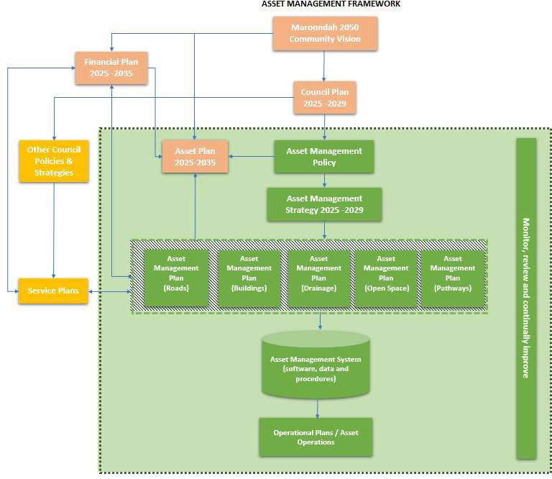

*Figure 6 – Council’s Asset Management Framework*

|  |  |
| --- | --- |
| **Document** | **What does this mean for asset management and service delivery?** |
| **Asset Management Policy** | Council’s Asset Management Policy outlines the objectives for asset management to support services that will meet current and future community needs. It recognises that these objectives can only be achieved if all parties responsible for asset management across the organisation work together to achieve the vision.  The policy:   * provides clear direction for asset management at Maroondah City Council. * outlines the vision, policy position, criteria and roles and responsibilities for how Council will sustainably manage the community’s assets in accordance with service delivery needs, strategic objectives and legislative requirements. * guides the development of Council’s Asset Management Strategy and Plans based on a sound Asset Management framework. |
| **Asset Management Strategy** | Council’s Asset Management Strategy outlines a framework for ongoing enhancement of asset management practices and systems, in accordance with Council’s Asset Management Policy and supports delivery of sustainable and effective services, to achieve the Community Vision. |
| **Asset Plan** | Council’s Asset Plan provides a high level 10-year view of Council’s priorities relating to asset maintenance, renewal, acquisition, expansion, upgrade and decommissioning and how these are integrated within Council’s decision-making processes and financial plans. The plan also summarises the key outcomes from community engagement that are used to guide Council’s decisions, needs and priorities over the next ten (10) years. |
| **Asset Management Plans** | Council’s Asset Management Plans provide information on the current state of its assets and how Council intends to manage each of the five (5) major infrastructure asset classes to meet the demands and aspirations of the community over the next ten (10) years They provide the roadmap for achieving value from Council’s assets by optimising cost, risk, and performance across the asset lifecycle.  The plans are operational documents that support:   * Council planning and deliberative engagement processes (Community Vision, Council Plan, Asset Plan and Financial Plan) * Establishing a foundation for the effective lifecycle management of Council’s assets in partnership with key service areas/delivery teams * Continuing to sustainably deliver quality services and infrastructure without greatly increasing costs (effectively balancing services with best value to benefit to the whole community). |

*Table 6 - Council’s Asset Management Framework Documents*

## Asset Lifecycle Management

Underpinning the above Asset Management framework is Council’s asset lifecycle shown below:

**Planning &**

**Design**

**Disposal or**

**Rationalisation**

**Construction**

**or Acquisition**

**Renewal or**

**Replacement**

**Operations &**

**Maintenance**

*Figure 7 – Asset Lifecycle Stages*

Each of the above stages of the asset lifecycle require different approaches to drive the most efficient service delivery outcome with a balance between cost, risk and performance, as summarised below:

|  |  |
| --- | --- |
| **Asset Lifecycle**  **Stage** | **Council’s Lifecycle Management Approach** |
| **Planning & Design** | * Asset requirements are identified to support service delivery needs over the long term. * Assets are designed with a focus on affordability, accessibility, equity and equality, maintainability, sustainability and climate resilience. * Informed and transparent decision-making processes are adopted, considering whole of life implications of acquiring, operating, maintaining, renewing and finally disposing of the asset. |
| **Construction or Acquisition** | * Objectives are well-defined and appropriate procurement strategies are adopted to ensure that value for money is achieved in project delivery. * Council plans, manages and controls construction projects to ensure minimal impacts on the environment and community. * Newly acquired assets are assessed for quality and adherence to design specifications before they are accepted and placed into service. |
| **Operations & Maintenance** | * Continuous monitoring of the performance is undertaken to ensure assets operate to   their service potential over their useful life and continue to deliver on the required levels of service.   * Regular inspections, servicing and planned maintenance is undertaken to ensure that Council’s assets remain safe, compliant and continuously available for use. * Council uses systems and processes to record information about its assets and undertake proactive maintenance and intervention works as necessary, to minimise critical asset failures and maintenance costs. |
| **Renewal or Replacement** | * Council adopts a holistic approach to determine renewal or replacement of assets based on asset condition, utilisation levels, fit for purpose assessments and environmental sustainability aspects, rather than age alone. * Council’s cyclical condition and performance assessment program ensures assets continue to meet changing community needs and enables renewal or replacement as   required. |

|  |  |
| --- | --- |
| **Asset Lifecycle**  **Stage** | **Council’s Lifecycle Management Approach** |
|  | * Council aims to optimise the timing of the renewal or replacement, so that assets remain safe, functional and resilient to climate change impacts with timely investments being made, to save money in the long term. |
| **Disposal or Rationalisation** | * If assets are not required to directly support core service delivery, they are considered for rationalisation, where practicable, to reduce overall asset lifecycle costs or disposed, if deemed surplus to the community’s needs. * Council aims to maximise the use of its assets through adaptive re-use or co-location of services, where possible. |

*Table 7 – Asset Lifecycle Management Approach*

## Asset Investment/Expenditure Categories

For the purposes of this Asset Plan, Council spending on its infrastructure is categorised as follows:

|  |  |  |  |
| --- | --- | --- | --- |
| **Expenditure Category** | **Expenditure Type** | **Activity** | **Description** |
| **Recurrent** | **Non-discretionary** | **Maintenance** | Ongoing work required to keep an asset performing at the required level of service. |
| **Non-discretionary** | **Operations** | Recurrent expenditure that is continuously  required to provide a service. |
| **Renewal** | **Non-discretionary** | **Renewal** | Returns the service potential or the life of the asset up to that which it had originally. |
| **Growth** | **Discretionary** | **Upgrade** | Enhancements to an existing asset to provide a higher level of service. |
| **Discretionary** | **Expansion** | Extends or expands an existing asset at the same standard as is currently enjoyed, to a new group  of users. |
| **Discretionary** | **New** | Creates a new asset that provides a service that does not currently exist. |

*Table 8 - Asset Investment/Expenditure Categories*

Classifying Council’s investment/expenditure ensures Council can plan, budget and track spending on assets and services.

## Asset Investment Strategy

Council is committed to prioritising the renewal funding of its existing infrastructure base before allocating funds to any discretionary projects relating to new assets or expansion or upgrade of existing assets. This is based on the logic that Council cannot afford to expand its asset portfolio if it cannot afford to look after what it already owns/manages. As a result, the funding of renewal is deemed a non-discretionary expenditure item and has been allocated the highest priority in Council’s Capital Works Program.

Balancing the investment in maintenance and renewal of existing assets and investment in new or upgraded assets to meet current and future needs of the community, is an ongoing challenge within the constrained financial environment.

Retiring old or under-utilised assets and reducing levels of service may also need to be explored, to ensure that the existing asset base is managed responsibly and sustainably into the future.

As a result, the prioritisation of capital works is driven by the following decision-making principles, which have also been influenced by the outcomes of the community engagement undertaken:

* Prioritise renewal of Council’s ageing infrastructure to continue to maintain appropriate levels of service to the existing community.
* Continue to comply and meet all relevant legislative requirements.
* Ensure asset resilience to climate change impacts.
* Develop and further enhance assets that promote the health and well-being of the community in an equitable and inclusive manner.
* Manage impacts of population growth and establish multi-use facilities and shared hubs.
* Develop universally accessible and sustainable transport connections.
* Continue to maintain and enhance assets supporting passive recreation and the natural environment.

This approach to prioritising asset investments can be summarised, as shown in the diagram below:

**Growth**

***(Discretionary)***

**Asset Upgrade, Expansion and New**

**Sustaining Services**

***(Non-discretionary)***

**Asset Maintenance and**

**Renewal**

**Allocation of Funding**

**Asset Maintenance and performance assessments**

**Asset resilience to climate change**

**Statutory and legislative requirements**



**Population growth analysis & shared facilities**

**Inclusive community health & well- being**

**Passive recreation & natural environment**

**Sustainable & accessible transport connections**

*Figure 8 – Asset Investment Strategy*

# State of Council Assets

## Road Infrastructure

|  |  |  |  |  |
| --- | --- | --- | --- | --- |
|  |  | **Service** | Council’s roads form the vehicular transportation network to ensure key  linkages that maintain access and movement across the municipality. Safe and suitable off-street carpark facilities are also provided at key locations. | |
| **Future Challenges & Opportunities** | | | | |
| Integrated Transport | | | Changing Population | Road Safety |
| * There are pressing transport related challenges facing the city, including:   + Managing congestion and through traffic   + Pollution emitted from transport   + Emerging transport services and technology   + Transport options for connecting disadvantaged groups   + Unreliable on-road public transport * There is a need to respond to future transport issues and demands and make it easier for people to get to the places they want to. | | | * Significant residential and commercial intensification and redevelopment occurring (e.g., Ringwood Metropolitan Activity Centre) with projected population increases potentially resulting in higher traffic volumes, congestion, and demand for parking. * Monitor population and traffic count data alongside continuing to develop works programs with consideration of population trends. * Work with the Department of Transport and Planning to improve traffic conditions at known congestion hotspots. * Continue to use contributions from new developments to fund part of the cost of delivering road   network improvements. | * Additional road safety improvements such as crossings, safety barriers and signage are required to reduce conflict between road vehicles and pedestrians. * Assess and develop Local Area Traffic Management plans to implement physical and non- physical traffic calming measures at a local level. |
| **Asset Condition** | | | | |

Council’s sealed local road network and sealed car parks are considered fit for the future with over 97% in fair or better condition.

**0.1%**

**.7%**

**Very Good Good Fair Poor Very Poor**

**12.1% 2**

**51.7%**

**33.4%**

|  |  |
| --- | --- |
| **Current Performance** | **Fit for the Future?** |
| The Community satisfaction rating for roads has declined in the past year, even though the condition of approximately 85% of the network is in very good or good condition as shown above. This survey does not distinguish between local roads and arterial roads, and given that state of the arterial roads is declining rapidly, it is highly likely that the survey responses were heavily weighted towards arterial roads.  Approximately 10 km of local roads are gravel or unsealed. Condition of these roads can change frequently due to gravel quality, weather, traffic volumes and driver behaviours resulting in dust, corrugations and potholes, which is quite often the complaint of local residents. In response, Council has modified its approach to grading and materials selections and in some cases taken the initiative to seal  lengths of gravel roads, which is an expensive exercise. | The Maroondah Transport Strategy will guide transport planning decision-making and actions over the next decade. Implementing the key actions from this strategy will help Council respond to transport pressures and opportunities arising from current and anticipated urban development, economic growth and environmental and social change.  Council will also focus on materials and design to ensure that road infrastructure remains climate- resilient to handle long-term environmental impacts. Approximately 4 km of gravel roads have been prioritised for upgrading to sealed roads over the next 10 years, subject to community support. |



**Council’s Strategic Response to Funding**

The continued funding of long-term road renewal and maintenance is essential to preserve Council’s road infrastructure in a safe condition to deliver the required levels of service to the community. The projected allocations set aside in Council’s capital works program are sufficient to deliver on the desired goal of ensuring that Council’s road network is in good condition, while retaining affordability for the community. This funding is supplemented by the Federal Government’s Roads to Recovery grant funding which is $2,863,323 for the funding period 2024-29.

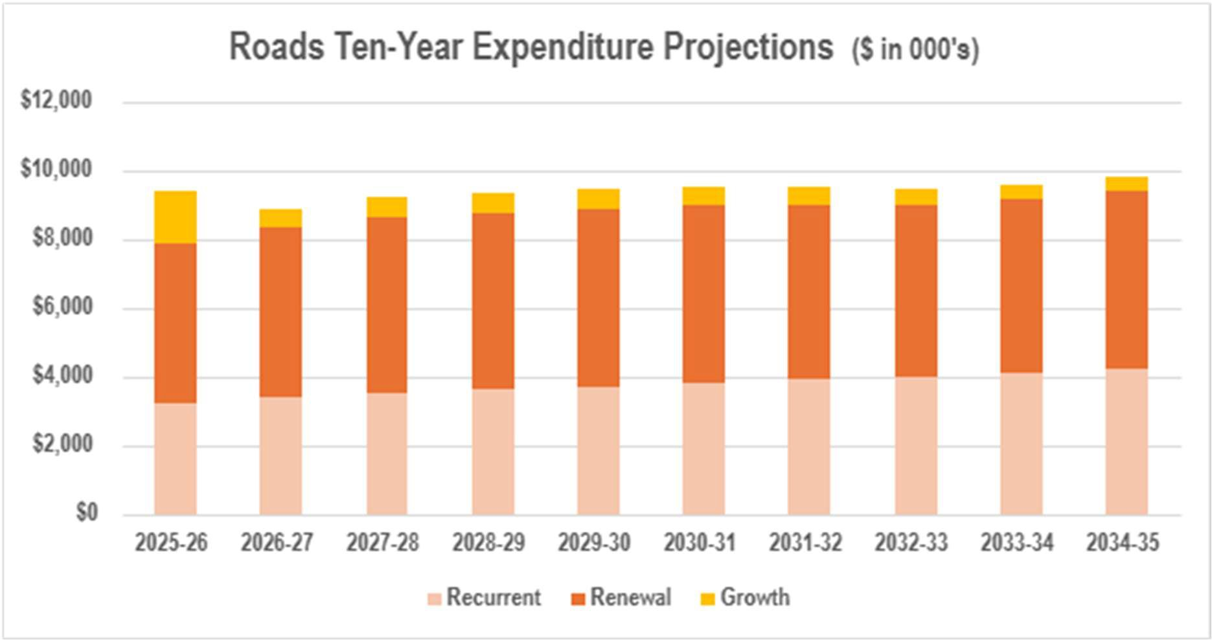

|  |  |  |
| --- | --- | --- |
| **Key Programs** | | |
|  | **Ongoing Programs (over 10 years)** | * $25.0 M - Local Road renewals * $6.2 M - Kerb and channel replacement * $6.4 M - Local Road reconstruction * $9.2M - Local Road improvements funded by Federal Government * $4.0 M - Car park improvements * $1.3 M - Local area traffic management renewal * $3.7 M -Local area traffic management upgrade works * $1.0 M - Traffic lights and pedestrian crossing upgrades |

## Pathways

|  |  |  |  |  |  |
| --- | --- | --- | --- | --- | --- |
|  |  | **Service** | | Council’s integrated pathway network provides safe and  accessible linkages for pedestrians and cyclists to local destinations and facilitates access to recreation and health and fitness opportunities. | |
| **Future Challenges & Opportunities** | | | | | |
| Changing Population & Demographics | | | Integrated Transport | | City Development |
| * Increase in users on local pathways due to population growth. * Universal access requirements and an ageing population will necessitate improvements to pathways to accommodate diverse mobility needs and safety. * Provision of infrastructure to accommodate a diversity of uses and experiences. e.g., equestrian use on shared trails and connection with regional trail networks. | | | * People want to get to the places they want to go easily and be able to use active transport options as a viable mode of travel. * Continued pathway improvements and extensions will be needed to create a safe, accessible, and connected pedestrian and cycling network. * Greater variation exists in types of bicycles and devices with different speeds, widths, and sizes that impact on the movement flow and space   'take up' of pathways. | | * Development works may potentially damage pathways during construction activities and result in additional pathways being handed over by developers for ongoing management by Council. |
| **Asset Condition** | | | | | |

Council’s pathways are considered fit for the future with over 98% being in very good or good condition.

**0.1%**

**98.7%**

**1.2%**

**Very Good Good Fair Poor Very Poor**

|  |  |
| --- | --- |
| **Current Performance** | **Fit for the Future?** |
| The approach adopted to assess the pathway condition and forecast for renewal, is informed by the service level commitments made in the *Road Management Plan* and the *Principal Pedestrian Network (PPN),* which is a strategic network of pedestrian routes to promote walking for transport.  Council also undertakes regular inspections of pedestrian bridges and boardwalks, however, there is a need to measure their condition more consistently using the standard rating system.  Council rectifies pathway defects such as surface irregularities and displacements, in accordance with defined intervention levels and response times outlined in the *Road Management Plan.* The intervention levels define the point in time at which the asset is considered no longer functioning at an acceptable service level. | Council will continue to improve the connectivity and accessibility across its pathway network by building new linkages guided by the *Principal Pedestrian Network Strategy.* The aim is to provide routes within the *PPN* with the highest level of priority for pedestrians and having characteristics such as generous paths, shade and weather protection, seating, and priority over other transport modes at intersections*.* The *PPN* also gives Council a strategic tool to lobby State Government when negotiating transport mode priorities.  Council will implement the recommendations and actions from the Eastern Regional Trails Strategy to improve connections of local trails to the larger regional trail network and to promote use by a broad mix of users including walkers, cyclists and horse riders.  Council will continue to monitor population and traffic count data whilst continuing to develop works programs with consideration of population trends. |



**Council’s Strategic Response to Funding**

The foreshadowed budget is adequate to meet the anticipated renewal demands based on the information available on the condition of the existing pathways. Council will also prepare a *Pathways Assessment and Prioritisation Framework* to document the business rules for prioritising the annual pathways works programs.

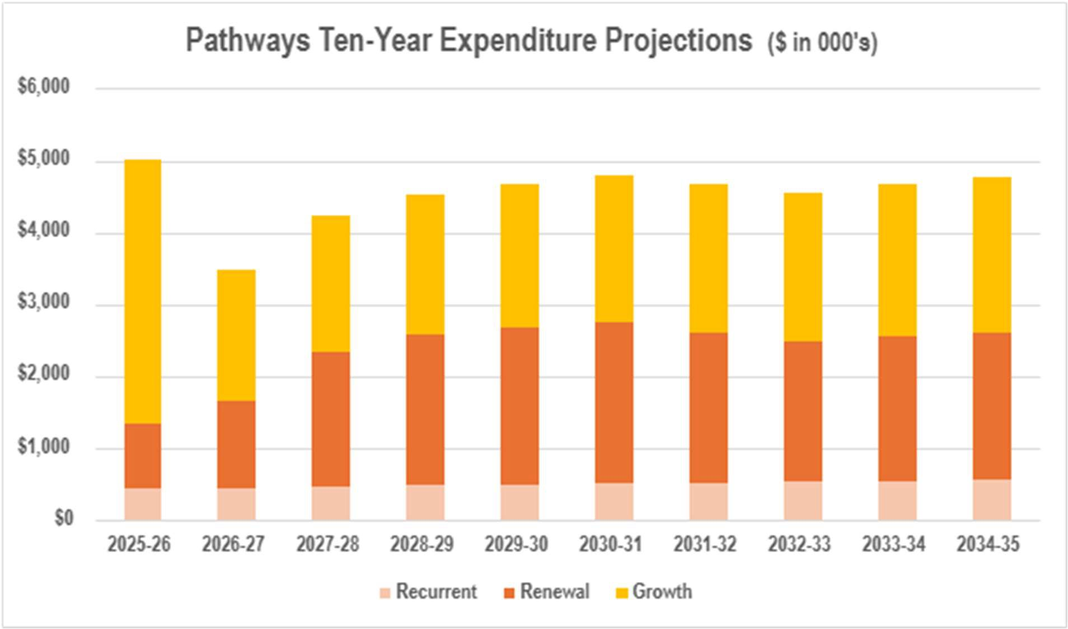

|  |  |  |
| --- | --- | --- |
| **Key Programs** | | |
|  |  | * $18.7 M - New footpath construction |
|  | * $9.9 M - Footpath replacements |
|  | * $5.2 M - Shared (bike) path improvements |
|  | * $3.8 M - Footpath accessibility improvements |
| **Ongoing** | * $0.9 M - Footpath improvements in parks and reserves |
| **Programs**  **(over 10** | * $2.0 M – Footbridge and boardwalk improvements |
| **years)** |  |

## Stormwater Drainage Assets

|  |  |  |  |  |  |
| --- | --- | --- | --- | --- | --- |
|  |  | **Service** | Council’s stormwater drainage network, including underground pipes and  drainage pits help protect the city from flooding and helps keep the waterways clean. | | |
| **Future Challenges & Opportunities** | | | | | |
| City Development | | | | Ageing Infrastructure | Climate Change |
| * Continued urban consolidation   will affect stormwater runoff volume and quality. Capacity of the existing drainage network will need to be progressively upgraded to mitigate flooding.   * Historic construction over drainage easements such as illegal structures and plantings create access issues and impact the performance of underground drains. | | | | * Deteriorating condition of   drainage assets as they age.   * Some older drainage assets are also under capacity and require upgrade to improve flood mitigation. * Council’s stormwater drainage network has been developed over many years. In some areas there are gaps in the provision of a connection to the underground stormwater drainage system for properties. This can exacerbate nuisance flooding and result in poor   outcomes for residents. | * Projected increase in extreme   weather events will leave the city more vulnerable to flooding, especially in known hotspot locations such as the Croydon Central Flow Path, Kauri Court and San Remo Road.   * Having appropriate climate adaptation and emergency response plans becomes ever more important. * Additional emergency management and recovery resources may be needed due to elevated risks of major flooding. |
| **Asset Condition** | | | | | |

85% of the drainage network is in fair or better condition and requires some improvement to meet future needs.

**5.5%**

**24.0%**

**55.5%**

**15.0%**

**Very Good Good Fair Poor Very Poor**

|  |  |
| --- | --- |
| **Current Performance** | **Fit for the Future?** |
| In the absence of having detailed condition information for large portions of the drainage network, Council has made some conservative estimates on the condition of its drainage assets, based on operational knowledge. The current condition, shown above, is representative of an ageing asset base located in a highly treed municipality. Knowledge of the performance of the drainage network will improve as Council undertakes more inspections and analysis. Council carries out CCTV inspections of a small percentage of the underground pipe network each year, to help identify what work needs to be done including cleaning, repairsor in some cases pipe replacement.  Council has worked closely with Melbourne Water to develop an updated and sophisticated flood map for the city. This map helps Council to minimise the impact of flooding on the community and guides the management of its maintenance programs, emergency management planning and capital works projects. It also assists in assessing impacts of future development across the city. | Council will use its flood mapping to understand flooding impacts under various climate change scenarios and prioritise the implementation of appropriate structural or non-structural measures to mitigate risk to people and property. Council will use its *Flood Mitigation Prioritisation Framework* to rank the known flood prone sites in order of importance and identify potential flood mitigation works that may be considered in alleviating flooding at these locations.  Council will also continue to manage new subdivisons and infill deveopments through planning processes which place controls on stormwater management.  Where feasible, Council will include in its annual works program, the extension of the underground drainage network through provision of easement drains, if necessary, so that a connection can be provided to existing properties that are currently not directly connected to the stormwater network. |



**Council’s Strategic Response to Funding**

Council’s current strategy is to invest the funding set aside for stormwater drainage on the renewal and upgrade of high risk assets to improve flood mitigation. Strengthening Council’s investment in asset renewal will mean that it will be replacing its ageing infrastructure at the right time, mitigating potential impacts of flooding, and ensuring the stormwater drainage network is responsive to climate adaptation needs.

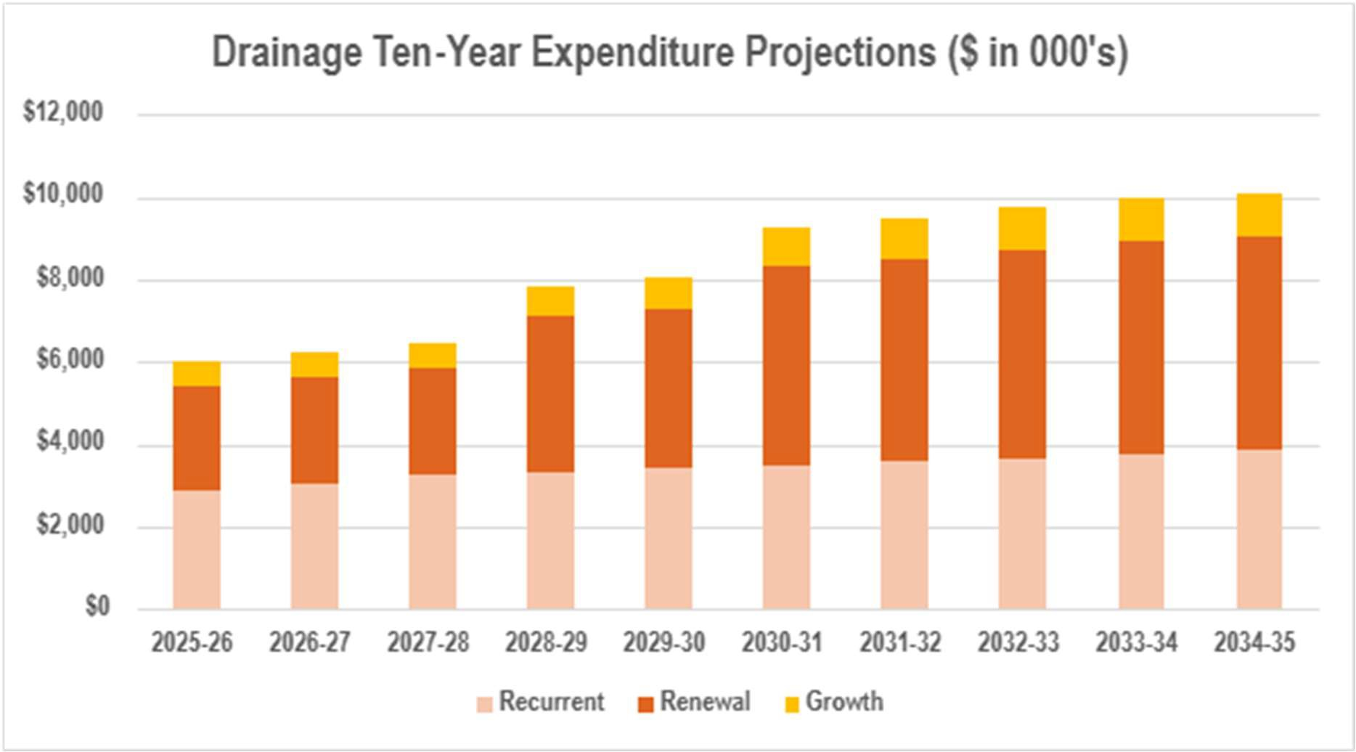

|  |  |  |
| --- | --- | --- |
| **Key Programs** | | |
|  | **Ongoing Programs (over 10 years)** | * $41.8M - Stormwater drainage renewal * $1.8 M - Waterway improvements * $5.3 M - Ringwood Metropolitan Activity Centre drainage infrastructure |

## Buildings

|  |  |  |  |  |  |
| --- | --- | --- | --- | --- | --- |
|  |  | **Service** | | Council’s community-owned buildings/facilities accommodate various  services and support social connectedness and well-being by serving as community focal points. They also provide opportunities for recreation and maintaining a healthy lifestyle. | |
| **Future Challenges & Opportunities** | | | | | |
| Population Growth & Demographics | | | Built Environment | | Climate Change |
| * Forecast population growth over next 10 years indicates increases in population under working age and population of retirement age. * Need to improve access to community facilities for all genders, abilities and communities of cultural diversity and other under- represented communities by adopting universal design and inclusiveness principles in the design and construction of buildings. | | | * Maximising the use of existing facilities through adaptive reuse. * Increasing demand to renew and renovate ageing facilities. * Ensuring compliance with all relevant governing legislation (e.g., accessibility, fire safety, etc.). * A more integrated approach is needed to understand long term service needs so that Council’s facilities can be planned considering primary and complementary uses. | | * More frequent and intense weather events will increase risk of facility damage. * Council needs to meet its zero net emissions target as set out in the *Carbon Neutral Strategy.* * Ensuring that new builds and renovations meet the sustainability objectives of the *Environmentally Sustainable Design Policy and Guidelines.* * Community expectations relating to leadership in environmental sustainability. |
| **Asset Condition** | | | | | |

Over 96% of Council’s buildings are considered to be in fair or better condition as shown below.

|  |  |  |
| --- | --- | --- |
| **50.3% 17.1% 28.9% 3.7%**  **Very Good Good Fair Poor Very Poor** | |  |
| **Current Performance** | **Fit for the Future?** | |
| The annual Local Government satisfaction survey indicates that the community is generally satisfied with the recreation and cultural based facilities. This measure is reflective of both the standards of service and the condition and quality of the buildings that are used to support these services.  Council is currently conducting a detailed condition and performance assessment/audit of its buildings to assess their:   * Function or fit for purpose * Location and accessibility * Utilisation and capacity * Legislative compliance   The resulting audit information will guide the future investment in buildings. The types and standards of buildings Council will need to provide will continue to evolve because of increasing demands, use trends, and  community expectations. | Council’s buildings will need to be adaptable multi-use spaces with co-located services that encourage diversity of use. They will also need to remain compliant and safe and be accessible and promote equity by removing barriers where possible.  Council will continue to improve the energy performance of its facilities to reduce dependence on fossil fuel derived energy and make them more sustainable and resilient to changing climate conditions and future climate shocks. | |



**Council’s Strategic Response to Funding**

The ten-year expenditure projection shown below is based on currently available information on building condition and performance and aims to achieve a balance between service quality, costs and risks, to achieve the best outcomes for the community. Council will continue to look for efficiencies in the way it undertakes building maintenance and will prepare long-term building maintenance and renewal programs according to its priorities and availability of funding. The outcomes of the building performance assessments, as well as any grant funding that Council may be successful in obtaining in the future, will also influence Council’s investment priorities for continuous delivery of financially sustainable services.

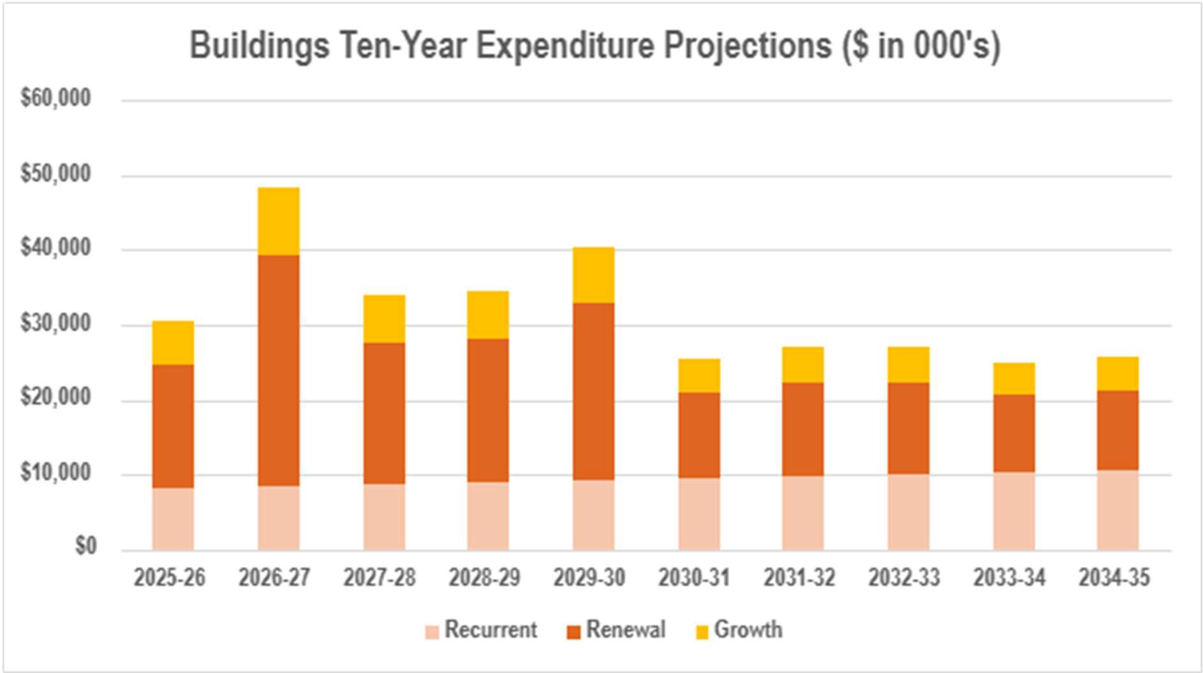

|  |  |  |
| --- | --- | --- |
| **Key Programs** | | |
|  | **Ongoing Programs (over 10 years)** | * $86.0 M - Facilities improvements * $22.2 M - Facilities replacement * $5.8 M - Carbon neutral energy revolving fund * $4.2 M - Funding for community groups * $4.1 M - Facilities major plant renewal * $3.4 M - Public toilet improvements * $2.8 M - Community facilities - access & inclusion |

## Open Space Assets

|  |  |  |  |  |
| --- | --- | --- | --- | --- |
|  |  | **Service** | Council’s Open Space assets allow the community to enjoy the many outdoor  aspects of the city. They allow participation in active recreation and other non- structured leisure activities; provide access to the natural environment for enhanced wellbeing, social and cultural connection. | |
| **Future Challenges & Opportunities** | | | | |
| Population Growth & Demographics | | | Trends in Sport & Recreation | Climate Change & Biodiversity |
| * Increasing demand resulting from population growth is placing pressures on current sports fields provision, with indications that demand will exceed capacity in the future. * More inclusive and accessible parks and amenities will need to be provided for the anticipated increase in population of retirement age. * Increased emphasis on safety in public spaces. | | | * Participation patterns in sport and recreation-based activities are changing to better match and align with peoples' evolving lifestyles. * Shifting demographics, increased use of technology, and changing attitudes towards organised, structured sports may impact on the provision of sports and recreation facilities. | * Climate change impacts on parks, gardens and local flora and fauna due to prolonged drought conditions increasing the need for planting of drought tolerant plants and grasses. * Potential for higher levels of water consumption to maintain presentation of open spaces and the safe function of sporting ovals. * Recognising the importance of the landscapes to the cultural values of Traditional Owners. * Improving biodiversity and carefully managing local extinctions and   competing uses and values. |
| **Asset Condition** | | | | |

Approximately 74% of Council’s Open Space assets are in fair or better condition.

|  |  |
| --- | --- |
| **31.5% 26.1% 16.1% 22.5% 3.8%**  **Very Good Good Fair Poor Very Poor** | |
| **Current Performance** | **Fit for the Future?** |
| Many of the existing open space and recreation facilities were designed to meet standards and expectations at the time, and hence, require major renewal/upgrade to meet current and future community needs and expectations and be inclusive and accessible to diverse community groups.  Specific service deficiencies in terms of capacity and performance are detailed in the open space, playspace, and regional sport specific strategies. Council continually strives to implement the recommendations and initiatives from these strategies, subject to funding availability and grant opportunities.  Open spaces are designed to consider provision of permanent shade such as canopy trees and we are continuing with implementation of the *Maroondah Vegetation Strategy* for the planting and management of trees on Council and public land. | Formal condition inspections and inventory checks of open space assets will be undertaken to provide a sound basis for planning and decision-making and to further improve condition of these assets, by prioritising asset renewals and also making them more resilient to climate change.  Council will continue to monitor participation and leisure trends and adapt/provide facilities by investigating other innovative approaches to provision of recreation facilities.  Opportunities for establishing more spaces for structured recreation, and non-competitive, social, cultural and passive leisure will be explored.  Council will increase its efforts to build sustainability features into open space design to limit the demand on water and provide increased water retention and water harvesting options. Opportunities for more effectively integrating and managing water features such as watercourses, ponds and lakes and green features such as plants, trees and bushland will be explored, to provide environmetnal benefits and contribute to quality of life and biodiversity outcomes. |

Council will continue to invest in existing open space assets to balance priorities across compliance, accessibility, inclusivity, sustainability and functional serviceability. Council will also accommodate costs associated with new open space assets, where practicable, within existing budget allocations. Council has a strong reliance on grants to deliver such initiatives, as capacity to fund improvements from its source revenue is limited. Hence, Council will continue to advocate to all levels of government for funding to upgrade or establish new open space assets to meet the diverse needs of the growing population.



**Council’s Strategic Response to Funding**

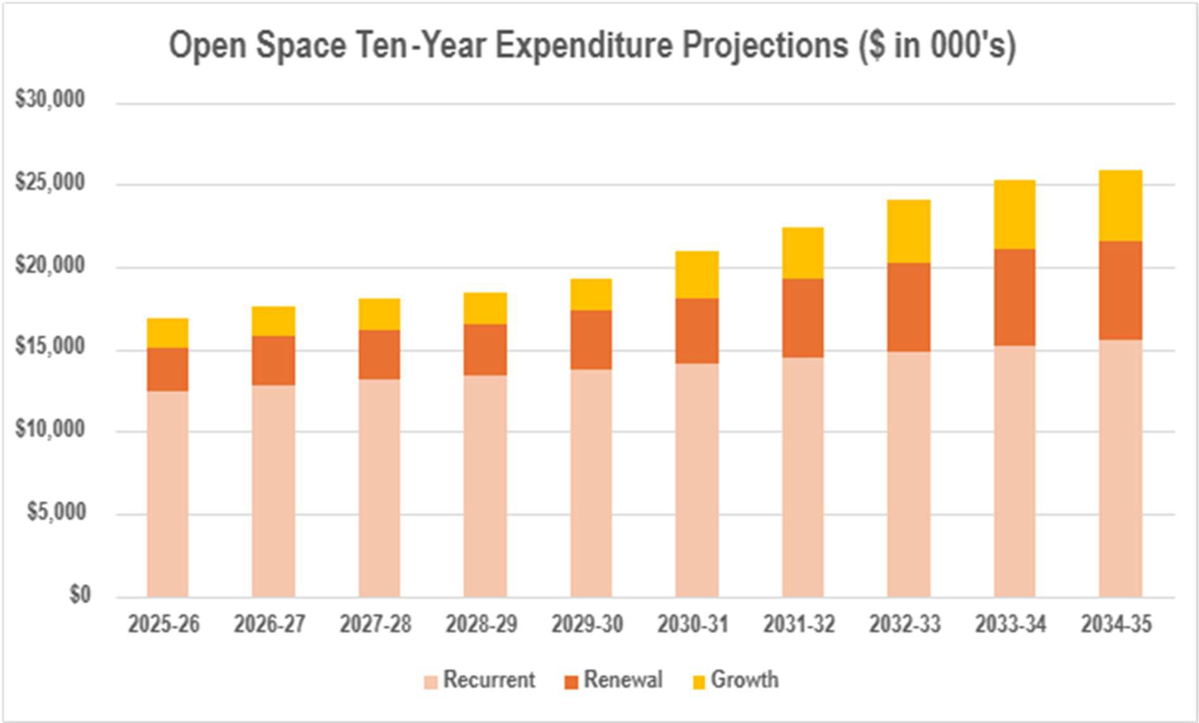

|  |  |  |
| --- | --- | --- |
| **Key Programs** | | |
|  |  | * $20.5M - Play spaces improvement |
|  | * $15.3M - New trees planting |
|  | * $11.3 M - Sports field improvement |
| **Ongoing programs (over 10 years)** | * $7.3 M - Open space improvement * $4.7 M - Golf course improvement * $3.1M - Sport & recreation infrastructure improvement * $2.7 M - Sports field lighting improvement * $1.0 M - Sports oval fence replacement |
|  | * $1.1 M - Sports field irrigation improvement |
|  | * $0.7 M - Bushland improvement |
|  | * $0.8 M - Open space lighting improvement |

# Funding the Asset Plan

## Capital Expenditure Projections

This section outlines the projected capital expenditure requirements for Council’s infrastructure over the next ten

(10) years. These funding requirements have been determined based on the affordability assessments made in the Financial Plan and represent the investment that is required to maintain appropriate levels of service to meet changing community needs.

The following graph (Figure 9) summarises the expenditure categories of Council’s currently planned infrastructure capital program totalling $440 million over the next ten (10) years. It indicates that most of the investments, i.e.: 73%, relate to non-discretionary asset renewal. This allocation aligns with Council’s principle of prioritising asset renewal when making capital investment decisions, thereby ensuring Council’s existing assets are properly managed to provide acceptable levels of service. The balance of 27%, is allocated to upgrading or constructing new assets to cater to the population growth and changing needs of the community.

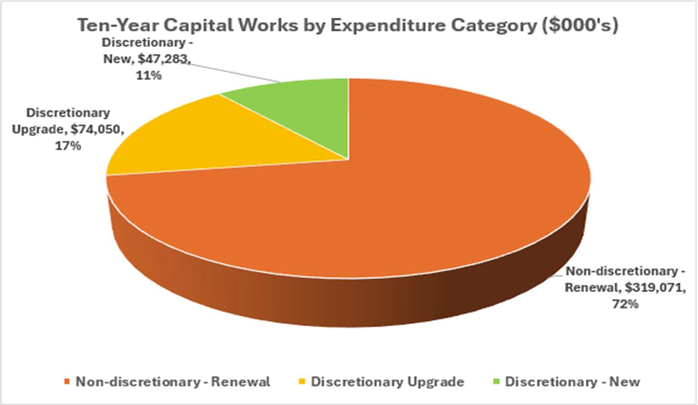

*Figure 9 – Ten-Year Capital Expenditure by Category*

The estimates included in this Asset Plan are for projected asset costs to cover the planned asset activities in the next ten (10) years. These are based on Council’s determination of the most likely and affordable scenarios for upgrade and renewal of its infrastructure to meet community needs and the resulting ongoing expenditure required to manage the impact on Council’s assets.

Based on the current knowledge of the condition of Council’s assets, the renewal funding requirements for Council’s infrastructure assets are almost fully allocated in its Financial Plan. The adequacy of Council’s renewal funding depends on many variables, including how long individual assets last.

Increased signs of deterioration are beginning to show in some asset classes. This will require monitoring and further analysis as new asset information becomes available through Council’s periodic condition surveys. The ability of current assets to service the community also requires further consideration, with some assets potentially being able to be retired and / or replaced with more contemporary and climate change resilient assets.

Funding requirements may potentially change in the future, to continue with the same level of service that is currently provided to the community, and hence, adjustments may be required to both this Asset Plan and the Financial Plan.

## Total Expenditure Projections

The following graph (Figure 10) summarises the total capital, maintenance and operational expenditure projections across the infrastructure assets included in this Asset Plan over the next ten (10) years:

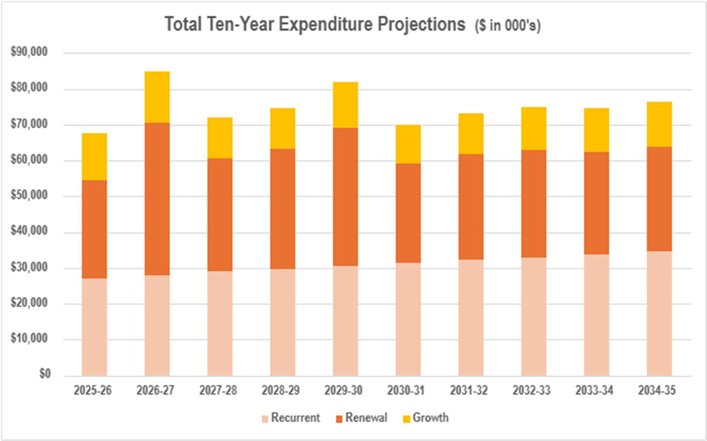

*Figure 10 – Total Ten-Year Expenditure Projections*

The following table summarises projected total expenditure for each of the five (5) major asset classes over the next ten (10) years. Figure 11 on the following page shows the 10-year projections by funding category.

|  |  |  |  |  |
| --- | --- | --- | --- | --- |
| **Asset Class** | **Recurrent**  **($’000)** | **Renewal**  **($’000)** | **Growth**  **($’000)** | **Total**  **($’000)** |
| Road Infrastructure | $37,673 | $50,668 | $6,155 | **$94,496** |
| Pathways | $4,916 | $18,619 | $21,832 | **$45,367** |
| Stormwater Drainage Assets | $34,329 | $40,549 | $8,355 | **$83,233** |
| Buildings | $92,710 | $167,660 | $57,642 | **$318,012** |
| Open Space Assets | $139,912 | $41,575 | $27,348 | **$208,835** |
| **Total** | **$309,540** | **$319,0071** | **$121,332** | **$749,943** |

*Table 9 – Ten-Year Projected Expenditure by Asset Class*

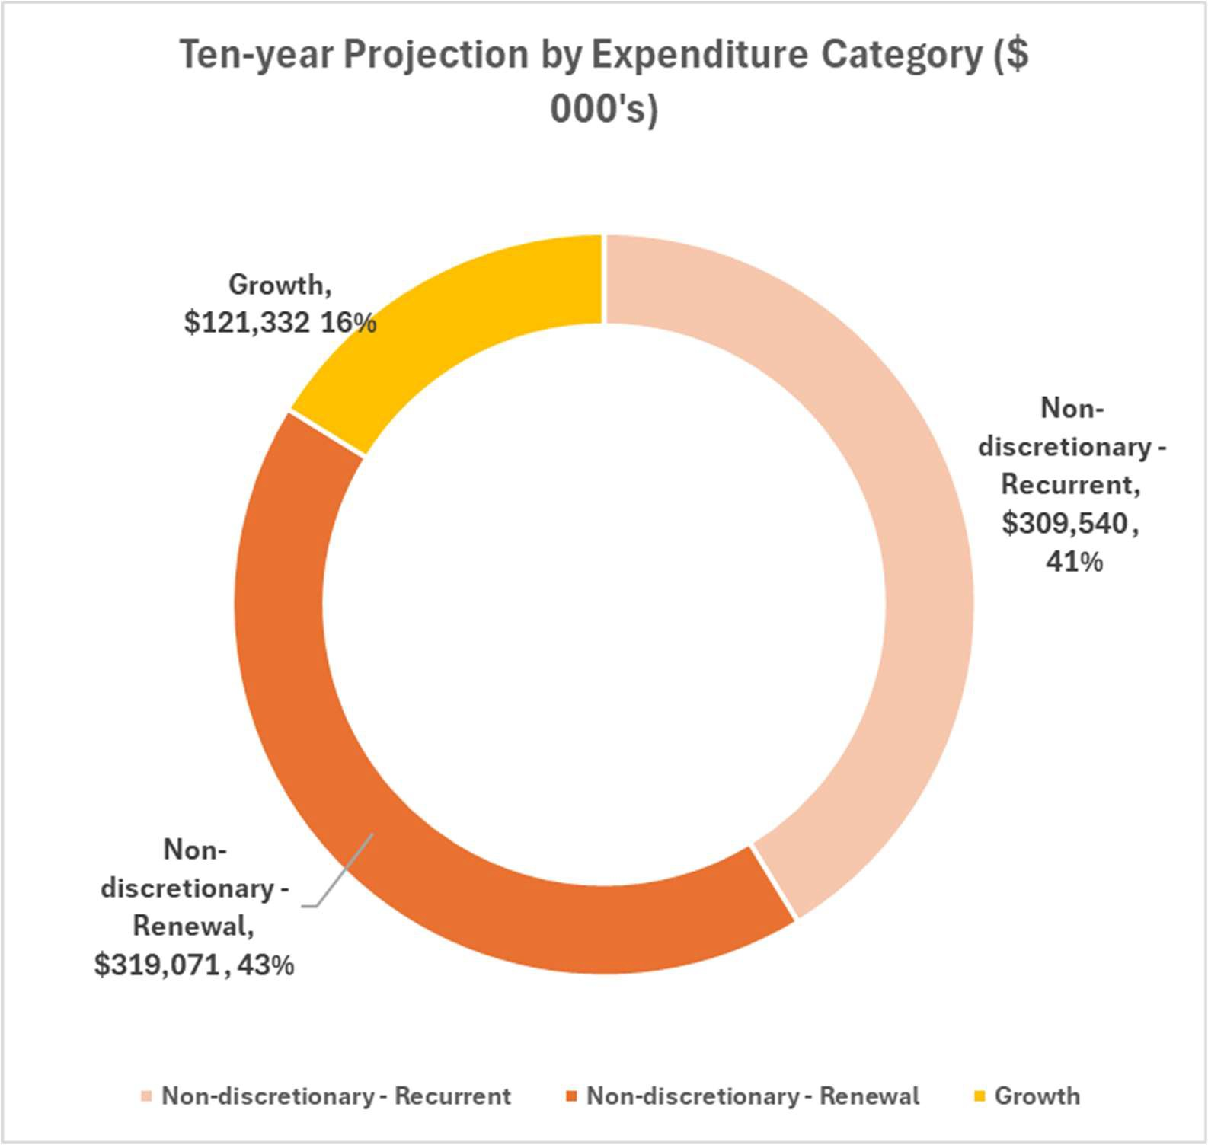

*Figure 11 - Total Expenditure Projections by Category*

Council’s projected expenditure over the next ten (10) years may also be summarised as follows:

**Total asset expenditure of $750 M over 10 years**

**$319 M (43%) renewal expenditure for replacing assets reaching end of their lives**

**$121 M (16%) to meet additional future demand or growth**

**$310 M (41%) for ongoing maintenance and other activties to make sure Council's assets are safe and functional**

*Figure 12 – Summary of Ten-Year Expenditure Projections*

A total investment in the order of ***$750 million*** on Council’s infrastructure asset portfolio over the next ten (10) years is proposed to ensure assets remain fit for purpose, safe and support the delivery of services to the community.

## Asset Management Financial Performance Indicators

Current practice indicates that if a Council is within the industry target bands specified in the table below for a rolling 10-year period, it will be able to demonstrate that it’s operating in a financially sustainable responsible way. Although this is at the discretion of each council, it is worth noting anything outside the specified bands is high-risk.

Council’s performance measures demonstrate that it is overall investing in the infrastructure assets in a financially sustainable manner, to ensure that levels of service to the community are maintained.

|  |  |  |  |
| --- | --- | --- | --- |
| **Measure** | | **Industry Target** | **Maroondah’s projection over Ten- Year Period 2025-2035** |
|  | **Asset renewal funding ratio** – Indicates if Council has the financial capacity to fund the forecast asset renewal demands over the next 10 years  *This is calculated as planned renewal expenditure divided by required renewal expenditure.* | 90% to100% | **93%** |
|  | **Asset Sustainability Ratio** - measures the extent to which assets are being replaced as they reach the end of their useful life**.**  *This is calculated as capital renewal funding divided by depreciation.* | 90% to 110% | **97%** |
|  | **Capital Investment** – measures whether Council’s assets are being renewed or upgraded at the rate they are wearing out.  *This is calculated as Asset Renewal and Upgrade funding as a percentage of depreciation.* | >100% | **109%** |
|  | **Remaining Service Potential** – Seeks to highlight the condition of the asset portfolio based on financial values.  *This is calculated as written down value of the assets divided by their current replacement value.* | 40% to 80% | **62%** |

*Figure 13 – Performance Indicators for the Ten-Year Period 2025-2035*

This Asset Plan has been developed based on existing processes, practices, data and standards.

Council is committed to striving towards best practice asset management and is always working to improve what it knows about its assets as well as enhancing the tools that it uses to manage them.

To contact Council

* phone 1300 88 22 33 or (03) 9298 4598
* SMS 0480 020 200
* visit the website at [www.maroondah.vic.gov.au](http://www.maroondah.vic.gov.au/)
* email [maroondah@maroondah.vic.gov.au](mailto:maroondah@maroondah.vic.gov.au)

Translating and Interpreter Service

13 14 50

National Relay Service (NRS)

13 36 77

